Mon, 20 March 2017

Storyboard:- Propertyp

Content Mode: Scale to Fill, Aspect Fit, Aspect Fill, Redraw, Top, Bottom, Center, Left Top, Left Bottom, right top, right bottom,
Is best used in ImageViews

Tint: is used to have theme colors to views, for images,(Assest) we need to set render as “template image”.

Semantic: is to override the target options, example to add new targets
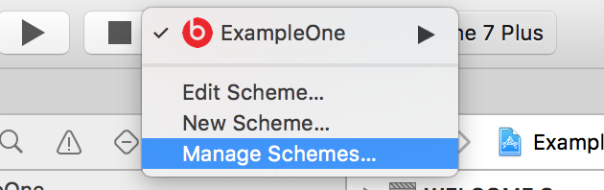

Press + button, Give a name (Arabic R2L), Close,

Tue, 21 March 2017

Tag:
- Can access the controls of the view using “viewWithTag()”
- Common methods with sender tag and match with case pattern

User Interaction Enabled:
Enable/Disable user action on the control

Alpha: creating transparency, alpha=1 Opaque, alpha = 0 transparent.

Background : used to change the background color of the controls and used animation using
UIView.animation

Wed, 22 March 2017

Hidden:

Clip to Bounds :

AutoResize subViews :

Sttething->Slicing :

CornerRadius:

Now click on edit, select Run and Application Language to Right to left
