SWC Seminar Series Final Project

Eric D. Johnson

Thursday, March 19, 2015

This is a simple analyziz of some gapminder data for the SWC final project. Look at this great Afghanistan data! The trend is all wack!

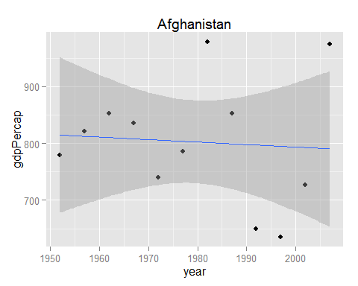

Look at this great United States data; the trend is bomb-diggity!

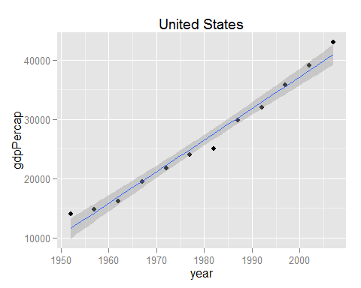

Look at this great Zimbabwe data; super gnar!

