# **Database Assignment 1 – Database Design**

**Title:** Bike Shop Rental and Servicing Database Design

**Name:** Gary Houston

**Student Number:**

**Module:** Database

**Date:** 18/10/20

# **Table of Contents:**

**1) Business Description & Database Rquirements pg.3**

**2) Conceptuual Design – Enhanced Entity-Relationship Diagram pg.4**

**3) Logical Database Design – Relationship Mapping pg. 5- 6**

# **Business Description**

Bike Rental Limited is a bike rental company based in several popular tourist locations around the country. For insurance and quality control purposes a database may be highly beneficial to track serval of the businesses main functions. Each store employees two types of staff they are either members of the Store Front team or the Technicians Team. Store Front Staff are required to engage with customers face to face, over the phone and by email and if required process any rentals made by these customers.

These rentals, the staff member that processes them and the details of the customer must be recorded for insurance purposes. Each rental relates to one bicycle and one customer only, it is also processed by only one Store Front staff member. Each customer can however make many rentals.

Every time a Bicycle is returned from a rental it must be inspected by a member of the Technician Team in order to assess any damage to the Bicycle and also to ensure it is safe to be put back into rental rotation. Each rental will always lead to one inspection carried out by a single member of the technical team. The date, time and technician information for each inspection needs to be recorded, to ensure transparency in the event of an incident involving this bicycle and a customer.

Should the inspection lead to the detection of an issues, the bicycle must be taken out of rental rotation until a member of the technicians performed a service job on the bike and repair the issue. Each service job will require one Technician, their Staff Id, the Bike Id and a record of work performed will need to be logged for future reference.

The Technician Team max. 3 per shift will need to be supervised by a member of the Team in order to ensure work is being performed to a high standard and in a timely fashion in order to ensure quality control and to ensure Bicycles do not spend excessive periods out of circulation.

This system would be a valuable resource to this business as it helps to track the relationship between rentals and maintenance of Bicycles in such a way as to ensure they are regularly inspected and serviced. This will increase the company’s safety standards, minimizing the chances of any potentially avoidable hazards to customer safety while also protecting the value and lifecycle of each Bicycle in their fleet.

This system will also increase the likelihood of detecting and Customer damage to the bikes through negligence and/or misuse which as per T&C’s would result in the retention of their deposit and in the case of suspected theft, the involvement of the authorities.

# **Enhanced Entity-Relationship Diagram**

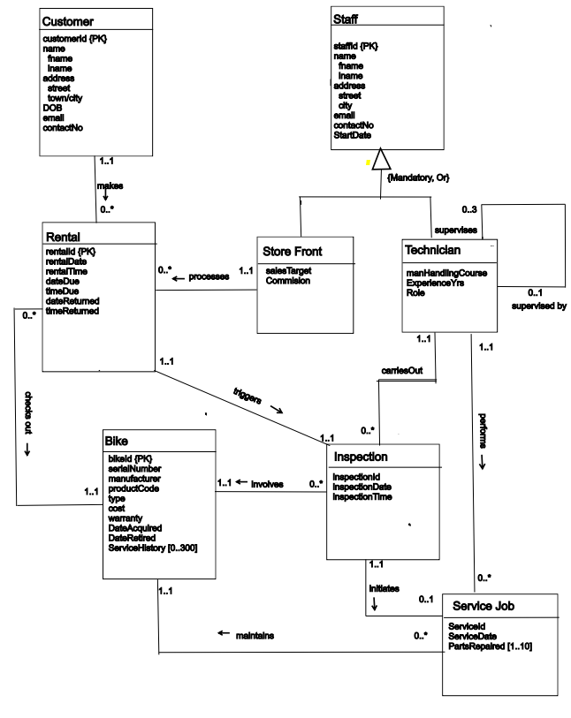

# **Logical Design: Entity-Relationship Mapping (Full Tables)**

**Customer**(customerId, fname, lname, street, city, DOB, email, contactNumber)

Primary key: customerId

**StoreFront**(staffId, ppsn, fName, lName, street, city, email, contactNo, salesTarget, commission)

Primary Key staffId

Foreign Key rental references Rental(rentalId)

**Technician**(staffId, fName, lName, street, city, email, contactNo, manualHandlingDate, role, inspection, service, supervisor)

Primary Key staffId

Foreign Key inspection references Inspection(inspectionId)

Foreign Key service references ServiceJob(serviceId)

Foreign Key supervisor references Technician(staffId)

**Bike**(bikeId, serialNumber, manufacturer, type, cost, warranty, dateAcquired, dateRetired)

Primary Key bikeId

**Rental**(rentalId, rentalDate, rentalTime, dateDue, timeDue, dateReturned, timeReturned, customer, staffMember, bikeRented, inspection)

Primary Key rentalId

Foreign Key customer references Customer(customerId)

Foreign Key staffMember references StoreFront(staffId)

Foreign Key bike references Bike(bikeId)

Foreign Key inspection references Inspection(inspectionId)

**Inspection**(rentalId, inspectionDate, inspectionTime, bike, technician, service)

Primary Key rentalId, bike

Foreign Key rentalId references Rental(rentalId)

Foreign Key bike reference Bike(bikeId)

Foreign Key technician references Technician(staffId)

Foreign Key service references ServiceJob(serviceId)

**ServiceJob**(serviceId, serviceDate, partsRepaired, inspection, bike, technician)

Primary Key serviceId, technician, bike

Foreign Key inspection references Inspection(rentalId)

Foreign Key bike references Bike(bikeId)

Foreign Key technician references Technician(staffId)