MediaMarketplace Studio — Single-Server Deployment Diagram
Applies to: MediaMarketplace Studio 0.2.0 for WordPress and for Joomla
Purpose: show how the store runs on the one machine that already hosts the website
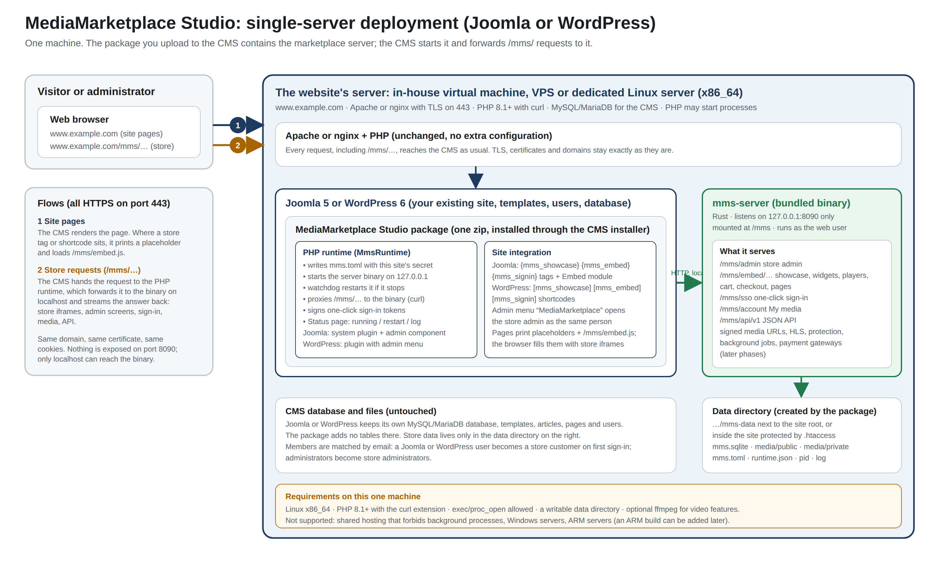
Single-server deployment: the CMS package contains and runs the marketplace server
Contents
Reading the diagram
What runs on the machine
Points worth noting

Reading the diagram
Number | Connection | From | To | Protocol and port
1 | Site pages | browser | Apache or nginx + PHP → CMS | HTTPS 443
2 | Store requests (/mms/…) | browser | Apache or nginx + PHP → CMS → PHP runtime → store server | HTTPS 443 outside, HTTP on localhost inside

What runs on the machine
Part | Provided by | Notes
Apache or nginx, PHP, MySQL/MariaDB | your existing hosting | unchanged; no proxy rules, no extra virtual host
Joomla or WordPress | your existing site | unchanged; the package adds no database tables
MediaMarketplace Studio package | the zip you upload | PHP runtime, CMS integration, the store server binary
Store server (mms-server) | inside the package | listens on 127.0.0.1 only; started and supervised by the runtime
Data directory | created by the package | database, media, configuration, log; outside the web root when possible

Points worth noting
- Only one machine and one domain. The store lives at the site's own address under /mms/, with the site's certificate and cookies.
- Nothing listens on a public port except the web server you already have. The store server's port is reachable from the machine itself only.
- The server needs to be able to run a background program: an in-house virtual machine, a VPS or a dedicated server. Shared hosting that forbids background programs cannot run it.
- Members and administrators are recognised through one-click sign-in tokens signed by the package; no second password exists.
- The CMS database is untouched. Back up the data directory with the site.

