MediaMarketplace Bridge — Joomla Installation Guide
Applies to: MediaMarketplace Bridge for Joomla 0.1.0, Joomla 5.0 or newer, PHP 8.1 or newer
Audience: the Joomla site administrator
Time needed: about 10 minutes
Joomla admin screens in this guide are mock-ups drawn to match the real screens. The store content shown inside the page is a live capture from the server.
Contents
1. Before you start
2. Register the site on the server
3. Install the package
4. Connect to the server
5. Put the store on the site
6. Tag and module reference
7. Troubleshooting

1. Before you start
- A running MediaMarketplace server (see the Server Installation Guide) reachable at an HTTPS address, for example https://media.example.com.
- Super User access to the Joomla site.
- The file mediamarketplace-bridge-joomla-0.1.0.zip.
VirtueMart is not needed. The bridge does not create products, orders or customers inside Joomla; all of that stays on the server.
The package installs two extensions:
Extension | Type | Purpose
System - MediaMarketplace Bridge | plugin | holds the connection settings, replaces {mms_…} tags in articles, builds sign-on links
MediaMarketplace Embed | site module | places a showcase, widget, player, cart or site pass block in any module position

2. Register the site on the server
- Sign in to the server admin and open Bridges.
- Under Add a site, enter a name, choose Joomla, and enter the Joomla site's origin, for example https://www.example.com (no path).
- Click Create site and secret.
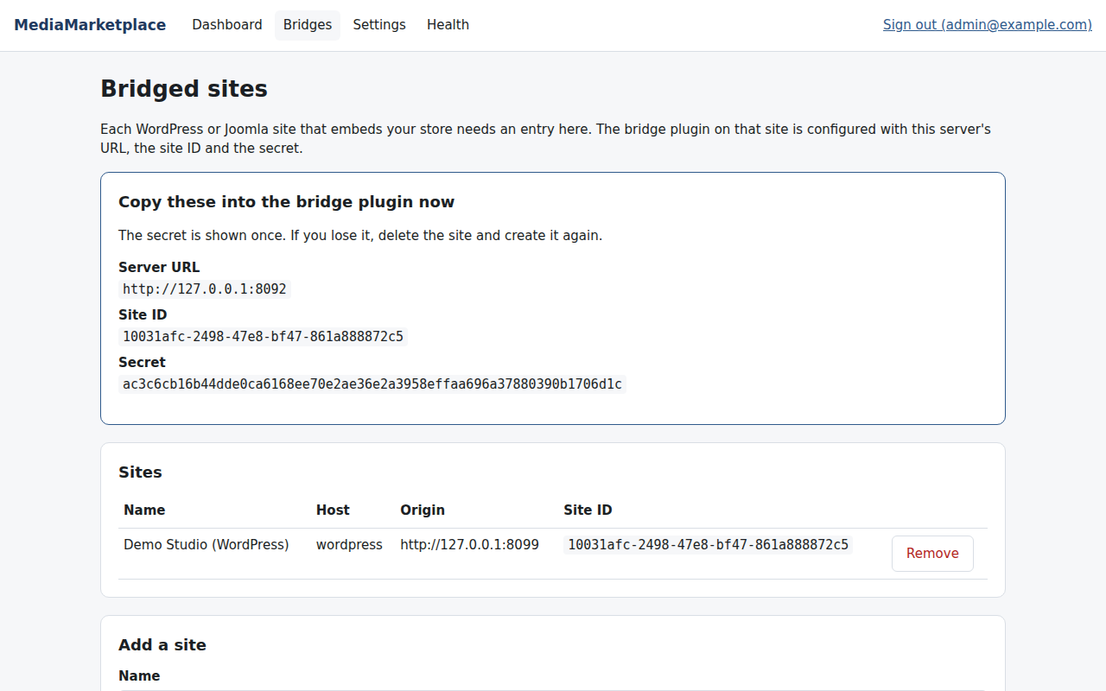
The server shows the three values to copy
Keep this page open. You will copy the Server URL, Site ID and Secret in §4.

3. Install the package
- In the Joomla administrator go to System → Install → Extensions.
- On the Upload Package File tab, drop mediamarketplace-bridge-joomla-0.1.0.zip or browse for it.
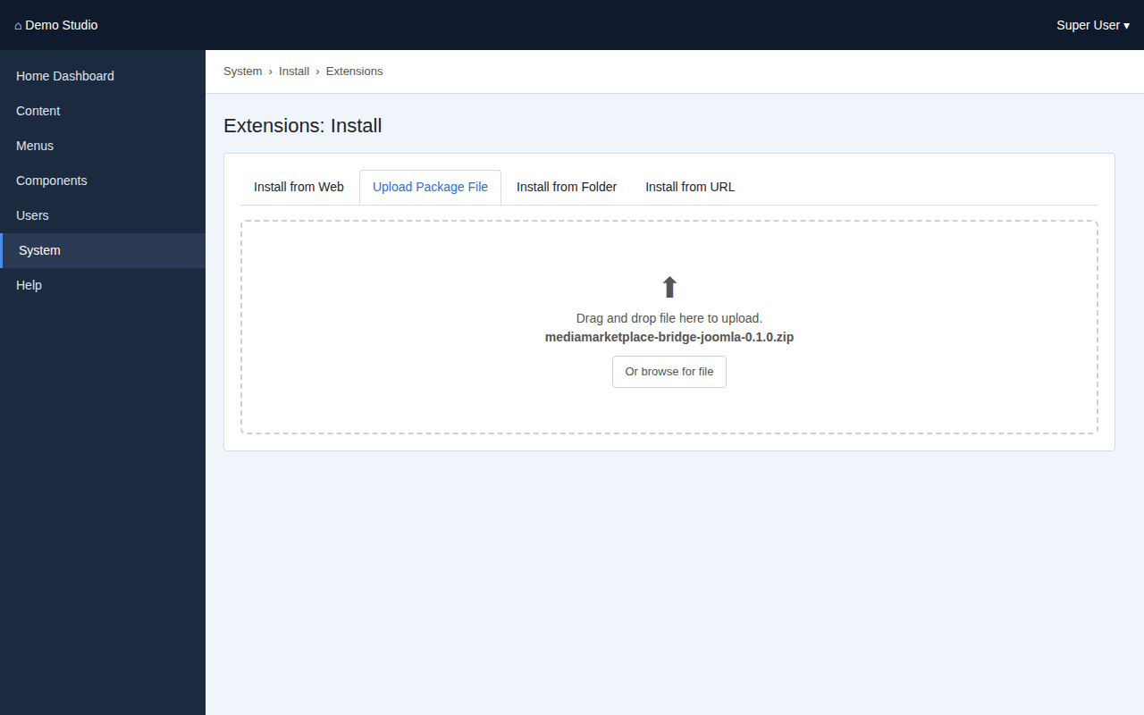
Uploading the package (mock-up)
- Joomla installs the package, the plugin and the module, and enables the plugin.
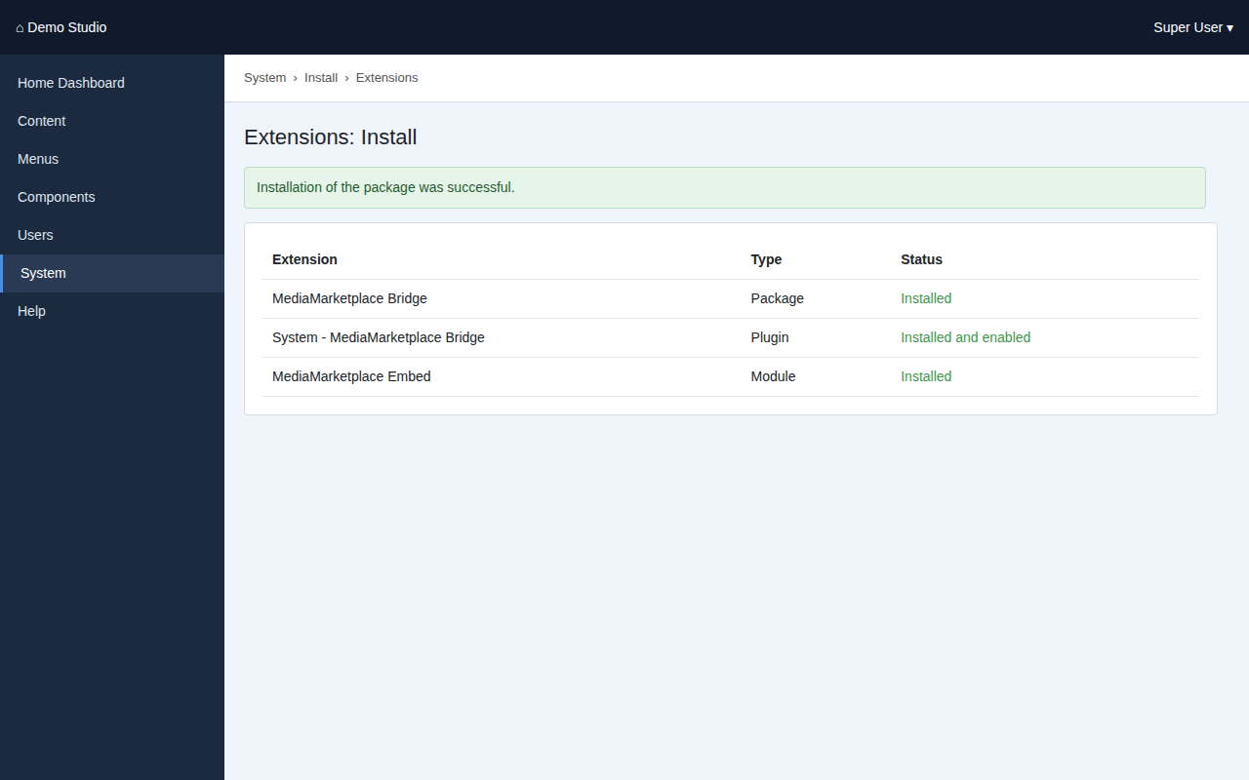
The installation result (mock-up)

4. Connect to the server
- Go to System → Plugins and open System - MediaMarketplace Bridge.
- Paste the Server URL, Site ID and Secret from §2.
- Make sure Status is Enabled and click Save & Close.
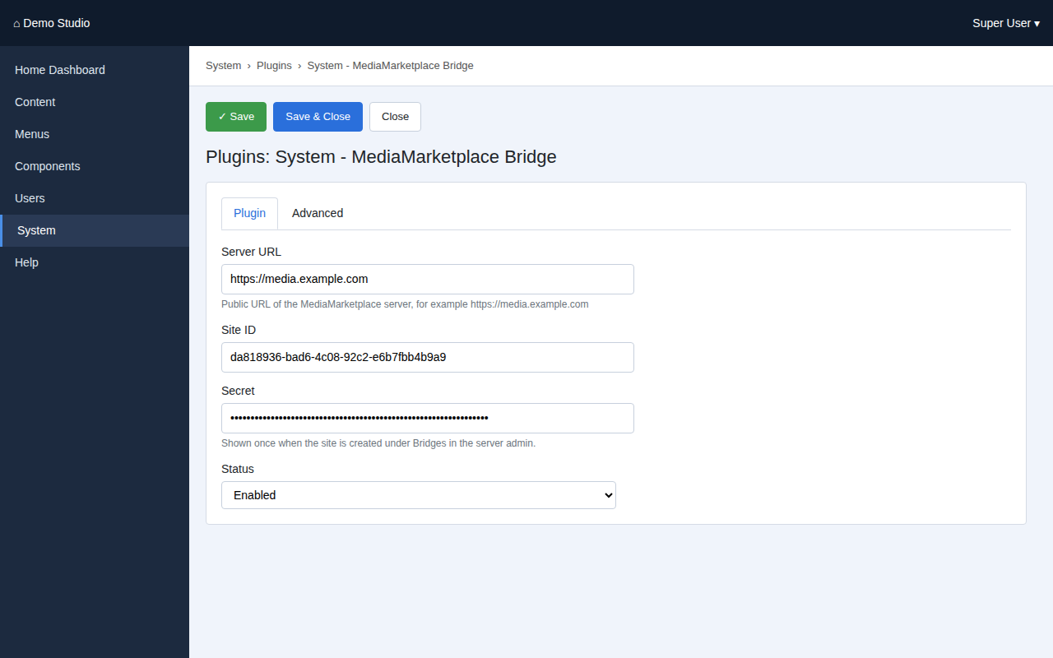
The plugin settings (mock-up)

5. Put the store on the site
You can use an article, a module, or both.
In an article. Edit the article, for example Store, and type {mms_showcase view=grid} where the store should appear. Add {mms_signin label="My media"} to give logged-in members a sign-on link. Save.
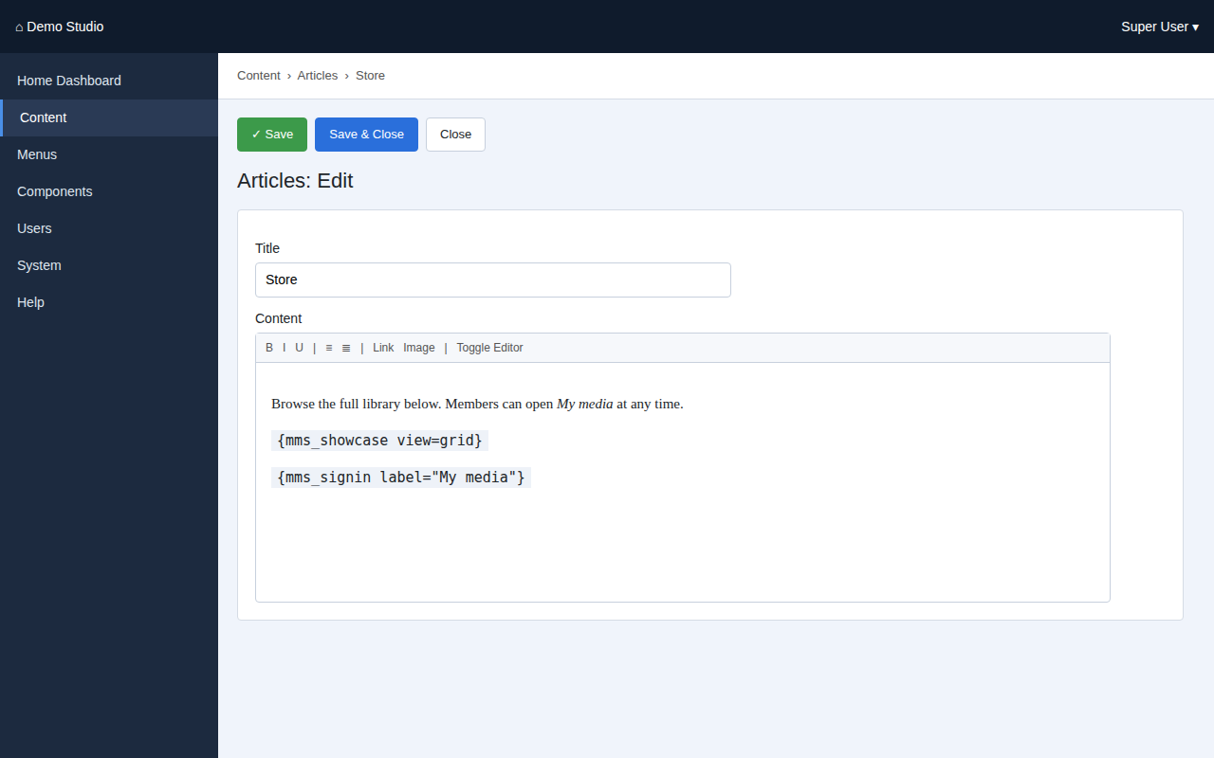
An article with the showcase and sign-in tags (mock-up)
In a module position. Go to Content → Site Modules → New, choose MediaMarketplace Embed, pick what to embed, a position and the menu assignment, and save.
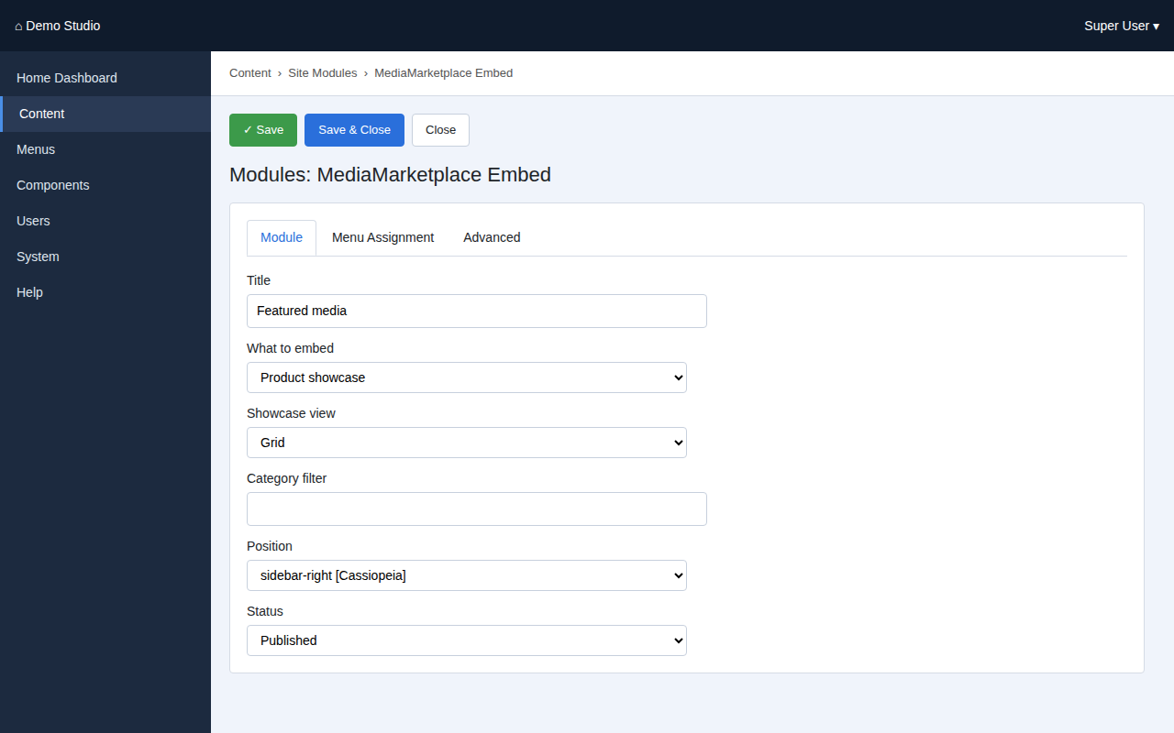
The MediaMarketplace Embed module settings (mock-up)
The store appears inside the page with the template's header and layout untouched.
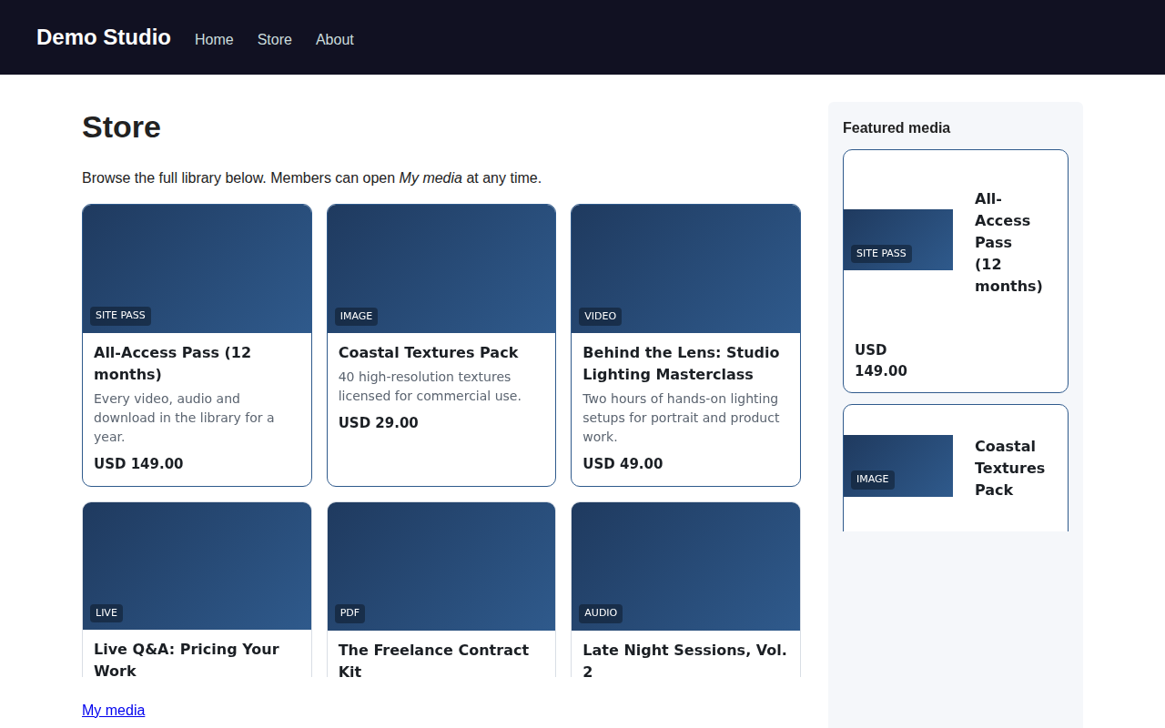
The site with the showcase in the article and the featured list in a module (mock-up page, live store content)

6. Tag and module reference
Tag | What it shows | Parameters
{mms_showcase} | the product showcase | view=grid or list, category=slug
{mms_embed kind=…} | any embed the server offers | kind = widget, player, cart, sitepass, page; id=… where required
{mms_signin} | single sign-on link for logged-in users | label="…", return=/account

Module options: What to embed (showcase, widget, player, cart, site pass plans), Widget or product ID, Showcase view, Category filter, plus the usual position, menu assignment and layout options.

7. Troubleshooting
Symptom | Cause | Fix
Tags appear as plain text | the plugin is disabled or the article is not passed through content plugins | enable the plugin; check the article is rendered by a normal content view
The store area is blank | the browser blocked the embed, or the site origin does not match | the origin entered on the server must equal the Joomla site's scheme and host exactly
"Unknown bridge site" inside the store area | wrong Site ID, or the site was removed on the server | recreate the site on the server and paste the new values
The sign-on link is missing | the visitor is a guest | log in, or use the server's own sign-in page
"Sign-on token rejected" | wrong secret, or clocks differ by more than five minutes | re-enter the secret; check the time on both machines

To remove the bridge, uninstall the MediaMarketplace Bridge package under System → Manage → Extensions. Nothing on the server is affected.

