MediaMarketplace Bridge — WordPress Installation Guide
Applies to: MediaMarketplace Bridge for WordPress 0.1.0, WordPress 6.4 or newer, PHP 8.1 or newer
Audience: the WordPress site administrator
Time needed: about 10 minutes
WordPress admin screens in this guide are mock-ups drawn to match the real screens. The store content shown inside the page is a live capture from the server.
Contents
1. Before you start
2. Register the site on the server
3. Install the plugin
4. Connect to the server
5. Put the store on a page
6. Shortcode reference
7. Troubleshooting

1. Before you start
- A running MediaMarketplace server (see the Server Installation Guide) reachable at an HTTPS address, for example https://media.example.com.
- Administrator access to the WordPress site.
- The file mediamarketplace-bridge-wordpress-0.1.0.zip.
WooCommerce is not needed. The bridge does not create products, orders or customers inside WordPress; all of that stays on the server.

2. Register the site on the server
- Sign in to the server admin and open Bridges.
- Under Add a site, enter a name, choose WordPress, and enter the WordPress site's origin, for example https://www.example.com (no path).
- Click Create site and secret.
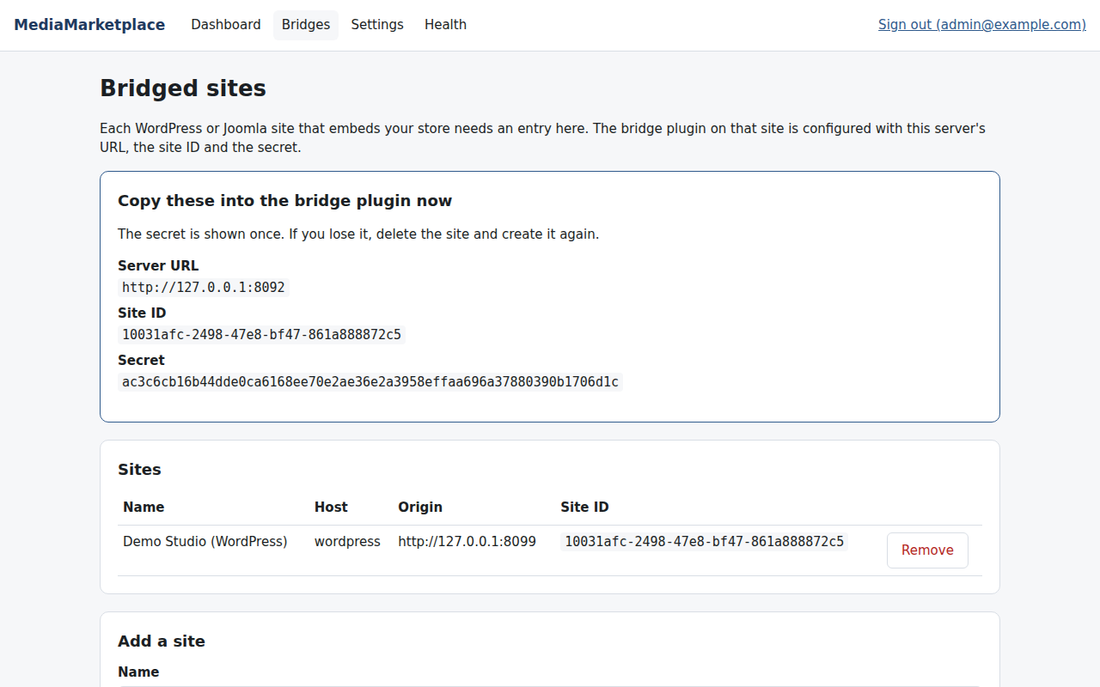
The server shows the three values to copy
Keep this page open. You will copy the Server URL, Site ID and Secret in §4.

3. Install the plugin
- In WordPress, go to Plugins → Add New Plugin and click Upload Plugin.
- Choose mediamarketplace-bridge-wordpress-0.1.0.zip and click Install Now.
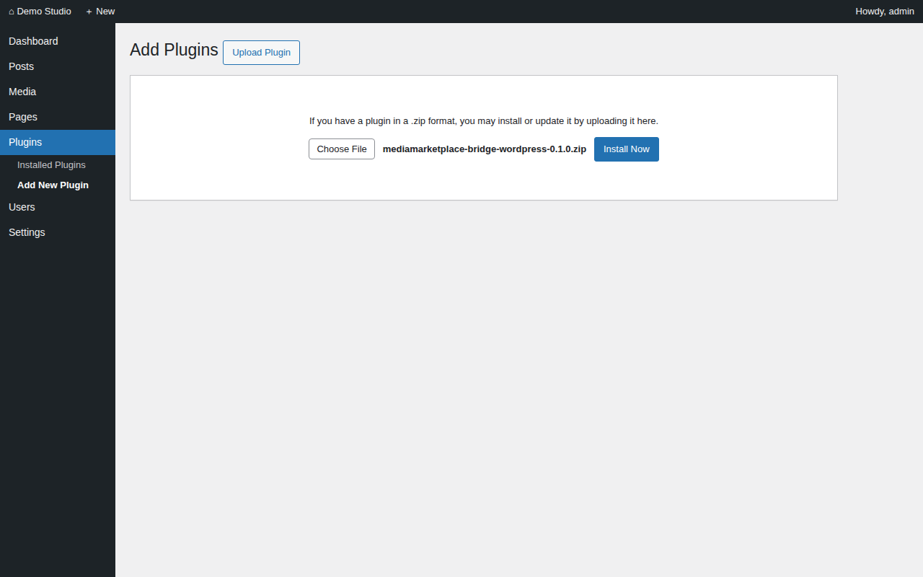
Uploading the plugin zip (mock-up)
- Click Activate Plugin. A notice reminds you that the bridge is not connected yet.
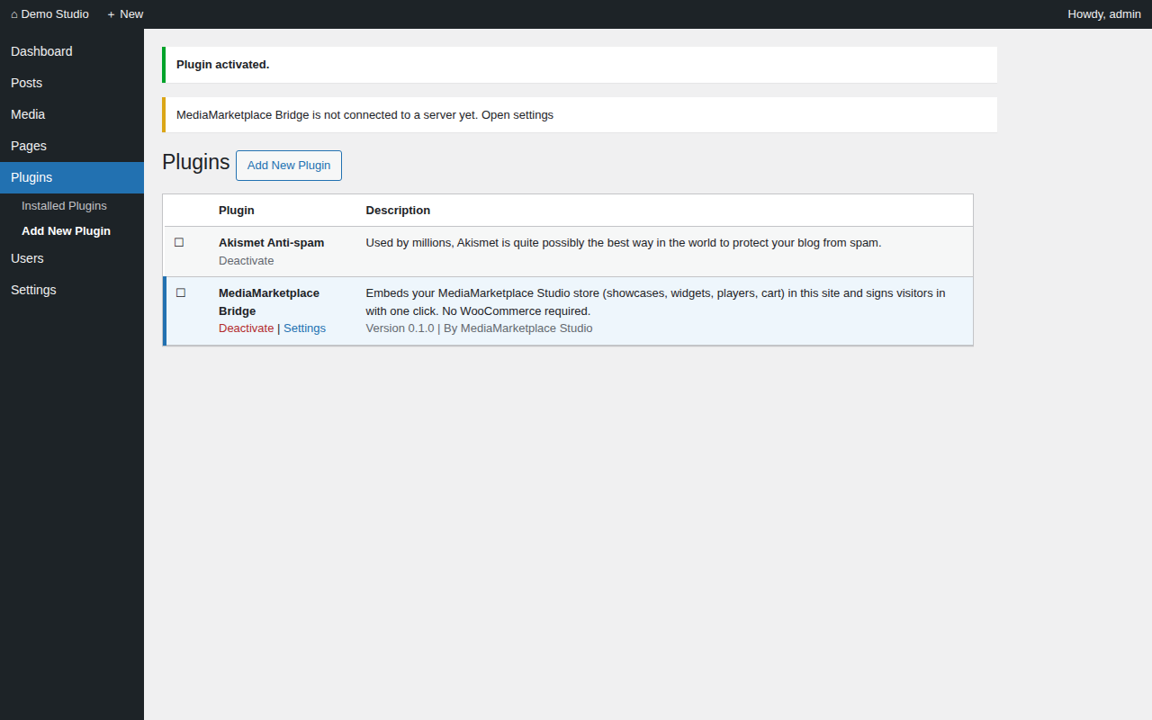
The plugin activated, with the connection notice (mock-up)

4. Connect to the server
- Go to Settings → MediaMarketplace.
- Paste the Server URL, Site ID and Secret from §2.
- Click Save Changes.
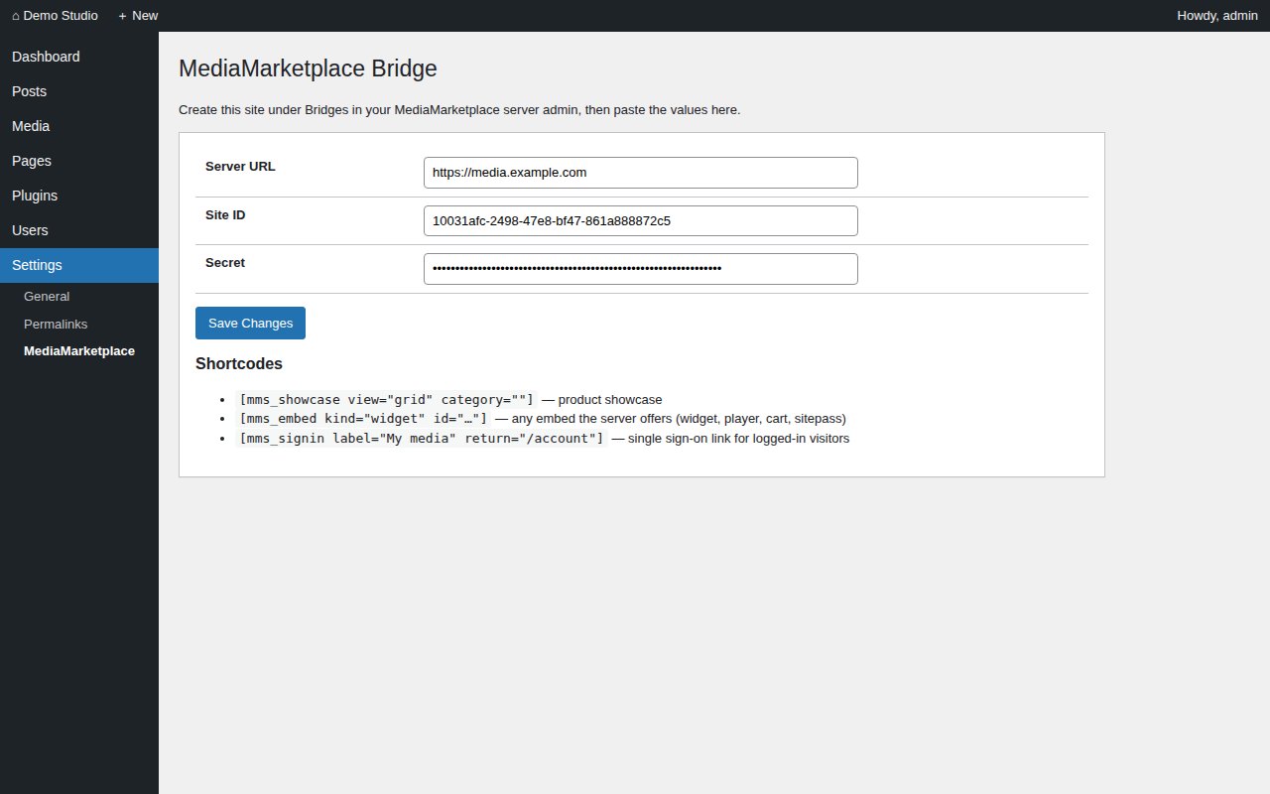
The bridge settings page (mock-up)
The secret field is write-only. It shows as empty after saving; leave it empty to keep the stored value, or paste a new one to replace it.

5. Put the store on a page
- Edit the page that should show the store, for example a page called Store.
- Add a Shortcode block containing [mms_showcase view="grid"].
- Optionally add another Shortcode block with [mms_signin label="My media"]. It renders a link only for logged-in WordPress users and signs them into the server.
- Publish the page.
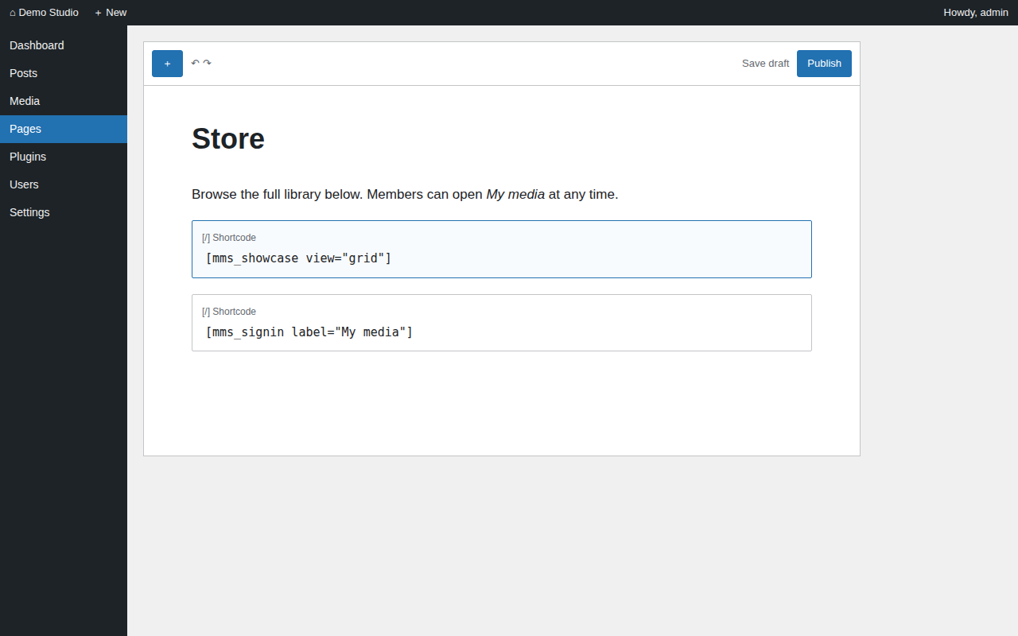
Shortcode blocks in the page editor (mock-up)
The store appears inside the page. Products, prices and layout come from the server; the theme's header, menu and fonts are untouched.
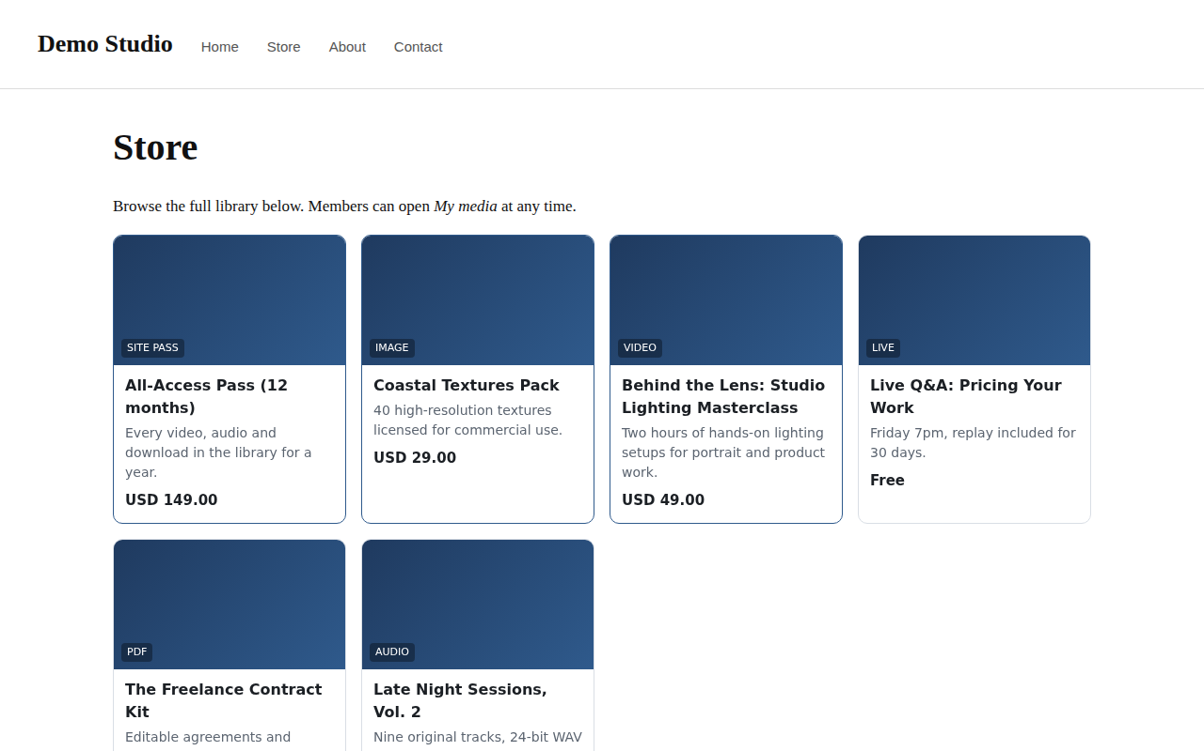
The published page with the live showcase (mock-up page, live store content)

6. Shortcode reference
Shortcode | What it shows | Attributes
[mms_showcase] | the product showcase | view="grid" or "list", category="slug"
[mms_embed kind="…"] | any embed the server offers | kind = widget, player, cart, sitepass, page; id where required
[mms_signin] | single sign-on link for logged-in users | label, return (path on the server, default /account), class

Theme developers can call MMS_Bridge::instance()->ssoUrl('/account') to build the sign-on link in templates.

7. Troubleshooting
Symptom | Cause | Fix
The page shows "MediaMarketplace Bridge is not configured" (admins only) | settings are empty | fill in Settings → MediaMarketplace
The store area is blank | the browser blocked the embed, or the site origin does not match | the origin entered on the server must equal the WordPress site's scheme and host exactly
"Unknown bridge site" inside the store area | wrong Site ID, or the site was removed on the server | recreate the site on the server and paste the new values
The sign-on link is missing | the visitor is not logged in to WordPress | log in, or use the server's own sign-in page
"Sign-on token rejected" | wrong secret, or the server and site clocks differ by more than five minutes | re-enter the secret; check the time on both machines

To remove the plugin, deactivate and delete it under Plugins. Its single setting is removed on uninstall. Nothing on the server is affected.

