MediaMarketplace Studio — Server Installation Guide
Applies to: mms-server 0.1.0
Audience: the person setting up the server (a VPS, dedicated server or Docker host)
Time needed: about 20 minutes
Contents
1. Before you start
2. Install as a system service (recommended)
3. Install with Docker (alternative)
4. First run: the setup wizard
5. Check the Health page
6. Connect your first website
7. Everyday commands
8. Troubleshooting

1. Before you start
What the server is. MediaMarketplace Studio is a single program, mms-server, that runs on your own Linux machine. It stores its database and media files in one data folder. Your WordPress or Joomla site connects to it with a small bridge plugin, which has its own guide.
What you need.
Item | Requirement
Machine | Linux, 64-bit (x86_64), 1 CPU and 1 GB RAM is enough to start
Access | a shell with sudo, or a Docker host
Domain | a hostname for the server, for example media.example.com, pointing at the machine
TLS | a reverse proxy (Caddy, nginx or Apache) that terminates HTTPS in front of the server
Optional | ffmpeg, for video thumbnails, transcoding and Level 3 watermarking

What you downloaded. The archive mms-server-0.1.0-linux-x86_64.tar.gz contains:
- mms-server — the program
- INSTALL.txt — a short version of this guide
- mms-server.service — a systemd unit file
- Dockerfile and docker-compose.yml — for Docker installs
Shared web hosting that only runs PHP cannot run the server. Install it on a VPS and point the bridge plugins at it.

2. Install as a system service (recommended)
Run these commands on the server as a user with sudo.
Step 1. Unpack and place the program.
tar -xzf mms-server-0.1.0-linux-x86_64.tar.gz
cd mms-server-0.1.0-linux-x86_64
sudo install -m 0755 mms-server /usr/local/bin/mms-server

Step 2. Create the service user and folders.
sudo useradd --system --create-home --home-dir /var/lib/mms mms
sudo mkdir -p /etc/mms
sudo chown mms:mms /etc/mms

Step 3. Initialise the configuration. Replace the public URL with your own domain.
sudo -u mms mms-server --config /etc/mms/mms.toml init \
--data-dir /var/lib/mms \
--bind 127.0.0.1:8090 \
--public-url https://media.example.com

This writes /etc/mms/mms.toml with a freshly generated secret key, creates the database and media folders under /var/lib/mms, and applies the database schema.
Step 4. Install and start the service.
sudo cp mms-server.service /etc/systemd/system/mms-server.service
sudo systemctl daemon-reload
sudo systemctl enable --now mms-server
sudo systemctl status mms-server

The status output should show active (running) and a log line like MediaMarketplace Studio 0.1.0 listening on 127.0.0.1:8090.
Step 5. Put a TLS reverse proxy in front. The server listens on localhost only; the proxy makes it public over HTTPS. Two examples:
Caddy (/etc/caddy/Caddyfile), which obtains certificates automatically:
media.example.com {
reverse_proxy 127.0.0.1:8090
}

nginx (inside a server block that already has TLS configured):
location / {
proxy_pass http://127.0.0.1:8090;
proxy_set_header Host $host;
proxy_set_header X-Forwarded-For $proxy_add_x_forwarded_for;
proxy_set_header X-Forwarded-Proto $scheme;
client_max_body_size 512m;
}

Reload the proxy, then open https://media.example.com in a browser. Continue with §4.

3. Install with Docker (alternative)
Step 1. Copy Dockerfile and docker-compose.yml to a folder on the Docker host. Edit docker-compose.yml and set MMS_PUBLIC_URL to your public address.
Step 2. Build and start:
docker compose up -d --build
docker compose logs -f mms

The container stores everything in the mms-data volume and listens on 127.0.0.1:8090 on the host. Put your reverse proxy in front exactly as in §2 Step 5.
Step 3. Open the public URL in a browser and continue with §4.

4. First run: the setup wizard
The first visit to the server opens the setup wizard. Nothing else is reachable until an administrator exists.
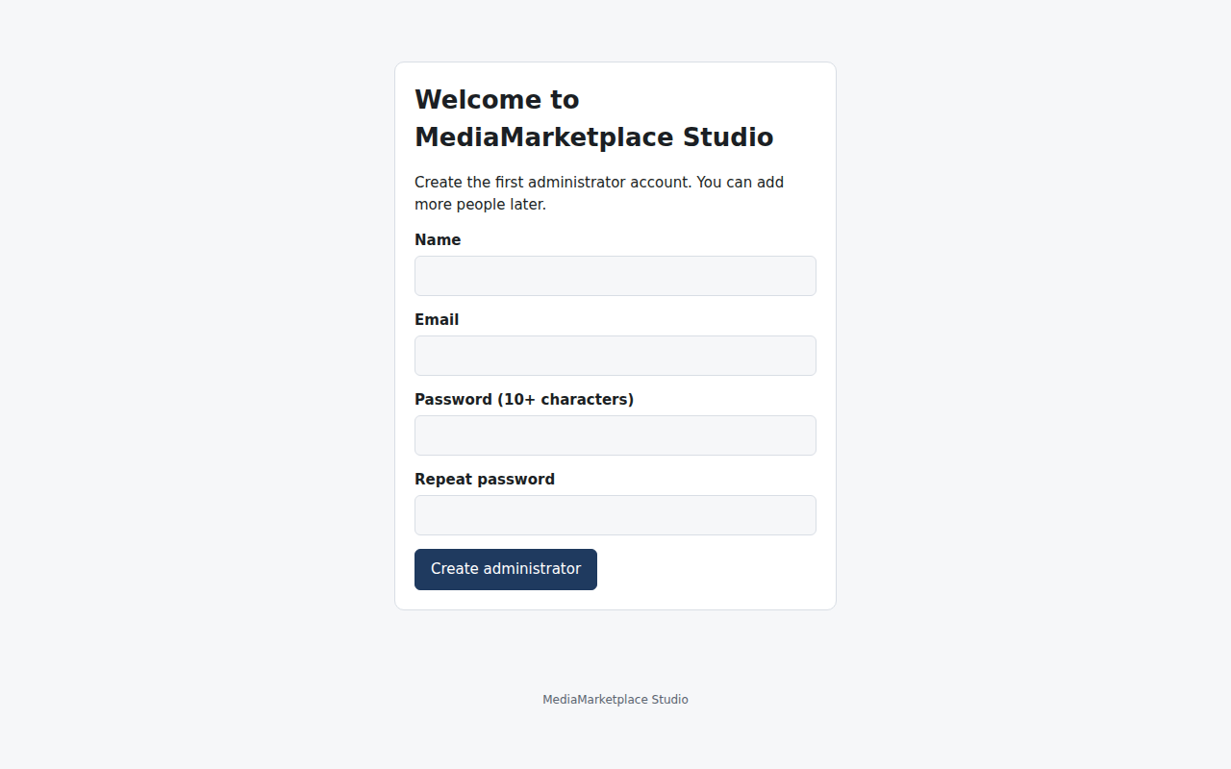
The setup wizard on first visit
- Enter your name and email address.
- Choose a password of at least 10 characters and repeat it.
- Click Create administrator. You are signed in and taken to the dashboard.
If you prefer the command line, create the administrator with sudo -u mms mms-server --config /etc/mms/mms.toml admin --email you@example.com and then sign in at /admin/login.
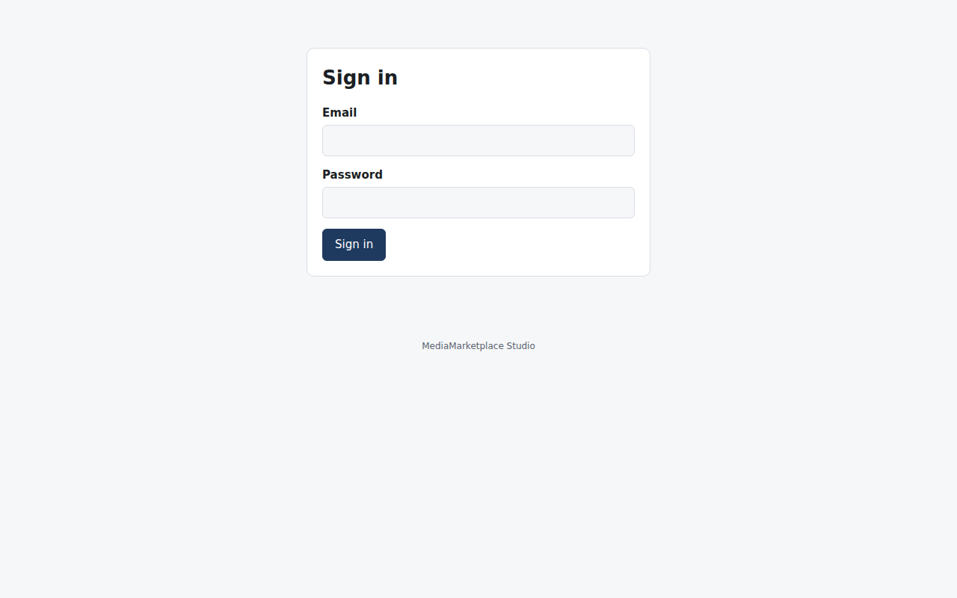
The sign-in page

5. Check the Health page
Open Health in the top bar. Every row should be green before you go live.
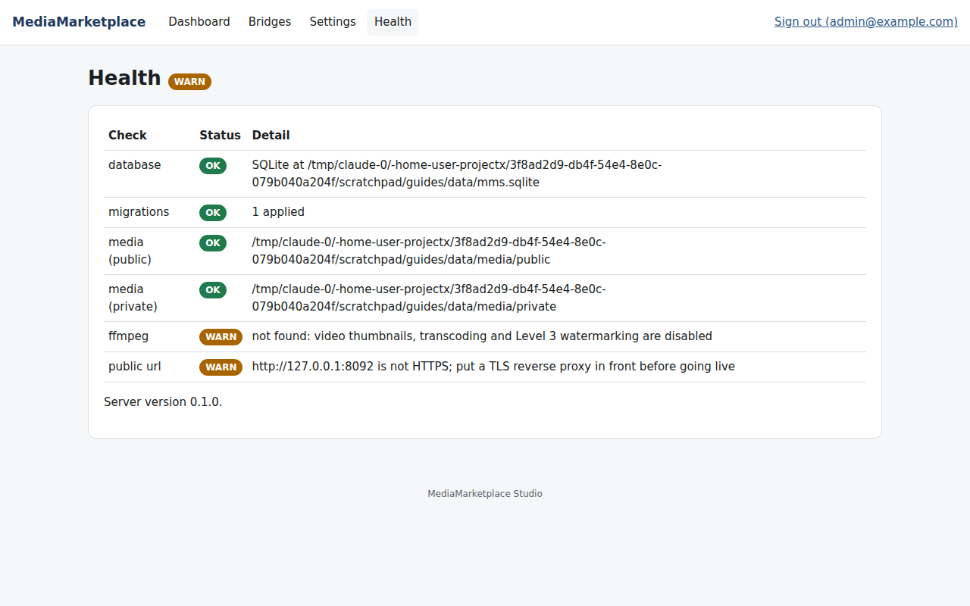
The Health page after a fresh install
Row | What it checks | If it is not green
database | the SQLite database opens | check that the data folder is owned by the mms user
migrations | every schema migration is applied | run mms-server migrate
media (public), media (private) | the media folders exist and are writable | fix ownership or the data_dir setting
ffmpeg | the ffmpeg binary is found | install ffmpeg or set media.ffmpeg_path; video features stay off until then
public url | the public URL uses HTTPS | finish the reverse proxy and set public_url to the https address

6. Connect your first website
Each WordPress or Joomla site that will show your store needs a bridge entry.
- Open Bridges in the top bar.
- Under Add a site, enter a name, choose WordPress or Joomla, and enter the site's origin (scheme and host only, for example https://www.example.com).
- Click Create site and secret.
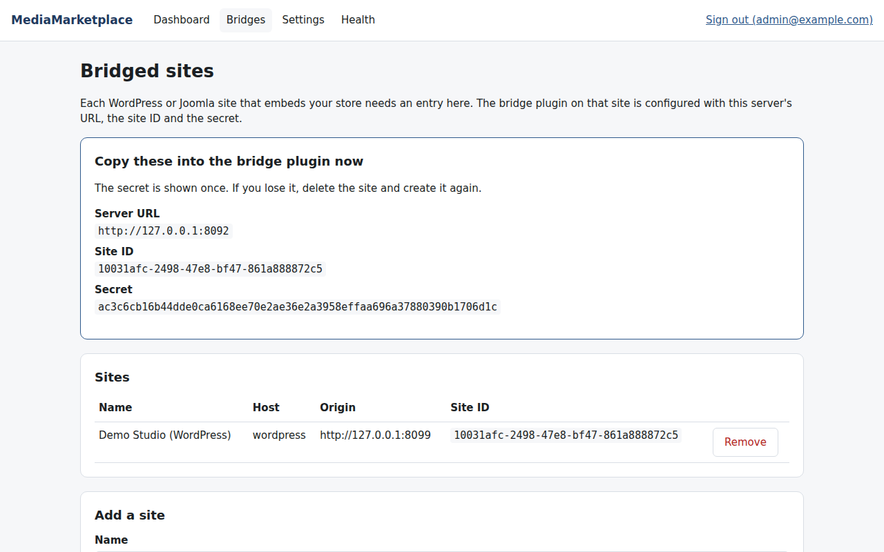
A newly created bridge site showing the values to copy
Copy the Server URL, Site ID and Secret into the bridge plugin on that website. The secret is shown only once. If you lose it, remove the site and create it again. The WordPress and Joomla installation guides continue from here.

7. Everyday commands
All commands take --config /etc/mms/mms.toml (or the MMS_CONFIG environment variable) and should run as the mms user.
Command | Purpose
mms-server health | print the health report as JSON; exit code 1 when something fails
mms-server migrate | apply pending database migrations after an upgrade
mms-server admin --email E | create another administrator
mms-server serve | run the server in the foreground (systemd does this for you)
systemctl restart mms-server | restart the service
journalctl -u mms-server -f | follow the log

Upgrading. Stop the service, replace /usr/local/bin/mms-server with the new binary, start the service. Migrations run automatically on start.
Backing up. Stop the service or use a quiet moment, then copy /var/lib/mms/mms.sqlite and the /var/lib/mms/media folder. Keep /etc/mms/mms.toml too: it holds the secret key that protects stored credentials.

8. Troubleshooting
Symptom | Likely cause | What to do
Browser shows a proxy error | the service is not running | systemctl status mms-server, then journalctl -u mms-server
"security.secret_key must be at least 32 bytes" | the config was edited by hand | run init --force to regenerate, or restore the original key
Setup page never appears, login shows instead | an administrator already exists | sign in, or create another with mms-server admin
Health says public url is not HTTPS | public_url is http | set it to the https address in mms.toml and restart
Embeds on the website show "Unknown bridge site" | the bridge plugin has a wrong Site ID | recreate the site under Bridges and paste the new values
Uploads fail above a size | proxy body limit | raise client_max_body_size (nginx) or the equivalent

