MediaMarketplace Studio — User Guide
Applies to: mms-server 0.1.0 with the WordPress and Joomla bridge plugins 0.1.0
Audience: store owners and administrators
Screens: server screens are live captures; WordPress and Joomla screens are mock-ups drawn to match the real screens
Contents
1. How it fits together
2. Signing in
3. The dashboard
4. Connected websites (Bridges)
5. Settings
6. Health
7. The store on your website
8. Member sign-on
9. Products (preview of the next release)
10. Roadmap
11. Glossary

1. How it fits together
MediaMarketplace Studio has two parts.
- The server runs on your own machine and holds everything: the media library, products, prices, customers, orders, access rights, protection settings. You manage it in a web admin at https://your-server/admin.
- The bridges are small plugins for WordPress and Joomla. They show the server's store inside your website's pages and let your website's members sign in to the server with one click. They hold no store data of their own.
A visitor sees your normal website. The store area inside a page is delivered by the server, so a change made in the server admin appears on every connected site at once.

2. Signing in
Open https://your-server/admin. On the very first visit you see the setup wizard, which creates the first administrator. After that, the sign-in page appears.
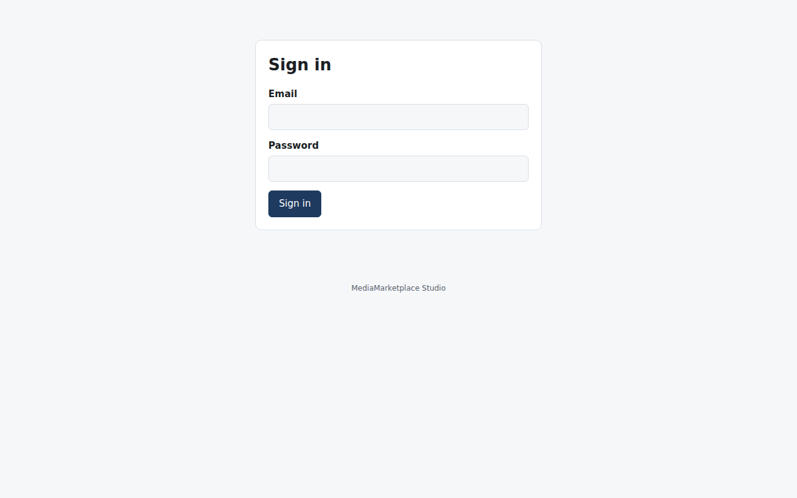
Sign in with the administrator email and password
Sessions last twelve hours by default. Sign out is at the right end of the top bar. If you forget the password, an administrator with shell access can create another administrator with the mms-server admin command.

3. The dashboard
The dashboard shows counts of products, media items, customers and connected sites, a list of recent activity from the audit log, and the next steps for a new install.
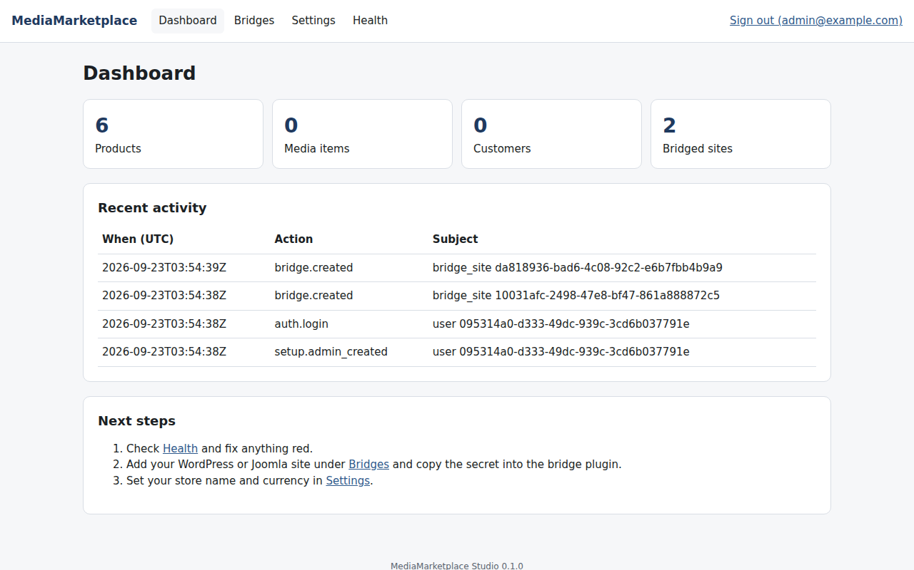
The dashboard with a few products and two connected sites
Recent activity records who did what and when: sign-ins, settings changes, bridge sites created or removed, access grants and revocations.

4. Connected websites (Bridges)
Bridges lists every WordPress or Joomla site allowed to show your store and sign visitors in.
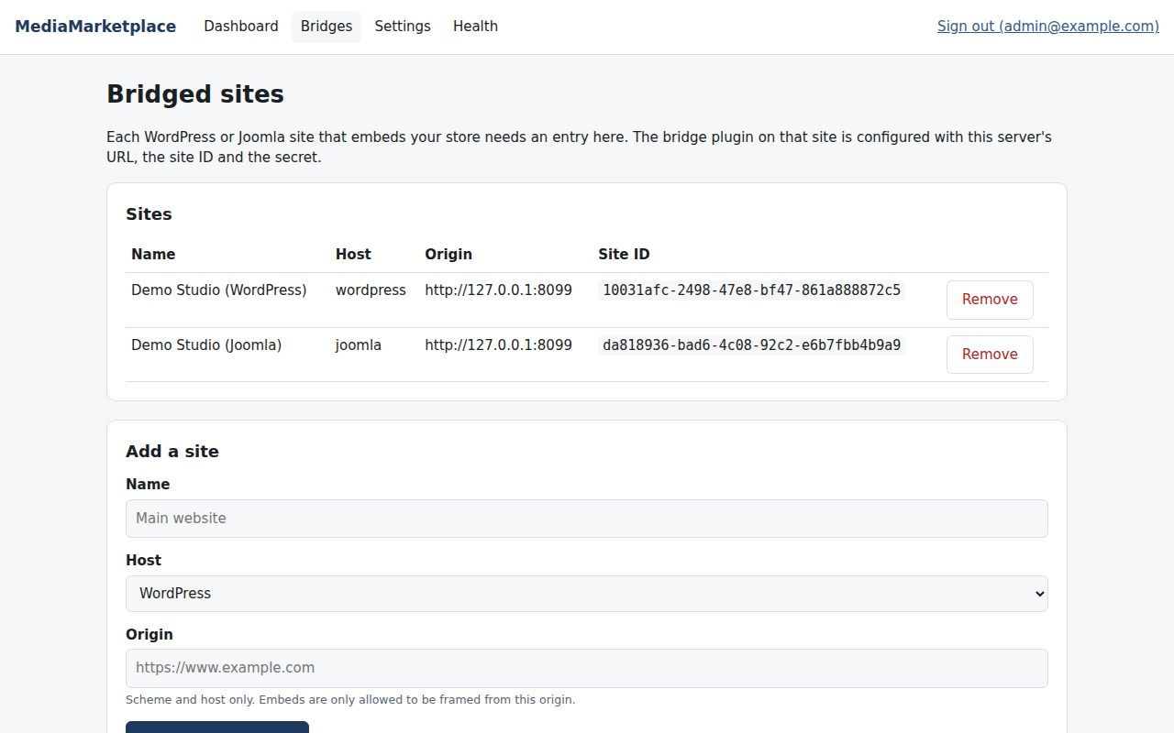
The Bridges page listing two connected sites
Adding a site. Enter a name, choose the host type, and enter the site's origin (scheme and host only). The server generates a secret and shows it once, together with the site ID and server URL. Copy the three values into the bridge plugin on that site.
Why the origin matters. The server only allows its store pages to be framed by the origin you enter. A copy of your embed code on another domain will not work.
Removing a site. Click Remove. Embeds and sign-on from that site stop immediately. The customers who signed in from it keep their accounts and purchases.

5. Settings
Settings groups every runtime option. Change values and click Save settings. Invalid values are refused with a message and nothing is saved.
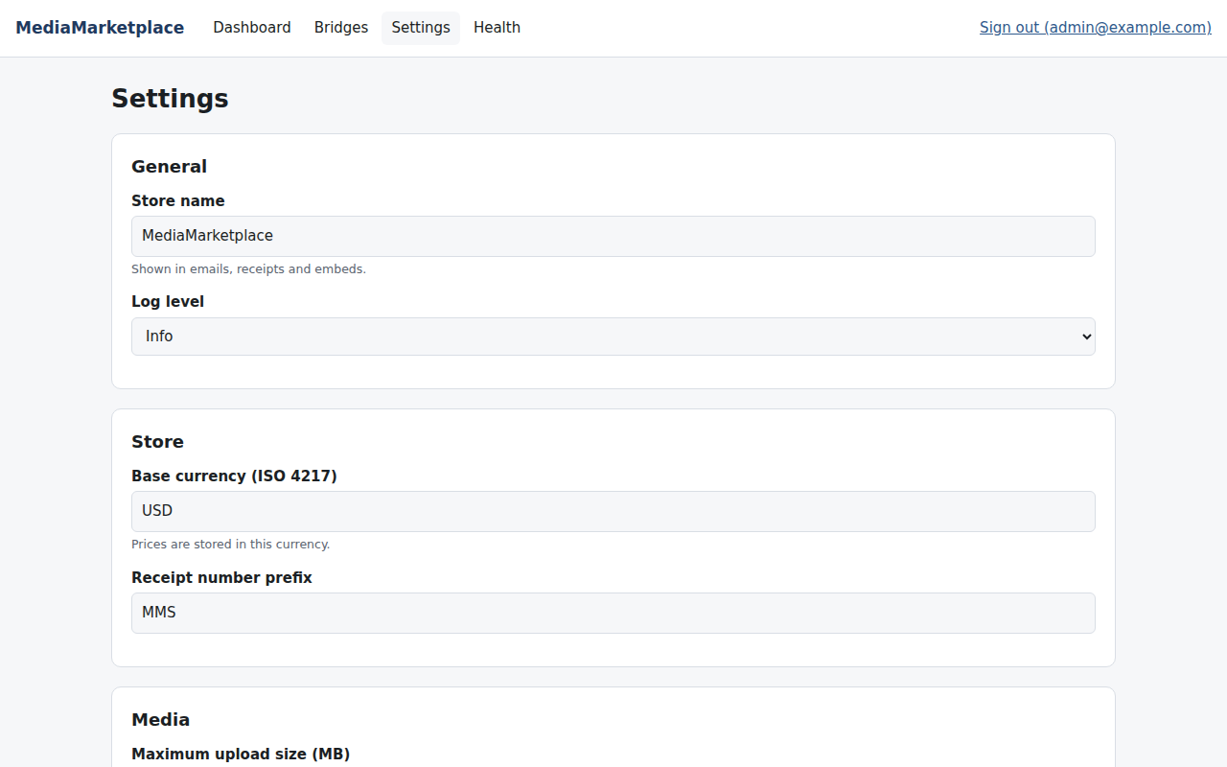
The settings page
Section | Settings
General | store name (shown in embeds, emails and receipts), log level
Store | base currency, receipt number prefix
Media | maximum upload size, path to ffmpeg
Players | default media player
Access control | signed URL lifetime, failed attempts before lockout, attempt window, lockout duration
Privacy | how many months to keep watermark sessions and audit entries
AI | Anthropic API key and Claude model for the Google Business Profile assistant

Secrets such as the API key are stored encrypted. The field shows only the last four characters after saving; leave it as it is to keep the stored value.

6. Health
Health tells you whether the server is ready. Each row is green (ok), amber (warning: a feature is unavailable) or red (something must be fixed).
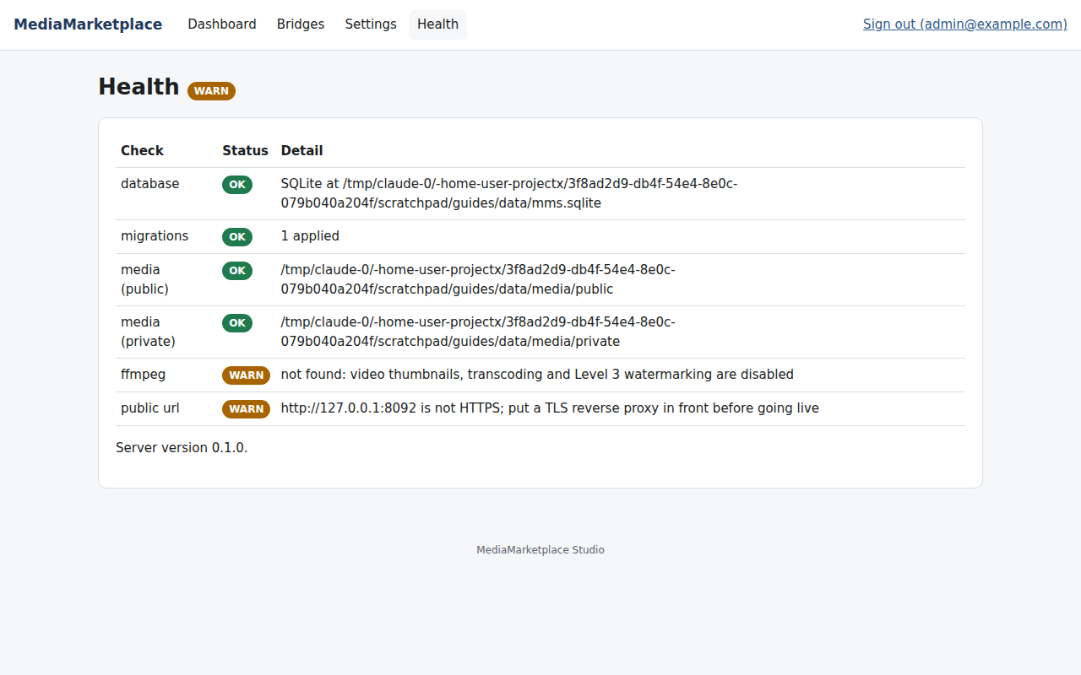
The Health page
The same report is available to scripts at /api/v1/health and on the command line with mms-server health.

7. The store on your website
The showcase is the store front. It lists published products with a type badge, title, description and price, and offers two layouts.
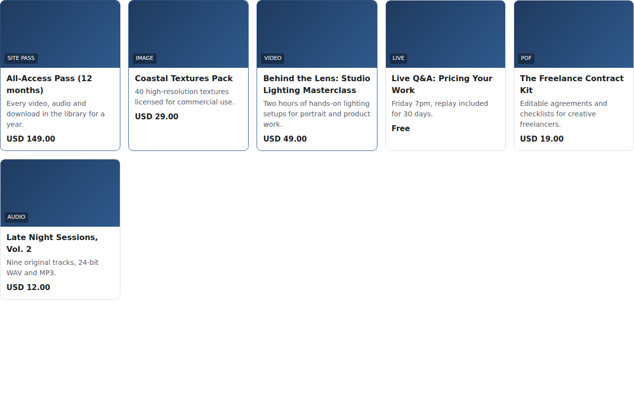
The showcase in grid view
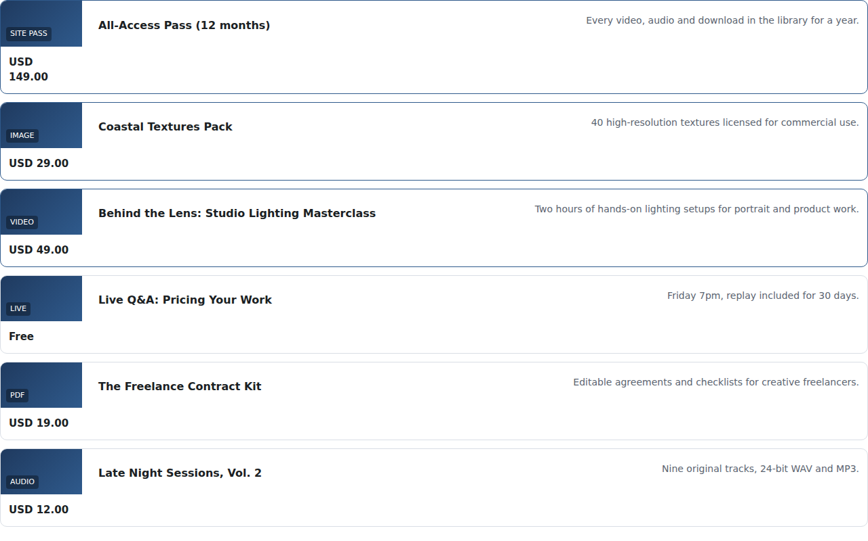
The showcase in list view
On WordPress, place [mms_showcase view="grid"] in a Shortcode block on any page.
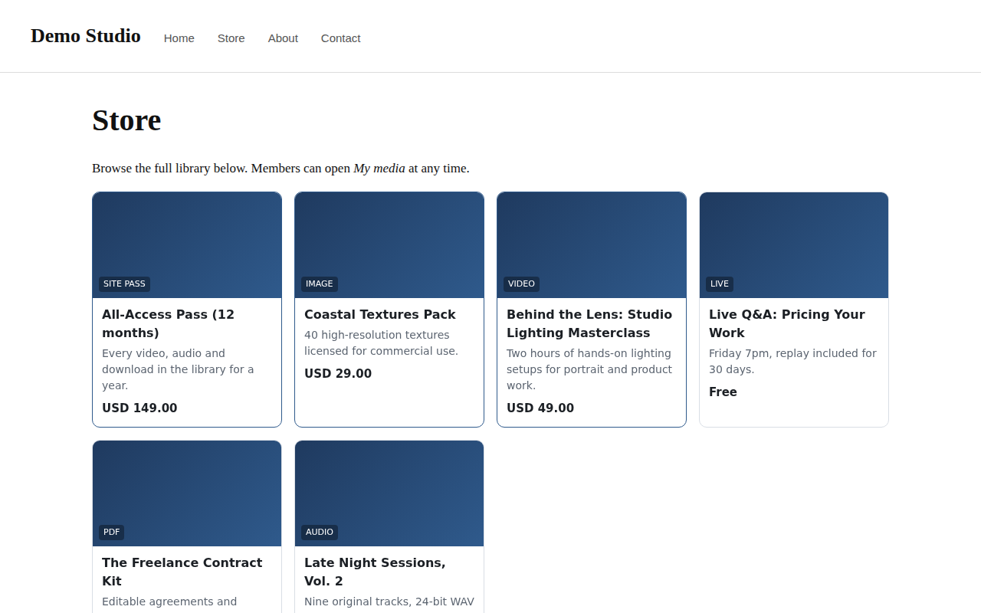
A WordPress page with the showcase (mock-up page, live store content)
On Joomla, type {mms_showcase view=grid} in an article, or add the MediaMarketplace Embed module to a position.
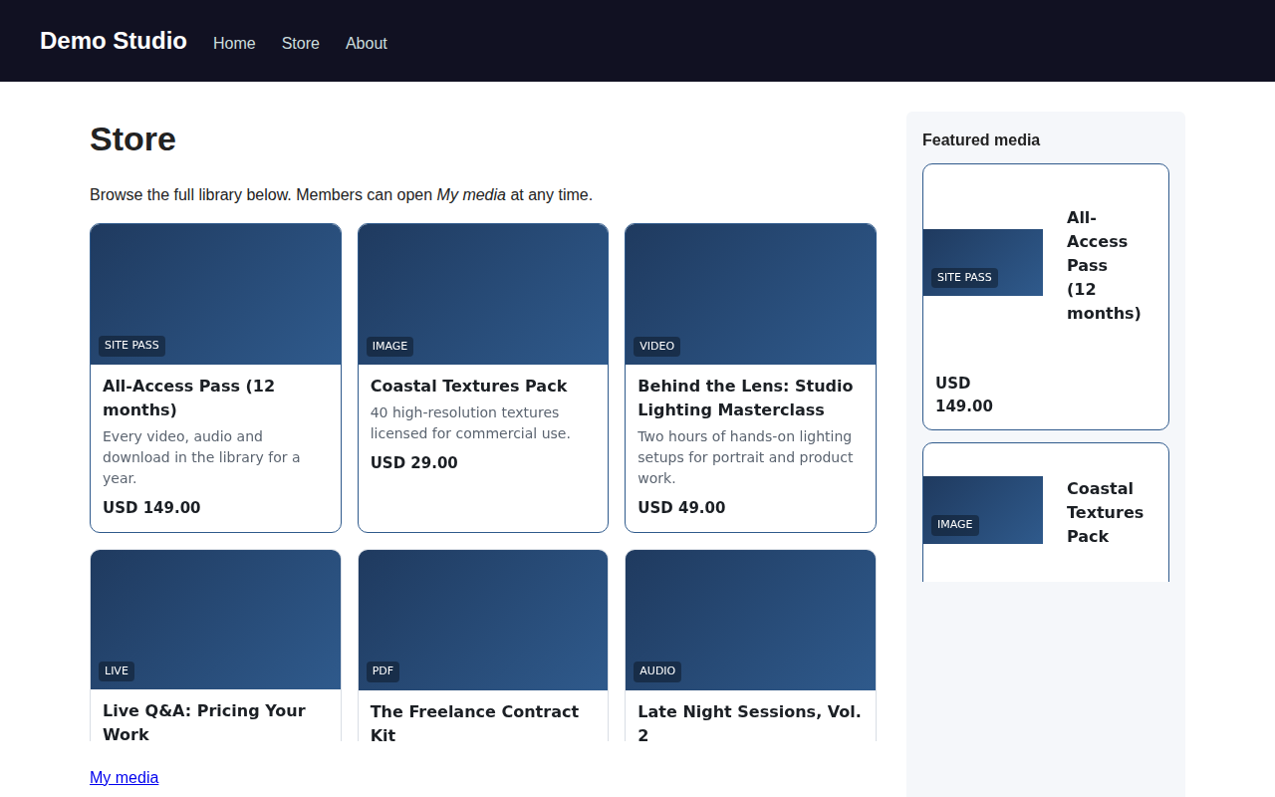
A Joomla page with the showcase in the article and a featured list in the sidebar (mock-up page, live store content)
The store area sizes itself to its content and follows the visitor's light or dark preference.

8. Member sign-on
Your website's logged-in members do not need a second password. The bridge adds a My media link ([mms_signin] on WordPress, {mms_signin} on Joomla). Clicking it sends the member to the server with a signed, five-minute token. The server recognises the member, creates a customer account on first visit, and opens their account page.
Behind the scenes: the token is signed with the site's secret, so only your website can produce it; the server checks the signature, the expiry and that the token came from the right kind of site.
People who are not members of your website can still buy: the server has its own sign-in and registration for customers.

9. Products (preview of the next release)
The product screens arrive in the next release. Ten product types are planned, each a normal product with its own price:
Type | What the customer gets
Video | streaming, optional download
Audio | streaming, optional download
Image | download at a chosen resolution; previews are watermarked
PDF | in-page reader, optional download stamped with the buyer's name
Live video | a gated live page during the event, replay afterwards
Private page | access to a page after signing an agreement
Site pass | everything in the library for a period
Meeting | a join link and calendar invitation
Consultation | a booking with an intake form and follow-up files
External page | a link revealed after purchase

Until then, products can be created by an administrator through the database or the API, and they appear in the showcase as soon as their status is published.

10. Roadmap
Release | What it adds
Next | media library with uploads and thumbnails, product screens, full showcase with search and filters, video and audio players, the customer's My media page
Then | widget builder with 35 templates, 12 site templates, exports for WordPress and Joomla
Then | cart and checkout with Stripe and PayPal, orders and receipts, subscriptions, private pages with ten signup templates, site passes
Then | image protection, video watermarking (three levels), copyright scanning and takedowns
Then | Square and Authorize.net, multi-currency, commercial players, Google Business Profile with AI assistance

11. Glossary
- Bridge — the WordPress plugin or Joomla package that shows the store and signs members in.
- Bridge site — a website registered on the server with an origin and a secret.
- Embed — a store area delivered by the server inside one of your pages.
- Origin — the scheme and host of a website, for example https://www.example.com.
- Showcase — the product listing.
- Entitlement — a record that a customer may access a product, page or the whole library for a period.
- Site pass — an entitlement that covers the whole library.
- Audit log — the record of administrative and access events shown on the dashboard.

