MediaMarketplace Studio — Joomla Installation Guide
Applies to: MediaMarketplace Studio for Joomla 0.2.0, Joomla 5.0 or newer, PHP 8.1 or newer
Audience: the Joomla site administrator
Time needed: about 10 minutes
Servers involved: one, the server your Joomla site already runs on
Joomla admin screens in this guide are mock-ups drawn to match the real screens. The store screens and the store content shown inside pages are live captures.
Contents
1. Before you start
2. Install the package
3. Start the server and check its status
4. Open the store admin
5. Put the store on the site
6. Set up payments
7. Where the data lives
8. Menu item, tag and module reference
9. Updating, disabling, removing
10. Troubleshooting

1. Before you start
What the package contains. One zip, mediamarketplace-studio-joomla-0.2.0.zip, with three Joomla extensions and, inside the system plugin, the marketplace server program. Nothing else is downloaded or installed anywhere.
Extension | Type | Purpose
System - MediaMarketplace Studio | plugin | runs the server, forwards /mms/… requests to it, provides the {mms_…} tags
MediaMarketplace Studio | component | admin menu: Open store admin and Server status; menu item types Showcase, Widget and My Media
MediaMarketplace Embed | site module | puts a showcase, widget, player, cart or site pass block in any module position

What the server must offer.
Requirement | How to check
Linux, 64-bit x86 | uname -m prints x86_64
PHP 8.1 or newer with the curl extension | System → System Information → PHP Information
PHP may start programs | exec and proc_open must not appear in disable_functions
A writable folder for store data | the package picks one automatically (see §5)
Optional: ffmpeg | needed only for video thumbnails, transcoding and forensic watermarking
PHP upload limits | upload_max_filesize and post_max_size in php.ini cap each uploaded file; raise them (for example to 512M) for large videos

Typical in-house virtual machines, VPS and dedicated servers meet all of these. Shared hosting that forbids background programs does not. VirtueMart is not needed and is never used.

2. Install the package
- In the Joomla administrator go to System → Install → Extensions.
- On the Upload Package File tab, drop mediamarketplace-studio-joomla-0.2.0.zip or browse for it.
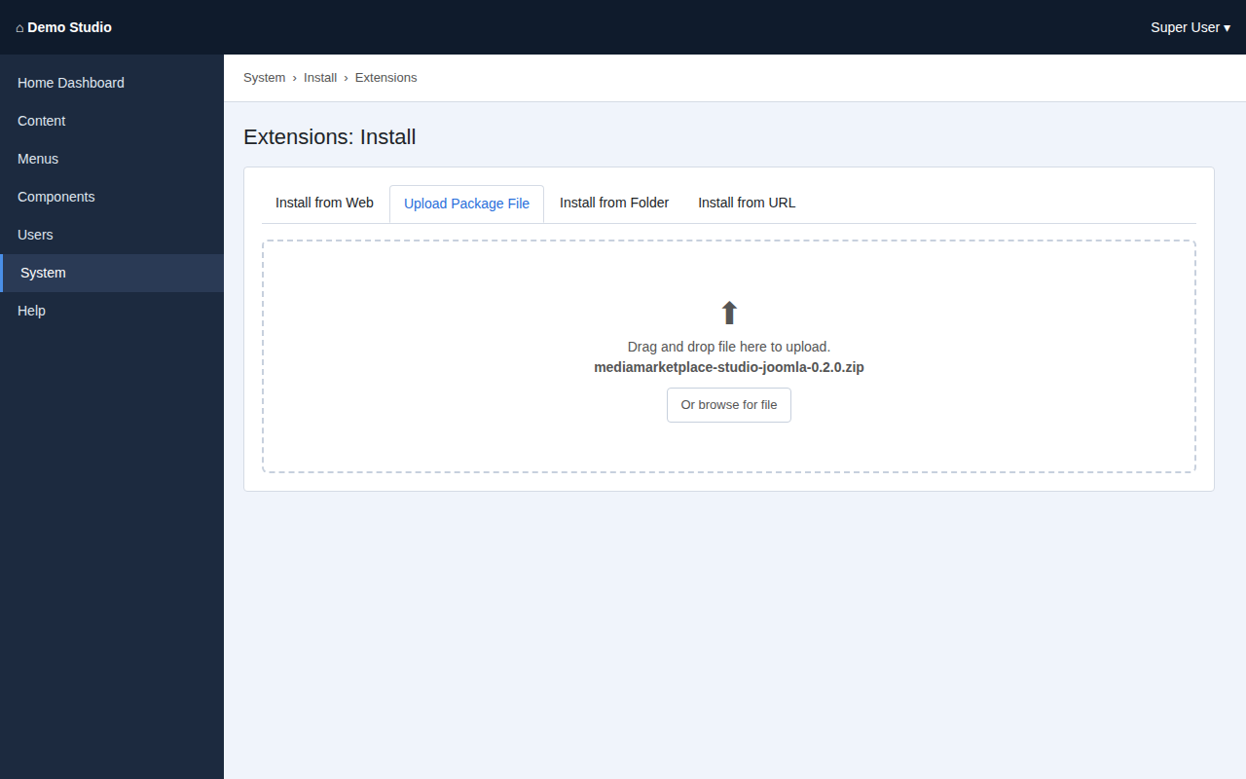
Uploading the package (mock-up)
- Joomla installs the plugin, the component and the module, and enables the plugin.
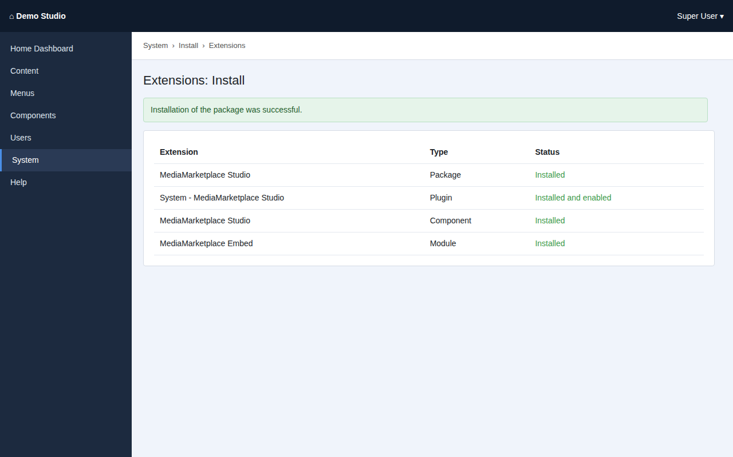
The installation result (mock-up)

3. Start the server and check its status
Open Components → MediaMarketplace → Server status. The first visit creates the data folder, writes the configuration and starts the server.
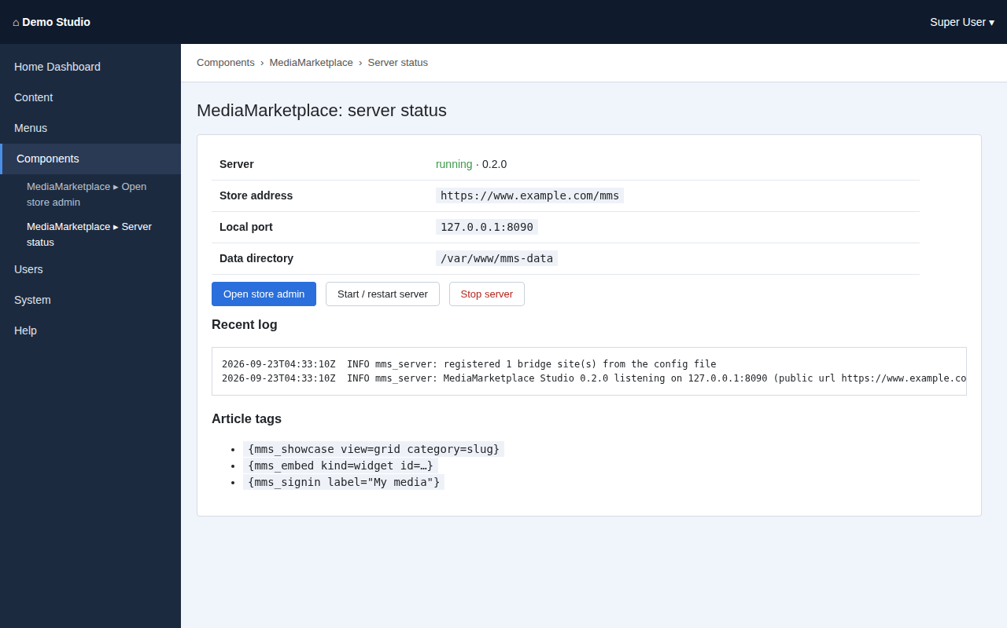
The server status page (mock-up)
Row | Meaning
Server | running with the version, or not running
Store address | your site address followed by /mms
Local port | the localhost port the server listens on; nothing outside the machine can reach it
Data directory | where the store database and media are kept
Problem | shown only when something needs attention

Use Start / restart server and Stop server as needed. The log below shows the last lines from the server.

4. Open the store admin
Click Components → MediaMarketplace → Open store admin. You are signed into the store as an administrator with your Joomla account; no second password exists.
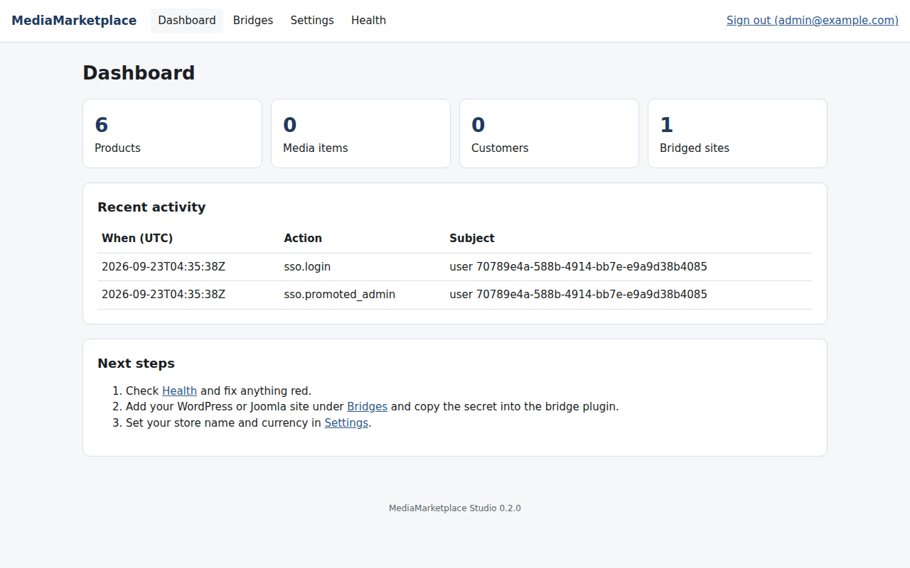
The store dashboard, opened from the Joomla menu
Check Health inside the store admin. Every row should be green; an amber ffmpeg row only means video features are off until ffmpeg is installed on the machine.
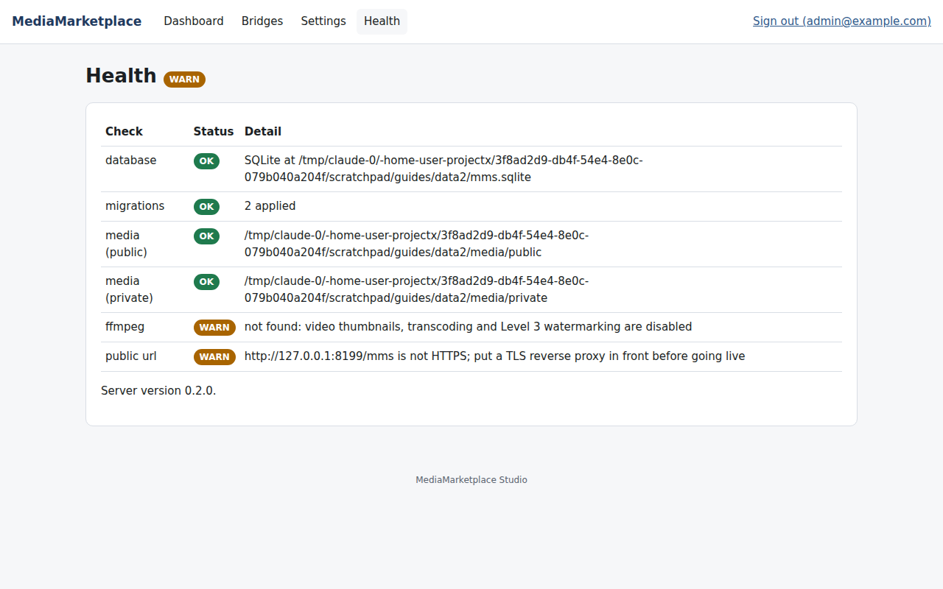
The store Health page
Set your store name and currency under Settings. Bridges shows this website, registered automatically; nothing needs to be added or copied there.
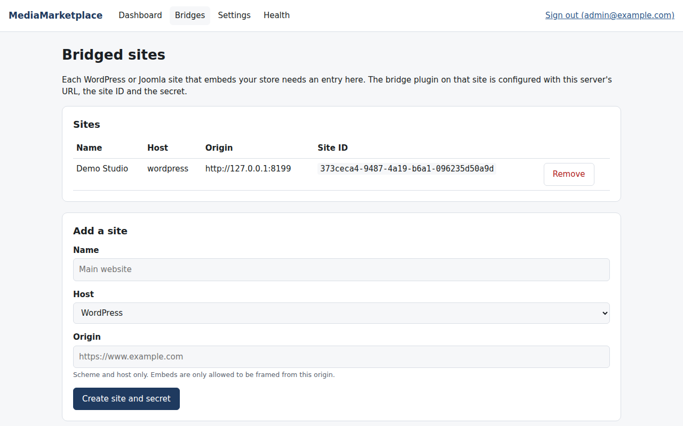
The site registered automatically

5. Put the store on the site
You can use a menu item, an article, a module, or any mix.
As a menu item. Go to Menus → Main Menu → New, click Select next to Menu Item Type and choose MediaMarketplace » Showcase. Pick grid or list and an optional category, give the item a title such as Store, and save. Two more types are available: MediaMarketplace » Widget shows a widget from the store's widget builder (paste the widget ID shown under Widgets in the store admin) and MediaMarketplace » My Media sends logged-in members straight into their store account.
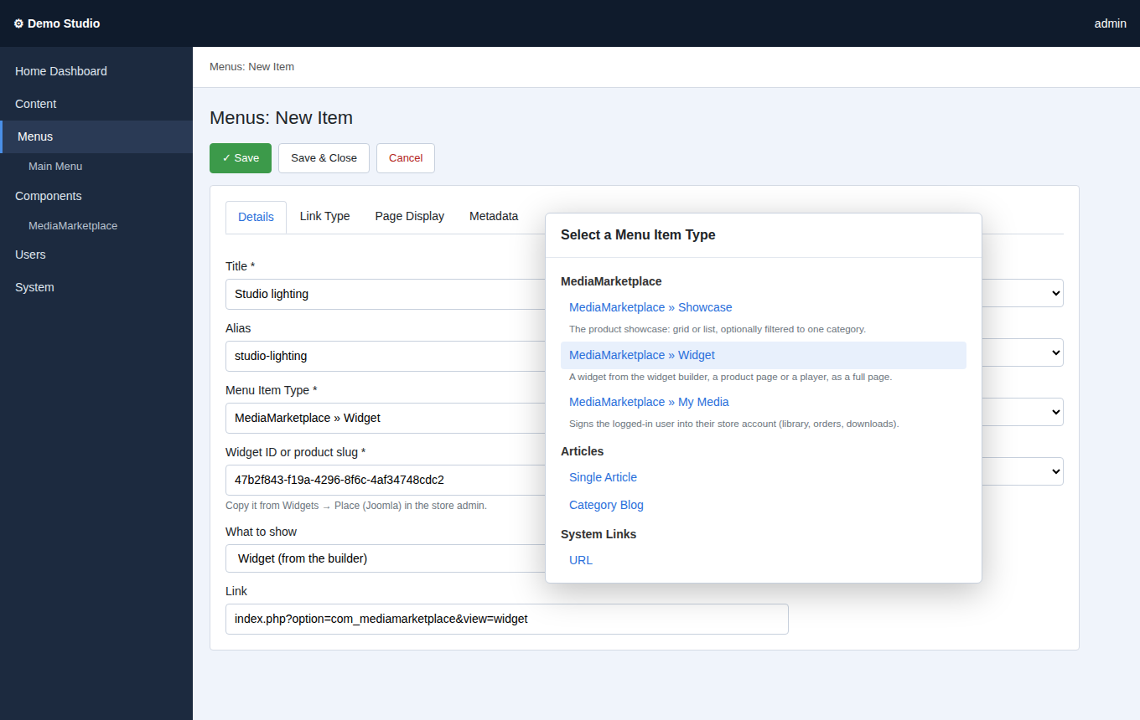
Choosing a MediaMarketplace menu item type (mock-up)
In an article. Edit the article, for example Store, and type {mms_showcase view=grid} where the store should appear. Add {mms_signin label="My media"} to give logged-in members a one-click link to their store account. Save.
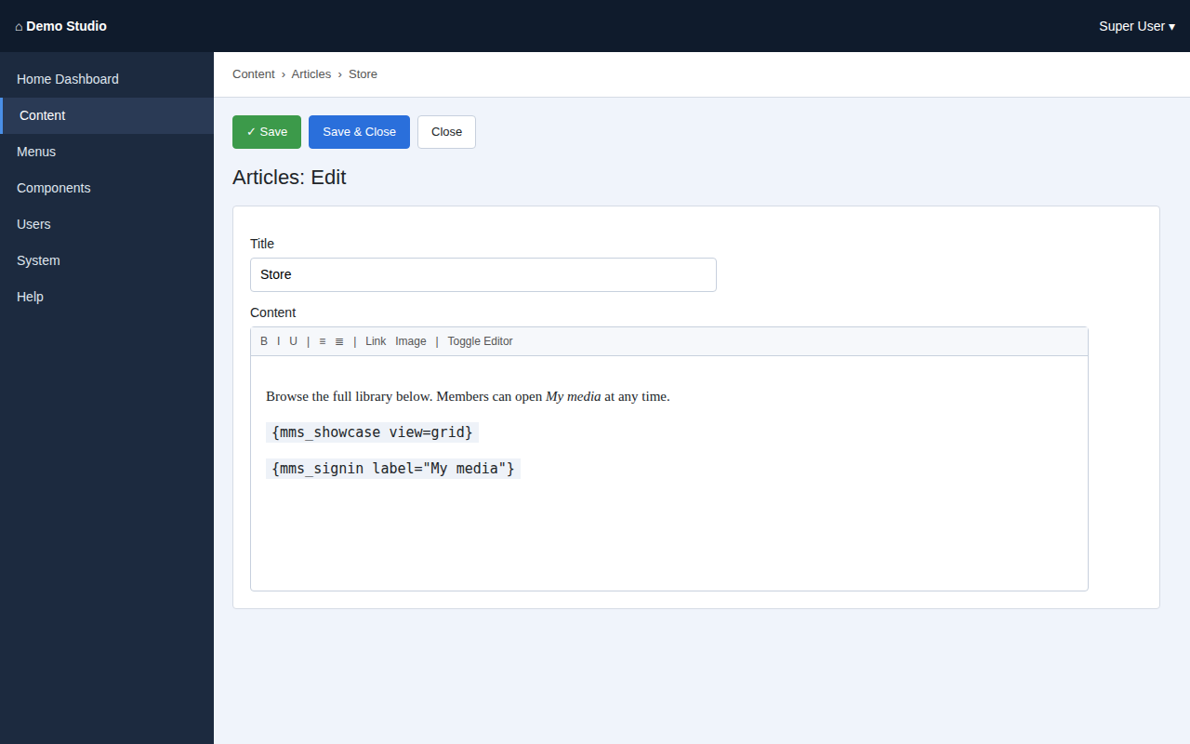
An article with the showcase and sign-in tags (mock-up)
In a module position. Go to Content → Site Modules → New, choose MediaMarketplace Embed, pick what to embed, a position and the menu assignment, and save.
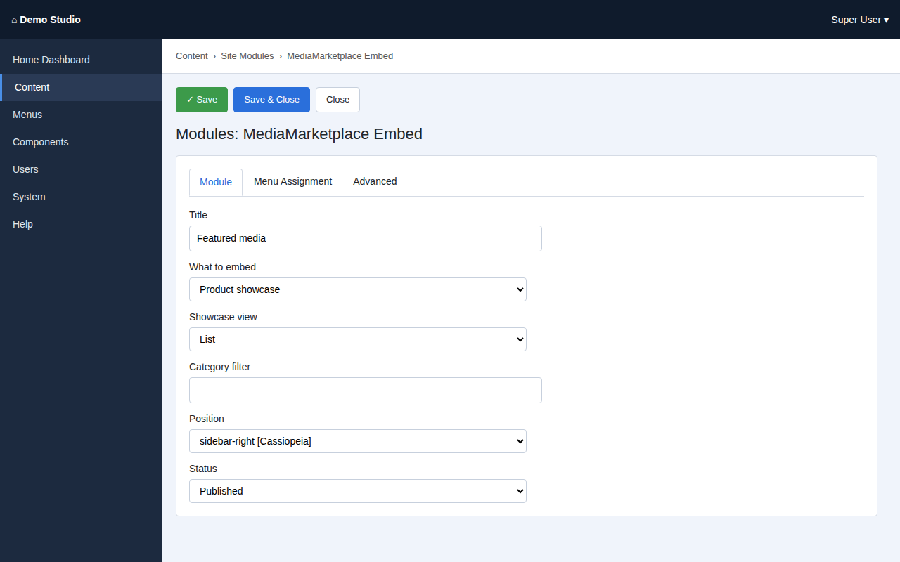
The MediaMarketplace Embed module settings (mock-up)
The store appears inside the page with the template's header and layout untouched.
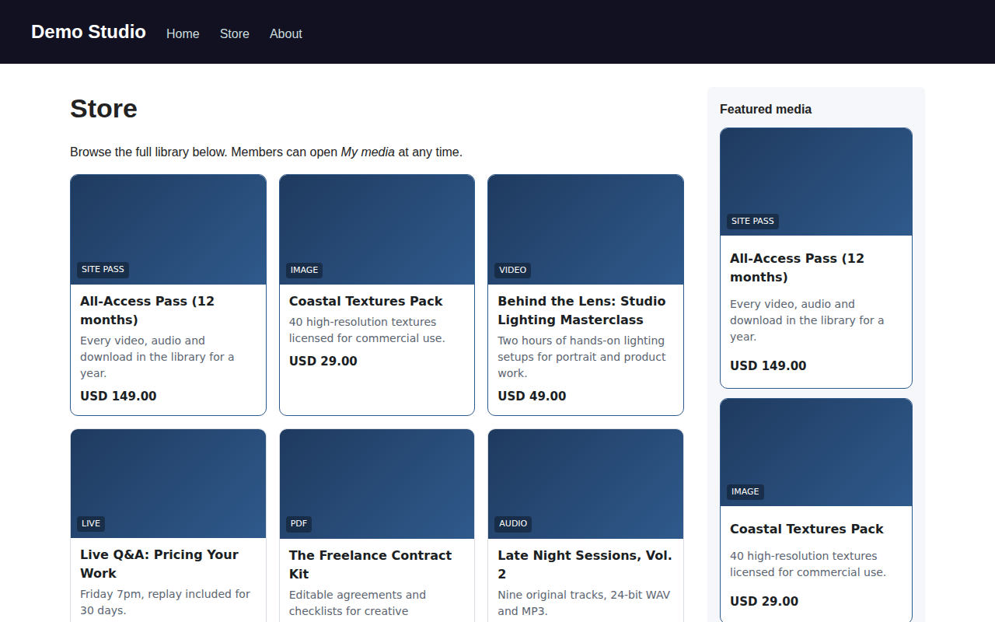
The site with the showcase in the article and a featured list in a module (mock-up page, live store content)

6. Set up payments
Open the store admin (Components → MediaMarketplace → Open store admin) and go to Settings → Payments.
- Stripe: paste the secret key. In the Stripe dashboard add a webhook endpoint for https://your-site/mms/webhooks/stripe with the events checkout.session.completed, charge.refunded, invoice.paid and customer.subscription.deleted, and paste its signing secret.
- PayPal: paste the client ID and secret of a PayPal app; add a webhook for https://your-site/mms/webhooks/paypal (PAYMENT.CAPTURE.COMPLETED, PAYMENT.CAPTURE.REFUNDED) and paste its webhook ID. Switch PayPal sandbox off for live use.
- Set Test payments to No before selling. While it is on, checkout offers a test method that completes without charging, which is the right way to try the store.
- Under Settings → Store set the currency, the receipt prefix and the receipt footer (address, VAT number).
Tax rates and coupons live under Orders → Coupons and tax in the store admin.

7. Where the data lives
The package chooses a data folder on first start:
- mms-data next to the Joomla root folder when that location is writable (outside the web root, the best choice), otherwise
- media/mms-data inside the site, protected by an .htaccess file and an empty index.html.
You may set a different path in the plugin options (System → Plugins → System - MediaMarketplace Studio → Data directory). The folder holds the store database (mms.sqlite), the media files, the server configuration and the log. Back it up together with your normal Joomla backup. The package never adds tables to the Joomla database.

8. Menu item, tag and module reference
Menu item type | What it shows | Options
MediaMarketplace » Showcase | the product showcase as a page | view (grid or list), category
MediaMarketplace » Widget | a widget from the builder, a product page, a player, a private page, the cart or site passes for sale, as a page | what to show, widget ID / page ID / product slug, view
MediaMarketplace » My Media | sends the logged-in user into their store account | which store page to open

Tag | What it shows | Parameters
{mms_showcase} | the product showcase | view=grid or list, category=slug
{mms_embed kind=…} | any store block | kind = widget, product, player, page, cart, sitepass; id=… where required
{mms_signin} | one-click sign-in for logged-in users | label="…", return=/account

Module options: What to embed, Widget or product ID, Showcase view, Category filter, plus the usual position, menu assignment and layout options.

9. Updating, disabling, removing
- Update: install the newer package zip over the old one. The server restarts and applies any database changes itself.
- Disable the plugin: stops the /mms/ forwarding and the tags; the server process keeps running until stopped on the status page.
- Uninstall the package under System → Manage → Extensions: stops the server and removes the extensions. The data folder is kept on purpose; delete it by hand if you want the store data gone.

10. Troubleshooting
Symptom | Cause | Fix
Status says "PHP must be allowed to start processes" | exec or proc_open is disabled in php.ini | remove them from disable_functions and reload PHP
Status says "built for x86_64" | the machine is ARM or 32-bit | use an x86_64 machine (an ARM build is planned)
Not running, log mentions "Permission denied" | the plugin folder or data folder is not writable by the web user | fix ownership and click Start / restart server
Not running, log mentions "address in use" | the port is taken | click Start / restart server; the package moves to the next free port
Tags appear as plain text | the plugin is disabled | enable System - MediaMarketplace Studio
The store area on a page is blank | page cache from before the install, or a security extension blocks /mms/ | clear caches; allow the /mms/ path
"Sign-on token rejected" when opening the store admin | the machine's clock is wrong | correct the system time
Uploads stop at a certain size | PHP's upload_max_filesize or post_max_size | raise both in php.ini and reload PHP; the status page shows the current limit

