MediaMarketplace Studio — WordPress Installation Guide
Applies to: MediaMarketplace Studio for WordPress 0.2.0, WordPress 6.4 or newer, PHP 8.1 or newer
Audience: the WordPress site administrator
Time needed: about 10 minutes
Servers involved: one, the server your WordPress site already runs on
WordPress admin screens in this guide are mock-ups drawn to match the real screens. The store screens and the store content shown inside pages are live captures.
Contents
1. Before you start
2. Install and activate
3. Check the status page
4. Open the store admin
5. Put the store on a page
6. Set up payments
7. Where the data lives
8. Block and shortcode reference
9. Updating, deactivating, removing
10. Troubleshooting

1. Before you start
What the package contains. One zip, mediamarketplace-studio-wordpress-0.2.0.zip, with the WordPress plugin and, inside it, the marketplace server program. Nothing else is downloaded or installed anywhere.
What the server must offer. The plugin starts the marketplace server as a background program on the same machine, so the machine must allow that:
Requirement | How to check
Linux, 64-bit x86 | uname -m prints x86_64
PHP 8.1 or newer with the curl extension | Tools → Site Health → Info → Server
PHP may start programs | exec and proc_open must not be listed under disable_functions in Site Health → Info → Server
A writable folder for store data | the plugin picks one automatically (see §5)
Optional: ffmpeg | needed only for video thumbnails, transcoding and forensic watermarking
PHP upload limits | upload_max_filesize and post_max_size in php.ini cap each uploaded file; raise them (for example to 512M) for large videos

Typical in-house virtual machines, VPS and dedicated servers meet all of these. Shared hosting that forbids background programs does not. WooCommerce is not needed and is never used.

2. Install and activate
- In WordPress go to Plugins → Add New Plugin and click Upload Plugin.
- Choose mediamarketplace-studio-wordpress-0.2.0.zip and click Install Now.
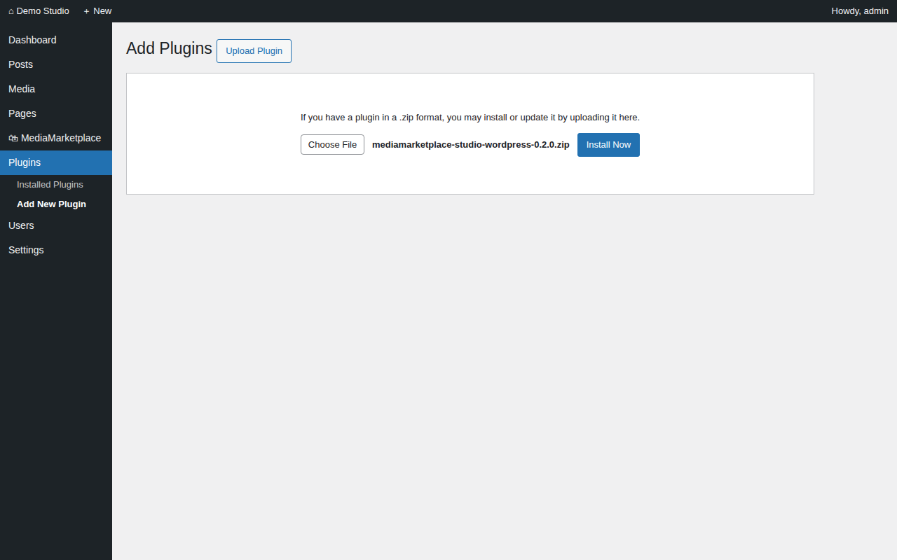
Uploading the package (mock-up)
- Click Activate Plugin. On activation the plugin creates the store's data folder, writes the server configuration and starts the server. A green notice confirms the activation.
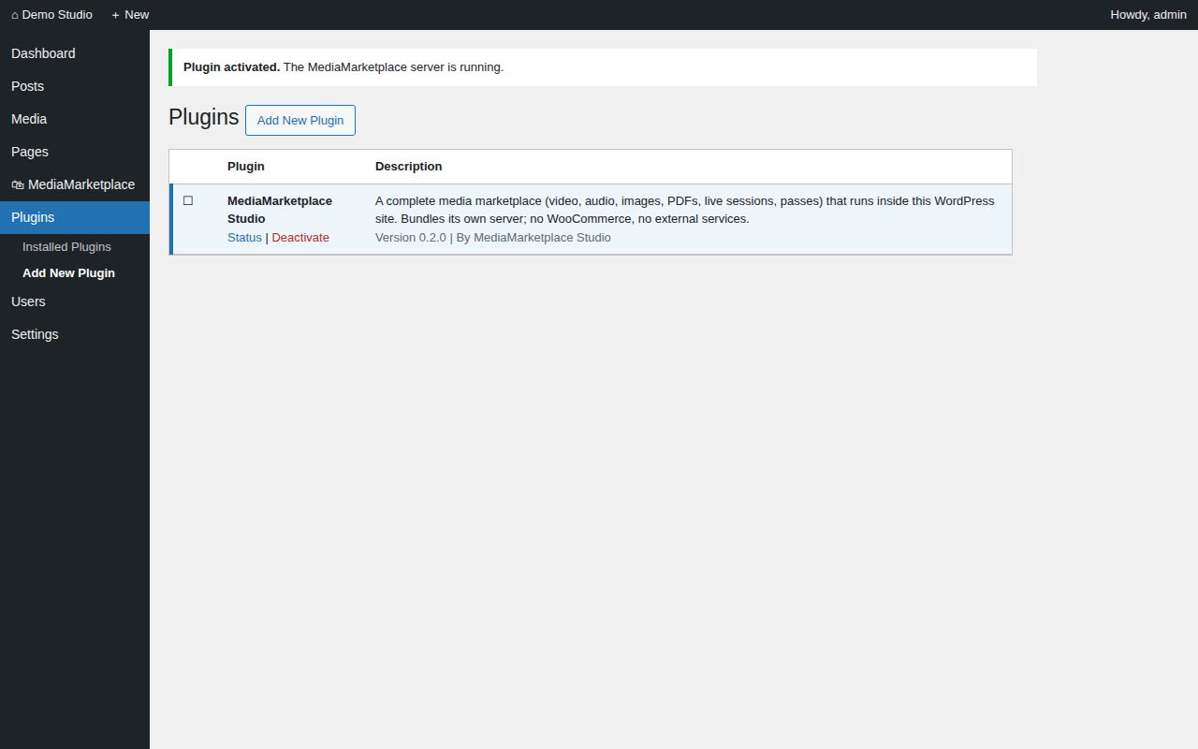
The plugin activated (mock-up)
If the server cannot start, a red notice explains why (for example, PHP is not allowed to start programs). Fix the cause and open MediaMarketplace → Status to start it.

3. Check the status page
Open MediaMarketplace → Status in the admin menu.
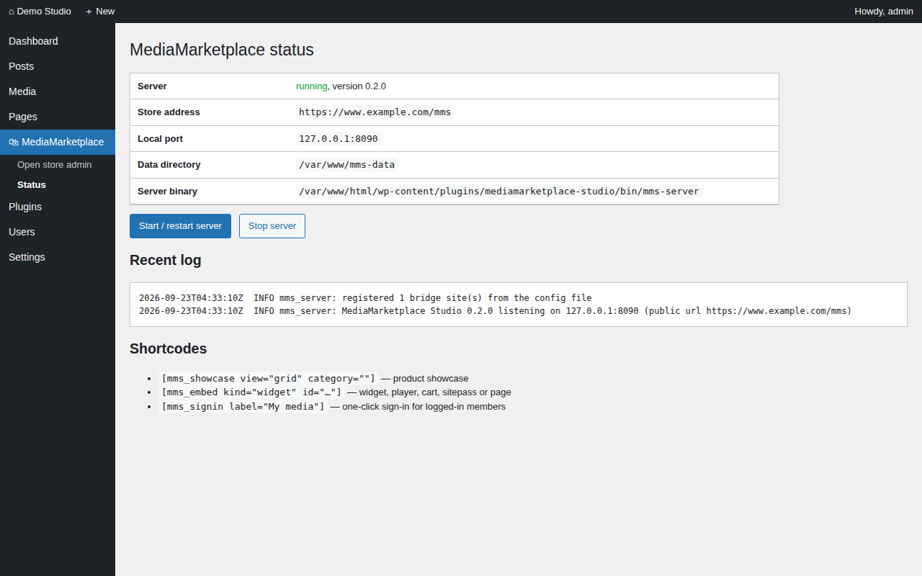
The status page with the server running (mock-up)
Row | Meaning
Server | running with the version, or not running
Store address | where the store lives: your site address followed by /mms
Local port | the localhost port the server listens on; nothing outside the machine can reach it
Data directory | where the store database and media are kept
Server binary | the program inside the plugin folder
Problem / Last error | shown only when something needs attention

The buttons start or restart the server and stop it. The log below shows the last lines from the server.

4. Open the store admin
Click MediaMarketplace (or MediaMarketplace → Open store admin). You are signed into the store as an administrator with your WordPress account; no second password exists.
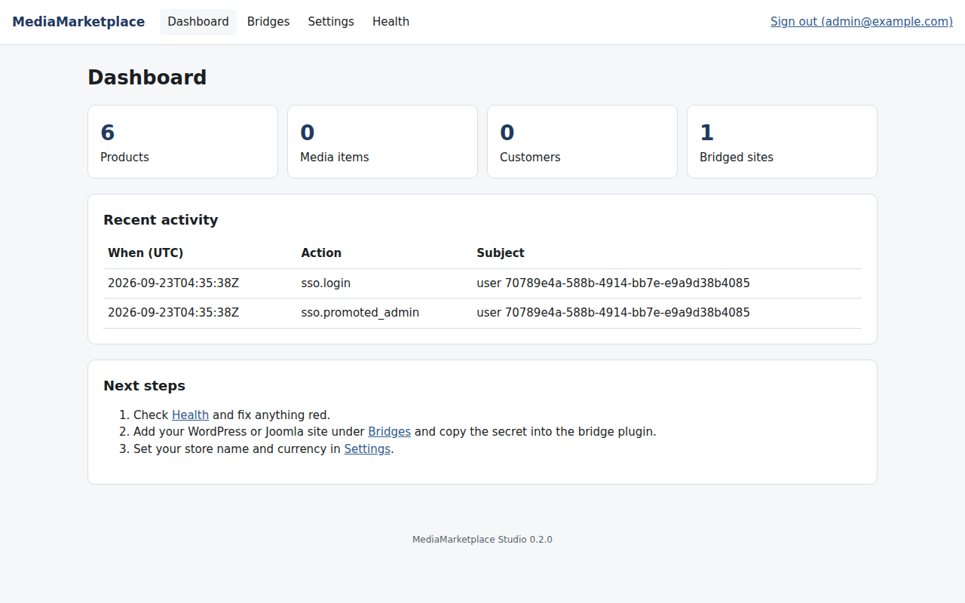
The store dashboard, opened from the WordPress menu
Check Health inside the store admin. Every row should be green; an amber ffmpeg row only means video features are off until ffmpeg is installed on the machine.
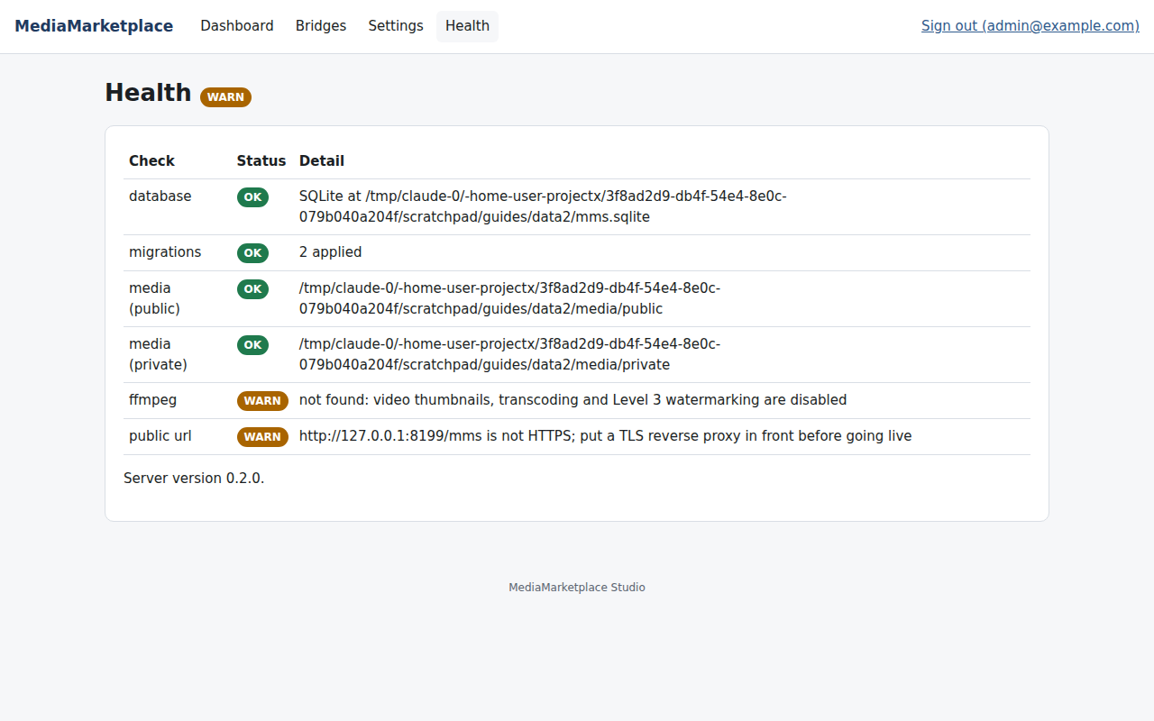
The store Health page
Set your store name and currency under Settings.
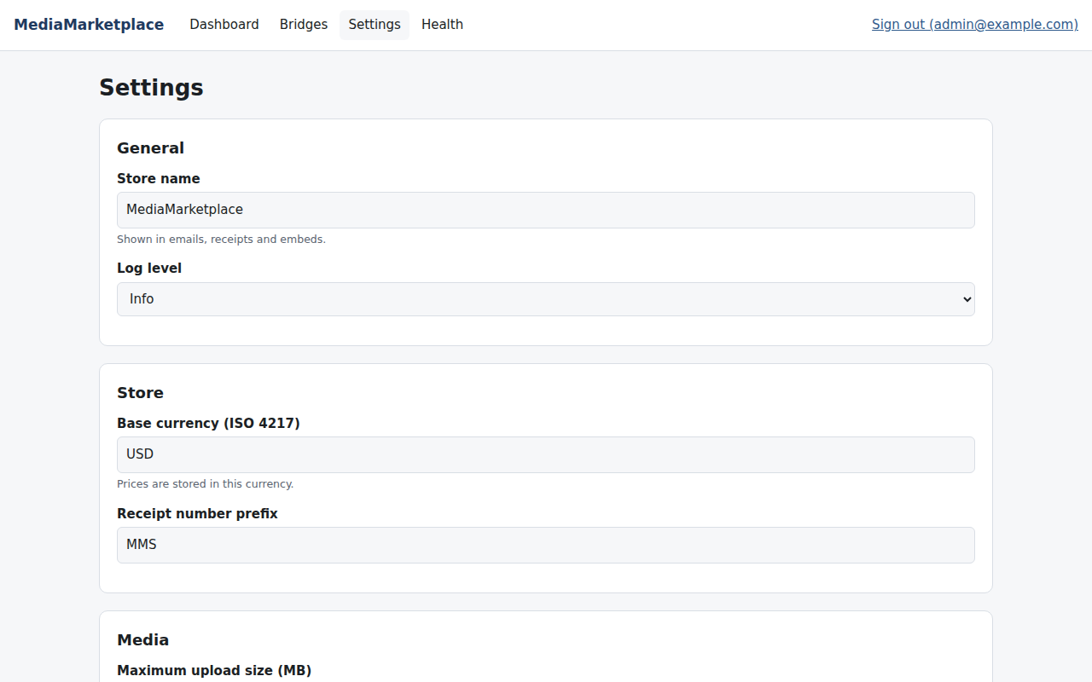
The store settings
Bridges shows this website, registered automatically by the plugin. You do not need to add or copy anything there.
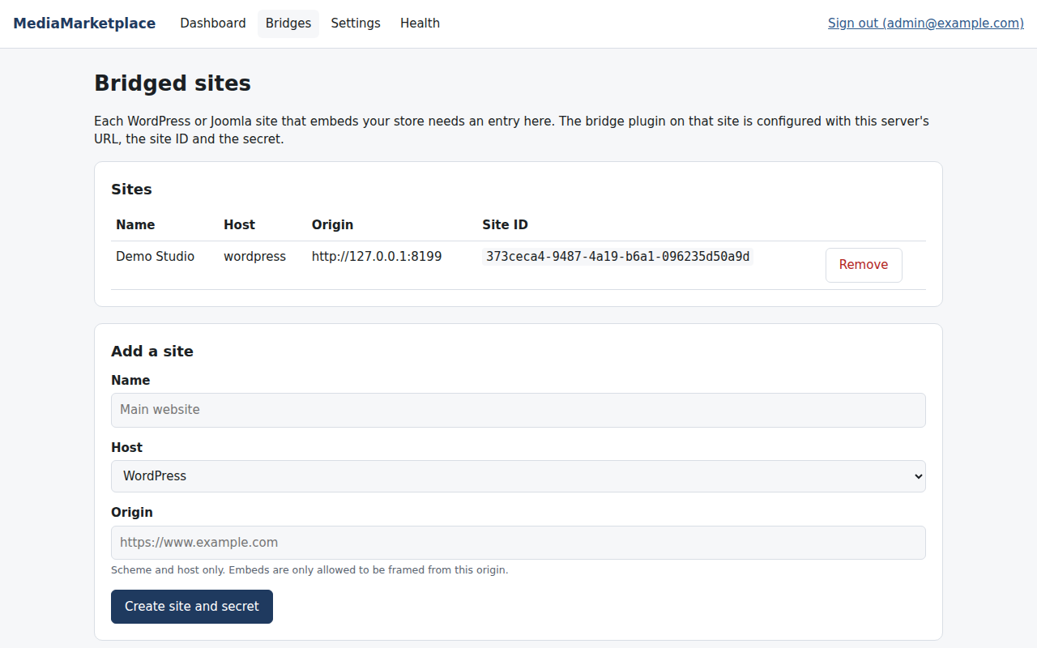
The site registered automatically

5. Put the store on a page
- Edit the page that should show the store, for example a page called Store.
- Add the MediaMarketplace Showcase block (type /mediamarketplace in the editor). Choose grid or list and, optionally, a category in the block settings.
- Optionally add the MediaMarketplace My Media link block. It shows a link only to logged-in WordPress users and opens their store account with one click.
- Publish the page.
The classic editor and page builders use the shortcodes instead: [mms_showcase view="grid"] and [mms_signin label="My media"] in a Shortcode block.
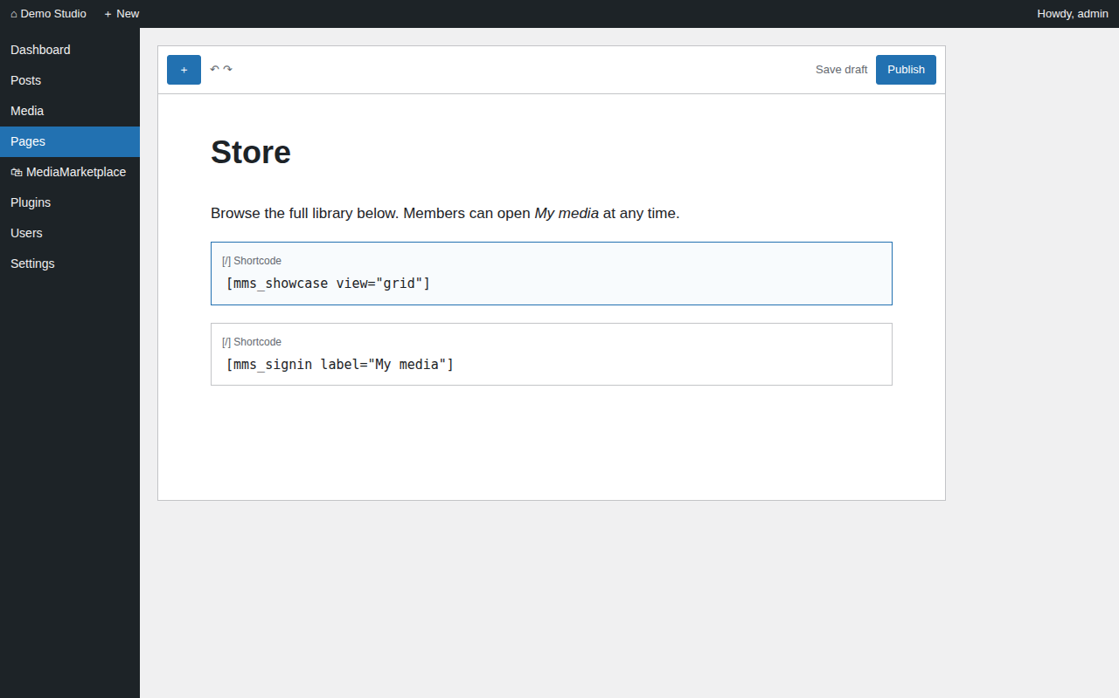
Shortcode blocks in the page editor (mock-up)
Widgets from the store's widget builder go on a page with the MediaMarketplace Embed block: choose Widget and paste the widget ID shown under Widgets in the store admin.
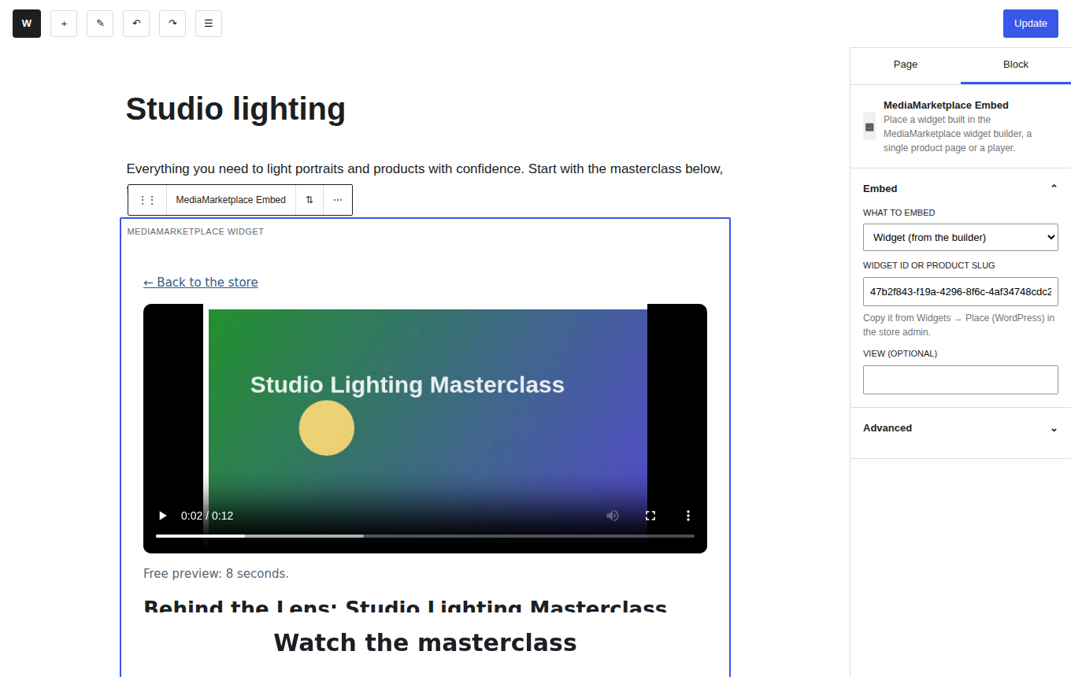
The MediaMarketplace Embed block with a widget from the builder (mock-up editor, live widget)
The store appears inside the page. Products, prices and layout come from the store; your theme's header, menu and fonts are untouched.
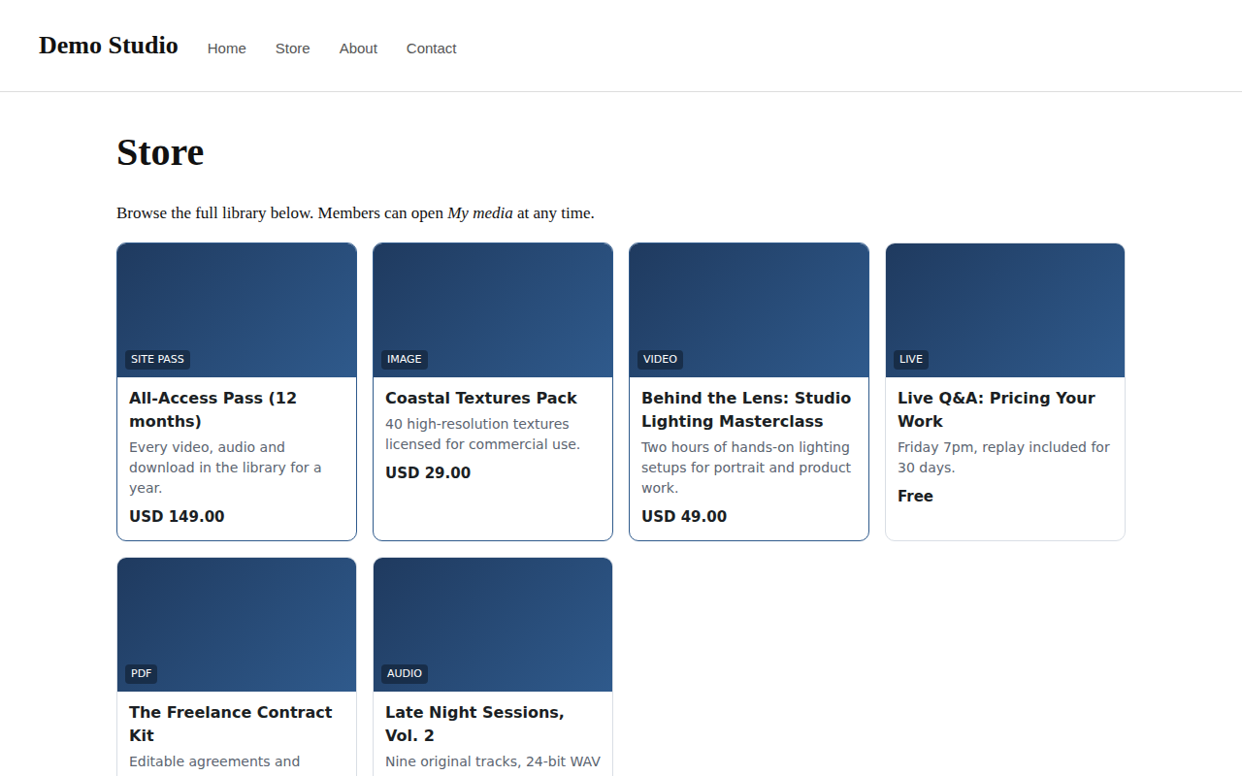
The published page with the live showcase (mock-up page, live store content)

6. Set up payments
Open the store admin (MediaMarketplace → Open store admin) and go to Settings → Payments.
- Stripe: paste the secret key. In the Stripe dashboard add a webhook endpoint for https://your-site/mms/webhooks/stripe with the events checkout.session.completed, charge.refunded, invoice.paid and customer.subscription.deleted, and paste its signing secret.
- PayPal: paste the client ID and secret of a PayPal app; add a webhook for https://your-site/mms/webhooks/paypal (PAYMENT.CAPTURE.COMPLETED, PAYMENT.CAPTURE.REFUNDED) and paste its webhook ID. Switch PayPal sandbox off for live use.
- Set Test payments to No before selling. While it is on, checkout offers a test method that completes without charging, which is the right way to try the store.
- Under Settings → Store set the currency, the receipt prefix and the receipt footer (address, VAT number).
Tax rates and coupons live under Orders → Coupons and tax in the store admin.

7. Where the data lives
The plugin chooses a data folder on activation:
- mms-data next to the WordPress root folder when that location is writable (outside the web root, the best choice), otherwise
- wp-content/uploads/mms-data, protected by an .htaccess file and an empty index.html.
The folder holds the store database (mms.sqlite), the media files, the server configuration and the log. Back it up together with your normal WordPress backup. The plugin never adds tables to the WordPress database.

8. Block and shortcode reference
Block | What it shows | Settings
MediaMarketplace Showcase | the product showcase | view (grid or list), category
MediaMarketplace Embed | a widget from the builder, a product page, a player, a private page, the cart, site passes for sale or the showcase | what to embed, widget ID / page ID / product slug, view
MediaMarketplace My Media link | one-click sign-in for logged-in users | link text, store page to open

Shortcode | What it shows | Attributes
[mms_showcase] | the product showcase | view="grid" or "list", category="slug"
[mms_embed kind="…"] | any store block | kind = widget, product, player, page, cart, sitepass; id where required
[mms_signin] | one-click sign-in for logged-in users | label, return (path inside the store, default /account), class

9. Updating, deactivating, removing
- Update: upload the newer zip over the old one (or use the WordPress updater when the plugin is distributed through one). The server restarts and applies any database changes itself.
- Deactivate: stops the server. The data folder is kept.
- Delete: removes the plugin files and stops the server. The data folder is kept on purpose; delete it by hand if you want the store data gone.

10. Troubleshooting
Symptom | Cause | Fix
Red notice: "PHP must be allowed to start processes" | exec or proc_open is disabled in php.ini | remove them from disable_functions and reload PHP
Red notice: "built for x86_64" | the machine is ARM or 32-bit | use an x86_64 machine (an ARM build is planned)
Status shows not running, log mentions "Permission denied" | the plugin folder or data folder is not writable by the web user | fix ownership (chown -R www-data) and click Start / restart server
Status shows not running, log mentions "address in use" | the port is taken | click Start / restart server; the plugin moves to the next free port
The store area on a page is blank | the page was cached before the plugin was active, or a security plugin blocks /mms/ | clear caches; allow the /mms/ path
The store address returns a WordPress 404 | permalinks were not refreshed | Settings → Permalinks → Save Changes
"Sign-on token rejected" when opening the store admin | the machine's clock is wrong | correct the system time
Uploads stop at a certain size | PHP's upload_max_filesize or post_max_size | raise both in php.ini and reload PHP; the status page shows the current limit

