MediaMarketplace Studio — Commerce Integration Guide
Applies to: MediaMarketplace Studio 0.2.0 for WordPress (WooCommerce) and for Joomla (VirtueMart)
Audience: store owners, site administrators and developers who want the CMS shop to take the money
Screens: store screens are live captures; WooCommerce and VirtueMart admin screens are mock-ups drawn to match the real screens
Related documents: the WordPress and Joomla User Guides (the store itself) and the Installation Guides
Contents
1. What this integration is
2. Choosing between the native checkout and the shop
3. Setting it up on WordPress (WooCommerce)
4. Setting it up on Joomla (VirtueMart)
5. What the customer sees
6. Behind the scenes: the sell-through API
7. Troubleshooting
8. What is not covered

1. What this integration is
MediaMarketplace Studio has its own cart, checkout and payment methods, and that native checkout stays the default. This guide covers an optional alternative: selling through the shop you already run in your CMS, WooCommerce on WordPress or VirtueMart on Joomla.
When checkout runs in the shop:
- every Buy button in the store (product pages, widgets, private pages, pass renewals) adds the linked shop product to the shop's cart;
- the shop takes the payment with its own payment methods, coupons, tax rules and currency;
- the shop reports the order to the store over a signed local API;
- the store creates the order, grants access, issues the numbered receipt, sends its webhooks and shows the order under Orders with the shop as payment method;
- a refund or cancellation in the shop revokes the access again;
- with WooCommerce Subscriptions, renewals keep recurring site passes alive.
Everything else about the store is unchanged: media, players, watermarks, private pages, site passes, receipts, privacy and backups work exactly as with the native checkout. Money never touches the store server in this mode.
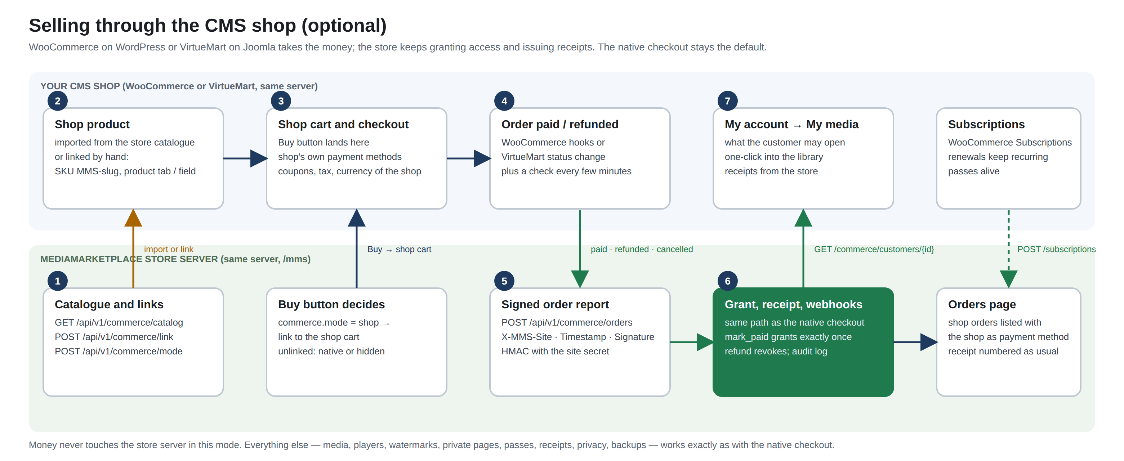
How selling through the shop works
The integration lives in its own files, loaded only when the shop is present, and is switched by one setting, Checkout runs in (Settings → Sell through, or the shop's own MediaMarketplace page). Switching back to the store's checkout takes one click and loses nothing.

2. Choosing between the native checkout and the shop
Native checkout (default) | Selling through the shop
Stripe, PayPal, Square, Authorize.net and Apple Pay set up in the store | the shop's payment gateways, whatever they are
the store's coupons, tax rates and display currencies | the shop's coupons, tax and currencies
receipts, orders and passes in the store | orders in both; receipts still from the store
recurring passes billed through Stripe | recurring passes through WooCommerce Subscriptions (VirtueMart has no subscriptions)
customers buy inside your page in one flow | customers use the shop's cart page and checkout
nothing else to install | WooCommerce or VirtueMart, and their payment plugins

Choose the shop when you already sell physical goods or services there and want one cart, one set of gateways and one order history for your customers. Choose the native checkout when the media store is the shop.

3. Setting it up on WordPress (WooCommerce)
Requirements: WooCommerce active on the same site. WooCommerce Subscriptions is optional, for recurring passes.
Step 1 — Open MediaMarketplace → WooCommerce. The page appears in the WordPress admin menu as soon as WooCommerce is active. It shows where checkout runs, how many store products are linked, and what happens to unlinked products.
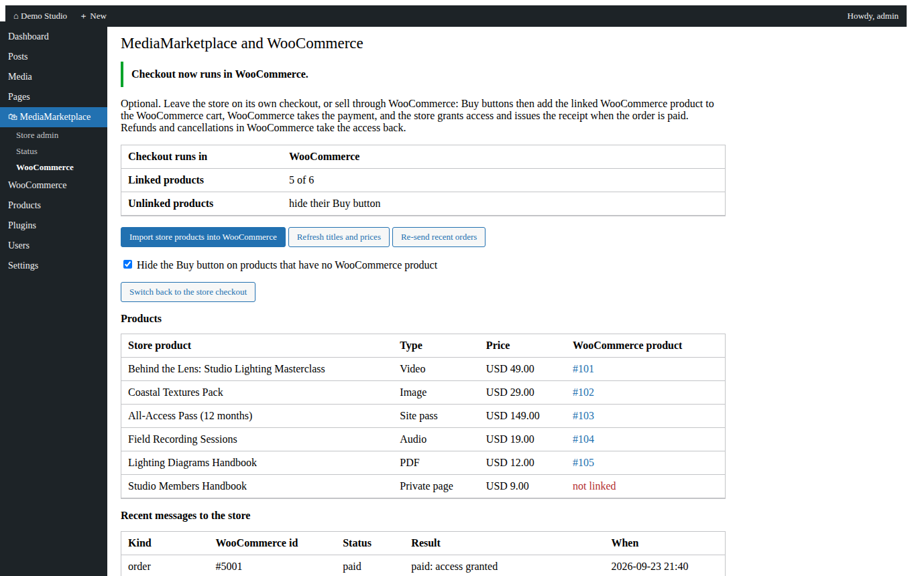
The MediaMarketplace → WooCommerce page after switching checkout to WooCommerce (mock-up)
Step 2 — Import the products. Click Import store products into WooCommerce. For every store product without a WooCommerce product the plugin creates a simple, virtual WooCommerce product with the same title, description, price and image, the SKU MMS-SLUG, and the store product recorded on it. Products you already had in WooCommerce can be linked by hand instead: edit the product and choose the store product under Product data → MediaMarketplace.
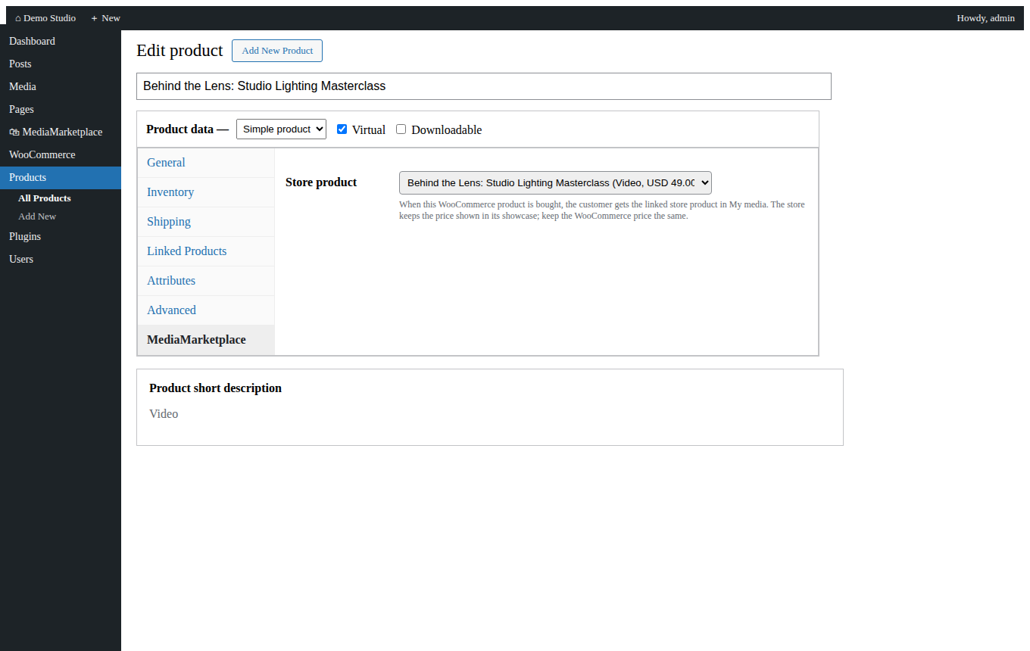
The MediaMarketplace tab on a WooCommerce product (mock-up)
Refresh titles and prices updates linked WooCommerce products from the store later. Keep the WooCommerce price equal to the store price: the showcase shows the store price, the cart charges the WooCommerce price.
Step 3 — Switch checkout. Click Sell through WooCommerce. From now on the Buy buttons in the store send shoppers to the WooCommerce cart. Tick Hide the Buy button on products that have no WooCommerce product if you would rather show nothing than the store's own checkout for unlinked products.
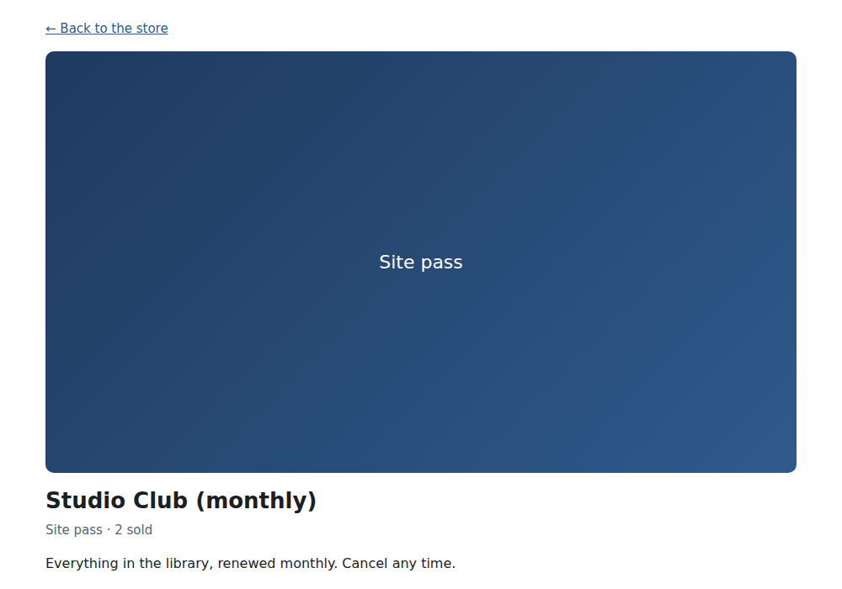
The store's product page with Buy pointing at the WooCommerce cart
Step 4 — Try it. Buy a linked product in WooCommerce with a test gateway. When the order reaches Processing or Completed (or WooCommerce fires payment complete), the store grants access, the WooCommerce order gets a note with the store's order number, and the customer sees the item under My account → My media and in the store's My media.
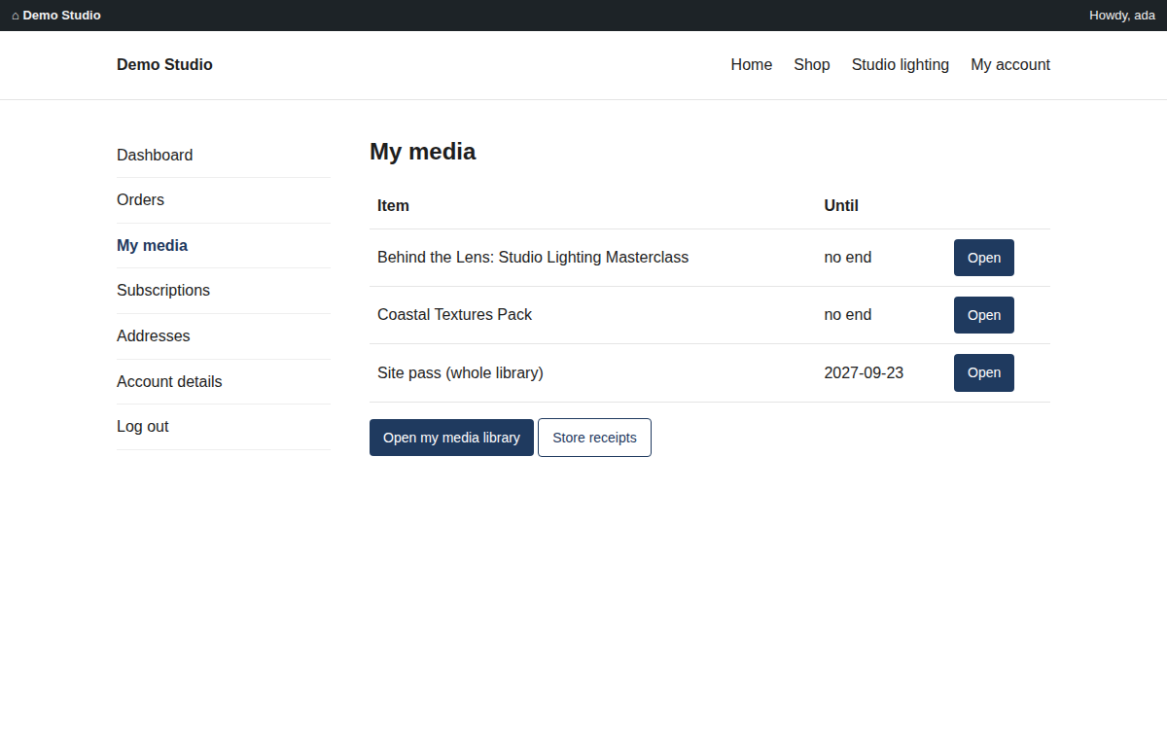
My account → My media in WooCommerce (mock-up)
Refunds and cancellations. A refund in WooCommerce (full refund or the Refunded status) revokes what the order granted and marks the store order refunded; Cancelled and Failed do the same for orders that had been paid, and simply cancel orders that never were.
Subscriptions. With WooCommerce Subscriptions, a subscription for a linked recurring site pass keeps the pass open: active and renewals extend it to the next payment date, pending cancellation lets it run to the period end, on hold, cancelled and expired close it.
Safety net. WooCommerce hooks can be missed (a plugin conflict, a server restart). Every hour the plugin re-sends the orders of the last two days; the store ignores what it already has. Re-send recent orders does the same on demand.

4. Setting it up on Joomla (VirtueMart)
Requirements: VirtueMart 3 or 4 installed and enabled on the same site. The MediaMarketplace package installs a small VirtueMart custom plugin (VirtueMart - MediaMarketplace Studio); VirtueMart only loads it when VirtueMart itself is installed.
Step 1 — Open Components → MediaMarketplace → VirtueMart. The page shows where checkout runs, the linked products and the recent messages sent to the store.
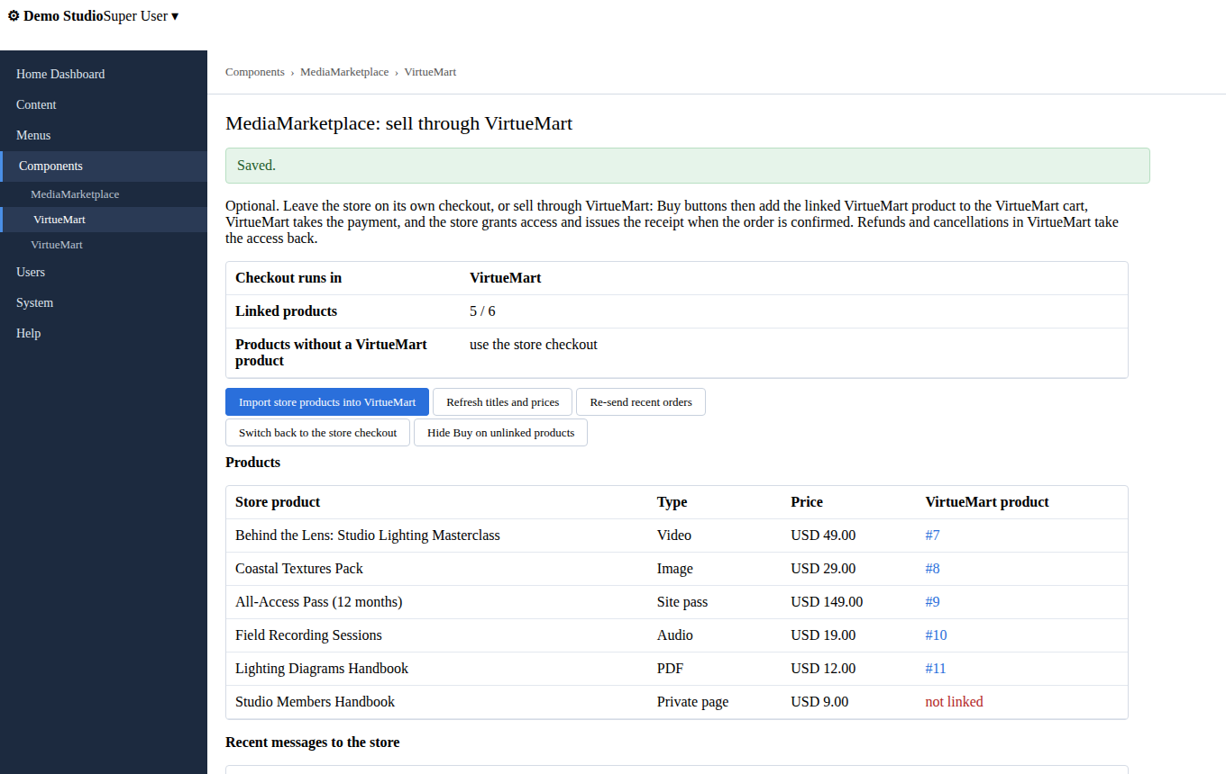
Components → MediaMarketplace → VirtueMart after switching checkout to VirtueMart (mock-up)
Step 2 — Import the products. Click Import store products into VirtueMart. For every store product without a VirtueMart product the bridge creates a published VirtueMart product in a MediaMarketplace category with the same name, description and price, the SKU MMS-SLUG and the MediaMarketplace custom field carrying the store slug. Products you already had in VirtueMart can be linked by hand: give the product the SKU MMS-<slug>, or add the MediaMarketplace custom field with the store slug.
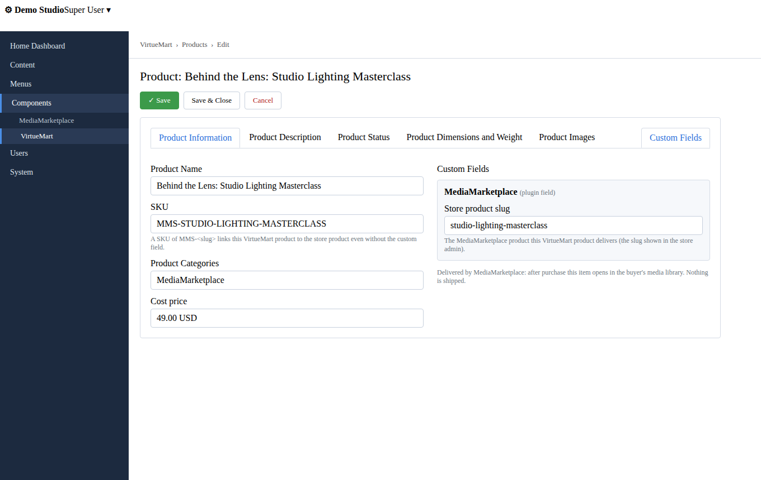
A VirtueMart product linked by SKU and by the MediaMarketplace custom field (mock-up)
Step 3 — Switch checkout. Click Sell through VirtueMart. Buy buttons now add the linked VirtueMart product to the VirtueMart cart. Hide Buy on unlinked products decides what unlinked products show.
Step 4 — Try it. Buy a linked product in VirtueMart. When the order status becomes Confirmed (or Shipped), the VirtueMart plugin reports it to the store at once, and the check that runs every five minutes on ordinary page loads reports it again in case the event was missed. The store grants access and issues the receipt; the customer opens the item from the My media menu item or the store's My media.
Refunds and cancellations. Refunded revokes what the order granted and marks the store order refunded; Cancelled and Denied do the same for orders that had been confirmed. Pending orders are not reported at all.
Subscriptions. VirtueMart has no subscriptions; sell recurring passes through the native checkout (Stripe) or sell fixed-length passes through VirtueMart.

5. What the customer sees
- The store's showcase, product pages and widgets look the same; only the Buy button leads to the shop's cart.
- In WooCommerce, My account → My media lists everything they may open with an Open button that signs them into the store; every order with store items has an Open in My media button. In Joomla the My media menu item does the same.
- Receipts come from the store as before, numbered in sequence, under My media → Orders and by email when SMTP is configured.
- Members of the site are recognised by their site account, so a WooCommerce or VirtueMart customer and a store customer are the same person. Guest checkout in the shop creates a store account for the email address; the customer sets a password at the store's sign-in page or signs in through the site later.

6. Behind the scenes: the sell-through API
The shop modules talk to the store over a small JSON API on the same server. Every request is signed with the secret the site already uses for single sign-on, so only the site the store runs in can report orders.
Headers: X-MMS-Site (the connected site's id), X-MMS-Timestamp (unix seconds, within five minutes of the server clock), X-MMS-Signature (lowercase hex HMAC-SHA256 with the site secret over timestamp + newline + METHOD + newline + path + newline + body; the path is the request path without the query string). Unsigned or badly signed calls get 401 or 403 and are written to the audit log.
Method and path | Purpose
GET /api/v1/commerce/status | mode, linked counts, recent shop messages
GET /api/v1/commerce/catalog?system=woocommerce | every product with price, description, image and its shop link
POST /api/v1/commerce/link | {system, links:[{slug, external_id, external_url}], unlink:[slug]}
POST /api/v1/commerce/mode | {mode: native or woocommerce or virtuemart, cart_url?, unlinked?}
POST /api/v1/commerce/orders | {system, external_id, status: paid, pending, refunded or cancelled, customer:{id,email,name}, currency, items:[{slug or external_id, quantity, unit_cents}], discount_cents, tax_cents, country, subscription?}
GET /api/v1/commerce/orders/{system}/{external_id} | the store order, its items and the access it granted
POST /api/v1/commerce/subscriptions | {system, external_id, status: active, renewed, pending_cancel, on_hold, cancelled, expired or ended, customer, slug or product_external_id, period_end, order_external_id}
GET /api/v1/commerce/customers/{external_id} | what a shop customer may open, with paths into the store

Orders are idempotent: reporting the same paid order twice grants once and answers "already recorded". Amounts are what the shop charged, so store reports agree with the shop. The whole flow is covered by the server's automated tests and by the package contract test, which signs real requests from PHP against the real binary.
Other shops. The same API serves any shop or automation that can sign requests with the site secret; system is woocommerce or virtuemart, and the Buy address can be changed under Settings → Sell through → Add-to-cart address ({origin} and {external_id} are replaced).
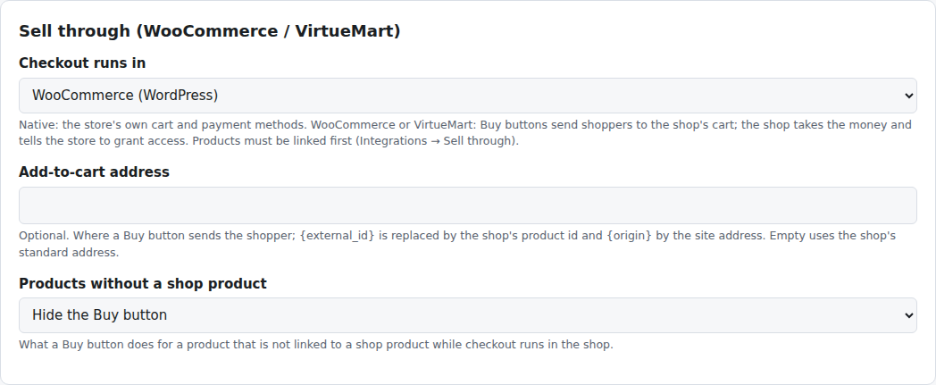
Settings → Sell through
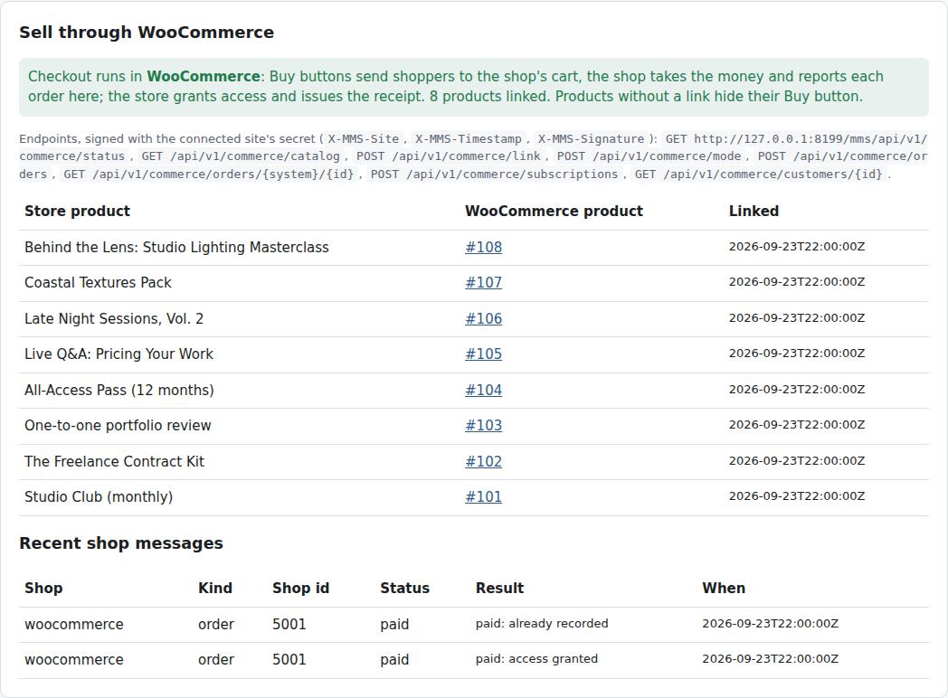
Integrations → Sell through in the store admin, with the linked products and the shop's messages

7. Troubleshooting
Symptom | Cause | What to do
The Buy button still opens the store's checkout | checkout runs in the store, or the product is not linked | check Checkout runs in and the product's link on the shop page
The Buy button is missing | the product is unlinked and unlinked products are hidden | link the product or switch unlinked products to the store checkout
A paid shop order did not grant access | the report failed (see the shop order's notes, or the store's Recent shop messages) | click Re-send recent orders; check the store server is running
"Bad request signature" in the store's activity log | the site secret changed or the server clock is off | restart the server from the status page; fix the clock
The customer cannot see the item in the shop's account page | the shop customer and the store account are different people | the store account is matched by site user id, then by email; check the email on the order
WooCommerce product has no image | the site could not fetch its own image address | add the image in WooCommerce by hand
VirtueMart import reports a database error | an unusual VirtueMart schema | create the VirtueMart product yourself with the SKU MMS-<slug>; the link works without the import

8. What is not covered
- PayPal, Square or Authorize.net configured in the store are not used while checkout runs in the shop; the shop's gateways are.
- Store coupons and tax rates do not apply to shop orders; the shop's do.
- Recurring passes need WooCommerce Subscriptions on WordPress; VirtueMart cannot renew passes.
- Multi-currency display in the store still works, but the shop charges in its own currency.

