MediaMarketplace Studio — Joomla Deployment Diagram
Applies to: mms-server 0.1.0 and MediaMarketplace Bridge for Joomla 0.1.0
Purpose: show the physical servers, the Joomla site, the Rust server and every connection between them
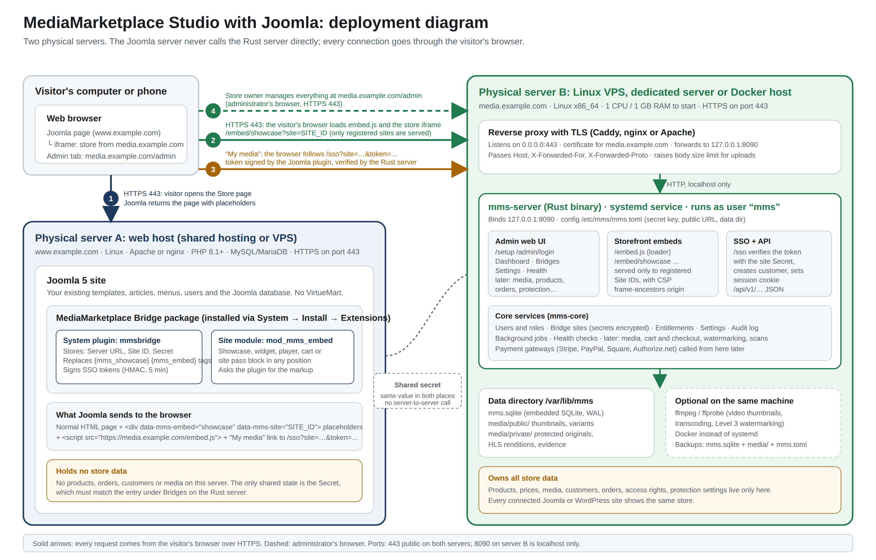
Deployment diagram: two physical servers, the Joomla site with the bridge package, and the Rust server
Contents
Reading the diagram
What runs where
Points worth noting

Reading the diagram
Number | Connection | From | To | Protocol and port
1 | Visitor opens the Store page | visitor's browser | Server A (Joomla) | HTTPS 443
2 | Browser loads the embed loader and the store iframe | visitor's browser | Server B (Rust) | HTTPS 443
3 | Member clicks "My media" and is signed in with a token | visitor's browser | Server B (Rust) | HTTPS 443
4 | Store owner manages the store | administrator's browser | Server B (Rust) | HTTPS 443
internal | Reverse proxy forwards to the application | Server B proxy | mms-server on the same machine | HTTP 8090, localhost only

What runs where
Server | Role | Software | Data held
A: web host | the public website | Linux, Apache or nginx, PHP 8.1+, MySQL/MariaDB, Joomla 5, MediaMarketplace Bridge package (system plugin + module) | the Joomla site only; the bridge stores the server URL, site ID and secret
B: Linux VPS / Docker host | the store | Linux, reverse proxy with TLS, mms-server (Rust), SQLite, optional ffmpeg | products, prices, media, customers, orders, entitlements, protection settings

Points worth noting
- Server A never opens a connection to Server B. Every request to the Rust server comes from a browser, so no firewall rule is needed between the two machines beyond public HTTPS on both.
- The shared secret is the only configuration that must match on both servers. It is created under Bridges on Server B and pasted into the plugin on Server A.
- Server B refuses to render store embeds for any site ID it does not know, and tells the browser that only the registered origin may frame them.
- Server A can be ordinary shared hosting. Server B must be able to run a process.
- Both servers can be the same physical machine if it runs both a PHP web server and the Rust binary; the diagram separates them because that is the usual arrangement.

