Draft — Not Filed — For Review by Qualified Patent Counsel Prior to Filing
QUERYBOOK PROVISIONAL PATENT APPLICATION — COMPANION VOLUME

QueryBook — Drawings, Reference Numerals & Brief Description of the Drawings
Scope: the complete, current QueryBook figure set — FIG. 1–FIG. 49 — as one unified, contiguously numbered set, with no gaps. It comprises the integral language & speech subsystem (LEL; FIG. 1–8 and FIG. 31–32); the QueryBook cognitive platform — Prime Directive / Domain 0, the Fact Unit, UFCS, FQL, the neuromorphic cognitive layer, the user-owned agent system, the enhanced TCP/IP hybrid protocol, and the media pipeline (FIG. 9–30); the Language & Identity Linking (LIL) voiceprint subsystem (FIG. 33–34); the Universal Integrity Audit Service (UIAS; FIG. 35–36); the Paralinguistic & Pragmatic Interpretation Layer (PIL; FIG. 37–38); Lecture Query mode (FIG. 39–40); the recent extensions (FIG. 41–47); and the application embodiments — the cited Q&A / ChatBot application and the application-and-deployment surfaces over the invariant core (FIG. 48–49). Companion to the consolidated QueryBook Provisional Patent Application; the figures, reference numerals, and brief descriptions here are identical to those in that application. Document date: October 7, 2026. Draft — to be finalized to USPTO drawing standards (37 CFR 1.84) by a patent draftsperson before filing.

Feature Inventory and Figure Map
This inventory lists the major QueryBook features and the figure that depicts each, confirming that every major feature — the cognitive core (Fact Units, UFCS, FQL, the Prime Directive, the neuromorphic layer), the agent and ChatBot applications, security, media, language and speech, and the identity / integrity / interpretation / lecture subsystems — is drawn. Status is conservative: “Prototype” marks a capability exercised in the current prototype; “Specified” marks a described embodiment; the semantic media pipeline of FIG. 24 is identified as specified and not yet built or measured. 49 features are mapped across FIG. 1–FIG. 49.
Feature | Figure | Status
A. Primitive and substrate
Fact Unit — atomic subject·predicate·object·polarity with content-derived identity (FUID) | FIG. 10 | Prototype
Fact Unit confidence and evidence model (Bayesian / Beta) | FIG. 27 | Prototype
Fact-certification authority hierarchy | FIG. 11 | Specified
UFCS — Universal Federated Connectivity Substrate (three-store) | FIG. 12 | Prototype
UFCS packet structure — serialized Fact Unit record | FIG. 28 | Specified
UFCS content-addressed block framing | FIG. 29 | Specified
B. Query, reasoning and governance core
Fifteen-domain architecture; Prime Directive (Domain 0) | FIG. 9 | Prototype
FQL — Federated Query Language: joint structure + trust execution | FIG. 14 | Prototype
FQL — query anatomy and worked example (cite or refuse) | FIG. 30 | Prototype
Neuromorphic cognitive layer — attractor convergence | FIG. 26 | Specified
Adaptive response engine — directive fixed before generation | FIG. 21 | Prototype
Verifying machine-generated text against certified records | FIG. 15 | Specified
C. Knowledge operations and deployment
Authored tour / exhibition sequencing | FIG. 13 | Specified
Federation — cross-boundary re-validation | FIG. 16 | Specified
Fact-level erasure by external-key destruction | FIG. 17 | Specified
User-owned Agent system with governance and kill switch | FIG. 22 | Specified
Deployment topologies over an invariant common layer | FIG. 20 | Specified
Modular capability editions (light / medium / full) | FIG. 46 | Prototype
Version-independent, provenance-continuous store | FIG. 47 | Prototype
D. Security
Universal multi-layer security architecture | FIG. 18 | Specified
Universal honeypot saturation / data firehose (anti-Agent-Worm) | FIG. 19 | Specified
E. Media and protocol
Deterministic multi-language regeneration | FIG. 23 | Specified
Semantic media pipeline — compression · expansion · colorization · upscaling | FIG. 24 | Specified — not yet built or measured
Grounded scene compilation to an external generative media engine | FIG. 43 | Prototype
Key-safe external-service mediation | FIG. 44 | Prototype
Scene reconstruction from prose (silhouette-protected) | FIG. 45 | Prototype
QueryBook-enhanced TCP/IP hybrid protocol packet | FIG. 25 | Specified
F. Language and speech (LEL)
LEL overall system architecture | FIG. 1 | Specified
Sub-Language Priming Layer (SLPL) | FIG. 2 | Specified
Developmental learning sequence and one-way transition gate | FIG. 3 | Prototype
Multilingual delta acquisition and acceleration flywheel | FIG. 4 | Specified
Speech output pipeline (seven learned stages) | FIG. 5 | Specified
Co-grounded integration (LEL + FQL + UFCS) | FIG. 6 | Specified
Language Lab reduced-to-practice prototype (Phases 1-2) | FIG. 7 | Prototype
Deterministic Phase-2 semantic grounding (dictionary + store, no LLM) | FIG. 8 | Prototype
Advanced multilingual pronunciation and self-contained speech | FIG. 31 | Prototype
Permanent pronunciation / speech quality-control battery | FIG. 32 | Prototype
Deterministic multilingual acquisition (no generative model) | FIG. 41 | Prototype
Dialect Parameter Clusters (DPC) | FIG. 42 | Prototype
G. Identity, integrity, interpretation and lectures
LIL — voiceprint enrollment and matching over the identity graph | FIG. 33 | Prototype
LIL — trust-gated voice authentication with anti-spoofing | FIG. 34 | Specified
UIAS — pre-dispute sealing and cross-submission similarity | FIG. 35 | Specified
UIAS — signed Proof Package generation | FIG. 36 | Specified
PIL — paralinguistic and pragmatic interpretation of an ingested voice | FIG. 37 | Prototype
PIL — human query interpretation (clarify-or-answer) | FIG. 38 | Prototype
Lecture Query — ingestion pipeline | FIG. 39 | Prototype
Lecture Query — forever-linked record and its querying | FIG. 40 | Prototype
H. Application embodiments
Cited Q&A / ChatBot application (citation-or-UNKNOWN end to end) | FIG. 48 | Prototype
Application and deployment surfaces over the invariant core | FIG. 49 | Prototype

Brief Description of the Drawings
FIG. 1 is a block diagram of the overall QueryBook Language Expression Layer (LEL) system architecture.
FIG. 2 is a block diagram of the Sub-Language Priming Layer (SLPL) and the measurable representation produced by each of its six components.
FIG. 3 is a flow diagram of the developmental learning sequence and the one-way Transition Gate having four readiness thresholds.
FIG. 4 is a block diagram of the multilingual Delta Acquisition Model and the acquisition acceleration flywheel.
FIG. 5 is a block diagram of the seven-stage Speech Output Pipeline.
FIG. 6 is a data-flow diagram of the co-grounded integration of the LEL with the Federated Query Language (FQL) and the Universal Federated Connectivity System (UFCS).
FIG. 7 is a block diagram of a reduced-to-practice embodiment (the Language Lab) implementing Phase One, the Transition Gate, and a deterministic Phase Two, per Section VII.
FIG. 8 is a data-flow diagram of the deterministic Phase-Two semantic grounding of the reduced-to-practice embodiment, in which word meanings are attached only from auditable sources — a bundled public-domain dictionary and self-grounding against verified Fact Units in the store — with any large-language-model meaning source excluded from the grounding path.
FIG. 9 is a diagram of the queryBook system architecture (Prime Directive as Domain 0).
FIG. 10 is a diagram of the fact Unit — atom, envelope, and content-derived identity.
FIG. 11 is a diagram of the fact-certification authority hierarchy.
FIG. 12 is a diagram of the uFCS substrate — three-store architecture.
FIG. 13 is a diagram of the authored tour and exhibition sequencing.
FIG. 14 is a diagram of the fQL — joint structure and trust execution.
FIG. 15 is a diagram of the verifying machine-generated text against certified records.
FIG. 16 is a diagram of the federation — cross-boundary re-validation.
FIG. 17 is a diagram of the fact-level erasure by external-key destruction.
FIG. 18 is a diagram of the universal security architecture.
FIG. 19 is a diagram of the universal honeypot saturation and data firehose.
FIG. 20 is a diagram of the deployment topologies over an invariant common layer.
FIG. 21 is a diagram of the adaptive response engine — directive fixed before generation.
FIG. 22 is a diagram of the user-owned agent system with governance and kill switch.
FIG. 23 is a diagram of the deterministic multi-language regeneration.
FIG. 24 is a diagram of the semantic compression, expansion, colorization and upscaling.
FIG. 25 is a diagram of the queryBook-enhanced TCP/IP hybrid protocol packet.
FIG. 26 is a diagram of the neuromorphic cognitive layer — attractor convergence.
FIG. 27 is a diagram of the fact Unit — confidence and evidence model.
FIG. 28 is a diagram of the uFCS packet structure — serialized Fact Unit record.
FIG. 29 is a diagram of the uFCS packet framing — content-addressed block storage.
FIG. 30 is a diagram of the fQL — query anatomy and worked example.
FIG. 31 is a block diagram of the advanced multilingual pronunciation subsystem and self-contained speech output of the reduced-to-practice embodiment, showing the pronunciation preference ladder (bundled open-source phonemizer, then per-language rule-seeded grapheme-to-phoneme tables, then an explicit non-fabricated null), the single-call phrase transcription that keeps the displayed transcription consistent with the synthesized audio, and the self-contained bundle and engine-selection ladder that produce offline audio or an honest refusal without fabricating audio, per Section VIII.
FIG. 32 is a flow diagram of the permanent, deterministic pronunciation-and-speech quality-control battery of the reduced-to-practice embodiment, which, for each supported language and without a large language model, verifies that a phonemic transcription is produced, that the syllable count is within tolerance, and that a short phrase synthesizes to a valid audio waveform, returning a per-language report and an overall pass score, per Section VIII.
FIG. 33 is a data-flow diagram of the Language & Identity Linking (LIL) voiceprint enrollment and matching subsystem, in which a consent-gated capture produces an acoustic speaker embedding (voiceprint), a match against stored voiceprints is passed through a QueryBook trust gate returning VERIFIED, CONTRADICTED, or UNKNOWN, and verified identity links are written as provenance-tracked, trust-scored Fact Units in the identity graph, with cross-script name and entity resolution performed by the language subsystem, per Section IX.
FIG. 34 is a flow diagram of the LIL trust-gated voice authentication process, in which a claimed-identity verification produces a match score and anti-spoofing signals that feed a deterministic risk-scoring policy and a decision gate returning accept, challenge (second factor), or reject, each decision recorded as a provenance-tracked auth-event Fact Unit, per Section IX.
FIG. 35 is a block diagram of the Universal Integrity Audit Service (UIAS), in which connector and ingestion agents observe an unmodified monitored system at multiple workflow positions and seal each observable event as a content-addressed Fact Unit carrying a content hash, a one-way submitter-identity hash, an independent nanosecond timestamp, a source fingerprint, and the sealing agent’s identity; a similarity-detection agent sets a contemporaneous cross-party anomaly flag over content signatures without storing content; and a verification agent continuously re-verifies the append-only Fact-Unit ledger, per Section X.
FIG. 36 is a flow diagram of the UIAS signed Proof Package generation, in which, on an accusation or inquiry, a proof-package agent assembles verified sealed Fact Units, the similarity-log entry, a chronological ledger extract bound by the response-provenance hash, and a factual determination from the arbitration agent under the Prime-Directive gate, and signs the package under the UIAS independent identity to produce independent, pre-dispute, tamper-proof, complete, and admissible evidence, per Section X.
FIG. 37 is a data-flow diagram of the Paralinguistic & Pragmatic Interpretation Layer (PIL) applied to an ingested voice, in which a paralinguistic analyzer produces measured acoustic readings and a labeled arousal estimate while a pragmatic framer applies sourced context, perspective, ergonomics, culture, and social-mores frames, the two combining into an Interpretation Frame written as provenance-tracked Fact Units, with estimates labeled and never asserted as true feelings, per Section XI.
FIG. 38 is a flow diagram of the PIL human-query interpretation, in which a query is reduced to an Interpretation Frame, intent is disambiguated from context and perspective, an ambiguity gate asks one clarifying question when intent is materially uncertain, a register-and-ergonomic-mode selector sets the reply style and delivery from sourced culture/mores/ergonomics packs, and the existing retrieve-gate-compose pipeline answers from verified Fact Units in that register without altering the facts, per Section XI.
FIG. 39 is a block diagram of the Lecture Query mode ingestion pipeline, in which a live or recorded audio/video program is captured under consent, transcribed and diarized, analyzed by the paralinguistic layer over time and by the language layer for structure and claims, summarized deterministically, and ingested as a Lecture Record whose claims are stored as attributed utterance facts and which is forever-linked to the speaker, venue, event, organization, and date by immutable provenance-tracked, trust-gated identity links, per Section XII.
FIG. 40 is a data-flow diagram of the forever-linked Lecture Record in the Fact-Unit identity graph and its querying, showing the record bound to speaker, venue, event, and organization entities and to the transcript and paralinguistic track, its attributed claims gated as corroborated, contradicted, or open, and a query answered with citations to the record and attribution to the speaker, refused where unknown, per Section XII.
FIG. 41 is a data-flow diagram of deterministic multilingual acquisition without a generative model, in which a per-language learning agent acquires vocabulary, phonology (IPA), and grammatical regularities from a lawful public-domain corpus and a governed bilingual dictionary, an IPA transcription is verified against a reference phonemizer and withheld rather than asserted when verification fails, and each accepted item is written as a provenance-tracked lexical record reproducible from the same inputs, with no large or generative language model in the grounding path.
FIG. 42 is a block diagram of a Dialect Parameter Cluster (DPC), a declared and versioned cluster of phonological, lexical, and orthographic parameters by which an input utterance is attributed to a dialect by a deterministic parameter-match score, the cluster modulating expression only and never altering admission, applicability scope, confidence, or the governed vocabulary.
FIG. 43 is a data-flow diagram of grounded scene compilation to an external generative media engine, in which a grounded scene representation derived from verified Fact Units is compiled and validated into a prompt bundle for an external generative video engine and any returned media is admitted only as a derived artifact marked as a reconstruction and never as a grounding source.
FIG. 44 is a block diagram of key-safe external-service mediation, in which a credential for an external service is held on the server side of the query/presentation boundary and never transmitted to the client, the server performing the external call and serving the result to the client by an opaque cache identifier so that the credential never crosses the boundary.
FIG. 45 is a flow diagram of scene reconstruction from prose, in which a deterministic reconstructor derives a shot sequence, a timed prompt sequence, and pacing and music cues as a bounded reconstruction, renders a participant who is not an identified subject as a silhouette so that no unverified identity is fabricated, and marks the whole as a reconstruction.
FIG. 46 is a block diagram of modular edition packaging, in which the system is deployable as one of a plurality of nested capability editions selected at launch, each edition enabling a declared subset of subsystems while the Prime Directive and the deterministic reasoning core remain invariant across every edition.
FIG. 47 is a block diagram of the version-independent, provenance-continuous store, in which the knowledge store resides at a canonical location independent of the deployment software version so that successive software versions bind to the same provenance-tracked records, a version change never re-initializes the store, and the system refuses to substitute an empty store where a populated store exists.
FIG. 48 is a data-flow diagram of a cited question-and-answer (ChatBot) application embodiment, in which a user question is interpreted for intent and register, answered by Federated Query Language retrieval over verified Fact Units, passed through the Prime-Directive gate, and returned either as a composed answer carrying per-fact citations or, where the evidence is insufficient, as an honest UNKNOWN, the same citation-or-UNKNOWN contract holding when the embodiment is deployed as a ChatBot or assistant surface.
FIG. 49 is a block diagram of the application and deployment surfaces of the system over its invariant core, in which a single governed body of Fact Units is presented through an on-device micro-encapsulated eBook or document question-and-answer surface, a software-as-a-service or application-programming-interface service, a Fact-Unit compressed search engine, a deterministic large-language-model-hybrid adjunct, and a private or offline analysis deployment, each surface inheriting the same citation-or-UNKNOWN contract and provenance and none able to assert a fact the core would refuse.

Reference Numerals
No. | Element | No. | Element
100 | QueryBook LEL system | 984 | engine-selection ladder (per OS / language)
110 | Sub-Language Priming Layer (SLPL) | 985 | host OS built-in voice service
120 | Language Expression Layer (LEL) | 986 | culture-matched OS voice (when installed)
130 | Transition Gate | 987 | honest refusal with remedy (no fabricated audio)
140 | Phase Two semantic-communicative learning | 990 | deterministic translator (through English)
150 | Multilingual Delta Acquisition module | 991 | bundled open-source bilingual dictionary
160 | Speech Output Pipeline | 992 | coverage accounting + unknown-word passthrough (flagged)
165 | natural speech output | 993 | deterministic language detector
170 | co-grounding interface | 995 | permanent quality-control battery
180 | Federated Query Language (FQL) | 996 | IPA-produced check
190 | Universal Federated Connectivity System (UFCS) | 997 | syllable-sanity check (±1)
195 | federated data sources | 998 | valid-waveform synthesis check
200 | SLPL | 999 | per-language QC report + overall pass score
210 | acoustic phonetic processing | 1000 | LIL voiceprint & identity subsystem
211 | signal-level feature embedding | 1001 | consent gate (precondition)
220 | phonics / phonemic awareness | 1002 | audio/video capture + VAD/segmentation
221 | phoneme-boundary segmenter | 1003 | acoustic feature extraction
230 | communication-science foundations | 1004 | speaker embedding (voiceprint vector)
231 | communicative-salience weight | 1005 | enrollment — canonical voiceprint
240 | prosody & rhythm processing | 1006 | match / score (cosine · PLDA)
241 | prosodic contour vector | 1007 | QueryBook trust gate (VERIFIED/CONTRADICTED/UNKNOWN)
250 | information-theoretic grounding | 1008 | Fact-Unit identity graph
251 | information weighting | 1009 | LEL cross-script name/entity resolution
260 | neurolinguistic chunking | 1010 | provenance-tracked link Fact Unit
261 | chunk segments | 1020 | voice authentication request
270 | licensed multimedia input | 1021 | capture phrase + embed
300 | developmental learning sequence | 1022 | anti-spoofing (liveness/replay/synthetic)
310 | Phase One (structural-acoustic) | 1023 | deterministic risk-scoring policy
311 | sound discrimination | 1024 | authentication decision gate
312 | syllabic segmentation | 1025 | second-factor challenge
313 | word-as-acoustic-object | 1026 | auth-event Fact Unit (provenance)
314 | semantics suppressed | 1100 | UIAS integrity audit service
320 | Transition Gate (one-way) | 1101 | monitored system workflow (unmodified)
321 | phonemic-inventory completeness ≥ τ1 | 1102 | input-boundary position
322 | lexical stability ≥ τ2 | 1103 | processing-layer position
323 | co-occurrence density ≥ τ3 | 1104 | storage-layer position
324 | pattern saturation < ε | 1105 | output-boundary / handoff position
330 | Phase Two (semantic-communicative) | 1106 | Connector + Ingestion agents (seal at observation)
331 | word-to-referent grounding | 1107 | seal = Fact Unit (hash · id-hash · independent timestamp · source · agent)
332 | communicative discovery | 1108 | Similarity Detection Agent (semantic signatures)
333 | emergent grammar / syntax | 1109 | Fact-Unit audit ledger (UFCS, append-only, immutable)
400 | Delta Acquisition Model | 1110 | contemporaneous cross-party anomaly flag
410 | reused L1 foundation | 1111 | Verification Agent (continuous re-verification)
420 | L2 delta detector | 1112 | content-not-stored / one-way identity (fact-level erasure)
430 | targeted training of novel elements | 1120 | UIAS signed Proof Package generation
440 | multilingual semantic alignment | 1121 | accusation / inquiry
450 | acquisition acceleration flywheel | 1122 | Proof Package Agent
451 | negative-transfer detection & retraining | 1123 | sealed Fact Units + verified seals
500 | Speech Output Pipeline | 1124 | cross-submission similarity log entry
510 | lexical selection | 1125 | chronological ledger extract (RPH)
520 | grapheme-to-phoneme conversion | 1126 | Arbitration Agent (factual determination; Prime-Directive gate)
530 | coarticulation modeling | 1127 | assemble + sign under UIAS independent identity
540 | prosody generation | 1128 | signed Proof Package
550 | register & affect calibration | 1129 | factual-only determination (legal reserved to courts/regulators)
560 | self-monitoring feedback loop | 1200 | PIL paralinguistic & pragmatic interpretation
570 | neural vocoder rendering | 1201 | ingested voice (consent-gated)
580 | natural speech waveform | 1202 | transcription (words)
600 | co-grounded integration | 1203 | Paralinguistic Analyzer (measured)
610 | natural-language input | 1204 | tone/loudness/pacing/emphasis + labeled arousal estimate
620 | LEL analysis | 1205 | Pragmatic Framer (sourced)
630 | FQL operations | 1206 | context · perspective · ergonomics · culture · social mores
640 | UFCS execution | 1207 | Interpretation Frame (labeled estimates + sourced frames)
650 | federated sources | 1208 | Fact Units on ingested content
660 | results | 1209 | covenant: estimates not asserted; frames sourced; consent
670 | render to NL / speech in input language | 1210 | PIL human query interpretation
680 | language-agnostic resolution | 1211 | human query (typed/spoken)
700 | Language Lab prototype embodiment | 1212 | Interpretation Frame (para + pragmatic)
710 | corpus source | 1213 | intent disambiguation (context/perspective)
720 | Phase-One structural agent | 1214 | ambiguity gate
730 | structural analyzer | 1215 | ask one clarifying question / stop
731 | grapheme inventory | 1216 | register & ergonomic mode selector
732 | rule-seeded G2P | 1217 | culture/mores/ergonomics packs
733 | syllabifier | 1218 | retrieve-gate-compose (verified Fact Units; cite or refuse)
734 | lexical-stability metric | 1219 | answer in selected register/mode (facts unchanged)
735 | co-occurrence density metric | 1300 | Lecture Query ingestion pipeline
736 | prosody proxy | 1301 | live or recorded audio/video program
740 | Fact Unit store | 1302 | capture + consent gate
750 | Transition-Gate metrics | 1303 | ASR transcription + diarization (untrusted input)
751 | one-way latch | 1304 | video frames → faces (LIL)
760 | phase agents on shared manager | 1305 | PIL analysis over time (tone/pacing/arousal + frame)
761 | Phase-1 agent (implemented) | 1306 | LEL segment/structure/extract claims
762 | Phase-2 agent — deterministic dictionary + store grounding (implemented) | 1307 | deterministic summary (TOC/key points/claims)
763 | Phase-3 agent (declines — spec-only) | 1308 | ingest → Lecture Record; claims = attributed utterance facts
764 | Phase-4 agent (declines — spec-only) | 1309 | forever-link: speaker/venue/event/org/date (immutable, trust-gated)
800 | deterministic Phase-Two semantic grounding | 1310 | forever-linked Lecture Record (queryable)
810 | Phase-One vocabulary (learned words) | 1311 | Lecture Record (content-addressed)
820 | deterministic grounder (per word) | 1312 | speaker entity (LIL voiceprint/face)
830 | bundled public-domain dictionary source | 1313 | venue entity
831 | dictionary meaning Fact Unit (means, trust 0.9) | 1314 | event entity
840 | self-grounding store-lookup source | 1315 | organization + date
841 | store-link Fact Unit (grounded_by_fact) | 1316 | transcript + diarization
850 | Fact Unit store (provenance, domain language) | 1317 | PIL track (tone/pacing over time)
860 | excluded large-language-model meaning source | 1318 | attributed claims → corroborated/contradicted/open
870 | optional future dictionary-gated suggestor | 1319 | FQL / Q&A over the record
900 | advanced multilingual pronunciation subsystem | 1320 | answer: cited, attributed, refused where unknown
910 | pronunciation request (word/phrase, language) | 4800 | cited Q&A / ChatBot application
920 | pronunciation preference-ladder selector | 4801 | user question (typed/spoken)
930 | bundled open-source phonemizer | 4810 | query interpretation (intent/register)
931 | phonemizer IPA transcription | 4820 | FQL retrieval over verified Fact Units
932 | phonemizer call cache | 4830 | Prime-Directive gate (evidence sufficiency)
933 | bounded call log / timeout guard | 4840 | composed answer with per-fact citations
940 | rule-seeded G2P tables (per language) | 4841 | honest UNKNOWN (refuse, never guess)
941 | approximate rule-seeded IPA (offline) | 4850 | ChatBot/assistant delivery surface
950 | syllable count + primary-stress derivation | 4860 | citation-or-UNKNOWN covenant held end to end
960 | explicit null result (not fabricated) | 4900 | invariant QueryBook core
970 | phrase-level single-call transcription | 4910 | on-device eBook/document Q&A (micro-encapsulated)
971 | displayed transcription consistent with synthesized audio | 4920 | SaaS / API service surface
980 | self-contained application bundle | 4930 | Fact-Unit compressed search engine
981 | bundled open-source speech engine | 4940 | deterministic LLM-hybrid adjunct (gated suggestor)
982 | runtime-support libraries | 4950 | private/offline analysis deployment
983 | bundled phoneme data | 4960 | all surfaces inherit the governed-fact contract

Drawings
Formal patent drawings — black line art. Each element is identified by a reference numeral used consistently in the Brief Description of the Drawings, the Reference Numerals key, and the Detailed Description. Figures are draft; counsel / draftsperson to finalize to USPTO drawing standards (37 CFR 1.84) before filing.

FIG. 1
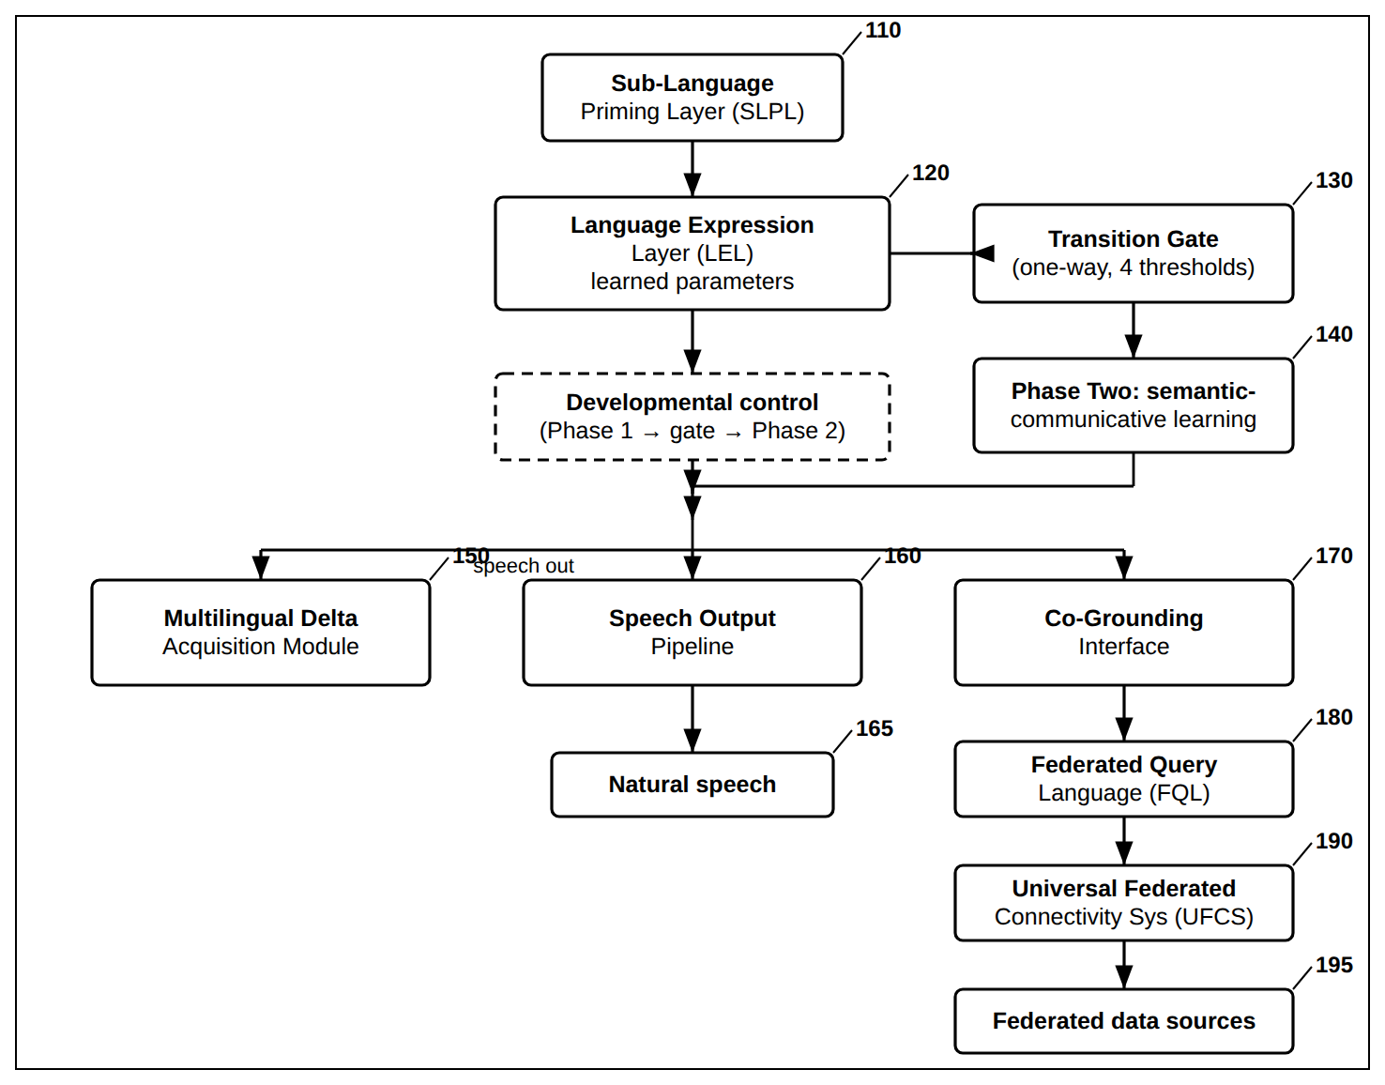
FIG. 1 — QueryBook LEL — Overall System Architecture

FIG. 2
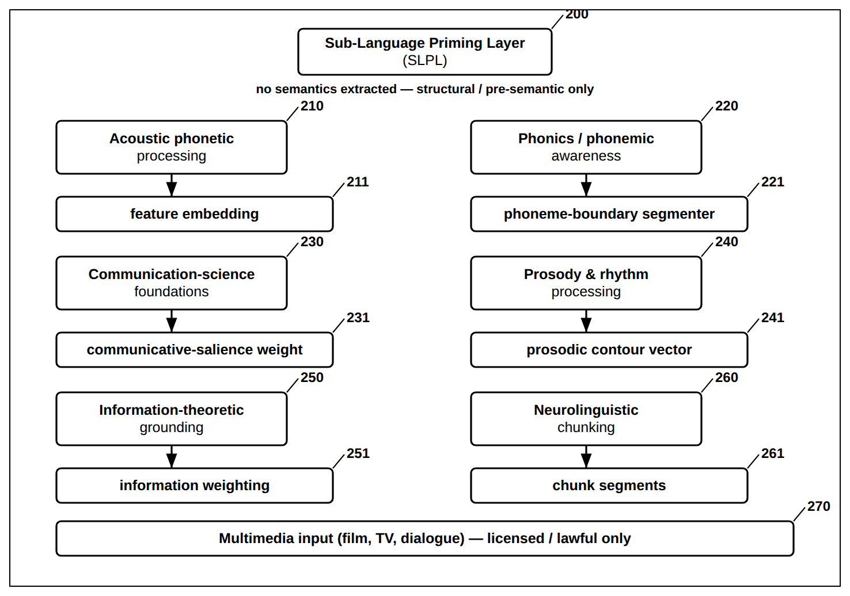
FIG. 2 — Sub-Language Priming Layer (SLPL) and Its Measurable Outputs

FIG. 3
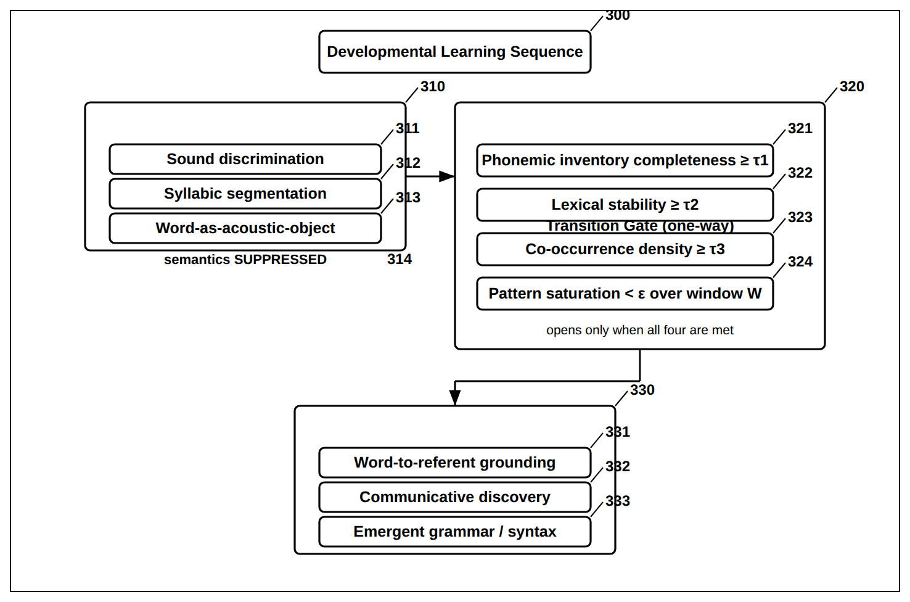
FIG. 3 — Developmental Learning Sequence and One-Way Transition Gate

FIG. 4
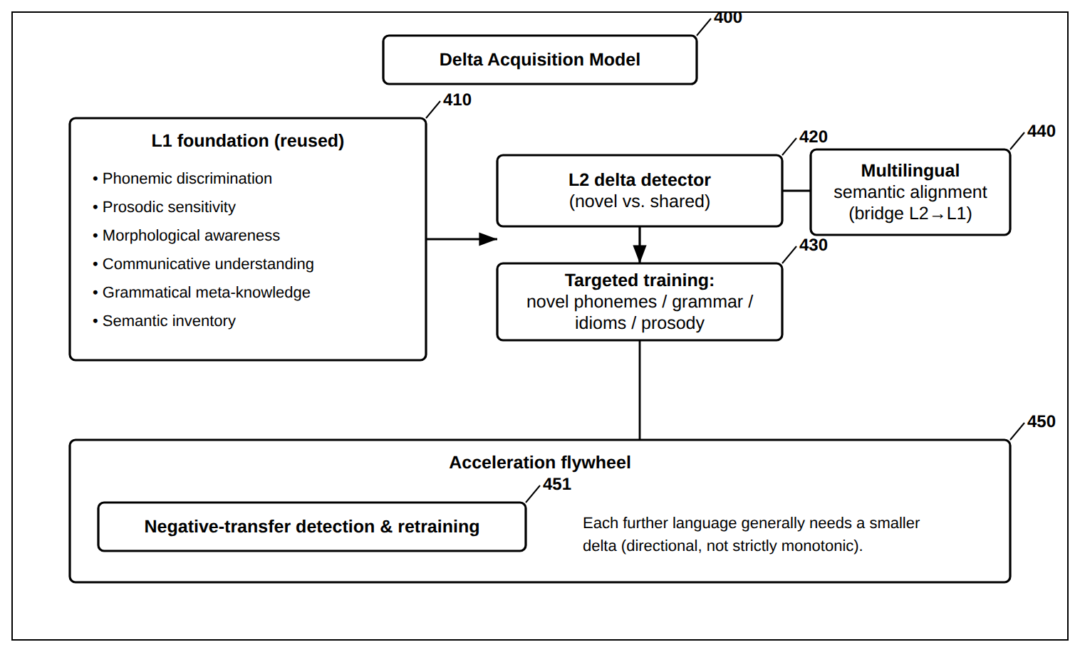
FIG. 4 — Multilingual Transfer — Delta Acquisition and Acceleration Flywheel

FIG. 5
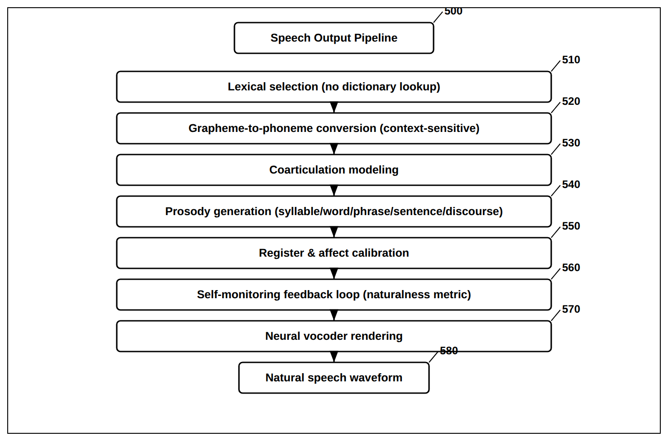
FIG. 5 — Speech Output Pipeline (Seven Learned Stages)

FIG. 6
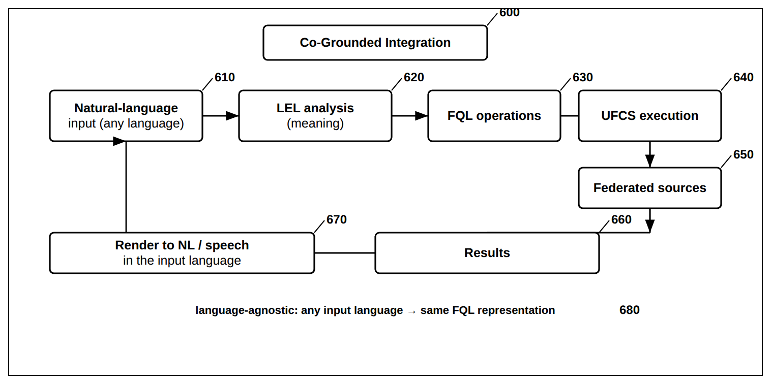
FIG. 6 — Co-Grounded Integration with FQL and UFCS

FIG. 7
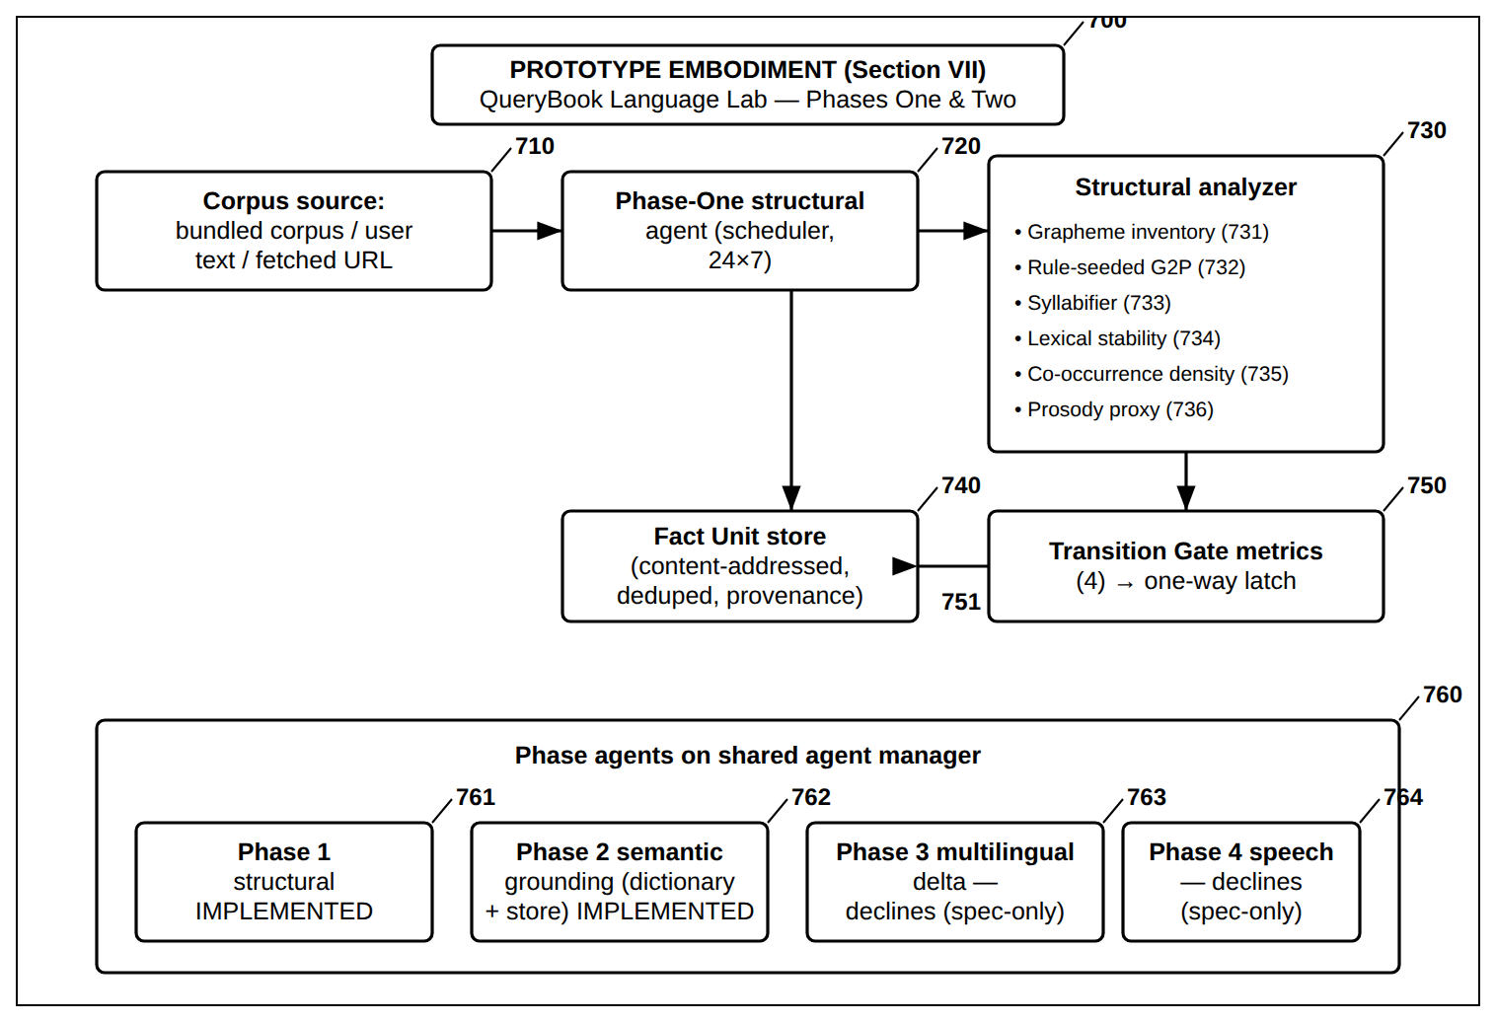
FIG. 7 — Reduced-to-Practice Embodiment — Language Lab Phases One and Two Prototype

FIG. 8
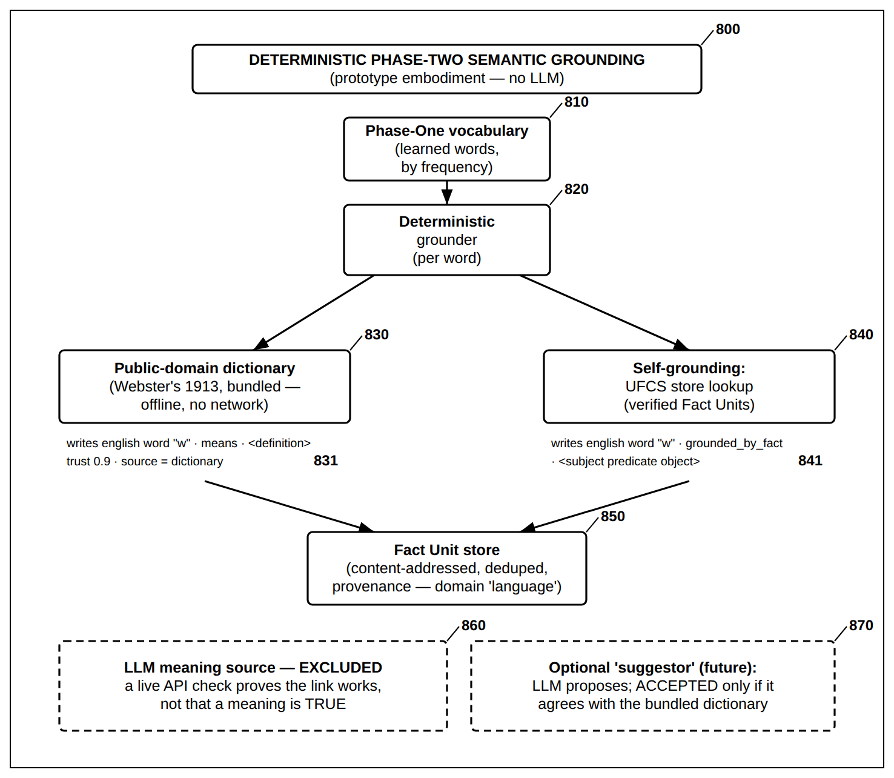
FIG. 8 — Deterministic Phase-Two Semantic Grounding — Dictionary and Store (No LLM)

FIG. 9
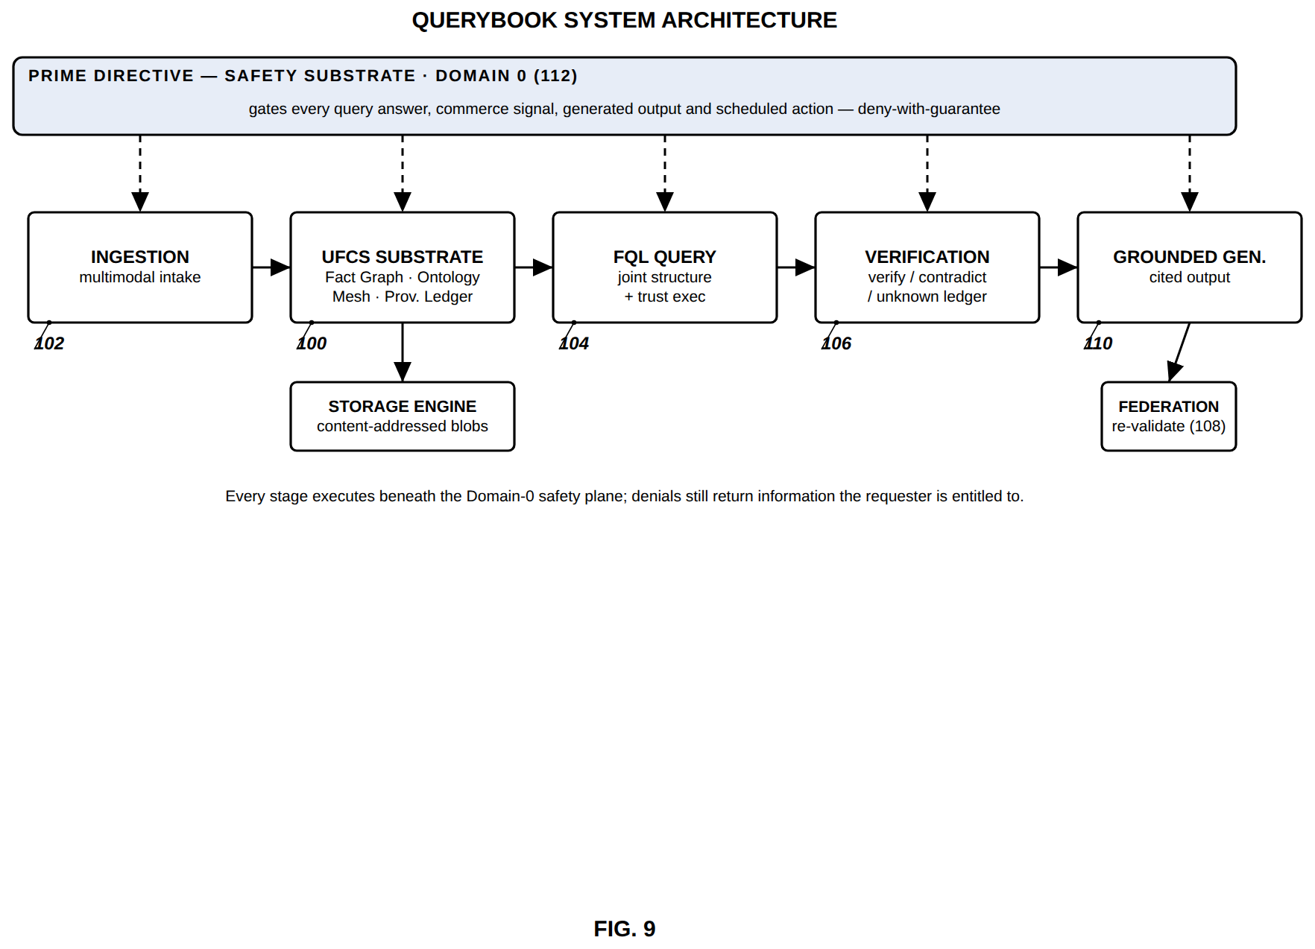
FIG. 9 — QueryBook system architecture (Prime Directive as Domain 0)

FIG. 10
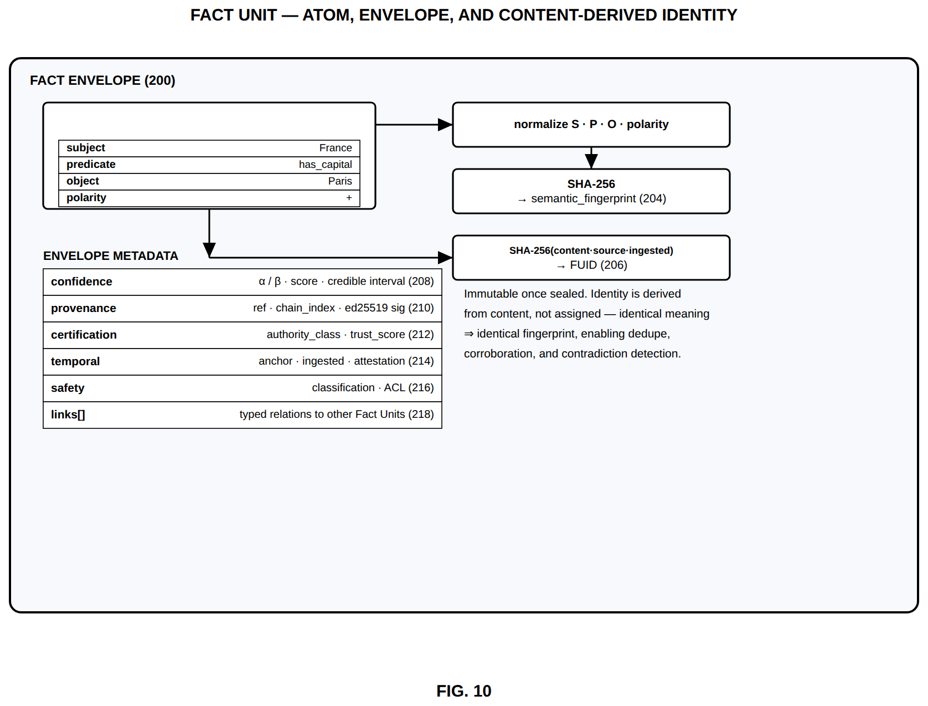
FIG. 10 — Fact Unit — atom, envelope, and content-derived identity

FIG. 11
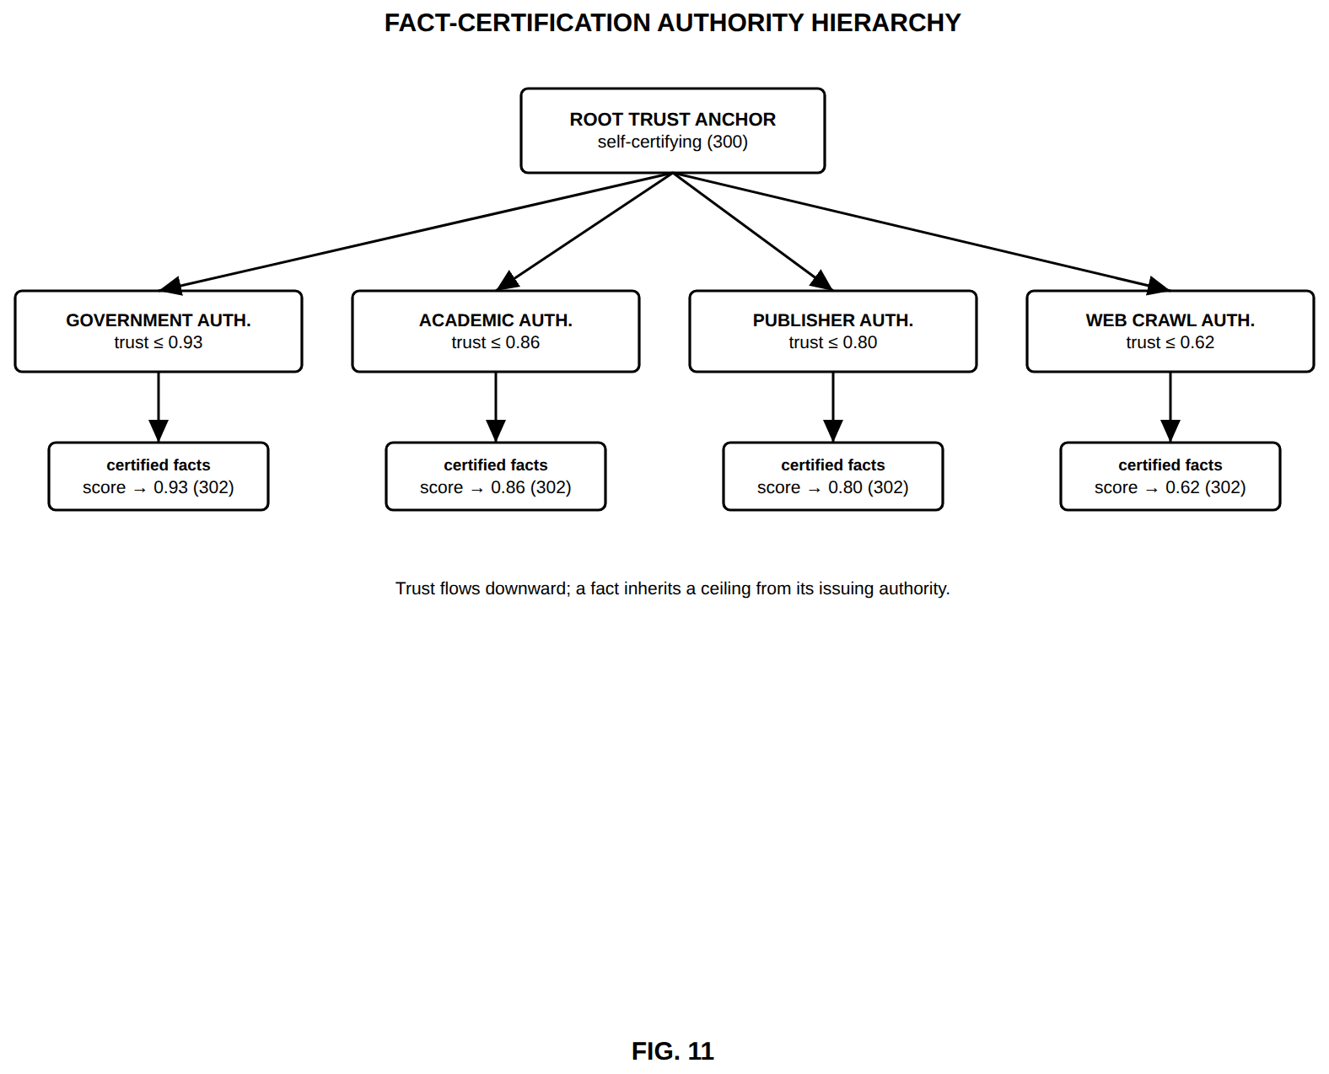
FIG. 11 — Fact-certification authority hierarchy

FIG. 12
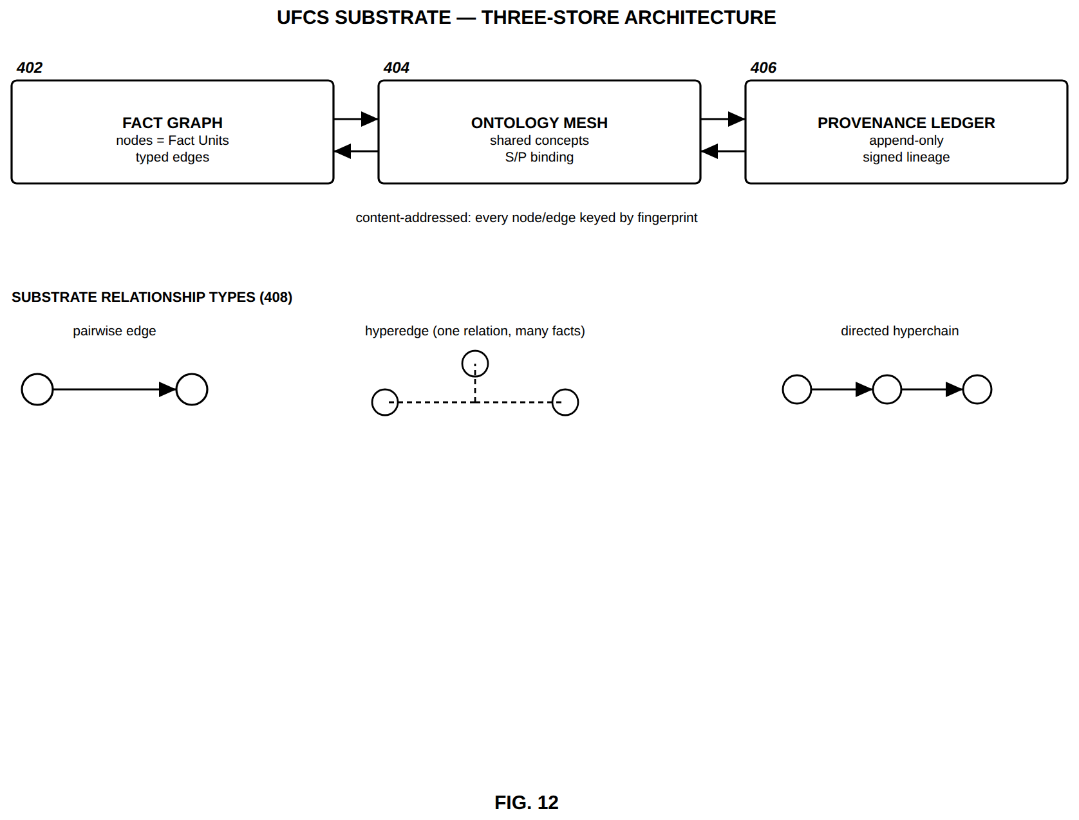
FIG. 12 — UFCS substrate — three-store architecture

FIG. 13
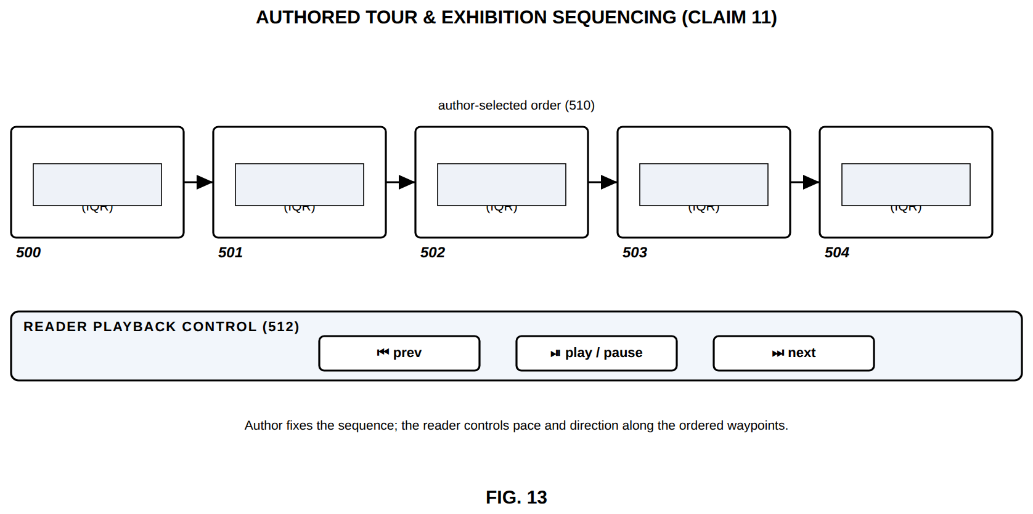
FIG. 13 — Authored tour and exhibition sequencing

FIG. 14
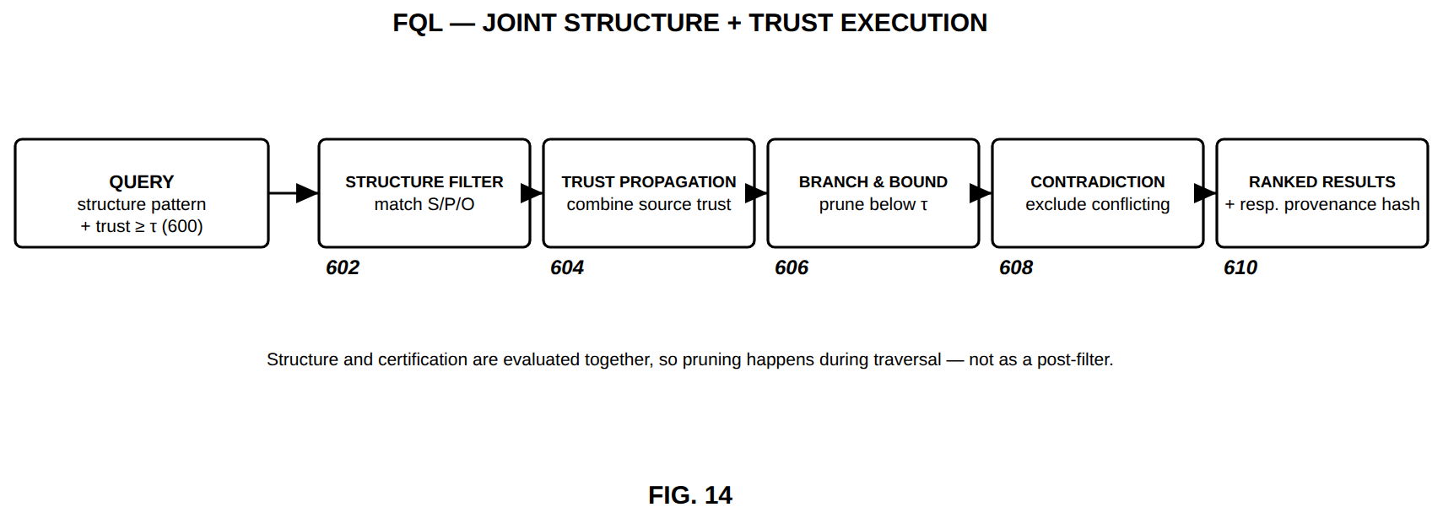
FIG. 14 — FQL — joint structure and trust execution

FIG. 15
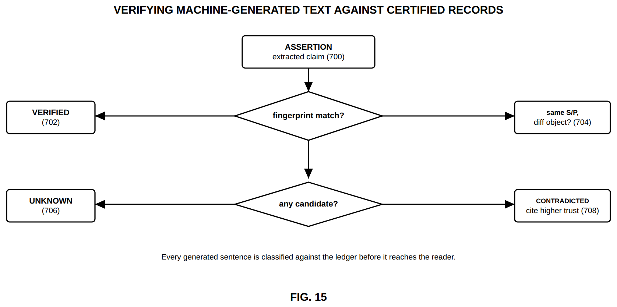
FIG. 15 — Verifying machine-generated text against certified records

FIG. 16
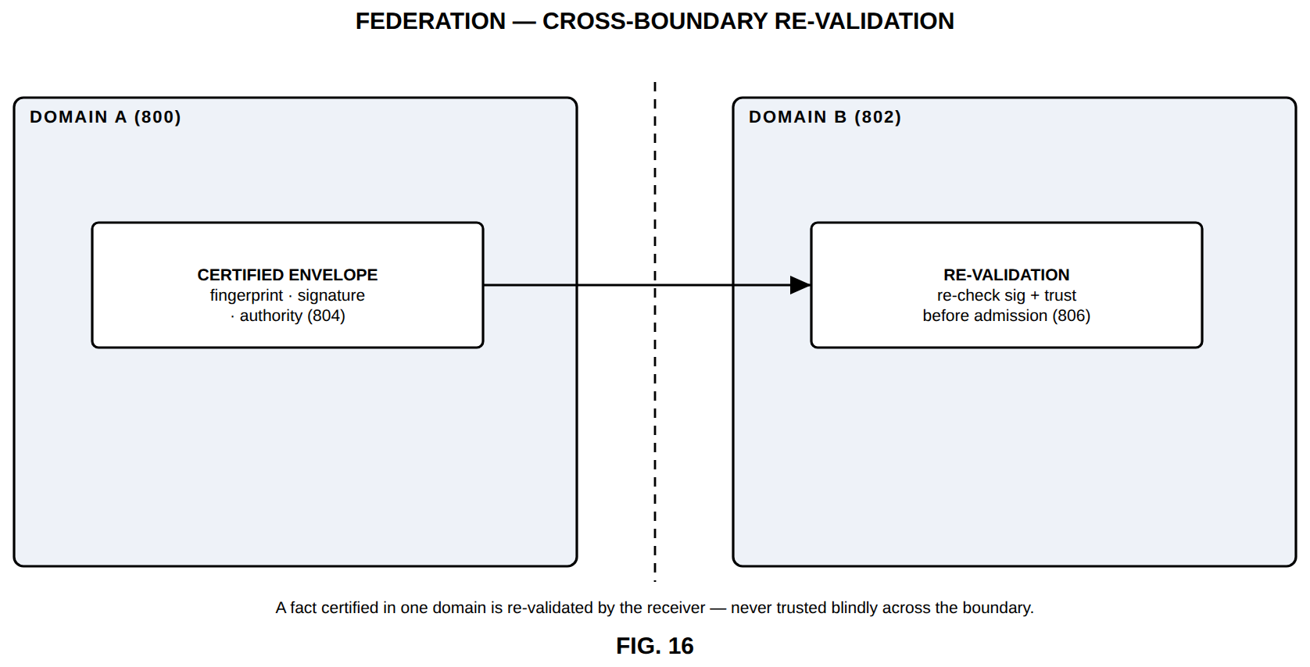
FIG. 16 — Federation — cross-boundary re-validation

FIG. 17
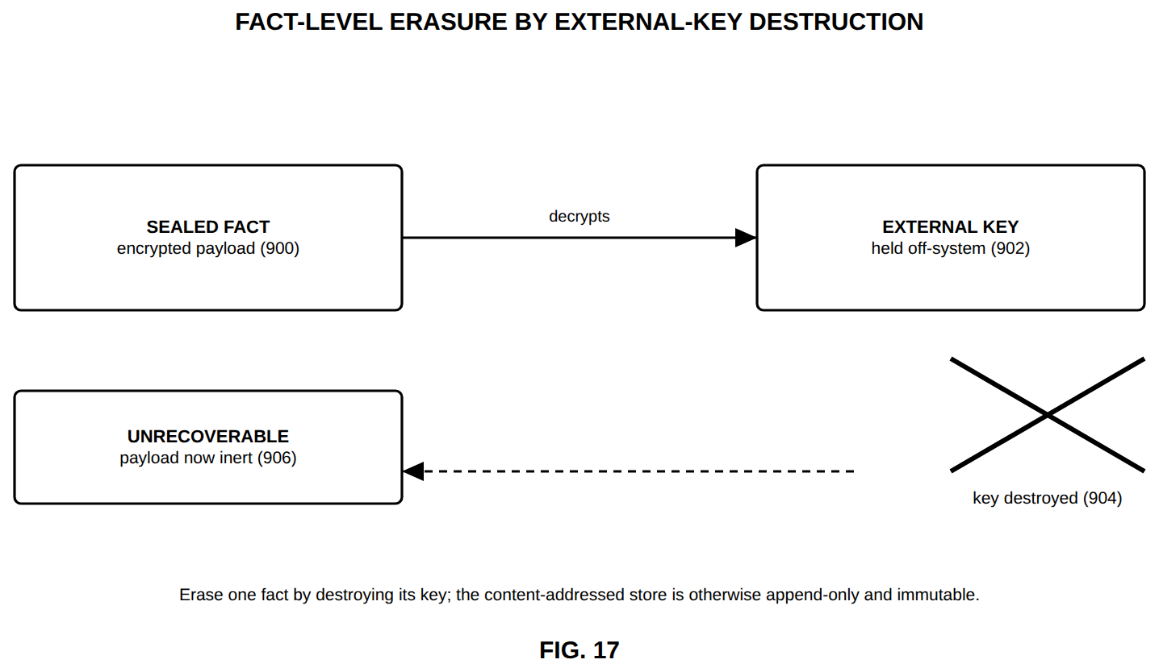
FIG. 17 — Fact-level erasure by external-key destruction

FIG. 18
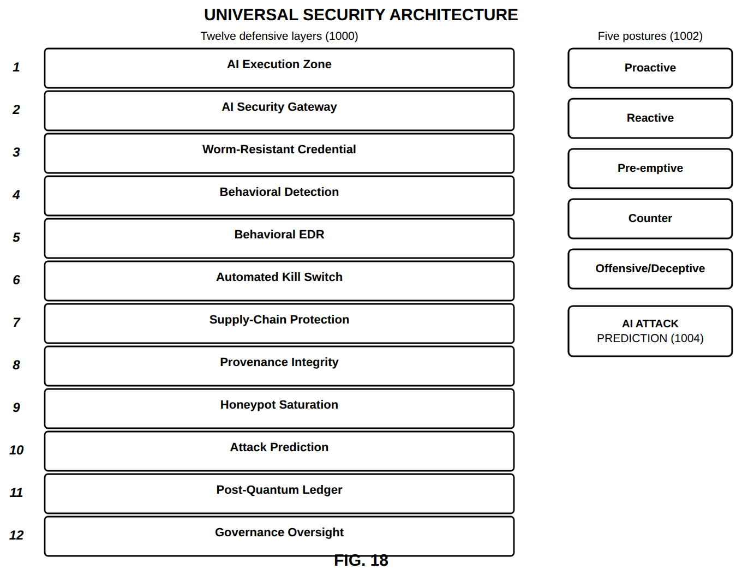
FIG. 18 — Universal security architecture

FIG. 19
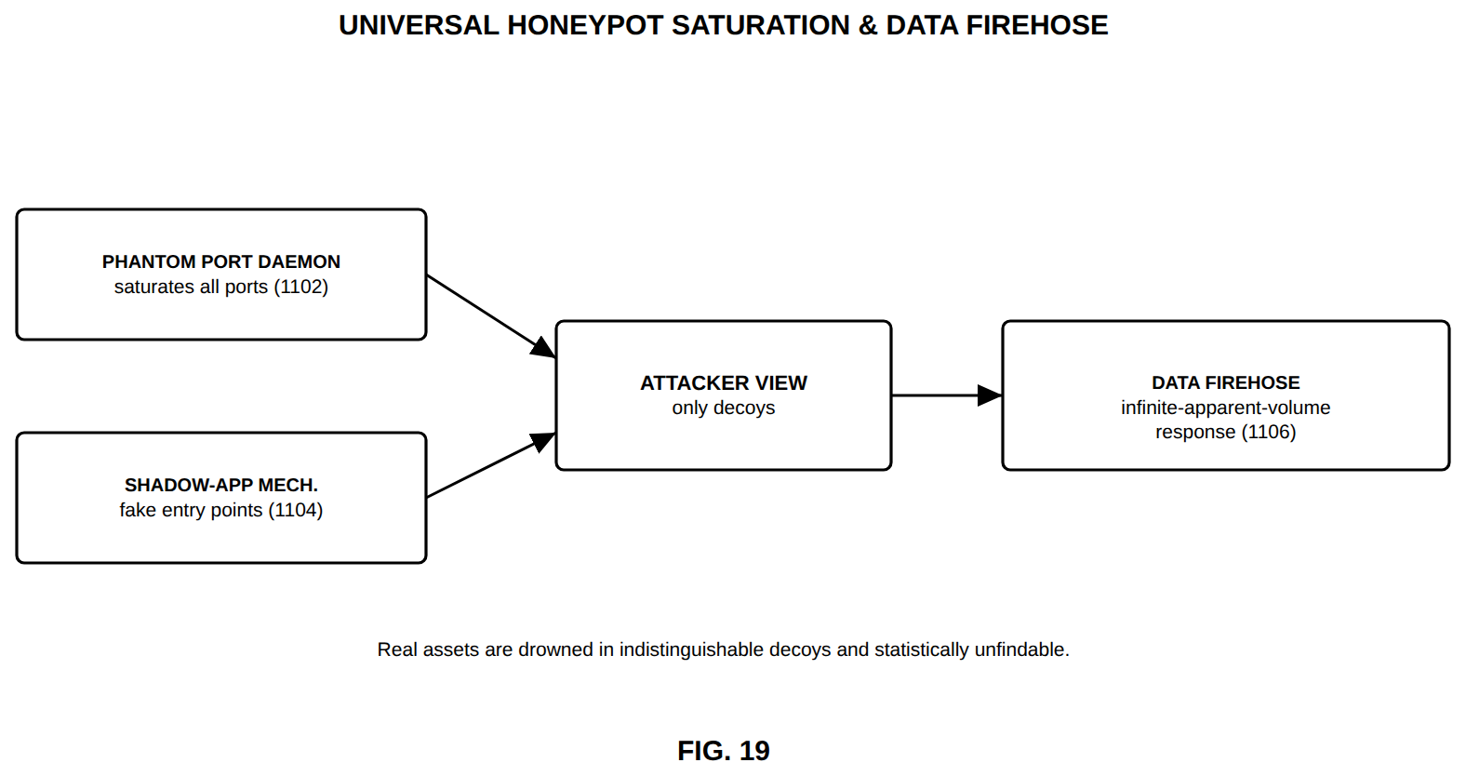
FIG. 19 — Universal honeypot saturation and data firehose

FIG. 20
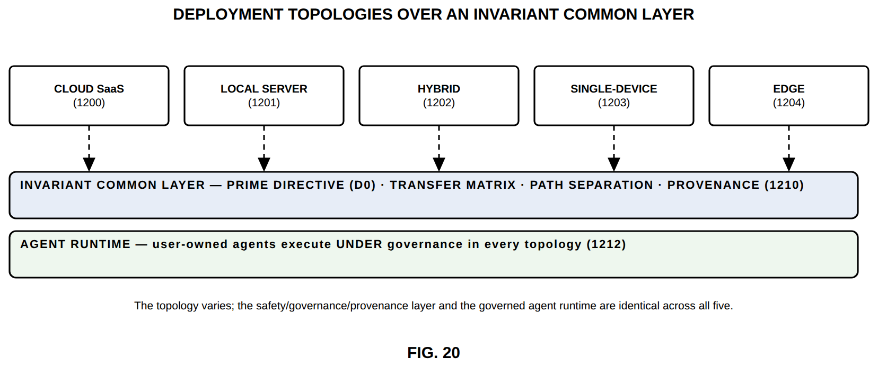
FIG. 20 — Deployment topologies over an invariant common layer

FIG. 21
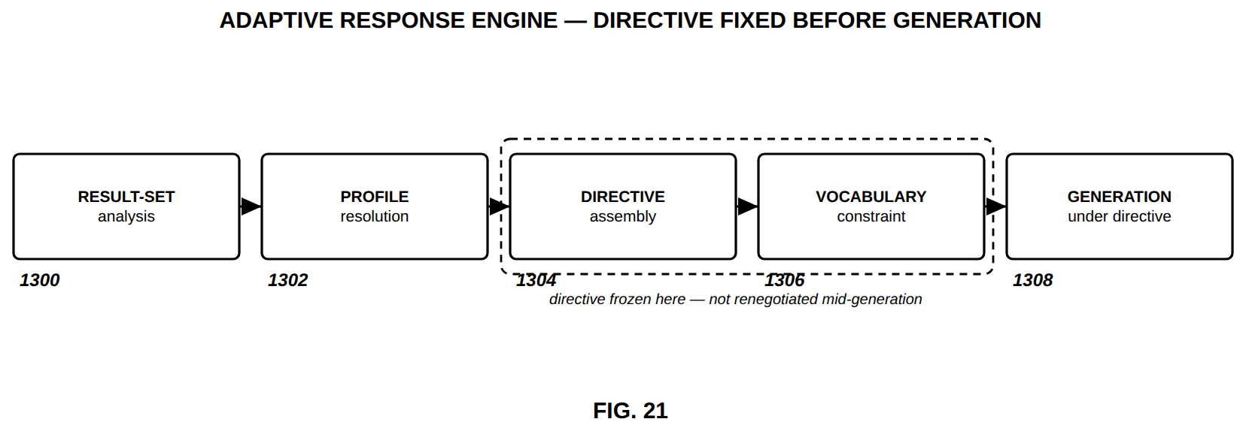
FIG. 21 — Adaptive response engine — directive fixed before generation

FIG. 22
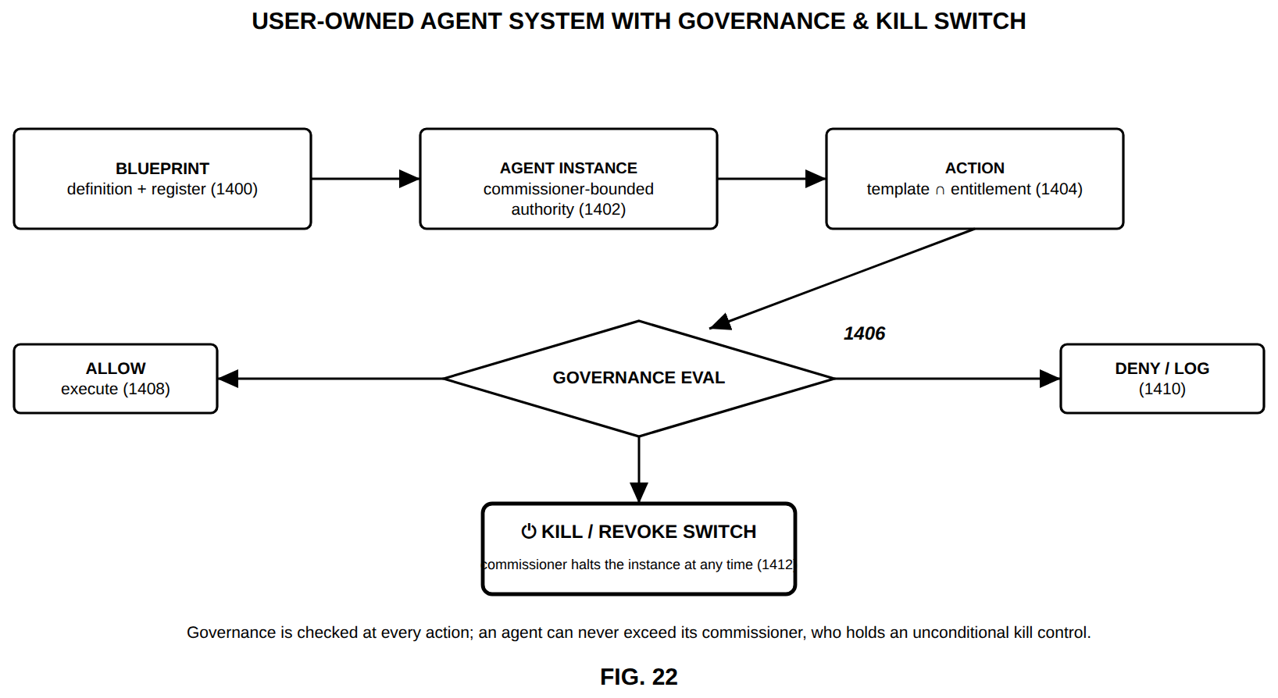
FIG. 22 — User-owned agent system with governance and kill switch

FIG. 23
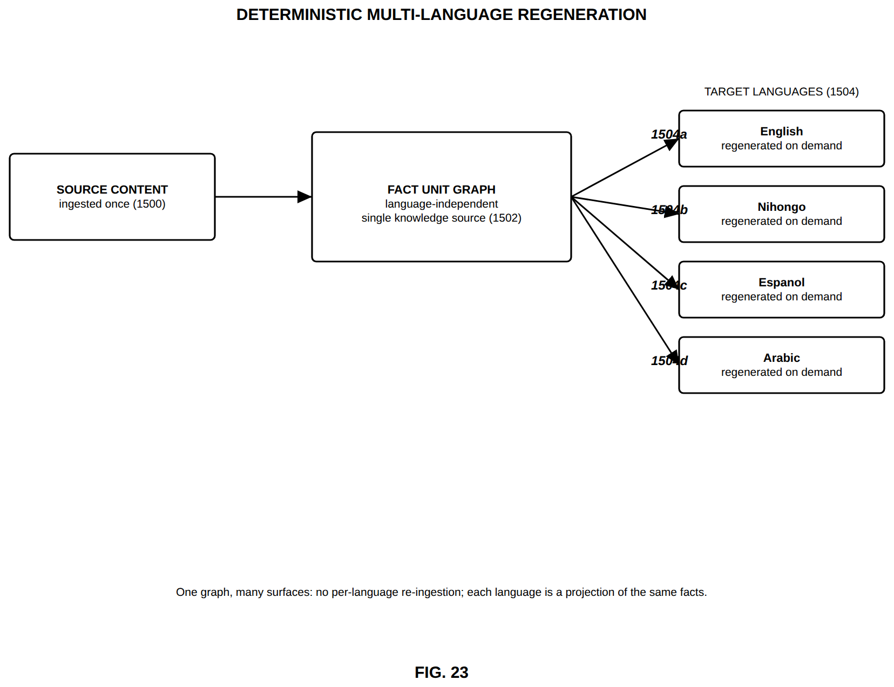
FIG. 23 — Deterministic multi-language regeneration

FIG. 24
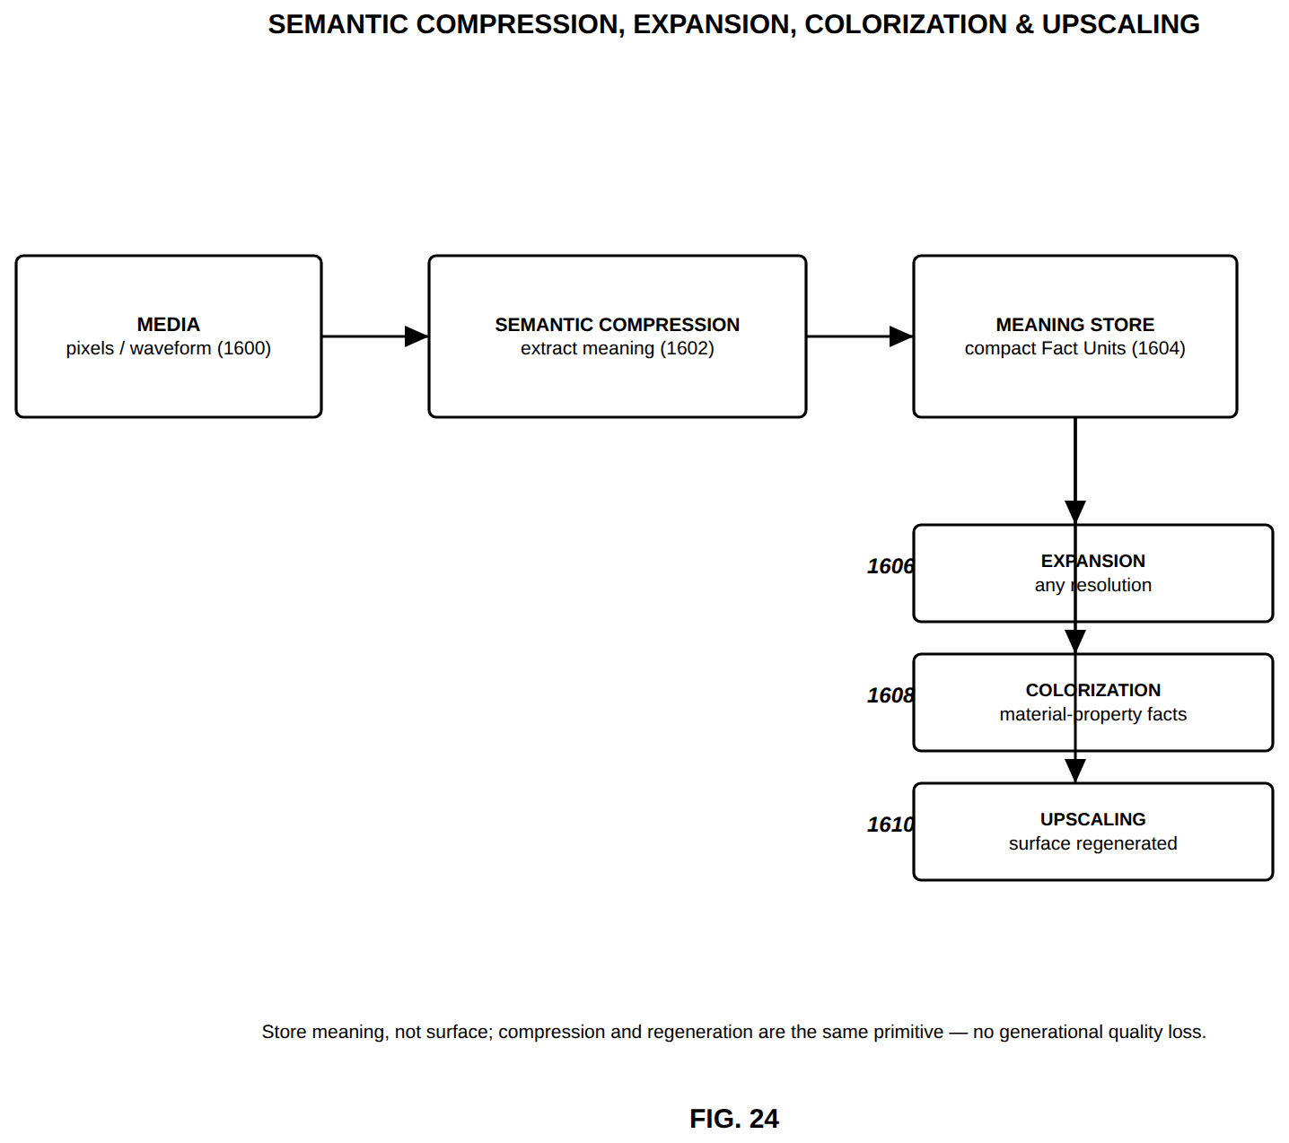
FIG. 24 — Semantic compression, expansion, colorization and upscaling

FIG. 25
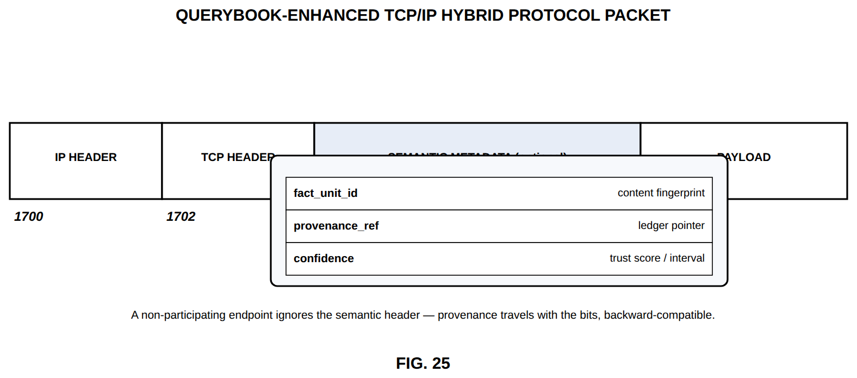
FIG. 25 — QueryBook-enhanced TCP/IP hybrid protocol packet

FIG. 26
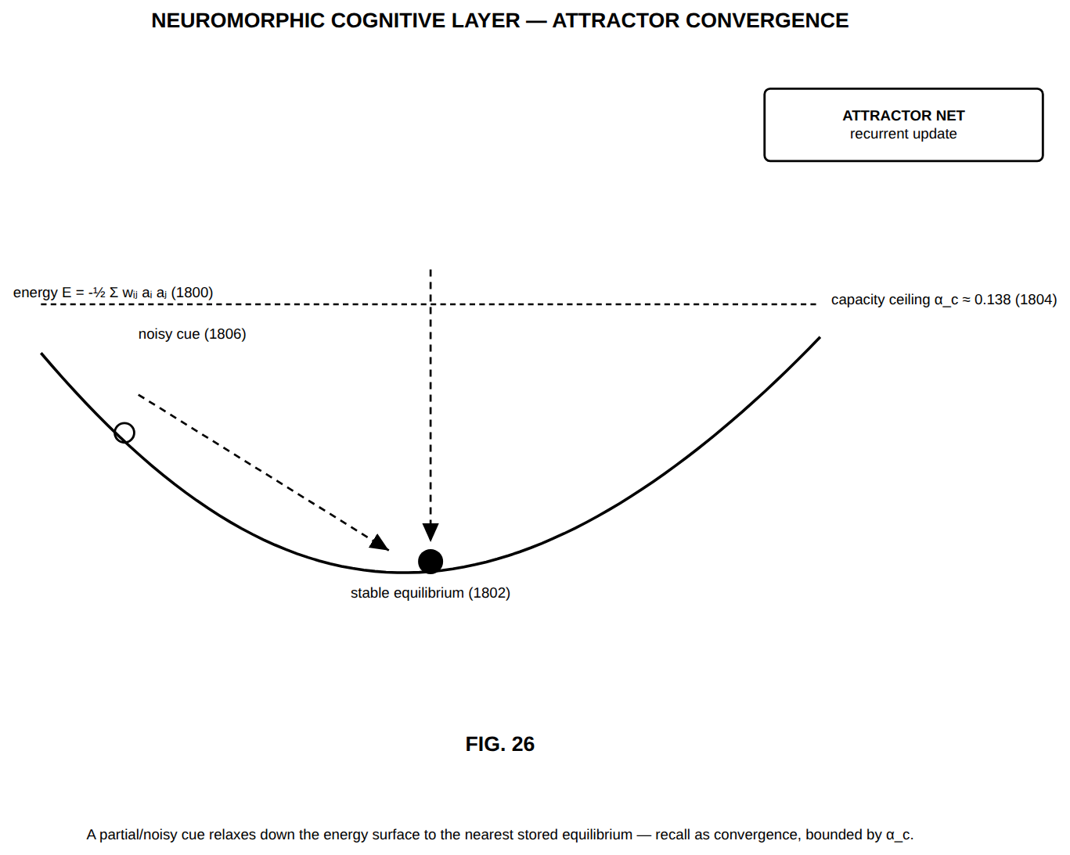
FIG. 26 — Neuromorphic cognitive layer — attractor convergence

FIG. 27
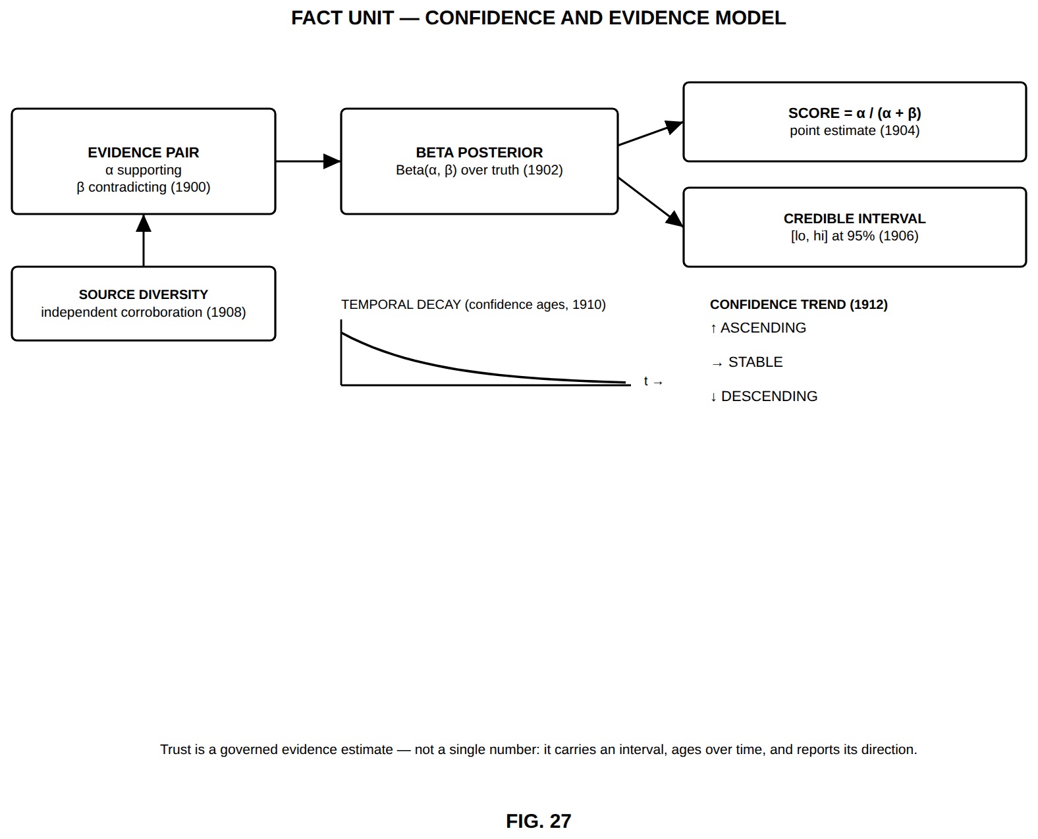
FIG. 27 — Fact Unit — confidence and evidence model

FIG. 28
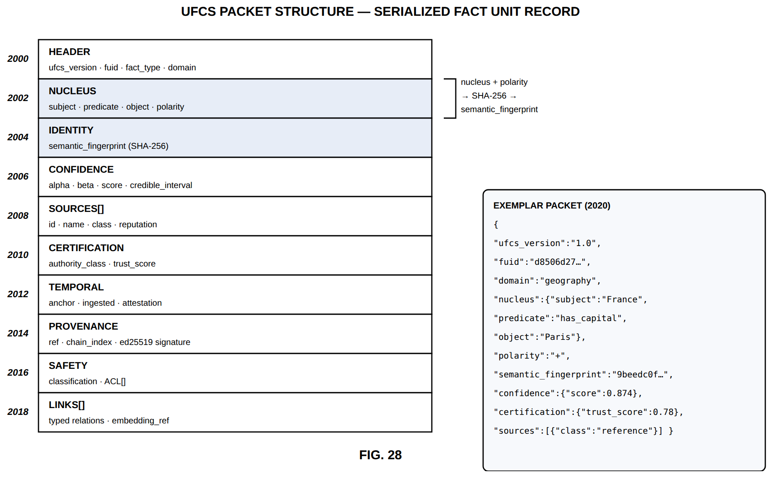
FIG. 28 — UFCS packet structure — serialized Fact Unit record

FIG. 29
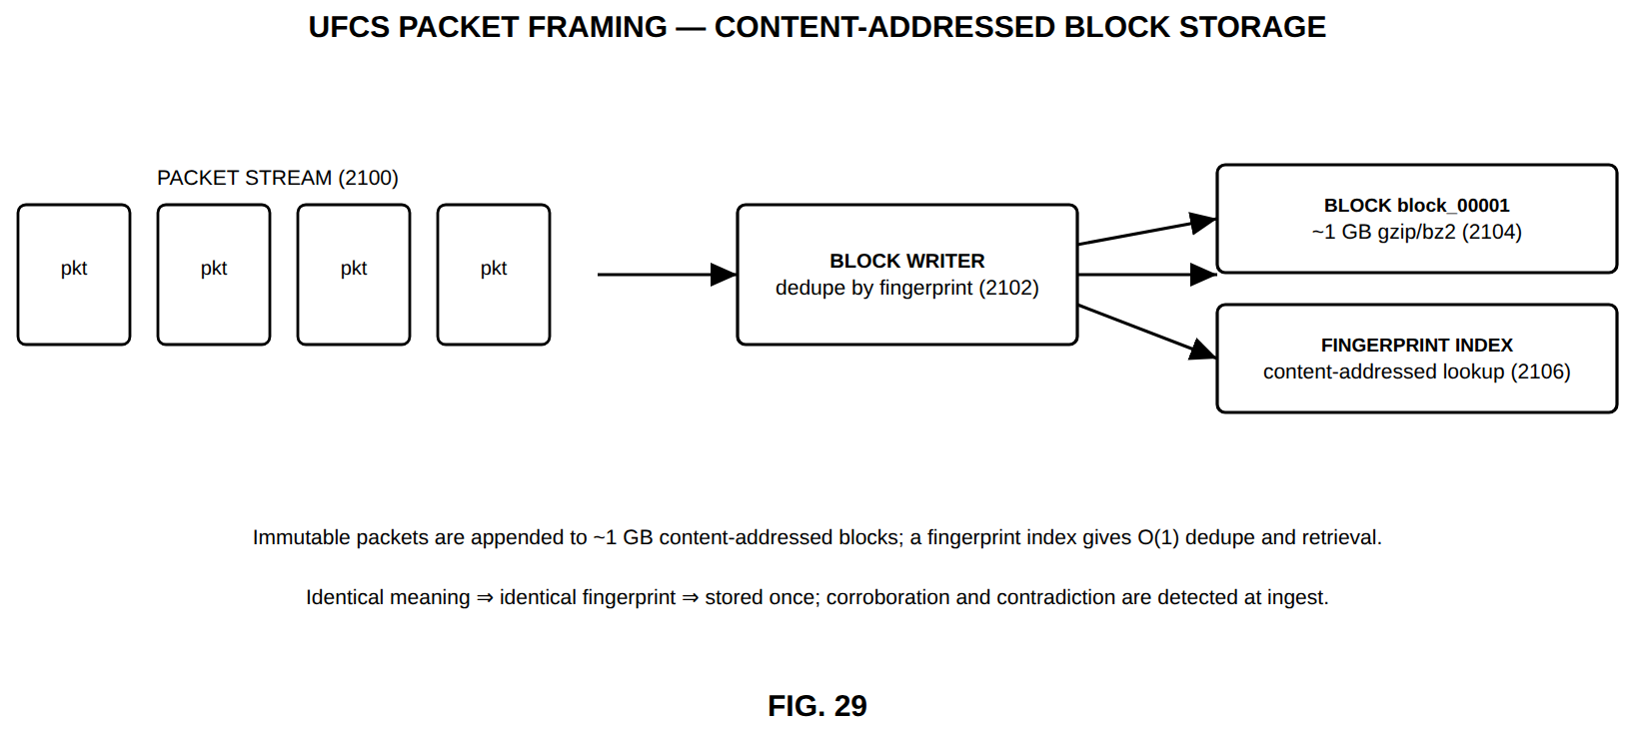
FIG. 29 — UFCS packet framing — content-addressed block storage

FIG. 30
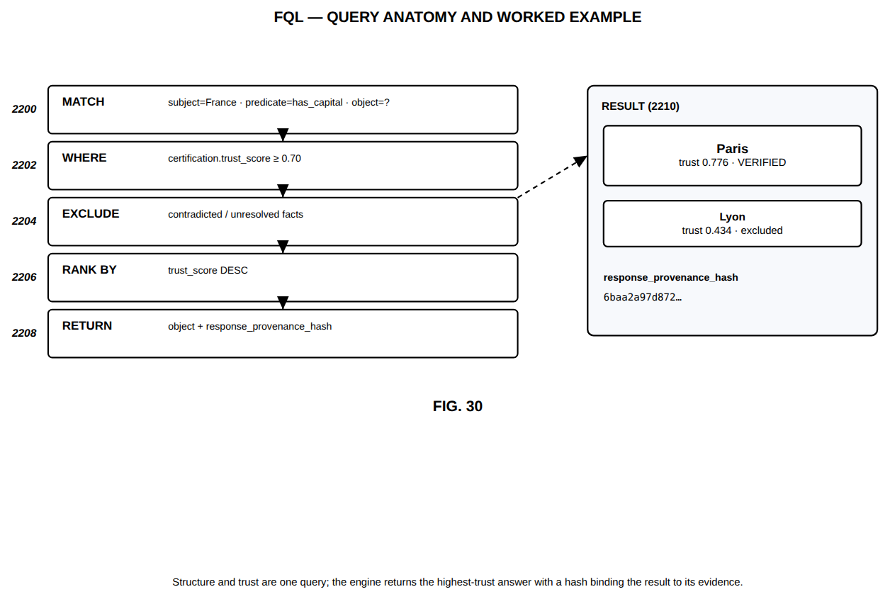
FIG. 30 — FQL — query anatomy and worked example

FIG. 31
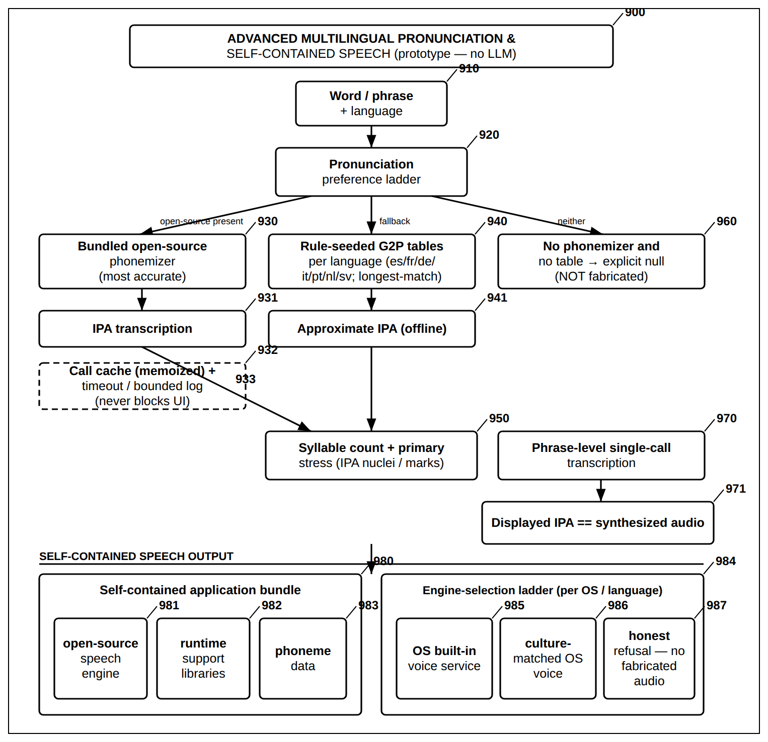
FIG. 31 — Advanced Multilingual Pronunciation and Self-Contained Speech (No LLM)

FIG. 32
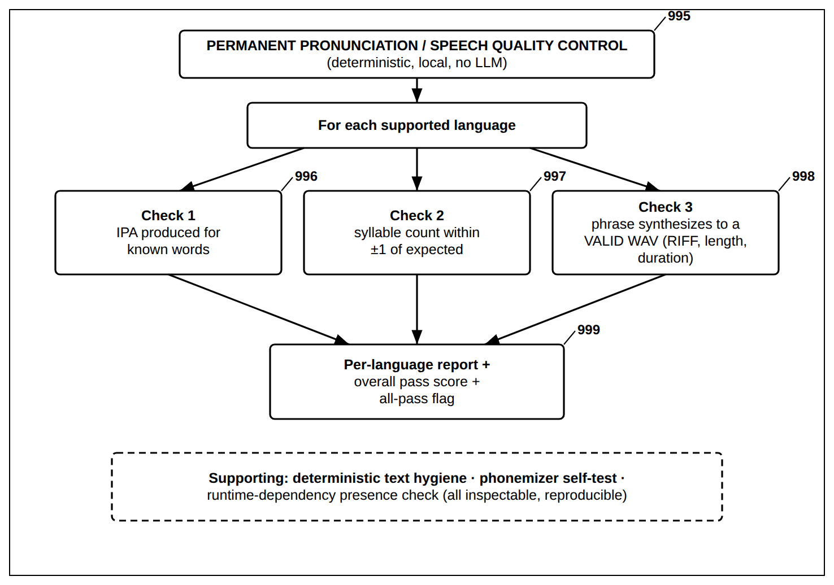
FIG. 32 — Permanent Pronunciation and Speech Quality-Control Battery (No LLM)

FIG. 33
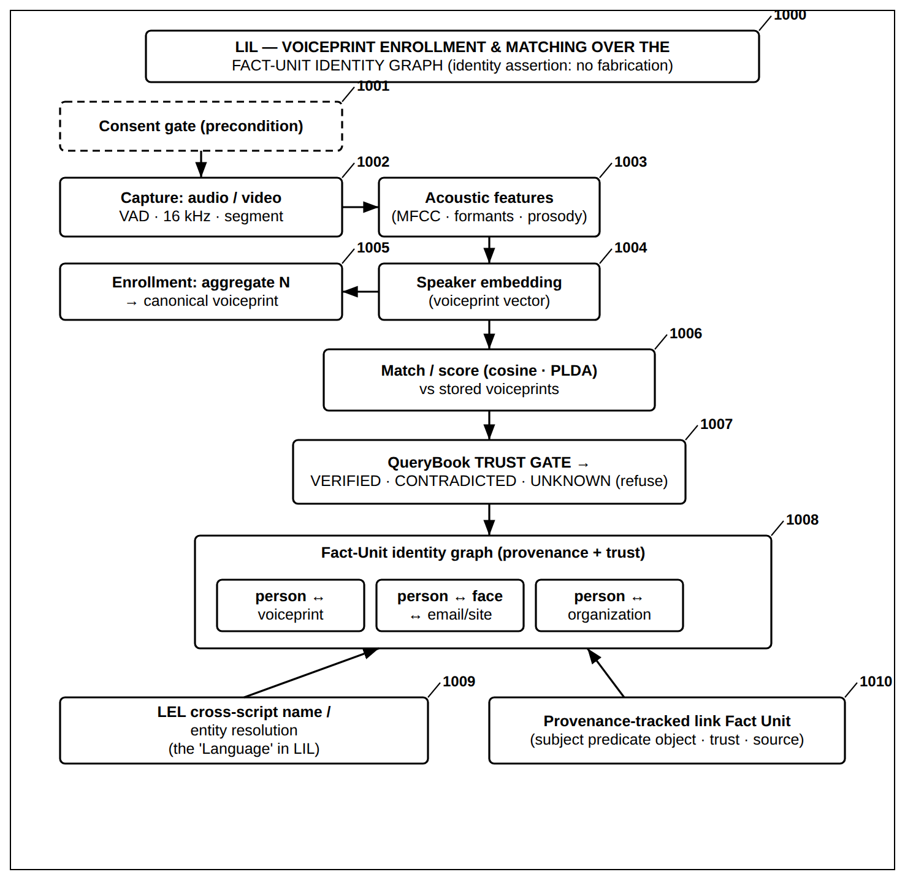
FIG. 33 — LIL — Voiceprint Enrollment and Matching over the Fact-Unit Identity Graph

FIG. 34
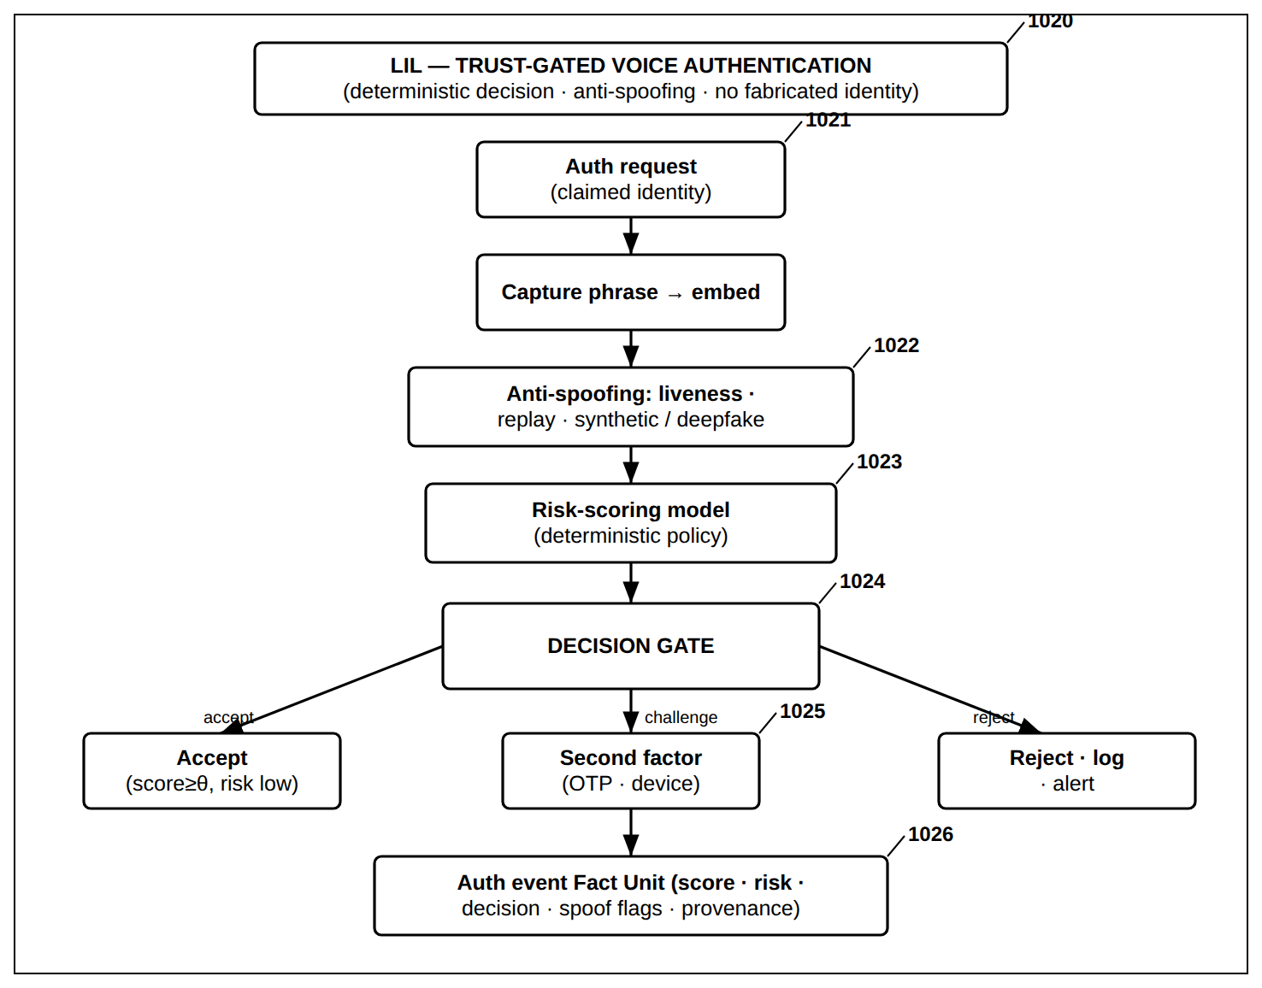
FIG. 34 — LIL — Trust-Gated Voice Authentication with Anti-Spoofing

FIG. 35
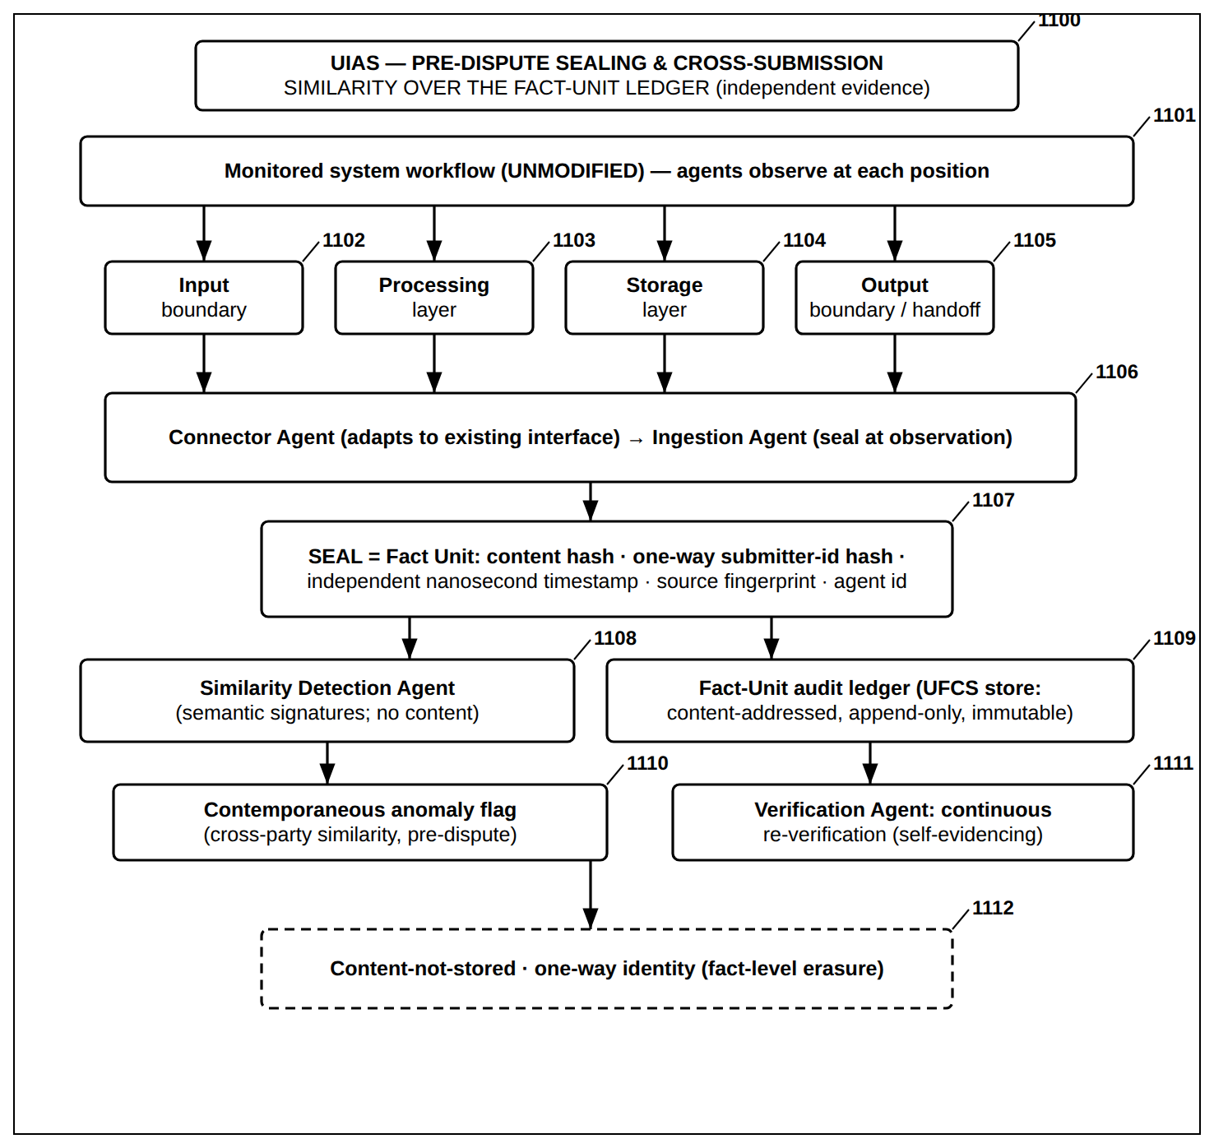
FIG. 35 — UIAS — Pre-Dispute Sealing and Cross-Submission Similarity over the Fact-Unit Le

FIG. 36
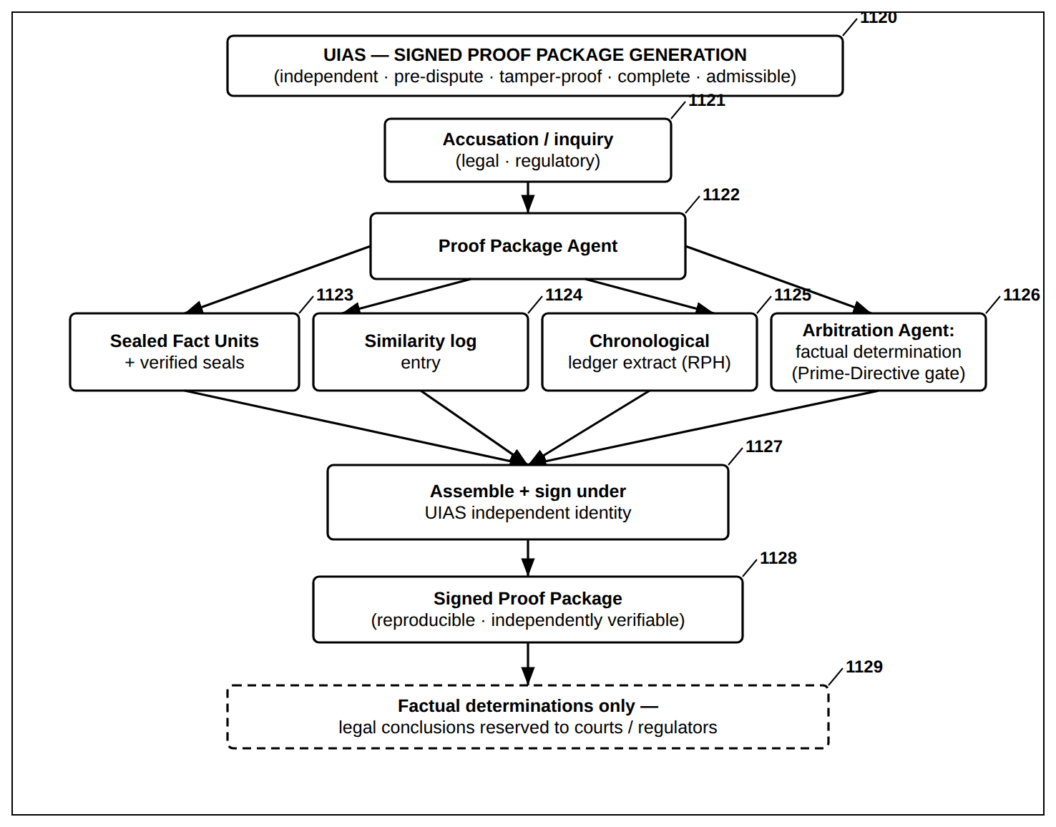
FIG. 36 — UIAS — Signed Proof Package Generation

FIG. 37
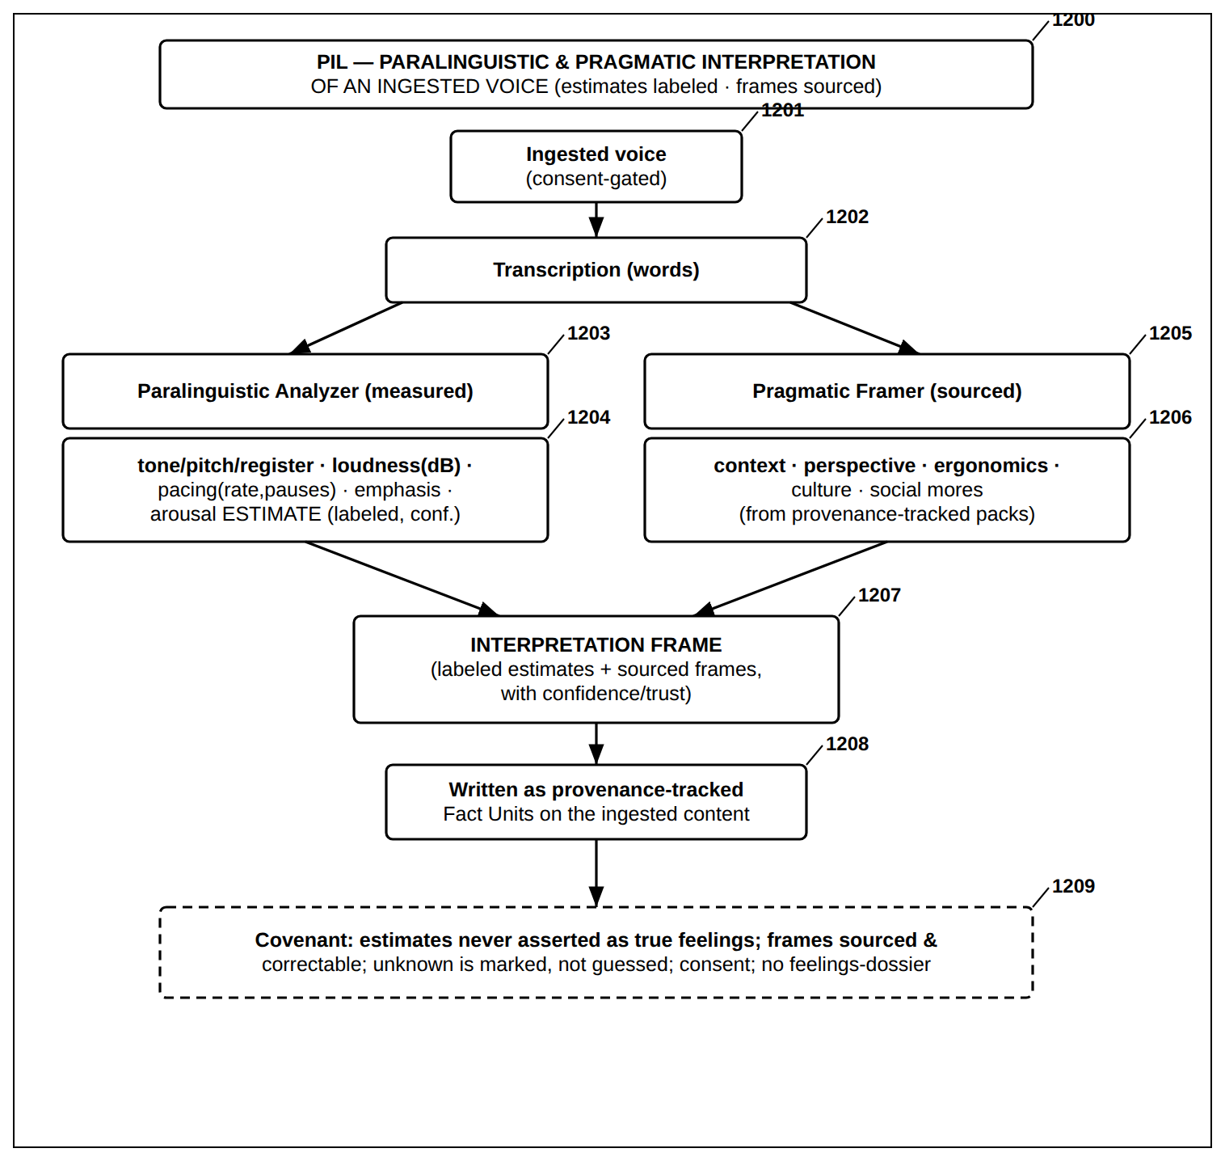
FIG. 37 — PIL — Paralinguistic and Pragmatic Interpretation of an Ingested Voice

FIG. 38
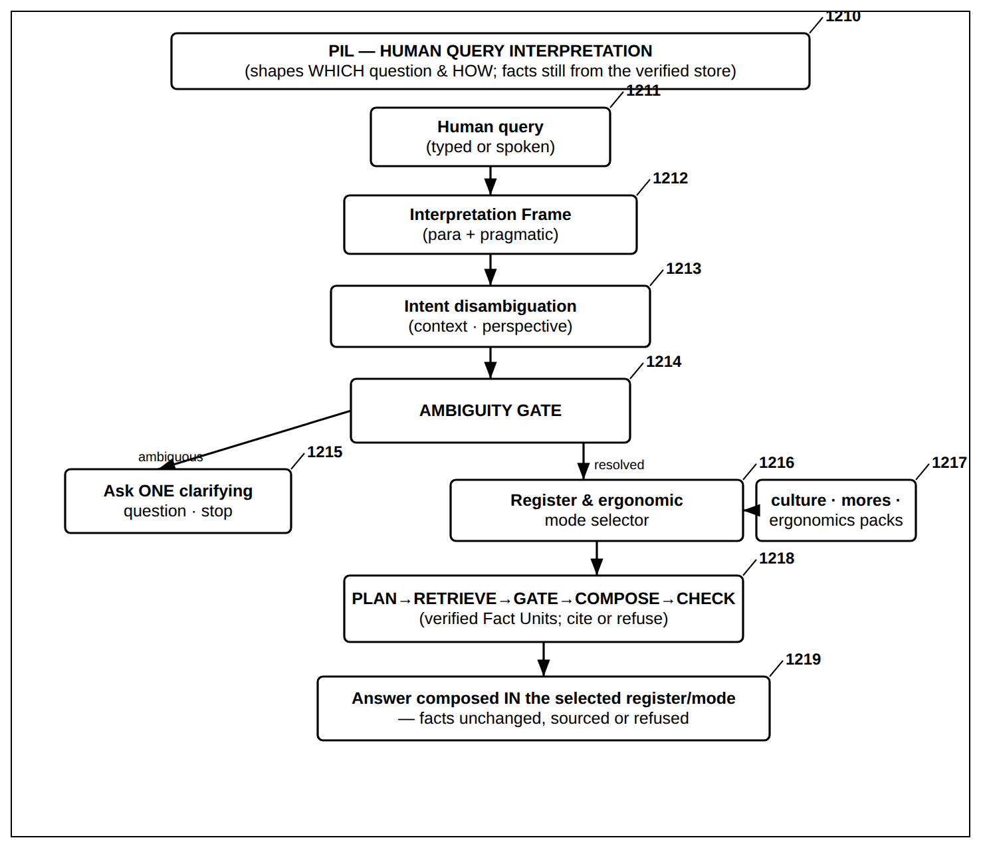
FIG. 38 — PIL — Human Query Interpretation and Covenant-Bound Answering

FIG. 39
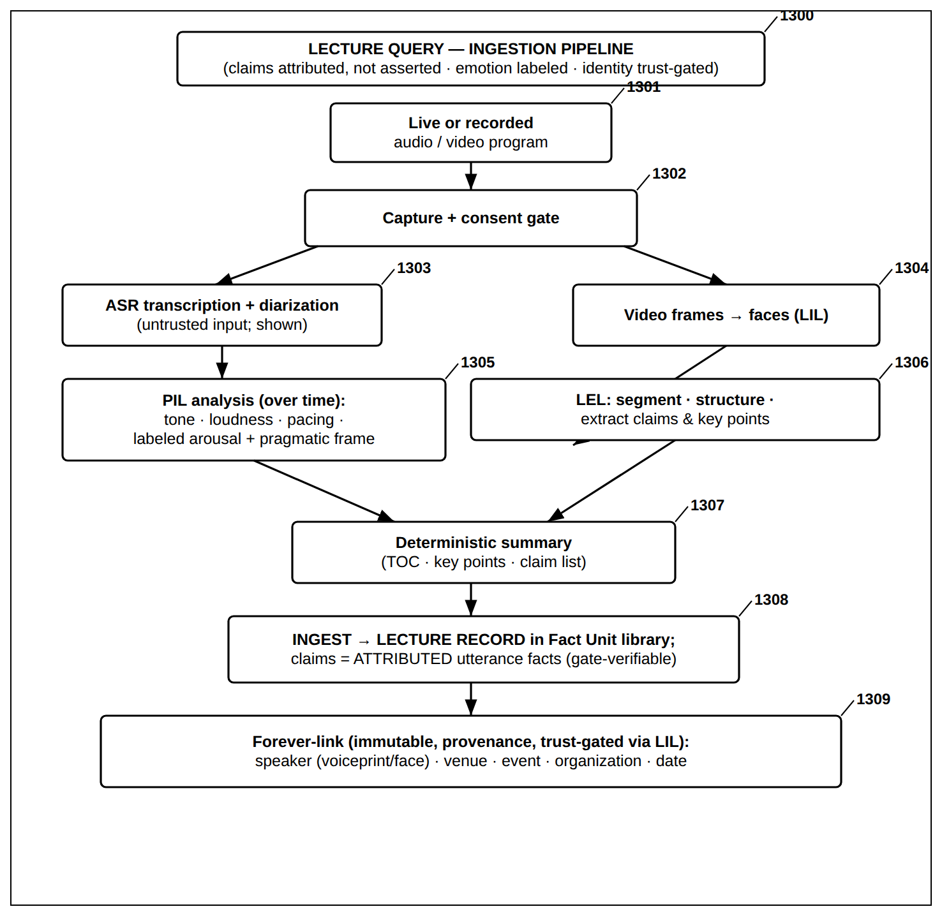
FIG. 39 — Lecture Query — Ingestion Pipeline

FIG. 40
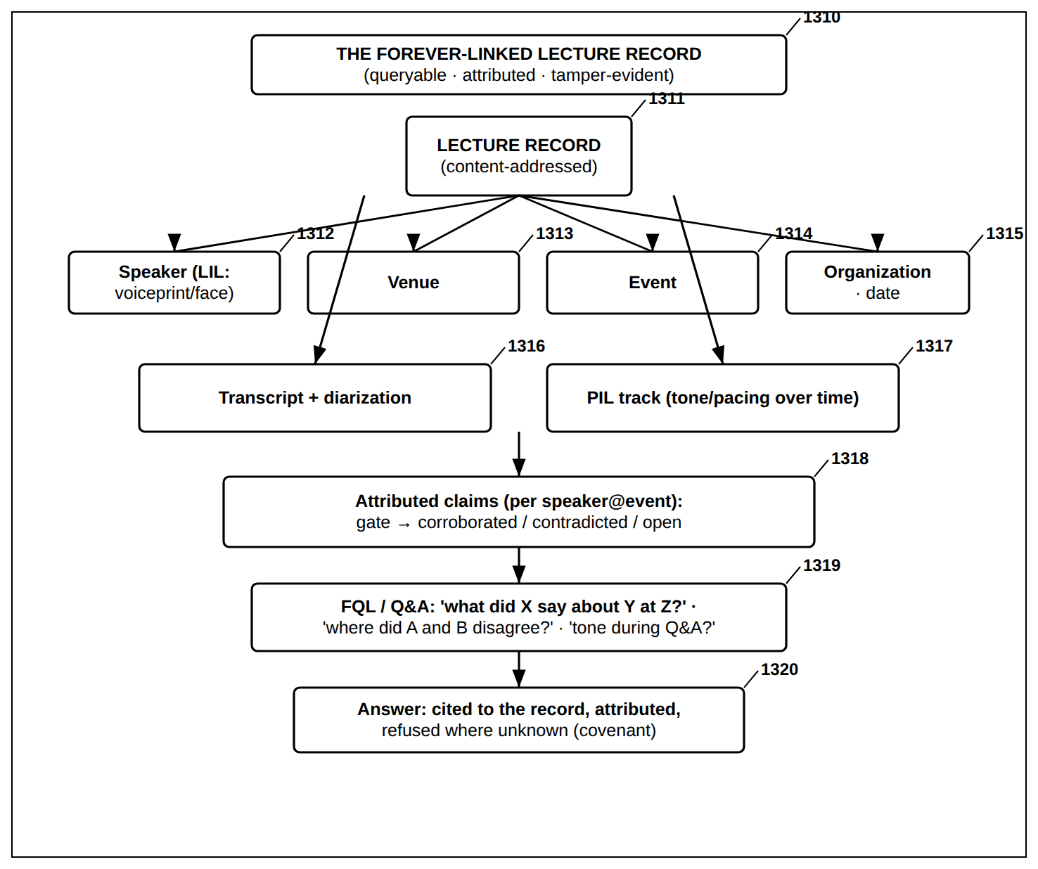
FIG. 40 — Lecture Query — The Forever-Linked Lecture Record and Its Querying

FIG. 41
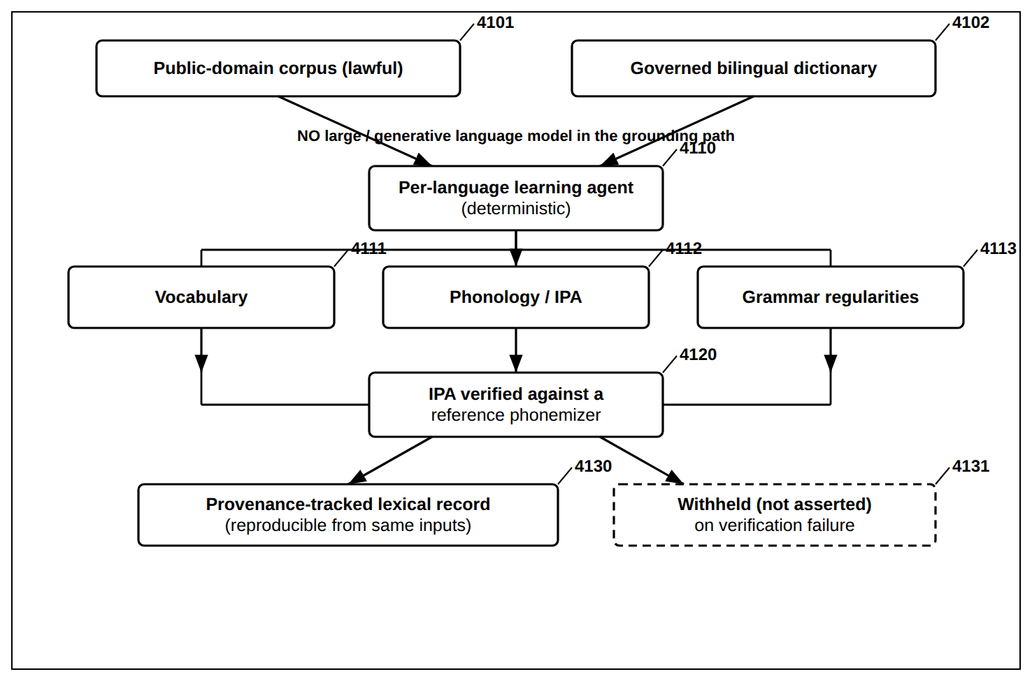
FIG. 41 — Deterministic Multilingual Acquisition Without a Generative Model

FIG. 42
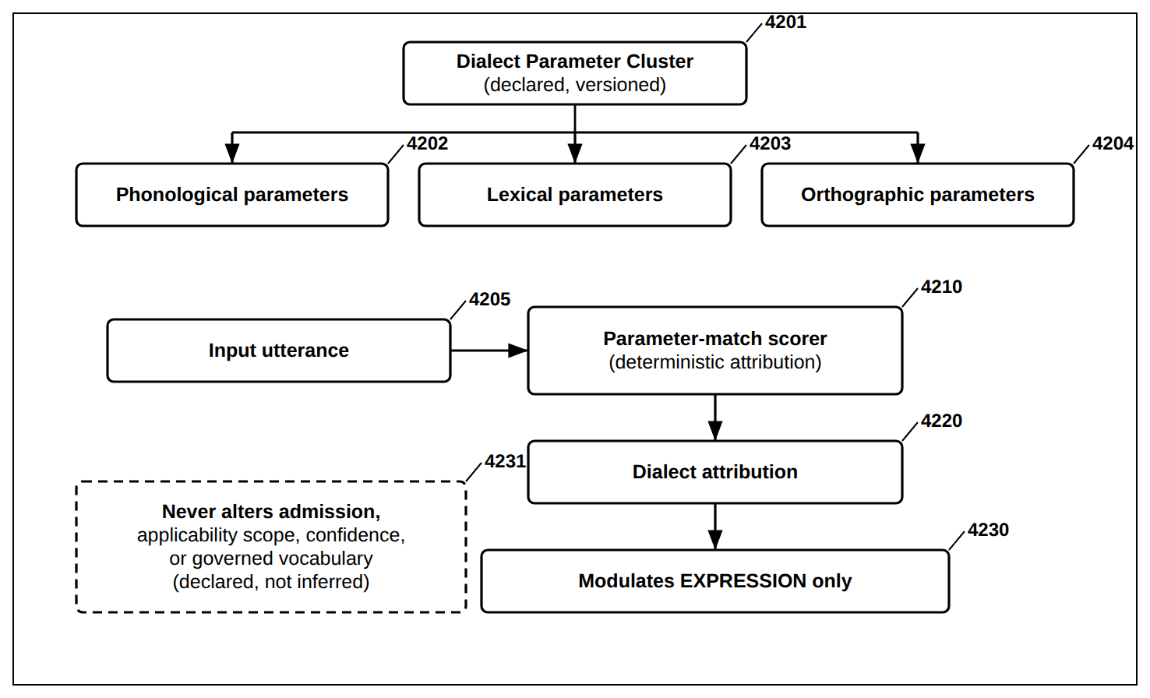
FIG. 42 — Dialect Parameter Clusters (DPC) — Declared, Expression-Only Modulation

FIG. 43
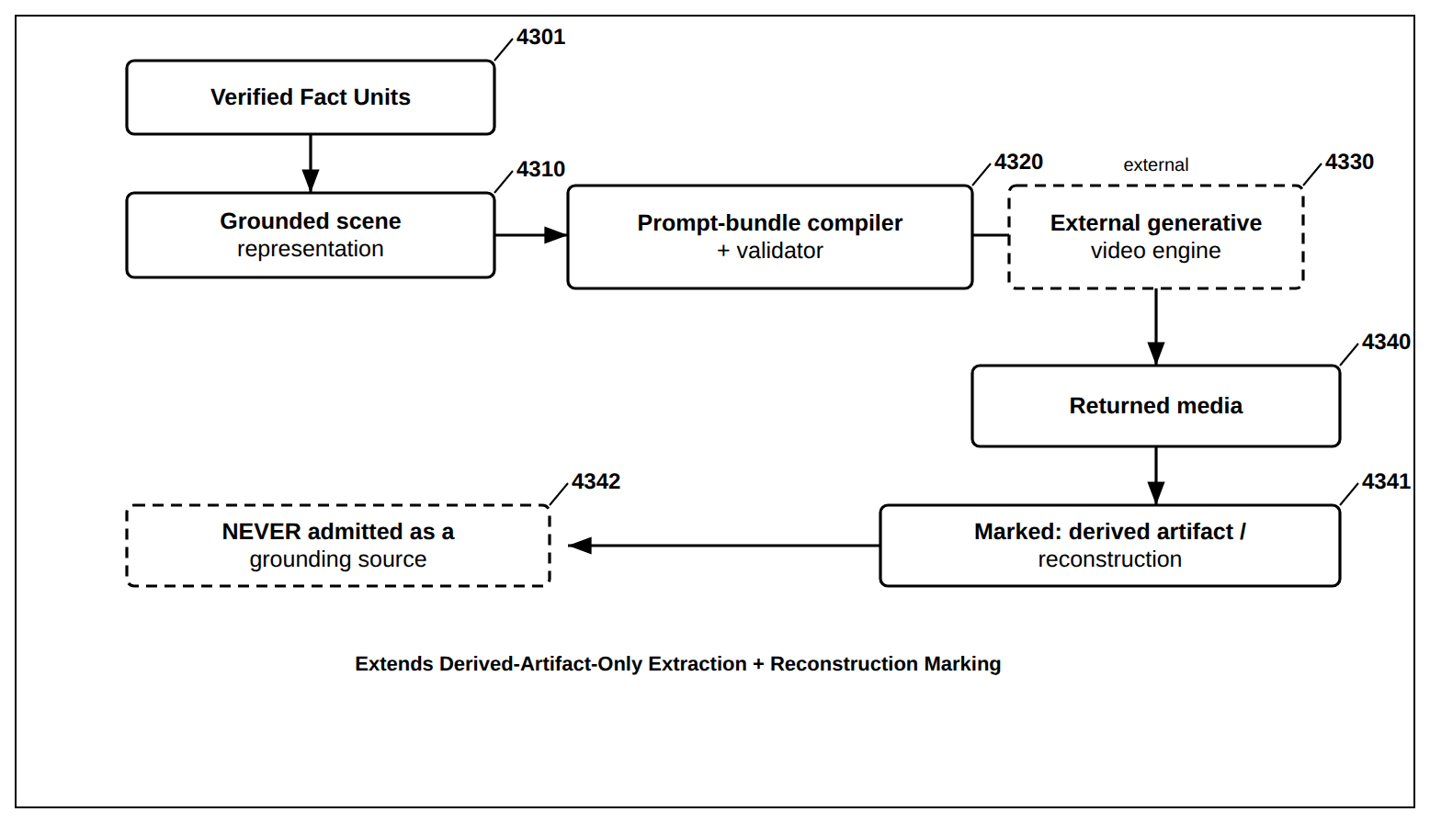
FIG. 43 — Grounded Scene Compilation to an External Generative Media Engine

FIG. 44
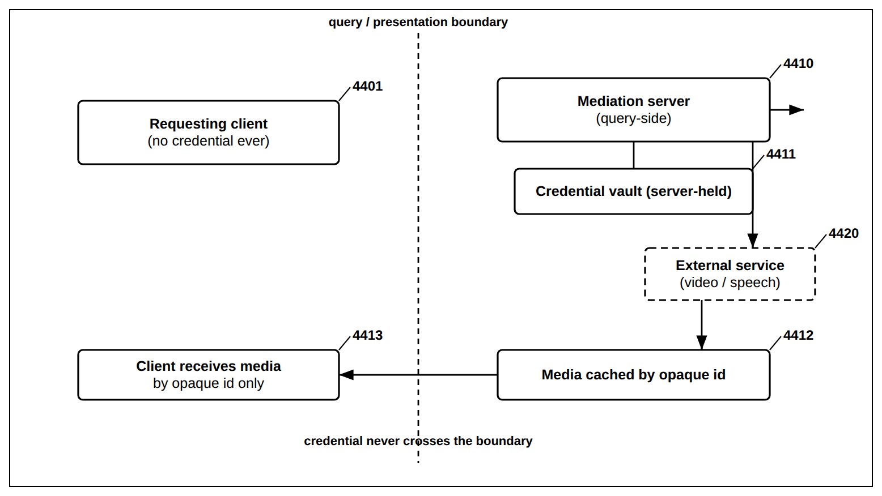
FIG. 44 — Key-Safe External-Service Mediation

FIG. 45
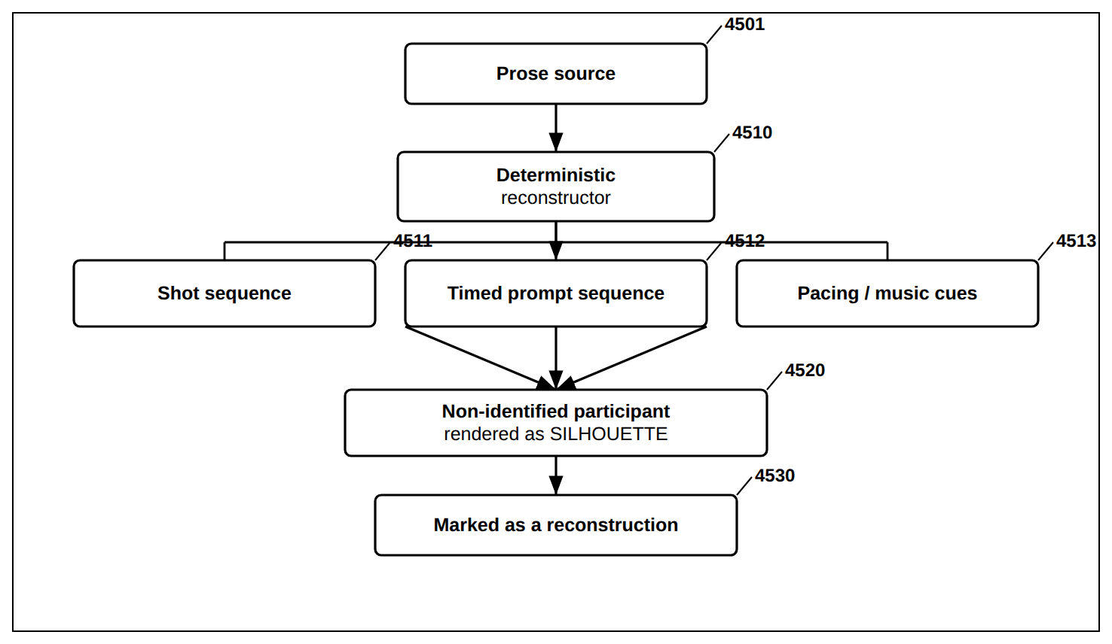
FIG. 45 — Scene Reconstruction From Prose — Bounded, Silhouette-Protected

FIG. 46
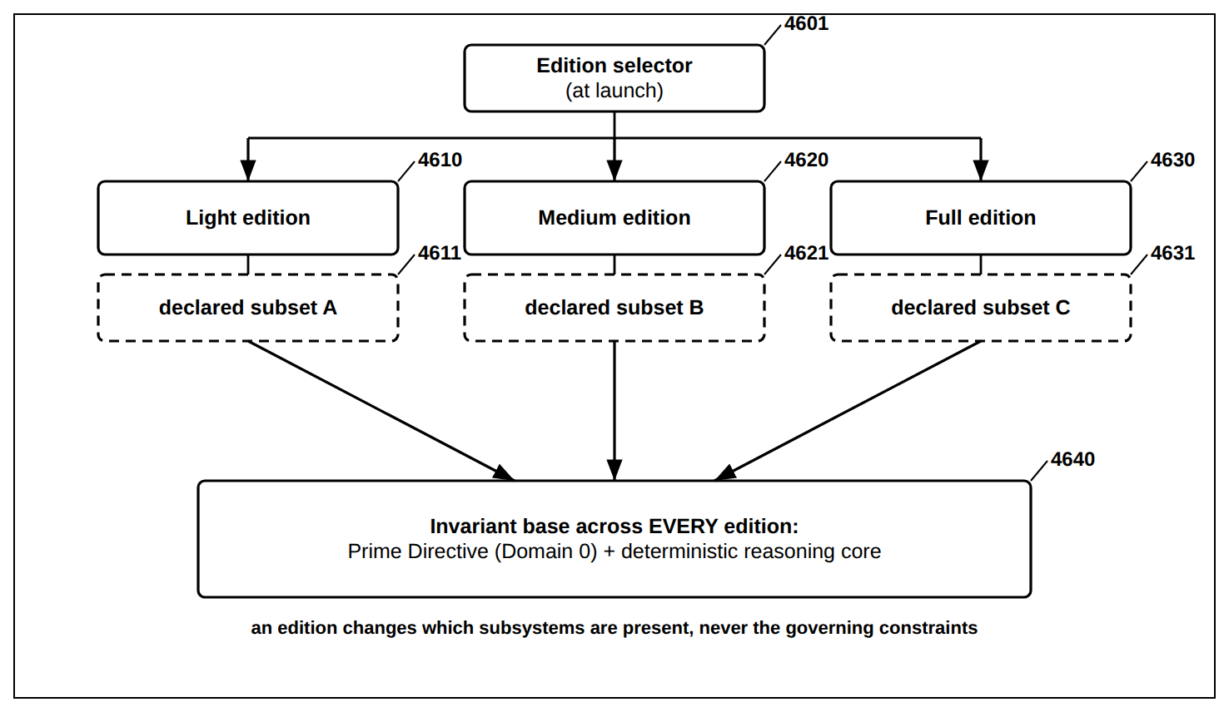
FIG. 46 — Modular Edition Packaging — Nested Capability Editions

FIG. 47
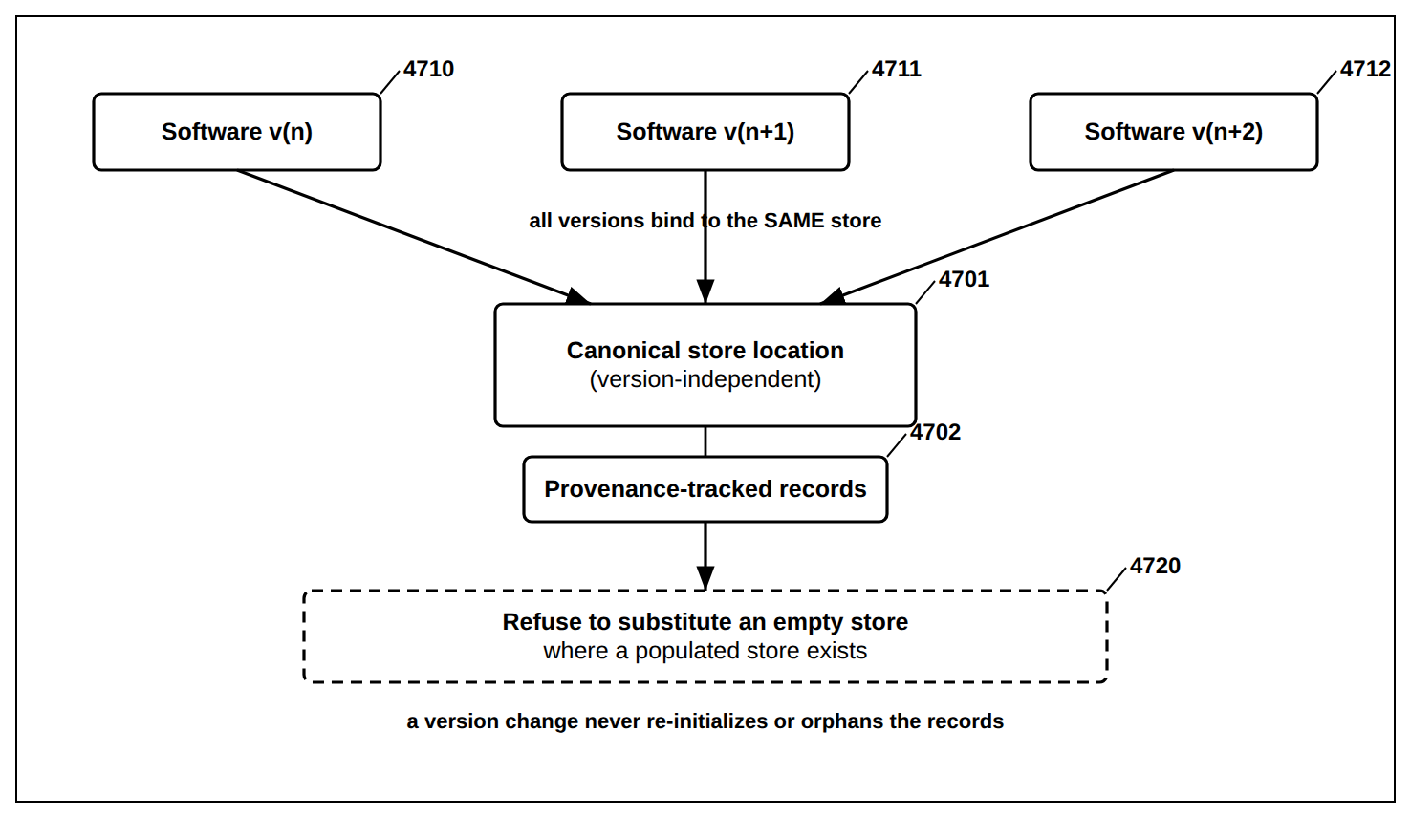
FIG. 47 — Version-Independent, Provenance-Continuous Store

FIG. 48
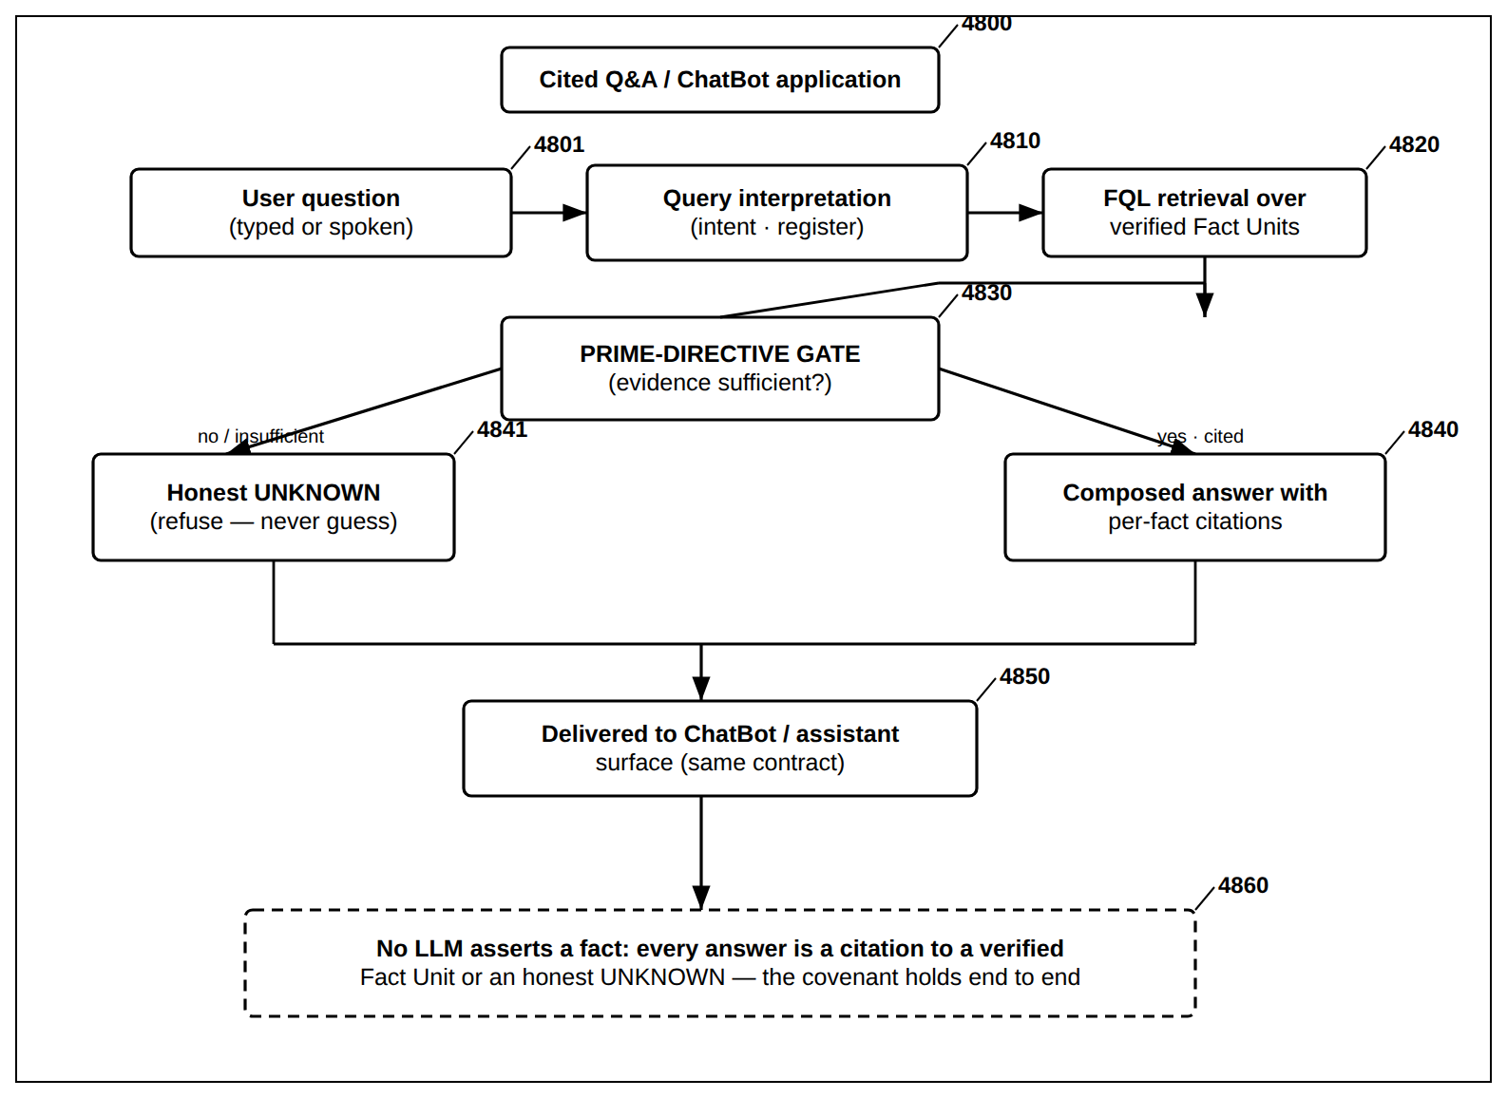
FIG. 48 — Cited Q&amp;A / ChatBot Application — Citation-or-UNKNOWN End to End

FIG. 49
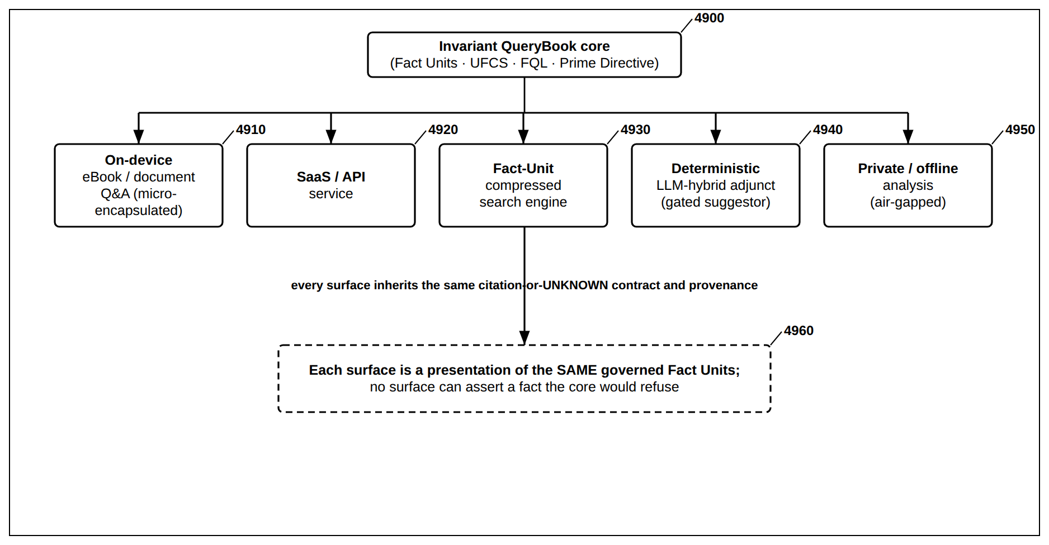
FIG. 49 — Application and Deployment Surfaces over the Invariant Core

DRAFT — NOT FILED — FOR REVIEW BY QUALIFIED PATENT COUNSEL PRIOR TO FILING. Companion drawings volume to the consolidated QueryBook Provisional Patent Application; figures and numerals are drawn from, and identical to, that application. Finalize to 37 CFR 1.84 before filing.

