MediaMarketplace Studio — Setup Wizards Guide
Applies to: MediaMarketplace Studio 0.2.0 for WordPress and for Joomla
Audience: store owners and administrators
Screens: live captures of the store admin; the wizard answers shown were produced by a scripted run of the same wizards so that every screen could be captured without a live model
Contents
1. What the wizards are
2. Switching the wizards on
3. Setting up a whole store with the Concierge
4. Reviewing and applying proposals
5. Ask the wizard on any page
6. Running one specialist on its own
7. Media intake and Analytics
Media intake
Analytics
8. What the wizards can and cannot do
9. Troubleshooting
10. For developers

1. What the wizards are
The setup wizards are a team of AI specialists that live inside the store admin under Wizards. Each one knows one part of the store, reads what you already have, asks you what it needs, and leaves you proposals: the exact fields it would fill in, with a one-line reason each. Nothing changes until you click Apply on a proposal. Applied proposals go through the same code as a manual save and are written to the activity log as "applied from wizard".
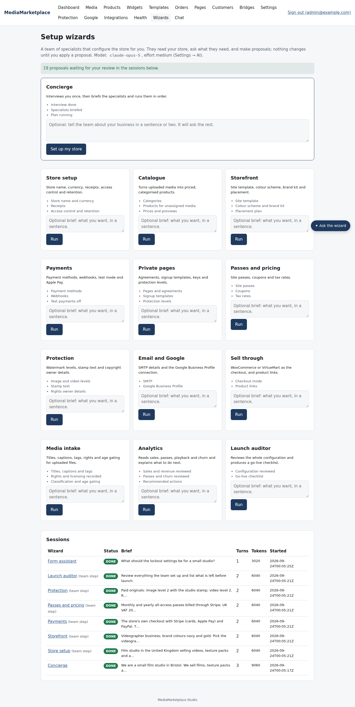
The Wizards page: the Concierge and twelve specialists
Wizard | What it configures
Concierge | interviews you once, briefs the specialists and runs them one after another
Store setup | store name, currency, display currencies, receipts, lockouts, retention
Media intake | titles, alt text, captions and tags for uploaded files; rights and licensing; audience categories and age gating
Catalogue | products for uploaded media, with categories, prices and previews
Storefront | site template, colour scheme, brand kit and a placement plan
Payments | Stripe, PayPal, Square, Authorize.net, webhooks, test payments
Private pages | pages with complete agreement text, signup templates, protection levels
Passes and pricing | site passes, coupons, tax rates
Protection | image and video watermark levels, stamp text, rights owner details
Email and Google | SMTP details and the Google Business Profile connection
Sell through | WooCommerce or VirtueMart as the checkout
Analytics | reads sales, passes, playback and churn and recommends what to do next
Launch auditor | reviews everything and produces a go-live checklist

A fourteenth wizard, the Form assistant, has no card: it is the Ask the wizard button at the bottom right of every admin page (section 5).

2. Switching the wizards on
The wizards use Claude through your own Anthropic API key. Enter it under Settings → AI, choose the model (the default is claude-opus-5) and the Wizard effort (medium fits most stores; high thinks longer and costs more). Without a key the Wizards page shows what the team does but the Run buttons are disabled.
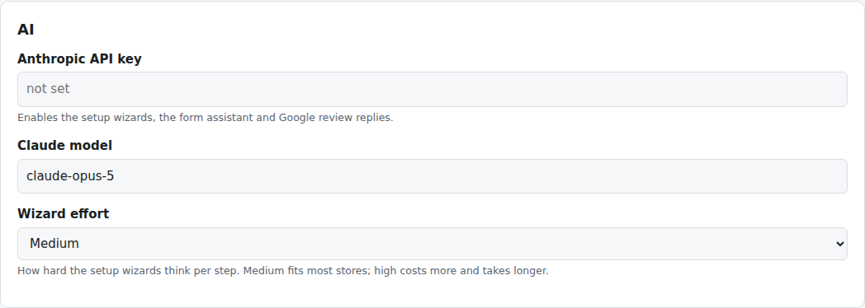
Settings → AI: the key, the model and the wizard effort
The key is stored encrypted. Every wizard call goes from your server to Anthropic and back; nothing else leaves the server. Secrets in your settings are never sent to the model: the wizard sees "set" or "not set", and proposes secrets as empty cards for you to fill.

3. Setting up a whole store with the Concierge
Type a sentence or two about your business into the Concierge card and click Set up my store. The Concierge reads the store, then asks its questions in one go: business type, country, currency, who takes the money, whether visitors sign agreements, whether you want site passes, brand colours.
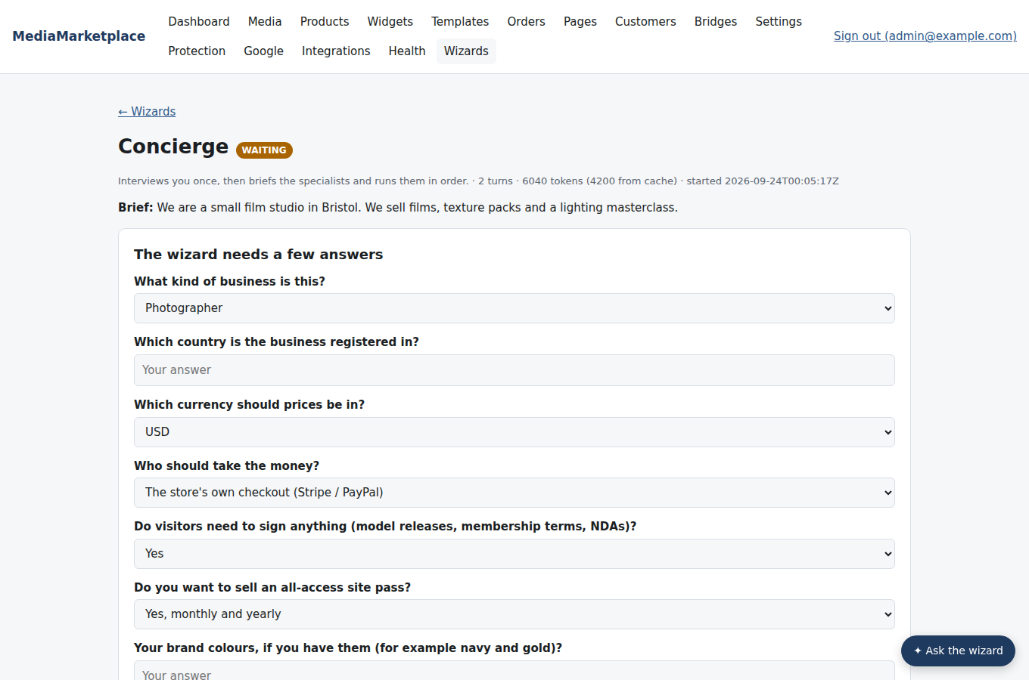
The Concierge's questions
Answer and click Send answers. The Concierge writes a plan: which specialists to run, in what order, with a brief for each. The specialists then run one after another in the background. The page refreshes itself while they work; each specialist appears in the table with its status and summary, and you can open any of them.
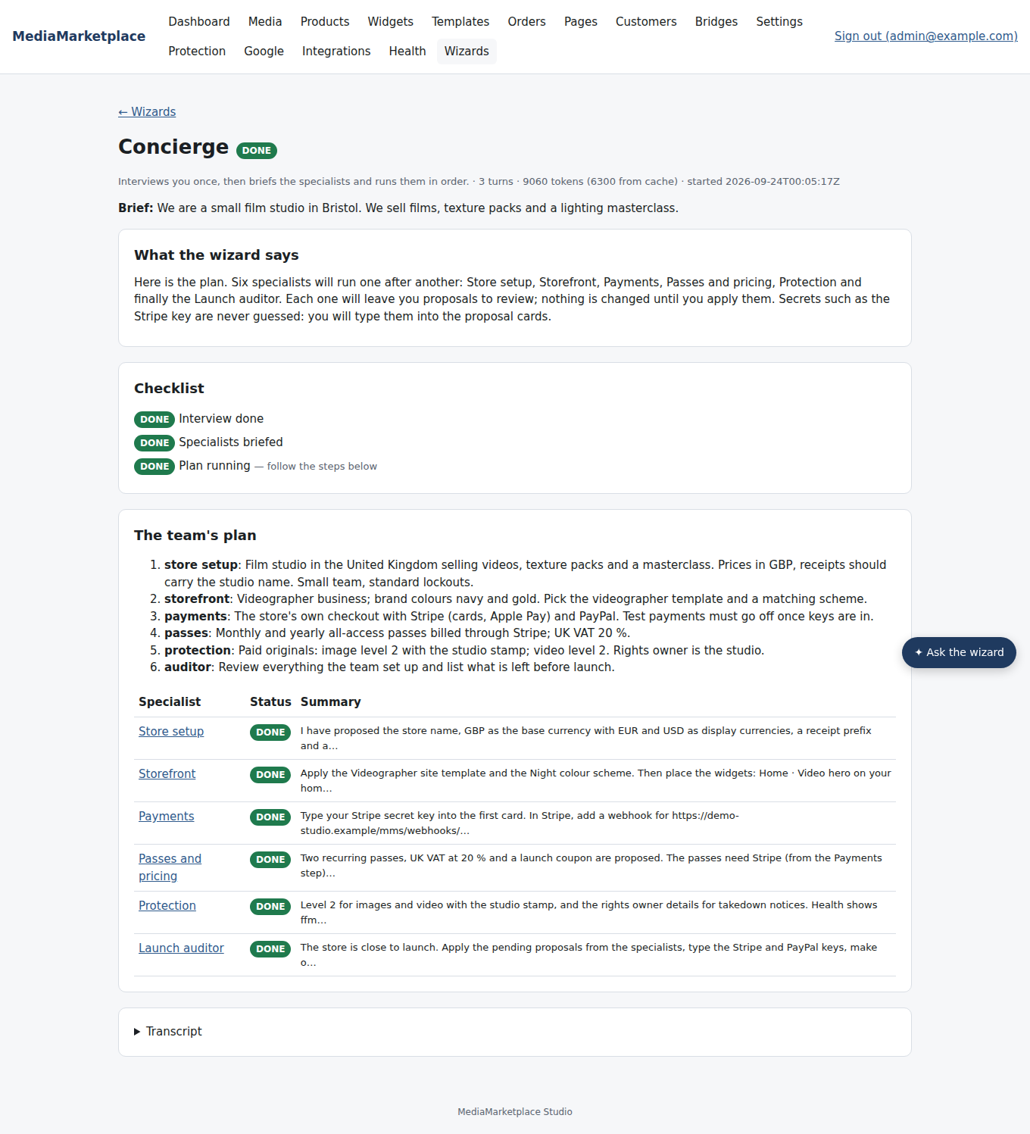
The Concierge's plan with every specialist finished
A typical run of six specialists takes a few minutes and uses roughly a hundred thousand tokens, most of them read from cache. The tokens used are shown on every session page.

4. Reviewing and applying proposals
Open a specialist's session. The summary is written for a store owner; the checklist says what is done, what is still to do and what needs you. The proposals are the changes it would make.
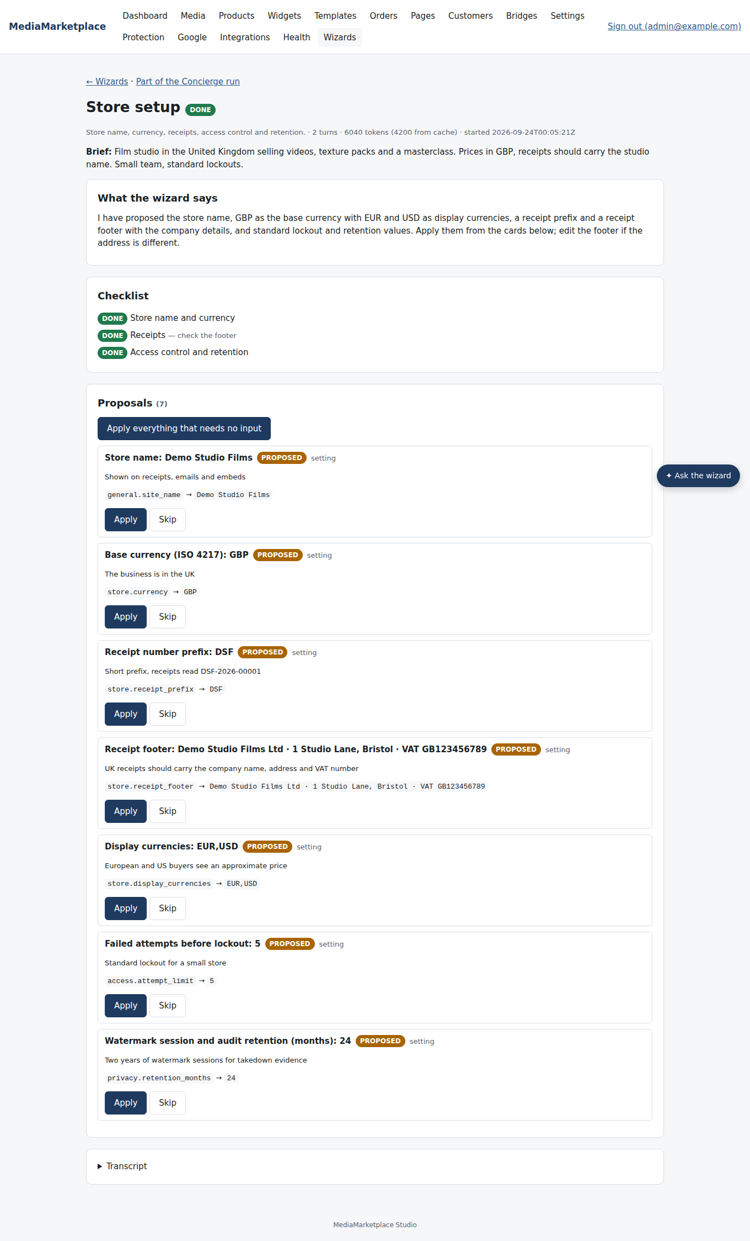
The Store setup specialist's proposals
- Apply applies one proposal. Skip dismisses it. Apply everything that needs no input applies all the plain ones and leaves the secrets and administrator-only items for you.
- A proposal that needs a secret shows a password field: type the value, then Apply. The wizard never sees what you typed.
- Settings and site templates can be applied by administrators only; staff can apply catalogue, page, coupon and tax proposals.
- Each applied proposal shows what happened (for example "product The Film created (published)"). A failed one shows why, and can be corrected by hand on the ordinary form.
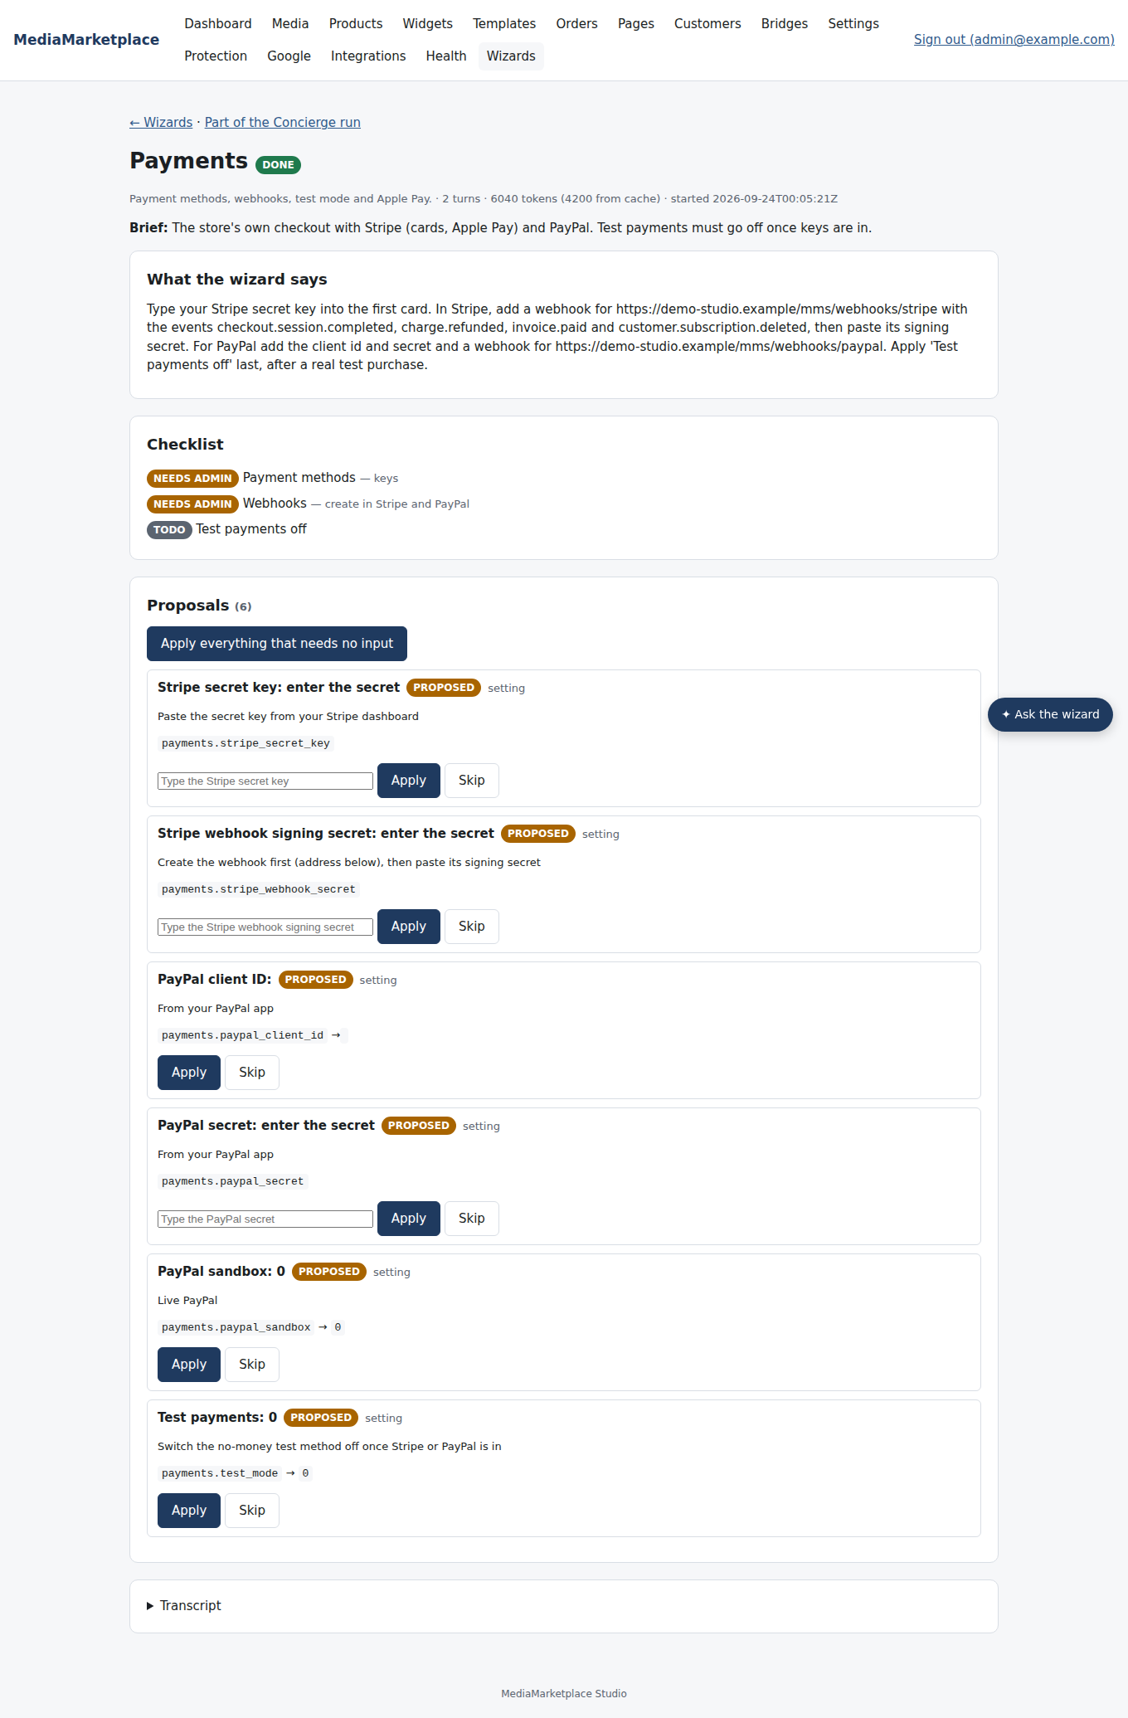
The Payments specialist leaves the secret cards for you
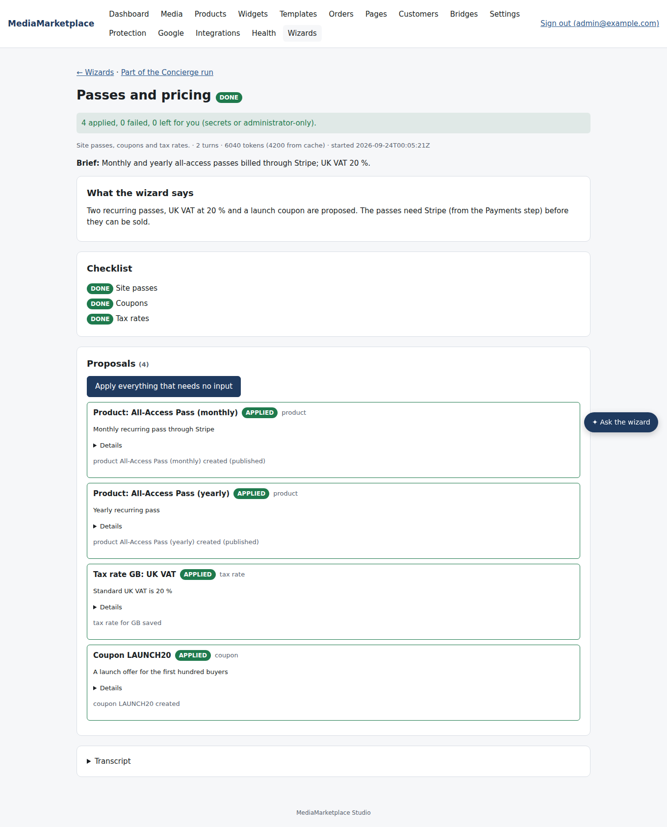
Passes and pricing after Apply everything: two passes, a tax rate and a coupon created
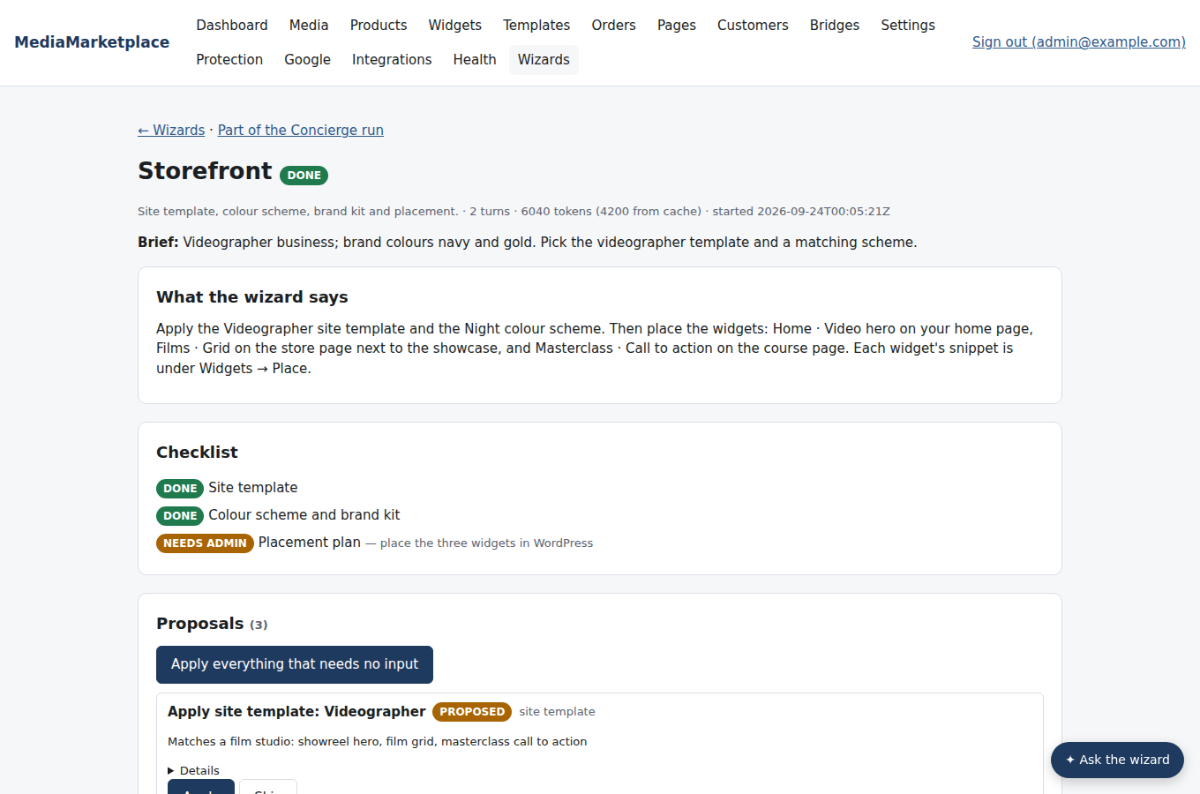
The Storefront specialist proposes a site template and explains where to place the widgets
The Launch auditor proposes nothing unless something is plainly wrong; its value is the go-live checklist.
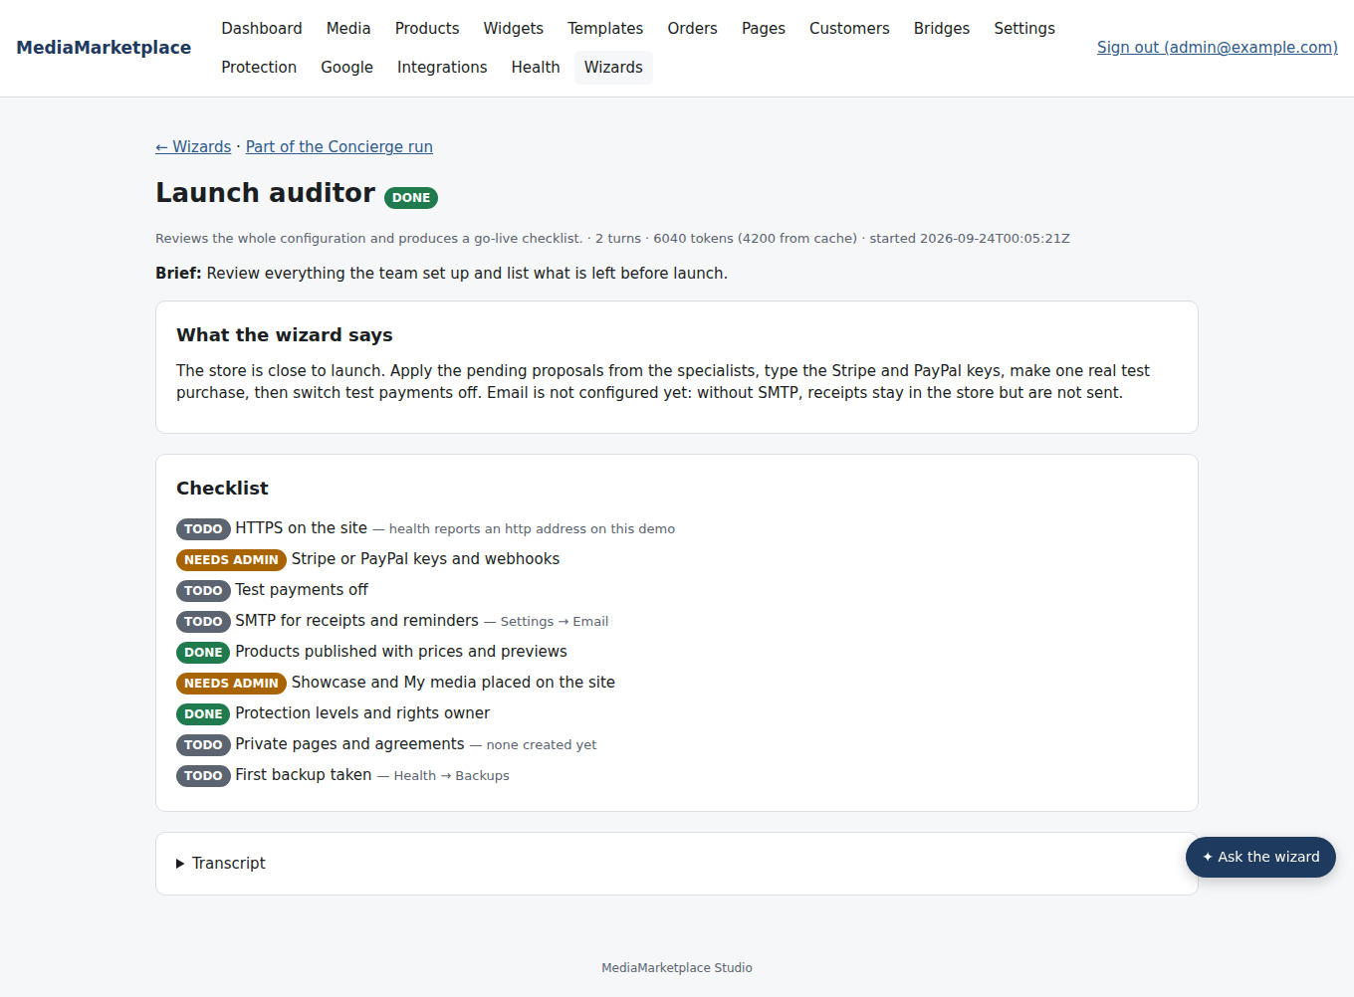
The Launch auditor's checklist

5. Ask the wizard on any page
Every admin page has an Ask the wizard button at the bottom right. Ask in plain language about the page you are on: what a setting means, what value fits your case, or ask for a change ("create a 30-day pass for £9"). The answer appears in the drawer with one-click proposals; Apply works right there.
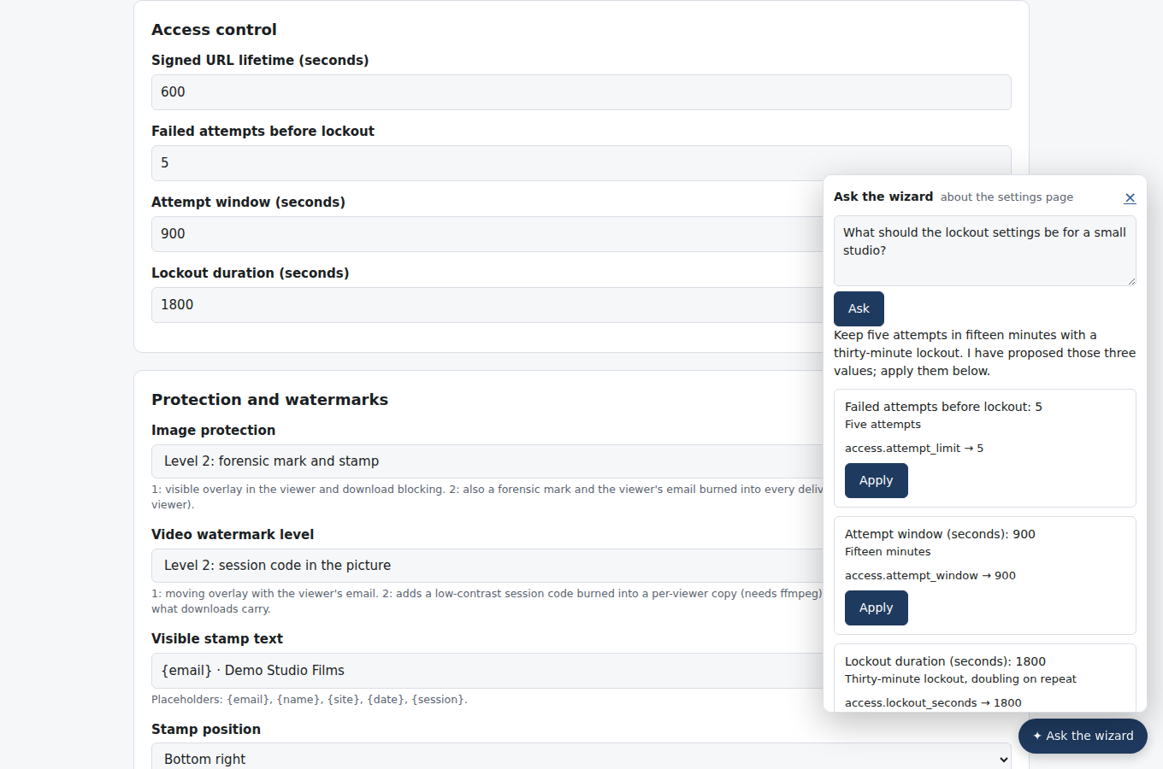
The drawer on the Settings page, with three proposals ready to apply
The drawer runs a short session (at most eight steps) and costs a few cents per question. Its sessions are listed on the Wizards page like any other.

6. Running one specialist on its own
Each card on the Wizards page has a Run button and an optional brief. Run Media intake and then the Catalogue after uploading new files, the Passes specialist to add a seasonal coupon, or the Launch auditor before every launch. A specialist that needs something it cannot read asks you, exactly like the Concierge.
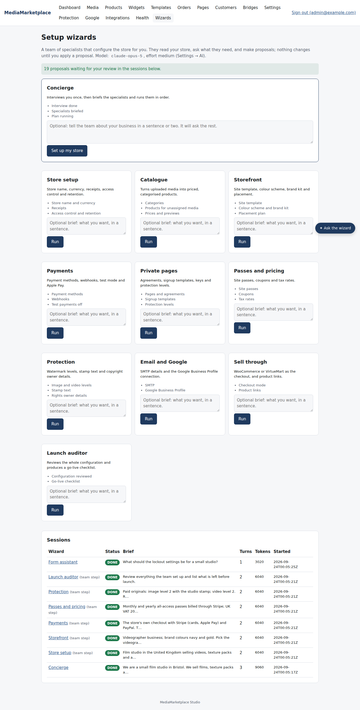
Sessions on the Wizards page

7. Media intake and Analytics
Two specialists work on a store that is already running rather than on its configuration.

Media intake
Run Media intake after uploading files. It reads the library and, for every file whose title is still the file name or whose caption or tags are empty, proposes a proper title, alt text for images, a caption written for a buyer and five to ten searchable tags. A proposal only changes the fields it names; anything it leaves out keeps its value.
It then asks the intake questions in one go: who owns the rights, whether anything is licensed from someone else and on what terms, whether sales are limited to certain countries, and whether any content is for adults only.
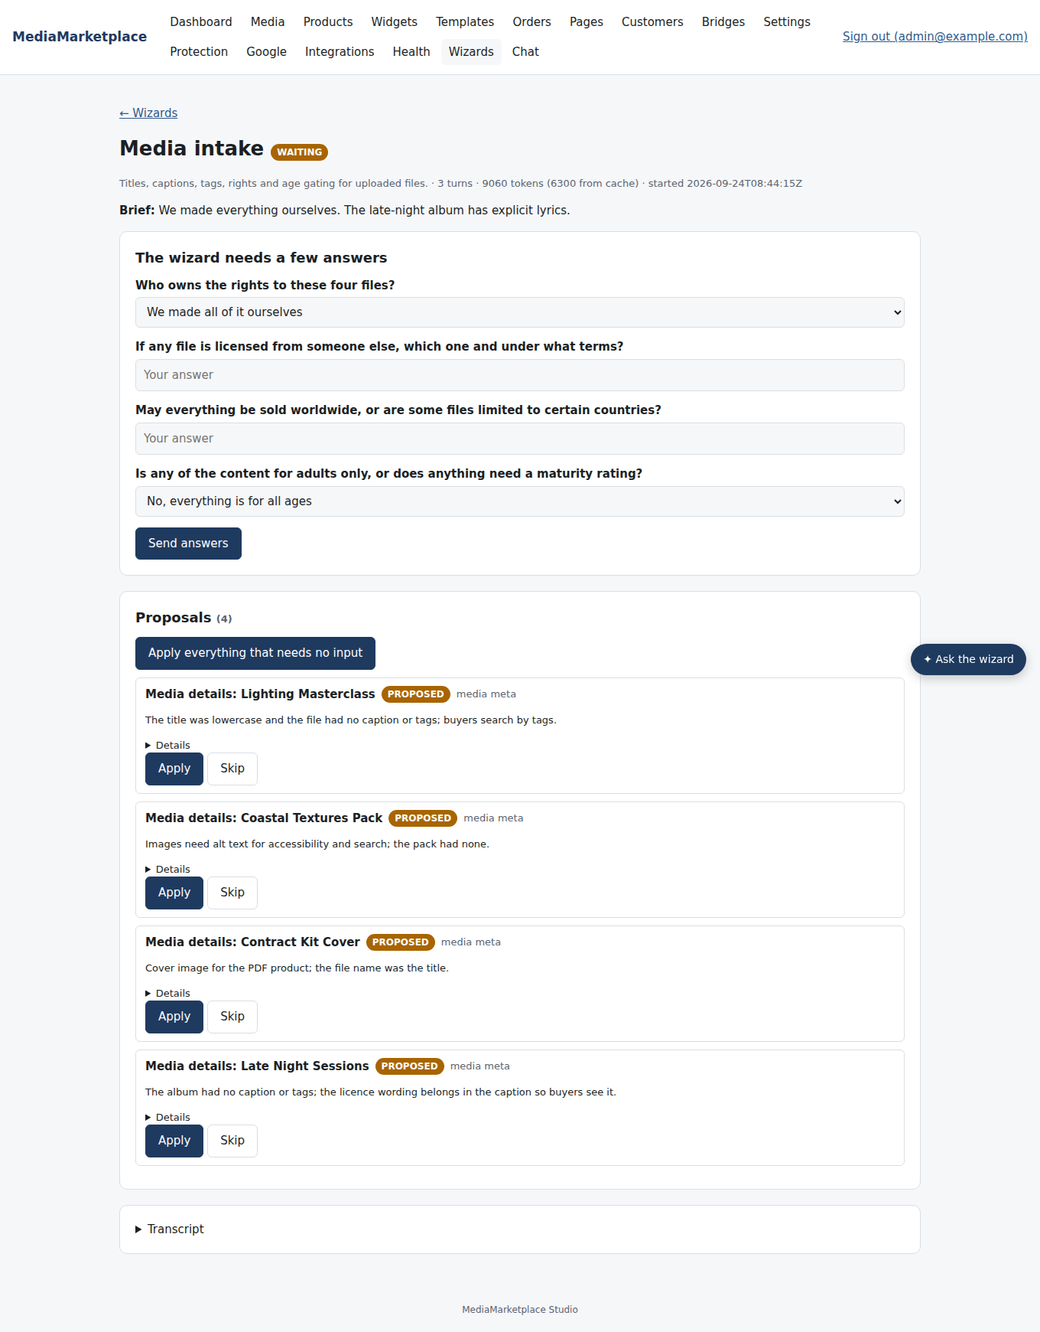
Media intake asks about rights, licensing, countries and audience
From the answers it proposes audience and subject categories and, for restricted content, a private page with the legal signup template, the minimum age and an agreement that names the rights owner and the licence. It never guesses rights: if you do not answer, it asks again rather than inventing them. It does not create products; run the Catalogue specialist afterwards, which can then put the restricted product behind the new page.
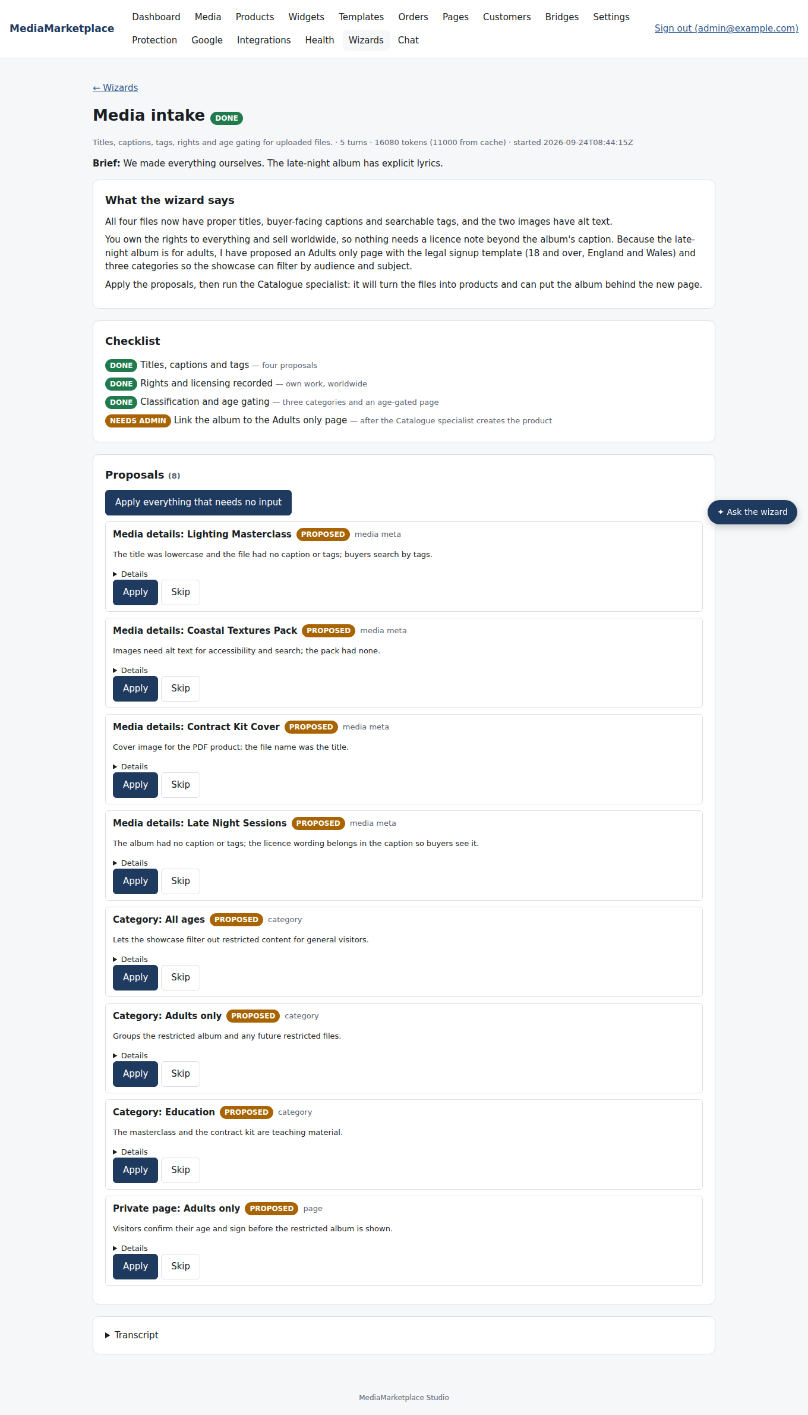
The Media intake proposals: file details, categories and an age-gated page
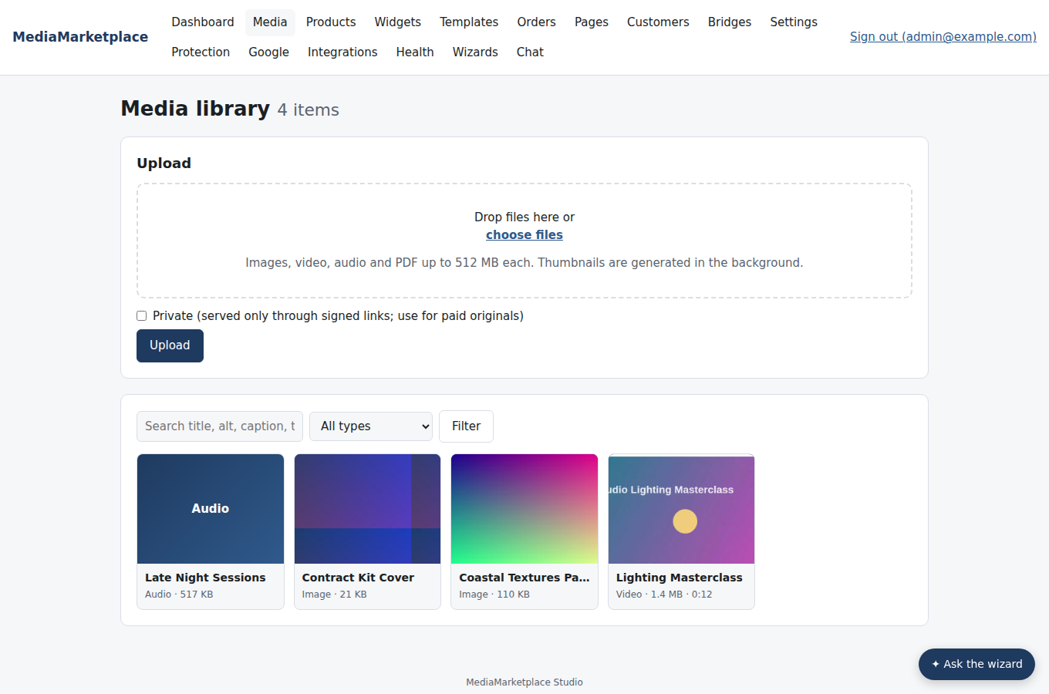
After Apply everything: the library shows the new titles; captions and tags appear on each file's page and in search

Analytics
Run Analytics whenever you want a plain-language reading of the store. It reads a report the server builds from your own data: revenue and orders by month, the products that earn and the products that never sold, payment methods, coupon use, passes and subscriptions (active, expiring within a week, churned in the last thirty days, monthly recurring revenue), what customers play and how far they get, new accounts and repeat buyers, and files that have no product yet. Every figure it quotes comes from that report; it is told never to estimate, and to say so when a store has too few orders to show a trend.
It recommends at most five actions and, where an action is a coupon or a site pass, proposes it so you can apply it in one click. It does not propose settings unless a setting is plainly the problem.
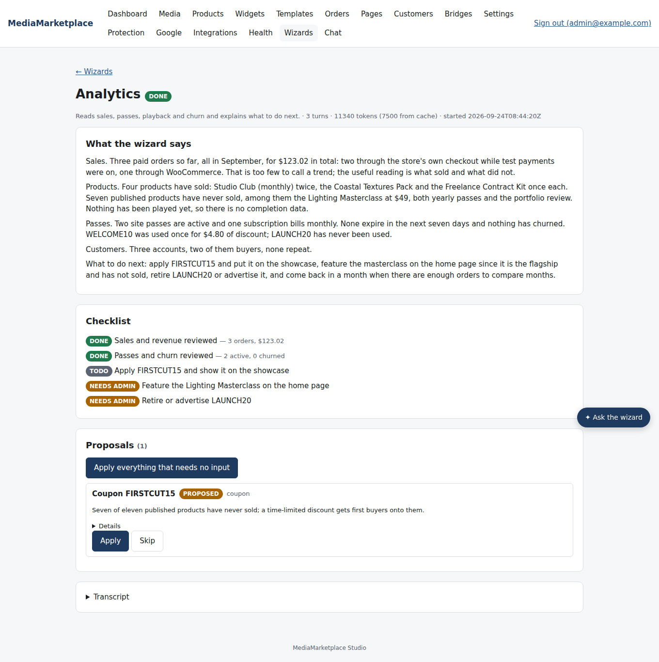
The Analytics review with its checklist and a proposed coupon
Numbers are in the store currency; orders paid in another currency are converted at the rate recorded on the order. The same report is available to the Form assistant, so you can ask "which products have never sold?" from any admin page.

8. What the wizards can and cannot do
- They read: settings (secrets masked), the media library, products and categories, site templates, health, the connected site, the analytics report, and the built-in guides for each area.
- They propose: settings, products, categories, private pages with agreements, coupons, tax rates, site templates, and the details of a media file (title, alt text, caption, tags).
- They never: write anything themselves, invent keys or passwords, send email, take money, change your WordPress or Joomla site, or run while the key is missing.
- Limits: a wizard stops after 30 steps and tells you so; the model may decline an unusual request, and the session then shows "failed" with the reason; a session whose answers you never send stays "waiting" and costs nothing.

9. Troubleshooting
Symptom | Cause | What to do
Run buttons are disabled | no Anthropic API key | Settings → AI
A session says "failed: Anthropic: …" | the key is wrong, out of credit, or the model name is not available | check the key and model under Settings → AI
A session stays "queued" | the background worker is busy or the server restarted | it resumes on its own; Restart from the status page if it does not
A proposal fails to apply | the value is no longer valid (a product slug taken, a page product missing) | apply it by hand on the ordinary form
The wizard proposed an unknown setting | it cannot: unknown keys are rejected before they become proposals | nothing to do
The drawer answers but proposes nothing | the question did not ask for a change | ask for the change explicitly

10. For developers
The wizards are ordinary code in the store server. Wizard definitions, tool schemas and the built-in knowledge are in mms-core::wizards; the runner, tools and proposal application are in routes::wizards. The model is called through the Messages API with tool use and adaptive thinking; the large stable prefix (rules, persona, store facts, tools) is cached with prompt caching. A Transport enum swaps the HTTPS client for a scripted list of responses: the automated tests drive the whole team that way, and the environment variable MMS_WIZARD_SCRIPT=/path/to/responses.json makes a running server use a script, which is how this guide's screenshots were made. Proposals live in the wizard_proposals table; sessions and transcripts in wizard_sessions and wizard_messages.

