MediaMarketplace Studio — WordPress User Guide
Applies to: MediaMarketplace Studio 0.2.0 for WordPress, complete: media, products, showcase, players, My media, widget builder, templates, branding, cart and checkout, orders and receipts, coupons and tax, site passes, private pages, API keys and webhooks, protection and watermarks, copyright and takedowns, multi-currency, Google Business Profile, email, privacy and backups
Audience: store owners, administrators and staff running the store inside a WordPress site
Screens: store screens are live captures of the real store admin and store front; WordPress screens are mock-ups drawn to match the real WordPress admin, with live store content inside them
Companion document: the WordPress Installation Guide covers installing and updating the plugin; this guide starts once the plugin is active
Contents
1. How it fits together
2. Opening the store admin
3. A tour of the store admin
4. Server status
5. Connected site (Bridges)
6. Settings
7. Health
8. Media library
9. Products
10. Customers and access
11. Putting the store on your pages
12. The My media link
13. Players and My media
14. The widget builder
Placing a widget
15. Widget templates
16. Site templates
17. Branding and colour schemes
18. Selling: cart and checkout
19. Payment settings
20. Orders, refunds and receipts
21. Coupons and tax
22. Site passes
23. Currencies and more payment methods
23b. Selling through WooCommerce (optional)
24. Private pages
25. Integrations: API keys and webhooks
26. Email
27. Google Business Profile
28. Protection and forensic watermarks
29. Copyright scans, violations and takedowns
30. Players
31. Privacy and roles
32. Backups and data
32b. Setup wizards (AI assistance)
32c. Support chat and remote agents
33. Troubleshooting
34. What comes next
35. Glossary
Appendix A. WordPress placement reference
Appendix B. Settings reference
Appendix C. A first week with the store

1. How it fits together
MediaMarketplace Studio installs into your WordPress site as one plugin and runs entirely on that site's server. Inside the plugin is the marketplace server, a small program that your site starts and keeps running in the background. It holds everything about the store: media, products, prices, customers, orders, access rights and protection settings. Nothing about the store is stored in the WordPress database.
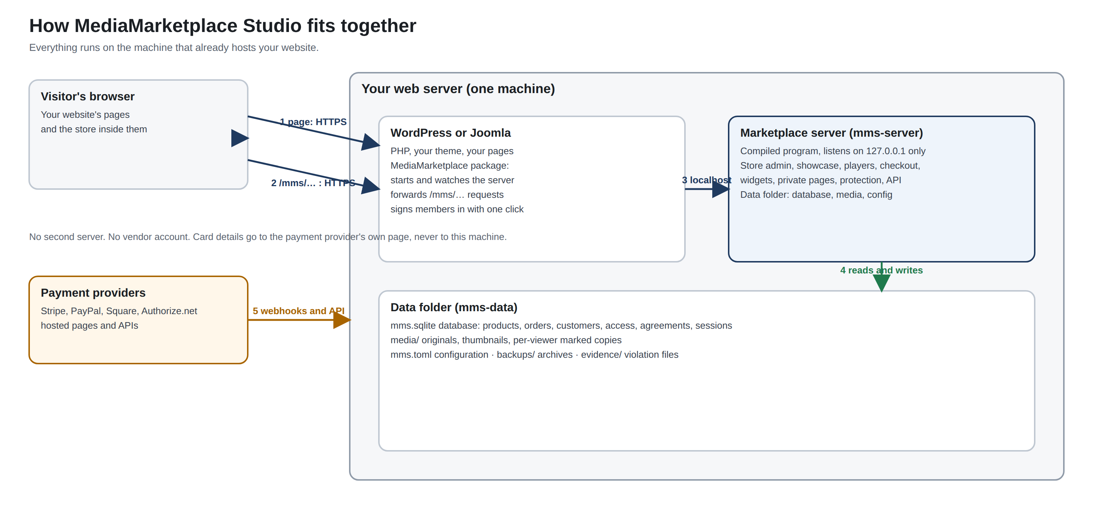
How the pieces fit together: the plugin inside your site, the store server it runs, and the paths visitors and administrators take
You never see that program directly. You manage the store in a web admin that opens from your WordPress menu at your site's own address followed by /mms/admin, and visitors see the store inside your normal WordPress pages. Every store address on your site begins with /mms/; the plugin passes those requests to the server and passes the answers back.
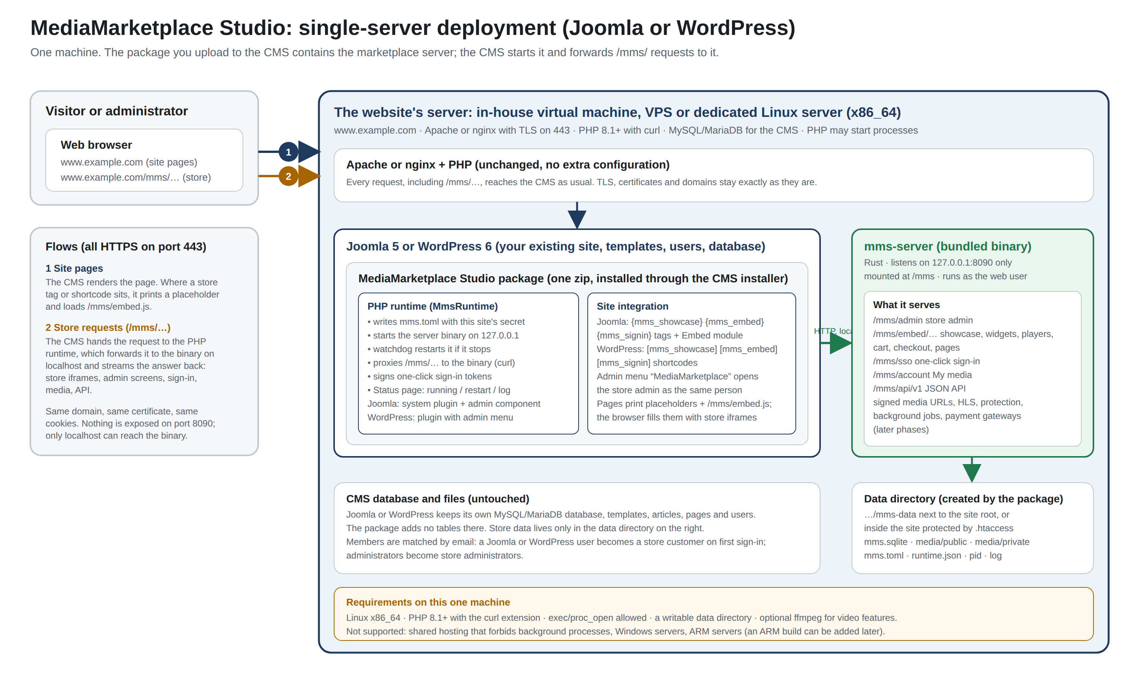
Everything on one server: the web server, WordPress with the plugin, and the store server with its data folder
Three kinds of people use the store:
- Administrators sign in from WordPress and run the whole store, including settings, payments, integrations, roles and backups.
- Staff run the day-to-day store (media, products, orders, pages, protection) but cannot change settings or integrations. Section 31 explains how to make someone staff.
- Customers are WordPress members who follow a My media link, or people who register directly at the store. They buy, watch, download and sign agreements.

2. Opening the store admin
Click MediaMarketplace → Store admin in the WordPress admin menu. The landing page shows whether the store server is running and links straight into each part of the store admin.
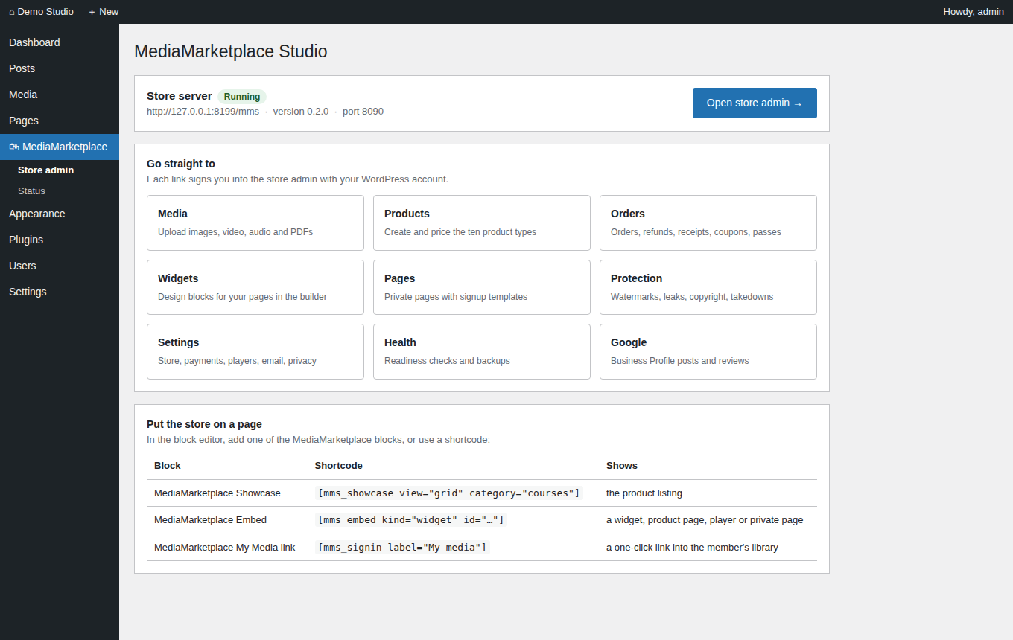
The MediaMarketplace menu in the WordPress admin, with the store server running and shortcuts into the store admin (mock-up)
You are signed into the store as an administrator with the WordPress account you are already using; there is no second password. Every WordPress administrator who opens the store this way becomes a store administrator, and the promotion is recorded in the activity log. Members of your site are recognised the same way when they follow a My media link.
There is also a direct sign-in page at /mms/admin/login for store-only administrator accounts, for example an assistant who has no WordPress account.
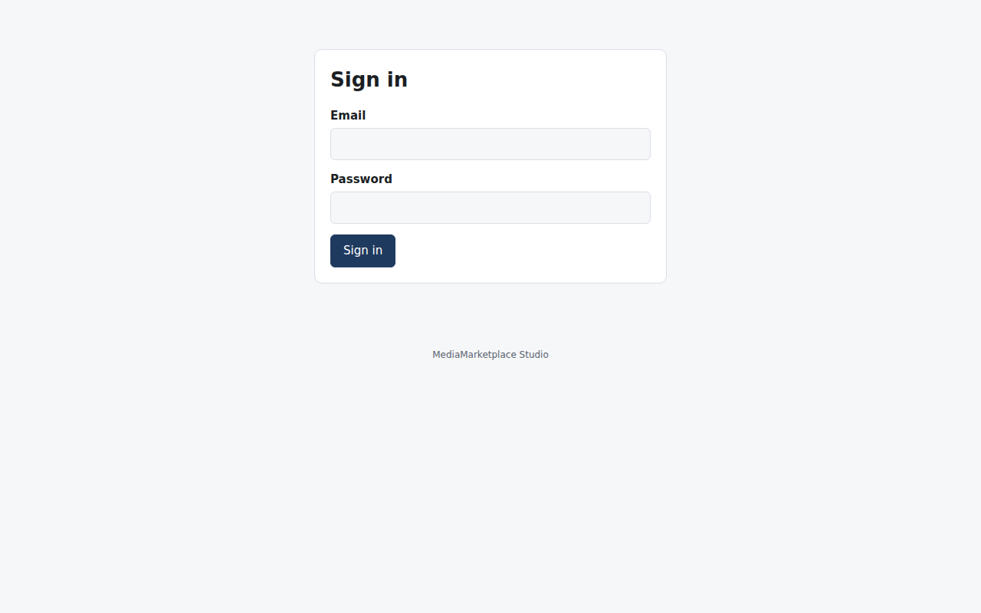
The store sign-in page, for store-only administrator accounts
Sessions last twelve hours. Sign out is at the right end of the top bar. The store admin is a normal web page and works in any current browser on a desktop or a tablet.

3. A tour of the store admin
The top bar of the store admin lists every area. The map below shows what lives where; the rest of this guide follows the same order.
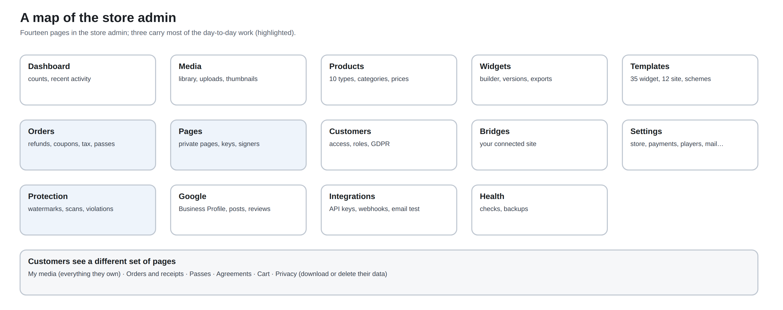
Map of the store admin: every area and the pages inside it
Area | What you do there | Sections
Dashboard | counts, recent activity, next steps | 3
Media | upload and manage files | 8
Products | create and price what you sell | 9
Widgets, Templates | design blocks for your pages, brand kit and colour schemes | 14 to 17
Orders | orders, refunds, receipts, coupons, tax, site passes | 20 to 22
Pages | private pages, signup templates, agreements, access keys | 24
Customers | accounts, access grants, staff role, privacy tools | 10, 31
Bridges | the connected website | 5
Settings | every runtime option, payments, players, email, sell through | 6, 19, 23, 23b, 26
Protection | watermarks, leak identification, copyright scans, violations | 28, 29
Google | Google Business Profile posts and reviews | 27
Integrations | API keys, outbound webhooks, sell through the shop, test email | 23b, 25, 26
Health | readiness checks and backups | 7, 32
Wizards | AI specialists that configure the store, proposals to apply | 32b
Chat | support agents, invitations, conversations | 32c

The dashboard shows counts of products, media items, customers and connected sites, a list of recent activity, and the next steps for a new install.
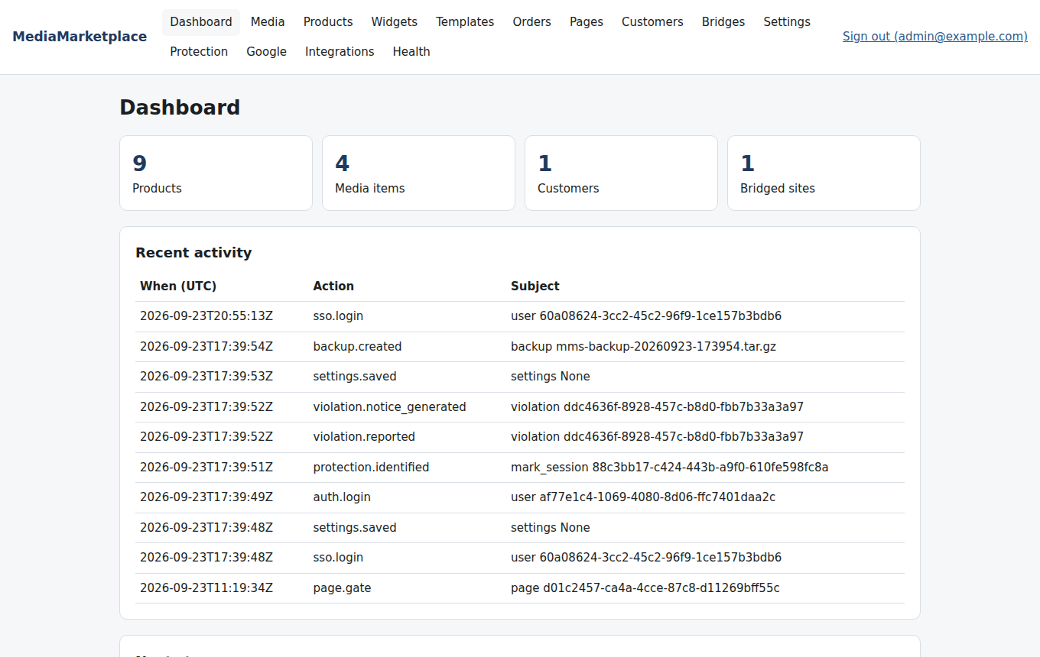
The dashboard with media, products and customers
Recent activity records who did what and when: sign-ins, settings changes, access grants and revocations, and administrator promotions from WordPress.

4. Server status
MediaMarketplace → Status shows the background server that the plugin runs.
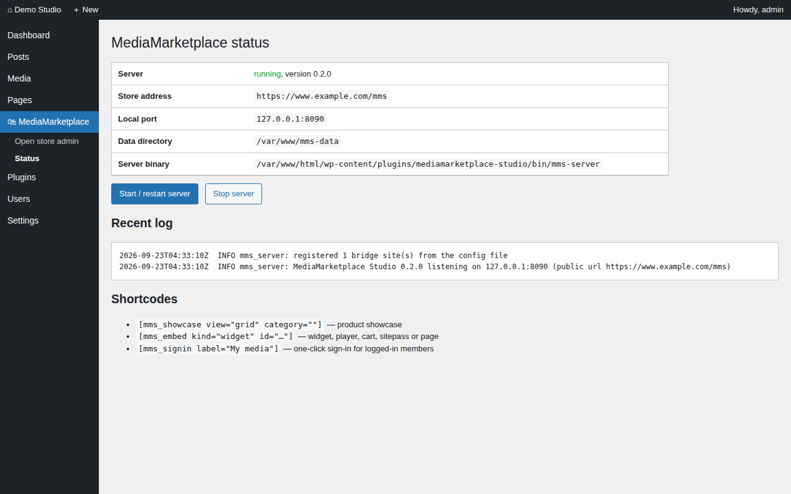
The WordPress status page (mock-up)
The page shows whether the server is running, the store address, the local port, the data folder, the version, the last error and the log tail, with buttons to Start, Restart and Stop. It also shows the PHP upload limit that applies to media uploads (section 8).
You rarely need this page. The server is checked and restarted automatically whenever the store is used, and it starts again after the web server restarts. Open it when:
- the store admin will not open (the page tells you the last error);
- you changed the site address or switched the site to HTTPS (click Restart);
- you want to read the log without opening the data folder.

5. Connected site (Bridges)
Bridges in the store admin lists the website the store runs in. The plugin registers your WordPress site automatically with its address and a secret, and marks it as trusted for administrator sign-in. Nothing needs to be entered here for the normal single-site setup.
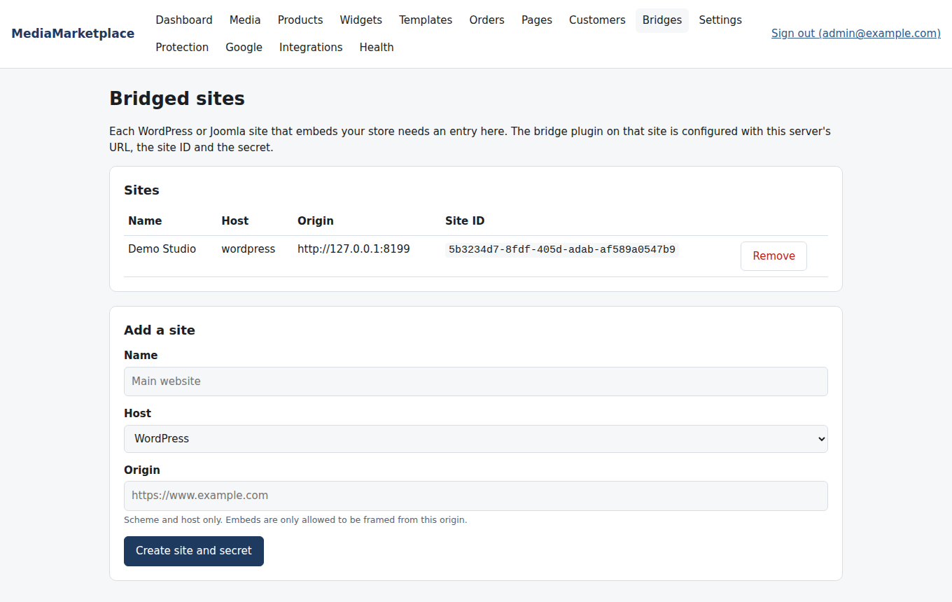
The Bridges page showing the site registered by the plugin
The secret is what lets WordPress sign people into the store without a second password. It is written by the plugin into the store's configuration file and registered again every time the server starts, so a site you delete here comes back on the next Restart; to change the secret, delete it from the plugin's runtime file on the status page and restart.
Advanced use: a second website (for example a WordPress site and a Joomla site sharing one store) can be added here; that site would then run its own plugin in "connect only" mode, which is planned for a later release.

6. Settings
Settings groups every runtime option into sections. Change values and click Save settings at the bottom. Invalid values are refused with a message and nothing is saved. Only administrators see this page; staff do not.
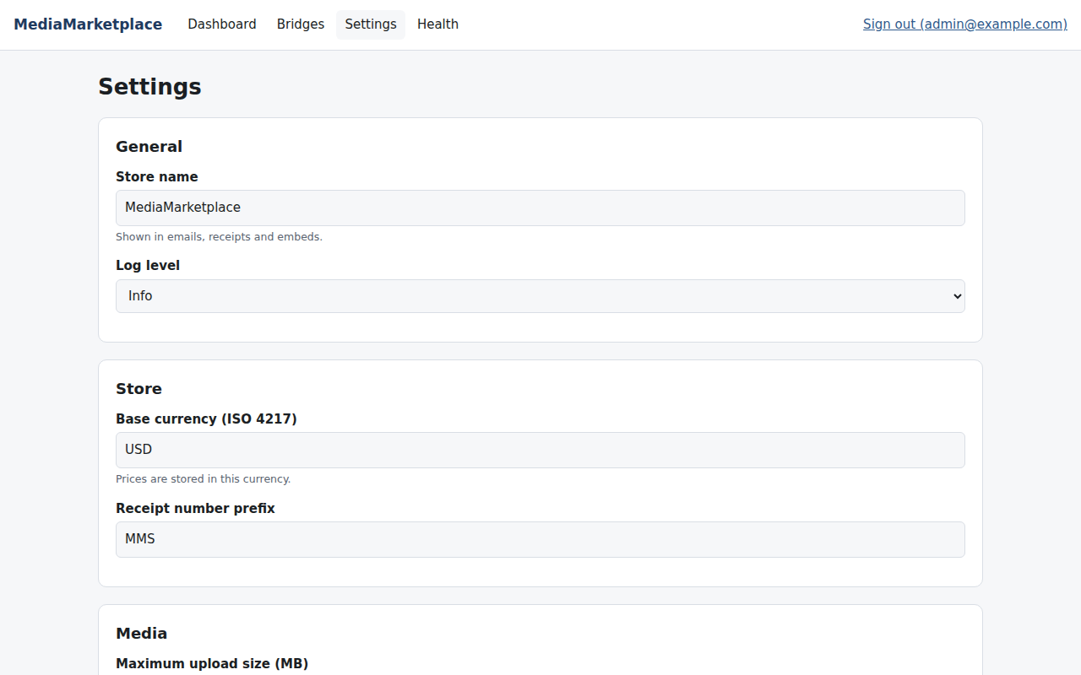
The settings page
General holds the store name (shown in embeds, emails and receipts), the log level, the store colour scheme and the brand kit.
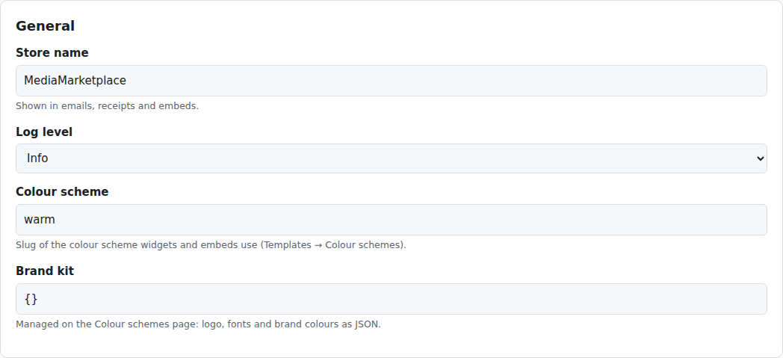
General settings
Store holds the base currency, receipt numbering, the receipt footer, the grace period for ended passes, and the display currencies for shoppers (section 23).
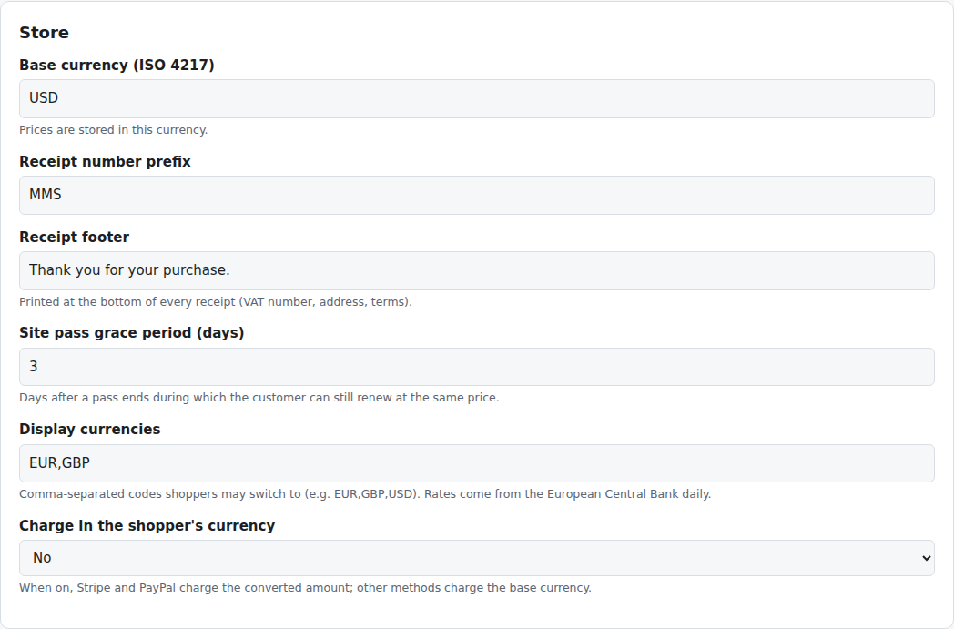
Store settings
Media sets the maximum upload size and the path to ffmpeg; Players picks the default media player and holds the licence keys for third-party players (section 30).
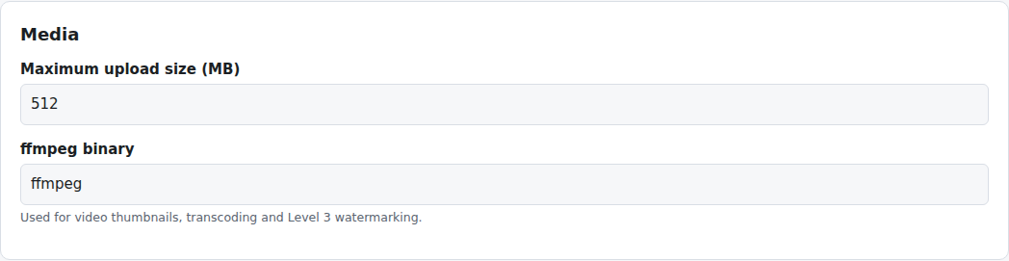
Media settings
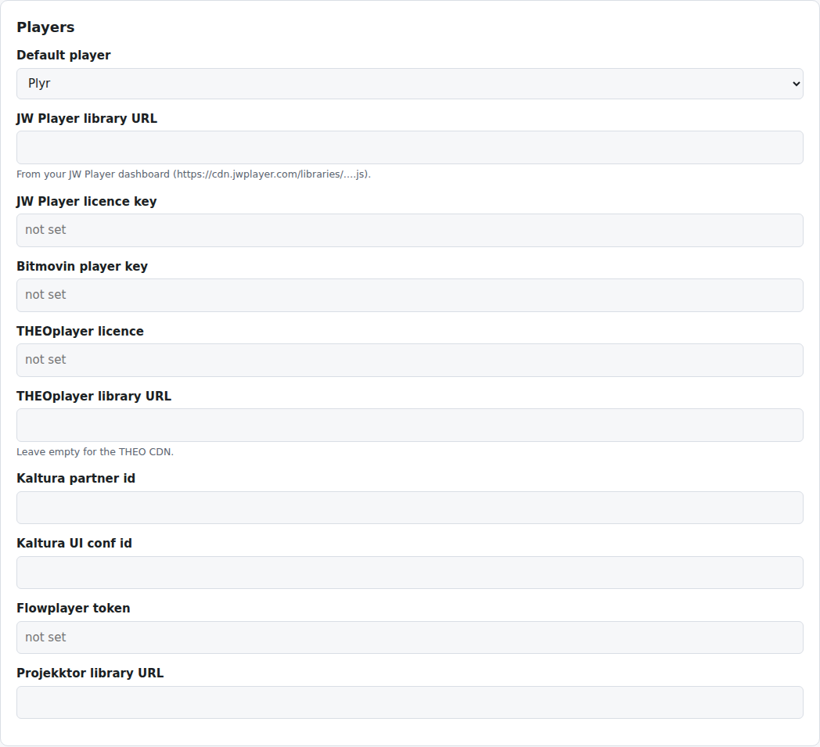
Player settings
Access control sets how long signed media links live, how many failed attempts are allowed before a lockout, the attempt window and the lockout duration. These limits apply to access keys on private pages and to sign-in attempts.
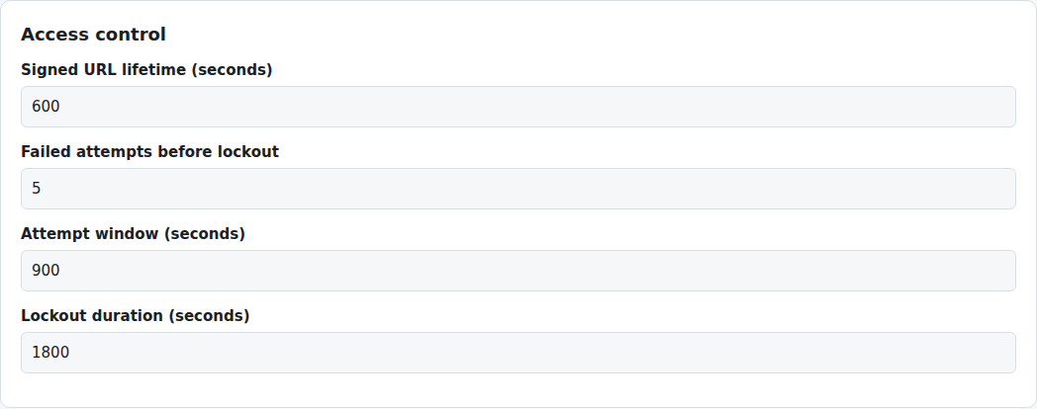
Access control settings
Privacy sets how many months to keep watermark sessions, playback sessions and audit entries, and where backups are written. AI holds the Anthropic API key and Claude model for the Google Business Profile reply assistant.
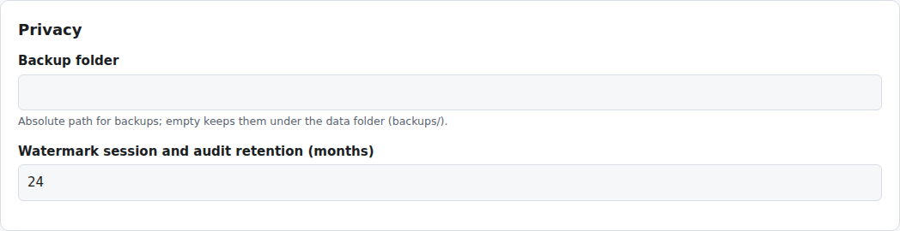
Privacy settings
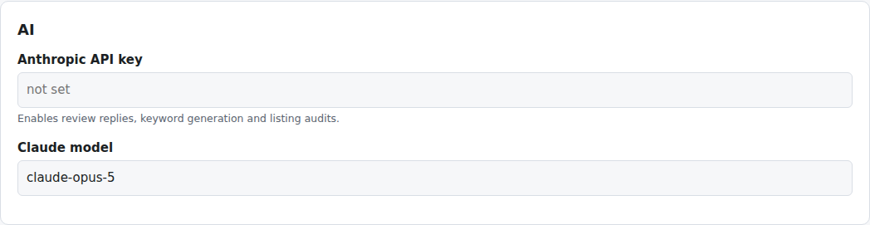
AI settings
The remaining sections have their own chapters: Payments (section 19), Protection and watermarks (28), Copyright services (29), Google Business Profile (27) and Email (26). Appendix B lists every setting in one table.
Secrets such as API keys and payment keys are stored encrypted. The field shows only the last four characters after saving; leave it as it is to keep the stored value, or type a new one to replace it.

7. Health
Health tells you whether the store is ready. Each row is green (ok), amber (warning: a feature is unavailable) or red (something must be fixed). Check it after installation, after moving the site, and whenever something stops working.
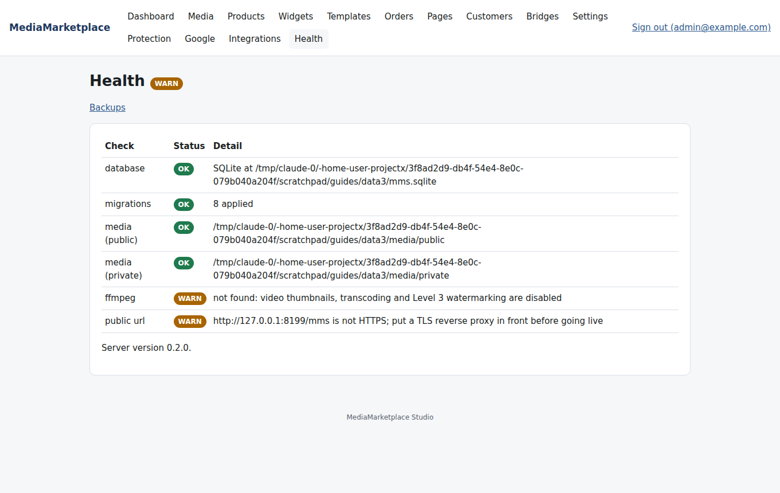
The Health page
Row | What it checks | If it is not green
database | the store database opens | check the data folder is writable by the web user
migrations | every schema update is applied | restart the server from the status page
media (public), media (private) | the media folders are writable | fix ownership of the data folder
ffmpeg | ffmpeg is installed on the machine | install it; until then video thumbnails, transcoding and Level 2 and 3 video watermarking are off
public url | the site uses HTTPS | enable HTTPS on the site

The same page holds Backups (section 32).

8. Media library
Media holds every file you sell or show: images, video, audio and PDFs. The library is the store's own; it is separate from the WordPress media manager, because private originals must never sit in a public folder.
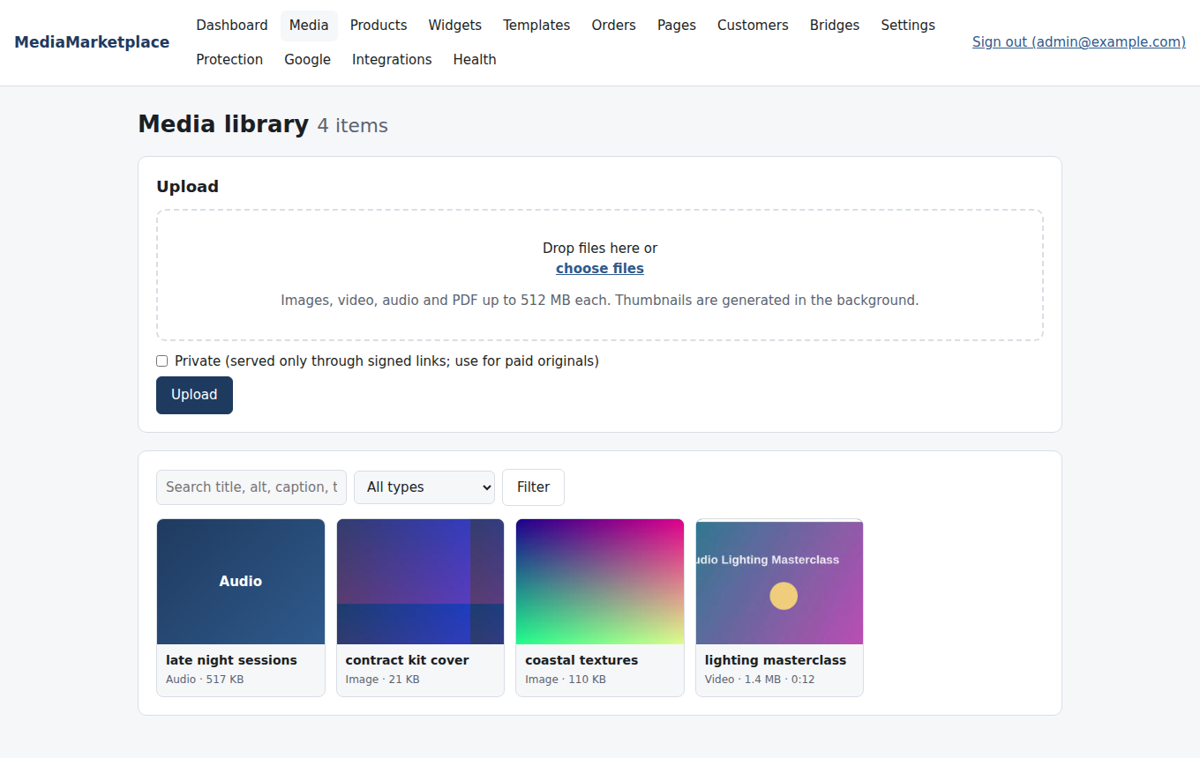
The media library with thumbnails
Uploading. Drop files onto the upload area or choose them, then click Upload. Files upload one after another with a progress bar each, so one bad file never blocks the others. Tick Private for originals that customers must pay for; private files are stored outside the public folder and are only ever served through short-lived signed links. Thumbnails are generated in the background: images at three sizes, videos from a frame at three seconds (needs ffmpeg on the server), audio and PDF with a type badge.
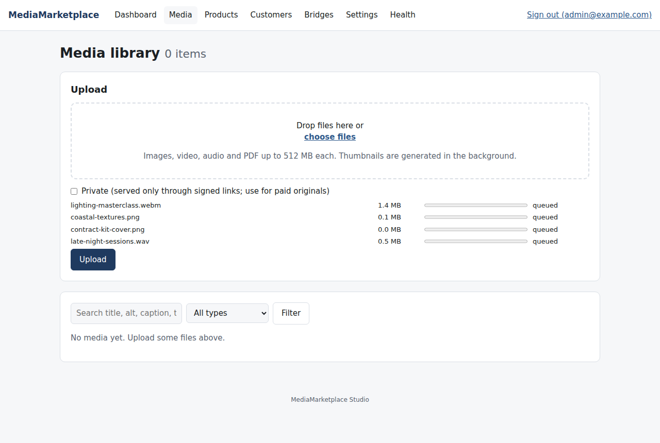
Files queued for upload
Limits. Each file may be as large as the store's Maximum upload size setting and the PHP upload limit of your server, whichever is smaller. The status page (MediaMarketplace → Status) shows the PHP limit; raise upload_max_filesize and post_max_size in php.ini for large videos.
Accepted types. jpg, jpeg, png, gif, webp, avif, svg (without scripts), mp4, webm, mov, m4v, mp3, wav, m4a, ogg, flac, aac, pdf. The file content is checked against its extension; a renamed file is refused.
Details. Click a file to preview it, edit its title, alt text, caption and tags, regenerate thumbnails, or delete it. Search and the type filter use these fields.
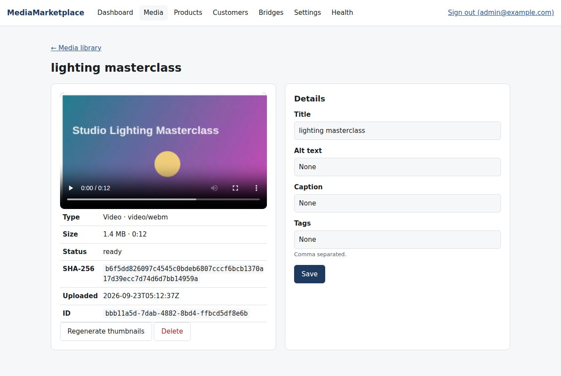
A video's detail page

9. Products
Products lists everything for sale with its type, price, status, rating, views and sales. Use the buttons at the top to create a product of any of the ten types.
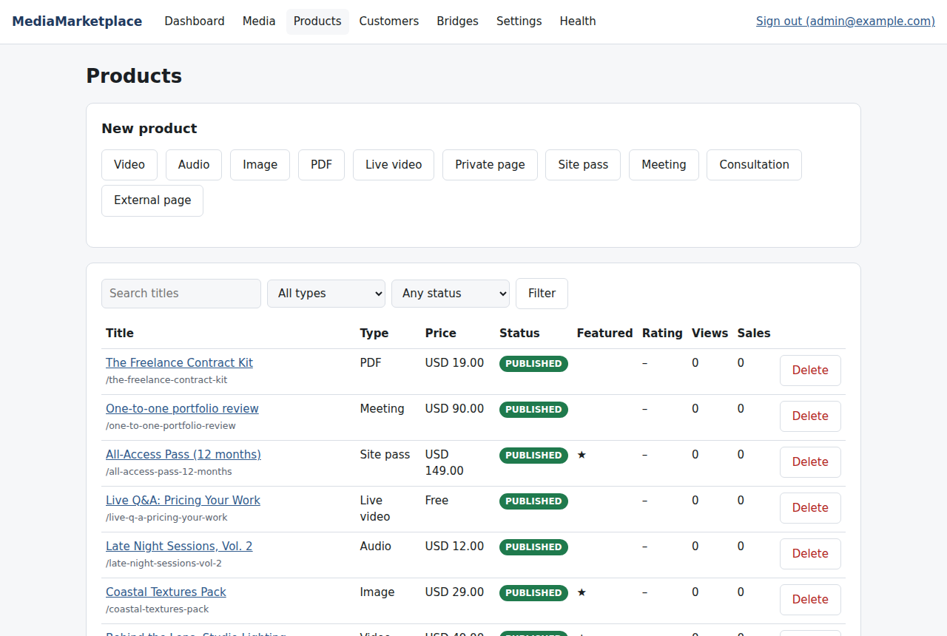
The product list
Every product has a title, slug, description, price and currency, a status (draft, published, archived), a featured flag and categories. Video, audio, image and PDF products pick their file from the media library; any product may pick a separate preview image. The right-hand column changes with the type:
Type | Settings
Video | preview clip start and length, allow download, player
Audio | preview clip, allow download, visualiser, player
Image | resolutions for sale, licence text
PDF | free preview pages, allow download, allow printing, stamp buyer name
Live video | provider, stream URL, start and end, chat embed
Private page | the page it unlocks, signup template
Site pass | validity (days, date, lifetime, recurring), days or end date, scope
Meeting | provider, join link, duration, seats
Consultation | provider, join link, duration, intake questions
External page | external URL, open in same or new tab, disclosure text

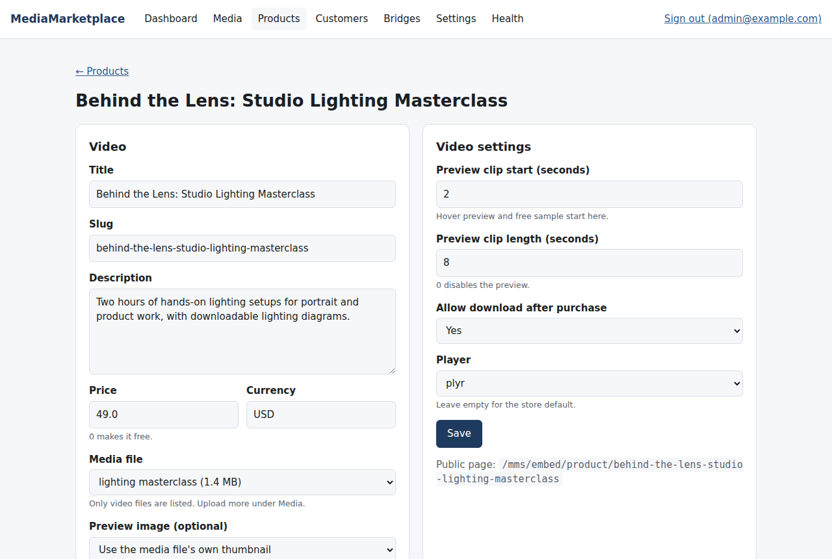
Editing a video product
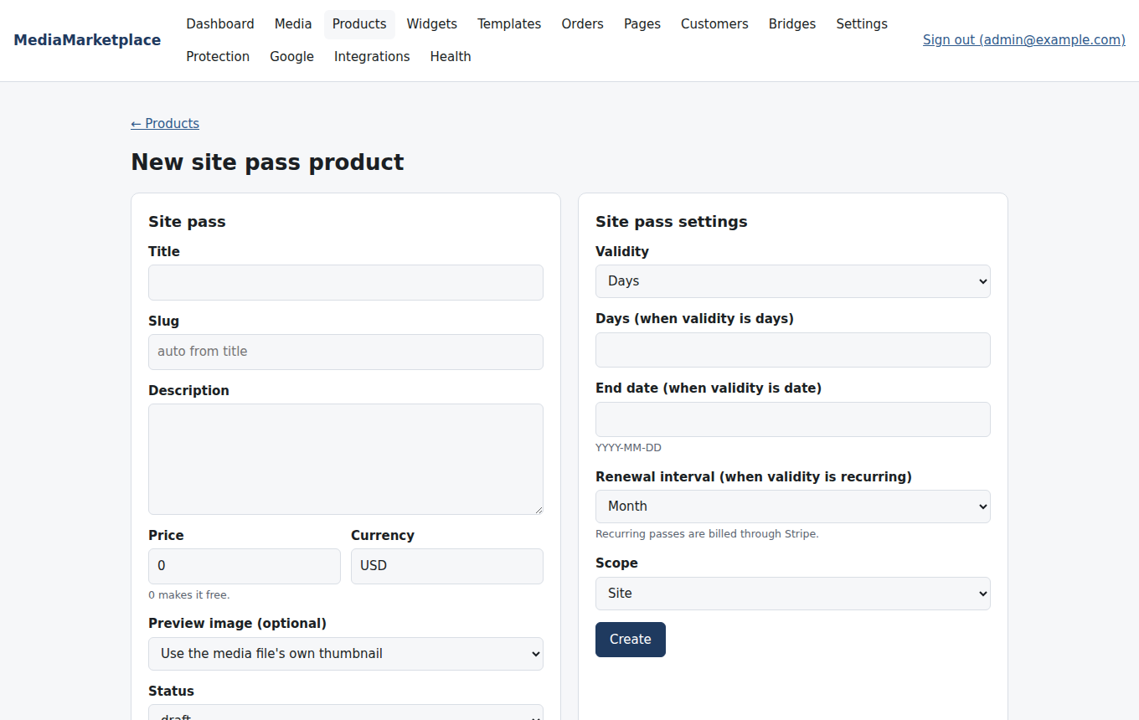
Creating a site pass product
Price 0 makes a product free: it still goes through the cart so the customer gets an order and access, but no payment method is shown.
Categories are managed at the bottom of the product list and appear as a menu and a filter in the showcase. A product's type is locked after its first sale, so that existing orders keep meaning what they meant.

10. Customers and access
Customers lists every account: store administrators, members who signed in from WordPress, and customers who registered directly at the store. Open one to see their orders, access and signed agreements.
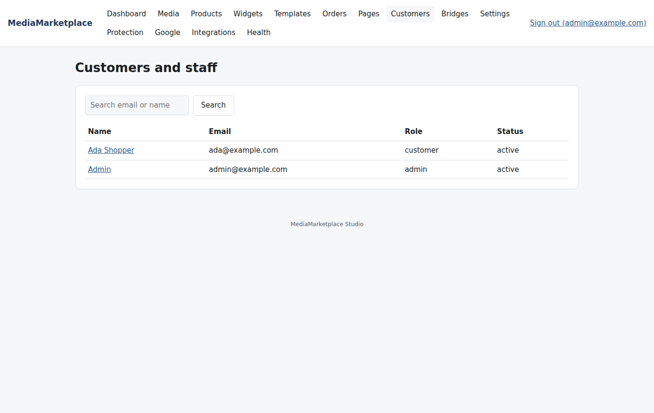
The customer list
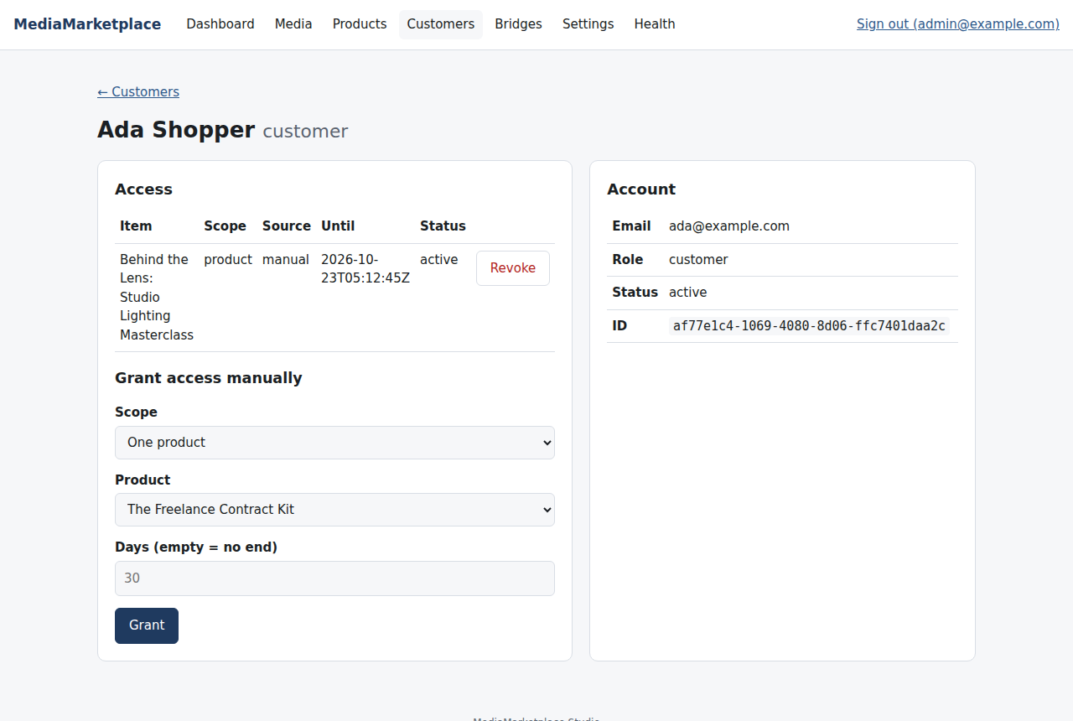
A customer with access granted by hand
Granting access by hand. Choose One product or Whole library, an optional number of days, and click Grant. This is how you give a reviewer, a partner or a customer who paid elsewhere something without an order. Revoke at any time. Every grant and revoke is written to the activity log.
A WordPress user who has never opened My media has no store account yet; they appear here the first time they follow the link. The store keeps its own account record (name, email, the WordPress user id) and never writes to the WordPress database.

11. Putting the store on your pages
WordPress gives you two ways to place store content, and both render the same store from the same server: blocks in the block editor, and shortcodes for the classic editor, widgets areas and page builders that accept shortcodes.
Blocks. Open the block inserter and look under MediaMarketplace. Three blocks are provided:
- MediaMarketplace Showcase: the product listing.
- MediaMarketplace Embed: a widget from the builder, a single product page, a player or a private page.
- MediaMarketplace My Media link: the one-click link into a member's library.
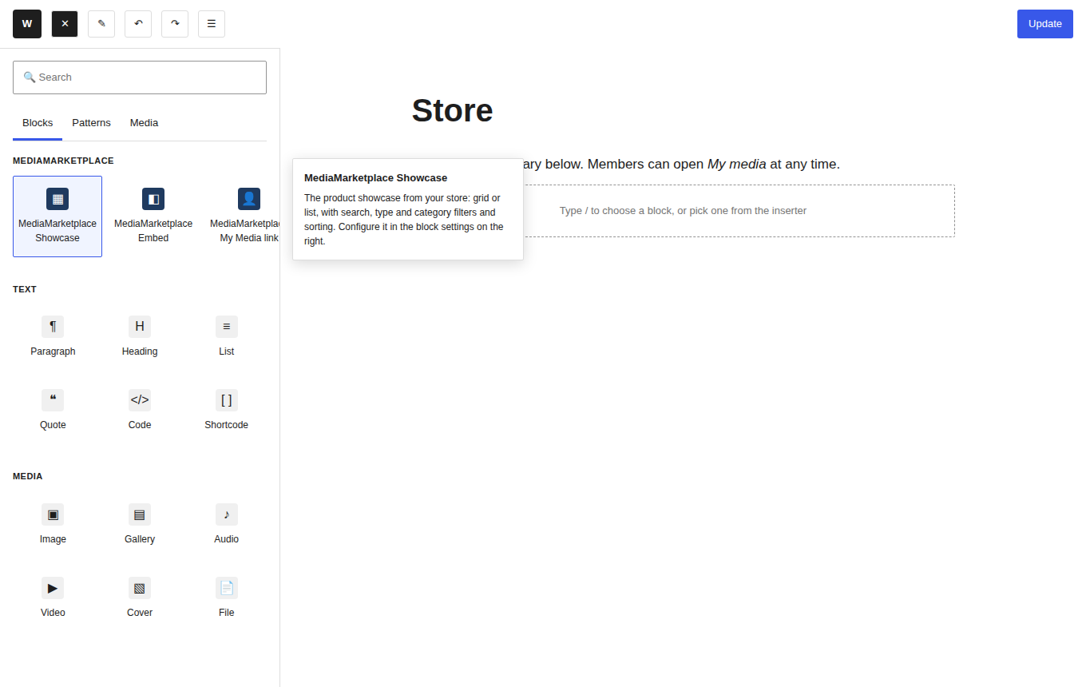
The block inserter with the MediaMarketplace blocks (mock-up editor)
Add the Showcase block to your store page. The block settings on the right choose the layout (grid or list) and an optional category to limit the listing to. The editor shows the live showcase, so you see exactly what visitors will.
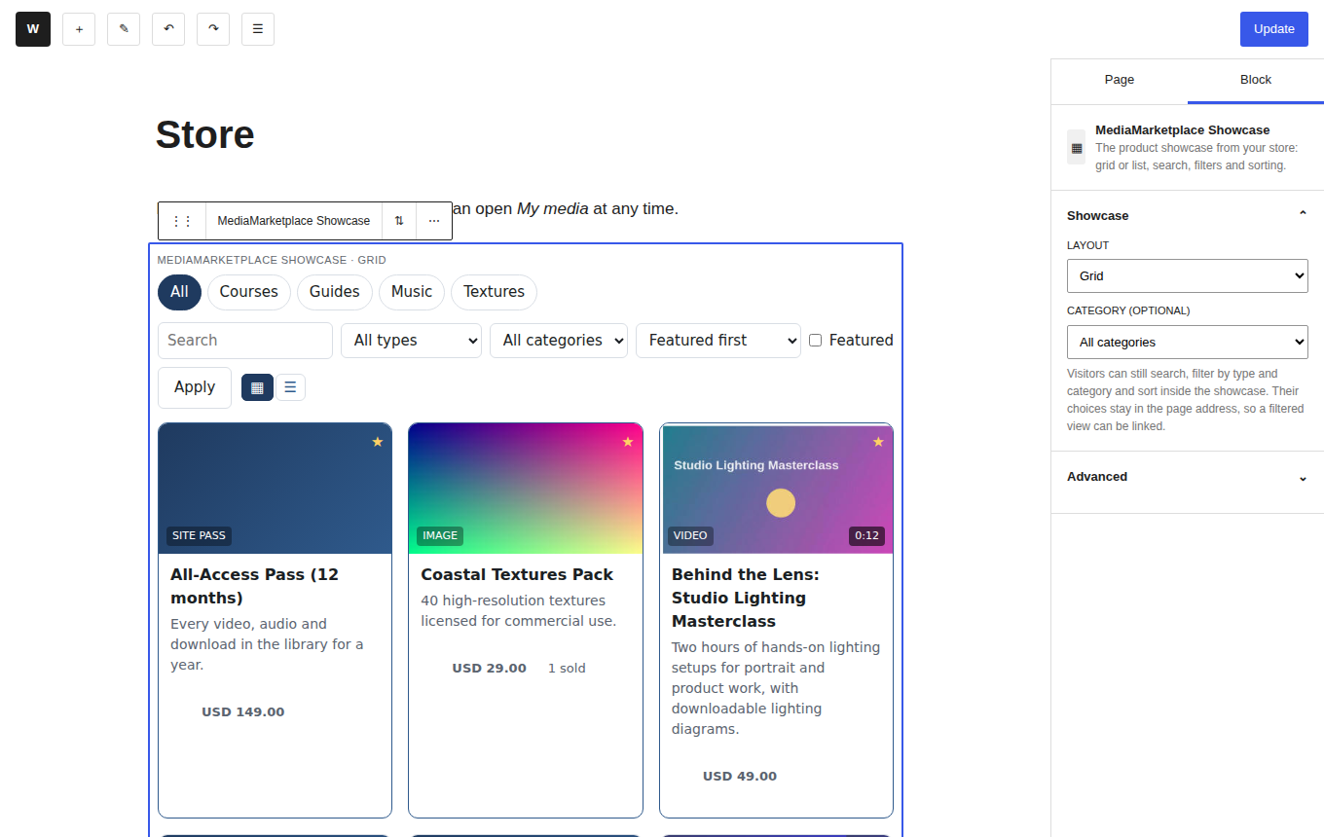
The Showcase block selected, with its settings and the live showcase in the editor (mock-up editor, live store content)
Shortcodes. The same three placements exist as shortcodes for a Shortcode block, the classic editor, a text widget or a page builder:
Shortcode | Attributes
[mms_showcase] | view grid or list; category slug
[mms_embed] | kind widget, product, player, page, sitepass or cart; id widget or page ID, or product slug; view an optional view of a widget
[mms_signin] | label link text; return store path to open, for example /account/orders

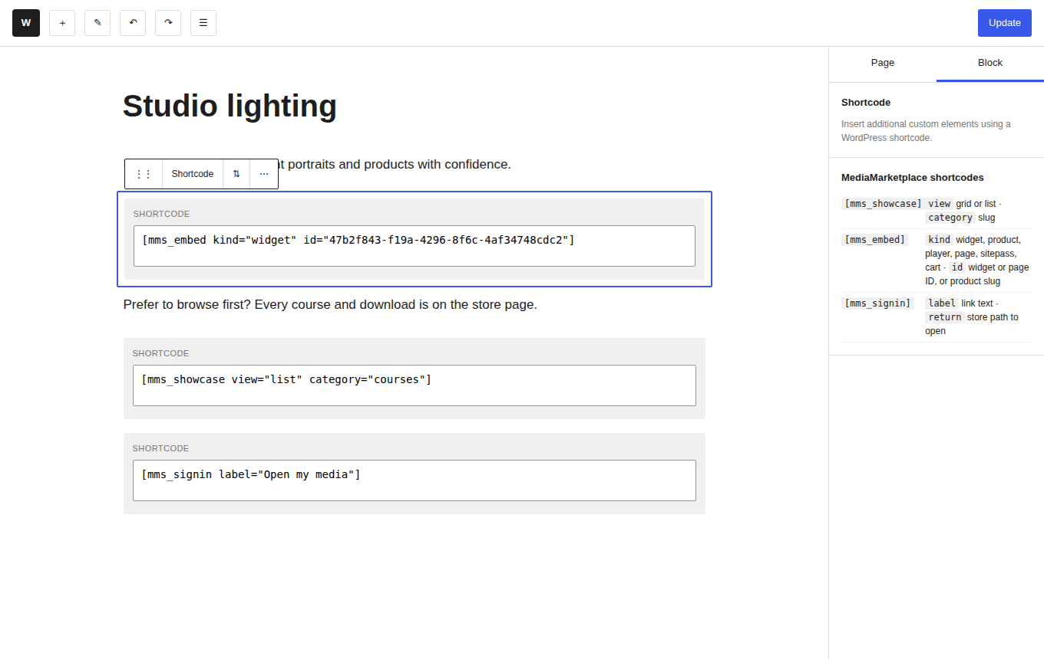
Shortcode blocks placing a widget, a filtered showcase and a My media link (mock-up editor)
On the page. Visitors see the showcase inside your theme, with your header, menu and footer around it. Nothing about your theme is changed.
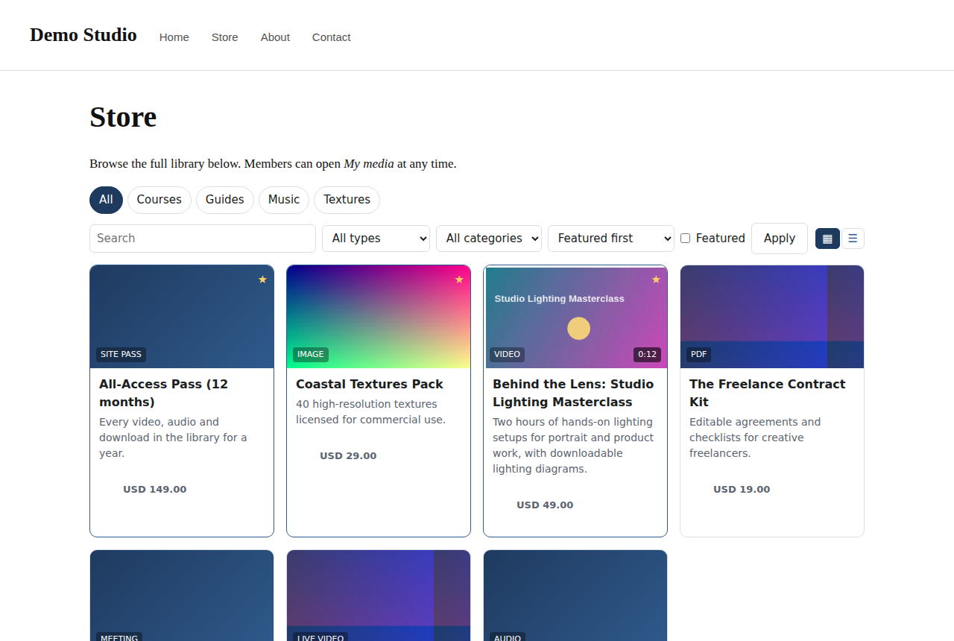
A WordPress page with the live showcase (mock-up page, live store content)
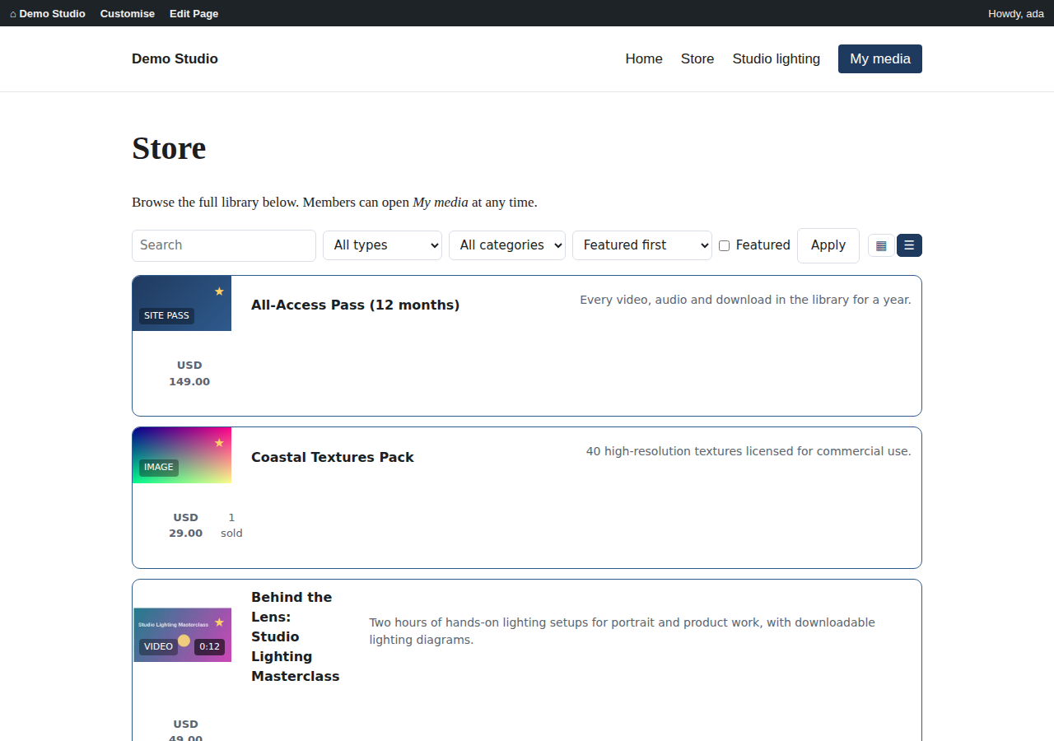
The store page in list view, with the My media link in the site menu (mock-up page, live store content)
What the visitor sees. The showcase is the store front. It shows published products as cards with a thumbnail, type badge, duration, price, rating and featured star, and offers search, type and category filters, sorting (featured, newest, price, rating, best selling, alphabetical), an optional category menu and grid or list layout. The visitor's choices stay in the address, so filtered views can be linked from anywhere on your site.
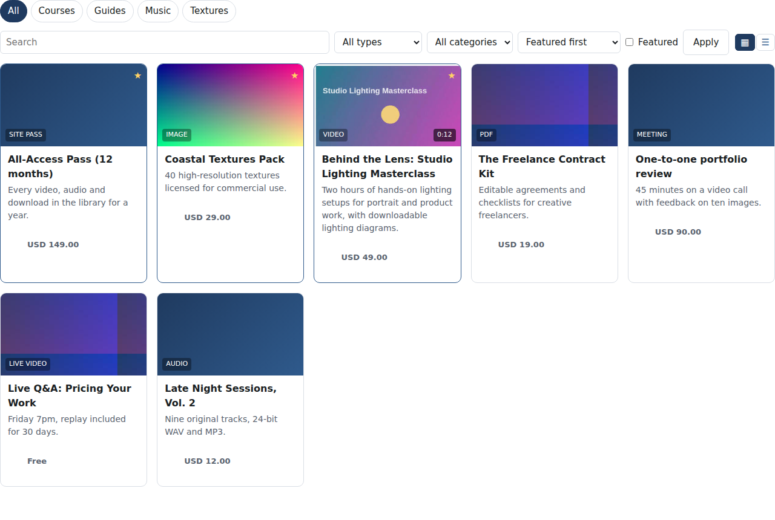
The showcase in grid view with the category menu
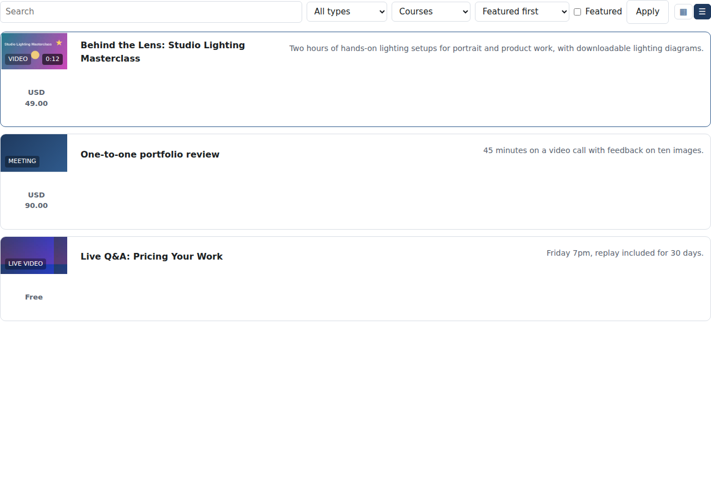
The showcase in list view filtered to a category
Clicking a card opens the product page: the preview image or a free preview clip, description, price, reviews, and a Buy button that puts the item in the cart (section 18). A visitor who already owns the item sees Open instead and can leave a rating.
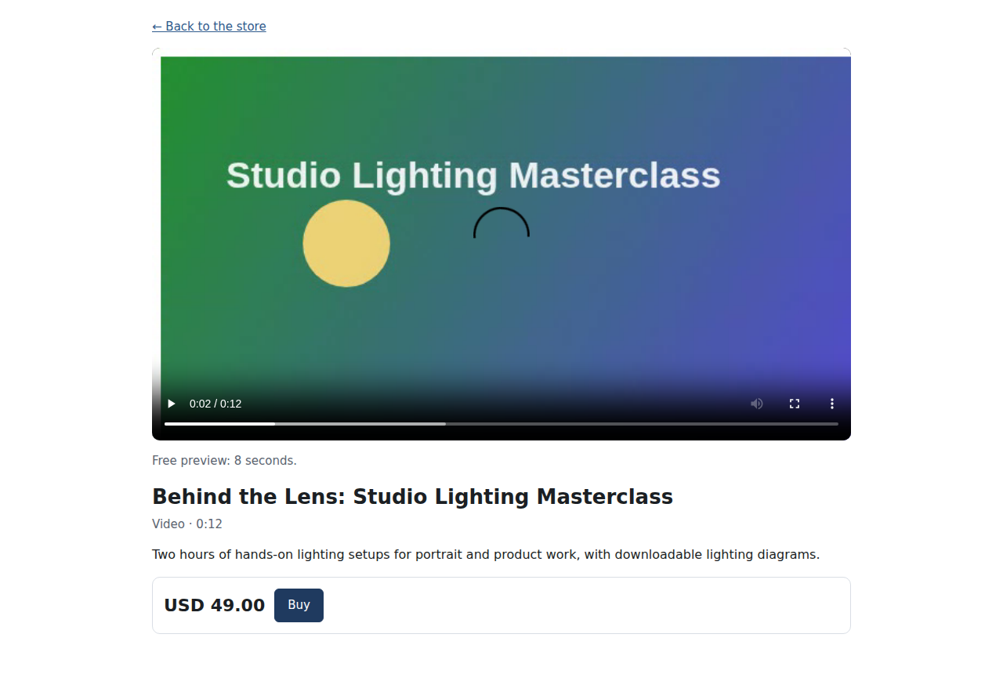
A product page with a free preview clip

12. The My media link
Members reach their library through a My media link on your site. The link signs the logged-in WordPress user into the store in one click and opens their library; guests are sent to the WordPress login first.
Add the MediaMarketplace My Media link block to a page or a navigation menu, or use [mms_signin label="My media"]. The return attribute sends the member to a specific area, for example their orders. Most sites put the link in the header menu next to the store page.
Customers without a WordPress account can register at the store's own sign-in page instead; both kinds of customer see exactly the same library.
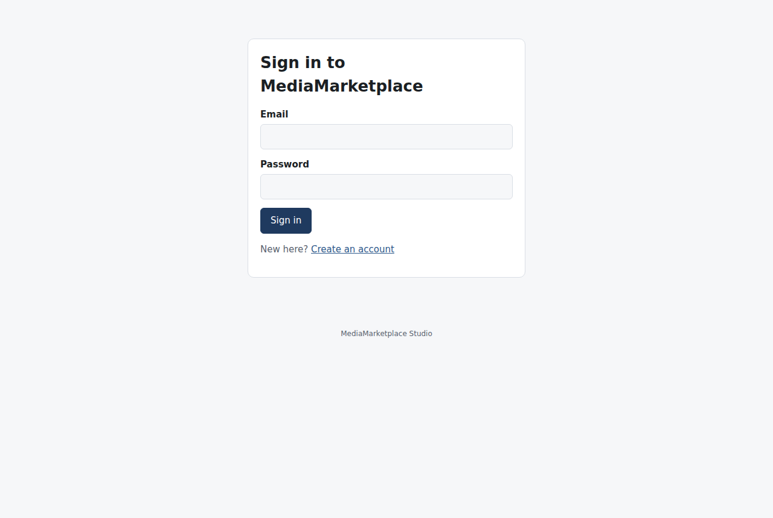
The store's own sign-in page

13. Players and My media
Customers open what they own from My media. The same area has their Orders with receipts, their recurring Passes, their signed Agreements, the Cart and Privacy.
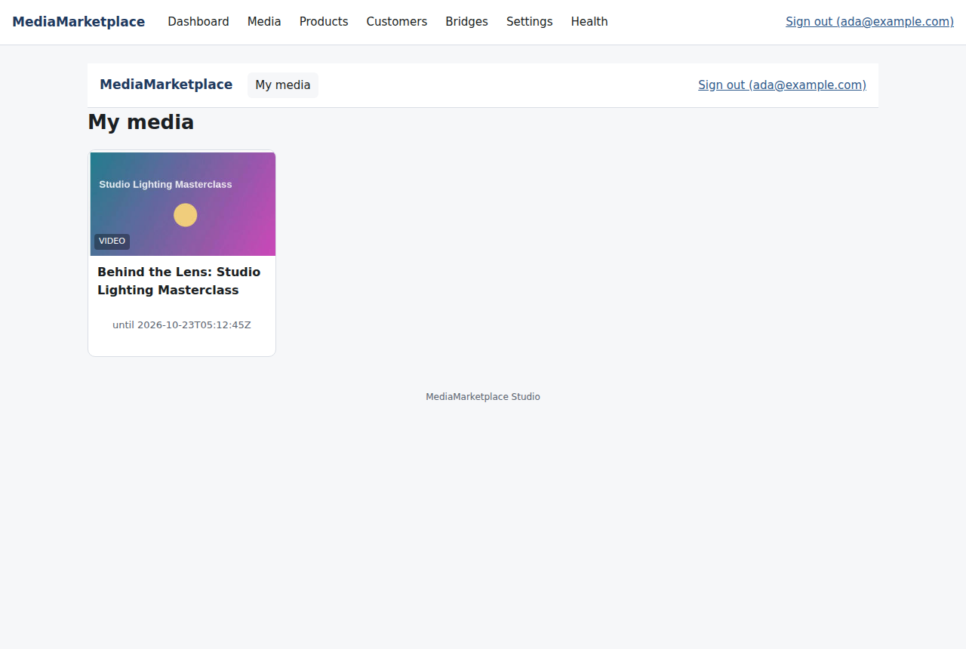
My media
Video and audio play in the universal player. The store default is Plyr; Video.js, Clappr and the browser's native controls are also available, per store or per product, and third-party players can be added (section 30). Every play uses a signed link that expires, is tied to the signed-in customer, and supports seeking. Videos carry a moving visible watermark with the customer's email. Owners can download when the product allows it.
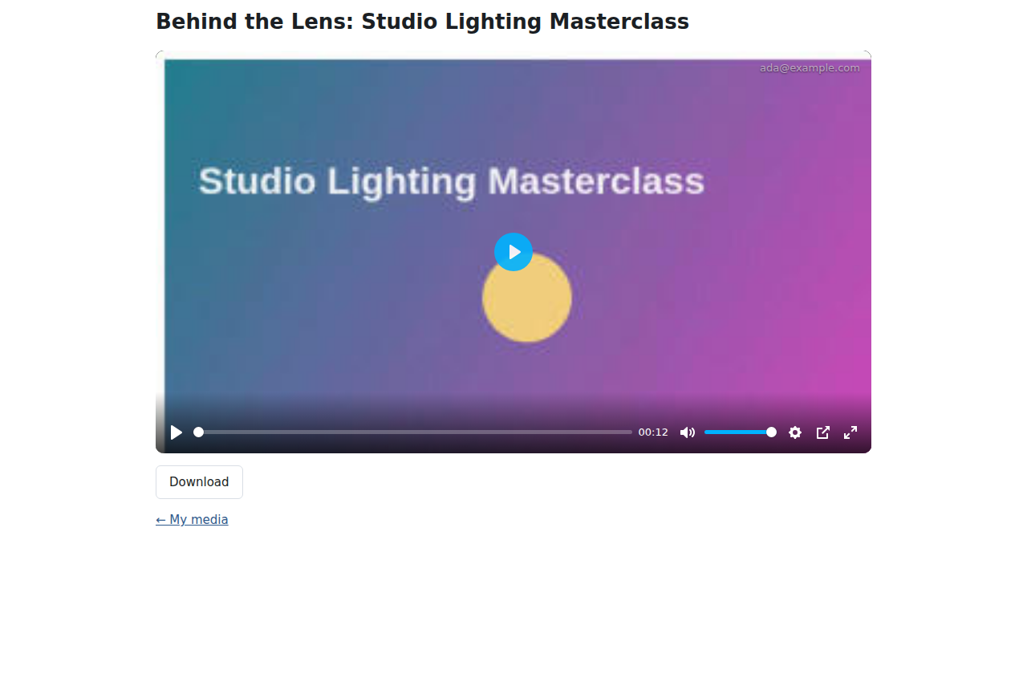
Playing a purchased video with Plyr, watermark at the top right
Images open at full size with a download button and, at protection level 1 or 2, inside the protected viewer (section 28); PDFs open in the page; live events show the stream and chat during their window; meetings and consultations reveal their join link; external pages reveal their link; a site pass opens the whole library.
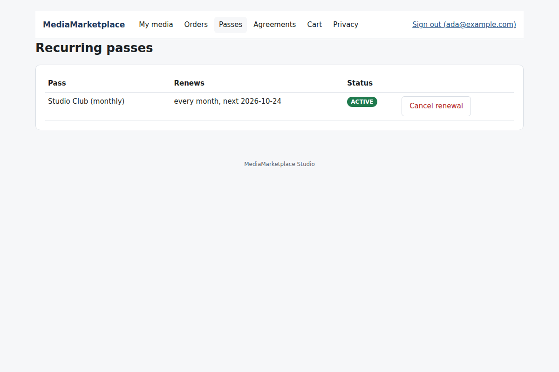
A customer's passes under My media

14. The widget builder
A widget is a block of store content you design once and place on any page: a video with a headline and a call to action, a gallery, a pricing table, a countdown to a live event, a row of product cards. Widgets are built in the store admin under Widgets, either blank or from one of the 35 templates.
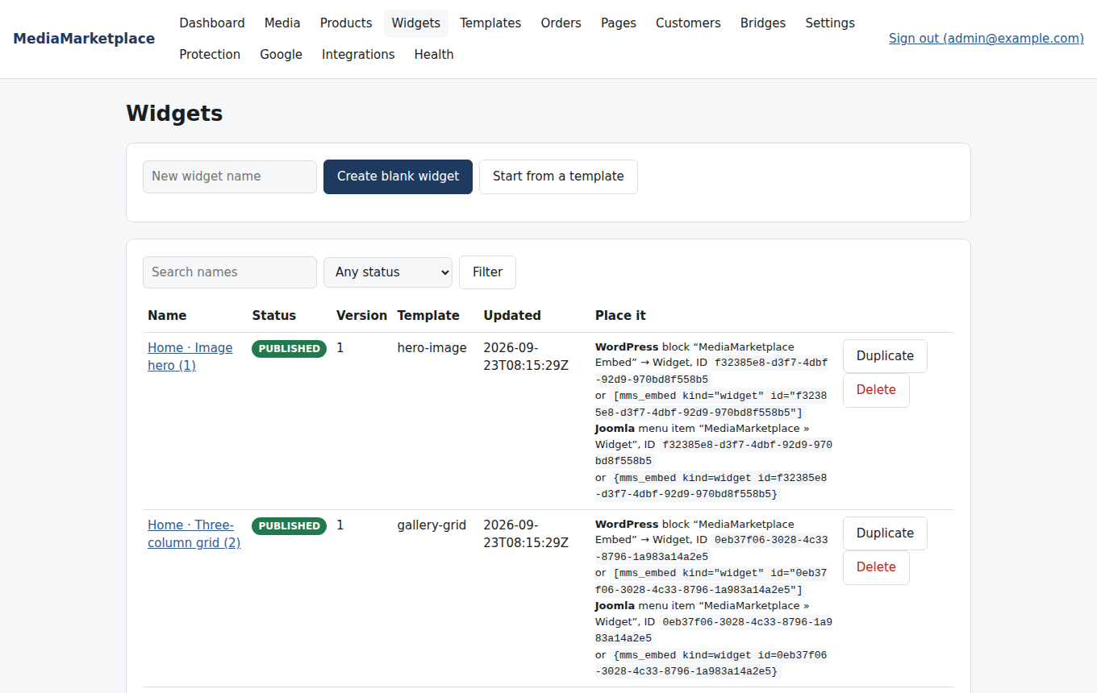
The widget list, with the placement snippet for each widget
The builder has three areas. On the left, the component palette (Container, Text, Image, Video, Audio, PDF, Button, Product card, Price, Add to cart, Countdown, Icon, Spacer, Divider) and the layer tree. In the middle, the canvas, a live preview rendered by the same code that renders the widget on your site. On the right, the properties of the selected component, with its animation, tablet and phone overrides, custom CSS, versions and Save as template.
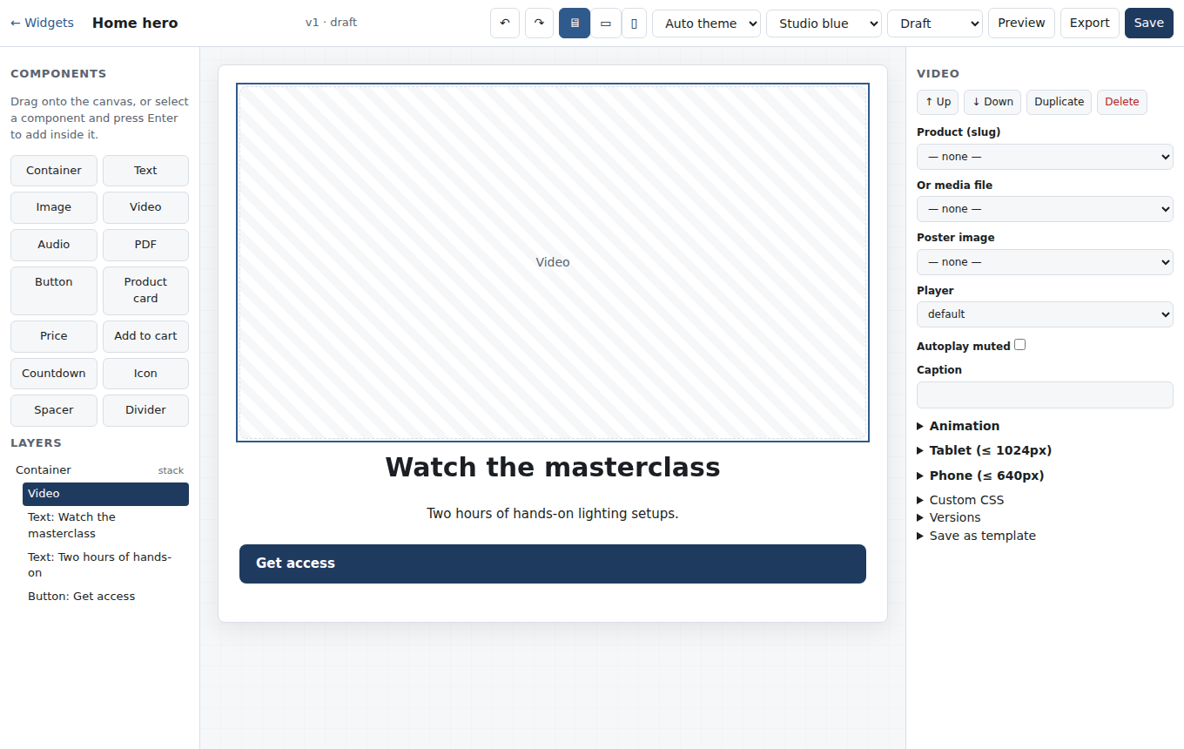
A widget opened from the Video hero template
Drag a component from the palette onto the canvas, or select a component in the layer tree and press Enter to add inside it. Click anything on the canvas or in the tree to select it; the properties panel follows. Text, alignment, colours, media and products are chosen in the panel; media comes from your library and products from your catalogue.
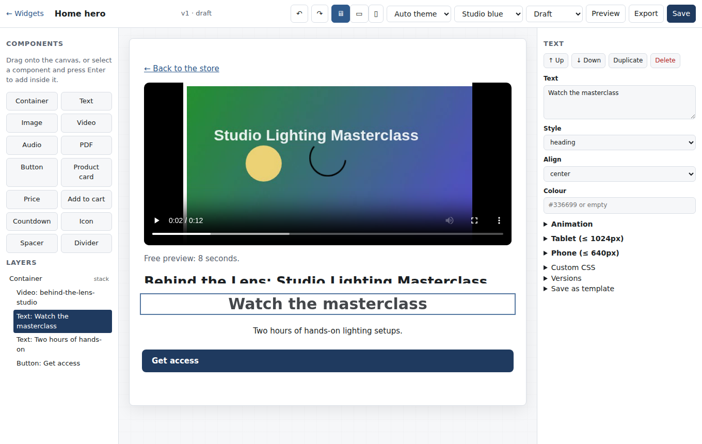
Editing the heading of a widget
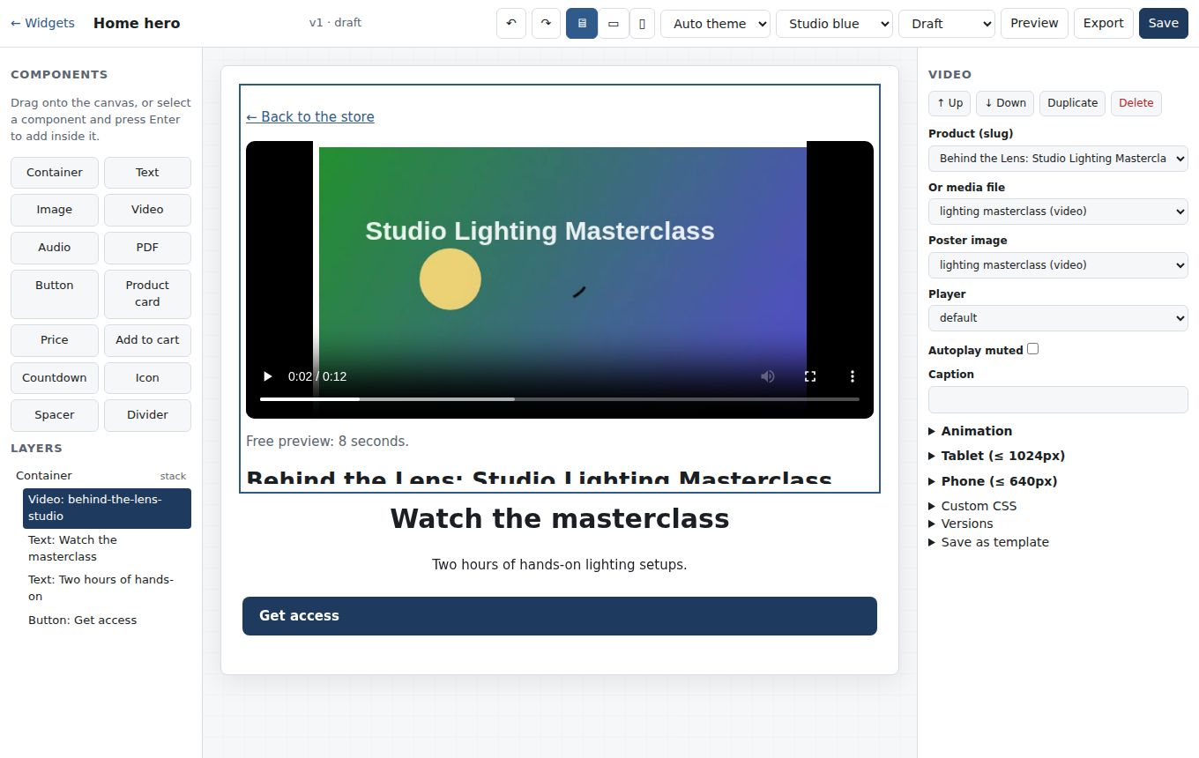
A video component selected on the canvas
The toolbar offers undo and redo (50 steps), desktop, tablet and phone previews, the theme (auto, light or dark), the colour scheme, the status and Save. A widget must be Published to appear on your site; drafts and archived widgets return "not published" to visitors.
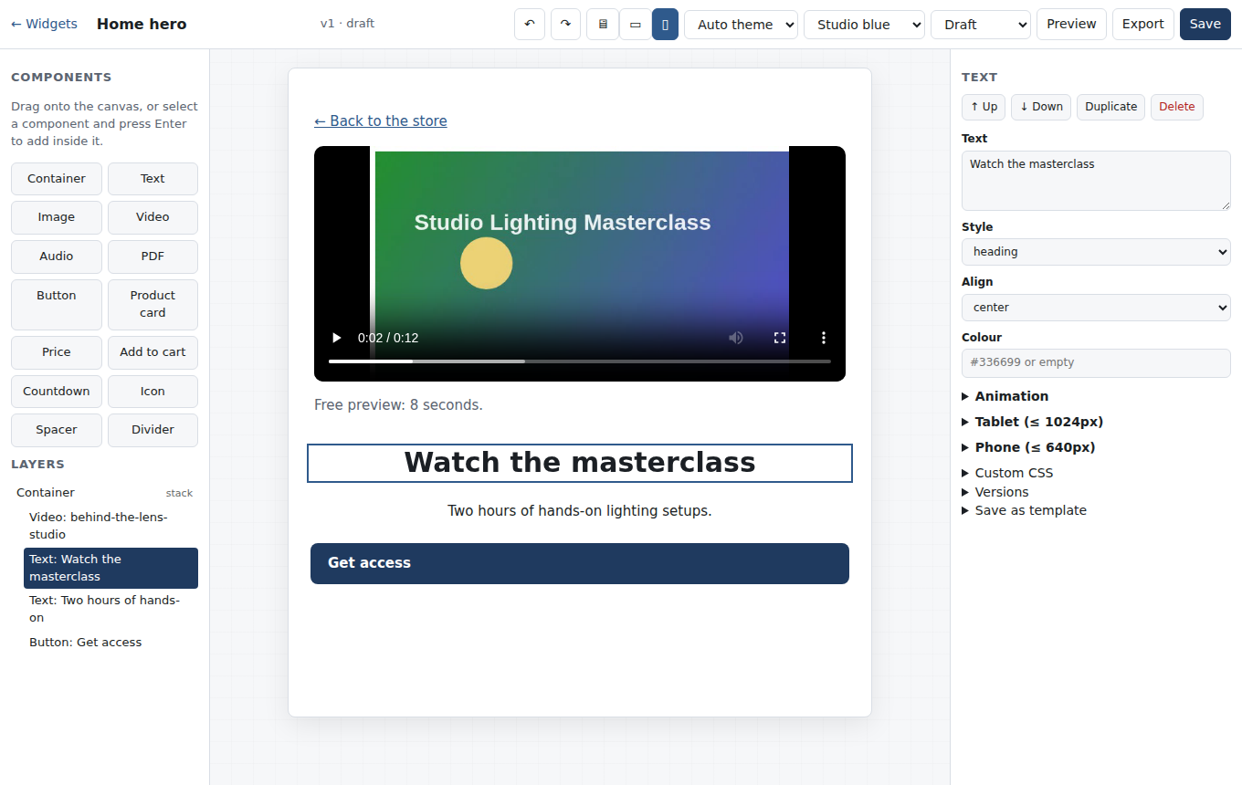
The phone preview
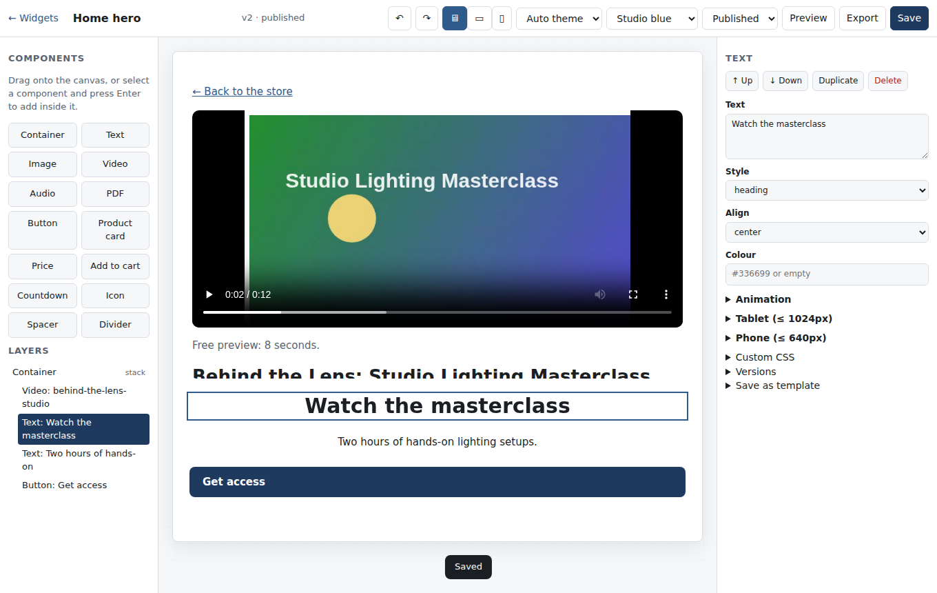
The widget saved and published
Every save creates a version. Open Versions in the properties panel to restore an earlier one (the last 50 are kept). Custom CSS applies to this widget only: it is scoped automatically, limited to 64 KB, and anything that scripts or imports is refused.

Placing a widget
Click Export in the builder to see the widget's ID and the ready-made snippets. Every widget also lists them under Widgets.
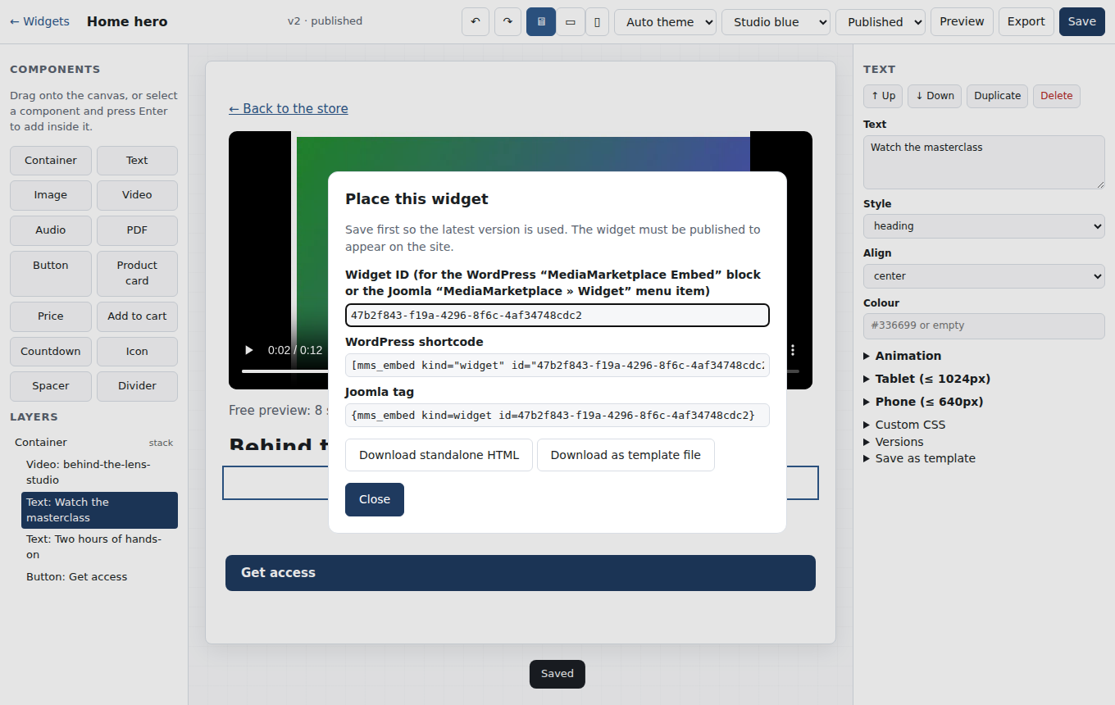
The Place this widget dialog
Add the MediaMarketplace Embed block, choose Widget and paste the ID, or put [mms_embed kind="widget" id="…"] in a Shortcode block. The editor shows the live widget.
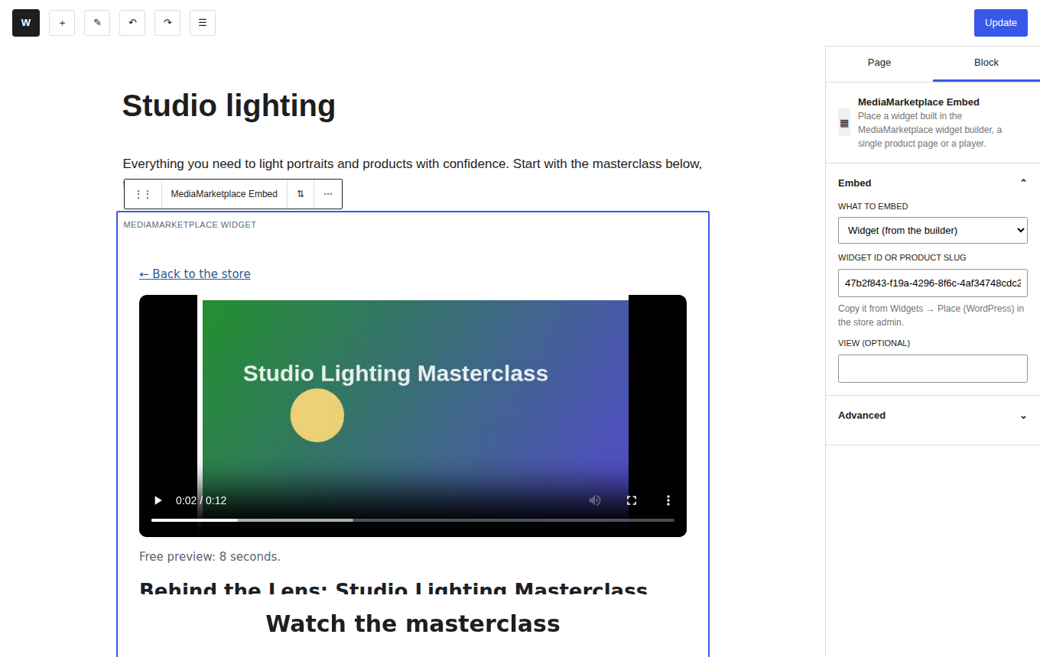
The MediaMarketplace Embed block in the WordPress editor (mock-up editor, live widget)
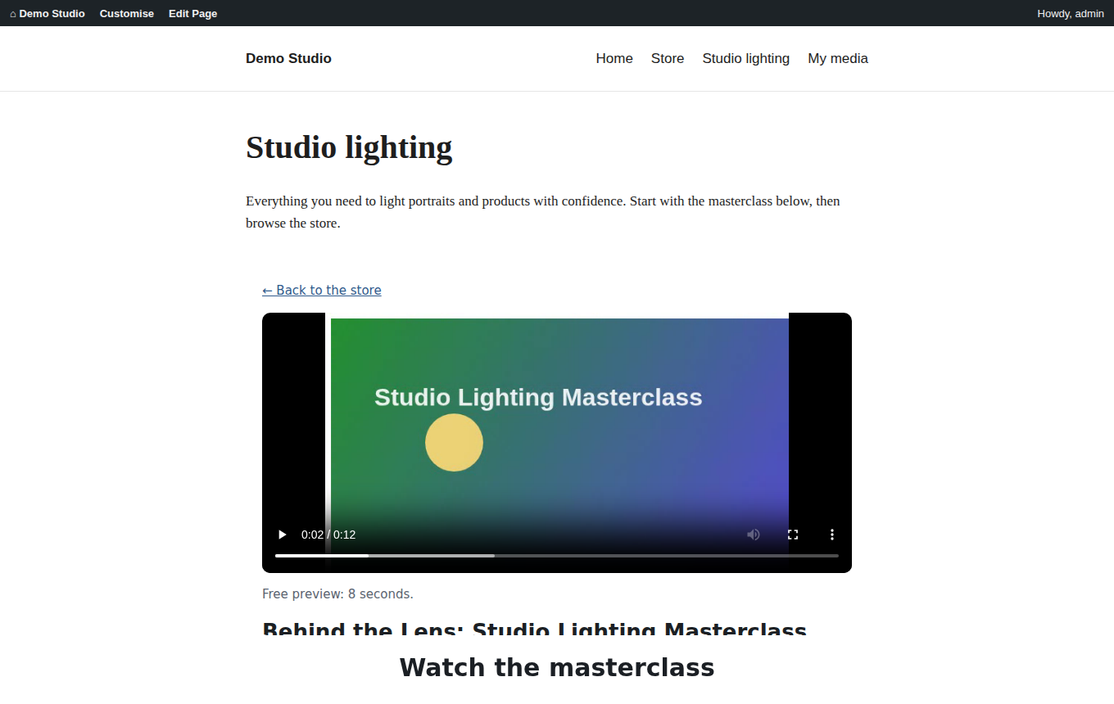
The widget on a WordPress page (mock-up page, live widget)
Anywhere else: Download standalone HTML gives a single file with the widget and its styles, pointing at your store for media, for a newsletter landing page or a site that is not this one.
Widgets follow the visitor's light or dark preference when the theme is Auto; you can force a theme per widget in the builder, or per placement by adding ?theme=dark to the widget's own address when you link to it directly.
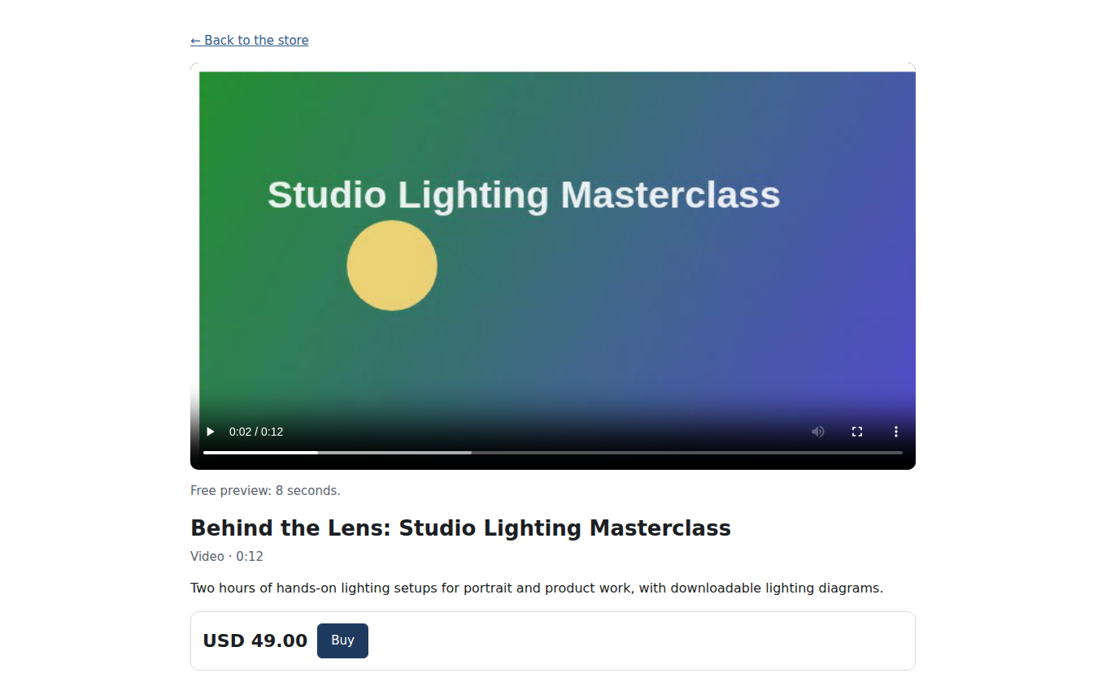
A widget in the light theme
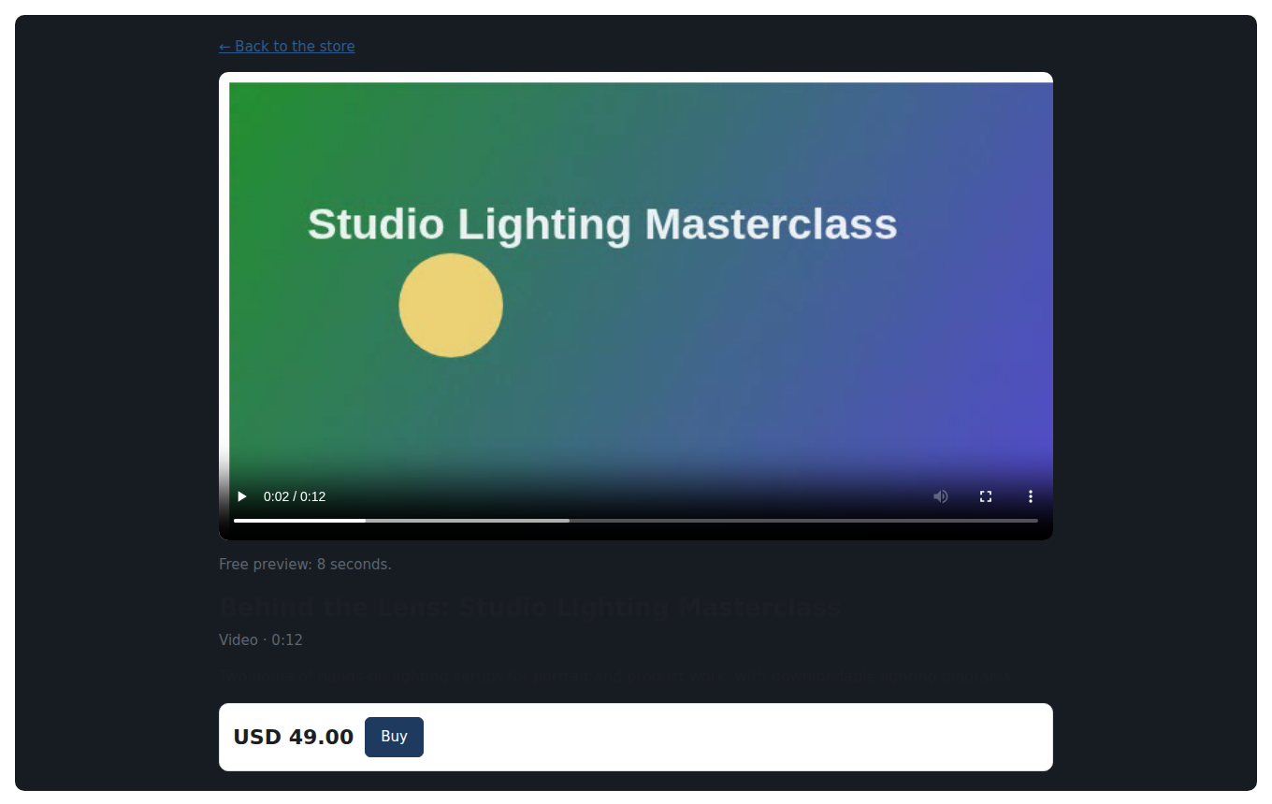
The same widget in the dark theme

15. Widget templates
Templates holds 35 built-in designs in eight categories: video showcase, audio player, image gallery, PDF viewer, product card, hero and call to action, pricing and site pass, live and meeting. Each card shows a live preview; Dark opens the dark variant, Export downloads the template as a file, and Use creates a widget from it (give it a name first if you like) and opens the builder.
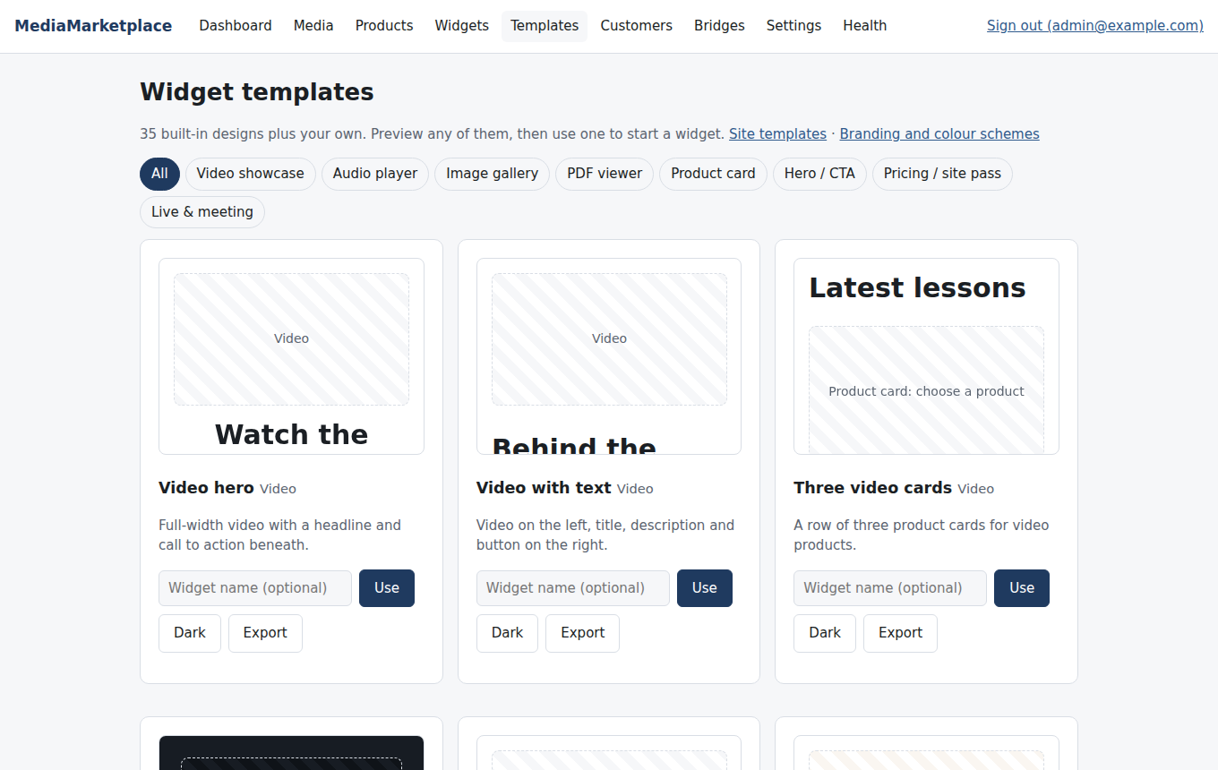
The template gallery
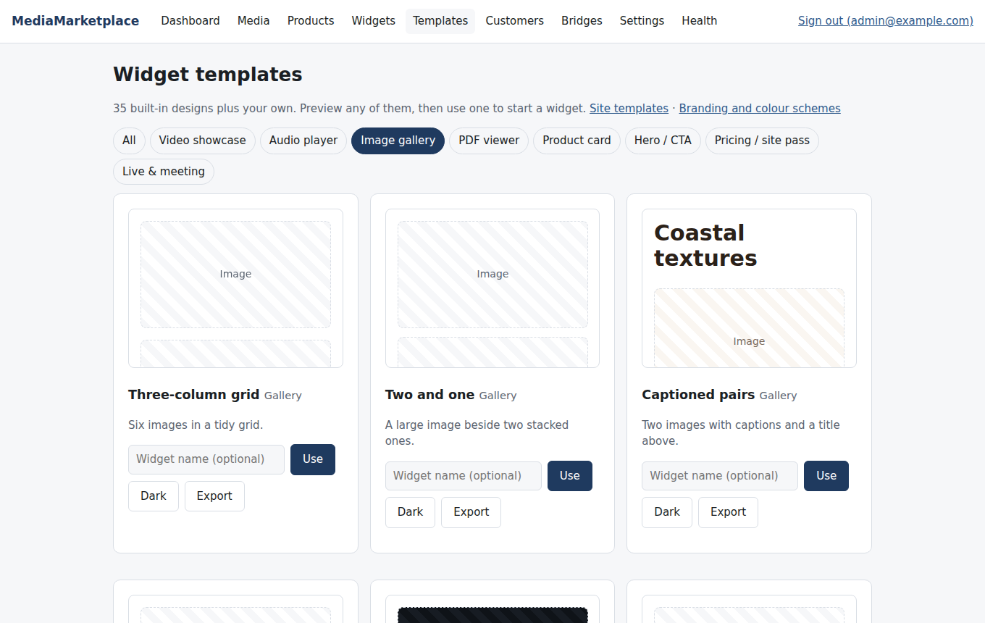
The gallery filtered to one category
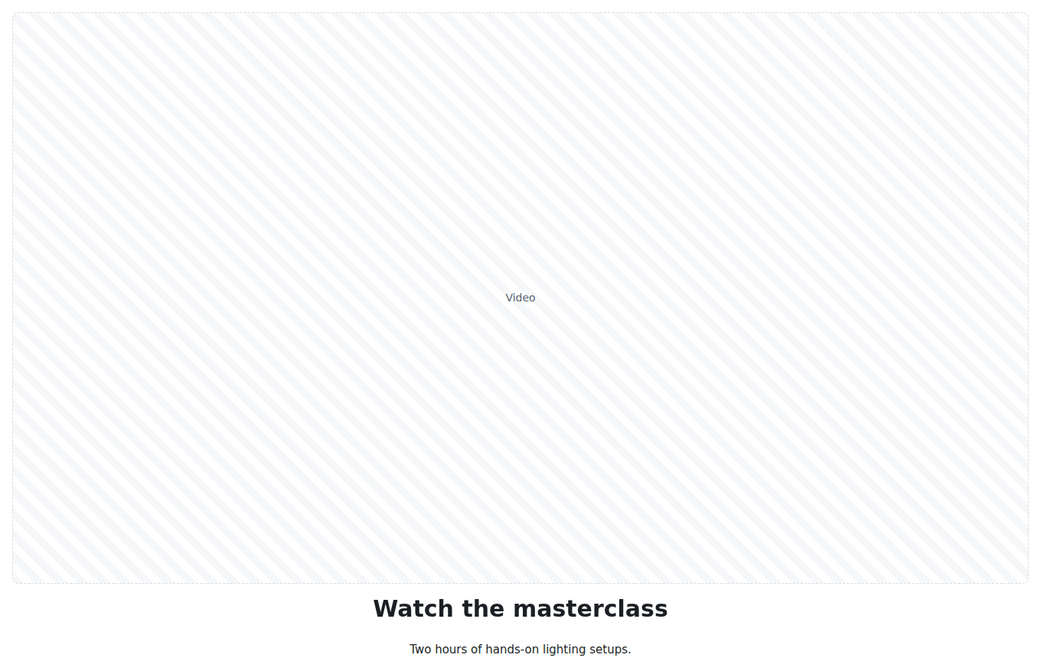
A template preview at full size
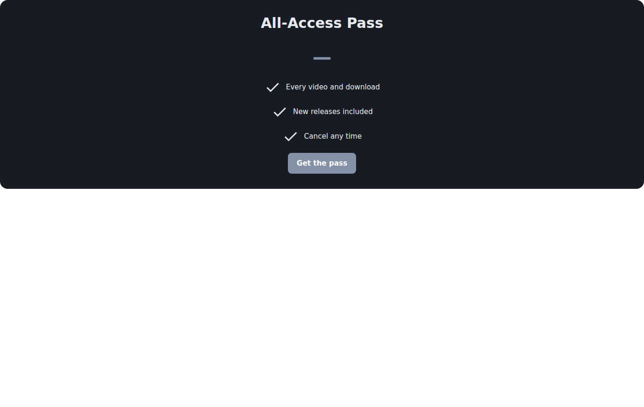
A template previewed in the dark theme
Your own templates appear below the built-in ones. Make one from any widget with Save as template in the builder; Import accepts a template file (.mmstpl.json) exported from this or another store. Templates are read-only starting points: changing a widget never changes the template it came from.

16. Site templates
A site template is an industry starter: a colour scheme plus a set of widgets for each page of a typical site. Twelve are included: Photographer, Videographer, Musician and podcaster, Online course, Consultant and coach, Fitness, Stock media, Publisher and e-books, Faith and community, Events and live stream, Agency, Generic store.
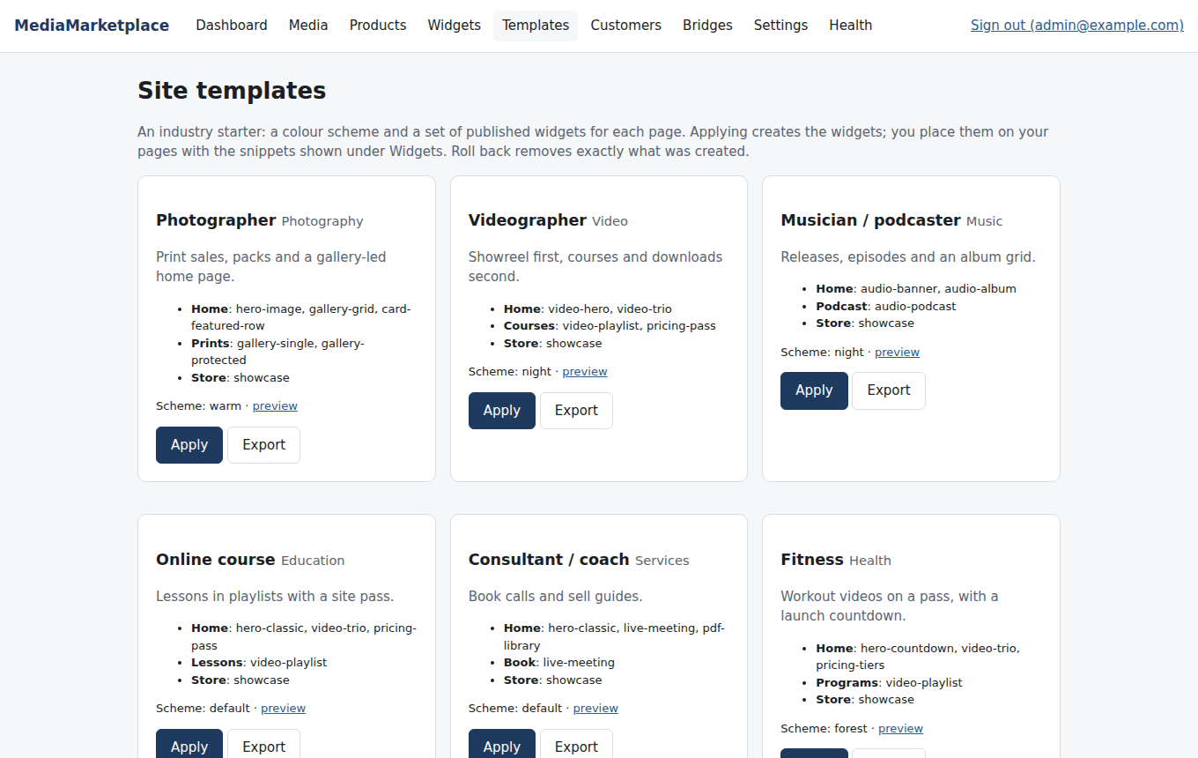
Site templates
Apply creates the widgets, publishes them and switches the store colour scheme. The widgets are named after their page (Home · Video hero (1)) so you can find them under Widgets and place them with the snippets shown there. Nothing in your WordPress theme is touched. Roll back deletes exactly the widgets an application created and nothing else.
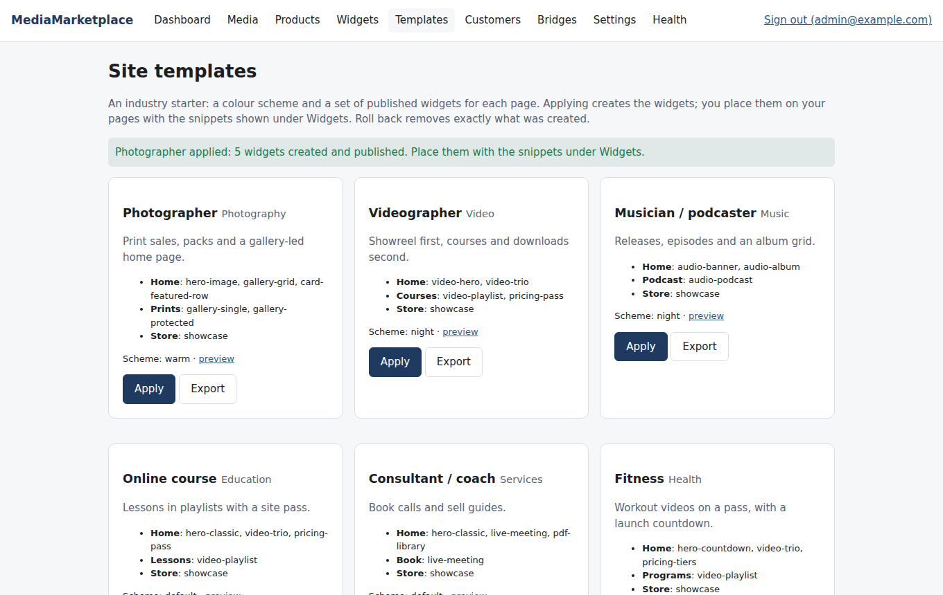
After applying the Photographer template
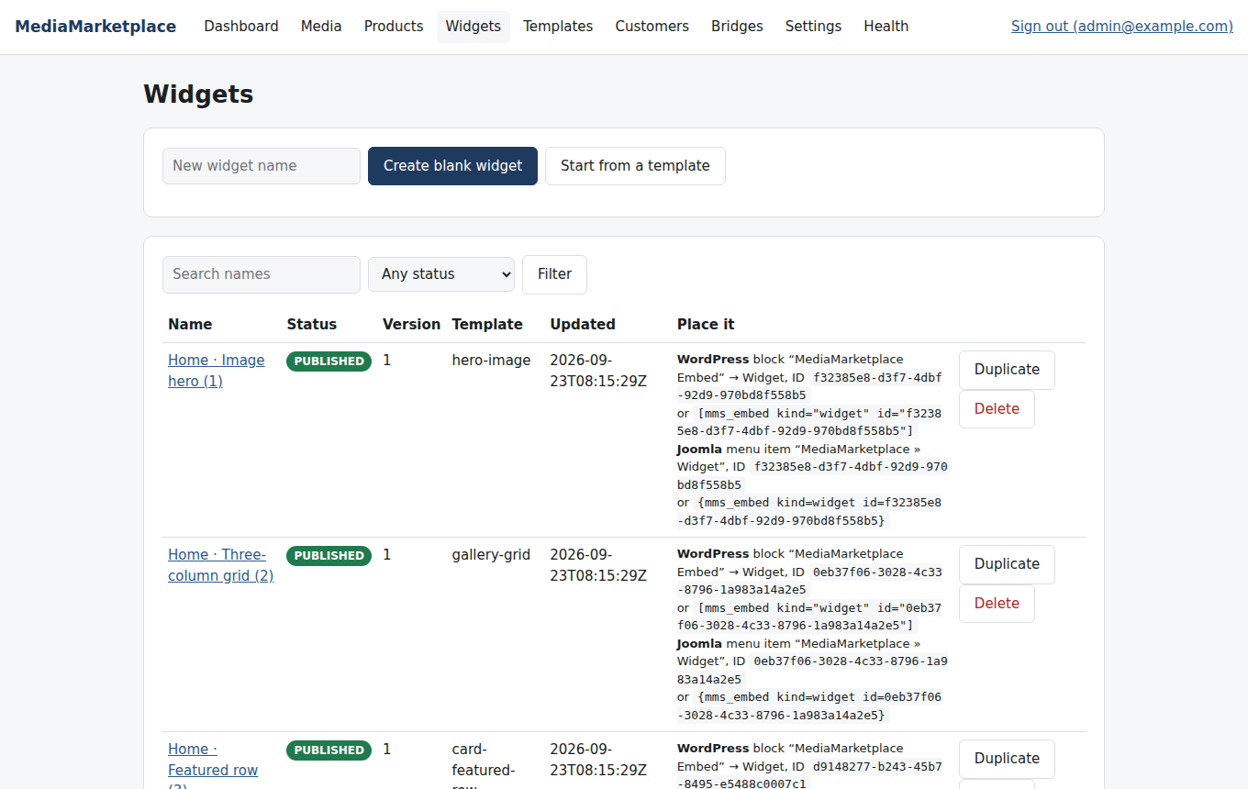
The widgets a site template created, with their placement snippets
A typical first afternoon: apply the site template closest to your business, place the Home widgets on your WordPress home page, put the showcase on a Store page, add the My media link to the menu, and adjust the widgets in the builder as your content grows.

17. Branding and colour schemes
Templates → Branding and colour schemes holds the brand kit and the schemes.
The brand kit (logo from the library, font stack, corner radius, shadow) applies to every widget. The store colour scheme is the default for widgets set to the store scheme; six schemes are built in (Studio blue, Night, Warm sand, Forest, Plum, Monochrome) and you can add your own from six colours. The table shows each scheme's swatches and its contrast ratios for text on background and white on the accent colour; aim for 4.5:1 or better. A dark variant of every scheme is derived automatically for dark-theme widgets.
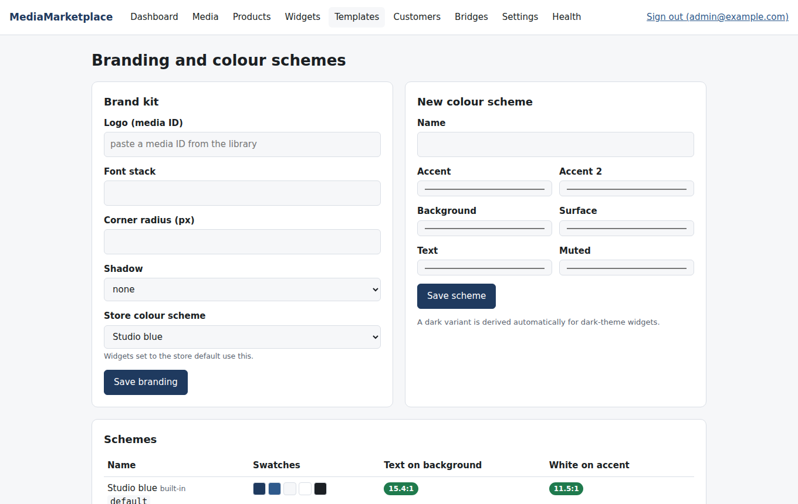
Branding and colour schemes
To match your WordPress theme, copy its accent and background colours into a new scheme and choose the same font stack in the brand kit; widgets then sit in your pages as if the theme had drawn them.

18. Selling: cart and checkout
The diagram shows the whole buying path. Every step happens on your site; only the payment itself happens at the provider.
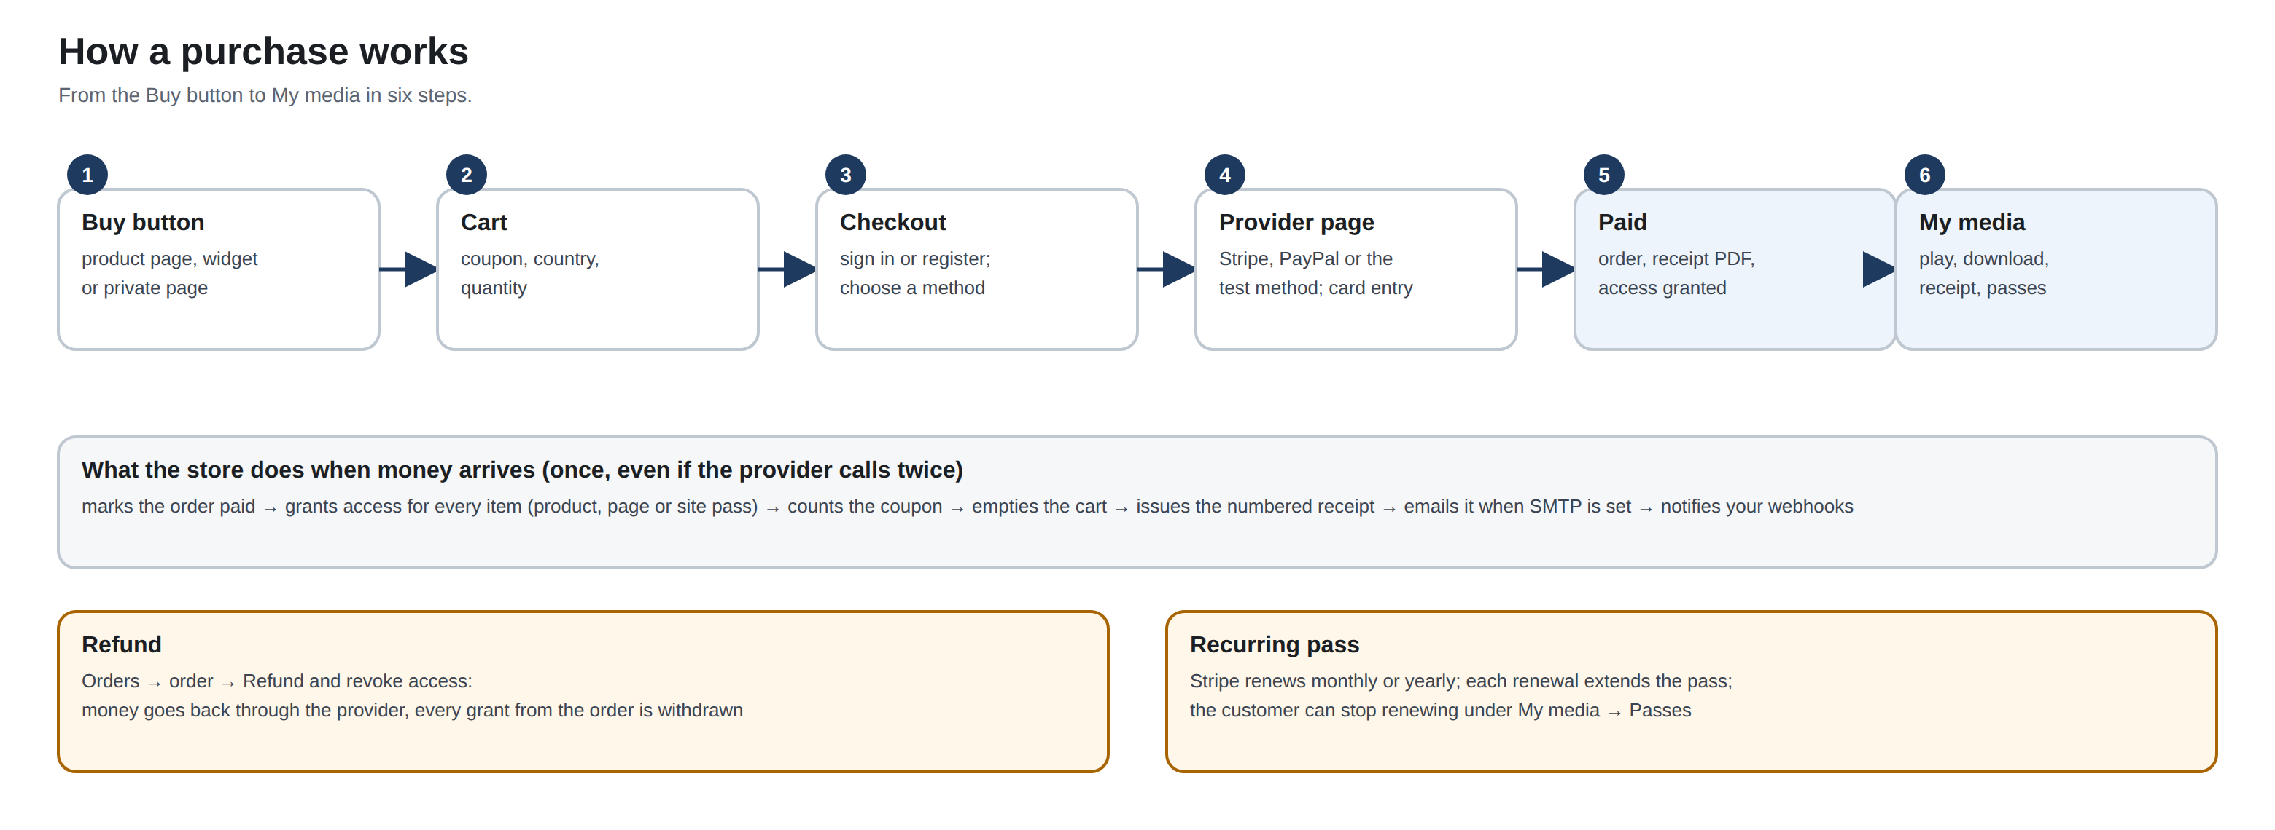
The buying flow from a Buy button to an open library
Every Buy button, add-to-cart widget component and "Buy access" link puts the item in the visitor's cart. Media products go in once; meetings can take several seats. Guests can fill a cart; they sign in or create an account when they check out, and the cart follows them.
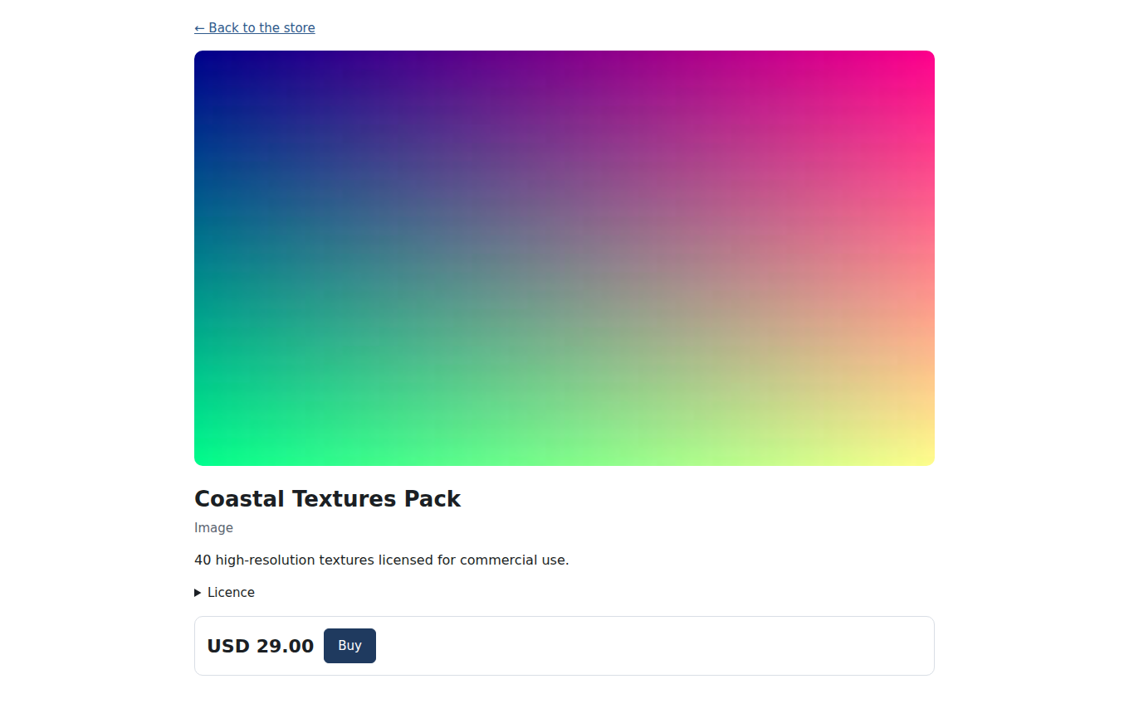
The Buy button on a product page
Inside your page the cart shows as a summary with Continue to secure checkout, which opens the checkout as a full page on your site. Card details are never typed into your site: every payment method sends the customer to the provider's own hosted page or card component and back.
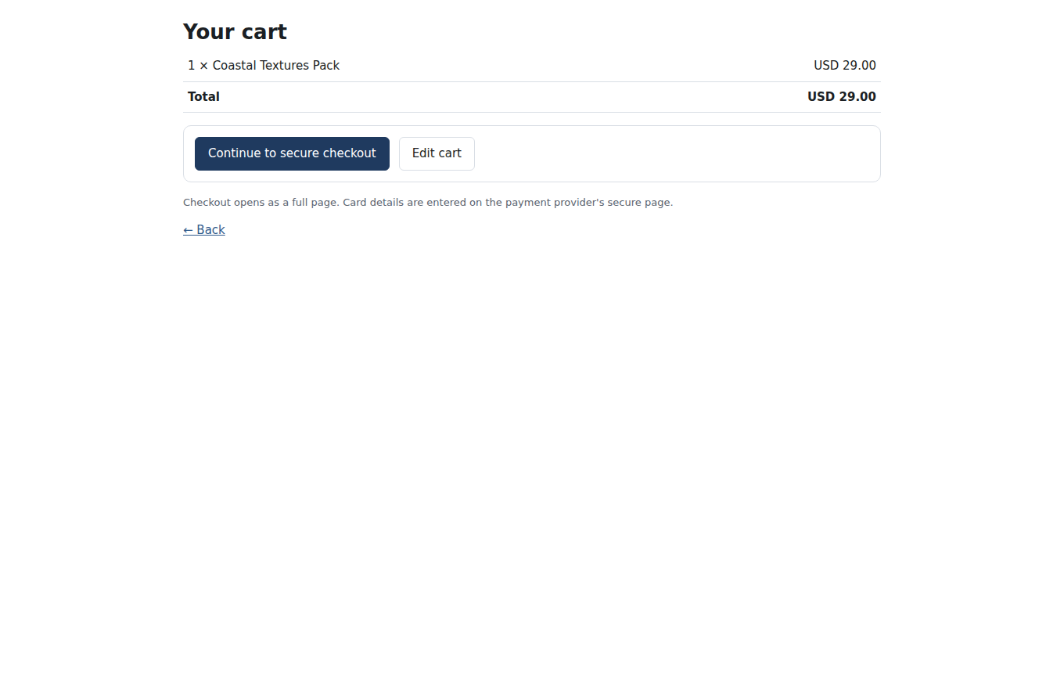
The embedded cart summary
The cart page lists the items, applies a coupon code and takes the customer's country so tax can be added (section 21).
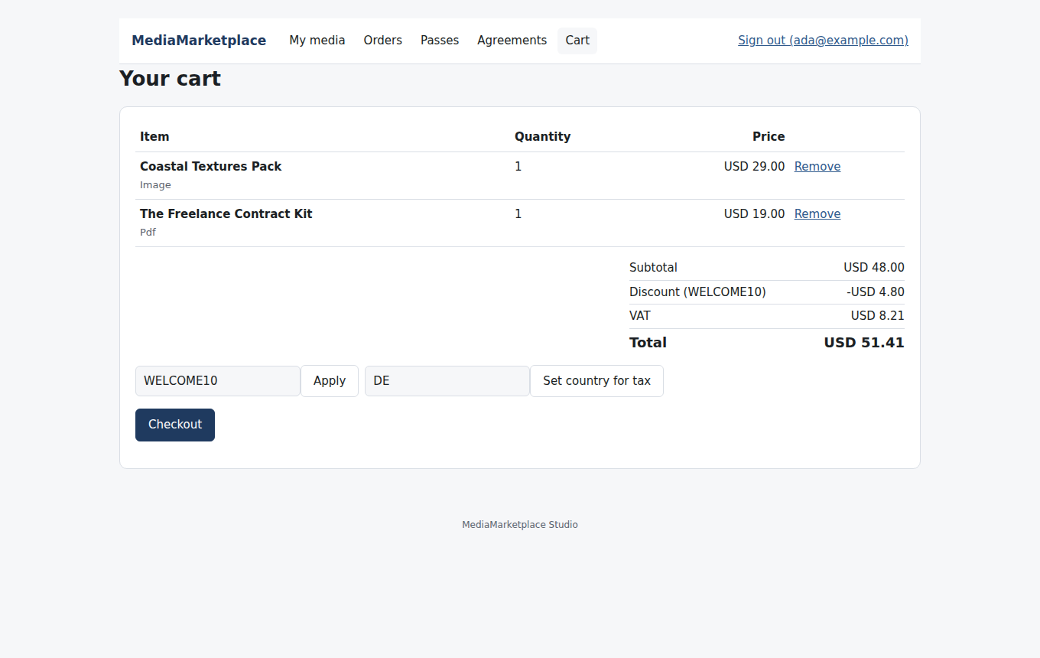
The cart with a coupon and tax
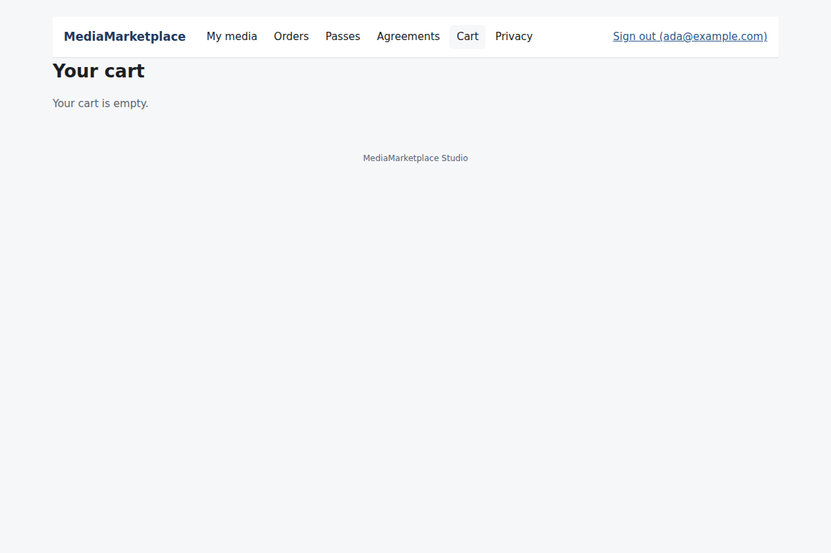
An empty cart
Checkout shows the order and the payment methods you have switched on. A zero total (free items, or a coupon covering everything) completes at once.
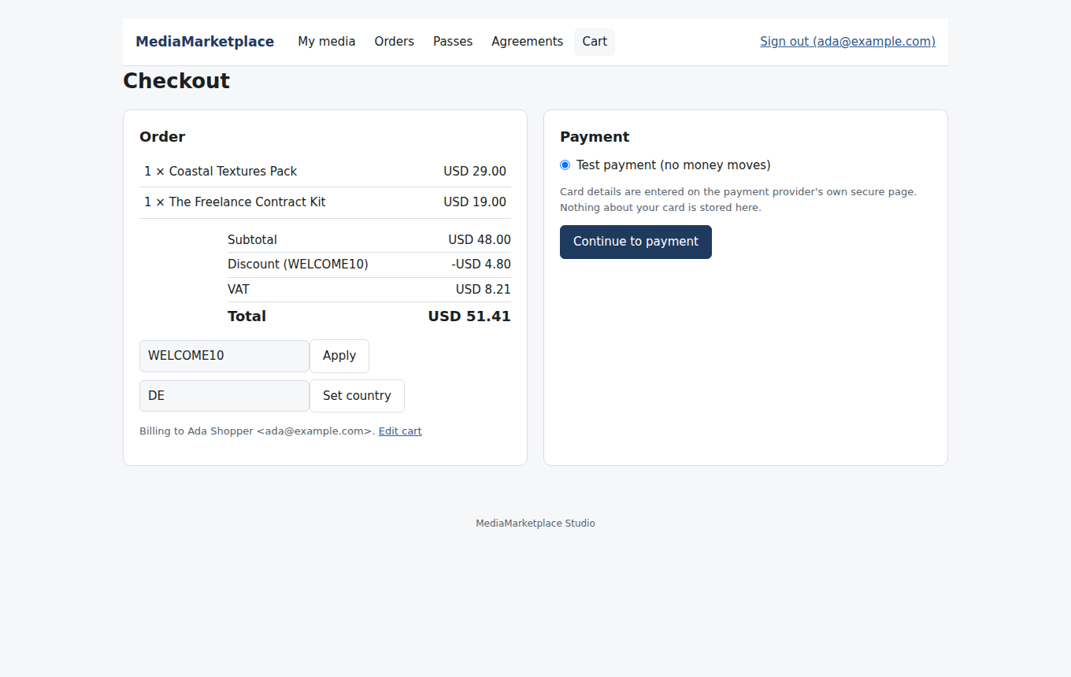
Checkout
While Test payments is on (it is on after installation) a built-in Test payment method is offered. It shows a page with Pay and Decline buttons and moves no money, so you can try the whole flow before entering real keys. Turn it off under Settings → Payments before selling for real.
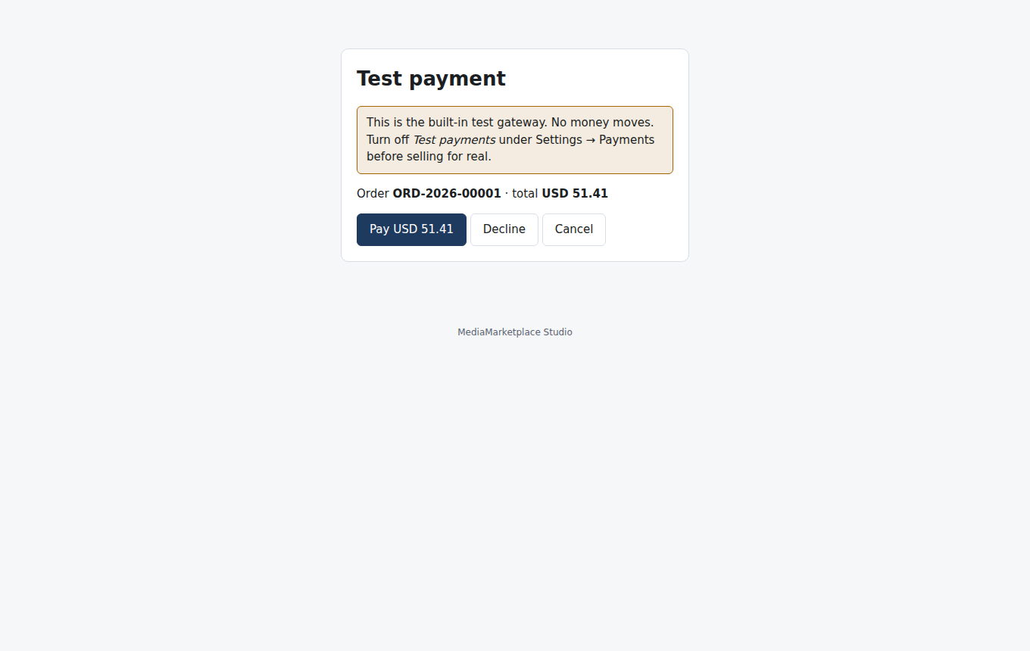
The test payment page
After payment the customer sees the order, a link to the receipt and a button into My media, where everything in the order is now open.
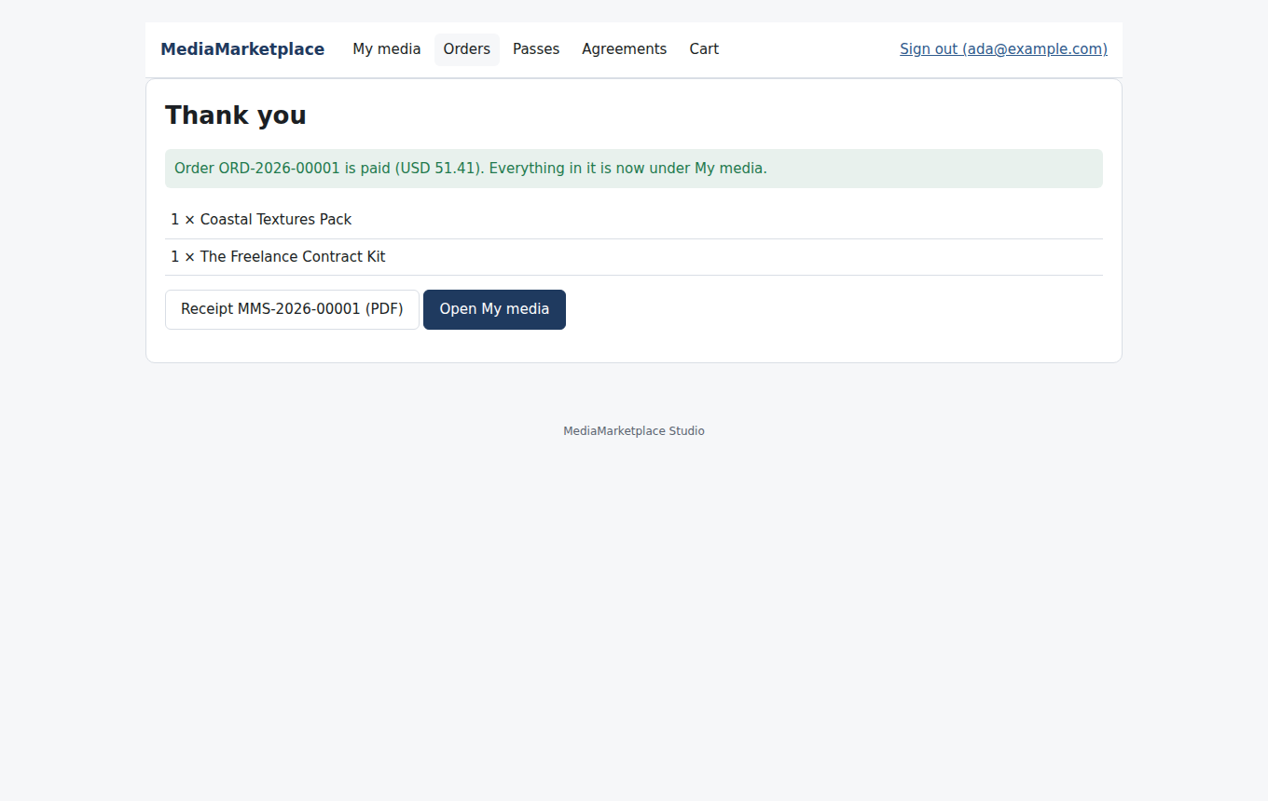
The thank-you page

19. Payment settings
Settings → Payments holds everything the store needs to take money.
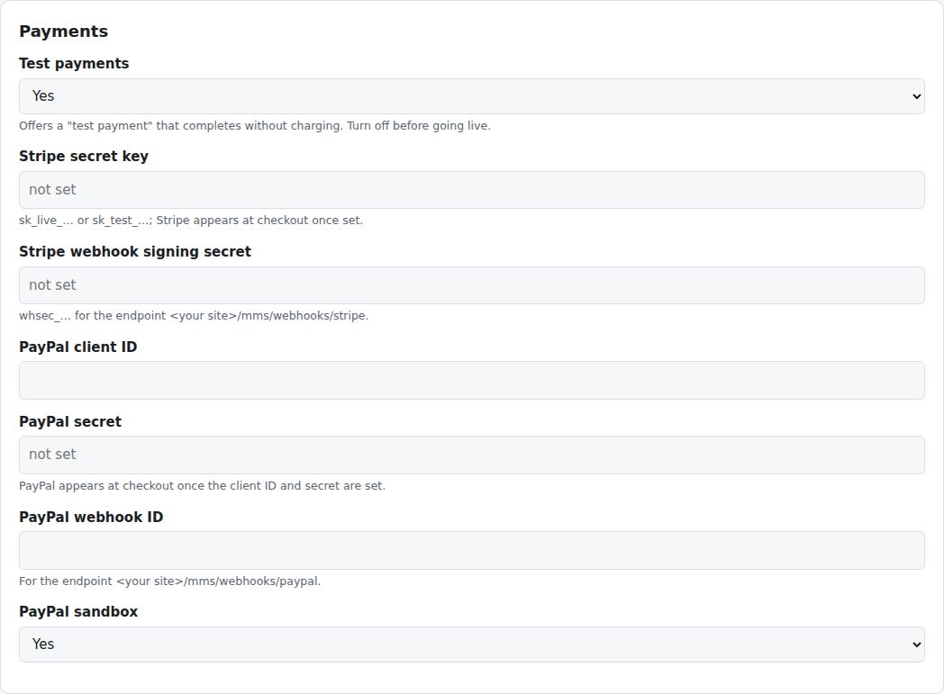
Payment settings
- Stripe (cards, Apple Pay and Google Pay): paste the secret key. Then, in your Stripe dashboard, add a webhook endpoint for https://your-site/mms/webhooks/stripe with the events checkout.session.completed, charge.refunded, invoice.paid and customer.subscription.deleted, and paste its signing secret. Stripe appears at checkout as soon as the secret key is saved; the webhook makes payments that complete after the customer leaves, refunds made in Stripe and subscription renewals reach the store.
- PayPal: paste the client ID and secret from a PayPal app. For live use switch PayPal sandbox off. Add a webhook for https://your-site/mms/webhooks/paypal (events PAYMENT.CAPTURE.COMPLETED and PAYMENT.CAPTURE.REFUNDED) and paste its webhook ID. Recurring passes are sold through Stripe only in this release.
- Square and Authorize.net: see section 23.
- Test payments: the no-money method described above. Off for a live store.
- Receipt prefix and Receipt footer (Settings → Store): receipts are numbered PREFIX-year-sequence; the footer is where your address, VAT number or terms go.
Webhook calls are verified (Stripe signatures, PayPal's verification service) and each event is processed once even if the provider sends it again. The webhook addresses are on your own site; the plugin passes them to the store server like every other /mms/ address, so no extra web server configuration is needed.

20. Orders, refunds and receipts
Orders lists every order with customer, total, status and method, and shows paid orders, revenue, active passes and recurring passes at the top.
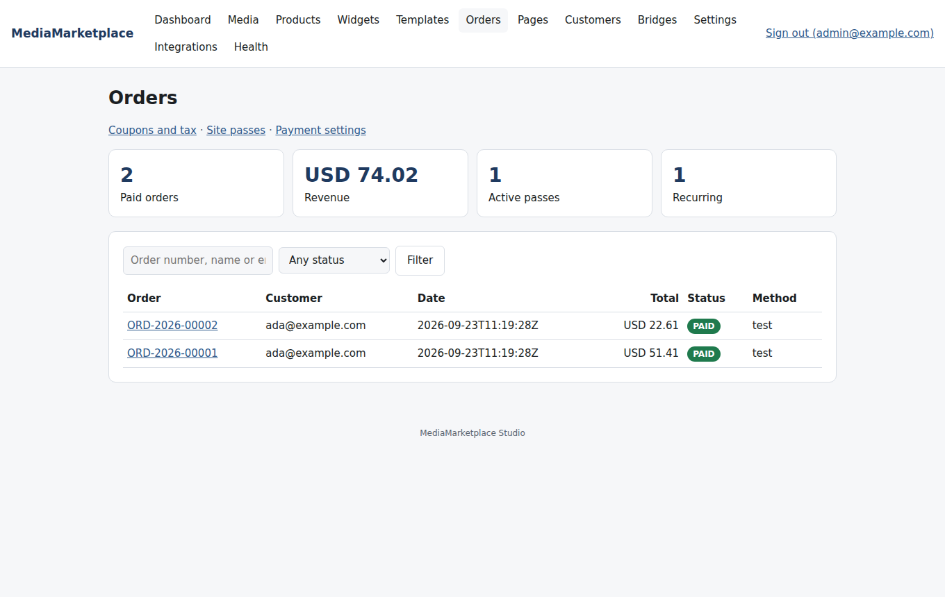
Orders
An order's page shows the items with unit prices, the discount, tax and total, the customer, the payment and the receipt. Refund and revoke access refunds the full amount through the payment provider and takes back everything the order granted.
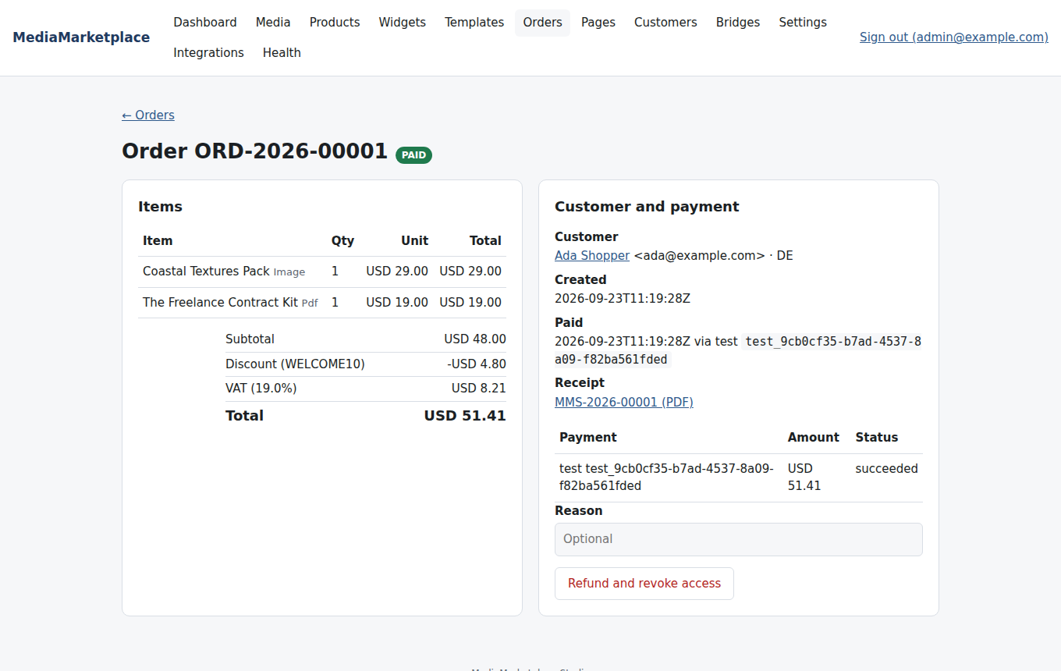
An order
Every paid order gets a receipt with a sequential number, as a PDF and as a web page, available to the customer under My media → Orders and to you from the order. With email configured (section 26) the receipt is also sent with the PDF attached.
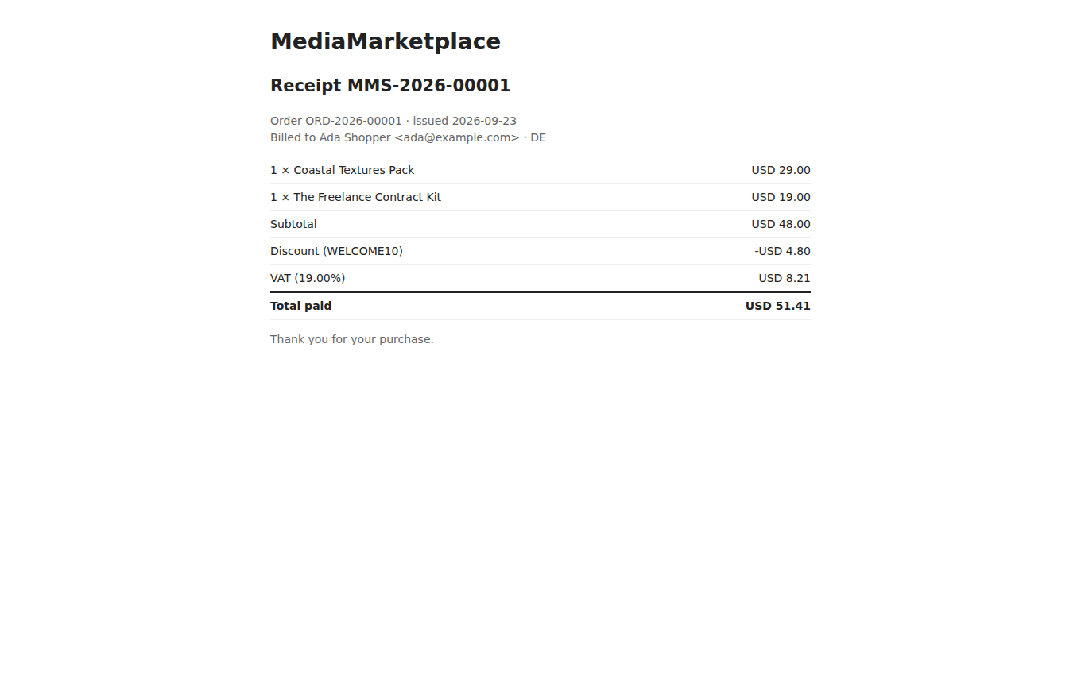
A receipt
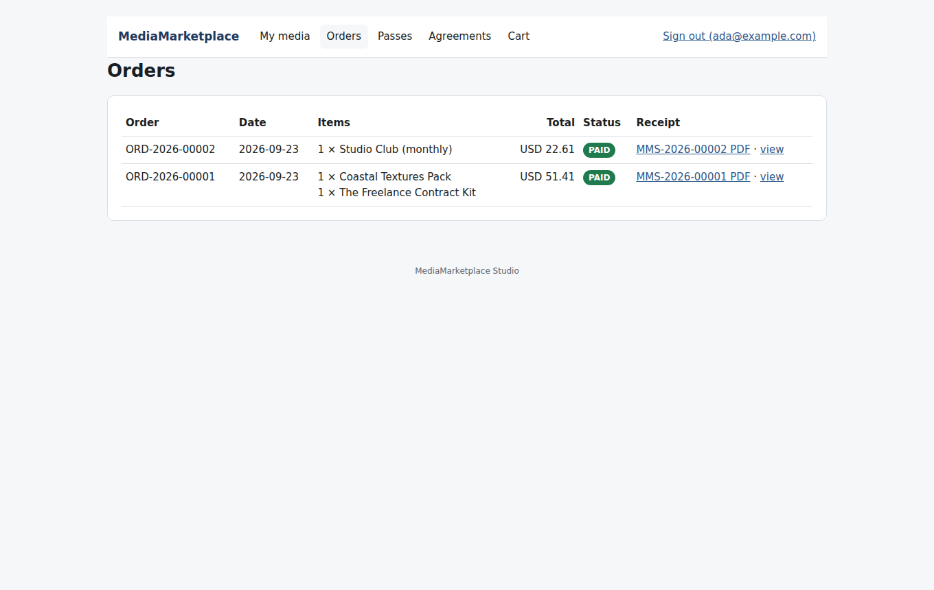
The customer's orders

21. Coupons and tax
Orders → Coupons and tax holds both.
A coupon is a percentage or a fixed amount off the subtotal, with an optional number of uses and expiry date. Disabled coupons stop working immediately. A tax rate is a percentage for a two-letter country code, added to the discounted subtotal at checkout when the customer picks that country. With no rate for a country, no tax is added. The discount is always applied first and tax is calculated on the discounted amount, rounded half up.
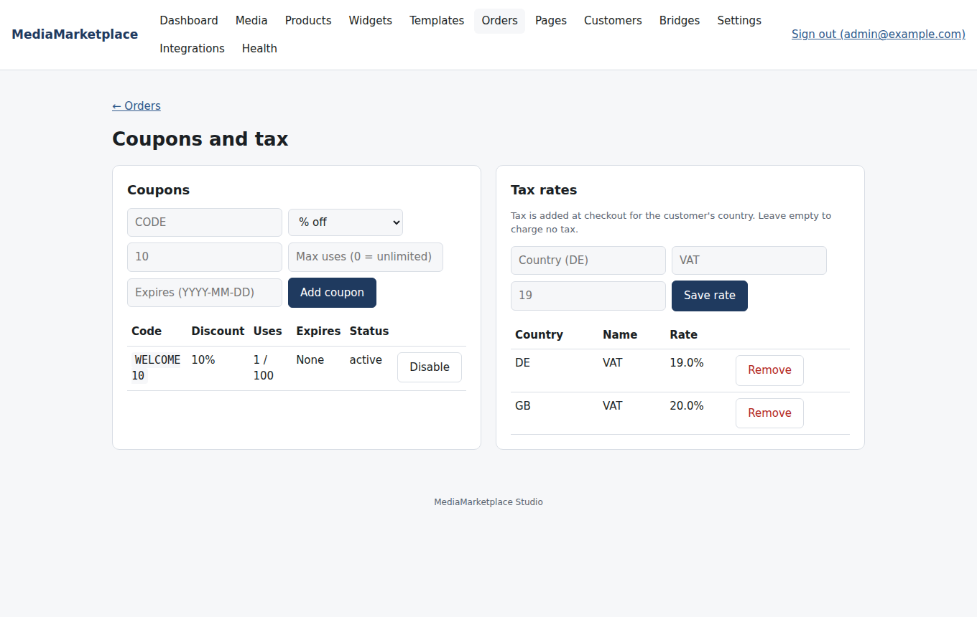
Coupons and tax rates

22. Site passes
A site pass is a product of type Site pass. Its validity is a number of days, a fixed end date, lifetime, or recurring (monthly or yearly, billed through Stripe). Its scope is the whole library or the product's categories. Buying one opens everything in scope under My media until it ends.
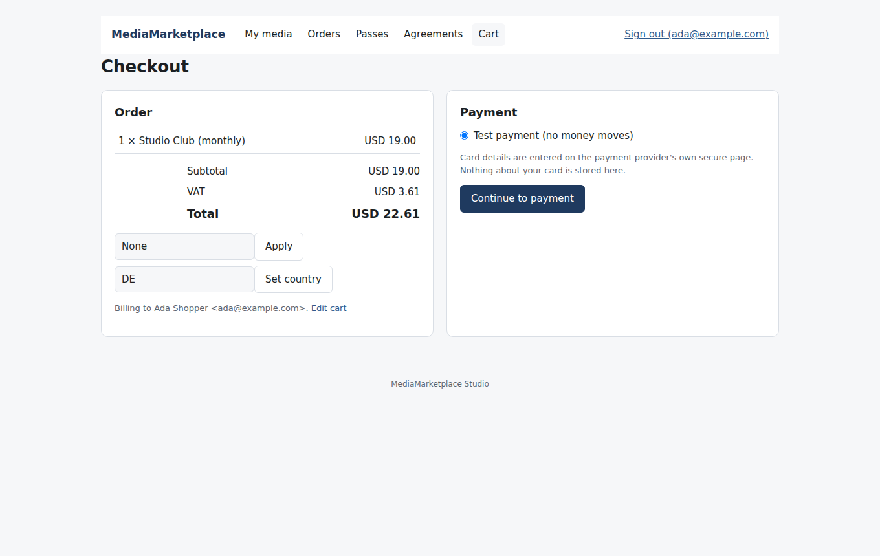
A recurring pass at checkout
Orders → Site passes shows active passes, recurring passes, monthly recurring revenue, passes ending within a week and cancellations in the last 30 days. Each holder can be extended by a number of days or revoked.
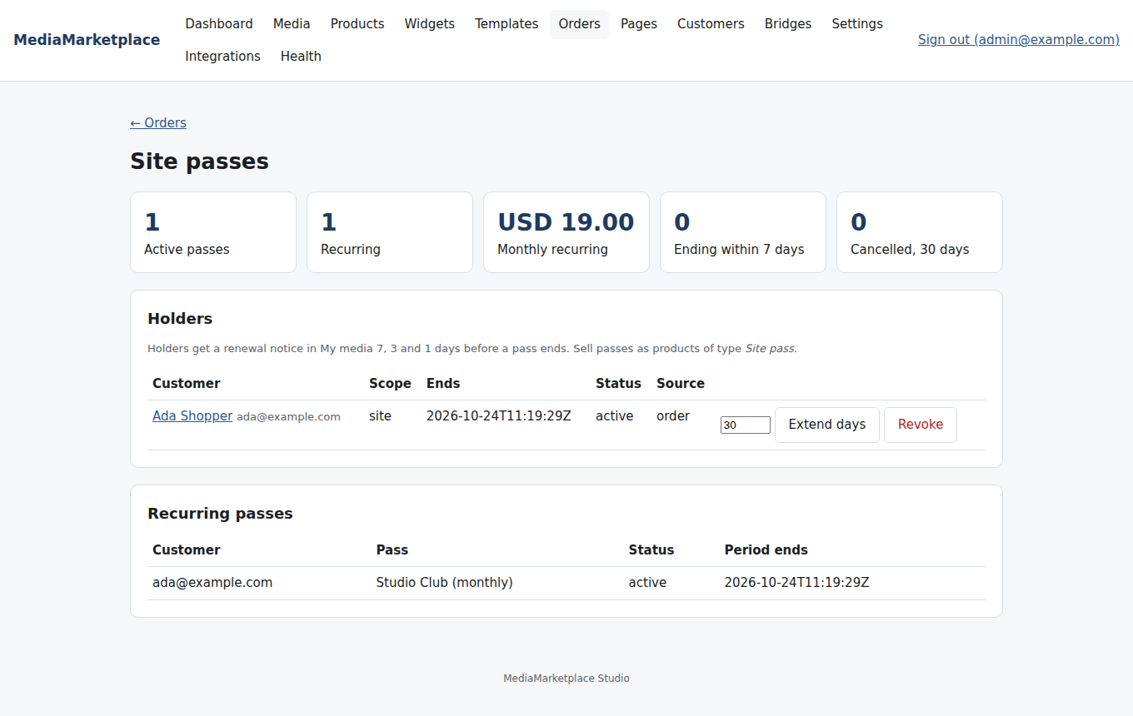
Site passes
Holders see a renewal notice in My media 7, 3 and 1 days before a pass ends, with a Renew now button, and receive the same reminders by email when SMTP is configured. Passes that end are expired automatically after the grace period in Settings → Store. Customers manage recurring passes under My media → Passes: Cancel renewal keeps the pass open until the end of the paid period and stops the next charge.
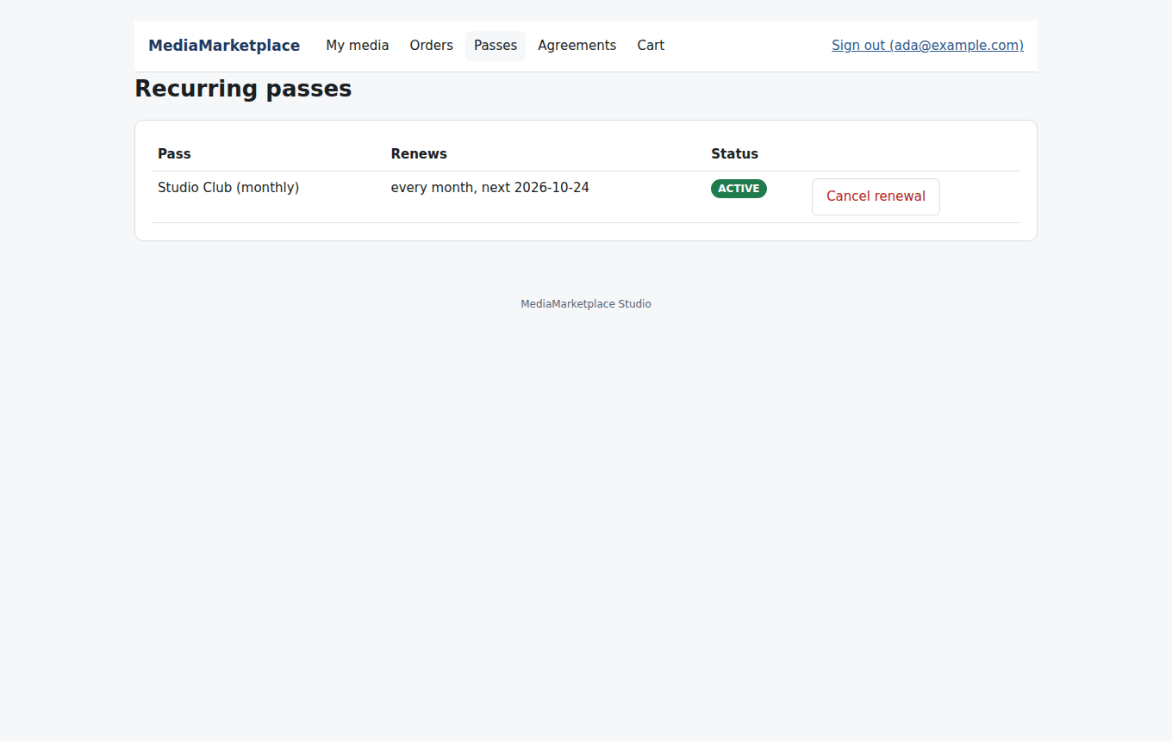
A customer's recurring pass

23. Currencies and more payment methods
Currencies: enter display currencies under Settings → Store (for example EUR,GBP). Rates come from the European Central Bank daily. Shoppers switch currency in the showcase and at checkout; prices show as approximate conversions. Switch on Charge in the shopper's currency to have Stripe and PayPal charge the converted amount; the order keeps the base currency and the rate used, and reports stay in your base currency.
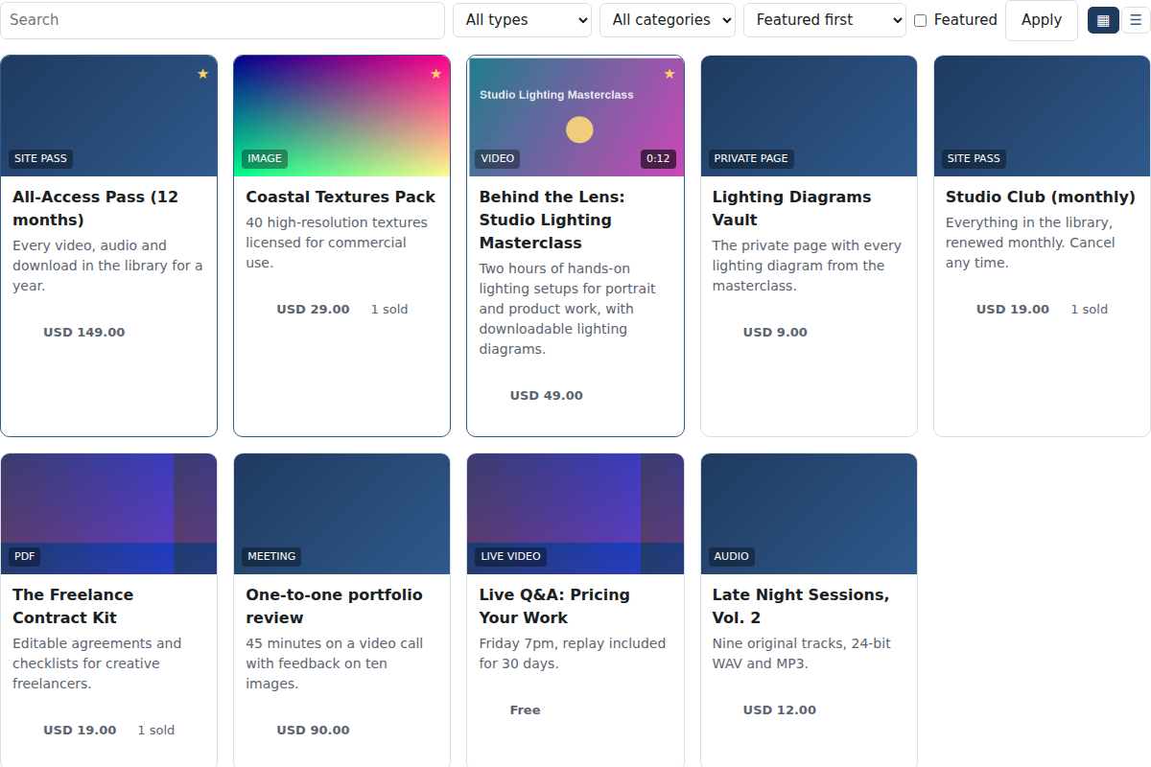
The showcase shown in euros
The same showcase in pounds
Square (cards, Apple Pay, Google Pay) and Authorize.net join Stripe, PayPal and the test method under Settings → Payments. Both take the card in the browser with the provider's own component and send only a token to the store. Square needs the access token, location id and application id; Authorize.net the API login id, transaction key and public client key. Refunds go back through the provider. Recurring passes stay with Stripe.
Apple Pay on your own domain: paste the domain association file from Stripe or Square into Settings → Payments; the plugin serves it at the .well-known address Apple checks, so nothing needs to be uploaded to the web server by hand.

23b. Selling through WooCommerce (optional)
The store's own checkout is the default. If you already run WooCommerce on this site you can let it take the money instead: Buy buttons then add the linked WooCommerce product to the WooCommerce cart, WooCommerce takes the payment with its own methods, coupons and tax, and the store grants access and issues the receipt when the order is paid. Refunds and cancellations in WooCommerce take the access back. Switching back takes one click.
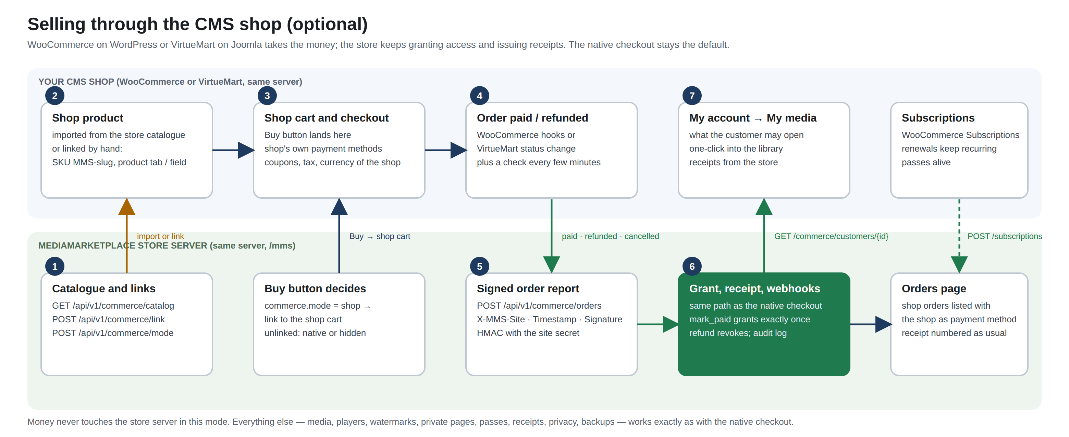
How selling through WooCommerce works
Open MediaMarketplace → WooCommerce (it appears when WooCommerce is active), click Import store products into WooCommerce, then Sell through WooCommerce. Any WooCommerce product can also be linked by hand under Product data → MediaMarketplace. Customers find what they bought under My account → My media; WooCommerce Subscriptions keep recurring passes alive.
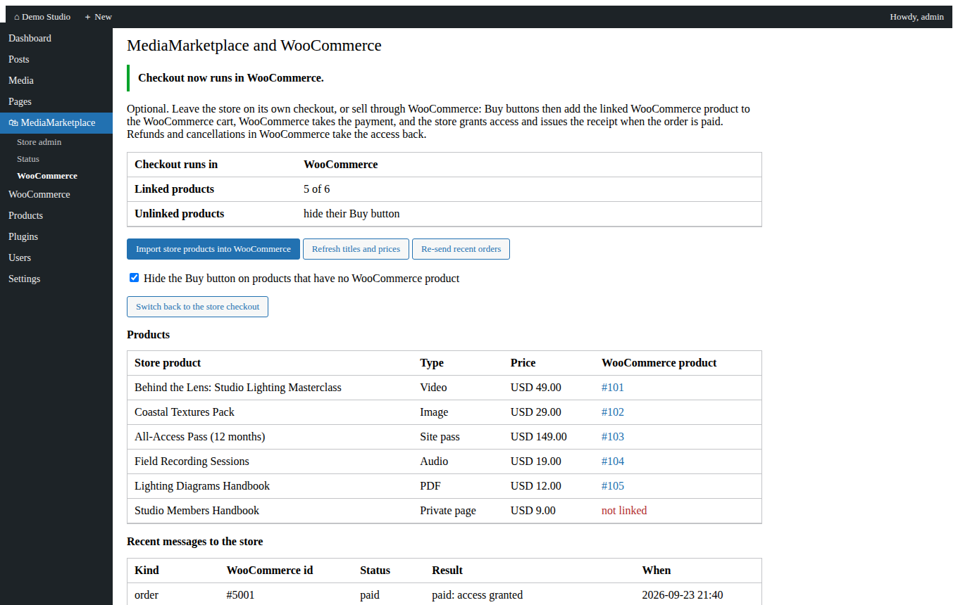
The MediaMarketplace → WooCommerce page (mock-up)
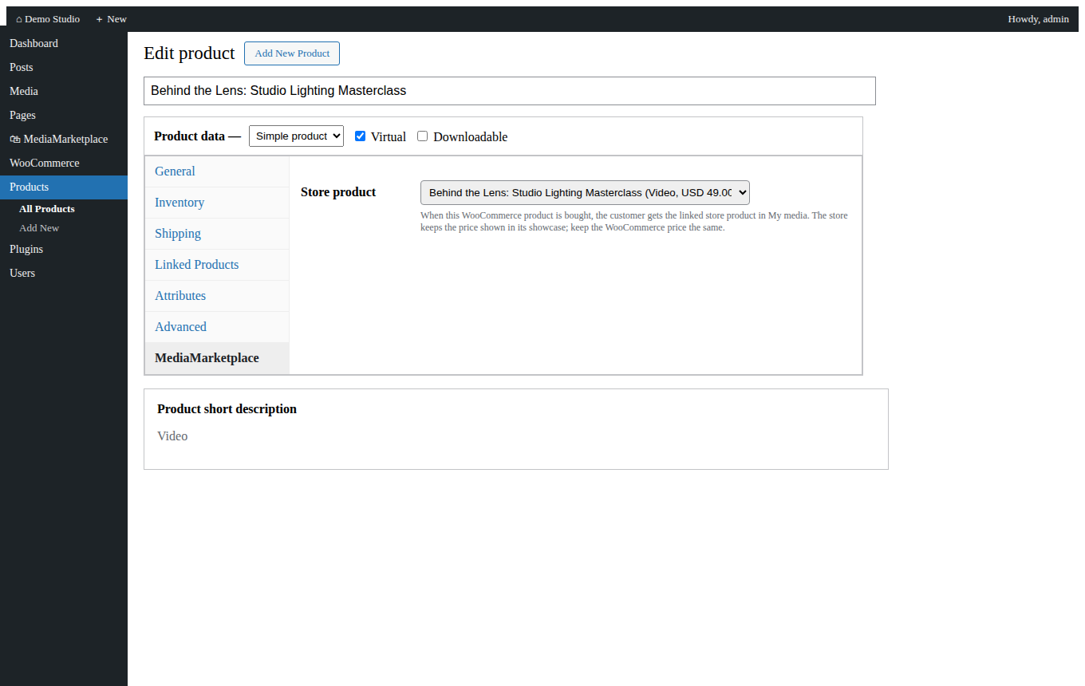
Linking a WooCommerce product to a store product (mock-up)
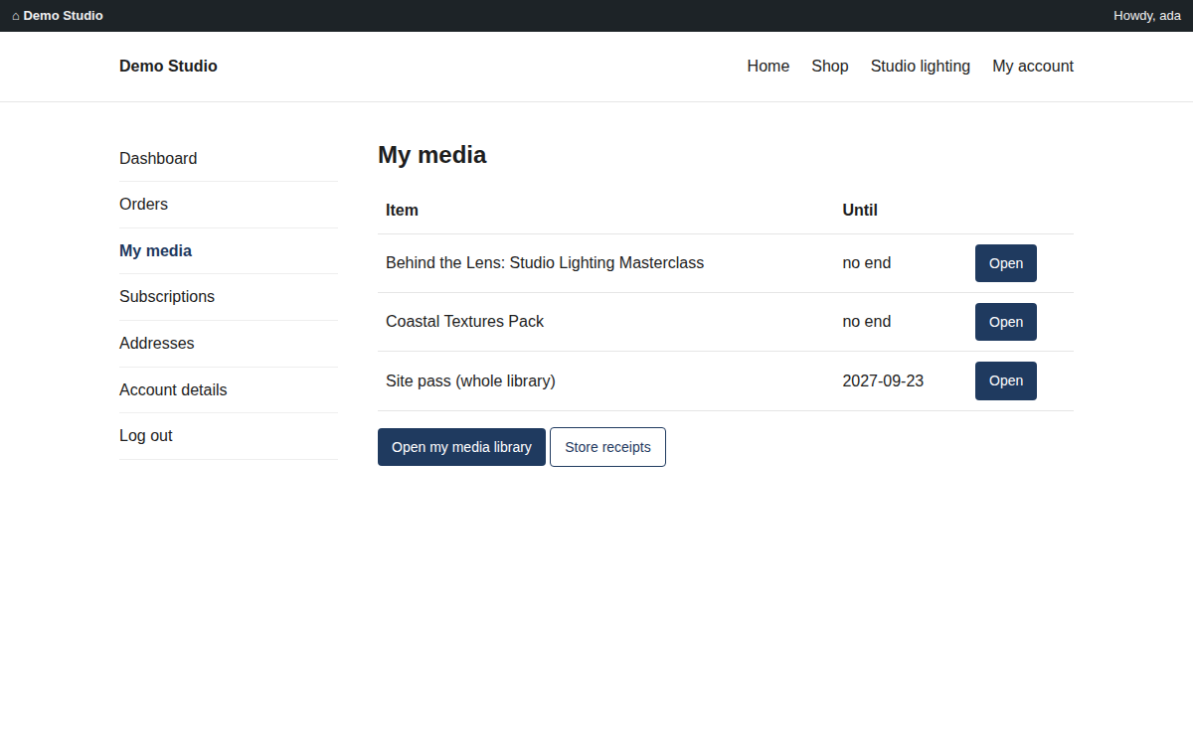
My account → My media (mock-up)
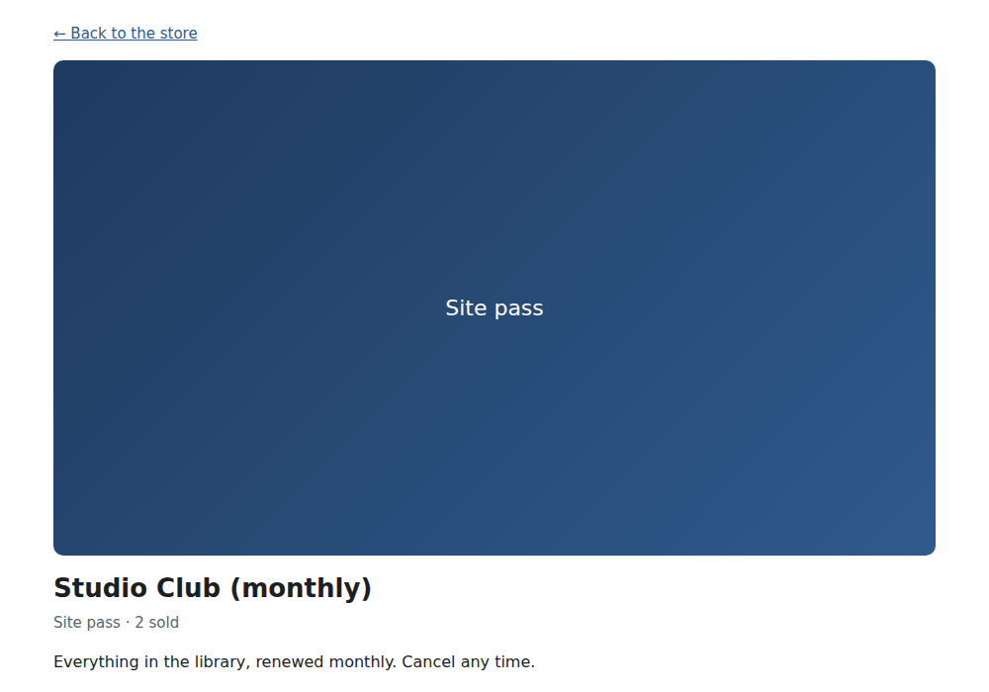
The store's product page with Buy pointing at the shop's cart
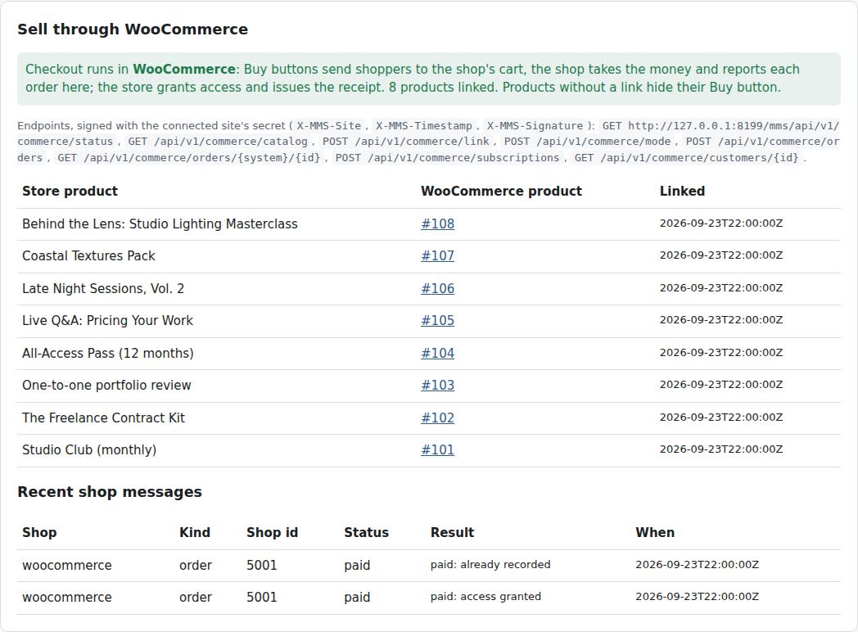
Integrations → Sell through in the store admin
The Commerce Integration Guide covers the set-up step by step, the customer experience, the signed API the shop uses and troubleshooting.

24. Private pages
A private page is content that a visitor sees only after signing an agreement, and for paid pages, after paying. The diagram shows every decision the gate makes.
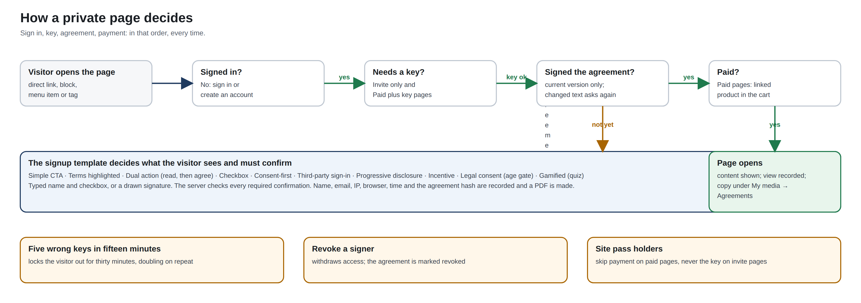
How a visitor reaches a private page: sign in, key, agreement, payment
Create one under Pages: title, content (headings, lists, bold, links), the agreement text, a signup template, a protection level and, for paid pages, the linked product of type Private page whose price the visitor pays.
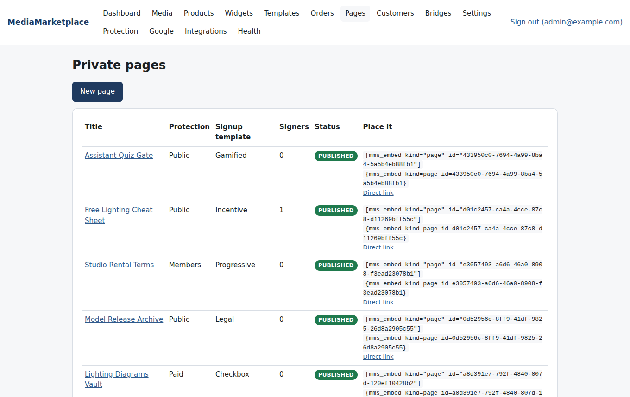
The pages list
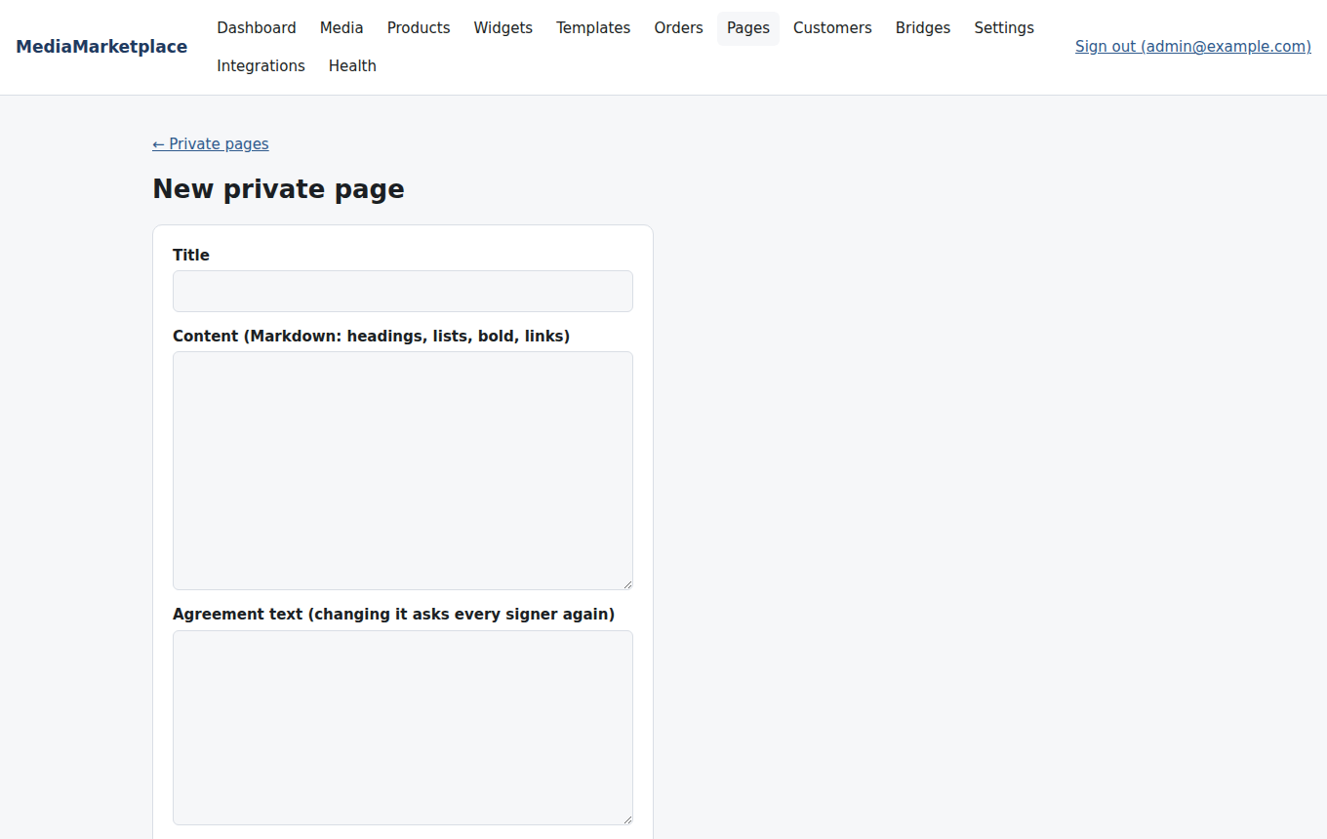
A new private page
Protection levels: Public with agreement (anyone with an account who signs), Site members only, Paid, Paid plus access key, Invite only (access key). Access keys are generated on the page, shown once and stored hashed; each has a number of uses and an optional expiry. Five wrong keys in fifteen minutes lock the visitor out for thirty minutes, doubling on repeat (Settings → Access control).
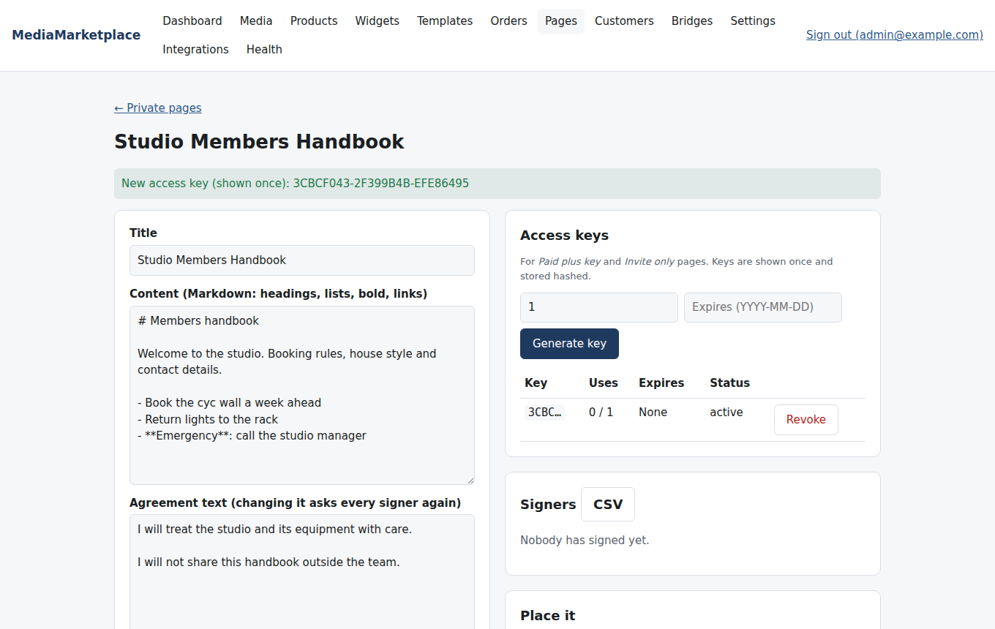
Access keys and signers
The ten signup templates decide how the agreement is presented and what the visitor must confirm. The server checks the confirmations, whichever template is used.
Template | What the visitor sees
Simple CTA | the agreement, a name field and one button
Terms highlighted | the agreement's paragraphs as highlighted bullets
Dual action required | "I have read" must be ticked before "I agree" appears
Checkbox confirmation | the button stays disabled until the box is ticked
Consent-first | a consent statement first; the form appears after it is ticked
Third-party sign-in | sign in with the WordPress account first, then agree
Progressive disclosure | the agreement is revealed section by section; reading to the end is required
Incentive-based | the bonus the signup unlocks, above the agreement
Legal consent | jurisdiction text, an age gate and consent purposes
Gamified entry | progress steps and an optional quiz question

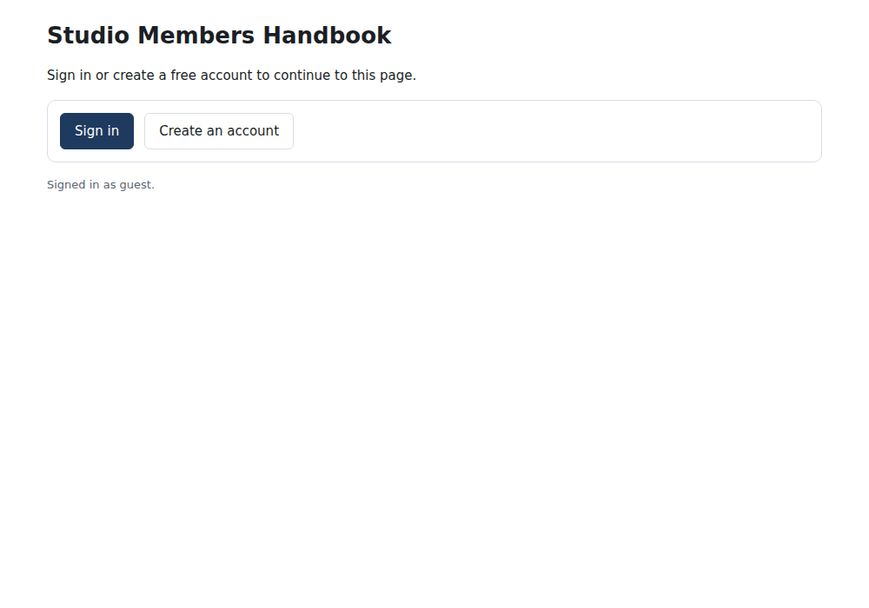
Visitors without an account are asked to sign in
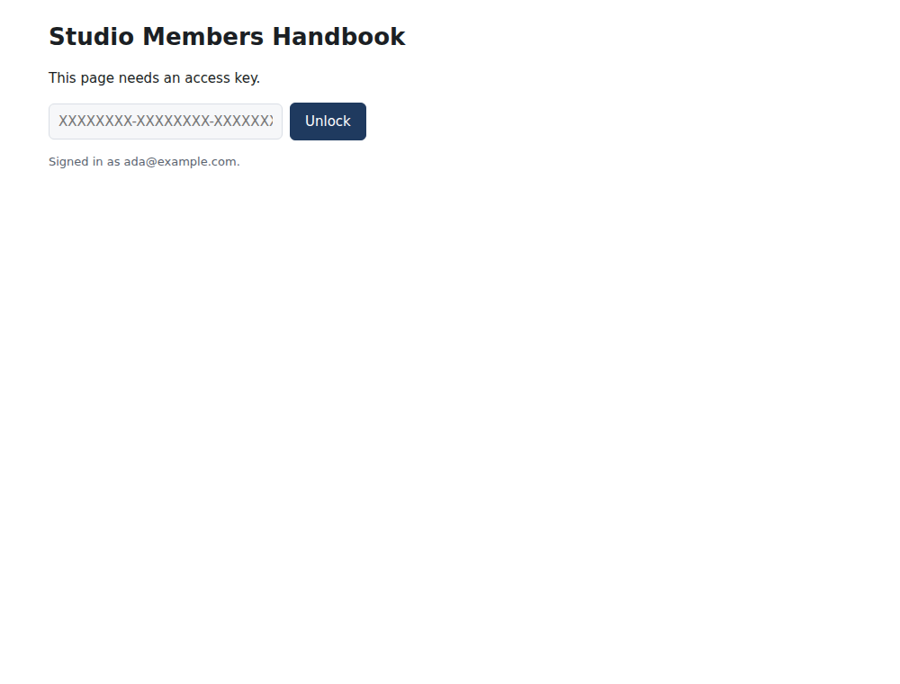
An invite-only page asks for the key
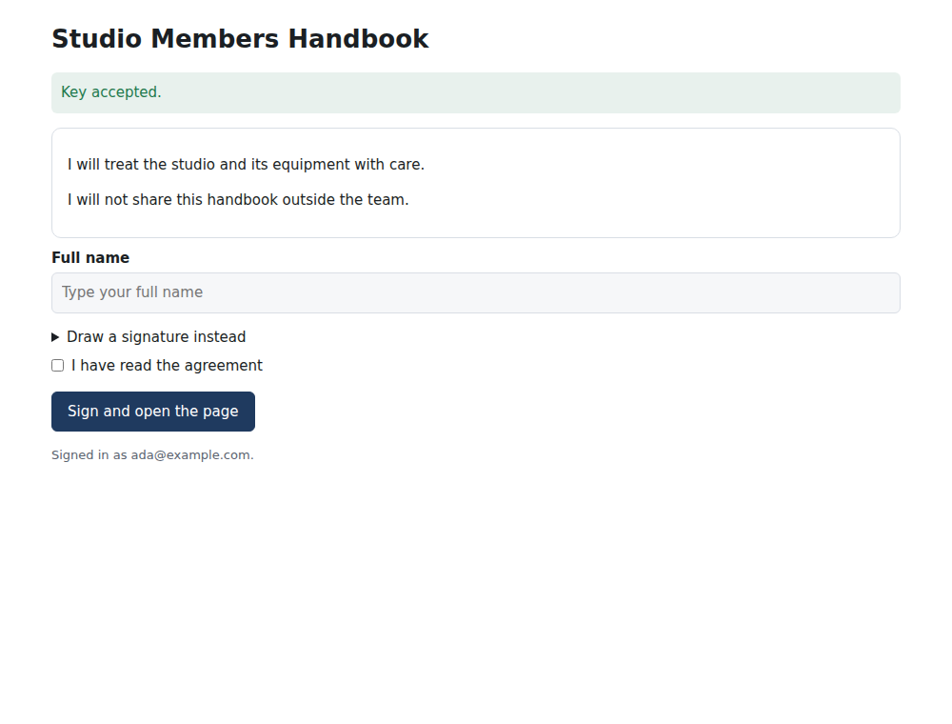
Dual action: read first
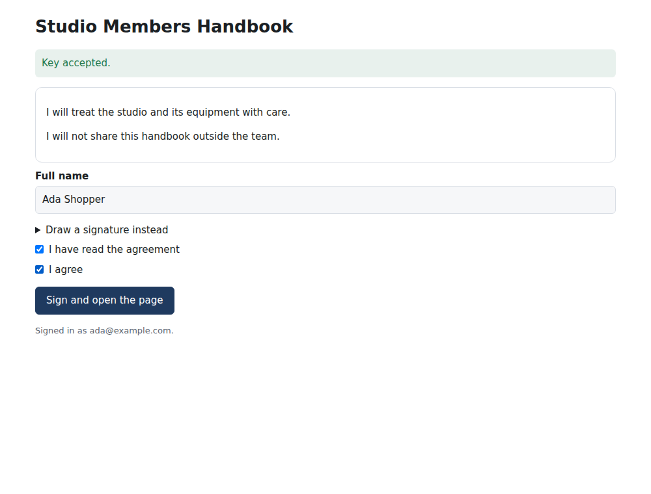
Dual action: then agree
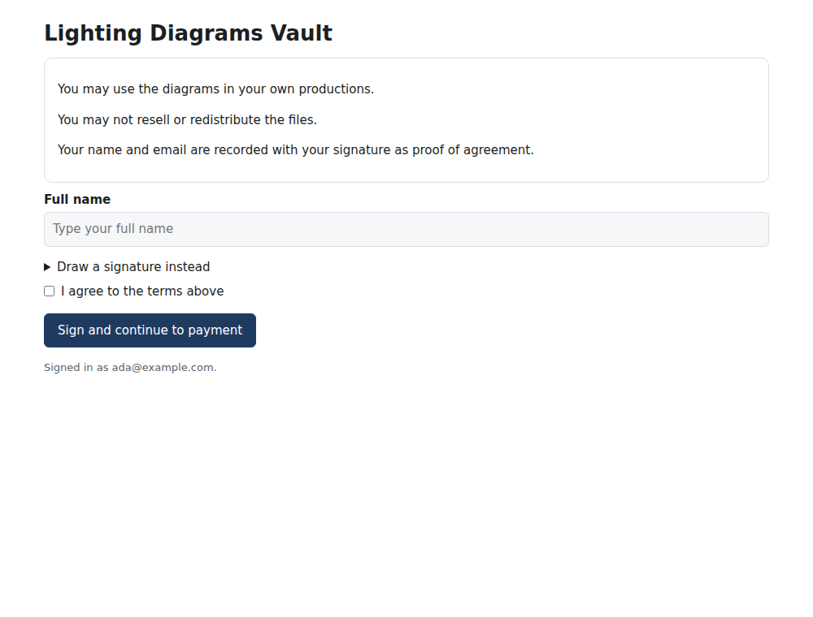
Checkbox confirmation on a paid page
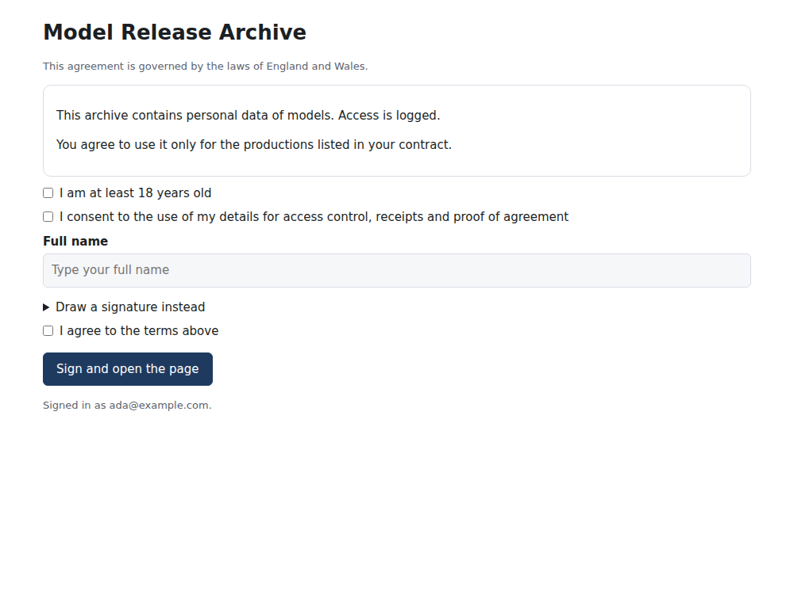
Legal consent with an age gate
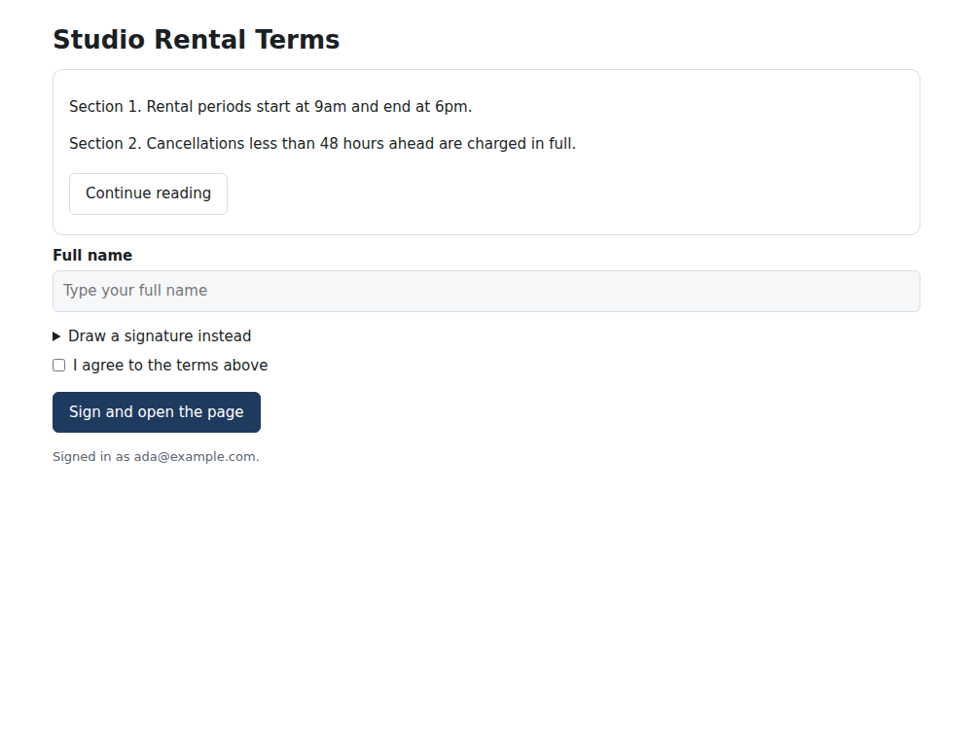
Progressive disclosure
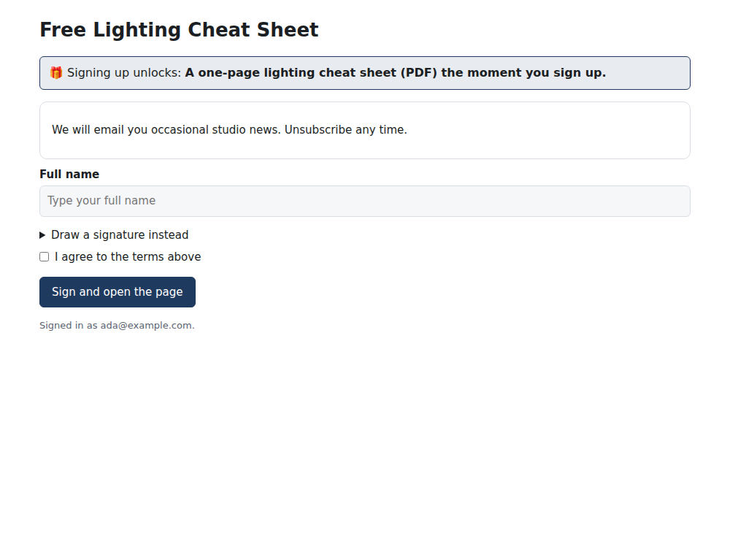
Incentive-based signup
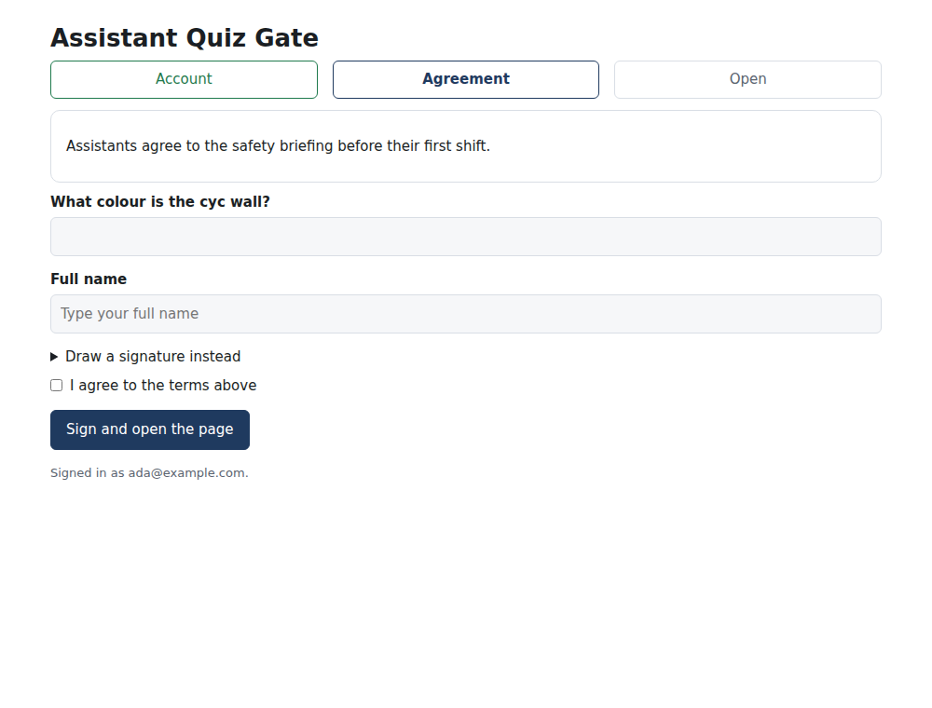
Gamified entry with a quiz question
Visitors sign by typing their full name and ticking the confirmations, or by drawing a signature. The name, email, IP address, browser, time, the confirmations and a hash of the agreement text are recorded, and a PDF of the signed agreement is generated. The customer keeps a copy under My media → Agreements; you keep every signature on the page with a CSV export.
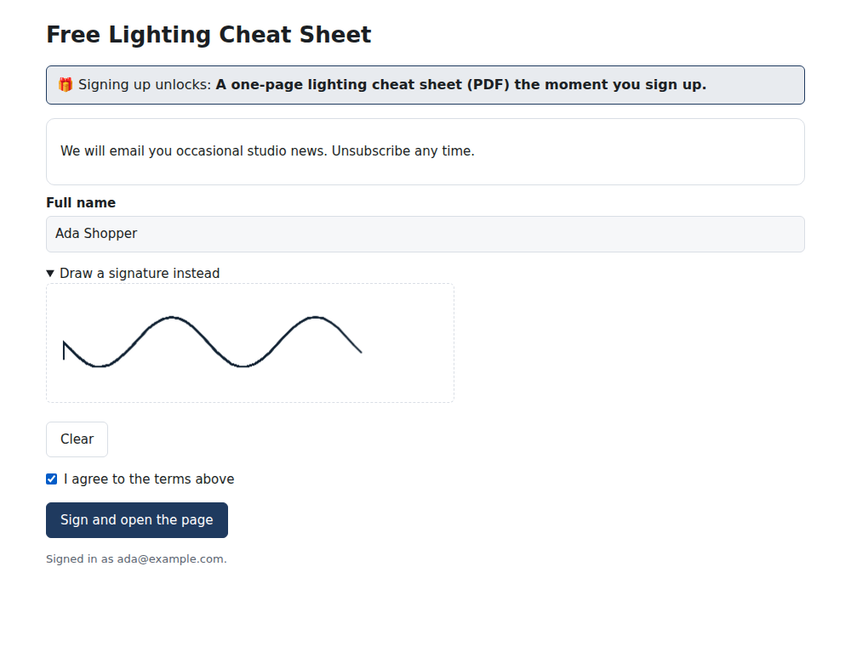
A drawn signature
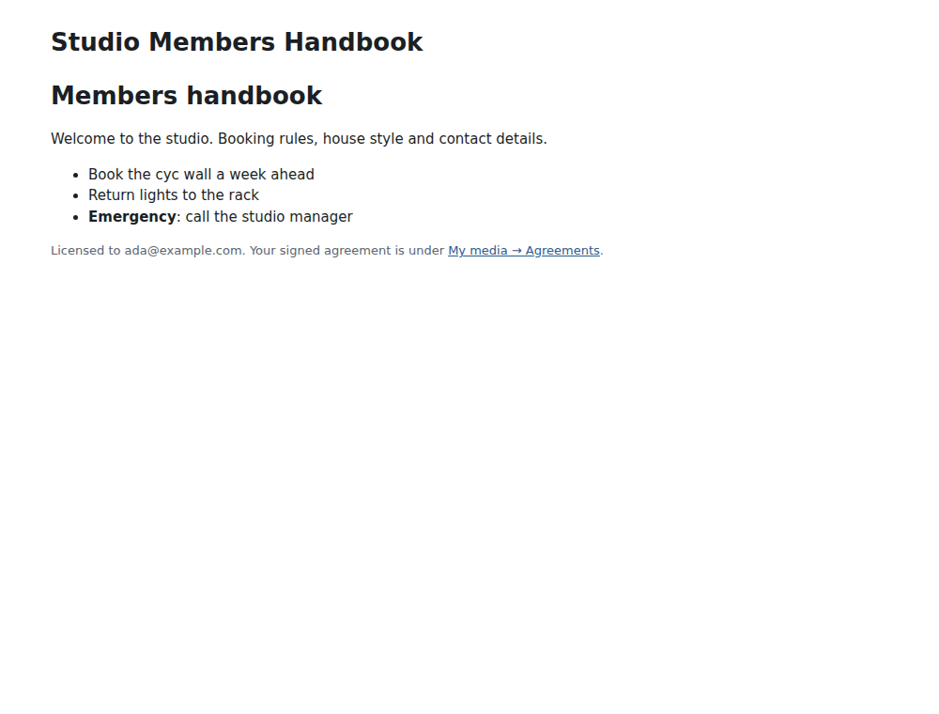
The page once signed
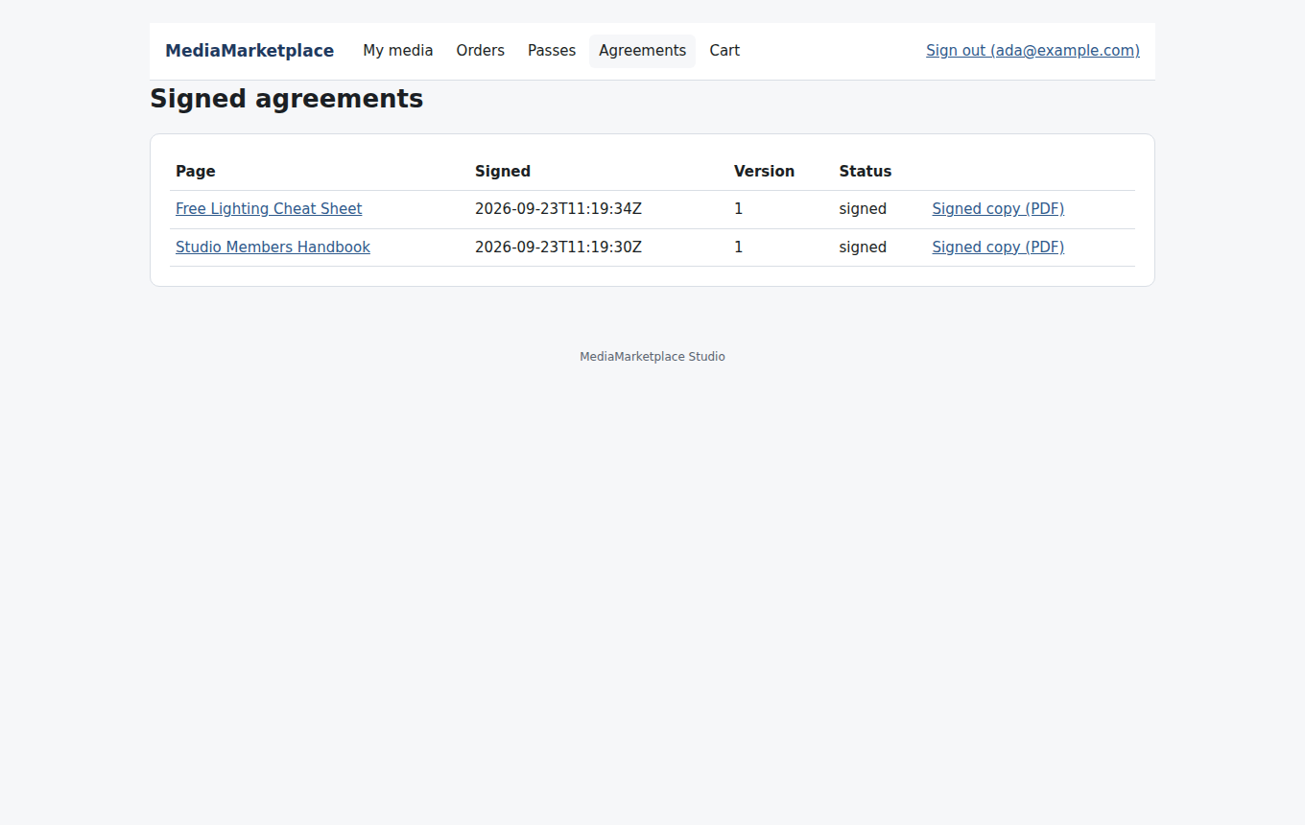
The customer's signed agreements
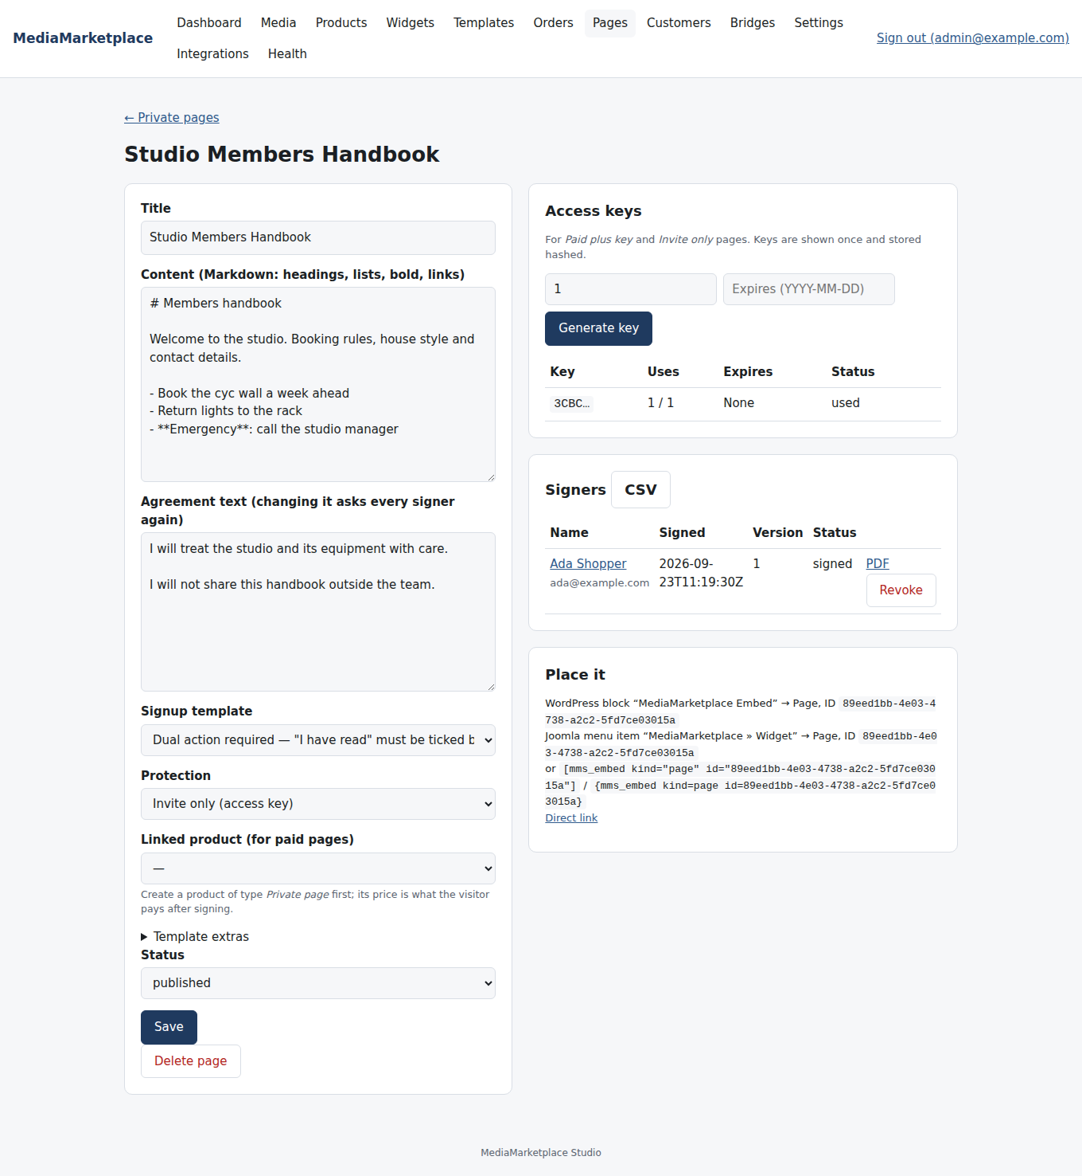
Signers on the page, with revoke and CSV
For paid pages the visitor signs first and is then sent to checkout with the linked product in the cart; the page opens once the order is paid. Site pass holders open paid pages without paying again. If you change the agreement text, every signer is asked to sign the new version before they see the page again. Revoke on a signer withdraws their access. Every gate decision, signature, key use and lockout is written to the audit log.
Placing a private page. Use the MediaMarketplace Embed block set to Private page with the page ID, or [mms_embed kind="page" id="…"], or link to the page's own address shown on its admin page. The gate and the content both appear inside your WordPress page.
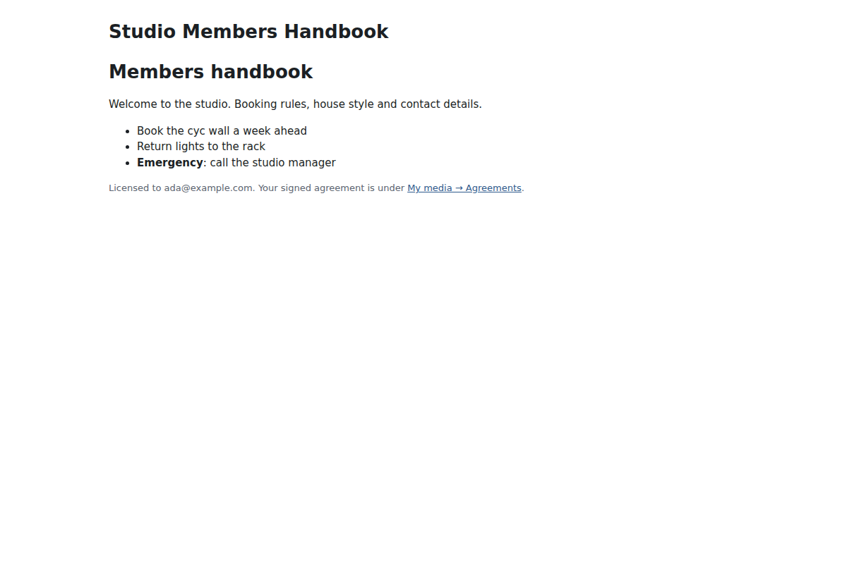
A private page embedded in a site page

25. Integrations: API keys and webhooks
Integrations connects other systems.
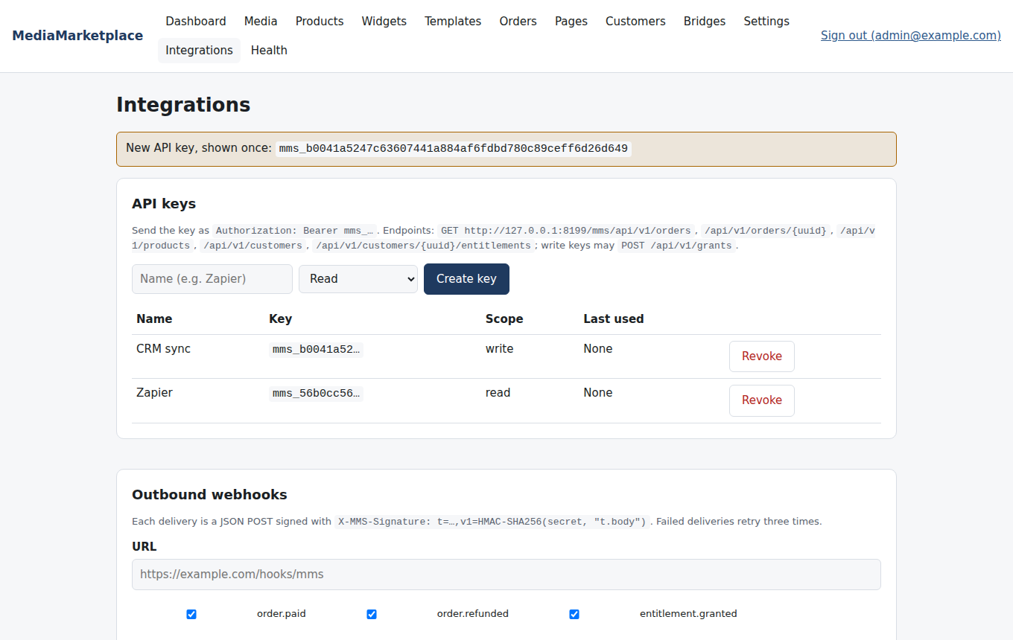
API keys and outbound webhooks
API keys are shown once and stored hashed. Send one as Authorization: Bearer … to read orders, products, customers and a customer's access. A key with write scope may also grant access to a customer, which is what an automation platform needs to give someone a product after an event elsewhere. The API lives at your site address followed by /mms/api/v1/.
Outbound webhooks send a signed JSON message to a URL when an order is paid or refunded, access is granted, an agreement is signed, or a recurring pass renews or ends. Each endpoint has its own signing secret; failed deliveries are retried three times and every delivery is listed with its result. Send a test event checks a new endpoint.

26. Email
Under Settings → Email enter your SMTP host, port, credentials, From address and encryption. Many WordPress sites already use an SMTP service for their own mail; the store needs the same details entered here, because it sends its own mail.
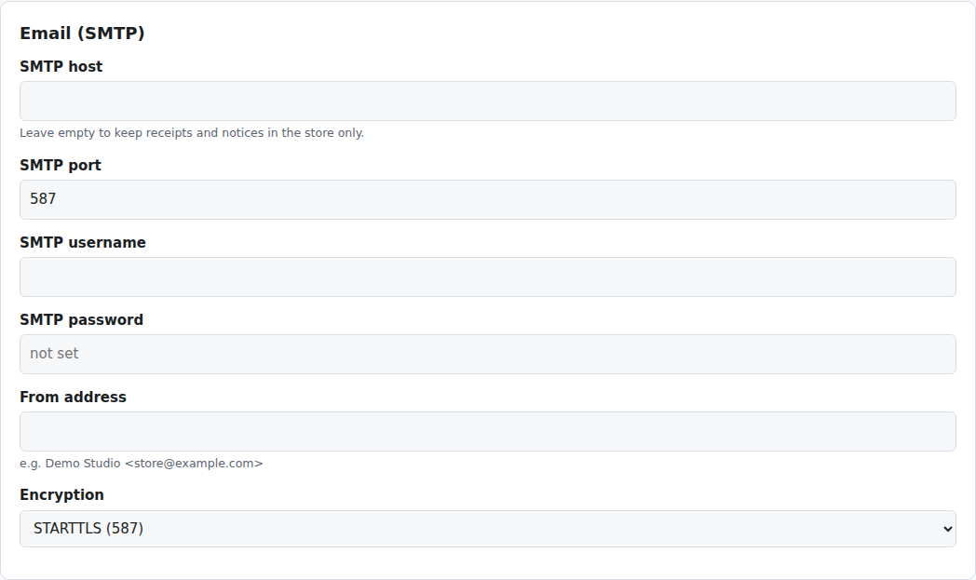
Email settings
From then on receipts are emailed with the PDF attached, signers receive their signed agreement, and site pass holders get the 7, 3 and 1 day reminders. Without SMTP nothing is lost: all of it stays in the store under My media. Send a test email lives on the Integrations page.
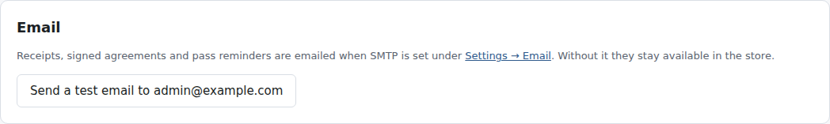
The email section on the Integrations page

27. Google Business Profile
Google in the store admin connects your Google Business Profile with your own Google Cloud OAuth client (enter it under Settings → Google Business Profile; the redirect address is shown on the page). After Connect Google account and Sync, your locations appear with a map preview (Maps API key optional).
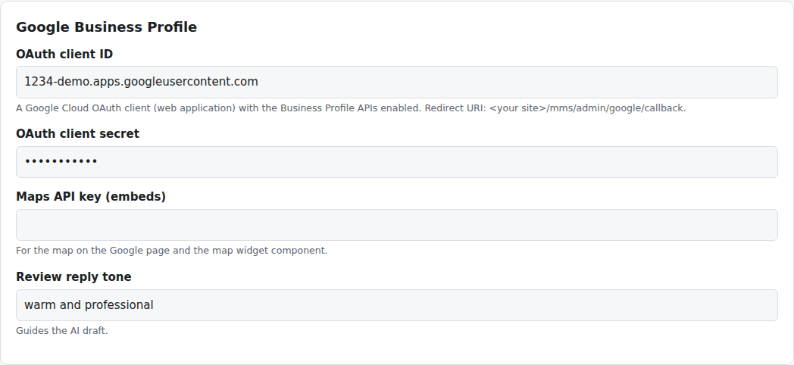
Google Business Profile settings
Posts: write a post with an optional button and photo, save it as a draft, schedule it for a date and time, or publish it now. Scheduled posts go out from the background worker. Reviews are synced with their ratings. Draft with AI writes a reply in your chosen tone using your Anthropic API key (Settings → AI); you edit and Approve and post. Nothing is ever posted without your approval.
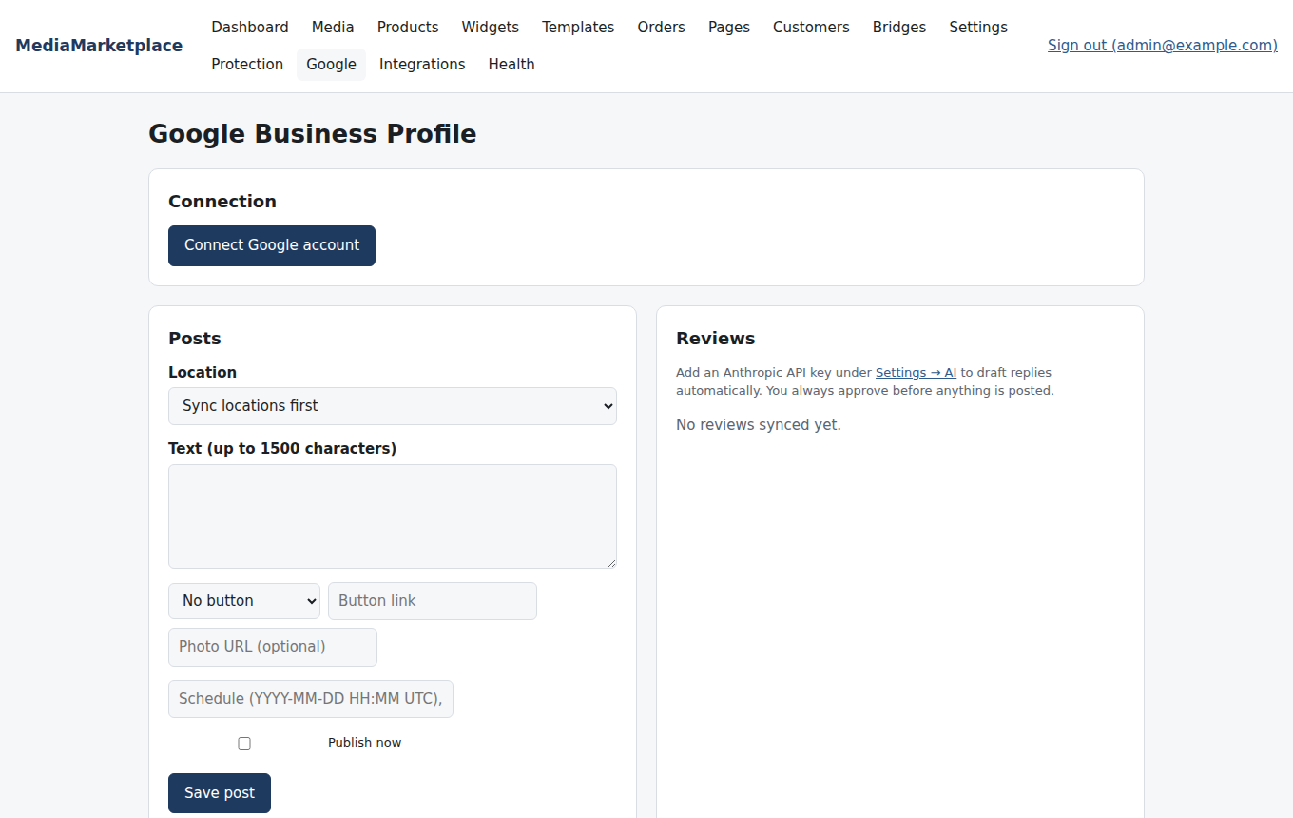
The Google Business Profile page before connecting

28. Protection and forensic watermarks
Protection in the store admin controls how images and videos are guarded and identifies leaked copies. The diagram shows how a mark gets into a file and how it comes back out.
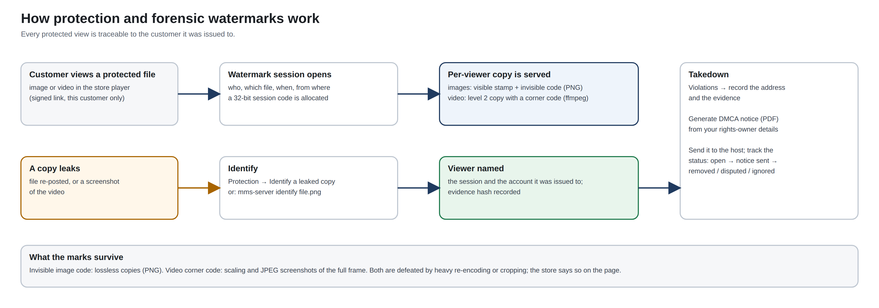
From a protected view to an identified leak
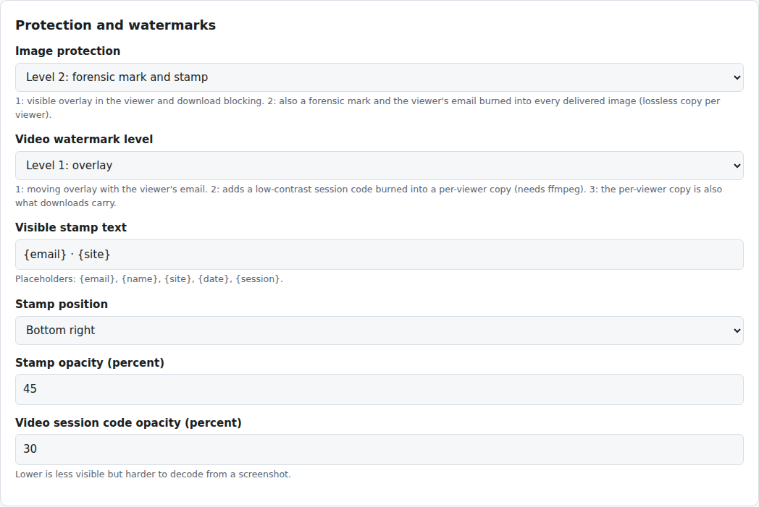
Protection and watermark settings
Image protection levels (Settings → Protection and watermarks):
- Level 1: the viewer shows images inside a shield that blocks right-click, drag and selection, with the viewer's email in the corner; files are served inline only.
- Level 2: every image delivered to a signed-in viewer is a copy made for that viewer: the stamp text (by default the viewer's email and the store name, position and opacity of your choice) is burned into the picture and an invisible session code is hidden in the pixels. The copy is kept and reused, so a viewer always gets the same file.
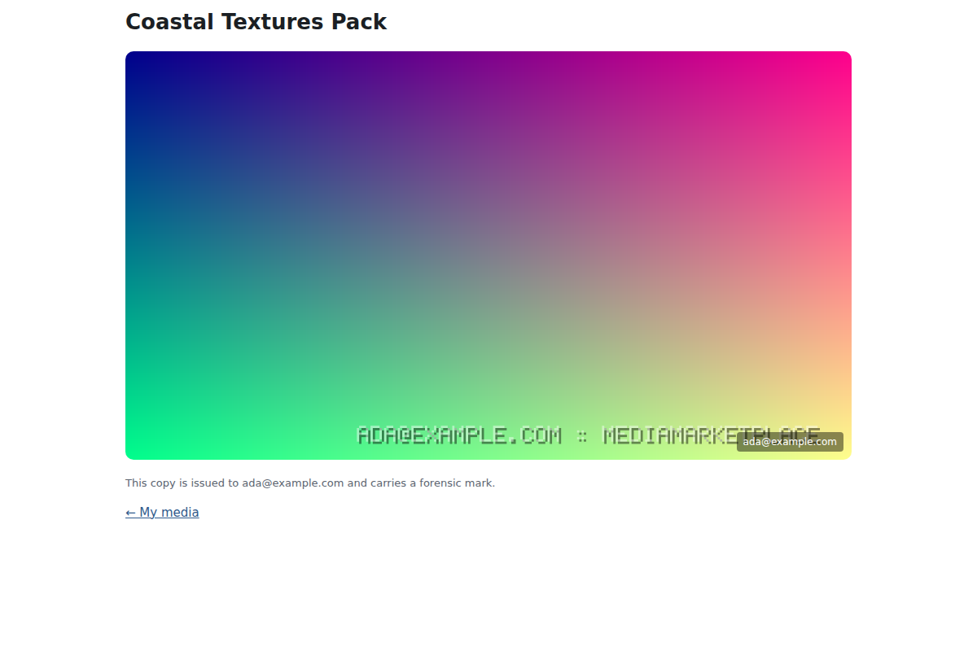
A protected image in the viewer: the shield, the burned-in stamp and the corner label
Video watermark levels:
- Level 1: the moving overlay with the viewer's email in the player (re-added if a script removes it).
- Level 2: the server also produces a copy of the video per viewer with a low-contrast session code in the bottom-right corner (needs ffmpeg on the server; until the copy is ready the level 1 overlay is used). The code survives scaling and screenshots.
- Level 3: downloads are the per-viewer copy as well.
Every protected view opens a watermark session that records viewer, media, time and address. Identify a leaked copy takes an uploaded image or a full-frame screenshot and names the session and viewer it was issued to. Marks survive lossless copies, scaling and JPEG screenshots; heavy re-encoding or cropping the corner defeats the video code, and the page says so plainly.
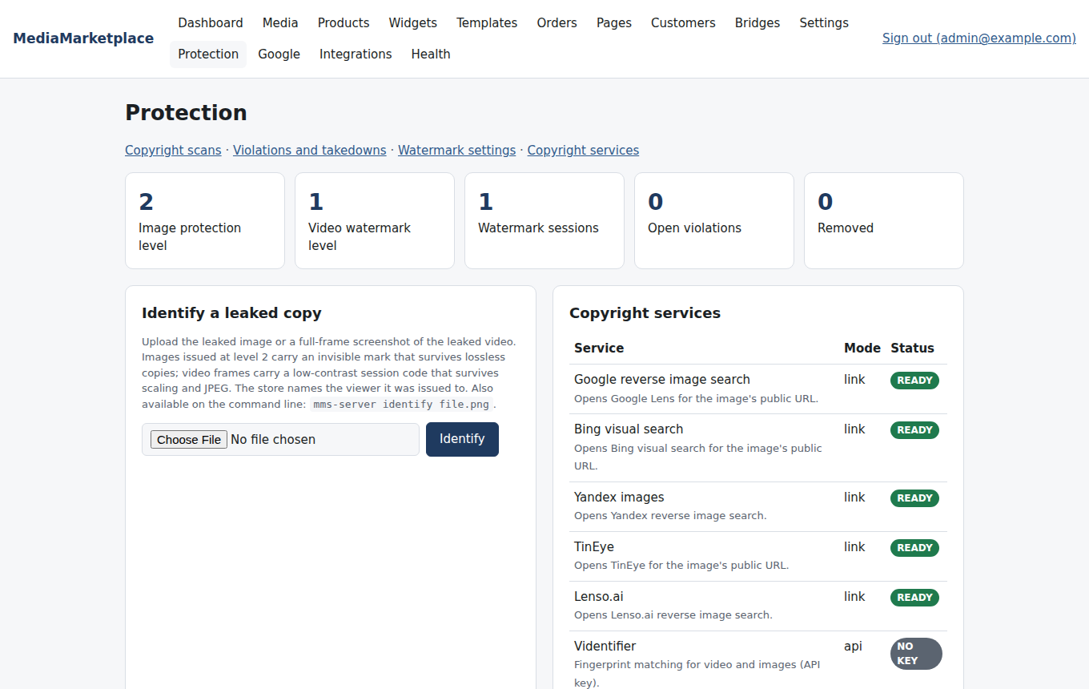
The Protection page
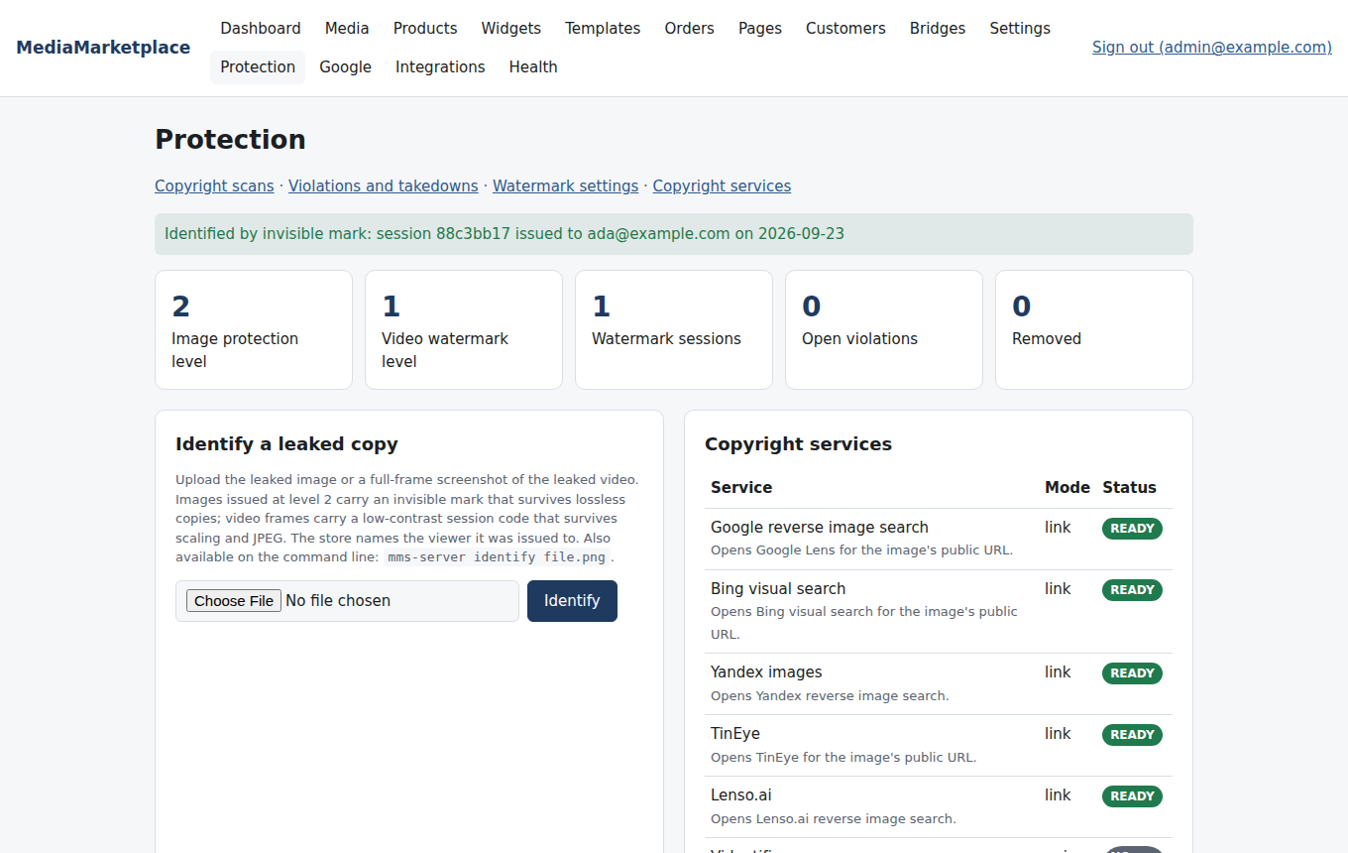
The Protection page after identifying a leaked copy

29. Copyright scans, violations and takedowns
Protection → Copyright scans prepares a reverse image search for any media file at Google, Bing, Yandex, TinEye and Lenso, and keeps a history of what you checked and found. API services (Videntifier, ScoreDetect, Copysentry, DMCA.com, Bolster.ai, Oxylabs, Urlbox) keep their keys encrypted under Settings → Copyright services and are shown with their status; submissions go through each service's own dashboard in this release.
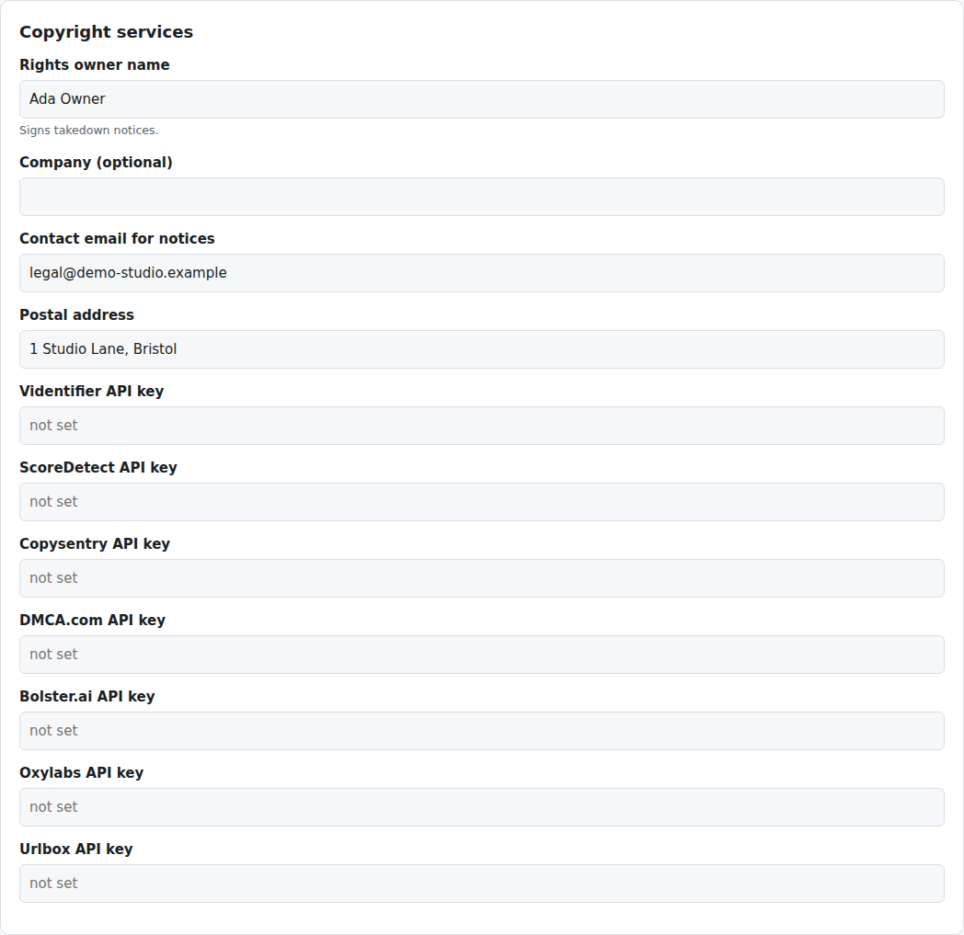
Copyright services and rights owner details
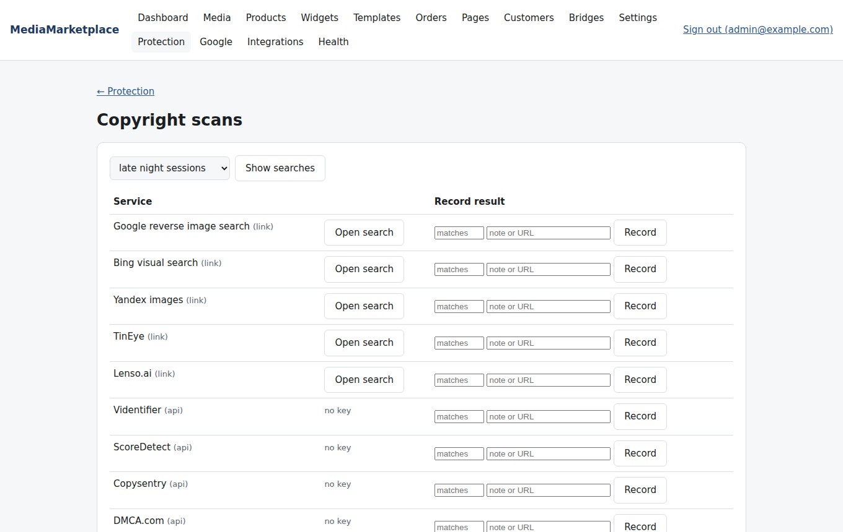
Prepared reverse image searches for a media file
Protection → Violations records an infringing address with your media file, a note and evidence. When the evidence is a marked image or screenshot, the store identifies the viewer it was issued to and links the violation to that session. Each violation has a timeline and a status (open, notice sent, removed, disputed, ignored).
Generate DMCA notice produces a notice under section 512(c) as a PDF from the rights owner details you enter once under Settings → Copyright services, naming the work, the infringing address, the evidence hash and, when known, the forensic session. Download it and send it to the host's abuse address; then track the outcome on the violation.
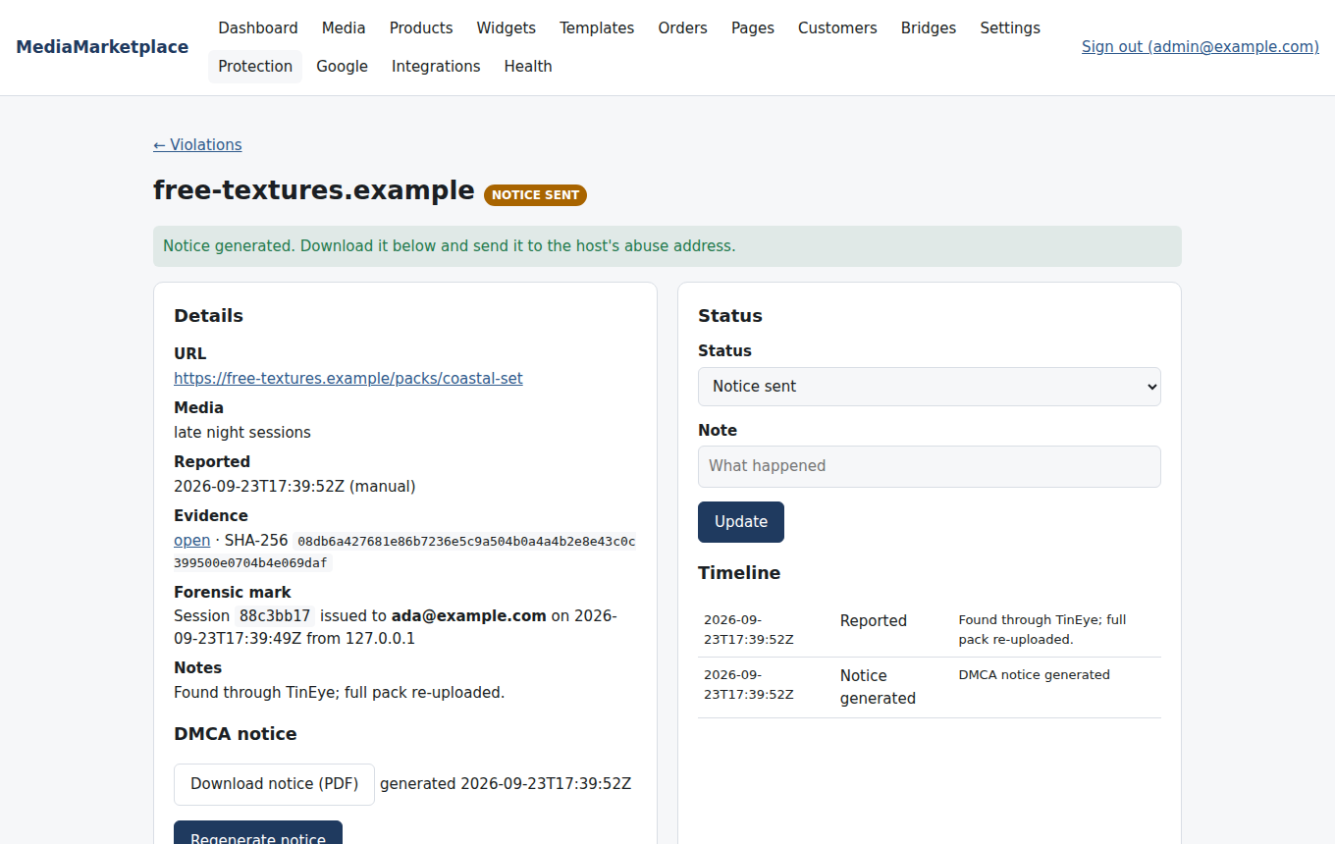
A violation linked to the viewer who leaked the file, with its DMCA notice
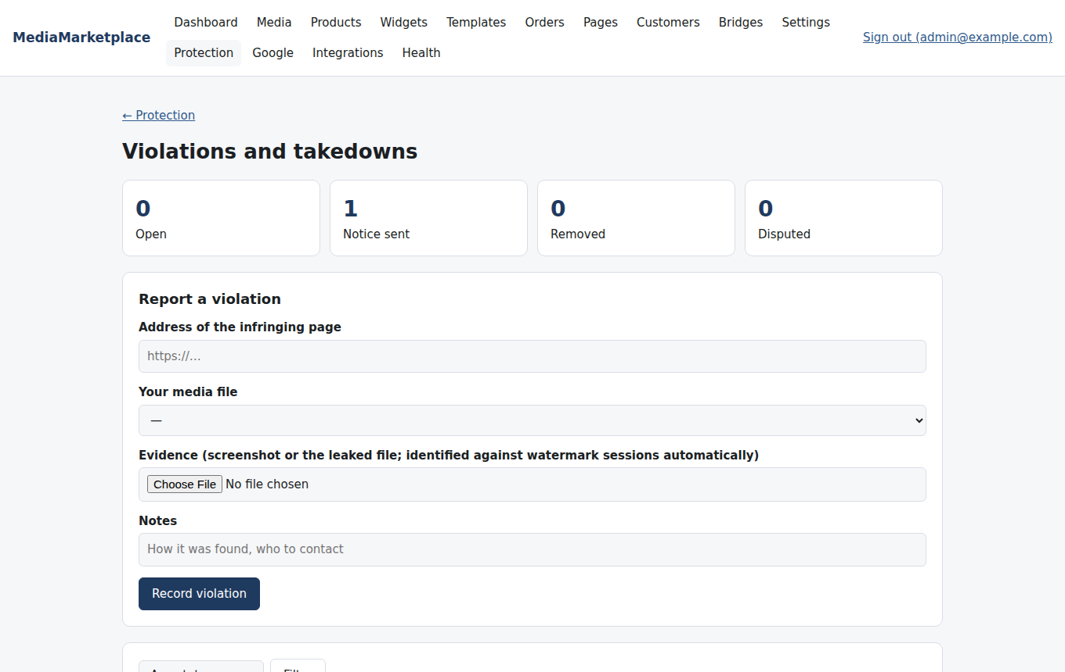
The violations list

30. Players
Plyr, Video.js, Clappr and the browser's native controls are bundled with the store. The Vimeo SDK plays vimeo.com sources. JW Player, Bitmovin, THEOplayer, Kaltura and Flowplayer load from their vendors with the licence, key or token you enter under Settings → Players; Projekktor loads from a library URL. The default is set per store and can be overridden per product; anything that fails to load falls back to the native player, so a lapsed licence never stops playback.
Player | Needs | Best for
Plyr (default) | nothing | most stores; clean controls, captions, speed
Video.js | nothing | plugins and streaming formats
Clappr | nothing | live streams
Native | nothing | minimum footprint
Vimeo SDK | a vimeo.com source | videos already hosted on Vimeo
JW Player, Bitmovin, THEOplayer, Kaltura, Flowplayer | licence or key from the vendor | sites already licensed for them
Projekktor | a library URL | self-hosted open-source alternative

31. Privacy and roles
Customers' data: My media → Privacy lets a customer download everything the store holds about them as one file and delete their account (personal details are removed, access ends, order records stay for accounting without name or email). The same export and erase buttons are on the customer's page in the admin, for requests that arrive by email.
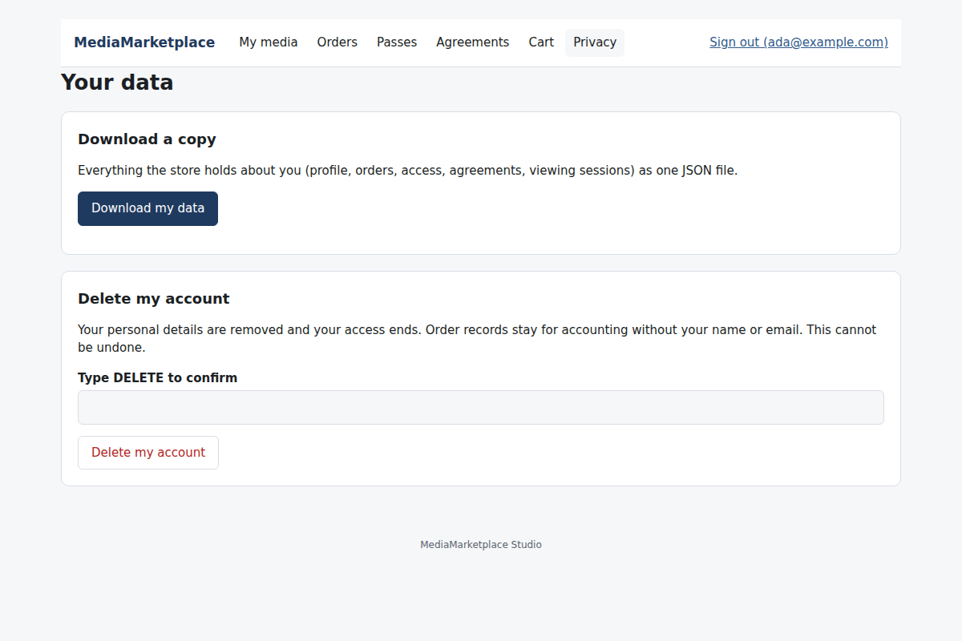
My media → Privacy
Staff: on a customer's page an administrator can make someone staff. Staff run the store (media, products, orders, pages, protection) but cannot change settings, connected sites, integrations, roles or backups. A WordPress administrator is always a store administrator; staff is for people who run the store without administering the site.
Sign-in protection: five failed sign-ins from one address lock it out for thirty minutes, doubling on repeat (Settings → Access control).
Retention: watermark sessions, playback sessions and audit entries older than the retention period (Settings → Privacy) are removed daily.

32. Backups and data
Everything the store owns lives in one data folder on the server (the status page shows where): the database, the media files, the configuration and the log. The plugin adds nothing to the WordPress database, so a WordPress backup alone does not include the store.
Health → Backups creates a single archive with a consistent copy of the database, the configuration and every media and evidence file, and lists earlier archives for download. Restore by unpacking into an empty data folder and restarting the server from the status page. The backup folder can be moved under Settings → Privacy, for example onto a mounted backup disk.
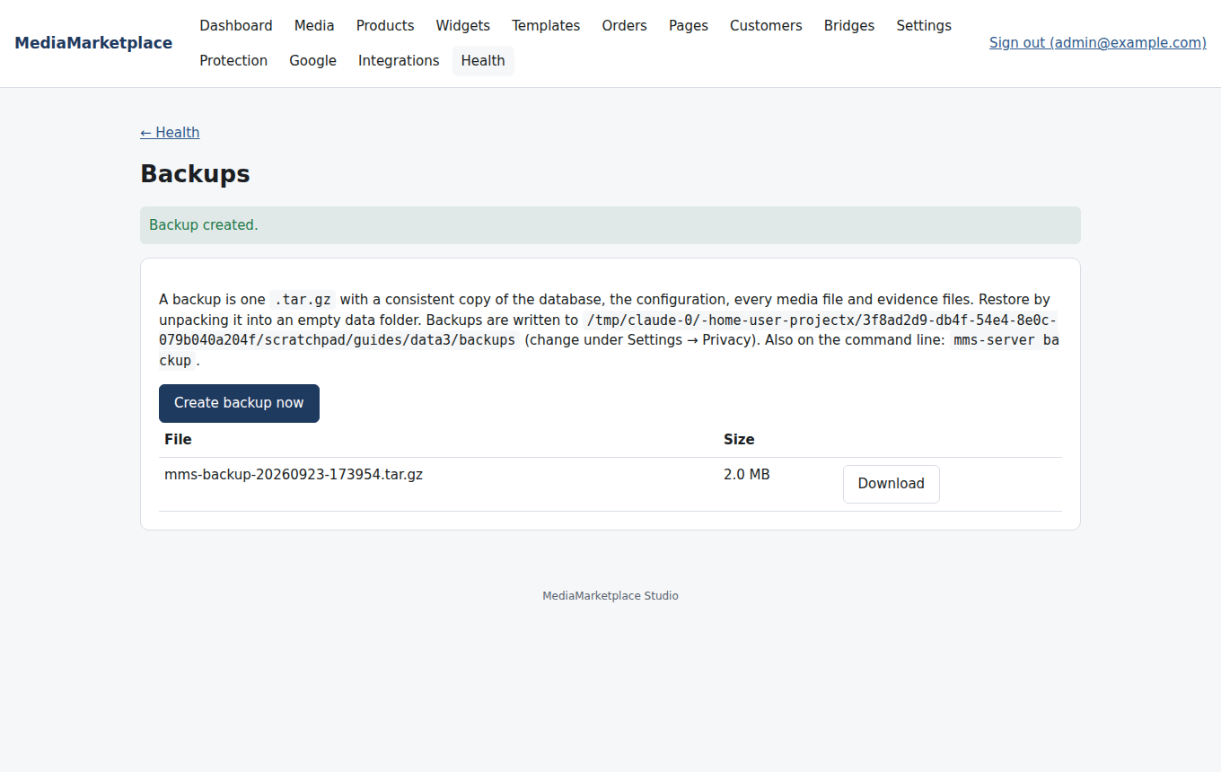
Backups
For a nightly copy, ask your host to run mms-server backup from the plugin's bin folder in a cron job, or include the data folder in the server's own backup. Moving the site to a new server means moving the WordPress files and database as usual plus the data folder; the store then starts on the new server with everything in place.
ARM servers: the plugin carries an x86_64 build and, when produced by the release pipeline, an aarch64 build; it picks the right one for the server.

32b. Setup wizards (AI assistance)
Wizards in the store admin is a team of AI specialists that configure the store for you. The Concierge interviews you once and runs the specialists (store setup, media intake, catalogue, storefront, payments, private pages, passes and pricing, protection, email and Google, sell-through, launch audit). Two more work on a running store: Media intake completes titles, captions, tags, rights and age gating for uploaded files, and Analytics reads your sales, passes and playback and recommends what to do next. Each one reads your store, asks what it needs and leaves proposals with a reason; nothing changes until you click Apply. Secrets are never guessed: you type them into the proposal card. Switch the wizards on with your Anthropic API key under Settings → AI.
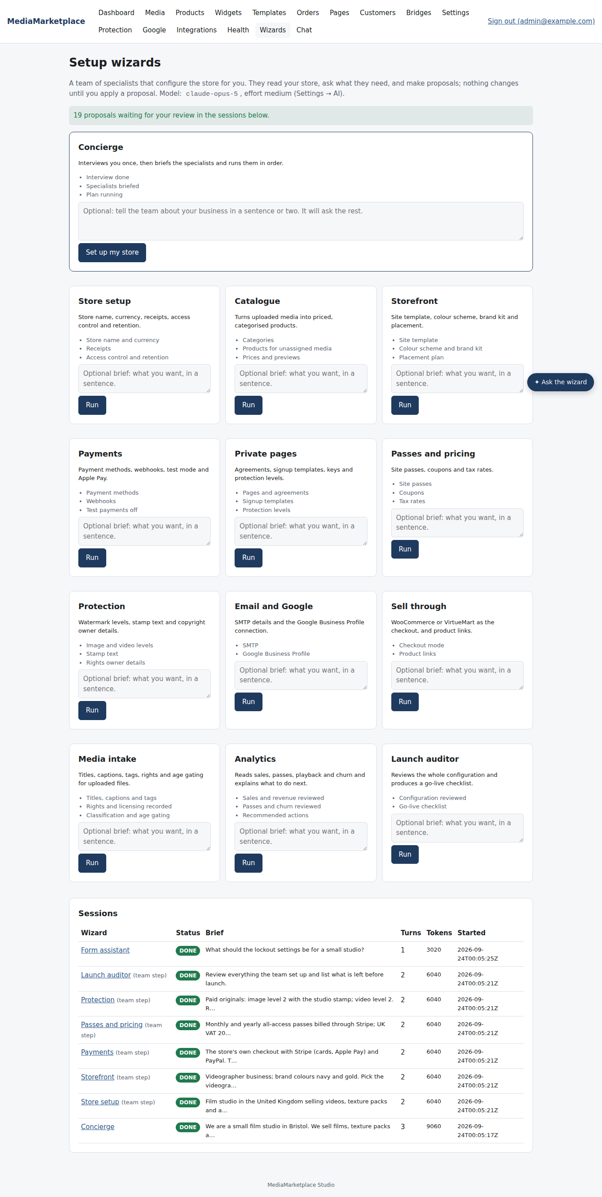
The Wizards page
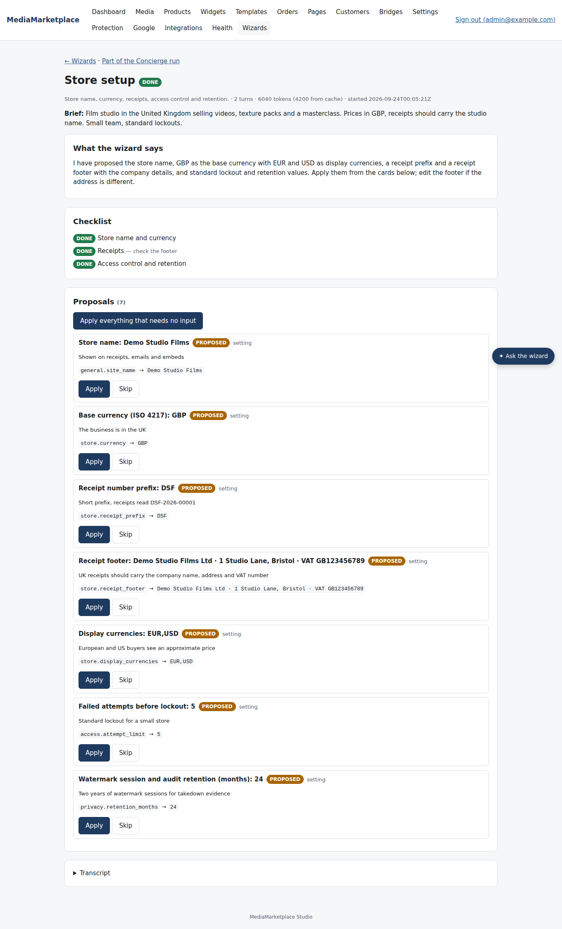
A specialist's proposals, ready to apply
Every admin page also has an Ask the wizard button at the bottom right: ask about the page you are on and apply the answer in one click.
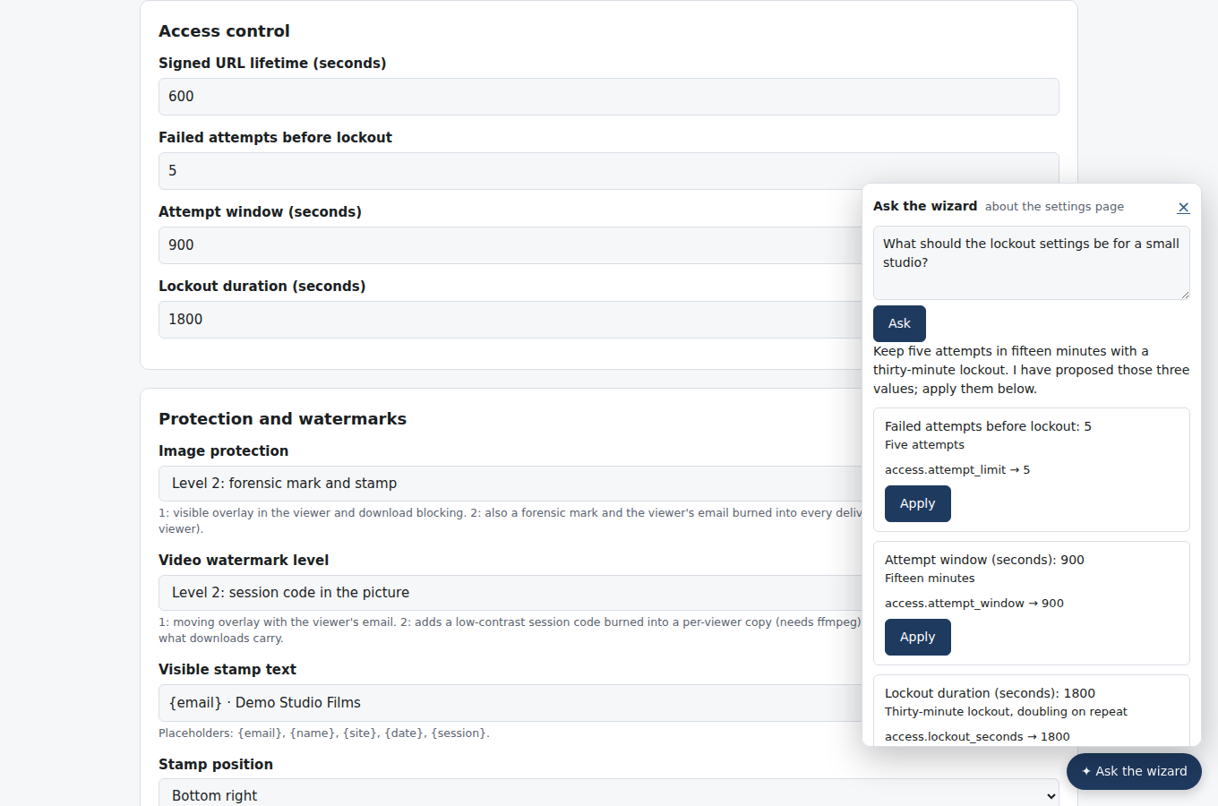
Ask the wizard on the Settings page
The Setup Wizards Guide covers the team, the interview, reviewing proposals and troubleshooting.

32c. Support chat and remote agents
The support chat lets visitors talk to your store from any page and from My media. The AI assistant answers first from how the store works, your policy text and the customer's own orders, and hands over to a human agent for refunds, cancellations or whenever the visitor asks for a person. Support agents are people you invite by link under Chat in the store admin: contractors or helpers who get agent status and nothing else, no admin pages and nothing to buy. Place the chat with the MediaMarketplace Embed block set to Support chat or [mms_embed kind="chat"]; signed-in customers also find it under My media → Help.
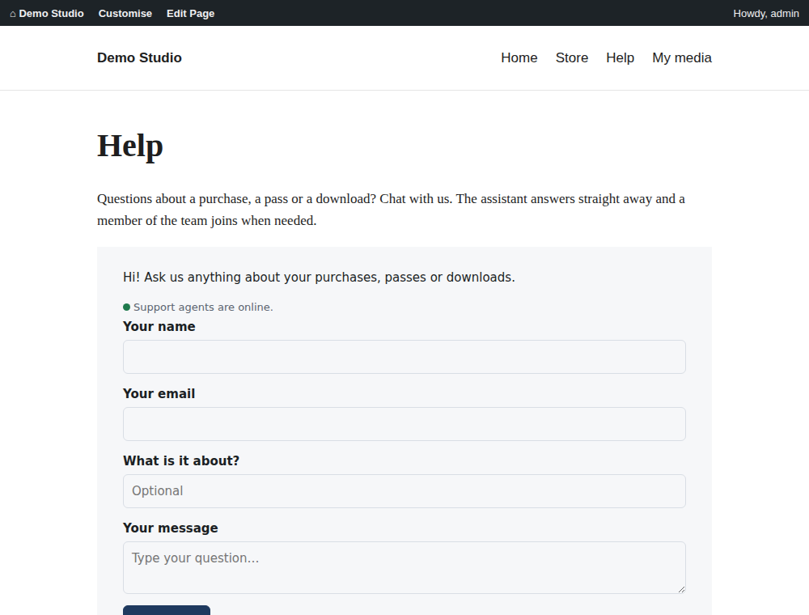
A help page with the chat embedded
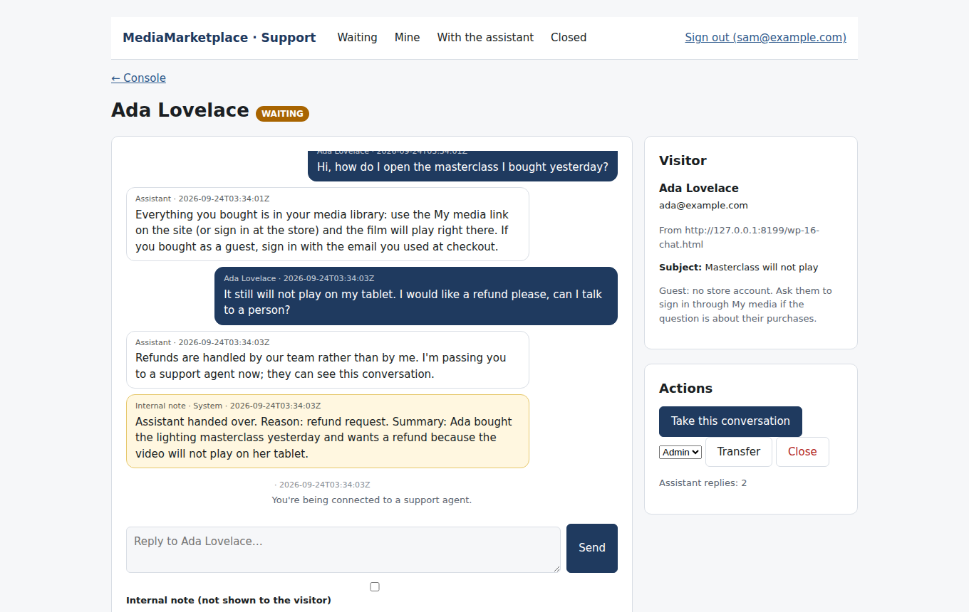
The agent's view of a hand-over, with the visitor's records
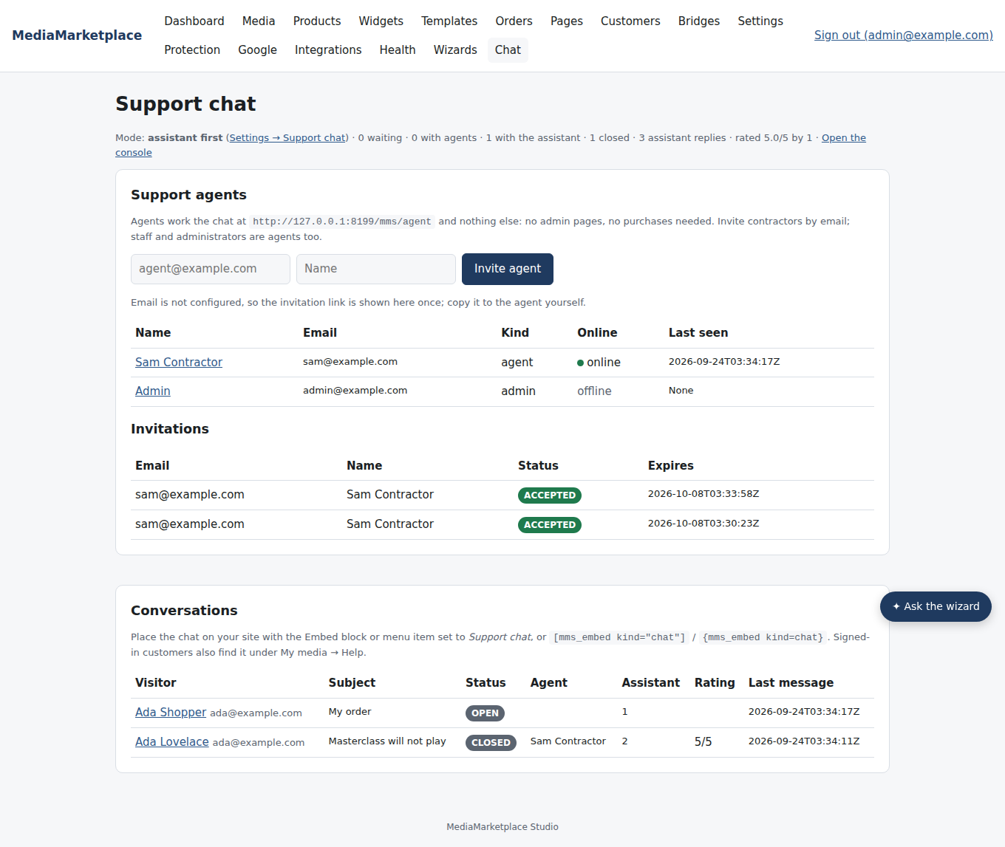
Chat in the store admin: agents, invitations and conversations
The Support Chat Guide covers settings, inviting agents, the assistant's limits and the agent console.

33. Troubleshooting
Symptom | Cause | What to do
The store admin shows a WordPress error page or "store unavailable" | the server is not running | open MediaMarketplace → Status, read the last error, click Start
"Start" fails with "permission denied" | the binary or data folder is not executable or writable by the web user | fix ownership as described in the installation guide
Video thumbnails and level 2 video marks are missing | ffmpeg is not installed | install ffmpeg; Health shows the row amber until then
Uploads stop at a certain size | the PHP upload limit | raise upload_max_filesize and post_max_size; the status page shows the current values
Embeds show "not published" | the widget or product is a draft | publish it in the builder or product form
Embeds show "site not registered" | the site address changed | open the store from WordPress again; the plugin re-registers the site; then Restart
A member's My media link asks them to sign in again | the session cookie is for another address | make sure the site's public address and the store address use the same scheme and host (HTTPS everywhere)
Payments complete at the provider but the order stays pending | the provider's webhook is not reaching the store | check the webhook address and secret under Settings → Payments and the provider's delivery log
Receipts and reminders are not emailed | no SMTP | enter SMTP details under Settings → Email and use Send a test email
Health shows "public url" amber | the site is on HTTP | enable HTTPS, then Restart

The log tail on the status page and the activity list on the dashboard answer most other questions; the full log is in the data folder.

34. What comes next
Every module in the feature list is delivered. Items left for a later release, all noted in the specification: PayPal subscriptions, dunning and proration for recurring passes, direct API submission to the copyright services (keys are stored; submissions go through their dashboards), Google Business Profile insights and listing audits, third-party sign-in buttons on signup templates, a second connected site in "connect only" mode, and a PostgreSQL option.

35. Glossary
- Plugin — the WordPress plugin you install; it contains the store server.
- Store server — the background program the plugin runs on your server; you use it through the store admin.
- Store admin — the web admin at your site address followed by /mms/admin.
- Showcase — the product listing placed in pages.
- Widget — a block of store content designed in the widget builder and placed on a page by ID.
- Template — a ready-made widget design; site template — a colour scheme plus a set of widgets for an industry.
- Colour scheme — six named colours (accent, second accent, background, surface, text, muted) that widgets use.
- Entitlement — a record that a customer may access a product, page or the whole library for a period.
- Site pass — an entitlement that covers the whole library.
- Signed link — a media address that expires and works only for the customer it was issued to.
- Order — a purchase; paid orders grant access and get a receipt.
- Coupon — a code for a percentage or fixed discount.
- Private page — content behind a signup template and a signed agreement, optionally paid.
- Access key — a single-use or multi-use key that opens an invite-only or paid-plus-key page.
- Recurring pass — a site pass billed monthly or yearly through Stripe until cancelled.
- API key — a bearer token that lets another system read the store's data.
- Webhook — a signed message the store sends to another system when something happens.
- Watermark session — the record of which viewer a protected image or video copy was issued to.
- Forensic mark — the invisible code in a delivered image or the corner code in a video frame that identifies the session.
- Violation — an infringing address you recorded, with evidence and a takedown status.
- Staff — a store user who can run the store but not change its settings.
- Data folder — where the store keeps its database, media and configuration.
- Bridge — the record of a connected website and the secret it uses to sign people in.

Appendix A. WordPress placement reference
Block | Shortcode | Attributes | Shows
MediaMarketplace Showcase | [mms_showcase] | view, category | the product listing
MediaMarketplace Embed | [mms_embed] | kind (widget, product, player, page, sitepass, cart), id, view | a widget, a product page, a player, a private page, a site pass offer or the cart
MediaMarketplace My Media link | [mms_signin] | label, return | the one-click link into the member's library

Examples:
[mms_showcase view="grid"]
[mms_showcase view="list" category="courses"]
[mms_embed kind="widget" id="47b2f843-f19a-4296-8f6c-4af34748cdc2"]
[mms_embed kind="product" id="studio-lighting-masterclass"]
[mms_embed kind="player" id="studio-lighting-masterclass"]
[mms_embed kind="sitepass" id="all-access-pass"]
[mms_embed kind="page" id="89eed1bb-4e03-4738-a2c2-5fd7ce03015a"]
[mms_embed kind="cart"]
[mms_signin label="My media" return="/account/orders"]

Blocks need no build step and work in the block editor, the site editor and block-based widget areas. Shortcodes work in the classic editor, text widgets and page builders. Both render the same markup and load one small script from your site (/mms/embed.js).

Appendix B. Settings reference
Section | Setting | Default | Notes
General | Store name | MediaMarketplace | emails, receipts, embeds
General | Log level | info | debug, info, warning, error
General | Store colour scheme | Studio blue (default) | default for widgets
General | Brand kit | — | logo, font stack, radius, shadow
Store | Base currency | USD | three-letter code
Store | Receipt prefix | MMS | receipts are PREFIX-year-sequence
Store | Receipt footer | — | address, VAT number, terms
Store | Grace days | 3 | days an ended pass stays open
Store | Display currencies | — | comma-separated, ECB rates
Store | Charge in the shopper's currency | off | Stripe and PayPal only
Sell through | Checkout runs in | native | native, WooCommerce or VirtueMart (section 23b)
Sell through | Add-to-cart address, unlinked products | shop default, native | section 23b
Support chat | mode, greeting, policy, canned replies, guests | assistant first | section 32c
Payments | Test payments | on | switch off before selling
Payments | Stripe secret key, webhook secret | — | section 19
Payments | PayPal client id, secret, webhook id, sandbox | sandbox on | section 19
Payments | Square access token, location id, application id, sandbox | sandbox on | section 23
Payments | Authorize.net login id, transaction key, public client key, sandbox | sandbox on | section 23
Payments | Apple Pay domain association file | — | served at the .well-known address
Media | Maximum upload size | 512 MB | also limited by PHP
Media | ffmpeg path | ffmpeg | thumbnails, transcoding, video marks
Players | Default player | Plyr | per product override
Players | Licence keys and library URLs | — | section 30
Access control | Signed URL lifetime | 600 s | media links
Access control | Failed attempts, window, lockout | 5, 15 min, 30 min | keys and sign-in
Protection | Image level, video level | 2, 1 | section 28
Protection | Stamp text, position, opacity | {email} · {site}, bottom right, 45 % | level 2 images
Protection | Video grid opacity | 30 % | level 2 and 3 video
Copyright | Rights owner name, email, address | — | DMCA notices
Copyright | Service API keys | — | encrypted
Privacy | Retention months | 24 | sessions and audit
Privacy | Backup folder | data folder/backups | section 32
AI | Anthropic API key, model, wizard effort | claude-opus-5, medium | wizards and review replies
Google | OAuth client id, secret, Maps API key | — | section 27
Email | SMTP host, port, user, password, From, encryption | — | section 26

Appendix C. A first week with the store
- Day 1: open the store admin from WordPress, check Health, set the store name and base currency, upload your first files.
- Day 2: create products for the files, publish them, place the MediaMarketplace Showcase block on a Store page and the MediaMarketplace My Media link block in your menu.
- Day 3: apply a site template, place its home widgets, tune colours to your WordPress theme.
- Day 4: buy something yourself with the test payment method, check the order, receipt and My media; then enter Stripe or PayPal keys and turn test payments off.
- Day 5: set protection levels, enter SMTP details, create a backup and download it.
- Day 6: create a private page with a signup template, and a site pass product.
- Day 7: add API keys or webhooks for your automation tools and connect Google Business Profile.

