QueryBook
Language Intelligence
Architecture
Dialect translation · Accent adaptation · Grammar · Rhetoric · Composition · Writing style
Design document — 12 November 2026
Status: design only. Nothing described here is built yet, except the parts listed under “What exists and is reused”.

1. The aim, stated honestly
QueryBook should understand and produce language with six skills: dialect translation, accent adaptation for the listener, grammar, rhetoric, composition, and the analysis and replication of writing style.
“Exceed the large language models” needs a precise meaning, because a rule-based system will not out-write a large model at open-ended fluent prose. The table shows what QueryBook can do that a model alone cannot.
QueryBook can | A model alone
Give the same answer every time | Varies from run to run
Name the rule behind every change | Cannot show its reasons
Measure the result: style distance, meaning kept, intelligibility | Asserts quality
Control sound at the level of single phonemes | Has no handle on audio
Keep every factual statement tied to a stored fact | Invents
Treat a dialect as a system with its own rules | Treats it as noisy standard language

So the design is a deterministic linguistic core that analyses, constrains, checks and measures, with a model used as one component for drafting and never as the judge. Where a model is used the result is labelled, as everywhere else in QueryBook.

2. The centre: one record for every utterance
Every skill reads and writes the same record, the Utterance Record. It keeps apart three things that most systems blur: what is meant, how it is worded, and how it sounds.
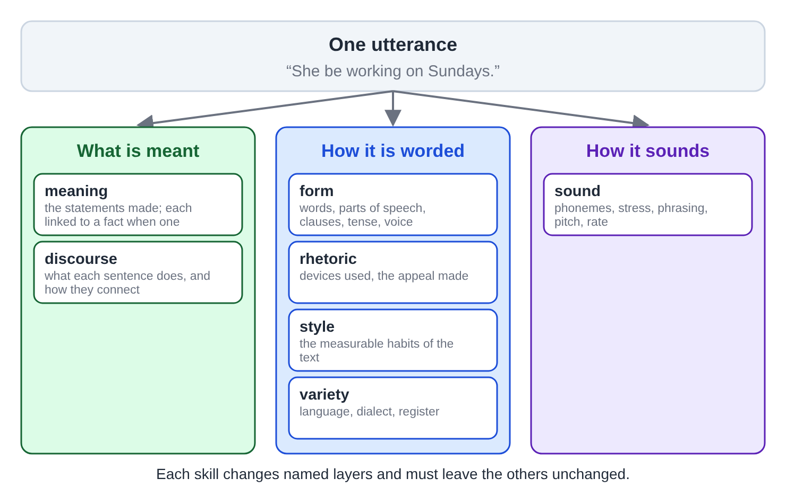
Figure 1. The Utterance Record: one utterance, described in seven layers under three headings.
Every transformation is a function from one record to another. It changes named layers and leaves the others alone. That gives each skill its test: after the transformation the layers it must keep are compared, and a difference there is a failure.
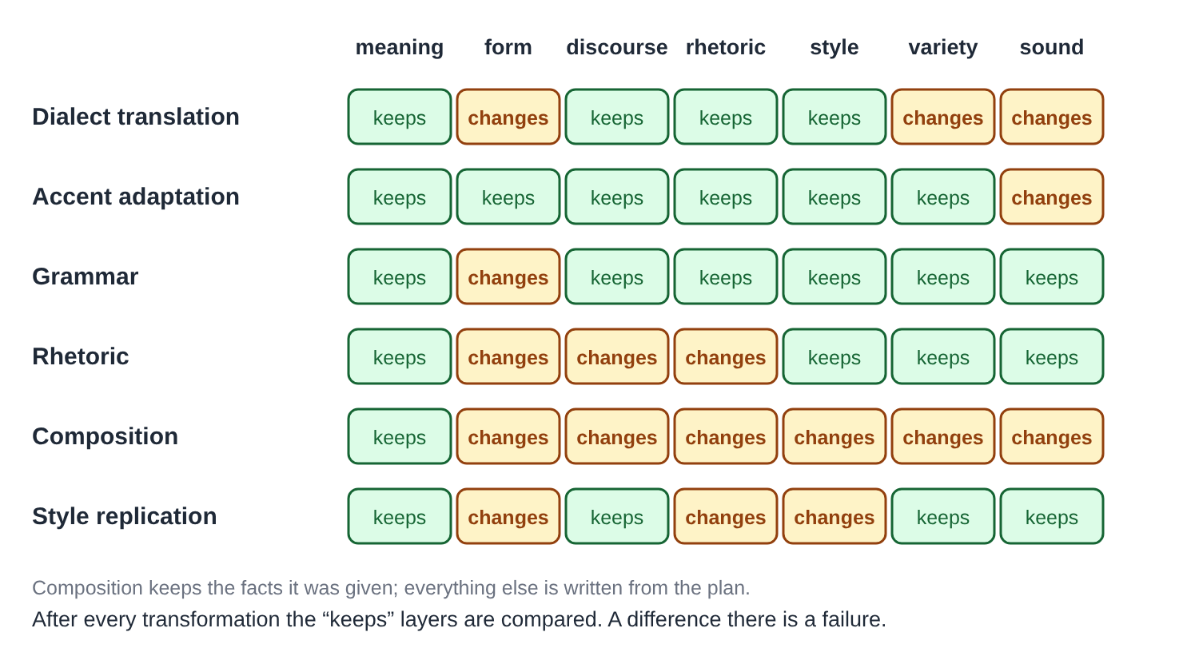
Figure 2. What each skill changes and what it must keep.

3. The layers
The architecture has seven layers. Six are deterministic, use only the standard library, and are written as pure modules so they can be ported to Rust like the existing formula, answer-mode and type-sense modules. One layer, generation, may call a model.
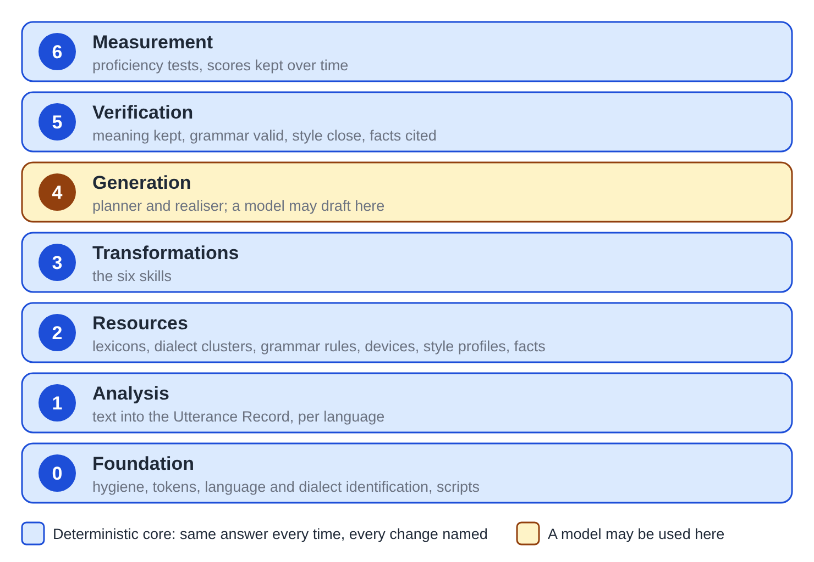
Figure 3. The seven layers. Only the generation layer may use a model.
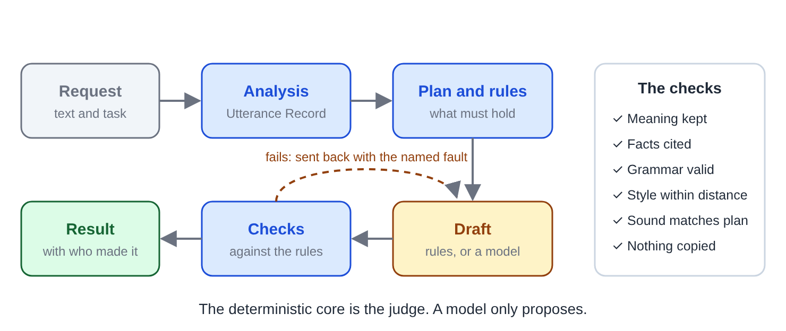
Figure 4. How a request is handled: the core plans and checks; a draft that fails is sent back with the fault named.

4. The six skills

4.1 Dialect translation
A dialect is a system. Translation goes dialect → meaning → dialect, never by swapping words on the surface.
- Each dialect description gains rules in both directions, each with its conditions and a cited source.
- Three kinds of rule: lexical (word and sense), constructional (habitual “be”, double modals, “fixin’ to”), and pragmatic (politeness, forms of address).
- Register is carried separately from dialect: informal standard English is not a dialect.
- What has no equivalent is kept and marked, never dropped or guessed.
- Only documented features are used. No invented spellings to make a dialect “sound” like itself.
- Detection gives a variety and a confidence. Below a threshold it says so and does not translate.

4.2 Accent adaptation for the listener
The words stay the same; only the sound layer changes. There are three operations on the pronunciation plan.
Operation | What it does
Adapt | Moves the speaker’s sounds toward the listener’s accent where that helps understanding
Add | Renders the text in a chosen accent
Remove | Moves toward a chosen reference accent

- It works on phonemes, stress, rhythm and intonation.
- Stage A: synthesised speech, where QueryBook controls every phoneme. This is practical now.
- Stage B: recorded speech, changing a real voice. This is much harder, and it needs the speaker’s consent through the same gate as voice cloning.
- It is measured, not asserted: a confusion model for each listener background predicts which sounds are misheard, and the result is checked with the existing speech-science measurement.
- This is a listener’s choice for intelligibility, and opt-in. No accent is treated as a defect.

4.3 Grammar
- A rule grammar for each language: agreement, tense and aspect, articles, word order, punctuation, sentence boundaries.
- Three outputs for each finding: the correction, the rule by name, and an example. It teaches as well as fixes.
- It is dialect-aware. A construction that is regular in the detected variety is not an error; it is reported as regular in that dialect, with the standard form beside it.
- QueryBook uses only the standard library, so this is its own rule engine (pattern rules over tagged words), not an imported parser.
- Every rule links to practice in the Language Lab.

4.4 Rhetoric
- A catalogue of devices with detection rules: repetition (anaphora, epistrophe), balance (antithesis, tricolon, chiasmus), questions, direct address.
- Argument structure: claim, evidence, warrant, concession, rebuttal.
- Appeals to character, to feeling and to reasoning, with the passages that make each.
- Fallacy patterns, flagged for a person to judge.
- Two confidence classes, always shown. Structural devices are found by rule. Devices that depend on meaning, such as metaphor and irony, need a model and are marked “model-judged”.
- Applying rhetoric: given an audience and a purpose, it proposes rewrites that add or remove named devices; the meaning check then runs.

4.5 Composition
Plan → outline → paragraphs → sentences, with a check at each step.
- Genre schemas: the outline arcs Book Studio already has, plus letter, report, essay, speech and story.
- Paragraph craft: topic sentence, development, known-before-new ordering, connectives that match the actual relation.
- The existing rhythm and hygiene controls and the revision report apply.
- Every factual sentence is tied to a fact or a passage: no uncited sentence.
- A model may draft a paragraph. The deterministic layer decides whether it meets the plan, the grammar, the style profile and the facts, and sends it back with named faults if not.

4.6 Style: analysis and replication
Analysis produces a Style Profile made of numbers, not adjectives:
- Sentence length: the average, the spread, and the pattern of long and short.
- Function-word frequencies, the established basis of authorship work.
- Punctuation habits, vocabulary richness and word length, favourite constructions.
- The rate of each rhetorical device, paragraph length, point of view, tense and register.
Replication is a loop with a measured stopping rule.
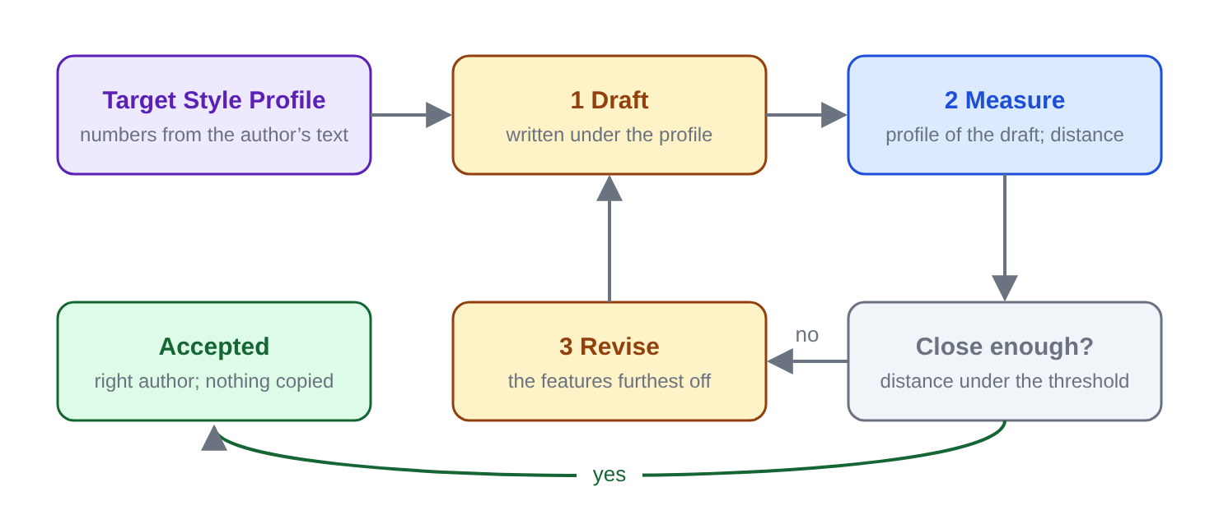
Figure 5. Style replication: draft, measure the distance to the target, revise what is furthest off, repeat.
The test uses the 19 public-domain books already in the QueryBook library:
- Attribution. Given an unseen passage, name its author. This proves the analysis sees real style.
- Imitation. Text written in the style of an author must be attributed to that author by the same classifier, while a check confirms no sentence was copied.
Replicating a living person’s style needs their consent, recorded as the voice persona’s consent is. Output is never presented as written by that person.

5. Verification
A result that fails a check is not shown as finished. It is shown with the failed check.
Check | Method
Meaning kept | The meaning before and after must match; any difference is listed
Facts | Every factual sentence cites a stored fact or passage
Grammar | The result passes the grammar of its target variety
Style | The distance to the target profile is under the threshold
Sound | The measured speech matches the pronunciation plan
Nothing copied | No sentence of a style source appears in the output

6. Measurement: a proficiency test
One suite for each skill, run on demand and daily, with scores kept over time on one card, as the relevance test does for the fact store.
Skill | Test | The number
Dialect | Round trip: dialect → standard → dialect | Meaning kept; constructions recovered
Accent | Predicted and measured intelligibility for a listener profile | Change against the unadapted speech
Grammar | A set of seeded errors and correct dialect sentences | Found, missed, wrongly flagged
Rhetoric | Annotated speeches | Devices found, by confidence class
Composition | Plans with known facts | Plan followed; sentences cited
Style | Attribution and imitation on the library | Accuracy; imitation accepted

7. What exists and is reused
Piece | Where | Role here
Dialect descriptions: phonology, lexicon, constructions, prosody | dialect.py | The dialect model, extended
Pronunciation resolution: heteronyms, per-engine forms, IPA | pronounce.py | The sound plan
Function-word lists | function_words.py | Style fingerprint
Speech engines, voice processing, formant voice | tts.py, voicedsp.py | Rendering sound
Speech-science measurement | speechsci.py | Measuring what was said
Offline translator; 139-language registry | ui/translate, lablangs.py | Across languages
Author persona and its consent gate | persona.py | The model for style consent
Prose controls and outline arcs | Book Studio | Composition
Plan → evidence → compose → verify | qbcompose.py | Grounded generation
Kinds of things, fame, the fact store | sense.py, qbbulk.py | Meaning
19 public-domain books | the library | Style test set

8. Build order
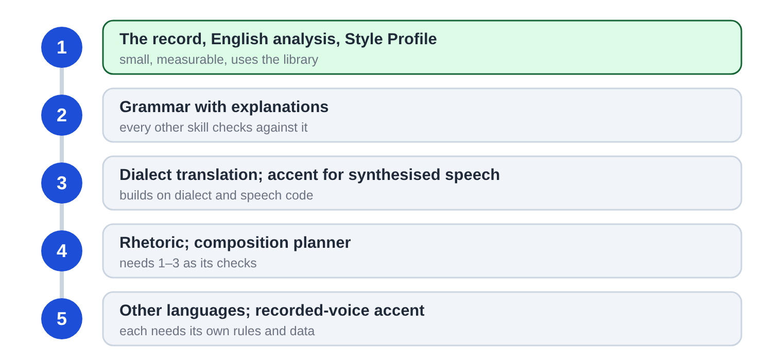
Figure 6. Five stages. Each stage supplies the checks the next one needs.

9. Open questions and risks
- Comparing meaning is the hard part. It is easy for statements tied to facts and hard for opinion, tone and implication. Stage 1 must show how far a rule-based comparison goes before the rest relies on it.
- Coverage by language. Rule grammars and dialect descriptions are written for each language. English comes first; each further language is real work, not a switch.
- Dialect data needs sources. Every feature should cite a published description. Where none is found the feature stays out.
- Changing the accent of a recorded voice is research-grade and may not reach usable quality with local tools.
- Where the model stays ahead. Open-ended drafting and meaning-dependent rhetoric will lean on a model for a long time. The design accepts that and confines it.

