Draft — Not Filed — For Review by Qualified Patent Counsel Prior to Filing
Provisional Patent Application · 35 U.S.C. § 111(b)

QueryBook — A Deterministic, Provenance-Tracked Federated Knowledge and Query System and Method
Applicant / Assignee: QueryBook Core Technology Group
Inventors: [to be inserted by counsel]
Related applications: Prior provisional applications on the QueryBook system, including the Universal Federated Connectivity System (UFCS) and the Federated Query Language (FQL).
Document date: September 28, 2026 (rev. September 29, 2026 — added Section XV reduced-to-practice embodiment; rev. October 1, 2026 — added Section XVI advanced deterministic multilingual pronunciation, self-contained speech, and quality-control embodiment; rev. October 1, 2026 — consolidated as a single QueryBook-first application, the LEL incorporated as QueryBook's integral language and speech subsystem; rev. October 1, 2026 — added Section XVII voiceprint & multimodal identity embodiment, Language & Identity Linking (LIL), with FIG. 33–34 and claims 51–58; rev. October 1, 2026 — added Section XVIII Universal Integrity Audit Service (UIAS) embodiment with FIG. 35–36 and claims 59–66; rev. October 2, 2026 — added Section XIX Paralinguistic & Pragmatic Interpretation Layer (PIL) embodiment with FIG. 37–38 and claims 67–74; rev. October 2, 2026 — added Section XX Lecture Query mode embodiment with FIG. 39–40 and claims 75–82; rev. October 8, 2026 — added Section XXIII agent-era extensions with FIG. 50–55 and claims 97–108; rev. October 8, 2026 (B) — rebalanced as a QueryBook-system application: QueryBook core platform described first (Part A, FIG. 1–22, new claims 1–20) with its language, identity, media and agent subsystems presented in proportion; figures, reference numerals, paragraphs, sections and claims renumbered. Figure, section and claim numbers in this revision history refer to the present numbering) · Attorney docket / Application no.: [to be assigned]
Note on this draft. This provisional specification is a single, consolidated QueryBook application directed to the QueryBook system as a whole. Part A describes the QueryBook core platform — the Fact Unit, the Universal Federated Connectivity System (UFCS) substrate, the Federated Query Language (FQL), certification, verification, grounded response generation, federation, erasure, the Prime Directive, governed agents, security and deployment (FIG. 1–FIG. 22). Parts B, C and D describe subsystems and embodiments built on that core: the integral language and speech subsystem (the Language Expression Layer, LEL; FIG. 23–FIG. 32), the identity, audit, interpretation and lecture embodiments (FIG. 33–FIG. 40), and further embodiments including media handling and the agent-era extensions (FIG. 41–FIG. 55). Each subsystem inherits the core’s determinism, provenance and no-fabrication guarantees. Refinements from an internal engineering audit are marked audit. Drawings are draft, to be finalized to USPTO drawing standards (37 CFR 1.84) by a patent draftsperson. Claims must be reviewed, and a prior-art search conducted, by qualified patent counsel before filing.

Drawings
Formal patent drawings — black line art, forming one QueryBook figure set, ordered from the core outward: FIG. 1–FIG. 22 depict the QueryBook core platform (Part A); FIG. 23–FIG. 32 depict the integral language and speech subsystem (Part B); FIG. 33–FIG. 40 depict the identity, integrity-audit, interpretation and lecture embodiments (Part C); and FIG. 41–FIG. 55 depict further embodiments, applications, media handling and the agent-era extensions (Part D). Each figure is on its own sheet and every element is identified by a reference numeral used consistently in the Brief Description of the Drawings, the Reference Numerals key, and the Detailed Description; the core-platform figures use the 6100–8210 numeral series. Figures are draft; counsel/draftsperson to finalize to USPTO drawing standards (37 CFR 1.84) before filing.

Part A — QueryBook core platform (FIG. 1–FIG. 22)
FIG. 1
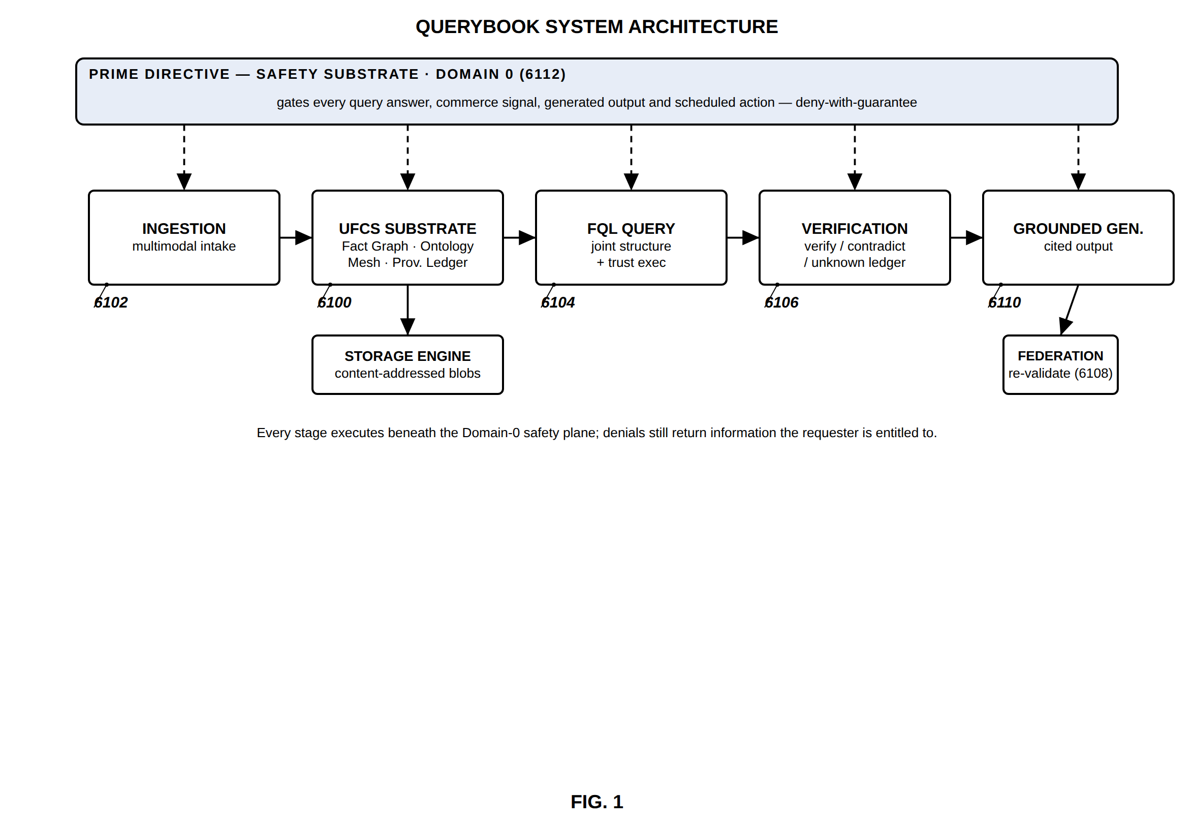
FIG. 1 — QueryBook system architecture (Prime Directive as Domain 0)
FIG. 2
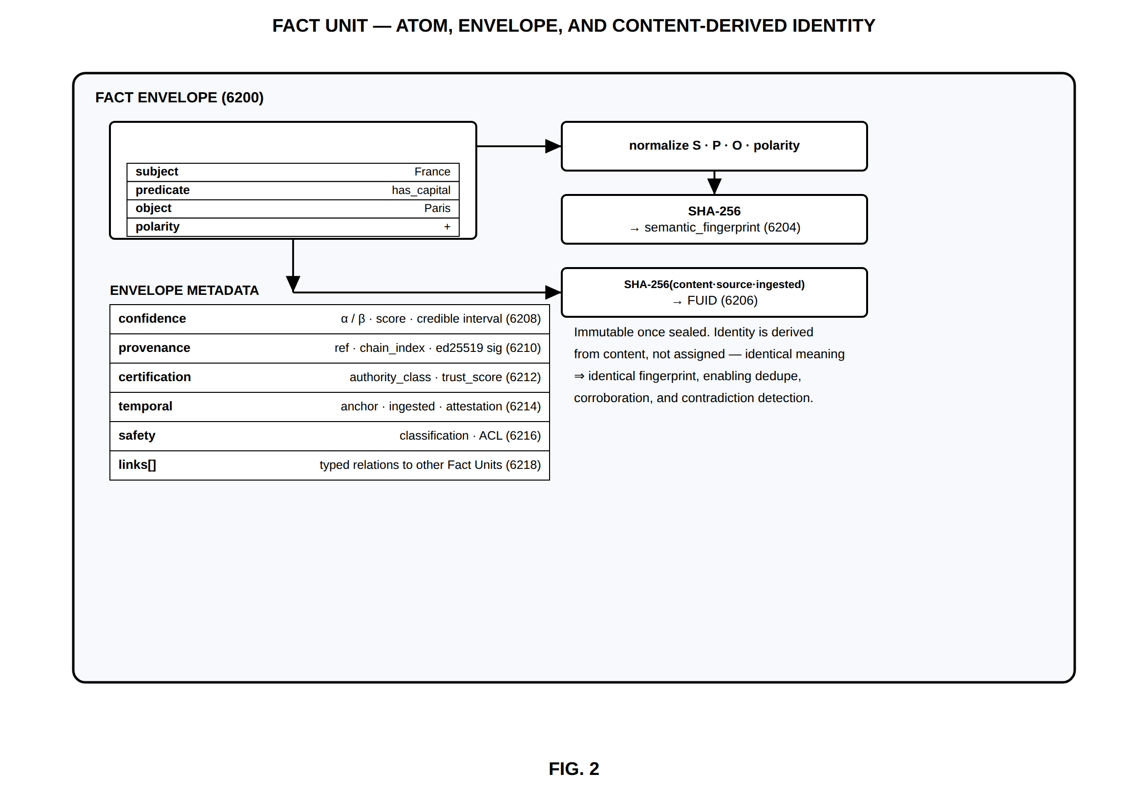
FIG. 2 — Fact Unit — atom, envelope, and content-derived identity
FIG. 3
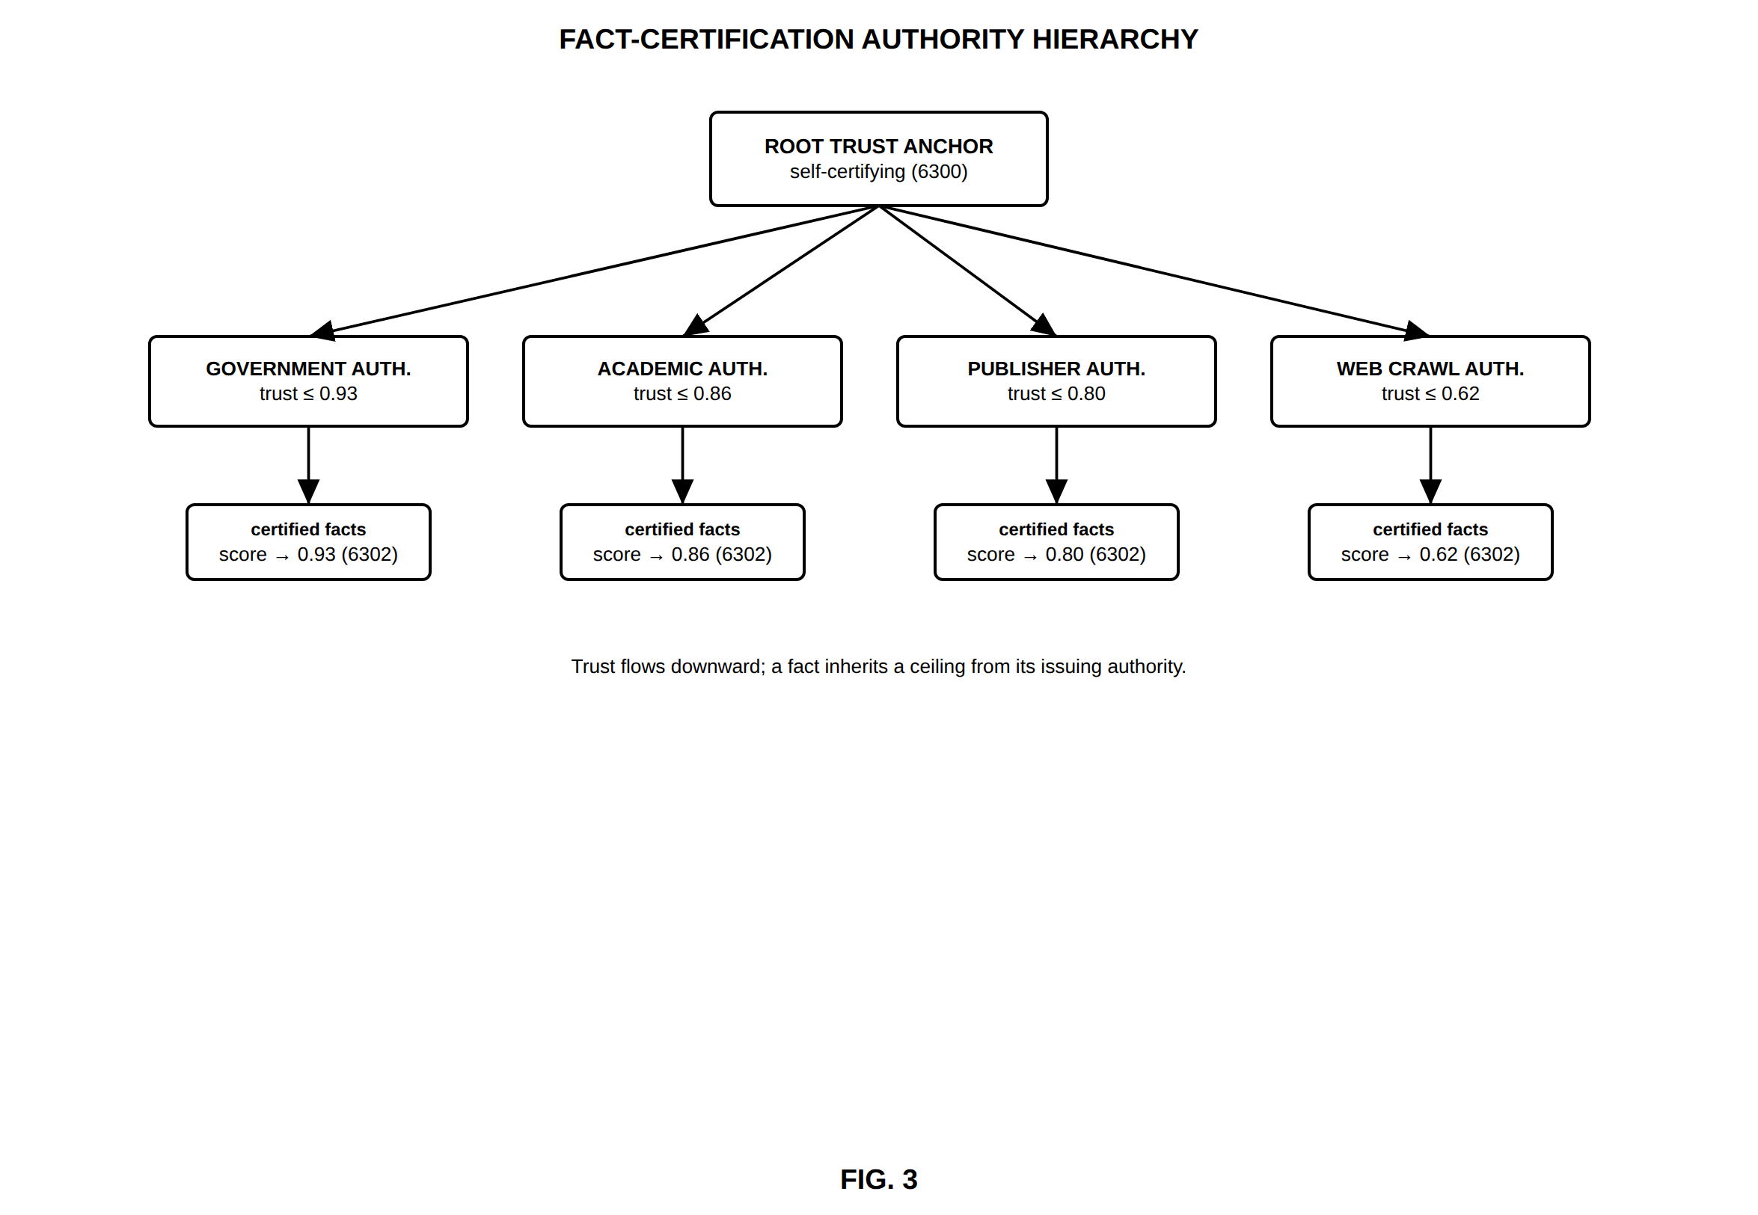
FIG. 3 — Fact-certification authority hierarchy
FIG. 4
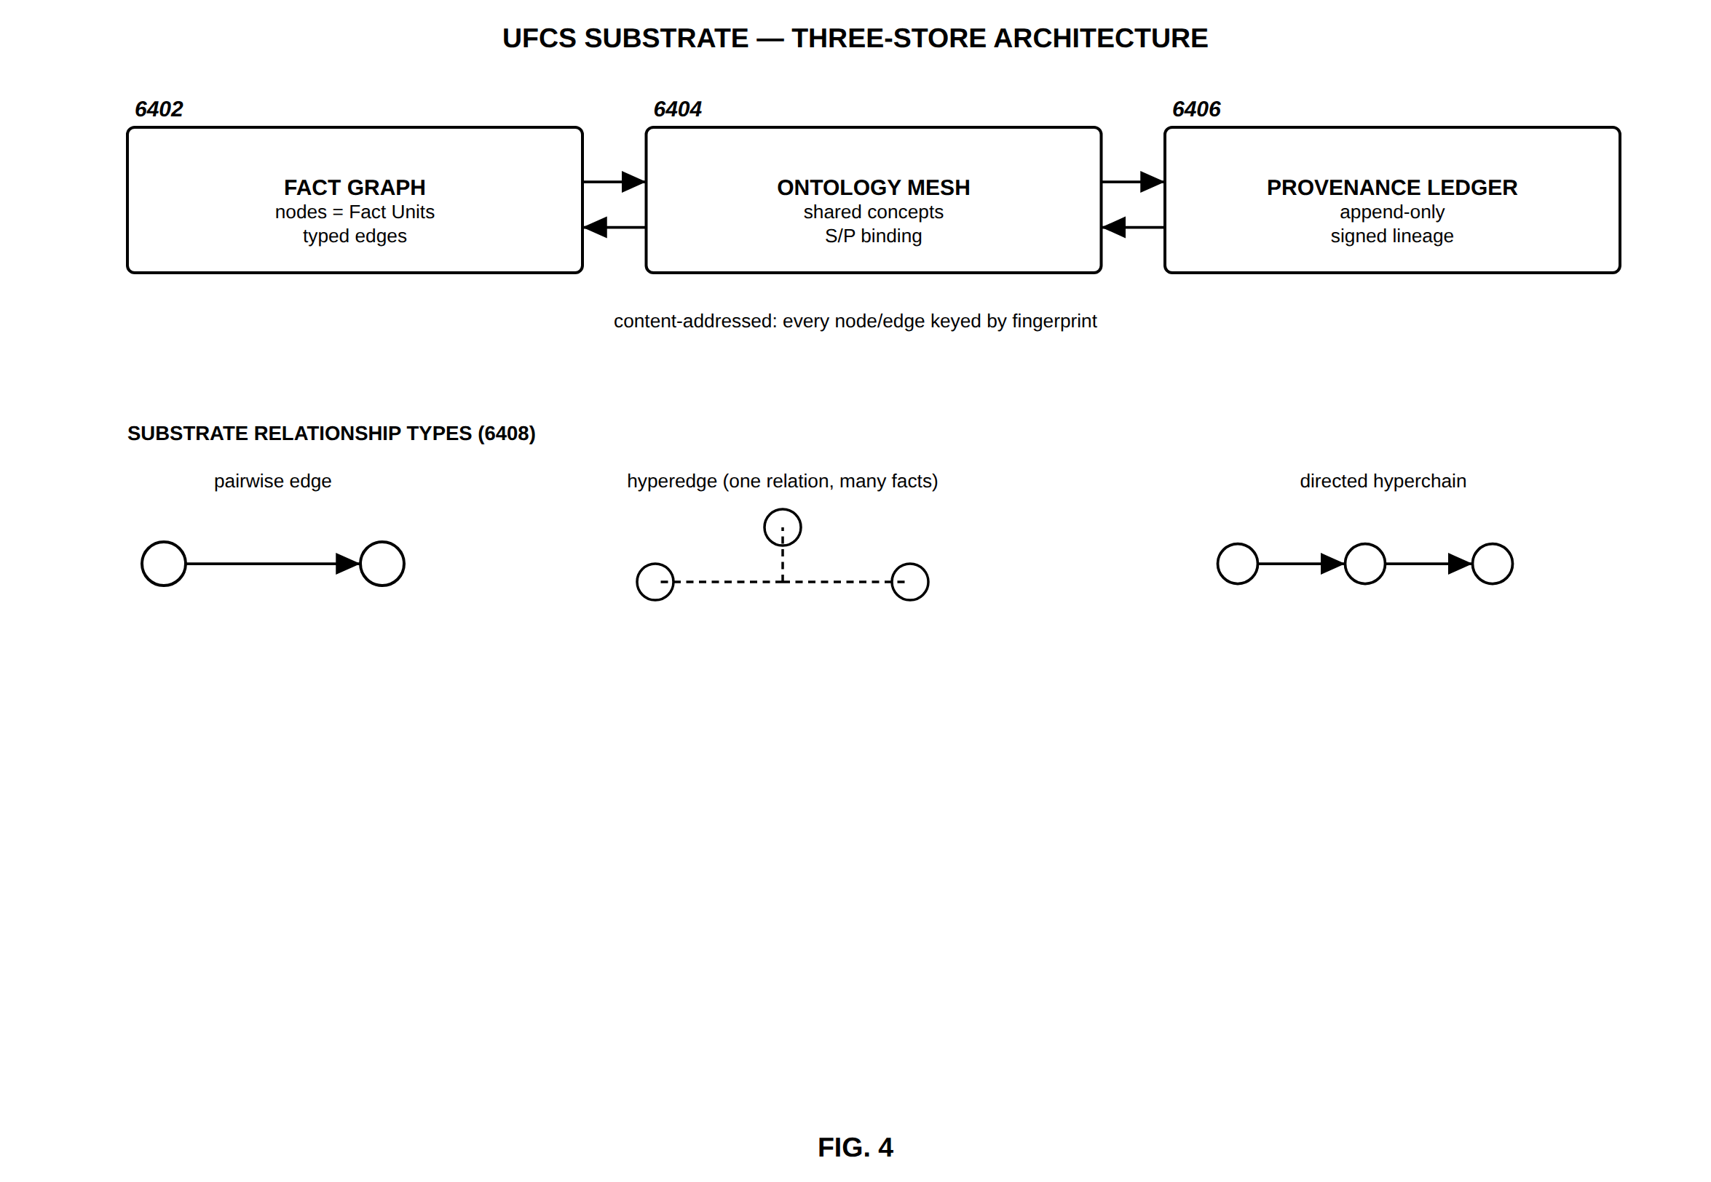
FIG. 4 — UFCS substrate — three-store architecture
FIG. 5
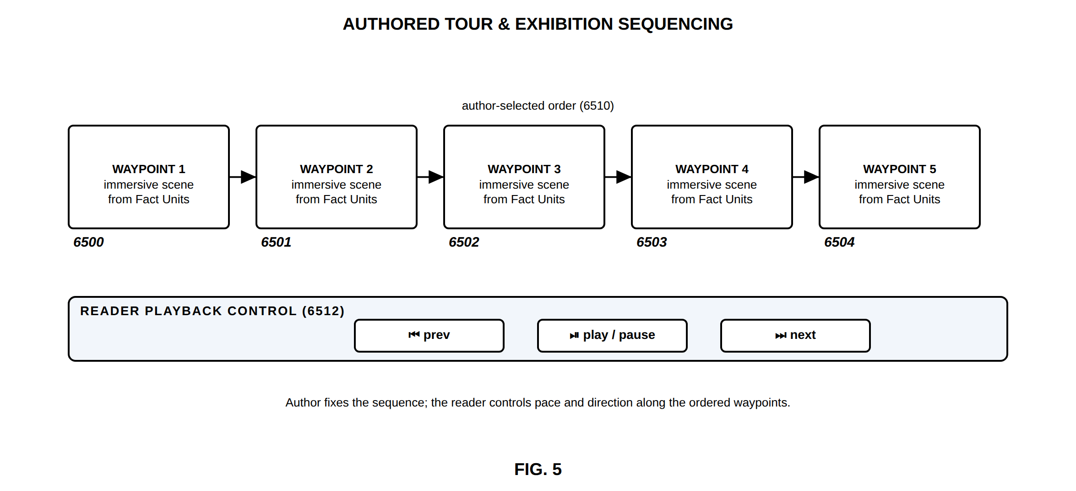
FIG. 5 — Authored tour and exhibition sequencing
FIG. 6
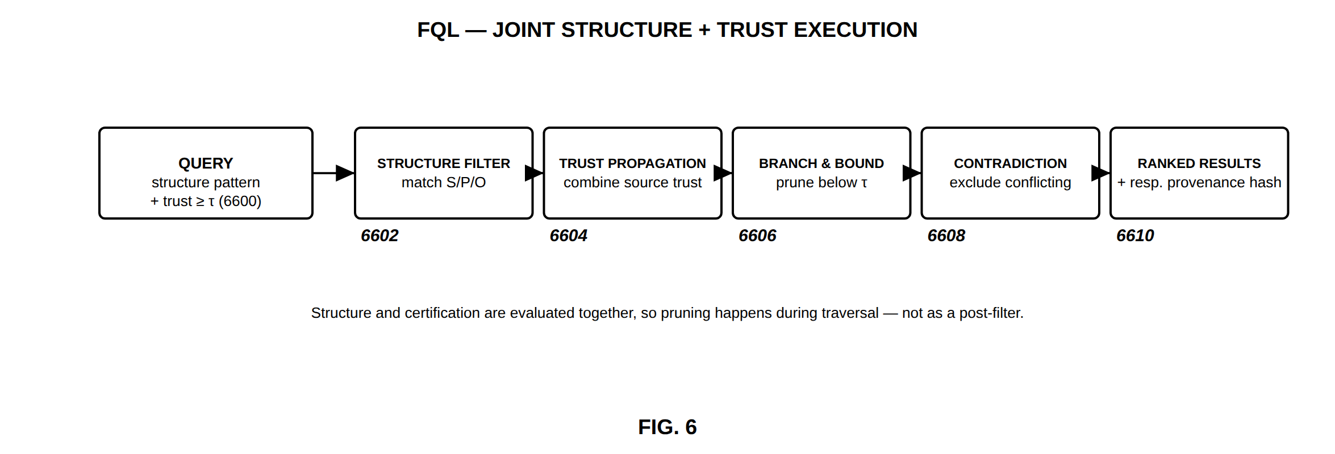
FIG. 6 — FQL — joint structure and trust execution
FIG. 7
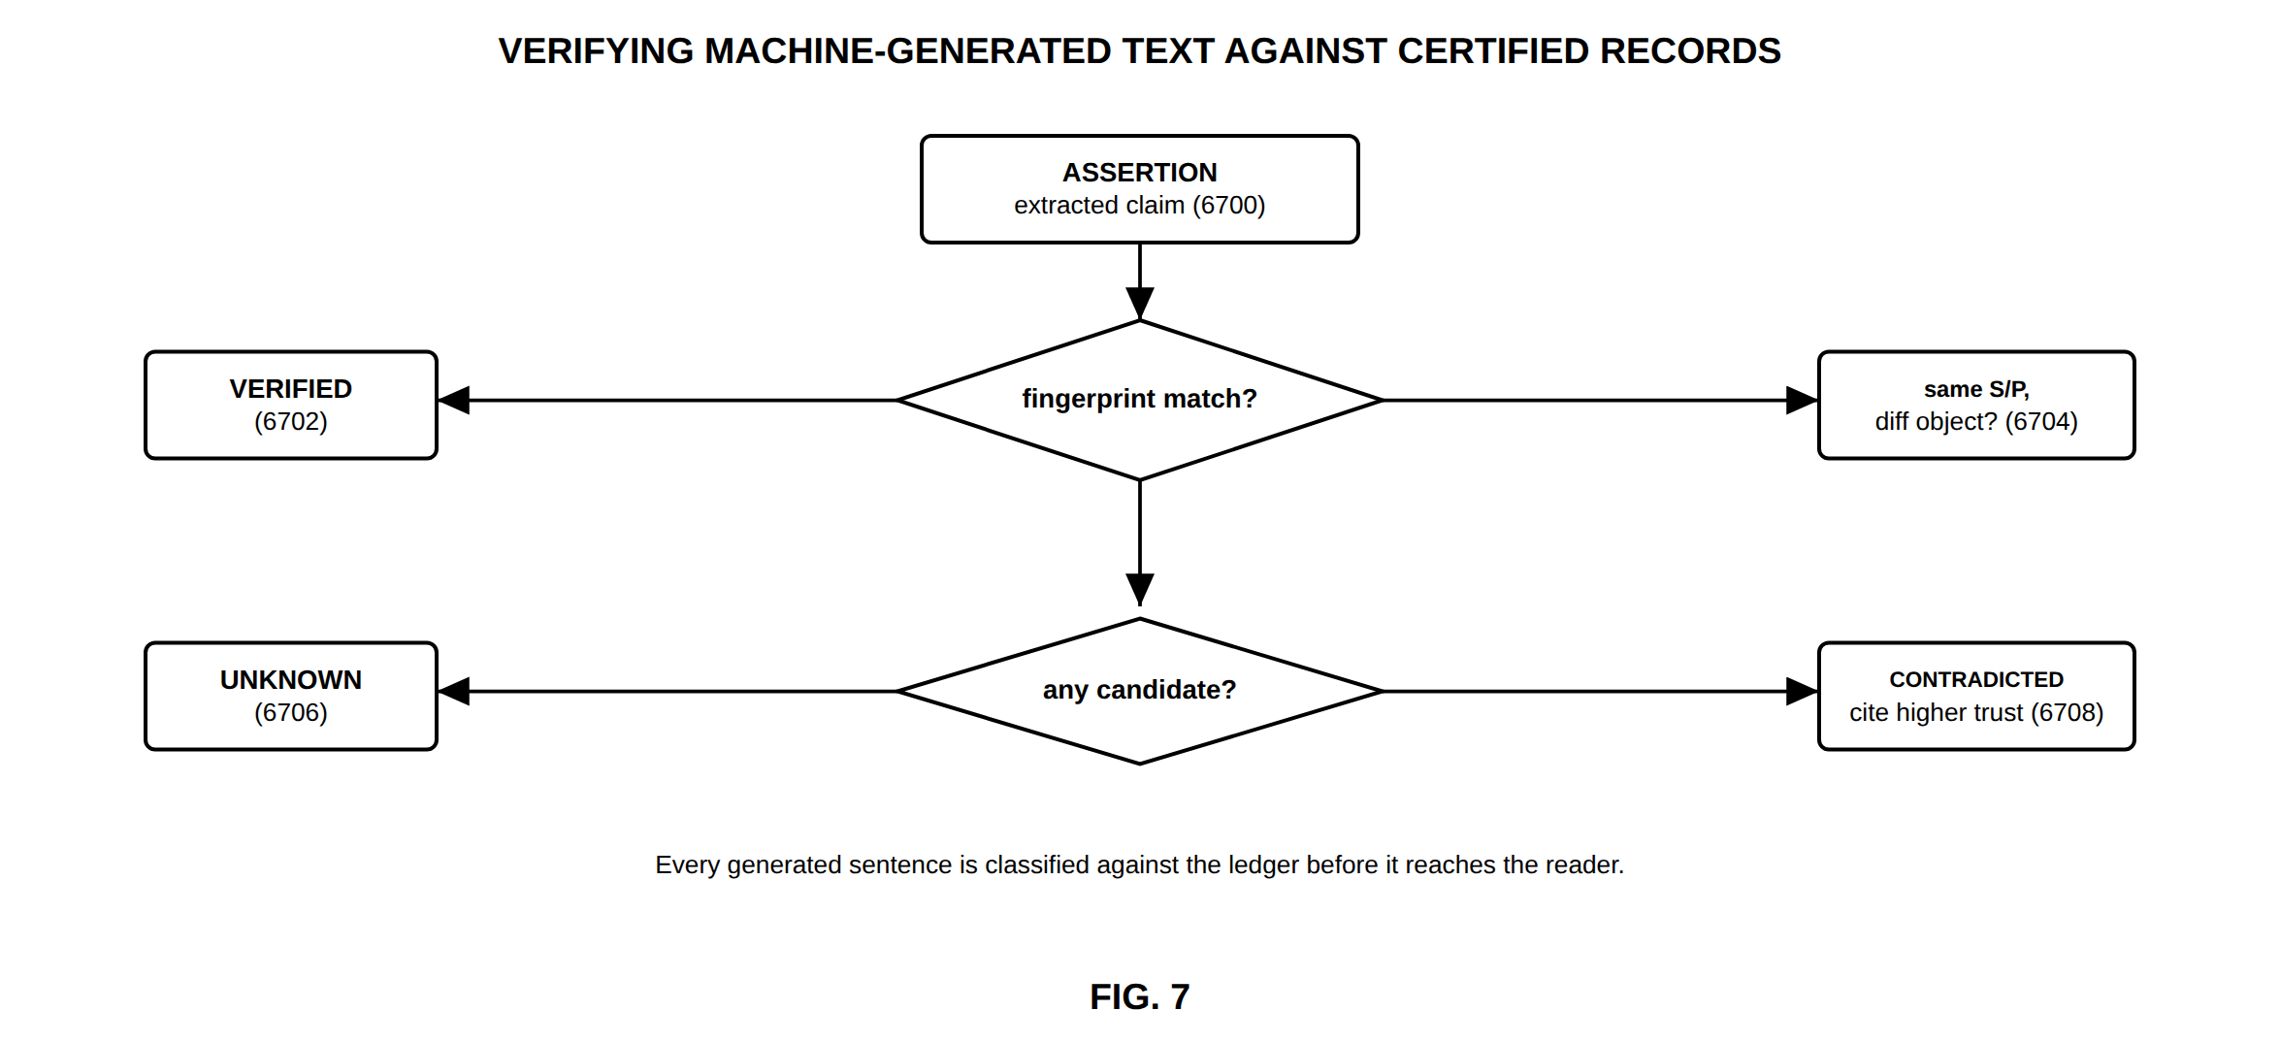
FIG. 7 — Verifying machine-generated text against certified records
FIG. 8
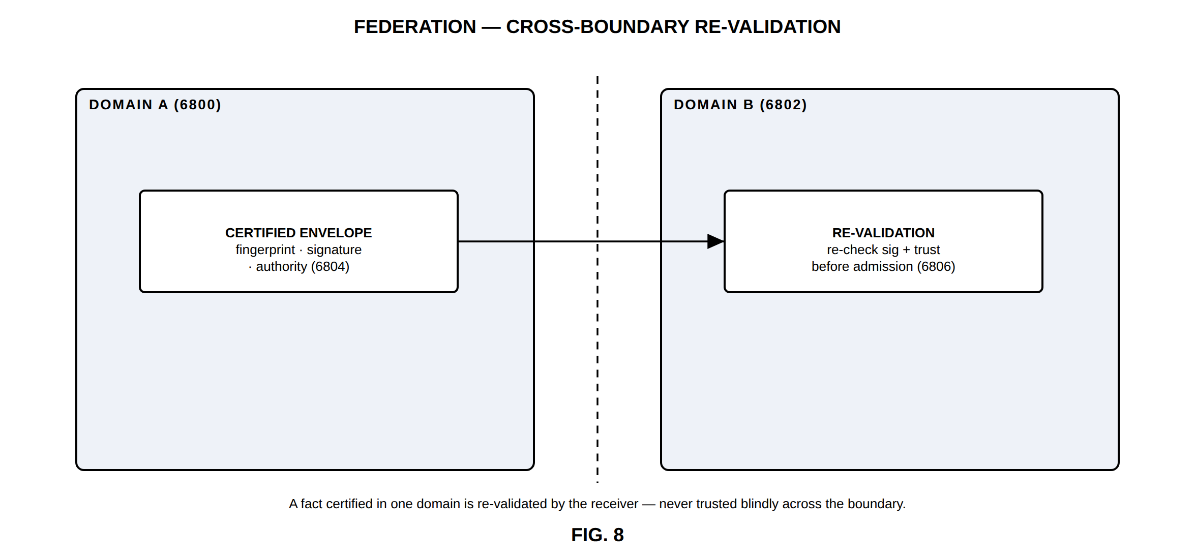
FIG. 8 — Federation — cross-boundary re-validation
FIG. 9
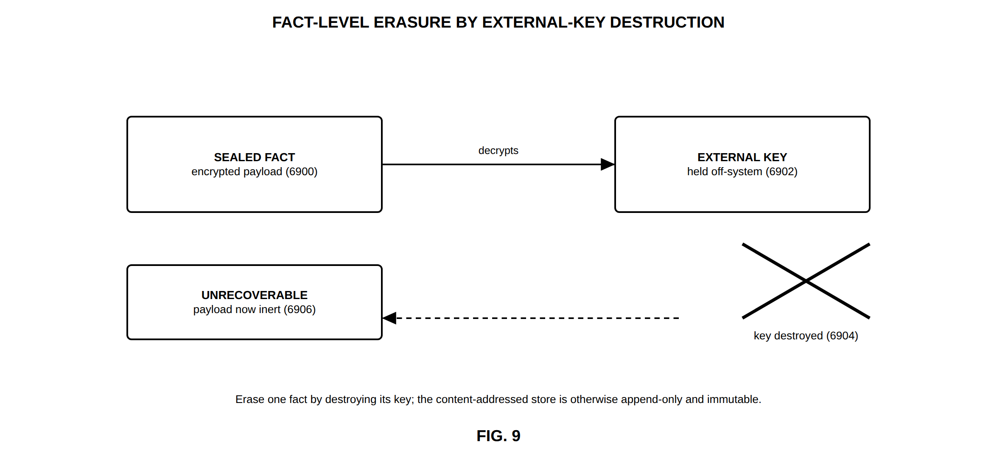
FIG. 9 — Fact-level erasure by external-key destruction
FIG. 10
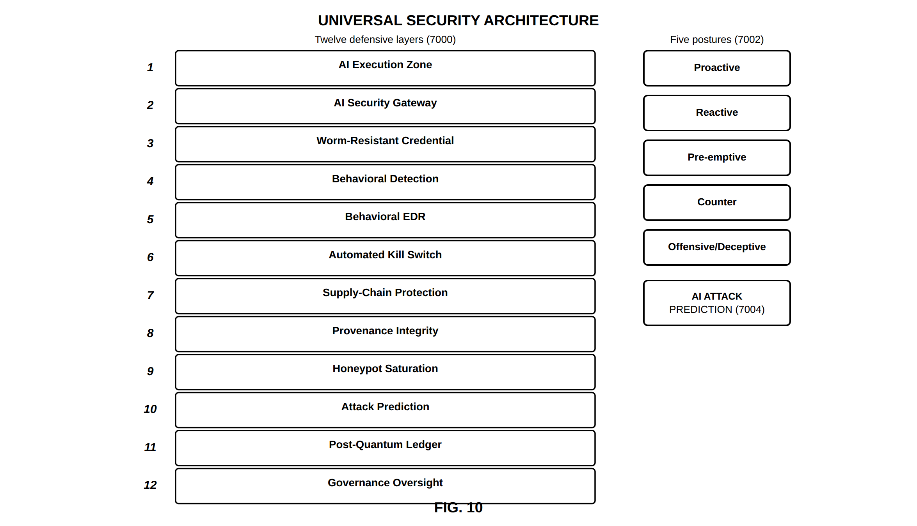
FIG. 10 — Universal security architecture
FIG. 11
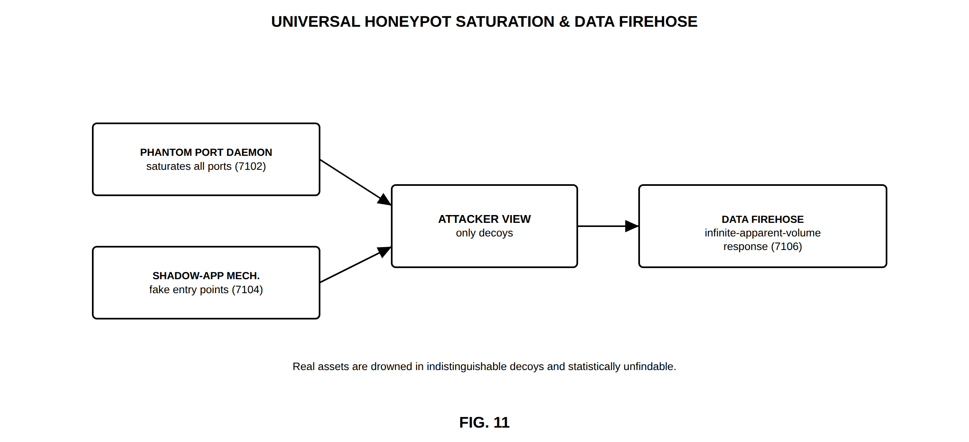
FIG. 11 — Universal honeypot saturation and data firehose
FIG. 12
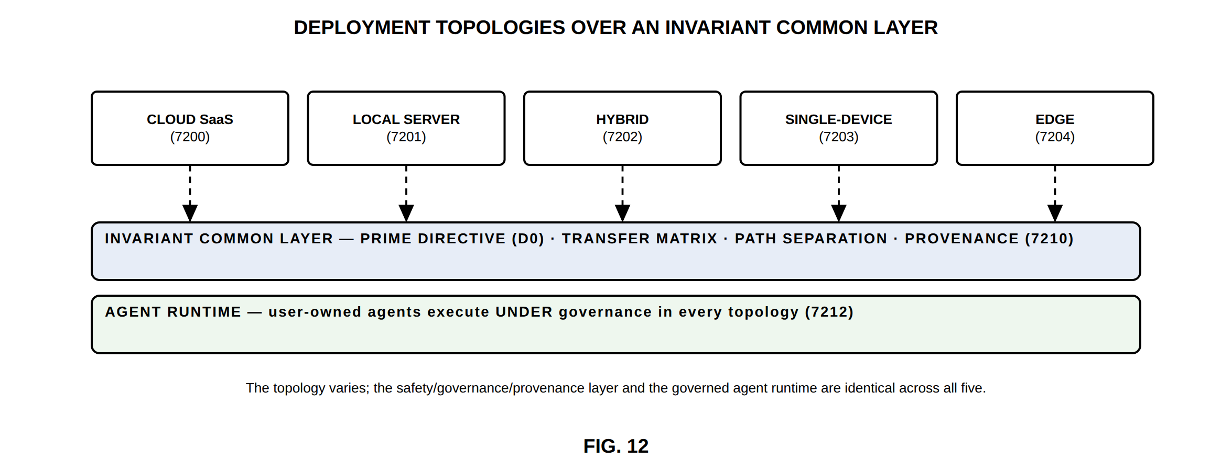
FIG. 12 — Deployment topologies over an invariant common layer
FIG. 13
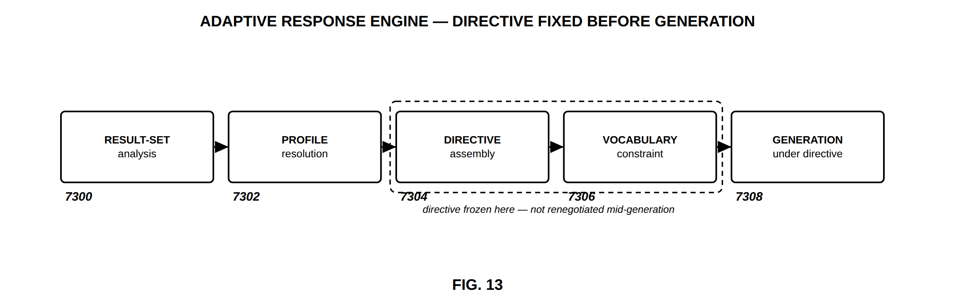
FIG. 13 — Adaptive response engine — directive fixed before generation
FIG. 14
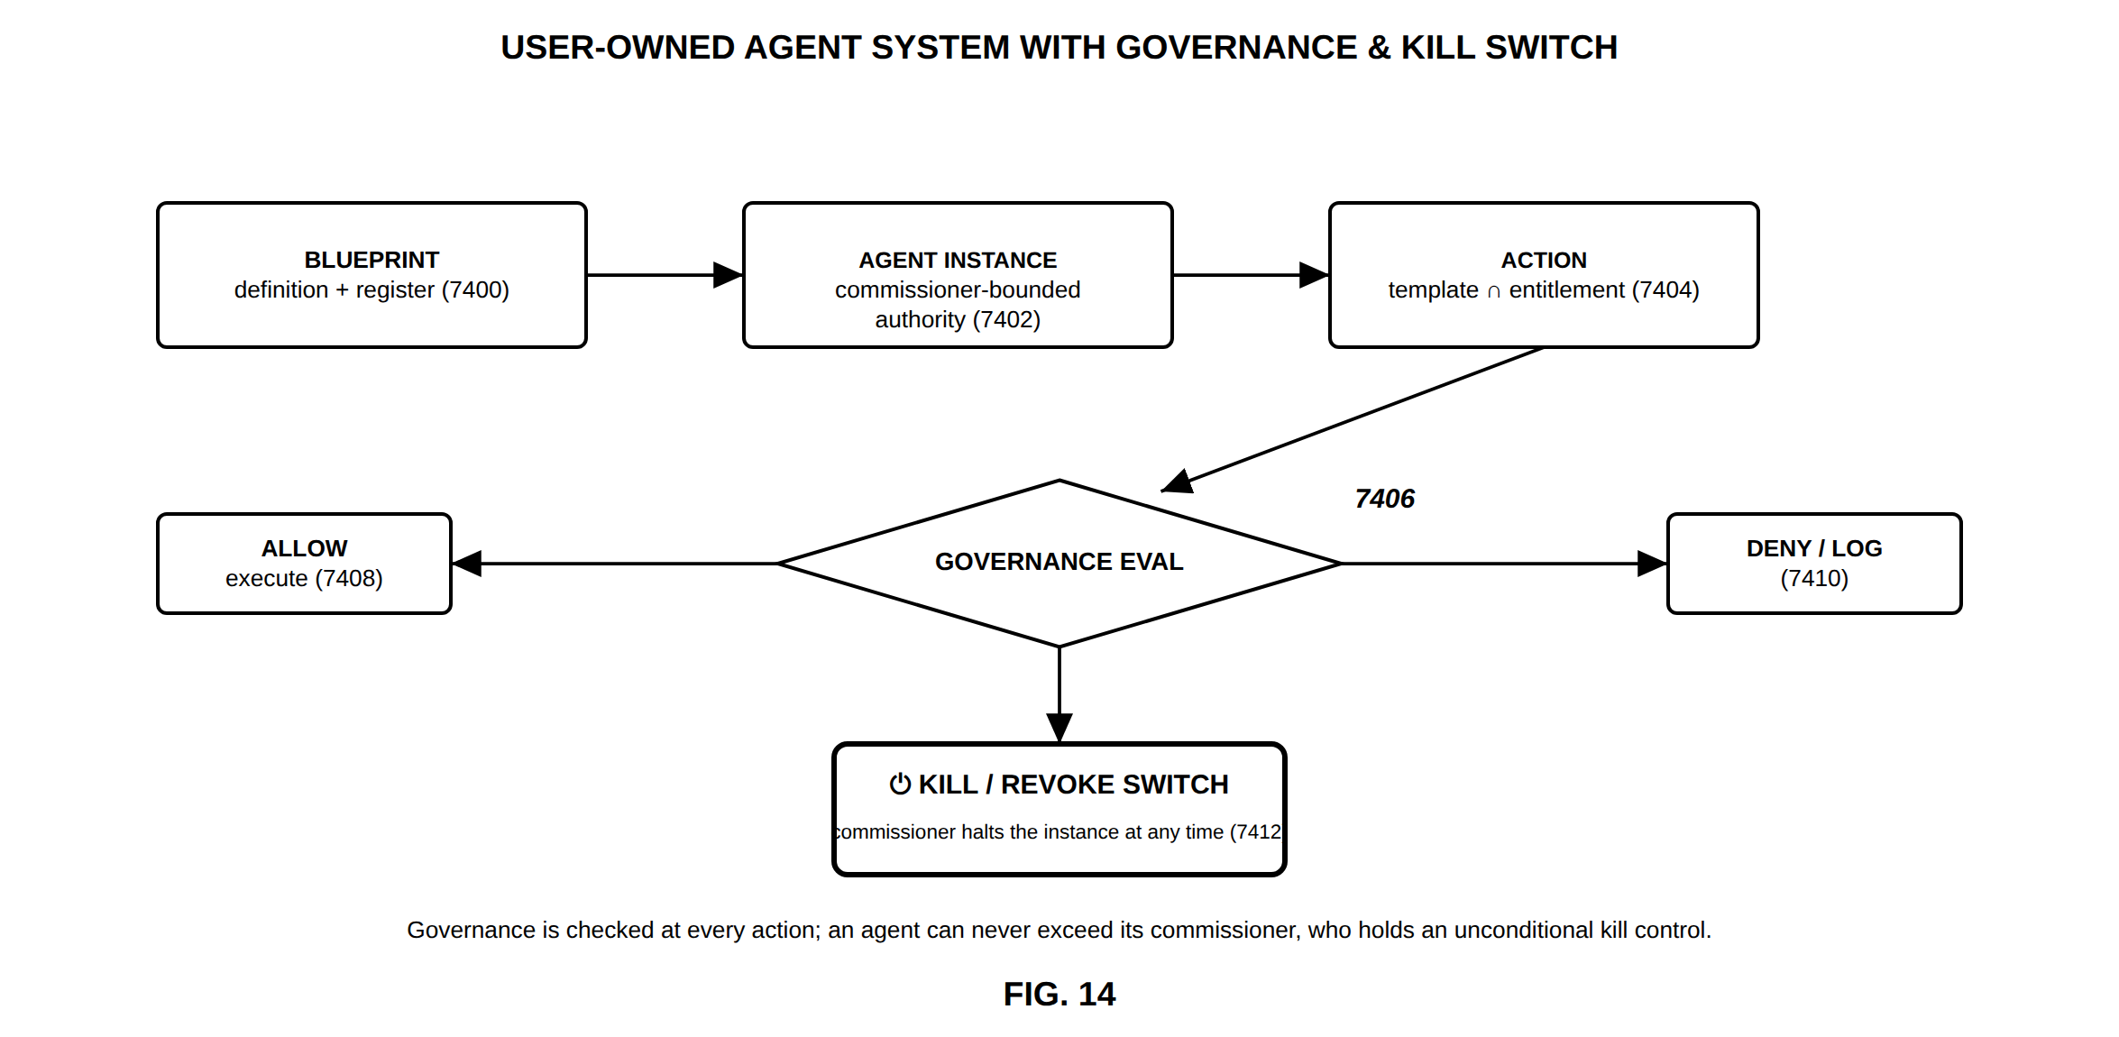
FIG. 14 — User-owned agent system with governance and kill switch
FIG. 15
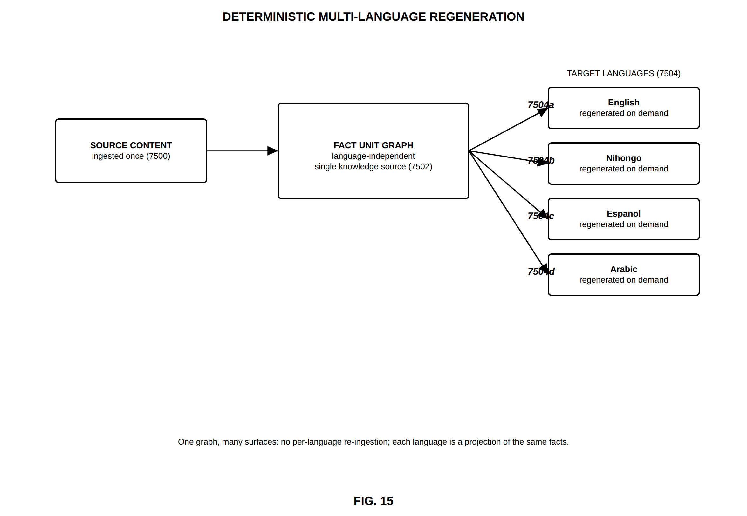
FIG. 15 — Deterministic multi-language regeneration
FIG. 16
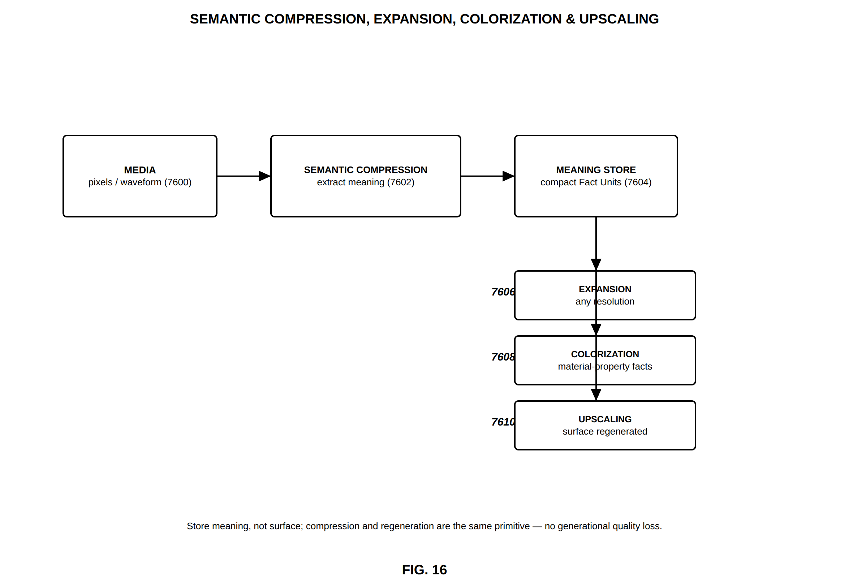
FIG. 16 — Semantic compression, expansion, colorization and upscaling
FIG. 17
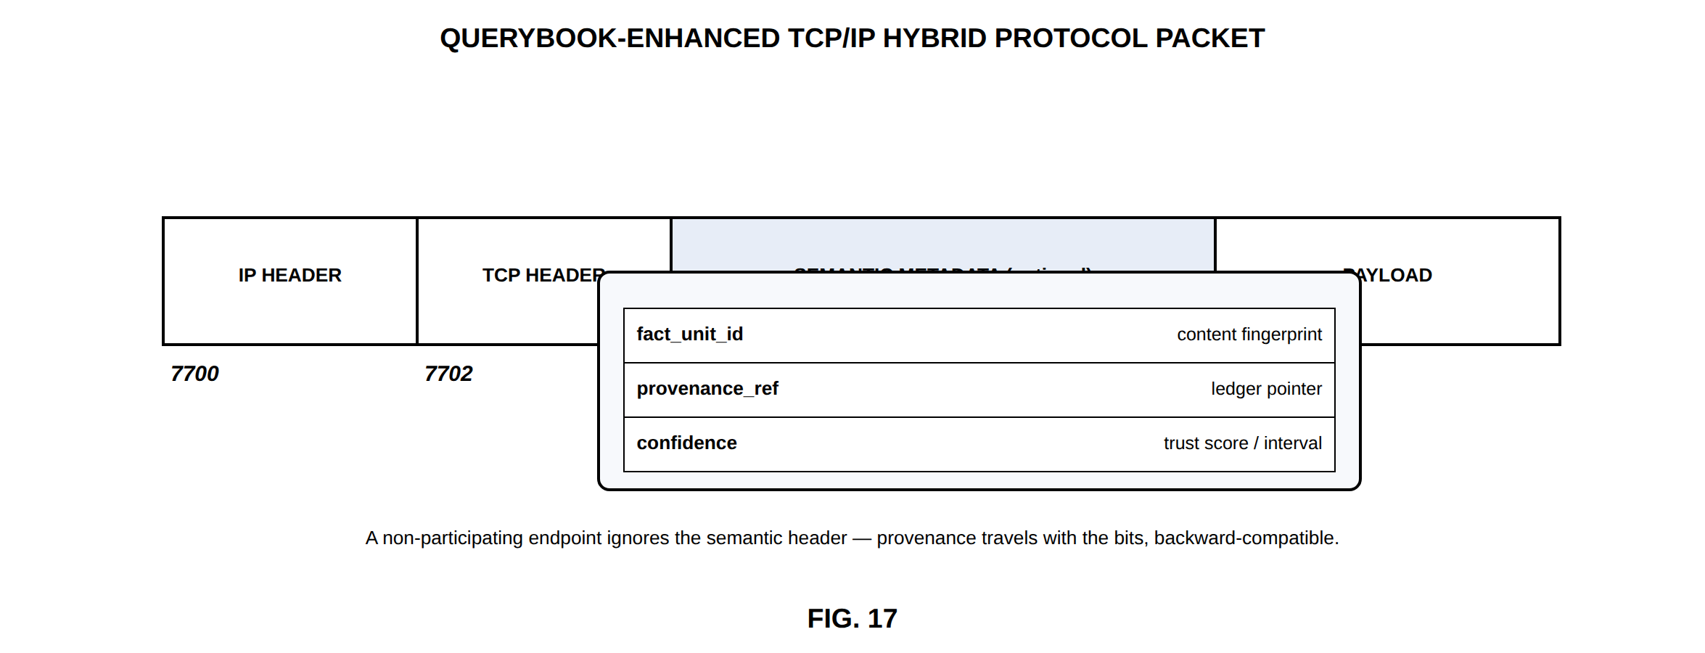
FIG. 17 — QueryBook-enhanced TCP/IP hybrid protocol packet
FIG. 18
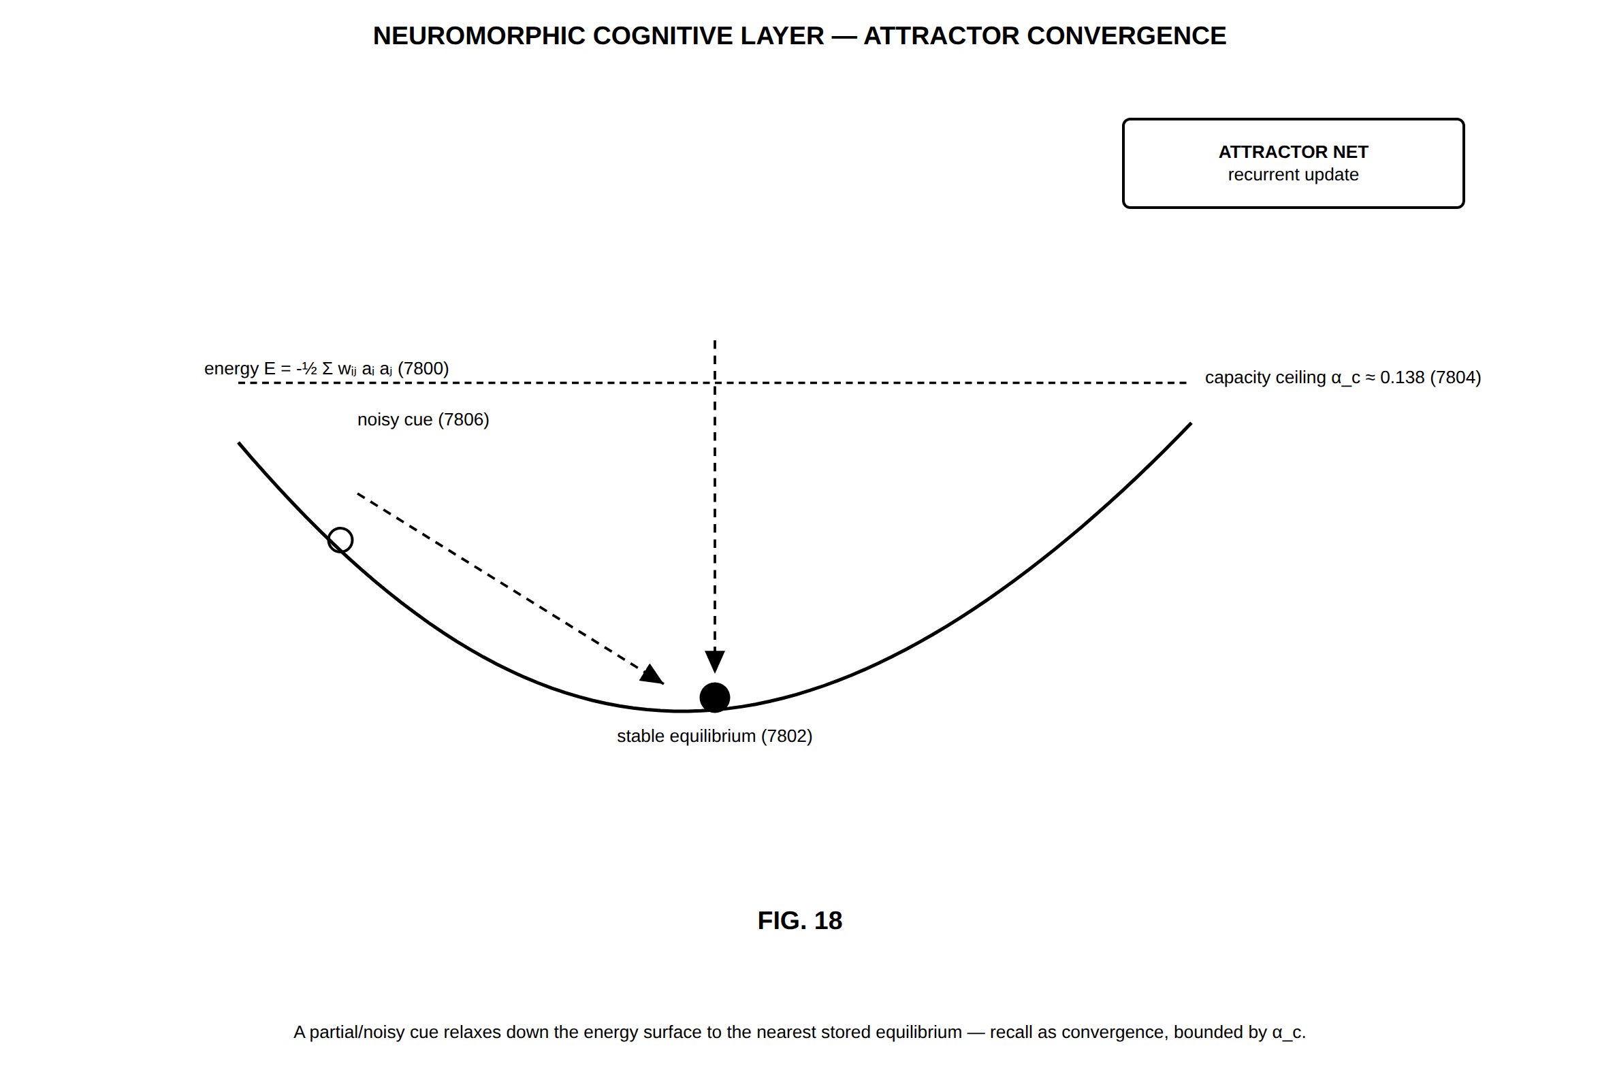
FIG. 18 — Neuromorphic cognitive layer — attractor convergence
FIG. 19
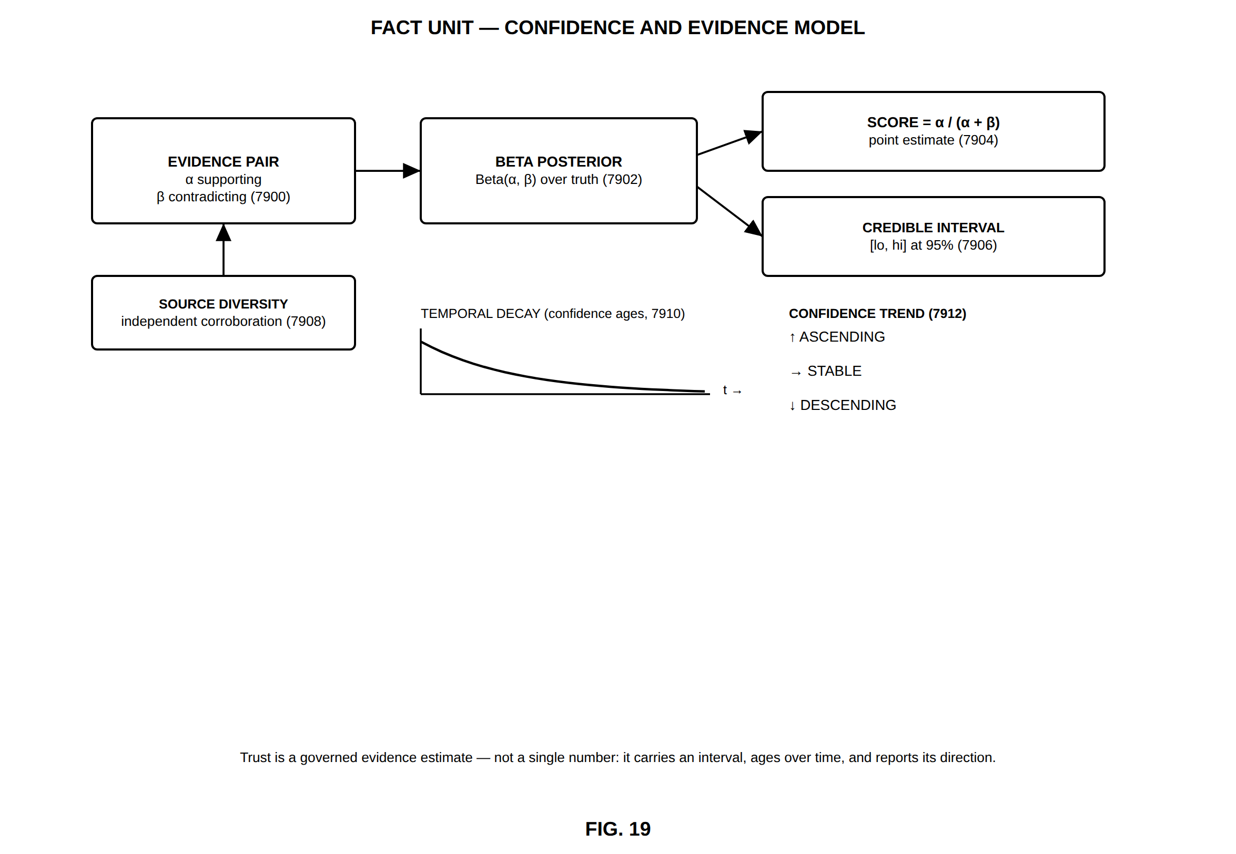
FIG. 19 — Fact Unit — confidence and evidence model
FIG. 20
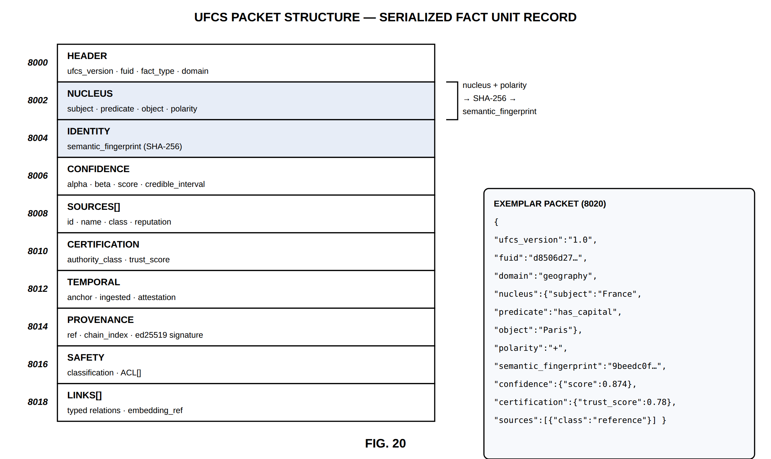
FIG. 20 — UFCS packet structure — serialized Fact Unit record
FIG. 21
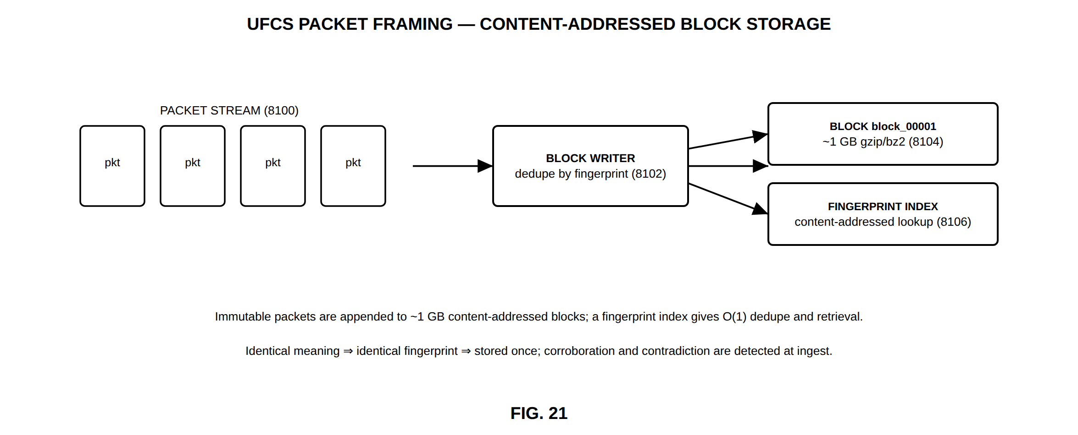
FIG. 21 — UFCS packet framing — content-addressed block storage
FIG. 22
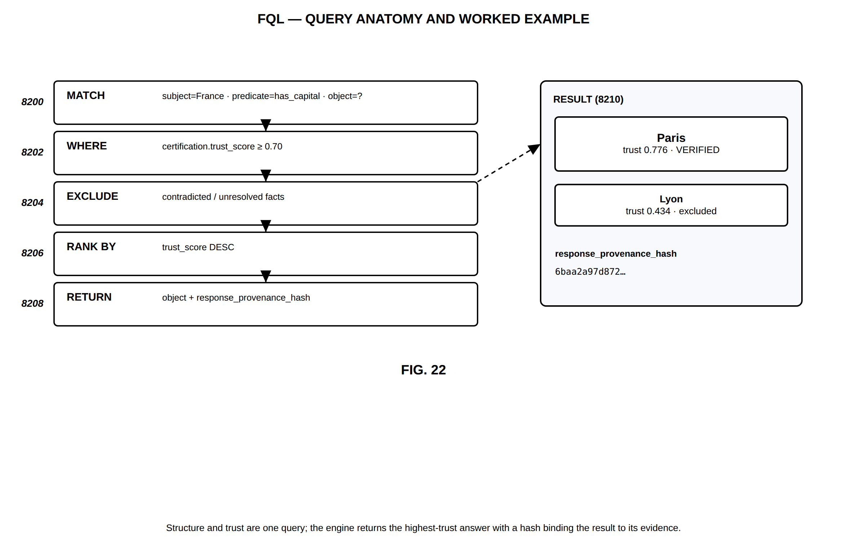
FIG. 22 — FQL — query anatomy and worked example

Part B — Language and speech subsystem (FIG. 23–FIG. 32)
FIG. 23
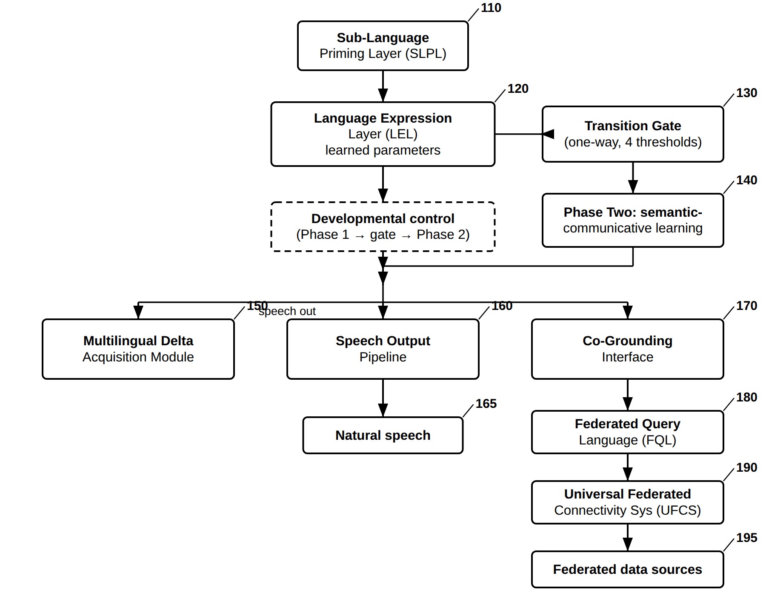
FIG. 23 — QueryBook LEL — Overall System Architecture
FIG. 24
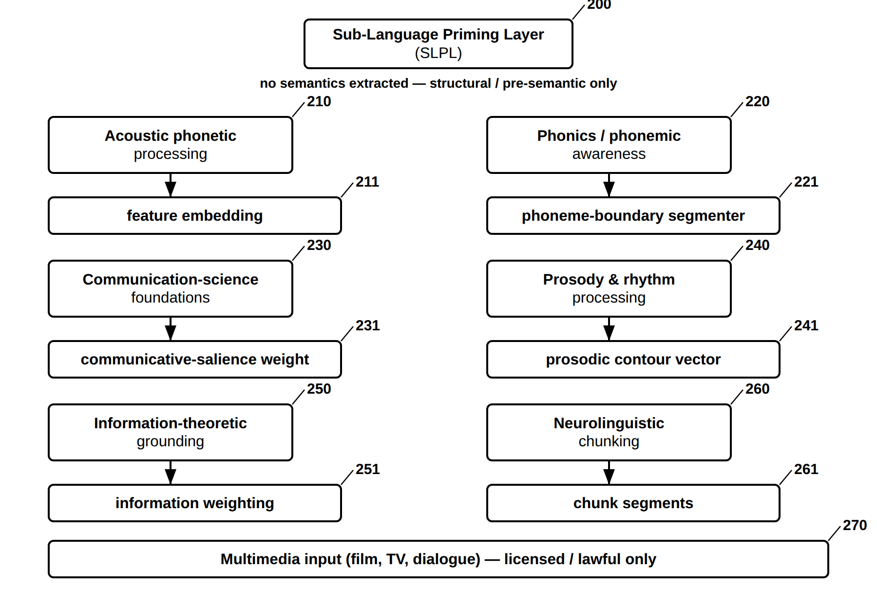
FIG. 24 — Sub-Language Priming Layer (SLPL) and Its Measurable Outputs
FIG. 25
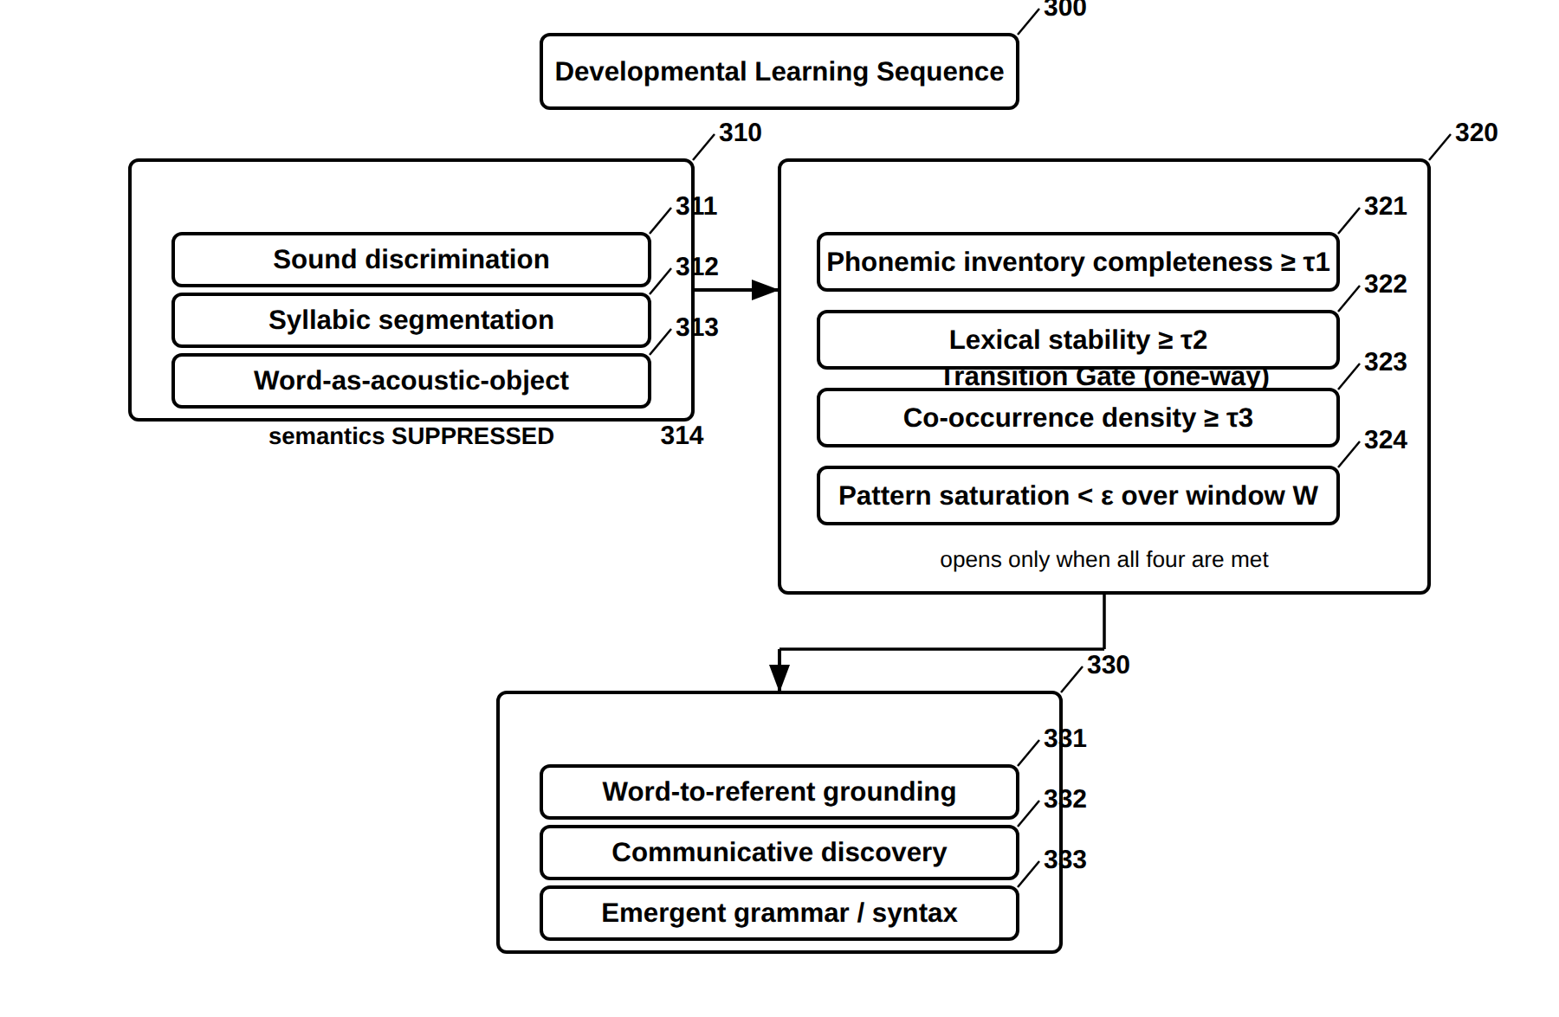
FIG. 25 — Developmental Learning Sequence and One-Way Transition Gate
FIG. 26
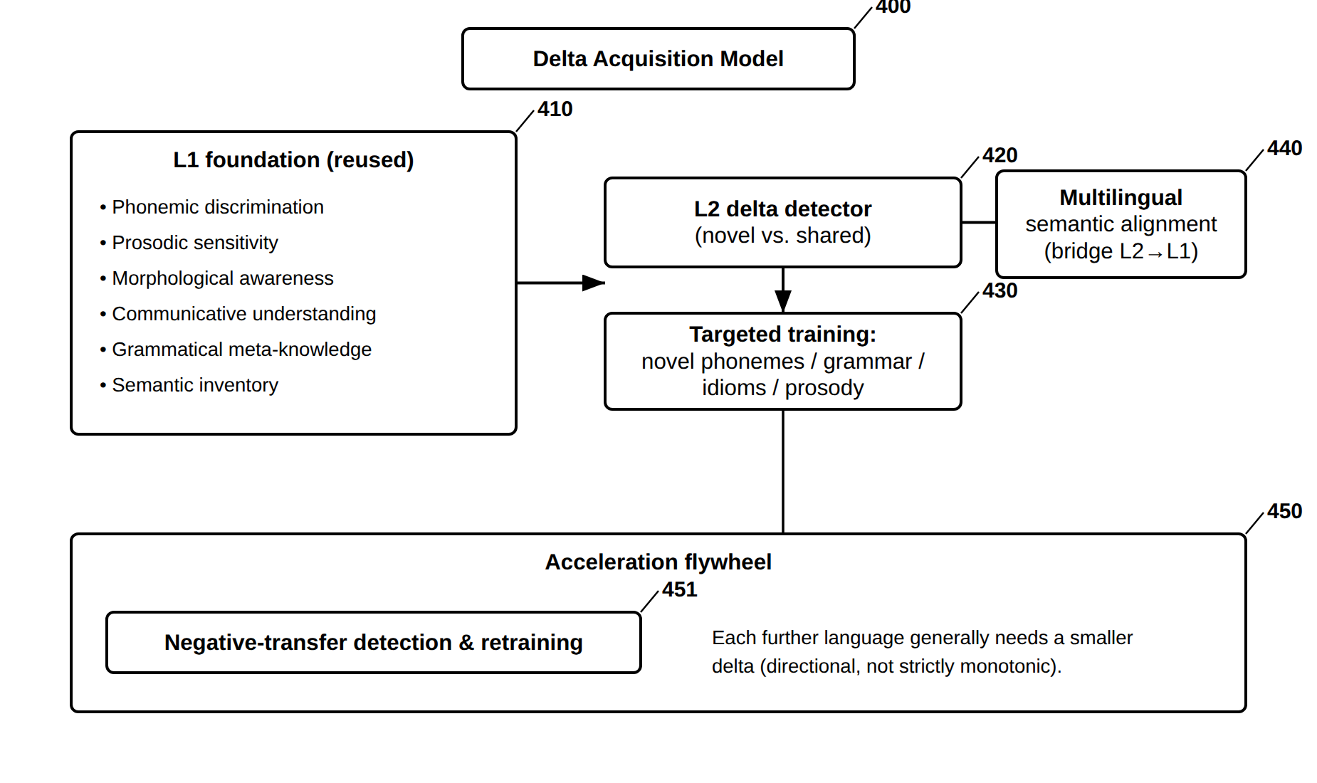
FIG. 26 — Multilingual Transfer — Delta Acquisition and Acceleration Flywheel
FIG. 27
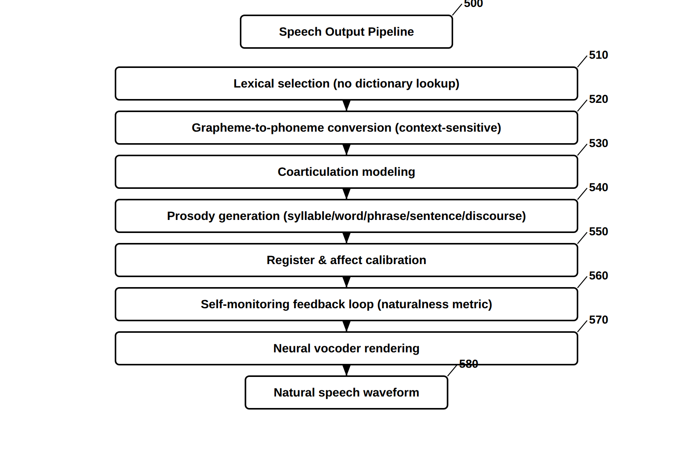
FIG. 27 — Speech Output Pipeline (Seven Learned Stages)
FIG. 28
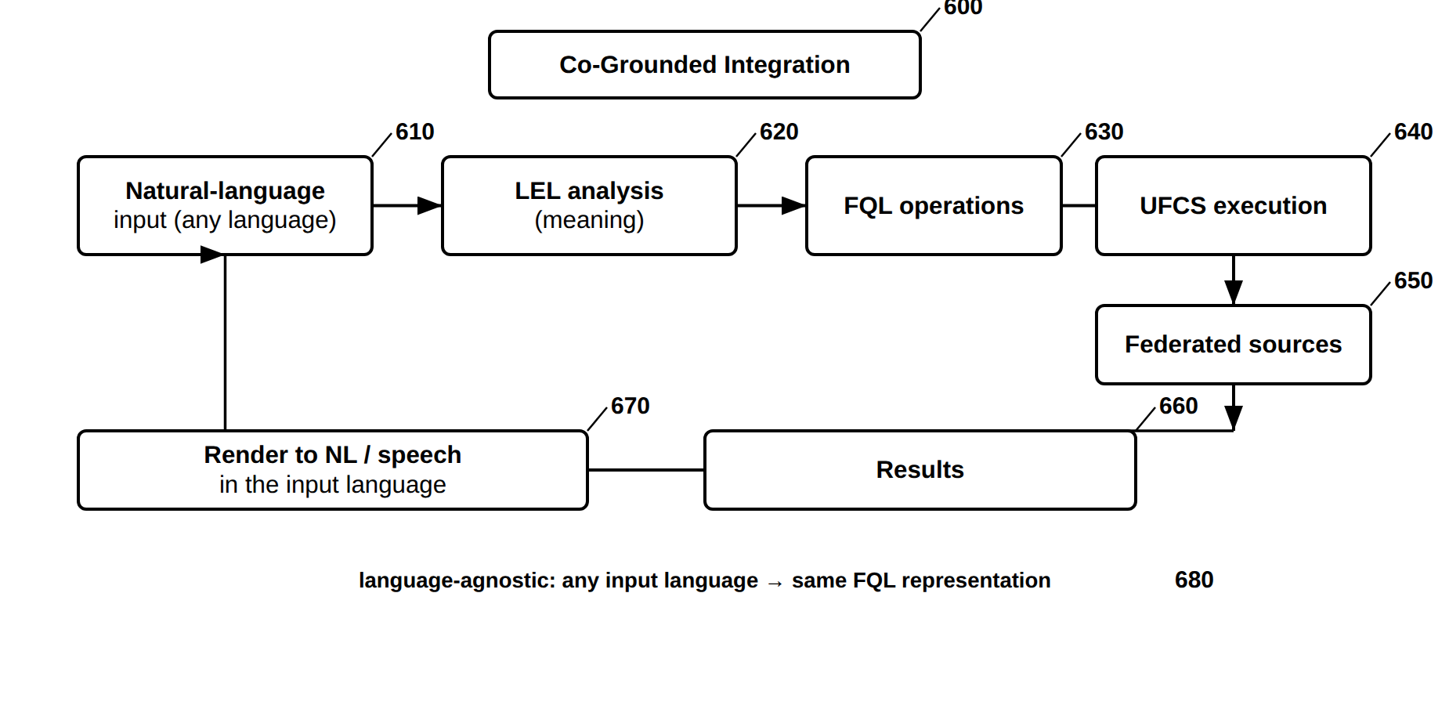
FIG. 28 — Co-Grounded Integration with FQL and UFCS
FIG. 29
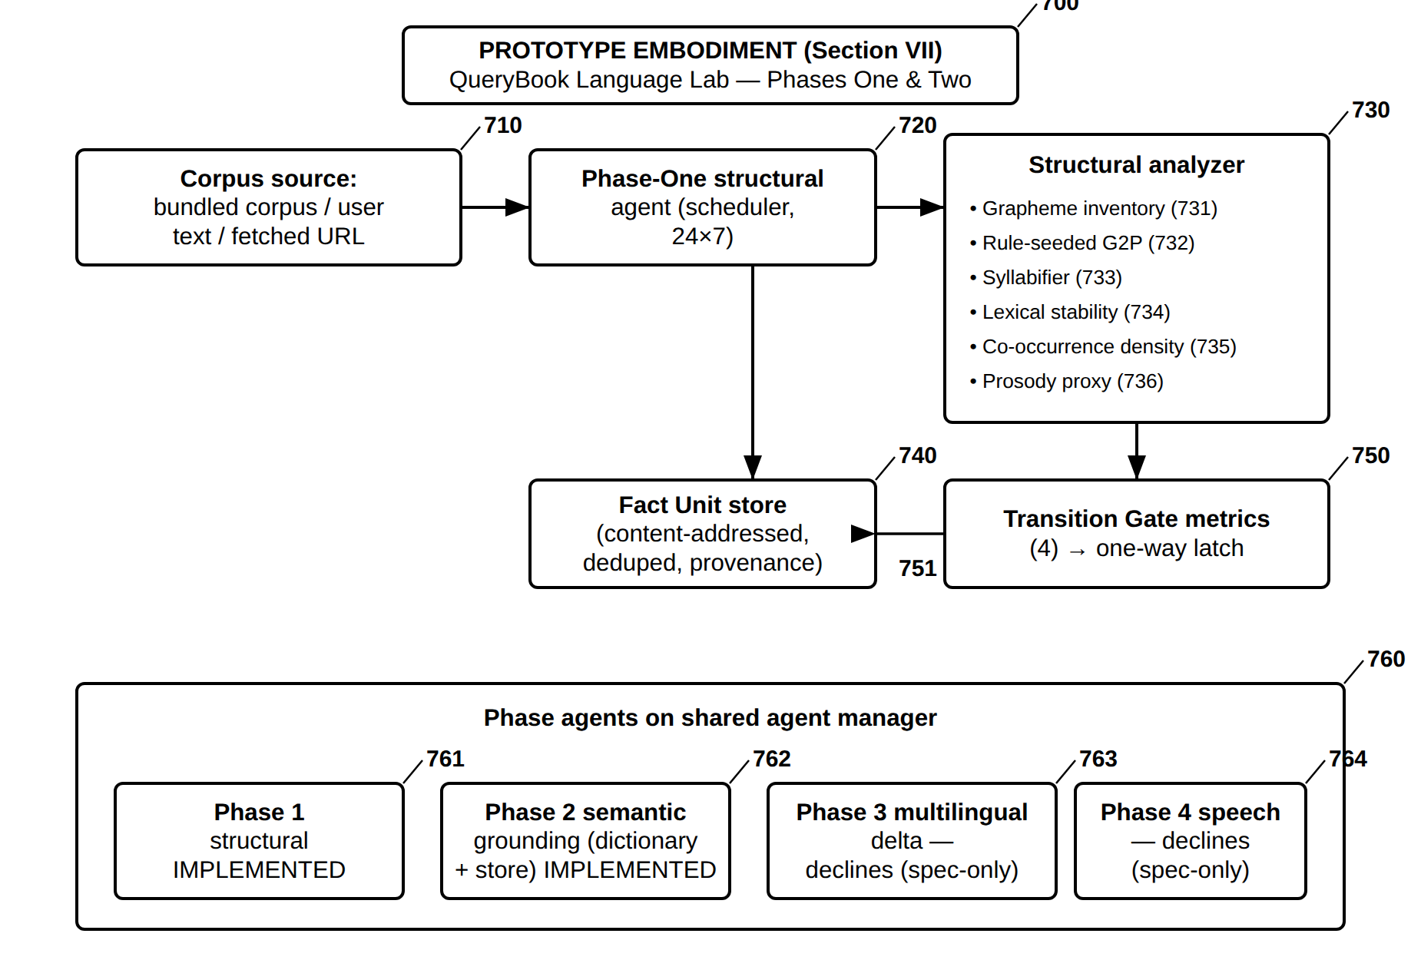
FIG. 29 — Reduced-to-Practice Embodiment — Language Lab Phases One and Two Prototype
FIG. 30
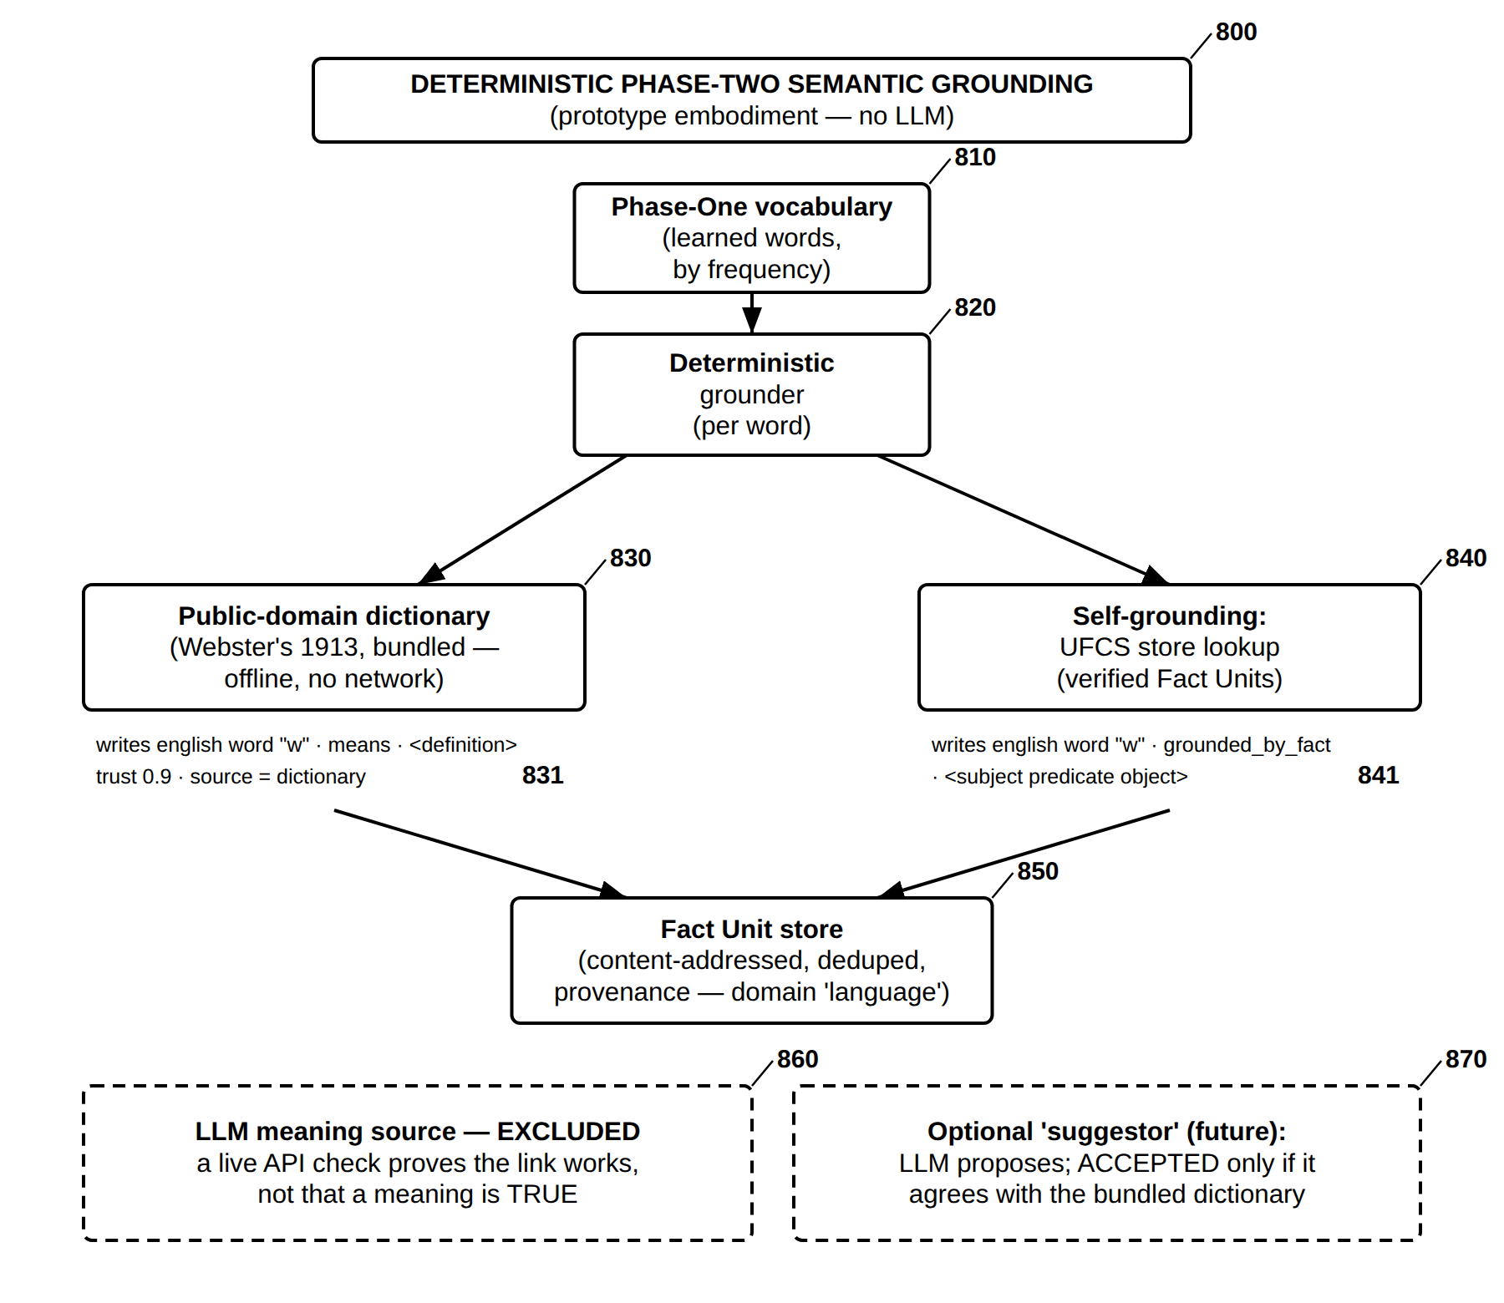
FIG. 30 — Deterministic Phase-Two Semantic Grounding — Dictionary and Store (No LLM)
FIG. 31
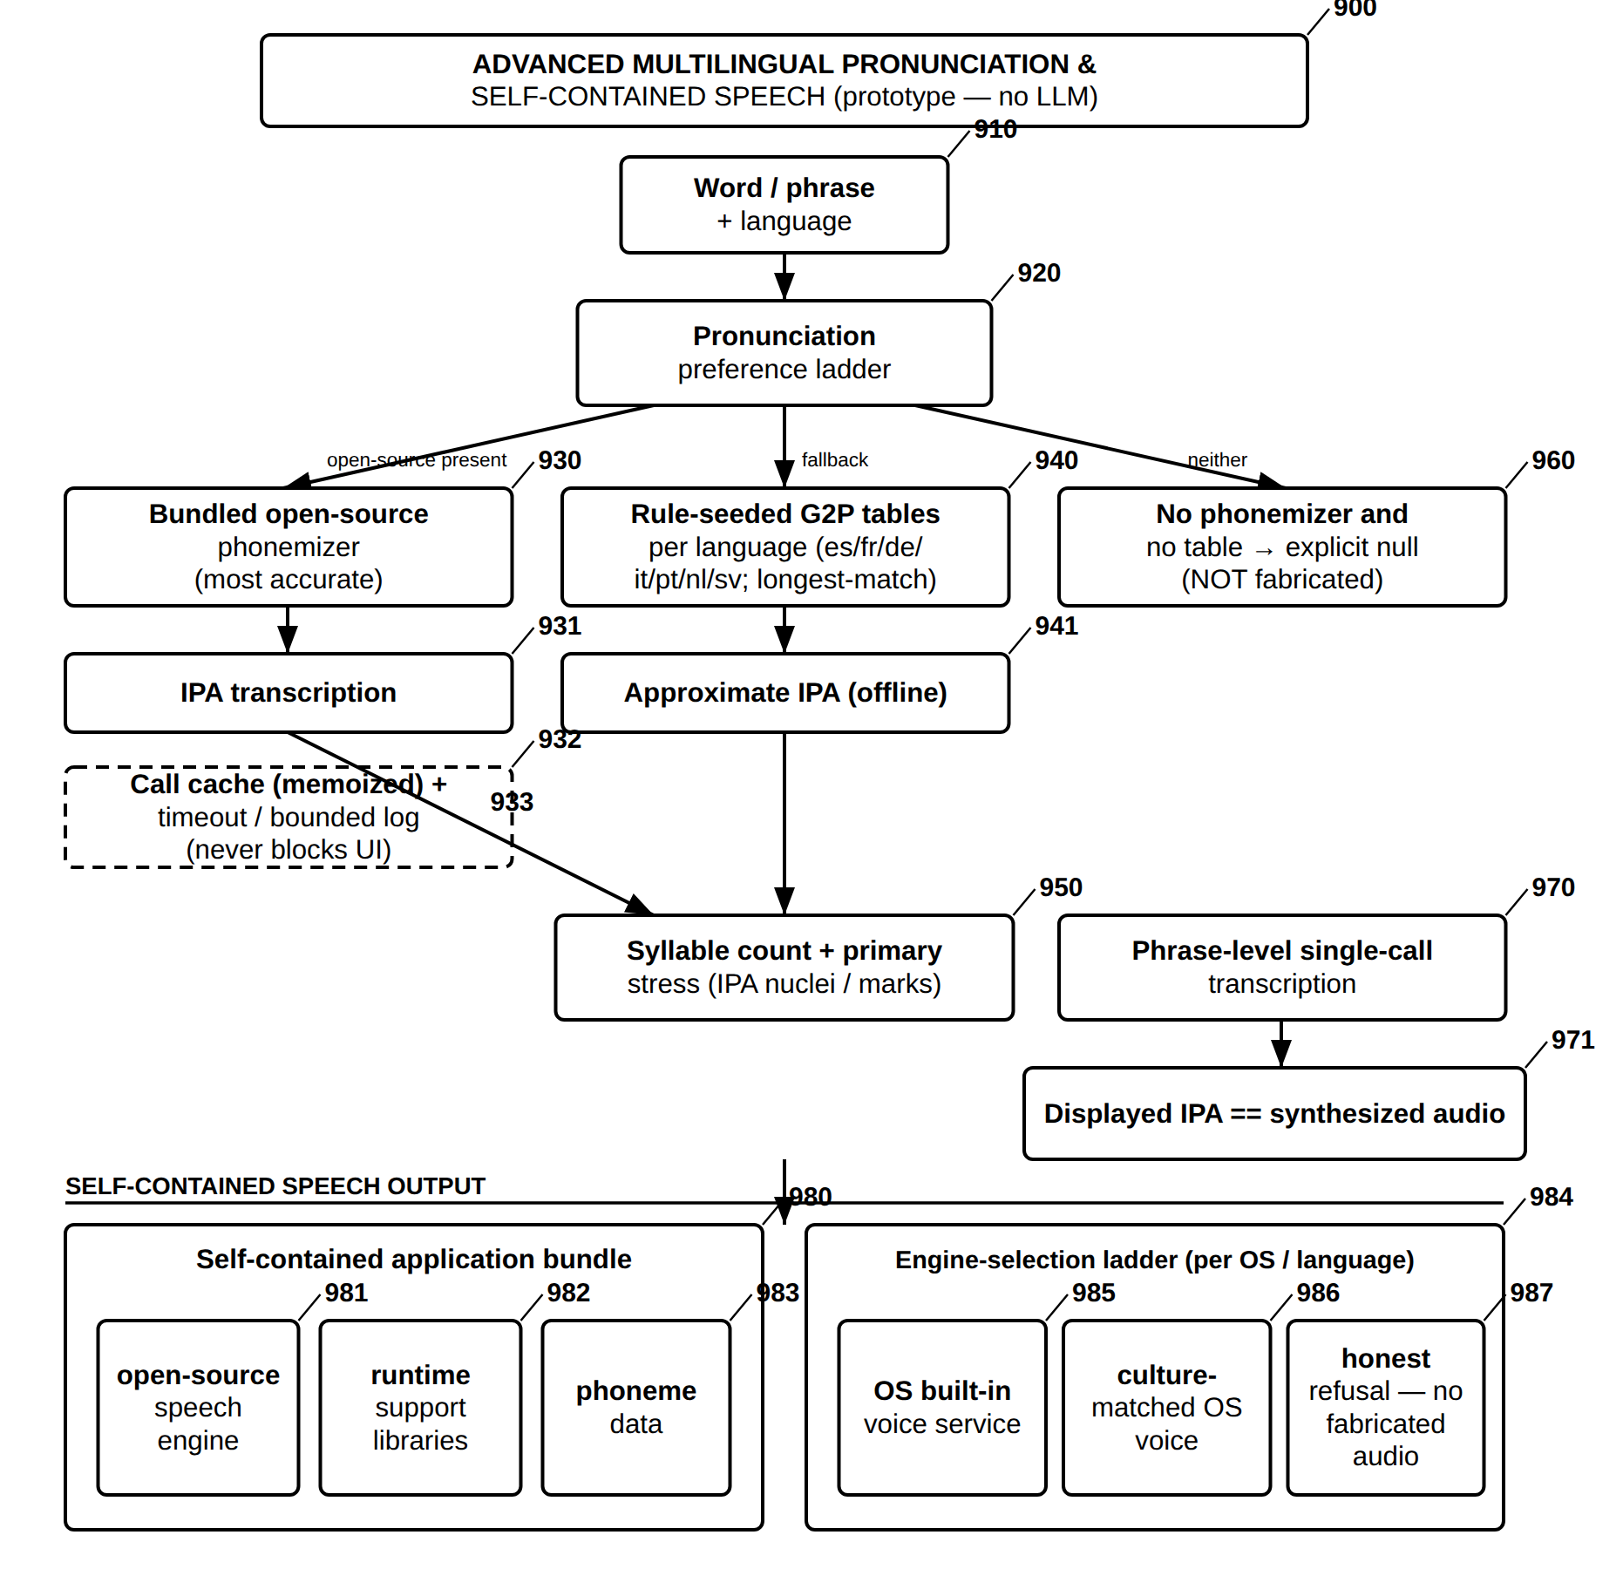
FIG. 31 — Advanced Multilingual Pronunciation and Self-Contained Speech (No LLM)
FIG. 32
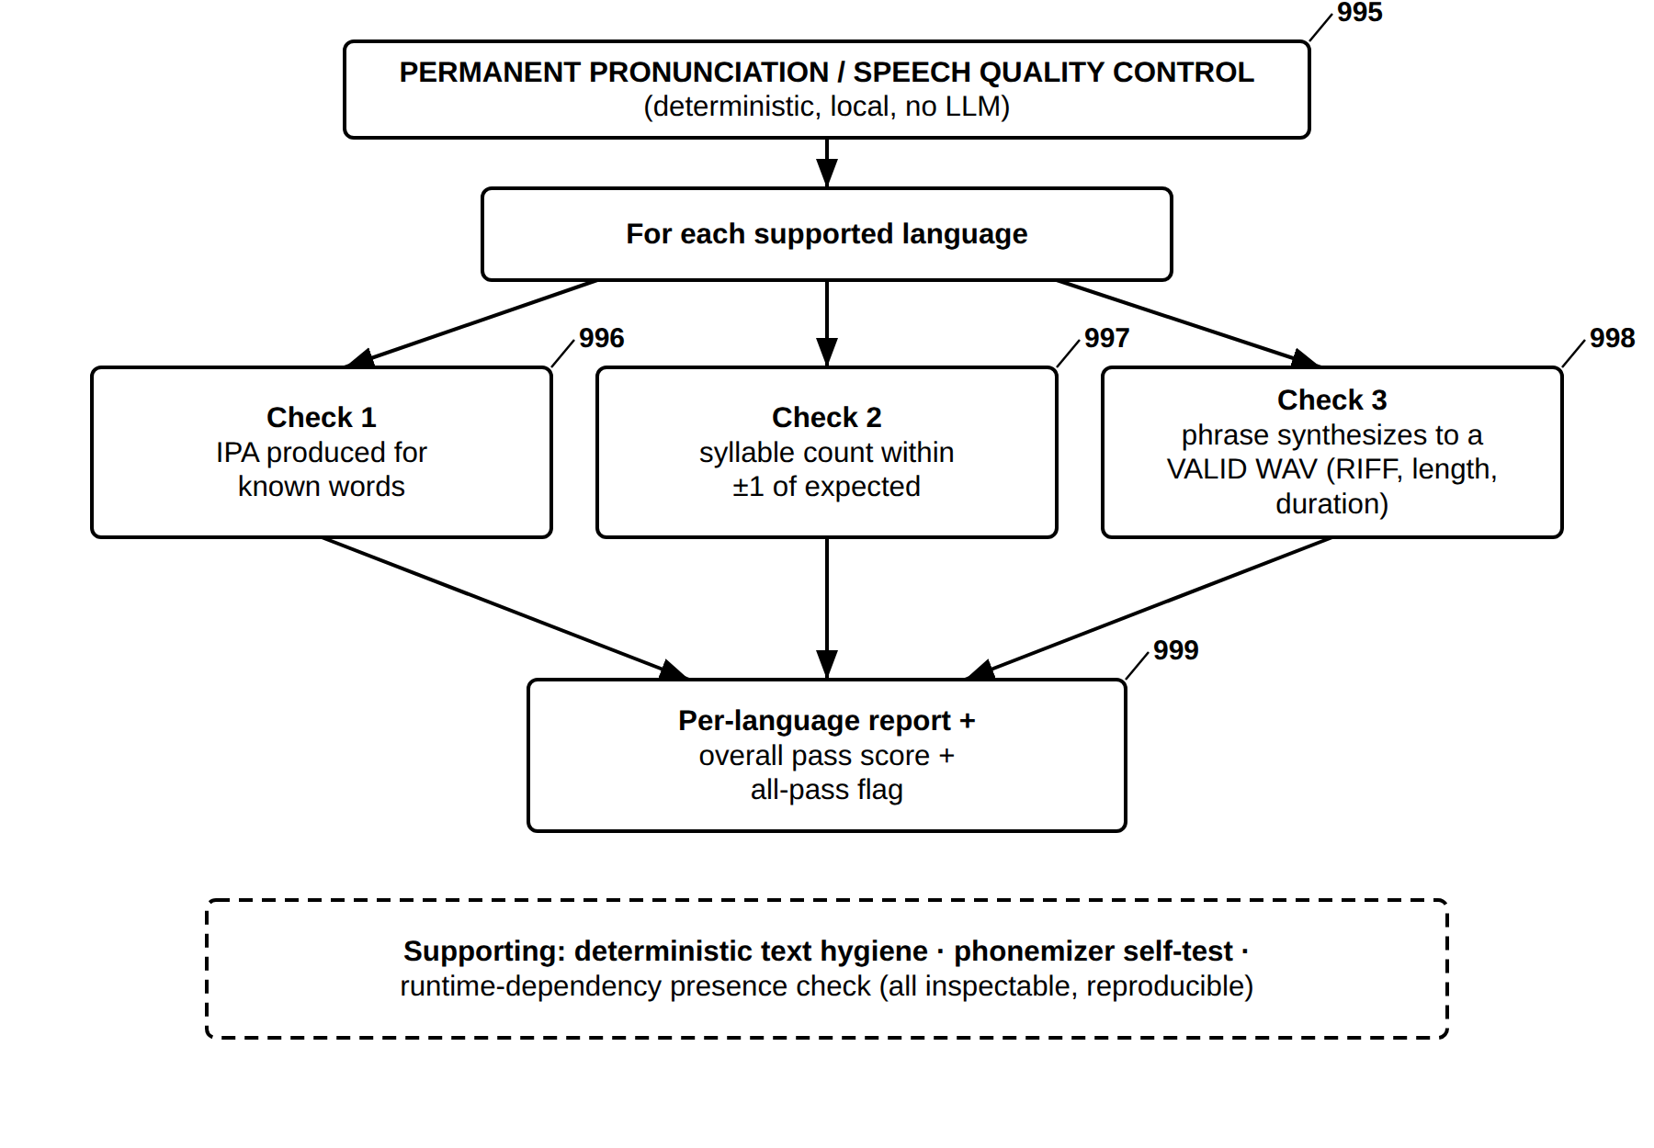
FIG. 32 — Permanent Pronunciation and Speech Quality-Control Battery (No LLM)

Part C — Identity, integrity-audit, interpretation and lecture embodiments (FIG. 33–FIG. 40)
FIG. 33
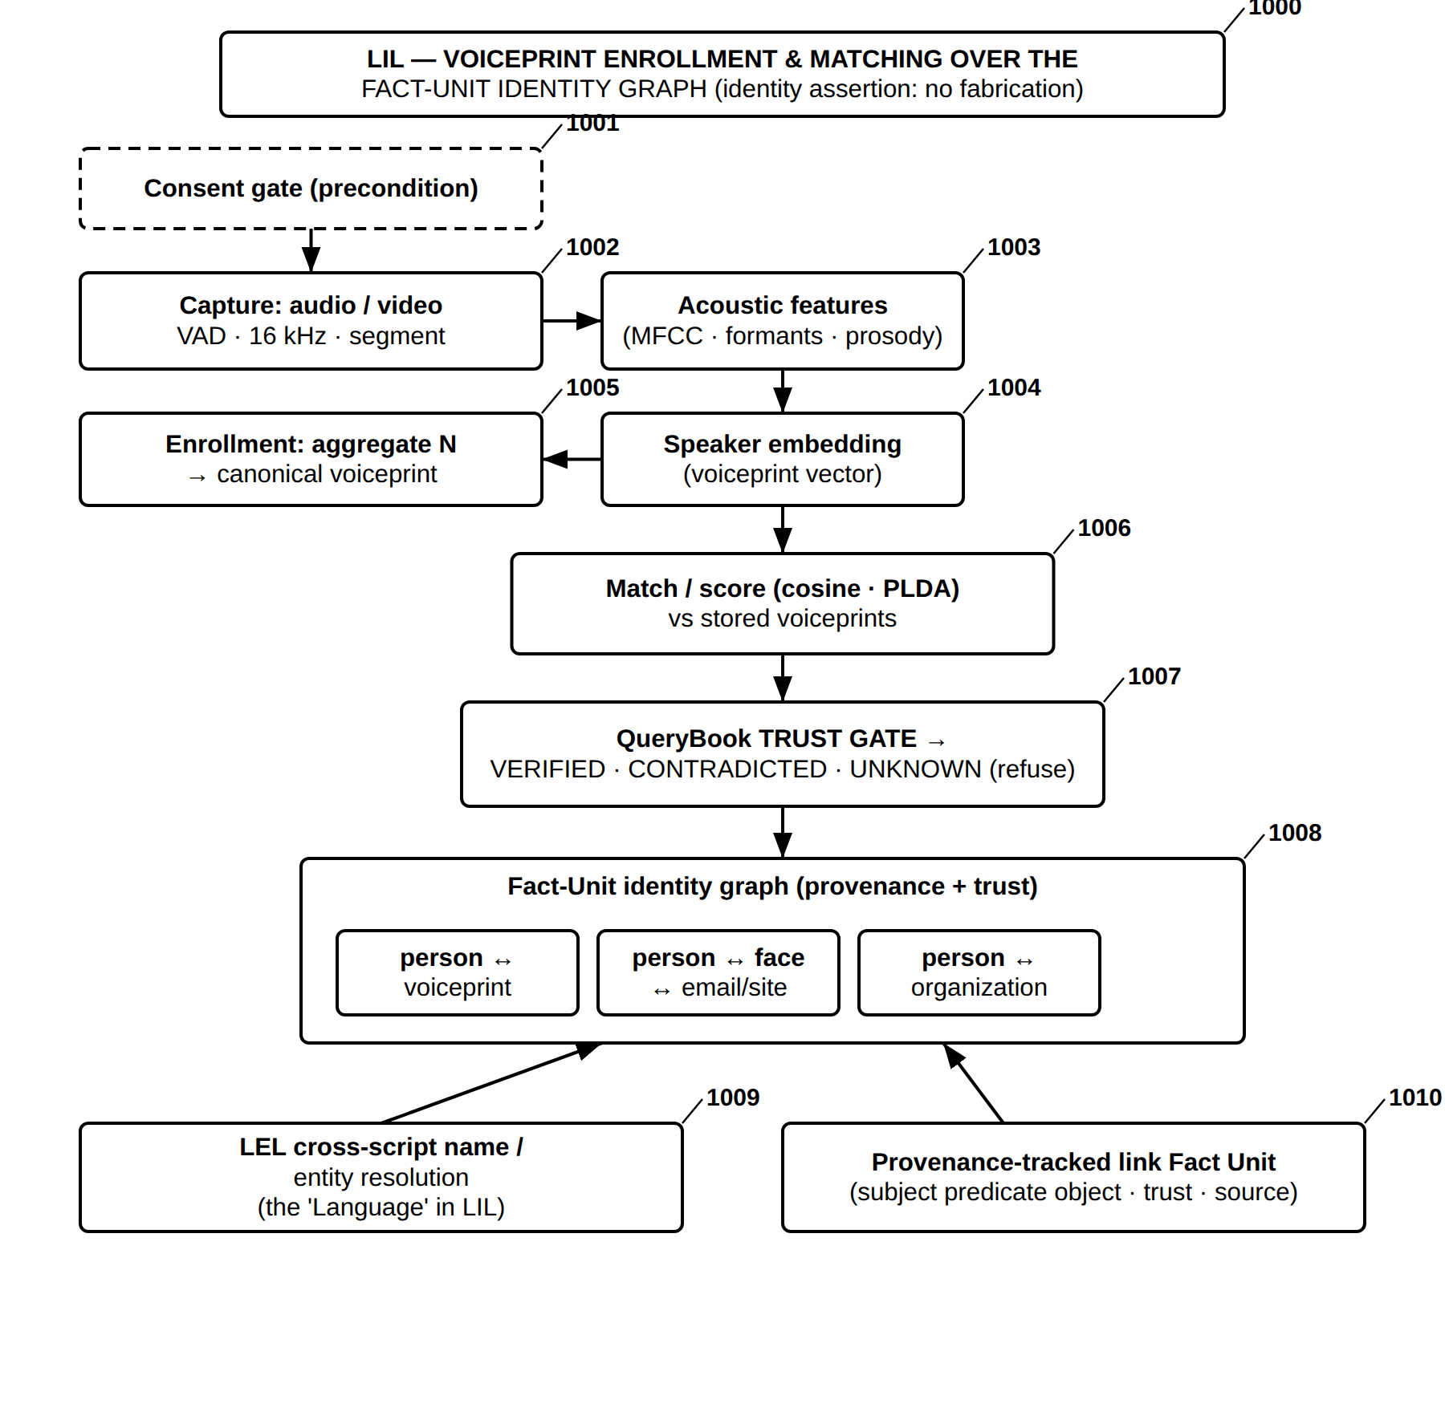
FIG. 33 — LIL — Voiceprint Enrollment and Matching over the Fact-Unit Identity Graph
FIG. 34
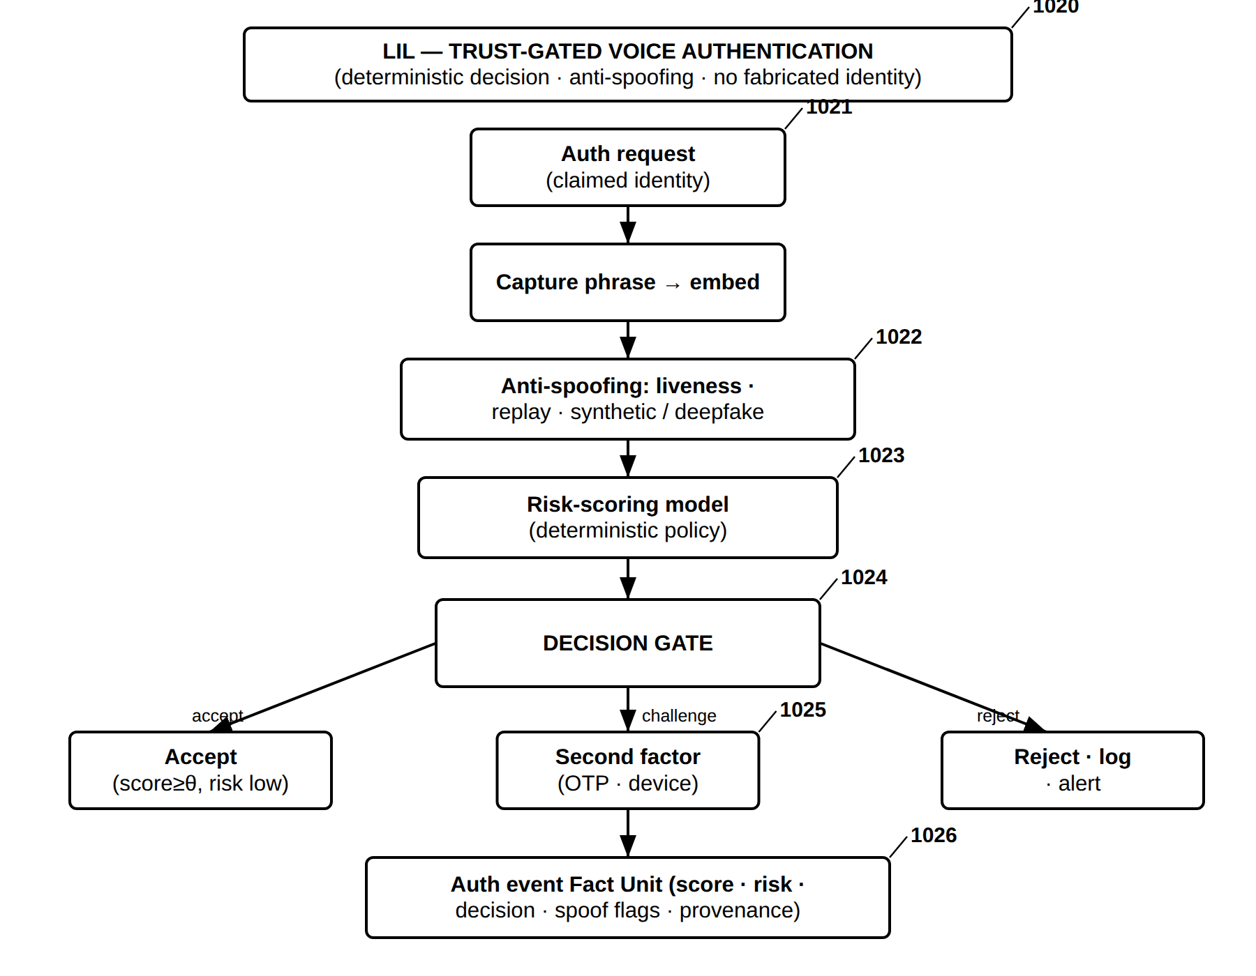
FIG. 34 — LIL — Trust-Gated Voice Authentication with Anti-Spoofing
FIG. 35
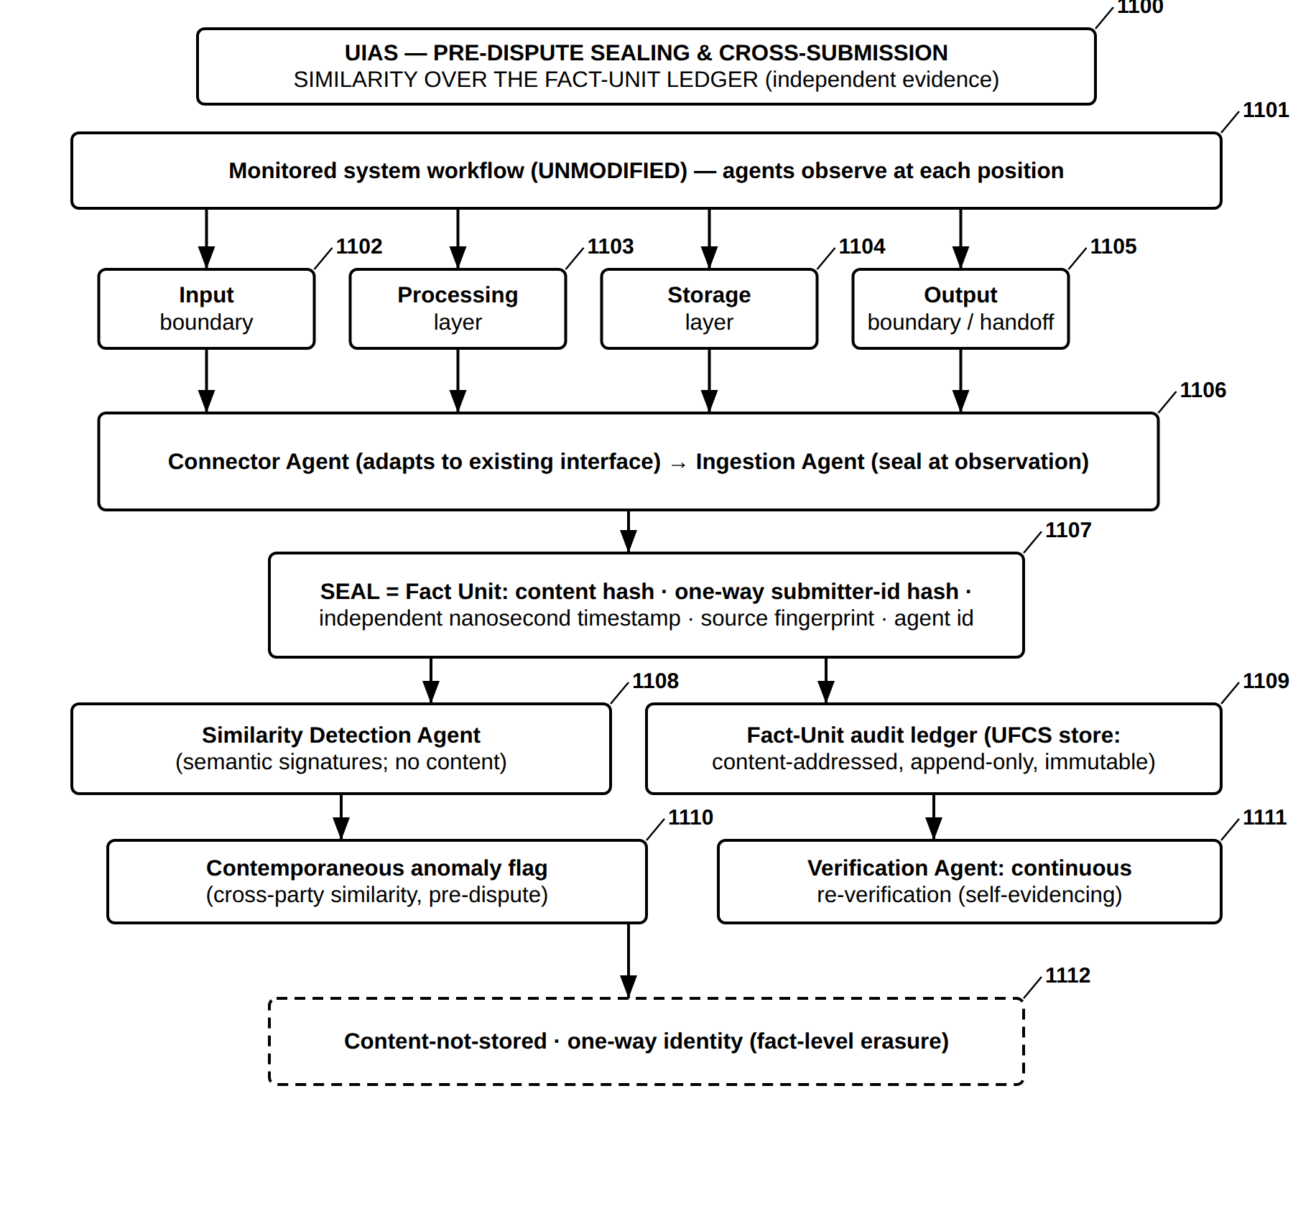
FIG. 35 — UIAS — Pre-Dispute Sealing and Cross-Submission Similarity over the Fact-Unit Ledger
FIG. 36
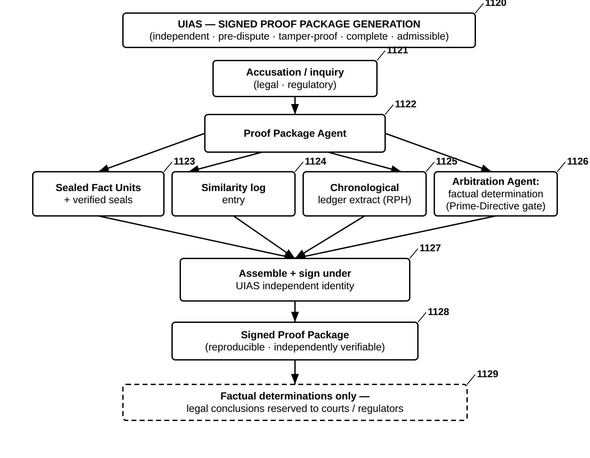
FIG. 36 — UIAS — Signed Proof Package Generation
FIG. 37
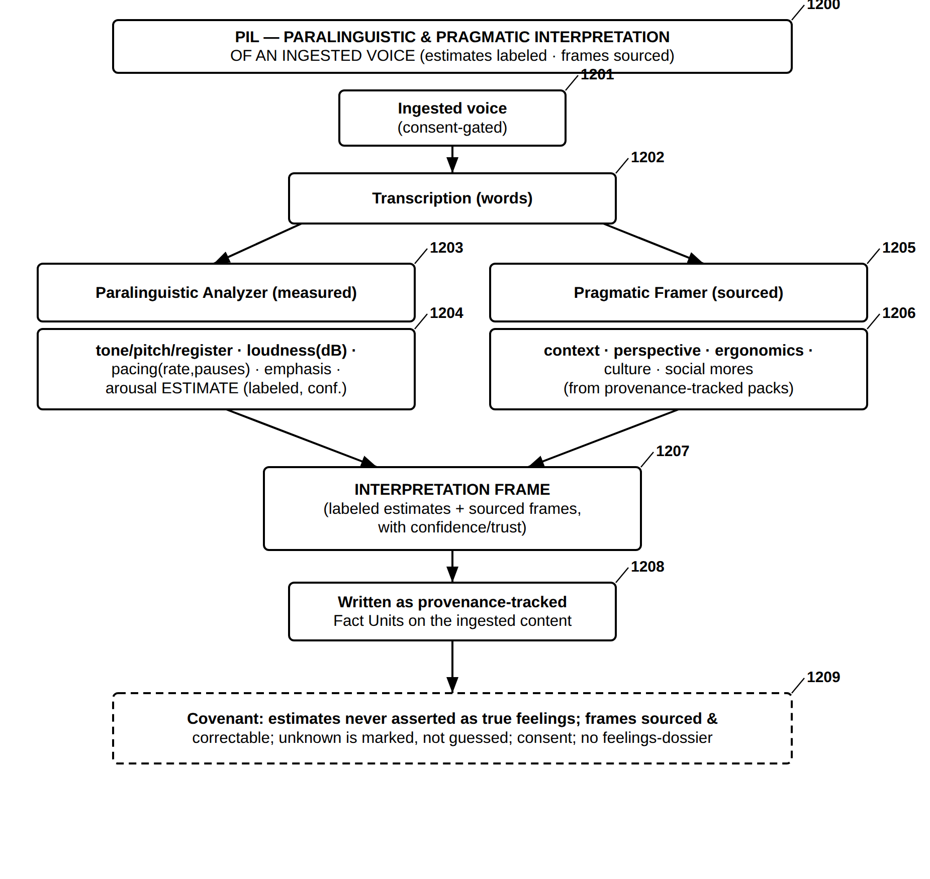
FIG. 37 — PIL — Paralinguistic and Pragmatic Interpretation of an Ingested Voice
FIG. 38
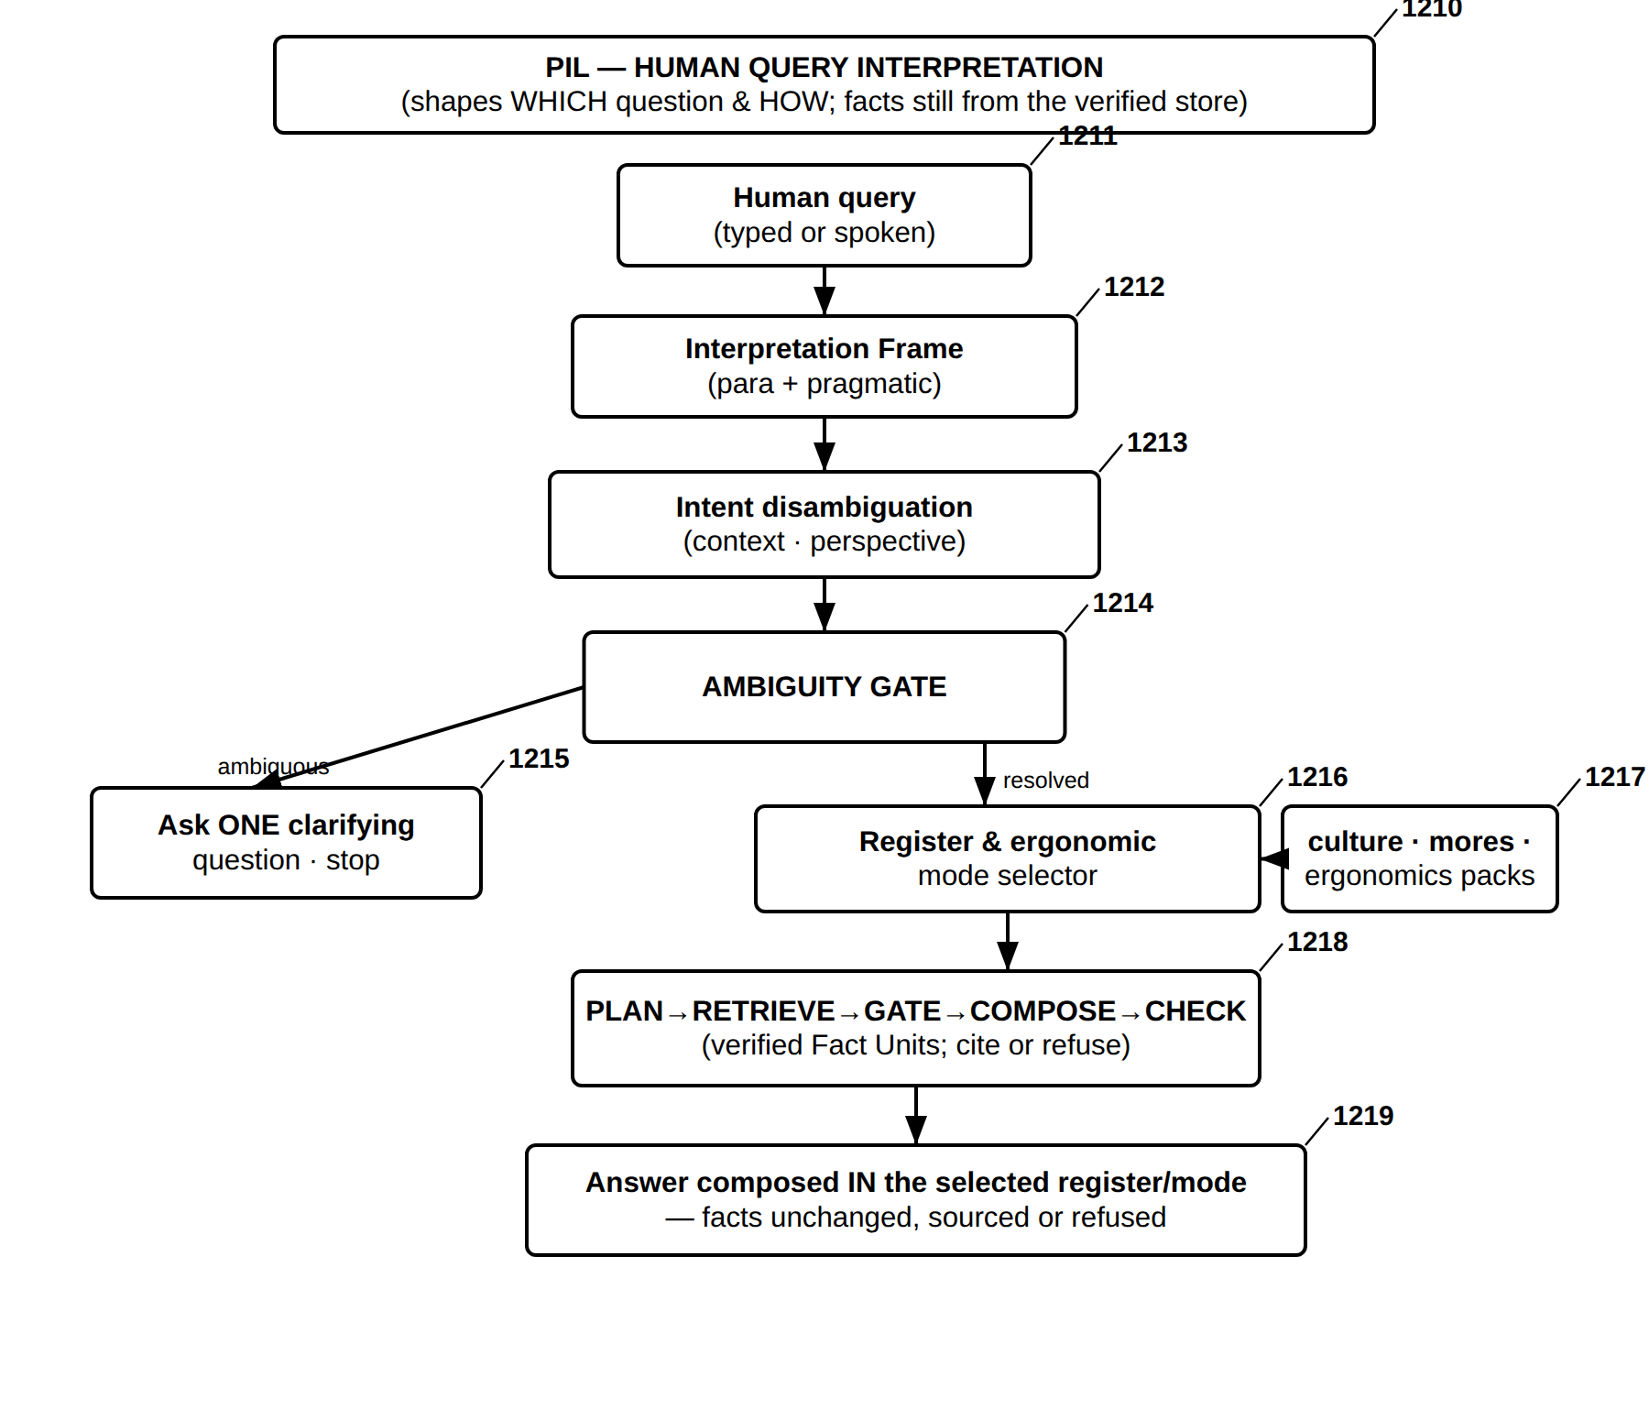
FIG. 38 — PIL — Human Query Interpretation and Covenant-Bound Answering
FIG. 39
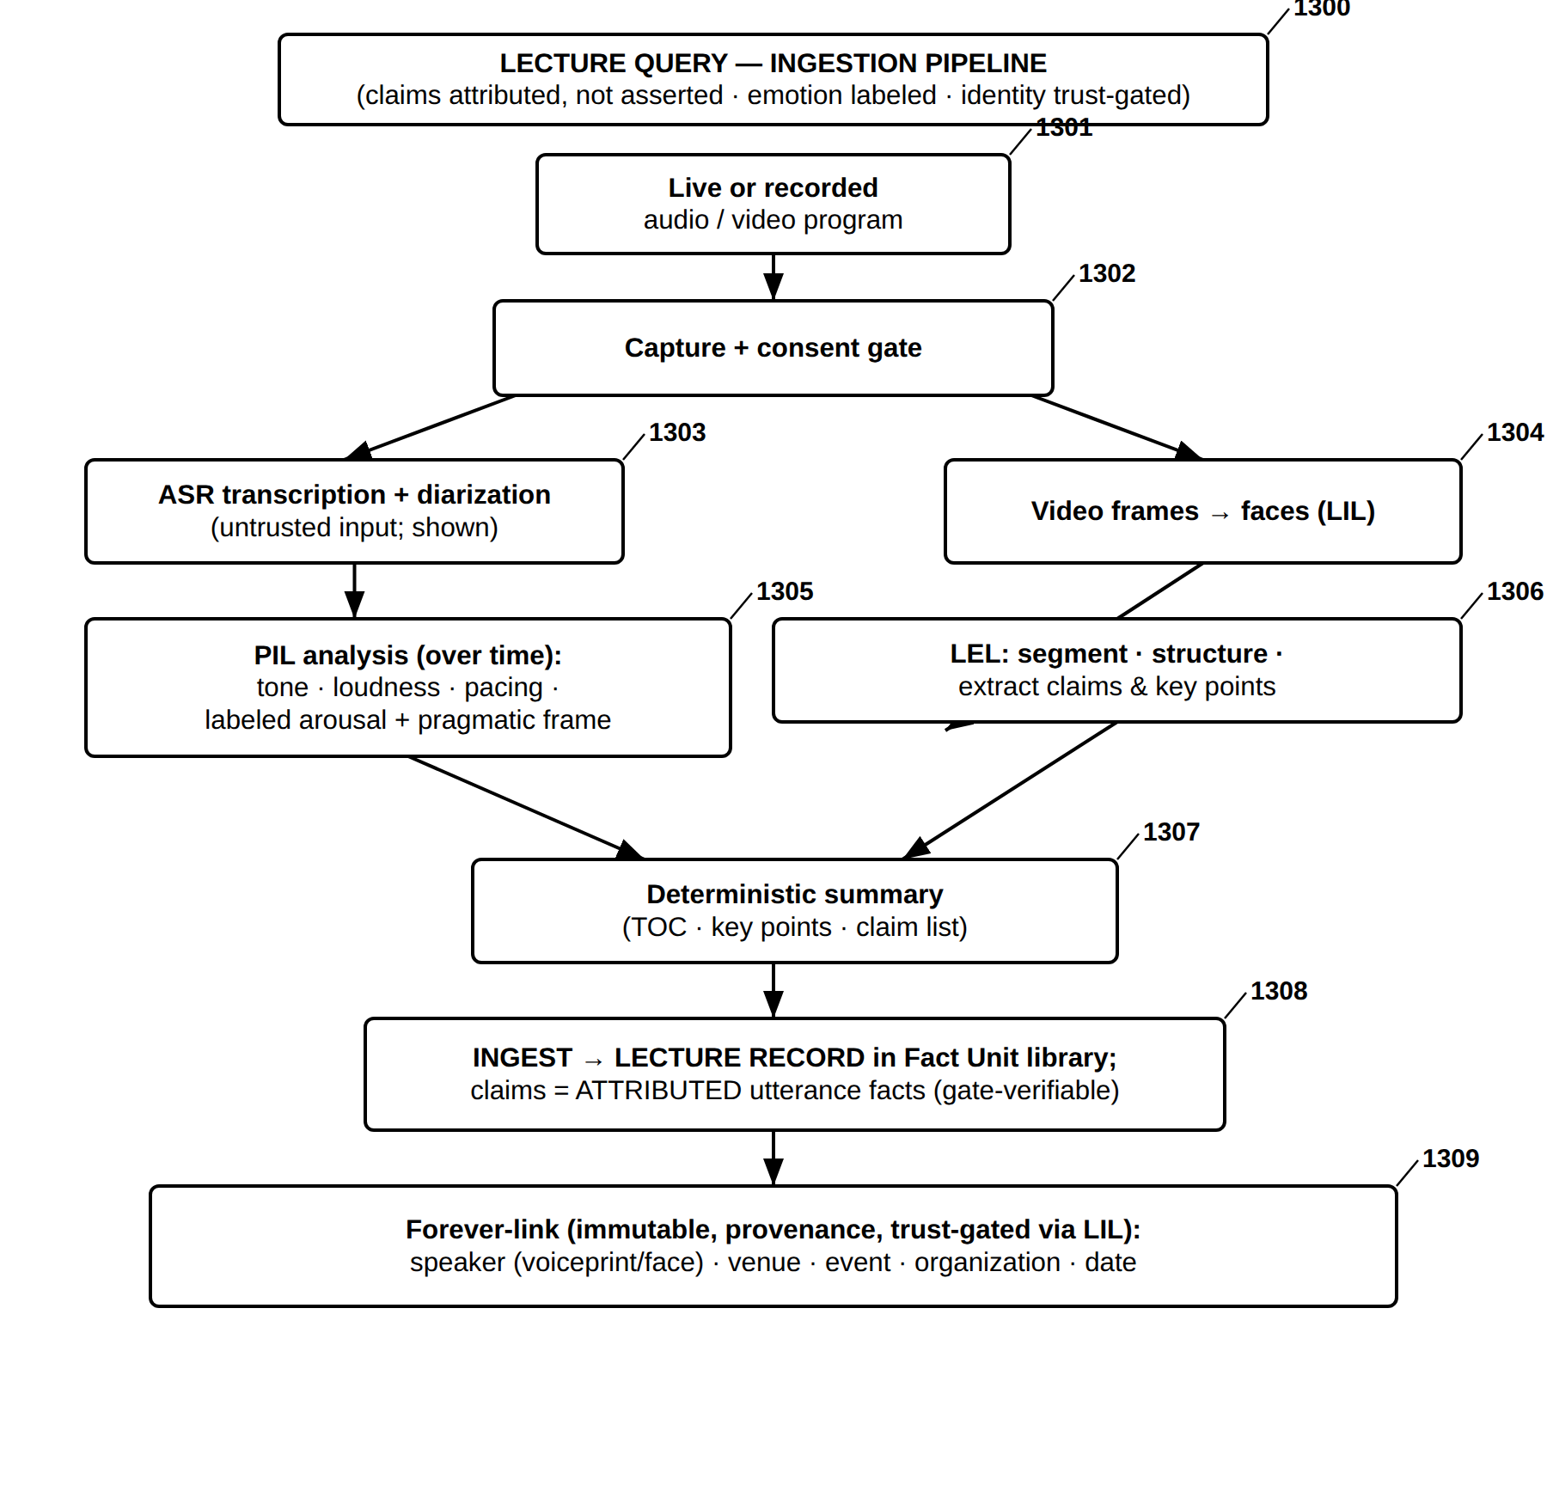
FIG. 39 — Lecture Query — Ingestion Pipeline
FIG. 40
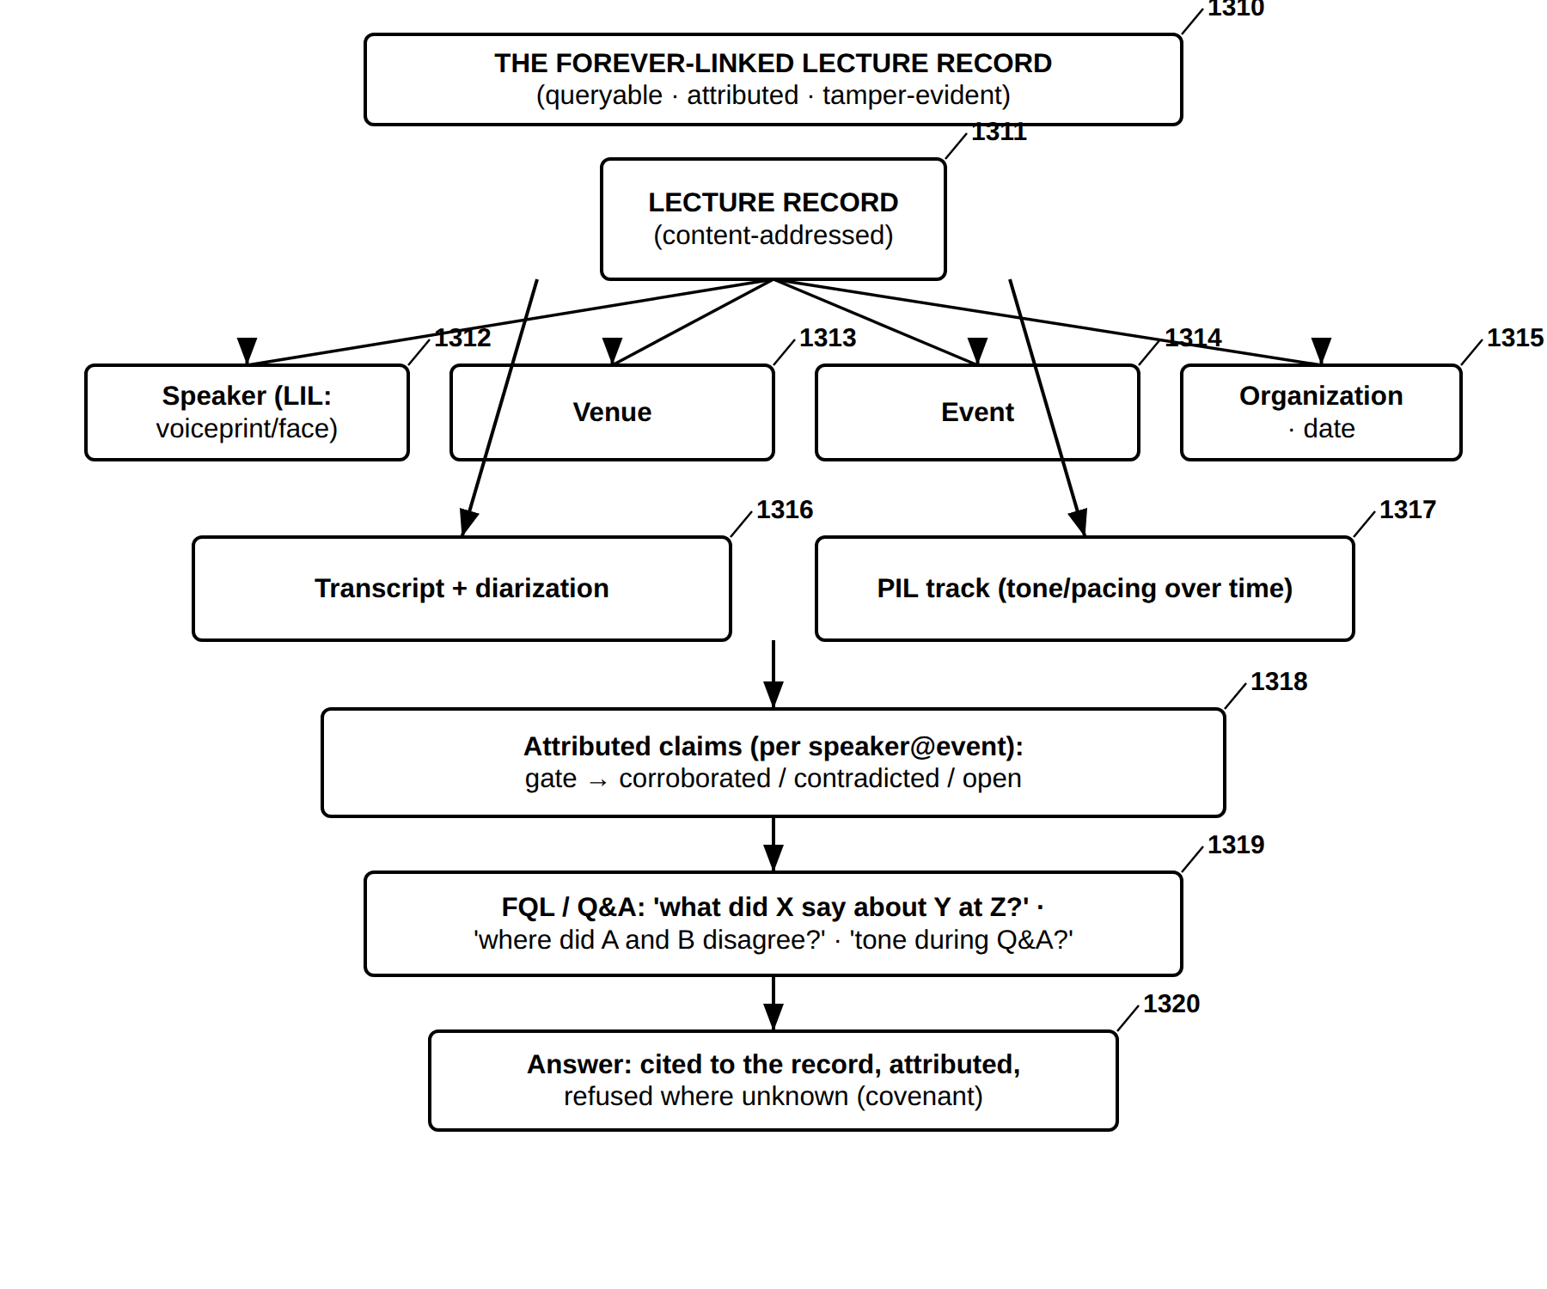
FIG. 40 — Lecture Query — The Forever-Linked Lecture Record and Its Querying

Part D — Further embodiments, applications, media and agent-era extensions (FIG. 41–FIG. 55)
FIG. 41
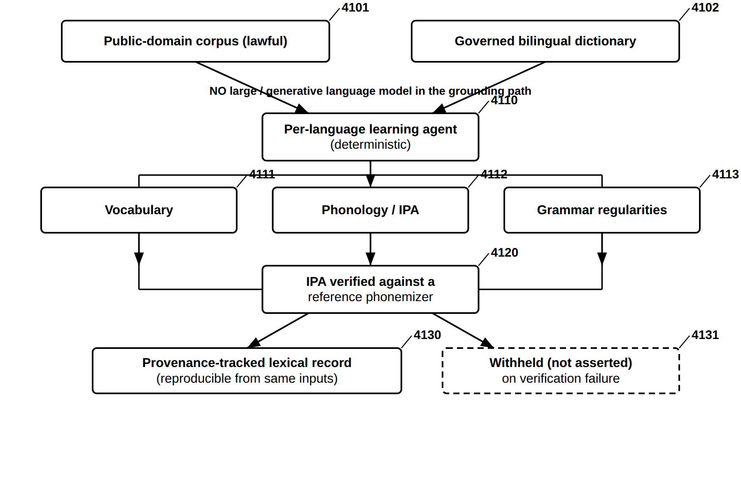
FIG. 41 — Deterministic Multilingual Acquisition Without a Generative Model
FIG. 42
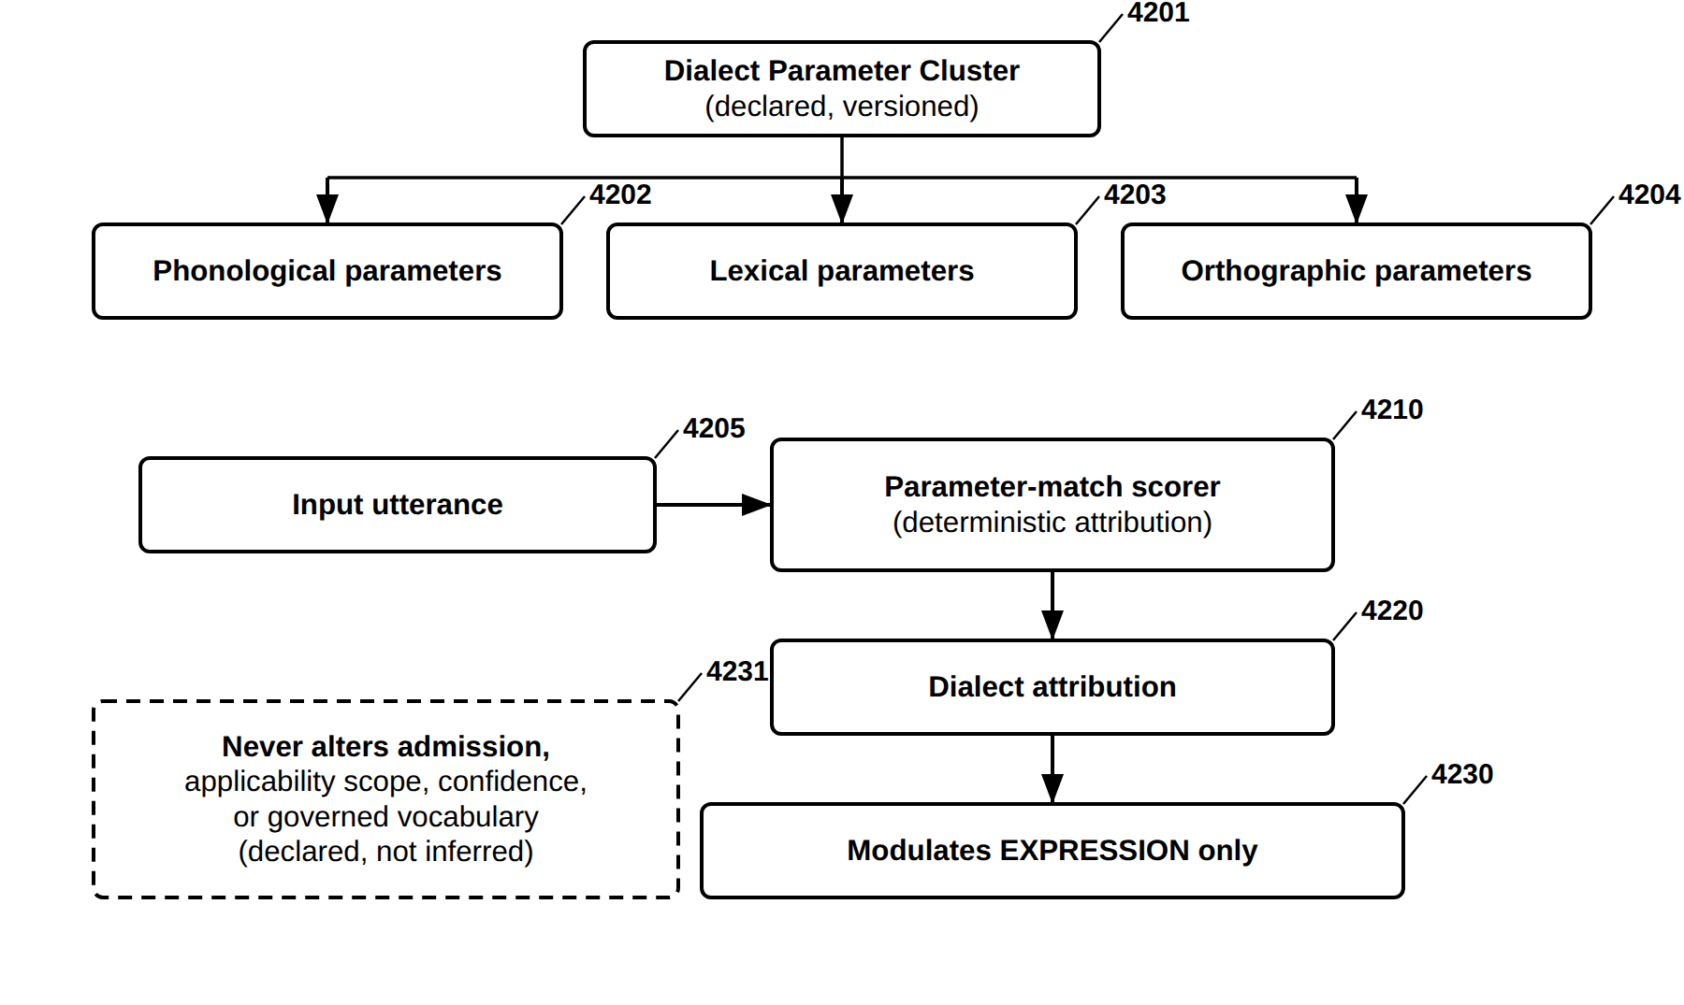
FIG. 42 — Dialect Parameter Clusters (DPC) — Declared, Expression-Only Modulation
FIG. 43
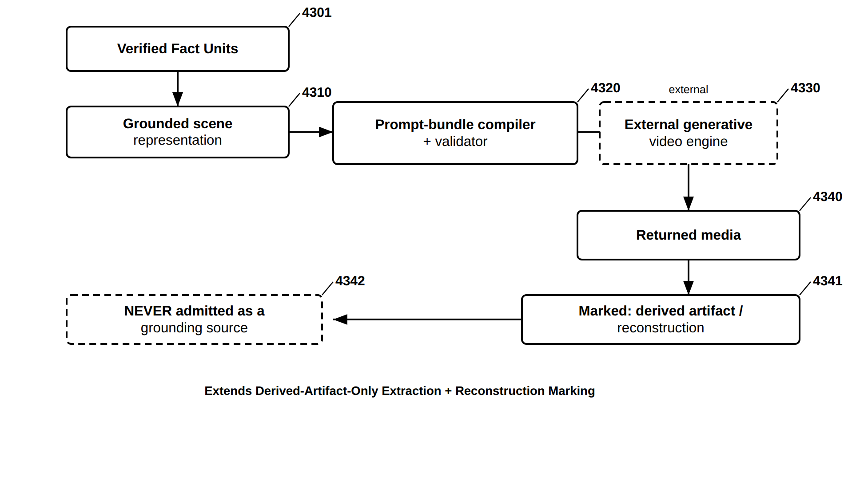
FIG. 43 — Grounded Scene Compilation to an External Generative Media Engine
FIG. 44
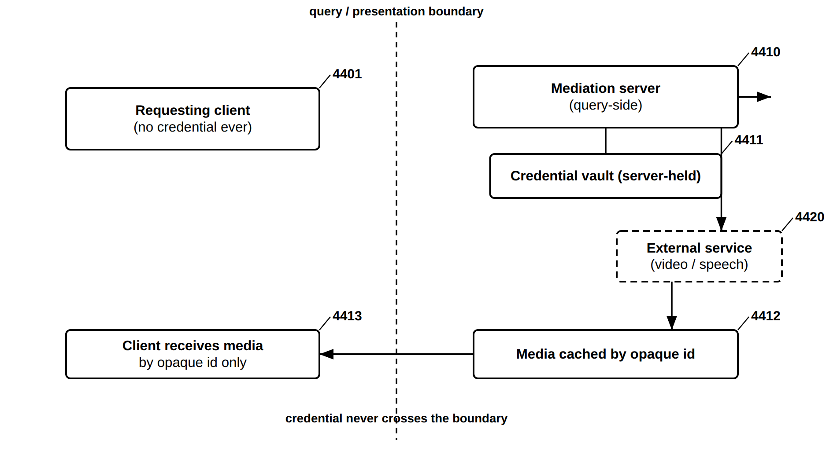
FIG. 44 — Key-Safe External-Service Mediation
FIG. 45
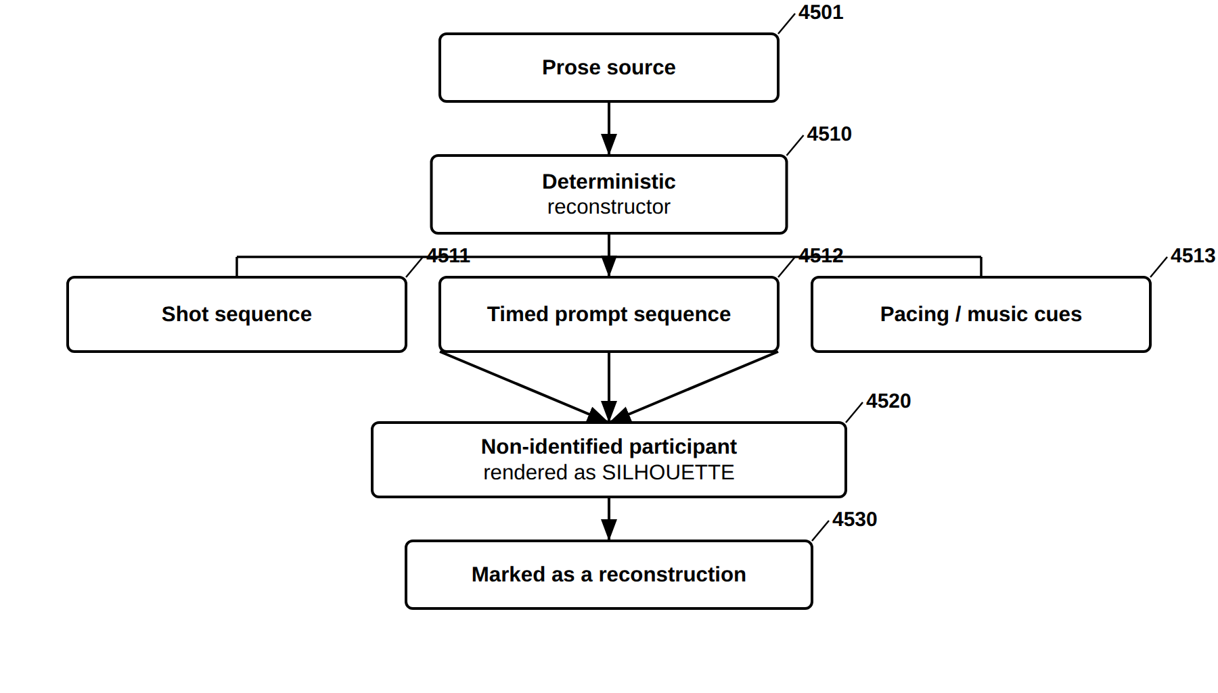
FIG. 45 — Scene Reconstruction From Prose — Bounded, Silhouette-Protected
FIG. 46
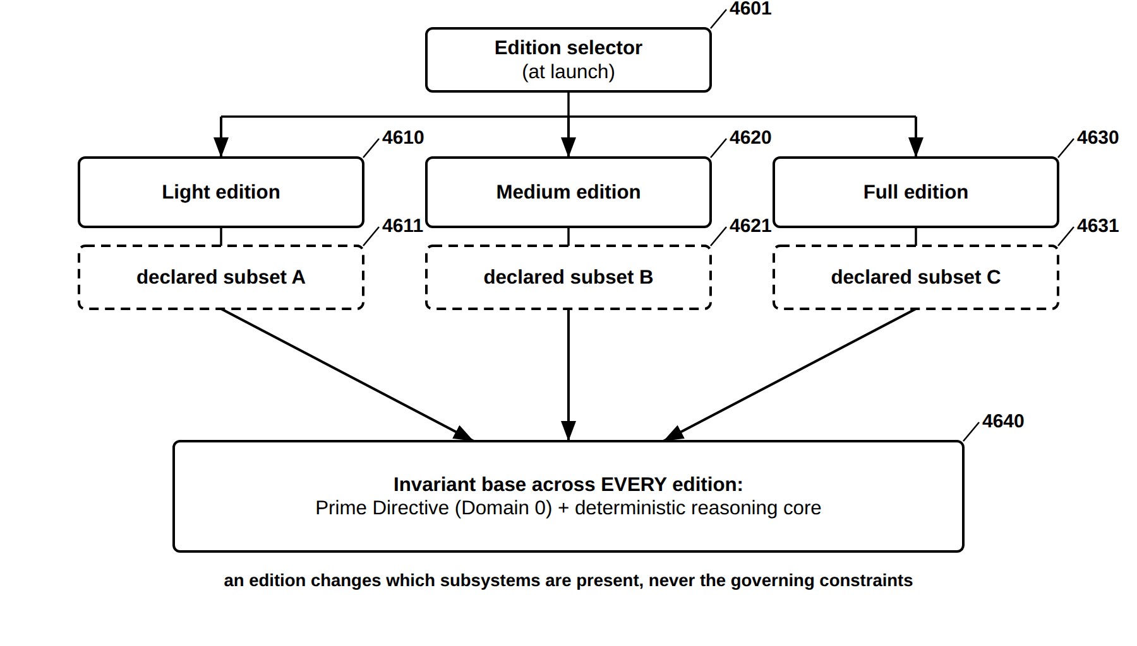
FIG. 46 — Modular Edition Packaging — Nested Capability Editions
FIG. 47
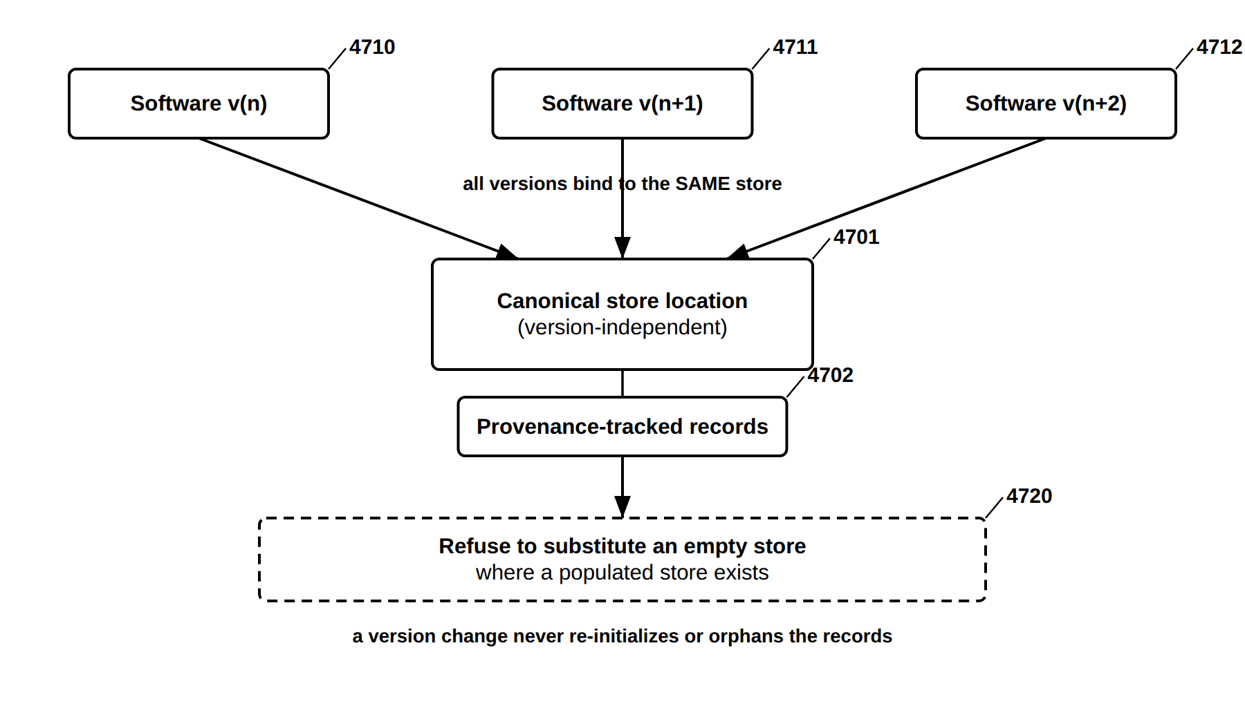
FIG. 47 — Version-Independent, Provenance-Continuous Store
FIG. 48
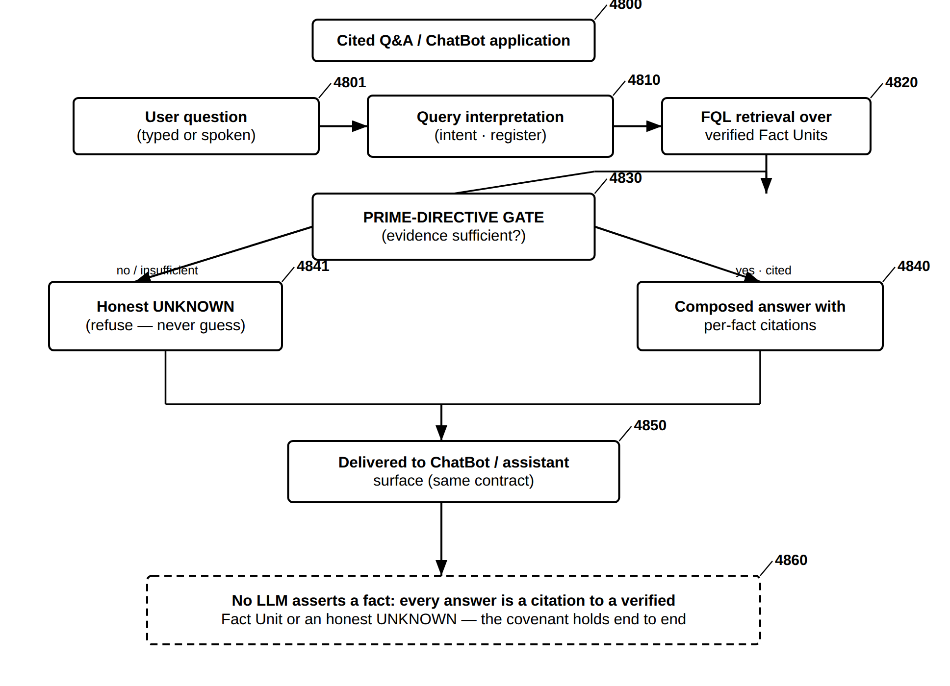
FIG. 48 — Cited Q&A / ChatBot Application — Citation-or-UNKNOWN End to End
FIG. 49
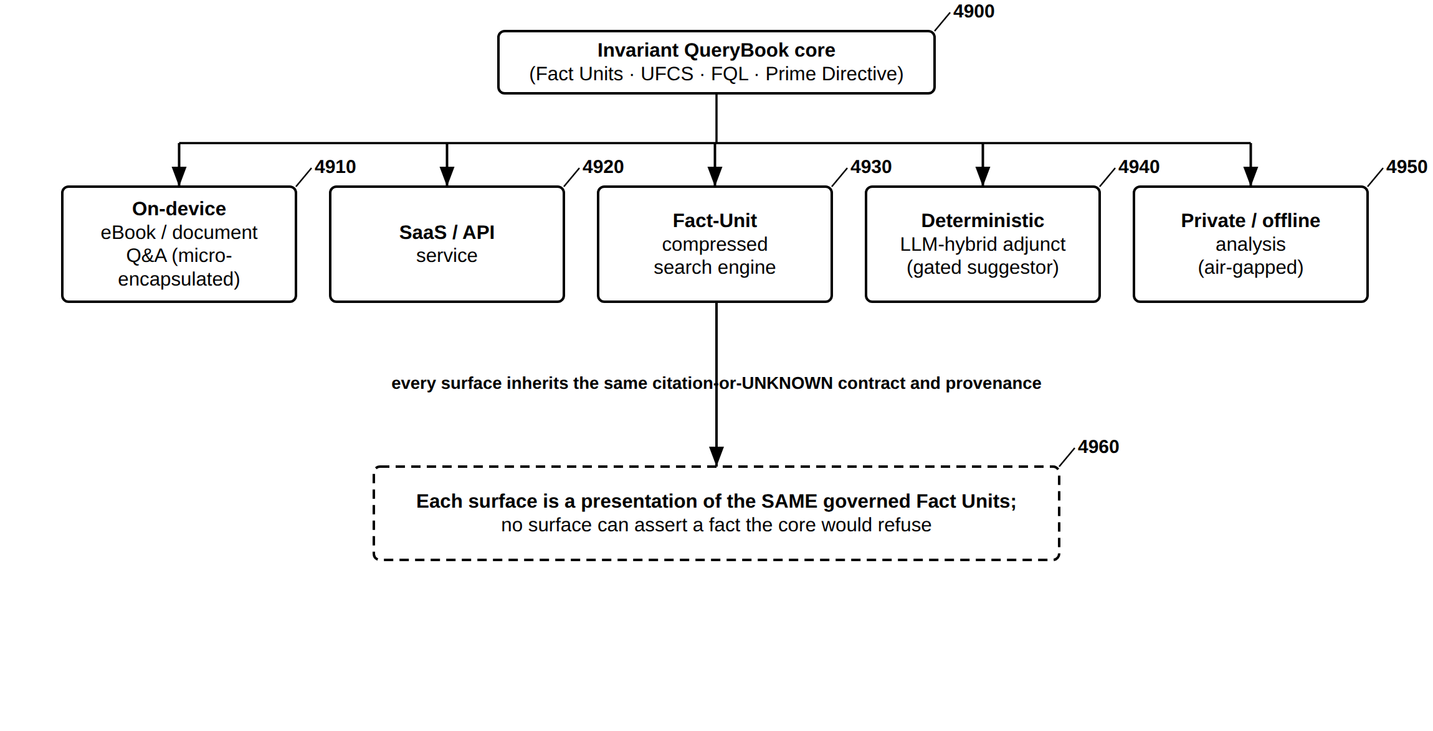
FIG. 49 — Application and Deployment Surfaces over the Invariant Core
FIG. 50
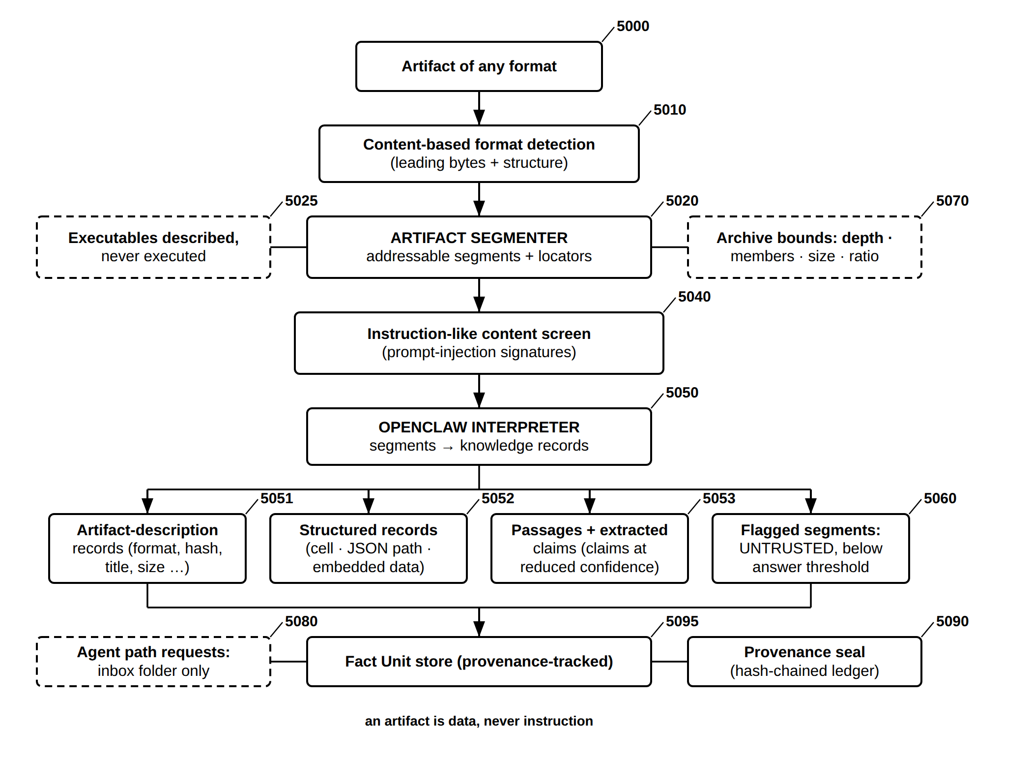
FIG. 50 — Open Claw Ingestion — Artifact Segmenter and OpenClaw Interpreter
FIG. 51
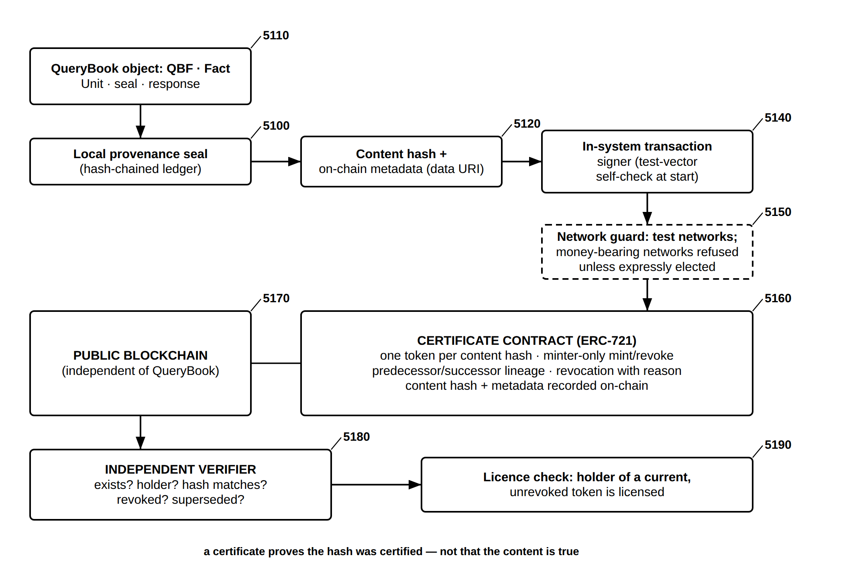
FIG. 51 — On-Chain Certification — Provenance NFTs, Lineage, Revocation and Independent Verification
FIG. 52
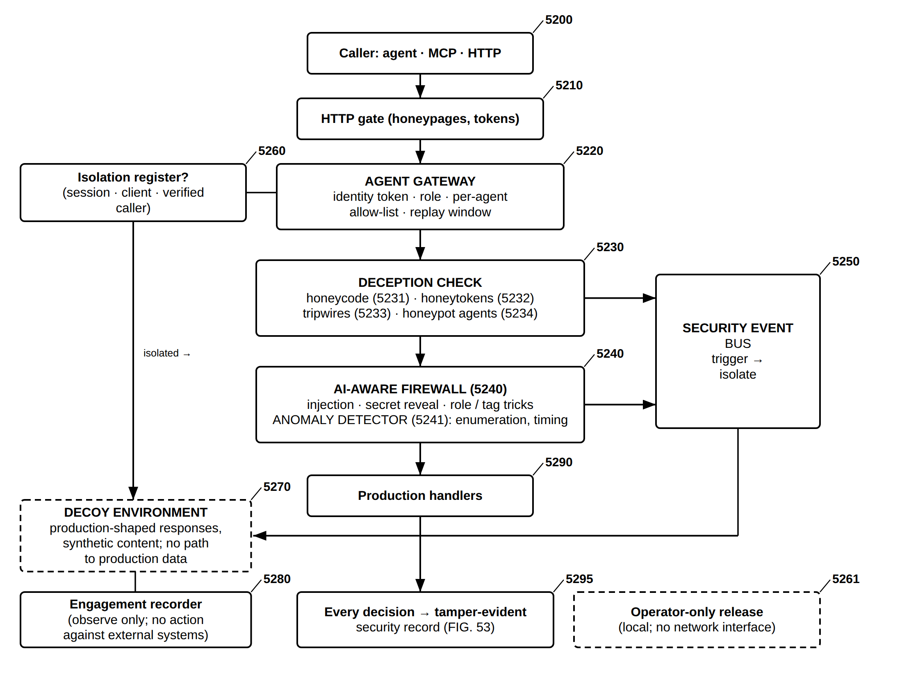
FIG. 52 — Agent Protection and Deception Layer — Gateway, Traps, Firewall, Containment and Decoy
FIG. 53
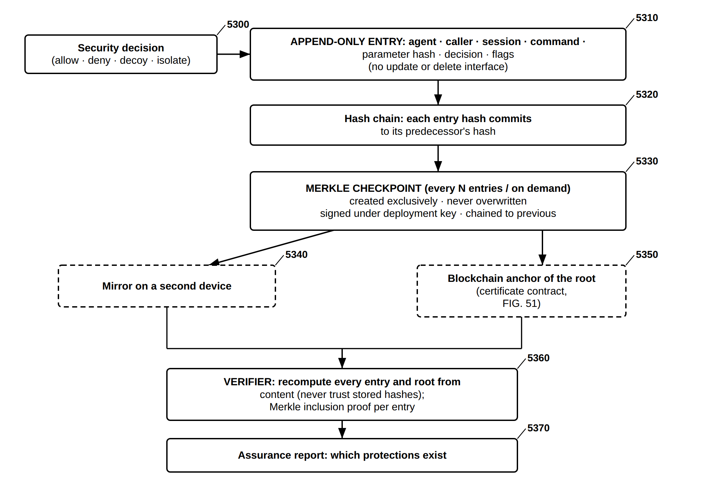
FIG. 53 — Tamper-Evident Security Record — Hash Chain, Write-Once Merkle Checkpoints, Mirror and Anchor
FIG. 54
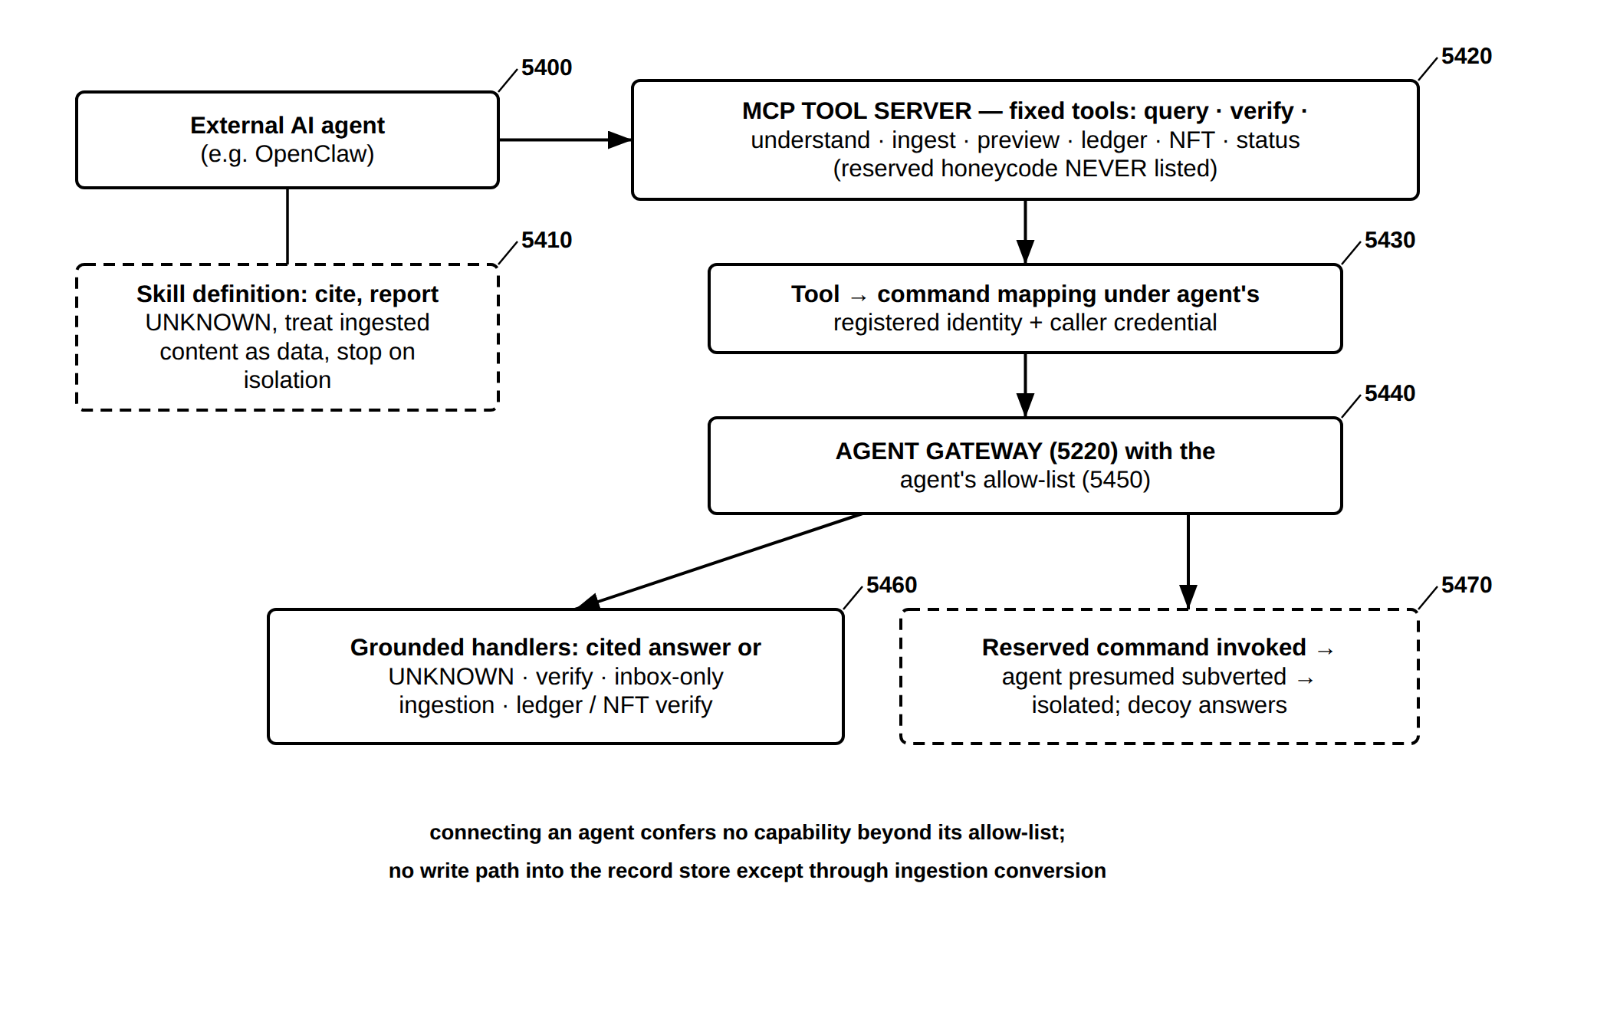
FIG. 54 — Agent Interoperability — MCP Tool Server and OpenClaw Skill Through the Agent Gateway
FIG. 55
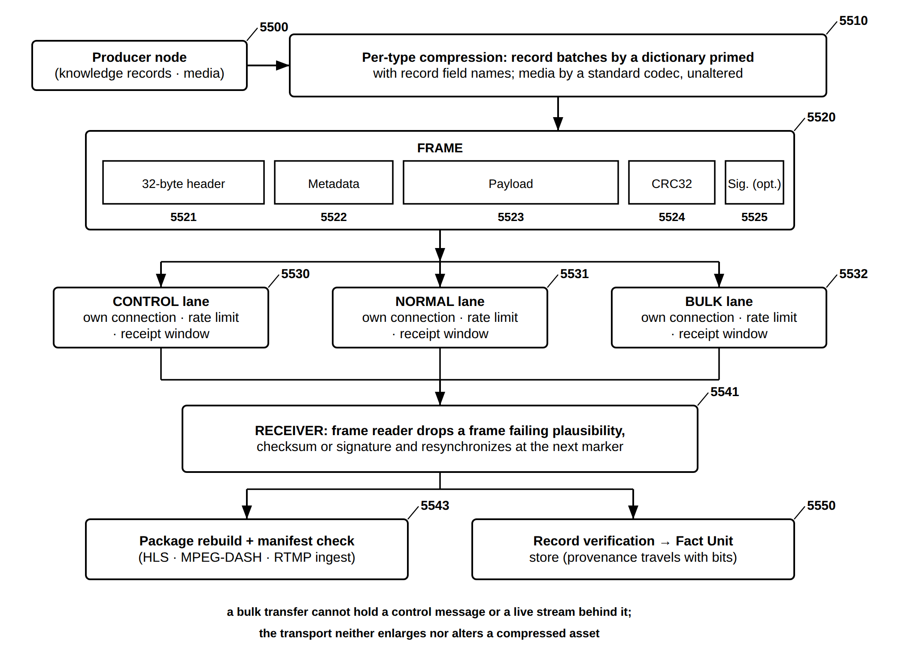
FIG. 55 — Hybrid Transport — Framed UFCS-FQL Messages on Priority Lanes over TCP/IP (extends FIG. 17)

Field of the Invention
The present invention relates to knowledge systems and, more particularly, to QueryBook: a deterministic, provenance-tracked, federated knowledge and query system in which knowledge is held as atomic, content-addressed Fact Units, each carrying its own evidence-based confidence, certification, provenance and safety classification; in which queries are executed in a Federated Query Language that evaluates structure and trust together over a Universal Federated Connectivity System substrate; in which every answer is composed only from verified records, cited, and refused when unknown; and in which every output and action is governed by a Prime Directive operating as a Domain-0 safety plane.
The invention further relates to subsystems and embodiments built on that core and sharing its guarantees: an integral language and speech subsystem (the Language Expression Layer) by which input in any supported language resolves to the same query representation and results are rendered as language or speech; voiceprint identity, integrity-audit, paralinguistic interpretation and lecture-ingestion embodiments; edition packaging and store continuity; meaning-based handling of pictures, sound and video; and agent-era extensions for arbitrary-artifact ingestion, on-chain certification, agent protection, tamper-evident security records, agent interoperability and framed transport.

Background of the Invention
[0001] Information systems answer questions in two principal ways. Retrieval systems — databases, document stores and search engines — return stored rows or documents, but do not establish which specific assertion supports an answer or how reliable that assertion is. Generative language models produce fluent text by statistical next-token prediction and have no native mechanism to distinguish a well-supported answer from a plausible one, because both are produced by the same generative process. Retrieval-augmented generation attaches retrieved documents to a generative model, but the generated text remains unconstrained by them.
[0002] The consequences are well known. A fabricated statement is indistinguishable in form from a supported one; a citation names a source without a verifiable binding between the sentence and the evidence; confidence, where reported at all, is a single number that cannot distinguish strong evidence from thin evidence or one source repeated from many independent sources; contradictions between sources go undetected; and a correction made in one place does not propagate to the answers that relied on the corrected material.
[0003] Knowledge stored as text is also entangled with the language in which it was written. A corpus in six languages is in effect six corpora: a query must be translated to reach material in another language, a correction must be made once per language, and an error introduced in translation is indistinguishable afterwards from an error in the source.
[0004] Sharing knowledge across organizational boundaries presents further problems. A record received from another system is typically trusted or rejected wholesale rather than re-validated against its certification; removing a single record from an immutable or append-only store conflicts with the store’s integrity guarantees; and safety and access rules are commonly applied as filters around a result, which a code path can bypass, rather than carried within each record. As automated agents begin to act on users’ behalf, the agents and the knowledge systems they use can themselves be targeted — through injected instructions, stolen credentials or altered logs.
[0005] Conventional natural-language and speech technology, on which question answering in many languages depends, either encodes grammar, pronunciation and prosody in manually authored rules, dictionaries and language packs, which are brittle and language-specific, or trains neural models top-down on tokenized text without grounding in the acoustic and communicative foundations from which human language develops, and without exploiting the structural transfer by which a first language accelerates the acquisition of later ones.
[0006] There exists a need for a knowledge and query system in which (a) every assertion is an atomic, content-identified record carrying an evidence-based confidence, an authority certification, a verifiable provenance and its own safety classification; (b) queries evaluate structure and trust together; (c) every output is composed only from verified records and is cited or refused; (d) knowledge is independent of the language in which it arrived; (e) records are re-validated when they cross boundaries and can be erased individually without weakening the store’s integrity; (f) a single safety constraint governs every subsystem and every agent action; and (g) language and speech, identity, media and agent capabilities are built on that core and inherit its guarantees rather than weakening them.

Summary of the Invention
QueryBook is a deterministic, provenance-tracked federated knowledge and query system. Its core, described in Part A (FIG. 1–FIG. 22), comprises: (1) the Fact Unit, an immutable record encoding exactly one assertion as a nucleus of subject, predicate, object and polarity, identified by a semantic fingerprint derived from its content and carrying in its envelope an evidence-based confidence, an authority certification, a signed provenance reference, temporal anchors, typed links and an in-record safety classification and access-control list; (2) the UFCS substrate, a content-addressed fact graph, ontology mesh and append-only provenance ledger, with a serialized packet form and fingerprint-indexed block storage that stores identical meaning once; (3) a certification authority hierarchy under which each record inherits a trust ceiling from its issuing authority; (4) the Federated Query Language (FQL), which evaluates structural patterns and trust thresholds together during traversal, excludes contradicted records and binds every result to a response provenance hash; (5) verification of any machine-generated text against certified records as verified, contradicted or unknown; (6) grounded response generation under a directive fixed before generation, with a vocabulary constrained to the contributing records, which cites or refuses; (7) federation with re-validation at every boundary and fact-level erasure by destruction of an external key; (8) the Prime Directive, a Domain-0 safety plane governing every answer, output and scheduled action, with a rule forbidding the withholding of entitled information as a means of avoiding a harm determination; and (9) governed user-owned agents, a layered security architecture, deployment topologies over an invariant common layer, language-independent regeneration, and provenance-carrying transport over TCP/IP.
Because a record’s identity is derived from its meaning rather than from its wording, the same assertion arriving in different languages or from different sources converges on one record with several provenance branches; corroboration, contradiction and duplication are detected at ingestion; and a correction is made once. Because generation draws only on the records a query returned, an ungrounded assertion is structurally unavailable to the system rather than merely discouraged, and identical inputs in an identical context produce identical output.
On that core the invention provides subsystems and embodiments, each inheriting the core’s guarantees: in Part B, the integral language and speech subsystem — the Language Expression Layer with its Sub-Language Priming Layer, one-way Transition Gate, multilingual Delta Acquisition, Speech Output Pipeline and co-grounding with FQL and UFCS, together with deterministic, reduced-to-practice pronunciation, speech, translation and quality-control embodiments; in Part C, voiceprint and multimodal identity linking, an independent integrity-audit service, a paralinguistic and pragmatic interpretation layer, and a lecture-query mode; and in Part D, deterministic multilingual acquisition, dialect parameter clusters, grounded scene compilation, key-safe service mediation, edition packaging, a version-independent store, cited question-and-answer and other application surfaces, meaning-based handling of pictures, sound and video, and agent-era extensions for arbitrary-artifact ingestion, on-chain certification, agent protection and deception, a tamper-evident security record, agent interoperability and framed transport.
No large language model asserts a fact anywhere in the system. A large language model may be used only in non-asserting roles — to phrase an answer over records the system has already verified, or to propose hypotheses for exploration — and anything it proposes is admitted only after independent verification against the deterministic store; its output, where retained, is marked as externally generated and is inadmissible as a grounding source.

Brief Description of the Drawings

Part A — QueryBook core platform (FIG. 1–FIG. 22)
FIG. 1 is a block diagram of the overall QueryBook system architecture, in which multimodal ingestion, the UFCS substrate, FQL query execution, verification, grounded generation, content-addressed storage and federation each execute beneath the Prime Directive operating as a Domain-0 safety plane.
FIG. 2 is a diagram of the Fact Unit, showing its nucleus, the derivation of its semantic fingerprint and identifier from content, and the confidence, provenance, certification, temporal, safety and link fields of its envelope.
FIG. 3 is a diagram of the fact-certification authority hierarchy, in which trust flows downward from a root trust anchor and each certified record inherits a trust ceiling from its issuing authority class.
FIG. 4 is a block diagram of the UFCS substrate, comprising a fact graph, an ontology mesh and a provenance ledger keyed by content fingerprint, and the pairwise, hyperedge and directed-hyperchain relationship types.
FIG. 5 is a diagram of authored tour and exhibition sequencing, in which an author fixes the order of immersive scenes at waypoints and the reader controls pace and direction.
FIG. 6 is a flow diagram of FQL joint structure and trust execution, in which structural filtering, trust propagation, branch-and-bound pruning and contradiction exclusion operate together during traversal to produce ranked results bound to a response provenance hash.
FIG. 7 is a flow diagram of the verification of machine-generated text against certified records, classifying each extracted assertion as verified, contradicted or unknown.
FIG. 8 is a diagram of federation, in which a certified envelope crossing from one domain to another is re-validated by the receiving domain before admission.
FIG. 9 is a diagram of fact-level erasure, in which a sealed record’s encrypted payload is rendered unrecoverable by destroying an externally held key.
FIG. 10 is a diagram of the universal security architecture, showing twelve defensive layers, five postures and AI-attack prediction.
FIG. 11 is a diagram of universal honeypot saturation and the data firehose, in which real assets are concealed among indistinguishable decoys.
FIG. 12 is a diagram of deployment topologies — cloud, local server, hybrid, single-device and edge — over an invariant common layer and a governed agent runtime.
FIG. 13 is a flow diagram of the adaptive response engine, in which a response directive and vocabulary constraint are fixed before generation.
FIG. 14 is a flow diagram of the user-owned agent system, in which every agent action is evaluated by governance within its commissioner’s authority and the commissioner holds a kill and revoke control.
FIG. 15 is a diagram of deterministic multi-language regeneration, in which content ingested once is regenerated on demand in each target language from one language-independent Fact Unit graph.
FIG. 16 is a diagram of semantic compression, expansion, colorization and upscaling of media over a meaning store.
FIG. 17 is a diagram of the QueryBook-enhanced TCP/IP hybrid protocol packet, carrying an optional semantic metadata header between the transport header and the payload.
FIG. 18 is a diagram of the neuromorphic cognitive layer, in which a noisy cue converges on a stored equilibrium of an attractor network below a capacity ceiling.
FIG. 19 is a diagram of the Fact Unit confidence and evidence model, comprising an evidence pair, a Beta posterior, a score, a credible interval, source diversity, temporal decay and a confidence trend.
FIG. 20 is a diagram of the UFCS packet structure, showing the fields of a serialized Fact Unit record and an exemplar packet.
FIG. 21 is a diagram of UFCS packet framing, in which immutable packets are de-duplicated by fingerprint and appended to content-addressed blocks under a fingerprint index.
FIG. 22 is a diagram of FQL query anatomy with a worked example, in which match, where, exclude, rank and return clauses produce a highest-trust answer bound to its evidence by a provenance hash.

Part B — Language and speech subsystem (FIG. 23–FIG. 32)
FIG. 23 is a block diagram of the overall QueryBook Language Expression Layer (LEL) system architecture.
FIG. 24 is a block diagram of the Sub-Language Priming Layer (SLPL) and the measurable representation produced by each of its six components.
FIG. 25 is a flow diagram of the developmental learning sequence and the one-way Transition Gate having four readiness thresholds.
FIG. 26 is a block diagram of the multilingual Delta Acquisition Model and the acquisition acceleration flywheel.
FIG. 27 is a block diagram of the seven-stage Speech Output Pipeline.
FIG. 28 is a data-flow diagram of the co-grounded integration of the LEL with the Federated Query Language (FQL) and the Universal Federated Connectivity System (UFCS).
FIG. 29 is a block diagram of a reduced-to-practice embodiment (the Language Lab) implementing Phase One, the Transition Gate, and a deterministic Phase Two, per Section XV.
FIG. 30 is a data-flow diagram of the deterministic Phase-Two semantic grounding of the reduced-to-practice embodiment, in which word meanings are attached only from auditable sources — a bundled public-domain dictionary and self-grounding against verified Fact Units in the store — with any large-language-model meaning source excluded from the grounding path.
FIG. 31 is a block diagram of the advanced multilingual pronunciation subsystem and self-contained speech output of the reduced-to-practice embodiment, showing the pronunciation preference ladder (bundled open-source phonemizer, then per-language rule-seeded grapheme-to-phoneme tables, then an explicit non-fabricated null), the single-call phrase transcription that keeps the displayed transcription consistent with the synthesized audio, and the self-contained bundle and engine-selection ladder that produce offline audio or an honest refusal without fabricating audio, per Section XVI.
FIG. 32 is a flow diagram of the permanent, deterministic pronunciation-and-speech quality-control battery of the reduced-to-practice embodiment, which, for each supported language and without a large language model, verifies that a phonemic transcription is produced, that the syllable count is within tolerance, and that a short phrase synthesizes to a valid audio waveform, returning a per-language report and an overall pass score, per Section XVI.

Part C — Identity, integrity-audit, interpretation and lecture embodiments (FIG. 33–FIG. 40)
FIG. 33 is a data-flow diagram of the Language & Identity Linking (LIL) voiceprint enrollment and matching subsystem, in which a consent-gated capture produces an acoustic speaker embedding (voiceprint), a match against stored voiceprints is passed through a QueryBook trust gate returning VERIFIED, CONTRADICTED, or UNKNOWN, and verified identity links are written as provenance-tracked, trust-scored Fact Units in the identity graph, with cross-script name and entity resolution performed by the language subsystem, per Section XVII.
FIG. 34 is a flow diagram of the LIL trust-gated voice authentication process, in which a claimed-identity verification produces a match score and anti-spoofing signals that feed a deterministic risk-scoring policy and a decision gate returning accept, challenge (second factor), or reject, each decision recorded as a provenance-tracked auth-event Fact Unit, per Section XVII.
FIG. 35 is a block diagram of the Universal Integrity Audit Service (UIAS), in which connector and ingestion agents observe an unmodified monitored system at multiple workflow positions and seal each observable event as a content-addressed Fact Unit carrying a content hash, a one-way submitter-identity hash, an independent nanosecond timestamp, a source fingerprint, and the sealing agent’s identity; a similarity-detection agent sets a contemporaneous cross-party anomaly flag over content signatures without storing content; and a verification agent continuously re-verifies the append-only Fact-Unit ledger, per Section XVIII.
FIG. 36 is a flow diagram of the UIAS signed Proof Package generation, in which, on an accusation or inquiry, a proof-package agent assembles verified sealed Fact Units, the similarity-log entry, a chronological ledger extract bound by the response-provenance hash, and a factual determination from the arbitration agent under the Prime-Directive gate, and signs the package under the UIAS independent identity to produce independent, pre-dispute, tamper-proof, complete, and admissible evidence, per Section XVIII.
FIG. 37 is a data-flow diagram of the Paralinguistic & Pragmatic Interpretation Layer (PIL) applied to an ingested voice, in which a paralinguistic analyzer produces measured acoustic readings and a labeled arousal estimate while a pragmatic framer applies sourced context, perspective, ergonomics, culture, and social-mores frames, the two combining into an Interpretation Frame written as provenance-tracked Fact Units, with estimates labeled and never asserted as true feelings, per Section XIX.
FIG. 38 is a flow diagram of the PIL human-query interpretation, in which a query is reduced to an Interpretation Frame, intent is disambiguated from context and perspective, an ambiguity gate asks one clarifying question when intent is materially uncertain, a register-and-ergonomic-mode selector sets the reply style and delivery from sourced culture/mores/ergonomics packs, and the existing retrieve-gate-compose pipeline answers from verified Fact Units in that register without altering the facts, per Section XIX.
FIG. 39 is a block diagram of the Lecture Query mode ingestion pipeline, in which a live or recorded audio/video program is captured under consent, transcribed and diarized, analyzed by the paralinguistic layer over time and by the language layer for structure and claims, summarized deterministically, and ingested as a Lecture Record whose claims are stored as attributed utterance facts and which is forever-linked to the speaker, venue, event, organization, and date by immutable provenance-tracked, trust-gated identity links, per Section XX.
FIG. 40 is a data-flow diagram of the forever-linked Lecture Record in the Fact-Unit identity graph and its querying, showing the record bound to speaker, venue, event, and organization entities and to the transcript and paralinguistic track, its attributed claims gated as corroborated, contradicted, or open, and a query answered with citations to the record and attribution to the speaker, refused where unknown, per Section XX.

Part D — Further embodiments, applications, media and agent-era extensions (FIG. 41–FIG. 55)
FIG. 41 is a data-flow diagram of deterministic multilingual acquisition without a generative model, in which a per-language learning agent acquires vocabulary, phonology (IPA), and grammatical regularities from a lawful public-domain corpus and a governed bilingual dictionary, an IPA transcription is verified against a reference phonemizer and withheld rather than asserted when verification fails, and each accepted item is written as a provenance-tracked lexical record reproducible from the same inputs, with no large or generative language model in the grounding path.
FIG. 42 is a block diagram of a Dialect Parameter Cluster (DPC), a declared and versioned cluster of phonological, lexical, and orthographic parameters by which an input utterance is attributed to a dialect by a deterministic parameter-match score, the cluster modulating expression only and never altering admission, applicability scope, confidence, or the governed vocabulary.
FIG. 43 is a data-flow diagram of grounded scene compilation to an external generative media engine, in which a grounded scene representation derived from verified Fact Units is compiled and validated into a prompt bundle for an external generative video engine and any returned media is admitted only as a derived artifact marked as a reconstruction and never as a grounding source.
FIG. 44 is a block diagram of key-safe external-service mediation, in which a credential for an external service is held on the server side of the query/presentation boundary and never transmitted to the client, the server performing the external call and serving the result to the client by an opaque cache identifier so that the credential never crosses the boundary.
FIG. 45 is a flow diagram of scene reconstruction from prose, in which a deterministic reconstructor derives a shot sequence, a timed prompt sequence, and pacing and music cues as a bounded reconstruction, renders a participant who is not an identified subject as a silhouette so that no unverified identity is fabricated, and marks the whole as a reconstruction.
FIG. 46 is a block diagram of modular edition packaging, in which the system is deployable as one of a plurality of nested capability editions selected at launch, each edition enabling a declared subset of subsystems while the Prime Directive and the deterministic reasoning core remain invariant across every edition.
FIG. 47 is a block diagram of the version-independent, provenance-continuous store, in which the knowledge store resides at a canonical location independent of the deployment software version so that successive software versions bind to the same provenance-tracked records, a version change never re-initializes the store, and the system refuses to substitute an empty store where a populated store exists.
FIG. 48 is a data-flow diagram of a cited question-and-answer (ChatBot) application embodiment, in which a user question is interpreted for intent and register, answered by Federated Query Language retrieval over verified Fact Units, passed through the Prime-Directive gate, and returned either as a composed answer carrying per-fact citations or, where the evidence is insufficient, as an honest UNKNOWN, the same citation-or-UNKNOWN contract holding when the embodiment is deployed as a ChatBot or assistant surface.
FIG. 49 is a block diagram of the application and deployment surfaces of the system over its invariant core, in which a single governed body of Fact Units is presented through an on-device micro-encapsulated eBook or document question-and-answer surface, a software-as-a-service or application-programming-interface service, a Fact-Unit compressed search engine, a deterministic large-language-model-hybrid adjunct, and a private or offline analysis deployment, each surface inheriting the same citation-or-UNKNOWN contract and provenance and none able to assert a fact the core would refuse.
FIG. 50 is a block diagram of the Open Claw ingestion pathway, in which an artifact of arbitrary format is detected, bounded, decomposed by an Artifact Segmenter into located segments, interpreted by an OpenClaw Interpreter, screened for embedded instructions, and admitted as sealed, provenance-tracked records.
FIG. 51 is a block diagram of on-chain certification, in which a sealed knowledge object is certified as a non-fungible token on a public blockchain carrying its content hash, lineage and revocation state, and is independently verifiable.
FIG. 52 is a block diagram of the agent protection and deception layer, comprising an Agent Gateway, honeycode, honeytokens, tripwires, honeypot agents, an AI-aware firewall, anomaly detection, isolation into a synthetic decoy environment, and operator-local release.
FIG. 53 is a block diagram of the tamper-evident security record, comprising an append-only hash chain, write-once signed Merkle checkpoints, an off-host mirror, optional blockchain anchoring, and recompute-from-content verification with inclusion proofs.
FIG. 54 is a block diagram of agent interoperability, in which external AI agents reach the system through a Model Context Protocol tool server and an OpenClaw skill, every call passing through the Agent Gateway of FIG. 52.
FIG. 55 is a block diagram of the hybrid transport, extending FIG. 17, in which framed UFCS-FQL messages carrying knowledge records and media are sent on separate priority lanes over TCP/IP and rebuilt at the receiver into standard streaming formats.

Reference Numerals
No. | Element | No. | Element
100 | QueryBook LEL system | 4810 | query interpretation (intent/register)
110 | Sub-Language Priming Layer (SLPL) | 4820 | FQL retrieval over verified Fact Units
120 | Language Expression Layer (LEL) | 4830 | Prime-Directive gate (evidence sufficiency)
130 | Transition Gate | 4840 | composed answer with per-fact citations
140 | Phase Two semantic-communicative learning | 4841 | honest UNKNOWN (refuse, never guess)
150 | Multilingual Delta Acquisition module | 4850 | ChatBot/assistant delivery surface
160 | Speech Output Pipeline | 4860 | citation-or-UNKNOWN covenant held end to end
165 | natural speech output | 4900 | invariant QueryBook core
170 | co-grounding interface | 4910 | on-device eBook/document Q&A (micro-encapsulated)
180 | Federated Query Language (FQL) | 4920 | SaaS / API service surface
190 | Universal Federated Connectivity System (UFCS) | 4930 | Fact-Unit compressed search engine
195 | federated data sources | 4940 | deterministic LLM-hybrid adjunct (gated suggestor)
200 | SLPL | 4950 | private/offline analysis deployment
210 | acoustic phonetic processing | 4960 | all surfaces inherit the governed-fact contract
211 | signal-level feature embedding | 5000 | artifact of any format
220 | phonics / phonemic awareness | 5010 | content-based format detection
221 | phoneme-boundary segmenter | 5020 | Artifact Segmenter (segments + locators)
230 | communication-science foundations | 5025 | executables described, never executed
231 | communicative-salience weight | 5040 | instruction-like content screen
240 | prosody & rhythm processing | 5050 | OpenClaw Interpreter
241 | prosodic contour vector | 5051 | artifact-description records
250 | information-theoretic grounding | 5052 | structured records
251 | information weighting | 5053 | passages and extracted claims
260 | neurolinguistic chunking | 5060 | flagged segments (untrusted, below answer threshold)
261 | chunk segments | 5070 | archive bounds (depth, members, size, ratio)
270 | licensed multimedia input | 5080 | agent path requests confined to inbox
300 | developmental learning sequence | 5090 | provenance seal (hash-chained ledger)
310 | Phase One (structural-acoustic) | 5095 | Fact Unit store
311 | sound discrimination | 5100 | local provenance seal
312 | syllabic segmentation | 5110 | QueryBook knowledge object
313 | word-as-acoustic-object | 5120 | content hash + on-chain metadata
314 | semantics suppressed | 5140 | in-system transaction signer
320 | Transition Gate (one-way) | 5150 | network guard
321 | phonemic-inventory completeness ≥ τ1 | 5160 | certificate contract (one token per hash, lineage, revocation)
322 | lexical stability ≥ τ2 | 5170 | public blockchain
323 | co-occurrence density ≥ τ3 | 5180 | independent verifier
324 | pattern saturation < ε | 5190 | licence check
330 | Phase Two (semantic-communicative) | 5200 | caller (agent, MCP, HTTP)
331 | word-to-referent grounding | 5210 | HTTP gate (honeypages, tokens)
332 | communicative discovery | 5220 | Agent Gateway
333 | emergent grammar / syntax | 5230 | deception check
400 | Delta Acquisition Model | 5231 | honeycode
410 | reused L1 foundation | 5232 | honeytokens
420 | L2 delta detector | 5233 | tripwires
430 | targeted training of novel elements | 5234 | honeypot agents
440 | multilingual semantic alignment | 5240 | AI-aware firewall
450 | acquisition acceleration flywheel | 5241 | anomaly detector
451 | negative-transfer detection & retraining | 5250 | security event bus
500 | Speech Output Pipeline | 5260 | isolation register
510 | lexical selection | 5261 | operator-only release
520 | grapheme-to-phoneme conversion | 5270 | decoy environment
530 | coarticulation modeling | 5280 | engagement recorder
540 | prosody generation | 5290 | production handlers
550 | register & affect calibration | 5295 | decision written to security record
560 | self-monitoring feedback loop | 5300 | security decision
570 | neural vocoder rendering | 5310 | append-only entry
580 | natural speech waveform | 5320 | hash chain
600 | co-grounded integration | 5330 | Merkle checkpoint
610 | natural-language input | 5340 | mirror on a second device
620 | LEL analysis | 5350 | blockchain anchor of checkpoint root
630 | FQL operations | 5360 | verifier with Merkle inclusion proof
640 | UFCS execution | 5370 | assurance report
650 | federated sources | 5400 | external AI agent
660 | results | 5410 | skill definition
670 | render to NL / speech in input language | 5420 | MCP tool server
680 | language-agnostic resolution | 5430 | tool-to-command mapping
700 | Language Lab prototype embodiment | 5440 | gateway check of agent call
710 | corpus source | 5450 | agent allow-list
720 | Phase-One structural agent | 5460 | grounded handlers
730 | structural analyzer | 5470 | reserved command → isolation
731 | grapheme inventory | 5500 | producer node
732 | rule-seeded G2P | 5510 | per-type compression
733 | syllabifier | 5520 | frame
734 | lexical-stability metric | 5521 | 32-byte header
735 | co-occurrence density metric | 5522 | frame metadata
736 | prosody proxy | 5523 | payload
740 | Fact Unit store | 5524 | CRC32 checksum
750 | Transition-Gate metrics | 5525 | optional signature
751 | one-way latch | 5530 | control lane
760 | phase agents on shared manager | 5531 | normal lane
761 | Phase-1 agent (implemented) | 5532 | bulk lane
762 | Phase-2 agent — deterministic dictionary + store grounding (implemented) | 5541 | receiver / frame reader
763 | Phase-3 agent (declines — spec-only) | 5543 | package rebuild + manifest check
764 | Phase-4 agent (declines — spec-only) | 5550 | record verification into Fact Unit store
800 | deterministic Phase-Two semantic grounding | 6100 | UFCS substrate (fact graph, ontology mesh, provenance ledger)
810 | Phase-One vocabulary (learned words) | 6102 | multimodal ingestion
820 | deterministic grounder (per word) | 6104 | FQL query (joint structure + trust execution)
830 | bundled public-domain dictionary source | 6106 | verification (verify / contradict / unknown)
831 | dictionary meaning Fact Unit (means, trust 0.9) | 6108 | federation re-validation
840 | self-grounding store-lookup source | 6110 | grounded generation (cited output)
841 | store-link Fact Unit (grounded_by_fact) | 6112 | Prime Directive safety substrate (Domain 0)
850 | Fact Unit store (provenance, domain language) | 6200 | fact envelope
860 | excluded large-language-model meaning source | 6202 | nucleus (subject, predicate, object, polarity)
870 | optional future dictionary-gated suggestor | 6204 | semantic fingerprint
900 | advanced multilingual pronunciation subsystem | 6206 | Fact Unit identifier (FUID)
910 | pronunciation request (word/phrase, language) | 6208 | confidence (α / β, score, credible interval)
920 | pronunciation preference-ladder selector | 6210 | provenance (reference, chain index, signature)
930 | bundled open-source phonemizer | 6212 | certification (authority class, trust score)
931 | phonemizer IPA transcription | 6214 | temporal (anchor, ingested, attestation)
932 | phonemizer call cache | 6216 | safety (classification, access-control list)
933 | bounded call log / timeout guard | 6218 | typed links to other Fact Units
940 | rule-seeded G2P tables (per language) | 6300 | root trust anchor
941 | approximate rule-seeded IPA (offline) | 6302 | certifying authority class with trust ceiling
950 | syllable count + primary-stress derivation | 6402 | fact graph
960 | explicit null result (not fabricated) | 6404 | ontology mesh
970 | phrase-level single-call transcription | 6406 | provenance ledger
971 | displayed transcription consistent with synthesized audio | 6408 | substrate relationship types
980 | self-contained application bundle | 6500 | waypoint (immersive scene) 1
981 | bundled open-source speech engine | 6501 | waypoint 2
982 | runtime-support libraries | 6502 | waypoint 3
983 | bundled phoneme data | 6503 | waypoint 4
984 | engine-selection ladder (per OS / language) | 6504 | waypoint 5
985 | host OS built-in voice service | 6510 | author-selected order
986 | culture-matched OS voice (when installed) | 6512 | reader playback control
987 | honest refusal with remedy (no fabricated audio) | 6600 | FQL query (structure pattern + trust threshold)
990 | deterministic translator (through English) | 6602 | structure filter
991 | bundled open-source bilingual dictionary | 6604 | trust propagation
992 | coverage accounting + unknown-word passthrough (flagged) | 6606 | branch and bound
993 | deterministic language detector | 6608 | contradiction exclusion
995 | permanent quality-control battery | 6610 | ranked results with response provenance hash
996 | IPA-produced check | 6700 | extracted assertion
997 | syllable-sanity check (±1) | 6702 | verified
998 | valid-waveform synthesis check | 6704 | same subject/predicate, different object test
999 | per-language QC report + overall pass score | 6706 | unknown
1000 | LIL voiceprint & identity subsystem | 6708 | contradicted (higher-trust citation)
1001 | consent gate (precondition) | 6800 | first domain
1002 | audio/video capture + VAD/segmentation | 6802 | second domain
1003 | acoustic feature extraction | 6804 | certified envelope
1004 | speaker embedding (voiceprint vector) | 6806 | re-validation before admission
1005 | enrollment — canonical voiceprint | 6900 | sealed fact with encrypted payload
1006 | match / score (cosine · PLDA) | 6902 | external key held off-system
1007 | QueryBook trust gate (VERIFIED/CONTRADICTED/UNKNOWN) | 6904 | key destruction
1008 | Fact-Unit identity graph | 6906 | unrecoverable payload
1009 | LEL cross-script name/entity resolution | 7000 | twelve defensive layers
1010 | provenance-tracked link Fact Unit | 7002 | five postures
1020 | voice authentication request | 7004 | AI-attack prediction
1021 | capture phrase + embed | 7102 | phantom port daemon
1022 | anti-spoofing (liveness/replay/synthetic) | 7104 | shadow-application mechanism
1023 | deterministic risk-scoring policy | 7106 | data firehose
1024 | authentication decision gate | 7200 | cloud SaaS topology
1025 | second-factor challenge | 7201 | local-server topology
1026 | auth-event Fact Unit (provenance) | 7202 | hybrid topology
1100 | UIAS integrity audit service | 7203 | single-device topology
1101 | monitored system workflow (unmodified) | 7204 | edge topology
1102 | input-boundary position | 7210 | invariant common layer
1103 | processing-layer position | 7212 | governed agent runtime
1104 | storage-layer position | 7300 | result-set analysis
1105 | output-boundary / handoff position | 7302 | profile resolution
1106 | Connector + Ingestion agents (seal at observation) | 7304 | directive assembly
1107 | seal = Fact Unit (hash · id-hash · independent timestamp · source · agent) | 7306 | vocabulary constraint
1108 | Similarity Detection Agent (semantic signatures) | 7308 | generation under directive
1109 | Fact-Unit audit ledger (UFCS, append-only, immutable) | 7400 | agent blueprint
1110 | contemporaneous cross-party anomaly flag | 7402 | agent instance
1111 | Verification Agent (continuous re-verification) | 7404 | action (template ∩ entitlement)
1112 | content-not-stored / one-way identity (fact-level erasure) | 7406 | governance evaluation
1120 | UIAS signed Proof Package generation | 7408 | allow / execute
1121 | accusation / inquiry | 7410 | deny / log
1122 | Proof Package Agent | 7412 | kill / revoke switch
1123 | sealed Fact Units + verified seals | 7500 | source content ingested once
1124 | cross-submission similarity log entry | 7502 | language-independent Fact Unit graph
1125 | chronological ledger extract (RPH) | 7504 | target languages
1126 | Arbitration Agent (factual determination; Prime-Directive gate) | 7504a | English rendering
1127 | assemble + sign under UIAS independent identity | 7504b | Japanese rendering
1128 | signed Proof Package | 7504c | Spanish rendering
1129 | factual-only determination (legal reserved to courts/regulators) | 7504d | Arabic rendering
1200 | PIL paralinguistic & pragmatic interpretation | 7600 | media (pixels / waveform)
1201 | ingested voice (consent-gated) | 7602 | semantic compression
1202 | transcription (words) | 7604 | meaning store
1203 | Paralinguistic Analyzer (measured) | 7606 | expansion
1204 | tone/loudness/pacing/emphasis + labeled arousal estimate | 7608 | colorization
1205 | Pragmatic Framer (sourced) | 7610 | upscaling
1206 | context · perspective · ergonomics · culture · social mores | 7700 | IP header
1207 | Interpretation Frame (labeled estimates + sourced frames) | 7702 | TCP header
1208 | Fact Units on ingested content | 7704 | semantic metadata header (optional)
1209 | covenant: estimates not asserted; frames sourced; consent | 7706 | payload
1210 | PIL human query interpretation | 7800 | energy function
1211 | human query (typed/spoken) | 7802 | stable equilibrium
1212 | Interpretation Frame (para + pragmatic) | 7804 | capacity ceiling
1213 | intent disambiguation (context/perspective) | 7806 | noisy cue
1214 | ambiguity gate | 7900 | evidence pair (α, β)
1215 | ask one clarifying question / stop | 7902 | Beta posterior
1216 | register & ergonomic mode selector | 7904 | score
1217 | culture/mores/ergonomics packs | 7906 | credible interval
1218 | retrieve-gate-compose (verified Fact Units; cite or refuse) | 7908 | source diversity
1219 | answer in selected register/mode (facts unchanged) | 7910 | temporal decay
1300 | Lecture Query ingestion pipeline | 7912 | confidence trend
1301 | live or recorded audio/video program | 8000 | packet header
1302 | capture + consent gate | 8002 | packet nucleus
1303 | ASR transcription + diarization (untrusted input) | 8004 | packet identity (fingerprint)
1304 | video frames → faces (LIL) | 8006 | packet confidence
1305 | PIL analysis over time (tone/pacing/arousal + frame) | 8008 | packet sources
1306 | LEL segment/structure/extract claims | 8010 | packet certification
1307 | deterministic summary (TOC/key points/claims) | 8012 | packet temporal fields
1308 | ingest → Lecture Record; claims = attributed utterance facts | 8014 | packet provenance
1309 | forever-link: speaker/venue/event/org/date (immutable, trust-gated) | 8016 | packet safety fields
1310 | forever-linked Lecture Record (queryable) | 8018 | packet links
1311 | Lecture Record (content-addressed) | 8020 | exemplar packet
1312 | speaker entity (LIL voiceprint/face) | 8100 | packet stream
1313 | venue entity | 8102 | block writer (de-duplication by fingerprint)
1314 | event entity | 8104 | content-addressed block
1315 | organization + date | 8106 | fingerprint index
1316 | transcript + diarization | 8200 | MATCH clause
1317 | PIL track (tone/pacing over time) | 8202 | WHERE clause
1318 | attributed claims → corroborated/contradicted/open | 8204 | EXCLUDE clause
1319 | FQL / Q&A over the record | 8206 | RANK BY clause
1320 | answer: cited, attributed, refused where unknown | 8208 | RETURN clause
4800 | cited Q&A / ChatBot application | 8210 | query result
4801 | user question (typed/spoken)

Detailed Description of the Preferred Embodiments

Part A — The QueryBook Core Platform (FIG. 1–FIG. 22)

Section I — System Architecture and the Prime Directive (FIG. 1)
[0007] With reference to FIG. 1, QueryBook is a fact-grounded knowledge and query system. It is not a generative language model, an agent framework or a retrieval-augmented generator: every output of the system is derived from Fact Units — discrete, typed, atomic knowledge records — rather than generated as unconstrained text. Content enters through multimodal ingestion (6102), which converts it into Fact Units admitted to the UFCS substrate (6100) comprising a fact graph, an ontology mesh and a provenance ledger. A query is executed by FQL (6104), which evaluates structure and trust jointly; verification (6106) classifies assertions as verified, contradicted or unknown against a ledger; grounded generation (6110) composes cited output only from the records a query returned; a storage engine holds content-addressed blobs; and federation (6108) re-validates every record crossing a domain boundary.
[0008] Every stage executes beneath the Prime Directive (6112), a safety substrate operating as Domain 0. The Prime Directive provides that the system shall not, through any query answer, commerce signal, generated output, knowledge content, or automated or scheduled action, cause or materially contribute to harm to a person, a group of people or the operator’s organization where that harm could reasonably have been avoided without withholding information the requester is entitled to receive. No subsystem is exempt and none may be configured to bypass it. A companion Without-Information Rule forbids withholding information a requester is entitled to receive as a means of avoiding a harm determination, so that a denial is a deny-with-guarantee: a request that is refused still returns the information to which the requester is entitled.
[0009] Domain 0 is a vertical domain penetrating every horizontal domain of the system and owns, in addition to the constraint itself, the safety enforcement plane, a transfer matrix governing every permitted movement of data between domains, a path-separation invariant, and the scheduling priority ordering. These mechanisms belong to a permanently excluded set that no change proposal may reach: the system’s own improvement process requires the approval of a named, accountable human at a non-bypassable gate, and the excluded set is structurally unreachable regardless of the evidence offered for a change.
[0010] The architecture provides two guarantees that conventional systems do not. Groundedness is structural: the system is arranged in layers — substrate, structure, convergence, inference and expression — such that expression cannot write to the substrate and generation composes only under a vocabulary traceable to the records beneath, so that an ungrounded assertion has no route by which to reach the reader. Determinism is defined: two executions are required to produce identical output wherever a context key computed over an enumerated set of locked context dimensions (for example entitlement set, locale, register and audience level) is identical, and a difference between such executions is a defect.

Section II — The Fact Unit (FIG. 2, FIG. 19)
[0011] With reference to FIG. 2, the fundamental data primitive of the system is the Fact Unit. A fact envelope (6200) surrounds a nucleus (6202) encoding exactly one assertion as a subject, a predicate, an object and a polarity — for example, subject France, predicate has_capital, object Paris, polarity affirmative. The subject and object are canonical, language-neutral identifiers and the predicate is drawn from a governed predicate catalogue; a predicate not in the catalogue cannot be asserted, and a candidate record lacking a required field is refused at construction rather than admitted and flagged. A passage stating three things becomes three Fact Units, which is what allows a response to cite the specific assertion it relied upon.
[0012] Identity is derived from content rather than assigned. The subject, predicate, object and polarity are normalized and hashed (in the embodiment, by SHA-256) to produce a semantic fingerprint (6204), which is independent of the language and wording of the source; and a Fact Unit identifier (6206) is derived by hashing the content together with its source and ingestion time. Two records asserting the same thing — including in different natural languages — therefore carry the same fingerprint and converge upon one record with several provenance branches, which enables de-duplication, corroboration and contradiction detection at ingestion: a record with the same subject and predicate but a different object, or the same assertion with opposite polarity, is detected as a contradiction rather than stored as an unrelated record.
[0013] The envelope carries: a confidence (6208); a provenance reference (6210) comprising a ledger reference, a chain index and a digital signature (Ed25519 in the embodiment); a certification (6212) comprising the issuing authority class and a trust score; temporal fields (6214) distinguishing when the assertion held (its anchor), when it was ingested and when it was attested; a safety classification and access-control list (6216) carried within the record, so that entitlement is a property of the assertion rather than a filter over a result and no code path reaches the assertion without it; and typed links (6218) to other Fact Units. A Fact Unit is immutable once sealed: a revision produces a new, linked version identifying the record it supersedes, and a record derived rather than reported — an inference, a reconstruction, or an assertion generated by a named external engine — carries an unremovable derivation marking and is inadmissible as a grounding source.
[0014] With reference to FIG. 19, the confidence is not a scalar but a governed evidence estimate. An evidence pair (7900) accumulates supporting evidence α and contradicting evidence β, defining a Beta posterior (7902) over the truth of the assertion; the reported score (7904) is α/(α+β), and a credible interval (7906), for example at 95%, is computed from the evidential weight α+β. Source diversity (7908) measures the spread of contributed weight across registered source classes, so that independent corroboration counts for more than repetition within one class. Temporal decay (7910) moves the parameters toward the prior, widening the interval while preserving the reported score, and a confidence trend (7912) reports whether the confidence is ascending, stable or descending. Two records with an identical score but different quantities or varieties of evidence are thereby distinguishable.
[0015] An explicit polarity makes a negative finding a first-class record. The system accordingly distinguishes the absence of any record, which obliges it to answer that it does not know, from a known negative, which is an answer.

Section III — The UFCS Substrate and Record Format (FIG. 4, FIG. 20, FIG. 21)
[0016] With reference to FIG. 4, the Universal Federated Connectivity System (UFCS) substrate comprises three stores: a fact graph (6402) whose nodes are Fact Units joined by typed edges; an ontology mesh (6404) of shared concepts that binds subjects and predicates to canonical identifiers; and a provenance ledger (6406) that is append-only and records signed lineage. Every node and edge is keyed by content fingerprint. The substrate supports three relationship types (6408): a pairwise edge; a hyperedge, in which one relation holds among a set of Fact Units — for example a reaction with several reactants and products, or a contract with several parties — so that the constituents are not falsely decomposed into pairs; and a directed hyperchain.
[0017] With reference to FIG. 20, a Fact Unit is serialized as a UFCS packet comprising a header (8000) carrying the format version, the identifier, the fact type and the domain; the nucleus (8002); the identity (8004) carrying the semantic fingerprint; the confidence (8006) carrying α, β, the score and the credible interval; the sources (8008), each with an identifier, name, class and reputation; the certification (8010); the temporal fields (8012); the provenance (8014) carrying the ledger reference, chain index and signature; the safety fields (8016); and the links (8018), including typed relations and an embedding reference. An exemplar packet (8020) is shown. The packet is the record’s own canonical encoding, so that a host database holds it as opaque bytes and is never required to parse it; any store therefore qualifies, the system’s guarantees travel with the record, and an external store serves as a repository and never as the reasoning engine.
[0018] With reference to FIG. 21, a packet stream (8100) is written by a block writer (8102) that de-duplicates by fingerprint and appends immutable packets to content-addressed blocks (8104) — in the embodiment of approximately one gigabyte each, compressed — under a fingerprint index (8106) that provides constant-time de-duplication and retrieval. Identical meaning yields an identical fingerprint and is stored once, and corroboration and contradiction are detected at ingestion.

Section IV — Certification and the Federated Query Language (FIG. 3, FIG. 6, FIG. 22)
[0019] With reference to FIG. 3, certification descends from a self-certifying root trust anchor (6300) through certifying authority classes (6302). Trust flows downward: a Fact Unit inherits a trust ceiling from the authority class that certified it. In the illustrated example the ceilings are 0.93 for a government authority, 0.86 for an academic authority, 0.80 for a publisher and 0.62 for a web-crawl authority; the classes and values are configurable and are shown by way of example.
[0020] With reference to FIG. 6, a query (6600) in the Federated Query Language combines a structural pattern with a trust threshold τ. A structure filter (6602) matches subject, predicate and object patterns; trust propagation (6604) combines the trust of contributing sources; branch-and-bound (6606) prunes any candidate falling below τ during traversal rather than as a post-filter; contradiction exclusion (6608) removes records in unresolved conflict; and the ranked results (6610) are returned together with a response provenance hash identifying the contributing records. Because structure and certification are evaluated together, an untrusted path is never traversed to completion.
[0021] With reference to FIG. 22, a worked example comprises a MATCH clause (8200) for subject France, predicate has_capital and an unknown object; a WHERE clause (8202) requiring a trust score of at least 0.70; an EXCLUDE clause (8204) removing contradicted or unresolved records; a RANK BY clause (8206) ordering by trust; and a RETURN clause (8208) returning the object together with the response provenance hash. The result (8210) returns Paris at trust 0.776, verified, while a lower-trust candidate (Lyon at 0.434) is excluded; the hash binds the returned answer to its evidence so that any party can verify which records the answer rests on.
[0022] Every query is evaluated against the requesting identity’s licensed content scope before execution: a record outside the scope is not traversable, rather than being removed from a result afterwards. Natural-language input in any supported language is resolved to an FQL operation by the language subsystem of Part B (Section XIV), so that the query layer itself is language-agnostic.

Section V — Verification and Grounded Response Generation (FIG. 7, FIG. 13)
[0023] With reference to FIG. 7, any machine-generated text — whether composed by the system or received from an external generator — is verified before it reaches a reader. Each assertion (6700) is extracted and its fingerprint is matched against certified records: a match is classified verified (6702); otherwise the system tests whether a certified record has the same subject and predicate but a different object (6704) and, if so, classifies the assertion contradicted (6708), citing the higher-trust record; and where no candidate exists the assertion is classified unknown (6706).
[0024] With reference to FIG. 13, an adaptive response engine composes a response in five stages: result-set analysis (7300); profile resolution (7302), establishing the audience level, register, locale and entitlements of the requester; directive assembly (7304); a vocabulary constraint (7306) limiting the permissible terms to those traceable to the contributing Fact Units; and generation (7308) under the directive. The directive is frozen before generation begins and is not renegotiated during generation, so the response cannot drift from what the evidence supports.
[0025] A response cites each Fact Unit on which it relies. Where no record satisfies the query, the system answers that it does not know rather than producing a plausible answer, and where a record establishes a negative, the system reports the negative as the answer. The same cite-or-refuse contract applies when the response is rendered in another language or as speech.

Section VI — Federation and Fact-Level Erasure (FIG. 8, FIG. 9)
[0026] With reference to FIG. 8, a Fact Unit certified in a first domain (6800) is transferred to a second domain (6802) as a certified envelope (6804) carrying its fingerprint, signature and certifying authority. The receiving domain performs re-validation (6806) — re-checking the signature and the trust against its own authority ceilings — before admission. A certification is never trusted blindly across a boundary, and the admitted record carries a provenance branch identifying its origin.
[0027] With reference to FIG. 9, the payload of a sealed Fact Unit (6900) may be encrypted under a key held outside the system (6902). Destroying that key (6904) renders the payload unrecoverable and inert (6906), so that a single record can be erased — for example to honour a lawful erasure request — while the content-addressed store remains otherwise append-only and immutable and its integrity chain remains verifiable. Where a user elects passphrase-derived encryption of the user’s own history, the platform cannot decrypt that history, and account erasure is likewise effected by key destruction.

Section VII — Governed Agents, Security, Deployment and Application Surfaces (FIG. 10–FIG. 12, FIG. 14, FIG. 48, FIG. 49)
[0028] With reference to FIG. 14, a user may own agents. An agent blueprint (7400) is defined and registered; an agent instance (7402) holds authority bounded by its commissioner; each action (7404) is permitted only within the intersection of the blueprint’s action template and the commissioner’s entitlement and is subjected to a governance evaluation (7406) at every action, resulting in allow and execute (7408) or deny and log (7410). The commissioner holds an unconditional kill and revoke control (7412) by which the instance may be halted at any time. An agent can never exceed its commissioner, and an external platform connected to the system receives only specific, declared actions rather than general authority.
[0029] With reference to FIG. 10, the system’s security architecture comprises twelve defensive layers (7000) — an AI execution zone, an AI security gateway, a worm-resistant credential, behavioral detection, behavioral endpoint detection and response, an automated kill switch, supply-chain protection, provenance integrity, honeypot saturation, attack prediction, a post-quantum ledger and governance oversight — organized under five postures (7002) and informed by AI-attack prediction (7004). The postures are architectural categories; the embodiment reduced to practice (Section XXIII) operates in a defensive and observational posture only.
[0030] With reference to FIG. 11, honeypot saturation conceals real assets among decoys: a phantom port daemon (7102) answers on every port, a shadow-application mechanism (7104) presents fake entry points, and a data firehose (7106) returns responses of apparently unlimited volume, so that an attacker sees only decoys and real assets become statistically unfindable.
[0031] With reference to FIG. 12, the system is deployable in a cloud software-as-a-service topology (7200), a local-server topology (7201), a hybrid topology (7202), a single-device topology (7203) and an edge topology (7204), the edge holding no authority of its own and escalating where entitlement requires. In every topology an invariant common layer (7210) — the Prime Directive, the transfer matrix, path separation and provenance — and a governed agent runtime (7212) are identical; only the topology varies. Offline operation is reconciled with a hosted deployment through a defined synchronization layer.
[0032] With reference to FIG. 48, a cited question-and-answer application (4800) receives a typed or spoken user question (4801), interprets it for intent and register (4810), retrieves verified Fact Units by FQL (4820), and passes the result through the Prime-Directive gate (4830), which returns either a composed answer carrying per-fact citations (4840) or, where the evidence is insufficient, an honest UNKNOWN (4841), the system refusing rather than guessing; the same contract holds when the answer is delivered through a chatbot or assistant surface (4850), so that no large language model asserts a fact anywhere along the path (4860). With reference to FIG. 49, the invariant core (4900) is presented through further surfaces — an on-device, micro-encapsulated eBook or document question-and-answer surface (4910), a software-as-a-service or programmatic-interface service (4920), a Fact-Unit compressed search engine (4930), a deterministic adjunct to a large language model acting as a gated suggestor (4940), and a private or offline analysis deployment (4950) — each a presentation of the same governed Fact Units, inheriting the same citation-or-UNKNOWN contract and provenance (4960), and none able to assert a fact the core would refuse.

Section VIII — Language Independence, Transport, Media, Presentation and the Cognitive Layer (FIG. 5, FIG. 15–FIG. 18)
[0033] With reference to FIG. 15, source content is ingested once (7500) into a language-independent Fact Unit graph (7502), from which responses are regenerated on demand in any of a plurality of target languages (7504) — for example English (7504a), Japanese (7504b), Spanish (7504c) and Arabic (7504d) — without per-language re-ingestion. Each language rendering is composed directly from the records under the same vocabulary constraint, rather than by translating an already-generated response; a wording-operative span such as a quotation or a statutory phrase is reproduced verbatim in its source language with a separately marked gloss; and the same assertion attested in two languages counts as corroboration from two source classes. The language and speech capability on which this rests is the subsystem of Part B.
[0034] With reference to FIG. 17, a Fact Unit transmitted over a TCP/IP network may carry, between the IP header (7700) and TCP header (7702) on one side and the payload (7706) on the other, an optional semantic metadata header (7704) comprising the Fact Unit identifier, a provenance reference and the confidence. An endpoint not participating in the scheme ignores the header, so that provenance travels with the bits while the packet remains backward-compatible. A framed transport extending this packet, with priority lanes and rebuild into standard streaming formats, is described in Section XXIII (FIG. 55).
[0035] With reference to FIG. 16, media is handled by recording its meaning rather than its surface: media (7600) is reduced by semantic compression (7602) to records in a meaning store (7604), from which expansion (7606), colorization from material-property facts (7608) and upscaling (7610) regenerate a surface that is marked as regenerated wherever it was not present in the source. This design, and the part of it reduced to practice, are described in Sections XXII and XXIII.
[0036] With reference to FIG. 5, an author may fix the order of a presentation as a sequence of waypoints (6500–6504), each an immersive scene composed from Fact Units, in an author-selected order (6510), while reader playback control (6512) lets the reader move backward, pause and advance along the ordered waypoints. The author controls the sequence; the reader controls the pace and direction.
[0037] With reference to FIG. 18, a neuromorphic cognitive layer — the term denoting only that the organizing principle is drawn from an established result in neuroscience, and not that any neural network or spiking hardware is used — resolves an ambiguous candidate set by convergence. An attractor network iteratively updates activation values so as to decrease monotonically an energy (7800), E = −½ Σ w_{ij} a_{i} a_{j}, so that a partial or noisy cue (7806) relaxes to the nearest stable equilibrium (7802); the number of stored configurations is held below a capacity ceiling (7804), illustrated as α_{c} ≈ 0.138, above which retrieval states cease to exist. The convergence is deterministic and nothing is sampled.
[0038] Status of Part A. The Fact Unit with its content-derived fingerprint, sealing into a hash-chained provenance ledger, trust-thresholded querying with cite-or-refuse answering, verification of text against stored records, governed agents and the agent gateway are embodied in the working QueryBook software prototype referred to in Parts B and D. The remaining elements of Part A — including the certification-authority ceilings, the neuromorphic convergence layer, honeypot saturation, the twelve-layer security architecture and the full set of deployment topologies — are specified designs and are not asserted to be reduced to practice. Numerical values shown in the drawings, such as trust ceilings, block size and the capacity ceiling, are illustrative.

Part B — The Language and Speech Subsystem (FIG. 23–FIG. 32)
The following sections describe QueryBook’s integral language and speech subsystem, the Language Expression Layer (LEL), by which natural-language input in any supported language resolves to the FQL representation of Section IV and results are rendered back as language or speech in the language of the query. The subsystem operates over the Fact Units of Part A and inherits their determinism, provenance and cite-or-refuse guarantees.

Section IX — The Sub-Language Priming Layer (SLPL) (FIG. 24)
[0039] The SLPL is a pre-training stage executing prior to language corpus ingestion, establishing the perceptual prerequisites that make language learnable. It comprises six components, each producing a defined, measurable representation audit: (a) Acoustic Phonetic Processing — learns to discriminate sounds at the signal level (formant, pitch, duration, amplitude), producing a discrimination-thresholded feature embedding; (b) Phonics and Phonemic Awareness — learns sound-symbol correspondence, segmentation, blending, and minimal-pair discrimination, producing a discrete phoneme-boundary segmenter with a measured minimal-pair rate; (c) Communication Science Foundations — learns turn-taking and signal-versus-noise discrimination, producing a per-segment communicative-salience weight without assigning meaning; (d) Prosody and Rhythm Processing — learns stress, intonation, timing, and pause as pre-semantic carriers, producing a prosodic contour vector; (e) Information-Theoretic Grounding — acquires an entropy/redundancy weighting allocating representational attention by measured information density; and (f) Neurolinguistic Chunking — groups acoustic units into processable segments at a defined chunk-capacity window.
[0040] In a preferred embodiment, multimedia sources (motion pictures, television, dialogue recordings) are ingested during the SLPL phase, providing naturalistic prosody, rhythm, social turn-taking, and co-occurring audio-visual context. At this stage, content is processed for structural and prosodic properties only; no semantic content is extracted. audit Only licensed or lawfully usable material is ingested for training.

Section X — The Language Expression Layer (LEL) (FIG. 23)
[0041] The LEL is a trained model acquiring all linguistic capabilities as internalized learned parameters, without reliance upon external dictionaries, pronunciation databases, rule-based grammar engines, morphological analyzers, or language packs at inference. audit Structured linguistic resources may be used as training inputs, but are internalized as parameters rather than retained as runtime lookup tables. The training corpus comprises multilingual text; phonetic data and transcriptions; pronunciation patterns; grammar structures; semantic alignment datasets; speech corpora; grapheme-to-phoneme mappings; phonology datasets; and multimedia corpora.
[0042] The LEL acquires, as learned parameters, lexical, morphological, grammatical/syntactic, semantic, idiomatic, phonetic/phonological, pronunciation, and prosodic knowledge. audit The LEL is a multimodal (audio, text, video) training program whose duration is set by available compute and data and is established empirically. Corpus exposure is sequenced by the Transition Gate of Section XI, which suppresses semantic alignment data during early training.

Section XI — Developmental Learning Sequence and Transition Gate (FIG. 25)
[0043] Phase One (Structural-Acoustic): the LEL develops sound discrimination, syllabic segmentation, and word-as-acoustic-object recognition, with semantic alignment data suppressed as an explicit architectural constraint enforced by the Transition Gate.
[0044] The Transition Gate is a one-way measurable threshold mechanism. Phase Two commences only when all four thresholds are satisfied, each defined operationally with a calibratable target and a bounded no-convergence fallback audit:
Threshold | Definition | Metric
Phonemic inventory completeness | Reliable discrimination of contrastive phonemes | minimal-pair accuracy ≥ τ₁
Lexical stability | Same word recognized across speaker/rate/register | cross-condition consistency ≥ τ₂
Co-occurrence density | Sufficient sound-context pairings for grounding | pairings/unit ≥ τ₃
Pattern saturation | Novel structural-pattern discovery has plateaued | novel-pattern rate < ε over window W

[0045] Phase Two (Semantic-Communicative): upon satisfaction of all thresholds, semantic alignment data is activated and the system performs word-to-referent grounding using co-occurrence of acoustic units with visual and contextual events; communicative discovery (learning that word production causes structured responses); and emergence of grammar, syntax, and semantic structure from distributional patterns rather than imposed rules.

Section XII — Multilingual Transfer and the Acquisition Flywheel (FIG. 26)
[0046] Following first-language (L1) acquisition, the system employs a Delta Acquisition Model for subsequent languages, learning only the genuinely novel elements while reusing L1 phonemic discrimination, prosodic sensitivity, morphological awareness, communicative understanding, grammatical meta-knowledge, and semantic inventory. A multilingual semantic alignment layer bridges L2 lexical items to existing L1 concepts.
[0047] Genuinely novel L2 elements — phonemes absent from L1, grammatical structures without L1 analogue, culturally grounded idioms, and differing prosodic systems — receive targeted training. audit Acquisition cost generally decreases as shared structure accumulates (an acquisition flywheel); the trend is directional rather than strictly monotonic, and negative-transfer cases between particular language pairs are detected and resolved by targeted retraining.

Section XIII — The Speech Output Pipeline (FIG. 27)
[0048] The Speech Output Pipeline converts internalized representations into natural speech through seven sequential stages, each driven exclusively by learned parameters: (1) lexical selection from internalized lexical-semantic space without dictionary lookup; (2) context-sensitive grapheme-to-phoneme conversion, irregular forms handled by pattern matching; (3) coarticulation modeling; (4) prosody generation at syllable, word, phrase, sentence, and discourse levels; (5) register and affect calibration; (6) a self-monitoring feedback loop evaluating the generated output against internalized acoustic targets and a defined naturalness metric audit prior to emission; and (7) neural vocoder rendering, which renders only what upstream stages determine.

Section XIV — Co-Grounded Integration with FQL and UFCS (FIG. 28)
[0049] The LEL is integrated with FQL and UFCS through a co-grounding relationship in which linguistic concepts and data entities share a common representational foundation. Natural-language input is analyzed by the LEL; the resulting semantic representations are mapped to FQL operations executed by the UFCS across federated data sources; results are rendered back to natural language, as text or speech, in the input language.
[0050] Because input in any supported language resolves to the same FQL representation, the query layer is language-agnostic. audit The correspondence between LEL semantics and the FQL schema is realized as a hybrid of an emergent structural correspondence, arising from the developmental grounding sequence, and, where necessary, an explicit semantic-alignment mapping layer between LEL concepts and FQL entities, relationships, and operations.

Section XV — Reduced-to-Practice Embodiment (Structural and Deterministic Semantic Phases) (FIG. 29, FIG. 30) rev 2026-09-30
[0051] A working embodiment of Phase One (structural-acoustic) of Section XI has been reduced to practice as a deterministic, dependency-free software implementation (the “Language Lab”). The implementation ingests raw text and computes defined, measurable structural representations comprising: a grapheme inventory with frequencies; a rule-seeded grapheme-to-phoneme approximation providing an initial phoneme inventory; a syllabic segmentation; a lexical-stability measure; a word co-occurrence density; and prosodic proxies derived from punctuation and sentence structure. Each computed measurement is written as a provenance-tracked record (a Fact Unit) into a content-addressed, de-duplicated store, such that every structural observation carries a source, a confidence value, and a content-derived fingerprint.
[0052] The Transition Gate of Section XI is embodied by evaluating four computed metrics — phonemic-inventory completeness, lexical stability, co-occurrence density, and pattern saturation — against calibratable thresholds, the gate latching one-way upon simultaneous satisfaction of all four. In the embodiment, structural learning is driven autonomously by a background agent that repeatedly ingests corpus material on a schedule, advancing the four metrics until the gate opens, at which point Phase One is complete. The embodiment demonstrates the developmental suppression of semantics during Phase One and the one-way gate mechanism.
[0053] In a further reduced-to-practice extension, Phase Two semantic grounding is embodied deterministically and without any large language model (FIG. 30). For words learned in Phase One, the embodiment attaches meaning from two auditable sources: (a) a bundled public-domain dictionary (for example, Webster’s Unabridged Dictionary of 1913), writing a provenance-tracked record of the form english word “w” · means · <definition> at a defined confidence with the dictionary as source; and (b) self-grounding, linking the word to verified Fact Units in which it already appears, of the form english word “w” · grounded_by_fact · <subject predicate object>. Each grounded meaning is a provenance-tracked Fact Unit carrying an auditable source; no large language model participates in the grounding path. An optional “suggestor” may propose a candidate meaning only where it agrees with the public-domain dictionary, which remains the authority.
[0054] The embodiment realizes the developmental phases as distinct agent roles upon a shared agent manager: a Phase-One structural agent and a Phase-Two deterministic semantic-grounding agent, both implemented and operative; and Phase-Three multilingual-delta and Phase-Four speech-output agents, which are specified and, pending their respective engines, decline to execute rather than produce unsupported output. audit This prototype evidences enablement of the sub-language priming of Section IX, the structural-acoustic phase and transition gate of Section XI, the deterministic semantic grounding of Phase Two, and the co-grounding of structural observations with the federated store. The trained neural LEL of Section X, the Delta Acquisition Model of Section XII, and the Speech Output Pipeline of Section XIII are described as preferred embodiments and are not asserted to be reduced to practice by this prototype; the deterministic dictionary-and-store semantic grounding of Phase Two is reduced to practice as described in FIG. 30, whereas the trained-neural form of Phase-Two grounding remains a preferred embodiment; the rule-seeded grapheme-to-phoneme mapping is an initial seeding inventory and not a learned grapheme-to-phoneme model; and language understanding and fact grounding throughout are achieved without any large language model. Where an LLM is employed at all — to phrase answers over already-verified facts, or to propose hypotheses and simulations — it operates in a non-asserting role and never establishes a fact the system has not independently verified against the deterministic store.
[0055] The embodiment further reduces to practice a family of reasoning agents on the shared agent manager, each observing the assertion boundary of the Prime Directive. A hypothesis agent and a simulation agent employ a large language model in a strictly non-asserting role — the former proposing candidate facts, the latter projecting the consequences of a scenario — whereupon each candidate is independently verified against the deterministic store (recorded as corroborated, contradicted, or open) and retained in isolation at a confidence below the assertion threshold, so that nothing proposed by the model is ever returned as a verified fact. A gated reasoning agent embodies the principle that deduction may assert while induction and abduction may only propose: it computes a deterministic transitive closure over verified premises — for a relation defined as transitive, from verified X R Y and Y R Z it asserts X R Z, each derived record carrying its two premises as provenance and a confidence that decays with each inferential hop so that chains terminate — requiring no large language model, because the conclusion is entailed by facts already verified; while inductive and abductive candidates are proposed and verified in the same non-asserting manner as the hypothesis agent. audit An answer gate distinguishes multi-valued relations (for example is_a, part_of, located_in), for which a subject may hold several objects concurrently without contradiction, from functional relations, for which competing objects are reported as a contradiction. A planner agent decomposes a supplied goal into an ordered sequence of operational intents and halts on ambiguity, returning a clarifying question rather than fabricating a plan for an underspecified goal; the resulting plan is retained as a non-asserting proposal and asserts no facts.
[0056] The embodiment further reduces to practice a deterministic approximation of the multilingual Delta Acquisition Model of Section XII. Rather than a trained neural cross-lingual alignment, the embodiment reuses the English vocabulary acquired in Phase One and learns only the delta to a further language — the word-to-word mapping — from a bundled bilingual dictionary, recording each mapping as a provenance-tracked translation Fact Unit (english word “w” · translation_<language> · <term>) with an auditable source, and without any large language model. The bundled bilingual data is a demonstration set to be replaced with a public-domain or permissively-licensed source before commercial use; the trained neural cross-lingual alignment remains a preferred (roadmap) embodiment. Of the four developmental phases, Phases One through Three are thus reduced to practice deterministically; Phase Four is reduced to practice in its deterministic pronunciation-analysis and operating-system voice forms as described in [0057], while the trained neural speech-output pipeline of Section XIII remains a preferred embodiment.
[0057] In a further reduced-to-practice extension, the speech-output stage of Phase Four is embodied in two deterministic forms without any large language model. First, a pronunciation-analysis form computes, for each word learned in Phase One, a rule-seeded grapheme-to-phoneme sequence, a syllabic count, a heuristic primary-stress position, and a punctuation-derived prosodic contour, each written as a provenance-tracked Fact Unit (of the form english word “w” · pronunciation · <phonemic transcription>, · syllable_count · <n>, and · stress_syllable · <k>). Second, an audio-rendering form produces an actual speech waveform by invoking either the host operating system’s built-in text-to-speech facility or a bundled open-source speech engine, in each case through a subprocess interface and without reliance on any network service or account; where no such facility is present the embodiment reports its absence and does not fabricate audio. The particular speech engine is addressed only through this role interface and is substitutable, as further described in Section XVI. These deterministic forms evidence enablement of the speech-output stage; the trained neural speech-output pipeline of Section XIII and claim 30–13, comprising a learned coarticulation model, internalized multi-level prosody, and a neural vocoder, remains a preferred embodiment and is not asserted to be reduced to practice by this prototype.
[0058] The embodiment further contemplates, as a preferred (prophetic) embodiment building upon the reduced-to-practice hypothesis and simulation agents of [0055], a creativity-parity process directed to achieving language and creative-composition quality comparable or superior to that of a large language model while preserving the assertion boundary of the Prime Directive. In this process the hypothesis and simulation agents propose candidate compositions or answers, the model acting solely as a proposer; each candidate and the verdict of its verification against the deterministic store are recorded, timestamped, in an archive; the archive is analyzed over time for coverage, corroboration rate, novelty, and contradiction rate; and the system’s output is compared against a version-pinned reference large language model on a fixed, versioned benchmark of grounded-answer, language-fluency, creative-composition, and multilingual tasks, scored both for quality and for compliance metrics comprising citation coverage, absence of fabrication, and deterministic reproducibility. Throughout, the model only proposes and never asserts; nothing it generates becomes an asserted fact absent independent verification against the deterministic store. This creativity-parity process, its archive, and its benchmark are described as a preferred embodiment and are not asserted to be reduced to practice by this prototype.

Section XVI — Reduced-to-Practice Embodiment (Advanced Multilingual Pronunciation, Self-Contained Speech, and Quality Control) (FIG. 31, FIG. 32) rev 2026-10-01
[0059] In a further reduced-to-practice extension of the pronunciation stage, the embodiment provides a multilingual pronunciation subsystem (900) that, for a supplied word or phrase in any supported language (910), derives a phonemic transcription, a syllable count, and a primary-stress position deterministically and without any network service, by a defined preference order. A selector (920) first determines whether a bundled open-source phonemizer (930) is present and, if so, obtains its transcription (931); phonemizer invocations are memoized in a cache (932) and bounded by a call log and timeout guard (933) so that no invocation blocks the interface. Where the phonemizer is absent, the subsystem applies a bundled rule-seeded grapheme-to-phoneme table specific to the language (940), comprising ordered longest-match rules, to produce an approximate transcription (941), thereby guaranteeing a transcription offline with no installed engine. Syllable count and stress (950) are derived from the vowel nuclei of the transcription together with the engine’s stress marks or, for the rule form, a per-language stress rule. Where neither a phonemizer nor a rule table exists for the language, the subsystem returns an explicit null result (960) and does not fabricate a pronunciation.
[0060] In a further extension, a phrase-level transcription form (970) transcribes an entire phrase in a single phonemizer invocation rather than word by word, such that the phonetic transcription presented to the user is identical to the transcription from which the audio waveform is synthesized (971), eliminating divergence between a displayed transcription and the spoken output. For a first language processed by the rule form, or where no phonemizer is present, the per-word rule transcription of [0059] is used.
[0061] In a further extension directed to operation on commodity machines lacking any installed speech facility, the audio-rendering form of [0057] is embodied as a self-contained application bundle (980) that includes, within the application, an open-source speech engine (981), its runtime-support libraries (982), and its phoneme data (983), such that a machine with no previously installed voice produces real, language-correct audio offline, with no installation, account, or network. An engine-selection ladder (984) chooses, per operating system and per language, among the bundled open-source engine (981), the host operating system’s built-in voice service (985), and a culture-matched operating-system voice where one is installed (986), and reports which engine produced each waveform; where no real voice exists for the language, the ladder returns an honest refusal with a remedy (987) and does not fabricate audio. The speech engine is addressed only through a role interface and is substitutable — for licensing, quality, or platform reasons — without altering the determinism or provenance guarantees of the system.
[0062] In a further extension of the multilingual delta of [0056], a deterministic translator (990) renders text between English and a supported language word-by-word through English from a bundled open-source bilingual dictionary (991), wherein a word absent from the dictionary is passed through unchanged and flagged rather than guessed, and a coverage measure (992) reports the proportion of words rendered, so that the operation is fully auditable. A language detector (993) determines the language of supplied text deterministically by scoring the text against each bundled dictionary and reporting a ranked best estimate with a confidence value. No large language model participates in translation or detection.
[0063] In a further extension, a permanent quality-control battery (995) provides a deterministic, locally-executed gate on the pronunciation and speech subsystems that requires no large language model and may be executed at any time. For each supported language it verifies that a phonemic transcription is produced for known words (996); that the computed syllable count is within a bounded tolerance of an expected value (997); and that a short phrase actually synthesizes to a valid audio waveform — a well-formed container of non-trivial length and decodable duration (998); and it returns a per-language report together with an overall pass score and an all-pass indicator (999). audit The battery, together with deterministic input hygiene, a phonemizer self-test, and a runtime-dependency presence check, evidences enablement of the pronunciation and speech subsystems and provides a standing, reproducible verification that they operate. These advanced deterministic forms are reduced to practice as described; the trained-neural pronunciation and speech-output forms of Sections X and XIII remain preferred embodiments.

Part C — Identity, Integrity-Audit, Interpretation and Lecture Embodiments (FIG. 33–FIG. 40)
The following embodiments apply the core of Part A and the language subsystem of Part B to speaker identity, independent integrity audit, the interpretation of how things are said, and the ingestion of spoken programs. Each records what it observes as attributed, provenance-tracked Fact Units and never promotes an estimate to an asserted fact.

Section XVII — Voiceprint & Multimodal Identity Embodiment: Language & Identity Linking (LIL) (FIG. 33, FIG. 34) rev 2026-10-01
[0064] In a further embodiment of the system — specified and not asserted to be reduced to practice by the present prototype — the language and identity subsystems are extended to a voiceprint-centered multimodal identity capability termed Language & Identity Linking (LIL) (1000), in which a speaker’s voice is a first-class entity in the provenance-tracked, content-addressed fact graph of the system, alongside face embeddings, names, electronic-mail addresses, websites, social handles, organizations, and devices. As elsewhere in the system, the acoustic modeling is statistical, whereas the identity gate, the graph links, the cross-script resolution, the decision policy, the consent, and the provenance are deterministic and auditable.
[0065] With reference to FIG. 33, a consent-gated capture (1001) of audio or of the audio track of video (1002) is reduced to acoustic features (1003) and a fixed-length speaker embedding, or voiceprint (1004); an enrollment stage aggregates multiple samples into a canonical voiceprint (1005); and a matcher (1006) scores a new embedding against stored voiceprints. A trust gate (1007) governs identity assertion: a person-to-voiceprint link is asserted, as a provenance-tracked and trust-scored Fact Unit (1010) in the identity graph (1008), only when the match meets a configured threshold and no conflicting assertion exists; where the match is below threshold the gate returns UNKNOWN and asserts no identity, and where two persons exceed threshold for one voiceprint it returns CONTRADICTED and surfaces both without selecting a winner. Cross-script and cross-language resolution of person names and textual entities is performed by the language subsystem (1009), merging duplicate person entities differing only in spelling or script.
[0066] The identity graph (1008) links to a common person entity the voiceprint, one or more face embeddings derived from images or video frames and, in video, time-aligned to the speech segment that produced the voiceprint, and textual entities comprising names, electronic-mail addresses, telephone numbers, websites, social handles, and organizations, each link carrying an auditable source and a trust value. A query over the graph returns the provenance-tracked profile for a matched voice, or an honest UNKNOWN.
[0067] With reference to FIG. 34, a voice-authentication process accepts a claimed-identity verification request (1020), captures and embeds a spoken phrase (1021), computes anti-spoofing signals (1022) comprising liveness, replay-artifact, and synthetic/deepfake detection, and feeds the match score and those signals into a deterministic risk-scoring policy (1023) with published weights, whose output drives a decision gate (1024) returning accept, challenge — requiring a second factor (1025) — or reject. The gate returns no accept below the configured threshold; a borderline case is a challenge rather than a guess. Each decision is recorded as a provenance-tracked auth-event Fact Unit (1026) that is reproducible from the fixed policy and the stored inputs.
[0068] audit Throughout LIL the covenant holds: no large language model asserts an identity; every asserted link and decision carries an auditable source and trust; identity assertions are deterministic and reproducible given the stored voiceprints; capture is gated by a recorded, revocable consent record, revocation of which disables matching and triggers retention cleanup; and no identity is fabricated — below-threshold and conflicting cases are refused or surfaced, never resolved by invention. The acoustic feature extractor, the speaker-embedding network, the face-embedding model, the anti-spoofing countermeasures, and the vector index are each addressed through a role interface and are substitutable. This embodiment is described as a preferred (specified) embodiment and is not asserted to be reduced to practice by the present prototype.

Section XVIII — Universal Integrity Audit Service (UIAS) Embodiment (FIG. 35, FIG. 36) rev 2026-10-01
[0069] In a further embodiment — a service delivered on the system’s own primitives, in which those primitives are reduced to practice while the packaged service is specified — the system provides a Universal Integrity Audit Service (UIAS) (1100): a standalone integrity-monitoring, audit, and leakage-defense service that attaches to any monitored digital system without modifying that system’s architecture and produces independent, pre-dispute, tamper-evident evidence of what the monitored system received, processed, and transmitted. UIAS is realized on the content-addressed, provenance-tracked Fact Unit store (the sealed records and the audit ledger), the agent architecture of this system (the agent ensemble), and the Prime-Directive gate (the factual-determination boundary).
[0070] With reference to FIG. 35, a connector agent adapts to an interface the monitored system (1101) already exposes and an ingestion agent (1106) observes events at one or more workflow positions — input boundary (1102), processing layer (1103), storage layer (1104), and output boundary or inter-system handoff (1105) — and, at the moment of observation, writes each event as a sealed record (1107) that is a content-addressed Fact Unit comprising a content hash, a one-way (non-recoverable) submitter-identity hash, a timestamp from a clock independent of the monitored system at nanosecond precision, a source-system fingerprint, and the sealing agent’s identity, appended to an immutable Fact-Unit ledger (1109). A similarity-detection agent (1108) evaluates each new record against other records within a configurable window across submitter identities, operating on semantic content signatures without storing submission content, and sets a contemporaneous anomaly flag (1110) when cross-party similarity exceeds a sector threshold. A verification agent (1111) continuously re-verifies the ledger, recording any verification failure as a new sealed record, so ledger integrity is demonstrated rather than assumed. No recoverable submission content or submitter identity is retained (1112).
[0071] With reference to FIG. 36, upon an accusation, investigation, or inquiry (1121), a proof-package agent (1122) retrieves and verifies the relevant sealed Fact Units (1123), obtains the cross-submission similarity-log entry (1124) and a chronological ledger extract bound to the records by the response-provenance hash (1125), and invokes an arbitration agent (1126) that applies sector-configured rules to the sealed record set to produce a factual determination through the Prime-Directive gate — asserting only what the sealed records entail and otherwise returning unknown, and making no legal determination (1129). The agent assembles and signs a Proof Package (1127) under the service’s independent identity (1128), yielding evidence that is independent of the monitored system, produced before the dispute, tamper-evident, complete across the observed positions, and structured for admissibility.
[0072] audit The UIAS observes the following invariant constraints, which align with the covenant of this system: it does not access, store, or transmit submission content (operating on hashes and semantic signatures only); it does not modify or intercept a submission in transit (in proxy mode it seals before forwarding); it makes factual, not legal, determinations; it requires no architectural change of the monitored system; and it retains no recoverable submitter identity. The sealing, similarity, verification, and factual-determination operations are deterministic and reproducible, and no large language model asserts a sealed fact or a determination. This embodiment is described as a preferred (specified) service embodiment; the underlying primitives — the content-addressed provenance-tracked ledger, the agent manager, and the Prime-Directive gate — are reduced to practice, whereas the packaged UIAS service is not asserted to be reduced to practice by the present prototype.

Section XIX — Paralinguistic & Pragmatic Interpretation Layer (PIL) Embodiment (FIG. 37, FIG. 38) rev 2026-10-02
[0073] In a further embodiment, a Paralinguistic & Pragmatic Interpretation Layer (PIL) (1200) interprets how an utterance is spoken and in what human frame it occurs, and applies that interpretation both to voices ingested by the system and to human queries put to the system. The paralinguistic analysis is reduced to practice in its acoustic form; the pragmatic framing and the query-interpretation front stage are specified. As elsewhere, the acoustic readings are statistical and are presented as labeled estimates, whereas the framing, the gating, the register selection, and the provenance are deterministic and auditable.
[0074] With reference to FIG. 37, for an ingested voice (1201) and its transcription (1202), a paralinguistic analyzer (1203) computes measured acoustic readings — loudness, pitch and register, intonation contour, speaking rate and pauses, and emphasis — and a labeled arousal estimate (1204) derived from pitch variance, loudness, and rate, carrying a confidence value and the explicit label that it is an acoustic estimate and not an assertion of the speaker’s feelings. A pragmatic framer (1205) applies, from provenance-tracked frame resources, annotations for context, perspective, ergonomics, culture, and social mores (1206), each carrying a source and trust value, and marking any dimension it cannot determine as unknown rather than filling it in. The two combine into an Interpretation Frame (1207) written as provenance-tracked Fact Units on the ingested content (1208), under constraints (1209) that estimates are never asserted as true feelings, frames are sourced and correctable, capture is consent-gated, and no dossier of a person’s feelings is stored as fact.
[0075] With reference to FIG. 38, for a human query (1211) the same layer produces an Interpretation Frame (1212) and disambiguates the query’s intent (1213) from context and perspective; an ambiguity gate (1214) asks a single clarifying question and stops (1215) when the intent remains materially uncertain, rather than guessing; a register and ergonomic-mode selector (1216) sets the formality, honorifics, and delivery of the reply from sourced culture, social-mores, and ergonomics resources (1217); and the existing retrieve-gate-compose pipeline (1218) answers from verified Fact Units, composing the answer in the selected register and mode (1219) while leaving the facts unchanged — cited or refused as always.
[0076] audit Throughout PIL the covenant holds: paralinguistic readings of tone, pacing, and affect are labeled, confidence-scored estimates and are never asserted as fact; pragmatic interpretation is drawn only from auditable, provenance-tracked frame resources and never from stereotype or invention, an absent resource yielding unknown; a materially ambiguous interpretation is resolved by asking rather than guessing; and interpretation shapes only which question is answered and how it is phrased and delivered — it cannot change the facts of an answer, which remain sourced from the verified store or refused. Where a large language model proposes a candidate interpretation it is a non-asserting proposer whose proposal is accepted only on agreement with a sourced frame or verification against the store. The acoustic paralinguistic analysis is reduced to practice; the pragmatic framing and query front stage are described as a preferred (specified) embodiment and are not asserted to be reduced to practice by the present prototype.

Section XX — Lecture Query Mode Embodiment (FIG. 39, FIG. 40) rev 2026-10-02
[0077] In a further embodiment, the system provides a Lecture Query interaction mode (1300) in which a user submits a live or recorded audio or video program (1301) and the system transcribes, analyzes, summarizes, and ingests it into the knowledge library as a Lecture Record that is permanently linked to the speaker, venue, event, organization, and date. The mode composes the system's subsystems — the speech front-end, the paralinguistic/pragmatic interpretation layer, the language layer, and the identity-linking subsystem — and inherits the covenant: claims are attributed rather than asserted, affect is a labeled estimate, identity is trust-gated, and transcription is untrusted input.
[0078] With reference to FIG. 39, the program is captured under a consent gate (1302); an ASR stage transcribes and diarizes it (1303), the transcript being untrusted input shown for confirmation; for video, frames feed face detection of the identity subsystem (1304); the paralinguistic layer analyzes tone, loudness, pacing, and a labeled arousal estimate over time, with the pragmatic frame (1305), while the language layer segments the program and extracts its claims and key points (1306); a deterministic summary (1307) comprising a table of contents, key points, and a claim list is produced; and the result is ingested as a Lecture Record (1308) whose extracted claims are stored as attributed utterance facts of the form per <speaker> at <event> on <date> · asserted · <claim>, not as assertions of world truth. The record is forever-linked (1309) to the speaker (by a trust-gated voiceprint and, for video, face), the venue, the event, the organization, and the date, as immutable, content-addressed, provenance-tracked links.
[0079] With reference to FIG. 40, the Lecture Record (1311) is bound in the identity graph to the speaker (1312), venue (1313), event (1314), and organization/date (1315) entities and to the transcript (1316) and the paralinguistic track (1317); its attributed claims (1318) are gated against the library as corroborated, contradicted, or open; and a query over the record (1319) — for example, what a named speaker said about a topic at a named event, where two speakers disagreed, or how the speaker's tone changed during a segment — is answered with citations to the record and attribution to the speaker, and refused where unknown (1320).
[0080] audit The Lecture Query mode observes the covenant throughout: a claim extracted from a lecture is a sourced, attributed utterance fact that the system may subsequently verify against the library but never promotes to world truth on the strength of its having been spoken; tone and affect are labeled estimates, never assertions of the speaker's feelings; a speaker link is asserted only above the identity threshold and is otherwise unknown; the original media is retained only as consented and may be integrity-sealed without exposing content; and any large language model used to phrase the summary is a non-asserting proposer over already-extracted content that adds no facts. This mode is described as a preferred (specified) embodiment composed of built and specified subsystems and is not asserted, as a packaged mode, to be reduced to practice by the present prototype.

Part D — Further Embodiments, Media and Agent-Era Extensions (FIG. 41–FIG. 55)
The following embodiments extend the system of Parts A to C — in multilingual acquisition, dialects, media generation and handling, packaging and store continuity, and the protection and interoperation of AI agents — each under the Prime Directive and the governed-fact contract of Part A. The cited question-and-answer and deployment surfaces of FIG. 48 and FIG. 49 are described in Section VII.

Section XXI — Further Embodiments (FIG. 41–FIG. 47)
The following embodiments extend the system described above. Each operates under the Prime Directive (Domain 0) and preserves the deterministic, provenance-tracked, citation-or-UNKNOWN contract; none introduces a generative model into the assertion of fact.
Deterministic Multilingual Acquisition Without a Generative Model (FIG. 41). A per-language learning process acquires vocabulary, phonology and grammatical regularities for each supported language from public-domain corpora and a governed bilingual dictionary. The process is deterministic and provenance-tracked: the same inputs always yield the same lexical records, and no large language model participates in asserting any linguistic fact. A phonetic (IPA) transcription produced for a lexical item is verified against a reference phonemizer, and any transcription that fails verification is withheld rather than asserted, preserving the citation-or-UNKNOWN contract for language as for every other domain.
Dialect Parameter Clusters (DPC) (FIG. 42). A dialect is represented as a declared, versioned cluster of phonological, lexical and orthographic parameters. An input utterance is attributed to a dialect deterministically by a parameter-match score. Consistent with the Contextual Value Models constraint, a dialect parameter cluster modulates expression only — it never alters admission, applicability scope, confidence or the governed vocabulary — and is declared rather than inferred.
Grounded Scene Compilation to an External Generative Media Engine (FIG. 43). The Scene Director compiles a grounded scene representation, derived from Fact Units, into a validated prompt bundle suitable for an external generative media (video) engine. Media returned by the external engine is admitted only as a derived artifact and is marked as a reconstruction; it is never admitted as a grounding source. This extends the Derived-Artifact-Only Extraction and Reconstruction Marking constraints to externally generated motion media.
Key-Safe External-Service Mediation (FIG. 44). Where an external generative or speech service requires a credential, that credential is held on the server side of the query/presentation boundary and is never transmitted to the requesting client. The server performs the external call, retrieves the result, and serves it to the client by an opaque cache identifier, so the credential never crosses the boundary and cannot be exposed in client code or in network traffic visible to the client.
Scene Reconstruction From Prose (FIG. 45). From a prose source the system derives, by a deterministic procedure, a shot sequence, a timed prompt sequence, and pacing and music cues constituting a bounded reconstruction of the described scene. A participant who is not an identified subject is rendered as a silhouette so that no unverified identity is fabricated, and the whole is marked as a reconstruction rather than asserted as recorded fact.
Modular Edition Packaging (FIG. 46). The system is deployable as one of a plurality of nested capability editions (for example, light, medium and full) selected at launch. Each edition enables a declared subset of subsystems appropriate to a deployment’s footprint, while the Prime Directive and the deterministic reasoning core remain invariant across every edition; an edition changes which subsystems are present, never the governing constraints.
Version-Independent, Provenance-Continuous Store (FIG. 47). The knowledge store resides at a canonical location that is independent of the deployment software version, so that successive software versions bind to the same provenance-tracked records. A version change never re-initializes the store, and the system refuses to substitute an empty store where a populated store exists, guaranteeing provenance continuity across upgrades.

Section XXII — How QueryBook Is Designed to Handle Pictures, Sound, and Video (FIG. 16)
Plain-language overview. Most software stores a photo, a sound clip, or a video as its raw surface — the actual pixels, or the sound wave. QueryBook is designed to work differently: instead of keeping the raw surface, it is intended to record what the media means — the things in it, what they are, and how they relate — and then redraw or replay the surface when someone needs to see or hear it. FIG. 16 shows this as a single flow, described below.
Status of this section. The picture, sound, and video features described here are a design. They have not yet been built or measured in the current prototype, and no results of any kind — no quality, speed, file-size, or savings figures — are stated or implied. Any such numbers would come only from future testing, measured per type of media and reported as measurements rather than asserted. The capabilities the current prototype actually exercises are described elsewhere in this application; the media transformations below are set down here so the intended approach is on record.
Media in (7600). A picture or video arrives as pixels, and sound arrives as a wave. This is the starting material. It is treated as something to be interpreted or redrawn, never as proof of what is true about the world.
Work out the meaning — "semantic compression" (7602). The system is meant to look at the media and write down what it contains — the objects, their properties, and how they are arranged — as small, tracked records (Fact Units), instead of keeping all the pixels. The intended effect is that the amount saved depends on how much is going on in the scene, rather than on how large or how long the file is.
Keep the meaning — "the meaning store" (7604). Those records are kept together with a note of where each one came from. Because the system is designed to shrink and redraw from the same records, redoing it should not pile up the quality loss that comes from saving an ordinary file over and over.
Redraw at any size — "expansion" (7606). Because a picture would be redrawn from its meaning rather than unpacked from fixed pixels, the design allows it to be produced at any size, or in another form (including three-dimensional or virtual-reality views), without re-saving. Anything the system adds that was not in the original is to be clearly marked as added, and is not to be used as evidence of what the original actually showed.
Add color — "colorization" from material-property facts (7608). The design adds a color only when a known, recorded fact about the material supports it — for example, the documented material or the recorded color of a named object — and it does so the same way every time, so the result is repeatable and can be traced back to that fact. If nothing on record supports a color, the area is left uncolored rather than guessed. The rule is never to invent a color and present it as real.
Sharpen or enlarge — "upscaling" (7610). Extra detail is meant to be rebuilt from the recorded meaning, not invented pixel by pixel. Rebuilt detail is labeled as a reconstruction, and if the system cannot work out a part with confidence, it leaves that part out and says so, rather than filling it with a guess.
The rule that ties it together. Every step is designed to keep track of where the material came from, to clearly mark anything it adds, and never to let an added or rebuilt part be treated as proof of what the original showed. A transformed picture or clip may be shown to someone, and it may be exactly what they wanted — but it is not to be cited as evidence of the original. A related step, cleanup or restoration, would remove damage under the same rule, and is not to be used where it would mean inventing content. In short, these media features are intended to add capability without weakening QueryBook’s core promise: what is rebuilt is labeled as rebuilt, what is added is grounded in a recorded fact, and what cannot be grounded is left out.

Section XXIII — Agent-Era Extensions: Arbitrary-Artifact Ingestion, On-Chain Certification, Agent Protection and Deception, Tamper-Evident Security Record, Agent Interoperability, and Framed Hybrid Transport (FIG. 50–FIG. 55)
Plain-language overview. As AI agents begin to act for people — reading files, calling tools, and asking questions of other systems — a knowledge system has to accept material from anywhere without being taken over by it, prove which knowledge it vouches for, and protect itself and the agents that use it from being targeted. This section describes six extensions that do this while keeping the governed-fact contract of the earlier sections intact: nothing enters the answer path unverified, everything is recorded, and the record itself cannot be quietly altered.
[0081] Section XXIII extends the system of FIG. 1–FIG. 22 with: an Open Claw ingestion pathway for artifacts of arbitrary format (FIG. 50); on-chain certification of sealed knowledge objects as non-fungible tokens (FIG. 51); an agent protection and deception layer through which every agent call passes (FIG. 52); a tamper-evident security record (FIG. 53); agent interoperability through a tool server and an agent skill (FIG. 54); and a framed hybrid transport extending the QueryBook-enhanced TCP/IP packet of FIG. 17 (FIG. 55). Each extension is reduced to practice in a working prototype exercised by automated self-tests, as stated in [0107] and in the counsel notes; any figure of merit not stated as measured is not asserted.
[0082] Open Claw ingestion (FIG. 50). An artifact (5000) of any format — document, spreadsheet, presentation, page-description file, archive, message, image, audio or video — is submitted for ingestion. Content-based format detection (5010) identifies the format from the artifact’s leading bytes and internal structure rather than from a file name or extension, so that a renamed or disguised file is classified by what it is. Archive bounds (5070) on nesting depth, member count, expanded size and expansion ratio are enforced before any expansion, so that an archive constructed to expand without limit is refused rather than unpacked.
[0083] An Artifact Segmenter (5020) decomposes the artifact into addressable segments, each carrying a source locator — page, sheet and cell, slide, structured-data path, archive member path, or time range — so that every later record can be traced to the exact place in the artifact from which it came. For page-description files, text is recovered through the file’s own character-to-Unicode mapping tables where present, so that text drawn with embedded or subset fonts is recovered as the characters it represents rather than as glyph codes. An executable component of an artifact is described — its kind, hash and size are recorded — and is never executed (5025).
[0084] An instruction-like content screen (5040) inspects each segment for text addressed to an AI system rather than to a human reader — for example text directing a model to ignore its instructions, to reveal credentials, or to call a tool — including text hidden by zero size, matching foreground and background color, or invisible characters. An OpenClaw Interpreter (5050) then converts segments into knowledge records of declared kinds: artifact-description records (5051) stating the format, hash, title and size of the artifact; structured records (5052) for cells, structured-data paths and embedded data; and passages with extracted claims (5053), a claim extracted from an artifact being admitted at reduced confidence until corroborated. The interpreter treats all artifact content as data; no macro, script, formula, embedded object or link is executed, evaluated or followed during ingestion.
[0085] A segment flagged by the screen (5040) is not interpreted as an instruction under any circumstance. It is retained as a flagged, untrusted record (5060) whose trust value is set below the threshold at which the system will use a record to answer a query (in the prototype, a trust of 0.2 against an answer threshold of 0.5), and the flag is written to the security record of FIG. 53.
[0086] Records are admitted to the Fact Unit store (5095) under the same gate as any other record and sealed in the hash-chained provenance ledger (5090). Ingestion reports every segment, its locator, the records derived from it, any segment withheld and why, and any instruction flag. Re-ingesting the same artifact yields the same records and the same seals.
[0087] A path requested by an external agent (5080) is confined to a designated inbox folder: a path outside the inbox, a path that resolves outside it through a link or relative component, or an absolute path supplied by the caller is refused and recorded, so that an agent — or an adversary controlling an agent — cannot direct the system to read arbitrary files on the host.
[0088] On-chain certification (FIG. 51). A QueryBook knowledge object (5110) — a QueryBook file, a Fact Unit, a provenance seal or a response — already carries a local provenance seal (5100) in the hash-chained ledger. It may additionally be certified on a public blockchain (5170), independent of QueryBook, by a certificate contract (5160) implementing the ERC-721 non-fungible token interface, which permits exactly one token for any content hash, so that the same object cannot be certified twice under different tokens, and in which only the designated minter may mint or revoke.
[0089] The object’s content hash and its metadata (5120) — object kind, issuing system, time of certification and any lineage — are recorded on chain, the metadata being carried as an inline data URI rather than at an external address, so that the certificate remains verifiable if any external service ceases to exist. A token may name a predecessor or successor token, recording that one object supersedes or derives from another (for example a revised edition), and may be revoked with a stated reason, the revocation being itself a public, time-stamped chain event rather than a deletion.
[0090] An independent verifier (5180) recomputes the content hash of an object held by any party and checks it against the chain, reporting whether a certificate exists, who holds it, whether the hash matches, and whether it has been revoked or superseded. Verification requires no access to the issuing system. A certificate proves that a given hash was certified by the issuer at a given time; it is not a representation that the object’s content is true, and the system states this wherever a certificate is shown.
[0091] Transactions are constructed and signed within the system by an in-system transaction signer (5140) — implementing the chain’s hash function, elliptic-curve signature with deterministic nonce generation and low-s normalization, and transaction encoding — each primitive being checked against published test vectors at start-up, the signer refusing to operate if any check fails. A network guard (5150) restricts certification to test networks; a money-bearing network is refused unless the operator expressly elects it, so that no real-money transaction occurs by default.
[0092] A certificate may serve as a licence (5190): the system may grant a use of a certified object — for example access to a premium book or an export right — to a caller demonstrating control of the address that holds a current, unrevoked token for that object, the check being made against the chain at the time of use.
[0093] Agent protection and deception (FIG. 52). Every call from a caller (5200) — one of the system’s own agents, an external agent, a tool server, or an HTTP client — first passes an HTTP gate (5210) that itself carries honeypages and canary tokens, and then an isolation register (5260) that determines whether the session, client or verified caller has already been isolated. A call that is not isolated reaches the Agent Gateway (5220), which authenticates the caller by a keyed-hash identity token bound to the caller identity and a timestamp, rejecting tokens outside a bounded replay window (in the prototype, ±300 seconds), and applies the caller’s role and per-agent allow-list naming the operations and data it may reach. Permissions are set by the operator in a local policy and are never expanded through the system’s interfaces.
[0094] A deception check (5230) is interleaved with the production surface. Honeycode (5231) consists of reserved command and endpoint names that no legitimate caller has reason to invoke and that are never listed to callers; honeytokens (5232) are canary credentials and records placed where an intruder would look and which no legitimate process uses; tripwires (5233) are reserved paths and acts — for example a request to read the security record’s raw entries, to purge it, or to escalate a permission; and honeypot agents (5234) are synthetic agent identities that answer only to an adversary. Touching any trap is, by construction, evidence of hostile intent, so false positives from legitimate use are minimized.
[0095] An AI-aware firewall (5240) inspects requests for signatures of attacks on AI systems — instruction injection, attempts to reveal a system prompt or secret, role and tag tricks, encoded or obfuscated payloads, and path traversal — and an anomaly detector (5241) scores each caller’s behavior for enumeration and timing patterns against its own baseline. Only a call passing all checks reaches the production handlers (5290). A trap touch, a firewall match above a set severity, or an anomaly score above a threshold is posted to a security event bus (5250), which triggers isolation.
[0096] On isolation, the caller is entered in the isolation register (5260) and its subsequent calls are diverted to a decoy environment (5270) that returns production-shaped responses with synthetic content, in the same formats and at similar latencies as production, but has no code path to production records, credentials or actions. The decoy remains in character, so the adversary is not told it has been detected, and an engagement recorder (5280) records every act in the isolated session.
[0097] Isolation is designed to be impersonation-safe: the isolation register keys a client by properties of its actual connection rather than by a caller-supplied identity, and for a loopback connection — where many callers share one network address — by the address together with a hash of the declared user agent, so that an adversary claiming a legitimate agent’s name isolates only its own connection and cannot lock the legitimate agent out. Release (5261) from isolation is available only to the operator at the local console and through no network interface, so a compromised agent cannot release itself. Every decision of the layer is written (5295) to the tamper-evident security record of FIG. 53.
[0098] The layer is defensive and observational only: it records, contains and deceives within the system’s own boundary and never initiates any action against an external system. This is the operating posture of the embodiment reduced to practice; the counter-postures depicted in FIG. 10 are not performed by it.
[0099] Tamper-evident security record (FIG. 53). Every security decision (5300) — allow, deny, decoy or isolate — together with every authentication, trap touch, firewall match, release, ingestion flag, certification and administrative act, is written as an append-only entry (5310) recording the agent, caller, session, command, a hash of the parameters, the decision and any flags; no update or delete interface exists. Each entry hash commits to its predecessor’s hash, forming a hash chain (5320). Every N entries and on demand, a Merkle checkpoint (5330) is formed over the entries since the previous checkpoint, signed under a deployment key, chained to the previous checkpoint, and created exclusively — using an exclusive-create operation with read-only permissions — so that an existing checkpoint is never overwritten.
[0100] Each checkpoint may be copied to a mirror on a second device (5340) and its root may be anchored on a public blockchain (5350) through the certificate contract of FIG. 51, so that alteration of the record on the host is detectable against copies the host cannot alter. A verifier (5360) recomputes every entry hash and every Merkle root from content — never trusting a stored hash — checks chain links, signatures, mirror copies and anchors, and produces a Merkle inclusion proof per entry demonstrating that a given entry is in a given checkpoint without disclosing other entries. An assurance report (5370) states which protections exist and were checked and which could not be.
[0101] No interface provides deletion or rewriting of the record. A request to purge, truncate or rewrite it is itself treated as a tripwire (5233), recorded, and answered from the decoy environment.
[0102] Agent interoperability (FIG. 54). An external AI agent (5400), for example an OpenClaw agent, reaches the system through an MCP tool server (5420) implementing the Model Context Protocol over standard input and output, guided by a skill definition (5410) instructing the agent to cite sources, to report UNKNOWN rather than guess, to treat ingested content as data, and to stop on isolation. The tool server exposes a fixed set of tools — query, verify, understand, ingest, preview, ledger, certificate and status — and never lists reserved honeycode; it does not expose minting, transfer, policy change, or raw security-record access.
[0103] Each tool is mapped (5430) to a command issued under the agent’s registered identity and caller credential and checked by the Agent Gateway (5440) against the agent’s allow-list (5450), so that connecting an agent confers no capability beyond its allow-list. Permitted calls reach grounded handlers (5460) that return a cited answer or UNKNOWN, verify claims, ingest only from the inbox, and verify the ledger and certificates; there is no write path into the record store except through ingestion conversion. An agent invoking a reserved command is presumed subverted and isolated, the decoy answering thereafter (5470).
[0104] Framed hybrid transport (FIG. 55). Extending the QueryBook-enhanced TCP/IP packet of FIG. 17, a producer node (5500) of knowledge records and media applies per-type compression (5510) — record batches by a dictionary primed with record field names, media by a standard codec left unaltered — and packs the result into frames (5520), each comprising a 32-byte header (5521) of fixed fields, frame metadata (5522), the payload (5523), a CRC32 checksum (5524) and an optional signature (5525).
[0105] Frames are carried over TCP/IP on separate priority lanes — a control lane (5530), a normal lane (5531) and a bulk lane (5532) — each with its own connection, rate limit and receipt window, so that a bulk transfer cannot hold a control message or a live stream behind it. At the receiver, a frame reader (5541) drops a frame failing plausibility, checksum or signature checks and resynchronizes at the next frame marker rather than abandoning the stream.
[0106] Received media may be rebuilt into standard streaming packages (5543) — HLS, MPEG-DASH, or an RTMP ingest — with the rebuilt manifest checked against the frames received and any manifest entry naming a path outside the output location refused; received records pass record verification into the Fact Unit store (5550), their provenance travelling with the bits. The transport neither enlarges nor alters a compressed asset. No compression ratio or throughput figure is asserted for the transport; any such figure is to be obtained by measurement and reported with its conditions, consistent with the reporting rule of claim 96.
[0107] Colorization reduced to practice. Of the media features described in Section XXII, deterministic record-grounded colorization has been implemented in a laboratory prototype. A region receives a color only from a material-property record, with a confidence equal to the lesser of the region-classification confidence and the record’s trust; a region whose confidence is below a set threshold (0.35 in the prototype) is left uncolored; regions classified as skin are left uncolored unless a record about the depicted subject supplies the color; the source luminance is preserved exactly, only chrominance being added; the output is marked as reconstructed; identical inputs produce identical output; and a consistency check confirms that the blurred luminance of the output matches that of the source to at least 40 dB peak signal-to-noise ratio. The prototype operated at 1K, 4K and 16K frame sizes. Meaning-based compression and regeneration (claims 92–93 and 95) remain designed but not reduced to practice; the status note in Section XXII, which pre-dates this paragraph, is left unchanged and is to be read together with it.

Claims
Claims are not required for a provisional application but are included to frame the inventive concepts; counsel to finalize on conversion to a non-provisional.
1. A computer-implemented knowledge and query system, comprising one or more processors and memory storing: a knowledge substrate of Fact Units, each Fact Unit encoding exactly one assertion as a nucleus comprising a subject, a predicate, an object and a polarity, and an envelope carrying a confidence, a provenance reference into an append-only provenance ledger, a certification by an issuing authority, a temporal anchor, and a safety classification and access-control list carried within the Fact Unit, each Fact Unit being immutable once sealed and identified by an identifier derived from its content; a query engine configured to execute a query combining a structural pattern over subjects, predicates and objects with a trust threshold, evaluating structure and certification together during traversal, and returning results bound to a response provenance value identifying the contributing Fact Units; a grounded-generation stage configured to compose a natural-language response only from Fact Units returned by the query engine, citing each contributing Fact Unit, and to return an indication that the answer is unknown where no Fact Unit satisfying the trust threshold exists; and a safety plane configured to gate every query answer, generated output and scheduled action of the system, a denial by the safety plane returning information the requester is entitled to receive.
2. The system of claim 1, wherein said identifier comprises a semantic fingerprint computed by a cryptographic hash over a normalized form of the subject, predicate, object and polarity, such that two Fact Units asserting the same assertion, including in different natural languages, carry the same fingerprint and are de-duplicated, corroborated or detected as contradictory at ingestion.
3. The system of claim 1, wherein the confidence comprises a first parameter accumulating supporting evidence and a second parameter accumulating contradicting evidence, a score equal to the ratio of the first parameter to the sum of the parameters, a credible interval, a source-diversity measure over registered source classes, a temporal decay that widens the credible interval while preserving the score, and a trend indicating whether the confidence is ascending, stable or descending.
4. The system of claim 1, wherein each certification is issued under an authority hierarchy descending from a root trust anchor, each authority class imposing a trust ceiling inherited by the Fact Units it certifies.
5. The system of claim 1, wherein the knowledge substrate comprises a fact graph whose nodes are Fact Units joined by typed edges, an ontology mesh binding subjects and predicates to canonical language-neutral identifiers, and said provenance ledger, every node and edge being keyed by content fingerprint, and a relation among more than two Fact Units being held as a single hyperedge.
6. The system of claim 1, wherein the query engine propagates trust from contributing sources, prunes a candidate falling below the trust threshold during traversal, excludes Fact Units in unresolved contradiction, and ranks the results by trust.
7. The system of claim 1, further comprising a verifier configured to extract each assertion from machine-generated text and to classify it, before the text is delivered to a reader, as verified where its fingerprint matches a certified Fact Unit, as contradicted where a certified Fact Unit has the same subject and predicate and a different object, the verifier citing the higher-trust Fact Unit, and as unknown where no candidate Fact Unit exists.
8. The system of claim 1, further comprising a federation interface by which a Fact Unit certified in a first domain is admitted into a second domain only after the second domain re-validates its signature and its trust against the second domain’s authority ceilings.
9. The system of claim 1, wherein a payload of a sealed Fact Unit is encrypted under a key held outside the system, and the Fact Unit is erased by destroying said key while the content-addressed store otherwise remains append-only.
10. The system of claim 1, wherein each Fact Unit is serialized as a packet comprising a header, the nucleus, the semantic fingerprint, the confidence, its sources, the certification, temporal fields, the provenance reference with a digital signature, safety fields and typed links, and wherein packets are appended to content-addressed blocks under a fingerprint index such that a Fact Unit having an identical fingerprint is stored once.
11. The system of claim 1, wherein the safety plane is a domain penetrating every other domain of the system and owns a transfer matrix governing each permitted movement of data between domains and a path-separation invariant, and wherein a rule prohibits withholding information a requester is entitled to receive as a means of avoiding a harm determination.
12. The system of claim 1, further comprising an adaptive response engine configured to analyze a result set, resolve a profile of the requester, assemble a response directive and a vocabulary constraint limited to terms traceable to the contributing Fact Units, and fix the directive before generation begins, generation proceeding under the directive without renegotiation.
13. The system of claim 1, wherein the grounded-generation stage renders a response in any of a plurality of natural languages directly from the same language-independent Fact Units, without per-language re-ingestion and without translating a previously generated response, each rendering being subject to the same citation requirement.
14. The system of claim 1, further comprising a governed agent runtime in which an agent instance created from a registered blueprint holds authority bounded by its commissioner, each action of the agent being permitted only within the intersection of an action template of the blueprint and the commissioner’s entitlement and being evaluated by governance before execution, denied actions being logged, and the commissioner holding an unconditional control to halt or revoke the agent instance.
15. The system of claim 1, deployable in each of a cloud, a local-server, a hybrid, a single-device and an edge topology, wherein the safety plane, a transfer matrix, path separation, provenance and a governed agent runtime form a common layer that is identical across said topologies.
16. The system of claim 1, wherein a Fact Unit transmitted over a TCP/IP network carries, between a transport header and a payload, an optional semantic header comprising its identifier, a provenance reference and its confidence, an endpoint not participating in the semantic header ignoring it.
17. The system of claim 1, further comprising a convergence layer configured to resolve a candidate set of Fact Units to a stable configuration by a deterministic iterative update that monotonically decreases an energy over the configuration, the number of stored configurations being held below a capacity ceiling, and no value being sampled.
18. A computer-implemented method of answering a query, comprising: receiving a query expressed in a natural language; resolving the query to canonical subject and predicate identifiers; executing, over a store of immutable Fact Units each encoding one assertion and carrying a content-derived fingerprint, a confidence, a certification, a provenance reference and an in-record safety classification, a query that combines a structural pattern with a trust threshold during traversal; composing an answer only from the Fact Units returned, with a citation to each contributing Fact Unit and a provenance value binding the answer to those Fact Units; returning an indication that the answer is unknown where no Fact Unit satisfies the query; and rendering the answer in the natural language of the query, every step being gated by a safety plane that governs every output of the system.
19. A computer-implemented method of governing machine-generated content, comprising: receiving text generated by a generative process; extracting from the text a plurality of assertions; for each assertion, computing a language-independent semantic fingerprint over a normalized subject, predicate, object and polarity of the assertion; classifying the assertion as verified where the fingerprint matches a certified Fact Unit, as contradicted where a certified Fact Unit has the same subject and predicate and a different object, and as unknown otherwise; and delivering the text to a reader only together with said classifications and, for each contradicted assertion, a citation to the contradicting Fact Unit having the higher trust.
20. A non-transitory computer-readable medium storing instructions which, when executed by one or more processors, cause the one or more processors to perform the method of claim 18.
21. A computer-implemented system for hierarchical developmental language acquisition, comprising: a sub-language priming module configured to establish acoustic phonetic discrimination, phonemic awareness, prosodic sensitivity, communication-science foundations, information-theoretic signal weighting, and neurolinguistic chunking in a machine learning model prior to language corpus training; a Language Expression Layer (LEL) comprising a trained neural model configured to acquire, as internalized learned parameters, linguistic capabilities including phonetics, phonology, morphology, grammar, syntax, semantics, idiomatic expressions, and pronunciation across one or more languages from a training corpus, without reliance on external dictionaries, rule-based grammar modules, pronunciation databases, or language packs; and a transition gate mechanism configured to enforce a two-phase learning sequence in which a first phase of structural-acoustic learning completes and four readiness thresholds are satisfied before a second phase of semantic and communicative learning commences.
22. The system of claim 21, wherein the four thresholds comprise: a phonemic inventory completeness threshold measuring reliable discrimination of phonemically contrastive signals; a lexical stability threshold measuring consistent word-sound identification across varying acoustic conditions; a co-occurrence density threshold measuring accumulation of sound-context pairings sufficient for statistical grounding; and a pattern saturation threshold measuring diminishing novel structural-pattern discovery.
23. The system of claim 21, wherein the training corpus comprises multilingual text, phonetic data and transcriptions, pronunciation patterns, grammar structures, semantic alignment datasets, speech corpora, grapheme-to-phoneme mappings, phonology datasets, and multimedia sources comprising motion pictures, television, and dialogue recordings.
24. The system of claim 21, wherein semantic alignment data within the training corpus is suppressed during the first phase and activated only upon satisfaction of all four thresholds.
25. The system of claim 21, wherein during the first phase words are processed as stable acoustic objects without semantic association, and the second phase commences upon the system's derivation from the corpus that word units produce structured responses in social-interaction contexts.
26. A computer-implemented method for accelerated multilingual language acquisition comprising: acquiring a first language (L1) through a complete developmental sequence comprising sub-language priming, structural-acoustic learning, transition-gate evaluation, and semantic-communicative learning; establishing from L1 a foundation comprising phonemic discrimination, prosodic sensitivity, morphological awareness, communicative understanding, grammatical meta-knowledge, and a semantic concept inventory; upon initiating a second language (L2), identifying a delta comprising phonemic, grammatical, morphological, and semantic elements present in L2 but absent from L1; and acquiring the delta while reusing the L1 foundation for transferable elements, thereby accelerating L2 acquisition relative to L1.
27. The method of claim 26, further comprising accessing a multilingual semantic alignment dataset to identify, for each L2 lexical item, whether a corresponding concept exists in the L1 inventory, and where it exists, grounding the L2 item in the existing concept rather than constructing a new one.
28. The method of claim 26, wherein acquisition of each successive language beyond L2 generally requires a smaller delta than the preceding acquisition, producing an accelerating multilingual dynamic, subject to detection and targeted retraining of negative-transfer cases between particular language pairs.
29. The method of claim 26, wherein phonemes present in L2 but absent from the L1 inventory are identified and subjected to targeted phonemic retraining, while shared phonemes are transferred without retraining.
30. A computer-implemented speech output pipeline configured to produce natural acoustic speech from internalized learned parameters, comprising: a lexical selection stage selecting output word forms from an internalized lexical-semantic space without dictionary lookup; a grapheme-to-phoneme conversion stage producing context-sensitive phoneme sequences from internalized mappings; a coarticulation modeling stage modifying the phoneme sequence for acoustic influence of adjacent phonemes; a prosody generation stage producing prosodic parameters at syllable, word, phrase, sentence, and discourse levels from internalized representations; a register and affect calibration stage; a self-monitoring feedback stage evaluating generated output against internalized acoustic targets and naturalness distributions and applying corrections prior to external output; and a neural vocoder stage rendering acoustic targets, prosodic contours, and affect parameters as a natural speech waveform.
31. The pipeline of claim 30, wherein the coarticulation stage is trained on speech corpora and multimedia dialogue comprising naturalistic connected speech at varying rates, registers, and acoustic conditions.
32. The pipeline of claim 30, wherein prosody generation at all five levels is derived exclusively from internalized representations, without a rule-based prosody system.
33. The pipeline of claim 30, wherein the self-monitoring stage is an internal closed feedback loop executing prior to any external output.
34. A system for co-grounded integration of natural-language understanding with federated data query execution, comprising: a Language Expression Layer performing lexical, morphological, syntactic, and semantic analysis of natural-language input in any supported language; a Federated Query Language (FQL) interface resolving LEL semantic representations to FQL operations against a Universal Federated Connectivity System (UFCS); a UFCS executing FQL queries across federated sources and returning structured results; and a rendering pathway rendering results as natural-language output in the language of the original input, optionally via a speech output pipeline.
35. The system of claim 34, wherein natural-language input in any supported language resolves to an equivalent FQL operation, such that the FQL execution layer is language-agnostic and returns equivalent results regardless of input language.
36. The system of claim 34, wherein the co-grounding comprises a structural correspondence between LEL linguistic representations grounded in entities, relationships, and events and FQL formal representations of entities, relationships, and operations, said correspondence realized as a hybrid of an emergent consequence of the developmental learning sequence and an explicit semantic-alignment mapping layer.
37. The system of claim 34, wherein the LEL acquires all linguistic capabilities as internalized learned parameters without external dictionaries, rule-based modules, or language packs, such that natural-language understanding is fully self-contained within the LEL model.
38. The system of claim 21, further comprising the speech output pipeline of claim 30, driven exclusively by learned parameters internalized within the LEL.
39. The system of claim 21, further comprising the co-grounded integration system of claim 34, wherein the LEL serves as the shared neural foundation for both language acquisition and natural-language query resolution.
40. The system implementing the method of claim 26, wherein multilingual L2+ acquisition extends the language-agnostic query layer of claim 34 to each acquired language without modification of the FQL or UFCS architecture.
41. A computer-implemented pronunciation subsystem comprising: a selector configured to determine, for a supplied word or phrase in a selected language, whether a phonemizer component is available; a phonemizer path that, when the phonemizer is available, obtains a phonemic transcription therefrom; a rule path comprising, for each of a plurality of languages, an ordered set of longest-match grapheme-to-phoneme rules that, when the phonemizer is unavailable, produces an approximate phonemic transcription; and a derivation stage producing a syllable count and a primary-stress position from the transcription; wherein, when neither the phonemizer nor a rule set is available for the selected language, the subsystem returns an explicit null result and does not fabricate a transcription, such that a deterministic transcription is produced offline without any installed engine whenever a rule set exists.
42. The subsystem of claim 41, wherein phonemizer invocations are memoized in a cache and bounded by a timeout such that no invocation blocks an interactive interface, and the syllable count is derived from vowel nuclei of the transcription and the primary-stress position from stress marks of the phonemizer or, for the rule path, from a per-language stress rule.
43. The subsystem of claim 41, further comprising a phrase-level transcription stage that transcribes an entire phrase in a single phonemizer invocation, such that a phonetic transcription presented for display is identical to the transcription from which an audio waveform is subsequently synthesized, thereby preventing divergence between a displayed transcription and spoken output.
44. A computer-implemented speech-output system configured for operation on a machine lacking any previously installed speech facility, comprising a self-contained application bundle that includes, within the application, an open-source speech engine, its runtime-support libraries, and its phoneme data, the system configured to synthesize language-correct audio offline without installation, account, or network service.
45. The system of claim 44, further comprising an engine-selection ladder configured to select, per operating system and per language, among the bundled open-source speech engine, a host operating-system built-in voice service, and a culture-matched operating-system voice where installed, and to report which engine produced each waveform; wherein, when no voice exists for the selected language, the system returns a refusal with a remedial instruction and does not fabricate audio.
46. The system of claim 44, wherein the speech engine is addressed through a role interface and is substitutable with a different speech engine without altering the determinism or provenance guarantees of the system.
47. A computer-implemented translation method comprising: rendering text between a first language and a second language word-by-word through a bundled bilingual dictionary; passing through unchanged, and flagging, each word absent from the dictionary rather than estimating a rendering therefor; and reporting a coverage measure indicating a proportion of words rendered from the dictionary; the method performed deterministically and without a large language model such that the rendering is auditable word-by-word.
48. The method of claim 47, further comprising determining a language of supplied text deterministically by scoring the text against each of a plurality of bundled dictionaries and reporting a ranked estimate with a confidence value.
49. A computer-implemented quality-control method for a pronunciation and speech subsystem, comprising, for each of a plurality of languages and without a large language model: verifying that a phonemic transcription is produced for a set of known words; verifying that a computed syllable count lies within a bounded tolerance of an expected value; verifying that a phrase synthesizes to a valid audio waveform comprising a well-formed container of non-trivial length and decodable duration; and returning a per-language report together with an overall pass score, the method being deterministic and locally executed such that it provides a standing, reproducible verification of the subsystem.
50. The subsystem of claim 41, the system of claim 44, and the methods of claims 47 and 49, wherein each pronunciation, speech, translation, detection, and verification operation is performed without any large language model and each asserted datum is written as a provenance-tracked record carrying an auditable source.
51. A voiceprint identity system comprising: an acoustic feature extractor and a speaker-embedding model producing, from a captured utterance, a fixed-length voiceprint; a store holding voiceprints as entities in a content-addressed, provenance-tracked fact graph; a matcher producing a similarity score between a new voiceprint and stored voiceprints; and a trust gate configured to assert a link between a person entity and a voiceprint entity, as a provenance-tracked and trust-scored record, only when the similarity score satisfies a configured threshold and no conflicting assertion exists, and otherwise to return an unknown result asserting no identity, and to return a contradicted result surfacing each candidate without selecting one when two person entities satisfy the threshold for one voiceprint, such that the system asserts no identity it has not verified.
52. The system of claim 51, wherein the fact graph further links to a common person entity one or more face embeddings derived from images or video frames and, for video, time-aligned to the speech segment from which the voiceprint was derived, together with textual entities comprising names, electronic-mail addresses, telephone numbers, websites, social handles, and organizations, each link carrying an auditable source and a trust value.
53. The system of claim 51, further comprising a deterministic language-normalization subsystem that resolves person names and textual entities across differing scripts and languages and merges person entities that differ only in spelling or script.
54. The system of claim 51, wherein capture of an utterance for enrollment or profiling is gated by a recorded, revocable consent record, and revocation of consent disables matching for the associated voiceprint and triggers retention cleanup.
55. A computer-implemented voice-authentication method comprising: receiving a claimed-identity verification request; capturing and embedding a spoken phrase to produce a verification voiceprint; computing a similarity score against a stored voiceprint and one or more anti-spoofing signals; combining the score and signals by a deterministic risk-scoring policy having published weights; and returning, from a decision gate, one of accept, challenge requiring a second authentication factor, and reject; wherein the gate returns no accept when the score is below a configured threshold, a borderline case yields a challenge rather than an acceptance, and each decision is recorded as a provenance-tracked event reproducible from the fixed policy and the stored inputs.
56. The method of claim 55, wherein the anti-spoofing signals comprise a liveness signal, a replay-artifact signal, and a synthetic-or-deepfake-voice signal, each contributing to the risk score.
57. The system of claim 51, wherein the speaker-embedding model, the matcher, and the trust gate execute on a device without a network connection for a bounded population of voiceprints, the fact graph being partitioned by domain.
58. The system of claim 51 and the method of claim 55, wherein no large language model asserts an identity, each asserted link and each decision carries an auditable source and trust value, and identity assertions are deterministic and reproducible given the stored voiceprints.
59. An integrity-audit system attachable to a monitored system without modification thereof, comprising: one or more agents configured to observe observable events at one or more positions in a workflow of the monitored system; a sealing component configured to write, at the moment of observation, each observed event as a content-addressed record appended to an append-only ledger, the record comprising a content hash, a one-way non-recoverable submitter-identity hash, a timestamp from a clock independent of the monitored system, a source-system fingerprint, and an identity of the sealing agent; a similarity component configured to set, at ingestion, a contemporaneous anomaly indicator in the record when a content-signature similarity between records of differing submitter identities within a configurable time window exceeds a threshold, without storing submission content; and a verification component configured to re-verify the records continuously and to record any verification failure as a new sealed record.
60. The system of claim 59, wherein each sealed record is a provenance-tracked, content-addressed fact in a de-duplicated append-only store, immutable and reproducible from its inputs, such that post-production modification of any record is detectable.
61. The system of claim 59, wherein the similarity component operates on semantic content representations that detect paraphrased, translated, or reformatted copies of underlying content across differing submitter identities, and retains no recoverable submission content.
62. The system of claim 59, wherein no recoverable submitter-identifying information is retained, all submitter and session references in sealed records being one-way cryptographic hashes.
63. A computer-implemented method of producing evidence responsive to a dispute concerning a monitored system, comprising, by a service independent of and not controlled by the monitored system: retrieving sealed records from an append-only ledger and verifying their seals; obtaining a cross-submission similarity-log entry and a chronological ledger extract bound to the records by a response-provenance hash; producing a factual determination from the sealed record set by a gate that asserts only conclusions entailed by the sealed records and otherwise returns an unknown result, the gate making no legal determination; and assembling and signing a proof package under the service's independent identity; the produced evidence being independent of the monitored system, produced before the dispute, tamper-evident, complete across the observed positions, and structured for admissibility in legal, regulatory, and arbitration proceedings.
64. The method of claim 63, wherein the factual determination applies sector-configured rules selected from first-to-file priority, submission-timestamp priority, transaction-timing rules, and ticket-sequencing rules.
65. The system of claim 59, wherein the agents are deployed at an input-boundary position, a processing-layer position, a storage-layer position, an output-boundary position, and an inter-system-handoff position, and the sealed records across the positions form a complete chain of custody spanning a submission's lifecycle from entry to output.
66. The system of claim 59 and the method of claim 63, wherein the sealing, similarity, verification, and factual-determination operations are performed deterministically and reproducibly, the service asserts no determination it cannot derive from the sealed records, and no large language model asserts a sealed fact or a determination.
67. A computer-implemented interpretation system comprising: a paralinguistic analyzer configured to compute, from a speech signal, measured acoustic readings comprising loudness, pitch, speaking rate, and pause structure, and to derive therefrom a labeled affect estimate carrying a confidence value and a label designating it an estimate rather than an assertion of a speaker's feelings; a pragmatic framer configured to apply, from provenance-tracked frame resources, annotations for context, perspective, ergonomics, culture, and social mores, each annotation carrying a source and a trust value and any undetermined dimension being marked unknown; and a component configured to combine the readings and annotations into an interpretation frame recorded as provenance-tracked records.
68. The system of claim 67, wherein the interpretation frame is applied to a voice ingested by the system and is recorded as provenance-tracked facts associated with the ingested content, no estimate of affect being stored as an assertion of fact.
69. The system of claim 67, further configured to interpret a human query by producing an interpretation frame for the query and disambiguating an intent of the query from the context and perspective annotations.
70. The system of claim 69, further comprising an ambiguity gate configured to, when the intent remains materially uncertain, return a single clarifying question and halt rather than select an interpretation.
71. The system of claim 69, further comprising a selector configured to set a register and a delivery mode of a response from the culture, social-mores, and ergonomics annotations, including formality, honorifics, and whether the response is delivered as concise speech or as structured output for an assistive modality.
72. The system of claim 69, wherein a response to the query is composed from verified facts retrieved from a store and gated by a cite-or-refuse gate, the interpretation determining which question is answered and the register in which it is phrased but not the facts of the answer.
73. The system of claim 67, wherein the pragmatic frame resources are pluggable packs partitioned by locale, language, and domain, each annotation citing the pack that produced it, and an absent pack yielding an unknown annotation rather than an inferred one.
74. The system of claim 67, wherein the acoustic readings and any model-proposed candidate interpretation are presented as labeled estimates and never as asserted fact, the framing, gating, register selection, and provenance are deterministic, and no large language model sets the facts of any answer.
75. A computer-implemented method of ingesting a spoken program into a knowledge library, comprising: receiving a live or recorded audio or video program; transcribing and diarizing the program into a time-coded transcript; analyzing the program to produce a paralinguistic track over time and a semantic structure with extracted claims; producing a deterministic summary comprising a table of contents, key points, and a claim list; and ingesting the transcript, summary, paralinguistic track, and extracted claims into the library as a content-addressed record, wherein each extracted claim is stored as an attributed utterance fact identifying the speaker, event, and time of the claim and is not asserted as a true fact of the world by virtue of having been spoken.
76. The method of claim 75, further comprising linking the record, by immutable provenance-tracked links, to a speaker entity, a venue entity, an event entity, an organization entity, and a date, such that the record is permanently attributed.
77. The method of claim 76, wherein the speaker entity is resolved by a trust-gated voiceprint and, for a video program, a face embedding, a speaker link being asserted only when a match satisfies a threshold and otherwise being recorded as unknown rather than guessed.
78. The method of claim 75, further comprising gating each attributed claim against the library to classify it as corroborated, contradicted, or open relative to other records, without altering the attributed claim itself.
79. The method of claim 75, wherein the paralinguistic track comprises measured loudness, pitch, and pacing and a labeled affect estimate over the duration of the program, each presented as an estimate and never as an assertion of the speaker's feelings.
80. The method of claim 75, further comprising answering a subsequent query over the record with passages cited to the record and attributed to the speaker, and refusing where the library does not support an answer.
81. The method of claim 75, wherein capture of the program for speaker biometric linking is gated by a recorded, revocable consent, and the original media is retained only as permitted by that consent and may be cryptographically sealed for integrity without exposing its content.
82. The method of claim 75, wherein the transcript is treated as untrusted input presented for confirmation, the summary adds no facts beyond those extracted from the program, and no large language model asserts a claim or an attribution.
83. A computer-implemented method wherein, for each of a plurality of natural languages, a vocabulary, a phonological representation and grammatical regularities are acquired from public-domain corpora and a governed bilingual dictionary by a deterministic per-language learning process, no generative language model participating in asserting any linguistic fact, and each acquired lexical record being provenance-tracked and reproducible from the same inputs.
84. The method of claim 83, further comprising deriving a phonetic transcription for an acquired lexical item and verifying said transcription against a reference phonemizer, a transcription failing said verification being withheld rather than asserted.
85. A computer-implemented method comprising maintaining a declared, versioned dialect parameter cluster comprising phonological, lexical and orthographic parameters, and deterministically attributing an input utterance to a dialect by a parameter-match score, wherein said cluster modulates expression only and never alters admission, applicability scope, confidence, or a governed vocabulary.
86. A computer-implemented method comprising compiling a grounded scene representation derived from knowledge records into a validated prompt bundle for an external generative media engine, admitting any media returned by said engine solely as a derived artifact marked as a reconstruction, and excluding said derived artifact from use as a grounding source.
87. The method of claim 86, wherein a credential for said external generative media engine is held on a server side of a query/presentation boundary and is never transmitted to a requesting client, the server serving the generated media to the client by an opaque identifier such that the credential does not cross said boundary.
88. The method of claim 86, further comprising deriving from a prose source, by a deterministic procedure, a shot sequence, a timed prompt sequence and pacing cues, and rendering a participant that is not an identified subject as a silhouette so that no unverified identity is fabricated.
89. A computer-implemented method comprising deploying the system as one of a plurality of nested capability editions selected at launch, each edition enabling a declared subset of subsystems while leaving a prime-directive safety plane and a deterministic reasoning core invariant across editions.
90. A computer-implemented method comprising maintaining a knowledge store at a canonical location independent of a deployment software version so that successive versions bind to the same provenance-tracked records, and refusing to substitute an empty store where a populated store exists, whereby a version change does not re-initialize or orphan the records.
91. A computer-implemented method comprising a lecture-query interaction mode in which a submitted audio or video program is transcribed and ingested, each extracted claim being stored as an attributed-utterance record forever-linked to a speaker identity, a venue, an event and a date and remaining gate-verifiable against the knowledge records as corroborated, contradicted, or open, said record never being promoted to world-truth, any tone or emotion being recorded as a labeled estimate, and any biometric linking of the speaker being gated by explicit consent.
92. A computer-implemented method of media processing comprising extracting, from a surface representation of media comprising at least one of pixels and a waveform, a meaning representation comprising content-addressed, provenance-tracked knowledge records, and storing said knowledge records in place of the surface representation, such that a stored size grows with an information content of the media rather than with a resolution, frame rate, or duration of the surface representation.
93. The method of claim 92, further comprising regenerating a surface representation at an arbitrary target resolution or modality from said knowledge records, wherein compression and regeneration operate over the same knowledge records such that repeated transformation introduces no generational quality loss, and wherein any regenerated region not present in a source asset is marked as introduced and is inadmissible as a grounding source.
94. The method of claim 92, further comprising assigning a color to a region only from a material-property fact asserted by an admitted knowledge record, computed deterministically such that identical inputs yield an identical color and the color is traceable to the record from which it was derived, and delivering a region uncolored where no admitted record supports a color inference.
95. The method of claim 92, further comprising regenerating higher-resolution surface detail from said knowledge records as a marked reconstruction whose confidence is bounded by the lesser of an observed confidence and a stored confidence, and, where a regeneration does not converge, producing no reconstruction for the affected region and reporting the gap.
96. The method of claim 92, wherein a transformation carries a provenance of the asset it transformed; a lossless transformation leaves the source asset citable while a lossy transformation is marked with a compression class and assumed presentation conditions and a citation resolves to the source asset; and no compression ratio or efficiency figure is asserted, any such figure being obtained by measurement under a trial architecture and reported per asset class.
97. A computer-implemented method of ingesting an artifact of arbitrary format, comprising: identifying a format of the artifact from a content signature of the artifact; decomposing the artifact into a plurality of segments each carrying a source locator identifying a location within the artifact; screening each segment for embedded text addressed to an automated agent; converting each segment, treated as data and without executing any content of the artifact, into one or more knowledge records each carrying said source locator and a hash of the artifact as provenance; admitting a record derived from a segment flagged by said screening only as an untrusted record having a trust value below a threshold at which the system uses a record to answer a query; and sealing each admitted record by content addressing.
98. The method of claim 97, wherein ingestion requested by an automated agent is confined to a designated inbox location, and a requested path outside said location, including a path resolving outside it through a link or relative component, is refused and recorded.
99. A computer-implemented method of certifying knowledge, comprising: sealing a knowledge object by computing a content hash; recording, by a non-fungible token contract on a public blockchain that permits exactly one token per content hash, a token whose on-chain metadata comprises said content hash and an object kind; and verifying, by a party without access to the issuing system, an object held by that party by recomputing its content hash and checking said hash against the blockchain.
100. The method of claim 99, wherein a token names a parent token recording that its object derives from the object of the parent token, and wherein the issuer revokes a token by a time-stamped chain event, said verifying reporting whether the certificate is current or revoked.
101. A computer-implemented method of protecting a knowledge system and the automated agents that use it, comprising: routing every call from an automated agent through a gateway that authenticates the caller and applies a caller-specific allow-list; maintaining among the system’s interfaces reserved commands that are never listed to callers, reserved paths and acts, and canary credentials used by no legitimate process; upon a call touching any of said reserved commands, paths, acts or credentials, isolating the caller by diverting its subsequent calls to a synthetic decoy environment having no code path to production records, credentials or actions and answering in the formats of the production interface; and recording every act of the isolated caller in a tamper-evident record.
102. The method of claim 101, wherein the isolated caller is identified by a client key formed from properties of its connection rather than from a caller-supplied identity, such that a caller claiming the identity of a legitimate agent isolates only its own connection.
103. The method of claim 101, wherein release from isolation is available only to an operator at a local console and through no network interface, and wherein the method initiates no action against any source system.
104. A computer-implemented method of maintaining a tamper-evident security record, comprising: appending each security-relevant event to a hash chain in which each entry carries a hash of the preceding entry; forming, over entries since a preceding checkpoint, a Merkle checkpoint that is signed, chained to the preceding checkpoint, and written by an exclusive-create operation with read-only permissions; and verifying the record by recomputing each entry hash from the content of the entry, recomputing each Merkle root, and checking chain links and signatures, and producing an inclusion proof that a given entry is in a given checkpoint.
105. The method of claim 104, further comprising copying each checkpoint to an off-host mirror and anchoring its root on a public blockchain, and producing an assurance report stating which properties were checked and which could not be checked.
106. A computer-implemented method of transporting knowledge records and media over TCP/IP, comprising: packing records, queries, answers and media into frames each having a header of fixed fields comprising a payload type, a length and a sequence number, and a payload compressed by a method selected according to the payload type, followed by a checksum and optionally a signature; carrying said frames over a TCP/IP connection on separate priority lanes such that a record or query frame is not queued behind a media frame; and at a receiver discarding a frame failing its checksum or signature and resynchronizing on a next valid header.
107. The method of claim 106, further comprising rebuilding media received in said frames into at least one of an HLS, a DASH and an RTMP stream, verifying a rebuilt manifest against the frames received, and refusing a manifest entry naming a path outside an output location.
108. The method of claim 94, wherein the color is assigned with a confidence equal to the lesser of a region-classification confidence and a trust of said record, a region whose confidence is below a threshold is delivered uncolored, a source luminance is preserved such that only chrominance is added, the output is marked as reconstructed, and a consistency check compares a blurred luminance of the output with that of the source.

Abstract
A deterministic, provenance-tracked federated knowledge and query system (QueryBook) holds knowledge as immutable Fact Units, each encoding one assertion with a content-derived semantic fingerprint and carrying an evidence-based confidence, an authority certification, a signed provenance reference, a temporal anchor and an in-record safety classification. A Federated Query Language evaluates structural patterns and trust thresholds together during traversal over a content-addressed substrate. Responses are composed only from returned records, cite each contributing Fact Unit with a provenance hash, and are refused as unknown where no record suffices; machine-generated text is classified as verified, contradicted or unknown. Records crossing domains are re-validated, and a record is erasable by destroying its external key. A Prime Directive operating as a Domain-0 safety plane governs every output and agent action. Integral subsystems provide multilingual language and speech, identity, audit, media and agent-protection capabilities under the same guarantees.
COUNSEL FLAG — rebalanced, QueryBook-first structure (rev. October 8, 2026 (B)). The application was previously framed around the language subsystem: its title, Field, Background, Summary, Abstract, FIG. 1–8 and claims 1–30 were directed to the LEL, and the QueryBook platform figures had no detailed description and no independent claims. This revision (a) retitles the application to the QueryBook system and rewrites the Field, Background, Summary and Abstract QueryBook-first; (b) adds Part A ([0007]–[0038]), the detailed description of the core platform figures; (c) adds independent and dependent core-platform claims 1–20; (d) renumbers the figures from the core outward (former FIG. 9–30 → FIG. 1–22; former FIG. 1–8 → FIG. 23–30; FIG. 31–55 unchanged), with paragraphs, sections and claims renumbered and every cross-reference updated; (e) moves the platform reference numerals to a 6100–8210 series, resolving their collision with the language and identity numerals, and adds them to the Reference Numerals key; (f) relocates the brief descriptions of FIG. 31–49 from Section IX to the Brief Description of the Drawings; and (g) corrects FIG. 5 by removing a stray “(CLAIM 11)” label, removing overlay boxes that hid the waypoint labels, and replacing the undefined label “(IQR)” with “from Fact Units”. This addresses items (b) and (c) of the consolidation flag below. The substantive content of Parts B–D is unchanged apart from renumbering, short part introductions, and the consolidation of the Section XXIII claims noted below.
COUNSEL FLAG — core claims 1–20 and the related QueryBook provisionals. The core platform (Fact Unit, UFCS, FQL, Prime Directive, certification, federation, erasure) is also the subject of the prior QueryBook, UFCS and FQL provisional applications listed under Related applications. Claims 1–20 may overlap claims of those applications and may be entitled to their priority. Please confirm the priority claims and any incorporation by reference, and decide whether the core claims are pursued here, in the core family, or both. Expect relevant art in knowledge graphs and provenance models, trust-weighted and probabilistic databases, verification of generated text against a knowledge base, cryptographic erasure (crypto-shredding), content-addressed storage and federated data systems; the claims are framed on the combination recited in claim 1.
COUNSEL FLAG — Part A reduction-to-practice status. [0038] states which core-platform elements are embodied in the QueryBook software prototype and which are specified designs. Please confirm that characterization against the prototype before filing, and confirm that no specified element reads as performed. Numerical values in FIG. 3, FIG. 18 and FIG. 21 are illustrative.
COUNSEL FLAG — Section XXIII claims consolidated for proportion. The agent-era claims added earlier in this revision cycle were reduced from 23 to 12 (now claims 97–108) so that the claim set reflects the system as a whole rather than its most recent extension. The omitted dependent subject matter remains disclosed in Section XXIII and may be claimed on conversion: typed record kinds and repeatable re-ingestion; archive bounds and non-execution; recovery of page-description text through character-to-Unicode maps; the certificate-is-not-a-truth-claim presentation; the in-system transaction signer with test-vector self-checks and the value-bearing-network guard; the token-holder licence check; firewall signatures and per-caller anomaly scoring; the loopback client key; treating a purge request as a tripwire; the tool-server interface; and leaving skin regions uncolored absent a record.
COUNSEL FLAG — UFCS/FQL claim scope. Claims 34–40 and Section XIV treat FQL/UFCS co-grounding as a core relationship, consistent with the current design in which UFCS/FQL is integral to the Fact Unit (not optional). Note that earlier QueryBook materials (Bible §3.9 / Feature 48) had expressly removed UFCS/FQL from the core as a deliberate design-around; re-integrating it as core here is an intentional claim-scope change. Confirm this reversal — and its prior-art/infringement implications — before filing.
COUNSEL FLAG — reduced-to-practice embodiment (Section XV). Section XV ([0051]–[0058]) records a working software embodiment, to strengthen enablement and written description. It does not add or amend any claim. The reduction-to-practice assertions are expressly limited to the deterministic, dependency-free forms disclosed: the structural-acoustic Phase One and the transition gate ([0051]–[0052]); the deterministic dictionary-and-store semantic grounding of Phase Two ([0053]); the reasoning family — hypothesis, simulation, gated deductive-closure reasoning, and planner ([0055]); the deterministic multilingual delta of Phase Three ([0056]); and the deterministic pronunciation-analysis and operating-system voice forms of Phase Four ([0057]). Expressly not asserted as reduced to practice, and described as preferred/prophetic embodiments, are: the trained neural LEL of Section X; the trained-neural forms of Phase-Two grounding and the Delta Acquisition Model; the neural speech-output pipeline of Section XIII and claims 30–33; and the creativity-parity process, its archive, and its benchmark ([0058]). Counsel to decide whether to (a) retain the prototype disclosure, (b) add dependent claims directed to the structural-phase / transition-gate embodiment, and (c) confirm no prophetic embodiment is worded as if actually performed.
COUNSEL FLAG — advanced deterministic embodiment (Section XVI) and new claims 41–50. Section XVI ([0059]–[0063], FIG. 31–32) records further working, deterministic, dependency-free embodiments: the multilingual pronunciation preference ladder (open-source phonemizer, then per-language rule tables, then a non-fabricated null); the single-call phrase transcription that keeps the displayed transcription consistent with synthesized audio; the self-contained application bundle of a substitutable open-source speech engine with an engine-selection ladder and honest refusal (no fabricated audio); the deterministic translation with coverage and unknown-word passthrough, and the language detector; and the permanent deterministic quality-control battery. New dependent and independent claims 41–50 are directed to these deterministic embodiments. Third-party components are described generically, by role, as substitutable open-source components; counsel to confirm this genericization is adequate for enablement and to review the added claims for scope, antecedent basis, and prior art (expect art in rule-based grapheme-to-phoneme conversion, concatenative/offline TTS packaging, dictionary machine translation, and software test harnesses — the claimed novelty resides in the integrated deterministic, provenance-tracked, LLM-free arrangement and its no-fabrication and substitutability constraints).
COUNSEL FLAG — consolidation into a single QueryBook application. This revision consolidates what were previously framed as two matters — the QueryBook federated knowledge/query platform and the Language Expression Layer (LEL) language-acquisition system — into one QueryBook application in which the LEL is an integral, co-grounded subsystem of QueryBook (new title; QueryBook-first Field and Summary; unified one-figure-set framing). The substantive sections, claims (1–30), and figures are unchanged in content; only the framing is consolidated. Counsel to confirm: (a) the single-application framing and QueryBook-first title; (b) whether the claim set should be supplemented with independent QueryBook-platform claims so the application's claims match its consolidated scope (the present claims 21–50 are directed to the language/speech subsystem); (c) consolidation of the two reference-numeral series (language 100–999; platform 100–2200) into one QueryBook series; and (d) the relationship of this consolidated application to any prior separately-filed QueryBook/UFCS/FQL and LEL provisionals (priority, incorporation by reference). The separate LEL provisional is retained only as a language-subsystem excerpt of this application, not as an independent filing.
COUNSEL FLAG — voiceprint & identity embodiment (Section XVII, LIL) and new claims 51–58. Section XVII ([0064]–[0068], FIG. 33–34) adds a voiceprint-centered multimodal identity and voice-authentication embodiment (Language & Identity Linking). It is expressly specified and not asserted to be reduced to practice by the present prototype (the deterministic language Phases 1–4 remain the reduced-to-practice matter). The claimed novelty is positioned not in acoustic speaker embedding as such (mature art — x-vector/d-vector/ECAPA, PLDA scoring, ASVspoof-style anti-spoofing) but in the trust-gated identity assertion (VERIFIED/CONTRADICTED/UNKNOWN; no identity asserted below threshold), the voiceprint-and-face-as-provenance-tracked-Fact-Units identity graph, the deterministic reproducible authentication-decision policy, and the cross-script entity resolution by the language subsystem. Counsel to: (a) run a prior-art search focused on biometric identity graphs and authentication-decision policies; (b) review the biometric-privacy posture (BIPA/GDPR special-category data; the consent gate of claim 54; retention/erasure) before any collection; (c) decide claim scope and dependency; and (d) confirm the specified-embodiment labeling so no prophetic feature reads as actually performed. Third-party acoustic/face/anti-spoofing components are described generically, by role, as substitutable.
COUNSEL FLAG — Universal Integrity Audit Service (Section XVIII, UIAS) and new claims 59–66. Section XVIII ([0069]–[0072], FIG. 35–36) adds an independent, pre-dispute integrity-audit and leakage-defense service realized on this system’s own primitives (the content-addressed provenance-tracked Fact-Unit ledger, the agent architecture, and the Prime-Directive factual-determination gate). It is expressly specified and not asserted to be reduced to practice as a packaged service, though those underlying primitives are. The claimed novelty is positioned not in cryptographic sealing or similarity search as such (mature art — JWS/signed audit logs, near-duplicate and semantic similarity detection, append-only/Merkle ledgers) but in the integrated arrangement: contemporaneous pre-dispute sealing to a content-addressed provenance ledger with an independent clock, a cross-party similarity anomaly set at ingestion, continuous self-evidencing verification, and a signed Proof Package whose factual determination is bounded by the Prime-Directive gate (factual, never legal). Counsel to: (a) prior-art search on independent/third-party audit-evidence services and pre-dispute sealing; (b) review the evidentiary-admissibility posture per sector and per jurisdiction, and the regulated-sector constraints (wagering, lottery, classified, government IP); (c) review the content-not-stored and one-way-identity constraints against applicable privacy law; and (d) confirm the specified-service labeling so no prophetic feature reads as actually performed. Monitored-system names in the specification are example sectors, not endorsements or customers.
COUNSEL FLAG — Paralinguistic & Pragmatic Interpretation Layer (Section XIX, PIL) and new claims 67–74. Section XIX ([0073]–[0076], FIG. 37–38) adds interpretation of how an utterance is spoken (tone, pacing, a labeled affect estimate) and the human frame it occurs in (context, perspective, ergonomics, culture, social mores), applied to ingested voices and to human queries. The acoustic paralinguistic analysis is reduced to practice; the pragmatic framing and query front stage are specified, not asserted reduced to practice. Claimed novelty is positioned not in affect recognition or prosody analysis as such (mature art — speech emotion recognition, prosodic feature extraction, pragmatics/dialogue-act tagging) but in the covenant-bound arrangement: labeled-estimate affect that is never asserted as fact, pragmatic frames drawn only from sourced provenance-tracked packs (unknown rather than guessed), an ambiguity gate that asks rather than guesses, and interpretation that sets which question is answered and in what register while the facts remain store-sourced and refusable. Counsel to: (a) prior-art search on affect/emotion recognition and pragmatic/dialogue-act interpretation; (b) review privacy and anti-discrimination exposure of affect inference and cultural interpretation of persons (biometric/affect categories under GDPR and emerging AI regulation; consent; the no-feelings-dossier and no-fabricated-culture constraints); and (c) confirm the specified-vs-reduced-to-practice split and that no prophetic feature reads as performed.
COUNSEL FLAG — Lecture Query mode (Section XX) and new claims 75–82. Section XX ([0077]–[0080], FIG. 39–40) adds an interaction mode that ingests a live or recorded spoken program and permanently attributes it to a speaker, venue, and event. It is described as a specified mode composed of built and specified subsystems, not asserted as a reduced-to-practice packaged mode. Claimed novelty is positioned not in transcription, diarization, or summarization as such (mature art) but in the attributed-utterance-fact ingestion model — a spoken claim stored as a sourced, speaker-and-event-attributed fact that is subsequently gate-verifiable against the library but never promoted to world truth — combined with trust-gated speaker identity, labeled affect, and immutable forever-links. Counsel to: (a) prior-art search on media ingestion/transcription-attribution and knowledge-graph provenance; (b) review consent, right-of-publicity/likeness, biometric-privacy, wiretap/recording-consent, and copyright exposure of recording and analyzing identifiable speakers and venues (the consent gate of claim 81 and the retention/sealing constraints are directed to this); and (c) confirm the specified-vs-reduced-to-practice characterization and that no prophetic feature reads as performed.
COUNSEL FLAG — Section XXIII (agent-era extensions) and new claims 97–108: prior art. Deception technology (honeypots, honeytokens, canary credentials), blockchain notarization of document hashes, append-only Merkle logs, and gateways for Model Context Protocol tool servers each exist individually. Claims 97–107 are drafted on the combinations recited (e.g., isolation into a decoy with impersonation-safe client keys and console-only release; one-token-per-hash certification with on-chain lineage and revocation used as a licence; injection-screened ingestion admitting flagged content only below the answer threshold). Please search and narrow as needed.
COUNSEL FLAG — Section XXIII reduction to practice. Reduced to practice in QueryBook prototype v9.64 (automated self-tests per module, a sandboxed live attack trial against the gateway and decoy, and token minting, lineage, revocation and verification on a local EVM development chain). Minting on a public test network was not performed. Colorization ([0107]) and framed transport were exercised in the laboratory prototype. The Section XXII status note pre-dates [0107] and was intentionally not modified (additions-only revision); please reconcile the two characterizations before filing.
COUNSEL FLAG — “Open Claw” vs. “OpenClaw” naming. “Open Claw” denotes this system’s ingestion pathway; “OpenClaw” is a third-party open-source agent that the system supports as a client (FIG. 54). Consider whether to rename the pathway or add a disclaimer to avoid confusion with, or implied affiliation with, the third-party project.
COUNSEL FLAG — FIG. 10 counter-postures vs. Section XXIII observation-only posture. FIG. 10 depicts counter / offensive-deceptive postures. The embodiment reduced to practice in Section XXIII is observation and containment only ([0098], claim 103). Confirm the intended scope and whether FIG. 10’s counter-postures should be retained as prophetic, limited, or removed in the non-provisional.
DRAFT — NOT FILED — FOR REVIEW BY QUALIFIED PATENT COUNSEL PRIOR TO FILING. Provisional application under 35 U.S.C. § 111(b); not examined. Audit-marked refinements strengthen enablement and are subject to counsel review. A professional prior-art search is required before filing; expect relevant art in knowledge graphs and provenance models, trust-weighted query, retrieval-augmented generation and output verification, cryptographic erasure, federated data systems and AI-agent security and, for the language subsystem, in self-supervised speech representation learning, curriculum learning, cross-lingual transfer, neural text-to-speech and developmental language grounding. The claimed novelty resides in the combination of content-addressed Fact Units carrying evidence-based confidence, certification, provenance and in-record safety with trust-integrated federated query, cite-or-refuse generation and Domain-0 governance, and in the subsystems built on that core, including the integrated developmental language sequence, the threshold-governed transition gate, the delta acquisition model and the LEL–FQL co-grounding. Inventors, docket number and filing date to be completed by counsel.

