MediaMarketplace Studio — Support Chat Guide
Applies to: MediaMarketplace Studio 0.2.0 for WordPress and for Joomla
Audience: store owners, administrators and support agents
Screens: live captures of the store; the assistant's answers were produced by a scripted run so that every screen could be captured without a live model
Contents
1. What the support chat is
2. Switching it on
3. Inviting a support agent
4. Putting the chat on your site
5. What a conversation looks like
6. The administrator's view
7. What the assistant can and cannot do
8. Troubleshooting

1. What the support chat is
The support chat lets visitors talk to your store from any page of your site and from My media. It has three participants:
- The assistant answers first, at once, from how the store works, your written policy and the signed-in visitor's own orders, passes and access. It never changes anything, never invents facts, and hands over to a person the moment money is involved, the visitor asks for a human, or it is unsure.
- Support agents are people you invite by link: contractors, freelancers, a friend who helps at weekends. They get a store account with agent status and nothing else: no admin pages, no subscription, nothing to buy. Staff and administrators are agents as well.
- Visitors are signed-in customers or guests who give a name and email.
Conversations are stored in the store, agents see the visitor's records next to the chat, and the customer can rate the conversation when it closes.

2. Switching it on
Settings → Support chat holds the mode and the wording.
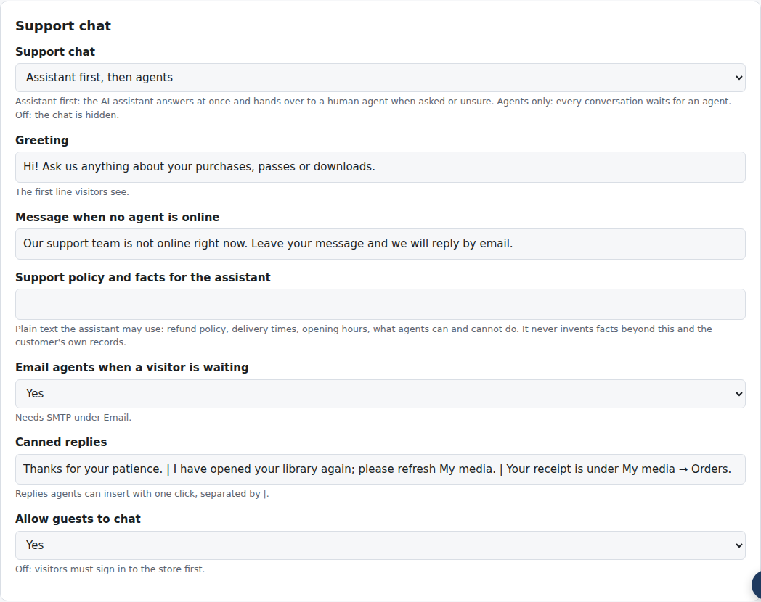
Settings → Support chat
Setting | What it does
Support chat | Assistant first, then agents (default), Agents only, or Off
Greeting | the first line visitors see
Message when no agent is online | shown while a visitor waits and nobody is online
Support policy and facts for the assistant | refund policy, delivery times, opening hours: the only facts the assistant may state beyond the store's own workings and the visitor's records
Email agents when a visitor is waiting | needs SMTP under Settings → Email
Canned replies | one-click replies for agents, separated by a vertical bar
Allow guests to chat | off means visitors must sign in first

The assistant uses the Anthropic API key under Settings → AI. Without a key the chat still works: every conversation goes straight to the agents.

3. Inviting a support agent
Open Chat in the store admin, enter the person's email and name and click Invite agent. The invitation link is emailed when SMTP is set up, and shown once on the page so you can send it yourself.
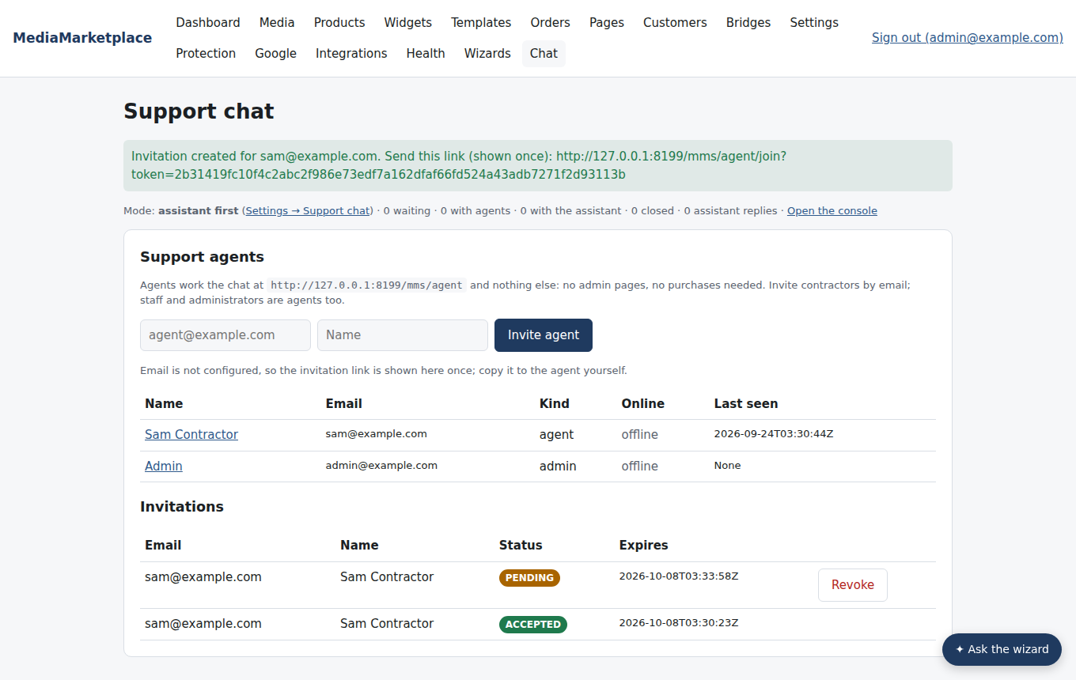
Chat in the store admin, with a fresh invitation link
The person opens the link, sees who invited them, chooses a password and lands in the support console. The link works once and expires after fourteen days. From then on they sign in at the store's sign-in page and are taken to the console.
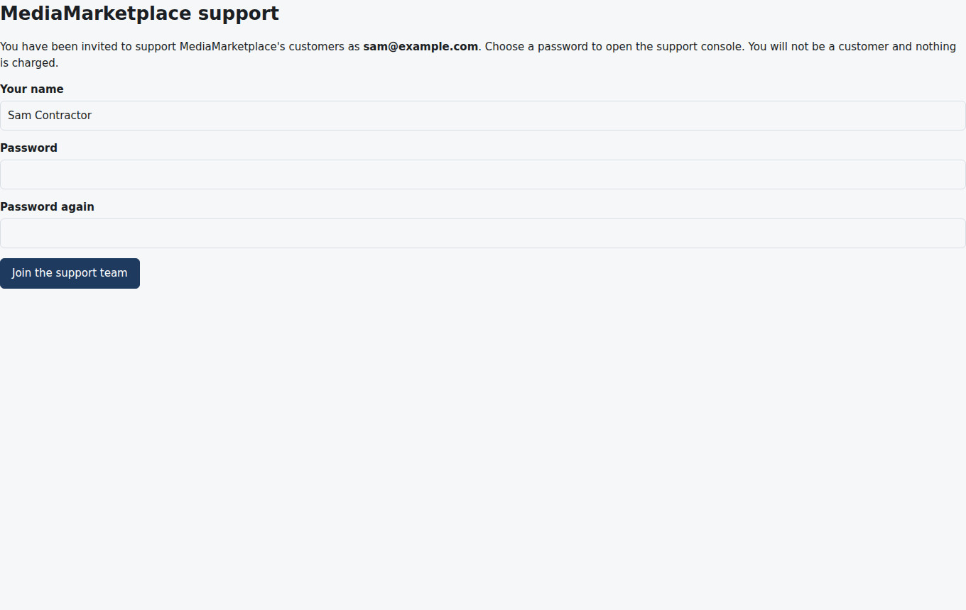
Joining by invitation link
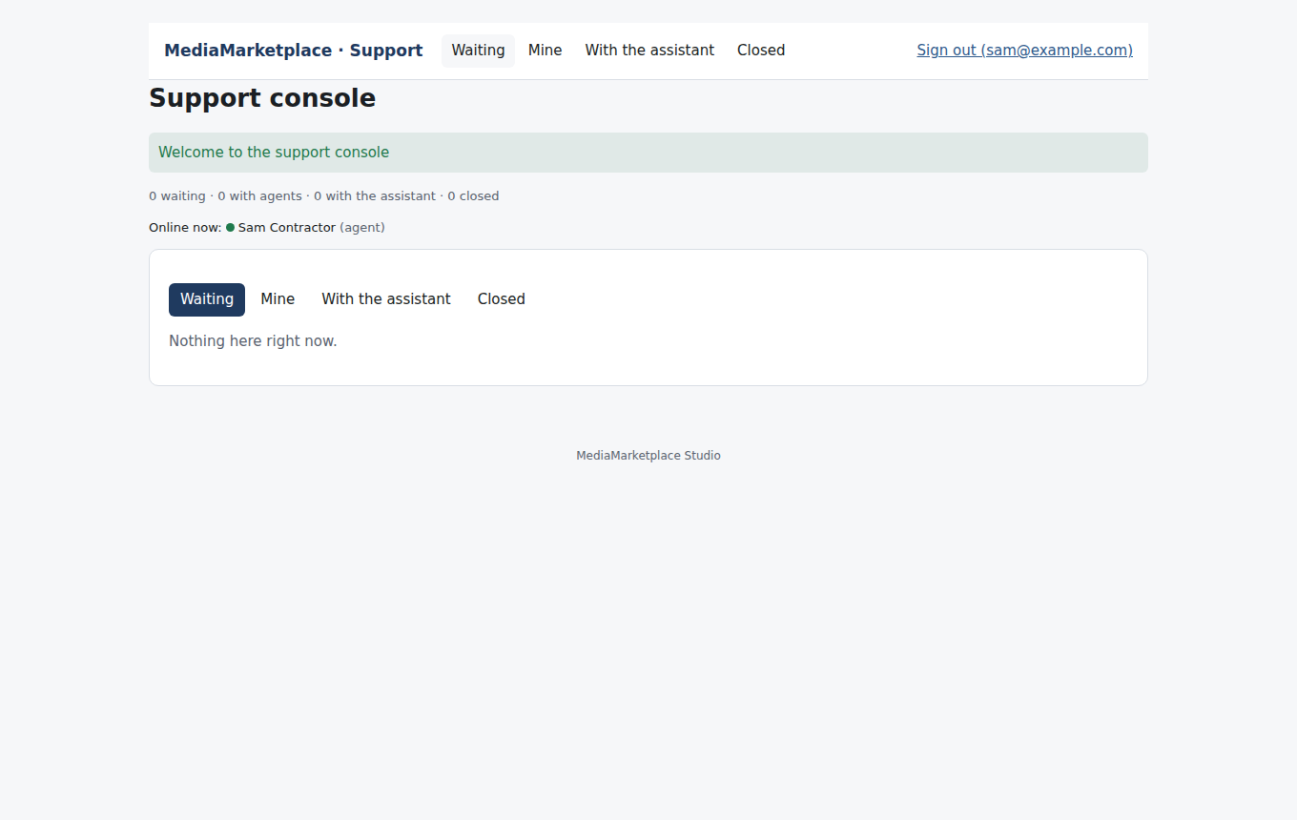
The support console, empty
Agent status can also be given to, or taken from, any existing account on its page under Customers with Make support agent. Agents cannot open admin pages: the Chat page, settings and everything else answer with "Support agent access required".
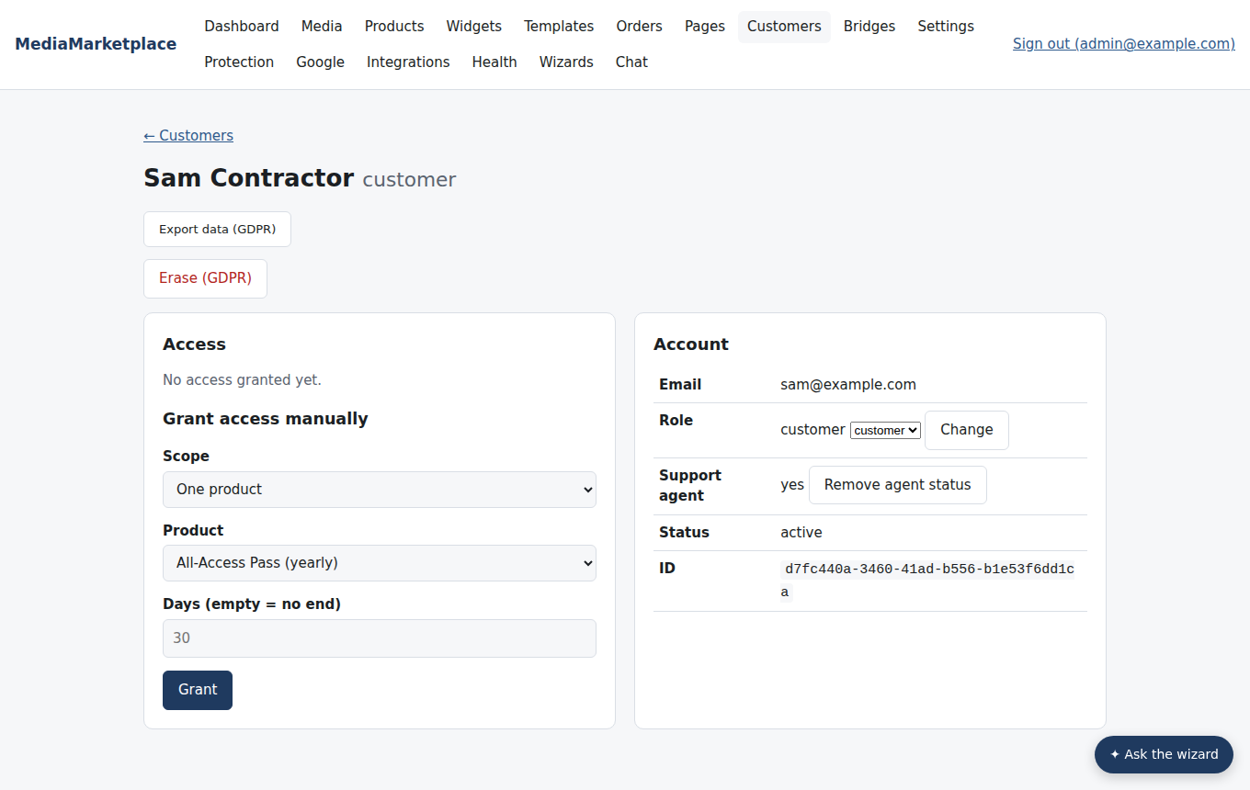
Agent status on a customer's page

4. Putting the chat on your site
- WordPress: add the MediaMarketplace Embed block and choose Support chat, or use [mms_embed kind="chat"].
- Joomla: add a MediaMarketplace » Widget menu item or the MediaMarketplace Embed module and choose Support chat, or type {mms_embed kind=chat} in an article.
- My media → Help shows the chat to every signed-in customer without any placement.
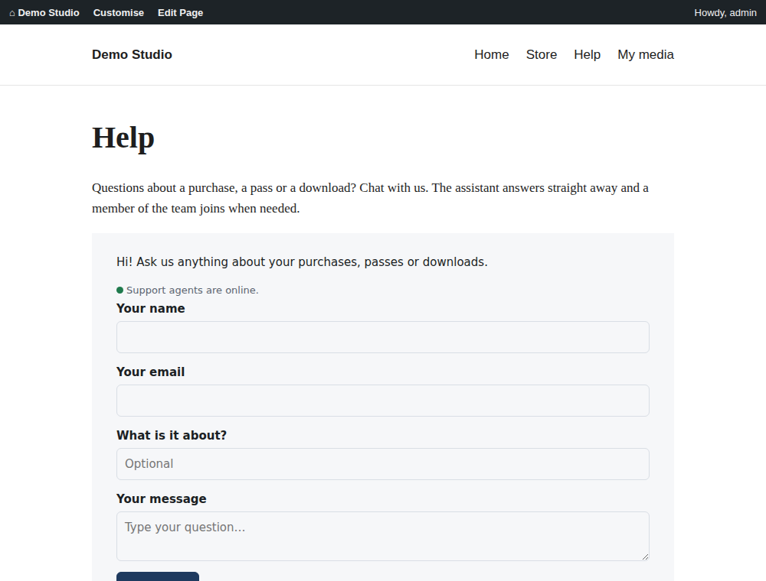
A WordPress help page with the chat embedded (mock-up page, live chat)
Guests give a name and email and start; signed-in customers just write. The chat remembers an open conversation, so a visitor who comes back sees where they left off.
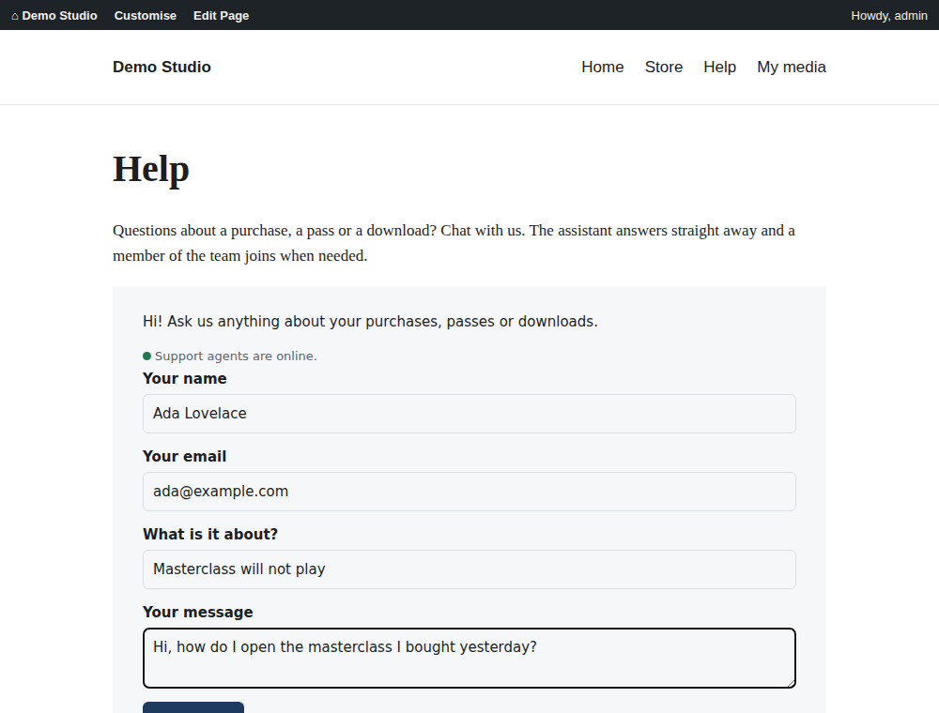
Starting a conversation as a guest

5. What a conversation looks like
The assistant answers the first question at once.
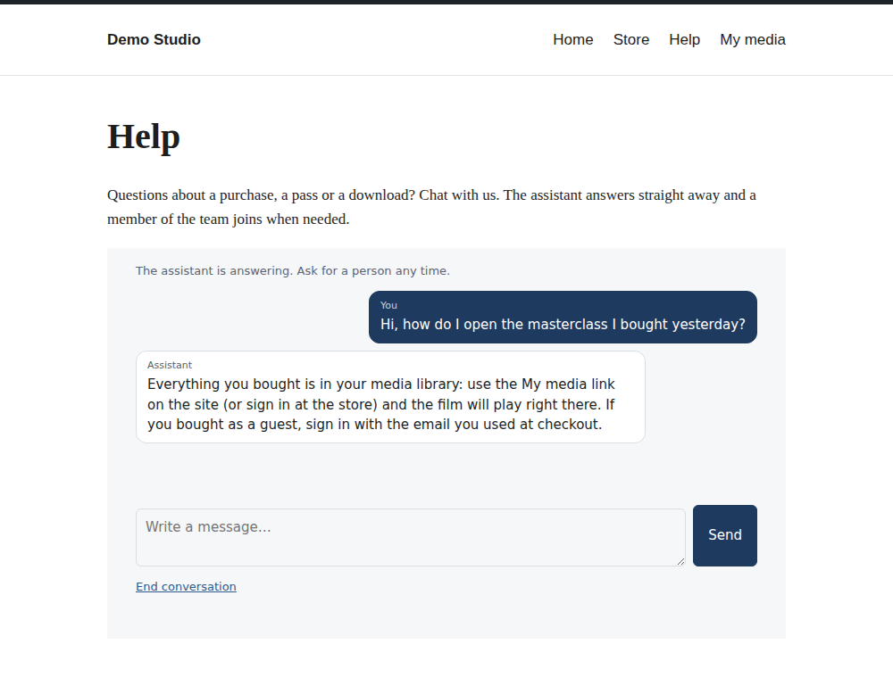
The assistant's first answer
When the visitor asks for a refund, or for a person, the assistant says so and hands over. The visitor sees that they are being connected; the agent sees an internal note with the reason and a summary.
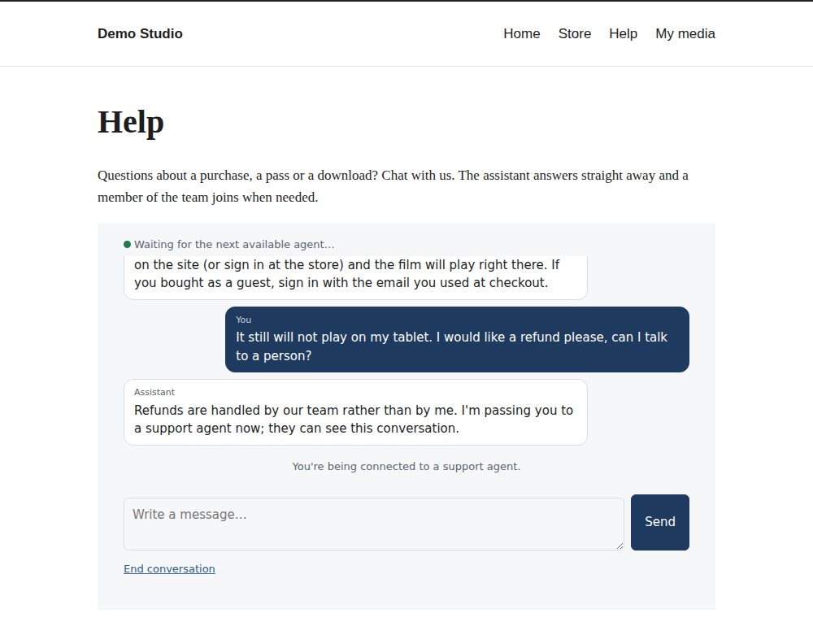
The hand-over as the visitor sees it
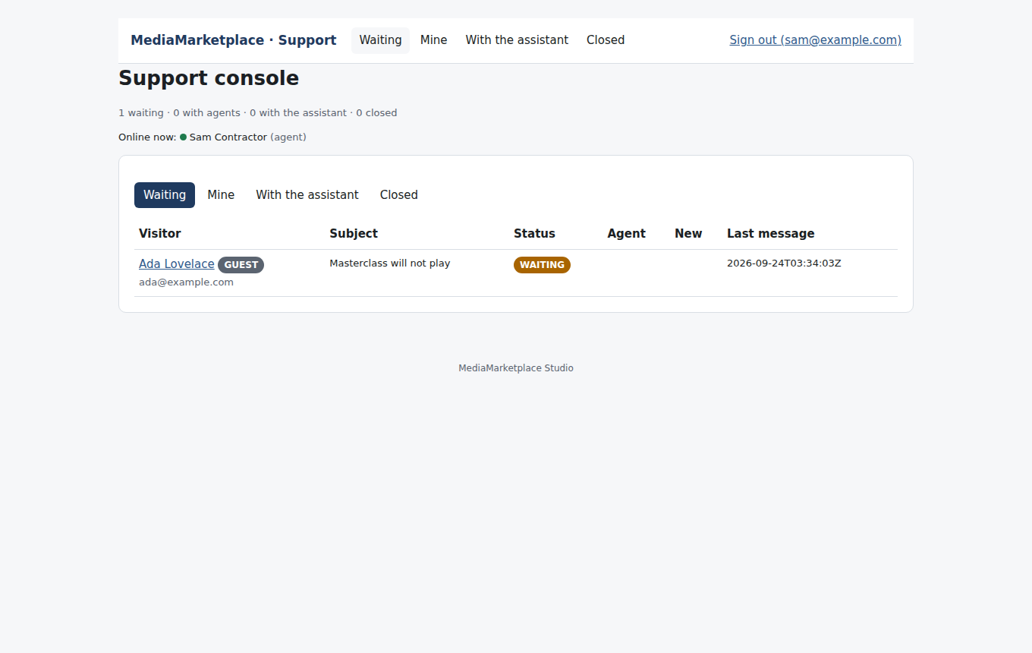
The agent's queue
The agent opens the conversation. On the right: the visitor's name, email, the page they wrote from, and for customers their orders, access and passes. Below the transcript: the reply box, an internal-note switch, the canned replies, and Suggest a reply, which drafts an answer from the transcript, the records and your policy for the agent to edit.
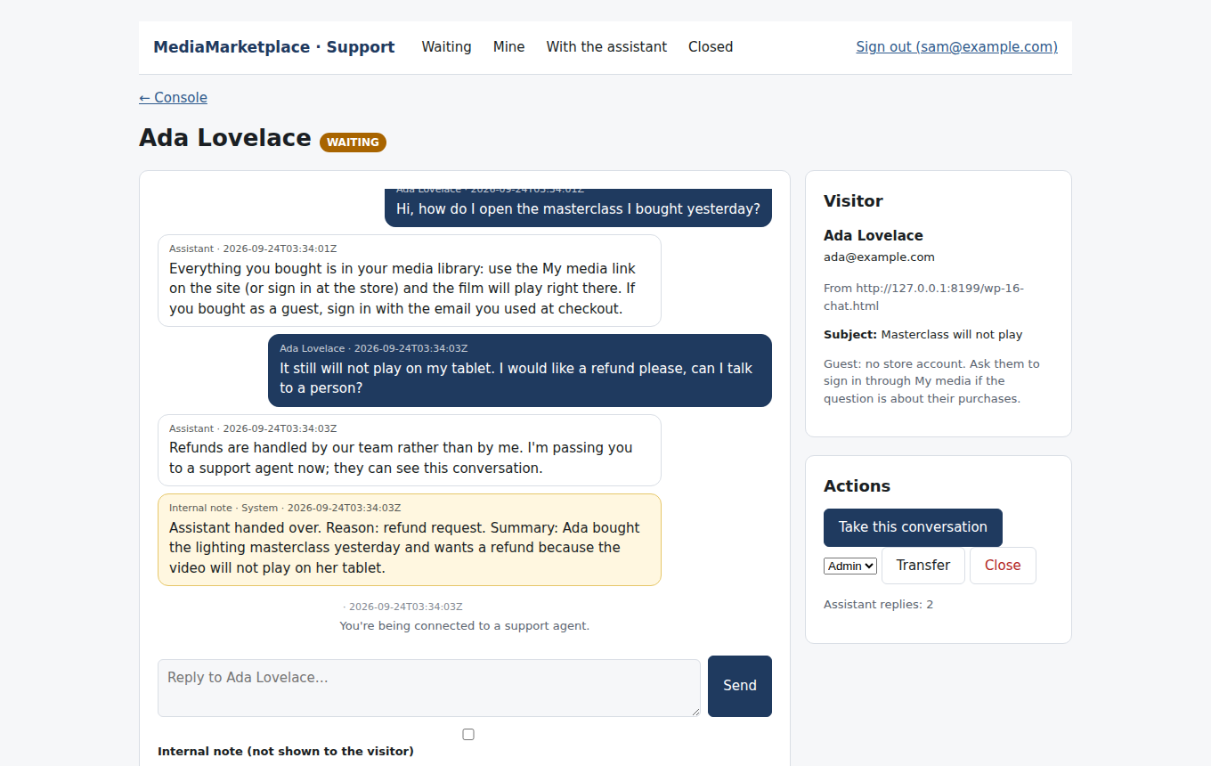
The agent's view, with the internal hand-over note
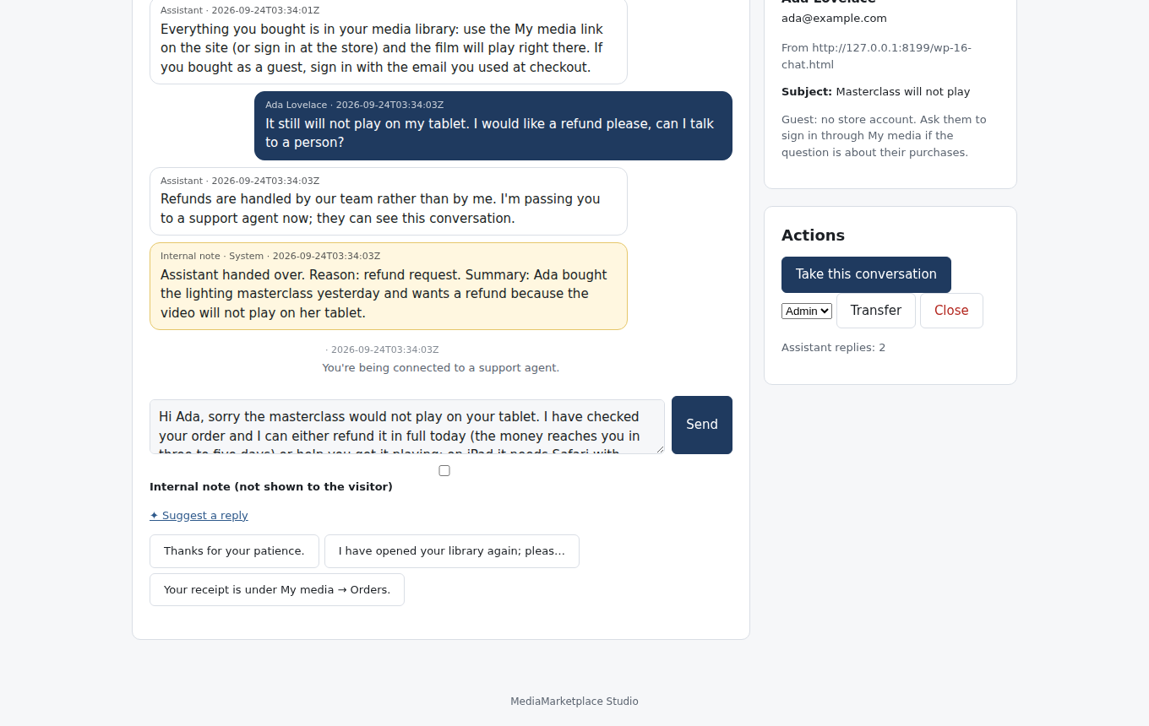
A suggested reply, ready to edit and send
Sending a reply takes the conversation; Transfer passes it to another agent, Back to queue releases it, Close ends it. The visitor sees the agent's name and reply within a few seconds and can rate the conversation once it is closed. Writing again reopens it with the same agent.
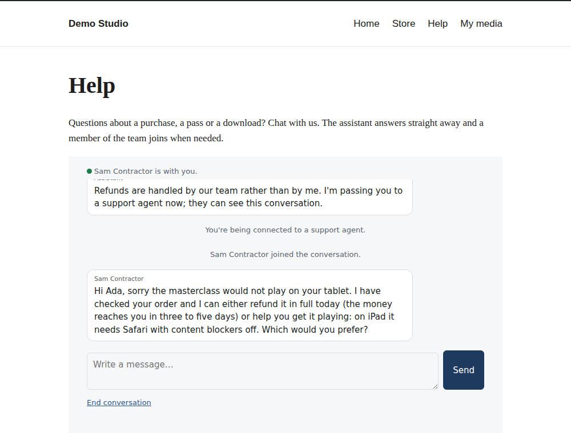
The agent's reply, as the visitor sees it
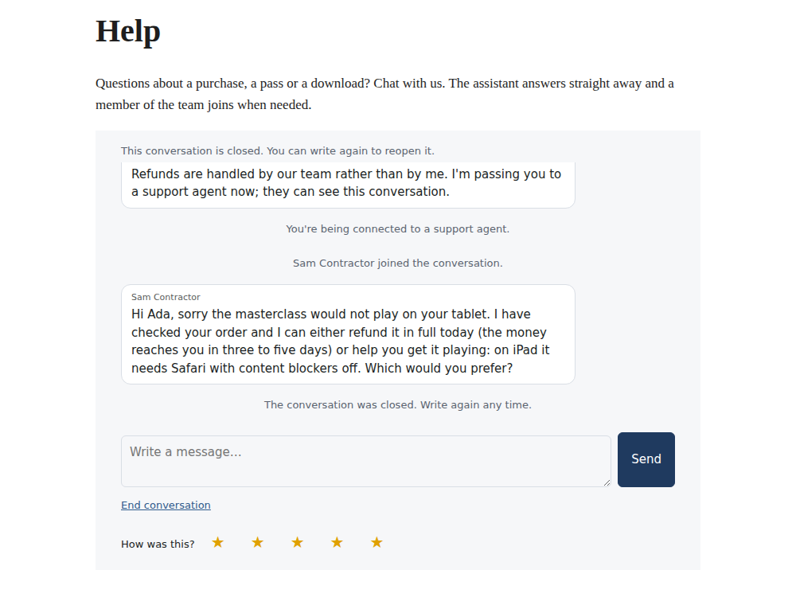
Rating a closed conversation
Signed-in customers get the same chat under My media → Help, and the assistant can look up their own records.
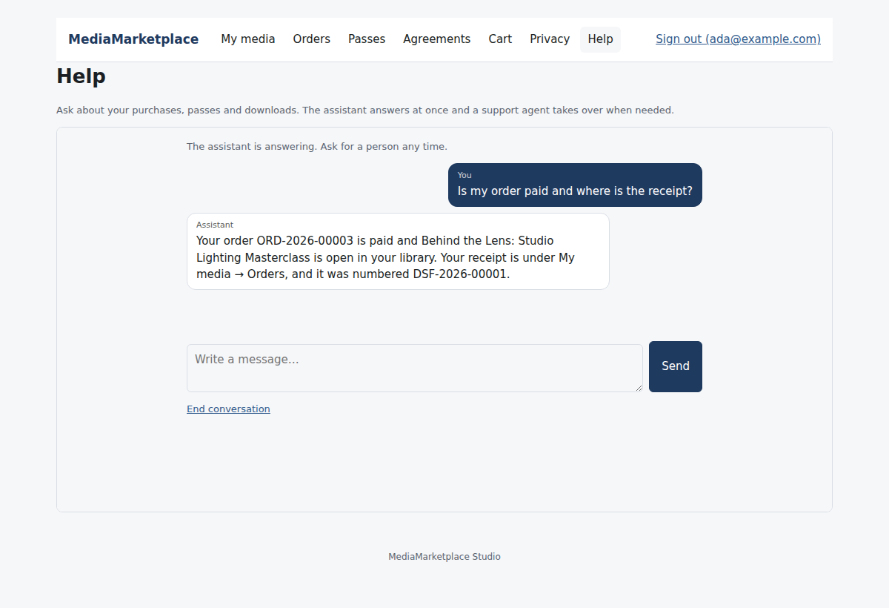
My media → Help, where the assistant has looked up the customer's order

6. The administrator's view
Chat in the store admin lists the agents with their online state, the pending and accepted invitations, every conversation with its status, agent, assistant replies and rating, and the totals.
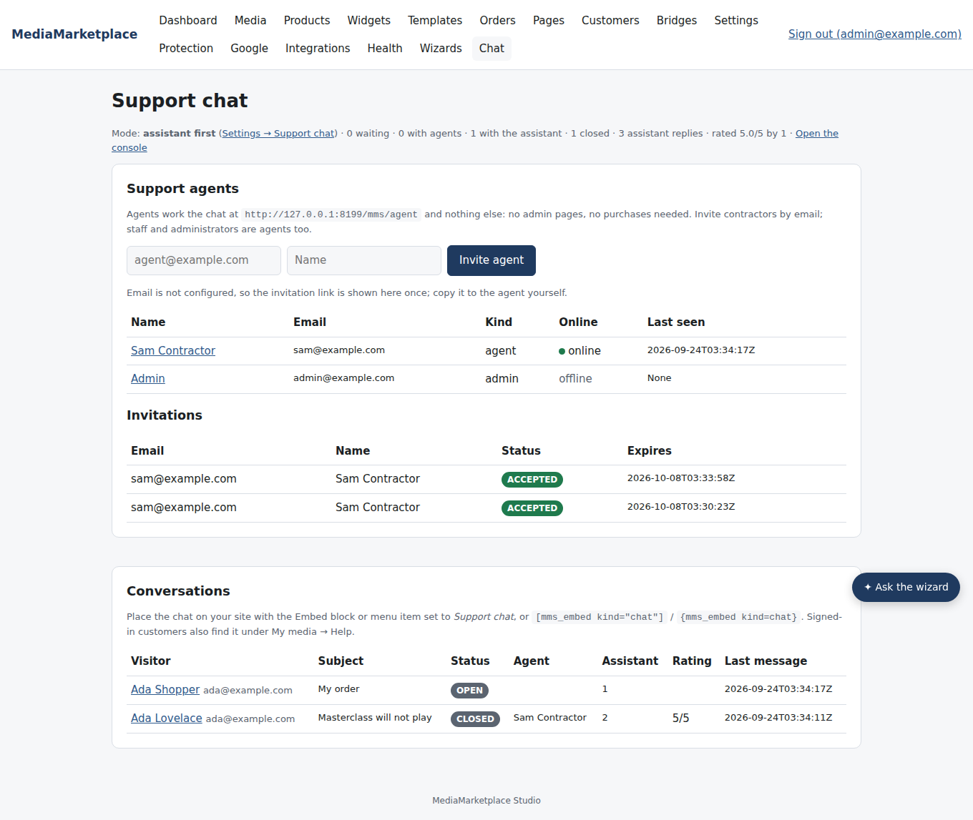
The Chat page in the store admin
Every reply, note, assignment, closure and invitation is written to the activity log.

7. What the assistant can and cannot do
- It reads how the store works (opening purchases, receipts, passes, sign-in, downloads, agreements, privacy), your policy text, and the signed-in visitor's own orders, access and passes.
- It hands over for refunds, charges, cancellations, anything it cannot see, and whenever the visitor asks for a person.
- It never sees other customers, never changes accounts, orders or access, never sends email, and never speaks for a guest's records.
- Each answer costs a fraction of a cent to a few cents; the number of assistant replies is shown per conversation and in the totals.

8. Troubleshooting
Symptom | Cause | What to do
The chat is not on the page | mode is Off, or the embed is not placed | Settings → Support chat; place the embed
Guests see "sign in to chat" | Allow guests is off | switch it on under Settings → Support chat
Every conversation waits for an agent | no Anthropic API key, or mode is Agents only | Settings → AI; Settings → Support chat
Agents get no email | SMTP not set, or notifications off | Settings → Email; Settings → Support chat
An invitation link does not work | used, revoked or older than fourteen days | invite again
An agent reaches the admin pages | they are staff or an administrator, not a contractor | agent status alone never opens admin pages
"You're being connected" but nobody comes | no agent has the console open | agents count as online while their console is open; email tells them a visitor is waiting

