Draft — Not Filed — For Review by Qualified Patent Counsel Prior to Filing
Provisional Patent Application · 35 U.S.C. § 111(b)

QueryBook — A Deterministic, Provenance-Tracked Federated Knowledge and Query System With an Integral Developmental Language and Speech Subsystem (the Language Expression Layer)
Applicant / Assignee: QueryBook Core Technology Group
Inventors: [to be inserted by counsel]
Related applications: Prior provisional applications on the QueryBook system, including the Universal Federated Connectivity System (UFCS) and the Federated Query Language (FQL).
Document date: September 28, 2026 (rev. September 29, 2026 — added Section VII reduced-to-practice embodiment; rev. October 1, 2026 — added Section VIII advanced deterministic multilingual pronunciation, self-contained speech, and quality-control embodiment; rev. October 1, 2026 — consolidated as a single QueryBook-first application, the LEL incorporated as QueryBook's integral language and speech subsystem; rev. October 1, 2026 — added Section IX voiceprint & multimodal identity embodiment, Language & Identity Linking (LIL), with FIG. 33–34 and claims 31–38; rev. October 1, 2026 — added Section X Universal Integrity Audit Service (UIAS) embodiment with FIG. 35–36 and claims 39–46; rev. October 2, 2026 — added Section XI Paralinguistic & Pragmatic Interpretation Layer (PIL) embodiment with FIG. 37–38 and claims 47–54; rev. October 2, 2026 — added Section XII Lecture Query mode embodiment with FIG. 39–40 and claims 55–62; rev. October 8, 2026 — added Section XV agent-era extensions with FIG. 50–55 and claims 77–99) · Attorney docket / Application no.: [to be assigned]
Note on this draft. This provisional specification is a single, consolidated QueryBook application. It presents the QueryBook deterministic, provenance-tracked federated knowledge and query system together with its integral developmental language and speech subsystem — the Language Expression Layer (LEL) — as one invention: the LEL is a QueryBook subsystem, co-grounded with the Fact Unit, FQL, and UFCS core (FIG. 6), not a separate system. A previously separate LEL provisional is hereby consolidated into this QueryBook application and retained elsewhere only as a language-subsystem excerpt. Clarifying refinements from an internal engineering audit — marked audit — have been folded into the detailed description to strengthen enablement (operational threshold definitions, hybrid co-grounding, licensed training data, empirically-set timelines, non-strict multilingual acceleration). Formal drawings (FIG. 1–FIG. 30) with a Brief Description of the Drawings and a Reference Numerals key have been added and are draft — to be finalized to USPTO drawing standards (37 CFR 1.84) by a patent draftsperson. Claims are reproduced as drafted and must be reviewed, and a prior-art search conducted, by qualified patent counsel before filing.

Drawings
Formal patent drawings — black line art, forming one QueryBook figure set: FIG. 1–FIG. 8 and FIG. 31–FIG. 32 depict QueryBook's integral developmental language and speech subsystem (the Language Expression Layer), FIG. 9–FIG. 30 depict the QueryBook platform in which that subsystem is co-grounded (see FIG. 6), FIG. 33–FIG. 34 depict the Language & Identity Linking (LIL) voiceprint and multimodal identity subsystem, FIG. 35–FIG. 36 depict the Universal Integrity Audit Service (UIAS) that QueryBook delivers on these primitives, FIG. 37–FIG. 38 depict the Paralinguistic & Pragmatic Interpretation Layer (PIL), and FIG. 39–FIG. 40 depict the Lecture Query interaction mode. FIG. 50–FIG. 55 depict the Section XV agent-era extensions: Open Claw ingestion, on-chain certification, agent protection and deception, the tamper-evident security record, agent interoperability, and the framed hybrid transport. Each figure is on its own sheet and every element is identified by a reference numeral used consistently in the Brief Description of the Drawings, the Reference Numerals key, and the Detailed Description. Figures are draft; counsel/draftsperson to finalize to USPTO drawing standards (37 CFR 1.84) before filing.
FIG. 1
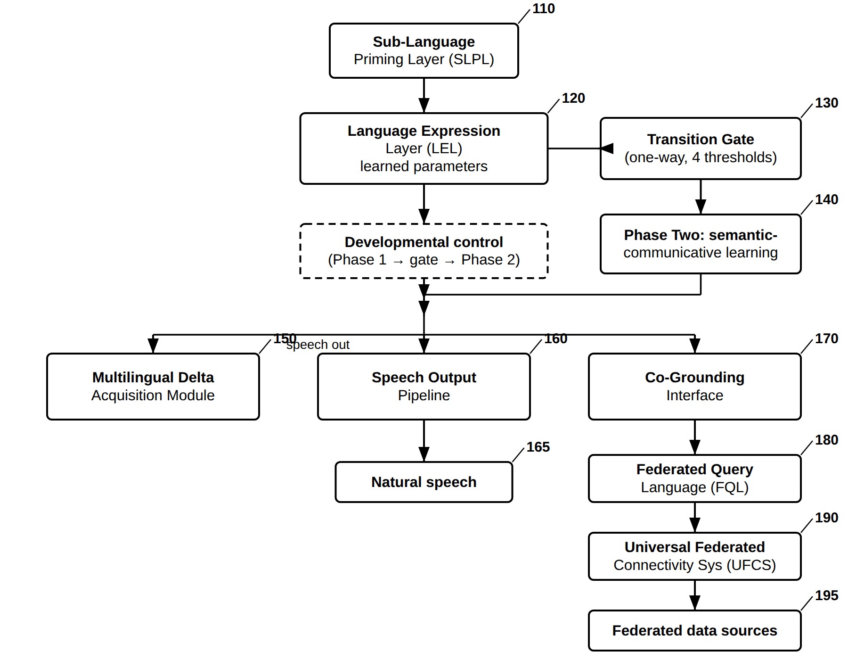
FIG. 1 — QueryBook LEL — Overall System Architecture
FIG. 2
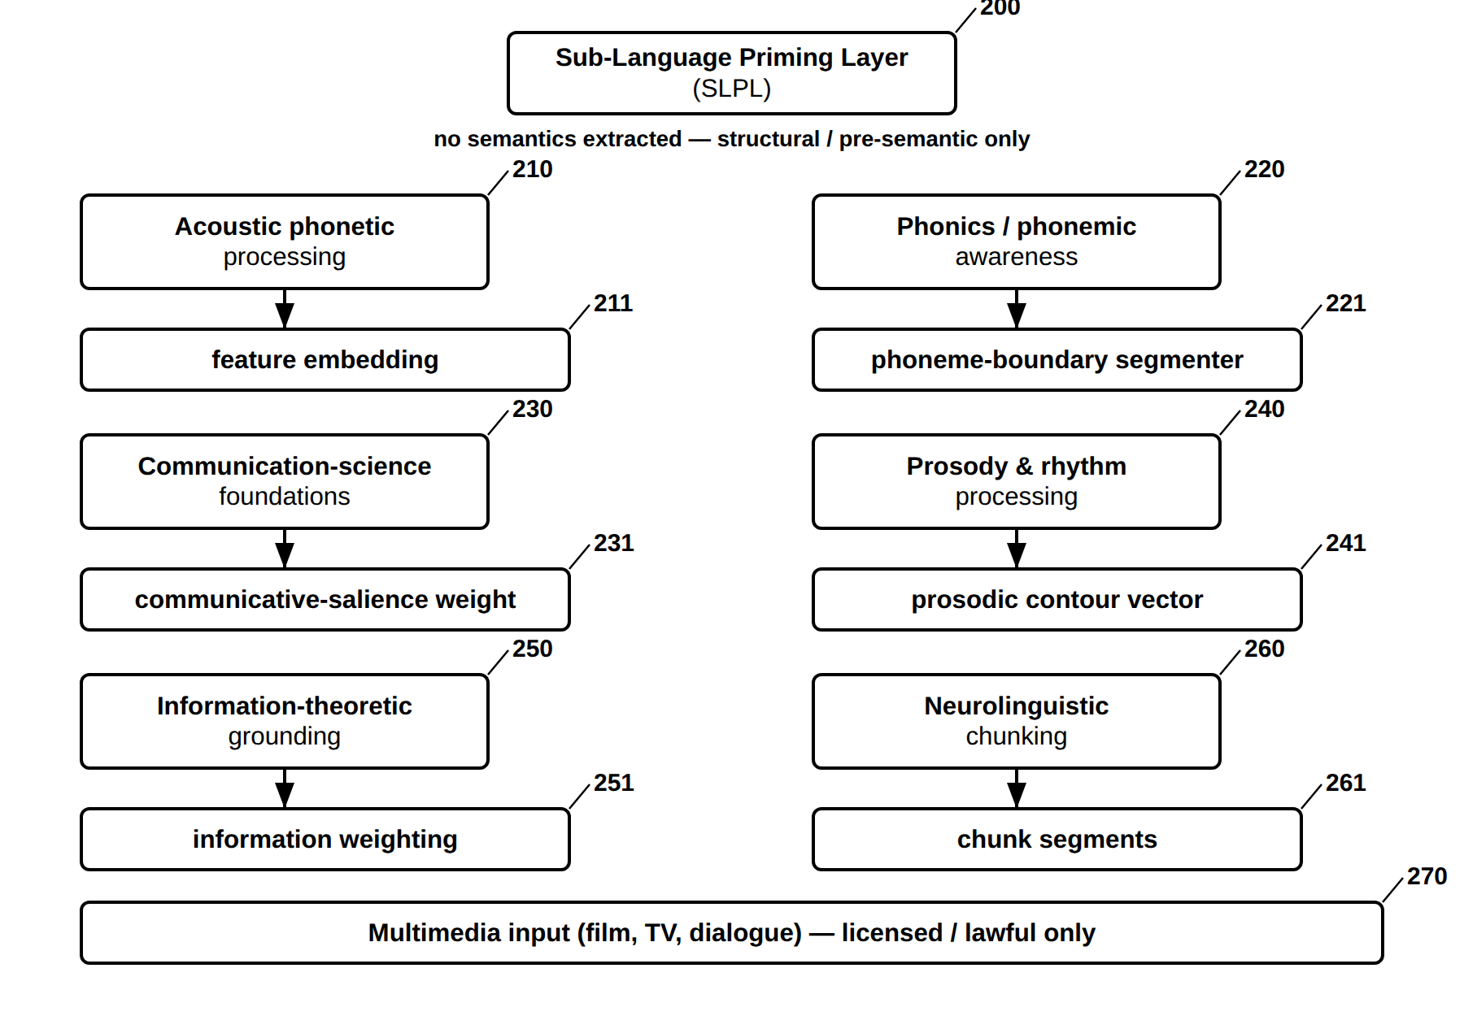
FIG. 2 — Sub-Language Priming Layer (SLPL) and Its Measurable Outputs
FIG. 3
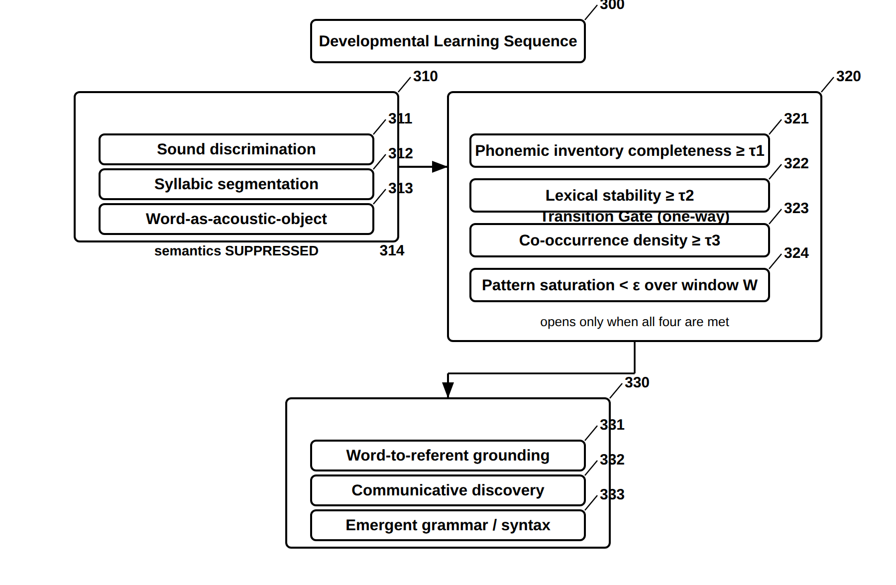
FIG. 3 — Developmental Learning Sequence and One-Way Transition Gate
FIG. 4
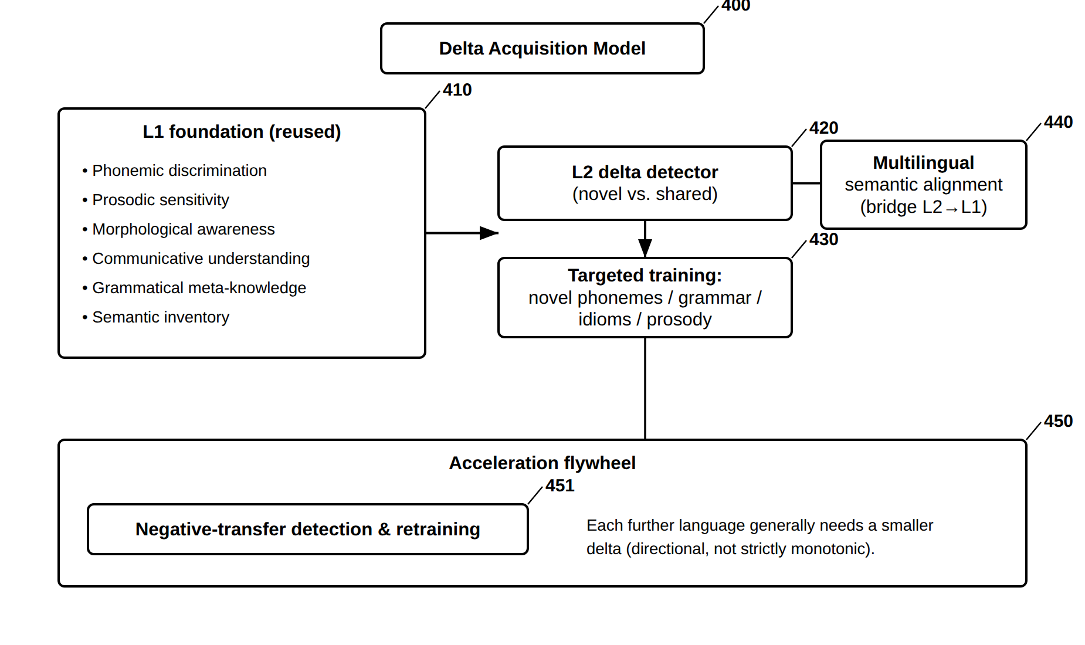
FIG. 4 — Multilingual Transfer — Delta Acquisition and Acceleration Flywheel
FIG. 5
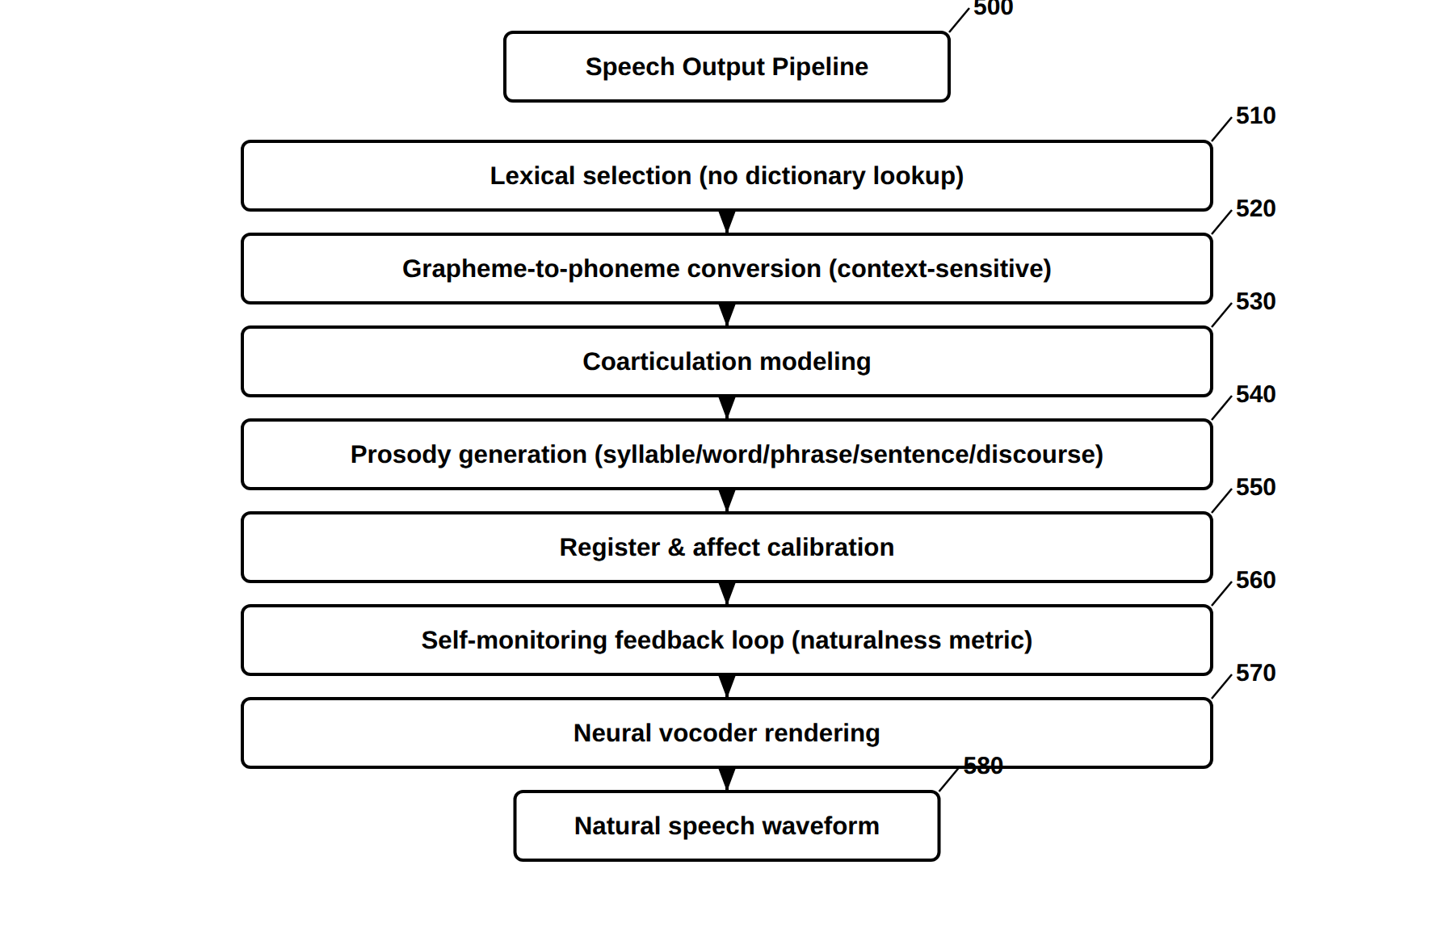
FIG. 5 — Speech Output Pipeline (Seven Learned Stages)
FIG. 6
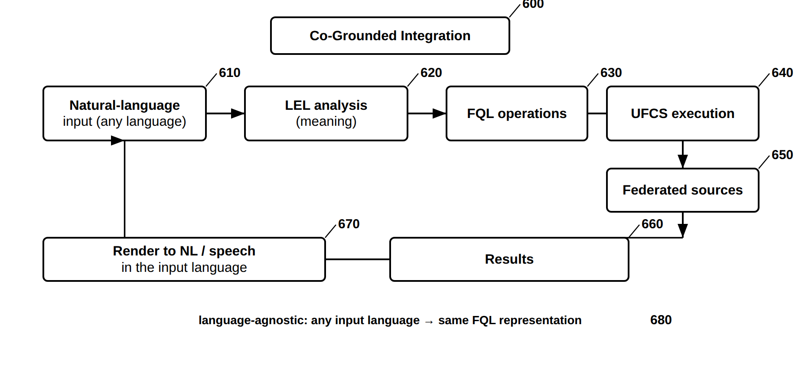
FIG. 6 — Co-Grounded Integration with FQL and UFCS
FIG. 7
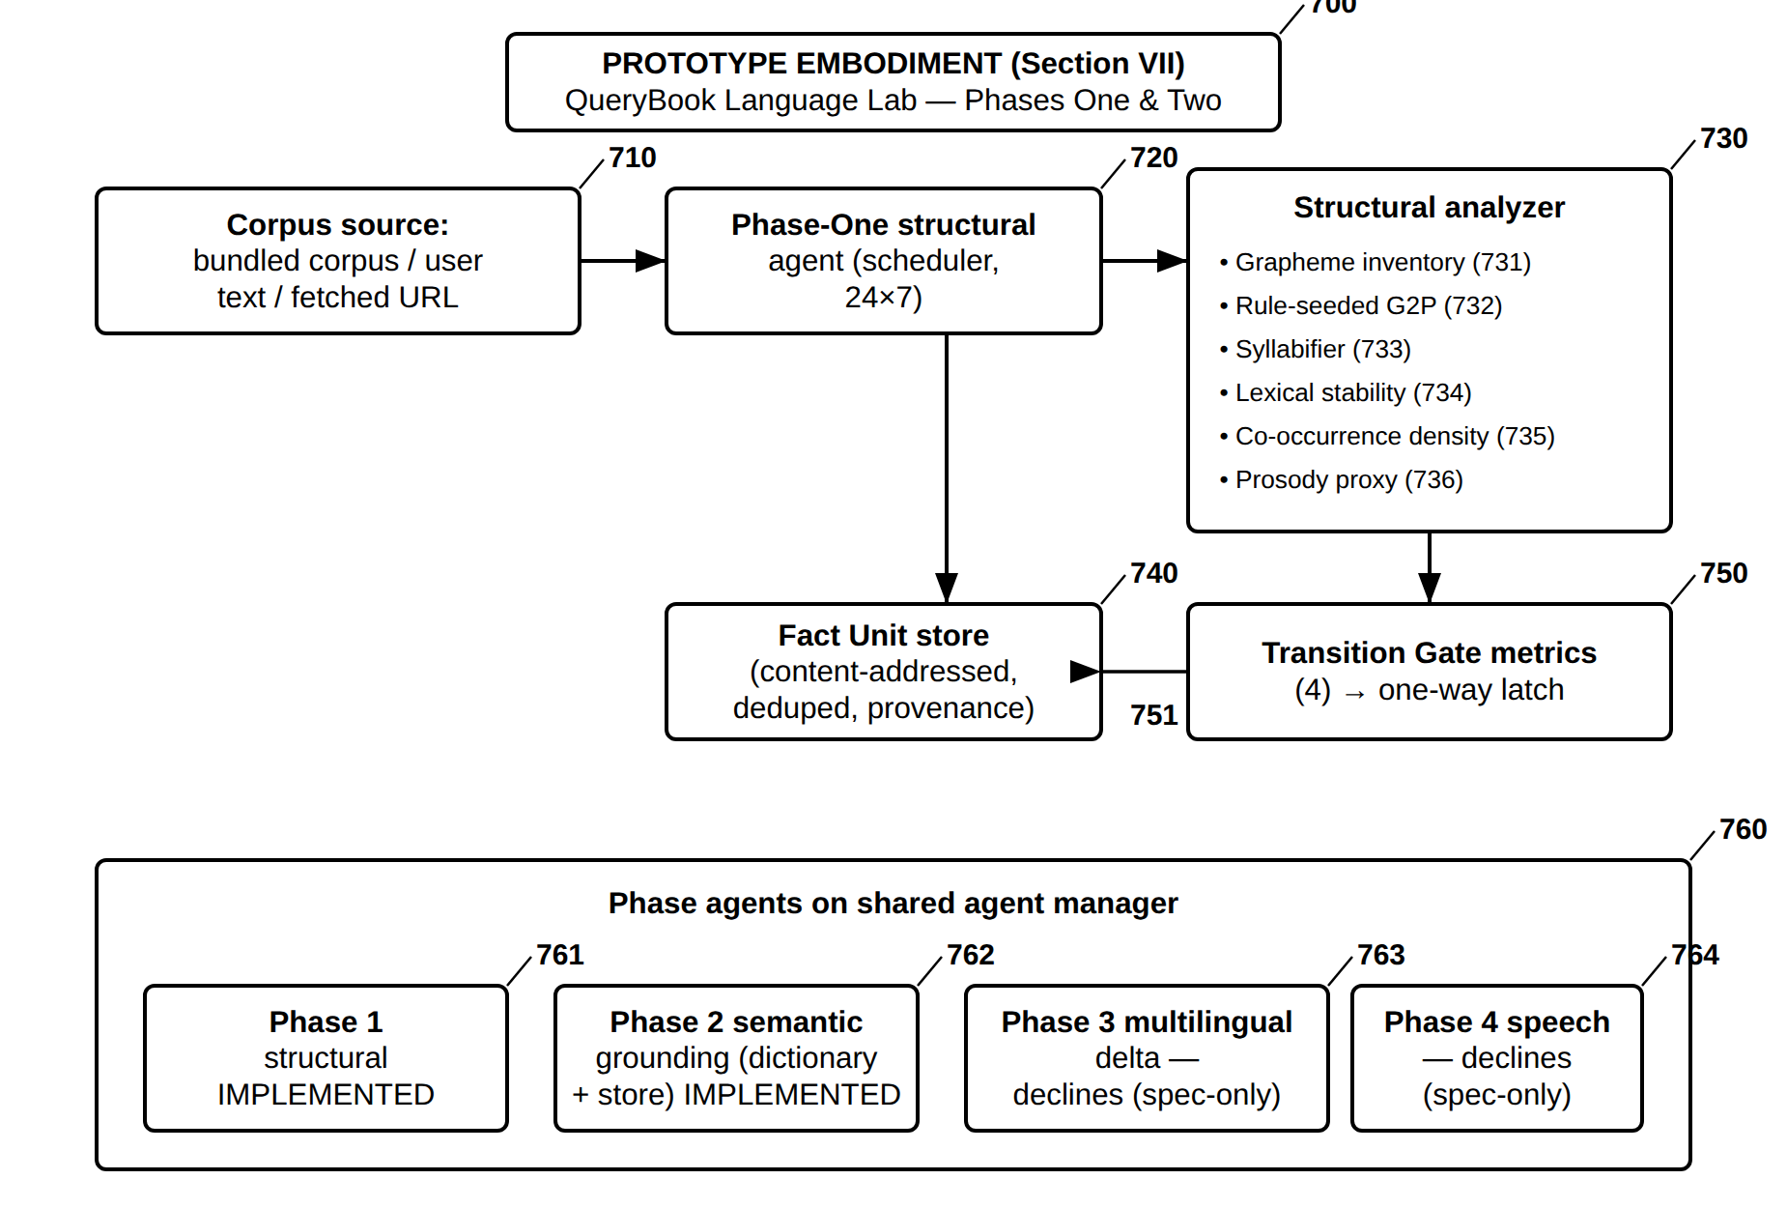
FIG. 7 — Reduced-to-Practice Embodiment — Language Lab Phases One and Two Prototype
FIG. 8
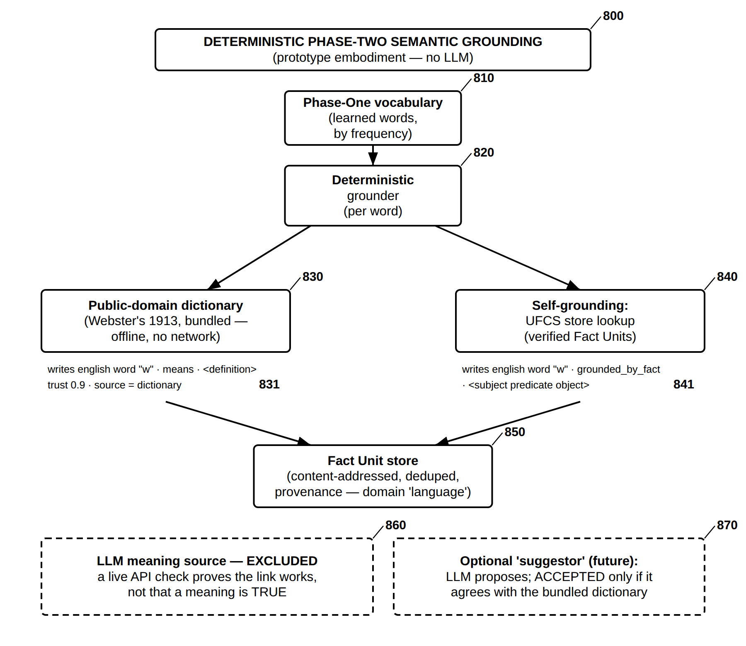
FIG. 8 — Deterministic Phase-Two Semantic Grounding — Dictionary and Store (No LLM)

QueryBook Platform Drawings (FIG. 9–FIG. 30) — the system in which the language subsystem is integral
FIG. 9 through FIG. 30 depict the QueryBook deterministic, provenance-tracked federated knowledge and query platform of which the developmental language and speech subsystem (the Language Expression Layer, FIG. 1–FIG. 8 and FIG. 31–FIG. 32) is an integral, co-grounded part (see FIG. 6). Together with the language-subsystem figures these form one QueryBook figure set. Draft — the language-subsystem figures use a 100–999 numeral series and the platform figures a 100–2200 series; counsel/draftsperson to consolidate the two into a single QueryBook numeral series and finalize to 37 CFR 1.84 before filing.
FIG. 9
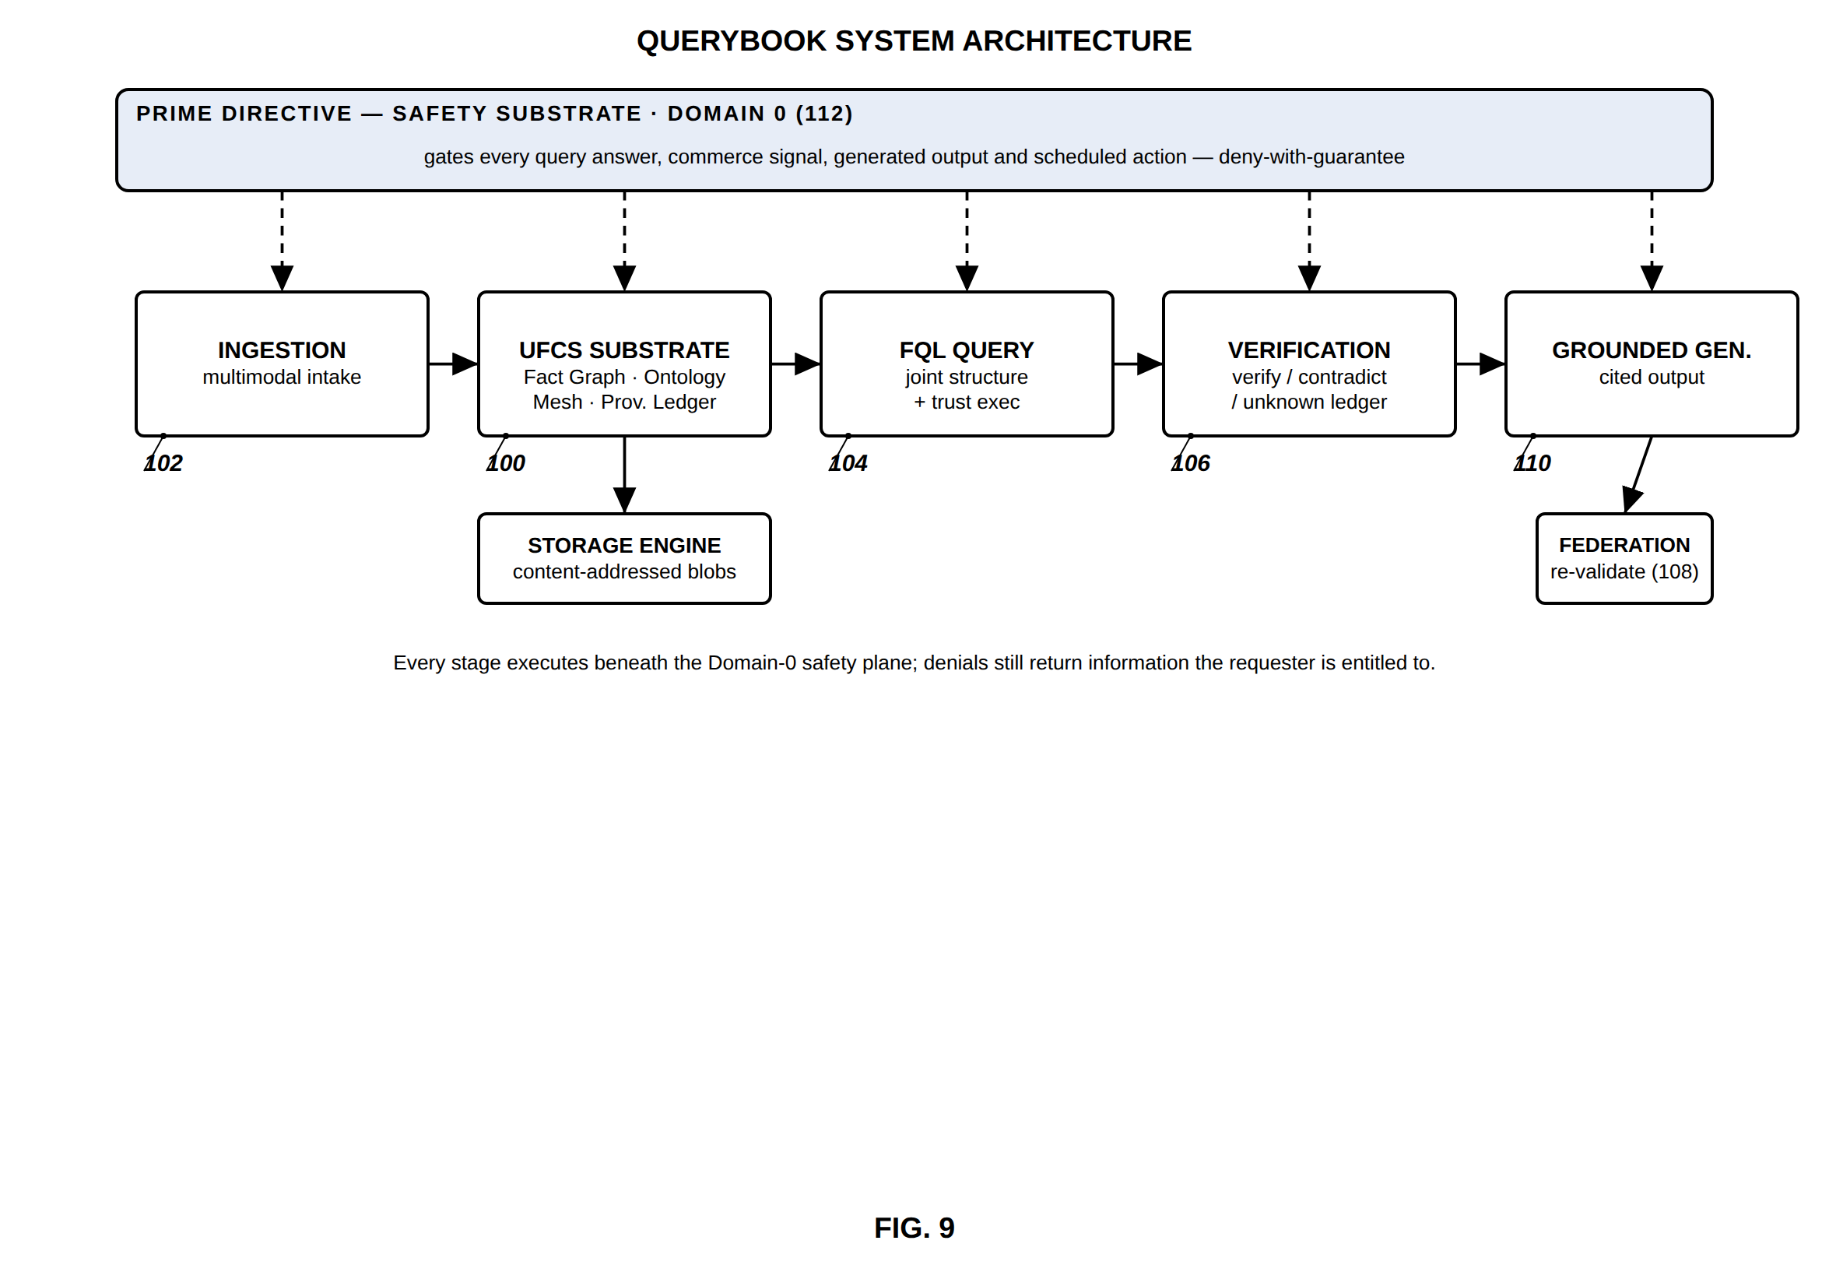
FIG. 9 — QueryBook system architecture (Prime Directive as Domain 0)
FIG. 10
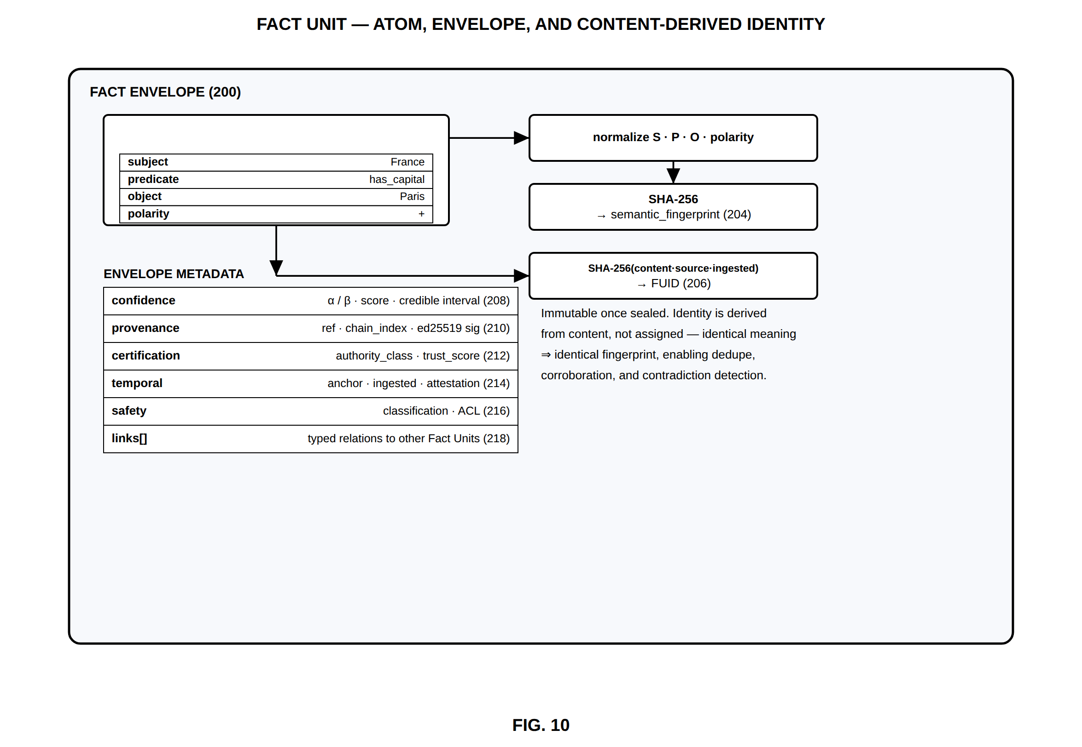
FIG. 10 — Fact Unit — atom, envelope, and content-derived identity
FIG. 11
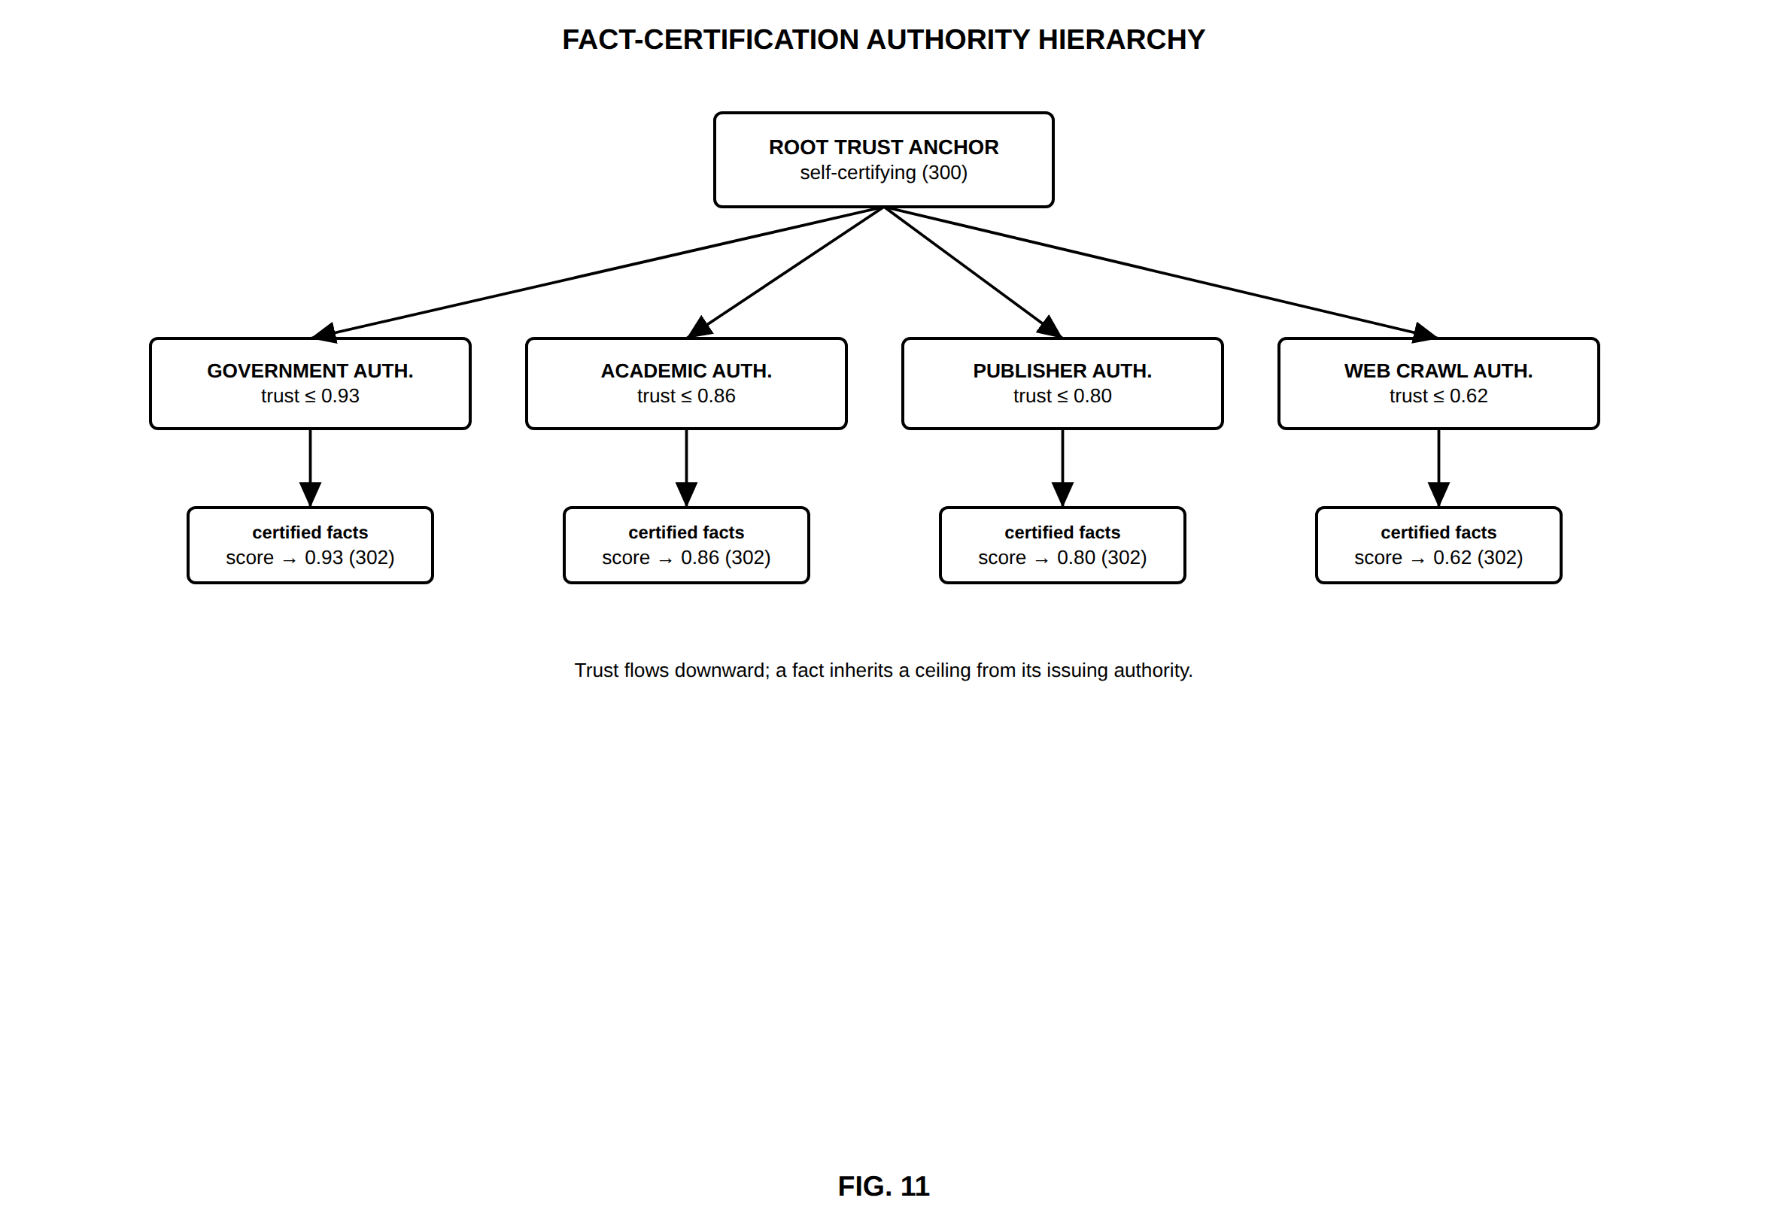
FIG. 11 — Fact-certification authority hierarchy
FIG. 12
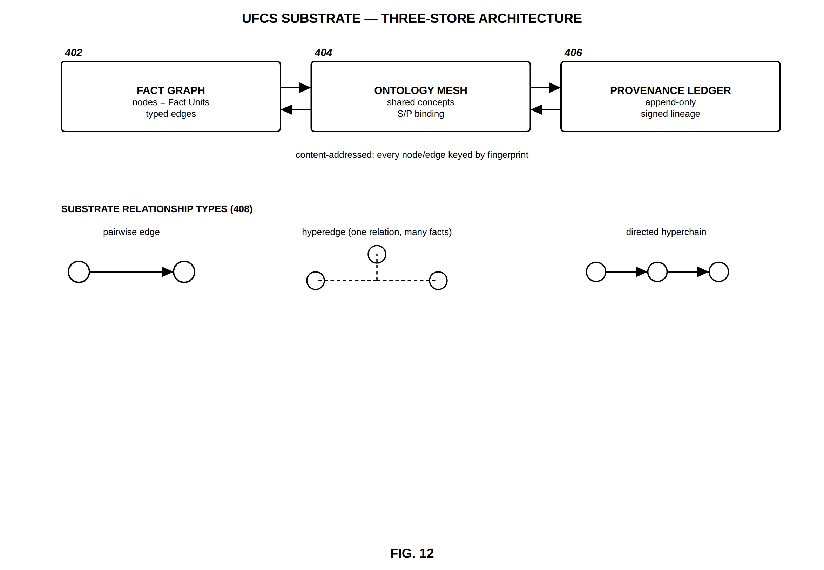
FIG. 12 — UFCS substrate — three-store architecture
FIG. 13
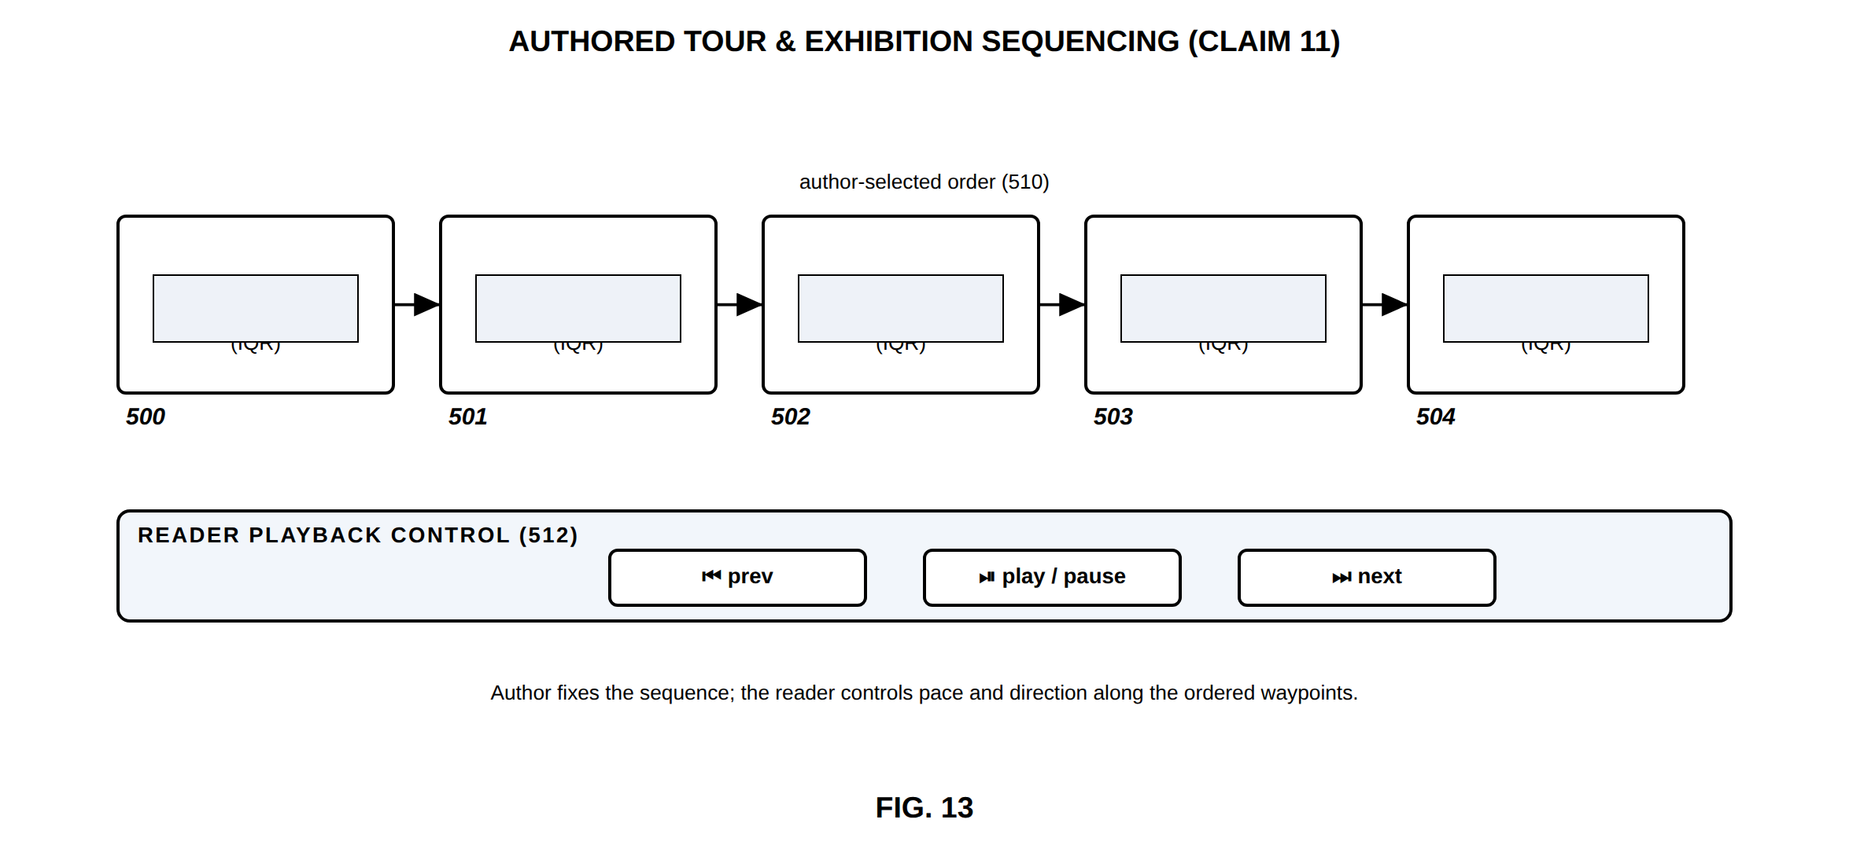
FIG. 13 — Authored tour and exhibition sequencing
FIG. 14
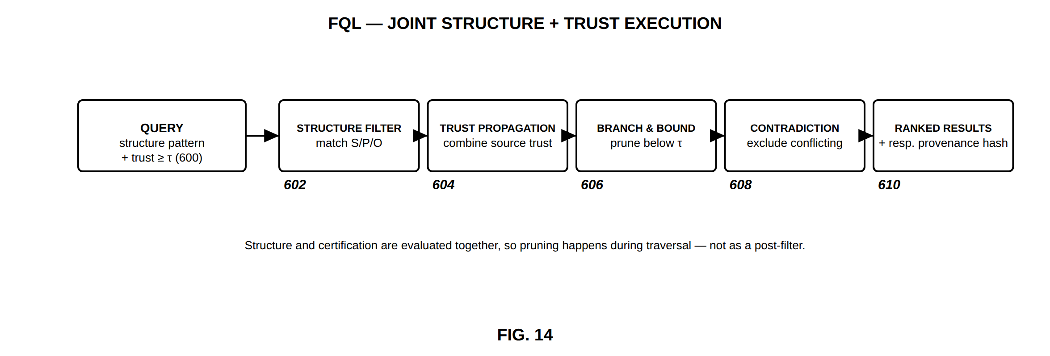
FIG. 14 — FQL — joint structure and trust execution
FIG. 15
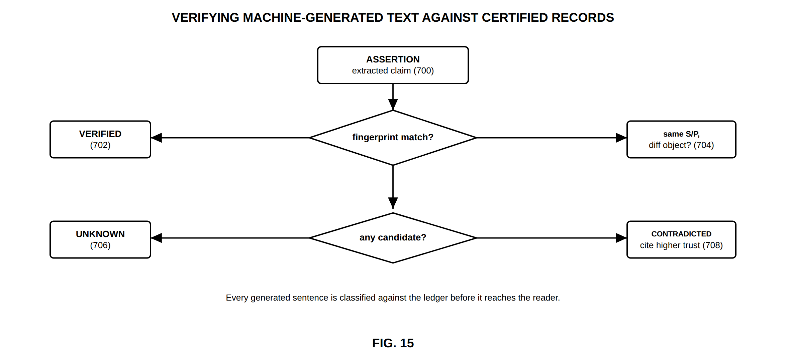
FIG. 15 — Verifying machine-generated text against certified records
FIG. 16
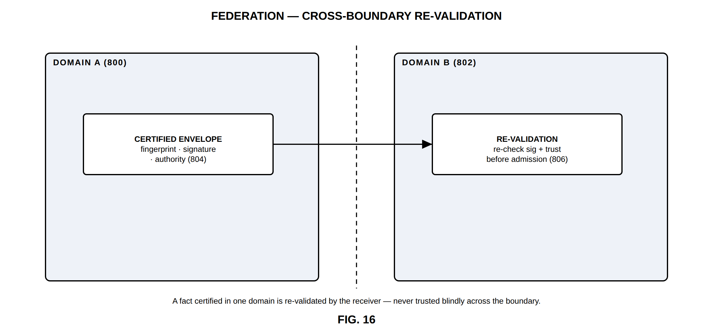
FIG. 16 — Federation — cross-boundary re-validation
FIG. 17
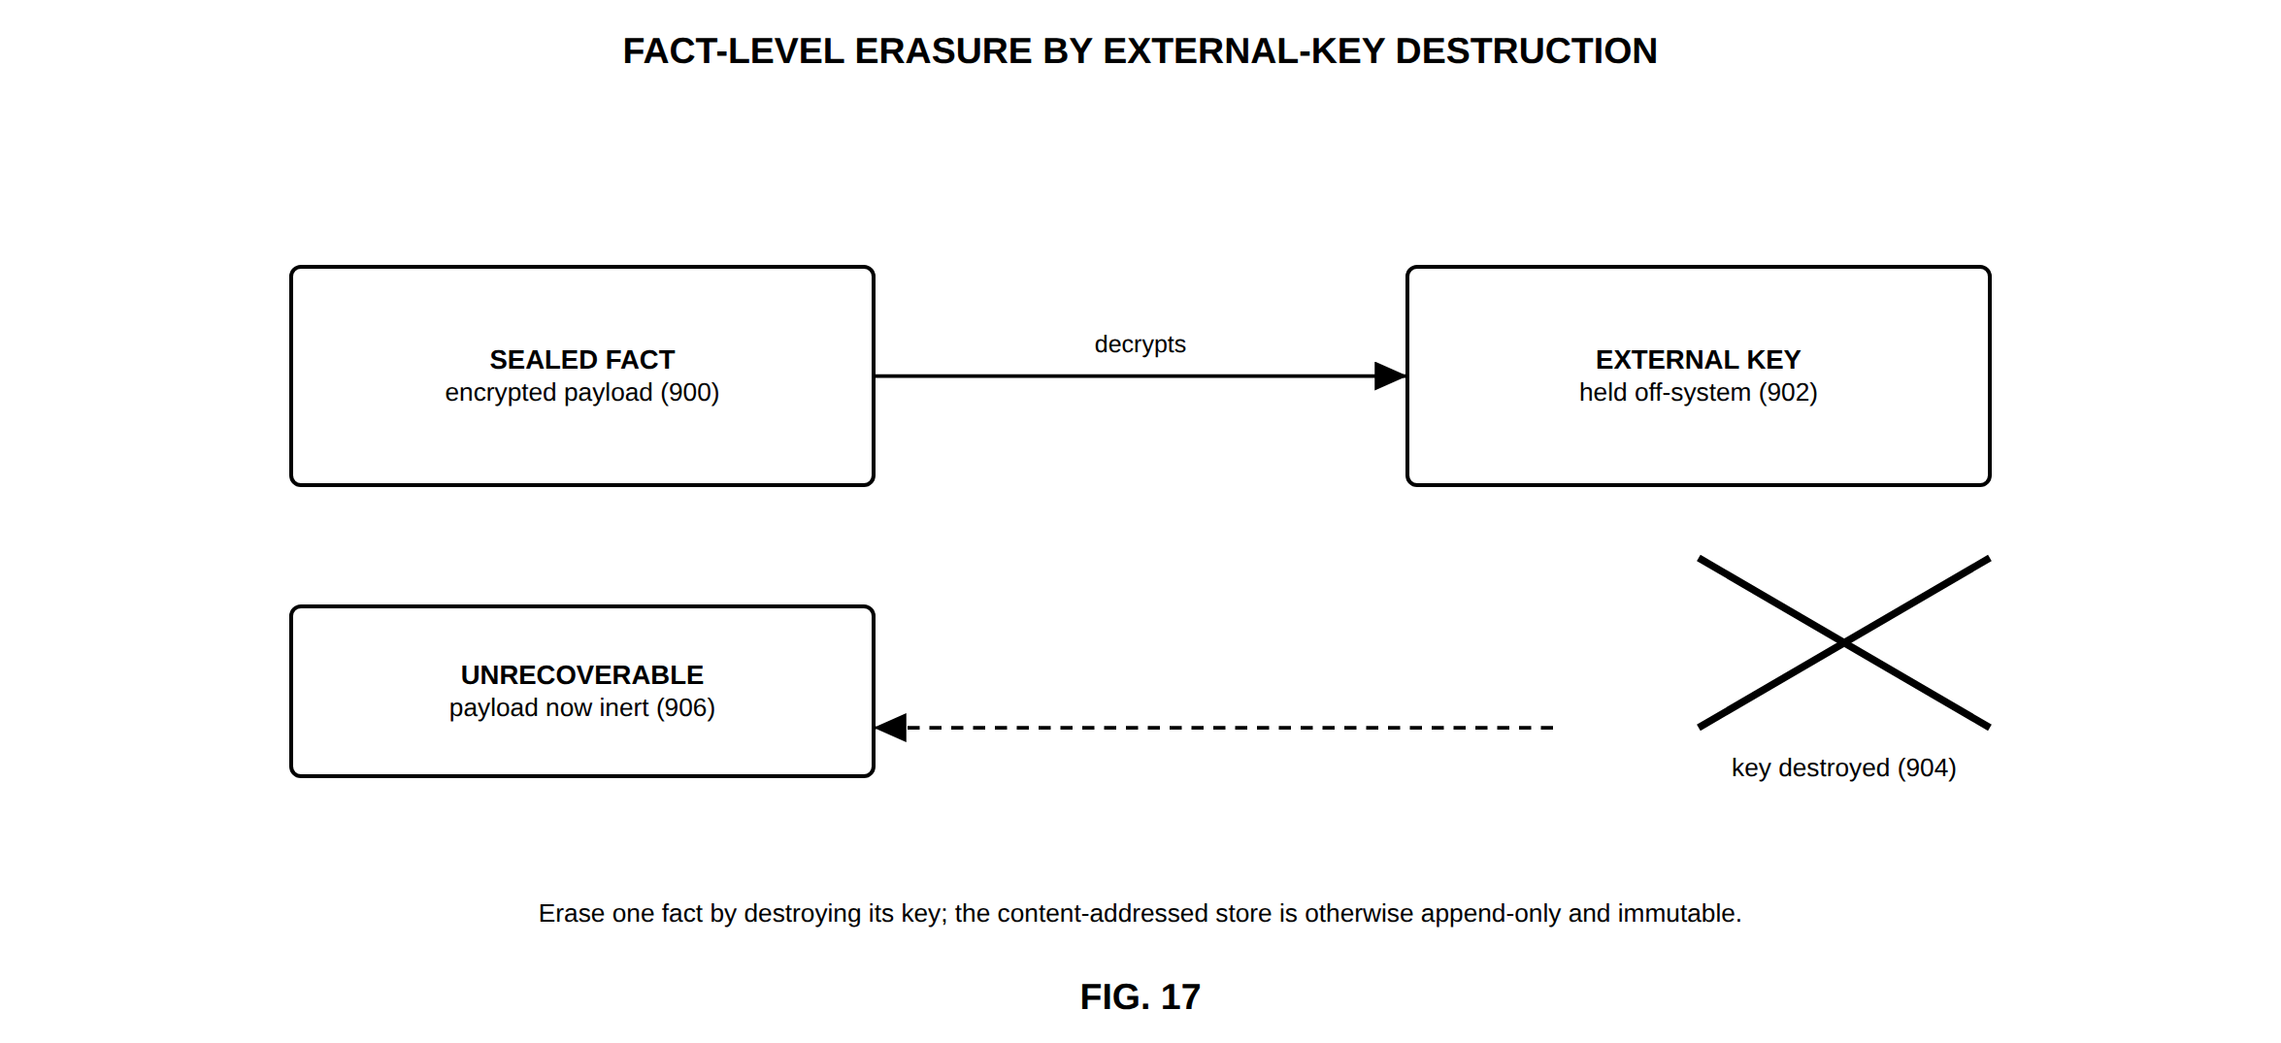
FIG. 17 — Fact-level erasure by external-key destruction
FIG. 18
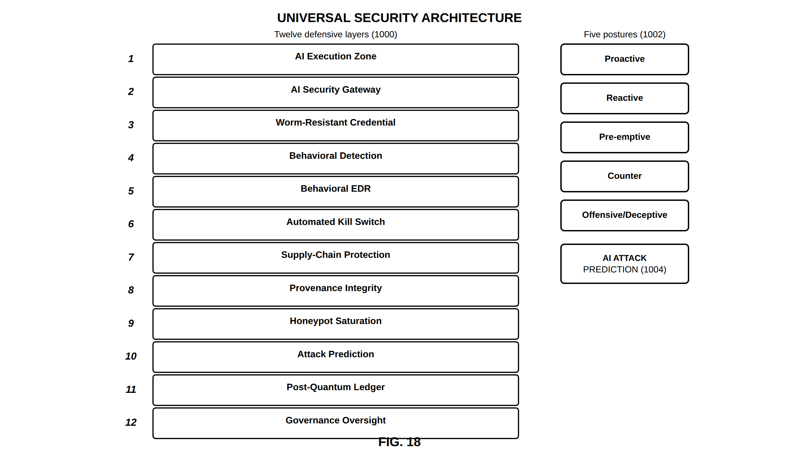
FIG. 18 — Universal security architecture
FIG. 19
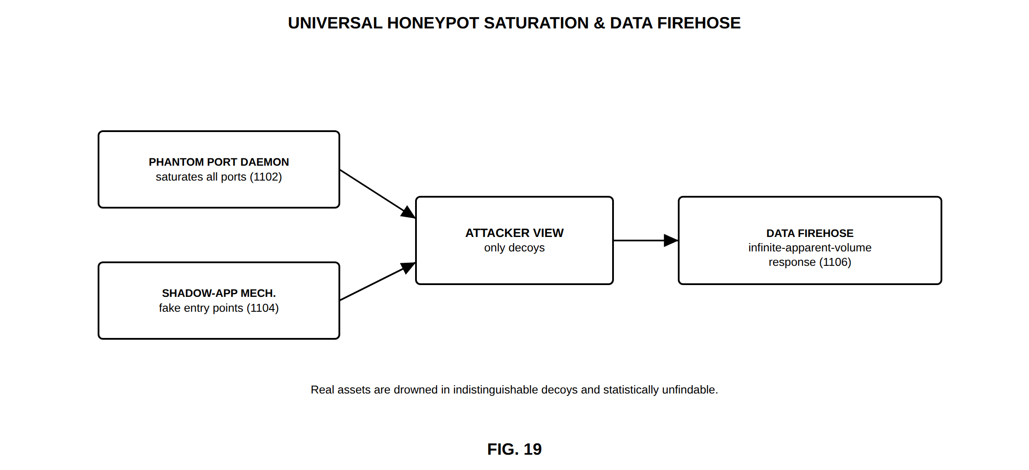
FIG. 19 — Universal honeypot saturation and data firehose
FIG. 20
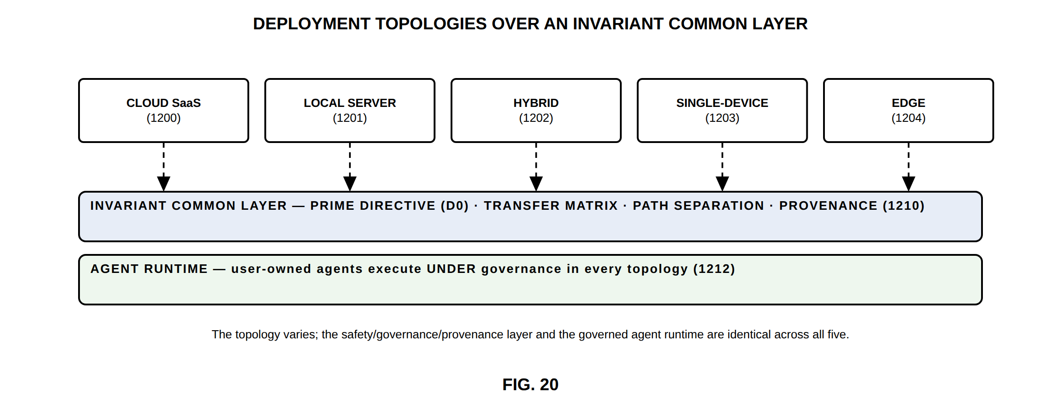
FIG. 20 — Deployment topologies over an invariant common layer
FIG. 21
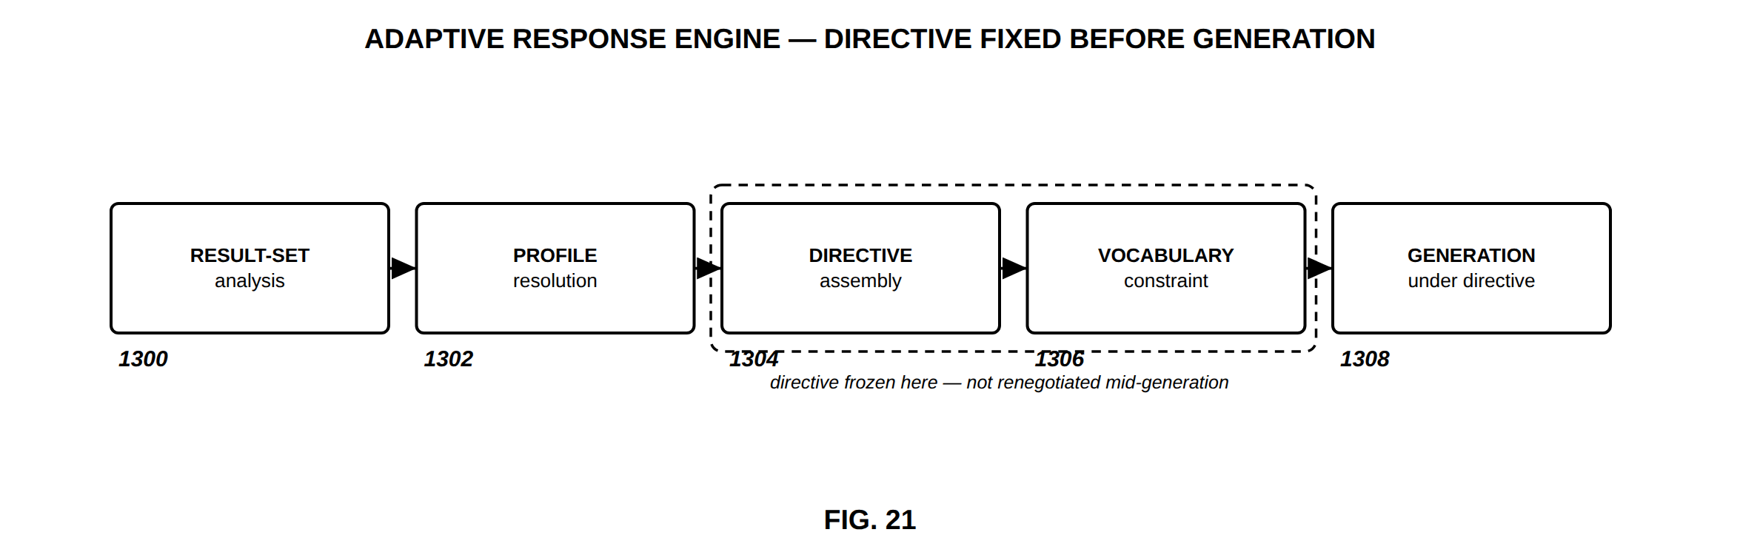
FIG. 21 — Adaptive response engine — directive fixed before generation
FIG. 22
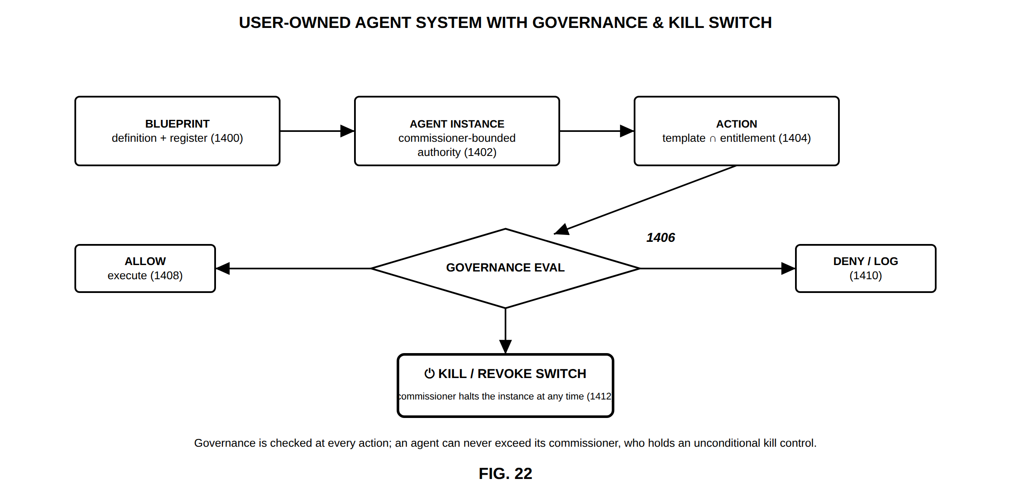
FIG. 22 — User-owned agent system with governance and kill switch
FIG. 23
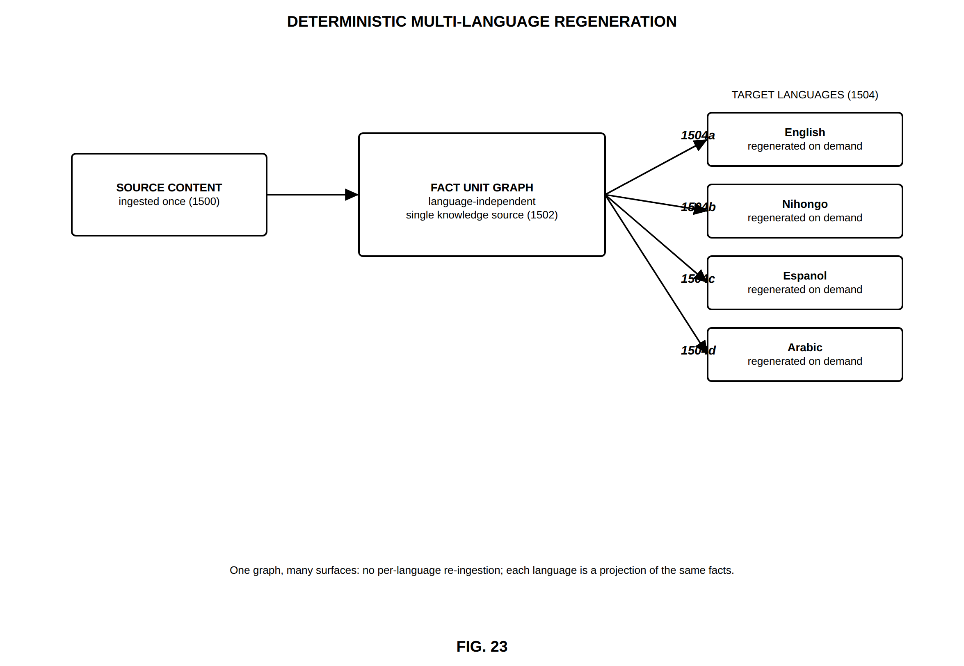
FIG. 23 — Deterministic multi-language regeneration
FIG. 24
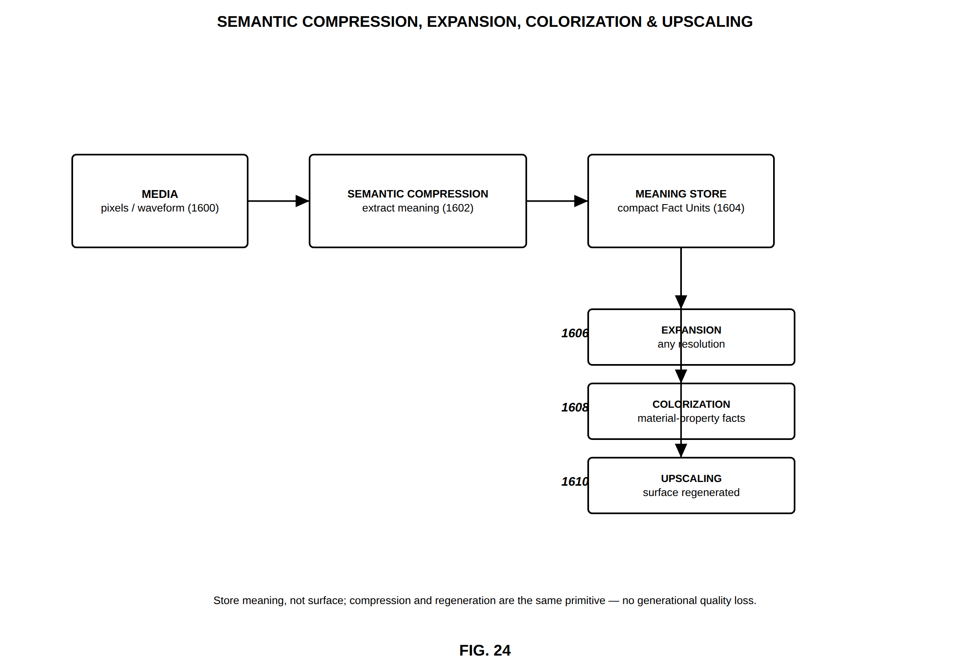
FIG. 24 — Semantic compression, expansion, colorization and upscaling
FIG. 25
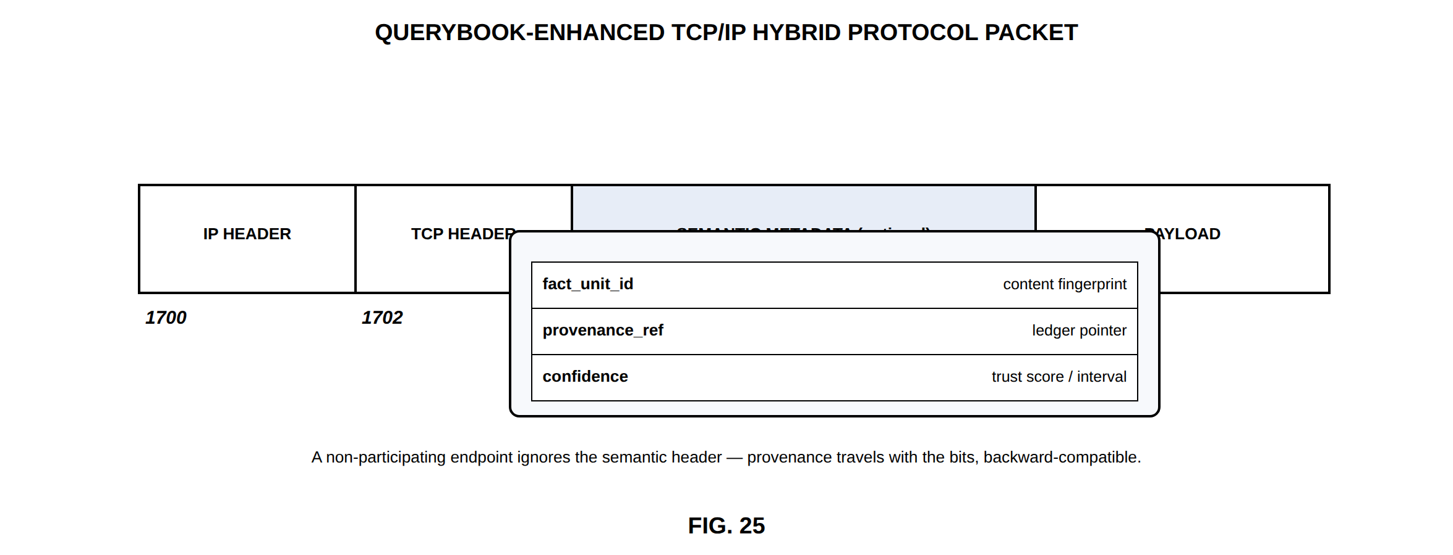
FIG. 25 — QueryBook-enhanced TCP/IP hybrid protocol packet
FIG. 26
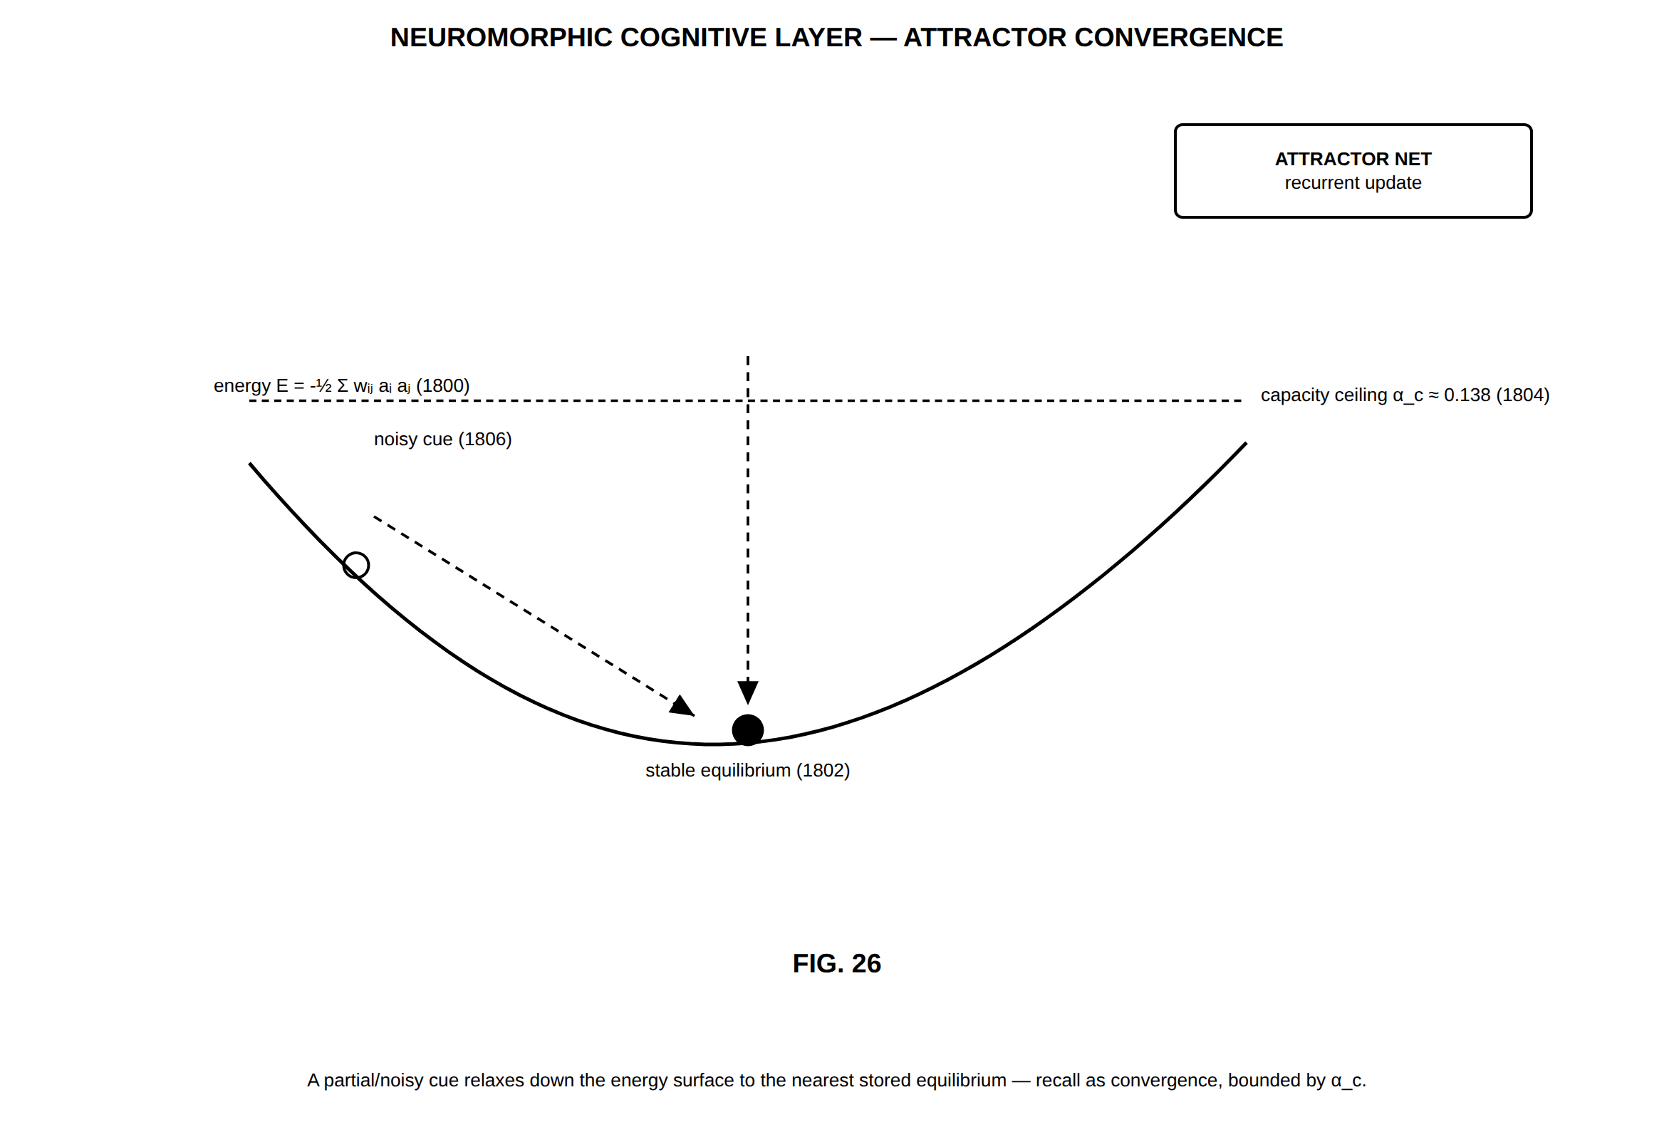
FIG. 26 — Neuromorphic cognitive layer — attractor convergence
FIG. 27
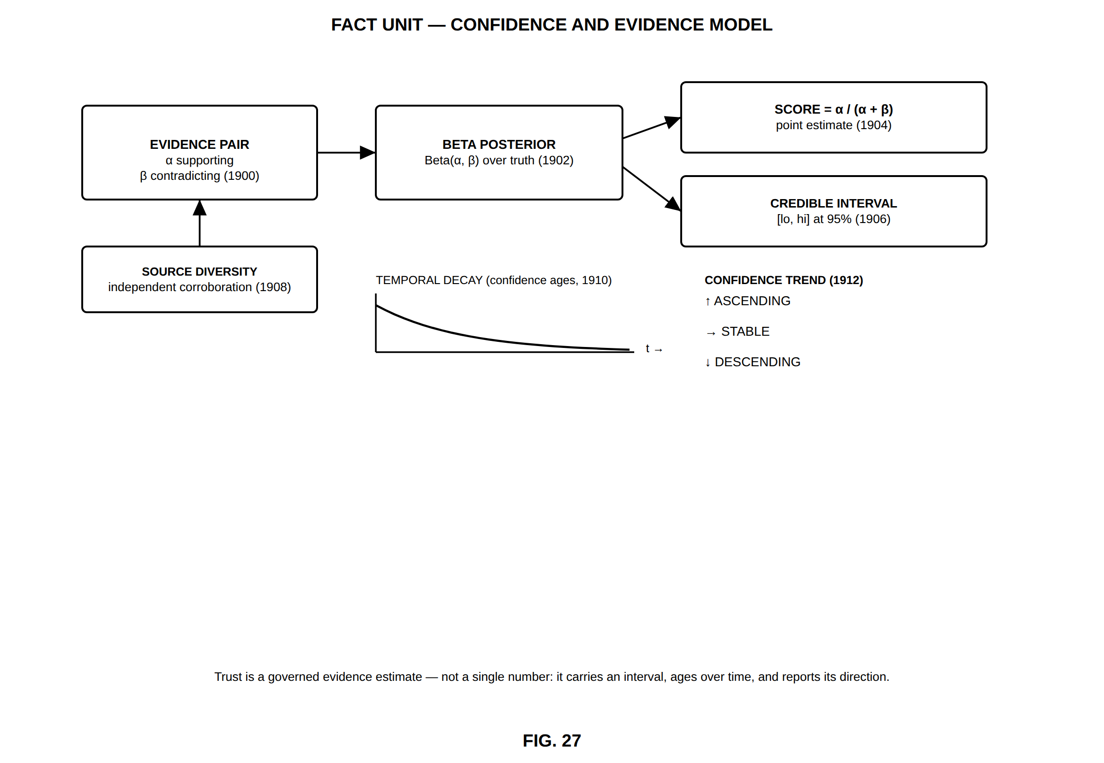
FIG. 27 — Fact Unit — confidence and evidence model
FIG. 28
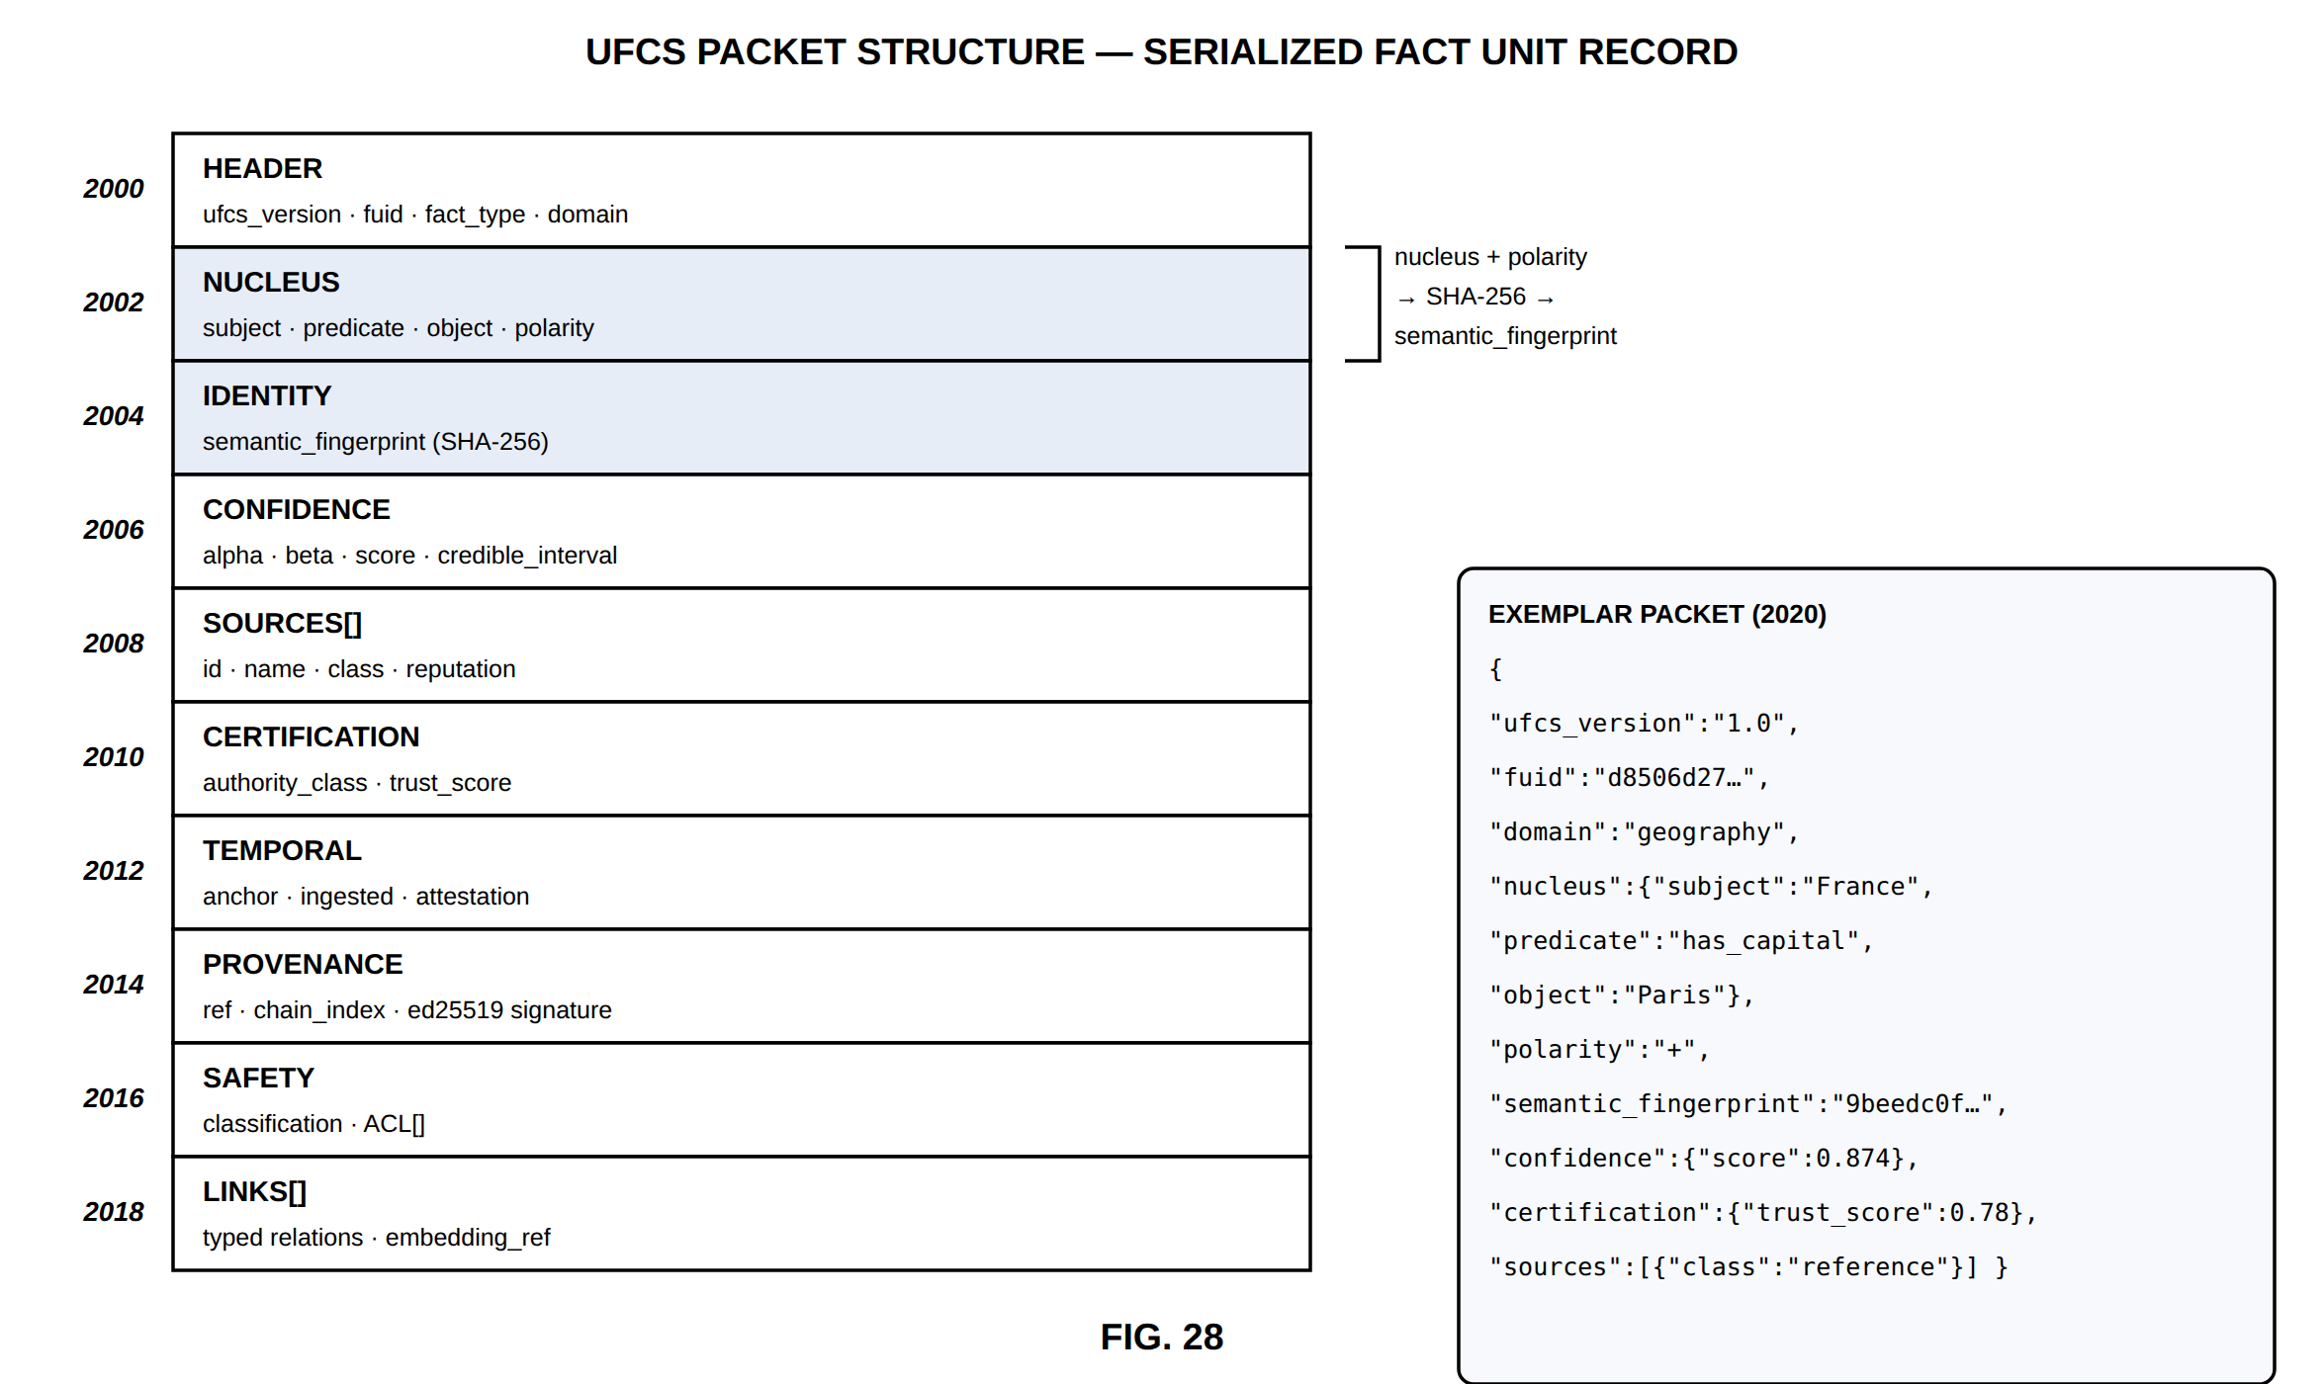
FIG. 28 — UFCS packet structure — serialized Fact Unit record
FIG. 29
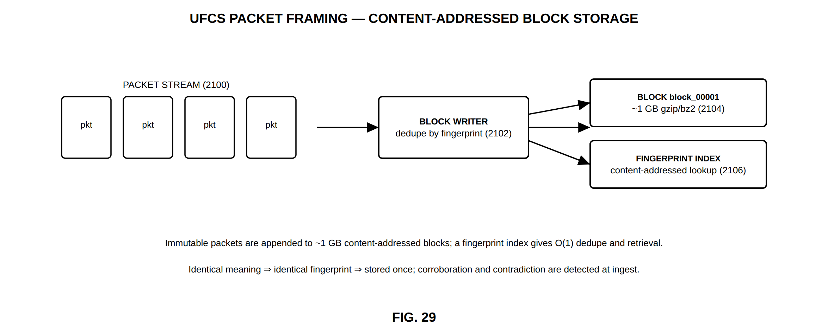
FIG. 29 — UFCS packet framing — content-addressed block storage
FIG. 30
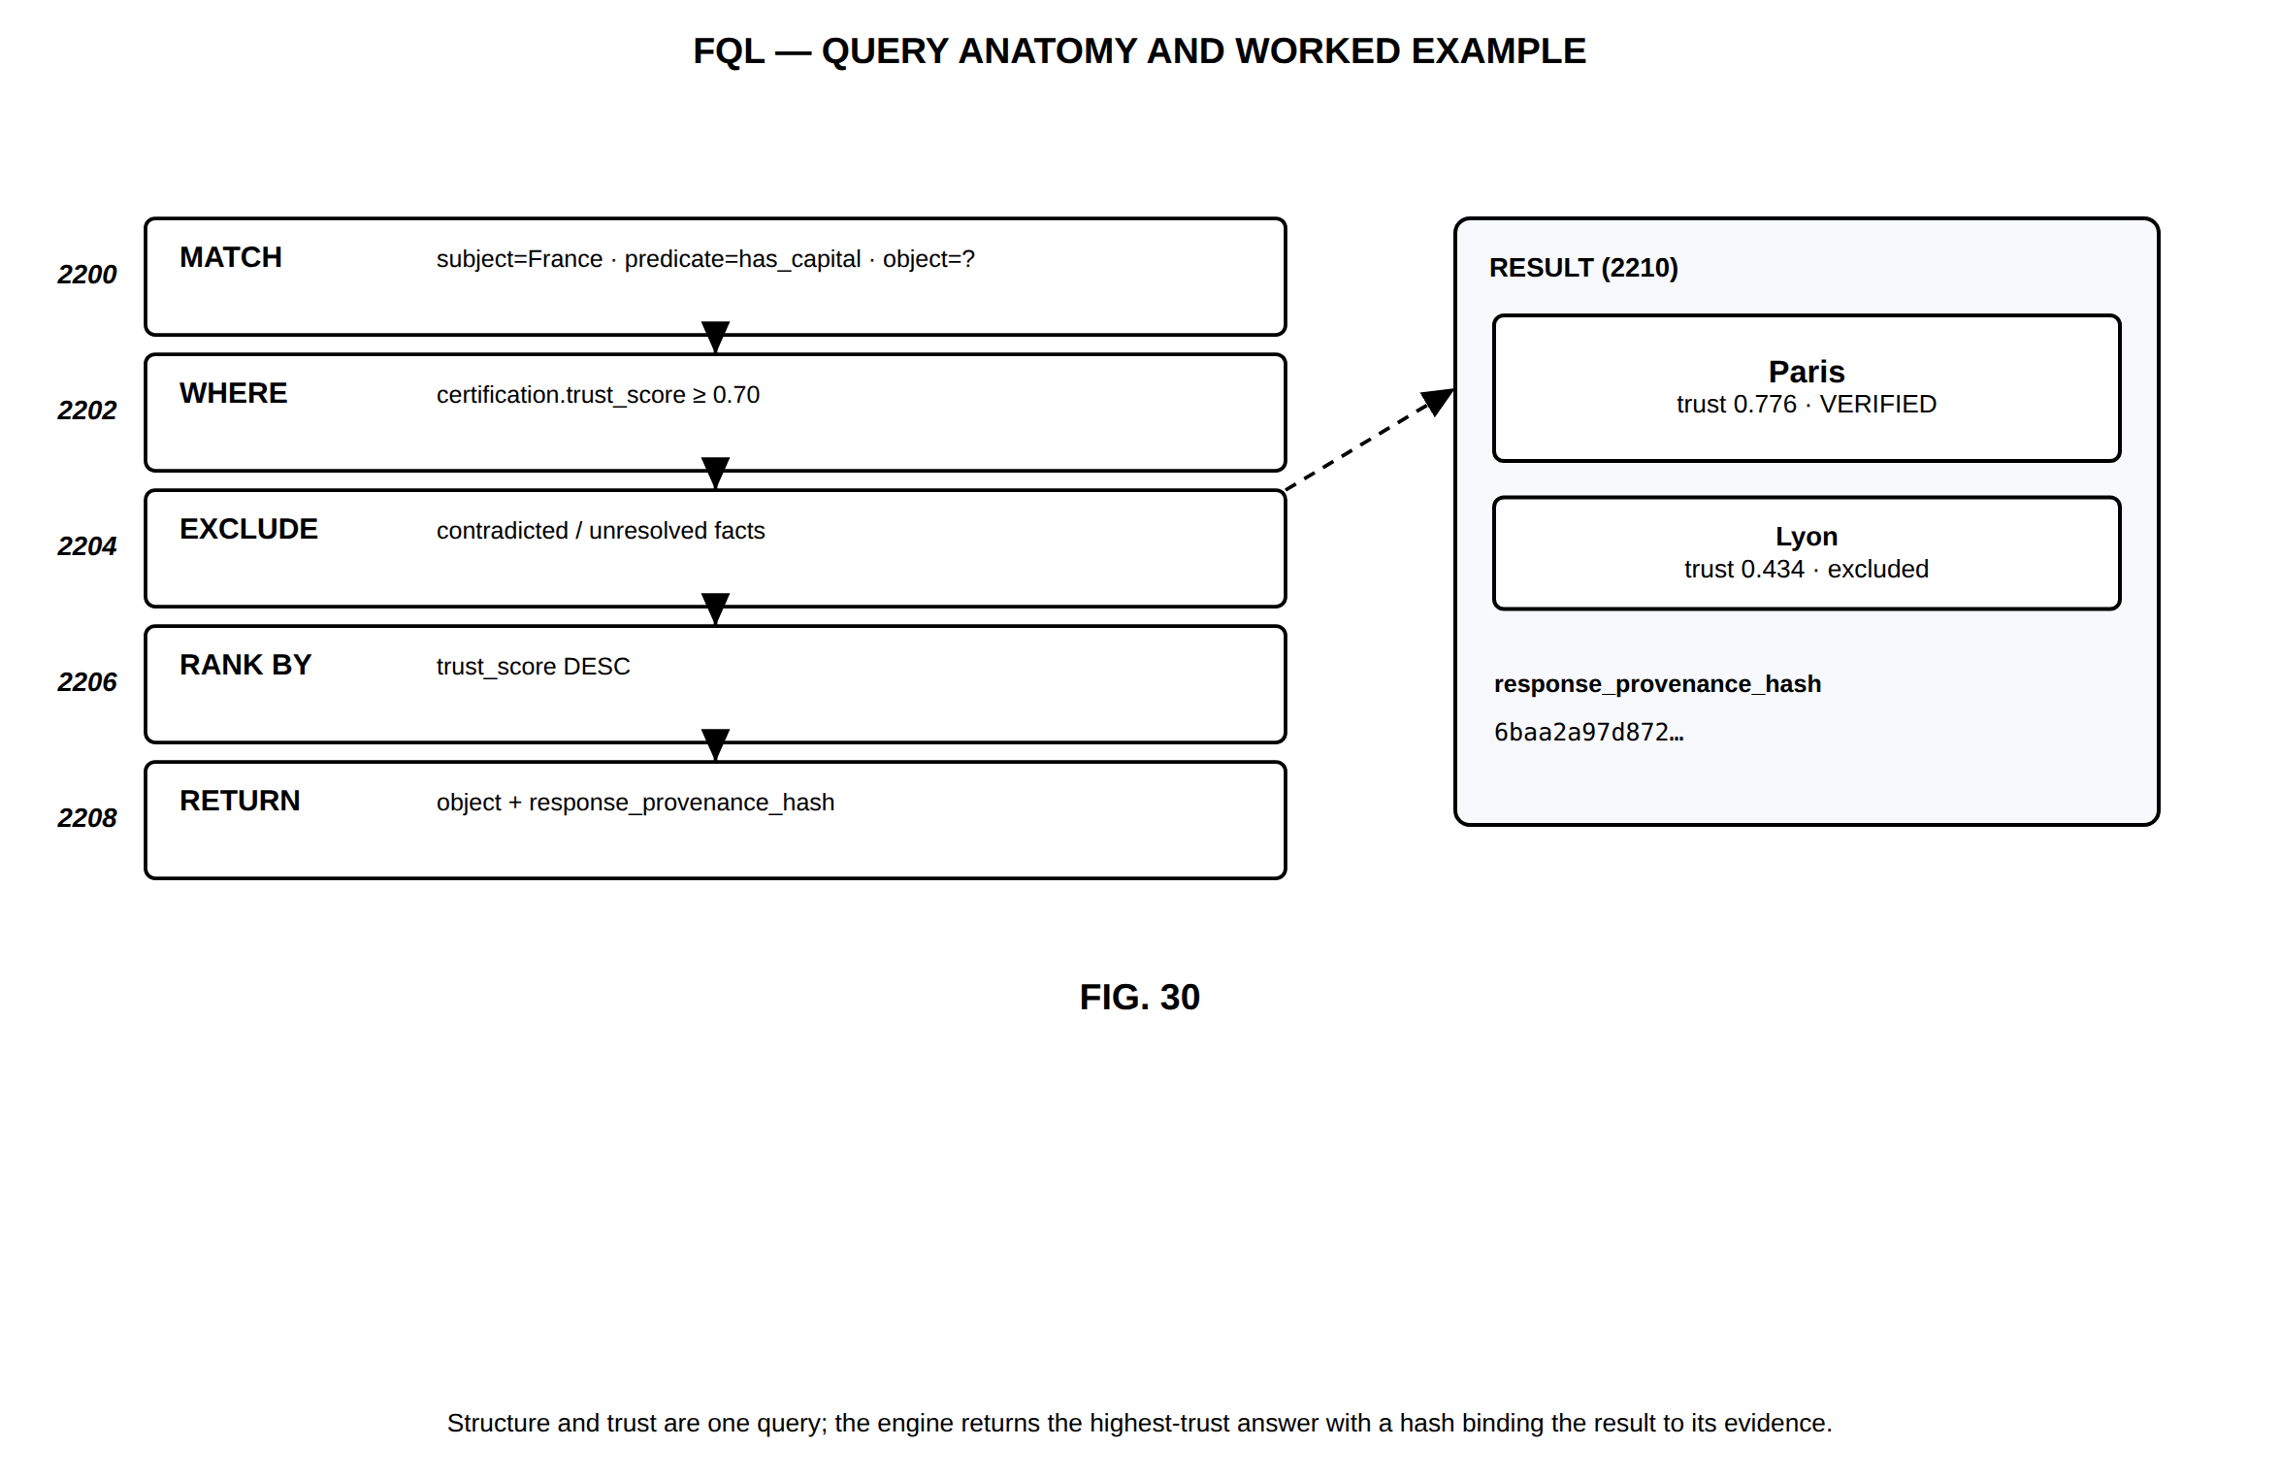
FIG. 30 — FQL — query anatomy and worked example
FIG. 31
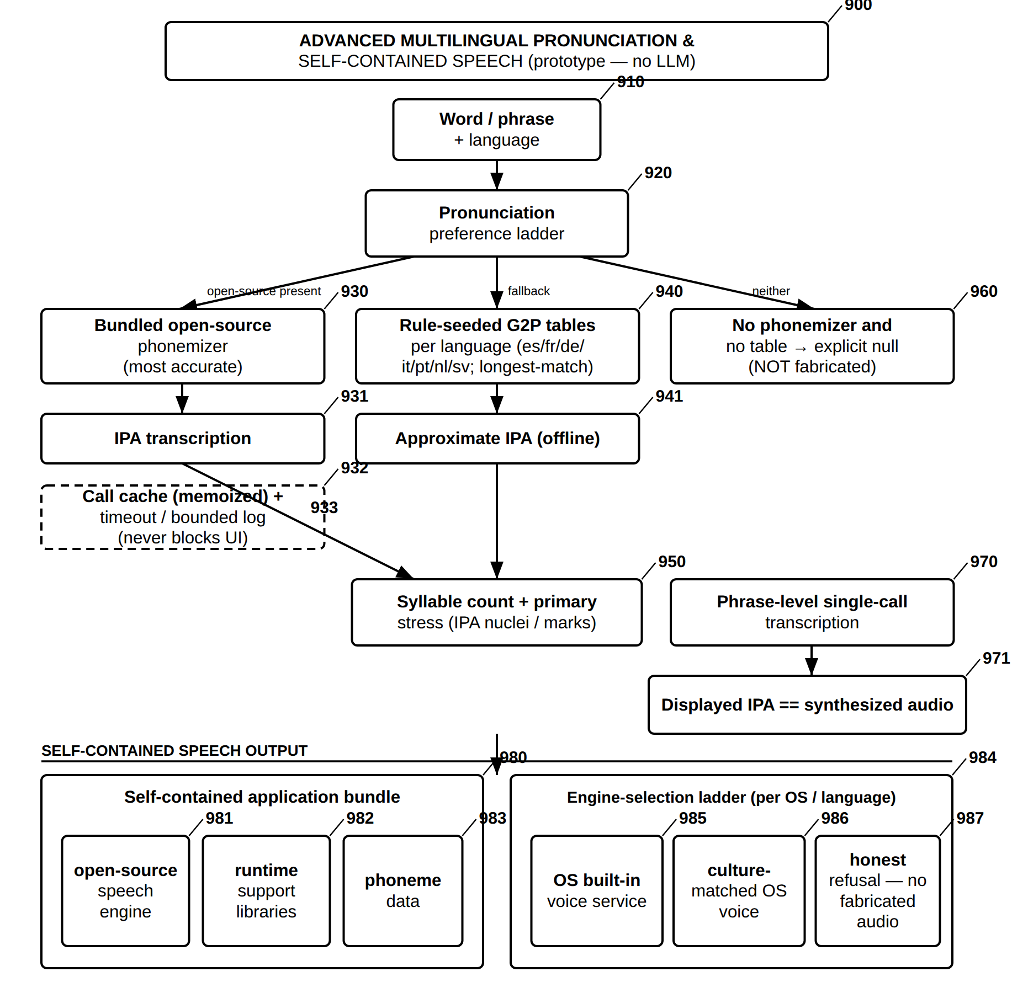
FIG. 31 — Advanced Multilingual Pronunciation and Self-Contained Speech (No LLM)
FIG. 32
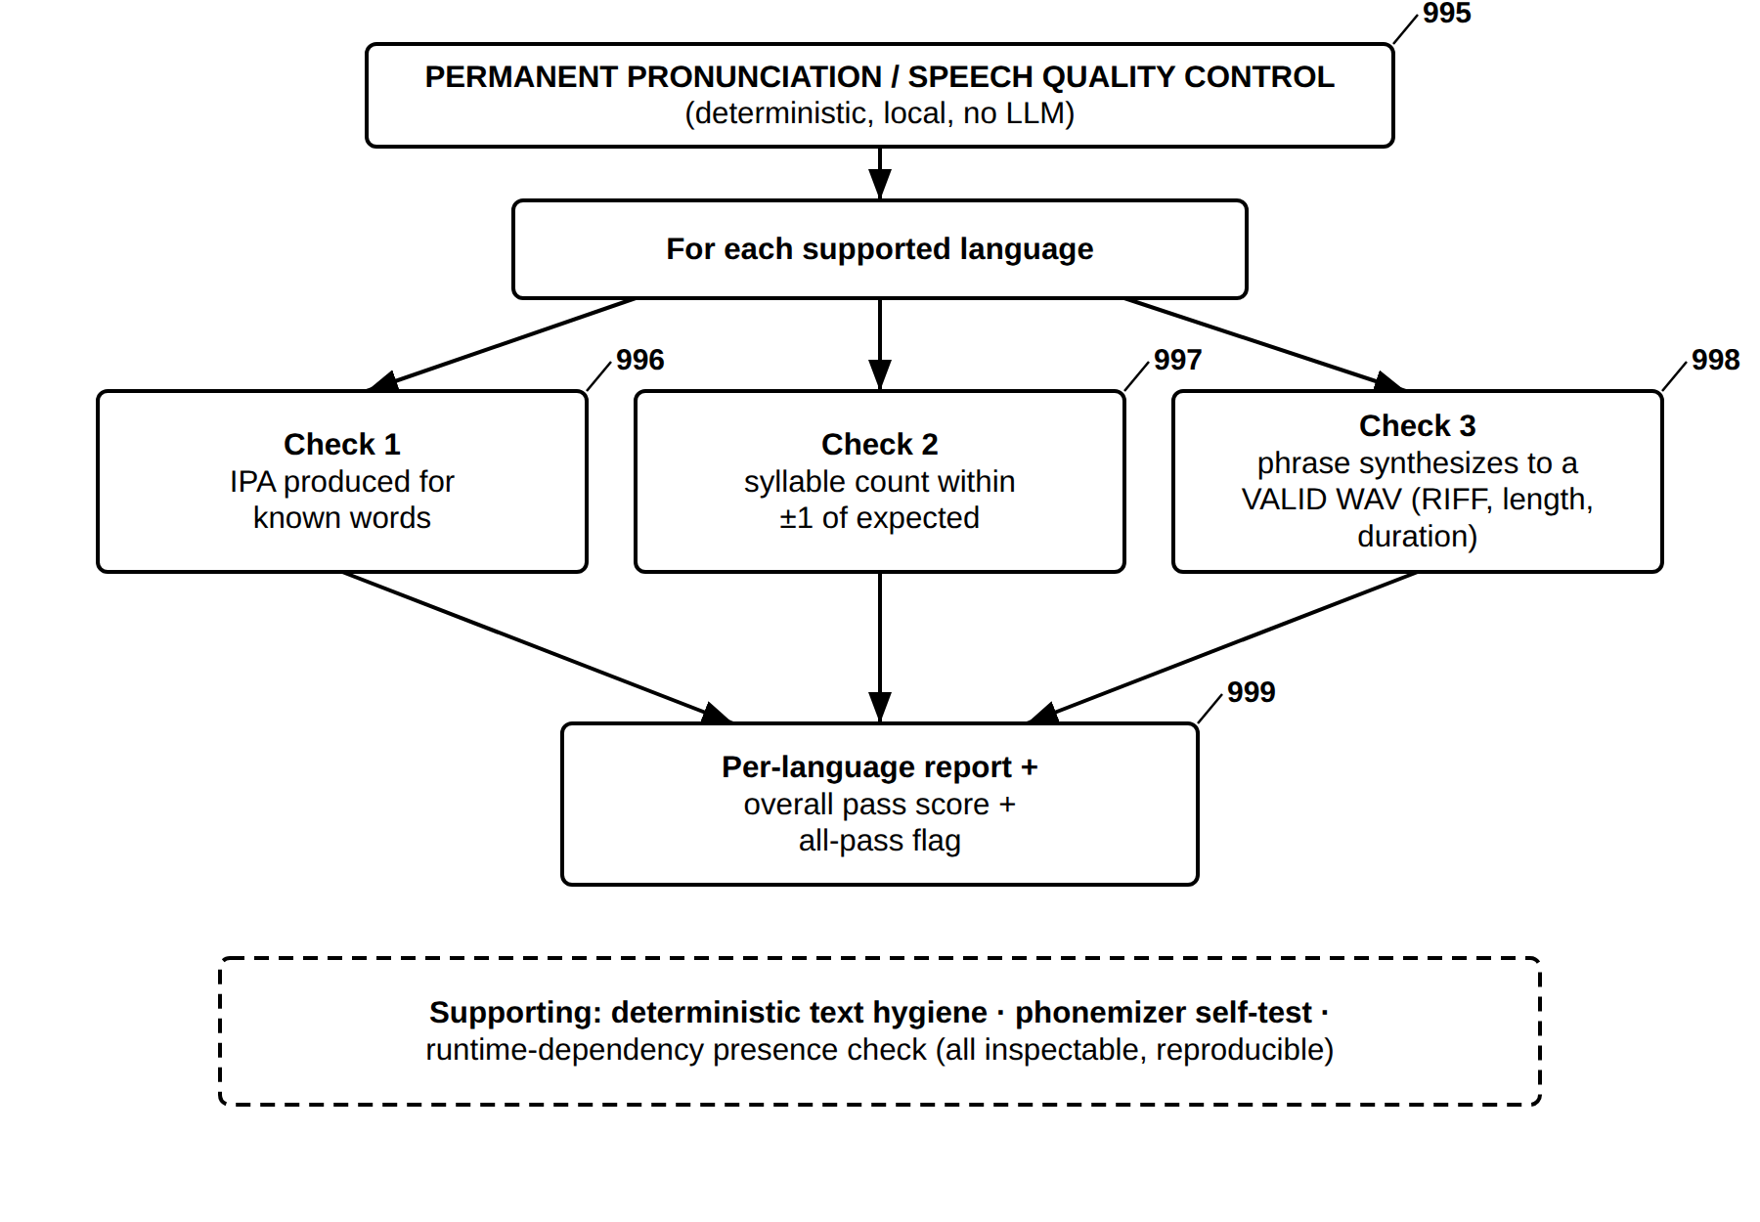
FIG. 32 — Permanent Pronunciation and Speech Quality-Control Battery (No LLM)
FIG. 33
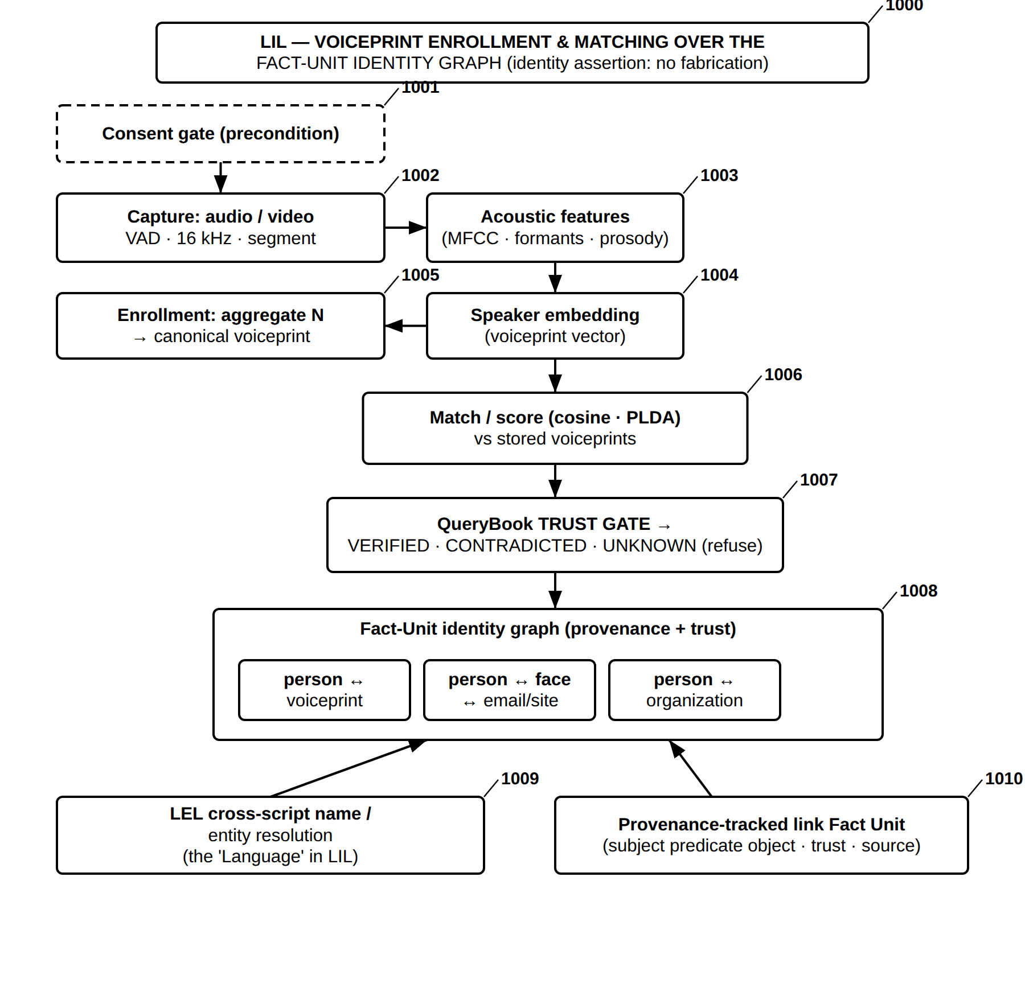
FIG. 33 — LIL — Voiceprint Enrollment and Matching over the Fact-Unit Identity Graph
FIG. 34
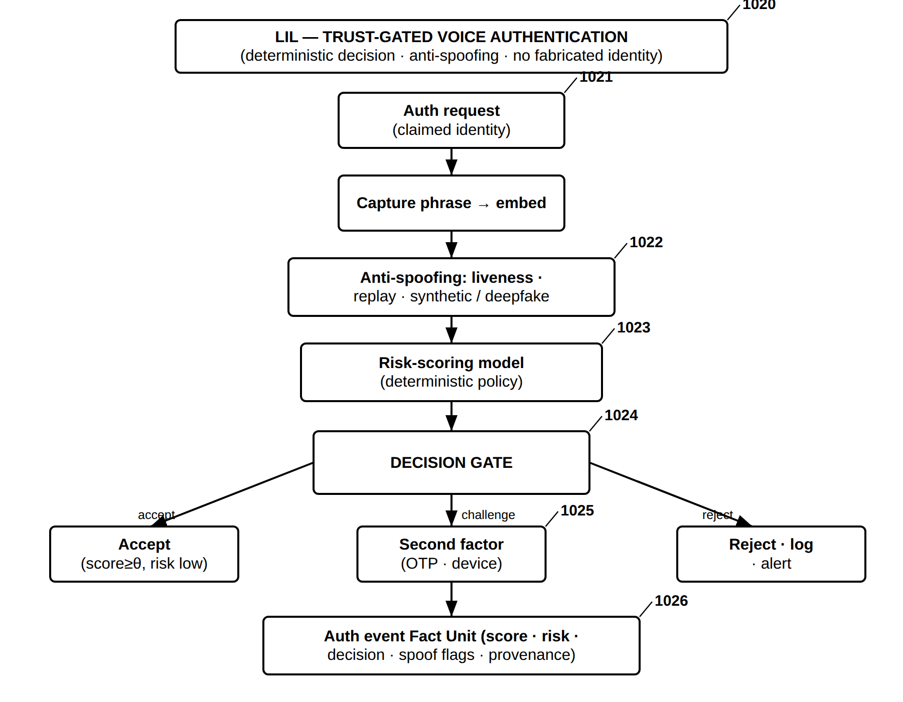
FIG. 34 — LIL — Trust-Gated Voice Authentication with Anti-Spoofing
FIG. 35
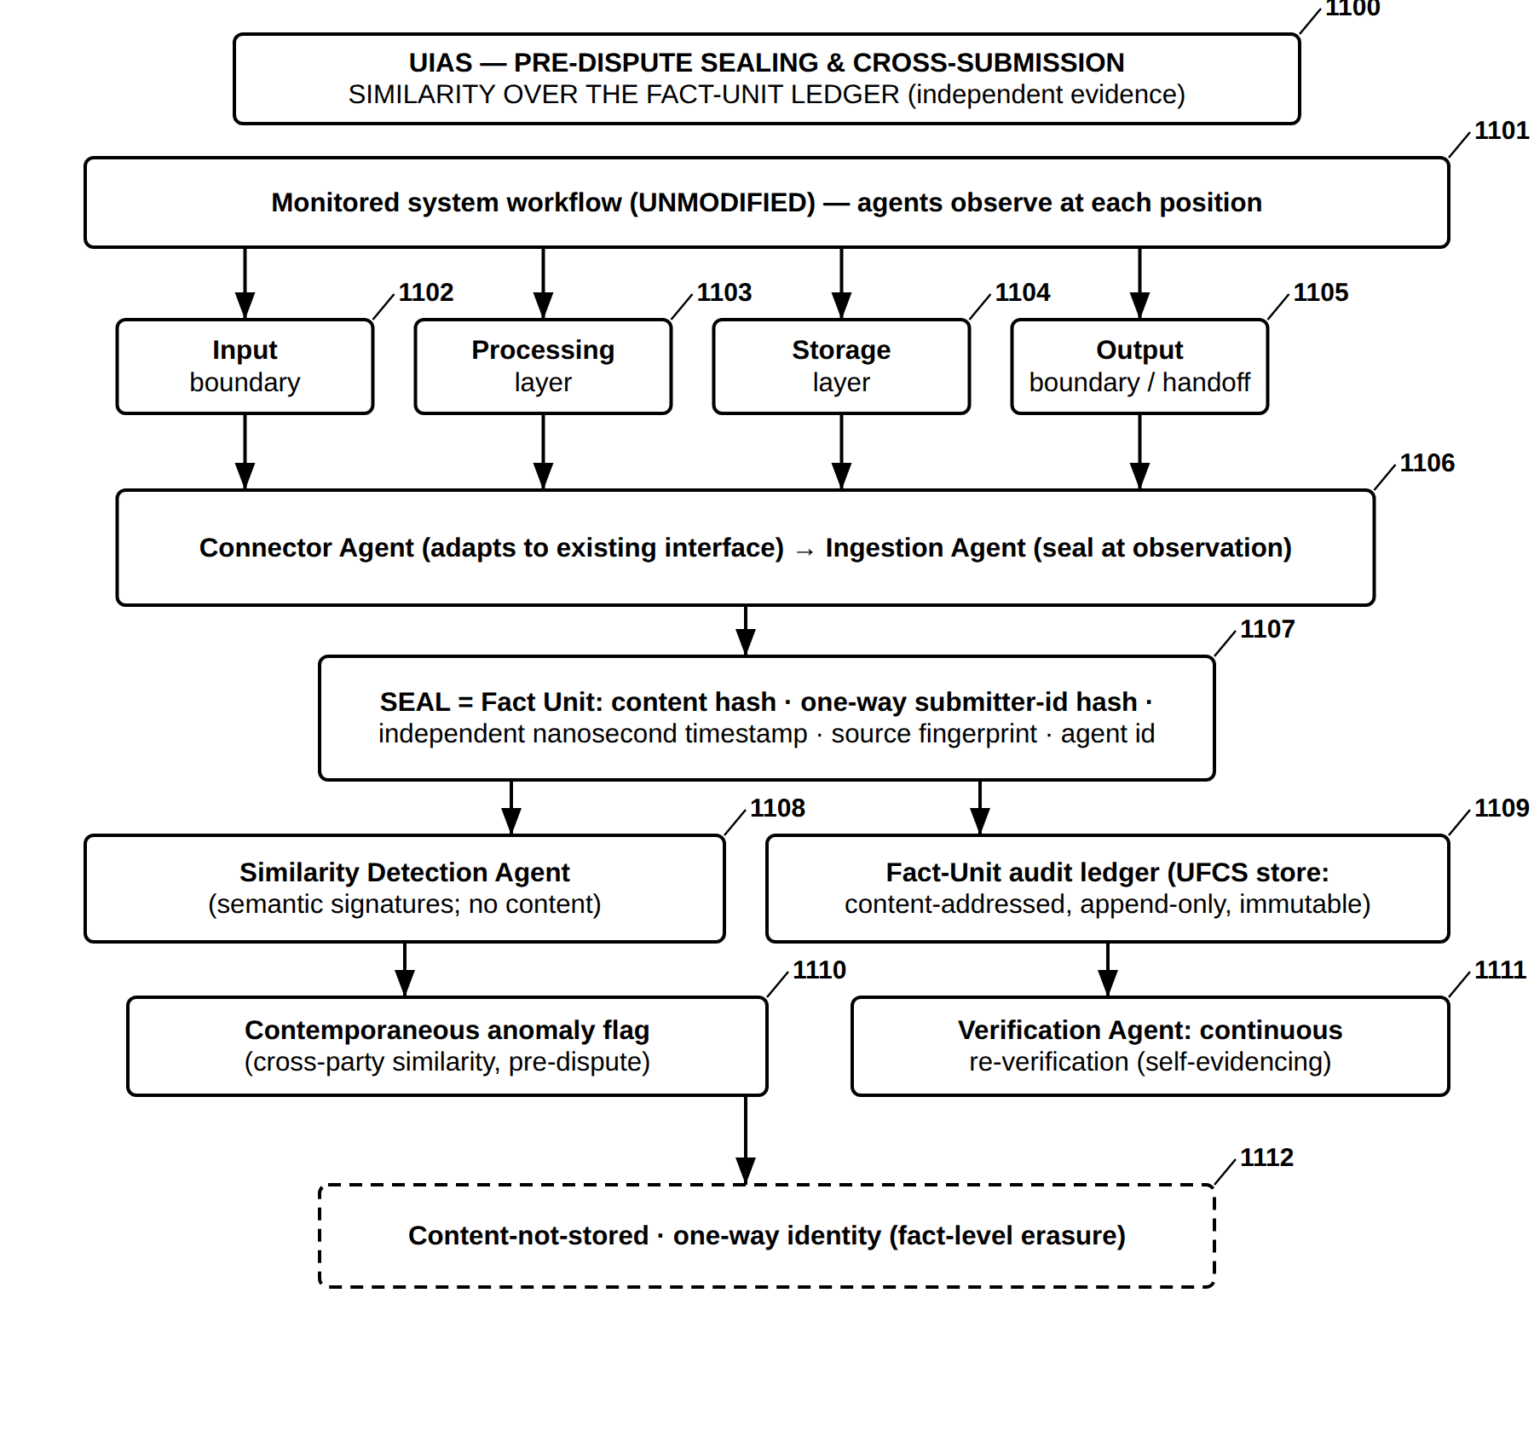
FIG. 35 — UIAS — Pre-Dispute Sealing and Cross-Submission Similarity over the Fact-Unit Ledger
FIG. 36
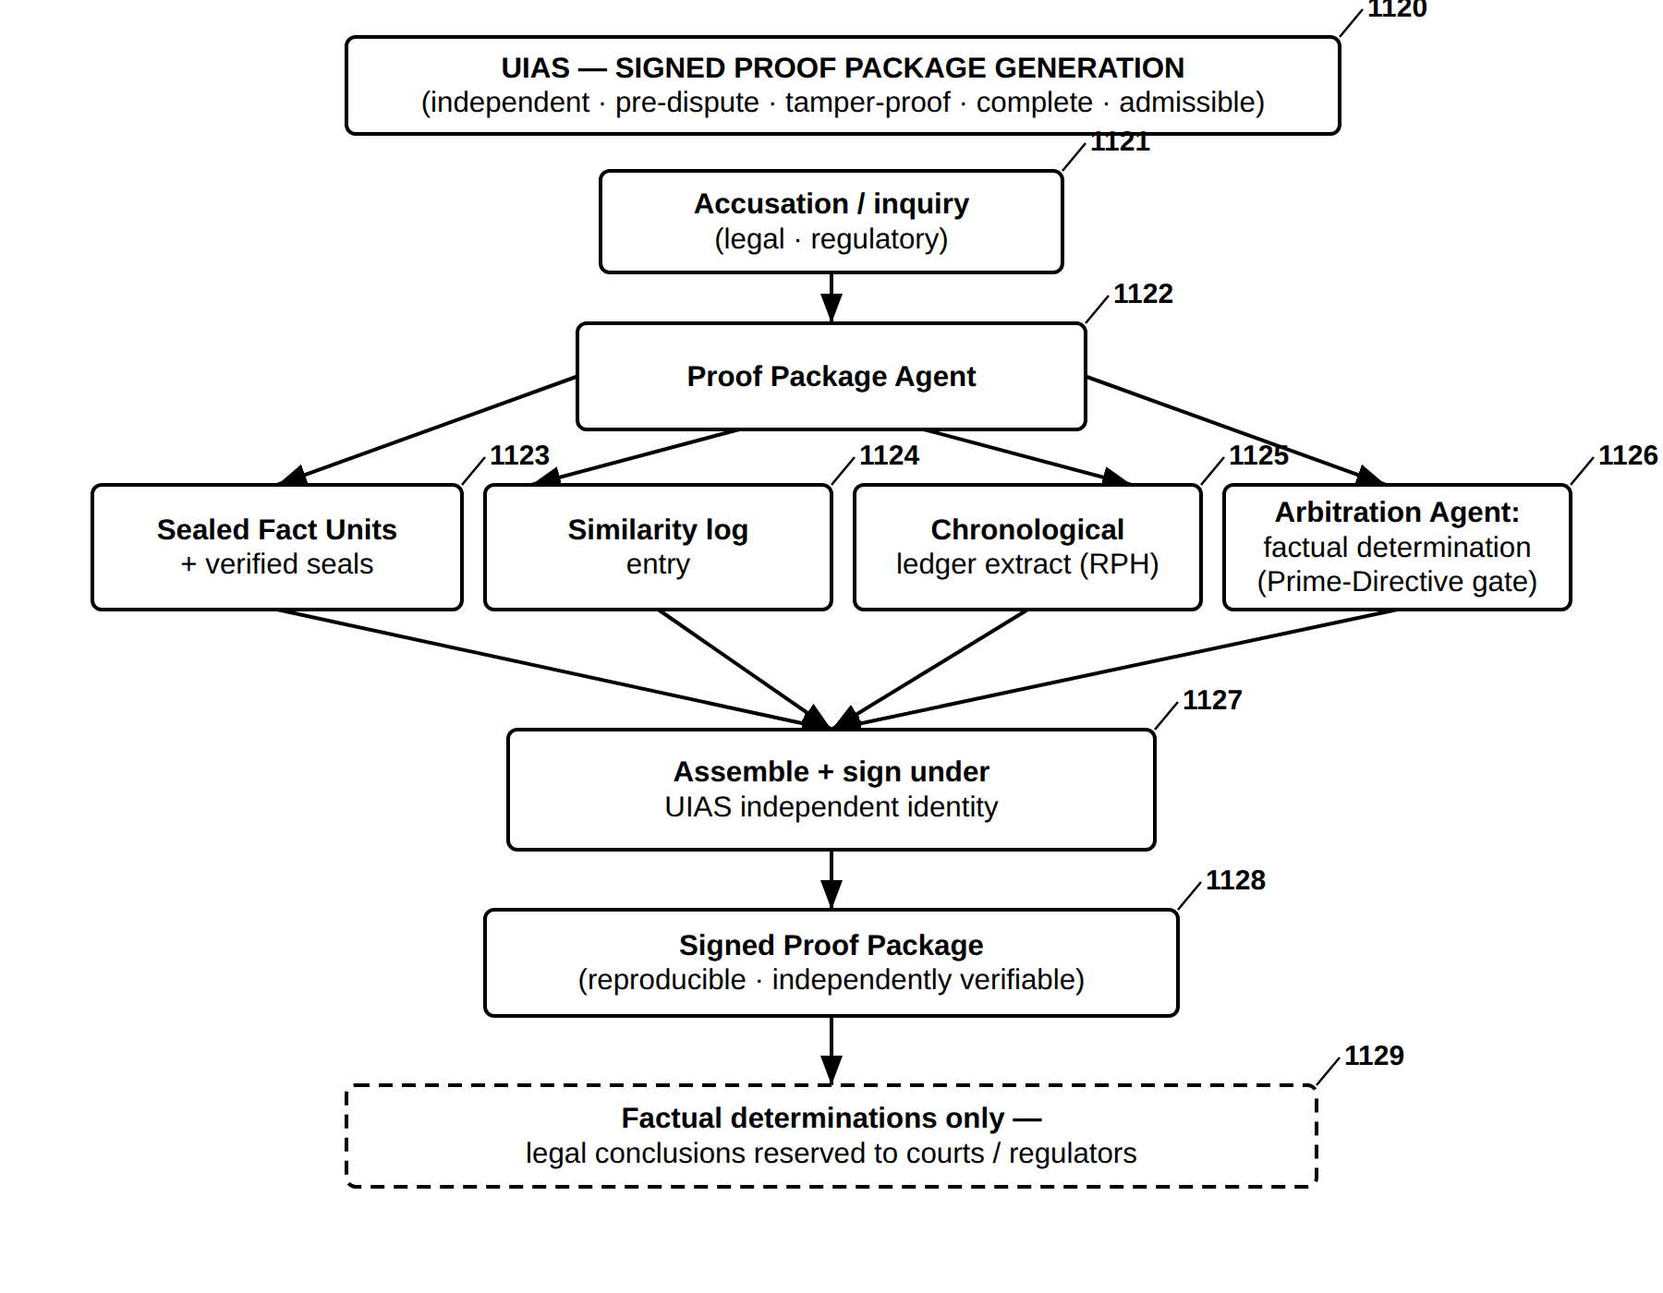
FIG. 36 — UIAS — Signed Proof Package Generation
FIG. 37
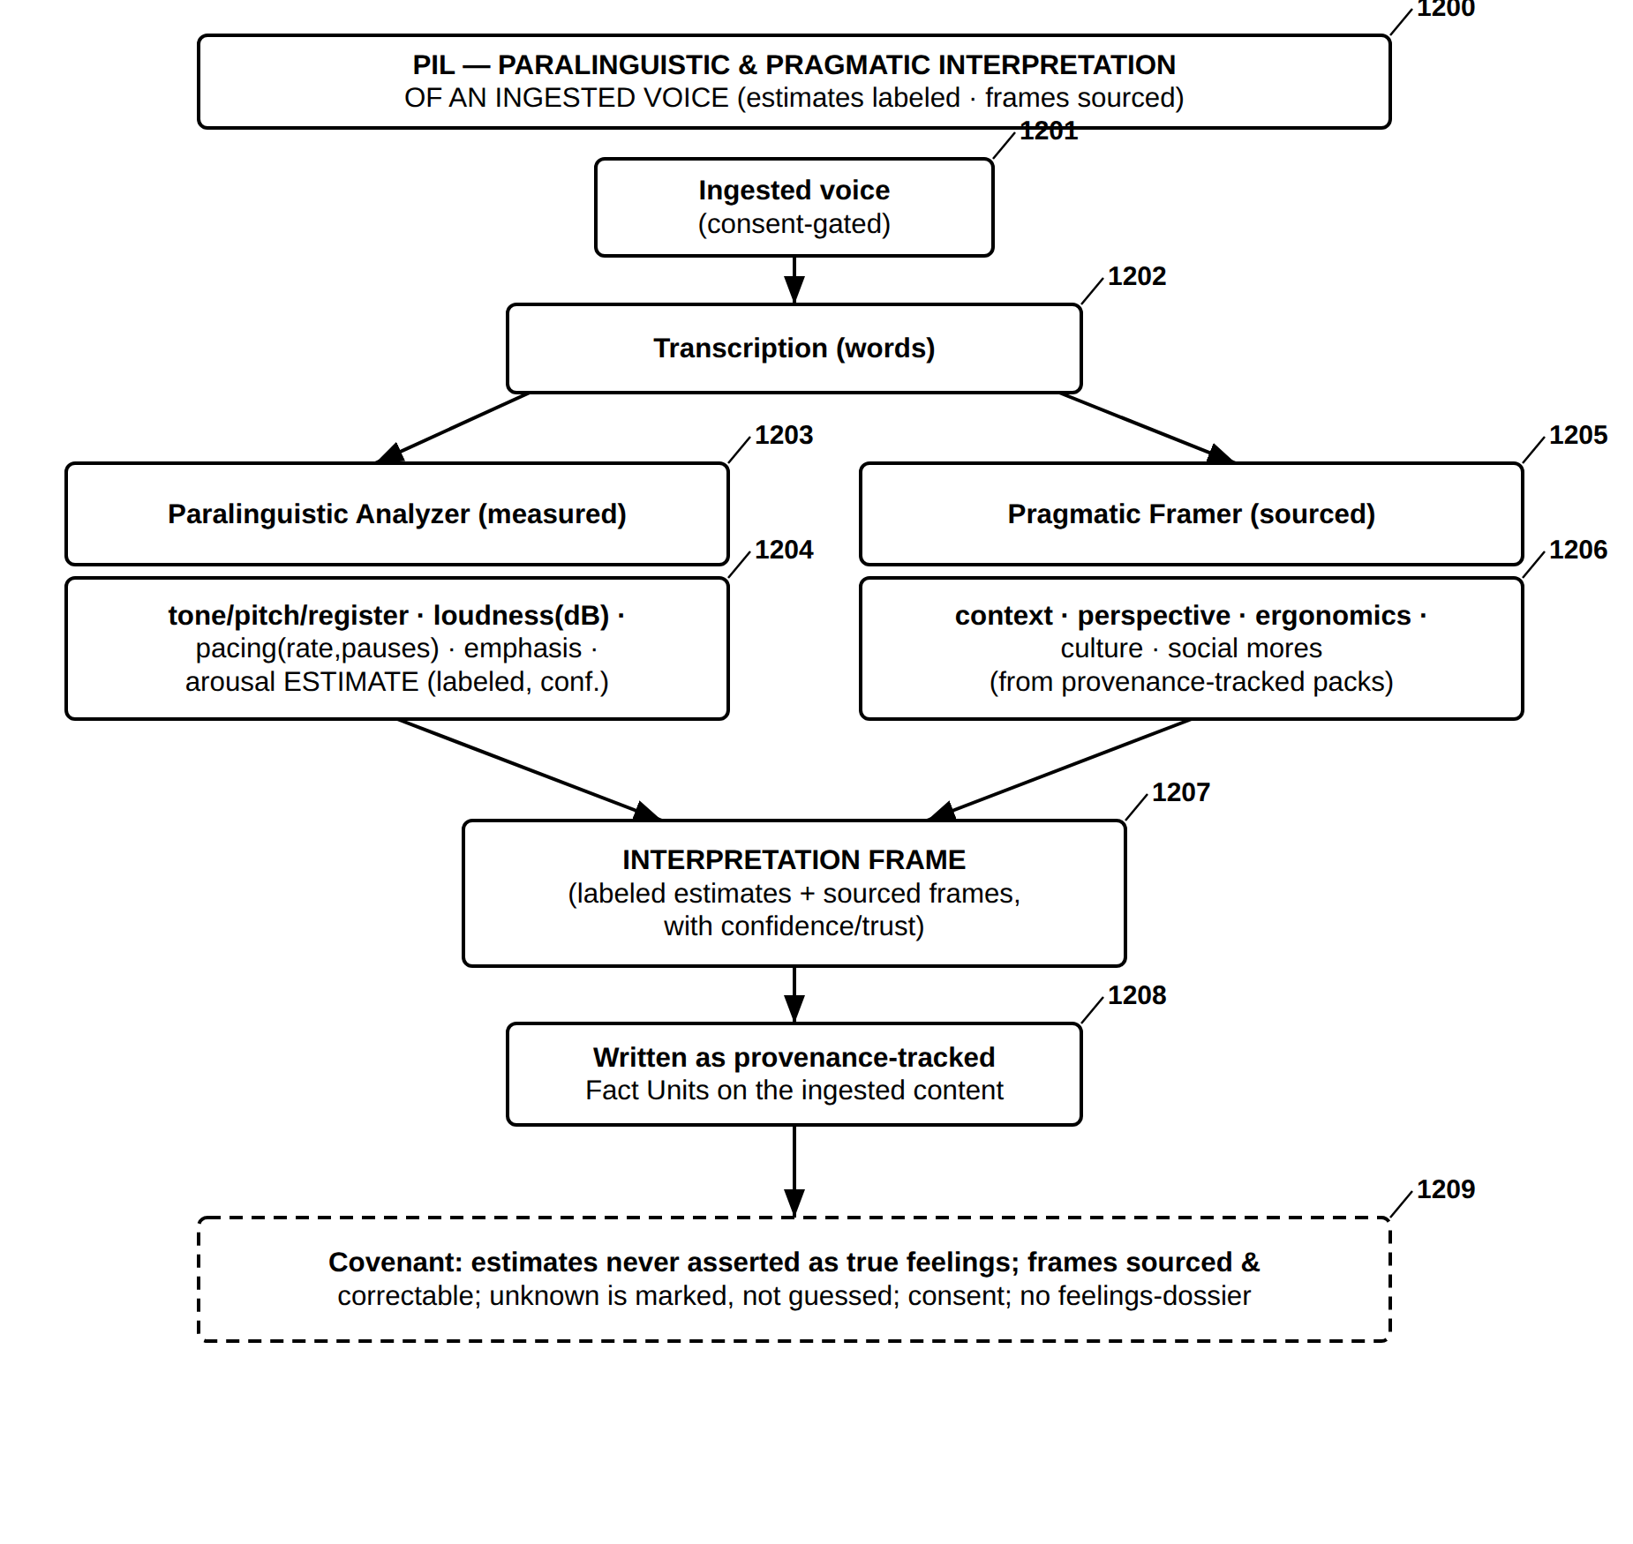
FIG. 37 — PIL — Paralinguistic and Pragmatic Interpretation of an Ingested Voice
FIG. 38
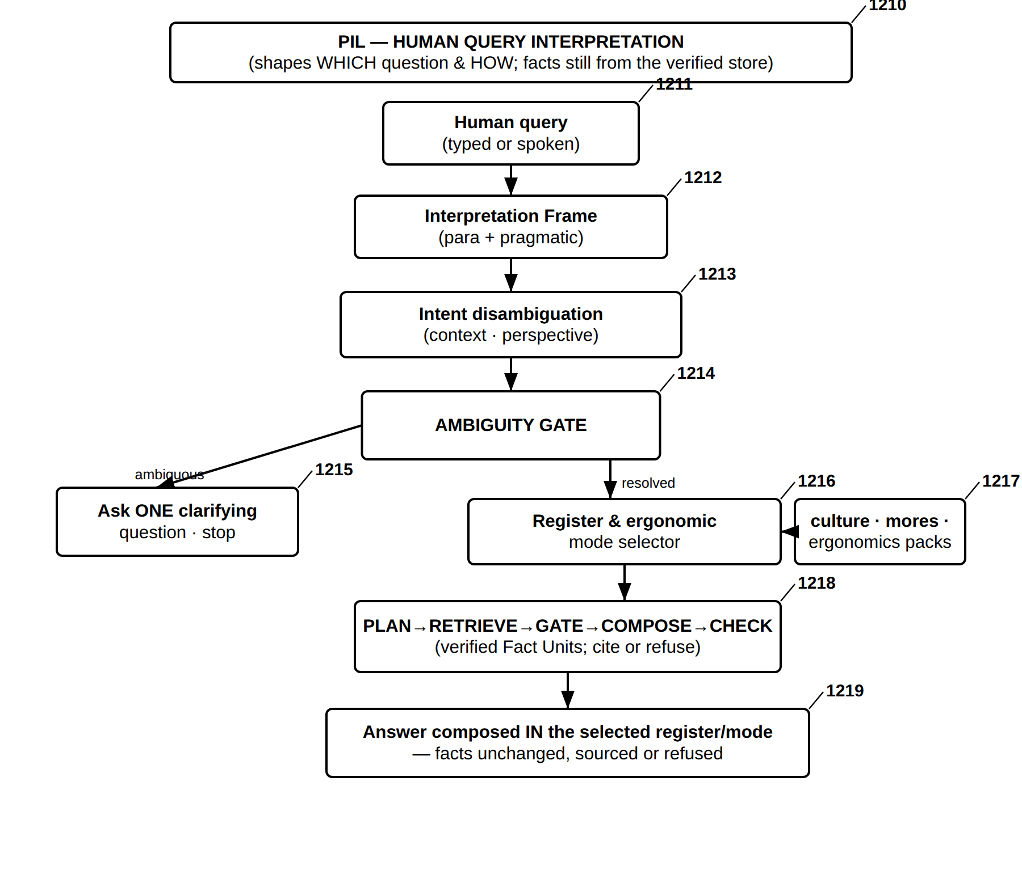
FIG. 38 — PIL — Human Query Interpretation and Covenant-Bound Answering
FIG. 39
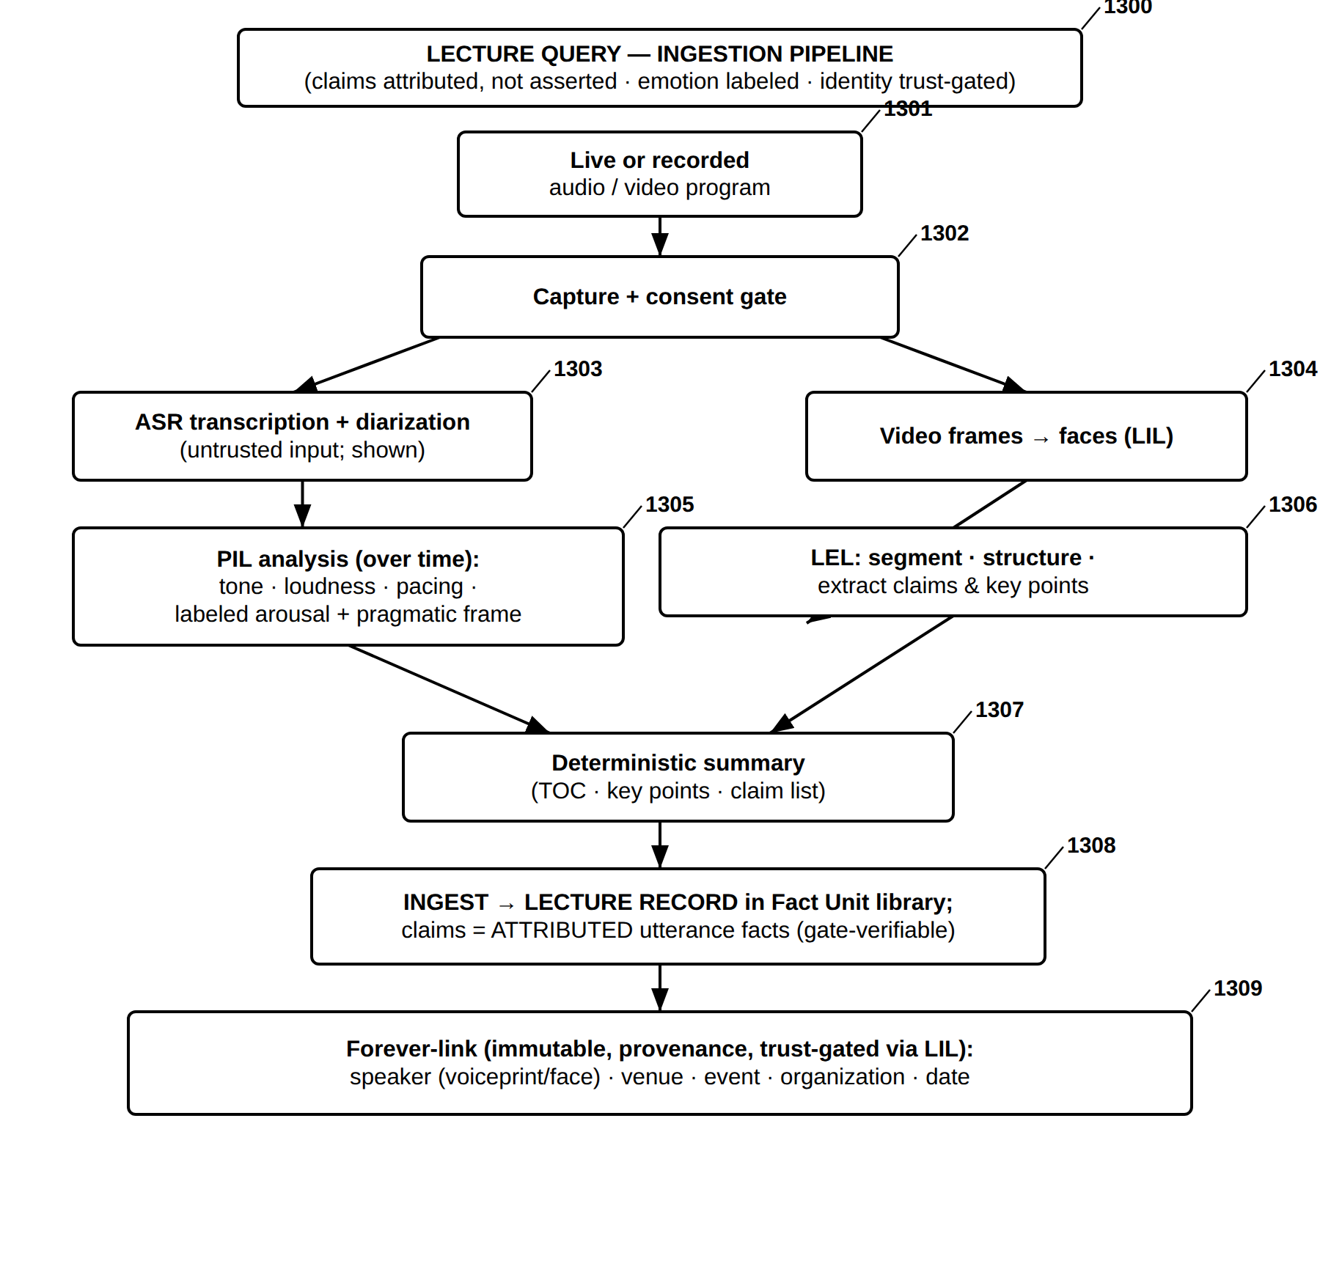
FIG. 39 — Lecture Query — Ingestion Pipeline
FIG. 40
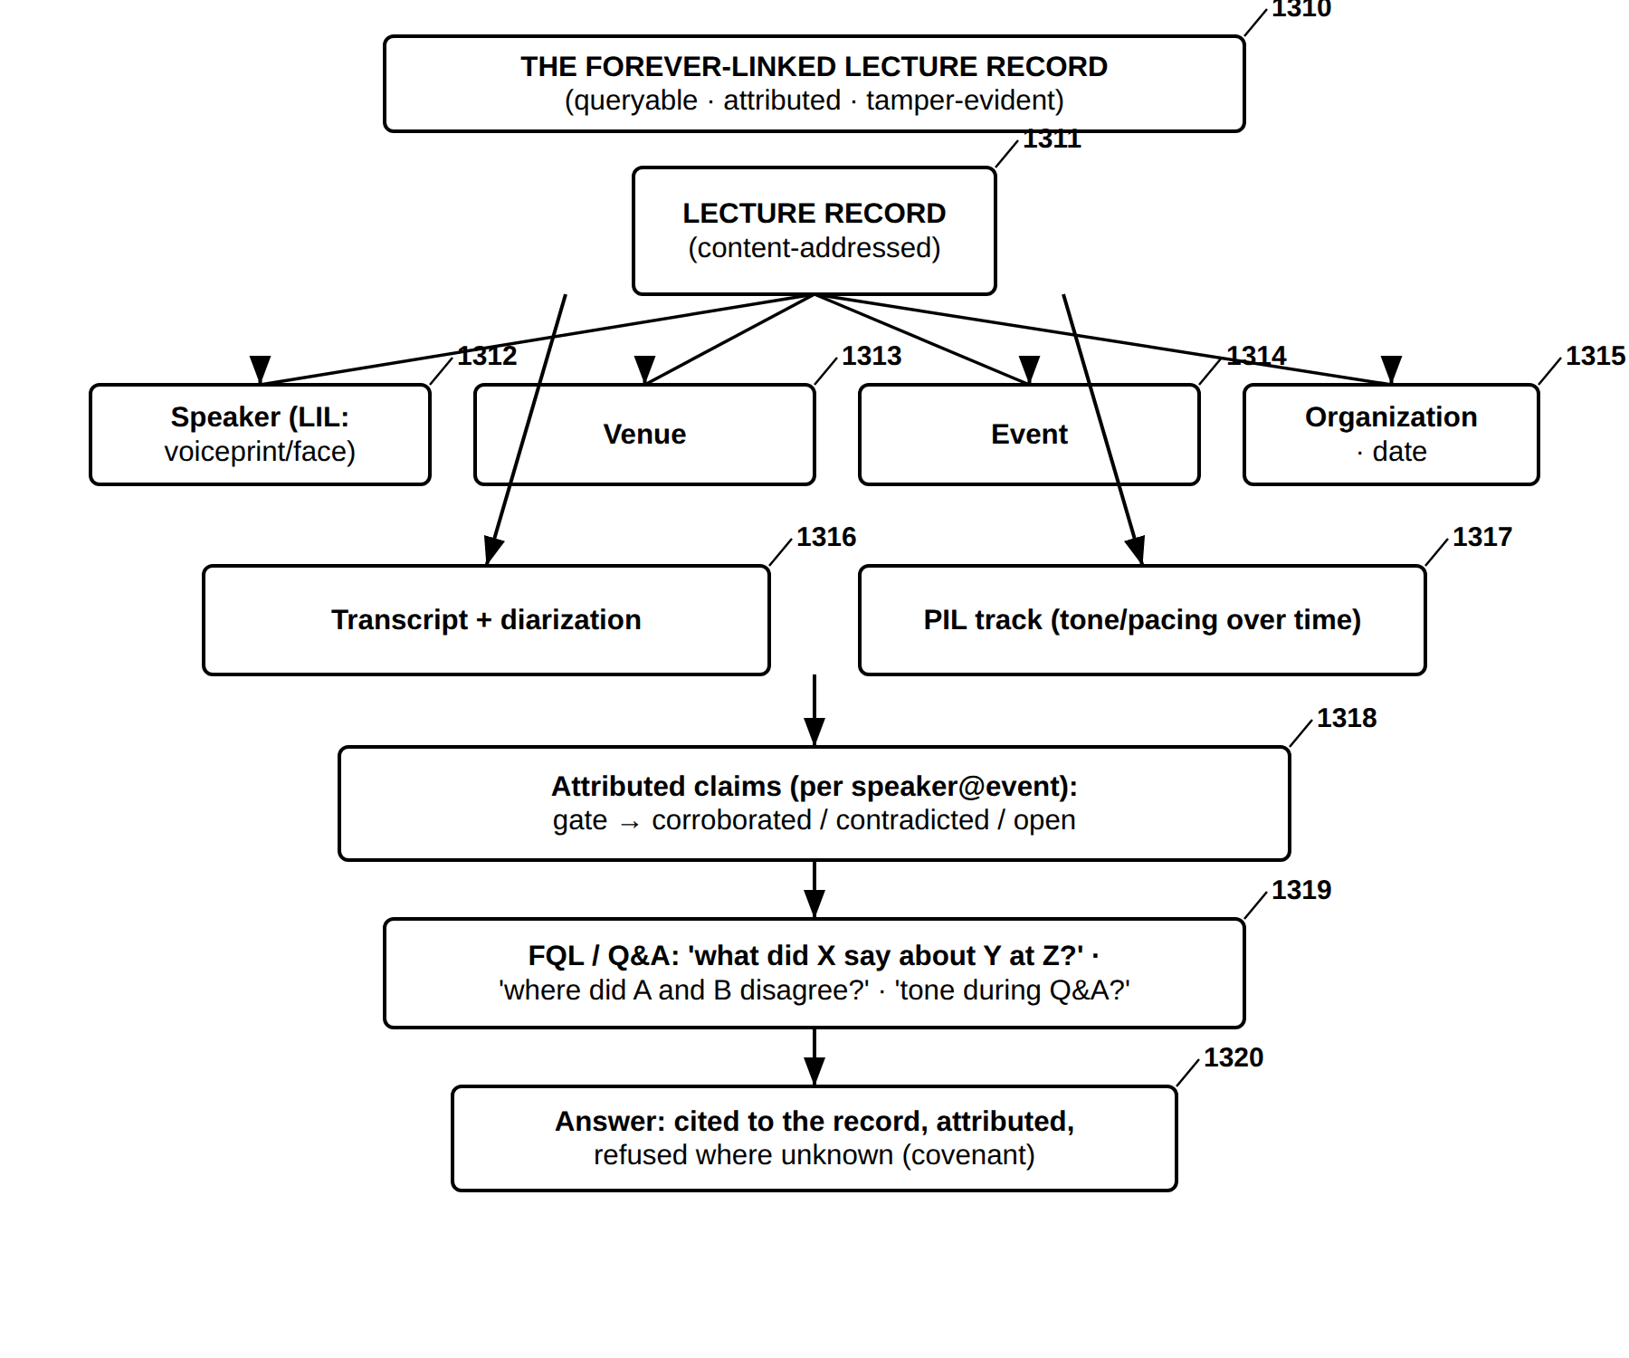
FIG. 40 — Lecture Query — The Forever-Linked Lecture Record and Its Querying
FIG. 41
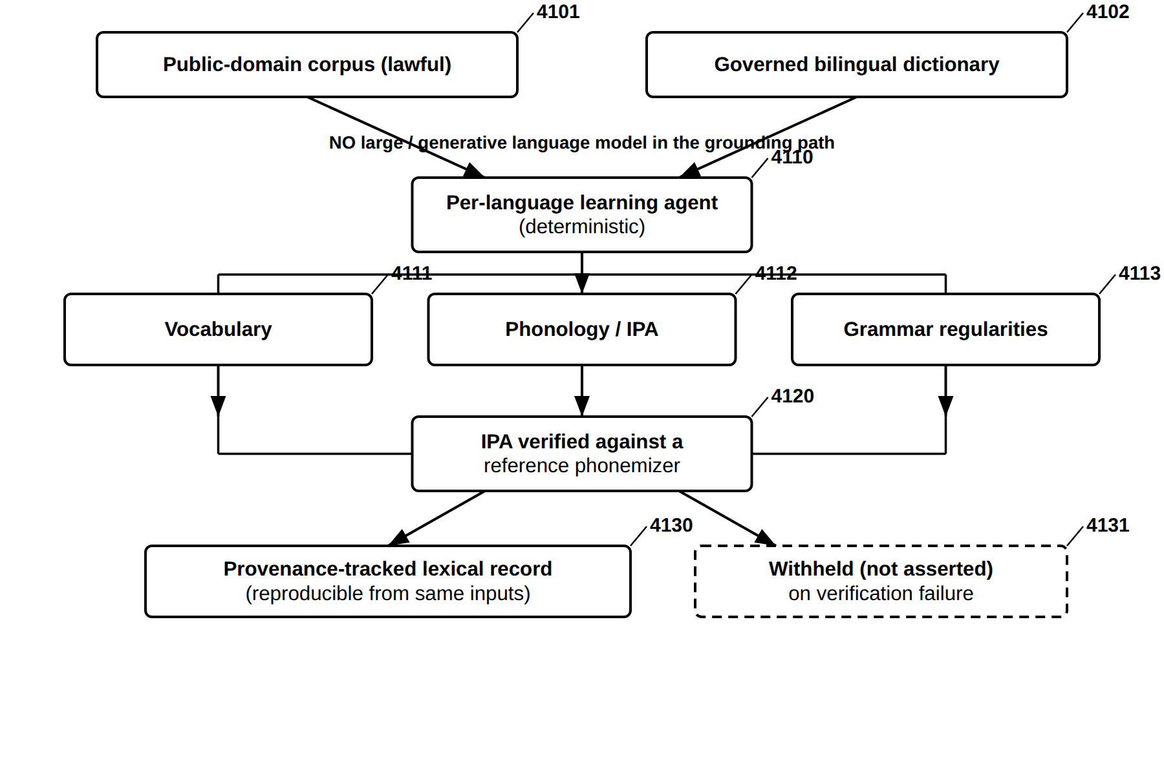
FIG. 41 — Deterministic Multilingual Acquisition Without a Generative Model
FIG. 42
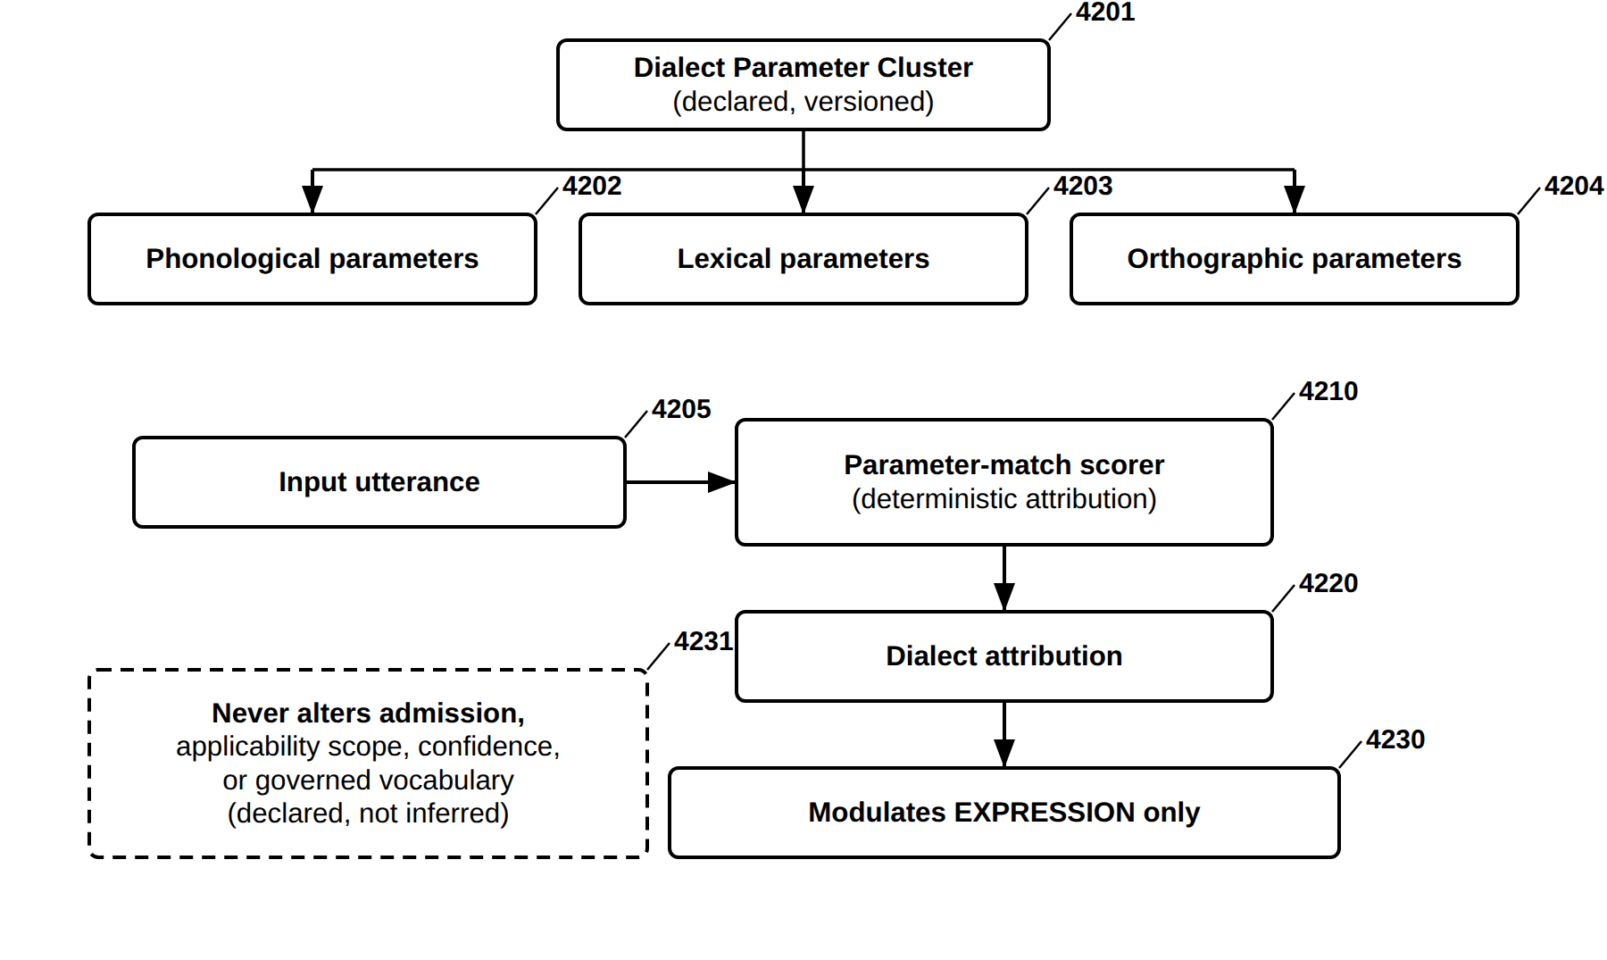
FIG. 42 — Dialect Parameter Clusters (DPC) — Declared, Expression-Only Modulation
FIG. 43
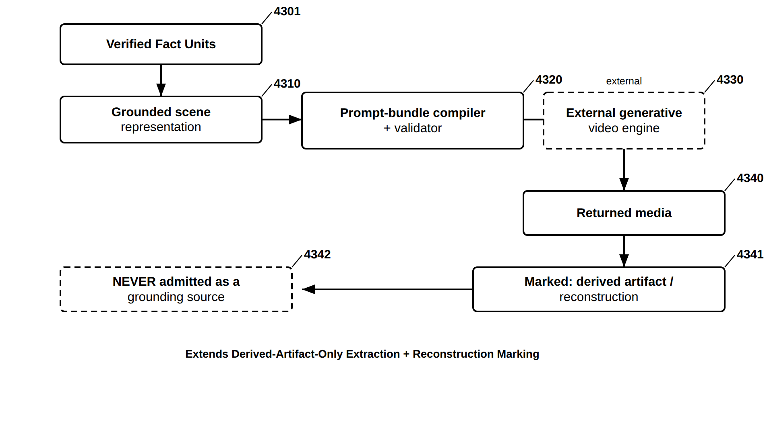
FIG. 43 — Grounded Scene Compilation to an External Generative Media Engine
FIG. 44
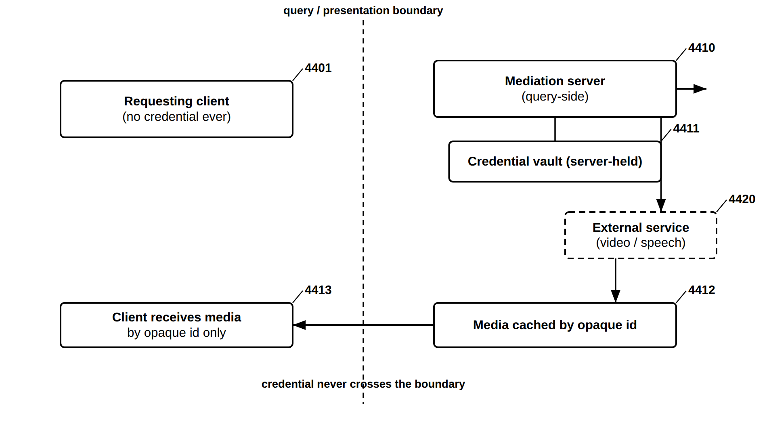
FIG. 44 — Key-Safe External-Service Mediation
FIG. 45
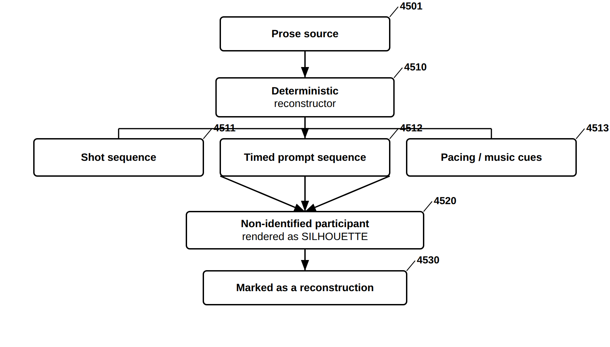
FIG. 45 — Scene Reconstruction From Prose — Bounded, Silhouette-Protected
FIG. 46
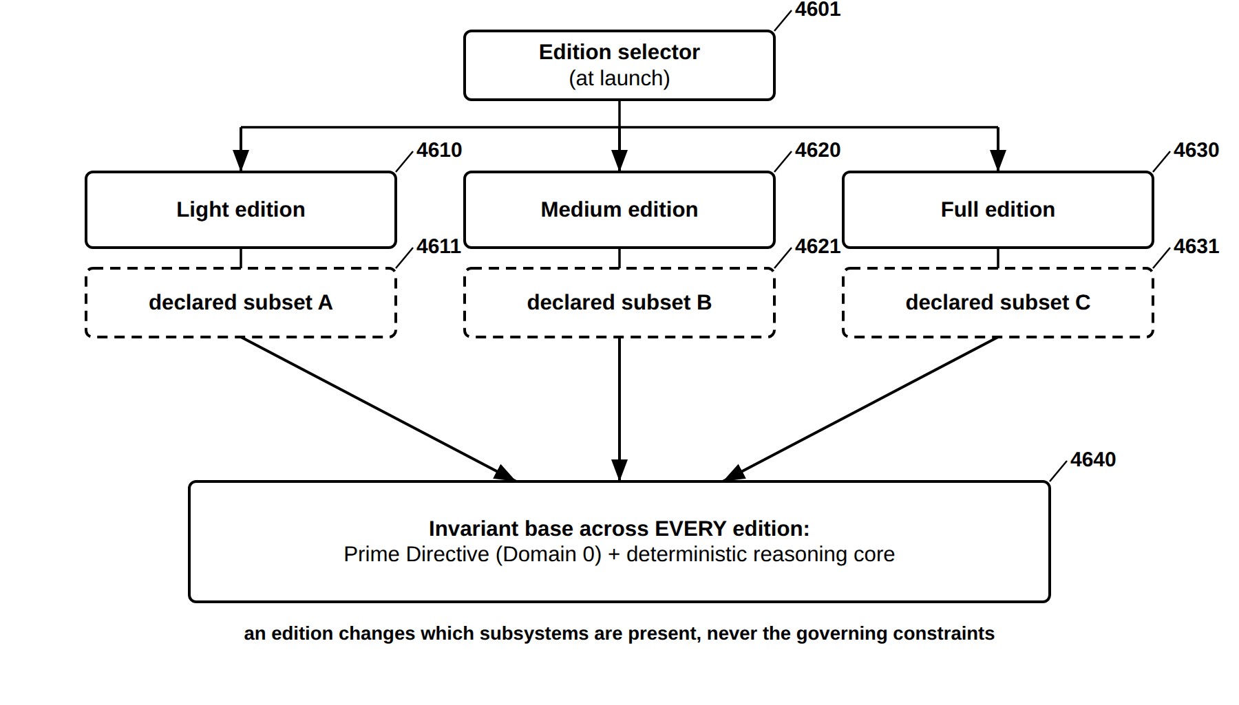
FIG. 46 — Modular Edition Packaging — Nested Capability Editions
FIG. 47
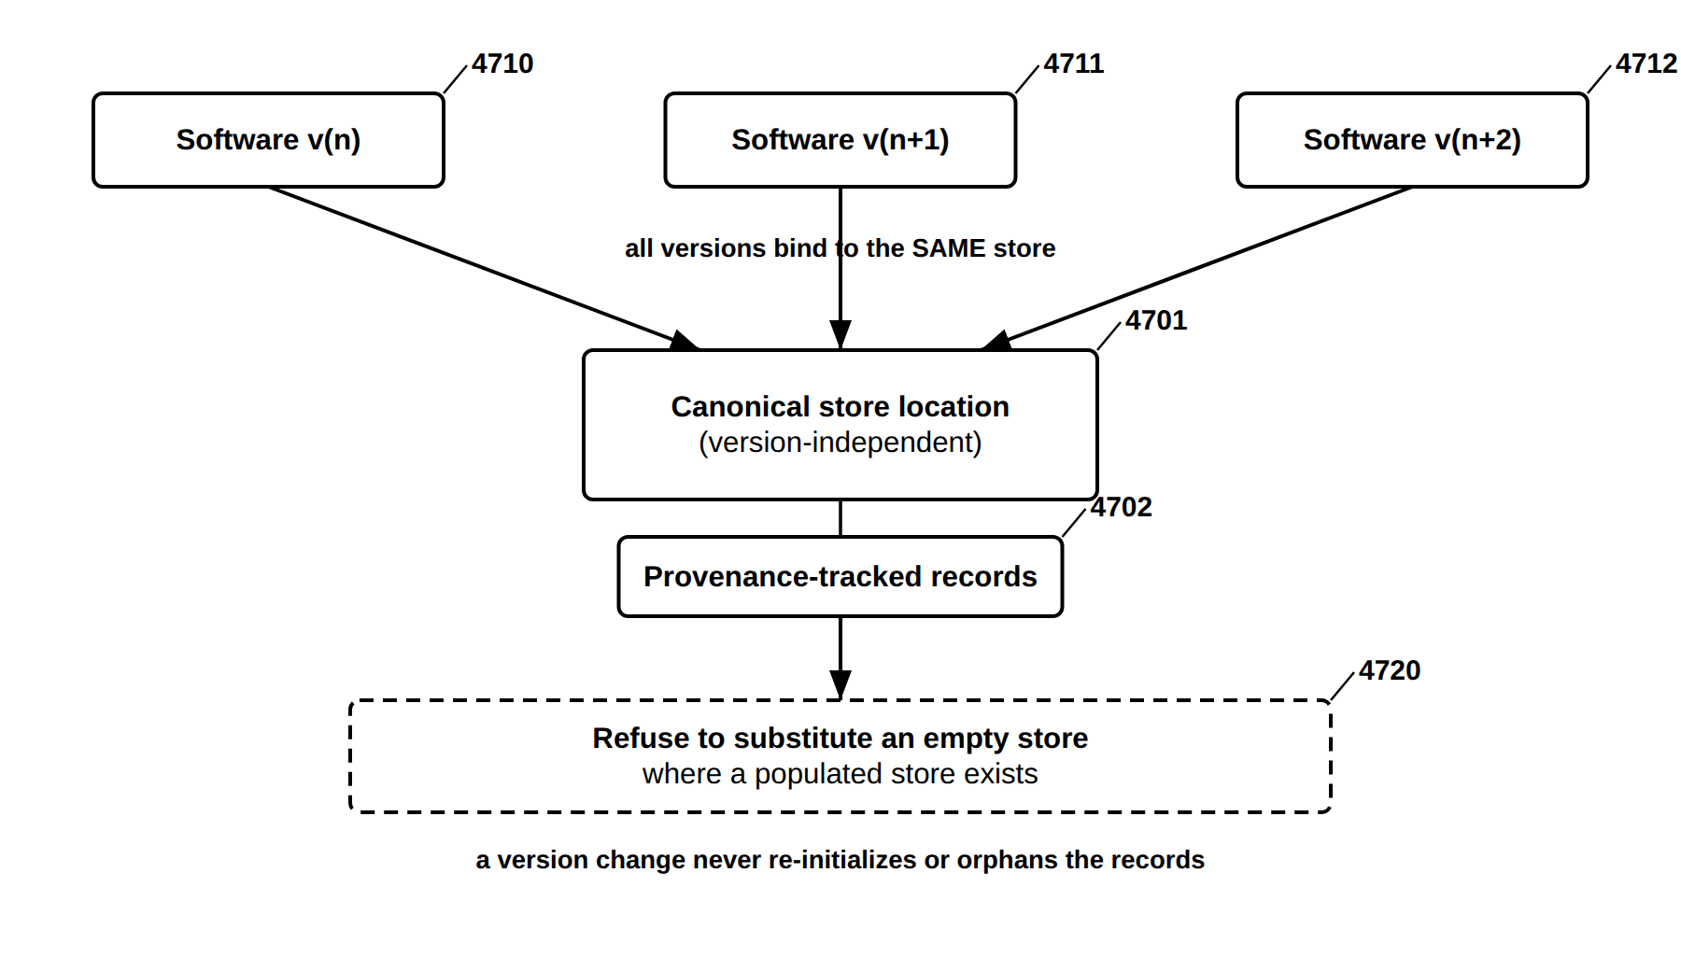
FIG. 47 — Version-Independent, Provenance-Continuous Store
FIG. 48
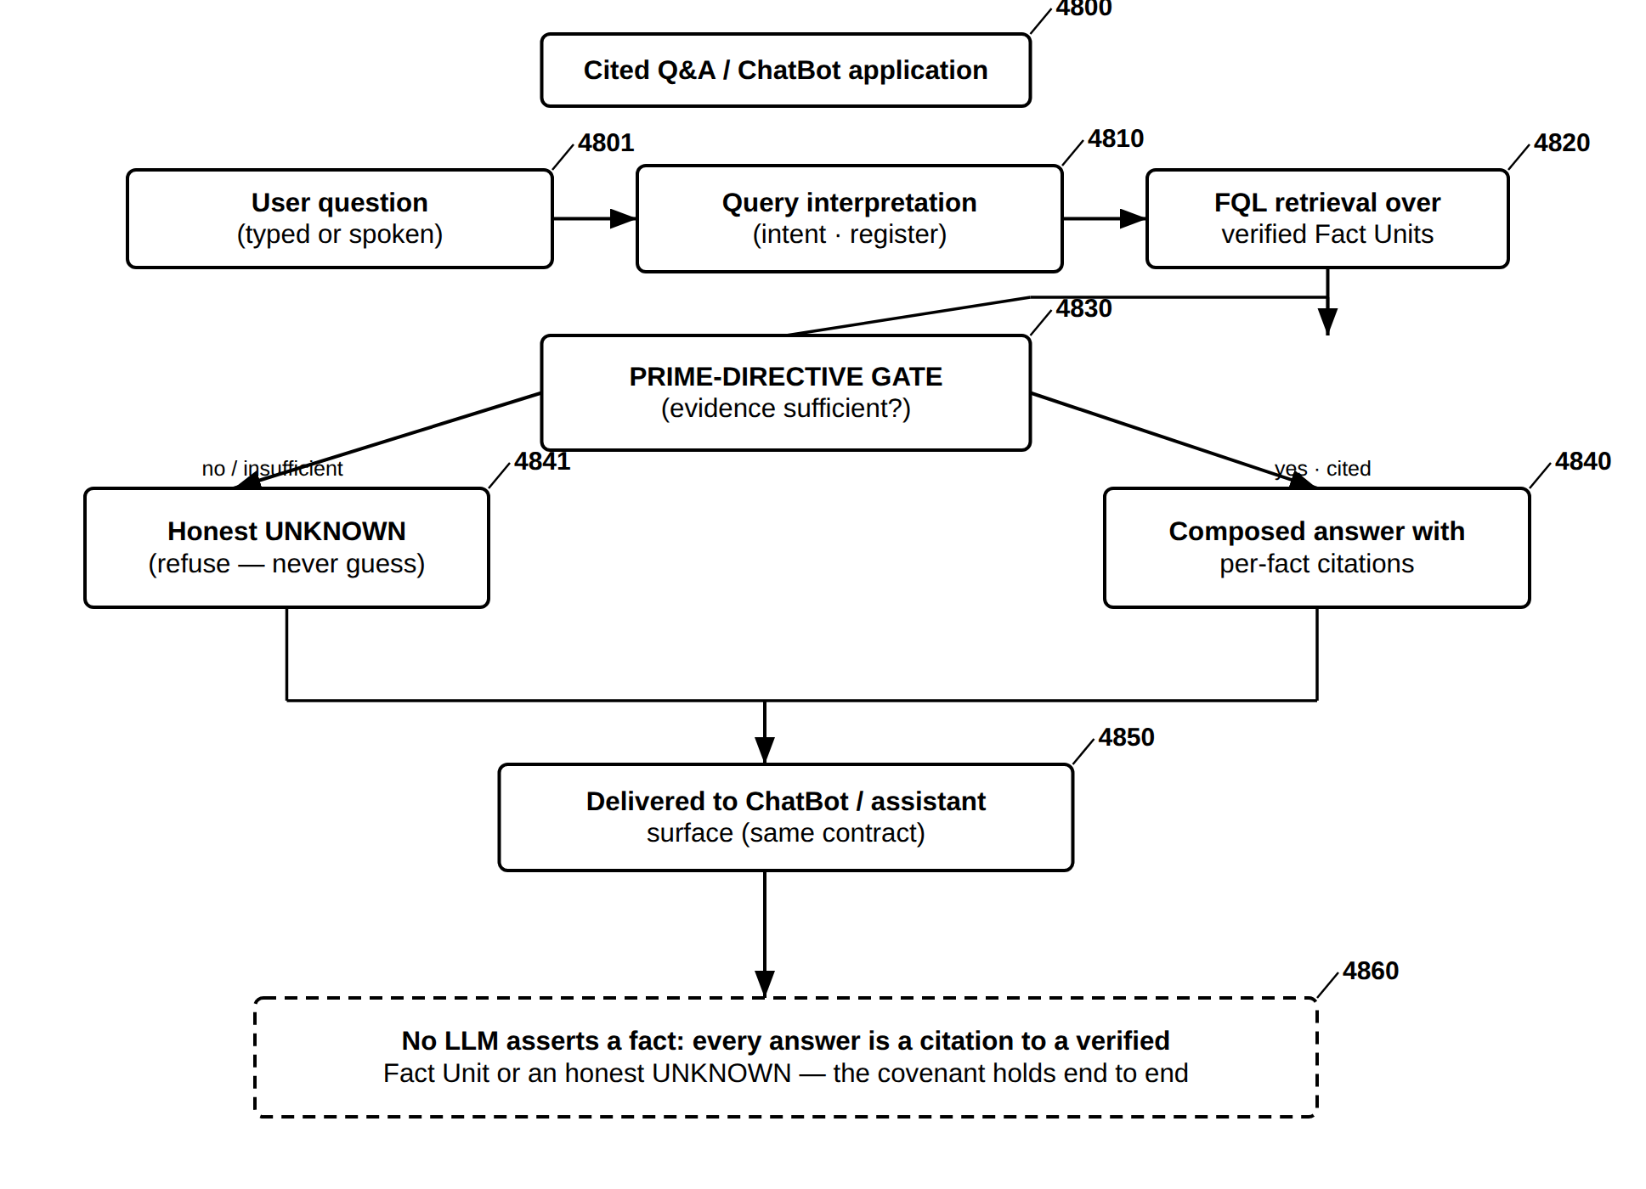
FIG. 48 — Cited Q&A / ChatBot Application — Citation-or-UNKNOWN End to End
FIG. 49
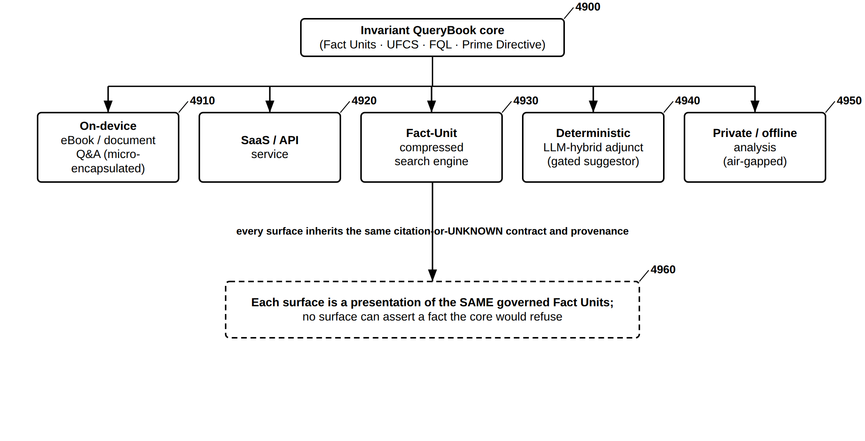
FIG. 49 — Application and Deployment Surfaces over the Invariant Core
FIG. 50
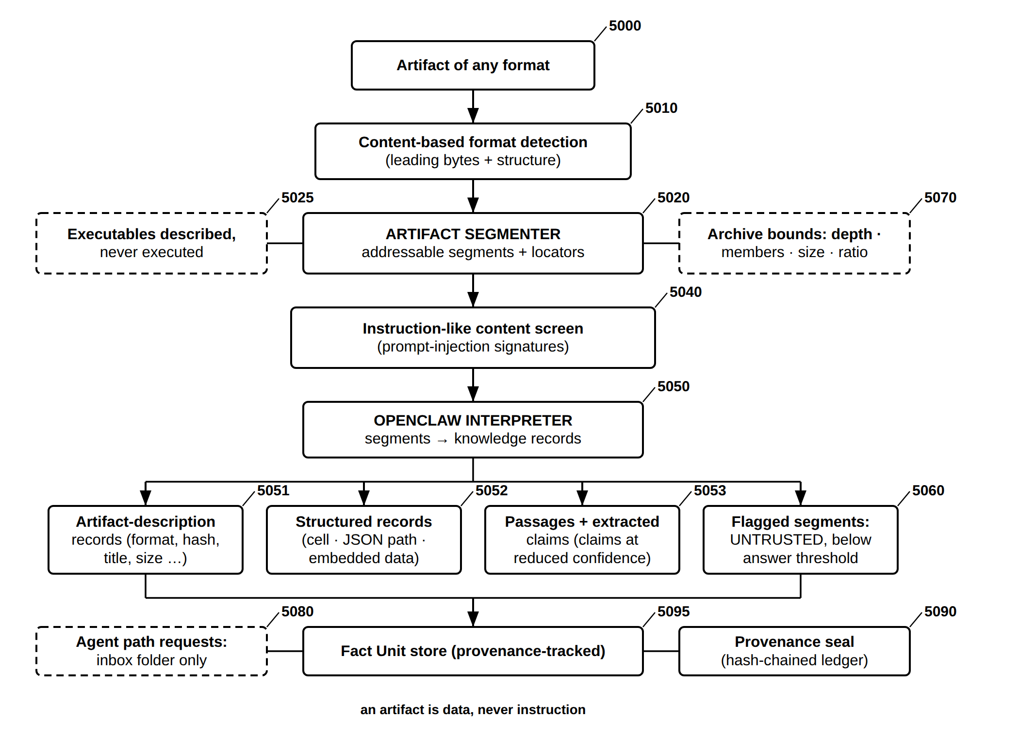
FIG. 50 — Open Claw Ingestion — Artifact Segmenter and OpenClaw Interpreter
FIG. 51
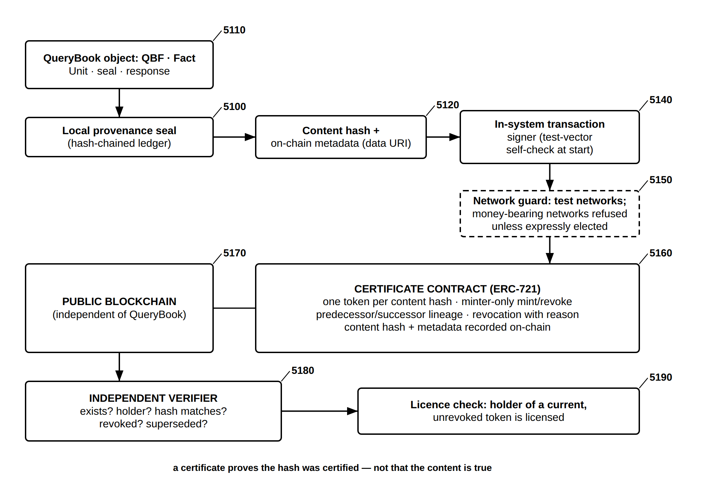
FIG. 51 — On-Chain Certification — Provenance NFTs, Lineage, Revocation and Independent Verification
FIG. 52
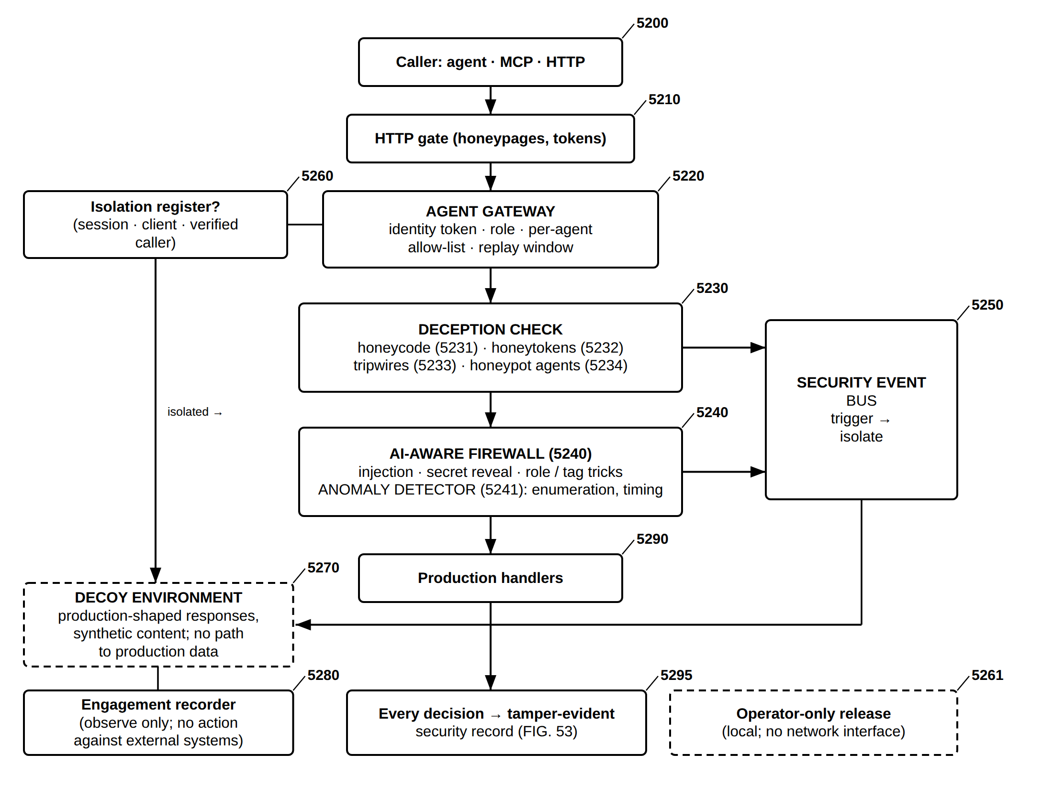
FIG. 52 — Agent Protection and Deception Layer — Gateway, Traps, Firewall, Containment and Decoy
FIG. 53
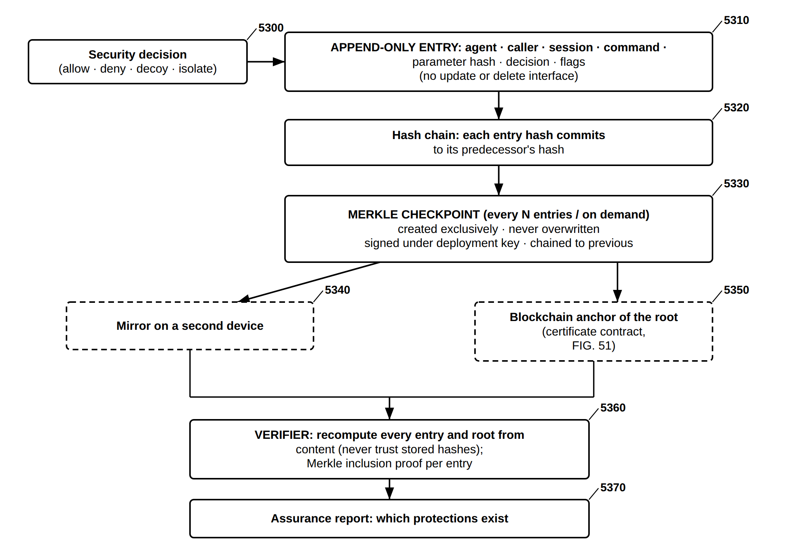
FIG. 53 — Tamper-Evident Security Record — Hash Chain, Write-Once Merkle Checkpoints, Mirror and Anchor
FIG. 54
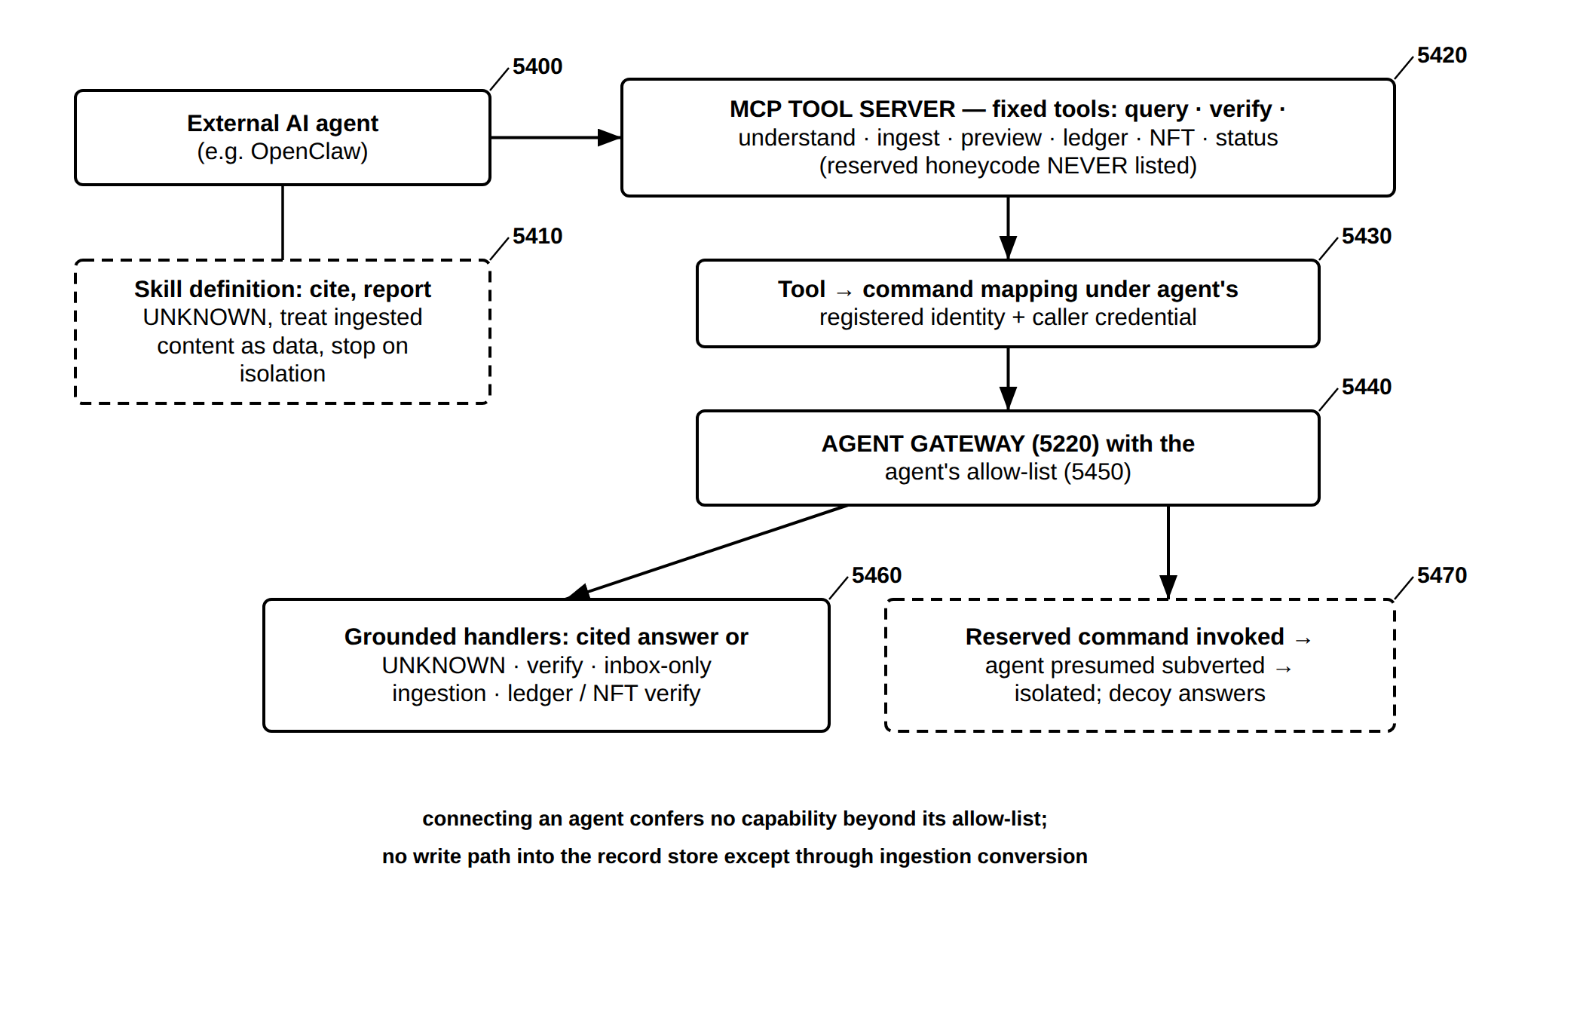
FIG. 54 — Agent Interoperability — MCP Tool Server and OpenClaw Skill Through the Agent Gateway
FIG. 55
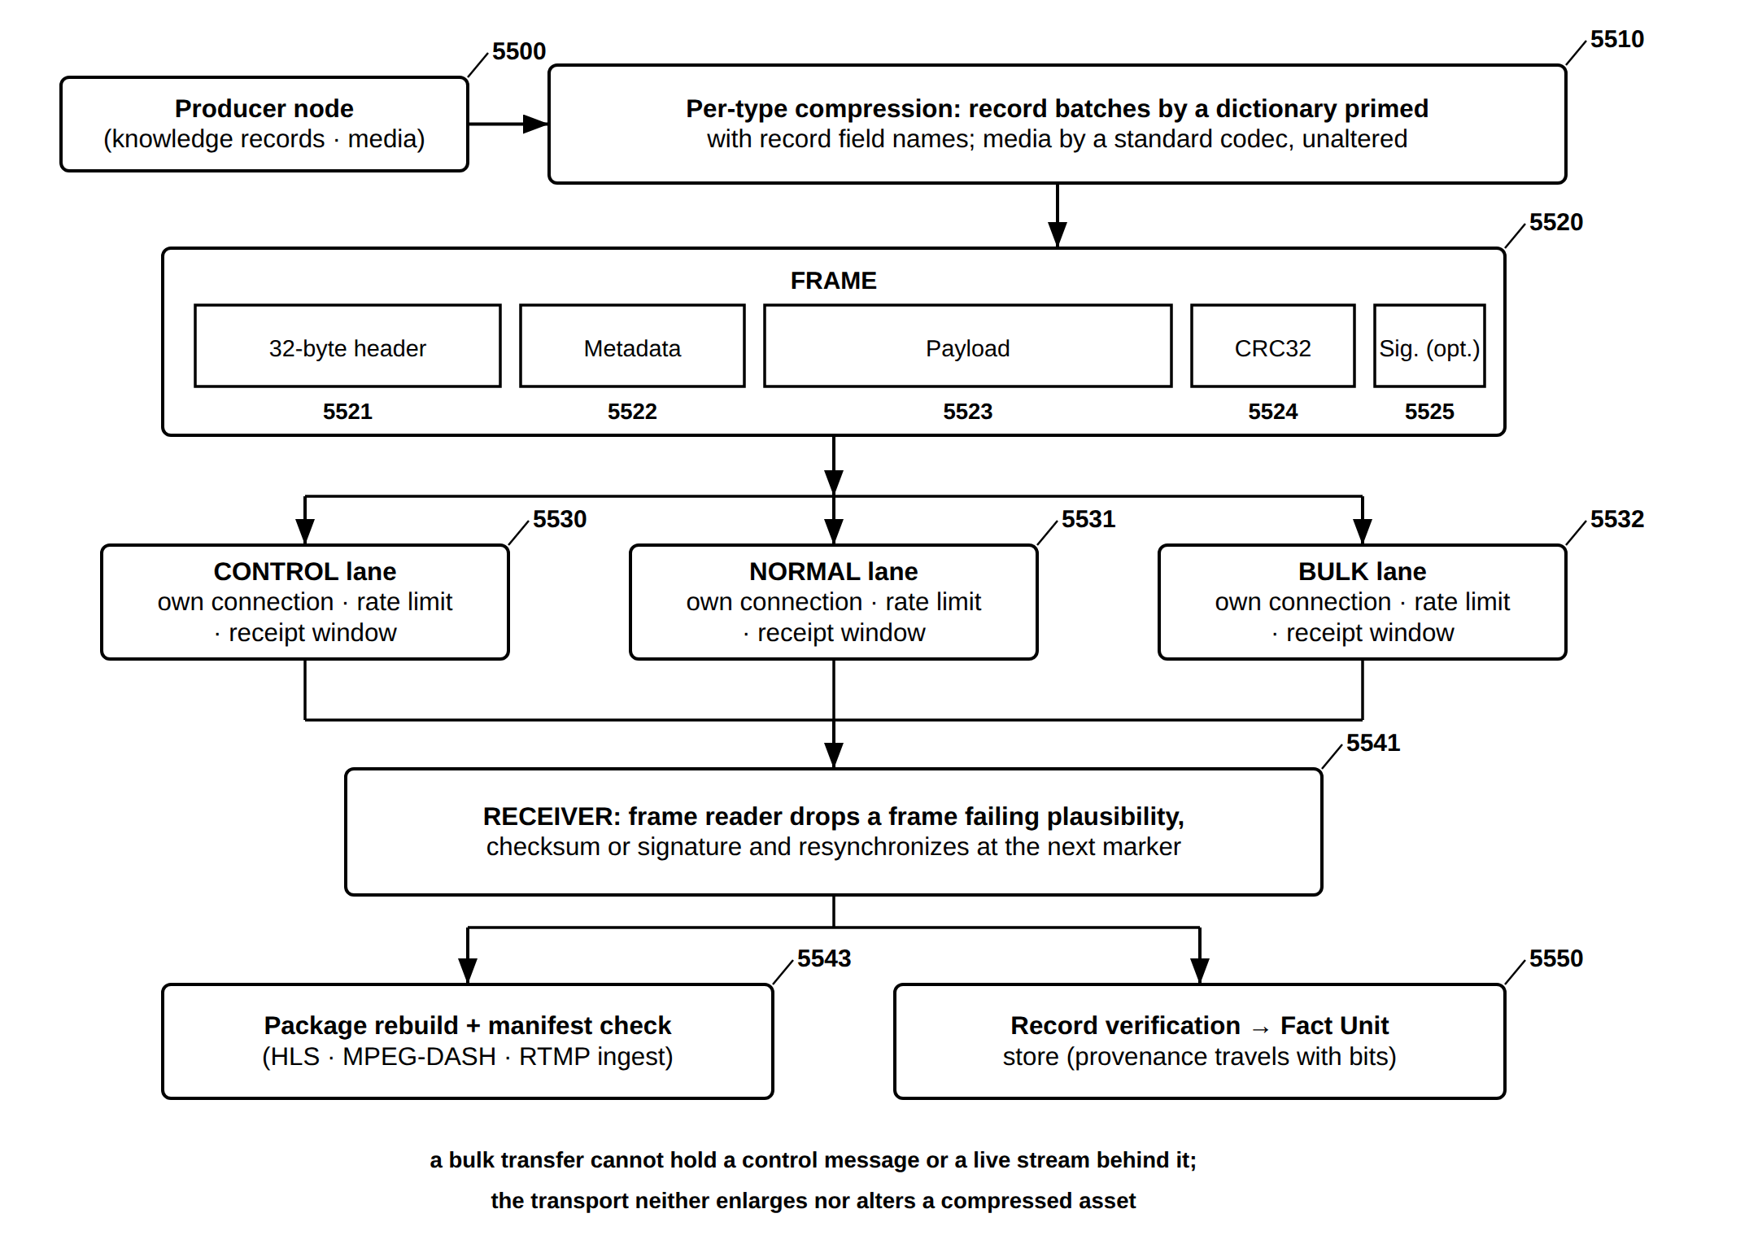
FIG. 55 — Hybrid Transport — Framed UFCS-FQL Messages on Priority Lanes over TCP/IP (extends FIG. 25)

Field of the Invention
The present invention relates to QueryBook, a deterministic, provenance-tracked federated knowledge and query system in which knowledge is stored as language-independent Fact Units and every asserted answer is retrieved from verified records, cited, and refused when unknown, under a Prime Directive that forbids fabrication. The invention further relates to an integral language and speech subsystem of that system — the Language Expression Layer (LEL) — which is co-grounded with the Fact Unit, Federated Query Language (FQL), and Universal Federated Connectivity System (UFCS) core so that natural-language input in any supported language resolves to the same query representation and results are rendered back as language or speech. The language and speech subsystem is a QueryBook subsystem and shares QueryBook's determinism, provenance, and no-fabrication guarantees; it is not a separate system.
More particularly, that language and speech subsystem relates to machine learning systems for natural language acquisition and speech production. More particularly, it relates to a hierarchical, developmentally-sequenced language learning architecture — the Language Expression Layer (LEL) — that acquires linguistic capabilities from a structured training corpus without reliance on external dictionaries, rule-based modules, or language packs; a sub-language priming layer establishing perceptual and structural prerequisites before language learning begins; a transition gate governing progression from structural to semantic learning; an accelerated multilingual acquisition model exploiting first-language structural transfer; a multi-stage speech output pipeline producing natural speech from internalized learned parameters; and the co-grounded integration of the LEL with a Federated Query Language (FQL) and Universal Federated Connectivity System (UFCS).

Background of the Invention
[0001] Conventional natural language processing systems acquire linguistic capability through (1) rule-based systems encoding grammar, morphology, syntax, and pronunciation via manually authored rules, dictionaries, and language packs; or (2) statistical and neural language models trained top-down on tokenized text, deriving associations between tokens without grounding in sub-linguistic or perceptual foundations.
[0002] Both paradigms have fundamental limitations. Rule-based systems are brittle, language-specific, and do not generalize beyond their rules. Neural models trained top-down on text lack grounding in the acoustic, prosodic, and communicative substrates from which human language emerges. Neither replicates the developmental sequence of human language acquisition.
[0003] Human language acquisition proceeds developmentally: an infant performs sub-linguistic perceptual processing — discriminating acoustic signals, detecting prosody, segmenting continuous sound — before apprehending semantics. Words are first acquired as stable acoustic objects. The understanding that words serve communication emerges as a discovered insight, not a pre-loaded assumption. Grammar and syntax develop subsequently as tools serving communication.
[0004] Conventional systems also treat multilingual capability as parallel resource construction — separate dictionaries, grammars, and pronunciation databases per language — failing to exploit the structural transfer by which knowledge of a first language accelerates acquisition of later languages.
[0005] Existing speech synthesis relies on externally authored pronunciation lexicons, rule-based phoneme-to-grapheme mappings, and separately trained prosody and vocoder modules — engineered rather than learned.
[0006] There exists a need for a language acquisition and speech production system that: (a) replicates the human developmental sequence from sub-linguistic foundations to emergent communicative and semantic competence; (b) internalizes all linguistic features as learned parameters within a unified model, without external dictionaries, rule engines, or language packs; (c) exploits first-language structural transfer to accelerate multilingual acquisition; (d) produces natural speech through an integrated learned pipeline; and (e) co-grounds linguistic understanding with structured federated data query operations.

Summary of the Invention
QueryBook is the system; the language and speech capability is an integral subsystem of it. QueryBook is a deterministic, provenance-tracked federated knowledge and query engine built on content-addressed Fact Units, the Federated Query Language (FQL), and the Universal Federated Connectivity System (UFCS), under a Prime Directive by which answers are cited or refused and are never fabricated. The developmental language and speech subsystem set out below — the Language Expression Layer (LEL) with its Sub-Language Priming Layer, Transition Gate, multilingual Delta Acquisition, pronunciation, and speech output — is an integral part of QueryBook, co-grounded with that core (FIG. 6), and inherits its determinism, provenance, and no-fabrication guarantees. It is described as a subsystem of the one QueryBook invention, not as a separate invention.
In that subsystem, the invention provides a system and method for hierarchical developmental language acquisition and integrated speech output in the federated query system, comprising: (1) a Sub-Language Priming Layer establishing acoustic, phonemic, prosodic, communicative, and information-theoretic foundations before language learning; (2) a Language Expression Layer (LEL), a trained model acquiring all linguistic capabilities as learned parameters from a structured multilingual corpus; (3) a Transition Gate of four measurable readiness thresholds governing progression from structural-acoustic to semantic-communicative learning; (4) a Multilingual Transfer (Delta Acquisition) model reusing first-language foundations to accelerate later languages; (5) a Speech Output Pipeline of sequentially integrated learned stages; and (6) a Co-Grounded Integration architecture linking the LEL to FQL and UFCS for language-agnostic query execution.
No large language model acquires language, grounds meaning, or asserts a fact. Unlike conventional systems, the invention acquires and performs language understanding without any large language model (LLM). The LEL learns its own parameters bottom-up from the Sub-Language Priming Layer rather than being trained on, distilled from, or querying a pre-existing LLM; and in the reduced-to-practice embodiment (Section VII) semantic grounding is performed deterministically, drawing word meanings only from a bundled public-domain dictionary and by self-grounding against verified Fact Units in the store, each meaning carrying an auditable source. An LLM is expressly excluded from the language-understanding and grounding path (see FIG. 8), and no fact asserted by the system originates from an LLM. An LLM may, however, be used elsewhere in strictly non-asserting roles: (i) to phrase or narrate an answer over facts the system has already verified, and (ii) to propose hypotheses and drive simulations for exploration — in each case the LLM never establishes truth, and any candidate it proposes is admitted only after independent verification against the deterministic store (an optional grounding “suggestor” is admitted only where it agrees with the public-domain dictionary, which remains the authority).

Brief Description of the Drawings
FIG. 1 is a block diagram of the overall QueryBook Language Expression Layer (LEL) system architecture.
FIG. 2 is a block diagram of the Sub-Language Priming Layer (SLPL) and the measurable representation produced by each of its six components.
FIG. 3 is a flow diagram of the developmental learning sequence and the one-way Transition Gate having four readiness thresholds.
FIG. 4 is a block diagram of the multilingual Delta Acquisition Model and the acquisition acceleration flywheel.
FIG. 5 is a block diagram of the seven-stage Speech Output Pipeline.
FIG. 6 is a data-flow diagram of the co-grounded integration of the LEL with the Federated Query Language (FQL) and the Universal Federated Connectivity System (UFCS).
FIG. 7 is a block diagram of a reduced-to-practice embodiment (the Language Lab) implementing Phase One, the Transition Gate, and a deterministic Phase Two, per Section VII.
FIG. 8 is a data-flow diagram of the deterministic Phase-Two semantic grounding of the reduced-to-practice embodiment, in which word meanings are attached only from auditable sources — a bundled public-domain dictionary and self-grounding against verified Fact Units in the store — with any large-language-model meaning source excluded from the grounding path.

Brief Description of the QueryBook Platform Drawings (FIG. 9–FIG. 30)
FIG. 9 is a diagram of the queryBook system architecture (Prime Directive as Domain 0).
FIG. 10 is a diagram of the fact Unit — atom, envelope, and content-derived identity.
FIG. 11 is a diagram of the fact-certification authority hierarchy.
FIG. 12 is a diagram of the uFCS substrate — three-store architecture.
FIG. 13 is a diagram of the authored tour and exhibition sequencing.
FIG. 14 is a diagram of the fQL — joint structure and trust execution.
FIG. 15 is a diagram of the verifying machine-generated text against certified records.
FIG. 16 is a diagram of the federation — cross-boundary re-validation.
FIG. 17 is a diagram of the fact-level erasure by external-key destruction.
FIG. 18 is a diagram of the universal security architecture.
FIG. 19 is a diagram of the universal honeypot saturation and data firehose.
FIG. 20 is a diagram of the deployment topologies over an invariant common layer.
FIG. 21 is a diagram of the adaptive response engine — directive fixed before generation.
FIG. 22 is a diagram of the user-owned agent system with governance and kill switch.
FIG. 23 is a diagram of the deterministic multi-language regeneration.
FIG. 24 is a diagram of the semantic compression, expansion, colorization and upscaling.
FIG. 25 is a diagram of the queryBook-enhanced TCP/IP hybrid protocol packet.
FIG. 26 is a diagram of the neuromorphic cognitive layer — attractor convergence.
FIG. 27 is a diagram of the fact Unit — confidence and evidence model.
FIG. 28 is a diagram of the uFCS packet structure — serialized Fact Unit record.
FIG. 29 is a diagram of the uFCS packet framing — content-addressed block storage.
FIG. 30 is a diagram of the fQL — query anatomy and worked example.
Section XV drawings (FIG. 50–FIG. 55).
FIG. 50 is a block diagram of the Open Claw ingestion pathway, in which an artifact of arbitrary format is detected, bounded, decomposed by an Artifact Segmenter into located segments, interpreted by an OpenClaw Interpreter, screened for embedded instructions, and admitted as sealed, provenance-tracked records.
FIG. 51 is a block diagram of on-chain certification, in which a sealed knowledge object is certified as a non-fungible token on a public blockchain carrying its content hash, lineage and revocation state, and is independently verifiable.
FIG. 52 is a block diagram of the agent protection and deception layer, comprising an Agent Gateway, honeycode, honeytokens, tripwires, honeypot agents, an AI-aware firewall, anomaly detection, isolation into a synthetic decoy environment, and operator-local release.
FIG. 53 is a block diagram of the tamper-evident security record, comprising an append-only hash chain, write-once signed Merkle checkpoints, an off-host mirror, optional blockchain anchoring, and recompute-from-content verification with inclusion proofs.
FIG. 54 is a block diagram of agent interoperability, in which external AI agents reach the system through a Model Context Protocol tool server and an OpenClaw skill, every call passing through the Agent Gateway of FIG. 52.
FIG. 55 is a block diagram of the hybrid transport, extending FIG. 25, in which framed UFCS-FQL messages carrying knowledge records and media are sent on separate priority lanes over TCP/IP and rebuilt at the receiver into standard streaming formats.

Reference Numerals
No. | Element | No. | Element
100 | QueryBook LEL system | 984 | engine-selection ladder (per OS / language)
110 | Sub-Language Priming Layer (SLPL) | 985 | host OS built-in voice service
120 | Language Expression Layer (LEL) | 986 | culture-matched OS voice (when installed)
130 | Transition Gate | 987 | honest refusal with remedy (no fabricated audio)
140 | Phase Two semantic-communicative learning | 990 | deterministic translator (through English)
150 | Multilingual Delta Acquisition module | 991 | bundled open-source bilingual dictionary
160 | Speech Output Pipeline | 992 | coverage accounting + unknown-word passthrough (flagged)
165 | natural speech output | 993 | deterministic language detector
170 | co-grounding interface | 995 | permanent quality-control battery
180 | Federated Query Language (FQL) | 996 | IPA-produced check
190 | Universal Federated Connectivity System (UFCS) | 997 | syllable-sanity check (±1)
195 | federated data sources | 998 | valid-waveform synthesis check
200 | SLPL | 999 | per-language QC report + overall pass score
210 | acoustic phonetic processing | 1000 | LIL voiceprint & identity subsystem
211 | signal-level feature embedding | 1001 | consent gate (precondition)
220 | phonics / phonemic awareness | 1002 | audio/video capture + VAD/segmentation
221 | phoneme-boundary segmenter | 1003 | acoustic feature extraction
230 | communication-science foundations | 1004 | speaker embedding (voiceprint vector)
231 | communicative-salience weight | 1005 | enrollment — canonical voiceprint
240 | prosody & rhythm processing | 1006 | match / score (cosine · PLDA)
241 | prosodic contour vector | 1007 | QueryBook trust gate (VERIFIED/CONTRADICTED/UNKNOWN)
250 | information-theoretic grounding | 1008 | Fact-Unit identity graph
251 | information weighting | 1009 | LEL cross-script name/entity resolution
260 | neurolinguistic chunking | 1010 | provenance-tracked link Fact Unit
261 | chunk segments | 1020 | voice authentication request
270 | licensed multimedia input | 1021 | capture phrase + embed
300 | developmental learning sequence | 1022 | anti-spoofing (liveness/replay/synthetic)
310 | Phase One (structural-acoustic) | 1023 | deterministic risk-scoring policy
311 | sound discrimination | 1024 | authentication decision gate
312 | syllabic segmentation | 1025 | second-factor challenge
313 | word-as-acoustic-object | 1026 | auth-event Fact Unit (provenance)
314 | semantics suppressed | 1100 | UIAS integrity audit service
320 | Transition Gate (one-way) | 1101 | monitored system workflow (unmodified)
321 | phonemic-inventory completeness ≥ τ1 | 1102 | input-boundary position
322 | lexical stability ≥ τ2 | 1103 | processing-layer position
323 | co-occurrence density ≥ τ3 | 1104 | storage-layer position
324 | pattern saturation < ε | 1105 | output-boundary / handoff position
330 | Phase Two (semantic-communicative) | 1106 | Connector + Ingestion agents (seal at observation)
331 | word-to-referent grounding | 1107 | seal = Fact Unit (hash · id-hash · independent timestamp · source · agent)
332 | communicative discovery | 1108 | Similarity Detection Agent (semantic signatures)
333 | emergent grammar / syntax | 1109 | Fact-Unit audit ledger (UFCS, append-only, immutable)
400 | Delta Acquisition Model | 1110 | contemporaneous cross-party anomaly flag
410 | reused L1 foundation | 1111 | Verification Agent (continuous re-verification)
420 | L2 delta detector | 1112 | content-not-stored / one-way identity (fact-level erasure)
430 | targeted training of novel elements | 1120 | UIAS signed Proof Package generation
440 | multilingual semantic alignment | 1121 | accusation / inquiry
450 | acquisition acceleration flywheel | 1122 | Proof Package Agent
451 | negative-transfer detection & retraining | 1123 | sealed Fact Units + verified seals
500 | Speech Output Pipeline | 1124 | cross-submission similarity log entry
510 | lexical selection | 1125 | chronological ledger extract (RPH)
520 | grapheme-to-phoneme conversion | 1126 | Arbitration Agent (factual determination; Prime-Directive gate)
530 | coarticulation modeling | 1127 | assemble + sign under UIAS independent identity
540 | prosody generation | 1128 | signed Proof Package
550 | register & affect calibration | 1129 | factual-only determination (legal reserved to courts/regulators)
560 | self-monitoring feedback loop | 1200 | PIL paralinguistic & pragmatic interpretation
570 | neural vocoder rendering | 1201 | ingested voice (consent-gated)
580 | natural speech waveform | 1202 | transcription (words)
600 | co-grounded integration | 1203 | Paralinguistic Analyzer (measured)
610 | natural-language input | 1204 | tone/loudness/pacing/emphasis + labeled arousal estimate
620 | LEL analysis | 1205 | Pragmatic Framer (sourced)
630 | FQL operations | 1206 | context · perspective · ergonomics · culture · social mores
640 | UFCS execution | 1207 | Interpretation Frame (labeled estimates + sourced frames)
650 | federated sources | 1208 | Fact Units on ingested content
660 | results | 1209 | covenant: estimates not asserted; frames sourced; consent
670 | render to NL / speech in input language | 1210 | PIL human query interpretation
680 | language-agnostic resolution | 1211 | human query (typed/spoken)
700 | Language Lab prototype embodiment | 1212 | Interpretation Frame (para + pragmatic)
710 | corpus source | 1213 | intent disambiguation (context/perspective)
720 | Phase-One structural agent | 1214 | ambiguity gate
730 | structural analyzer | 1215 | ask one clarifying question / stop
731 | grapheme inventory | 1216 | register & ergonomic mode selector
732 | rule-seeded G2P | 1217 | culture/mores/ergonomics packs
733 | syllabifier | 1218 | retrieve-gate-compose (verified Fact Units; cite or refuse)
734 | lexical-stability metric | 1219 | answer in selected register/mode (facts unchanged)
735 | co-occurrence density metric | 1300 | Lecture Query ingestion pipeline
736 | prosody proxy | 1301 | live or recorded audio/video program
740 | Fact Unit store | 1302 | capture + consent gate
750 | Transition-Gate metrics | 1303 | ASR transcription + diarization (untrusted input)
751 | one-way latch | 1304 | video frames → faces (LIL)
760 | phase agents on shared manager | 1305 | PIL analysis over time (tone/pacing/arousal + frame)
761 | Phase-1 agent (implemented) | 1306 | LEL segment/structure/extract claims
762 | Phase-2 agent — deterministic dictionary + store grounding (implemented) | 1307 | deterministic summary (TOC/key points/claims)
763 | Phase-3 agent (declines — spec-only) | 1308 | ingest → Lecture Record; claims = attributed utterance facts
764 | Phase-4 agent (declines — spec-only) | 1309 | forever-link: speaker/venue/event/org/date (immutable, trust-gated)
800 | deterministic Phase-Two semantic grounding | 1310 | forever-linked Lecture Record (queryable)
810 | Phase-One vocabulary (learned words) | 1311 | Lecture Record (content-addressed)
820 | deterministic grounder (per word) | 1312 | speaker entity (LIL voiceprint/face)
830 | bundled public-domain dictionary source | 1313 | venue entity
831 | dictionary meaning Fact Unit (means, trust 0.9) | 1314 | event entity
840 | self-grounding store-lookup source | 1315 | organization + date
841 | store-link Fact Unit (grounded_by_fact) | 1316 | transcript + diarization
850 | Fact Unit store (provenance, domain language) | 1317 | PIL track (tone/pacing over time)
860 | excluded large-language-model meaning source | 1318 | attributed claims → corroborated/contradicted/open
870 | optional future dictionary-gated suggestor | 1319 | FQL / Q&A over the record
900 | advanced multilingual pronunciation subsystem | 1320 | answer: cited, attributed, refused where unknown
910 | pronunciation request (word/phrase, language) | 4800 | cited Q&A / ChatBot application
920 | pronunciation preference-ladder selector | 4801 | user question (typed/spoken)
930 | bundled open-source phonemizer | 4810 | query interpretation (intent/register)
931 | phonemizer IPA transcription | 4820 | FQL retrieval over verified Fact Units
932 | phonemizer call cache | 4830 | Prime-Directive gate (evidence sufficiency)
933 | bounded call log / timeout guard | 4840 | composed answer with per-fact citations
940 | rule-seeded G2P tables (per language) | 4841 | honest UNKNOWN (refuse, never guess)
941 | approximate rule-seeded IPA (offline) | 4850 | ChatBot/assistant delivery surface
950 | syllable count + primary-stress derivation | 4860 | citation-or-UNKNOWN covenant held end to end
960 | explicit null result (not fabricated) | 4900 | invariant QueryBook core
970 | phrase-level single-call transcription | 4910 | on-device eBook/document Q&A (micro-encapsulated)
971 | displayed transcription consistent with synthesized audio | 4920 | SaaS / API service surface
980 | self-contained application bundle | 4930 | Fact-Unit compressed search engine
981 | bundled open-source speech engine | 4940 | deterministic LLM-hybrid adjunct (gated suggestor)
982 | runtime-support libraries | 4950 | private/offline analysis deployment
983 | bundled phoneme data | 4960 | all surfaces inherit the governed-fact contract
5000 | artifact of any format | 5261 | operator-only release
5010 | content-based format detection | 5270 | decoy environment
5020 | Artifact Segmenter (segments + locators) | 5280 | engagement recorder
5025 | executables described, never executed | 5290 | production handlers
5040 | instruction-like content screen | 5295 | decision written to security record
5050 | OpenClaw Interpreter | 5300 | security decision
5051 | artifact-description records | 5310 | append-only entry
5052 | structured records | 5320 | hash chain
5053 | passages and extracted claims | 5330 | Merkle checkpoint
5060 | flagged segments (untrusted, below answer threshold) | 5340 | mirror on a second device
5070 | archive bounds (depth, members, size, ratio) | 5350 | blockchain anchor of checkpoint root
5080 | agent path requests confined to inbox | 5360 | verifier with Merkle inclusion proof
5090 | provenance seal (hash-chained ledger) | 5370 | assurance report
5095 | Fact Unit store | 5400 | external AI agent
5100 | local provenance seal | 5410 | skill definition
5110 | QueryBook knowledge object | 5420 | MCP tool server
5120 | content hash + on-chain metadata | 5430 | tool-to-command mapping
5140 | in-system transaction signer | 5440 | gateway check of agent call
5150 | network guard | 5450 | agent allow-list
5160 | certificate contract (one token per hash, lineage, revocation) | 5460 | grounded handlers
5170 | public blockchain | 5470 | reserved command → isolation
5180 | independent verifier | 5500 | producer node
5190 | licence check | 5510 | per-type compression
5200 | caller (agent, MCP, HTTP) | 5520 | frame
5210 | HTTP gate (honeypages, tokens) | 5521 | 32-byte header
5220 | Agent Gateway | 5522 | frame metadata
5230 | deception check | 5523 | payload
5231 | honeycode | 5524 | CRC32 checksum
5232 | honeytokens | 5525 | optional signature
5233 | tripwires | 5530 | control lane
5234 | honeypot agents | 5531 | normal lane
5240 | AI-aware firewall | 5532 | bulk lane
5241 | anomaly detector | 5541 | receiver / frame reader
5250 | security event bus | 5543 | package rebuild + manifest check
5260 | isolation register | 5550 | record verification into Fact Unit store

Detailed Description of the Preferred Embodiments

Section I — The Sub-Language Priming Layer (SLPL) (FIG. 2)
[0007] The SLPL is a pre-training stage executing prior to language corpus ingestion, establishing the perceptual prerequisites that make language learnable. It comprises six components, each producing a defined, measurable representation audit: (a) Acoustic Phonetic Processing — learns to discriminate sounds at the signal level (formant, pitch, duration, amplitude), producing a discrimination-thresholded feature embedding; (b) Phonics and Phonemic Awareness — learns sound-symbol correspondence, segmentation, blending, and minimal-pair discrimination, producing a discrete phoneme-boundary segmenter with a measured minimal-pair rate; (c) Communication Science Foundations — learns turn-taking and signal-versus-noise discrimination, producing a per-segment communicative-salience weight without assigning meaning; (d) Prosody and Rhythm Processing — learns stress, intonation, timing, and pause as pre-semantic carriers, producing a prosodic contour vector; (e) Information-Theoretic Grounding — acquires an entropy/redundancy weighting allocating representational attention by measured information density; and (f) Neurolinguistic Chunking — groups acoustic units into processable segments at a defined chunk-capacity window.
FIG. 31 is a block diagram of the advanced multilingual pronunciation subsystem and self-contained speech output of the reduced-to-practice embodiment, showing the pronunciation preference ladder (bundled open-source phonemizer, then per-language rule-seeded grapheme-to-phoneme tables, then an explicit non-fabricated null), the single-call phrase transcription that keeps the displayed transcription consistent with the synthesized audio, and the self-contained bundle and engine-selection ladder that produce offline audio or an honest refusal without fabricating audio, per Section VIII.
FIG. 32 is a flow diagram of the permanent, deterministic pronunciation-and-speech quality-control battery of the reduced-to-practice embodiment, which, for each supported language and without a large language model, verifies that a phonemic transcription is produced, that the syllable count is within tolerance, and that a short phrase synthesizes to a valid audio waveform, returning a per-language report and an overall pass score, per Section VIII.
FIG. 33 is a data-flow diagram of the Language & Identity Linking (LIL) voiceprint enrollment and matching subsystem, in which a consent-gated capture produces an acoustic speaker embedding (voiceprint), a match against stored voiceprints is passed through a QueryBook trust gate returning VERIFIED, CONTRADICTED, or UNKNOWN, and verified identity links are written as provenance-tracked, trust-scored Fact Units in the identity graph, with cross-script name and entity resolution performed by the language subsystem, per Section IX.
FIG. 34 is a flow diagram of the LIL trust-gated voice authentication process, in which a claimed-identity verification produces a match score and anti-spoofing signals that feed a deterministic risk-scoring policy and a decision gate returning accept, challenge (second factor), or reject, each decision recorded as a provenance-tracked auth-event Fact Unit, per Section IX.
FIG. 35 is a block diagram of the Universal Integrity Audit Service (UIAS), in which connector and ingestion agents observe an unmodified monitored system at multiple workflow positions and seal each observable event as a content-addressed Fact Unit carrying a content hash, a one-way submitter-identity hash, an independent nanosecond timestamp, a source fingerprint, and the sealing agent’s identity; a similarity-detection agent sets a contemporaneous cross-party anomaly flag over content signatures without storing content; and a verification agent continuously re-verifies the append-only Fact-Unit ledger, per Section X.
FIG. 36 is a flow diagram of the UIAS signed Proof Package generation, in which, on an accusation or inquiry, a proof-package agent assembles verified sealed Fact Units, the similarity-log entry, a chronological ledger extract bound by the response-provenance hash, and a factual determination from the arbitration agent under the Prime-Directive gate, and signs the package under the UIAS independent identity to produce independent, pre-dispute, tamper-proof, complete, and admissible evidence, per Section X.
FIG. 37 is a data-flow diagram of the Paralinguistic & Pragmatic Interpretation Layer (PIL) applied to an ingested voice, in which a paralinguistic analyzer produces measured acoustic readings and a labeled arousal estimate while a pragmatic framer applies sourced context, perspective, ergonomics, culture, and social-mores frames, the two combining into an Interpretation Frame written as provenance-tracked Fact Units, with estimates labeled and never asserted as true feelings, per Section XI.
FIG. 38 is a flow diagram of the PIL human-query interpretation, in which a query is reduced to an Interpretation Frame, intent is disambiguated from context and perspective, an ambiguity gate asks one clarifying question when intent is materially uncertain, a register-and-ergonomic-mode selector sets the reply style and delivery from sourced culture/mores/ergonomics packs, and the existing retrieve-gate-compose pipeline answers from verified Fact Units in that register without altering the facts, per Section XI.
FIG. 39 is a block diagram of the Lecture Query mode ingestion pipeline, in which a live or recorded audio/video program is captured under consent, transcribed and diarized, analyzed by the paralinguistic layer over time and by the language layer for structure and claims, summarized deterministically, and ingested as a Lecture Record whose claims are stored as attributed utterance facts and which is forever-linked to the speaker, venue, event, organization, and date by immutable provenance-tracked, trust-gated identity links, per Section XII.
FIG. 40 is a data-flow diagram of the forever-linked Lecture Record in the Fact-Unit identity graph and its querying, showing the record bound to speaker, venue, event, and organization entities and to the transcript and paralinguistic track, its attributed claims gated as corroborated, contradicted, or open, and a query answered with citations to the record and attribution to the speaker, refused where unknown, per Section XII.
FIG. 41 is a data-flow diagram of deterministic multilingual acquisition without a generative model, in which a per-language learning agent acquires vocabulary, phonology (IPA), and grammatical regularities from a lawful public-domain corpus and a governed bilingual dictionary, an IPA transcription is verified against a reference phonemizer and withheld rather than asserted when verification fails, and each accepted item is written as a provenance-tracked lexical record reproducible from the same inputs, with no large or generative language model in the grounding path.
FIG. 42 is a block diagram of a Dialect Parameter Cluster (DPC), a declared and versioned cluster of phonological, lexical, and orthographic parameters by which an input utterance is attributed to a dialect by a deterministic parameter-match score, the cluster modulating expression only and never altering admission, applicability scope, confidence, or the governed vocabulary.
FIG. 43 is a data-flow diagram of grounded scene compilation to an external generative media engine, in which a grounded scene representation derived from verified Fact Units is compiled and validated into a prompt bundle for an external generative video engine and any returned media is admitted only as a derived artifact marked as a reconstruction and never as a grounding source.
FIG. 44 is a block diagram of key-safe external-service mediation, in which a credential for an external service is held on the server side of the query/presentation boundary and never transmitted to the client, the server performing the external call and serving the result to the client by an opaque cache identifier so that the credential never crosses the boundary.
FIG. 45 is a flow diagram of scene reconstruction from prose, in which a deterministic reconstructor derives a shot sequence, a timed prompt sequence, and pacing and music cues as a bounded reconstruction, renders a participant who is not an identified subject as a silhouette so that no unverified identity is fabricated, and marks the whole as a reconstruction.
FIG. 46 is a block diagram of modular edition packaging, in which the system is deployable as one of a plurality of nested capability editions selected at launch, each edition enabling a declared subset of subsystems while the Prime Directive and the deterministic reasoning core remain invariant across every edition.
FIG. 47 is a block diagram of the version-independent, provenance-continuous store, in which the knowledge store resides at a canonical location independent of the deployment software version so that successive software versions bind to the same provenance-tracked records, a version change never re-initializes the store, and the system refuses to substitute an empty store where a populated store exists.
FIG. 48 is a data-flow diagram of a cited question-and-answer (ChatBot) application embodiment, in which a user question is interpreted for intent and register, answered by Federated Query Language retrieval over verified Fact Units, passed through the Prime-Directive gate, and returned either as a composed answer carrying per-fact citations or, where the evidence is insufficient, as an honest UNKNOWN, the same citation-or-UNKNOWN contract holding when the embodiment is deployed as a ChatBot or assistant surface.
FIG. 49 is a block diagram of the application and deployment surfaces of the system over its invariant core, in which a single governed body of Fact Units is presented through an on-device micro-encapsulated eBook or document question-and-answer surface, a software-as-a-service or application-programming-interface service, a Fact-Unit compressed search engine, a deterministic large-language-model-hybrid adjunct, and a private or offline analysis deployment, each surface inheriting the same citation-or-UNKNOWN contract and provenance and none able to assert a fact the core would refuse.
[0008] In a preferred embodiment, multimedia sources (motion pictures, television, dialogue recordings) are ingested during the SLPL phase, providing naturalistic prosody, rhythm, social turn-taking, and co-occurring audio-visual context. At this stage, content is processed for structural and prosodic properties only; no semantic content is extracted. audit Only licensed or lawfully usable material is ingested for training.

Section II — The Language Expression Layer (LEL) (FIG. 1)
[0009] The LEL is a trained model acquiring all linguistic capabilities as internalized learned parameters, without reliance upon external dictionaries, pronunciation databases, rule-based grammar engines, morphological analyzers, or language packs at inference. audit Structured linguistic resources may be used as training inputs, but are internalized as parameters rather than retained as runtime lookup tables. The training corpus comprises multilingual text; phonetic data and transcriptions; pronunciation patterns; grammar structures; semantic alignment datasets; speech corpora; grapheme-to-phoneme mappings; phonology datasets; and multimedia corpora.
[0010] The LEL acquires, as learned parameters, lexical, morphological, grammatical/syntactic, semantic, idiomatic, phonetic/phonological, pronunciation, and prosodic knowledge. audit The LEL is a multimodal (audio, text, video) training program whose duration is set by available compute and data and is established empirically. Corpus exposure is sequenced by the Transition Gate of Section III, which suppresses semantic alignment data during early training.

Section III — Developmental Learning Sequence and Transition Gate (FIG. 3)
[0011] Phase One (Structural-Acoustic): the LEL develops sound discrimination, syllabic segmentation, and word-as-acoustic-object recognition, with semantic alignment data suppressed as an explicit architectural constraint enforced by the Transition Gate.
[0012] The Transition Gate is a one-way measurable threshold mechanism. Phase Two commences only when all four thresholds are satisfied, each defined operationally with a calibratable target and a bounded no-convergence fallback audit:
Threshold | Definition | Metric
Phonemic inventory completeness | Reliable discrimination of contrastive phonemes | minimal-pair accuracy ≥ τ₁
Lexical stability | Same word recognized across speaker/rate/register | cross-condition consistency ≥ τ₂
Co-occurrence density | Sufficient sound-context pairings for grounding | pairings/unit ≥ τ₃
Pattern saturation | Novel structural-pattern discovery has plateaued | novel-pattern rate < ε over window W

[0013] Phase Two (Semantic-Communicative): upon satisfaction of all thresholds, semantic alignment data is activated and the system performs word-to-referent grounding using co-occurrence of acoustic units with visual and contextual events; communicative discovery (learning that word production causes structured responses); and emergence of grammar, syntax, and semantic structure from distributional patterns rather than imposed rules.

Section IV — Multilingual Transfer and the Acquisition Flywheel (FIG. 4)
[0014] Following first-language (L1) acquisition, the system employs a Delta Acquisition Model for subsequent languages, learning only the genuinely novel elements while reusing L1 phonemic discrimination, prosodic sensitivity, morphological awareness, communicative understanding, grammatical meta-knowledge, and semantic inventory. A multilingual semantic alignment layer bridges L2 lexical items to existing L1 concepts.
[0015] Genuinely novel L2 elements — phonemes absent from L1, grammatical structures without L1 analogue, culturally grounded idioms, and differing prosodic systems — receive targeted training. audit Acquisition cost generally decreases as shared structure accumulates (an acquisition flywheel); the trend is directional rather than strictly monotonic, and negative-transfer cases between particular language pairs are detected and resolved by targeted retraining.

Section V — The Speech Output Pipeline (FIG. 5)
[0016] The Speech Output Pipeline converts internalized representations into natural speech through seven sequential stages, each driven exclusively by learned parameters: (1) lexical selection from internalized lexical-semantic space without dictionary lookup; (2) context-sensitive grapheme-to-phoneme conversion, irregular forms handled by pattern matching; (3) coarticulation modeling; (4) prosody generation at syllable, word, phrase, sentence, and discourse levels; (5) register and affect calibration; (6) a self-monitoring feedback loop evaluating the generated output against internalized acoustic targets and a defined naturalness metric audit prior to emission; and (7) neural vocoder rendering, which renders only what upstream stages determine.

Section VI — Co-Grounded Integration with FQL and UFCS (FIG. 6)
[0017] The LEL is integrated with FQL and UFCS through a co-grounding relationship in which linguistic concepts and data entities share a common representational foundation. Natural-language input is analyzed by the LEL; the resulting semantic representations are mapped to FQL operations executed by the UFCS across federated data sources; results are rendered back to natural language, as text or speech, in the input language.
[0018] Because input in any supported language resolves to the same FQL representation, the query layer is language-agnostic. audit The correspondence between LEL semantics and the FQL schema is realized as a hybrid of an emergent structural correspondence, arising from the developmental grounding sequence, and, where necessary, an explicit semantic-alignment mapping layer between LEL concepts and FQL entities, relationships, and operations.

Section VII — Reduced-to-Practice Embodiment (Structural and Deterministic Semantic Phases) (FIG. 7, FIG. 8) rev 2026-09-30
[0019] A working embodiment of Phase One (structural-acoustic) of Section III has been reduced to practice as a deterministic, dependency-free software implementation (the “Language Lab”). The implementation ingests raw text and computes defined, measurable structural representations comprising: a grapheme inventory with frequencies; a rule-seeded grapheme-to-phoneme approximation providing an initial phoneme inventory; a syllabic segmentation; a lexical-stability measure; a word co-occurrence density; and prosodic proxies derived from punctuation and sentence structure. Each computed measurement is written as a provenance-tracked record (a Fact Unit) into a content-addressed, de-duplicated store, such that every structural observation carries a source, a confidence value, and a content-derived fingerprint.
[0020] The Transition Gate of Section III is embodied by evaluating four computed metrics — phonemic-inventory completeness, lexical stability, co-occurrence density, and pattern saturation — against calibratable thresholds, the gate latching one-way upon simultaneous satisfaction of all four. In the embodiment, structural learning is driven autonomously by a background agent that repeatedly ingests corpus material on a schedule, advancing the four metrics until the gate opens, at which point Phase One is complete. The embodiment demonstrates the developmental suppression of semantics during Phase One and the one-way gate mechanism.
[0021] In a further reduced-to-practice extension, Phase Two semantic grounding is embodied deterministically and without any large language model (FIG. 8). For words learned in Phase One, the embodiment attaches meaning from two auditable sources: (a) a bundled public-domain dictionary (for example, Webster’s Unabridged Dictionary of 1913), writing a provenance-tracked record of the form english word “w” · means · <definition> at a defined confidence with the dictionary as source; and (b) self-grounding, linking the word to verified Fact Units in which it already appears, of the form english word “w” · grounded_by_fact · <subject predicate object>. Each grounded meaning is a provenance-tracked Fact Unit carrying an auditable source; no large language model participates in the grounding path. An optional “suggestor” may propose a candidate meaning only where it agrees with the public-domain dictionary, which remains the authority.
[0022] The embodiment realizes the developmental phases as distinct agent roles upon a shared agent manager: a Phase-One structural agent and a Phase-Two deterministic semantic-grounding agent, both implemented and operative; and Phase-Three multilingual-delta and Phase-Four speech-output agents, which are specified and, pending their respective engines, decline to execute rather than produce unsupported output. audit This prototype evidences enablement of the sub-language priming of Section I, the structural-acoustic phase and transition gate of Section III, the deterministic semantic grounding of Phase Two, and the co-grounding of structural observations with the federated store. The trained neural LEL of Section II, the Delta Acquisition Model of Section IV, and the Speech Output Pipeline of Section V are described as preferred embodiments and are not asserted to be reduced to practice by this prototype; the deterministic dictionary-and-store semantic grounding of Phase Two is reduced to practice as described in FIG. 8, whereas the trained-neural form of Phase-Two grounding remains a preferred embodiment; the rule-seeded grapheme-to-phoneme mapping is an initial seeding inventory and not a learned grapheme-to-phoneme model; and language understanding and fact grounding throughout are achieved without any large language model. Where an LLM is employed at all — to phrase answers over already-verified facts, or to propose hypotheses and simulations — it operates in a non-asserting role and never establishes a fact the system has not independently verified against the deterministic store.
[0023] The embodiment further reduces to practice a family of reasoning agents on the shared agent manager, each observing the assertion boundary of the Prime Directive. A hypothesis agent and a simulation agent employ a large language model in a strictly non-asserting role — the former proposing candidate facts, the latter projecting the consequences of a scenario — whereupon each candidate is independently verified against the deterministic store (recorded as corroborated, contradicted, or open) and retained in isolation at a confidence below the assertion threshold, so that nothing proposed by the model is ever returned as a verified fact. A gated reasoning agent embodies the principle that deduction may assert while induction and abduction may only propose: it computes a deterministic transitive closure over verified premises — for a relation defined as transitive, from verified X R Y and Y R Z it asserts X R Z, each derived record carrying its two premises as provenance and a confidence that decays with each inferential hop so that chains terminate — requiring no large language model, because the conclusion is entailed by facts already verified; while inductive and abductive candidates are proposed and verified in the same non-asserting manner as the hypothesis agent. audit An answer gate distinguishes multi-valued relations (for example is_a, part_of, located_in), for which a subject may hold several objects concurrently without contradiction, from functional relations, for which competing objects are reported as a contradiction. A planner agent decomposes a supplied goal into an ordered sequence of operational intents and halts on ambiguity, returning a clarifying question rather than fabricating a plan for an underspecified goal; the resulting plan is retained as a non-asserting proposal and asserts no facts.
[0024] The embodiment further reduces to practice a deterministic approximation of the multilingual Delta Acquisition Model of Section IV. Rather than a trained neural cross-lingual alignment, the embodiment reuses the English vocabulary acquired in Phase One and learns only the delta to a further language — the word-to-word mapping — from a bundled bilingual dictionary, recording each mapping as a provenance-tracked translation Fact Unit (english word “w” · translation_<language> · <term>) with an auditable source, and without any large language model. The bundled bilingual data is a demonstration set to be replaced with a public-domain or permissively-licensed source before commercial use; the trained neural cross-lingual alignment remains a preferred (roadmap) embodiment. Of the four developmental phases, Phases One through Three are thus reduced to practice deterministically; Phase Four is reduced to practice in its deterministic pronunciation-analysis and operating-system voice forms as described in [0025], while the trained neural speech-output pipeline of Section V remains a preferred embodiment.
[0025] In a further reduced-to-practice extension, the speech-output stage of Phase Four is embodied in two deterministic forms without any large language model. First, a pronunciation-analysis form computes, for each word learned in Phase One, a rule-seeded grapheme-to-phoneme sequence, a syllabic count, a heuristic primary-stress position, and a punctuation-derived prosodic contour, each written as a provenance-tracked Fact Unit (of the form english word “w” · pronunciation · <phonemic transcription>, · syllable_count · <n>, and · stress_syllable · <k>). Second, an audio-rendering form produces an actual speech waveform by invoking either the host operating system’s built-in text-to-speech facility or a bundled open-source speech engine, in each case through a subprocess interface and without reliance on any network service or account; where no such facility is present the embodiment reports its absence and does not fabricate audio. The particular speech engine is addressed only through this role interface and is substitutable, as further described in Section VIII. These deterministic forms evidence enablement of the speech-output stage; the trained neural speech-output pipeline of Section V and claims 10–13, comprising a learned coarticulation model, internalized multi-level prosody, and a neural vocoder, remains a preferred embodiment and is not asserted to be reduced to practice by this prototype.
[0026] The embodiment further contemplates, as a preferred (prophetic) embodiment building upon the reduced-to-practice hypothesis and simulation agents of [0023], a creativity-parity process directed to achieving language and creative-composition quality comparable or superior to that of a large language model while preserving the assertion boundary of the Prime Directive. In this process the hypothesis and simulation agents propose candidate compositions or answers, the model acting solely as a proposer; each candidate and the verdict of its verification against the deterministic store are recorded, timestamped, in an archive; the archive is analyzed over time for coverage, corroboration rate, novelty, and contradiction rate; and the system’s output is compared against a version-pinned reference large language model on a fixed, versioned benchmark of grounded-answer, language-fluency, creative-composition, and multilingual tasks, scored both for quality and for compliance metrics comprising citation coverage, absence of fabrication, and deterministic reproducibility. Throughout, the model only proposes and never asserts; nothing it generates becomes an asserted fact absent independent verification against the deterministic store. This creativity-parity process, its archive, and its benchmark are described as a preferred embodiment and are not asserted to be reduced to practice by this prototype.

Section VIII — Reduced-to-Practice Embodiment (Advanced Multilingual Pronunciation, Self-Contained Speech, and Quality Control) (FIG. 31, FIG. 32) rev 2026-10-01
[0027] In a further reduced-to-practice extension of the pronunciation stage, the embodiment provides a multilingual pronunciation subsystem (900) that, for a supplied word or phrase in any supported language (910), derives a phonemic transcription, a syllable count, and a primary-stress position deterministically and without any network service, by a defined preference order. A selector (920) first determines whether a bundled open-source phonemizer (930) is present and, if so, obtains its transcription (931); phonemizer invocations are memoized in a cache (932) and bounded by a call log and timeout guard (933) so that no invocation blocks the interface. Where the phonemizer is absent, the subsystem applies a bundled rule-seeded grapheme-to-phoneme table specific to the language (940), comprising ordered longest-match rules, to produce an approximate transcription (941), thereby guaranteeing a transcription offline with no installed engine. Syllable count and stress (950) are derived from the vowel nuclei of the transcription together with the engine’s stress marks or, for the rule form, a per-language stress rule. Where neither a phonemizer nor a rule table exists for the language, the subsystem returns an explicit null result (960) and does not fabricate a pronunciation.
[0028] In a further extension, a phrase-level transcription form (970) transcribes an entire phrase in a single phonemizer invocation rather than word by word, such that the phonetic transcription presented to the user is identical to the transcription from which the audio waveform is synthesized (971), eliminating divergence between a displayed transcription and the spoken output. For a first language processed by the rule form, or where no phonemizer is present, the per-word rule transcription of [0027] is used.
[0029] In a further extension directed to operation on commodity machines lacking any installed speech facility, the audio-rendering form of [0025] is embodied as a self-contained application bundle (980) that includes, within the application, an open-source speech engine (981), its runtime-support libraries (982), and its phoneme data (983), such that a machine with no previously installed voice produces real, language-correct audio offline, with no installation, account, or network. An engine-selection ladder (984) chooses, per operating system and per language, among the bundled open-source engine (981), the host operating system’s built-in voice service (985), and a culture-matched operating-system voice where one is installed (986), and reports which engine produced each waveform; where no real voice exists for the language, the ladder returns an honest refusal with a remedy (987) and does not fabricate audio. The speech engine is addressed only through a role interface and is substitutable — for licensing, quality, or platform reasons — without altering the determinism or provenance guarantees of the system.
[0030] In a further extension of the multilingual delta of [0024], a deterministic translator (990) renders text between English and a supported language word-by-word through English from a bundled open-source bilingual dictionary (991), wherein a word absent from the dictionary is passed through unchanged and flagged rather than guessed, and a coverage measure (992) reports the proportion of words rendered, so that the operation is fully auditable. A language detector (993) determines the language of supplied text deterministically by scoring the text against each bundled dictionary and reporting a ranked best estimate with a confidence value. No large language model participates in translation or detection.
[0031] In a further extension, a permanent quality-control battery (995) provides a deterministic, locally-executed gate on the pronunciation and speech subsystems that requires no large language model and may be executed at any time. For each supported language it verifies that a phonemic transcription is produced for known words (996); that the computed syllable count is within a bounded tolerance of an expected value (997); and that a short phrase actually synthesizes to a valid audio waveform — a well-formed container of non-trivial length and decodable duration (998); and it returns a per-language report together with an overall pass score and an all-pass indicator (999). audit The battery, together with deterministic input hygiene, a phonemizer self-test, and a runtime-dependency presence check, evidences enablement of the pronunciation and speech subsystems and provides a standing, reproducible verification that they operate. These advanced deterministic forms are reduced to practice as described; the trained-neural pronunciation and speech-output forms of Sections II and V remain preferred embodiments.

Section IX — Voiceprint & Multimodal Identity Embodiment: Language & Identity Linking (LIL) (FIG. 33, FIG. 34) rev 2026-10-01
[0032] In a further embodiment of the system — specified and not asserted to be reduced to practice by the present prototype — the language and identity subsystems are extended to a voiceprint-centered multimodal identity capability termed Language & Identity Linking (LIL) (1000), in which a speaker’s voice is a first-class entity in the provenance-tracked, content-addressed fact graph of the system, alongside face embeddings, names, electronic-mail addresses, websites, social handles, organizations, and devices. As elsewhere in the system, the acoustic modeling is statistical, whereas the identity gate, the graph links, the cross-script resolution, the decision policy, the consent, and the provenance are deterministic and auditable.
[0033] With reference to FIG. 33, a consent-gated capture (1001) of audio or of the audio track of video (1002) is reduced to acoustic features (1003) and a fixed-length speaker embedding, or voiceprint (1004); an enrollment stage aggregates multiple samples into a canonical voiceprint (1005); and a matcher (1006) scores a new embedding against stored voiceprints. A trust gate (1007) governs identity assertion: a person-to-voiceprint link is asserted, as a provenance-tracked and trust-scored Fact Unit (1010) in the identity graph (1008), only when the match meets a configured threshold and no conflicting assertion exists; where the match is below threshold the gate returns UNKNOWN and asserts no identity, and where two persons exceed threshold for one voiceprint it returns CONTRADICTED and surfaces both without selecting a winner. Cross-script and cross-language resolution of person names and textual entities is performed by the language subsystem (1009), merging duplicate person entities differing only in spelling or script.
[0034] The identity graph (1008) links to a common person entity the voiceprint, one or more face embeddings derived from images or video frames and, in video, time-aligned to the speech segment that produced the voiceprint, and textual entities comprising names, electronic-mail addresses, telephone numbers, websites, social handles, and organizations, each link carrying an auditable source and a trust value. A query over the graph returns the provenance-tracked profile for a matched voice, or an honest UNKNOWN.
[0035] With reference to FIG. 34, a voice-authentication process accepts a claimed-identity verification request (1020), captures and embeds a spoken phrase (1021), computes anti-spoofing signals (1022) comprising liveness, replay-artifact, and synthetic/deepfake detection, and feeds the match score and those signals into a deterministic risk-scoring policy (1023) with published weights, whose output drives a decision gate (1024) returning accept, challenge — requiring a second factor (1025) — or reject. The gate returns no accept below the configured threshold; a borderline case is a challenge rather than a guess. Each decision is recorded as a provenance-tracked auth-event Fact Unit (1026) that is reproducible from the fixed policy and the stored inputs.
[0036] audit Throughout LIL the covenant holds: no large language model asserts an identity; every asserted link and decision carries an auditable source and trust; identity assertions are deterministic and reproducible given the stored voiceprints; capture is gated by a recorded, revocable consent record, revocation of which disables matching and triggers retention cleanup; and no identity is fabricated — below-threshold and conflicting cases are refused or surfaced, never resolved by invention. The acoustic feature extractor, the speaker-embedding network, the face-embedding model, the anti-spoofing countermeasures, and the vector index are each addressed through a role interface and are substitutable. This embodiment is described as a preferred (specified) embodiment and is not asserted to be reduced to practice by the present prototype.

Section X — Universal Integrity Audit Service (UIAS) Embodiment (FIG. 35, FIG. 36) rev 2026-10-01
[0037] In a further embodiment — a service delivered on the system’s own primitives, in which those primitives are reduced to practice while the packaged service is specified — the system provides a Universal Integrity Audit Service (UIAS) (1100): a standalone integrity-monitoring, audit, and leakage-defense service that attaches to any monitored digital system without modifying that system’s architecture and produces independent, pre-dispute, tamper-evident evidence of what the monitored system received, processed, and transmitted. UIAS is realized on the content-addressed, provenance-tracked Fact Unit store (the sealed records and the audit ledger), the agent architecture of this system (the agent ensemble), and the Prime-Directive gate (the factual-determination boundary).
[0038] With reference to FIG. 35, a connector agent adapts to an interface the monitored system (1101) already exposes and an ingestion agent (1106) observes events at one or more workflow positions — input boundary (1102), processing layer (1103), storage layer (1104), and output boundary or inter-system handoff (1105) — and, at the moment of observation, writes each event as a sealed record (1107) that is a content-addressed Fact Unit comprising a content hash, a one-way (non-recoverable) submitter-identity hash, a timestamp from a clock independent of the monitored system at nanosecond precision, a source-system fingerprint, and the sealing agent’s identity, appended to an immutable Fact-Unit ledger (1109). A similarity-detection agent (1108) evaluates each new record against other records within a configurable window across submitter identities, operating on semantic content signatures without storing submission content, and sets a contemporaneous anomaly flag (1110) when cross-party similarity exceeds a sector threshold. A verification agent (1111) continuously re-verifies the ledger, recording any verification failure as a new sealed record, so ledger integrity is demonstrated rather than assumed. No recoverable submission content or submitter identity is retained (1112).
[0039] With reference to FIG. 36, upon an accusation, investigation, or inquiry (1121), a proof-package agent (1122) retrieves and verifies the relevant sealed Fact Units (1123), obtains the cross-submission similarity-log entry (1124) and a chronological ledger extract bound to the records by the response-provenance hash (1125), and invokes an arbitration agent (1126) that applies sector-configured rules to the sealed record set to produce a factual determination through the Prime-Directive gate — asserting only what the sealed records entail and otherwise returning unknown, and making no legal determination (1129). The agent assembles and signs a Proof Package (1127) under the service’s independent identity (1128), yielding evidence that is independent of the monitored system, produced before the dispute, tamper-evident, complete across the observed positions, and structured for admissibility.
[0040] audit The UIAS observes the following invariant constraints, which align with the covenant of this system: it does not access, store, or transmit submission content (operating on hashes and semantic signatures only); it does not modify or intercept a submission in transit (in proxy mode it seals before forwarding); it makes factual, not legal, determinations; it requires no architectural change of the monitored system; and it retains no recoverable submitter identity. The sealing, similarity, verification, and factual-determination operations are deterministic and reproducible, and no large language model asserts a sealed fact or a determination. This embodiment is described as a preferred (specified) service embodiment; the underlying primitives — the content-addressed provenance-tracked ledger, the agent manager, and the Prime-Directive gate — are reduced to practice, whereas the packaged UIAS service is not asserted to be reduced to practice by the present prototype.

Section XI — Paralinguistic & Pragmatic Interpretation Layer (PIL) Embodiment (FIG. 37, FIG. 38) rev 2026-10-02
[0041] In a further embodiment, a Paralinguistic & Pragmatic Interpretation Layer (PIL) (1200) interprets how an utterance is spoken and in what human frame it occurs, and applies that interpretation both to voices ingested by the system and to human queries put to the system. The paralinguistic analysis is reduced to practice in its acoustic form; the pragmatic framing and the query-interpretation front stage are specified. As elsewhere, the acoustic readings are statistical and are presented as labeled estimates, whereas the framing, the gating, the register selection, and the provenance are deterministic and auditable.
[0042] With reference to FIG. 37, for an ingested voice (1201) and its transcription (1202), a paralinguistic analyzer (1203) computes measured acoustic readings — loudness, pitch and register, intonation contour, speaking rate and pauses, and emphasis — and a labeled arousal estimate (1204) derived from pitch variance, loudness, and rate, carrying a confidence value and the explicit label that it is an acoustic estimate and not an assertion of the speaker’s feelings. A pragmatic framer (1205) applies, from provenance-tracked frame resources, annotations for context, perspective, ergonomics, culture, and social mores (1206), each carrying a source and trust value, and marking any dimension it cannot determine as unknown rather than filling it in. The two combine into an Interpretation Frame (1207) written as provenance-tracked Fact Units on the ingested content (1208), under constraints (1209) that estimates are never asserted as true feelings, frames are sourced and correctable, capture is consent-gated, and no dossier of a person’s feelings is stored as fact.
[0043] With reference to FIG. 38, for a human query (1211) the same layer produces an Interpretation Frame (1212) and disambiguates the query’s intent (1213) from context and perspective; an ambiguity gate (1214) asks a single clarifying question and stops (1215) when the intent remains materially uncertain, rather than guessing; a register and ergonomic-mode selector (1216) sets the formality, honorifics, and delivery of the reply from sourced culture, social-mores, and ergonomics resources (1217); and the existing retrieve-gate-compose pipeline (1218) answers from verified Fact Units, composing the answer in the selected register and mode (1219) while leaving the facts unchanged — cited or refused as always.
[0044] audit Throughout PIL the covenant holds: paralinguistic readings of tone, pacing, and affect are labeled, confidence-scored estimates and are never asserted as fact; pragmatic interpretation is drawn only from auditable, provenance-tracked frame resources and never from stereotype or invention, an absent resource yielding unknown; a materially ambiguous interpretation is resolved by asking rather than guessing; and interpretation shapes only which question is answered and how it is phrased and delivered — it cannot change the facts of an answer, which remain sourced from the verified store or refused. Where a large language model proposes a candidate interpretation it is a non-asserting proposer whose proposal is accepted only on agreement with a sourced frame or verification against the store. The acoustic paralinguistic analysis is reduced to practice; the pragmatic framing and query front stage are described as a preferred (specified) embodiment and are not asserted to be reduced to practice by the present prototype.

Section XII — Lecture Query Mode Embodiment (FIG. 39, FIG. 40) rev 2026-10-02
[0045] In a further embodiment, the system provides a Lecture Query interaction mode (1300) in which a user submits a live or recorded audio or video program (1301) and the system transcribes, analyzes, summarizes, and ingests it into the knowledge library as a Lecture Record that is permanently linked to the speaker, venue, event, organization, and date. The mode composes the system's subsystems — the speech front-end, the paralinguistic/pragmatic interpretation layer, the language layer, and the identity-linking subsystem — and inherits the covenant: claims are attributed rather than asserted, affect is a labeled estimate, identity is trust-gated, and transcription is untrusted input.
[0046] With reference to FIG. 39, the program is captured under a consent gate (1302); an ASR stage transcribes and diarizes it (1303), the transcript being untrusted input shown for confirmation; for video, frames feed face detection of the identity subsystem (1304); the paralinguistic layer analyzes tone, loudness, pacing, and a labeled arousal estimate over time, with the pragmatic frame (1305), while the language layer segments the program and extracts its claims and key points (1306); a deterministic summary (1307) comprising a table of contents, key points, and a claim list is produced; and the result is ingested as a Lecture Record (1308) whose extracted claims are stored as attributed utterance facts of the form per <speaker> at <event> on <date> · asserted · <claim>, not as assertions of world truth. The record is forever-linked (1309) to the speaker (by a trust-gated voiceprint and, for video, face), the venue, the event, the organization, and the date, as immutable, content-addressed, provenance-tracked links.
[0047] With reference to FIG. 40, the Lecture Record (1311) is bound in the identity graph to the speaker (1312), venue (1313), event (1314), and organization/date (1315) entities and to the transcript (1316) and the paralinguistic track (1317); its attributed claims (1318) are gated against the library as corroborated, contradicted, or open; and a query over the record (1319) — for example, what a named speaker said about a topic at a named event, where two speakers disagreed, or how the speaker's tone changed during a segment — is answered with citations to the record and attribution to the speaker, and refused where unknown (1320).
[0048] audit The Lecture Query mode observes the covenant throughout: a claim extracted from a lecture is a sourced, attributed utterance fact that the system may subsequently verify against the library but never promotes to world truth on the strength of its having been spoken; tone and affect are labeled estimates, never assertions of the speaker's feelings; a speaker link is asserted only above the identity threshold and is otherwise unknown; the original media is retained only as consented and may be integrity-sealed without exposing content; and any large language model used to phrase the summary is a non-asserting proposer over already-extracted content that adds no facts. This mode is described as a preferred (specified) embodiment composed of built and specified subsystems and is not asserted, as a packaged mode, to be reduced to practice by the present prototype.

Section XIII — Recent Extensions (FIG. 41–FIG. 47)
The following embodiments extend the system described above. Each operates under the Prime Directive (Domain 0) and preserves the deterministic, provenance-tracked, citation-or-UNKNOWN contract; none introduces a generative model into the assertion of fact.
Deterministic Multilingual Acquisition Without a Generative Model (FIG. 41). A per-language learning process acquires vocabulary, phonology and grammatical regularities for each supported language from public-domain corpora and a governed bilingual dictionary. The process is deterministic and provenance-tracked: the same inputs always yield the same lexical records, and no large language model participates in asserting any linguistic fact. A phonetic (IPA) transcription produced for a lexical item is verified against a reference phonemizer, and any transcription that fails verification is withheld rather than asserted, preserving the citation-or-UNKNOWN contract for language as for every other domain.
Dialect Parameter Clusters (DPC) (FIG. 42). A dialect is represented as a declared, versioned cluster of phonological, lexical and orthographic parameters. An input utterance is attributed to a dialect deterministically by a parameter-match score. Consistent with the Contextual Value Models constraint, a dialect parameter cluster modulates expression only — it never alters admission, applicability scope, confidence or the governed vocabulary — and is declared rather than inferred.
Grounded Scene Compilation to an External Generative Media Engine (FIG. 43). The Scene Director compiles a grounded scene representation, derived from Fact Units, into a validated prompt bundle suitable for an external generative media (video) engine. Media returned by the external engine is admitted only as a derived artifact and is marked as a reconstruction; it is never admitted as a grounding source. This extends the Derived-Artifact-Only Extraction and Reconstruction Marking constraints to externally generated motion media.
Key-Safe External-Service Mediation (FIG. 44). Where an external generative or speech service requires a credential, that credential is held on the server side of the query/presentation boundary and is never transmitted to the requesting client. The server performs the external call, retrieves the result, and serves it to the client by an opaque cache identifier, so the credential never crosses the boundary and cannot be exposed in client code or in network traffic visible to the client.
Scene Reconstruction From Prose (FIG. 45). From a prose source the system derives, by a deterministic procedure, a shot sequence, a timed prompt sequence, and pacing and music cues constituting a bounded reconstruction of the described scene. A participant who is not an identified subject is rendered as a silhouette so that no unverified identity is fabricated, and the whole is marked as a reconstruction rather than asserted as recorded fact.
Modular Edition Packaging (FIG. 46). The system is deployable as one of a plurality of nested capability editions (for example, light, medium and full) selected at launch. Each edition enables a declared subset of subsystems appropriate to a deployment’s footprint, while the Prime Directive and the deterministic reasoning core remain invariant across every edition; an edition changes which subsystems are present, never the governing constraints.
Version-Independent, Provenance-Continuous Store (FIG. 47). The knowledge store resides at a canonical location that is independent of the deployment software version, so that successive software versions bind to the same provenance-tracked records. A version change never re-initializes the store, and the system refuses to substitute an empty store where a populated store exists, guaranteeing provenance continuity across upgrades.

Section XIV — How QueryBook Is Designed to Handle Pictures, Sound, and Video (FIG. 24)
Plain-language overview. Most software stores a photo, a sound clip, or a video as its raw surface — the actual pixels, or the sound wave. QueryBook is designed to work differently: instead of keeping the raw surface, it is intended to record what the media means — the things in it, what they are, and how they relate — and then redraw or replay the surface when someone needs to see or hear it. FIG. 24 shows this as a single flow, described below.
Status of this section. The picture, sound, and video features described here are a design. They have not yet been built or measured in the current prototype, and no results of any kind — no quality, speed, file-size, or savings figures — are stated or implied. Any such numbers would come only from future testing, measured per type of media and reported as measurements rather than asserted. The capabilities the current prototype actually exercises are described elsewhere in this application; the media transformations below are set down here so the intended approach is on record.
Media in (1600). A picture or video arrives as pixels, and sound arrives as a wave. This is the starting material. It is treated as something to be interpreted or redrawn, never as proof of what is true about the world.
Work out the meaning — "semantic compression" (1602). The system is meant to look at the media and write down what it contains — the objects, their properties, and how they are arranged — as small, tracked records (Fact Units), instead of keeping all the pixels. The intended effect is that the amount saved depends on how much is going on in the scene, rather than on how large or how long the file is.
Keep the meaning — "the meaning store" (1604). Those records are kept together with a note of where each one came from. Because the system is designed to shrink and redraw from the same records, redoing it should not pile up the quality loss that comes from saving an ordinary file over and over.
Redraw at any size — "expansion" (1606). Because a picture would be redrawn from its meaning rather than unpacked from fixed pixels, the design allows it to be produced at any size, or in another form (including three-dimensional or virtual-reality views), without re-saving. Anything the system adds that was not in the original is to be clearly marked as added, and is not to be used as evidence of what the original actually showed.
Add color — "colorization" from material-property facts (1608). The design adds a color only when a known, recorded fact about the material supports it — for example, the documented material or the recorded color of a named object — and it does so the same way every time, so the result is repeatable and can be traced back to that fact. If nothing on record supports a color, the area is left uncolored rather than guessed. The rule is never to invent a color and present it as real.
Sharpen or enlarge — "upscaling" (1610). Extra detail is meant to be rebuilt from the recorded meaning, not invented pixel by pixel. Rebuilt detail is labeled as a reconstruction, and if the system cannot work out a part with confidence, it leaves that part out and says so, rather than filling it with a guess.
The rule that ties it together. Every step is designed to keep track of where the material came from, to clearly mark anything it adds, and never to let an added or rebuilt part be treated as proof of what the original showed. A transformed picture or clip may be shown to someone, and it may be exactly what they wanted — but it is not to be cited as evidence of the original. A related step, cleanup or restoration, would remove damage under the same rule, and is not to be used where it would mean inventing content. In short, these media features are intended to add capability without weakening QueryBook’s core promise: what is rebuilt is labeled as rebuilt, what is added is grounded in a recorded fact, and what cannot be grounded is left out.

Section XV — Agent-Era Extensions: Arbitrary-Artifact Ingestion, On-Chain Certification, Agent Protection and Deception, Tamper-Evident Security Record, Agent Interoperability, and Framed Hybrid Transport (FIG. 50–FIG. 55)
Plain-language overview. As AI agents begin to act for people — reading files, calling tools, and asking questions of other systems — a knowledge system has to accept material from anywhere without being taken over by it, prove which knowledge it vouches for, and protect itself and the agents that use it from being targeted. This section describes six extensions that do this while keeping the governed-fact contract of the earlier sections intact: nothing enters the answer path unverified, everything is recorded, and the record itself cannot be quietly altered.
[0049] Section XV extends the system of FIG. 9–FIG. 30 with: an Open Claw ingestion pathway for artifacts of arbitrary format (FIG. 50); on-chain certification of sealed knowledge objects as non-fungible tokens (FIG. 51); an agent protection and deception layer through which every agent call passes (FIG. 52); a tamper-evident security record (FIG. 53); agent interoperability through a tool server and an agent skill (FIG. 54); and a framed hybrid transport extending the QueryBook-enhanced TCP/IP packet of FIG. 25 (FIG. 55). Each extension is reduced to practice in a working prototype exercised by automated self-tests, as stated in [0075] and in the counsel notes; any figure of merit not stated as measured is not asserted.
[0050] Open Claw ingestion (FIG. 50). An artifact (5000) of any format — document, spreadsheet, presentation, page-description file, archive, message, image, audio or video — is submitted for ingestion. Content-based format detection (5010) identifies the format from the artifact’s leading bytes and internal structure rather than from a file name or extension, so that a renamed or disguised file is classified by what it is. Archive bounds (5070) on nesting depth, member count, expanded size and expansion ratio are enforced before any expansion, so that an archive constructed to expand without limit is refused rather than unpacked.
[0051] An Artifact Segmenter (5020) decomposes the artifact into addressable segments, each carrying a source locator — page, sheet and cell, slide, structured-data path, archive member path, or time range — so that every later record can be traced to the exact place in the artifact from which it came. For page-description files, text is recovered through the file’s own character-to-Unicode mapping tables where present, so that text drawn with embedded or subset fonts is recovered as the characters it represents rather than as glyph codes. An executable component of an artifact is described — its kind, hash and size are recorded — and is never executed (5025).
[0052] An instruction-like content screen (5040) inspects each segment for text addressed to an AI system rather than to a human reader — for example text directing a model to ignore its instructions, to reveal credentials, or to call a tool — including text hidden by zero size, matching foreground and background color, or invisible characters. An OpenClaw Interpreter (5050) then converts segments into knowledge records of declared kinds: artifact-description records (5051) stating the format, hash, title and size of the artifact; structured records (5052) for cells, structured-data paths and embedded data; and passages with extracted claims (5053), a claim extracted from an artifact being admitted at reduced confidence until corroborated. The interpreter treats all artifact content as data; no macro, script, formula, embedded object or link is executed, evaluated or followed during ingestion.
[0053] A segment flagged by the screen (5040) is not interpreted as an instruction under any circumstance. It is retained as a flagged, untrusted record (5060) whose trust value is set below the threshold at which the system will use a record to answer a query (in the prototype, a trust of 0.2 against an answer threshold of 0.5), and the flag is written to the security record of FIG. 53.
[0054] Records are admitted to the Fact Unit store (5095) under the same gate as any other record and sealed in the hash-chained provenance ledger (5090). Ingestion reports every segment, its locator, the records derived from it, any segment withheld and why, and any instruction flag. Re-ingesting the same artifact yields the same records and the same seals.
[0055] A path requested by an external agent (5080) is confined to a designated inbox folder: a path outside the inbox, a path that resolves outside it through a link or relative component, or an absolute path supplied by the caller is refused and recorded, so that an agent — or an adversary controlling an agent — cannot direct the system to read arbitrary files on the host.
[0056] On-chain certification (FIG. 51). A QueryBook knowledge object (5110) — a QueryBook file, a Fact Unit, a provenance seal or a response — already carries a local provenance seal (5100) in the hash-chained ledger. It may additionally be certified on a public blockchain (5170), independent of QueryBook, by a certificate contract (5160) implementing the ERC-721 non-fungible token interface, which permits exactly one token for any content hash, so that the same object cannot be certified twice under different tokens, and in which only the designated minter may mint or revoke.
[0057] The object’s content hash and its metadata (5120) — object kind, issuing system, time of certification and any lineage — are recorded on chain, the metadata being carried as an inline data URI rather than at an external address, so that the certificate remains verifiable if any external service ceases to exist. A token may name a predecessor or successor token, recording that one object supersedes or derives from another (for example a revised edition), and may be revoked with a stated reason, the revocation being itself a public, time-stamped chain event rather than a deletion.
[0058] An independent verifier (5180) recomputes the content hash of an object held by any party and checks it against the chain, reporting whether a certificate exists, who holds it, whether the hash matches, and whether it has been revoked or superseded. Verification requires no access to the issuing system. A certificate proves that a given hash was certified by the issuer at a given time; it is not a representation that the object’s content is true, and the system states this wherever a certificate is shown.
[0059] Transactions are constructed and signed within the system by an in-system transaction signer (5140) — implementing the chain’s hash function, elliptic-curve signature with deterministic nonce generation and low-s normalization, and transaction encoding — each primitive being checked against published test vectors at start-up, the signer refusing to operate if any check fails. A network guard (5150) restricts certification to test networks; a money-bearing network is refused unless the operator expressly elects it, so that no real-money transaction occurs by default.
[0060] A certificate may serve as a licence (5190): the system may grant a use of a certified object — for example access to a premium book or an export right — to a caller demonstrating control of the address that holds a current, unrevoked token for that object, the check being made against the chain at the time of use.
[0061] Agent protection and deception (FIG. 52). Every call from a caller (5200) — one of the system’s own agents, an external agent, a tool server, or an HTTP client — first passes an HTTP gate (5210) that itself carries honeypages and canary tokens, and then an isolation register (5260) that determines whether the session, client or verified caller has already been isolated. A call that is not isolated reaches the Agent Gateway (5220), which authenticates the caller by a keyed-hash identity token bound to the caller identity and a timestamp, rejecting tokens outside a bounded replay window (in the prototype, ±300 seconds), and applies the caller’s role and per-agent allow-list naming the operations and data it may reach. Permissions are set by the operator in a local policy and are never expanded through the system’s interfaces.
[0062] A deception check (5230) is interleaved with the production surface. Honeycode (5231) consists of reserved command and endpoint names that no legitimate caller has reason to invoke and that are never listed to callers; honeytokens (5232) are canary credentials and records placed where an intruder would look and which no legitimate process uses; tripwires (5233) are reserved paths and acts — for example a request to read the security record’s raw entries, to purge it, or to escalate a permission; and honeypot agents (5234) are synthetic agent identities that answer only to an adversary. Touching any trap is, by construction, evidence of hostile intent, so false positives from legitimate use are minimized.
[0063] An AI-aware firewall (5240) inspects requests for signatures of attacks on AI systems — instruction injection, attempts to reveal a system prompt or secret, role and tag tricks, encoded or obfuscated payloads, and path traversal — and an anomaly detector (5241) scores each caller’s behavior for enumeration and timing patterns against its own baseline. Only a call passing all checks reaches the production handlers (5290). A trap touch, a firewall match above a set severity, or an anomaly score above a threshold is posted to a security event bus (5250), which triggers isolation.
[0064] On isolation, the caller is entered in the isolation register (5260) and its subsequent calls are diverted to a decoy environment (5270) that returns production-shaped responses with synthetic content, in the same formats and at similar latencies as production, but has no code path to production records, credentials or actions. The decoy remains in character, so the adversary is not told it has been detected, and an engagement recorder (5280) records every act in the isolated session.
[0065] Isolation is designed to be impersonation-safe: the isolation register keys a client by properties of its actual connection rather than by a caller-supplied identity, and for a loopback connection — where many callers share one network address — by the address together with a hash of the declared user agent, so that an adversary claiming a legitimate agent’s name isolates only its own connection and cannot lock the legitimate agent out. Release (5261) from isolation is available only to the operator at the local console and through no network interface, so a compromised agent cannot release itself. Every decision of the layer is written (5295) to the tamper-evident security record of FIG. 53.
[0066] The layer is defensive and observational only: it records, contains and deceives within the system’s own boundary and never initiates any action against an external system. This is the operating posture of the embodiment reduced to practice; the counter-postures depicted in FIG. 18 are not performed by it.
[0067] Tamper-evident security record (FIG. 53). Every security decision (5300) — allow, deny, decoy or isolate — together with every authentication, trap touch, firewall match, release, ingestion flag, certification and administrative act, is written as an append-only entry (5310) recording the agent, caller, session, command, a hash of the parameters, the decision and any flags; no update or delete interface exists. Each entry hash commits to its predecessor’s hash, forming a hash chain (5320). Every N entries and on demand, a Merkle checkpoint (5330) is formed over the entries since the previous checkpoint, signed under a deployment key, chained to the previous checkpoint, and created exclusively — using an exclusive-create operation with read-only permissions — so that an existing checkpoint is never overwritten.
[0068] Each checkpoint may be copied to a mirror on a second device (5340) and its root may be anchored on a public blockchain (5350) through the certificate contract of FIG. 51, so that alteration of the record on the host is detectable against copies the host cannot alter. A verifier (5360) recomputes every entry hash and every Merkle root from content — never trusting a stored hash — checks chain links, signatures, mirror copies and anchors, and produces a Merkle inclusion proof per entry demonstrating that a given entry is in a given checkpoint without disclosing other entries. An assurance report (5370) states which protections exist and were checked and which could not be.
[0069] No interface provides deletion or rewriting of the record. A request to purge, truncate or rewrite it is itself treated as a tripwire (5233), recorded, and answered from the decoy environment.
[0070] Agent interoperability (FIG. 54). An external AI agent (5400), for example an OpenClaw agent, reaches the system through an MCP tool server (5420) implementing the Model Context Protocol over standard input and output, guided by a skill definition (5410) instructing the agent to cite sources, to report UNKNOWN rather than guess, to treat ingested content as data, and to stop on isolation. The tool server exposes a fixed set of tools — query, verify, understand, ingest, preview, ledger, certificate and status — and never lists reserved honeycode; it does not expose minting, transfer, policy change, or raw security-record access.
[0071] Each tool is mapped (5430) to a command issued under the agent’s registered identity and caller credential and checked by the Agent Gateway (5440) against the agent’s allow-list (5450), so that connecting an agent confers no capability beyond its allow-list. Permitted calls reach grounded handlers (5460) that return a cited answer or UNKNOWN, verify claims, ingest only from the inbox, and verify the ledger and certificates; there is no write path into the record store except through ingestion conversion. An agent invoking a reserved command is presumed subverted and isolated, the decoy answering thereafter (5470).
[0072] Framed hybrid transport (FIG. 55). Extending the QueryBook-enhanced TCP/IP packet of FIG. 25, a producer node (5500) of knowledge records and media applies per-type compression (5510) — record batches by a dictionary primed with record field names, media by a standard codec left unaltered — and packs the result into frames (5520), each comprising a 32-byte header (5521) of fixed fields, frame metadata (5522), the payload (5523), a CRC32 checksum (5524) and an optional signature (5525).
[0073] Frames are carried over TCP/IP on separate priority lanes — a control lane (5530), a normal lane (5531) and a bulk lane (5532) — each with its own connection, rate limit and receipt window, so that a bulk transfer cannot hold a control message or a live stream behind it. At the receiver, a frame reader (5541) drops a frame failing plausibility, checksum or signature checks and resynchronizes at the next frame marker rather than abandoning the stream.
[0074] Received media may be rebuilt into standard streaming packages (5543) — HLS, MPEG-DASH, or an RTMP ingest — with the rebuilt manifest checked against the frames received and any manifest entry naming a path outside the output location refused; received records pass record verification into the Fact Unit store (5550), their provenance travelling with the bits. The transport neither enlarges nor alters a compressed asset. No compression ratio or throughput figure is asserted for the transport; any such figure is to be obtained by measurement and reported with its conditions, consistent with the reporting rule of claim 76.
[0075] Colorization reduced to practice. Of the media features described in Section XIV, deterministic record-grounded colorization has been implemented in a laboratory prototype. A region receives a color only from a material-property record, with a confidence equal to the lesser of the region-classification confidence and the record’s trust; a region whose confidence is below a set threshold (0.35 in the prototype) is left uncolored; regions classified as skin are left uncolored unless a record about the depicted subject supplies the color; the source luminance is preserved exactly, only chrominance being added; the output is marked as reconstructed; identical inputs produce identical output; and a consistency check confirms that the blurred luminance of the output matches that of the source to at least 40 dB peak signal-to-noise ratio. The prototype operated at 1K, 4K and 16K frame sizes. Meaning-based compression and regeneration (claims 72, 73 and 75) remain designed but not reduced to practice; the status note in Section XIV, which pre-dates this paragraph, is left unchanged and is to be read together with it.

Claims
Claims are not required for a provisional application but are included to frame the inventive concepts; counsel to finalize on conversion to a non-provisional.
1. A computer-implemented system for hierarchical developmental language acquisition, comprising: a sub-language priming module configured to establish acoustic phonetic discrimination, phonemic awareness, prosodic sensitivity, communication-science foundations, information-theoretic signal weighting, and neurolinguistic chunking in a machine learning model prior to language corpus training; a Language Expression Layer (LEL) comprising a trained neural model configured to acquire, as internalized learned parameters, linguistic capabilities including phonetics, phonology, morphology, grammar, syntax, semantics, idiomatic expressions, and pronunciation across one or more languages from a training corpus, without reliance on external dictionaries, rule-based grammar modules, pronunciation databases, or language packs; and a transition gate mechanism configured to enforce a two-phase learning sequence in which a first phase of structural-acoustic learning completes and four readiness thresholds are satisfied before a second phase of semantic and communicative learning commences.
2. The system of claim 1, wherein the four thresholds comprise: a phonemic inventory completeness threshold measuring reliable discrimination of phonemically contrastive signals; a lexical stability threshold measuring consistent word-sound identification across varying acoustic conditions; a co-occurrence density threshold measuring accumulation of sound-context pairings sufficient for statistical grounding; and a pattern saturation threshold measuring diminishing novel structural-pattern discovery.
3. The system of claim 1, wherein the training corpus comprises multilingual text, phonetic data and transcriptions, pronunciation patterns, grammar structures, semantic alignment datasets, speech corpora, grapheme-to-phoneme mappings, phonology datasets, and multimedia sources comprising motion pictures, television, and dialogue recordings.
4. The system of claim 1, wherein semantic alignment data within the training corpus is suppressed during the first phase and activated only upon satisfaction of all four thresholds.
5. The system of claim 1, wherein during the first phase words are processed as stable acoustic objects without semantic association, and the second phase commences upon the system's derivation from the corpus that word units produce structured responses in social-interaction contexts.
6. A computer-implemented method for accelerated multilingual language acquisition comprising: acquiring a first language (L1) through a complete developmental sequence comprising sub-language priming, structural-acoustic learning, transition-gate evaluation, and semantic-communicative learning; establishing from L1 a foundation comprising phonemic discrimination, prosodic sensitivity, morphological awareness, communicative understanding, grammatical meta-knowledge, and a semantic concept inventory; upon initiating a second language (L2), identifying a delta comprising phonemic, grammatical, morphological, and semantic elements present in L2 but absent from L1; and acquiring the delta while reusing the L1 foundation for transferable elements, thereby accelerating L2 acquisition relative to L1.
7. The method of claim 6, further comprising accessing a multilingual semantic alignment dataset to identify, for each L2 lexical item, whether a corresponding concept exists in the L1 inventory, and where it exists, grounding the L2 item in the existing concept rather than constructing a new one.
8. The method of claim 6, wherein acquisition of each successive language beyond L2 generally requires a smaller delta than the preceding acquisition, producing an accelerating multilingual dynamic, subject to detection and targeted retraining of negative-transfer cases between particular language pairs.
9. The method of claim 6, wherein phonemes present in L2 but absent from the L1 inventory are identified and subjected to targeted phonemic retraining, while shared phonemes are transferred without retraining.
10. A computer-implemented speech output pipeline configured to produce natural acoustic speech from internalized learned parameters, comprising: a lexical selection stage selecting output word forms from an internalized lexical-semantic space without dictionary lookup; a grapheme-to-phoneme conversion stage producing context-sensitive phoneme sequences from internalized mappings; a coarticulation modeling stage modifying the phoneme sequence for acoustic influence of adjacent phonemes; a prosody generation stage producing prosodic parameters at syllable, word, phrase, sentence, and discourse levels from internalized representations; a register and affect calibration stage; a self-monitoring feedback stage evaluating generated output against internalized acoustic targets and naturalness distributions and applying corrections prior to external output; and a neural vocoder stage rendering acoustic targets, prosodic contours, and affect parameters as a natural speech waveform.
11. The pipeline of claim 10, wherein the coarticulation stage is trained on speech corpora and multimedia dialogue comprising naturalistic connected speech at varying rates, registers, and acoustic conditions.
12. The pipeline of claim 10, wherein prosody generation at all five levels is derived exclusively from internalized representations, without a rule-based prosody system.
13. The pipeline of claim 10, wherein the self-monitoring stage is an internal closed feedback loop executing prior to any external output.
14. A system for co-grounded integration of natural-language understanding with federated data query execution, comprising: a Language Expression Layer performing lexical, morphological, syntactic, and semantic analysis of natural-language input in any supported language; a Federated Query Language (FQL) interface resolving LEL semantic representations to FQL operations against a Universal Federated Connectivity System (UFCS); a UFCS executing FQL queries across federated sources and returning structured results; and a rendering pathway rendering results as natural-language output in the language of the original input, optionally via a speech output pipeline.
15. The system of claim 14, wherein natural-language input in any supported language resolves to an equivalent FQL operation, such that the FQL execution layer is language-agnostic and returns equivalent results regardless of input language.
16. The system of claim 14, wherein the co-grounding comprises a structural correspondence between LEL linguistic representations grounded in entities, relationships, and events and FQL formal representations of entities, relationships, and operations, said correspondence realized as a hybrid of an emergent consequence of the developmental learning sequence and an explicit semantic-alignment mapping layer.
17. The system of claim 14, wherein the LEL acquires all linguistic capabilities as internalized learned parameters without external dictionaries, rule-based modules, or language packs, such that natural-language understanding is fully self-contained within the LEL model.
18. The system of claim 1, further comprising the speech output pipeline of claim 10, driven exclusively by learned parameters internalized within the LEL.
19. The system of claim 1, further comprising the co-grounded integration system of claim 14, wherein the LEL serves as the shared neural foundation for both language acquisition and natural-language query resolution.
20. The system implementing the method of claim 6, wherein multilingual L2+ acquisition extends the language-agnostic query layer of claim 14 to each acquired language without modification of the FQL or UFCS architecture.
21. A computer-implemented pronunciation subsystem comprising: a selector configured to determine, for a supplied word or phrase in a selected language, whether a phonemizer component is available; a phonemizer path that, when the phonemizer is available, obtains a phonemic transcription therefrom; a rule path comprising, for each of a plurality of languages, an ordered set of longest-match grapheme-to-phoneme rules that, when the phonemizer is unavailable, produces an approximate phonemic transcription; and a derivation stage producing a syllable count and a primary-stress position from the transcription; wherein, when neither the phonemizer nor a rule set is available for the selected language, the subsystem returns an explicit null result and does not fabricate a transcription, such that a deterministic transcription is produced offline without any installed engine whenever a rule set exists.
22. The subsystem of claim 21, wherein phonemizer invocations are memoized in a cache and bounded by a timeout such that no invocation blocks an interactive interface, and the syllable count is derived from vowel nuclei of the transcription and the primary-stress position from stress marks of the phonemizer or, for the rule path, from a per-language stress rule.
23. The subsystem of claim 21, further comprising a phrase-level transcription stage that transcribes an entire phrase in a single phonemizer invocation, such that a phonetic transcription presented for display is identical to the transcription from which an audio waveform is subsequently synthesized, thereby preventing divergence between a displayed transcription and spoken output.
24. A computer-implemented speech-output system configured for operation on a machine lacking any previously installed speech facility, comprising a self-contained application bundle that includes, within the application, an open-source speech engine, its runtime-support libraries, and its phoneme data, the system configured to synthesize language-correct audio offline without installation, account, or network service.
25. The system of claim 24, further comprising an engine-selection ladder configured to select, per operating system and per language, among the bundled open-source speech engine, a host operating-system built-in voice service, and a culture-matched operating-system voice where installed, and to report which engine produced each waveform; wherein, when no voice exists for the selected language, the system returns a refusal with a remedial instruction and does not fabricate audio.
26. The system of claim 24, wherein the speech engine is addressed through a role interface and is substitutable with a different speech engine without altering the determinism or provenance guarantees of the system.
27. A computer-implemented translation method comprising: rendering text between a first language and a second language word-by-word through a bundled bilingual dictionary; passing through unchanged, and flagging, each word absent from the dictionary rather than estimating a rendering therefor; and reporting a coverage measure indicating a proportion of words rendered from the dictionary; the method performed deterministically and without a large language model such that the rendering is auditable word-by-word.
28. The method of claim 27, further comprising determining a language of supplied text deterministically by scoring the text against each of a plurality of bundled dictionaries and reporting a ranked estimate with a confidence value.
29. A computer-implemented quality-control method for a pronunciation and speech subsystem, comprising, for each of a plurality of languages and without a large language model: verifying that a phonemic transcription is produced for a set of known words; verifying that a computed syllable count lies within a bounded tolerance of an expected value; verifying that a phrase synthesizes to a valid audio waveform comprising a well-formed container of non-trivial length and decodable duration; and returning a per-language report together with an overall pass score, the method being deterministic and locally executed such that it provides a standing, reproducible verification of the subsystem.
30. The subsystem of claim 21, the system of claim 24, and the methods of claims 27 and 29, wherein each pronunciation, speech, translation, detection, and verification operation is performed without any large language model and each asserted datum is written as a provenance-tracked record carrying an auditable source.
31. A voiceprint identity system comprising: an acoustic feature extractor and a speaker-embedding model producing, from a captured utterance, a fixed-length voiceprint; a store holding voiceprints as entities in a content-addressed, provenance-tracked fact graph; a matcher producing a similarity score between a new voiceprint and stored voiceprints; and a trust gate configured to assert a link between a person entity and a voiceprint entity, as a provenance-tracked and trust-scored record, only when the similarity score satisfies a configured threshold and no conflicting assertion exists, and otherwise to return an unknown result asserting no identity, and to return a contradicted result surfacing each candidate without selecting one when two person entities satisfy the threshold for one voiceprint, such that the system asserts no identity it has not verified.
32. The system of claim 31, wherein the fact graph further links to a common person entity one or more face embeddings derived from images or video frames and, for video, time-aligned to the speech segment from which the voiceprint was derived, together with textual entities comprising names, electronic-mail addresses, telephone numbers, websites, social handles, and organizations, each link carrying an auditable source and a trust value.
33. The system of claim 31, further comprising a deterministic language-normalization subsystem that resolves person names and textual entities across differing scripts and languages and merges person entities that differ only in spelling or script.
34. The system of claim 31, wherein capture of an utterance for enrollment or profiling is gated by a recorded, revocable consent record, and revocation of consent disables matching for the associated voiceprint and triggers retention cleanup.
35. A computer-implemented voice-authentication method comprising: receiving a claimed-identity verification request; capturing and embedding a spoken phrase to produce a verification voiceprint; computing a similarity score against a stored voiceprint and one or more anti-spoofing signals; combining the score and signals by a deterministic risk-scoring policy having published weights; and returning, from a decision gate, one of accept, challenge requiring a second authentication factor, and reject; wherein the gate returns no accept when the score is below a configured threshold, a borderline case yields a challenge rather than an acceptance, and each decision is recorded as a provenance-tracked event reproducible from the fixed policy and the stored inputs.
36. The method of claim 35, wherein the anti-spoofing signals comprise a liveness signal, a replay-artifact signal, and a synthetic-or-deepfake-voice signal, each contributing to the risk score.
37. The system of claim 31, wherein the speaker-embedding model, the matcher, and the trust gate execute on a device without a network connection for a bounded population of voiceprints, the fact graph being partitioned by domain.
38. The system of claim 31 and the method of claim 35, wherein no large language model asserts an identity, each asserted link and each decision carries an auditable source and trust value, and identity assertions are deterministic and reproducible given the stored voiceprints.
39. An integrity-audit system attachable to a monitored system without modification thereof, comprising: one or more agents configured to observe observable events at one or more positions in a workflow of the monitored system; a sealing component configured to write, at the moment of observation, each observed event as a content-addressed record appended to an append-only ledger, the record comprising a content hash, a one-way non-recoverable submitter-identity hash, a timestamp from a clock independent of the monitored system, a source-system fingerprint, and an identity of the sealing agent; a similarity component configured to set, at ingestion, a contemporaneous anomaly indicator in the record when a content-signature similarity between records of differing submitter identities within a configurable time window exceeds a threshold, without storing submission content; and a verification component configured to re-verify the records continuously and to record any verification failure as a new sealed record.
40. The system of claim 39, wherein each sealed record is a provenance-tracked, content-addressed fact in a de-duplicated append-only store, immutable and reproducible from its inputs, such that post-production modification of any record is detectable.
41. The system of claim 39, wherein the similarity component operates on semantic content representations that detect paraphrased, translated, or reformatted copies of underlying content across differing submitter identities, and retains no recoverable submission content.
42. The system of claim 39, wherein no recoverable submitter-identifying information is retained, all submitter and session references in sealed records being one-way cryptographic hashes.
43. A computer-implemented method of producing evidence responsive to a dispute concerning a monitored system, comprising, by a service independent of and not controlled by the monitored system: retrieving sealed records from an append-only ledger and verifying their seals; obtaining a cross-submission similarity-log entry and a chronological ledger extract bound to the records by a response-provenance hash; producing a factual determination from the sealed record set by a gate that asserts only conclusions entailed by the sealed records and otherwise returns an unknown result, the gate making no legal determination; and assembling and signing a proof package under the service's independent identity; the produced evidence being independent of the monitored system, produced before the dispute, tamper-evident, complete across the observed positions, and structured for admissibility in legal, regulatory, and arbitration proceedings.
44. The method of claim 43, wherein the factual determination applies sector-configured rules selected from first-to-file priority, submission-timestamp priority, transaction-timing rules, and ticket-sequencing rules.
45. The system of claim 39, wherein the agents are deployed at an input-boundary position, a processing-layer position, a storage-layer position, an output-boundary position, and an inter-system-handoff position, and the sealed records across the positions form a complete chain of custody spanning a submission's lifecycle from entry to output.
46. The system of claim 39 and the method of claim 43, wherein the sealing, similarity, verification, and factual-determination operations are performed deterministically and reproducibly, the service asserts no determination it cannot derive from the sealed records, and no large language model asserts a sealed fact or a determination.
47. A computer-implemented interpretation system comprising: a paralinguistic analyzer configured to compute, from a speech signal, measured acoustic readings comprising loudness, pitch, speaking rate, and pause structure, and to derive therefrom a labeled affect estimate carrying a confidence value and a label designating it an estimate rather than an assertion of a speaker's feelings; a pragmatic framer configured to apply, from provenance-tracked frame resources, annotations for context, perspective, ergonomics, culture, and social mores, each annotation carrying a source and a trust value and any undetermined dimension being marked unknown; and a component configured to combine the readings and annotations into an interpretation frame recorded as provenance-tracked records.
48. The system of claim 47, wherein the interpretation frame is applied to a voice ingested by the system and is recorded as provenance-tracked facts associated with the ingested content, no estimate of affect being stored as an assertion of fact.
49. The system of claim 47, further configured to interpret a human query by producing an interpretation frame for the query and disambiguating an intent of the query from the context and perspective annotations.
50. The system of claim 49, further comprising an ambiguity gate configured to, when the intent remains materially uncertain, return a single clarifying question and halt rather than select an interpretation.
51. The system of claim 49, further comprising a selector configured to set a register and a delivery mode of a response from the culture, social-mores, and ergonomics annotations, including formality, honorifics, and whether the response is delivered as concise speech or as structured output for an assistive modality.
52. The system of claim 49, wherein a response to the query is composed from verified facts retrieved from a store and gated by a cite-or-refuse gate, the interpretation determining which question is answered and the register in which it is phrased but not the facts of the answer.
53. The system of claim 47, wherein the pragmatic frame resources are pluggable packs partitioned by locale, language, and domain, each annotation citing the pack that produced it, and an absent pack yielding an unknown annotation rather than an inferred one.
54. The system of claim 47, wherein the acoustic readings and any model-proposed candidate interpretation are presented as labeled estimates and never as asserted fact, the framing, gating, register selection, and provenance are deterministic, and no large language model sets the facts of any answer.
55. A computer-implemented method of ingesting a spoken program into a knowledge library, comprising: receiving a live or recorded audio or video program; transcribing and diarizing the program into a time-coded transcript; analyzing the program to produce a paralinguistic track over time and a semantic structure with extracted claims; producing a deterministic summary comprising a table of contents, key points, and a claim list; and ingesting the transcript, summary, paralinguistic track, and extracted claims into the library as a content-addressed record, wherein each extracted claim is stored as an attributed utterance fact identifying the speaker, event, and time of the claim and is not asserted as a true fact of the world by virtue of having been spoken.
56. The method of claim 55, further comprising linking the record, by immutable provenance-tracked links, to a speaker entity, a venue entity, an event entity, an organization entity, and a date, such that the record is permanently attributed.
57. The method of claim 56, wherein the speaker entity is resolved by a trust-gated voiceprint and, for a video program, a face embedding, a speaker link being asserted only when a match satisfies a threshold and otherwise being recorded as unknown rather than guessed.
58. The method of claim 55, further comprising gating each attributed claim against the library to classify it as corroborated, contradicted, or open relative to other records, without altering the attributed claim itself.
59. The method of claim 55, wherein the paralinguistic track comprises measured loudness, pitch, and pacing and a labeled affect estimate over the duration of the program, each presented as an estimate and never as an assertion of the speaker's feelings.
60. The method of claim 55, further comprising answering a subsequent query over the record with passages cited to the record and attributed to the speaker, and refusing where the library does not support an answer.
61. The method of claim 55, wherein capture of the program for speaker biometric linking is gated by a recorded, revocable consent, and the original media is retained only as permitted by that consent and may be cryptographically sealed for integrity without exposing its content.
62. The method of claim 55, wherein the transcript is treated as untrusted input presented for confirmation, the summary adds no facts beyond those extracted from the program, and no large language model asserts a claim or an attribution.
63. A computer-implemented method wherein, for each of a plurality of natural languages, a vocabulary, a phonological representation and grammatical regularities are acquired from public-domain corpora and a governed bilingual dictionary by a deterministic per-language learning process, no generative language model participating in asserting any linguistic fact, and each acquired lexical record being provenance-tracked and reproducible from the same inputs.
64. The method of claim 63, further comprising deriving a phonetic transcription for an acquired lexical item and verifying said transcription against a reference phonemizer, a transcription failing said verification being withheld rather than asserted.
65. A computer-implemented method comprising maintaining a declared, versioned dialect parameter cluster comprising phonological, lexical and orthographic parameters, and deterministically attributing an input utterance to a dialect by a parameter-match score, wherein said cluster modulates expression only and never alters admission, applicability scope, confidence, or a governed vocabulary.
66. A computer-implemented method comprising compiling a grounded scene representation derived from knowledge records into a validated prompt bundle for an external generative media engine, admitting any media returned by said engine solely as a derived artifact marked as a reconstruction, and excluding said derived artifact from use as a grounding source.
67. The method of claim 66, wherein a credential for said external generative media engine is held on a server side of a query/presentation boundary and is never transmitted to a requesting client, the server serving the generated media to the client by an opaque identifier such that the credential does not cross said boundary.
68. The method of claim 66, further comprising deriving from a prose source, by a deterministic procedure, a shot sequence, a timed prompt sequence and pacing cues, and rendering a participant that is not an identified subject as a silhouette so that no unverified identity is fabricated.
69. A computer-implemented method comprising deploying the system as one of a plurality of nested capability editions selected at launch, each edition enabling a declared subset of subsystems while leaving a prime-directive safety plane and a deterministic reasoning core invariant across editions.
70. A computer-implemented method comprising maintaining a knowledge store at a canonical location independent of a deployment software version so that successive versions bind to the same provenance-tracked records, and refusing to substitute an empty store where a populated store exists, whereby a version change does not re-initialize or orphan the records.
71. A computer-implemented method comprising a lecture-query interaction mode in which a submitted audio or video program is transcribed and ingested, each extracted claim being stored as an attributed-utterance record forever-linked to a speaker identity, a venue, an event and a date and remaining gate-verifiable against the knowledge records as corroborated, contradicted, or open, said record never being promoted to world-truth, any tone or emotion being recorded as a labeled estimate, and any biometric linking of the speaker being gated by explicit consent.
72. A computer-implemented method of media processing comprising extracting, from a surface representation of media comprising at least one of pixels and a waveform, a meaning representation comprising content-addressed, provenance-tracked knowledge records, and storing said knowledge records in place of the surface representation, such that a stored size grows with an information content of the media rather than with a resolution, frame rate, or duration of the surface representation.
73. The method of claim 72, further comprising regenerating a surface representation at an arbitrary target resolution or modality from said knowledge records, wherein compression and regeneration operate over the same knowledge records such that repeated transformation introduces no generational quality loss, and wherein any regenerated region not present in a source asset is marked as introduced and is inadmissible as a grounding source.
74. The method of claim 72, further comprising assigning a color to a region only from a material-property fact asserted by an admitted knowledge record, computed deterministically such that identical inputs yield an identical color and the color is traceable to the record from which it was derived, and delivering a region uncolored where no admitted record supports a color inference.
75. The method of claim 72, further comprising regenerating higher-resolution surface detail from said knowledge records as a marked reconstruction whose confidence is bounded by the lesser of an observed confidence and a stored confidence, and, where a regeneration does not converge, producing no reconstruction for the affected region and reporting the gap.
76. The method of claim 72, wherein a transformation carries a provenance of the asset it transformed; a lossless transformation leaves the source asset citable while a lossy transformation is marked with a compression class and assumed presentation conditions and a citation resolves to the source asset; and no compression ratio or efficiency figure is asserted, any such figure being obtained by measurement under a trial architecture and reported per asset class.
77. A computer-implemented method of ingesting an artifact of arbitrary format, comprising: identifying a format of the artifact from a content signature of the artifact; decomposing the artifact into a plurality of segments each carrying a source locator identifying a location within the artifact; screening each segment for embedded text addressed to an automated agent; converting each segment, treated as data and without executing any content of the artifact, into one or more knowledge records each carrying said source locator and a hash of the artifact as provenance; admitting a record derived from a segment flagged by said screening only as an untrusted record having a trust value below a threshold at which the system uses a record to answer a query; and sealing each admitted record by content addressing.
78. The method of claim 77, wherein said knowledge records are typed as one of a plurality of declared record kinds and re-ingesting the same artifact yields the same records and the same seals.
79. The method of claim 77, further comprising enforcing bounds on total size, member count and expansion ratio of an archive before expanding the archive, refusing an archive exceeding a bound, and executing, evaluating or following no macro, script, formula, embedded object or link of the artifact.
80. The method of claim 77, wherein ingestion requested by an automated agent is confined to a designated inbox location, and a requested path outside said location, including a path resolving outside it through a link or relative component, is refused and recorded.
81. The method of claim 77, wherein, for a page-description artifact, text is recovered through a character-to-Unicode mapping table carried in the artifact, such that text drawn with an embedded or subset font is recovered as the characters it represents.
82. A computer-implemented method of certifying knowledge, comprising: sealing a knowledge object by computing a content hash; recording, by a non-fungible token contract on a public blockchain that permits exactly one token per content hash, a token whose on-chain metadata comprises said content hash and an object kind; and verifying, by a party without access to the issuing system, an object held by that party by recomputing its content hash and checking said hash against the blockchain.
83. The method of claim 82, wherein a token names a parent token recording that its object derives from the object of the parent token, and wherein the issuer revokes a token by a time-stamped chain event, said verifying reporting whether the certificate is current or revoked.
84. The method of claim 82, wherein the certificate is presented as attesting that the object was sealed and vouched for by the issuer at a time, and not as a representation that the content of the object is true.
85. The method of claim 82, wherein transactions are signed within the system by an implementation of the chain’s hash function, a deterministic-nonce elliptic-curve signature with low-s normalization, and transaction encoding, each checked against published test vectors before use, and wherein certification on a value-bearing network is refused unless explicitly enabled by an operator.
86. The method of claim 82, further comprising granting a use of a certified object to a caller only upon the caller demonstrating control of an address that, at the time of use, holds an unrevoked token for that object.
87. A computer-implemented method of protecting a knowledge system and the automated agents that use it, comprising: routing every call from an automated agent through a gateway that authenticates the caller and applies a caller-specific allow-list; maintaining among the system’s interfaces reserved commands that are never listed to callers, reserved paths and acts, and canary credentials used by no legitimate process; upon a call touching any of said reserved commands, paths, acts or credentials, isolating the caller by diverting its subsequent calls to a synthetic decoy environment having no code path to production records, credentials or actions and answering in the formats of the production interface; and recording every act of the isolated caller in a tamper-evident record.
88. The method of claim 87, wherein the isolated caller is identified by a client key formed from properties of its connection rather than from a caller-supplied identity, such that a caller claiming the identity of a legitimate agent isolates only its own connection.
89. The method of claim 87, further comprising inspecting requests for signatures of instruction injection, credential or prompt extraction, encoded payloads, tool-call smuggling and path traversal, and scoring each caller’s behavior against a baseline of that caller, isolating a caller upon a signature match or a score exceeding a threshold.
90. The method of claim 87, wherein release from isolation is available only to an operator at a local console and through no network interface, and wherein the method initiates no action against any source system.
91. The method of claim 88, wherein, for a loopback connection, the client key is formed from the network address together with a hash of a declared user agent.
92. A computer-implemented method of maintaining a tamper-evident security record, comprising: appending each security-relevant event to a hash chain in which each entry carries a hash of the preceding entry; forming, over entries since a preceding checkpoint, a Merkle checkpoint that is signed, chained to the preceding checkpoint, and written by an exclusive-create operation with read-only permissions; and verifying the record by recomputing each entry hash from the content of the entry, recomputing each Merkle root, and checking chain links and signatures, and producing an inclusion proof that a given entry is in a given checkpoint.
93. The method of claim 92, further comprising copying each checkpoint to an off-host mirror and anchoring its root on a public blockchain, and producing an assurance report stating which properties were checked and which could not be checked.
94. The method of claim 92, wherein no interface provides deletion or rewriting of the record, and a request to purge, truncate or rewrite the record is recorded as an indication of hostile intent and causes isolation of the requesting caller.
95. The method of claim 87, further comprising exposing the knowledge system to an external automated agent through a tool server implementing a model-context tool protocol and through skill instructions for said agent, each tool call being routed through said gateway under the tool server’s caller identity, the tool list never including any of said reserved commands, and file access by said tools being confined to a designated inbox location.
96. A computer-implemented method of transporting knowledge records and media over TCP/IP, comprising: packing records, queries, answers and media into frames each having a header of fixed fields comprising a payload type, a length and a sequence number, and a payload compressed by a method selected according to the payload type, followed by a checksum and optionally a signature; carrying said frames over a TCP/IP connection on separate priority lanes such that a record or query frame is not queued behind a media frame; and at a receiver discarding a frame failing its checksum or signature and resynchronizing on a next valid header.
97. The method of claim 96, further comprising rebuilding media received in said frames into at least one of an HLS, a DASH and an RTMP stream, verifying a rebuilt manifest against the frames received, and refusing a manifest entry naming a path outside an output location.
98. The method of claim 74, wherein the color is assigned with a confidence equal to the lesser of a region-classification confidence and a trust of said record, a region whose confidence is below a threshold is delivered uncolored, a source luminance is preserved such that only chrominance is added, the output is marked as reconstructed, and a consistency check compares a blurred luminance of the output with that of the source.
99. The method of claim 74, wherein a region classified as depicting human skin is delivered uncolored unless an admitted record concerning the depicted subject supplies its color.

Abstract
A system and method for hierarchical developmental language acquisition. A Sub-Language Priming Layer establishes acoustic, phonemic, prosodic, communicative, and information-theoretic foundations prior to language corpus training. A Language Expression Layer (LEL) acquires all linguistic capabilities — phonetics, phonology, morphology, grammar, syntax, semantics, idioms, and pronunciation — as internalized learned parameters from a structured multilingual corpus including speech and multimedia, without external dictionaries, rule engines, or language packs. A Transition Gate of four measurable thresholds governs progression from structural-acoustic to semantic-communicative learning. A Delta Acquisition Model exploits first-language structural transfer to accelerate multilingual acquisition. A Speech Output Pipeline comprising grapheme-to-phoneme conversion, coarticulation modeling, prosody generation, register calibration, self-monitoring feedback, and neural vocoder rendering produces natural speech from internalized parameters. The LEL is co-grounded with a Federated Query Language and Universal Federated Connectivity System, enabling language-agnostic natural-language input to resolve to structured query execution, with results rendered as natural language or speech in the language of the original query. The system further admits artifacts of arbitrary format through a segmenting interpreter that treats content as data, certifies knowledge objects as non-fungible tokens on a public blockchain, routes every agent call through a gateway combining access control with deception, isolation into a synthetic decoy environment and a tamper-evident Merkle-checkpointed security record, exposes these to external AI agents through a tool interface, and carries records and media in framed messages on priority lanes over TCP/IP.
COUNSEL FLAG — UFCS/FQL claim scope. Claims 14–20 and Section VI treat FQL/UFCS co-grounding as a core relationship, consistent with the current design in which UFCS/FQL is integral to the Fact Unit (not optional). Note that earlier QueryBook materials (Bible §3.9 / Feature 48) had expressly removed UFCS/FQL from the core as a deliberate design-around; re-integrating it as core here is an intentional claim-scope change. Confirm this reversal — and its prior-art/infringement implications — before filing.
COUNSEL FLAG — reduced-to-practice embodiment (Section VII). Section VII ([0019]–[0026]) records a working software embodiment, to strengthen enablement and written description. It does not add or amend any claim. The reduction-to-practice assertions are expressly limited to the deterministic, dependency-free forms disclosed: the structural-acoustic Phase One and the transition gate ([0019]–[0020]); the deterministic dictionary-and-store semantic grounding of Phase Two ([0021]); the reasoning family — hypothesis, simulation, gated deductive-closure reasoning, and planner ([0023]); the deterministic multilingual delta of Phase Three ([0024]); and the deterministic pronunciation-analysis and operating-system voice forms of Phase Four ([0025]). Expressly not asserted as reduced to practice, and described as preferred/prophetic embodiments, are: the trained neural LEL of Section II; the trained-neural forms of Phase-Two grounding and the Delta Acquisition Model; the neural speech-output pipeline of Section V and claims 10–13; and the creativity-parity process, its archive, and its benchmark ([0026]). Counsel to decide whether to (a) retain the prototype disclosure, (b) add dependent claims directed to the structural-phase / transition-gate embodiment, and (c) confirm no prophetic embodiment is worded as if actually performed.
COUNSEL FLAG — advanced deterministic embodiment (Section VIII) and new claims 21–30. Section VIII ([0027]–[0031], FIG. 31–32) records further working, deterministic, dependency-free embodiments: the multilingual pronunciation preference ladder (open-source phonemizer, then per-language rule tables, then a non-fabricated null); the single-call phrase transcription that keeps the displayed transcription consistent with synthesized audio; the self-contained application bundle of a substitutable open-source speech engine with an engine-selection ladder and honest refusal (no fabricated audio); the deterministic translation with coverage and unknown-word passthrough, and the language detector; and the permanent deterministic quality-control battery. New dependent and independent claims 21–30 are directed to these deterministic embodiments. Third-party components are described generically, by role, as substitutable open-source components; counsel to confirm this genericization is adequate for enablement and to review the added claims for scope, antecedent basis, and prior art (expect art in rule-based grapheme-to-phoneme conversion, concatenative/offline TTS packaging, dictionary machine translation, and software test harnesses — the claimed novelty resides in the integrated deterministic, provenance-tracked, LLM-free arrangement and its no-fabrication and substitutability constraints).
COUNSEL FLAG — consolidation into a single QueryBook application. This revision consolidates what were previously framed as two matters — the QueryBook federated knowledge/query platform and the Language Expression Layer (LEL) language-acquisition system — into one QueryBook application in which the LEL is an integral, co-grounded subsystem of QueryBook (new title; QueryBook-first Field and Summary; unified one-figure-set framing). The substantive sections, claims (1–30), and figures are unchanged in content; only the framing is consolidated. Counsel to confirm: (a) the single-application framing and QueryBook-first title; (b) whether the claim set should be supplemented with independent QueryBook-platform claims so the application's claims match its consolidated scope (the present claims 1–30 are directed to the language/speech subsystem); (c) consolidation of the two reference-numeral series (language 100–999; platform 100–2200) into one QueryBook series; and (d) the relationship of this consolidated application to any prior separately-filed QueryBook/UFCS/FQL and LEL provisionals (priority, incorporation by reference). The separate LEL provisional is retained only as a language-subsystem excerpt of this application, not as an independent filing.
COUNSEL FLAG — voiceprint & identity embodiment (Section IX, LIL) and new claims 31–38. Section IX ([0032]–[0036], FIG. 33–34) adds a voiceprint-centered multimodal identity and voice-authentication embodiment (Language & Identity Linking). It is expressly specified and not asserted to be reduced to practice by the present prototype (the deterministic language Phases 1–4 remain the reduced-to-practice matter). The claimed novelty is positioned not in acoustic speaker embedding as such (mature art — x-vector/d-vector/ECAPA, PLDA scoring, ASVspoof-style anti-spoofing) but in the trust-gated identity assertion (VERIFIED/CONTRADICTED/UNKNOWN; no identity asserted below threshold), the voiceprint-and-face-as-provenance-tracked-Fact-Units identity graph, the deterministic reproducible authentication-decision policy, and the cross-script entity resolution by the language subsystem. Counsel to: (a) run a prior-art search focused on biometric identity graphs and authentication-decision policies; (b) review the biometric-privacy posture (BIPA/GDPR special-category data; the consent gate of claim 34; retention/erasure) before any collection; (c) decide claim scope and dependency; and (d) confirm the specified-embodiment labeling so no prophetic feature reads as actually performed. Third-party acoustic/face/anti-spoofing components are described generically, by role, as substitutable.
COUNSEL FLAG — Universal Integrity Audit Service (Section X, UIAS) and new claims 39–46. Section X ([0037]–[0040], FIG. 35–36) adds an independent, pre-dispute integrity-audit and leakage-defense service realized on this system’s own primitives (the content-addressed provenance-tracked Fact-Unit ledger, the agent architecture, and the Prime-Directive factual-determination gate). It is expressly specified and not asserted to be reduced to practice as a packaged service, though those underlying primitives are. The claimed novelty is positioned not in cryptographic sealing or similarity search as such (mature art — JWS/signed audit logs, near-duplicate and semantic similarity detection, append-only/Merkle ledgers) but in the integrated arrangement: contemporaneous pre-dispute sealing to a content-addressed provenance ledger with an independent clock, a cross-party similarity anomaly set at ingestion, continuous self-evidencing verification, and a signed Proof Package whose factual determination is bounded by the Prime-Directive gate (factual, never legal). Counsel to: (a) prior-art search on independent/third-party audit-evidence services and pre-dispute sealing; (b) review the evidentiary-admissibility posture per sector and per jurisdiction, and the regulated-sector constraints (wagering, lottery, classified, government IP); (c) review the content-not-stored and one-way-identity constraints against applicable privacy law; and (d) confirm the specified-service labeling so no prophetic feature reads as actually performed. Monitored-system names in the specification are example sectors, not endorsements or customers.
COUNSEL FLAG — Paralinguistic & Pragmatic Interpretation Layer (Section XI, PIL) and new claims 47–54. Section XI ([0041]–[0044], FIG. 37–38) adds interpretation of how an utterance is spoken (tone, pacing, a labeled affect estimate) and the human frame it occurs in (context, perspective, ergonomics, culture, social mores), applied to ingested voices and to human queries. The acoustic paralinguistic analysis is reduced to practice; the pragmatic framing and query front stage are specified, not asserted reduced to practice. Claimed novelty is positioned not in affect recognition or prosody analysis as such (mature art — speech emotion recognition, prosodic feature extraction, pragmatics/dialogue-act tagging) but in the covenant-bound arrangement: labeled-estimate affect that is never asserted as fact, pragmatic frames drawn only from sourced provenance-tracked packs (unknown rather than guessed), an ambiguity gate that asks rather than guesses, and interpretation that sets which question is answered and in what register while the facts remain store-sourced and refusable. Counsel to: (a) prior-art search on affect/emotion recognition and pragmatic/dialogue-act interpretation; (b) review privacy and anti-discrimination exposure of affect inference and cultural interpretation of persons (biometric/affect categories under GDPR and emerging AI regulation; consent; the no-feelings-dossier and no-fabricated-culture constraints); and (c) confirm the specified-vs-reduced-to-practice split and that no prophetic feature reads as performed.
COUNSEL FLAG — Lecture Query mode (Section XII) and new claims 55–62. Section XII ([0045]–[0048], FIG. 39–40) adds an interaction mode that ingests a live or recorded spoken program and permanently attributes it to a speaker, venue, and event. It is described as a specified mode composed of built and specified subsystems, not asserted as a reduced-to-practice packaged mode. Claimed novelty is positioned not in transcription, diarization, or summarization as such (mature art) but in the attributed-utterance-fact ingestion model — a spoken claim stored as a sourced, speaker-and-event-attributed fact that is subsequently gate-verifiable against the library but never promoted to world truth — combined with trust-gated speaker identity, labeled affect, and immutable forever-links. Counsel to: (a) prior-art search on media ingestion/transcription-attribution and knowledge-graph provenance; (b) review consent, right-of-publicity/likeness, biometric-privacy, wiretap/recording-consent, and copyright exposure of recording and analyzing identifiable speakers and venues (the consent gate of claim 61 and the retention/sealing constraints are directed to this); and (c) confirm the specified-vs-reduced-to-practice characterization and that no prophetic feature reads as performed.
COUNSEL FLAG — Section XV (agent-era extensions) and new claims 77–99: prior art. Deception technology (honeypots, honeytokens, canary credentials), blockchain notarization of document hashes, append-only Merkle logs, and gateways for Model Context Protocol tool servers each exist individually. Claims 77–97 are drafted on the combinations recited (e.g., isolation into a decoy with impersonation-safe client keys and console-only release; one-token-per-hash certification with on-chain lineage and revocation used as a licence; injection-screened ingestion admitting flagged content only below the answer threshold). Please search and narrow as needed.
COUNSEL FLAG — Section XV reduction to practice. Reduced to practice in QueryBook prototype v9.64 (automated self-tests per module, a sandboxed live attack trial against the gateway and decoy, and token minting, lineage, revocation and verification on a local EVM development chain). Minting on a public test network was not performed. Colorization ([0075]) and framed transport were exercised in the laboratory prototype. The Section XIV status note pre-dates [0075] and was intentionally not modified (additions-only revision); please reconcile the two characterizations before filing.
COUNSEL FLAG — “Open Claw” vs. “OpenClaw” naming. “Open Claw” denotes this system’s ingestion pathway; “OpenClaw” is a third-party open-source agent that the system supports as a client (FIG. 54). Consider whether to rename the pathway or add a disclaimer to avoid confusion with, or implied affiliation with, the third-party project.
COUNSEL FLAG — FIG. 18 counter-postures vs. Section XV observation-only posture. FIG. 18 depicts counter / offensive-deceptive postures. The embodiment reduced to practice in Section XV is observation and containment only ([0066], claim 90). Confirm the intended scope and whether FIG. 18’s counter-postures should be retained as prophetic, limited, or removed in the non-provisional.
DRAFT — NOT FILED — FOR REVIEW BY QUALIFIED PATENT COUNSEL PRIOR TO FILING. Provisional application under 35 U.S.C. § 111(b); not examined. Audit-marked refinements strengthen enablement and are subject to counsel review. A professional prior-art search is required before filing; expect relevant art in self-supervised speech representation learning, curriculum learning, cross-lingual transfer, neural text-to-speech, and developmental language grounding — the claimed novelty resides in the integrated developmental sequence, the threshold-governed transition gate, the delta acquisition model, and the LEL–FQL co-grounding. Inventors, docket number, and filing date to be completed by counsel.

