# Currency Exchange Data

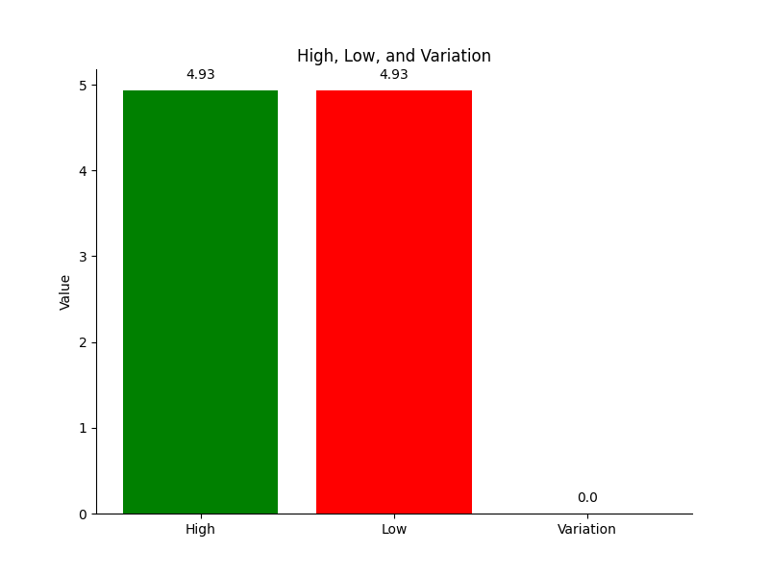

code: USD

codein: BRL

name: Dólar Americano/Real Brasileiro

high: 4.9338

low: 4.9338

varBid: 0.0003

pctChange: 0.01

bid: 4.9335

ask: 4.9342

timestamp: 1709079700

create_date: 2024-02-27 21:21:40