**Mission Scientist Report**

DC-8 Research Flight 04 (RF04) – 26 August 2021

Shuyi Chen (with contribution from Edo Mazza, Ajda Savarin, Amin Nehir)

Takeoff (UTC): 2021-08-26 1733  
Landing (UTC): 2021-08-27 0117

Science Objectives:

* Tropical Storm Ida over the Caribbean Sea
* Dynamic and thermodynamic processes in TC genesis
* Potential convection development offshore of Puerto Rico
* Land-sea circulation across Puerto Rico and coastal ocean (saildrones)
* Aeolus Cal/Val (a short underfly near Puerto Rico)

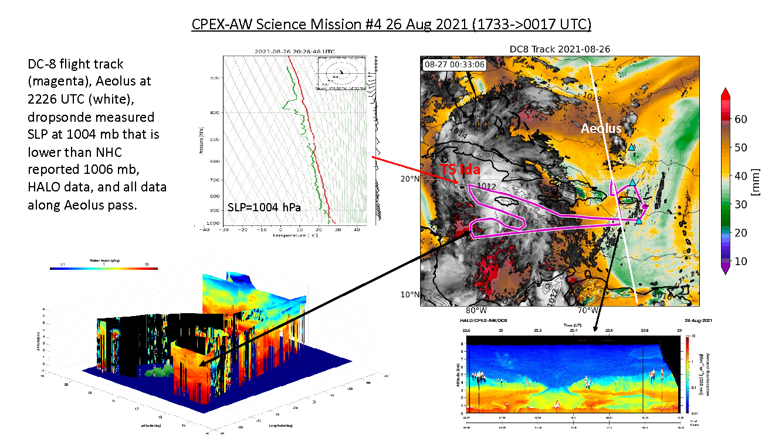

Figure 1. DC-8 flight track (magenta) and weather conditions as shown by satellite TPW and IR on 26 August 2021. Preliminary quick look of dropsonde and HALO data.

Outcome:

* Captured a closed low level center circulation and minimum SLP 1004 hPa in TS Ida
* PR sounding, DC-8, and Aeolus collocated measurements

Highlights:

-

**Instrument Performance:**

=Up =Provisional =Down =No Report

|  |  |  |  |  |
| --- | --- | --- | --- | --- |
|  |  |  |  |  |

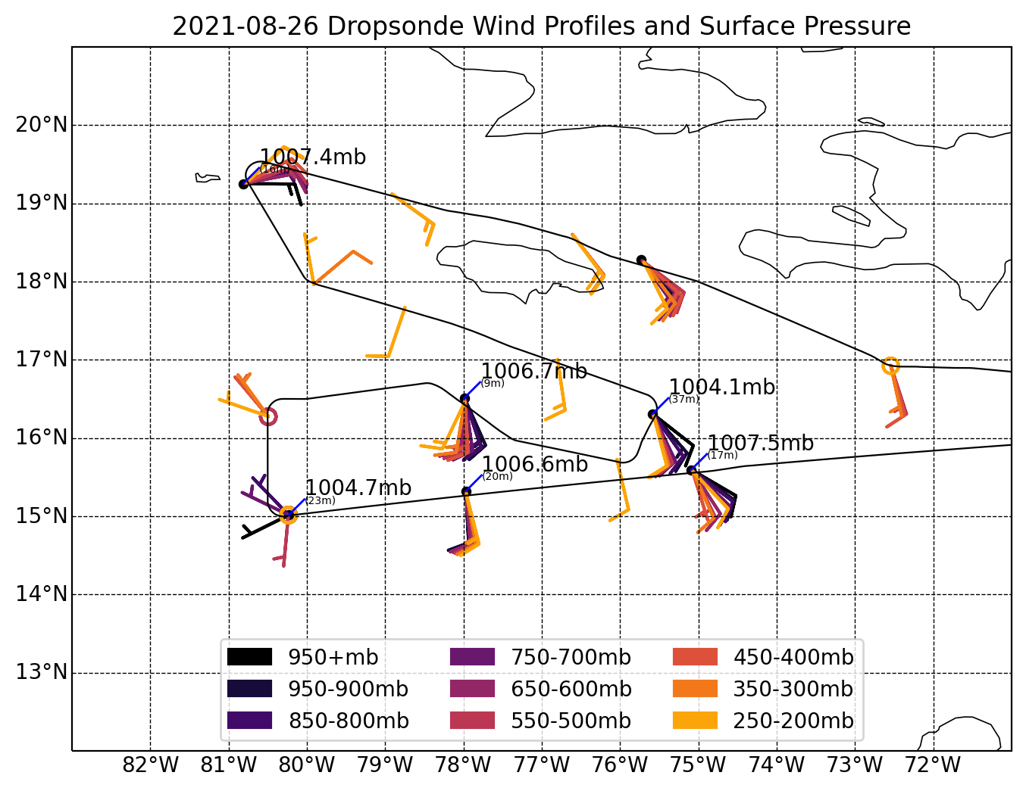

Figure 2. 3D circulation measured by dropsonde data.