# Software Requirements Specification (SRS) – Task Board

## **1. Introduction**

This SRS document describes the specifications of a Task Management Web Application. The purpose of this web application is to provide an interface for managing tasks. Users can create, view, and edit tasks. They can also view tasks organized by boards and search for specific tasks.

### **1.1 Purpose**

The purpose of this document is to outline the functional and non-functional requirements of the Task Board web application. It serves as a guide for the development team to design and implement the application according to the specified requirements. Additionally, it provides a reference for testers to create test cases and for stakeholders to understand the features and functionalities of the application.

### **1.2 Scope**

The Task Board application focuses on providing essential task management capabilities. Users can create tasks, assign them to specific boards, view task details, edit task information, and search for tasks based on keywords. The application also includes a Web API for advanced users to interact with the application programmatically.

### **1.3 Overall Description**

The Task Board application provides a user-friendly interface for managing tasks efficiently. It allows users to organize tasks based on different boards and provides features for creating, viewing, editing, and searching tasks. The application aims to streamline task management processes and improve productivity by offering intuitive and accessible functionalities.

## **2. Functional Requirements**

### **2.1 Home Page**

The Home Page serves as the main entry point for the Task Board application. It provides users with an overview of the available functionalities and allows easy navigation to other sections of the application. The following features and functionalities are present on the Home Page**:**

### **2.1.1 Welcome Message**

Upon accessing the Home Page, users are greeted with a "Welcome" message.

**2.1.2. Side Menu**Consistent across all pages and contains options for Home, Task Board, Create, and Search.

**2.1.3. Task Summary Section**

Display the total number of tasks available in the system.

Display a summary of tasks organized by boards, showing the board name and the number of tasks associated with each board.

**2.1.4. Quick Access Buttons**Below the summary section, providing quick access to important actions. The buttons should include options for Task Board, Create Task, Search Tasks, and RESTful API.

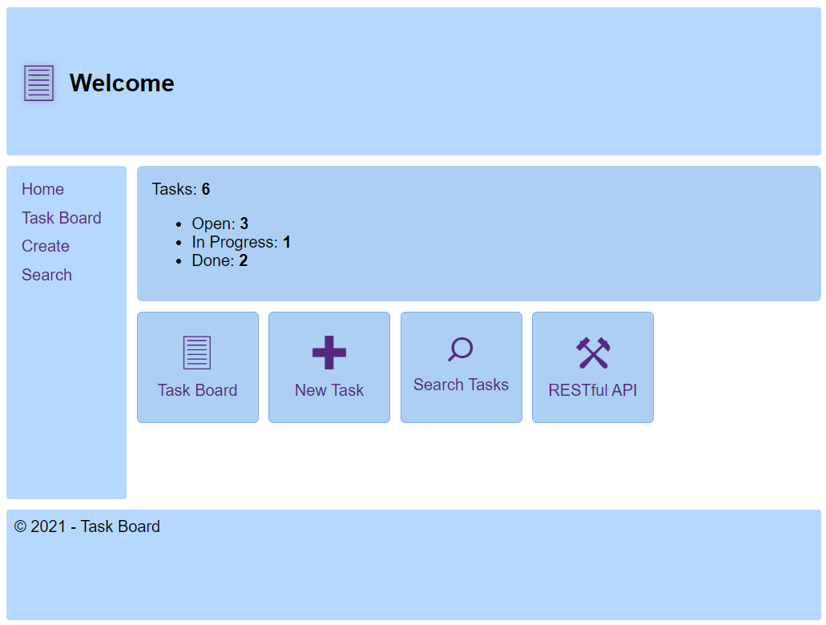

### **2.2. Task Board Page**

Display tasks organized by boards in a grid layout.

The boards should be ordered as follows: Open, In Progress, Done.

Each task should include the task title, a brief description, and action options such as "View" and "Edit."

Users can access the Task Board Page through the following methods:

* From the side menu: Users can select the "Task Board" option from the side menu, available on all pages of the application.
* From the quick access buttons: Users can click on the "Task Board" button located on the Home Page, providing a convenient shortcut to the Task Board Page.

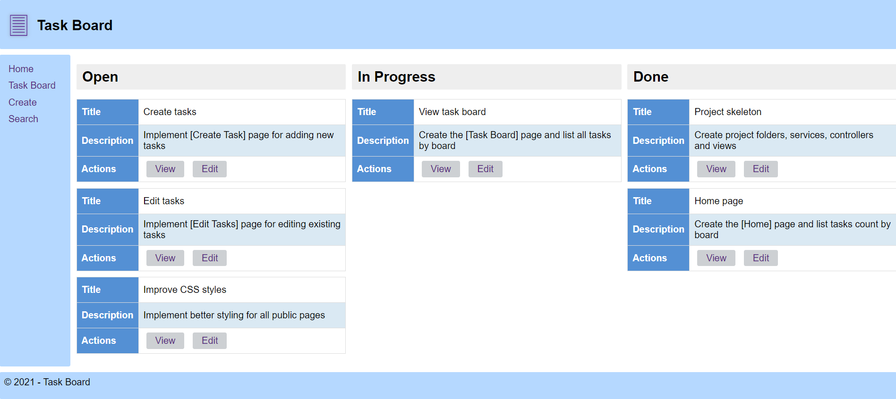

### **2.3. Task Creation**

Users can create a new task by navigating to the "Create" option from either the side menu, or by clicking on the "New Task" button located on the Home Page for quick access.

The task creation form requires the following information:

* **Title:** Users must provide a title for the task.
* **Description:** Users can optionally provide a description for the task.
* **Board:** Users need to select the board where the task will be placed.

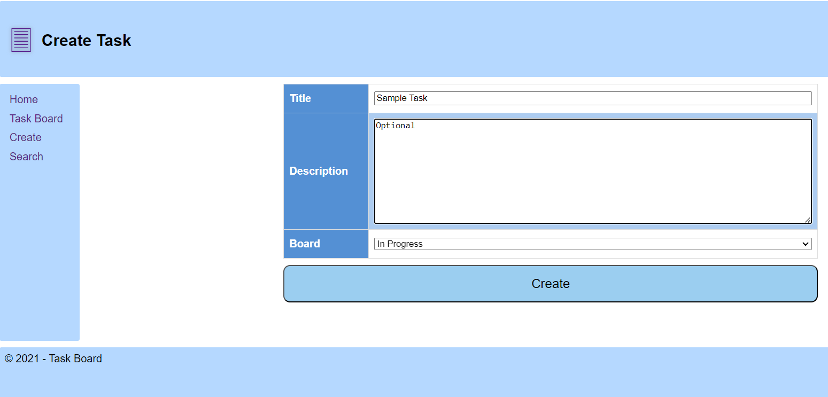

**Note:** Task creation should not be allowed without a title. The title field should be validated to ensure it is not empty before allowing the task to be created.

### **2.4. Task Viewing**

Users can view all tasks in the system organized by boards by selecting the "Task Board" option. Each task will display its title, a brief description, and action options. Users can also view the complete details of a task by clicking the "View" button associated with each task.

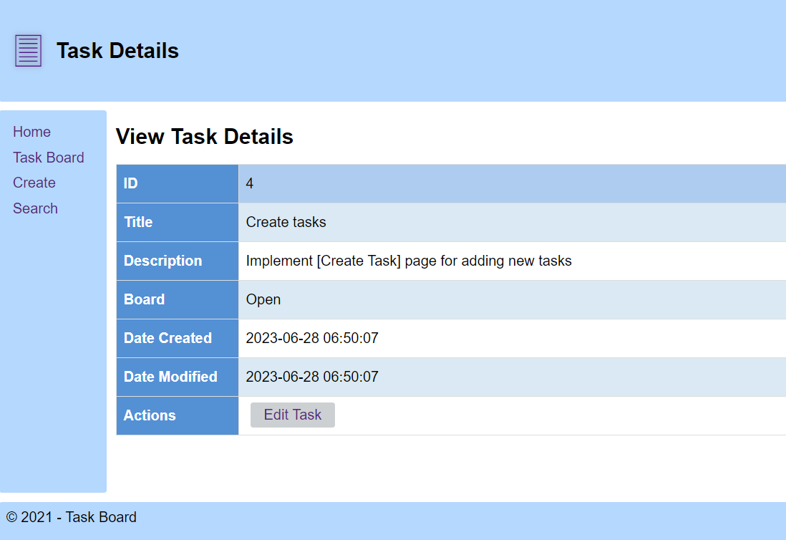

### **2.5. Task Editing**

For each task, there is an "Edit" option. Users can edit the title, description, or move the task to a different board. After editing, the user must click the "Edit" button to save the changes.

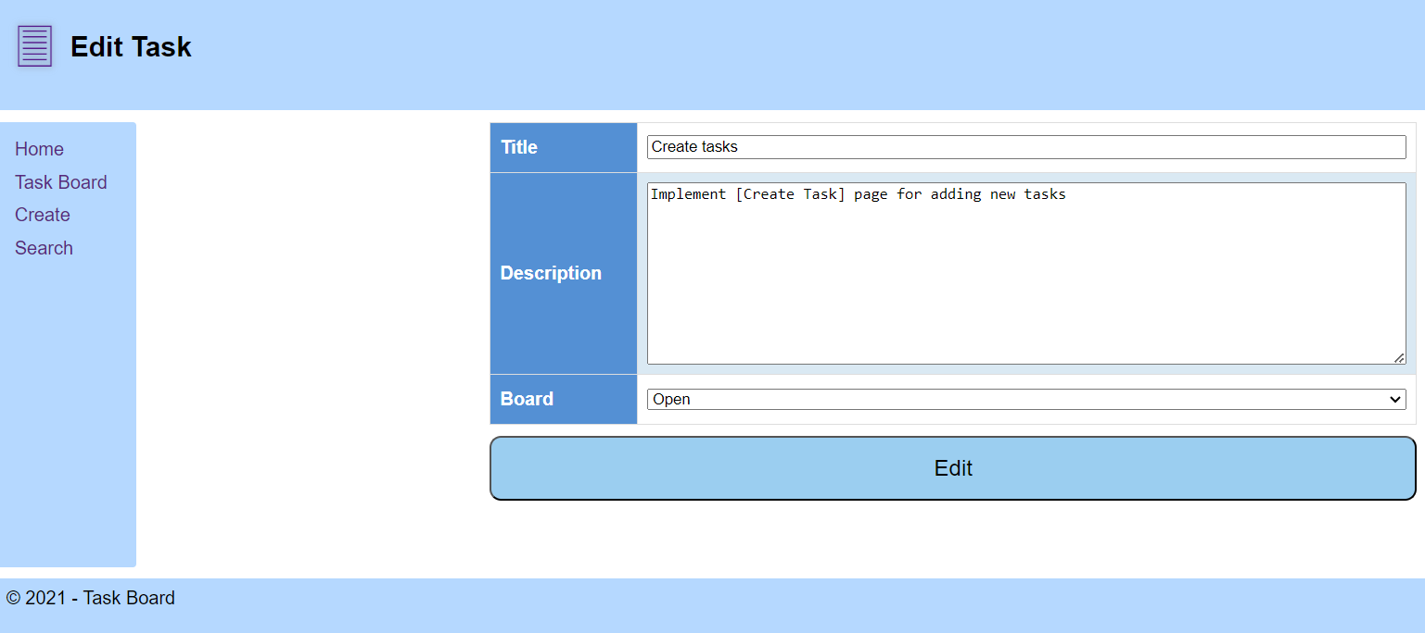

### **2.6. Task Searching**

Users can search for specific tasks by using the "Search" option, which is accessible from the side menu on all pages of the application, as well as from the quick access buttons on the Home Page. They need to provide a keyword, and the application will display all tasks whose title or description matches the keyword.

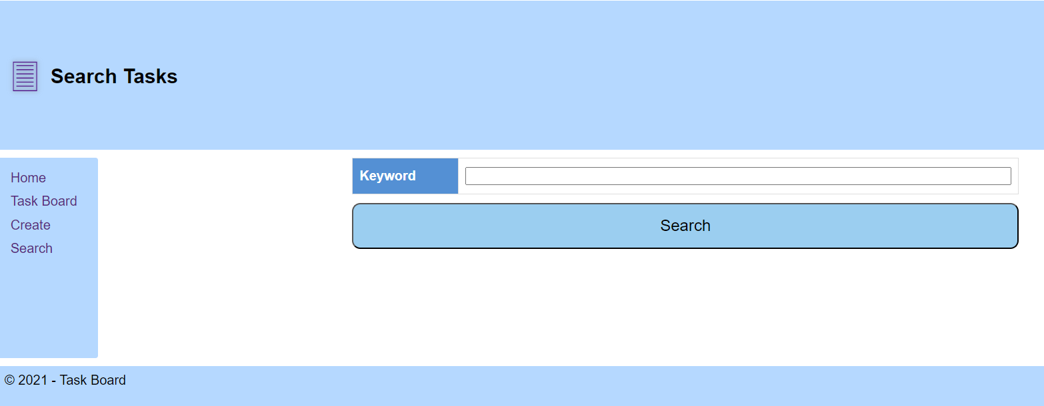

### **2.7. Search Results**

Upon performing a search, the application will present the search results on the search page in a clear and organized manner. Users will be able to view the total number of tasks found, which is indicated by a counter based on the search criteria. Each search result will provide essential information, including the task title, board name, and a brief description if available. Additionally, users have the option to initiate a new search by entering a different keyword in the search field and clicking on the "Search" button again.

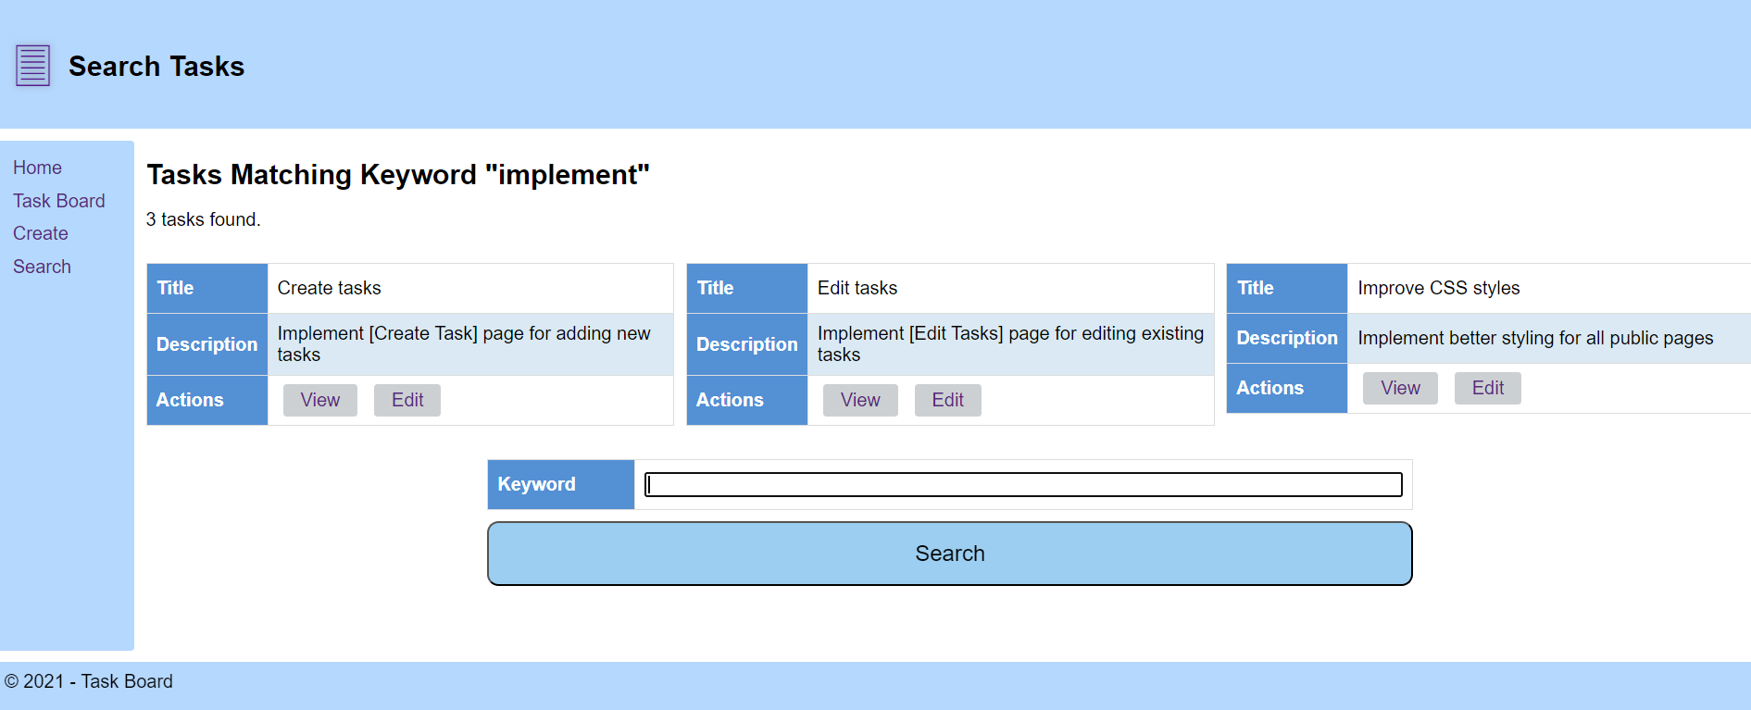

### **2.8 Web API**

**2.8.1 Accessing Web API**

Users can access the Web API by clicking on the "Web API" option from the Quick Access Buttons. The Web API provides a set of endpoints for performing CRUD (Create, Read, Update, Delete) operations on tasks. It allows users to interact with the application programmatically.

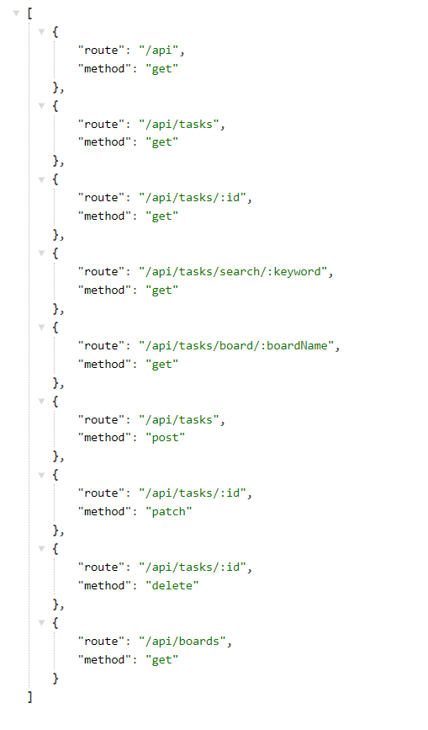

## **3. Non-Functional Requirements**

### **3.1 Usability**

The application should have a user-friendly interface with clear navigation menus. All pages should display the side menu with options to navigate to Home, Task Board, Create, and Search.

### **3.2 Performance**

The application should load tasks quickly, and the search functionality should return results in a timely manner.

### **3.3 Security**

Any data manipulation such as task creation and editing should be conducted over secure connections.

## **4. Use Cases**

### **4.1. Use Case: Accessing the App / View Home Page**

**Description:** The user should be able to access the Home Page of the Task Board application. Upon accessing the Home Page, the user should be greeted with a welcome message. The Home Page should include a side menu and Quick Access Buttons that allows navigation to different sections of the application. Additionally, the user should be able to view the total number of tasks available in the system and the count of tasks organized by boards.

### **4.2. Use Case: View Task Board**

**Description:** The user should be able to navigate to the Task Board page, where tasks are organized by boards. The Task Board should display tasks in the following order: Open, In Progress, Done. Each task should include a title, brief description, and action options for viewing and editing.

### **4.3. Use Case: Create Task**

**Description:** The user should be able to create a new task by providing a title, description (optional), and selecting the board for the task. It should be mandatory for the user to provide a title for the task. The application should validate the title field to ensure it is not empty before allowing the task to be created.

**4.4. Use Case: View Task**  
The user should be able to view the complete details of a task. This can be done by clicking on the "View" button associated with each task. The task details page should display information such as the task title, description, board, date created, and date modified.

### **4.5. Use Case: Edit Task**

**Description:** The user should be able to edit a task by modifying the title, description, or moving it to a different board. After making the desired changes, the user should be able to save the edits.

### **4.6. Use Case: Search Task**

**Description:** The user should be able to search for specific tasks by entering a keyword. The search results page should present relevant task information to the user, including the task title, board name, and a brief description if available. Additionally, the search results page should display a counter indicating the total number of tasks found based on the search criteria.

### **4.7. Use Case: Web API Documentation**

**Description:** The user should be able to access the API documentation, which provides detailed information about the available endpoints, supported request methods, request parameters, and response formats. The API documentation serves as a reference guide for developers or users who wish to integrate the application with other systems or build custom applications using the API.

The SRS document ends here. After this point, the software design and implementation process will start, and any changes in requirements will be updated in this SRS document. This SRS will be used by testers to create test cases and find any bugs in the system.

**5. API Endpoints**

Your task is to write API requests for certain RESTful API endpoints

· Get all boards

· Get all tasks

· Get the tasks from the board named "Done"

· Find tasks by keyword "home"

· Find tasks by keyword "missing "{randnum}"

· Create a new task

· Edit created task

· Delete existing task