# QA Fundamentals and Manual Testing Regular Exam



# Part I – Movie Catalog Web Application

You are provided with a web application, **Movie Catalog**, along with a specification of the requirements. The primary objective of the exam is to ensure **the App** works as expected according to the provided use cases. This involves **creating test cases for each of the** **USE CASES**. It also includes the **detection and detailed documentation of any identified bugs**. You have to document all your work in the provided **Test Management and Bug Tracker Template**.

## Software Requirements

### 1. Introduction

#### 1.1. Purpose

The objective of this document is to provide a description of the **Movie Catalog application** (also referred to as **the App**). It will present an overview of the key functionalities.

#### 1.2. Scope

This document includes high-level descriptions of the **basic functionalities of the App**, such as user registration, login, profile editing, adding movies and managing them. It does not cover any special user (Administrator) functionalities.

### 2. Overall Description

#### 2.1. System environment

**Movie Catalog** can be reached online and is designed for people who want to manage the movies they watch better. **The App** is available on the **following url**:

[**https://d24hkho2ozf732.cloudfront.net/**](https://d24hkho2ozf732.cloudfront.net/)

#### 2.2. Key Features

**Unregistered/non-logged users** have access only to the Landing page of the App, with the option to either **REGISTER** or **LOGIN**. On the other hand, **registered/logged users** have access to the **main functionalities**, including **Profile editing**, **Movie adding**, and **Movie management**.

##### 2.2.1. LANDING Page for unregistered / non-logged users

The **Landing Page** of Movie Catalog serves as the **primary portal** for the application. It features a **sidebar**, also known as a **navigation menu**, on the left-hand side, containing buttons **for ABOUT US, OUR SERVICES, LOGIN, REGISTER,** and **COPYRIGHTS**. The design of the Landing page is **scrollable**, meaning users can **navigate** to different sections either by **scrolling** or by **clicking on the corresponding buttons** in the navigation menu.

Upon loading, the page unfolds into **various sections**, each dedicated to a specific aspect of the application.

**The first section**, **ABOUT US** welcomes the user and provides a **brief introduction** to what users can expect from Movie Catalog, emphasizing the ease of managing a personal movie collection.

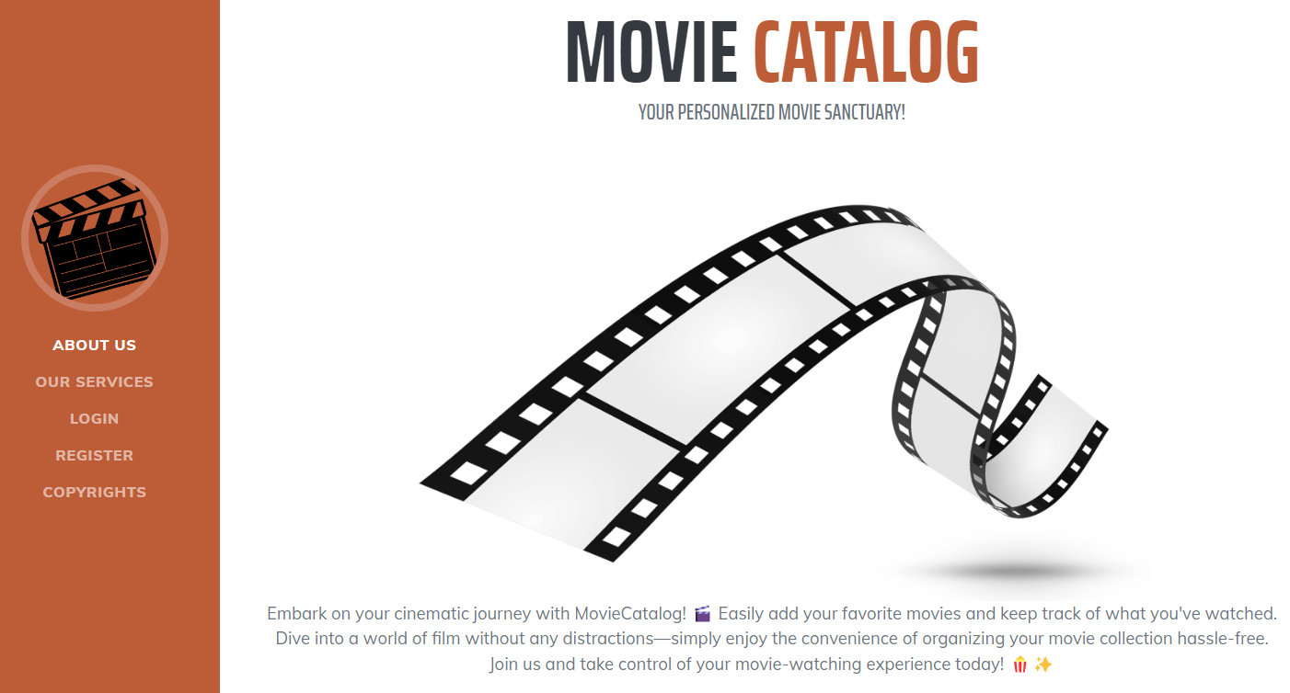

**The second section, SERVICES**, presents the **main features offered** by the website through a combination of icons and descriptive text. Users can learn about the convenience of adding new movie titles, utilizing their personal catalog, marking movies as watched, and deleting titles from their catalog. This part of the website can be accessed by **scrolling** or clicking on the **OUR SERVICES** **button** in the navigation menu.

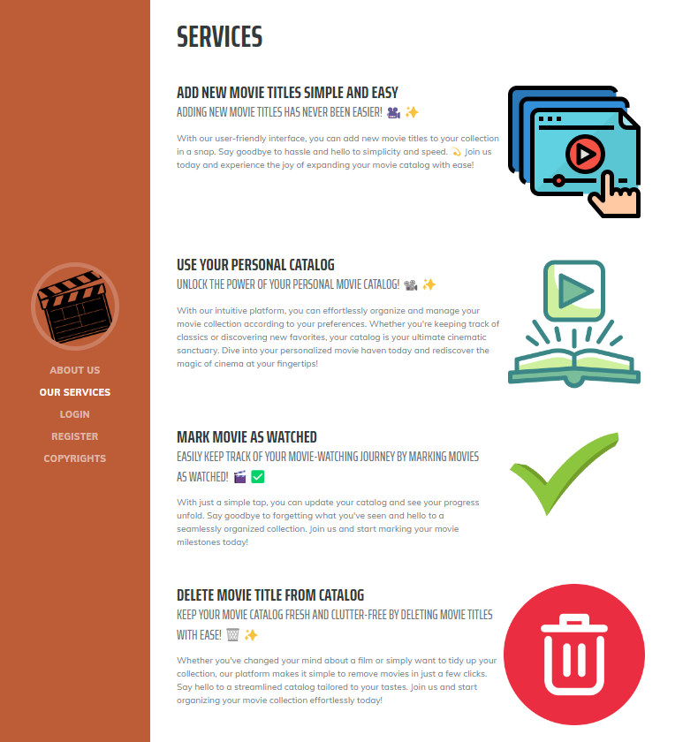

**In the third section, LOGIN**, returning users are welcomed and encouraged to access their personalized movie catalog by loging in. The section includes a **direct link to the login page**.

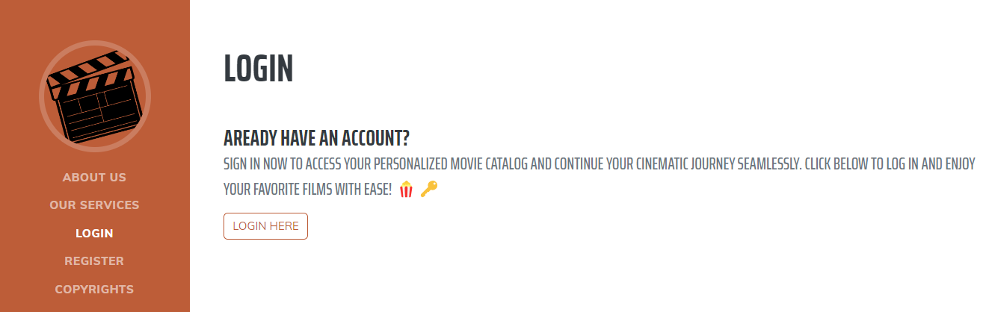

**The fourth section, REGISTER NOW**, invites new users to join Movie Catalog. It emphasizes the exclusive features available upon registration and provides a **quick link to the register process**.

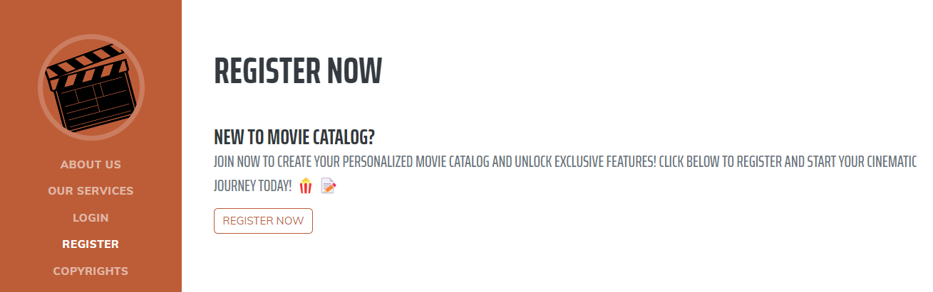

**The final section, COPYRIGHTS**, delineates the legal protections of the content and the terms and conditions for   
the Movie Catalog.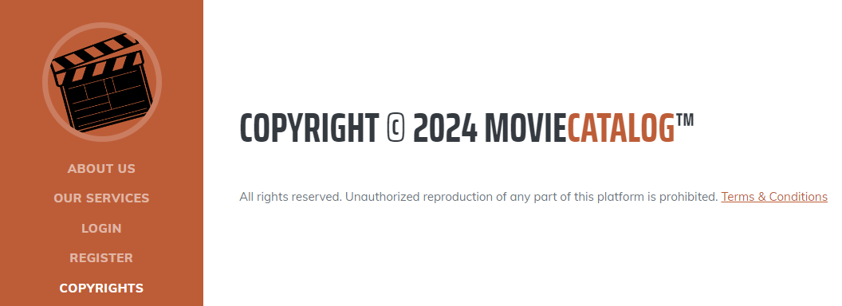

**"Terms & Conditions" part of the text is clickable** and it leads to **Terms of Service page**.

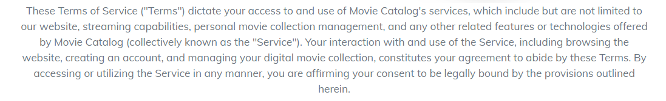

Each section is designed to be intuitive and user-friendly, ensuring that both new visitors and returning members can navigate the website with ease and enjoy their cinematic journey.

##### 2.2.2. REGISTER Form

**The Register Form** is accessed by scrolling down the Home page or by clicking **Register link** on the navigation menu and then clicking on the **Register Now button**. It contains form fields for entering a **First Name, Last Name, Username, Email, Password,** and **Repeat password**. The form also includes a **Register button to submit the form**. The acceptable requirements for each field are specified as follows:

**First Name:** A 1-80 character field, accepting all character types.

**Last Name:** A 1-80 character field, accepting all character types.  
**Username:** A 5-60 character field, accepting all character types.

**Email:** Requires a valid email address in the format 'something@domain.com'. The email does not have to be real but must be 6 characters long at minimum and follow the correct format.

**Password:** Any characters are acceptable, with a length of 6-30 characters.

**Repeat Password:** Must match password.  
Upon **clicking on Register button** and successful registration the user is redirected to the login screen.

Below the registration form is a quick link for existing members: "Already have an Account? **Login here**." This provides a fast track back to the login page.

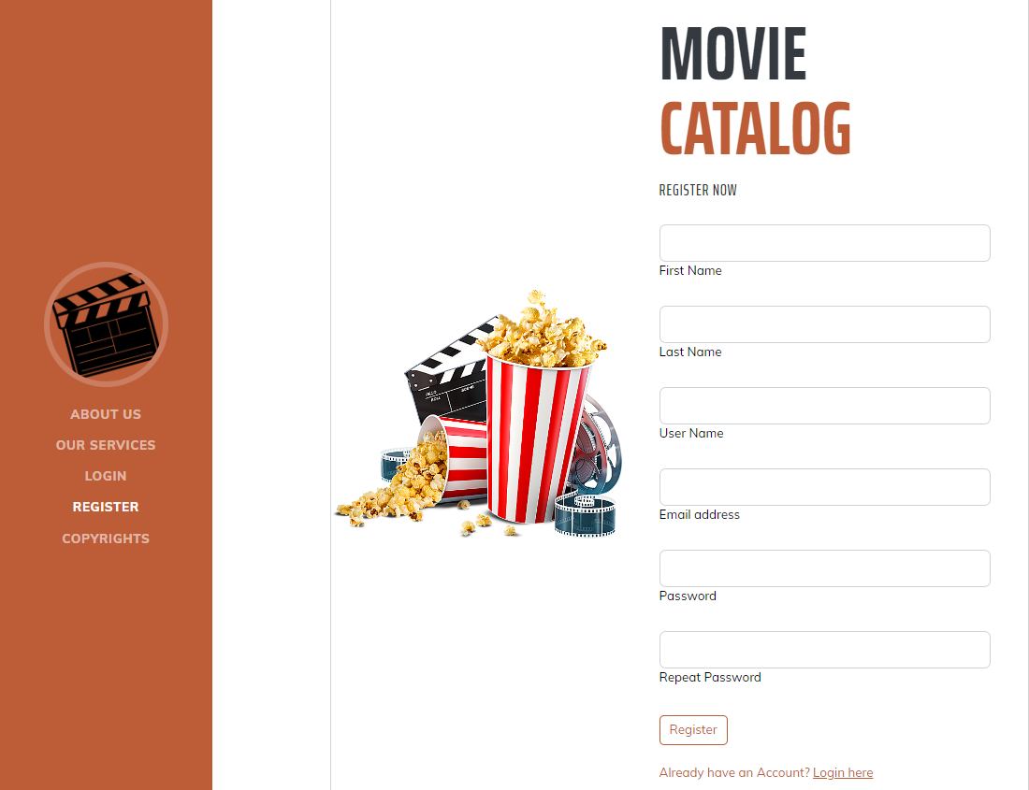

##### 2.2.3. LOGIN Page

The **Login page** is accessed by scrolling down the Home page or by clicking **LOGIN link** on the navigation menu and then clicking on the **Login Here button**.

Users can **enter their email address** and **password into the respective fields**. Below the login button, there are options for those who may need to **reset their password**. **Forgot Password** functionality leads to a Restore password page, where the password can be restored by verified email.

The links to the **Register page, 'Terms of use' and 'Privacy policy'** are provided at the bottom for easy reference.

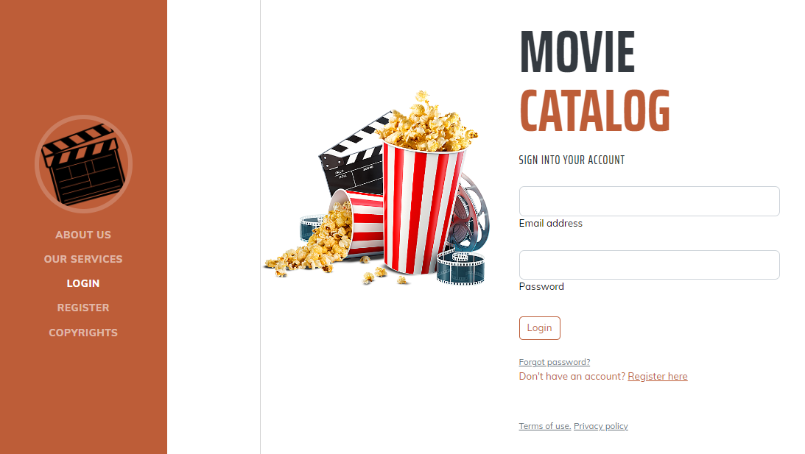

##### 2.2.4. HOME PAGE for logged users

The **Homepage for logged-in users** on Movie Catalog features again a sidebar with navigation options including **PROFILE PICTURE (Empty by default)**, **ADD MOVIE**, **ALL MOVIES**, **WATCHED MOVIES**, and **UNWATCHED MOVIES**, each leading to **different functionalities of the site**. The main area greets the user by its username. A brief description underscores the site as a destination for managing and enjoying a personal collection of movies. There’s also a **LOGOUT** option at the bottom of the sidebar for when users wish to exit their session.

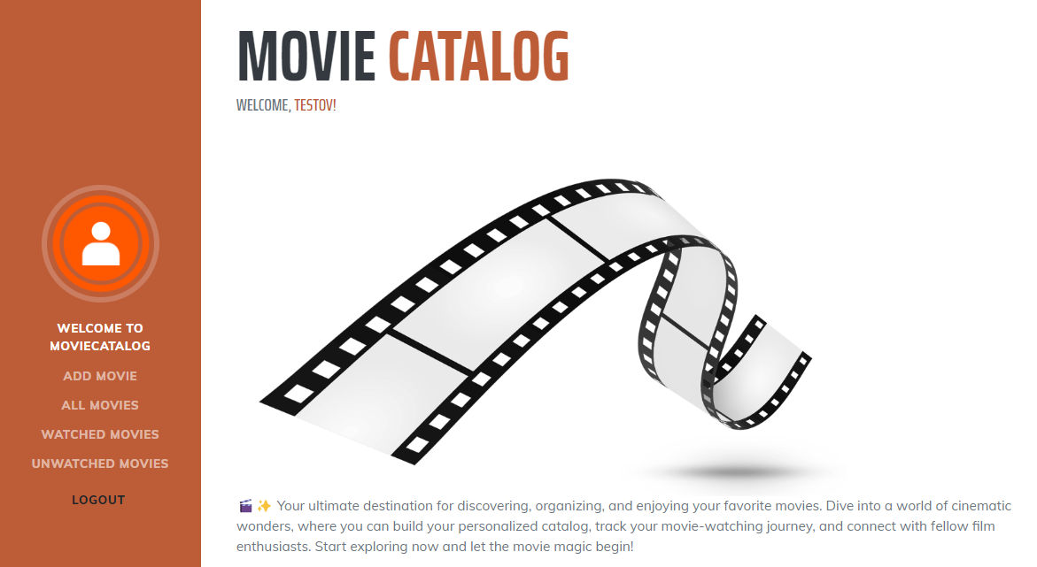

##### 2.2.5. PROFILE INFO PAGE

The **Profile Info page** is accessible for logged users by **clicking on the profile icon/picture on the Sidebar**. It includes a **default empty profile picture**, the username and the email of the current user, three counters for movies: all movies, watched movies, non-watched movies, **each set to 0 by default**. There is also an **Edit button**.

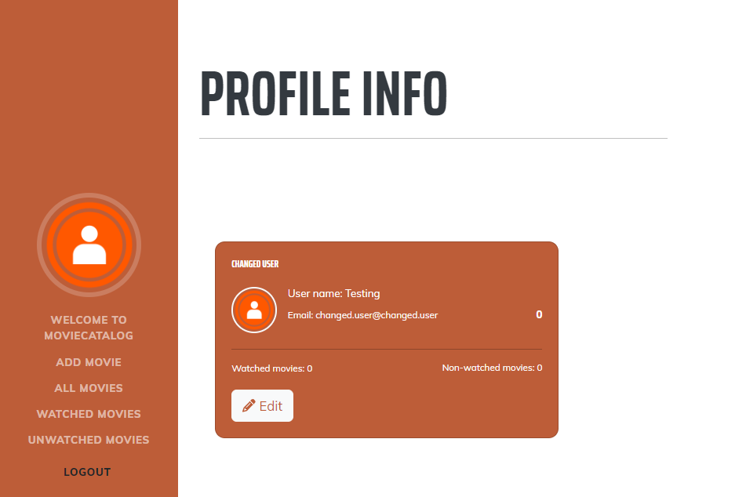

##### 2.2.6. EDIT PROFILE Page

Accessible from **Edit button on Profile Info**, this page allows **users to** **edit their profile information**, including **First name**, **Last name**, **Email**, **Username** and also to **add** **Profile image** (picture is not uploaded, but must be a **valid URL of a picture,** for example http://......jpg),

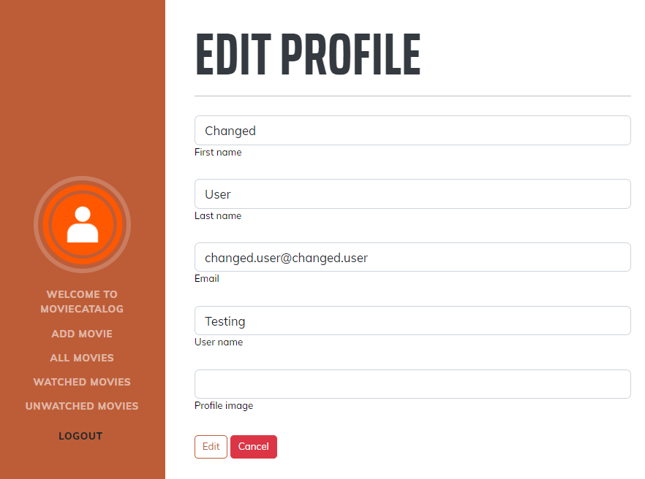

Changes are **saved by clicking the Edit** button, or **discarded with Cancel.**

##### 2.2.7. ADD MOVIE Page

When users click on the **Add Movie** option in the sidebar of Movie Catalog, they're directed to a form where they can enter details about a new movie to add to their catalog. The form requires a **movie title, with a minimum of 1 character and a maximum of 120, and allows for a description up to 256 characters.** The **title and the description are required**. Users can also provide a poster URL, which must match standard image file formats, and a **YouTube trailer link**. There's also an option to immediately **mark the movie as watched** before submitting the form with the **Add** button or canceling with **Cancel**.

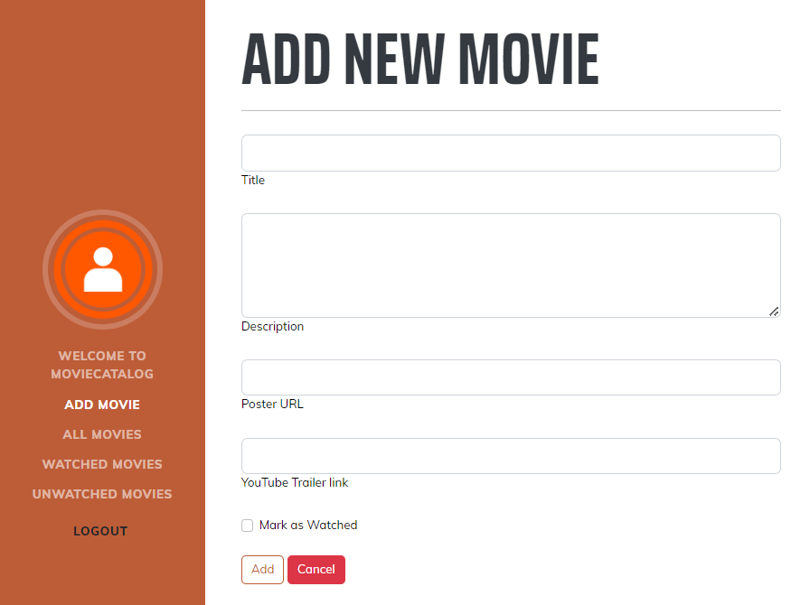

##### 2.2.8. ALL MOVIES Page

Upon adding a new movie user is redirected to **ALL MOVIES** **page**, which also is available through the Sidebar. On the All Movies page of Movie Catalog, users are presented with a **display of their entire movie collection**. Each movie in the catalog is showcased on a dedicated card that includes the title and a brief description, which are mandatory fields. If provided during the addition process, the movie's poster and a link to its YouTube trailer are also displayed, enhancing the visual appeal and providing quick access to the trailer. For each movie, there are options to **View details, Edit, or Delete**, allowing for easy management. Additionally, users can quickly **mark movies as watched or unwatched** with corresponding buttons. The movies are paginated, with this page showing three movies, and navigation options to move between pages.

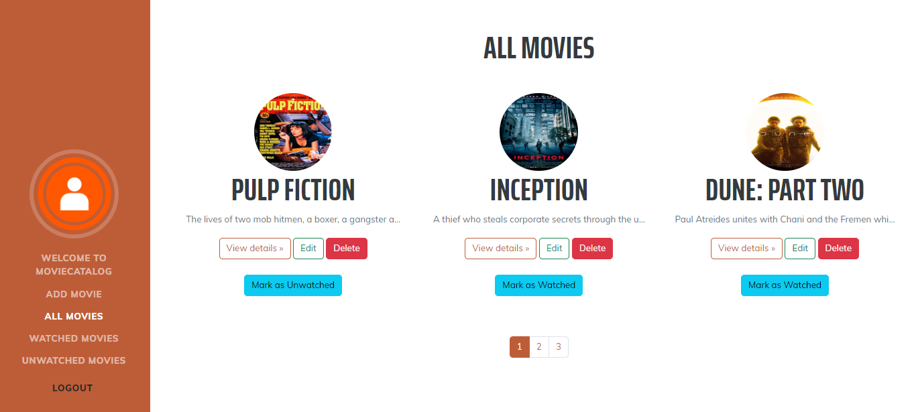

##### 2.2.8. WATCHED / UNWATCHED Pages

In the Movie Catalog, both the **WATCHED** Movies and **UNWATCHED** Movies sections display movies similar to **ALL MOVIES** Page. Users can interact with each movie card through options to **View details, Edit, or Delete** the movie. Additionally, each movie can be marked as Watched or **Unwatched** depending on its current status, allowing users to easily manage their viewing history.

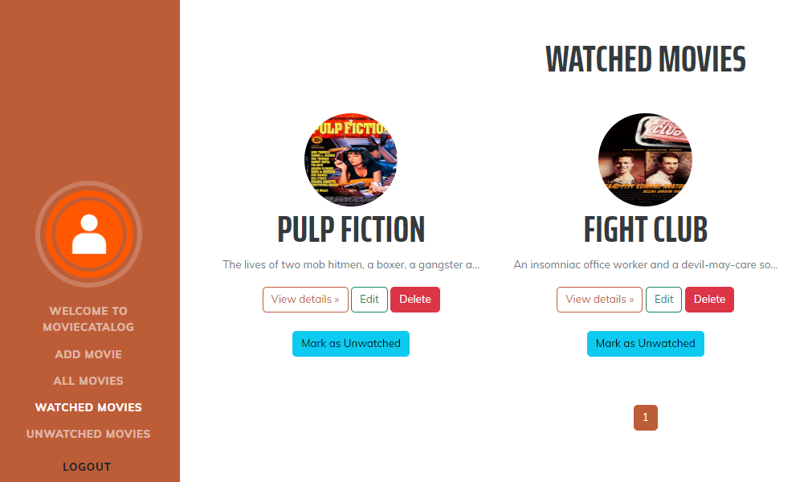

##### а. View Details

Available after clicking on **VIEW Details button**. The user is able to VIEW the movie. Also have the option to EDIT it or navigate back to the previous page.



##### b. EDIT

Available after clicking on **EDIT button**. All details of the movie is editable, including: Title, Description, Poster URL, YouTube Trailer link.

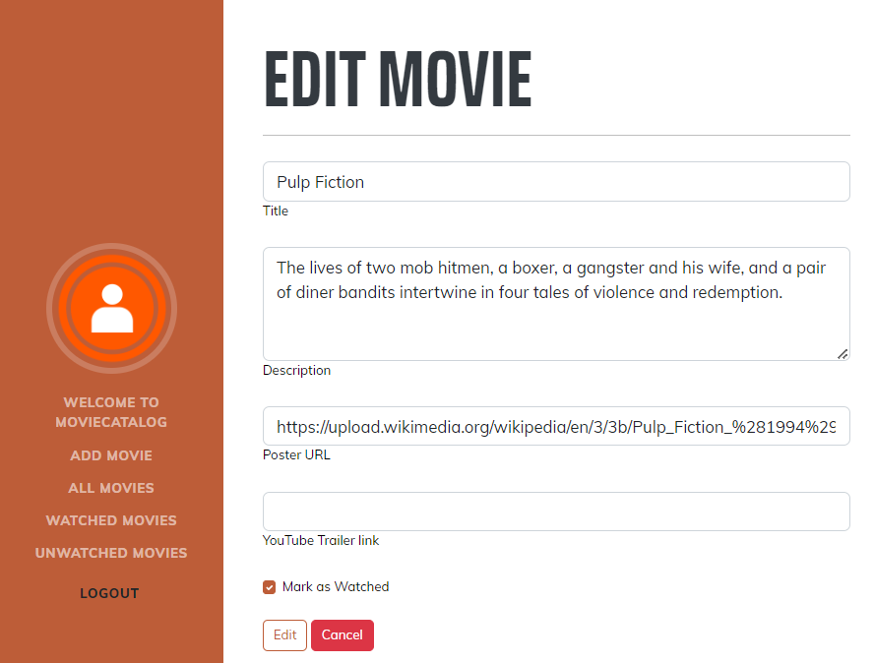

##### c. DELETE

After clicking on **DELETE button**, the user is asked to confirm the deletion with simple **yes/no option**. If yes is chosen, the movie disappears from the collection.

## Functional Requirements

### 1. Use Case 1 (Landing Page / Home Page)

Users should be able to access The Movie Catalog App from its designated URL via the Internet, which should load the Landing page / Home page, appropriate to the user's logged-in status (unregistered/non-logged or registered/logged).

### 2. Use Case 2 (User Registration)

Unregistered users should be able to successfully go through the Register process. This involves the utilization of fields such as First Name, Last Name, Username, Email, Password and Repeat Password, all subject to their respective constraints and character type acceptance.

### 3. Use Case 3 (User Login)

Registered users should be able to successfully go through the Login process. They should be able to log in using Email and Password. Users also should be able to recover their password via Forgot Password functionality.

### 4. Use Case 4 (Profile Management)

Upon successful Login, logged users should be able to navigate to their Profile Info page, edit their profile details, and view their Movies count. This involves the changing of profile picture inserted via URL, and editing of user data fields including First Name, Last Name, Email and Username sections.

### 5. Use Case 5 (Adding Movies)

Logged users should be able to navigate to the Add Movie page, where they can add a new Movie with a Title, Description, Picture (URL), and an youtube link (URL). After the Movie is added, users should be redirected to All Movies page, where the newly added Movie should be present.

### 6. Use Case 6 (Movies Management)

On All Movies Page, logged users should see all their Movies listed. Each Movie should have options for View Details, Edit, Delete, and an option to mark the movie as watched or unwatched depending on its current status. Watched Movies and Unwatched Movies pages should operate in a similar manner with the same options.

## Movie Catalog Web App Tasks

### **1. Test Cases**

You need to write **test cases** **for each of the** **6 Use cases**.  
**Each Use case** should have at **least 2 Test Cases**.

You should write **at least 15 test cases**.

### 2. Bug Reports

You should find and describe at least **5** bugs.

**2 of the bugs** should have **high priority** OR **blocking/critical severity**.

### 3. Template Use the provided Test-Management-and-Bug-Tracking-Template.xlsx to document your work.

# Part II – Movie Catalog API

This section provides information about the **Movie Catalog API endpoints** and their functionalities. It serves as a guide to understand how to interact with the Movie Catalog API. The API is available and all supported endpoints can be found here:

[**https://d24hkho2ozf732.cloudfront.net/api**](https://d24hkho2ozf732.cloudfront.net/api)

**The endpoints that you will need for the current exam, are as follows:**

### 1. User

* POST /api/User/Register – create a new user: post a JSON object in the request body, e.g.   
  {

"userName": "string",

"firstName": "string",

"lastName": "string",

"email": "user@example.com",

"password": "string",

"rePassword": "string"

}

* POST /api/User/Authentication: log in an existing user: post a JSON object in the request body, e.g.   
  {

"email": "user@example.com",

"password": "string"

}

### Access Token

* When a user logs in, the response format is JSON object, e.g.   
  **{**"email": " user@example.com", **"password": "string", "accessToken": "eyJhbGciOiJ…"}**

**NB! Access token is needed for all movie requests. It should be placed under the Authorization tab, Bearer Token option.**

### 2. Movie

All of the **following requests require Authorization**.

* **POST /api/Movie/Create** – add a new movie to the catalog: post a JSON object in the request body, e.g.   
  **{**

**"title": "string",**

**"description": "string",**

**"posterUrl": "",**

**"trailerLink": "",**

**"isWatched": true**

**}**

**Keep in mind:**

To **add / edit** a movie, the **title** and the **description** are **mandatory**.

**posterUrl**, **trailerLink** and **isWatched** are optional. You can add a movie without them.

If you decide to use the **posterUrl** attribute, notice, that it has to point to a picture format or it can be left blank.

If you decide to use the **trailerLink** attribute, notice, that it has to point to an YouTube video or it can be left blank.

If you decide to use the **isWatched** attribute, notice, that it has only two values true or false.

* PUT /api/Movie/Edit– replace the existing movie with the new one: post a JSON object in the request body, e.g.

**{**

**"title": "string",**

**"description": "string",**

**"posterUrl": "",**

**"trailerLink": "",**

**"isWatched": true**

**}**  
**Requires queryParameter: ?movieId={movieId}**

**HINT:** 

* DELETE **/api/Movie/Delete** – delete existing movie;   
  **Requires queryParameter: ?movieId={movieId}**

**HINT:**



### 3. Catalog

GET **/api/Catalog/All** – get all movies;

## Movie Catalog API Tasks: Postman Requests

Your task is to write **API requests** with Postman for certain RESTful API endpoints.  **You should organize your requests in a collection.**

### **1. Log in to the API**

**Send a POST request with your email and password**, that you previously created from the Movie Catalog Web App. If properly executed, you will receive your access token as a part of the response body. Use it as a Bearer Token in the Authorization section for the next requests.

### 2. Add a new movie

**Send a POST request with the attributes needed for adding a new movie.**

### 3. List all movies

**Send a GET request to receive a list of all added movies**.

This request will return all movies created through your profile. So, if you created any movies via the Web App, they also will be listed.

### 4. Change the title of the movie you added

**Send a PUT request with the attributes needed to replace the title of the movie you created in the second task.** The movieId could be obtained from the previous request.

### 5. Delete Revue

**Send a DELETE request with the attributes needed for deleting the movie you just edited.**

**IMPORTANT:**

* **Export your collection of request in Collection v.2.1 format. The export will create a JSON file.**
* **Make sure that the exported collection can be imported back, e.g. it opens with Postman without problems.**
* **Do not delete ot alter the data in the exported JSON file.**

# How to submit your work

**1. Create a .zip or .rar archive containing the following:**

* For the first task: **Test-Management-and-Bug-Tracker.xlsx** file;
* For the second task: **JSON file containing your collection of requests, created via Postman**.

**2. Upload your archive on the SoftUni website, into Regular Exam section.**