Git Basic Concepts:

1) Snapshots, Not Differences
Conceptually, most other systems store information as a list of file-based changes.
over(this is commonly described as delta-based version control).
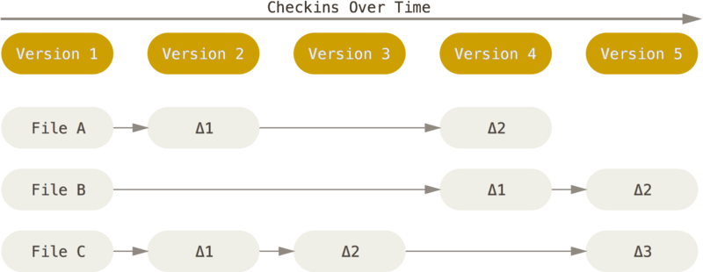
Figure 4. Storing data as changes to a base version of each file.

Git thinks of its data more like a series of snapshots of a miniature filesystem
about its data more like a stream of snapshots.
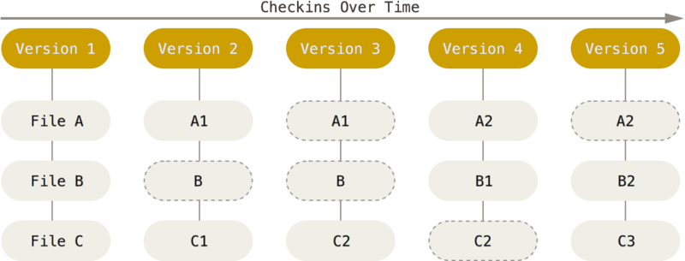
Figure 5. Storing data as snapshots of the project over time.

2) Nearly Every Operation Is Local
3) Git Has Integrity
Everything in Git is check-summed before it is stored and is then referred to by that checksum. This means it’s impossible to change the contents of any file or directory without Git knowing about it.
The mechanism that Git uses for this checksumming is called a SHA-1 hash. This is a 40-character string composed of hexadecimal characters (0–9 and a–f) and calculated based on the contents of a file or directory structure in Git. A SHA-1 hash looks something like this:
24b9da6552252987aa493b52f8696cd6d3b00373
You will see these hash values all over the place in Git because it uses them so much. In fact, Git stores everything in its database not by file name but by the hash value of its contents
4) Git Generally Only Adds Data
5) The Three States
Git has three main states that your files can reside in: committed, modified, and staged:
- Committed means that the data is safely stored in your local database.
- Modified means that you have changed the file but have not committed it to your database yet.
- Staged means that you have marked a modified file in its current version to go into your next commit snapshot.
This leads us to the three main sections of a Git project: the Git directory, the working tree, and the staging area.
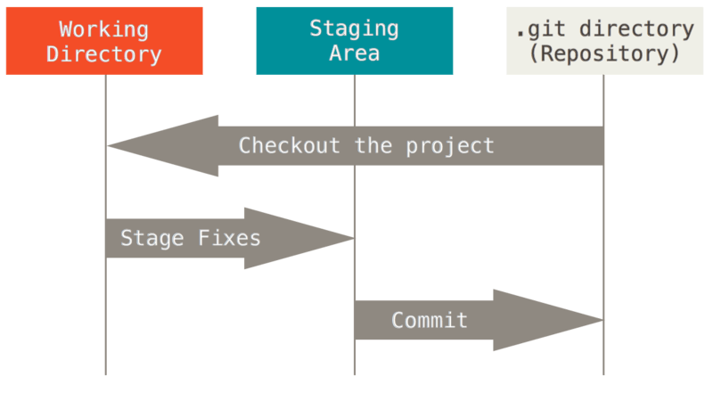
Figure 6. Working tree, staging area, and Git directory.

The staging area is a file, generally contained in your Git directory, that stores information about what will go into your next commit. Its technical name in Git parlance is the “index”, but the phrase “staging area” works just as well.

6) Git commands:

Git task | Notes | Git commands
Tell Git who you are | Configure the author name and email address to be used with your commits.  Note that Git strips some characters (for example trailing periods) from user.name. | git config --global user.name "Sam Smith"  git config --global user.email sam@example.com
Create a new local repository |  | git init
Check out a repository | Create a working copy of a local repository: | git clone /path/to/repository
Check out a repository | For a remote server, use: | git clone username@host:/path/to/repository
Add files | Add one or more files to staging (index): | git add <filename>  git add *
Commit | Commit changes to head (but not yet to the remote repository): | git commit -m "Commit message"
Commit | Commit any files you've added with git add, and also commit any files you've changed since then: | git commit -a
Push | Send changes to the master branch of your remote repository: | git push origin master
Status | List the files you've changed and those you still need to add or commit: | git status
Connect to a remote repository | If you haven't connected your local repository to a remote server, add the server to be able to push to it: | git remote add origin <server>
Connect to a remote repository | List all currently configured remote repositories: | git remote -v
Branches | Create a new branch and switch to it: | git checkout -b <branchname>
Branches | Switch from one branch to another: | git checkout <branchname>
Branches | List all the branches in your repo, and also tell you what branch you're currently in: | git branch
Branches | Delete the feature branch: | git branch -d <branchname>
Branches | Push the branch to your remote repository, so others can use it: | git push origin <branchname>
Branches | Push all branches to your remote repository: | git push --all origin
Branches | Delete a branch on your remote repository: | git push origin :<branchname>
Update from the remote repository | Fetch and merge changes on the remote server to your working directory: | git pull
Update from the remote repository | To merge a different branch into your active branch: | git merge <branchname>
Update from the remote repository | View all the merge conflicts:  View the conflicts against the base file:  Preview changes, before merging: | git diff  git diff --base <filename>  git diff <sourcebranch> <targetbranch>
Update from the remote repository | After you have manually resolved any conflicts, you mark the changed file: | git add <filename>
Tags | You can use tagging to mark a significant changeset, such as a release: | git tag 1.0.0 <commitID>
Tags | CommitId is the leading characters of the changeset ID, up to 10, but must be unique. Get the ID using: | git log
Tags | Push all tags to remote repository: | git push --tags origin
Undo local changes | If you mess up, you can replace the changes in your working tree with the last content in head:  Changes already added to the index, as well as new files, will be kept. | git checkout -- <filename>
Undo local changes | Instead, to drop all your local changes and commits, fetch the latest history from the server and point your local master branch at it, do this: | git fetch origin  git reset --hard origin/master
Search | Search the working directory for foo(): | git grep "foo()"

