Elliot Bay Industries

2019-02-19

Proprietary Information

Assembly Instructions for the McFly Transmitter Circuit Board

Part number: EllBayInd-TxLRU-v3p0

Assembly Notes:

1. All soldering to be performed using RoHS compliant lead-free solder and water soluble flux.

2. This assembly is static sensitive and must be handled as such.

3. PCBA to be assembled per IPC-A-610, Class 2 Requirements.

4. For moisture sensitive components,follow each manufacturers' instructions and refer to IPC/JEDEC J-STD-20 MSL.

5. Install all components listed on BoM, unless noted DNI.

6. Observe polarity on connectors.

7. When depaneling, leave no loose material or material extending beyond the edge of the PCB.

8. Do Not Install

MK201, MK202, MK203, MK204, MK205, MK206, MK207, MK208, MK209, J202, J203, J204, J205, J206, J207, J208, J209, J210, J211 – There are no parts associated with these footprints.

Attached Files Index:

|  |  |  |  |
| --- | --- | --- | --- |
| **#** | **Filename** | **Purpose** | **Description or note** |
| 1 | EllBayInd-TxLRU-v3p0-BoM.xls | Bill of Mat | Parts list with reference designators |
| 2 | EllBayInd-TxLRU-v3p0.d356 | CAM Info |  |
| 3 | EllBayInd-TxLRU-v3p0-top.pos | CAM Info | Placement locations and orientation |
| 4 | EllBayInd-TxLRU-v3p0-layout.pdf | Reference | Plot of each PCB layer |
| 5 | EllBayInd-TxLRU-v3p0-RC1-gerbers.zip | CAM Info | Gerber files for PCB manufacture |
| 6 | EllBayInd-TxLRU-v3p0-Assembly_Instructions.docx | CAM Info | Overview and exception information (this file) |

PCB Specifications

Material Type: 370HR

Layer Count: 4  
Material Thickness: 0.062"  
Finish Plating: Lead Free Solder  
X Dimension: 4.331  
Y Dimension: 5.91  
Array X Dimension: N/A  
Array Y Dimension: N/A  
Array Up: N/A  
Outer Copper Wt: 1 oz  
Inner Copper Wt: 0.5 oz  
Castellated Holes: No  
Min. Castellated Hole Size: N/A  
Solder Mask Sides: Both Sides  
Solder Mask Color: Green  
Silkscreen Sides: Both Sides  
Silkscreen Color: White  
Tab Route: No  
Scoring: No  
Plated Slots: No  
Plated Edges: No  
Controlled Impedance: No  
Controlled Dielectric: No  
Gold Fingers: None  
ITAR: No  
CounterSink: No  
# Plated CounterSinks: 0  
# Non-Plated CounterSinks: 0  
CounterBore: No  
# Plated CounterBores: 0  
# Non-Plated CounterBores: 0  
Certification: IPC Class 2-A600  
AS9100: No  
Via-In-Pad: None  
Blind/Buried Vias: None  
Microvias: None  
Soldermask Plugged Vias: No

Reference Images

Layout – Top View

Red = Top Copper

Inner ground layer turned off for clarity

Pink = Inner Copper

Green = Bottom Copper

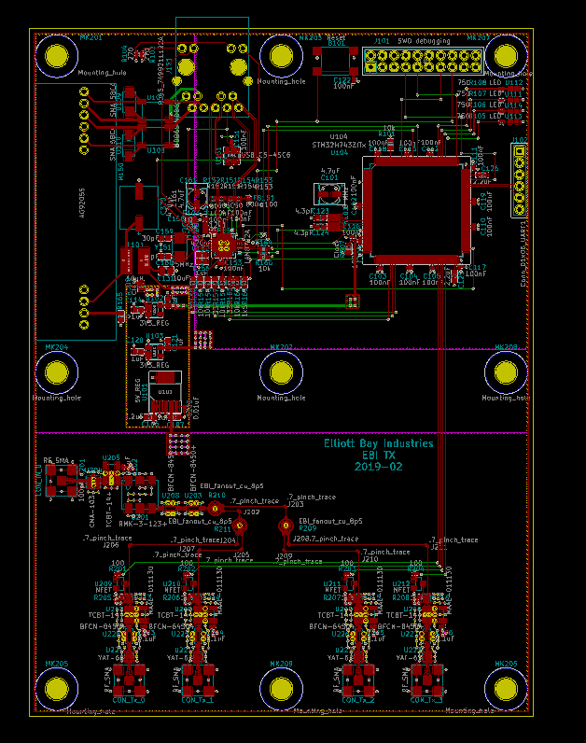

3D view top and bottom:

