Data visualization Project  
a storytelling dashboard about health Quality

January 2019

**Team Members:** Cuong Huynh Erica Rosa Jensen Binoji Ted Stagner

## Project Topic and Rationale

One of the healthcare industry’s main challenges is improving health outcomes while reducing costs. The health of a population can be characterized by understanding two important measures: the accessibility to health services and the quality of health services. We will build an interactive dashboard which will take a focused look at end-stage renal disease health quality, via CMS Quality Incentive Program Reporting Data.

## Dataset

**Data Source:** ESRD QIP Measures Data ([link](https://catalog.data.gov/dataset?q=qip&sort=views_recent+desc&publisher=Centers+for+Medicare+%26+Medicaid+Services&organization=hhs-gov&as_sfid=AAAAAAWFyfg2ZtMvhEdwfIRubVd_OPL2ApXXDeHLbzyVydMJPvrVA_1YMicXYC8FvuHYRSn5wpu2CXh_DcaVA_EaudJ7Oa1MVICS3iBGjRY6ypJesXHLmdOurdYLzCZXxBW_8bU%3D&as_fid=5ed58c8575d7bd19e491e769888c273657ac799e&ext_location=&ext_bbox=&ext_prev_extent=-142.03125%2C8.754794702435618%2C-59.0625%2C61.77312286453146))

**Format:** CSV / JSON

**Visualization ideas:**

* Chloropleth map of state average scores
* Map with clusters of how many clinics reported data by zip code
* Bar plots of state averages filtered by highest /lowest five performing states
* Scatterplot of state averages, with different metrics able to be selected as the X and Y axes (similar to D3 advanced homework)

## Inspiration

## Image result for interactive dashboard health performance

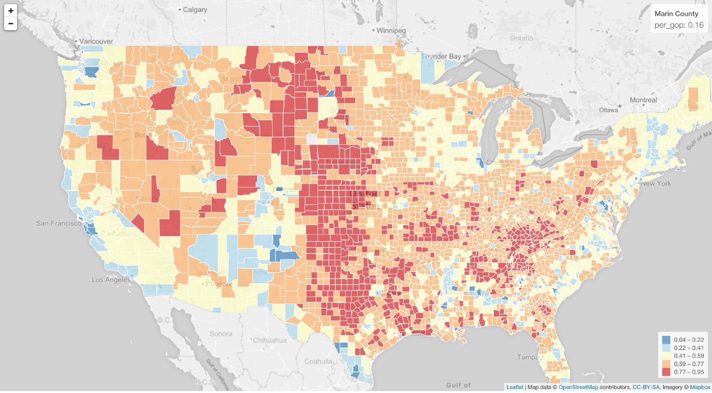

## Sketch

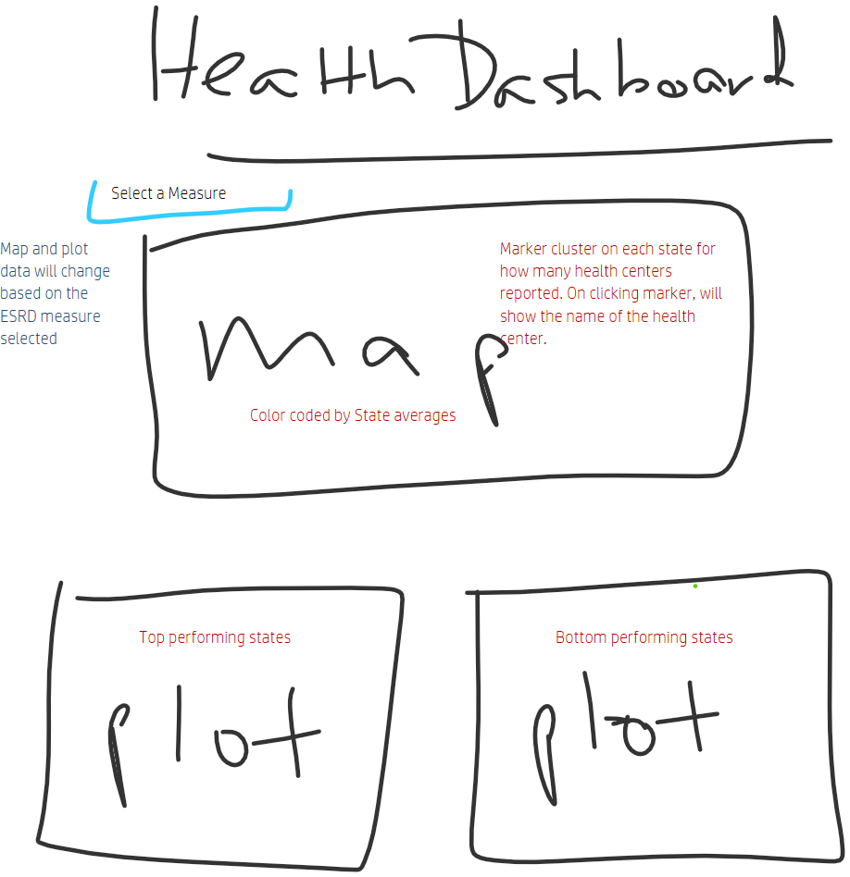

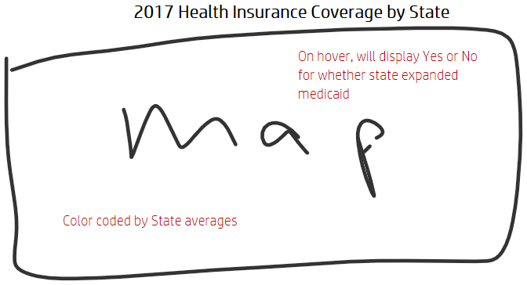

## Repo:

<https://github.com/ghteds/project3>

**Tasks:**

1. Use jupyter notebook to create dataframes that will feed the visualizations

* Pandas merge to add lat/lon to datasets (zipcodes.csv)
* A df for each metric, all data
* A df for each metric, state averages

1. Etl into mysql (ex. etl project) or flask route to mongo (ex. mission to mars hw)

1. Build HTML

* Metrics buttons
* <div id="chloromap"></div>
* <div id="lowbar"></div>
* <div id="highbar"></div>
* <div id="clustermap"></div>
* <div id="scatter"></div>

1. Build Flask app

* home (/) route that reads the mysql data & renders html template
* Routes/functions that define chosen dataset for each metric
* Buttons in html with ahref = /chosenroute^ (ex. mission to mars hw)

1. Build App.js

* builds out the charts
* Update data function for when metric buttons are clicked

1. Additional JS library - <https://www.designbombs.com/javascript-libraries/>

* Chartist -responsive charts - <http://gionkunz.github.io/chartist-js/index.html>
* Wow.js - animations when scrolling- <https://wowjs.uk/>
* Others?

**Directory**

* App.py - flask app to render html, functions to change database based on metric
* FOLDER : Data
  + Mysql or mongo
  + Datasets.json
  + Jupyter notebook
* FOLDER : Static
  + FOLDER : Js
    - App.js - build charts and maps
  + FOLDER : Css
    - Style.css
* FOLDER : Templates
  + Index.html