**AN ANALYSIS ON EXPRESSMART SALES PERFORMANCE DATA**

**Prepared by:** Gabriel Ofori Boateng

**Date:** 8th October 2024

**Table of Contents**

* + **Introduction**
  + **Data Preparation**
  + **Dashboard Design and Features**
  + **Key Insights**
  + **Recommendations**
  + **Conclusion**

**Introduction**

**Project Objective:** Provides insightful reporting by developing a dashboard on ExpressMart, a retail and e-commerce business operating successfully in major cities in the United States.

Despite strong sales figures at ExpressMart, the management team is keen on enhancing overall business performance by understanding customer purchasing behaviors, identifying sales trends and optimizing operational efficiency.

Several key areas that need detailed analysis and actionable insights have been identified and the task is to leverage the provided dataset to address the challenges.

**Scope:** The dashboard should serve as a decision-support tool highlighting key metrics and performance indicators.

The dashboard will highlight key deliverables such as, metrics on Months, Cities, Years, Total Sales, Total Quantity, Total Products, Top Five Products by Sales, Sales by City, Sales by Month, Sales by Quarter, Sales by Period of Day and Quantity Ordered by Hour.

**Data Preparation**

* + **Data Source:** The data used in this analysis, *‘EXPRESS MART DATA’,* was provided by ***Only Quality Data****.*
  + **Metadata:**

1. *Order ID*: The id of the order placed by a customer.
2. *Product*: The product ordered by the customer.
3. *Quantity* Ordered: The quantity ordered by the customer.
4. *Price*: The price of the product.
5. *Order Date*: The data the order was made.
6. *Purchase Address*: The purchase address of the customer.
7. *Time*: The time of day the order was made.
8. *Sales*: How much revenue was made from that order. It is obtained by multiplying quantity ordered by price.
   * **Data Cleaning:** The data was loaded to Power Query Editor, a tool in Microsoft Excel and the first order of business was making sure the data types for each column was checked and verified in relation to the data. Example: The datatype of the **Date** column was changed from *‘Whole Number’* to *‘Date’* and the **Price Each** column was changed from *‘Decimal’* to *‘Currency’*
   * **Data Preparation:** Transformations were made to the dataset such as the addition of multiple columns to make analysis from the dashboard. Example: The addition of the **Hour** column helps to analyze sales that peaked throughout the day. The addition of the **Month**, **Quarter, Year, City** and **AM/PM** columns were also used in analysis.

**Dashboard Design and Features**

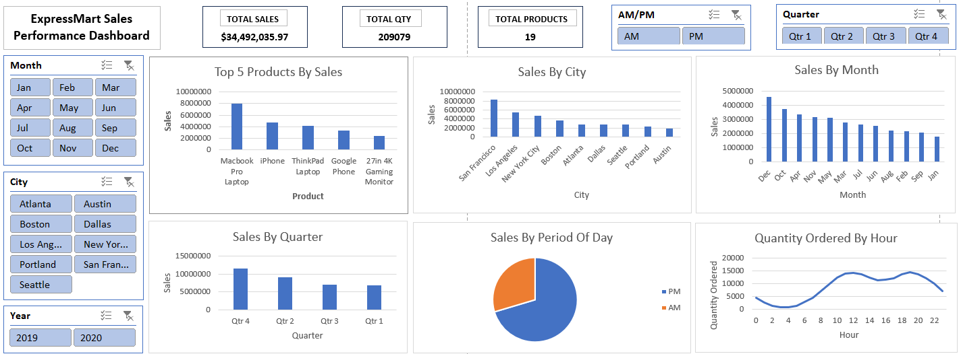

The dashboard highlights key deliverables such as, metrics on:

**Total Sales**: The single value card provides a quick and straight forward count, displaying the total amount of sales.

**Total Qty**: The single value card provides a quick and straight forward count, displaying the total number of products sold.

**Total Products**: The single value card provides a quick and straight forward count, displaying the total number of unique products available for purchase.

**Slicers for AM/PM, Quarter, Month, City, Year:** These slicers help to filter the dashboard by focusing on specific identifiers and making inferences based on the identifier.

**Top 5 Products By Sales**: This chart represents the top performing products with regards to sales.

**Sales By City**: This chart represents the sales performance across different cities.

**Sales By Month**: This chart represents the sales performance across different months in the year.

**Sales By Quarter**: This chart represents the sales performance across the different quarters.

**Sales By Period Of Day**: The pie chart compares sales by period of day (AM/PM).

**Quantity Ordered By Hour:** The line chart displays the hour at which quantities are ordered

**Key Insights**

* Total Sales were $34,492,035.97. Total Quantity was 209079 products and Total Products were 19 unique products.
* Sales are greater during the last half of the day. This can be seen from the pie chart as the aggregated sum of sales in the PM covers 70% ($24,274,253.98) while the aggregated sum of sales in the AM covers 30% ($10,217,781.99).
* There are two peak periods that is at 12pm and 7pm. Product quantity ordered during these hours are very high and coincide with the peak sales. These activities show a rise from 6pm and gradually dies around the 10pm hour mark.
* Highest sales across the months were in December. January recorded the least sales. The trend gathered from **Sales By Month** indicates that sales during festive periods are high presumably due to the fact that people purchase items not only for themselves but also as gifts for others. Case in point December *(Christmas)* and April *(Easter/Passover)*. The presence of foreigners in December for *Holidays* or *Vacations* add up to the population and increase purchasing power.
* Increased sales across the four quarters are in the order; *Qtr 4, Qtr 3, Qtr 2, Qtr 1.* The trend gathered from **Sales By Quarter** indicate the preparation of people for the festive season.
* **Top 5 Products By Sales.** Although these are not in the top 5 of quantities ordered, they fall in the top 5 of Product Prices hence why they are the top 5 performing products as purchases for any of these generate higher sales than those with greater quantities ordered.
* From **Sales By City**, we determined the performance of cities with regards to sales and they doubled down as the cities with most order quantities. These coincided with the fact that the top performing products were purchased more in these cities. Increased population in these cities may also be a contributing factor to high sales.

**Recommendations**

* More staff should be available during the last half of the day that is during the PM since that is the period when the business receives more customers as well as during the last quarter of the year. To effectively handle the peak periods (12PM and 7PM), the company can reallocate break periods such as lunch and rest during those times.
* Provisions should be made for top performing products to make sure that there are no shortages. Products that are also purchased with huge quantities should be available.
* ExpressMart can tailor products to match class of people living in the various cities since standard of living varies. This can be achieved by understanding the demographics of people and tailoring sales of products based on that.
* To get rid of underperforming products sales wise, these products can be sold at a discount or included as a surplus for other products purchased. Months with the least sales should attract promotional programs to boost sales during those months.

**Conclusion**

This report has detailed the development and insights from a comprehensive dashboard analyzing ExpressMart's sales performance. Key findings include:

1. Total sales of $34,492,035.97 across 209,079 products sold, with 19 unique products available.

2. Sales are significantly higher (70%) during PM hours, with peak ordering times at 12 PM and 7 PM.

3. December shows the highest sales, likely due to holiday shopping, while January records the lowest.

4. Quarterly sales increase progressively throughout the year, peaking in Q4.

5. The top 5 products by sales are high-priced items, not necessarily the most frequently ordered.

6. Sales performance varies significantly by city, correlating with population and purchasing power.

The dashboard has proven to be a valuable decision-support tool, offering actionable insights into customer behavior, sales trends, and operational efficiency.

**Future Work**

To further enhance the value of this analysis, some suggestions are:

1. Integrating customer demographic data to provide deeper insights into purchasing patterns across different segments.

2. Incorporating inventory management data to optimize stock levels based on sales trends.

3. Implementing predictive analytics to forecast future sales and identify potential market opportunities.

4. Expanding the dashboard to include profitability metrics, allowing for margin analysis alongside sales performance.

By pursuing these enhancements, ExpressMart can further leverage data-driven insights to drive business growth and maintain its competitive edge in the retail and e-commerce sectors.