Who Pays for the Bit? Evidence-Aware Energy Attribution Across Shared 5G and 6G Network Infrastructure
Ghufran Shakeel
24 October 2026
Independent researcher, Lahore, Pakistan. BSc Electrical Engineering, University of Engineering and Technology (UET) Taxila. Email: ghufr7an@gmail.com. ORCID: 0009-0006-3683-8405

Abstract
Operators can meter the energy of radio, transport, core and edge equipment, but a device-level figure does not say how much belongs to a given service, slice or tenant. Because equipment draws much of its power regardless of traffic, service-level figures depend on allocation rules, measurement boundaries and data quality, which are rarely reported with the number. We propose Evidence-Aware Energy Attribution (EAEA), an accounting method that checks measurement boundaries, separates baseline from traffic-dependent energy, allocates each under a declared policy, preserves unallocated energy, and grades each result from a reconciled estimate to insufficient evidence. In a fixed-seed synthetic study of 72,000 trials, EAEA’s mean allocation error was 0.046 across 59,891 reported trials; full-population means over 72,000 trials were 0.271 for traffic-proportional and 0.200 for resource-weighted allocation; a second study with baseline shares taken from published equipment data gave 0.049, 0.315 and 0.268. In a deterministic case study on a published base-station model, three defensible baseline allocation rules produced energy estimates for a low-traffic service that differed by a factor of 2.5 from the same meter reading. All service-level results are simulated, and the advantage in simulation is partly built into the test design, so it is not evidence of accuracy on commercial equipment. We also state when per-service energy is bounded and when it cannot be identified from meter totals.
Keywords: network energy efficiency; energy attribution; network slicing; shared infrastructure; measurement uncertainty; 5G; 6G; sustainability reporting.

1. Introduction
A mobile service crosses radio units, transport links, user-plane functions and often an edge host before it reaches its destination. Each resource is metered, estimated or modelled in a different way, by a different team, in a different system. Energy-efficiency work in telecommunications has produced mature component-level and network-level metrics. What remains difficult is the step an operator’s sustainability, finance and engineering teams now ask for: how much energy is attributable to this service, and how sure are we?
Three properties make the question hard. First, most network equipment draws a large share of its power regardless of traffic, so the “attributable” part of a domain’s energy is a modelling decision, not an observation. Second, measurement boundaries differ: a rack meter may already include a server whose own meter is also read, and summing both double-counts. Third, a method that always returns a number conceals the cases where the data cannot support one.
Standards bodies have addressed related ground. 3GPP TS 28.310 specifies the energy-efficiency assessment and energy saving of 5G networks, including energy-efficiency KPIs [2]; we read the Release 17 text only, and later releases may add service-level provisions. 3GPP TR 26.942 studies energy consumption exposure for media services and lists the TS 28.554 energy KPIs among the network energy information collected by OAM [3]. ETSI ES 203 228 defines assessment of mobile network energy efficiency [4], and the ITU-R IMT-2030 framework names sustainability as an objective of future systems [1]. We therefore do not claim that service-level energy information is absent from standards. Our claim is narrower: that an auditable accounting procedure combining boundary checks, declared shared-energy policy, preserved residuals and evidence-gated reporting is a useful, testable addition, and we evaluate it as such.
Contributions.
- EAEA, a six-stage accounting method with evidence classes, boundary identifiers and a provenance ledger (Section 3).
- Reporting categories A to D that limit the specificity of a published figure to what the evidence supports, including an explicit insufficiency result (Section 4).
- A reproducible comparison against two common allocation rules over 72,000 synthetic trials, with conservation, overlap and policy-sensitivity checks (Sections 5 and 6).
- An operator reporting profile listing the minimum fields needed to make a service-level energy figure reproducible and comparable (Section 7).
Two further results use only published equipment parameters and no random numbers (Sections 6.1 and 6.2): a deterministic case study in which three defensible baseline rules produce energy estimates for a low-traffic service differing by a factor of 2.5 from the same meter reading, and two propositions stating when per-service energy is bounded and when it is identifiable from meter totals.

2. Background and related work
Telecom energy management. TS 28.310 specifies management concepts and KPIs for energy efficiency of physical and virtualized network functions [2]. Energy and data volume are related through equipment state, load and measurement interval, so ratios such as energy per bit vary with load even when power is nearly constant; the literature on energy-intensity metrics discusses these limits [5]. EAEA treats energy per delivered bit as a derived indicator, not as the accounting basis.
Open and cloud-native RAN. O-RAN specifications released since November 2025 add network energy-saving use cases, for example power-amplifier optimization, advanced sleep mode and external power source coordination, across several working groups, and the fronthaul conformance tests include energy-saving cases [6]. The announcement we read lists no specification on service-level energy attribution. In cloud-native deployments one host runs several functions and other workloads, so host energy must be apportioned. This is the setting in which the shared-baseline problem is sharpest.
Allocation of shared costs. Cost-accounting and cooperative-game methods, notably the Shapley value [7], allocate a shared total among users under stated fairness axioms. They show that more than one allocation can be defensible, which motivates our requirement that the policy be declared and reported. ISO/IEC 30134-9 defines total data-centre energy as measured at the data-centre boundary, separately from IT equipment energy, requires twelve months of documented cumulative data, and defines categories of the water-usage KPI “to refine the accuracy” together with interim, partial, design, quality and peak derivatives [8]. This shows the same need for boundary definition between IT and facility quantities and a precedent for graded reporting; its categories refine the measurement scope, whereas ours decide whether the evidence supports a figure at all.
Measurement uncertainty. The GUM and its Monte Carlo supplement [9][10] provide the vocabulary and propagation methods we use. They also distinguish statistical error from model uncertainty, a distinction we preserve: allocation-policy uncertainty is reported as scenario spread, not as a confidence interval.
Gap tested. We hypothesize that existing mechanisms provide the ingredients but not a single, reproducible procedure that (a) rejects overlapping boundaries, (b) keeps unallocated energy visible, and (c) withholds figures the evidence cannot support. This is a hypothesis; a systematic review of vendor and operator practice would be needed to establish priority.
Closest prior work found. Service-level attribution is already specified, and its rule is simple. TS 28.554 defines network-slice energy consumption as the sum of the energy of the network functions in the slice; where a gNB or a UPF is shared between slices, the energy attributable to each slice is estimated as the slice’s share of the data volume carried, and the case of other shared core functions is not addressed [13]. The same specification estimates the energy of a virtualized function from its relative virtual CPU, memory, disk and I/O usage, and treats a function instance shared between several network functions as out of scope [13]. A draft SA5 contribution to TR 28.880 records that this clause needs mathematical formulas for the participation of gNBs and core functions such as AMF, SMF and UPF [15]. TS 22.261 requires per-slice and per-subscriber energy monitoring and accepts attribution that is as accurate as possible, for example based on data volume [14]. Hossfeld et al. analyse the limits of apportioning network energy to services through energy intensity and show that transmitted data and energy are poorly correlated at short time scales [5]. US Patent 11,711,771 B2 estimates a slice’s energy as the difference between measurements with and without it [16], and US Patent 9,621,360 B2 sums power-efficiency figures along a service’s network path [18]. A June 2026 poster from the EU EXIGENCE project describes measurement and attribution of power at network-function and user level [17]. As far as we have read them, none states a boundary-overlap rule, a preserved residual, policy-free bounds and an identifiability condition together, and our claim is limited to what we read.
What the standards documents we read say. TS 28.310 Release 17 (V17.8.0, October 2024) states that in a virtualized infrastructure the finest grain at which energy can be measured is the host node, so the energy of each virtualized function cannot be measured separately and must be estimated [2]. Its method gives each function a proportion of the host node’s energy equal to its mean vCPU usage relative to the sum over all functions on that node [2]. As written, the shares sum to one, so the whole node energy, baseline included, is divided among the listed functions with no residual, and the proportion is undefined when total vCPU usage is zero (our reading). For the RAN it counts only the energy of the distributed unit and of non-split gNBs, on the assumption that centralized-unit energy is very small, and notes that a correction between deployment scenarios may be needed [2]. It also treats a network operator’s data centres as telecommunication sites [2], so data-centre boundary rules are relevant [8]. ITU-R M.2160-0 calls sustainability a foundational aspiration of IMT-2030 and defines energy efficiency as bits per joule, expected to improve as capacity grows [1]. Our paper treats energy per bit only as a derived indicator, because of the weak link between data volume and energy discussed in [5].
The differential method of [16] is the natural ground-truth protocol for a testbed: running a service with and without the others provides a measured per-service reference against which EAEA can be scored.

3. System model and the EAEA method

3.1 Accounting identity
Let S be the set of services, D a set of non-overlapping accounting domains (RAN, transport, core, edge) and T a common interval. For each domain d, with $E_{d}$ the domain energy in joules, $E_{s,d}$ the energy attributed to service s and $E_{u,d}$ the unallocated energy:
Ed=s∈S​Es,d+Eu,d, Es,d≥0, Eu,d≥0.
The end-to-end figure Es=d​Es,d is valid only when the domains do not overlap and cover compatible intervals. The reconciliation residual is Rd=Ed−s​Es,d−Eu,d; a valid account has $R_{d}$ = 0 up to numerical tolerance, and any discrepancy is reported, never normalized away.

3.2 Stages
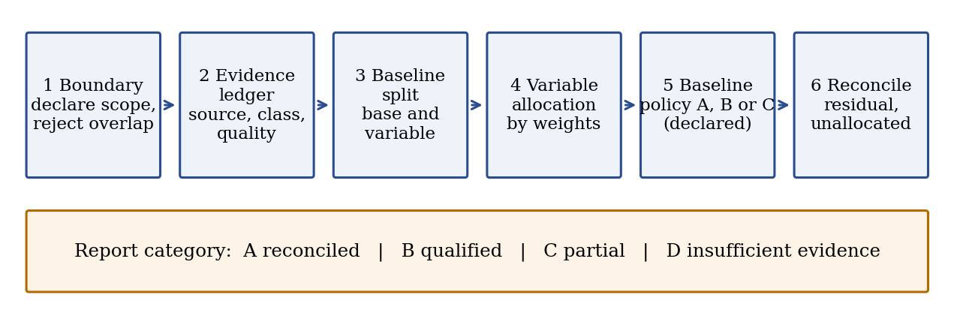
The six EAEA stages and the resulting report category.
Stage 1, boundary. The operator declares included equipment, interval, services and energy sources (device, rack, site or facility). Every record carries a boundary identifier. If one boundary contains another (a rack meter that includes a metered server), the contained quantity is subtracted from the container before summation. If containment cannot be established, the affected quantity is marked unresolved.
Stage 2, evidence ledger. Each input is stored as r = (id, domain, interval, boundary, value, unit, quality, provenance) with its transformation history. Evidence classes describe origin, not accuracy: M1 direct measurement, M2 equipment-reported, M3 telemetry-derived estimate, M4 model-derived estimate, M5 allocation assumption, M0 unavailable.
Stage 3, baseline separation. Where a validated model supports it, $E_{d}=E_{base,d}+E_{var,d}$. The baseline is model-dependent and is never presented as observed.
Stage 4, variable allocation. With weights $w_{s,d}≥0$ (traffic, CPU time, active radio resources, link utilization or a calibrated model), Es,dvar=Evar,d ws,d/j​wj,d, defined only when the denominator is positive. Missing weights are not silently replaced; a declared fallback is recorded as class M5 and lowers the report category.
Stage 5, shared baseline policy. Policy A retains the baseline as unallocated. Policy B allocates it by a declared cost-causation proxy (for example reserved capacity). Policy C reports several policies side by side. The policy is part of the reported result.
Stage 6, reconcile and report. Compute $R_{d}$, unallocated fractions $U_{d}=E_{u,d}/E_{d}$, evidence coverage and the report category.

3.3 Uncertainty
For $E_{s,d}=f\left(E_{d},w,θ\right)$, first-order propagation gives $u^{2}\left(E_{s,d}\right)≈∇f^{T} Σ ∇f$, valid under differentiability and a justified covariance $Σ$; correlated meters must not be treated as independent without argument [9]. Where distributions are defensible, Monte Carlo propagation is used [10]. Where uncertainty is dominated by the choice among allocation policies, scenario ranges are reported instead of a probabilistic interval.

4. Confidence-gated reporting
Category | Meaning
A, Reconciled estimate | Boundary defined, all required evidence present, uncertainty characterized, residual within tolerance
B, Qualified estimate | Usable with stated assumptions, for example a declared fallback weight in one domain
C, Partial account | Only domains with complete evidence are quantified; the end-to-end total is incomplete
D, Insufficient evidence | No defensible service-level estimate can be produced
The categories are a proposed reporting convention, not an existing standard. In the evaluation, the thresholds are: A if no domain has a missing weight and declared meter uncertainty is at most 5%; B if one domain has a missing weight; C if two or three domains do; D if all four do. These thresholds are illustrative and would need calibration on operator data.
The purpose of gating is defensibility, not coverage. A method that assigns every joule can look complete while resting on unsupported assumptions, so a low unallocated fraction is not by itself a quality indicator.

5. Evaluation design
Setting. Five services and four domains (RAN, transport, core, edge). Domain energies are in arbitrary units (1000 × [3, 1, 1.5, 2.5]). The true variable-energy driver of each domain is a mixture of traffic share and a compute/resource share, with traffic weights [0.8, 0.9, 0.5, 0.1] for the four domains. The reference baseline rule is reserved-capacity share. All data are synthetic; nothing here measures commercial equipment.
Factors (36 scenarios, 2,000 trials each, 72,000 trials in total, seed 20260101). Traffic distribution (uniform, Dirichlet α = 20; skewed, α = 0.3); baseline fraction $β∈\{0.2,0.5,0.8\}$; probability that a service-domain weight is missing $∈\{0,0.1,0.3\}$; weight observation noise $σ_{w}$ $∈\{0.05,0.20\}$. Domain-total meter noise is 5% and the EAEA baseline-split model has 10% error in every scenario.
Methods. B1: traffic-proportional allocation of the whole measured total, which is the rule TS 28.554 prescribes for shared gNBs and UPFs [13]. B2: resource-weighted allocation of the whole total, with silent fallback to traffic share where a weight is missing, in the spirit of the resource-based estimate TS 28.554 uses for virtualized functions [13]. EAEA: variable part by observed weights, baseline by a noisy capacity proxy under Policy B, with gating as in Section 4.
Error metric. For in-scope domains, e=12s,d​|Es,d−Es,dref|/d​Ed, the share of energy assigned to the wrong service. For Category C the comparison is restricted to the domains EAEA reports, and B2 is also scored on that same scope. Category D trials have no EAEA output.
Checks. Conservation (maximum $|R_{d}|$ over all trials), non-negativity, and a controlled overlap test.
Literature-calibrated scenario. A second set of 12 scenarios (2,000 trials each, 24,000 in total) replaces the fixed baseline fractions with domain-specific values derived from published measurements. RAN: a macro base station modelled with a constant 605 W and a load-dependent 1,067.7 W at full load [11], so the baseline share at load ρ is 605 / (605 + 1,067.7ρ), with ρ drawn uniformly from 0.1 to 0.6 (baseline 49% to 85%). Core and edge hosts: idle power equal to half of peak, linear in utilization [12], with utilization drawn uniformly from 0.1 to 0.5 (baseline 67% to 91%). Transport: an assumed baseline drawn uniformly from 0.5 to 0.9, for which we have no verified source. Traffic distribution, weight noise and weight missingness are varied as before. Only the baseline fractions are anchored to published data; the services, their traffic and the reference allocation remain synthetic.

6. Results
All values below are produced by the released scripts (eaea_experiment.py and case_study.py) and stored in results.json. Apart from the published equipment parameters named in the text, they are synthetic results.
Overall. Across all 72,000 trials, mean error was 0.271 (95% CI ±0.001) for B1 and 0.200 (±0.001) for B2. EAEA mean error was 0.046 (±0.0002) across the 59,891 trials in which it reported an estimate (83.2% of trials). EAEA’s error was lower than B2’s on the same scope in 99.2% of those trials.
Reporting categories. Across all trials: A 37.5%, B 11.5%, C 34.2%, D 16.8%. Withheld or restricted output (C and D) therefore occurred in 51.0% of trials, and 62.5% if B is counted as a qualified output.
Table 1. Effect of missing weights (mean error; share of trials by category).
P(weight missing) | B1 | B2 | EAEA | A | B | C | D
0.0 | 0.271 | 0.191 | 0.046 | 100% | 0% | 0% | 0%
0.1 | 0.271 | 0.198 | 0.047 | 12.4% | 33.2% | 51.5% | 3.0%
0.3 | 0.271 | 0.212 | 0.046 | 0.1% | 1.5% | 50.9% | 47.5%
Table 2. Effect of baseline fraction.
Baseline fraction β | B1 | B2 | EAEA | Policy spread
0.2 | 0.202 | 0.105 | 0.043 | 3.1%
0.5 | 0.267 | 0.197 | 0.043 | 7.6%
0.8 | 0.343 | 0.299 | 0.052 | 12.2%
Policy spread is the mean range of a service’s end-to-end energy share across three defensible baseline policies (traffic, reserved capacity, equal split).
Table 3. Traffic skew and weight noise.
Condition | B1 | B2 | EAEA
Uniform traffic | 0.140 | 0.139 | 0.044
Skewed traffic | 0.402 | 0.262 | 0.048
$σ_{w}$ = 0.05 | 0.271 | 0.194 | 0.031
$σ_{w}$ = 0.20 | 0.271 | 0.207 | 0.061
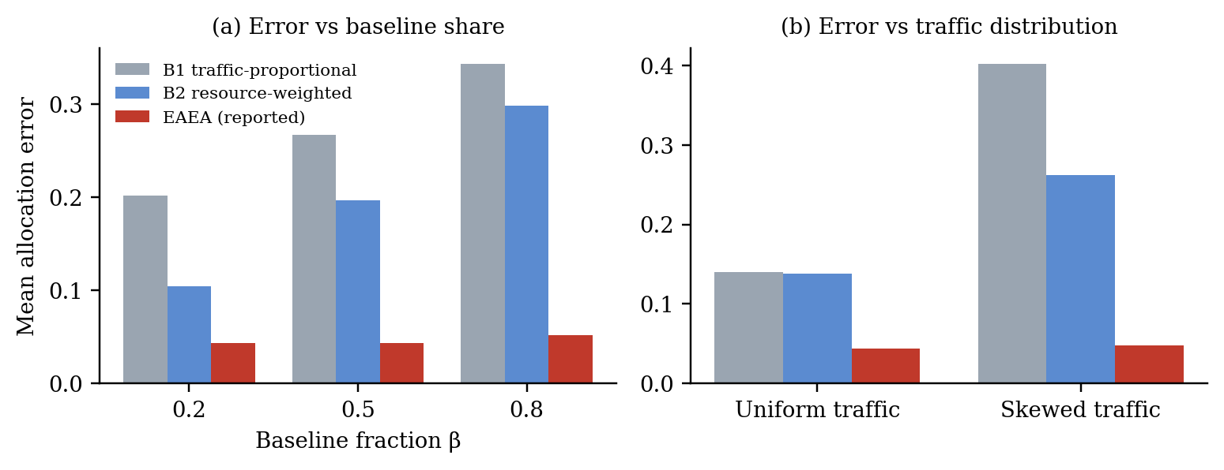
Mean allocation error of the three methods (a) against baseline fraction and (b) against traffic distribution; 72,000 synthetic trials.
Table 4. Error by report category.
Category | Share | EAEA error | B2 error, same scope
A | 37.5% | 0.0456 | 0.191
B | 11.5% | 0.0494 | 0.196
C | 34.2% | 0.0457 | 0.191
D | 16.8% | no output | 0.217 (B2 full scope)
Conservation and overlap. The maximum residual across all trials was 1.4 × ${10}^{−12}$ J, at floating-point level. In the overlap test, a 100-unit rack meter that includes a 40-unit server meter was summed naively to 140; boundary-aware subtraction returned 100.
Literature-calibrated scenario. With baseline fractions averaging 0.63 (RAN), 0.70 (transport), 0.78 (core) and 0.78 (edge), mean error was 0.315 (±0.002) for B1, 0.268 (±0.001) for B2 and 0.049 (±0.0003) for EAEA over the 20,027 trials in which EAEA reported. EAEA beat B2 on the same scope in 99.9% of those trials. Report categories were A 37.4%, B 11.9%, C 34.1% and D 16.6%, close to the first scenario set. Higher baseline shares widen the gap between methods and between policies.
Table 5. Literature-calibrated scenario by traffic distribution.
Traffic | B1 | B2 | EAEA | Policy spread
Uniform | 0.185 | 0.186 | 0.045 | 5.2%
Skewed | 0.444 | 0.350 | 0.052 | 16.4%
By category the error of EAEA was again nearly flat (A 0.0486, B 0.0496, C 0.0488), against 0.263, 0.266 and 0.264 for B2 on the same scope, so the finding that the categories do not predict error holds in this scenario set too.

6.1 Deterministic case study with published equipment parameters
This case study uses no random numbers. The equipment model is the published macro base station of [11]: 605 W constant plus 1,067.7 W at full load. The three service traffic shares (eMBB 70%, mMTC 20%, URLLC 10%) and the reserved-capacity shares (50%, 20%, 30%) are illustrative assumptions, because no public dataset gives per-service energy ground truth. The values below are therefore computed from a published model and assumed service mixes; they are not measurements of a service.
Table 6. Power attributed to each service at 30% cell load (total 925.3 W; baseline 65.4% of total).
Service | Traffic-proportional (W) | Variable by traffic, baseline equal (W) | Variable by traffic, baseline by reserved capacity (W) | Bounds without a policy (W)
eMBB | 647.7 | 425.9 | 526.7 | 224.2 to 829.2
mMTC | 185.1 | 265.7 | 185.1 | 64.1 to 669.1
URLLC | 92.5 | 233.7 | 213.5 | 32.0 to 637.0
Three defensible rules give URLLC between 92.5 W and 233.7 W, a ratio of 2.5, from the same metered 925.3 W. Without any declared policy the only supportable statement is the bounds column: the variable part is the floor and the variable part plus the entire baseline is the ceiling. The ratio between the highest and lowest policy for URLLC is 2.98 at 10% load (baseline 85.0%), 2.53 at 30% and 2.13 at 60% (baseline 48.6%). Policy dependence therefore falls as load rises but stays above 2 for a low-traffic service across the whole range.
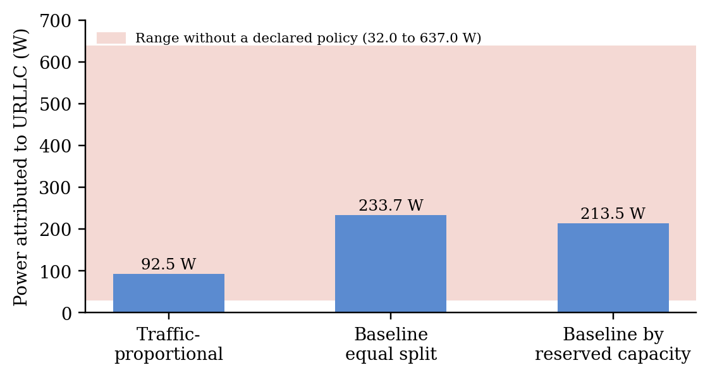
Power attributed to the URLLC service at 30% cell load under three defensible rules, and the range supportable without a declared policy.

6.2 Attribution bounds and identifiability
Proposition (bounds). For a domain with measured energy E, baseline $E_{base}$ and variable energy $E_{var}$ allocated by weights $w_{s}$, any allocation that conserves E and assigns each service at least its variable share lies in $\left[E_{var}w_{s}, E_{var}w_{s}+E_{base}\right]$ for every service s. The width of the interval equals the baseline, independent of the service, so a low-traffic service has the largest relative uncertainty.
Proposition (identifiability from meters alone). If the only observations are domain energy totals over T intervals and per-service load series $x_{s}$(t), the model Et=b+s​asxst identifies the baseline b and every coefficient $a_{s}$ only if the matrix $\left[1,x_{1},…,x_{S}\right]$ has full column rank. When one service’s load is proportional to another’s, the rank drops and the two coefficients cannot be separated from totals alone, however accurate the meter.
We checked the second proposition numerically on a 24-hour design with sinusoidal loads. With independent loads the matrix has rank 4 of 4 columns (condition number 33); when service 3’s load is exactly half of service 1’s, the rank is 3 of 4 and the condition number is 2.9 × 10¹⁶. The practical reading is that a single hour-by-hour meter series can recover per-service energy only when services have loads that vary independently, and EAEA should classify a service whose load is collinear with another as Category C or D rather than report a split. Regression-based attribution is a known technique; the contribution here is making rank deficiency an explicit, reported reason to withhold.

7. Discussion
Where the benefit comes from. Traffic-proportional allocation fails when services differ in how much they load compute-heavy domains: error rose from 0.140 with uniform traffic to 0.402 with skewed traffic, while EAEA moved only from 0.044 to 0.048. Both baselines also degrade as baseline energy dominates, because they hand the shared baseline to whoever carries the most traffic.
Policy dependence is a reporting problem. At β = 0.8 the same measured infrastructure yields service shares differing by about 12 percentage points depending on which defensible baseline policy is used. Two operators comparing figures without disclosing the policy are comparing different quantities.
What the gating did and did not do. Gating succeeded in refusing output where evidence was thin: it removed Category D trials, where the baseline error was highest (0.217), and it excluded incomplete domains in Category C. But the error of the figures it did report was almost flat across A, B and C (0.046, 0.049, 0.046). So in this experiment the categories describe evidence completeness; they do not predict allocation error. Making categories predictive of error needs fallbacks whose error differs from the primary weights, which our synthetic fallback (traffic share) only partly provides. We regard calibrating categories to observed error as the main open item for the method.
Operator reporting profile. A reproducible service-level energy figure should be published with: accounting interval; domain and resource identity; boundary identifier; energy value and unit; evidence class; source and timestamp; service or slice identifier; allocation policy; unallocated energy; uncertainty or scenario range; and reconciliation status. This is a proposed profile; before being called standards-compliant it must be mapped to existing 3GPP management data models. The method can run offline on exported telemetry; real-time integration is not needed to establish correctness. Because attribution data can reveal tenant identities, topology and load, access control, integrity protection and audit logging are required in production.

8. Threats to validity and limitations
- Built-in advantage. The reference allocation uses the same cost-causation structure (resource drivers, reserved-capacity baseline) that EAEA models, with noise. EAEA therefore starts closer to the reference than the baselines do. The result shows that EAEA behaves as designed and degrades gracefully under the tested noise and missingness; it does not show that EAEA is more accurate on real networks. An unbiased test requires measured service-level ground truth, for example a testbed where each service runs alone and in combination.
- No ground truth for baseline energy. The baseline split is a model assumption; different models can fit the same observations and give different allocations (Section 7).
- Reconciliation is not correctness. B1 and B2 conserve energy to floating-point precision while having errors of 0.27 and 0.20.
- Synthetic parameters. Domain scales, mixture weights, noise levels and Dirichlet parameters are illustrative; only the baseline fractions in the calibrated scenario set (RAN and server hosts) come from published measurements, the transport fraction is an assumption, and modern servers may be more energy-proportional than the half-of-peak idle figure used. They are not measurements of commercial RAN, transport or core equipment, and conclusions about magnitudes should not be transferred.
- Thresholds and categories are untuned conventions.
- Novelty is unverified. We searched public sources only (Section 2); we read Release 17 of TS 28.310 and the relevant clauses of TS 28.554 and TS 22.261, but not all cited specifications in full, nor vendor documentation or operator practice, and later releases or existing work may already cover parts of EAEA.
- Scope. The study addresses accounting, not energy saving. No claim is made that EAEA reduces network energy use.

9. Conclusion
Service-level energy figures in shared telecom infrastructure are accounting results that depend on boundaries, allocation policy and evidence quality. EAEA makes those dependencies explicit, preserves unallocated energy, rejects double-counted boundaries and withholds figures that the evidence cannot support. In a synthetic study it reduced allocation error substantially relative to traffic-proportional and resource-weighted rules, with the caveat that the reference model favours its structure, and it showed that baseline policy alone can move service shares by about 12 percentage points. Priority next steps are validation on measured service-level energy in a testbed or operator trial, calibration of the report categories against observed error, and mapping the reporting profile onto TS 28.310 data models.

Data and code availability
Code, data and the scripts that generate every number in Section 6 are available at https://github.com/ghufr7an/eaea-energy-attribution and archived on Zenodo. Supplementary material (extended literature matrix, the full 36-scenario table and code listings) accompanies this preprint.

References
[1] ITU-R, “Framework and overall objectives of the future development of IMT for 2030 and beyond,” Recommendation ITU-R M.2160-0, Nov. 2023.
[2] 3GPP, “Management and orchestration; Energy efficiency of 5G,” TS 28.310, Release 17, V17.8.0 (ETSI TS 128 310 V17.8.0), Oct. 2024.
[3] 3GPP, “Study on Media Energy Consumption Exposure and Evaluation Framework,” TR 26.942, Release 19.
[4] ETSI, “Environmental Engineering (EE); Assessment of mobile network energy efficiency,” ES 203 228, V1.4.1, Apr. 2022.
[5] T. Hossfeld, S. Wunderer, F. Loh and D. Schien, “Analysis of energy intensity and generic energy efficiency metrics in communication networks: limits, practical applications, and case studies,” IEEE Access, vol. 12, pp. 105527-105549, 2024, doi:10.1109/ACCESS.2024.3435716.
[6] O-RAN ALLIANCE, “71 new or updated O-RAN technical documents released since November 2025,” news announcement, www.o-ran.org, 2026.
[7] L. S. Shapley, “A value for n-person games,” in Contributions to the Theory of Games II, Princeton Univ. Press, 1953.
[8] ISO/IEC 30134-9:2022, Information technology - Data centres key performance indicators - Part 9: Water usage effectiveness (WUE), Mar. 2022.
[9] JCGM 100:2008, Evaluation of measurement data - Guide to the expression of uncertainty in measurement (GUM).
[10] JCGM 101:2008, Evaluation of measurement data - Supplement 1 to the GUM - Propagation of distributions using a Monte Carlo method, doi:10.59161/JCGM101-2008.
[11] M. Deruyck, E. Tanghe, W. Joseph and L. Martens, “Characterization and optimization of the power consumption in wireless access networks by taking daily traffic variations into account,” EURASIP J. Wireless Commun. Netw., 2012, art. 248, doi:10.1186/1687-1499-2012-248.
[12] L. A. Barroso and U. Hölzle, “The case for energy-proportional computing,” IEEE Computer, vol. 40, no. 12, 2007.
[13] 3GPP, “Management and orchestration; 5G end to end Key Performance Indicators (KPI),” TS 28.554, clause 6.7.3.3, Network Slice Energy Consumption.
[14] 3GPP, “Service requirements for the 5G system,” TS 22.261, clause 6.15a.4.2.
[15] 3GPP TSG-SA5, draft pCR to TR 28.880, “Per-network-slice gNB and 5GC NF energy consumption,” S5-247121 (working document).
[16] US Patent 11,711,771 B2, “Method for evaluating the energy consumption of a service unit in a communications network,” granted 25 July 2023.
[17] TNO (EXIGENCE project, grant 101139120), “End to end power consumption measurements for user traffic streams in a 5G network,” poster, EUCNC 2026, Zenodo, 2 June 2026, https://zenodo.org/records/20645561.
[18] US Patent 9,621,360 B2, “System and method for analyzing network power consumption.”

Appendix A. Theory and proofs
A.1 Conservation. For domain d with measured energy $E_{d}$, allocations $E_{s,d}$ ≥ 0 and unallocated $E_{u,d}$ ≥ 0:
Ed=s∈S​Es,d+Eu,d, Rd=Ed−s​Es,d−Eu,d
Any proportional allocation of a component C with positive weights, Es,d=C ws/j​wj, sums to C, so $R_{d}$ = 0 for every weight vector. Conservation is therefore necessary but says nothing about correctness.
A.2 Bounds without a policy. Split $E_{d}=E_{var}+E_{base}$ with variable shares $E_{var}w_{s}$, s​ws=1. If a service is charged at least its variable share and the baseline is divided nonnegatively among services:
$$E_{var}w_{s} ≤ E_{s,d} ≤ E_{var}w_{s}+E_{base}$$
Proof. Write $E_{s,d}=E_{var}w_{s}+b_{s}$ with $b_{s}≥0$ and s​bs=Ebase. Then $0≤b_{s}≤E_{base}$, giving both bounds; each end is reached when service s receives none or all of the baseline. The width is $E_{base}$ for every service, so relative uncertainty is largest for the service with the smallest $E_{var}$ $w_{s}$. □
A.3 Identifiability from meter totals. Observe $E\left(t\right)$, $t=1,…,T$, and load series $x_{s}\left(t\right)$, with Et=b+s​asxst+noise. Let $X=\left[1,x_{1},…,x_{S}\right]$.
Claim. The least-squares estimate of $\left(b,a_{1},…,a_{S}\right)$ is unique iff $X$ has full column rank $S+1$. If $x_{j}=c x_{i}$ for $j≠i$, only $a_{i}+c a_{j}$ is identifiable.
Proof. The normal equations $X^{T}Xθ=X^{T}E$ have a unique solution iff $X^{T}X$ is invertible, iff $X$ has full column rank. If $x_{j}=c x_{i}$ then $a_{i}x_{i}+a_{j}x_{j}=\left(a_{i}+c a_{j}\right)x_{i}$, so $\left(a_{i}+k c, a_{j}−k\right)$ for any $k$ gives the same fit. □
A.4 Report categories. D when no domain has complete evidence or when identifiability fails for a requested split; C when only some domains are quantified; B when a declared fallback is used in one domain; A otherwise. Thresholds in the simulation are conventions.

Appendix B. Additional data
Values are generated by the scripts in the repository (seed 20260101) and stored in results.json. Errors are the share of energy assigned to the wrong service, 0.5 Σ |estimate − reference| / total. The full 36-scenario table is in the supplementary material.
One result the main text does not stress: with uniform traffic and noisy weights ($σ_{w}$ = 0.2), resource-weighted allocation (B2) is slightly worse than plain traffic-proportional allocation (B1), for example 0.090 against 0.077 at β = 0.2. Weights help only when their error is smaller than the difference between traffic and the true driver. EAEA stays lowest in those rows (0.063) mainly because it handles the baseline separately.
Table B1. Literature-calibrated study (24,000 trials). Mean baseline fractions: RAN 0.63, transport 0.70, core 0.78, edge 0.78. B1 0.315, B2 0.268, EAEA 0.049 over 20,027 reported trials; categories A 37.4%, B 11.9%, C 34.1%, D 16.6%; EAEA lower than B2 in 99.9% of comparable trials. Uniform traffic: 0.185, 0.186, 0.045, spread 5.2%. Skewed traffic: 0.444, 0.350, 0.052, spread 16.4%.
Table B2. Case study, published macro-base-station model, assumed service mix (eMBB 70%, mMTC 20%, URLLC 10%; reserved shares 50%, 20%, 30%).
Cell load | Power (W) | Baseline share | URLLC traffic rule (W) | URLLC equal baseline (W) | URLLC reserved baseline (W) | URLLC bounds (W) | URLLC max/min ratio
0.1 | 711.8 | 85.0% | 71.2 | 212.3 | 192.2 | 10.7 to 615.7 | 2.98
0.3 | 925.3 | 65.4% | 92.5 | 233.7 | 213.5 | 32.0 to 637.0 | 2.53
0.6 | 1,245.6 | 48.6% | 124.6 | 265.7 | 245.6 | 64.1 to 669.1 | 2.13
Table B3. Checks. Maximum conservation residual over all trials 1.4 × ${10}^{−12}$ J. Overlap test: rack 100 units including a 40-unit server meter, naive sum 140, boundary-aware 100. Identifiability test (24 hourly points): independent loads rank 4 of 4, condition number 33; one load half of another, rank 3 of 4, condition number 2.9 × 10¹⁶.
No measured service-level energy is included in any table.

