Beyond Utilization Thresholds: A Transparent, Risk-Aware Framework for Virtual Machine Rightsizing
Ghufran Shakeel
Independent Technical Report | Version 1.0

Abstract
Virtual-machine (VM) rightsizing aligns allocated CPU and memory with workload demand while preserving performance and operational safety. Low average utilization alone is weak evidence that a change is safe: monitoring coverage, workload variability, contention signals, criticality, and vendor constraints also matter. This report presents VMValue, a rule-based, transparent decision-support workflow that keeps four things separate and visible: a candidate resource estimate, an evidence-quality score, hard safety gates, and an illustrative allocation-cost proxy. The method is implemented in a spreadsheet and demonstrated on twelve entirely synthetic VM records. Under the stated cost assumptions, the candidate sizing yields a gross modeled difference of 672 cost units per month across all twelve records, but only six records pass the gates, with a combined modeled difference of 525 cost units per month. A utilization-only rule applied to the same inventory would flag eleven records (678 cost units of positive difference); the five additional records are held by VMValue because they are critical or have incomplete telemetry. A sensitivity analysis over the sizing targets shows the review-candidate total ranging from 450 to 606 cost units per month. All figures are arithmetic outputs of invented inputs: they are not measured savings and are not evidence of production safety, novelty, or superiority over commercial tools. The contribution is a reproducible decision structure with explicit uncertainty reporting, together with a validation protocol for testing it on representative telemetry.
Keywords: virtual machine rightsizing; virtualization; capacity management; evidence quality; decision support; operational risk; synthetic data

1. Introduction
Virtualization lets multiple workloads share physical infrastructure, but allocated vCPU and memory often exceed what workloads need. A large-scale characterization of private-cloud data centers reported a strong tendency toward over-provisioning of CPU and memory [1]. Reducing that excess is a practical concern wherever capacity, power, licensing, or chargeback is constrained.
A utilization threshold alone, however, cannot establish that a VM is safe to resize. A low CPU percentile can conceal bursty behavior, unobserved peak periods, dependencies, or configuration constraints. Vendor guidance for VMware ESXi examines CPU utilization together with CPU Ready and co-stop, and reviews active memory, ballooning, and swapping [2]. Research on workload prediction and VM placement likewise shows that workload history and uncertainty influence resource-management decisions [3], [5].
VMValue addresses a narrow operational question: how can a rightsizing review record its assumptions, evidence sufficiency, hard-stop conditions, and modeled cost difference so that another engineer can reproduce and challenge it? It is a transparent companion analysis. It is not a replacement for platform capacity tools, a hypervisor scheduler, or workload-owner approval.

1.1 Research questions
RQ1. Can candidate CPU/memory sizing, evidence quality, and safety gates be expressed as explicit, auditable rules in a spreadsheet workflow?
RQ2. How does separating modeled cost difference from evidence quality change the ordering and disposition of candidates, compared with a utilization-only rule, in a controlled synthetic scenario?
RQ3. How sensitive are the outputs to the sizing targets, and what telemetry and outcome data would be needed to validate the rubric in a real environment?

1.2 Scope and contributions
This report contributes (i) a documented rule-based workflow, (ii) a reproducible four-component evidence rubric, (iii) explicit hold conditions that make abstention a first-class output, (iv) a twelve-VM synthetic worked example with a utilization-only comparison and a target-sensitivity analysis, and (v) a validation protocol. These are engineering contributions. The report does not establish novelty against all prior work, does not compare against a commercial product, and makes no claim of empirical performance improvement.

2. Related Work

2.1 Workload characterization and consolidation
Birke et al. studied 90,000 VMs on 8,000 physical servers across several corporate data centers over 19 days and reported a large tendency toward CPU and memory over-provisioning [1]. This motivates rightsizing but does not imply that any individual low-utilization VM can safely be reduced.
Rozehkhani, Mahan, and Pedrycz review VM consolidation across physical-machine detection, VM selection, and VM placement, covering literature from 2015 to 2024 [4]. VMValue does not propose a consolidation or placement algorithm; it documents the evidence and reasoning behind an individual resize candidate.

2.2 Operational sizing signals
Broadcom’s ESXi 8.0 rightsizing article covers vCPU and memory sizing, NUMA considerations, and automated rightsizing in VCF Operations and Aria Operations [2]. It lists counters such as CPU utilization, CPU Ready, co-stop, active and consumed memory, ballooning, and swap, and suggests capturing baseline data over a representative period; its example is a 24-hour window. It also advises avoiding odd vCPU counts that cross NUMA boundaries. This report therefore does not claim that commercial tools lack rightsizing recommendations or that these signals are new. The 30-day coverage threshold used below is a design choice of this report, not a vendor recommendation.

2.3 Prediction, uncertainty, and explainability
Resource Central used production Azure workload characterization and telemetry-based prediction to inform resource management [3]. Ahmadi et al. proposed confidence-interval-based overload avoidance for VM placement [5]. Prediction and uncertainty are therefore established topics in resource management. VMValue’s evidence score is a simple heuristic for human review; it is not a calibrated confidence interval or a probability that a recommendation will succeed.
VMValue also uses no machine-learning model. Its transparency comes from rule visibility: every input, threshold, and gate is readable in the workbook. This differs from post-hoc explanation of learned models, which addresses a different problem. The report does not review explainable-AI methods for infrastructure optimization, and that remains an open item for a fuller literature search.

2.4 Positioning
The motivation for VMValue is practical transparency: a lightweight record that keeps resource estimates, evidence coverage, hard gates, and cost assumptions together. The literature reviewed here is selective, so no research gap is asserted. The workflow is presented as a proposed, reproducible engineering artifact.

3. Framework and Method

3.1 Inputs and assumptions
Each synthetic VM record contains allocated vCPU and RAM, P95 CPU utilization, P95 active RAM, telemetry completeness and duration, an illustrative coefficient of variation (CV) of daily P95 CPU, CPU Ready and co-stop percentages, ballooning and swap indicators, criticality, owner confirmation, and vendor-constraint verification. All values are invented for demonstration; none were collected from a hypervisor or customer environment.
The scenario uses a monthly allocation-cost proxy of 12 cost units per allocated vCPU and 3 per GB of allocated RAM, a target CPU utilization of 0.70, and a target memory working-set ratio of 0.80. The rates are arbitrary scenario assumptions, not a market price or a bill. Changing them changes the cost outputs.

3.2 Candidate sizing equations
Let C_{i} be allocated vCPU and u_{i} the P95 CPU utilization as a fraction. The CPU demand proxy is d_{i} = C_{i} u_{i}. With target τ_{C} = 0.70, the candidate vCPU count is:
C′_{i} = max(1, ⌈ d_{i} / τ_{C} ⌉) (1)
Let A_{i} be the P95 active memory in GB and τ_{M} = 0.80 the memory target. The candidate RAM is:
M′_{i} = max(1, ⌈ A_{i} / τ_{M} ⌉) (2)
With p_{C} and p_{M} the per-vCPU and per-GB rates and M_{i} the allocated RAM, the current and candidate cost proxies and the gross modeled difference are:
K_{i} = p_{C} C_{i} + p_{M} M_{i}, K′_{i} = p_{C} C′_{i} + p_{M} M′_{i}, ΔK_{i} = K_{i} − K′_{i} (3)
The equations are intentionally simple. They ignore CPU frequency, application latency, guest cache behavior, NUMA topology, reservations, high availability, storage and network I/O, licensing, and inter-VM dependencies. Ceiling rounding can yield odd vCPU counts and can yield a candidate larger than the current allocation; a negative ΔK_{i} means the formula would increase the proxy and is not an instruction to add resources.

3.3 Evidence-quality rubric
Four components are scored and averaged: E_{i} = (E1_{i} + E2_{i} + E3_{i} + E4_{i}) / 4. E1 to E3 take values 0, 0.5, or 1.0; E4 is binary (0 or 1) in this implementation. The thresholds are design choices for this demonstration, not validated universal values.
Component | Score 1.0 | Score 0.5 | Score 0.0
E1: coverage | Complete telemetry, ≥ 30 days | Complete telemetry, 14–29 days | Incomplete, or < 14 days
E2: stability | Daily P95 CPU CV < 0.30 | CV 0.30 to < 0.60 | CV ≥ 0.60 or unknown
E3: pressure | CPU Ready < 5%, co-stop < 3%, no balloon or swap | CPU Ready 5–10%, co-stop 3–5%, or a minor signal | CPU Ready > 10%, co-stop > 5%, ballooning or swap present
E4: context | Non-critical; owner and vendor constraints confirmed | Not applicable (E4 is binary) | Critical, owner unconfirmed, or vendor constraints unverified
Table 1. Evidence rubric. Thresholds are illustrative design choices.
Labels are High for E ≥ 0.75, Medium for 0.40 ≤ E < 0.75, and Low for E < 0.40. For the priority proxy only, the multipliers are High = 1.0, Medium = 0.6, and Low = 0.2. They are illustrative ranking weights, not calibrated probabilities.

3.4 Hard gates and decision output
A record is marked HOLD / EXPERT REVIEW if it is critical, telemetry is incomplete, P95 CPU utilization is at least 70%, P95 active RAM is at least the allocated RAM, E3 = 0, or E4 = 0. A record with a positive ΔK_{i} and no triggered gate is marked REVIEW CANDIDATE; otherwise it is marked NO POSITIVE SAVING. A REVIEW CANDIDATE is not an approval to resize. It is a request for the workload owner and a platform engineer to validate peaks, service levels, cluster headroom, rollback, licensing, and vendor requirements.

3.5 Risk-adjusted priority proxy
R_{i} = max(0, ΔK_{i}) × m_{i}, where m_{i} is the confidence multiplier. R_{i} is a prioritization heuristic. It is not an expected value, a probability-weighted forecast, or a realizable-savings claim. ΔK_{i}, E_{i}, the label, and the gate status are always reported separately so that the underlying decision stays inspectable.

4. Evaluation Design
This first demonstration is a deterministic synthetic scenario, not an empirical benchmark. It checks that the stated rules produce reproducible, inspectable outputs. The synthetic inventory was constructed to include critical workloads, incomplete telemetry, and a high-utilization VM, so the results illustrate how the rules behave; they do not measure how well the method detects unsafe changes in real environments.

4.1 Baseline and metrics
Within the scenario, the comparison baseline is a utilization-only rule: flag any VM with P95 CPU below 70% and a positive modeled difference. A full evaluation should compare VMValue with this baseline and, where available, with a configured commercial capacity tool, using expert-reviewed outcomes. Suggested metrics are unsafe-recommendation rate, candidate precision, abstention quality (whether held cases contain real missing evidence or risk), unnecessary-hold rate, service-level violations after approved changes, and sensitivity to telemetry duration, seasonality, and target ratios.

4.2 Reproducibility and verification
All outputs derive from the accompanying workbook, whose formulas implement Sections 3.2 to 3.5. An independent re-implementation of the same rules, written separately from the workbook, reproduced every value reported in Section 5. A production validation should use de-identified telemetry that covers peak and seasonal windows, document sampling intervals and missing-data treatment, select thresholds on a calibration subset, and report results on held-out workloads along with adverse outcomes.

5. Synthetic Demonstration Results
Across the twelve records, the current allocation-cost proxy totals 2,280 cost units per month and the candidate proxy totals 1,608, a gross modeled difference of 672 per month (8,064 per year by simple multiplication). This total includes held rows and one negative row (VM-05, −6). The sum of positive differences is 678 per month. Six records pass the gates, and their gross difference is 525 per month. The risk-adjusted priority proxy summed over all twelve records is 616.80; it includes held records for comparison and is not an actionable total.

5.1 Worked example: VM-11
VM-11 is a synthetic development/test VM with 8 vCPU and 32 GB RAM and an invented 30-day complete record: P95 CPU of 9%, P95 active memory of 4 GB, and no pressure indicators. The CPU demand proxy is 8 × 0.09 = 0.72 vCPU, so the candidate is ⌈ 0.72 / 0.70 ⌉ = 2 vCPU. The memory candidate is ⌈ 4 / 0.80 ⌉ = 5 GB. The current proxy is 8 × 12 + 32 × 3 = 192 per month and the candidate proxy is 2 × 12 + 5 × 3 = 39, a gross difference of 153. VM-11 scores 1.0 on all four components, so E = 1.0 (High), no gate is triggered, and the record is a REVIEW CANDIDATE. This walkthrough demonstrates arithmetic and rule flow only; it does not show that a real 8-vCPU/32-GB VM can run safely at 2 vCPU/5 GB.

5.2 Inventory summary
VM | Alloc. vCPU/GB | P95 CPU | Cand. vCPU/GB | Gross Δ/mo | E | Label | Decision | Hold reason
VM-01 | 8/32 | 22% | 3/12 | 120 | 1.000 | High | REVIEW CANDIDATE | —
VM-02 | 8/64 | 62% | 8/60 | 12 | 0.625 | Medium | HOLD | Critical
VM-03 | 4/16 | 18% | 2/7 | 51 | 1.000 | High | REVIEW CANDIDATE | —
VM-04 | 12/48 | 35% | 6/28 | 132 | 1.000 | High | REVIEW CANDIDATE | —
VM-05 | 8/16 | 78% | 9/14 | -6 | 1.000 | High | HOLD | P95 CPU ≥ 70%
VM-06 | 4/64 | 28% | 2/55 | 51 | 0.625 | Medium | HOLD | Critical
VM-07 | 2/8 | 12% | 1/3 | 27 | 1.000 | High | REVIEW CANDIDATE | —
VM-08 | 8/32 | 48% | 6/23 | 51 | 0.625 | Medium | HOLD | Telemetry incomplete (10 days)
VM-09 | 16/64 | 67% | 16/50 | 42 | 0.875 | High | REVIEW CANDIDATE | —
VM-10 | 4/32 | 20% | 2/32 | 24 | 0.625 | Medium | HOLD | Critical
VM-11 | 8/32 | 9% | 2/5 | 153 | 1.000 | High | REVIEW CANDIDATE | —
VM-12 | 4/8 | 42% | 3/7 | 15 | 0.625 | Medium | HOLD | Critical; vendor unverified
Table 2. Synthetic inventory results. All inputs are invented; cost rates and thresholds are illustrative. “Gross Δ” is a modeled allocation-cost difference in cost units per month, not measured financial savings.

5.3 Comparison with a utilization-only rule
Rule | Records flagged | Positive difference / mo | Records withheld
Utilization-only (P95 CPU < 70% and positive ΔK) | 11 | 678 | None
VMValue (gates and evidence) | 6 | 525 | 5 (VM-02, 06, 08, 10, 12); 153 units
Table 3. Disposition under two rules on the synthetic inventory. Four of the five withheld records are critical workloads (VM-12 also has unverified vendor constraints) and VM-08 has incomplete telemetry. Because these cases were built into the inventory, the table shows how the rules behave, not detection accuracy.
The difference between the two rules is the set of records whose modeled difference is positive but whose evidence or context is insufficient. VMValue does not delete these opportunities; it reports them as HOLD with a stated reason so a reviewer can decide whether to collect more evidence.

5.4 Sensitivity to sizing targets
CPU target \ memory target | 0.70 | 0.80 | 0.90
0.60 | 5 records; 450 | 6 records; 489 | 6 records; 522
0.70 | 6 records; 480 | 6 records; 525 | 6 records; 558
0.80 | 6 records; 528 | 6 records; 573 | 6 records; 606
Table 4. Review-candidate count and their summed gross modeled difference (cost units per month) as the sizing targets vary; the cost rates and gates are unchanged. The scenario values are the center cell (0.70, 0.80).
Higher targets imply tighter sizing and larger modeled differences, so the review-candidate total ranges from 450 to 606 cost units per month, about −14% to +15% around the scenario value of 525. In the strictest corner (CPU 0.60, memory 0.70), VM-09 no longer shows a positive difference because its candidate vCPU count rises above its allocation. Target ratios are therefore influential assumptions that a real review must justify per workload class.

5.5 Figures
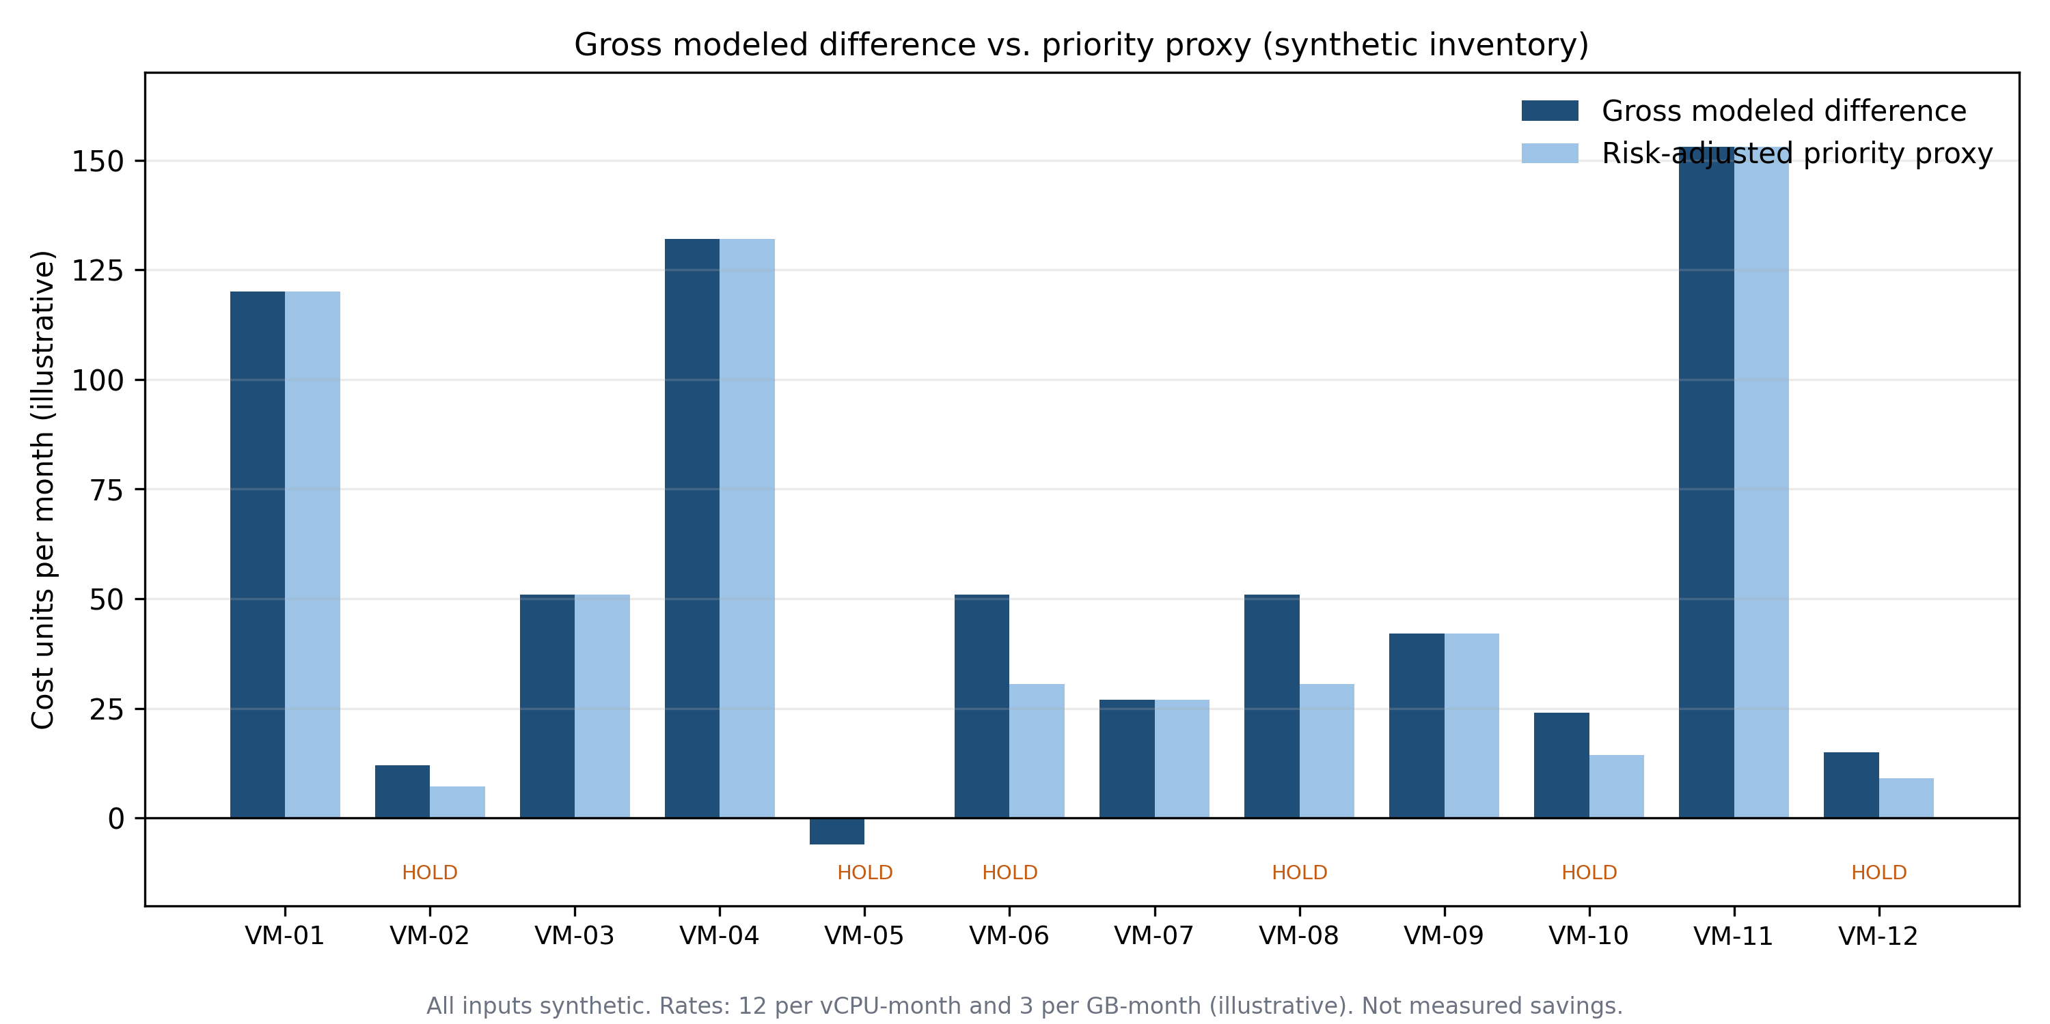
Figure 1. Gross modeled difference and risk-adjusted priority proxy per synthetic VM. The proxy is a ranking heuristic, not an expected value or a realized-savings estimate.
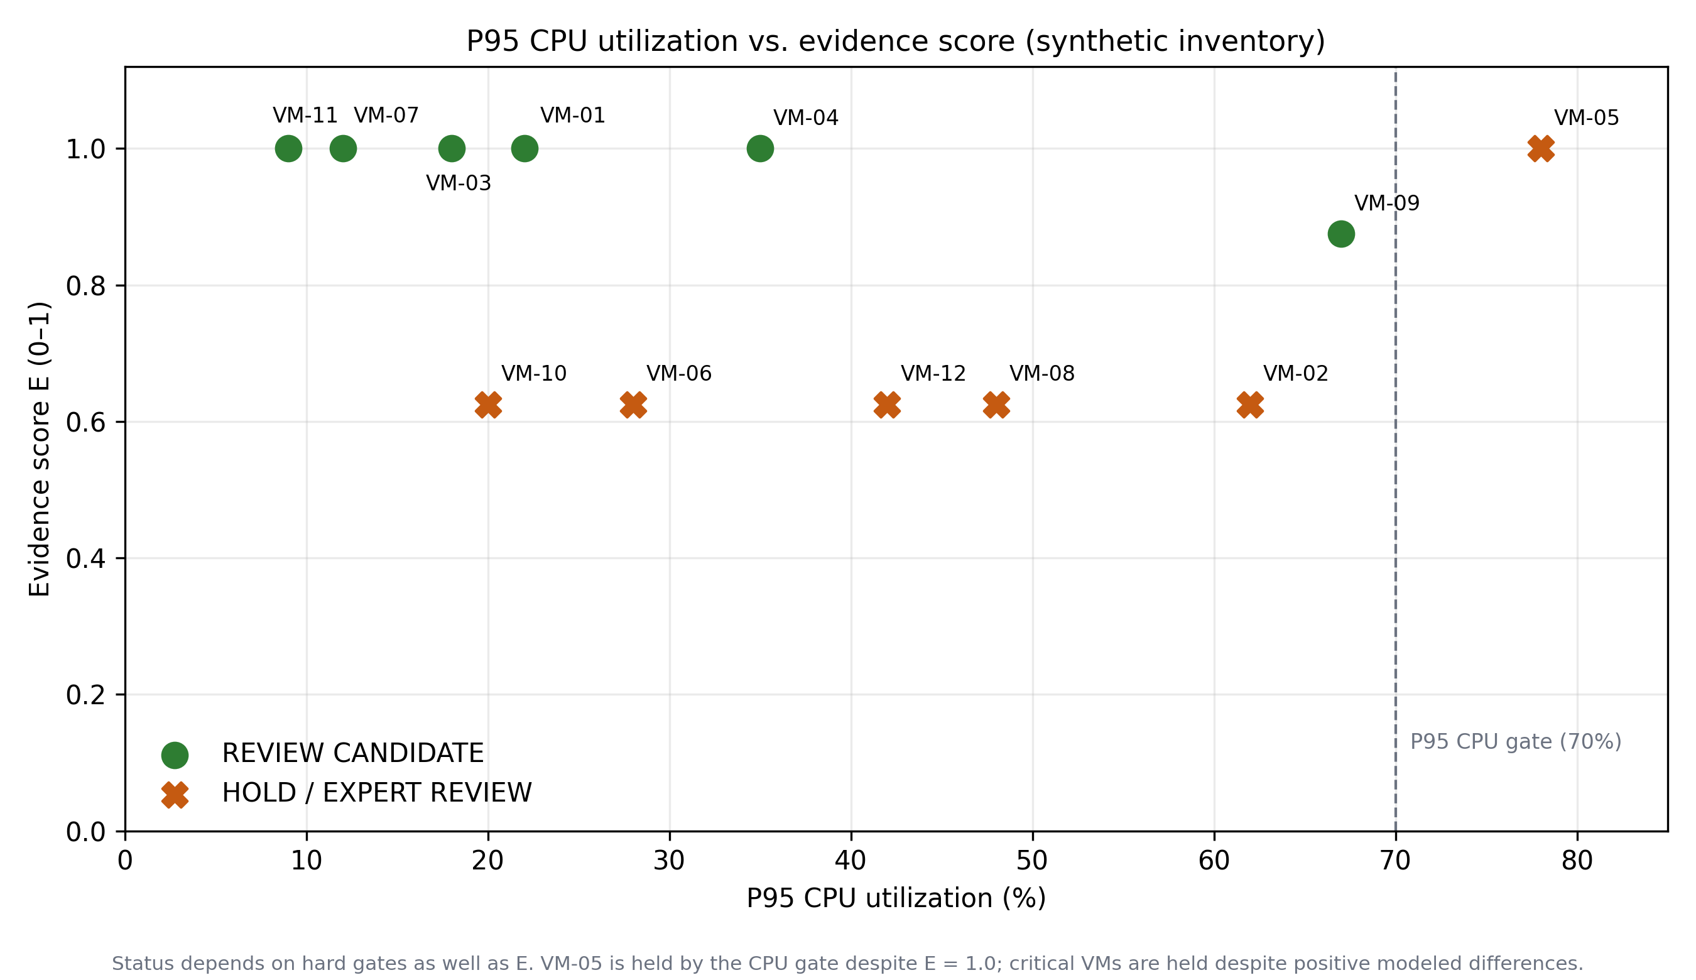
Figure 2. P95 CPU utilization against the evidence score. Status also depends on hard gates; the score alone does not authorize resizing.
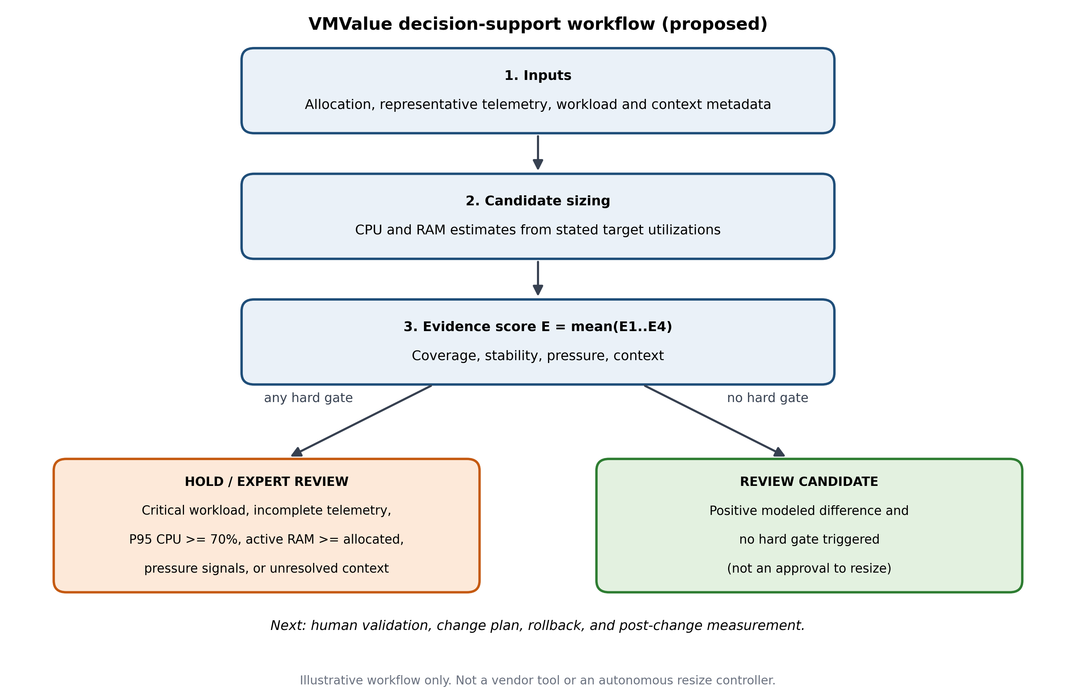
Figure 3. Proposed VMValue decision-support workflow. Final action requires human validation and post-change measurement.

6. Limitations and Threats to Validity
First, all twelve records and all performance indicators are synthetic, so the scenario cannot establish real-world safety, savings, or generalizability. Second, the CV values and pressure counters are scenario assumptions rather than measurements. Third, thresholds and multipliers are heuristic and uncalibrated; VM-09 passes with P95 CPU of 67%, close to the 70% gate, which shows how sensitive dispositions are to a chosen cutoff. Fourth, the sizing equations use only P95 CPU and active memory and omit latency objectives, burst patterns, host and cluster capacity, NUMA, reservations, storage and network I/O, licensing, dependencies, and high-availability constraints. Fifth, candidate sizes can be odd vCPU counts (for example 3 or 9), which vendor guidance advises against when they cross NUMA boundaries [2]; the method does not yet snap candidates to platform-valid shapes. Sixth, the 30-day coverage rule and the cost rates are illustrative and do not map to cash savings. Finally, the literature review is selective and novelty is not claimed.
Accordingly, no causal or comparative-performance claim is made. VMValue should be read as a prototype for review-workflow design, not as a validated recommender or an autonomous resize system.

7. Conclusion and Future Work
This report described a transparent workflow that keeps VM rightsizing candidates, evidence quality, hard gates, and modeled cost differences visible in one reproducible artifact. On a twelve-record synthetic scenario, the rules produce six review candidates worth 525 cost units per month in modeled difference, withhold five records that a utilization-only rule would flag, and show target-driven variation between 450 and 606 units. These are illustrative arithmetic results, not empirical evidence of savings or safety.
Future work has four parts: (i) evaluate on public or de-identified VM traces with documented ground truth; (ii) calibrate the thresholds and multipliers on a held-out split; (iii) constrain candidates to platform-valid VM shapes; and (iv) compare against threshold-only and platform baselines using the metrics in Section 4.1. Until that is done, the defensible claim is that a rule-based framework and spreadsheet prototype were designed and demonstrated on synthetic data.

References
[1] R. Birke, A. Podzimek, L. Y. Chen, and E. Smirni, “Virtualization in the private cloud: State of the practice,” IEEE Trans. Netw. Service Manag., vol. 13, no. 3, pp. 608–621, 2016, doi: 10.1109/TNSM.2016.2601646.
[2] Broadcom, “Rightsizing virtual machines on ESXi 8.0: vCPU, memory, and CPU topology guidance,” Knowledge Base Article 438023. [Online]. Available: https://knowledge.broadcom.com/external/article/438023 (accessed Oct. 22, 2026).
[3] E. Cortez, A. Bonde, A. Muzio, M. Russinovich, M. Fontoura, and R. Bianchini, “Resource Central: Understanding and predicting workloads for improved resource management in large cloud platforms,” in Proc. 26th ACM Symp. Operating Systems Principles (SOSP), 2017, pp. 153–167, doi: 10.1145/3132747.3132772.
[4] S. M. Rozehkhani, F. Mahan, and W. Pedrycz, “VM consolidation steps in cloud computing: A perspective review,” Simul. Model. Pract. Theory, art. no. 103034, 2025, doi: 10.1016/j.simpat.2024.103034.
[5] J. Ahmadi, A. T. Haghighat, A. M. Rahmani, and R. Ravanmehr, “Confidence interval-based overload avoidance algorithm for virtual machine placement,” Softw.: Pract. Exper., 2022, doi: 10.1002/spe.3127.

