NEURO APP

Batch-01

Week 03

Submitted by:
Muhammad Ghufran
EMAIL: ghufranmuhammad156@gamil.com
Flutter Internee

GitHub repository link:
https://github.com/ghufran1718/Flutter_Internship_B_01_W_01
FLUTTER INTERNSHIP 2026

Task 3.1: Flutter Installation & First App (2 hours)
Install Flutter SDK, Android Studio, and VS Code with Flutter extensions. Create your first Flutter app "hello_flutter" using flutter create command. Explore project structure, run app on emulator/device, modify main.dart to display custom text and colors. Take screenshots and push to GitHub.

CODE:
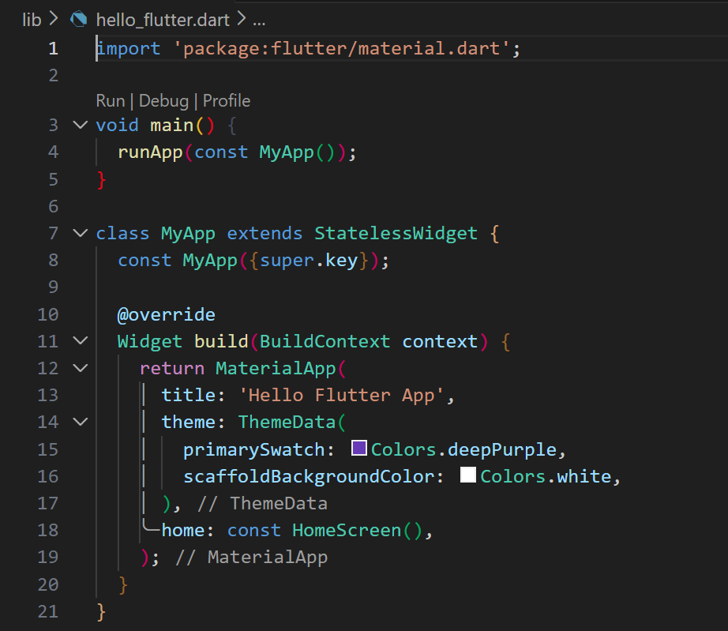
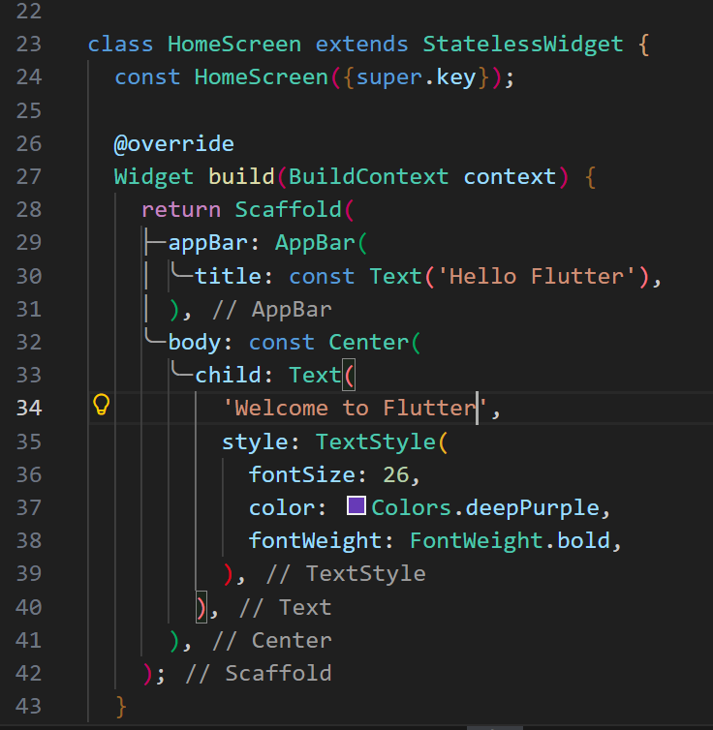
OUTPUT:
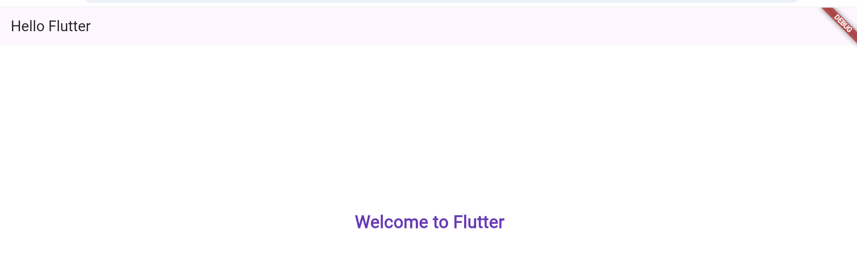

Task 3.2: Stateless Widgets & Basic Layout (3 hours)
Create "basic_widgets_app" demonstrating Container, Text, Icon, Image, Row, Column, Stack widgets. Build a profile card UI using class ProfileCard extends StatelessWidget. Use padding, margin, alignment, and decoration. Create reusable custom widgets for different sections.
CODE:
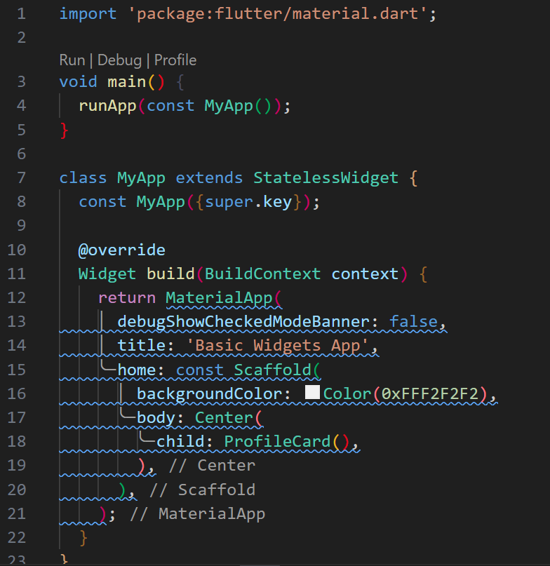
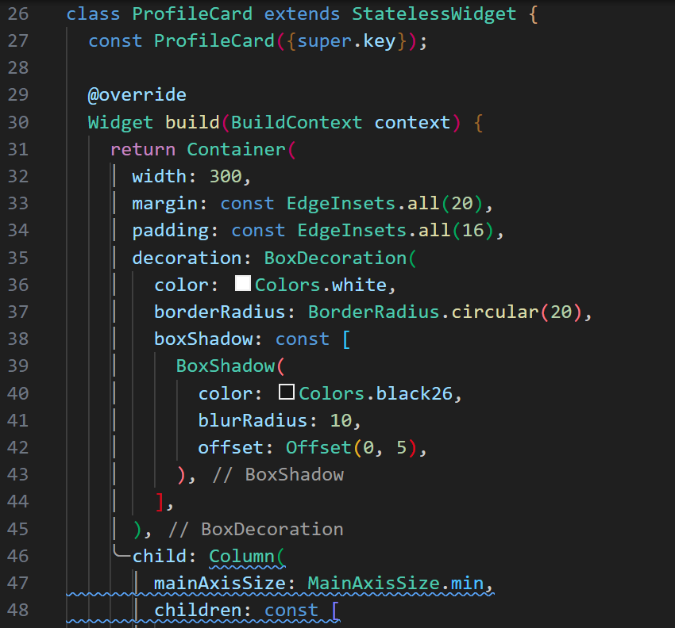
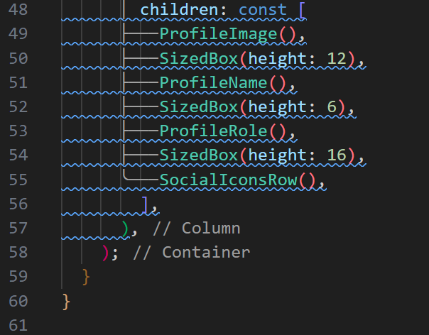

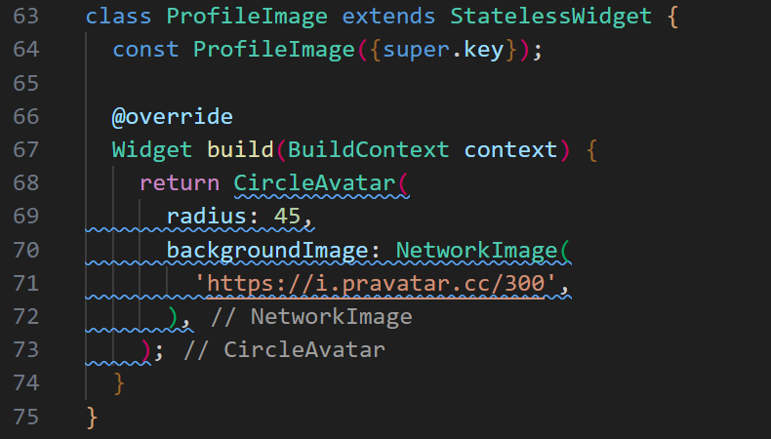
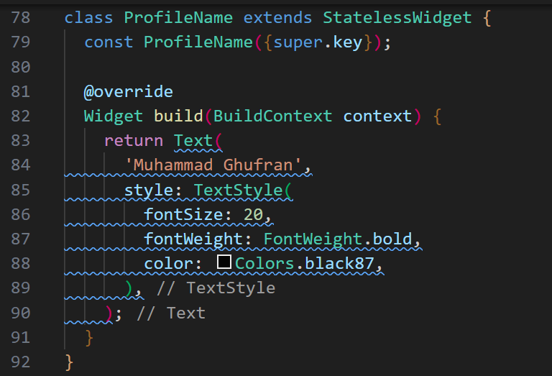
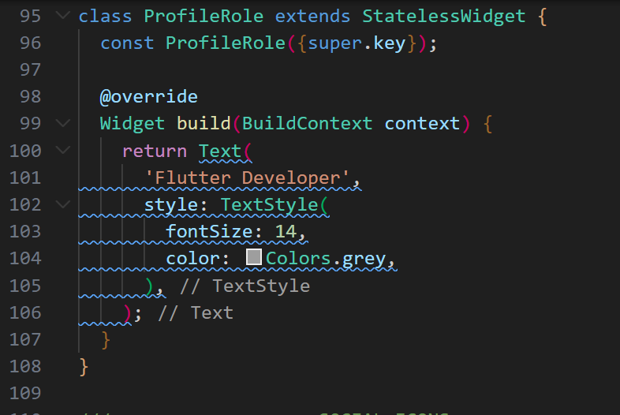
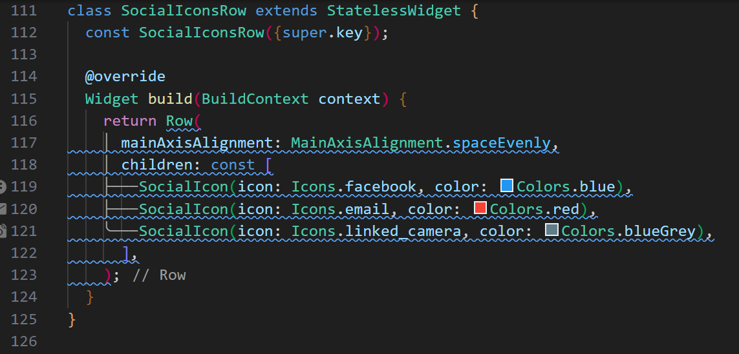
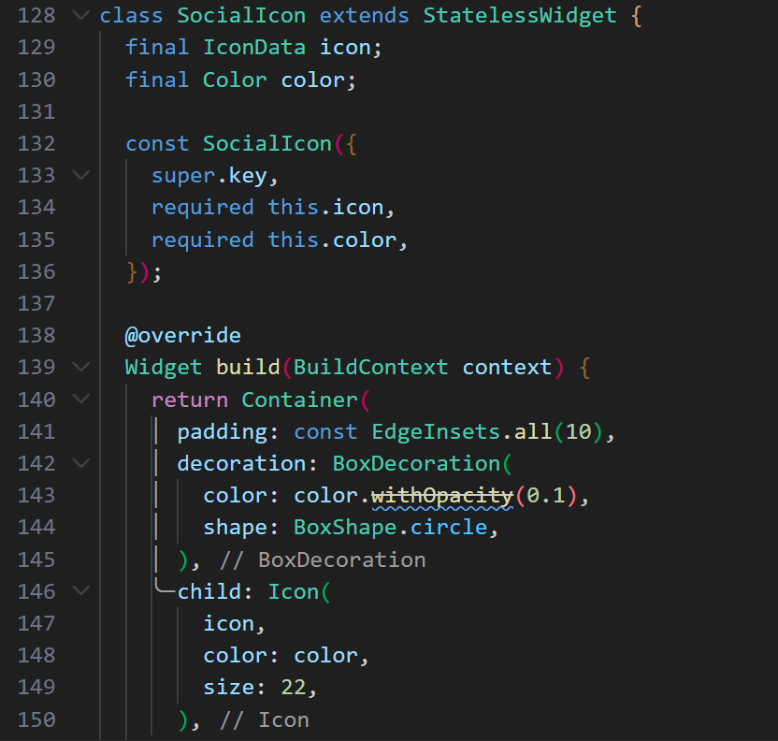
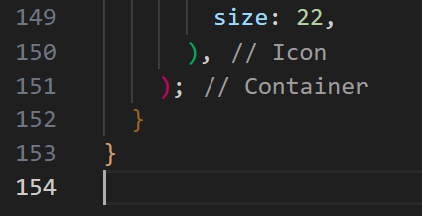
OUTPUT:
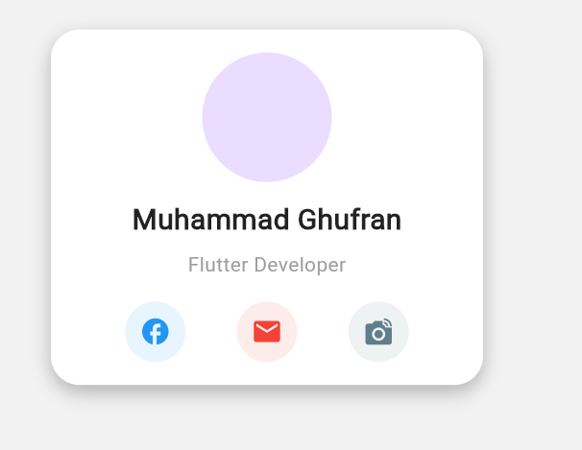

Task 3.3: Stateful Widgets & State Management (4 hours)
Create "counter_app" implementing StatefulWidget. Build a counter with increment, decrement, and reset buttons. Create "todo_simple" app with ability to add and remove items from list. Demonstrate setState() usage, TextEditingController, and ListView.builder().
CODE:
counter_app
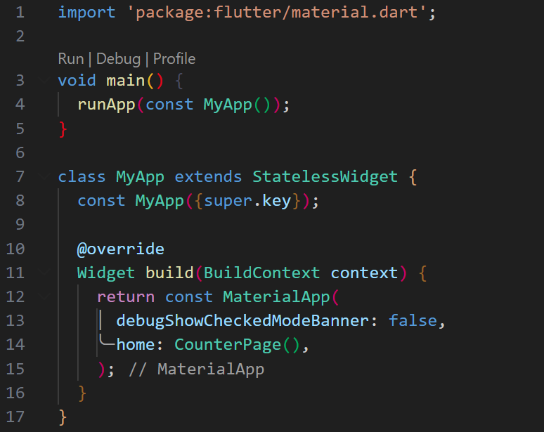
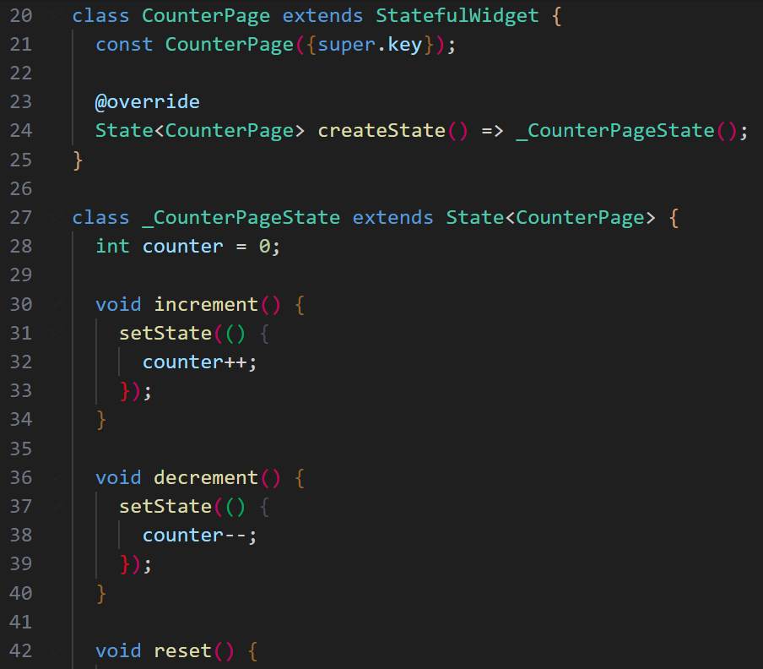
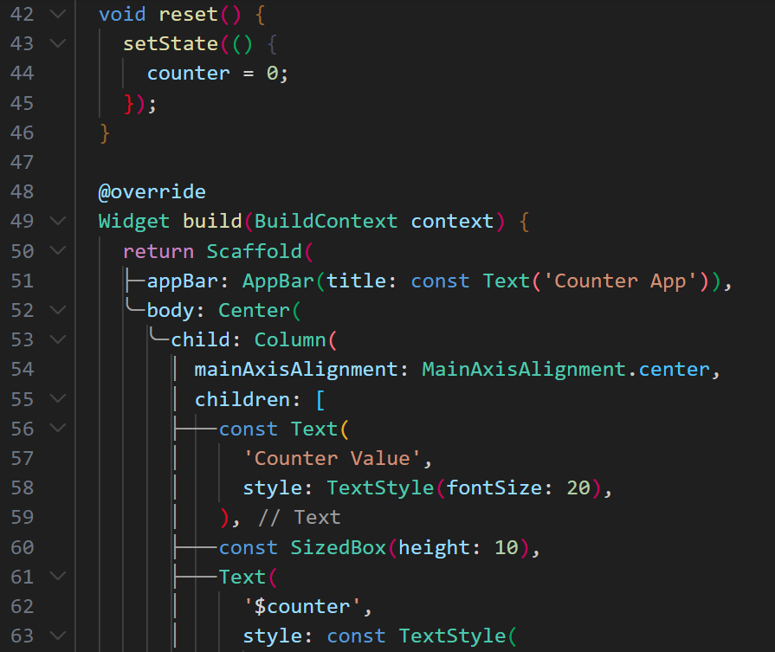
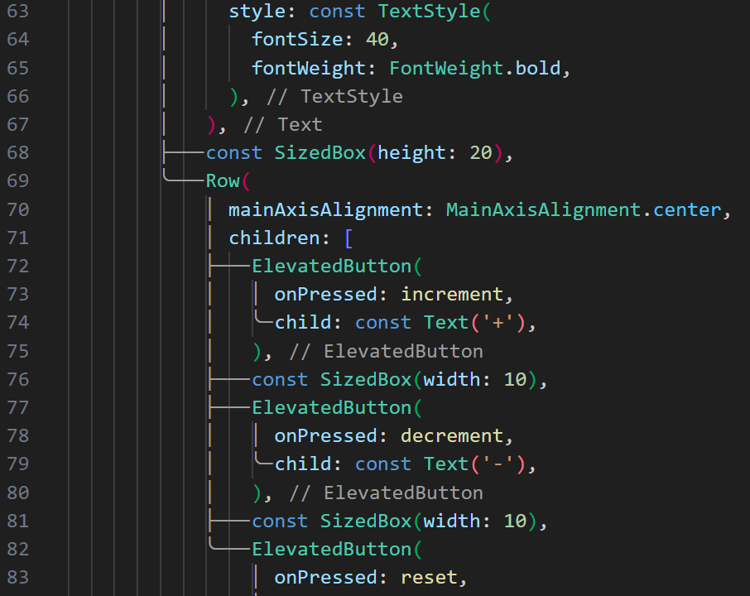
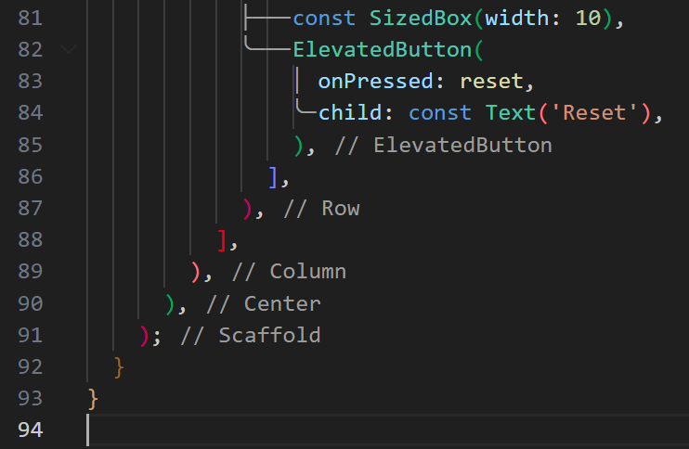

OUTPUT:
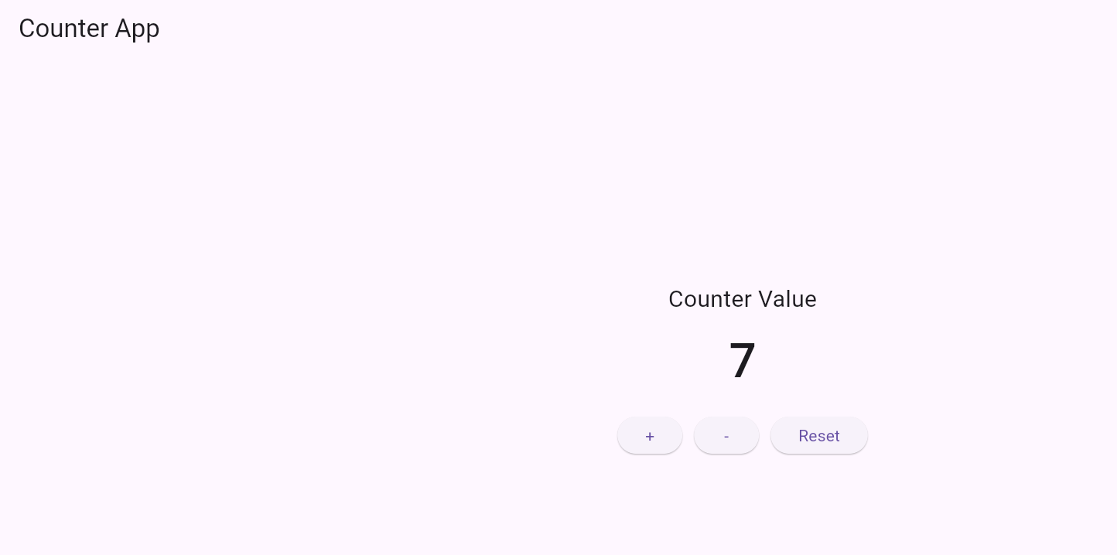
TODO_APP:
CODE:
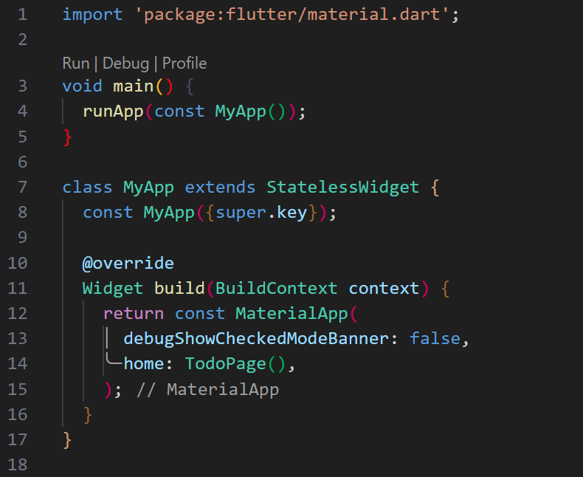

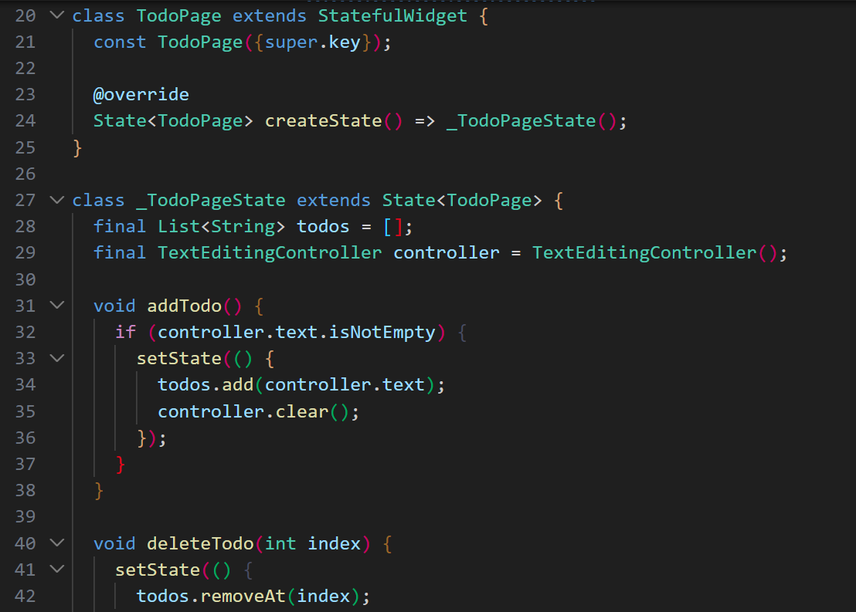
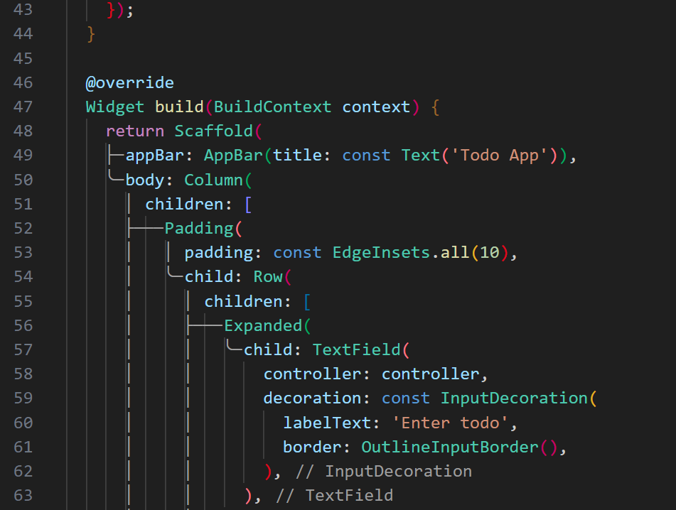
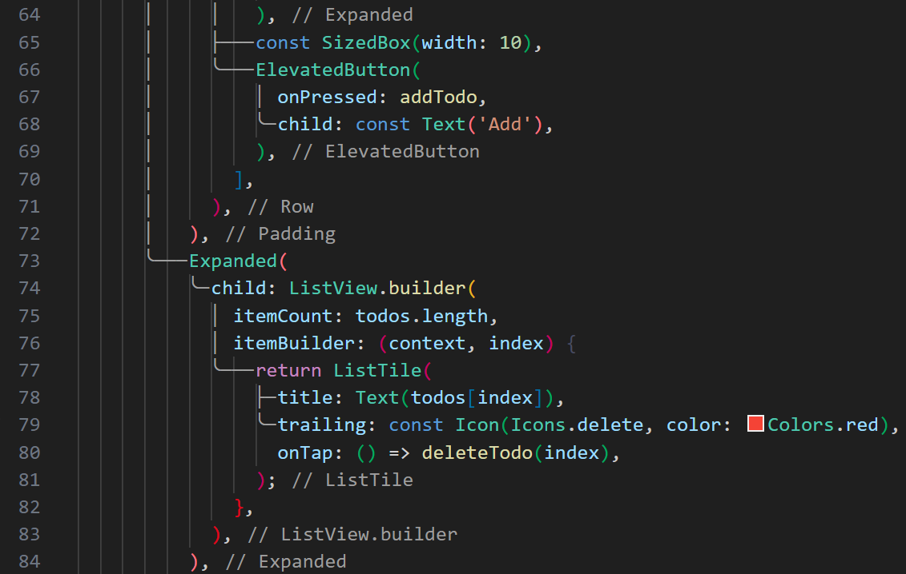
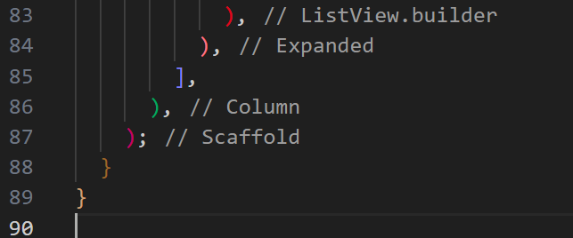
OUTPUT:
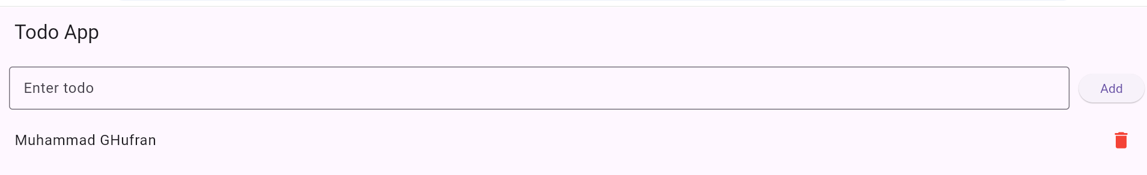

Task 3.4: Navigation & Routes (3 hours)
Create "navigation_app" with multiple screens. Implement Navigator.push(), Navigator.pop(), and named routes. Create HomeScreen, ProfileScreen, and SettingsScreen. Pass data between screens using constructor parameters and route arguments. Implement bottom navigation bar.
Main.dart
CODE:
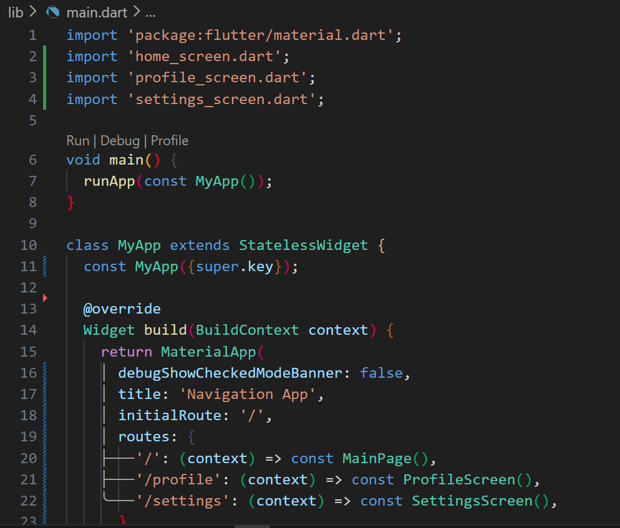
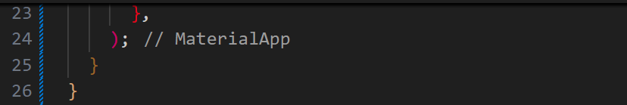

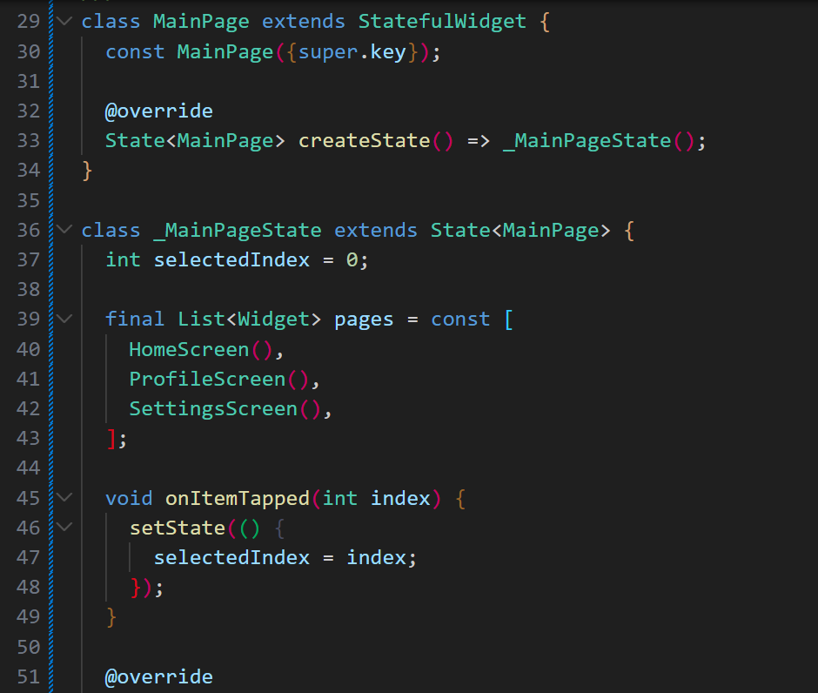
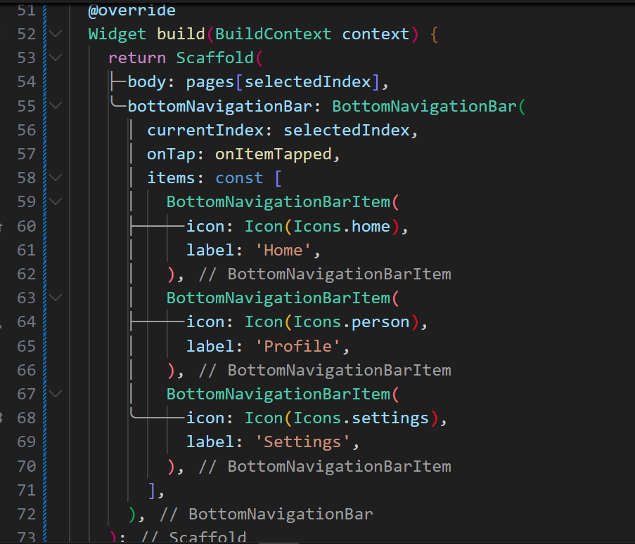
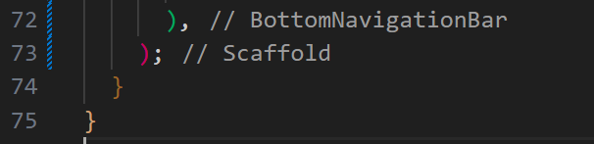
HOME_SCREEN.dart
CODE:
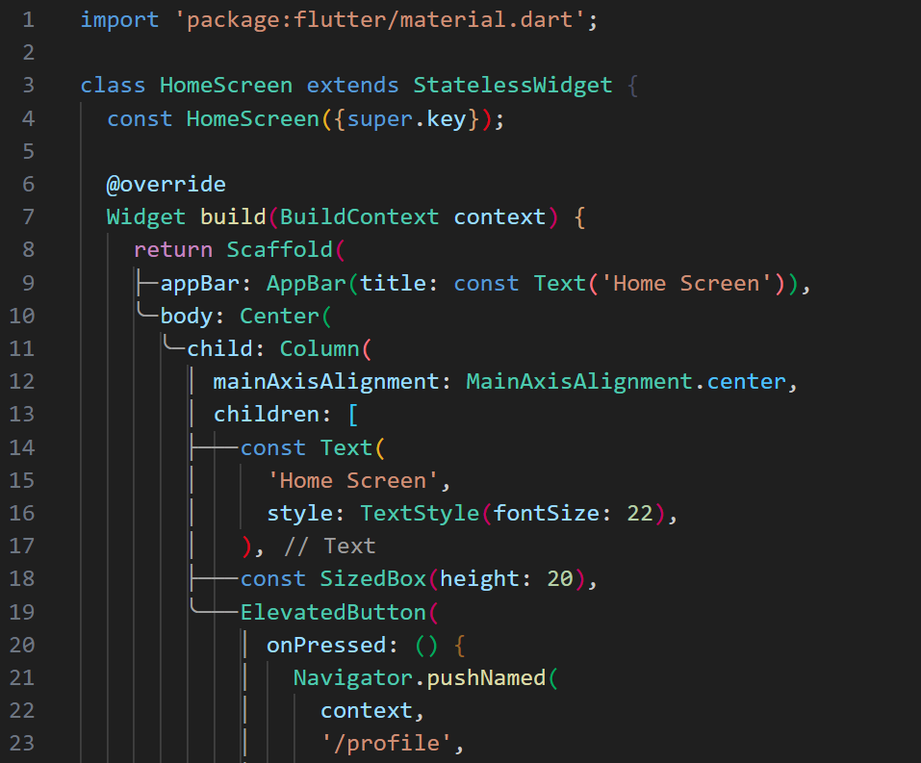
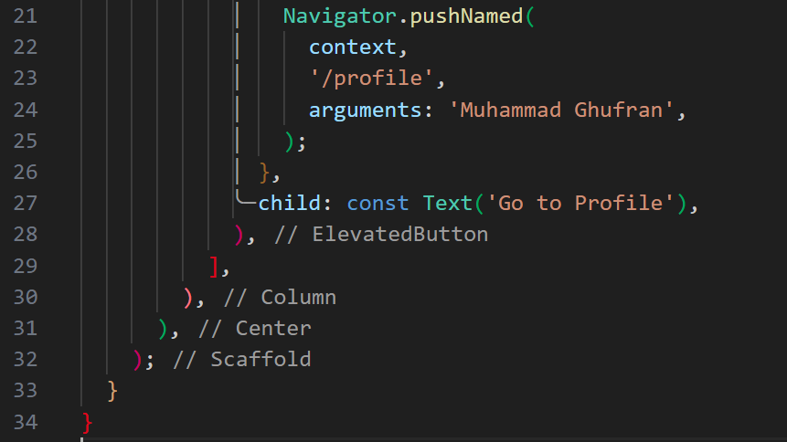
Profile_Screen.dart
CODE:
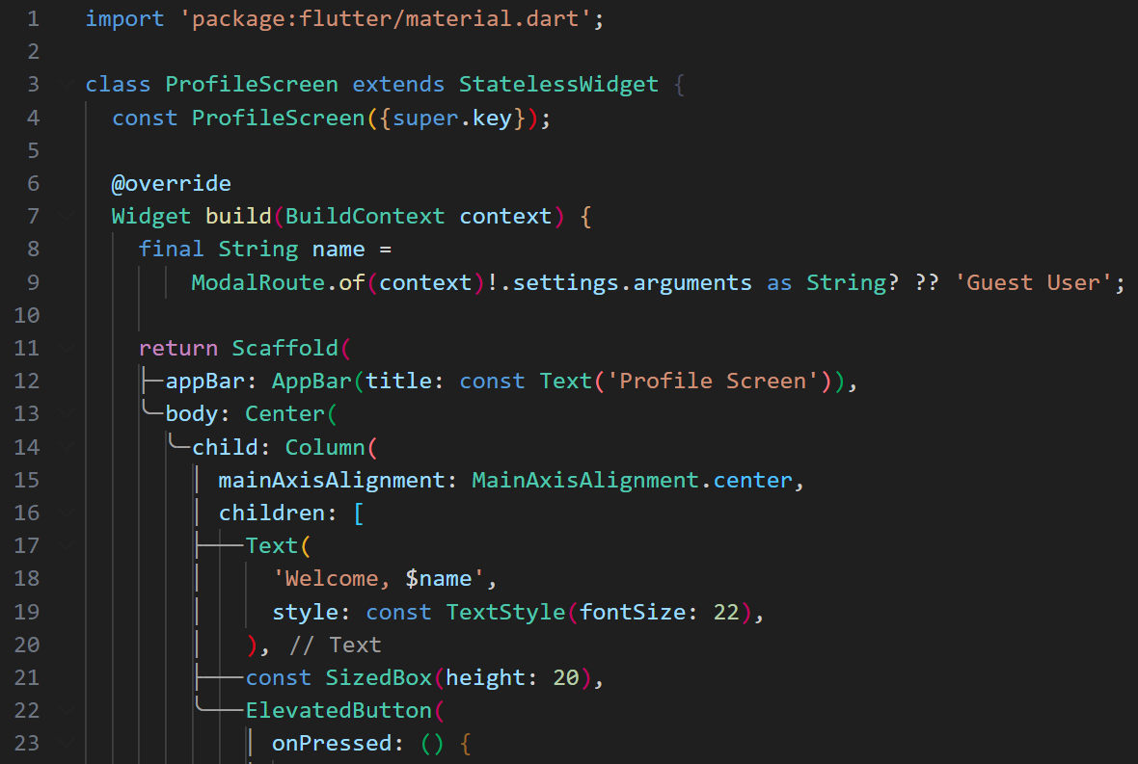
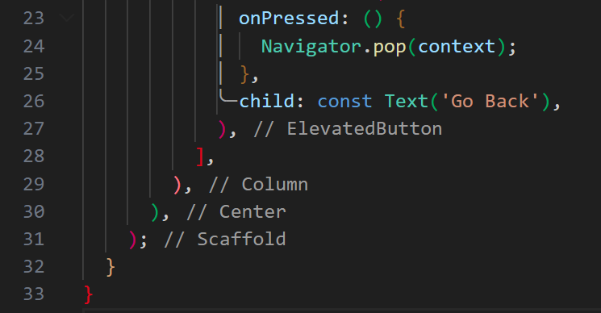

Setting_Sreen.dart
CODE:
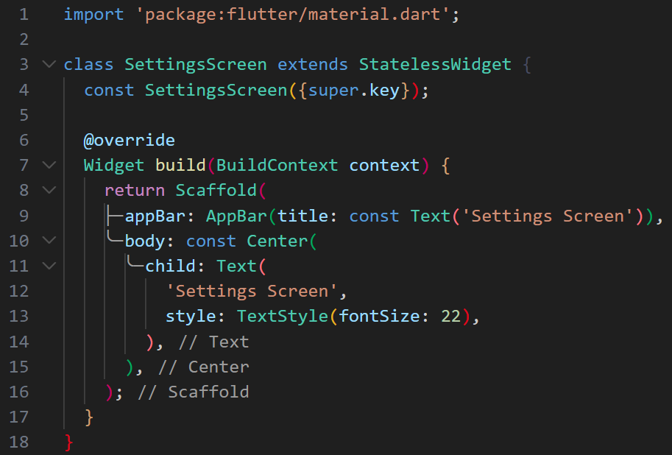
OUTPUT:
