Task 1
Database Search and Reporting

- Comparison Assignment: Flat File Systems vs. Relational Databases

Aspect | Flat File Systems | Relational Databases
Structure | Data is stored in a single file, usually in text or CSV format, with no clear separation between different data types. | Data is stored in multiple tables, where each table represents a specific entity and is organized into rows and columns.
Data Redundancy | High data redundancy, as the same information may be repeated multiple times within the file. | Low data redundancy, as data is stored once and referenced using keys.
Relationships | Does not support relationships between data elements. | Supports relationships between tables using primary keys and foreign keys.
Example Usage | Simple applications, small datasets, temporary data storage, or early-stage systems. | Banking systems, library systems, enterprise applications, and systems that require structured and reliable data storage.
Drawbacks | Difficult to manage and update, high data duplication, poor scalability, and higher risk of data inconsistency. | More complex to design and maintain, requires knowledge of SQL and database management concepts.

- DBMS Advantages – Mind Map

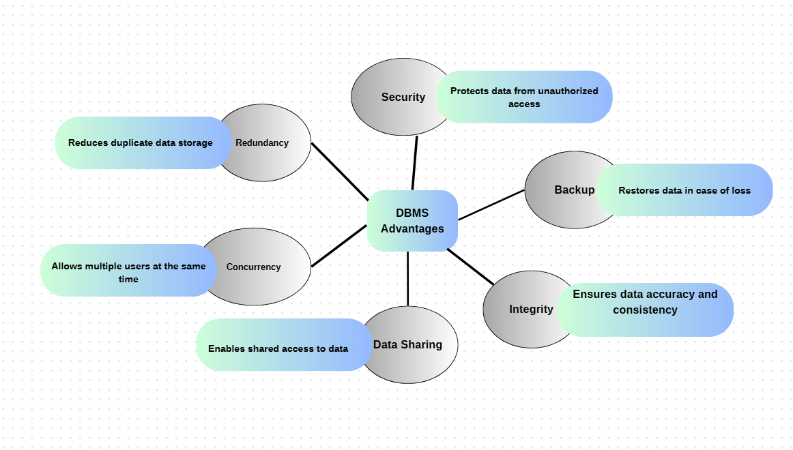

- Roles in a Database System and What They Do in a Database Project

System Analyst:
Analyzes business requirements, understands user needs, and defines what the database system should do. Acts as a bridge between users and the technical team.

Database Designer:
Designs the structure of the database, including tables, relationships, keys, and constraints, to ensure data is organized efficiently.

Database Developer:
Implements the database design by creating tables, writing SQL queries, stored procedures, and ensuring data operations work correctly.

Database Administrator (DBA):
Manages and maintains the database system, handles security, backups, performance tuning, and ensures data availability and reliability.

Application Developer:
Develops applications that interact with the database, writes code to retrieve, insert, update, and delete data using the database.

BI (Business Intelligence) Developer:
Analyzes data and creates reports, dashboards, and visualizations to help organizations make informed business decisions.

- Types of Databases
- Relational vs. Non-Relational Databases
Relational Databases
- Data is stored in tables (rows & columns)
- Uses SQL
- Supports relationships using keys
Example: MySQL, Oracle, SQL Server
Use Case:
- Banking systems
- Library systems
- Any system with structured and related data

Non-Relational Databases (NoSQL)
- Data stored in documents, key-value, or columns
- Flexible structure
- Handles large and unstructured data
Examples:
- MongoDB – document-based database
- Cassandra – column-based database
Use Case:
- Social media applications
- Big data and real-time systems
- Applications with rapidly changing data

- Centralized vs. Distributed vs. Cloud Databases
Centralized Databases
- Database stored in one central location
- All users access the same server
Use Case:
- Small organizations
- University systems
- Single-office applications

Example: University systems
- Distributed Databases
Distributed Databases
- Data is stored across multiple locations or servers
- Improves availability and fault tolerance
Use Case:
- Large enterprises
- Banking systems with multiple branches
- Global applications
Example: Enterprise systems

- Cloud Databases
- Database hosted on cloud platforms
- Scalable and accessible over the internet
Use Case:
- Web applications
- Mobile applications
- Startups and modern systems

Example: Web & mobile apps

