**PROJECT SYNOPSIS**

On

LawAssist: AI-Based FIR Support System with Case Law Integration

**BACHELOR OF ENGINEERING**

**Information Technology**

SUBMITTED BY

1. Prashant Dilip Chaudar [21]
2. Pavan Rajesh Gosavi [22]
3. Sarthak Anik Keche [61]
4. Dipak Machindra Ghuge [58]

**Under the Guidance of**

Mrs. Abhilasha Kore



**DEPARTMENT OF INFORMATION TECHNOLOGY**

**D. Y. PATIL COLLEGE OF ENGINEERING, AKURDI, PUNE**

**SAVITRIBAI PHULE PUNE UNIVERSITY, PUNE**

**| 2025-2026 |**

# INDEX

|  |  |  |
| --- | --- | --- |
| Sr. No. | Content | Page No. |
|  | Title of the Project …………………………………………………………... | 1 |
|  | Domain ……………………………………………………………………... | 1 |
|  | Internal Guide……………………………………………………………… | 1 |
|  | Team ………………………………………………………………………... | 1 |
|  | Abstract……………………………………………………………………… | 1 |
|  | Keywords …………………………………………………………………… | 1 |
|  | Problem Statement ………………………………………………………….. | 1 |
|  | Literature Survey …………………………………………………………… | 2 |
|  | Goal and Objective………………………………………………………… | 2 |
|  | Scope of the Project ……………………………………….………………. | 2 |
|  | System Architecture ………………………………………………………… | 3 |
|  | Technical Details ……………………………………………………………. | 3 |
|  | Probable Date of Completion ……………………………………………….. | 4 |
|  | Plan of Project Execution…………………………………………………… | 4 |
|  | References …………………………………………………………………... | 4 |

# Title of the Project

LawAssist: AI-Based FIR Support System with Case Law Integration

# Domain

MERN Stack with Machine Learning

# Internal Guide:

Mrs. Abhilasha Kore

# Assistant Professor

# Dept of Information Technology.

# D Y Patil College of Engineering, Akurdi, Pune.

# Team

# Group ID:

|  |  |  |  |  |  |
| --- | --- | --- | --- | --- | --- |
| **Sr. No.** | **Roll No.** | **Name of the Student** | **Leader/Member** | **Contact No.** | **Mail Id** |
| 1 | 58 | Dipak Ghuge | Leader | 9834061694 | dipakghuge65@gmail.com |
| 2 | 22 | Pavan Gosavi | Member | 9657379053 | pavangosavi7@gmail.com |
| 3 | 61 | Sarthak Keche | Member | 8830286448 | kechesarthak412@gmail.com |
| 4 | 21 | Prashant Chaudar | Member | 7057242892 | prashantchaudar666@gmail.com |

# Abstract:

# In the current legal and law enforcement framework in India, one of the recurring challenges faced by police officers, especially at the police station level, is the accurate and complete drafting of First Information Reports (FIRs). This challenge is often attributed to the lack of on-site legal experts and limited legal knowledge among investigating officers. The incorrect or incomplete application of Indian Penal Code (IPC) sections and Criminal Procedure Code (CrPC) provisions can lead to significant delays in investigation, prosecution, and even wrongful interpretations of justice. Recognizing this gap, our project titled "LawAssist: AI-Based FIR Support System with Case Law Integration" proposes a smart solution that leverages the power of Artificial Intelligence (AI) and Natural Language Processing (NLP) to assist law enforcement officers in accurately drafting FIRs.

# LawAssist is a mobile and web-based application designed to provide real-time suggestions of relevant IPC and CrPC sections based on the narrative of the incident provided by the complainant or the police officer. The input can be provided in written text or through voice commands, making it accessible and easy to use even in fast-paced or rural police stations. The system analyzes the incident description using NLP techniques and matches it with a pre-trained dataset of case types, section mappings, and real-world legal judgments. It then outputs the most suitable legal provisions and landmark case references that are contextually relevant to the situation.

# A unique and innovative aspect of LawAssist is its integration with a curated legal case law database. Once the AI engine identifies the applicable sections, the system simultaneously retrieves landmark judgments and relevant precedents from historical case data. This not only provides legal context and justification for the sections suggested but also equips the officer with deeper insights into the judicial interpretation of similar incidents. This feature becomes particularly useful during preliminary investigation or when an FIR needs to be reviewed or justified before legal scrutiny.

# The core technology stack of LawAssist includes Python for backend logic, integrating pre-trained transformer models like BERT for NLP-based incident classification. A voice-to-text engine such as Google Speech API or OpenAI Whisper is used for converting spoken complaints into analyzable text. The frontend is built using React Native to support both Android and web platforms. The system architecture is modular and scalable, enabling future integration with police databases or e-governance platforms.

# LawAssist is designed with multilingual capabilities to cater to officers and complainants speaking regional languages such as Hindi, Marathi, and others. Data privacy, encryption, and offline functionality are also part of the design to ensure the tool can be used securely in both urban and remote police stations with limited internet access.

# The potential impact of LawAssist is significant. It minimizes legal errors in FIRs, speeds up the FIR drafting process, and enhances the confidence of police officers while dealing with sensitive or complex legal complaints. Moreover, by embedding legal intelligence directly into the reporting process, the app ensures better alignment with judicial standards and promotes faster, fairer justice delivery.

# In conclusion, LawAssist is not just a technological tool but a practical response to a real-world legal system bottleneck. By combining AI with legal databases and user-friendly design, the system bridges the gap between law enforcement and legal expertise, contributing to a more efficient and just policing system in India.

# Keyword:

# This project combines emerging technologies like Artificial Intelligence (AI) and Natural Language Processing (NLP) to streamline and enhance the legal documentation process, particularly in drafting First Information Reports (FIRs). By analyzing the complaint narrative provided in text or voice form, the system suggests relevant Indian Penal Code (IPC) and Criminal Procedure Code (CrPC) sections, helping officers file accurate and legally sound FIRs. Additionally, the application is integrated with a case law retrieval engine, which fetches similar judicial precedents and landmark judgments to support the recommended sections, ensuring both contextual and legal accuracy. With features like speech-to-text processing, voice-enabled inputs, and multilingual support, it proves effective even in low-connectivity or rural police stations. This solution is part of the broader field of LegalTech and functions as a Legal Decision Support System designed to reduce errors and promote smart policing. It supports police automation, empowers law enforcement, and enhances access to justice.

# Problem Statement:

In India, police officers at the station level are often the first point of contact for citizens seeking justice through the registration of First Information Reports (FIRs). However, due to the absence of legal experts and the complexity of legal provisions under the Indian Penal Code (IPC) and Criminal Procedure Code (CrPC), investigating officers frequently face challenges in accurately identifying and applying the correct legal sections while drafting FIRs. This lack of legal expertise can lead to incomplete, incorrect, or misclassified FIRs, which may adversely impact the subsequent investigation, trial, and delivery of justice.

Additionally, officers do not have access to real-time legal resources or tools that could guide them through similar past cases or landmark judgments. This gap increases reliance on experience or guesswork, introducing inconsistencies and errors into the legal process. In rural or high-pressure environments, this issue becomes even more critical due to time constraints, high workload, and language barriers.

There is a pressing need for an intelligent, user-friendly system that can assist officers by analyzing incident descriptions—whether written or spoken—and suggesting accurate legal sections, acts, and relevant case laws in real time, thus improving legal accuracy and enabling fairer, faster justice delivery.

# Literature Survey

|  |  |  |  |  |  |
| --- | --- | --- | --- | --- | --- |
| **Sr. No.** | **Paper Details** | **Problem Discussion** | **Algorithm /Technique used** | **Parameter Consider** | **Result** |
| 1 |  |  |  |  |  |
| 2 |  |  |  |  |  |
| 3 |  |  |  |  |  |
| 4 |  |  |  |  |  |
| 5 |  |  |  |  |  |

# Goal and Objective

**✅ Goals:**

The primary goal of this project, **LawAssist: AI-Based FIR Support System with Case Law Integration**, is to develop an intelligent, AI-powered software application that assists police officers in accurately drafting FIRs by suggesting relevant legal sections and acts, while also providing references to landmark judgments and similar past cases. The system aims to reduce errors in legal documentation, enhance investigation quality, and promote efficient justice delivery.

**✅ Objectives:**

**To develop a smart legal assistant** that analyzes written or spoken descriptions of incidents using **Natural Language Processing (NLP)** and suggests appropriate **IPC/CrPC sections**.

**To integrate a case law retrieval module** that fetches **relevant judgments and legal precedents** based on the nature of the complaint.

**To support both text and voice inputs**, enabling ease of use in rural, remote, or high-pressure environments.

**To enable multilingual support** for regional languages like Hindi, Marathi, etc., ensuring inclusivity and accessibility.

**To implement a user-friendly interface** (web and mobile) that is intuitive and efficient for on-ground police personnel.

**To ensure offline usability and data privacy**, making the application usable in low-connectivity areas without compromising on security.

**To reduce dependency on legal experts** at the FIR drafting stage and improve legal accuracy and consistency across police stations.

**To promote smart policing and legal tech innovation** within the law enforcement ecosystem, especially in under-resourced areas.

# Scope of the Project

**1.FIR Assistance:**  
The system will assist police officers in accurately drafting First Information Reports (FIRs) by suggesting relevant IPC and CrPC sections based on the incident description.

**2.AI-Based Legal Mapping:**  
Utilizes Artificial Intelligence (AI) and Natural Language Processing (NLP) to understand and process both text and voice inputs.

**3.Voice & Text Input Support:**  
Allows users to enter complaints via typing or speaking, improving accessibility for non-technical users.

**4.Case Law Integration:**  
Provides references to landmark judgments and similar past cases to strengthen legal reasoning and improve investigation accuracy.

**5.Multilingual Capability:**  
Supports regional languages like Hindi, Marathi, etc., ensuring usability in diverse linguistic regions.

**6.User-Friendly Interface:**  
Simple and intuitive UI designed for police personnel, accessible via both mobile and web applications.

**7.Offline Accessibility:**  
Core features available offline, ensuring continuous usability in low or no internet areas.

**8.Data Privacy & Security:**  
Ensures secure storage and processing of sensitive legal data through encryption and secure architecture.

**9.Scalability:**  
The system is designed to be scalable and can be integrated into existing police or e-governance platforms in the future.

1. **Future Enhancements:**  
   The project can be extended to include court integration, real-time lawyer assistance, and automated charge sheet generation.

# FlowChart

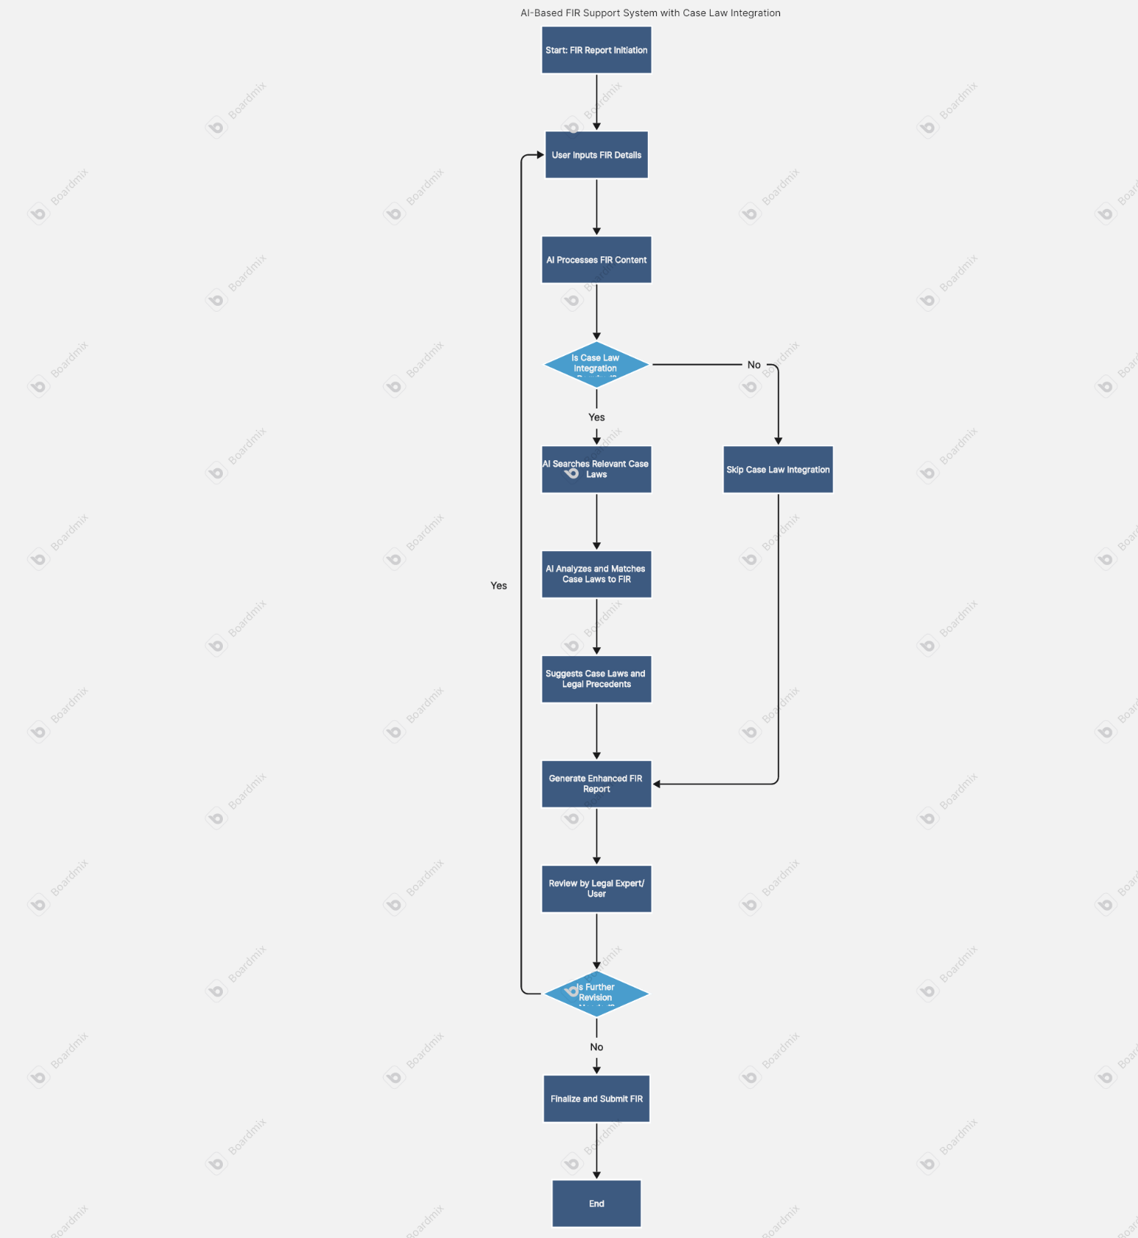

# Technical Details

* **Software Requirements:**
* Windows/Ubuntu OS
* React.js / Next.js + Tailwind CSS / Bootstrap
* Node.js with Express.js OR Django (Python-based
* MongoDB (NoSQL) OR PostgreSQL / MySQL
* **Hardware Requirements:**
* i5 Processor
* 1TB HDD
* 8GB RAM
* GPU 4GB VRAM with CUDA support.

# Probable Date of Completion:

# March 2026

# Plan of Project Execution:

# Using planner or alike project management tool.

# References:

# 1.Smart India Hackathon Official Website Website: <https://www.sih.gov.in> Description: Government platform for innovation and problem-solving via national-level hackathons. The problem statements from all ministries including MP Police are published here.

# 2.Ministry of Education – Innovation Cell Website: <https://mic.gov.in/> Description: Governing body under which SIH is conducted. Useful for understanding the scope and theme of your problem statement.

# 3.MP Police Official Website Website: <https://mppolice.gov.in> Description: Useful for understanding the operational structure and possible use cases your project may impact.