
Factors Affecting Students’ Academic Performance
An Exploratory Data Analysis and Regression Approach Using R

June 15, 2026



Submitted to: Mam Wajiha Nasir
Submitted by: Ghulam Fatima
Roll No: 36
Department: Statistics
Session: 2025-2029
Institute: GCWUS

Sr. No. | Contents | Page No.
1 | Introduction | 3
2 | Dataset Description | 4
3 | Question 1: Import Dataset and Display First Six Observations | 5
4 | Question 2: Determine Observations, Variables, and Names | 6
5 | Question 3: Descriptive Statistics of Quantitative Variables | 7
6 | Question 4: Identify Students with the Highest and Lowest Final Scores | 8
7 | Question 5: Average Study Hours, Attendance and Final Score | 9
8 | Question 6: Histogram for Final Score | 10
9 | Question 7: Boxplot Analysis of Study Hours | 11
10 | Question 8: Comparison of Final Scores for the First 10 Students | 12
11 | Question 9: Scatter Plot of Study Hours vs Final Score | 13
12 | Question 10: Correlation Heatmap for Numerical Variables | 14
13 | Question 11: Simple Linear Regression Model | 15
14 | Question 12: Multiple Linear Regression Model | 16
15 | Conclusion | 18

TABLE OF CONTENTS

Introduction
Factors Affecting Students' Academic Performance
This project analyzes different factors that influence students' academic performance. Variables such as Study Hours, Attendance, Sleep Hours, Internet Usage, and Previous GPA are examined to understand their relationship with Final Score. Various statistical techniques including descriptive statistics, graphical analysis, correlation analysis, and regression models are used to identify the most important factors affecting academic achievement.

Dataset Description

Variable | Description
Student_ID | Unique Student Identifier
Study_Hours | Weekly Study Hours
Attendance | Attendance Percentage
Sleep_Hours | Average Sleep Hours
Internet_Hours | Daily Internet Usage
Previous_GPA | Previous Academic GPA
Final_Score | Final Exam Score

Question 1: Import Dataset and Display First Six Observations

student_data <- read.csv("student_performance.csv")
knitr::kable(head(student_data))
Student_ID | Study_Hours | Attendance | Sleep_Hours | Internet_Hours | Previous_GPA | Final_Score
1 | 10 | 75 | 6 | 5 | 2.1 | 58
2 | 12 | 80 | 7 | 4 | 2.3 | 61
3 | 15 | 82 | 7 | 4 | 2.5 | 65
4 | 18 | 85 | 7 | 3 | 2.8 | 68
5 | 20 | 88 | 8 | 3 | 3.0 | 72
6 | 22 | 90 | 8 | 2 | 3.1 | 74

Interpretation: The dataset is successfully loaded, and the head() function displays the first 6 rows to verify that all variable columns are correctly structured.

Question 2: Determine Observations, Variables, and Names

dim(student_data)
[1] 50 7
names(student_data)
[1] "Student_ID" "Study_Hours" "Attendance" "Sleep_Hours"
[5] "Internet_Hours" "Previous_GPA" "Final_Score"

Interpretation: The dataset contains exactly 50 student observations (rows) and 7 unique variables (columns) representing their academic metrics.

Question 3: Descriptive Statistics of Quantitative Variables
quantitative_data <- student_data[, 2:7]
knitr::kable(summary(quantitative_data))
Study_Hours | Attendance | Sleep_Hours | Internet_Hours | Previous_GPA | Final_Score
Min. : 8.00 | Min. :70.00 | Min. :6.00 | Min. :1.00 | Min. :1.900 | Min. :52.00
1st Qu.:16.25 | 1st Qu.:82.25 | 1st Qu.:7.00 | 1st Qu.:2.00 | 1st Qu.:2.625 | 1st Qu.:66.25
Median :22.00 | Median :88.00 | Median :8.00 | Median :3.00 | Median :3.100 | Median :74.00
Mean :22.20 | Mean :87.38 | Mean :7.44 | Mean :2.86 | Mean :3.044 | Mean :74.20
3rd Qu.:28.00 | 3rd Qu.:93.00 | 3rd Qu.:8.00 | 3rd Qu.:4.00 | 3rd Qu.:3.475 | 3rd Qu.:82.75
Max. :37.00 | Max. :99.00 | Max. :8.00 | Max. :6.00 | Max. :4.000 | Max. :95.00
# Calculate Standard Deviation
knitr::kable(sapply(quantitative_data, sd), col.names = "Standard Deviation")
 | Standard Deviation
Study_Hours | 7.64
Attendance | 7.231
Sleep_Hours | 0.705
Internet_Hours | 1.4144
Previous_GPA | 0.543
Final_Score | 10.455

Interpretation: Students study an average of 22.2 hours per week and achieve an average final score of 74.2 marks. Attendance is generally high, indicating good class participation among students.

Question 4: Identify Students with the Highest and Lowest Final Scores

 | Student_ID | Study_Hours | Attendance | Sleep_Hours | Internet_Hours | Previous_GPA | Final_Score
Highest Score | 50 | 37 | 99 | 8 | 1 | 4.0 | 95
Lowest Score | 31 | 8 | 70 | 6 | 6 | 1.9 | 52
highest_score <- student_data[which.max(student_data$Final_Score), ]
lowest_score <- student_data[which.min(student_data$Final_Score), ]
extreme_students <- rbind(highest_score, lowest_score)
rownames(extreme_students) <- c("Highest Score", "Lowest Score")
knitr::kable(extreme_students)

Interpretation: The highest-scoring student achieved 95 marks, while the lowest-scoring student obtained 52 marks.

Question 5: Average Study Hours, Attendance and Final Score
avg_study <- round(mean(student_data[, 2]), 2)
avg_attend <- round(mean(student_data[, 3]), 2)
avg_score <- round(mean(student_data[, 7]), 2)
average_table <- data.frame(
Variable = c("Study Hours", "Attendance", "Final Score"),
Average = c(avg_study, avg_attend, avg_score)
)
knitr::kable(average_table)
Variable | Average
Study Hours | 22.20
Attendance | 87.38
Final Score | 74.20

Interpretation: Students study an average of 22.2 hours per week, maintain 87.38% attendance, and achieve an average final score of 74.2 marks.

Question 6: Histogram for Final Score

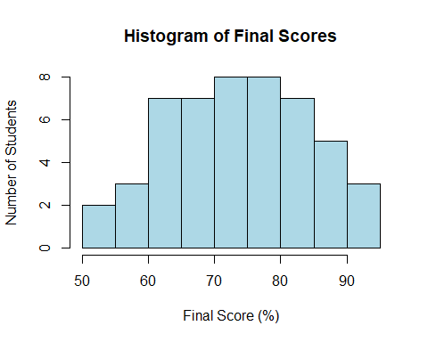
hist(student_data[, 7],
main = "Histogram of Final Scores",
xlab = "Final Score (%)",
ylab = "Number of Students",
col = "lightblue",
border = "black")

Interpretation: The histogram indicates that most students obtained scores around the average range, with fewer students having very low or very high scores.

Question 7: Boxplot Analysis of Study Hours

boxplot(student_data[, 2],
main = "Boxplot of Study Hours",
ylab = "Weekly Study Hours",
col = "lightgreen",
border = "darkgreen")
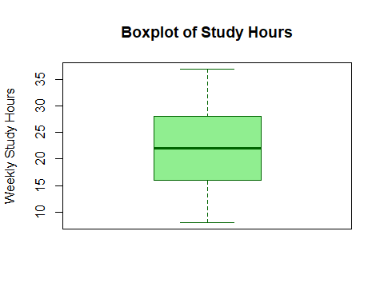
Interpretation: The boxplot shows a clean distribution with no isolated dots, indicating that there are no outliers in Study Hours.

Question 8: Comparison of Final Scores for the First 10 Students
first_10_students <- student_data[1:10, ]
barplot(first_10_students[, 7],
names.arg = first_10_students[, 1],
main = "Final Scores of First 10 Students",
xlab = "Student ID",
ylab = "Final Score (%)",
col = "lightcoral",
border = "black")
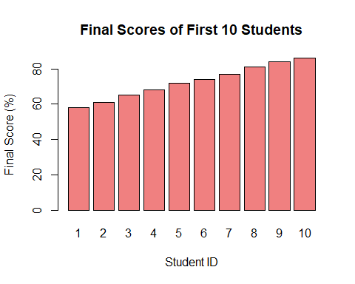

Interpretation: The bar chart compares the final scores of the first 10 students, showing individual variations in their academic performance.

Question 9: Scatter Plot of Study Hours vs Final Score
plot(student_data[, 2], student_data[, 7],
main = "Scatter Plot of Study Hours vs Final Score",
xlab = "Weekly Study Hours",
ylab = "Final Score (%)",
col = "blue",
pch = 19)
abline(lm(student_data[, 7] ~ student_data[, 2]), col = "red", lwd = 2)
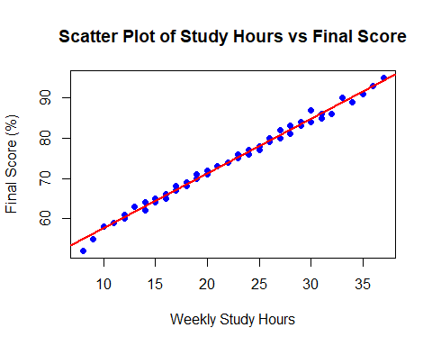

Interpretation: The scatter plot shows a strong positive relationship, meaning that as weekly study hours increase, the final scores of the students also increase.

Question 10: Correlation Heatmap for Numerical Variables
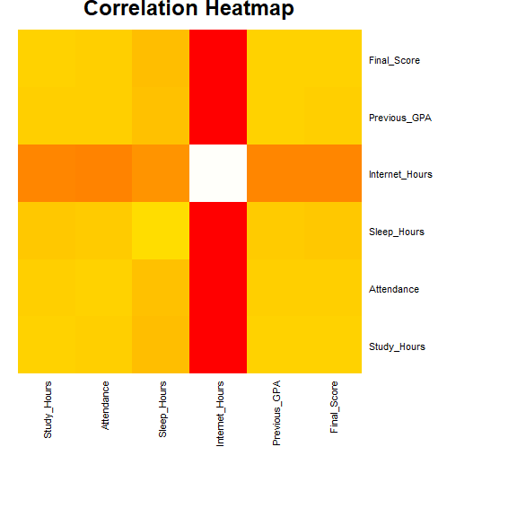
num_cols <- student_data[, 2:7]
corr_matrix <- cor(num_cols)
heatmap(corr_matrix,
Rowv = NA, Colv = NA,
main = "Correlation Heatmap",
col = heat.colors(100),
cexCol = 0.8,
cexRow = 0.8,
margins = c(10, 10))

Interpretation: The heatmap indicates positive relationships among several academic variables. Study Hours, Attendance, and Previous GPA show strong positive associations with Final Score.

Question 11: Simple Linear Regression Model
simple_model <- lm(student_data[, 7] ~ student_data[, 2])
intercept <- round(coef(simple_model)[1], 2)
slope <- round(coef(simple_model)[2], 2)
r_squared <- round(summary(simple_model)$r.squared, 4)
regression_results <- data.frame(
Metric = c("Intercept (β₀)", "Slope (β₁)", "R²"),
Value = c(intercept, slope, r_squared)
)
knitr::kable(regression_results)
 | Metric | Value
(Intercept) | Intercept (β₀) | 43.9200
student_data[, 2] | Slope (β₁) | 1.3600
 | R² | 0.9926
Predicted Final Score = 43.92 + 1.36(Study Hours)
Interpretation:
• For every additional study hour, the final score increases by approximately 1.36 marks.
• The model explains approximately 99.26% of the variation in final scores.

Question 12: Multiple Linear Regression Model
multiple_model <- lm(student_data[, 7] ~ student_data[, 2] + student_data[, 3] + student_data[, 6])
b0 <- round(coef(multiple_model)[1], 2)
b1 <- round(coef(multiple_model)[2], 2)
b2 <- round(coef(multiple_model)[3], 2)
b3 <- round(coef(multiple_model)[4], 2)
r_sq_multi <- round(summary(multiple_model)$r.squared, 4)
multi_results <- data.frame(
Coefficient = c("Intercept (β₀)", "Study Hours (β₁)", "Attendance (β₂)", "Previous GPA (β₃)", "R²"),
Value = c(b0, b1, b2, b3, r_sq_multi)
)
knitr::kable(multi_results)
 | Coefficient | Value
(Intercept) | Intercept (β₀) | 27.3700
student_data[, 2] | Study Hours ( β₁) | 0.7700
student_data[, 3] | Attendance ( β₂) | 0.0800
student_data[, 6] | Previous GPA ( β₃) | 7.3700
 | R² | 0.9955

Predicted Final Score = 27.37 + 0.77(Study Hours) + 0.08(Attendance) + 7.37(Previous GPA)
Interpretation:
• An increase of one study hour increases the final score by approximately 0.77 marks.
• A 1% increase in attendance increases the final score by approximately 0.08 marks.
• A one-point increase in GPA increases the final score by approximately 7.37 marks.
• The model explains approximately 99.55% of the variation in final scores.

Summary of Findings
- Study Habits: A strong positive correlation exists between study hours and final scores. Each additional hour of study increases the final score by approximately 1.36 marks, confirming that consistent study habits are essential for academic success.
- Attendance: Class attendance has a positive impact on student performance. A 1% increase in attendance contributes to a 0.08 mark increase in the final score.
- Academic Performance: Previous GPA is the most significant predictor of final results, with a 7.37-mark increase per GPA point. Collectively, study hours, attendance, and previous GPA explain 99.55% of the variation in final scores.

