

The University of Azad Jammu and Kashmir, Muzaffarabad
Department of Software Engineering

Assignment 1

Name: Ghulam Hussain
Roll No: 2024 – SET –35
Course: Graphic Design
Course Code: ST-2205
Semester: 3rd semester
Session: 2024 –28
Lab Instructor: Engr. Fatima

Save Water Campaign Poste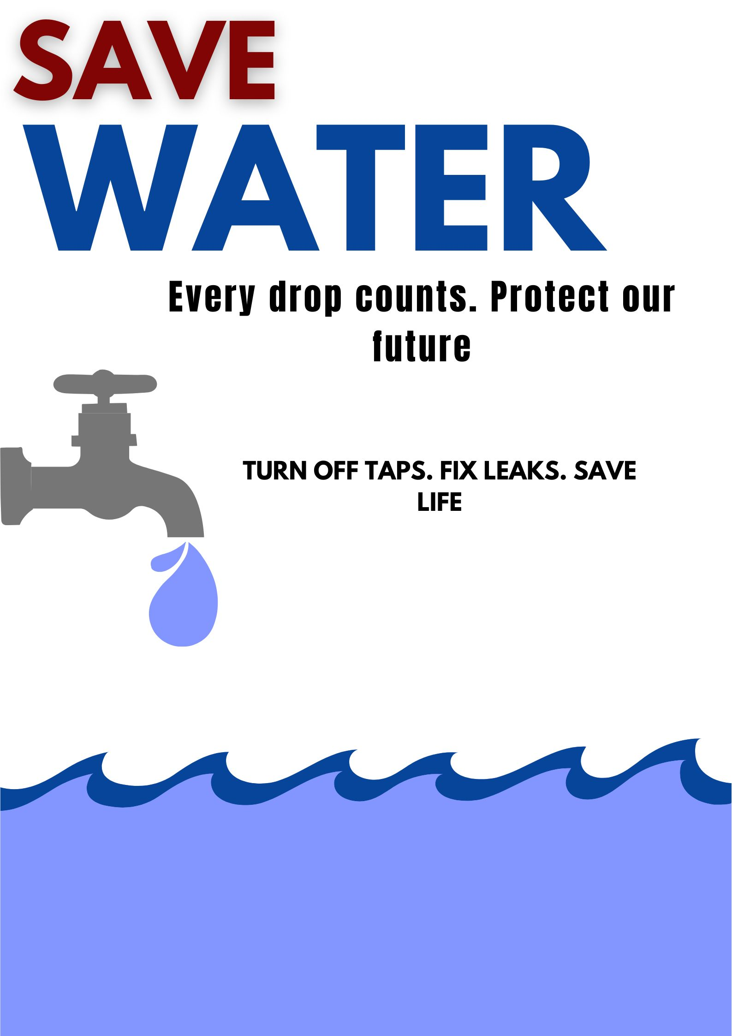r

Design Explanation
Topic: Save Water Campaign Word Count: Approximately 130 words
Color Choice Analysis: For this poster, I have utilized a palette of four colors: Navy Blue, Maroon, Grey, and Black. Blue was chosen as the primary theme because it represents water and trust. I used a dark maroon for the word "SAVE" to create a sense of urgency and call to action, contrasting with the blue "WATER." The grey tap and blue waves provide a visual connection to the topic, while black text ensures high readability against the white background.
Typography and Layout: I selected a bold sans-serif font for the main title to ensure it catches the viewer's attention immediately. The secondary text is kept simple and centered to maintain a balanced layout. The design follows a vertical flow, starting with the header, followed by the supporting message, and concluding with a strong visual of water waves to emphasize conservation. This ensures the poster is neat and easy to understand for all viewers.

