

The University of Azad Jammu and Kashmir, Muzaffarabad
Department of Software Engineering

LAB NO: 01

Name: Ghulam Hussain
Roll No: 2024 – SET –35
Course: Software Testing
Course Code: ST-2203
Semester: 5th semester
Session: 2024 –28
Lab Instructor: Engr. Fahad Nisar

Contents
Objective 3
Environment 3
Step 1: Install Node.js 3
Step 2: Verify Node.js and npm 3
Step 3: Create the Project Folder 4
Step 4: Initialize the Node.js Project 5
Step 5: Install and Initialize Playwright 5
Step 6: Inspect the Project 6
Step 7: Run the Sample Tests 7
Step 8: View the HTML Report 8

Objective
To install Node.js and npm, initialize a Node.js project, set up Playwright with JavaScript, and verify the setup by running the generated sample tests.

Environment
Operating System: Windows 10pro | Terminal: Command Prompt | Internet connection required

Step 1: Install Node.js
Downloaded the Windows Installer (.msi) for the LTS release from https://nodejs.org/en/download, accepted the license, and kept the default options (including npm and Add to PATH).
Node.js version installed: v24.22.0
Screenshot 1: Node.js installer / download page (optional)
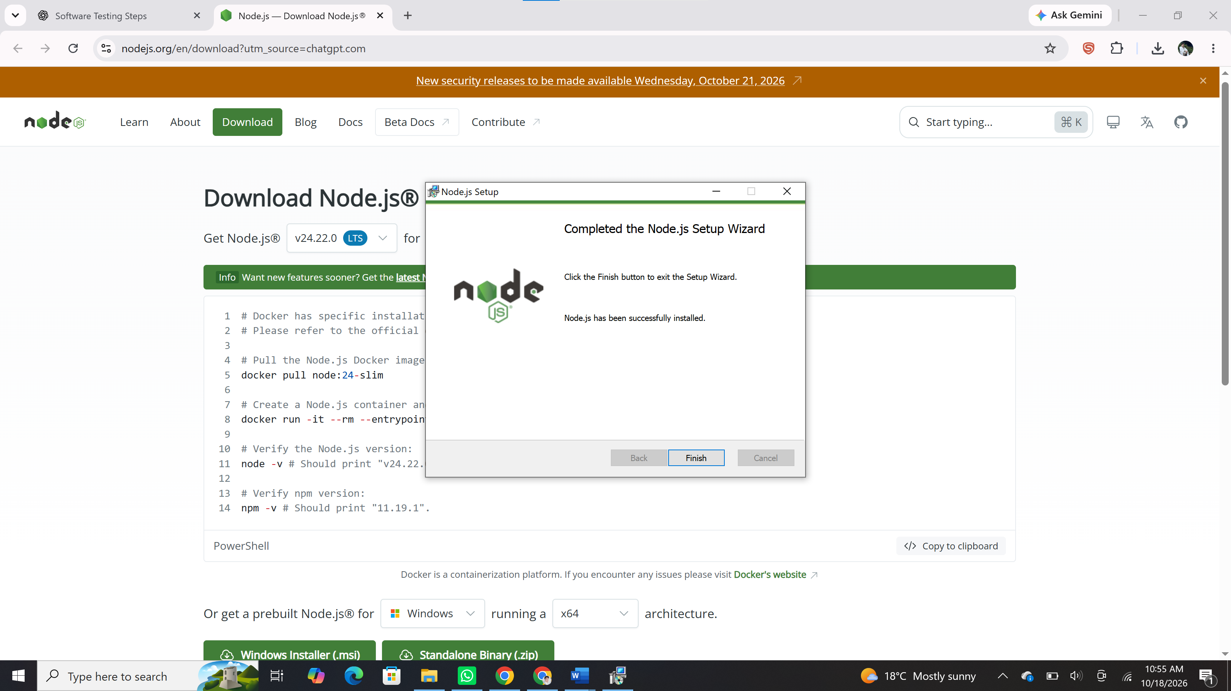

Step 2: Verify Node.js and npm
Commands run in a new Command Prompt window:
node --version
npm --version

Output: Node.js v24.22.0 | npm: 11.19.1

Screenshot 2: Output of node --version and npm --version
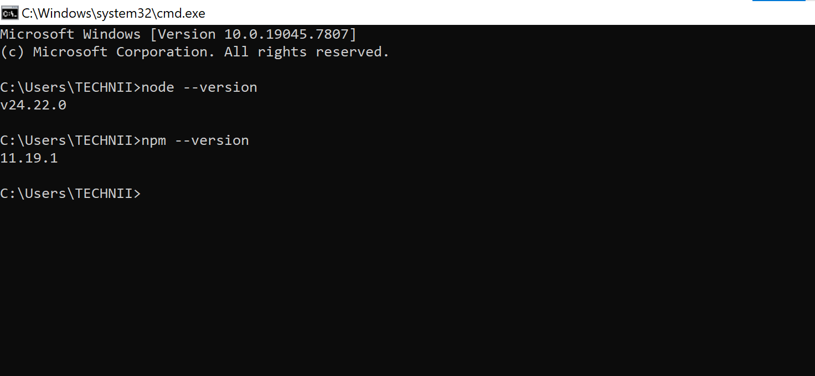

Step 3: Create the Project Folder
mkdir software-testing-lab
cd software-testing-lab

Screenshot 3: Folder created and navigated into
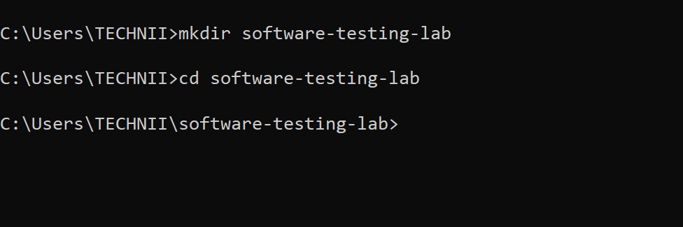

Step 4: Initialize the Node.js Project
npm init -y

Expected result: a package.json file is created. The -y option accepts the default project settings.
Screenshot 4: Output of npm init -y (showing package.json contents)
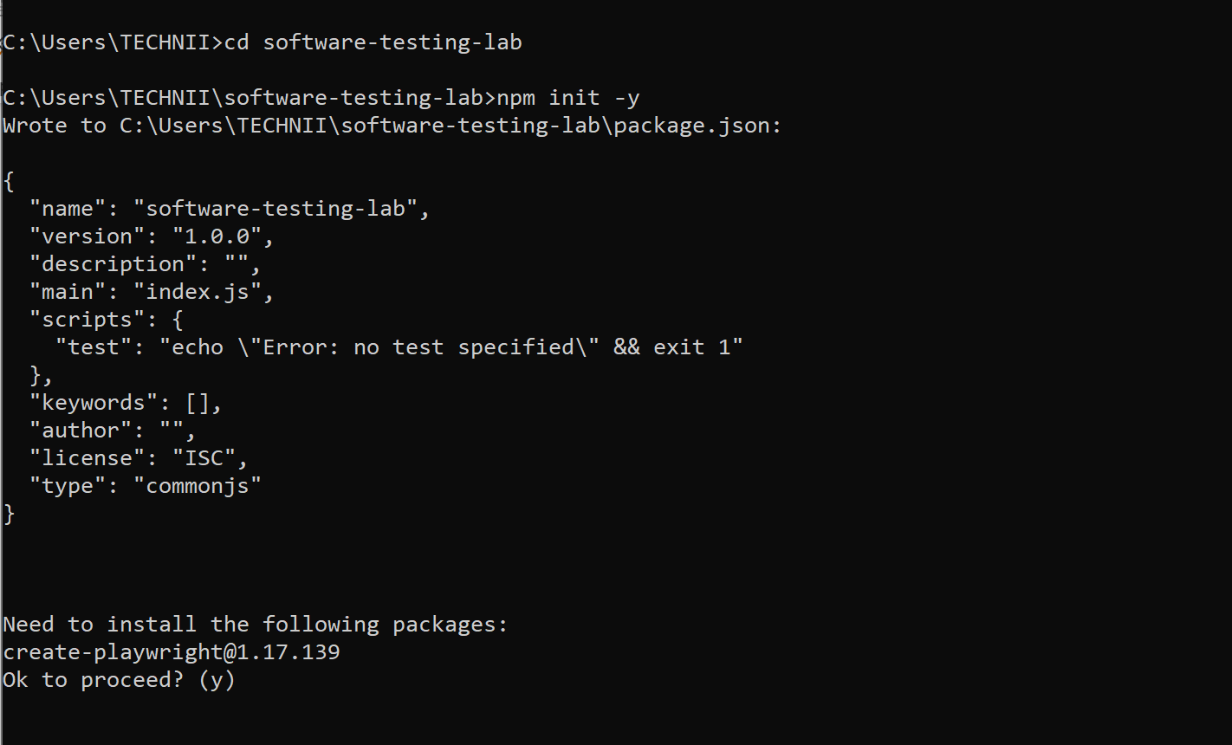

Step 5: Install and Initialize Playwright
npm init playwright@latest

Options selected: JavaScript; test folder = tests; GitHub Actions = No; install Playwright browsers = Yes.
Screenshot 5: Playwright initializer prompts and options selected
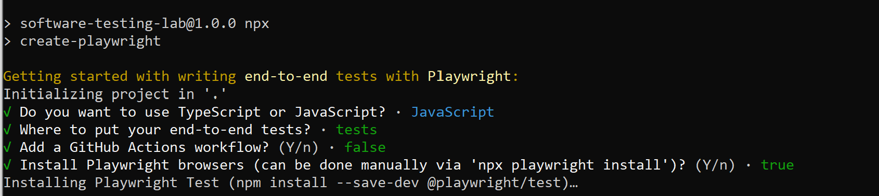
Screenshot 6: Playwright installation completed
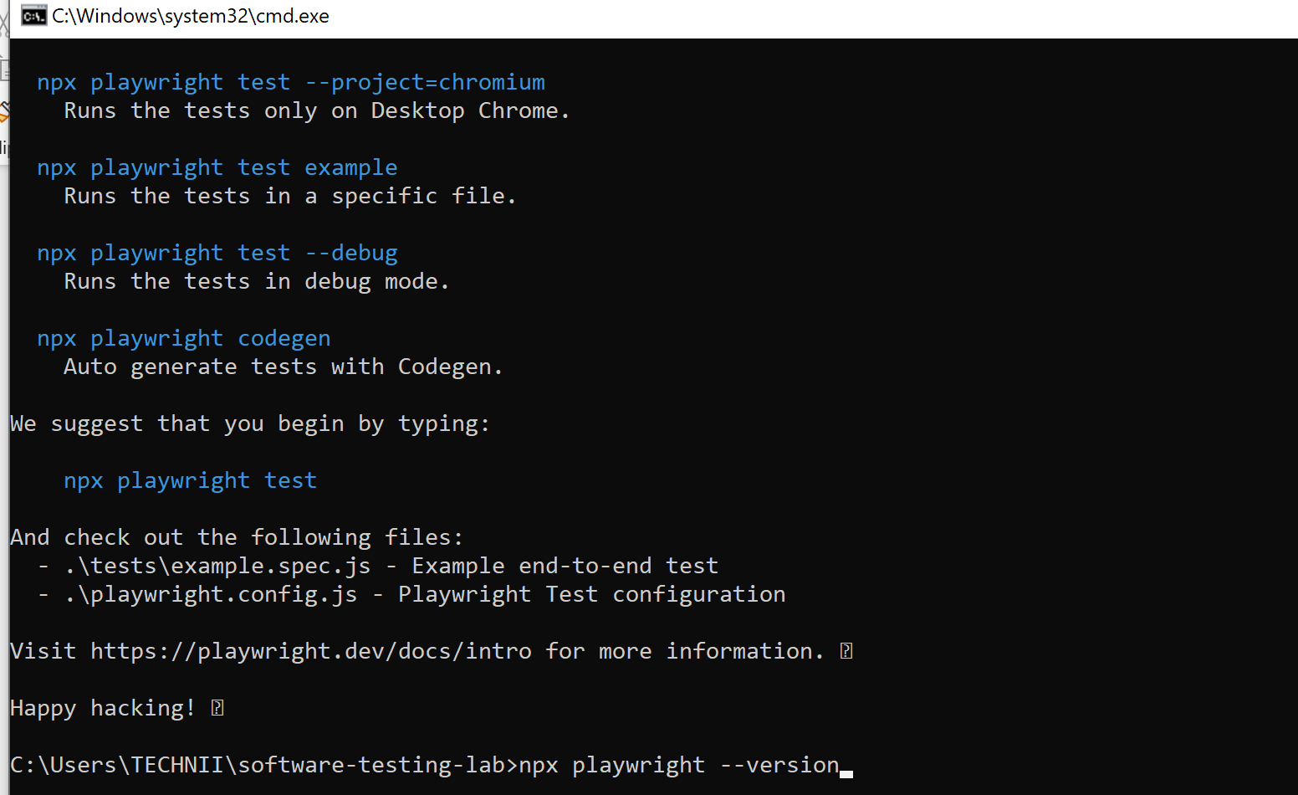

Step 6: Inspect the Project
Project files located: package.json, package-lock.json, node_modules, playwright.config.js, tests/example.spec.js.
Screenshot 7: Generated project files (File Explorer or dir command)
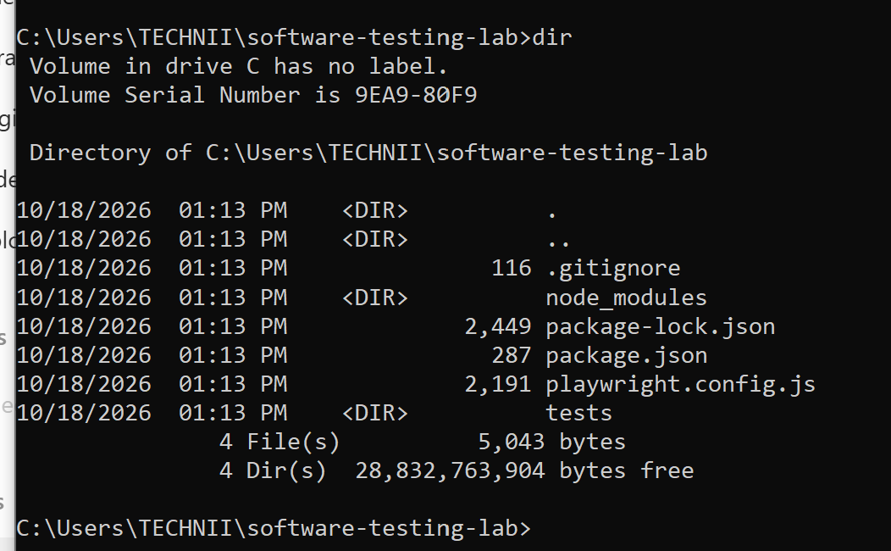
npx playwright --version

Playwright version: 1.64.1
Screenshot 8: Output of npx playwright --version
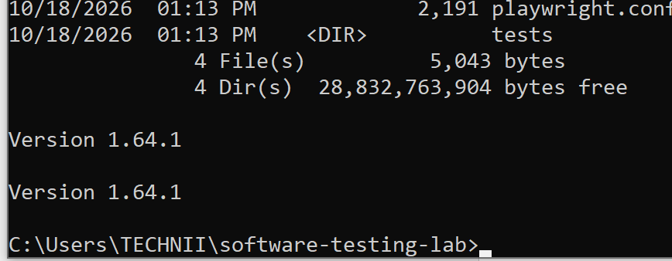

Step 7: Run the Sample Tests
npx playwright test

Screenshot 9: Full command and passing test results
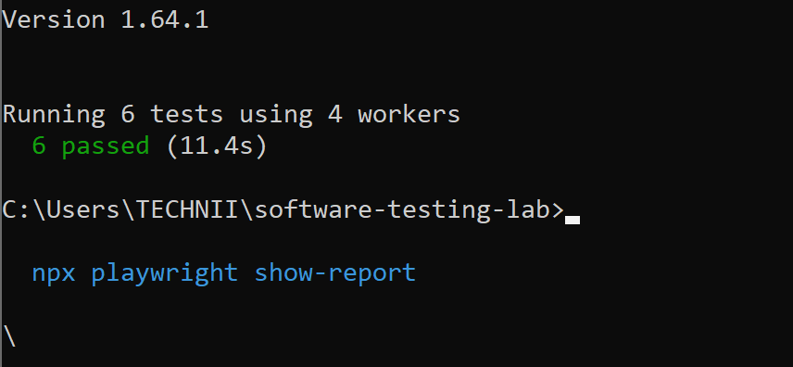

Step 8: View the HTML Report
npx playwright show-report

Press Ctrl + C in Command Prompt to stop the report server.
Screenshot 10: HTML report opened in the browser showing test results
