TOOLCART
  - FINAL COLOUR SYSTEM V3 | 12 OCTOBER 2026
Industrial Cobalt + Action Lime — no copper, purple, violet, lavender or teal brand colours.
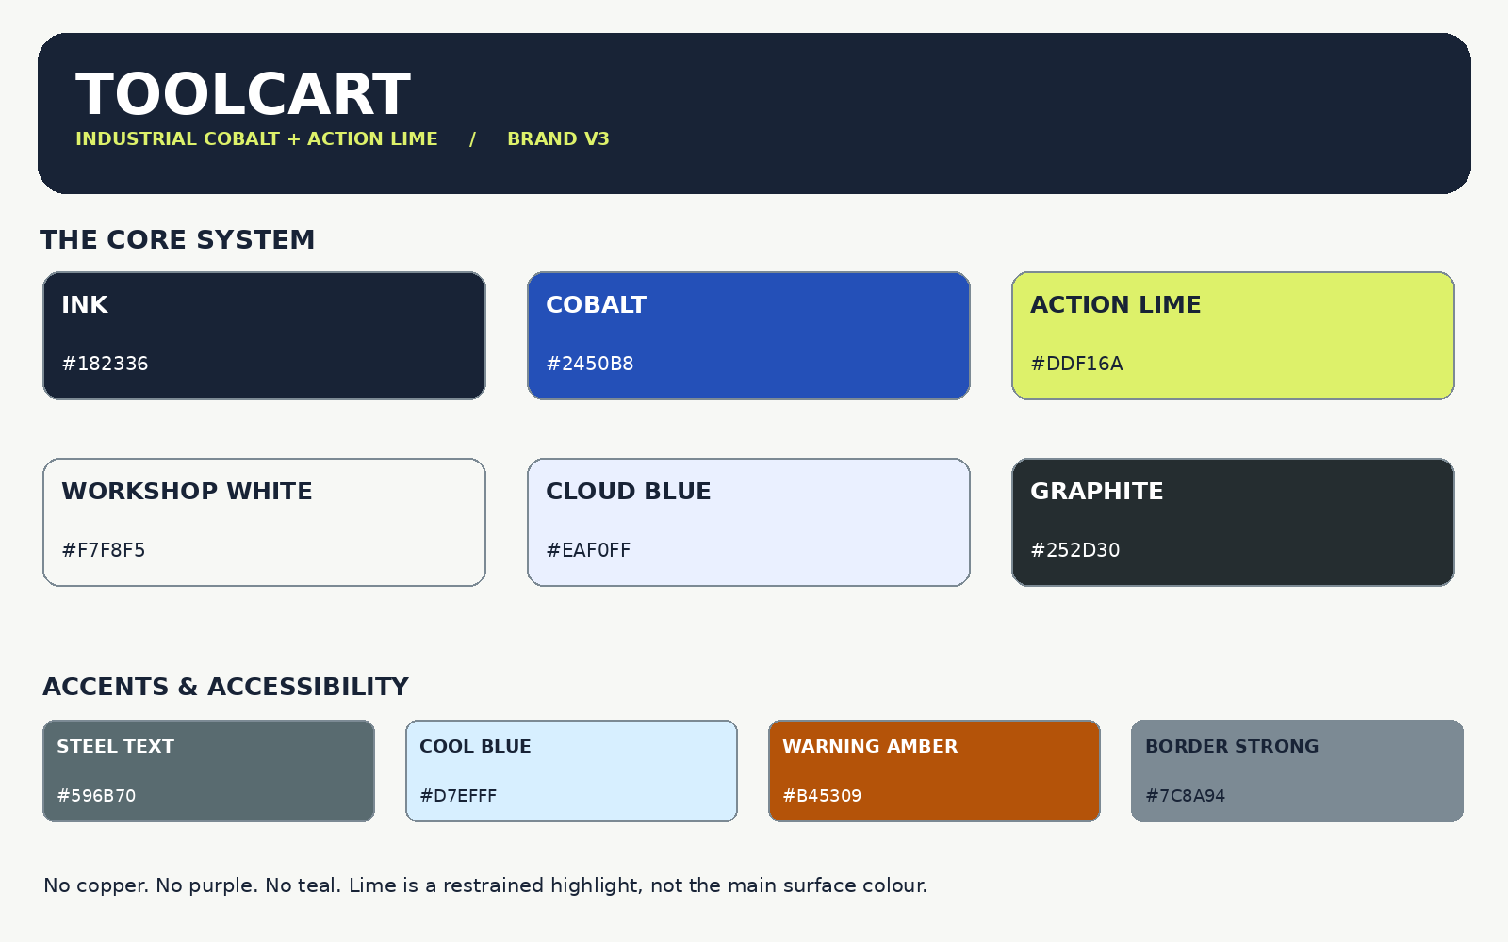
Decision: keep the exact Ink, Cobalt, Action Lime, Workshop White, Cloud Blue and Graphite shades you selected. Make cobalt the primary purchase action; use lime sparingly for memorable brand accents. Warm and cool whites keep real product imagery clean.
Important: this is a well-specified design recommendation, not a study proving all UK customers prefer these colours or that they increase sales.

01 / Final palette hierarchy
Primary retail identity: Ink + Cobalt. Signature highlight: Lime. Information and product surfaces: Workshop White, Pure White and Cloud Blue. The supporting shades are defined below rather than added as competing brand identities.
Role | Name | HEX | Use
Brand foundation | Ink | #182336 | header, footer, wordmark, text on lime
Buying action | Cobalt | #2450B8 | primary CTAs, interactive links, focus
Signature accent | Action Lime | #DDF16A | limited badges, selected actions, packaging detail
Canvas | Workshop White | #F7F8F5 | page background
Cards | Pure White | #FFFFFF | product tiles, checkout, forms
AI & education | Cloud Blue | #EAF0FF | Ask ToolCart surfaces and info panels
Primary content | Graphite | #252D30 | body copy, product descriptions
Muted on white | Steel Grey | #66767A | secondary text ON pure white only
Muted everywhere | Accessible Steel | #596B70 | secondary text on off-white/pale blue
Additional: Chalk #F7F5F1 (optional alternative neutral); Cool Blue #D7EFFF (verified trend-inspired illustration shade); Warning Amber #B45309 (functional warnings only).

Visual distribution (design guidance, not a measured ratio)
65–75% white/off-white product canvas; 15–25% Ink/Graphite navigation, copy and framing; 5–10% Cobalt actions and links; no more than 2–4% Action Lime accents. Adjust per page type and accessibility.

02 / Safe use and actual contrast verification
WCAG 2.2 AA expects at least 4.5:1 contrast for regular text and 3:1 for large text; essential non-text control boundaries generally need 3:1. The numbers below are mathematically computed from the exact sRGB HEX values.
Combination | Contrast | Verdict
Primary CTA | 7.21:1 | PASS
Lime accent CTA | 12.66:1 | PASS
Secondary text on pure white | 4.73:1 | PASS
Secondary text on workshop | 5.24:1 | PASS
Secondary text on AI panel | 4.89:1 | PASS
Strong border on cloud | 3.11:1 | PASS
Lime alone on white (do not use) | 1.25:1 | DO NOT USE
Steel Grey on canvas (do not use) | 4.44:1 | DO NOT USE
White on Lime (do not use) | 1.25:1 | DO NOT USE
Key correction: original Steel Grey #66767A scores 4.73:1 on white but 4.44:1 on Workshop White and 4.15:1 on Cloud Blue. For text on those surfaces, use Accessible Steel #596B70 instead. White text on Action Lime is prohibited; ink text on lime is 12.66:1.
If a lime-coloured control appears on white, surround it with a high-contrast Ink border: a lime fill alone is too visually close to white to define the control boundary.

03 / Brand application guide

Retail website
Header: Pure White, Ink wordmark and a Cobalt search/primary action. Navigation can use Ink or Cobalt but not competing accent bands. Product-grid background: Workshop White. Product tiles: white with stable layout, clear prices and real supplier-licensed imagery.

Hero and marketing banners
Primary hero: Cloud Blue or Workshop White with a strong Ink heading and Cobalt CTA. Action Lime can accent the wordmark, a small 2–4 word micro-label, or a clearly outlined secondary CTA. Never cover the page with lime or create a fluorescent gradient.

AI product adviser
“Ask ToolCart” uses the same brand as the storefront: Cloud Blue panel, Ink heading, Cobalt action and text. No separate futuristic purple/cyan branding. Never imply a product is in stock, compatible or safe without verified supplier/manufacturer data.

Checkout
Keep pure white surfaces, black/Graphite text, cobalt primary payment action, and colour-independent field errors. Functional red/green/amber colours are status signals, not marketing colours.

Physical use
Logo must work as Ink-on-white and White-on-Ink first. For packaging, consider single-colour Ink with limited Cobalt/Lime label details; test litho/digital print and Pantone matching before production. HEX values are digital only, not a substitute for press proofs.

04 / Emerging shades — controlled extensions only
Trend evidence: Pinterest’s official 2026 palette includes Cool Blue #D7EFFF and Wasabi #E9F056, based on Pinterest search and save signals. These document trend momentum; they are not evidence that ToolCart customers prefer those colours.
Cloud Blue  #EAF0FF | Base AI and information background

Cool Blue  #D7EFFF | Optional guide or social campaign illustration

Action Lime  #DDF16A | Core, founder-approved small brand accent

Lime Hover  #CFDE53 | Hovered outlined accent button

Cobalt Hover  #193F99 | Hovered primary button

Chalk  #F7F5F1 | Optional warm background on editorial pages

What we are not adding
No Copper #B84C32; no purple/violet/lavender; no teal as an independent brand colour; no overused AI glow/neon gradient. Status colours are exceptions only when conveying meaning (warning, error, success).

05 / Production design tokens & acceptance criteria
Source of truth: design/tokens.json and design/tokens.css in the developer package. Do not hardcode retired colours anywhere in the UI or marketing templates. Use semantic token names such as --tc-primary, --tc-action-lime, --tc-canvas and --tc-text-secondary.
Typography retained from prior approved direction: Manrope headings, IBM Plex Sans body/UI. Base normal text 16 px; responsive typography with accessible line-height and clear prices/measurements.

Acceptance checklist
☐ Exact founder-approved HEX values preserved; brand accents use only Ink/Cobalt/Lime.
☐ Every regular text/background pair passes WCAG AA 4.5:1; focus/input states remain visibly distinct.
☐ No white text on lime; steel grey darkened when used on Workshop White or Cloud Blue.
☐ Mobile 360px and desktop 1440px screens have no overflow; navigation, search and checkout remain legible.
☐ Product photo colours are not altered with blue/lime filters; product identity/packing is accurate.
☐ All legal/business, supplier and stock claims remain unverified until founder sign-off.
☐ Compare two identical real-product layouts and test with UK DIY and trade participants before final investment.

Reference and evidence
W3C WCAG 2.2: https://www.w3.org/TR/wcag/
W3C non-text contrast: https://www.w3.org/WAI/WCAG22/Understanding/non-text-contrast.html
Pinterest 2026 palette: https://business.pinterest.com/en-gb/pinterest-palette/
Baymard buttons: https://baymard.com/blog/button-design
Method note: contrasts calculated from linearised sRGB; design quality requires actual-browser/accessibility testing. Industry/trend research informs the shortlist but does not establish a universal colour preference.

