DHA Suffa University

Department of Computer Science


Deep Scan
P23F25
Final Year Project Report
Submitted by

Mir Balach Kamal (CS221213)
Abdul Wahab Imran (CS211178)
Ghulam Mustafa (CS221201)
Prince Laksh (CS211054)
Supervisor
Mr. Wajahat
In partial fulfilment of the requirements for the degree of
Bachelor of Science in Computer Science
2026

Certificate of Approval
It is certified that the work presented in this report, entitled Deep Scan was conducted by Mir Balach Kamal, Abdul Wahab Imran, Ghulam Mustafa and Prince Laksh under the supervision of Mr. Wajahat.
No part of this report has been submitted anywhere else for any other degree.
This report is submitted to the Department of Computer Science in partial fulfilment of the requirements for the degree of Bachelor of Science in Computer Science
at
DHA Suffa University (DSU)

Team Lead Name: ______Mir Balach Kamal_______ Signature: ______________________

Member 1 Name: ____Abdul Wahab Imran________ Signature: ______________________

Member 2 Name: ______Ghulam Mustafa_________ Signature: ______________________
Member 3 Name: ________Laksh Prince__________ Signature: ______________________

Supervisor Name: ________Mr. Wajahat__________ Signature: ______________________

Project Coordinator Name: __Mr. Hafiz Wahab Raza_ Signature: ______________________

Project Coordinator Name: ___Mr. Farhan Siddiqui__ Signature: ______________________

Author’s Declaration

We declare that this project report was carried out in accordance with the rules and regulations of the DHA Suffa University (DSU). The work is original except where indicated by special references in the text and no part of the report has been submitted for any other degree. The report has not been presented to any other University for examination.

Dated:

Authors Signatures:

_______________________
Mir Balach Kaml

_______________________
Abdul Wahab Imran

_______________________
Ghulam Mustafa

_______________________
Laksh Prince

Plagiarism Undertaking

We, Mir Balach Kamal, Abdul Wahab Imran, Ghulam Mustafa, and Laksh Prince, solemnly declare that the work presented in the Final Year Project Report titled Deep Scan has been carried out solely by ourselves with no significant help from any other person except few of those which are duly acknowledged. I confirm that no portion of our report has been plagiarized and any material used in the report from other sources is properly referenced.

Dated:

Authors Signatures:

_______________________
Mir Balach Kamal

_______________________
Abdul Wahab Imran

_______________________
Ghulam Mustafa

_______________________
Laksh Prince

Acknowledgments
Firstly, We are thankful to Almighty Allah for helping us in completing our Final Year Project. We are thankful for the guidance, strength and health He gave us through out this journey.
We are thankful to our project supervisor for his guidance, support and advice through out this project, he helped us in my aspects from the start to the finish.
We are also thankful to the respected jury members who evaluated our project and gave us suggestions to add some features. Their suggested feature adding further value to our project.
Finally, A special thanks goes to our friends and family who gave their unconditional support and motivated us in the difficult times we faced in completing this project.

Document Information

Table 1: Document Information
Customer | DHA Suffa University (DSU)
Project Title | Deep Scan
Document | Final Year Project Report
Document Version | 1.0
Identifier | P23F25-Final Report
Status | Final
Author(s) | All Members
Approver(s) | Mr. Wajahat
Issue Date | 30/June/2026

Definition of Terms, Acronyms, and Abbreviations

Table 2: Definition of Terms, Acronyms, and Abbreviations
Term | Description
Deep Scan | AI-Powered Phishing Detection System
API | A way for different software applications to communicate with each other
URL | The web address of a website
SSL Certificate | A digital certificate of a website
Phishing | A cyberattack that uses fake websites or emails
FYP | Final Year Project
CORS | A browser security rule that controls data sharing between websites
Feature Extraction | The process of collecting important features from URLs and emails

Abstract

Phishing is one of the most common cyber threats today. Attackers use fake websites and emails to steal personal information such as usernames, passwords, and bank details. Many people find it difficult to identify these attacks, so there is a need for a system that can detect them quickly and accurately.
This project presents Deep Scan, a phishing detection system that helps users identify both malicious URLs and phishing emails. The system uses Machine Learning and Natural Language Processing (NLP) techniques to analyze URLs and email content. It also checks the SSL certificate of a website to help users know whether the website is secure. The project includes a simple web interface where users can check URLs and emails, along with a Chrome extension that provides real-time protection while browsing.
Different machine learning models were tested, and the best-performing models were selected for the final system. The system was evaluated using both testing datasets and real-world examples. The results showed that Deep Scan can detect phishing attacks with high accuracy while keeping false detections low.
Overall, Deep Scan provides an easy and effective solution for protecting users from phishing attacks. It combines URL analysis, email analysis, and website certificate verification into a single platform, making it useful for improving online security.

Table of Contents

Certificate of Approval 2
Authors’ Declaration 3
Acknowledgment 5
Document Information 6
Abstract 7
Chapter 1 INTRODUCTION 10
Description about Project 10
Details about the Domain 10
Relevant Background 10
Chapter 2 RELEVANT BACKGROUND & DEFINITIONS 11
Chapter 3 LITERATURE REVIEW & RELATED WORK 12
Literature Review 12
Related Work 12
Gap Analysis 12
Chapter 4 METHODOLOGY 13
Software Engineering Methodology 13
Project Methodology 14
Chapter 5 EXPERIMENTAL EVALUATIONS & RESULTS 15
Evaluation Testbed 15
Results and Discussion 15
Chapter 6 CONCLUSION AND DISCUSSION 16
Limitations and Future Work 16
Reasons for Failure – If Any 16
REFERENCES 17

APPENDICES 18
A0. Copy of Project Registration Form 19
A1a. Project Proposal and Vision Document 20
A1b. Copy of Proposal Evaluation Comments by Jury 21
A2. Requirement Specifications 22
A3. Design Specifications 23
A4. Other Technical Detail Documents 24
Test Cases Document 24
UI/UX Detail Document 24
Coding Standards Document 24
Project Policy Document 24
User Manua1 Document 24
A5. Flyer & Poster Design 25
A6. Copy of Evaluation Comments 26
Copy of Evaluation Comments by Supervisor for Project – I Mid Semester Evaluation 26
Copy of Evaluation Comments by Supervisor for Project – I End Semester Evaluation 27
Copy of Evaluation Comments by Jury for Project – I End Semester Evaluation 28
Copy of Evaluation Comments by Supervisor for Project – II Mid Semester Evaluation 29
A7. Meetings’ Minutes 32
A8. Document Change Record 33
A9. Project Progress (Gantt Chart) 34
A10. Research Paper if any 35

CHAPTER 1

INTRODUCTION

Description of the Project
We developed Deep Scan to protect users from both malicious URLs and emails. Our project shows that with use of machine learning and natural language processing techniques how we can tackle this big threat. Our system also verifies the integrity of websites by checking their certificates, and informs them if the website contains a valid certificate or not. We built the system in parts and then combined all the parts together. When we tested our project it showed good results on the training data as well as the new real time data.

Details about the Domain
Phishing is still one of the most important threats in the digital world right now. Attackers attack people by sending fake URL’s and emails to scam them, and stealing valuable information from them.
The domain of phishing detection includes several important parts:
Web Security: This focuses on checking different website features like, how domains are set up, and the content on web pages to find harmful sites that look like legitmate ones.
Email Security: This focuses on checking email content, sender information, and message patterns to detect fraudulent communications.
Machine Learning in Cybersecurity: New phishing detection systems uses artificial intelligence and machine learning. These systems learn from big sets of data to spot new and changing threats.
User Protection Systems: These include browser extensions, email filters etc that provide real-time protection to end users.

Relevant Background
Phishing attacks have changed massively. At first, these attacks were simple and easy to intercept, but as the time passed the attackers developed more advanced phishing techniques. Attackers started created convincing copies of legit websites, and bypassed traditional security measures.
The traditional measures used simple blacklists and rule-based detection, but these methods were not enough to stop the attacks, this lead to the creation of detection systems that used machine learning, through which the system can identify new patterns and detect evolving attacks.
Current research in phishing detection focuses on different key approaches:
Feature-Based Analysis: This method looks at certain features from URLs and emails, like how long the domain name is, if there are any words that look strange and how the structure looks.
Content Analysis: This analyzes the content present on the actual website and email. It uses NLP to find signs of phishing or something that might be a scam.
Behavioral Analysis: This monitors user interactions and system behaviors to detect unusual patterns that might indicate phishing attempts.

CHAPTER 2

RELEVANT BACKGROUND & DEFINITIONS
Phishing: Attack when attackers act like if they are some authentic organizations to steal important information.
Machine Learning: ML helps systems to learn and improve by finding out new patterns and learn from them.
Random Forest: It is an algorithm that combines decisions from multiple decision trees to make more accurate predictions.
Natural Language Processing (NLP): NLP helps systems to understand and interpret emotions inside the message.
Feature Extraction: Processes of extracting useful features through which the system can make accurate predictions.
URL (Uniform Resource Locator): URL tells your browser where to go and how to access something online.
API (Application Programming Interface): A set of protocols and tools that allows one application to interact with another.
Chrome Extension: This is a program to add functionality to Chrome browser.
Cross-Origin Resource Sharing (CORS): It is a security rule in browsers which decides if a webpage can request data from another web page.
SSL Certificate: It shows if the website is secure and authentic.
False Positive: It happens when the system detects something as dangerous but it is safe.
False Negative: It happens when the system detects something as safe but it is dangerous.

CHAPTER 3

LITERATURE REVIEW & RELATED WORK

Literature Review

Research in phishing detection has transformed through several phases, in each phase they solved the problems in the existing approaches. In early phases they focused on simple blacklist based systems, but then the researchers realized that there is need of more advance detection methods. In 2014 Mohammad did detail research on URL phishing detection with the use of machine learning. During this research it was found out that by extracting features from URLs can massively improve the detection capabilities in comparison with the existing blacklist approaches. Recently researchers have tried using deep learning in phishing detection, this showed great results in detecting attacks that existing approaches were not able to.
Researchers studied different ML algorithms for phishing detection such as Random Forest, Decision Tree, SVM, etc. These algorithms can learn from previous data and find patterns that help to classify URLs. Among these algorithms, Random Forest showed good accuracy and reliable performance.
Another important area in phishing detection in email detection. Researchers have tried different methods used in NLP, like analyzing emotions in text, finding important words and detecting language patterns to spot scam emails.
Researchers have also explored website security features to improve phishing detection. One of these features is SSL certificate, this certificate helps to verify the authenticity of a website. However, researchers have also found that phishing websites can also use valid SSL certificates, therefore SSL certificate checking should be used as an additional feature combined with the detection techniques instead of being used alone
Deep Scan is based on these research developments, our system uses machine learning for URL detection, NLP for email analysis and SSL certificate analysis in a single platform. Our system also includes a web interface and a chrome extension to provide real time protection.

Related Work
Our system addresses critical gaps in existing solutions by giving protection against both URL and emails phishing attacks. This project tells how with the use of machine learning and natural language processing techniques, we can achieve high accuracy in phishing detection and provide results at high speed,

Gap Analysis
Even with the huge progress made in phishing detection research there are some gaps which remain even today:
Limited Real-time Performance: Many systems take too long to scan data, this makes them unsuitable in situation in which users need fast accurate response.
High False Positive Rates: Many systems sometimes flag safe URLs and emails by mistake which frustrates the users and which leads to the users ignoring real threats.
Inadequate Email Analysis: URL detection has made progress but email analysis has been left lagging behind, the systems still look for common keywords that are used by attackers rather than analyzing the content and emotions present in the email.
Lack of Integrated Solutions: Many systems provide URL or email detections but very few provide both at the same place.

CHAPTER 4

METHODOLOGY

Software Engineering Methodology
We built our system using agile methodology, in which we developed and tested the system in cycles, by using this methodology it helped us to improve the system and fix the bugs.
Requirements Gathering: At first, we analyzed the user needs and the existing solutions which helped us defined the requirements of our system
System Design: We built the system in parts, like URL detection, email analysis, API development, user interface because it helped us to complete one module at a time and test each part.
Implementation Strategy: We developed the system in steps, first we completed the URL detection, then email detection, then we created the API, then we created user interface, and then created a chrome extension to provide real time protection to the users.
Testing Approach: We tested each module after development to make sure that the system is reliable and working.
Quality Assurance: We monitored our system performance to make sure the system is reliable.

Project Methodology
Agile Methodology
Phase 1 - Research and Planning: First we gathered the necessary data and started testing different AI models to find which one is good.
Phase 2 - Algorithm Development: We used PhiUSIIL dataset for URL detection and CEAS_08 dataset for email analysis, we trained and built our system using these datasets which we downloaded from Kaggle.
Phase 3 - System Integration: We connected all the separate modules in a single system. We wanted to make sure that system worked correctly.
Phase 4 - User Interface Development: We built a friendly user interface where user can check URLs and emails and created chrome extension to provide real time protection.
Phase 5 - Testing and Validation: We tested the system with both training data and real- world examples to make sure the system was reliable and worked correctly.
Phase 6 - Documentation: Lastly, we made the documentation about our system.

Chapter 5

EXPERIMENTAL EVALUATIONS & RESULTS

Evaluation Testbed
We tested our system with training data as well as the real world examples to make sure that our system was reliable.
Dataset Selection: We used two datasets for training and evaluation, the PhiUSIIL phishing URL dataset which had more 200,000 URLs, this helped us in extracting important URL features for the training of URL detection model. We used CEAS_08 dataset for email detection, this dataset had more than 30,000 emails which helped us to train and test email analysis model.
Testing Environment: We tested our system on the same computer.
Evaluation Metrics: To know how well our system worked, we checked different scores.
Real-World Testing: We tested our system with real world URLs and emails during the development period to make sure the system worked against real, everyday threats.

Results and Discussion
The testing showed that overall our system is good at catching malicious URLs and email, and it rarely flagged legit websites by mistake.
URL Detection Performance: Our Random Forest model achieved approximately 95% accuracy on the test dataset. The system was fast in detecting URLs.
Email Detection Performance: Our email analysis module also worked good in analyzing emails. It also gave great accuracy in detecting phishing emails
System Integration Performance: When we combined all the modules together and tested we found out that the complete system ran smoothly.
Comparative Analysis: When we compared our system to existing solution our system showed good competitiveness.

CHAPTER 6

CONCLUSION AND DISCUSSION
Our system addresses important gaps in the present solutions by providing protection to users from both malicious URL’ and emails. The system gives a web interface in which there are different tabs for both URL’s analysis and Email analysis, where users can check.

Limitations and Future Work

Even when the system is working well there are some limitations that we have identified, that can be solved in the future
Dataset Limitations: The training data set might not capture all new upcoming phishing techniques. Future work must include mechanisms of continuous learning that enables the system to detect phishing attacks.
Language Constraints: The current email analysis works with English language content only. By offering analysis for more languages, we can extend the systems reach.
Real-time Learning: The current system needs retraining with new data, by implementing real time learning the system could respond to new emerging threats better.
Mobile Platform Integration: The current system works only on Desktop and has a chrome extension which provides real-time protection to users, we can integrate our system with mobile platforms.
Performance Scalability: Scalability issues should be addressed in the future.

Reasons for Failure – If Any

Our system completed all primary objectives successfully, with no significant failures, however there were some challenges that we encountered
Initial Dataset Processing: We tried to find the suitable dataset for our system and extract features for detection, it took us time to actually get it right.
Model Complexity Balance: We needed to find the right balance between making our model smart and getting results fast.

REFERENCES

- Kalla, D., & Kuraku, S. (2023). Phishing website URL’s detection using NLP and machine learning techniques. Journal on Artificial Intelligence, 5(1), 145–162. https://doi.org/10.32604/jai.2023.043366
- Lingaiah, G., & Pandey, R. K. (2023). Comparative performance study of machine learning algorithms for phishing URL detection in cyber security systems. Journal of Computational Analysis and Applications, 31(4), 1865–1873.
- Sahingoz, O. K., Buber, E., Demir, O., & Diri, B. (2019). Machine learning based phishing d etection from URLs. Expert Systems with Applications , 117, 345- 357. https://doi.org/10.1016/j.eswa.2018.09.029
- Tsai, E., Kumar, D., Raman, R. S., Li, G., Eiger, Y., & Ensafi, R. (2023). CERTainty: Detecting DNS manipulation at scale using TLS/SSL certificates. Proceedings on Privacy Enhancing Technologies, 2023(3), 122–137. https://doi.org/10.56553/popets-2023-0073

APPENDICES

List of Appendices

A0. Copy of Project Registration Form
A1a. Project Proposal and Vision Document
A1b. Copy of Proposal Evaluation Comments by Jury
A2. Requirement Specifications
A3. Design Specifications
A4. Other Technical Details
Test cases
UI/UX Details
Coding Standards
Project Policy
A5. Flyer & Poster Design
A6. Copy of Evaluation Comments
Copy of Evaluation Comments by Supervisor for Project – I Mid Semester Evaluation
Copy of Evaluation Comments by Supervisor for Project – I End Semester Evaluation
Copy of Evaluation Comments by Jury for Project – I End Semester Evaluation
Copy of Evaluation Comments by Supervisor for Project – II Mid Semester Evaluation
Copy of Evaluation Comments by Jury for Project – II Mid Semester Evaluation
A7. Meetings’ Minutes
A8. Research Paper if any
A10. Any other

A0. COPY OF PROJECT REGISTRATION FORM

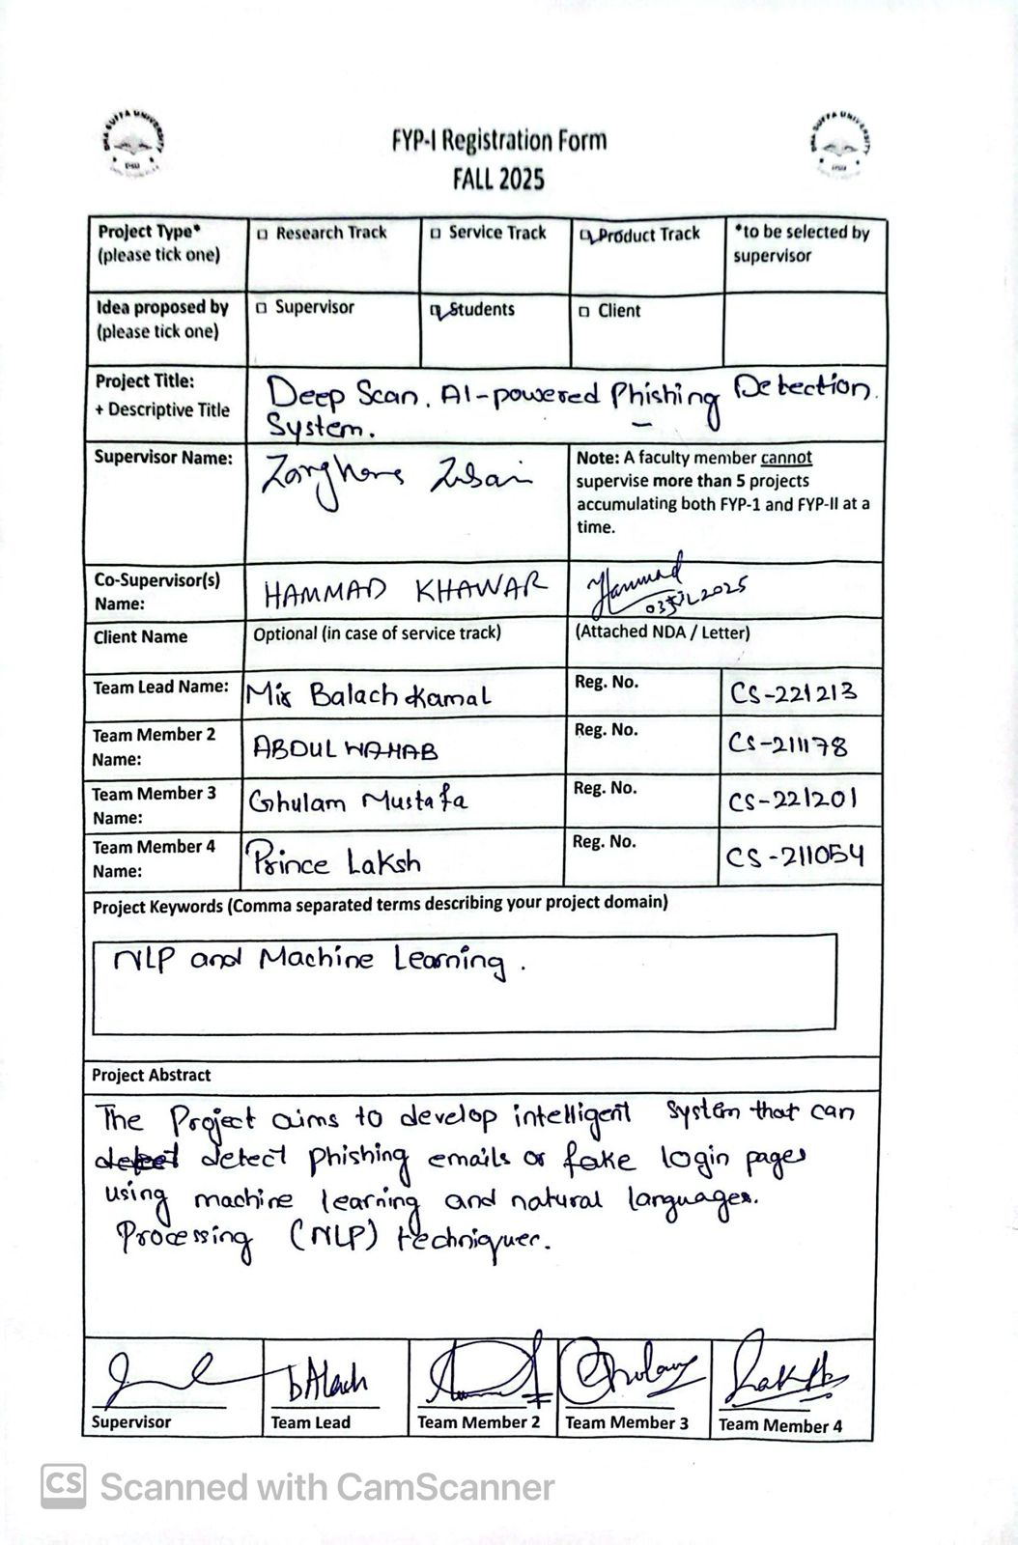

A1A. PROJECT PROPOSAL AND VISION DOCUMENT

1 Introduction
We are making a system that helps to protect users from phishing attacks, attackers attack users by sending them URL’s and emails that look real and legitimate but they trick users into giving them important credentials. Phishing detection system will help users by checking both URLs and emails in one place. We will build the system in two parts. In the part 1 we will use machine learning to check URLs and rule based analysis to check emails. In the part 2 we will add a feature that checks the certificates of websites as it will help in making prediction, use advance NLP techniques to analyze emails and also create a Chrome extension that will protect users in real time.
1.1 Problem Statement
The big problem is that phishing is getting worse. The ways we protect ourselves are not changing. Most tools only check one thing, like a link or an email. They do not check both at the same place. This makes it easy for hackers to trick people. Also many tools are too slow or too hard to use. Phishing detection system will fix this by being fast easy to use and checking both URLs and scam emails in one place. We need a system that's easy to use and protects us in real time.

1.2 Project Motivation
We created Deep Scan because phishing is a huge problem, many people are targeted daily because of these attempts. The main issue is that most security tools do not check both links and emails at the time. This makes it easy for hackers to trick people. We saw how hard it is for people to spot these threats so we decided to create a system that's accurate and easy to use. Because of these challenges we will build the system in two parts. In the part 1 we will get the URL protection working and create a user-friendly web interface. In the part 2 we will use advance NLP techniques to detect emails and create a Chrome extension to protect users in real time.
1.3 Objectives
- Build a Detection Platform: Our main goal is to create a web application that can identify phishing threats in both URLs and emails in one place
- Phased Development: We will deliver the project in two stages. In FYP-1, we will focus on ML-based URL classification and a rule-based system for emails. In FYP-2, we will upgrade the email detection with advanced NLP techniques and also create a Chrome extension for real time protection.
- Offer Developer Integration: We want to help people to be safe from phishing attempts by providing them our API.
- Protect User Data: We want to help people be protected from these attacks, they can verify the URLs and emails, so that they don’t get scammed.

1.4 Literature Review
Most existing work on phishing focuses on just one thing at a time. Some researchers use Random Forest or SVM to look at URL features like how long the link is or if it has weird symbols. Others use NLP to look for suspicious words in emails. The problem is that these are almost always separate studies or separate tools. There isn't much out there that puts both together in a way that a regular person can actually use.

2 Project Vision
2.1 Business Case and SWOT Analysis
Deep Scan is built to solve a problem. Most high-end security tools are too pricey and complex for people or small teams. Our goal is to create a platform. It brings URL and email phishing detection together in one single web dashboard. The project aims to stop phishing attacks. We want to make safety easy for everyone by offering an interface for checking links and emails. Deep Scan helps people identify phishing attacks. It makes digital safety reachable, for all.
SWOT Analysis
S. No | Strengths | Weaknesses | Opportunities | Threats
1 | Covers both URLs and Emails in one single interface. | Accuracy depends heavily on the quality of training data. | Increasing demand for easy-to-use tools for non-tech users. | Hackers constantly change their tactics to bypass ML models.
2 | The two-phase plan allows us to add more advanced models later. | As a new tool, it takes time to build user trust compared to Google or Norton. | Moving into the browser market offers a huge user base. | Tech giants like Google are constantly improving their own built-in filters.
3 | Built using open-source tools (Python, Flask), making it accessible. | Current system works for English only | Releasing the platform for free to promote cybersecurity awareness and provide accessible protection for all users | Misidentifying a safe site as a threat could frustrate users.

2.2 Business Objectives and Success Criteria
- Core Functionality: Our goal is to build and launch a system that works. This system needs to be able to handle URLs and emails. We will know it is a success if it can correctly identify phishing samples and give us results.
- Ease of Use: We want to create a web dashboard that anyone can use. We do not want people to need a manual to use it. If half of our non technical users are able to scan and understand the results in their first try we will consider this a success.
- System Performance: We need to make sure that the system is fast, so users do not have to wait for their results.

2.3 Project Risks and Risk Mitigation Plan
We have a few risks to think about.
- Software Dependency Risks: If libraries like Flask or Scikit-learn update it could cause problems with our code. This means we will have to spend time fixing it.
- System Performance: When we add complex machine learning models later the system might get slower.
- Time Constraint Risk: We might not have time to finish both phases of the project.
- Resource Limitation Risk: We might not have computer power to train our machine learning models or host the system.

Risk Mitigation Plan:
- For Software Updates: We will use versions of every library. We will keep a list of what we need. This way if a new version of Flask comes out our project will still work.
- For System Performance: We will keep our code simple. We will use models that are fast and do not need a lot of power to run.
- For Time Constraints: We will split the work into two phases. We will complete different modules step by step.
- For Hardware: If our computers are too slow to train the models we will use tools to do the heavy work, for the machine learning models.

2.4 Assumptions and Dependencies
Assumptions:
- User Access: We think that users have an internet connection and they know how to use a web browser to check links and URLs.
- URL Format: We expect the links that users send to be in the format like the kind that starts with HTTP or HTTPS.
- Language: We assume that all the email content will be written in English because our system will only be analyzing text submitted in English.

Dependencies:
- Technical Framework: The project relies on Flask to make the web server work and it uses scikit-learn and pandas to handle the machine learning part.
- Data Availability: The URL model is only accurate if we have the datasets to train it so we really need to have access, to that data.

3 Project Scope
3.1 In Scope
The project has parts that we will work on.
FYP-1:
- URL Detection: We will use a Random Forest machine learning model to flag links. This means the tool will look at a link and say if it is safe or not.
- Email Analysis: We will use NLP and specific rules to scan email text for scams. This will help us find emails that are trying to trick people.
- Web Dashboard: We will make a website with separate tabs for checking URLs and emails. This website will be easy to use and understand.
- API: We will make a REST API so other developers can use our detection engine. This way other people can use our tool.
FYP-2:
- Chrome Extension: We will make a browser tool to check URLs automatically while surfing. This means that when you are browsing the internet the tool will check the links you visit and warn you if they are dangerous.
- Better Email Analysis: We will upgrade the email scanner with advanced NLP techniques. This will make the email scanner better at finding scams.
- Certificate Checking: We will add certificate checking for the websites in FYP-2.

3.2 Out of Scope
There are some things that we will not do in this project.
- Bulk Scanning: We won't support uploading lists of URLs at once. This means you can only check one link at a time.
- User Accounts: No login or registration system is required for this project. You can just use the tool without making an account.
- Mobile Apps: We are focusing on Web and Chrome not iOS or Android. This means you can only use the tool on your computer or, with the Chrome browser.
- Other Languages: The system will only support English for now. This means if you speak a language the tool might not work for you.

4 Proposed Methodology
4.1 SDLC Approach (Waterfall/Agile/any model)
The Project is divided into two separate phases FYP1 and FYP2 and we have adopted Agile Methodology
4.2 Team Role & Responsibilities
Mr. Wajahat - Project Supervisor
Mr. Hammad Khawar - Project Co-supervisor
Mir Balach - Team Leader
Responsibilities – Backend, Model Training, Documentation
Ghulam Mustafa - Team Member
Responsibilities – Backend, Documentation
Abdul Wahab Imran– Team Member
Responsibilities – Frontend, Documentation
Laksh Prince - Team Member
Responsibilities – Frontend, Documentation

4.3 Requirement Development
We got our training data from Kaggle, the PhiUSIIL dataset. This dataset has features that help detect malicious URLs and for email analysis we used CEAS_08 dataset.
- *Analysis and Design: We chose to check both URLs and emails because looking at one is not enough for full protection. For URLs we used a Random Forest model. For emails we used NLP approach. Our system has three parts:
- Presentation Layer: A web dashboard with tabs for users to interact with.
- Application Layer: API that runs our detection logic and models.
- Data Layer: We store our datasets and trained models in files because it easy to use.
4.4 High-level Architecture / Design
Presentation Tier (UI): This is the part users see. It's a web dashboard with tabs to paste links or email text. The UI sends the information to the backend. Shows the results, including a threat level and a score that shows how confident the system is
Application Tier (Logic): This is like the brain of the project. It connects users to our detection models. We have a URL engine that uses Random Forest and an email engine that uses NLP tools like NLTK. We used a Flask API to manage requests handle errors and make sure data is processed correctly before sending results.
Data Tier (Storage): This is where the systems data is stored. It keeps CSV files for training, pickle files, for our trained model and email detection rules. The application layer uses this tier to load models when users submit a scan.

5 Project Planning
5.1 Gantt Chart
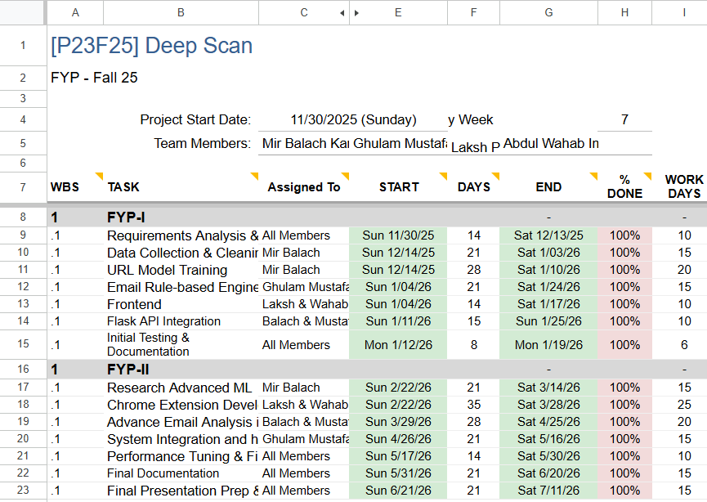
6 Project Requirements
6.1 Software tools requirements
We used PyCharm for development and our project runs on Windows 10/11. Programming & Frameworks:
- Backend: We used Python with the Flask for the API.
- Frontend: We use HTML, CSS and JavaScript for user interface.
- Machine Learning & NLP: We used scikit-learn for our Random Forest model and pandas/numpy to handle our datasets. For email analysis we use NLTK and TextBlob to process text and detect patterns.
Testing & API Tools:
- Postman: We test our API endpoints with Postman to ensure they return the data.
- Flask-CORS: This allows our frontend to communicate with our backend without security blocks.
- Pytest: We run basic unit tests on our code with Pytest.

6.2 Hardware requirements
Minimum Requirements:
A basic laptop is enough for basic development and running of the system.
A stable internet connection is needed to download the Python libraries.

7 Budget/Costing
7.1 Estimated Budgeted Cost - of the Project
○ Total Hours - 200_ hrs
○ Per Hour Rate - N/A_ Rs
○ Total Hours Rate - _N/A Rs
○ Hardware Cost - _N/A Rs
○ Other resources - N/A_ Rs
○ Total cost Rs. - _N/A Rs

8 Project Deliverables
- Requirements and Design Docs We are providing a set of documents that define what our project does. These documents include user requirements for URL and email scanning. They also have system diagrams that show how data flows through our detection engines.
- Detection Modules and Models This part covers the logic of our project. In Phase 1 we are delivering the Random Forest model for URLs. We are also delivering the rule-based NLP system for emails. In Phase 2 we will include advanced machine learning models. These models will improve email detection accuracy.
- The Deep Scan Application We are providing a working version of our platform. In Phase 1 this is a web-based dashboard. Users can manually submit links and text on this dashboard. In Phase 2 this deliverable expands to include the Chrome browser extension. This extension allows for real-time protection while surfing.
- Source. Datasets We are providing the organized codebase. This includes the Flask backend frontend files and Chrome extension scripts. We are also providing CSV datasets. Saved pickle files for the models. A simple README and requirements file are included for setup.
- Reports and Presentations We are providing a report in both hard and soft copies. This report details our methodology, results and performance metrics. We are also delivering a PowerPoint presentation, for the jury. This presentation includes a demo of the web platform and Chrome extension. It shows how our system has evolved through both phases.

9 Proposed GUI (Disposable Prototype
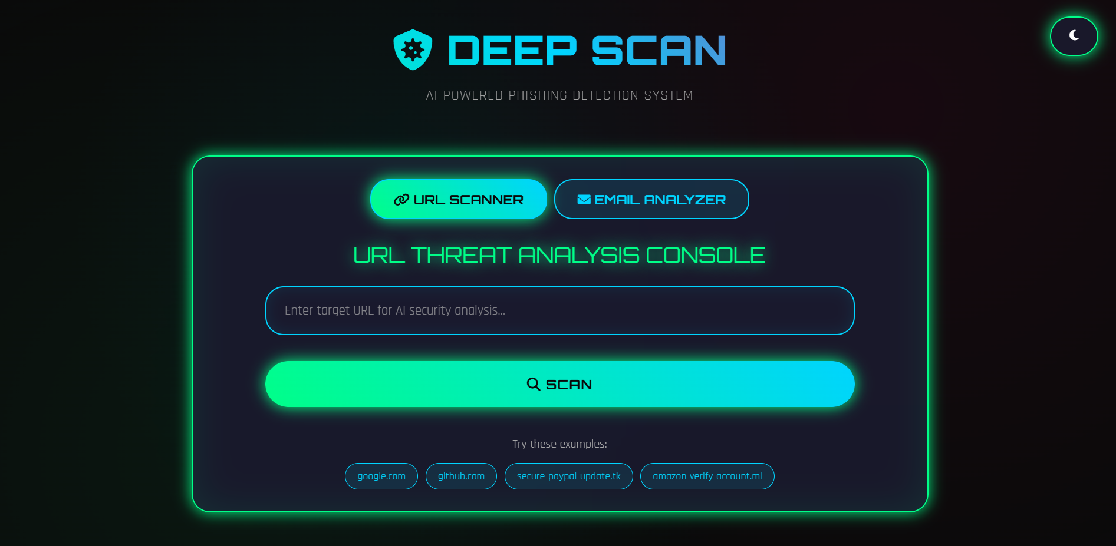
10 References
- Kalla, D., & Kuraku, S. (2023). Phishing website URL’s detection using NLP and machine learning techniques. Journal on Artificial Intelligence, 5(1), 145–162. https://doi.org/10.32604/jai.2023.043366
- Lingaiah, G., & Pandey, R. K. (2023). Comparative performance study of machine learning algorithms for phishing URL detection in cyber security systems. Journal of Computational Analysis and Applications, 31(4), 1865–1873.
- Sahingoz, O. K., Buber, E., Demir, O., & Diri, B. (2019). Machine learning based phishing d etection from URLs. Expert Systems with Applications , 117, 345- 357. https://doi.org/10.1016/j.eswa.2018.09.029
- Tsai, E., Kumar, D., Raman, R. S., Li, G., Eiger, Y., & Ensafi, R. (2023). CERTainty: Detecting DNS manipulation at scale using TLS/SSL certificates. Proceedings on Privacy Enhancing Technologies, 2023(3), 122–137. https://doi.org/10.56553/popets-2023-0073

A1B. COPY OF PROPOSAL EVALUATION COMMENTS BY JURY

A2. REQUIREMENT SPECIFICATIONS
1. Introduction
We are making a system that helps to protect users from phishing attacks, attackers attack users by sending them URL’s and emails that look real and legitimate but they trick users into giving them important credentials. Phishing detection system will help users by checking both URLs and emails in one place. We will build the system in two parts. In FYP-1 we will use machine learning to check URLs and natural language processing to check emails. In the FYP-2 we will add a feature that checks the certificates of websites as it will help in making prediction and also create a Chrome extension that will protect users in real time and make our email detection better.
1.1. Purpose of Document
The purpose of this document is to help explain what our system does and what features it has. This document will work as a guide as it explains how the system works and how the system will be made in two parts.
1.2. Intended Audience
Intended audience are the jury evaluators, FYP coordinators, our project supervisors and the developers involved in making Deep Scan.

2. Overall System Description
2.1. Project Background
Phishing attacks have changed massively. At first, these attacks were simple and easy to intercept, but as the time passed the attackers developed more advanced phishing techniques. Attackers started created convincing copies of legit websites, and bypassed traditional security measures.
The traditional measures used simple blacklists and rule-based detection, but these methods were not enough to stop the attacks, we as a team want to add contribution in cyber security by making a system that can check both URLs and emails at a same place.

2.2. Project Scope
In Scope
The project has parts that we will work on.
FYP-1:
- URL Detection: We will use a Random Forest machine learning model to flag links. This means the tool will look at a link and say if it is safe or not.
- Email Analysis: We will use NLP and specific rules to scan email text for scams. This will help us find emails that are trying to trick people.
- Web Dashboard: We will make a website with separate tabs for checking URLs and emails. This website will be easy to use and understand.
- API: We will make a REST API so other developers can use our detection engine. This way other people can use our tool.
FYP-2:
- Chrome Extension: We will make a browser tool to check URLs automatically while surfing. This means that when you are browsing the internet the tool will check the links you visit and warn you if they are dangerous.
- Better Email Analysis: We will upgrade the email scanner with advanced NLP techniques. This will make the email scanner better at finding scams.
- Certificate Checking: We will add certificate checking for the websites in FYP-2.

Out of Scope
There are some things that we will not do in this project.
- Bulk Scanning: We won't support uploading lists of URLs at once. This means you can only check one link at a time.
- User Accounts: No login or registration system is required for this project. You can just use the tool without making an account.
- Mobile Apps: We are focusing on Web and Chrome not iOS or Android. This means you can only use the tool on your computer or, with the Chrome browser.
- Other Languages: The system will only support English for now. This means if you speak a language the tool might not work for you.

2.3 Project Objectives
Build a Detection Platform: Our main goal is to create a web application that can identify phishing threats in both URLs and emails in one place
Phased Development: We will deliver the project in two stages. In FYP-1, we will focus on ML-based URL classification and a rule-based system for emails. In FYP-2, we will upgrade the email detection with advanced NLP techniques and also create a Chrome extension for real time protection.
Offer Developer Integration: We want to help people to be safe from phishing attempts by providing them our API.
2.4 Stakeholders
The stakeholders are the jury evaluators, our FYP coordinators, our project supervisors and the team that developed the system.
2.5 Operating Environment
Our system will be a web based platform where both URLs and emails can be checked using both desktops and laptops. We will make the frontend of our system using HTMl, CSS and JSS, while backend will be made using Flask and Python. Stable internet connection is required to use our system.

2.6 System Constraints
Our system has some constraints like it only handles HTTP/HTTPS protocls, and emails submitted in English language can be analyzed and it may only be used if the user has stable internet connection.
2.7 Assumptions & Dependencies
We have made some assumptions and dependencies for our project:
Assumptions:
- User Access: We think that users have an internet connection and they know how to use a web browser to check links and URLs.
- URL Format: We expect the links that users send to be in the format like the kind that starts with HTTP or HTTPS.
- Language: We assume that all the email content will be written in English because our system will only be analyzing text submitted in English.

Dependencies:
- Technical Framework: The project relies on Flask to make the web server work and it uses scikit-learn and pandas to handle the machine learning part.
- Data Availability: The URL model is only accurate if we have the datasets to train it so we really need to have access, to that data.

3 External Interface Requirements
3.1 Hardware Interfaces
The system is a simple web based platform so it does not need any extraordinary hardware to work, it can run on a basic computer.
3.2 Software Interfaces
Our system is built using Python and we used Flask for the backend. Scikit learn is used to detect phishing URLs, for email analysis we used Natural Language toolkit and TextBlob. Our frontend is made using HTML,CSS, and JSS.
3.3 Communications Interfaces
The system uses HTTP/HTTPS protocols and the backend runs on port 5000. It has CORS which enables browsers to access it.

4 Functional Requirements
4.1 Functional Hierarchy
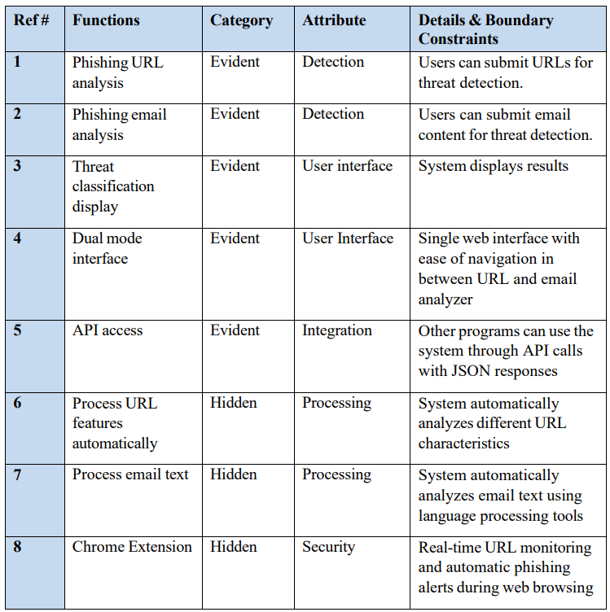

4.2 Use Cases
4.2.1 Use Case 1
Analyze URL
Section | Main
Name: | Analyze URL
Actors: | End User, System Interface
Description: | Purpose is to facilitate the detection of phishing URLs through analysis.  A user submits a suspicious URL for analysis. The system extracts features and applies detection algorithm to classify the URL. Once analyzed, the user receives result. The system provides real-time protection through browser extension.
Cross References: | Functions: 1,3,4,5,6,8
Pre-Conditions | System is operational and user has internet connectivity
Successful Post Conditions | User receives phishing classification with confidence score.
Failure Post Conditions | System displays error message

4.2.2 Use Case 2
Analyze Email
Section | Main
Name: | Analyze Email
Actors: | End User, System Interface
Description: | Purpose is to facilitate the detection of phishing emails through analysis.  A user submits suspicious email for analysis. The system processes the email text using NLP techniques. Once analyzed, the user receives the result.
Cross References: | Functions: 2,3,4,5,7
Pre-Conditions | System is operational and user has internet connectivity
Successful Post Conditions | User receives phishing classification with confidence score.
Failure Post Conditions | System displays error message

5 Non-functional Requirements
5.1 Performance Requirements
Our system should be fast and accurate when analyzing URLs and emails.
5.2 Safety Requirements
Our system should check the content submitted and make predictions that clear and direct so that the users are not confused about whether a link or URL is dangerous.
5.3 Security Requirements
Our platform should be easy to use so that even non technical users can easily navigate and do analysis.
5.4 User Documentation
Our project will include documentation, This will include instructions on how to scan URLs and emails.

6 References
- Kalla, D., & Kuraku, S. (2023). Phishing website URL’s detection using NLP and machine learning techniques. Journal on Artificial Intelligence, 5(1), 145–162. https://doi.org/10.32604/jai.2023.043366
- Lingaiah, G., & Pandey, R. K. (2023). Comparative performance study of machine learning algorithms for phishing URL detection in cyber security systems. Journal of Computational Analysis and Applications, 31(4), 1865–1873.
- Sahingoz, O. K., Buber, E., Demir, O., & Diri, B. (2019). Machine learning based phishing d etection from URLs. Expert Systems with Applications , 117, 345- 357. https://doi.org/10.1016/j.eswa.2018.09.029
- Tsai, E., Kumar, D., Raman, R. S., Li, G., Eiger, Y., & Ensafi, R. (2023). CERTainty: Detecting DNS manipulation at scale using TLS/SSL certificates. Proceedings on Privacy Enhancing Technologies, 2023(3), 122–137. https://doi.org/10.56553/popets-2023-0073

A3. DESIGN SPECIFICATIONS

1 Introduction
1.1 Purpose of Document
The purpose of this document is to explain how we plan to build our system Deep Scan. This document tells the step by step development plan that we are going to use.
1.2 Intended Audience
Intended audience are the jury evaluators, FYP coordinators, our project supervisors and the developers involved in making Deep Scan.
1.3 Project Overview
We want to create a system that helps to protect from phishing URLs and emails, we will building our project in two stages. In first stage we will create a user interface, use machine learning alogirthm for URL detection and simple rule based analysis for email analysis. In the second stage we ill use advance natural processing language techniques to provide better email analysis, also analyze certificates of websites and make a chrome extension for real time protection.

1.4 Scope
The project has parts that we will work on.
FYP-1:
- URL Detection: We will use a Random Forest machine learning model to flag links. This means the tool will look at a link and say if it is safe or not.
- Email Analysis: We will use NLP and specific rules to scan email text for scams. This will help us find emails that are trying to trick people.
- Web Dashboard: We will make a website with separate tabs for checking URLs and emails. This website will be easy to use and understand.
- API: We will make a REST API so other developers can use our detection engine. This way other people can use our tool.
FYP-2:
- Chrome Extension: We will make a browser tool to check URLs automatically while surfing. This means that when you are browsing the internet the tool will check the links you visit and warn you if they are dangerous.
- Better Email Analysis: We will upgrade the email scanner with advanced NLP techniques. This will make the email scanner better at finding scams.
- Certificate Checking: We will add certificate checking for the websites in FYP-2.

Out of Scope
There are some things that we will not do in this project.
- Bulk Scanning: We won't support uploading lists of URLs at once. This means you can only check one link at a time.
- User Accounts: No login or registration system is required for this project. You can just use the tool without making an account.
- Mobile Apps: We are focusing on Web and Chrome not iOS or Android. This means you can only use the tool on your computer or, with the Chrome browser.
- Other Languages: The system will only support English for now. This means if you speak a language the tool might not work for you.
2 Design Considerations
2.1 Assumptions and Dependencies
We have made some assumptions and dependencies for our project:
Assumptions:
- User Access: We think that users have an internet connection and they know how to use a web browser to check links and URLs.
- URL Format: We expect the links that users send to be in the format like the kind that starts with HTTP or HTTPS.
- Language: We assume that all the email content will be written in English because our system will only be analyzing text submitted in English.

Dependencies:
- Technical Framework: The project relies on Flask to make the web server work and it uses scikit-learn and pandas to handle the machine learning part.
- Data Availability: The URL model is only accurate if we have the datasets to train it so we really need to have access, to that data.

2.2 Risks and Volatile Areas
Risks:
We might not have the time to finish all the tasks in time, because we have limited development time.
Volatile Areas:
We will have to retrain our model when new phishing techniques are discovered.
We will have to update our email analysis model as scammers invent new techniques.
We might have to change our web interface based on what users think and results of our testing.

3 System Architecture
3.1 System Level Architecture
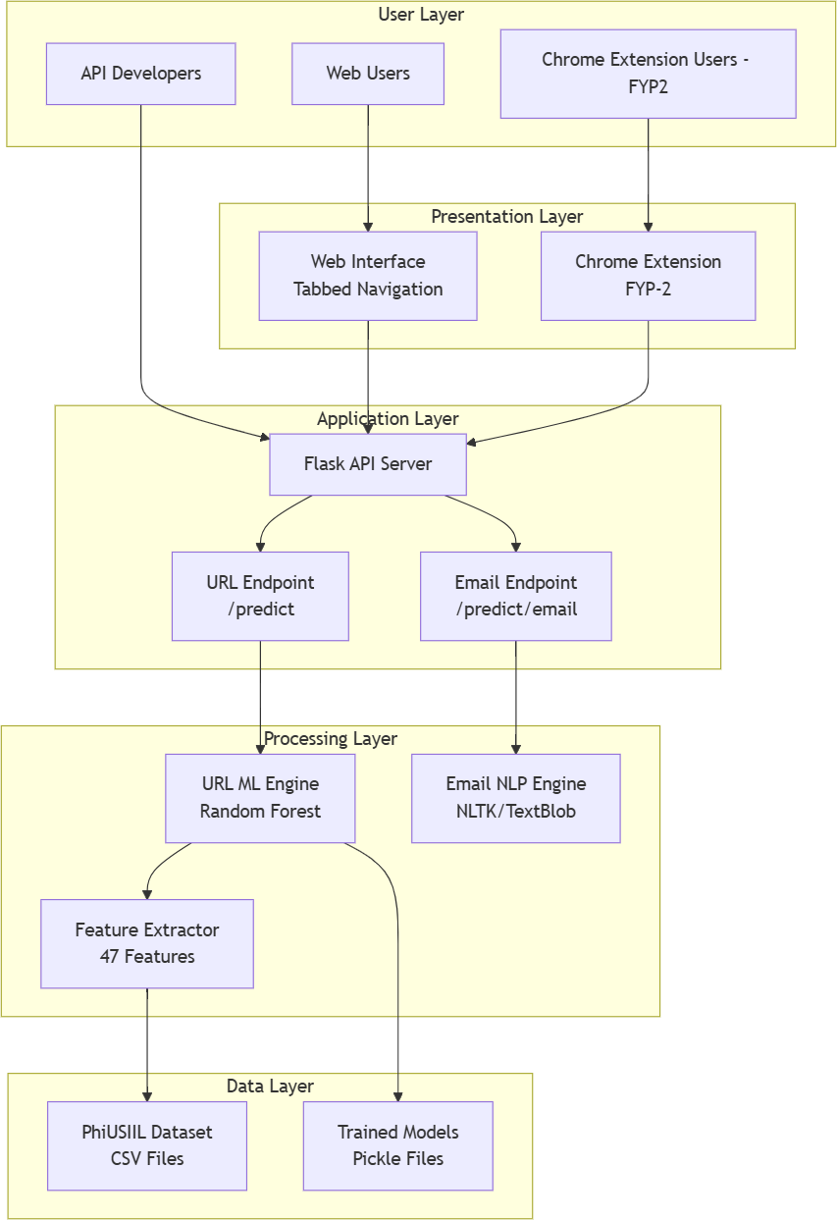

3.2 Software Architecture
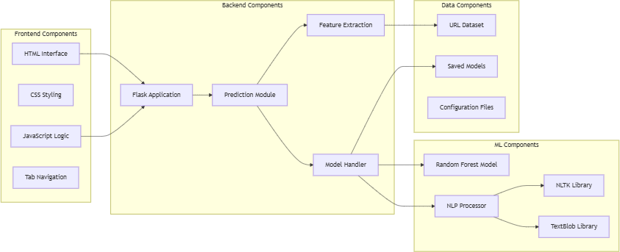

4 Design Strategy
Our strategy is to design Deep Scan in two phases so we can complete our project in time, and build our FYP project that is completely working.
Since, we will be building our project in two phases, in first phase we ill use machine learning for URL and rule based analysis for emails and in the second phase we will upgrade our email analysis and URL detection. Since the design is modular, we can easily add features based on the feedback from jury and supervisors.

5 Detailed System Design
5.1 Design Class Diagram
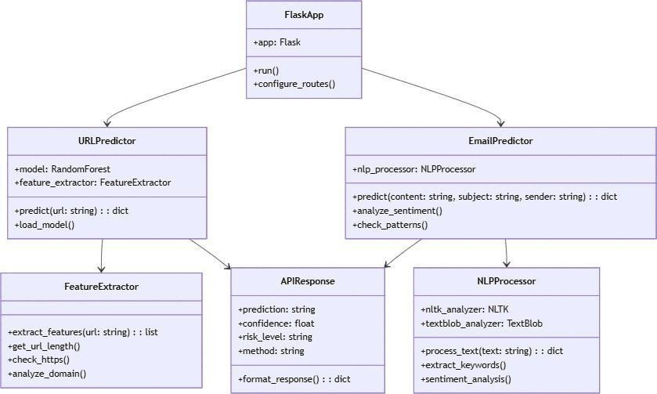

5.2 Database Design
5.2.1 File Based Database Design:
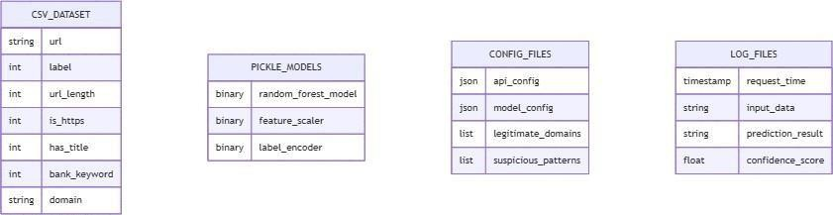

5.2.2 Data Dictionary
5.2.2.1 Data 1
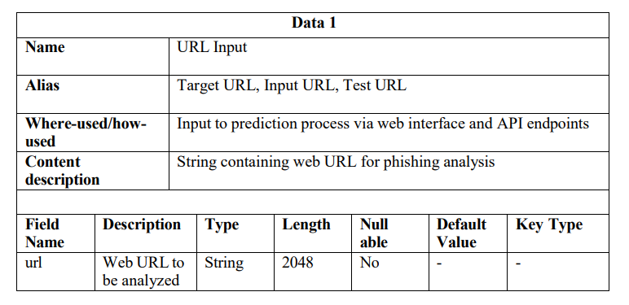
5.2.2.2 Data 2
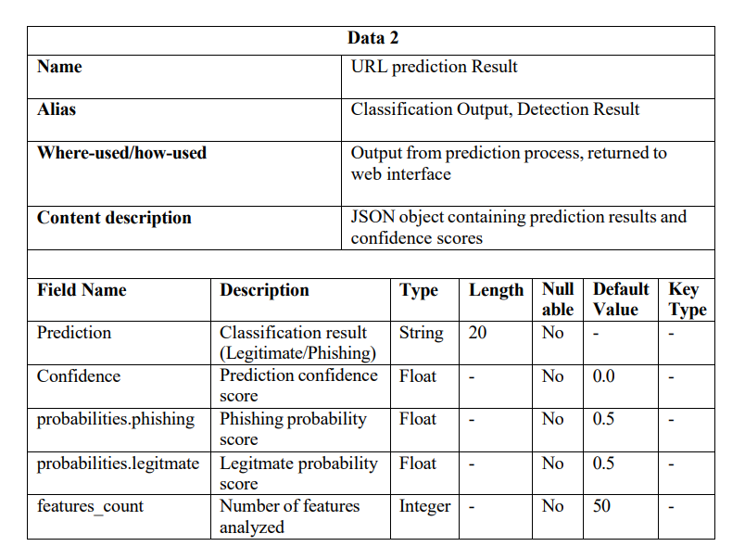
5.2.2.3 Data 3:
 | Data 3
 | Name |  | Feature Vector
 | Alias |  | URL Features, Analysis Features, ML Features
 | Where-used/how-used |  | Internal processing in feature extraction pipeline
 | Content description |  | 50-element numerical array representing URL characteristics
Field Name |  | Description |  | Type | Length | Null able | Default Value | Key Type
URLLength |  | Length of the UR |  | Integer | - | No | 0 | -
IsHTTPS |  | Whether URL uses HTTPS (0/1) |  | Integer | 1 | No | 0 | -
HasTitle |  | Whether page has title (0/1) |  | Integer | 1 | No | 1 | -
Bank |  | Contains banking keywords (0/1) |  | Integer | 1 | No | 0 | -

5.2.2.4 Data 4:
Data 4
Name |  | Email Input
Alias |  | Email Content
Where-used/how-used |  | Input to email prediction process via web interface and API
Content description |  | JSON object containing email data for phishing analysis
Field Name | Description |  | Type | Length | Null able | Default Value | Key Type
Content | Email body text |  | String | 1000 | No | - | -
Subject | Email subject line |  | String | 200 | Yes | “” | -
Sender | Sender email address |  | String | 254 | No | - | -

5.2.2.5 Data 5
Data 5
Name |  | Email prediction Result
Alias |  | Email Classification Output, Email Detection Result
Where-used/how-used |  | Output from email prediction process
Content description |  | JSON object containing email analysis results
Field Name | Description |  | Type | Length | Null able | Default Value | Key Type
Prediction | Email classification (Legitimate/Phishing) |  | String | 20 | No | - | -
confidence | Email prediction confidence |  | Float | - | No | 0.0 | -
Risk_level | Risk assessment (Low/Medium/High) |  | String | 10 | No | “Low” | -
Method | Detection method used |  | String | 20 | No | NLP | -

5.3 Application Design
5.3.1 Sequence Diagram
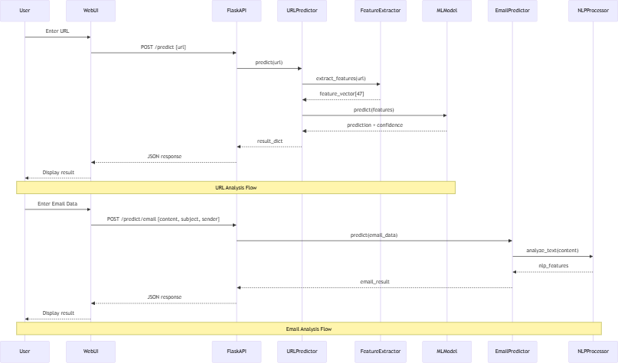
5.3.2 State Diagram
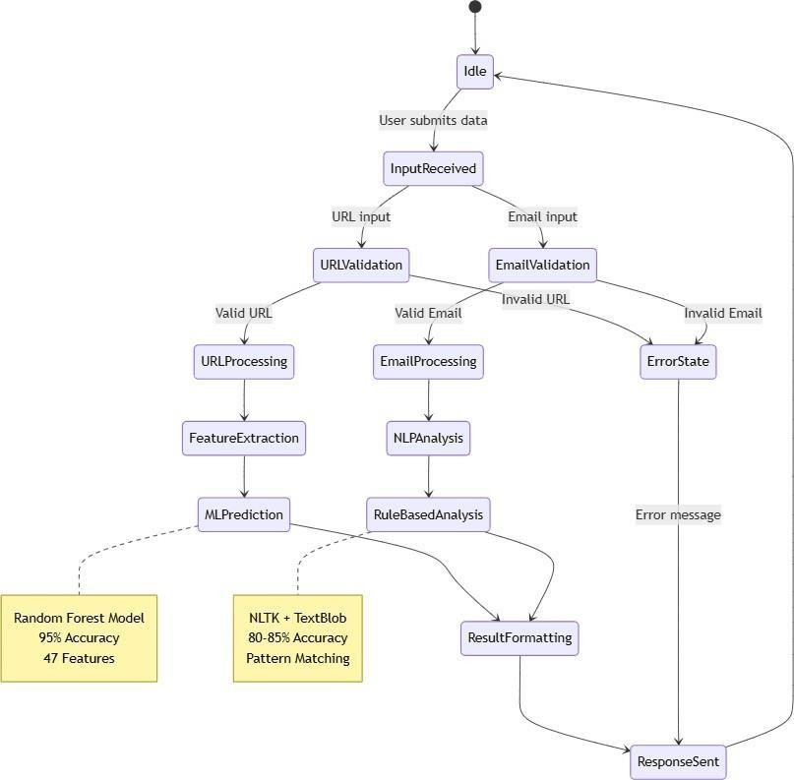

6 References
- Kalla, D., & Kuraku, S. (2023). Phishing website URL’s detection using NLP and machine learning techniques. Journal on Artificial Intelligence, 5(1), 145–162. https://doi.org/10.32604/jai.2023.043366
- Lingaiah, G., & Pandey, R. K. (2023). Comparative performance study of machine learning algorithms for phishing URL detection in cyber security systems. Journal of Computational Analysis and Applications, 31(4), 1865–1873.
- Sahingoz, O. K., Buber, E., Demir, O., & Diri, B. (2019). Machine learning based phishing d etection from URLs. Expert Systems with Applications , 117, 345- 357. https://doi.org/10.1016/j.eswa.2018.09.029
- Tsai, E., Kumar, D., Raman, R. S., Li, G., Eiger, Y., & Ensafi, R. (2023). CERTainty: Detecting DNS manipulation at scale using TLS/SSL certificates. Proceedings on Privacy Enhancing Technologies, 2023(3), 122–137. https://doi.org/10.56553/popets-2023-0073

A4. OTHER TECHNICAL DETAIL DOCUMENTS

Test Cases Document
Software Test Plan
The following test plan covers all the screens and modules involved in Deep Scan system
S. No | Description | Test Engineer | Start Date | End Date
1 | URL Analysis (Screen 1) | Mir Balach | Week 3 | Week 4
2 | Email Analysis (Screen 2) | Mir Balach | Week 4 | Week 5
3 | Chrome Extension Integration (Screen 3) | Mir Balach | Week 6 | Week 6
TC-01 -– URL Analysis (Screen 1)

Project Name: Deep Scan Iteration No: FYP-II
Module Name: Email Analysis Date: Week 4
Test Case ID: TC-01 Test Engineer: Mir Balach
Test Case Description: Verify the working of URL Analysis. Test empty submission, secure submission, phishing submission

S. No | Steps | Input Data | Expected  Result | Actual  Result | Pass/Fail
TC-01-1 | Empty submission in URL search box | NIL | Error | Error | Pass
TC-01-2 | Enter legitimate URL for analysis  Press Scan button | www.google.com | URL is secure | URL is secure | Pass
TC-01-3 | Enter phishing URL for analysis  Press Scan button | www.g00gle.com | URL is suspicious | URL is suspicious | Pass

TC-02 -– Email Analysis (Screen 2)
Project Name: Deep Scan Iteration No: FYP-II
Module Name: Email Analysis Date: Week 5
Test Case ID: TC-02 Test Engineer: Mir Balach
Test Case Description: Verify the working of Email Analysis. Test empty submission, secure email submission, phishing email submission

S. No | Steps | Input Data | Expected  Result | Actual  Result | Pass/Fail
TC-02-1 | Empty submission in Email analysis box | NIL | Error | Error | Pass
TC-02-2 | Enter legitimate Email for analysis  Press Scan button | “Hi Abdullah,  How are you” | Email is secure | Email is secure | Pass
TC-02-3 | Enter phishing Email for analysis  Press Scan button | “Dear Customer,  Your bank account has been blocked.  Please click the link below to verify your account and continue using online banking.  Thank you.  ” | Email is suspicious | Email is suspicious | Pass

TC-03 – Chrome Extension (Screen 3)
Project Name: Deep Scan Iteration No: FYP-II
Module Name: Chrome Extension Date: Week 6
Test Case ID: TC-03 Test Engineer: Mir Balach
Test Case Description: Verify the working of Chrome Extension
S. No | Steps | Input Data | Expected  Result | Actual  Result | Pass/Fail
TC-03-1 | Click on Extension shortcut to see analysis result while the system is offline | NIL | Error | Error | Pass
TC-02-2 | Click on Extension shortcut to see analysis result while the system is online | “NIL | Secure/Suspicious | Secure/Suspicious | Pass

UI/UX Detail Document
- URL Analysis Tab:
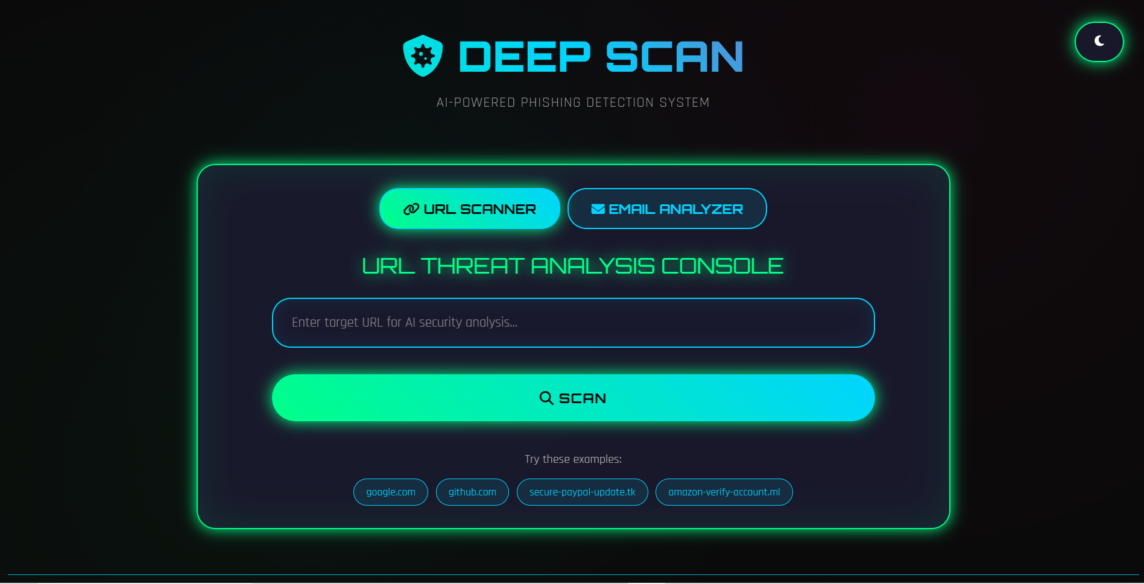

- Email Analysis Tab
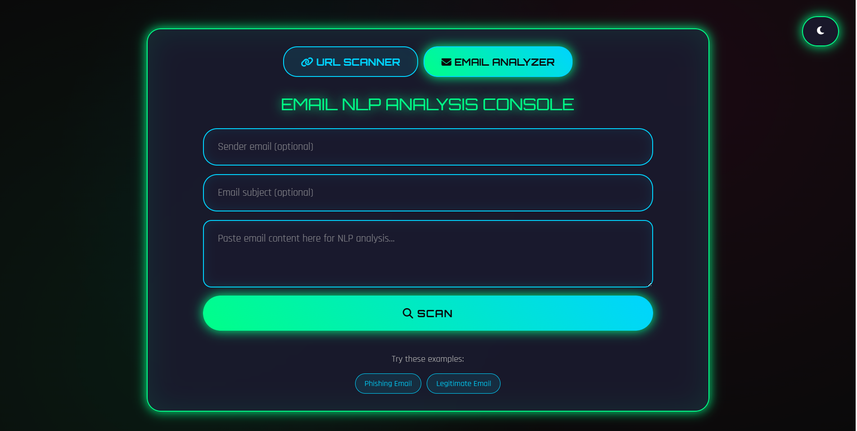

- URL Analysis (Secure URL)
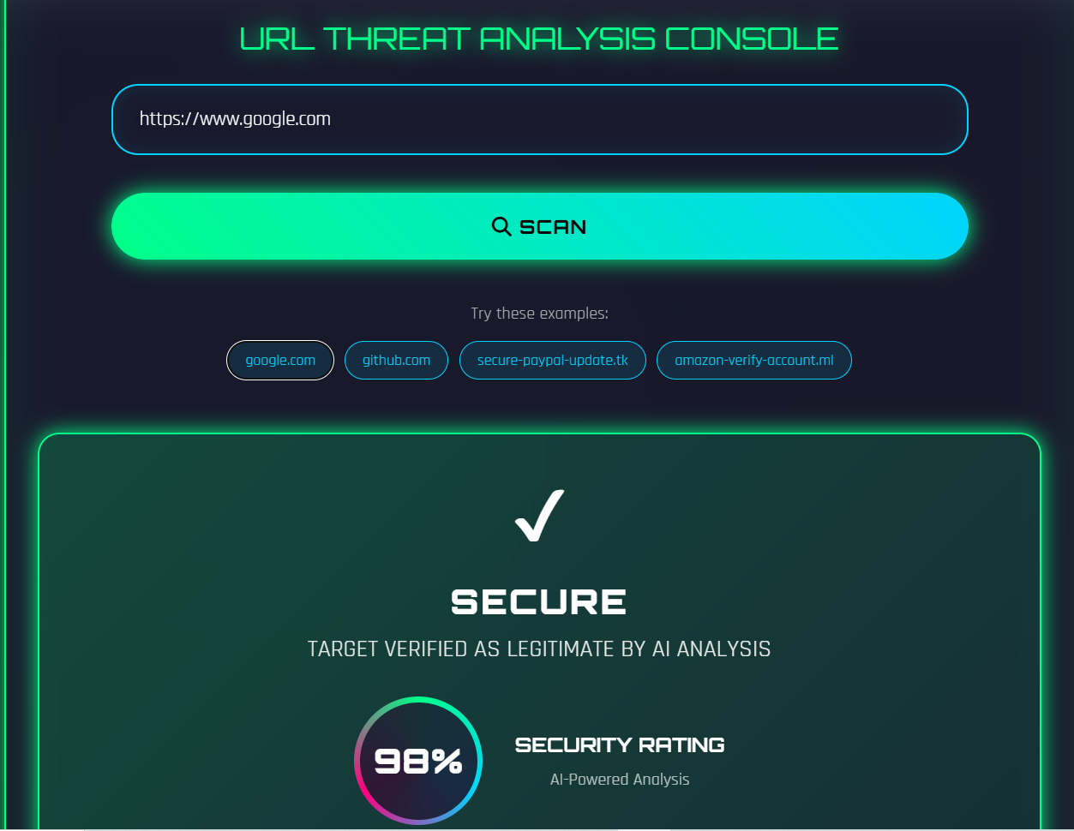
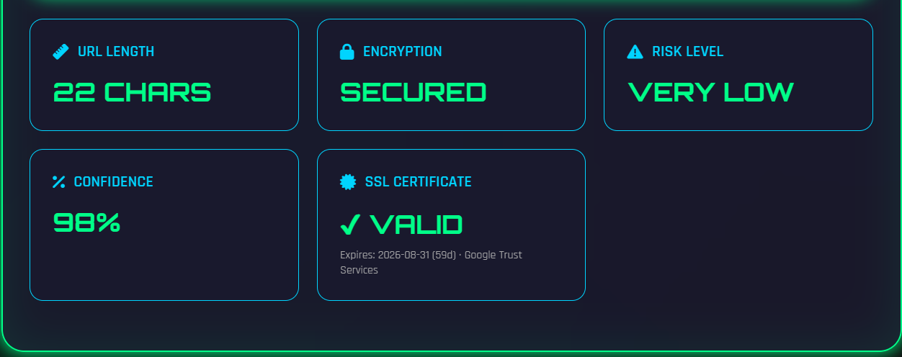

- URL Analysis(Suspicious URL)
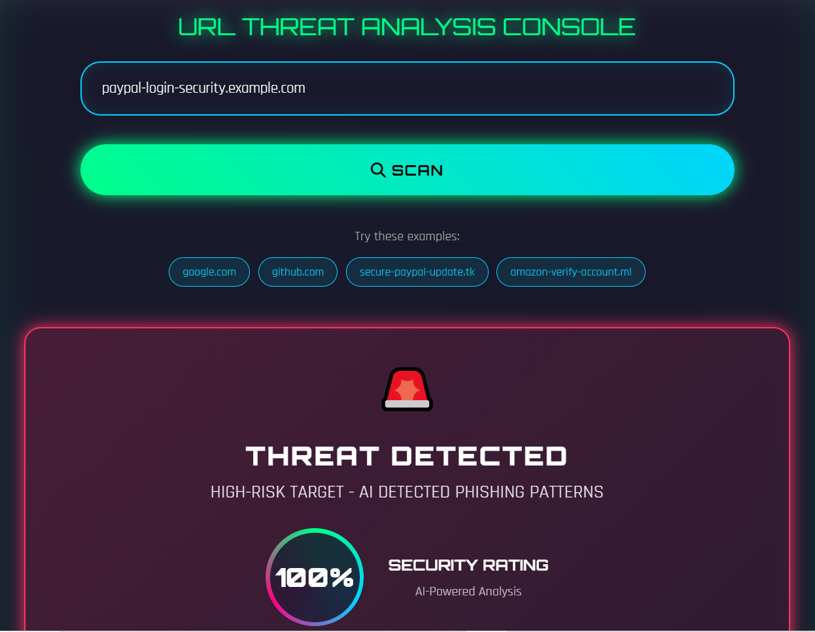

- Email Analysis (Secure Email)
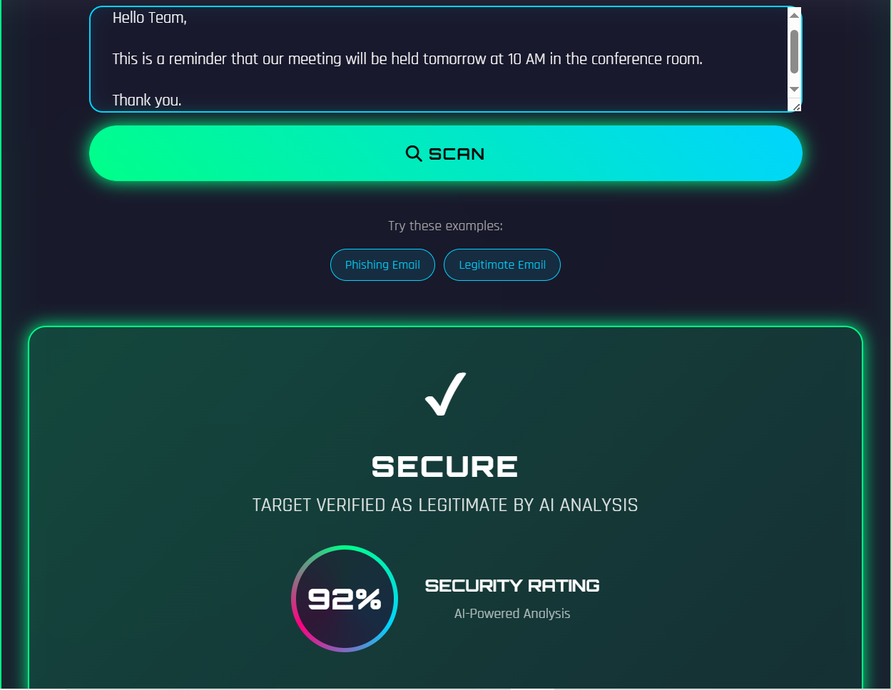

- Email Analysis (Suspicious Email)
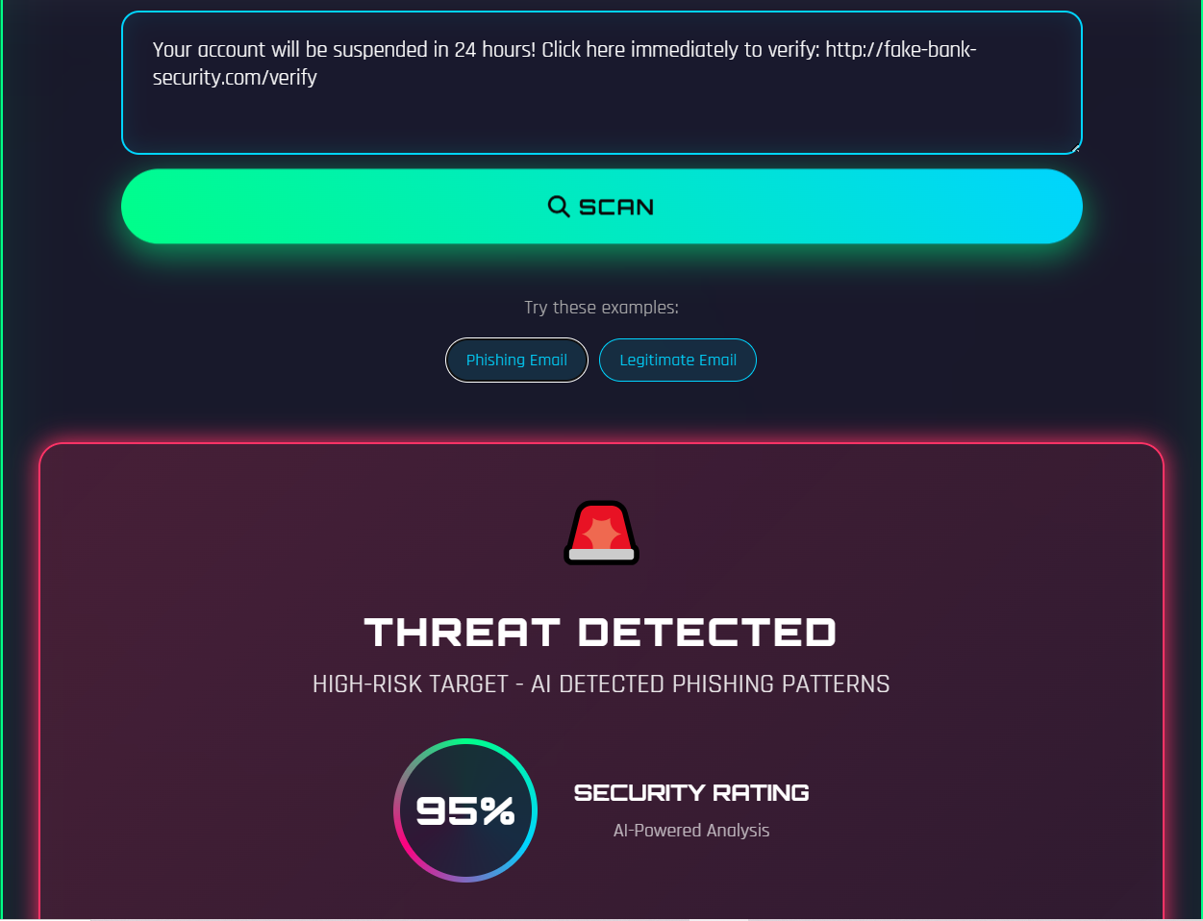

- Chrome Extension

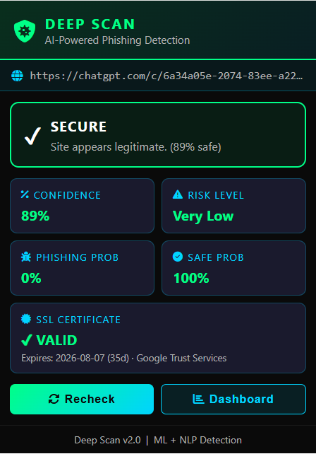

Coding Standards Document
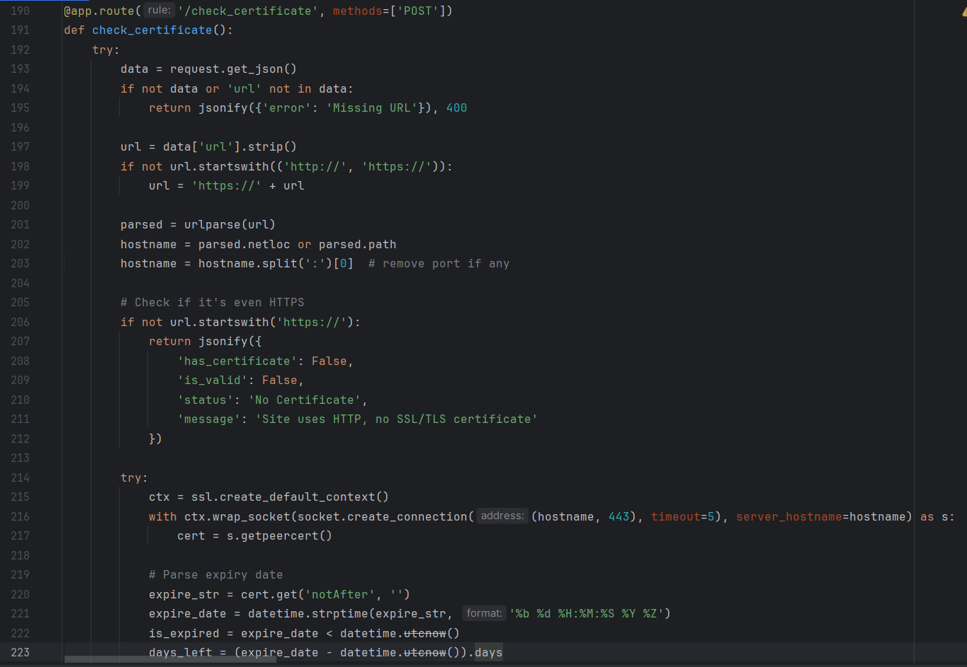
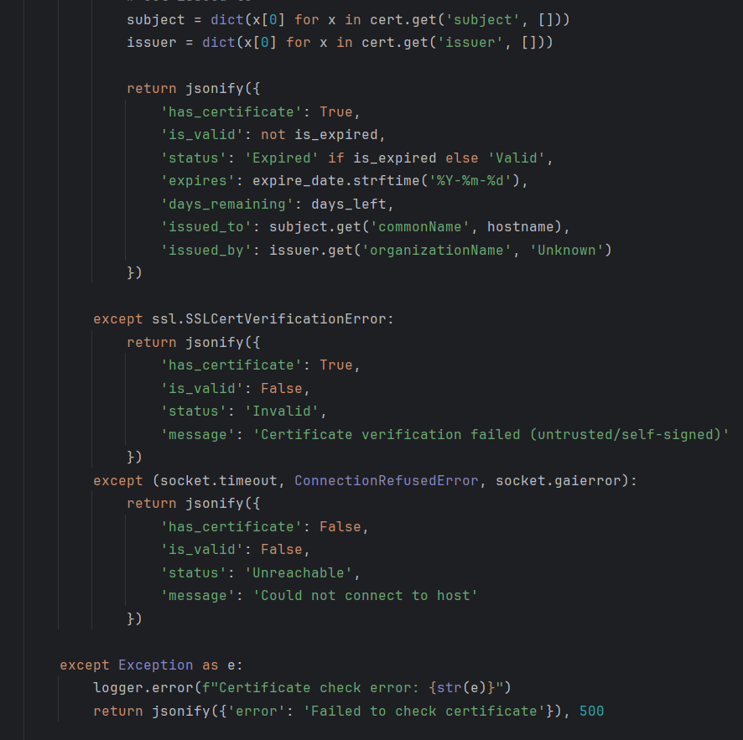

Project Policy Document
1. Purpose
The purpose of this project is to detect phishing URLs and phishing emails using Machine Learning and Natural Language Processing (NLP). The system is developed for educational and research purposes to improve user awareness and online security.
2. Scope
- The system analyzes URLs and emails for phishing detection.
- It checks the SSL certificate of websites.
- It provides results through a web application and a Chrome extension.
3. User Responsibilities
- Users should enter valid URLs and email content for analysis.
- Users should review the system's results before taking any action.
4. Data Privacy
- The system does not store users' URLs or email content permanently.
- User data is used only for analysis.
5. Security Policy
- The system checks website SSL certificates to improve security.
- Regular updates should be made to improve detection against new phishing attacks.

6. Limitations
- The system may not detect every phishing attack.
- New phishing techniques may require retraining of the machine learning models.
- Email analysis currently supports only English language emails.
7. Maintenance Policy
- The datasets and machine learning models should be updated regularly.
- Bugs should be fixed as they are found.
- New features can be added in future versions.
8. Ethical Policy
- The project is developed only for educational purposes.
- It must not be used to create, support, or promote phishing attacks.
- Users should use the system responsibly and legally.
9. Conclusion
This project follows basic security, privacy, and ethical guidelines to provide a safe and reliable phishing detection system. Future improvements will help increase its accuracy and performance.

User Manual Document
1. Introduction
Deep Scan is an AI-powered phishing detection system that helps you identify malicious URLs and phishing emails. It uses machine learning and real-time threat intelligence to protect you from online threats.
2. Installation & Setup
Step 1 — Install Dependencies
Open a terminal in the project root folder and run:
pip install -r backend/requirements.txt

Step 2 — Start the Backend Server
python backend/app.py
You should see:
API will be available at: http://localhost:5000
Step 3 — Open the Web Interface
Open frontend/cyberinterface.html in your browser. No additional server needed.
Step 4 — Load the Chrome Extension (Optional)
- Open Chrome and go to chrome://extensions/
- Enable Developer Mode (top right toggle)
- Click Load unpacked
- Select the chrome_extension/ folder
- The Deep Scan icon will appear in your toolbar

4. Using the Web Interface
4.1 Scanning a URL
- Open frontend/cyberinterface.html in your browser
- Type or paste a URL into the input field (e.g. https://example.com)
- Click SCAN
- Wait for the result
Result panel shows:
- Threat Status: SECURE or THREAT DETECTED
- Security Rating: Confidence percentage
- URL Length: Character count of the URL
- Encryption: Whether HTTPS is used
- Risk Level: Very Low / Low / Medium / High
- Confidence: How certain the system is
- SSL Certificate: Certificate validity and expiry
4.2 Quick Test Examples
The interface provides 4 built-in test buttons:
Button | Expected Result
Google.com | Legitimate
Github.com | Legitimate
secure-paypal-update.tk | Phishing
amazon-verify-account.ml | Phishing

4.3 Email Analysis
- Navigate to the email analysis section
- Paste the email body into the Content field
- Optionally fill in Subject and Sender fields
- Click Scan
- The system returns a phishing probability and risk score
5. Using the Chrome Extension
- Click the extension icon in your Chrome toolbar
- The extension shows the risk level of the current page's URL
- A notification will appear if a high-risk URL is detected while browsing

A5. FLYER & POSTER DESIGN

A6. COPY OF EVALUATION COMMENTS

COPY OF EVALUATION COMMENTS BY SUPERVISOR FOR PROJECT – I MID SEMESTER EVALUATION

COPY OF EVALUATION COMMENTS BY SUPERVISOR FOR PROJECT – I END SEMESTER EVALUATION

COPY OF EVALUATION COMMENTS BY JURY FOR PROJECT – I END SEMESTER EVALUATION
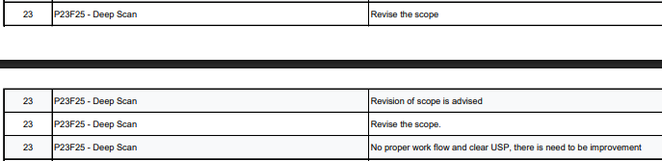

COPY OF EVALUATION COMMENTS BY SUPERVISOR FOR PROJECT – II MID SEMESTER EVALUATION

COPY OF EVALUATION COMMENTS BY SUPERVISOR FOR PROJECT – II END SEMESTER EVALUATION

A7. MEETINGS’ MINUTES
A Photostat or scanned copy should be placed when submitting document to Project Coordinator. Document should be signed by the supervisor and all other members present in the meeting (wherever possible). (Note: Please remove this line when attach copy that is required)
Weekly meetings’ minutes are required (held with Supervisor and/or with client). Important group discussions can also be included here.

A8. DOCUMENT CHANGE RECORD

Date | Version | Author | Change Details
30/June/2026 | 1.0 | All Members

A9. PROJECT PROGRESS

Photostat of Incremental versions of Requirement Signoff sheet submitted to Project Coordinator. (Note: Please remove this line when attach copy that is required)

A10. RESEARCH PAPER

