QUESTION 1

import java.util.Scanner;

public class task1

{

public static double calculateBMI(double weight, double height)

{

double BMI=weight/(height\*height)\*703;

return BMI;

}

public static String findStatus(double BMI)

{

if(BMI<18.5)

{

return "Underweight";

}

if(BMI>18.5 && BMI<24.9)

{

return "Normal";

}

if(BMI>=25.0 && BMI<29.9)

{

return "Overweight";

}

if(BMI>30.0)

{

return "Obese";

}

else

{

System.out.println("Invalid input!");

}

return " ";

}

public static void main(String args[])

{

Scanner input=new Scanner(System.in);

System.out.println("Enter the mass in pounds:");

double mass=input.nextDouble();

System.out.println("Enter the height in inches:");

double height=input.nextDouble();

System.out.println("BMI="+Math.round(calculateBMI(mass,height)\*100.0)/100.0+" and status is "+findStatus(calculateBMI(mass,height)));

}

}

OUTPUT

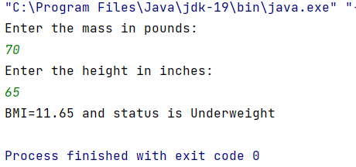

QUESTION 2

import java.util.Scanner;

public class Task2

{

int num;

char c;

int get(int no, char ch)

{

return no;

}

char get(char ch, int no)

{

return ch;

}

public static void main(String args[])

{

Task2 print=new Task2();

Scanner input=new Scanner(System.in);

System.out.println("Enter any number:");

int num=input.nextInt();

System.out.println("Enter any character:");

char c=input.next().charAt(0);

System.out.println("Integer="+print.get(num,c)+" and Charcter="+print.get(c,num));

}

}

OUTPUT

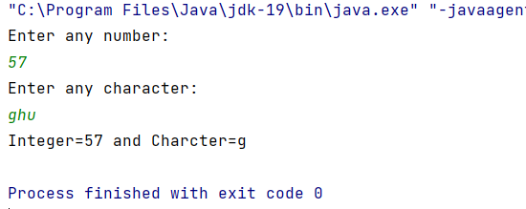

QUESTION 3

import java.util.\*;

public class Task3

{

public static void main(String args[])

{

Scanner input=new Scanner(System.in);

System.out.println("Enter any digit:");

int num=input.nextInt();

System.out.println("last digit="+lastDigit(num));

}

static int lastDigit(int num)

{

return num % 10;

}

}

OUTPUT

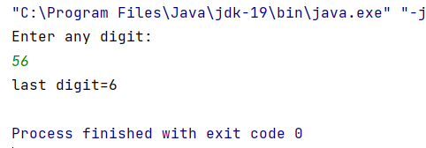

QUESTION 4

import java.util.Scanner;

public class GCD {

public static void main(String[] args)

{

Scanner sc = new Scanner(System.in);

int n1 , n2 ;

System.out.print("Enter the number 1 : ");

n1 = sc.nextInt();

System.out.print("Enter the number 2 : ");

n2 = sc.nextInt();

int hcf = hcf(n1, n2);

System.out.printf("G.C.D of "+n1+" and "+n2+" is "+ hcf);

}

public static int hcf(int n1, int n2)

{

if (n2 != 0)

return hcf(n2, n1 % n2);

else

return n1;

}

}

OUTPUT

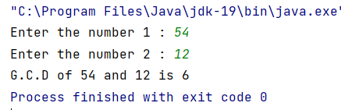

QUESTION 5

import java.util.Scanner;

public class string

{

public static void printReverse(String s) {

if (s.length() == 0) {

return;

} else {

printReverse(s.substring(1));

System.out.print(s.charAt(0));

}

}

public static void main(String[] args)

{

String str ="";

Scanner sc = new Scanner(System.in);

System.out.print("Enter the string : ");

str = sc.nextLine();

System.out.print("String is : ");

printReverse(str);

}

}

OUTPUT

