***TASK1***

*//part a*

public class Employee

{

String firstName;

String lastName;

String CNIC;

Employee() {

firstName = null;

lastName = null;

CNIC = null;

}

Employee(String firstName, String lastName, String CNIC) {

this.firstName = firstName;

this.lastName = lastName;

this.CNIC = CNIC;

}

public void setData(String firstName, String lastName, String CNIC) {

this.firstName = firstName;

this.lastName = lastName;

this.CNIC = CNIC;

}

public String getFirstName() {

return firstName;

}

public String getLastName() {

return lastName;

}

public String getCNIC() {

return CNIC;

}

public String toString() {

return "\nFirstName:" + firstName + "\nlastName:" + lastName + "\nCNIC#:" + CNIC;

}

public double earning() {

return 0.00;

}

}

public class SalariedEmployee extends Employee {

double weeklySalary;

SalariedEmployee(double weeklySalary) {

super();

weeklySalary = 0;

}

SalariedEmployee(String firstName, String lastName, String CNIC, double weeklySalary) {

super(firstName, lastName, CNIC);

if (weeklySalary < 0) {

this.weeklySalary=0;

}

this.weeklySalary = weeklySalary;

}

void setWeeklySalary(double weeklySalary) {

if (weeklySalary < 0) {

this.weeklySalary=0;

}

this.weeklySalary = weeklySalary;

}

double getWeeklySalary() {

return weeklySalary;

}

public String toString() {

return super.toString() + "\nSalaried employee:" ;

}

public double earning() {

return weeklySalary;

}

}

public class HourlyEmployee extends Employee {

double wage;

double hours;

void setWage(double wage) {

if (wage < 0) {

this.wage=0;

}

this.hours = hours;

}

void setHours(double hours) {

if (hours < 0) {

this.hours=0;

}

this.hours = hours;

}

double getWage() {

return wage;

}

double getHours() {

return hours;

}

HourlyEmployee() {

super();

wage = hours = 0.0;

}

HourlyEmployee(String firstName, String lastName, String CNIC, double hours, double wage) {

super(firstName, lastName, CNIC);

if (hours < 0) {

this.hours=0; }

if (wage < 0) {

this.wage=0;

}

this.hours = hours;

this.wage = wage;

}

public String toString() {

return "HourlyEmployee:" + super.toString();

}

public double earning() {

if (hours <= 40) {

return wage * hours;

} else {

return 40 * wage + (hours - 40) * wage * 1.5;

}

}

}

public class CommissionEmployee extends Employee

{

double grossSales;

double commissionRate;

void setGrossSales(double grossSales)

{

if(grossSales<0)

{

this.grossSales=0; }

}

void setCommissionRate(double commissionRate)

{

if(commissionRate<0)

{

this.commissionRate=0;

}

}

double getGrossSales()

{

return grossSales;

}

double getCommissionRate()

{

return commissionRate;

}

CommissionEmployee()

{

super();

grossSales=commissionRate=0.0;

}

CommissionEmployee(String firstName ,String lastName, String CNIC, double grossSales ,double commissionRate )

{

super(firstName, lastName, CNIC);

if (grossSales < 0) {

this.grossSales=0;

}

if (commissionRate < 0) {

this.commissionRate=0;

}

this.grossSales = grossSales;

this.commissionRate = commissionRate;

}

public String toString()

{

return "\nCommissionEmployee:"+super.toString();

}

public double earning()

{

return grossSales*commissionRate;

}

}

public class BasePlusCommissionEmployee extends CommissionEmployee {

double baseSalary;

public void setBaseSalary(double baseSalary) {

if (baseSalary < 0) {

this.baseSalary=0;

}

this.baseSalary = baseSalary;

}

public double getBaseSalary() {

return baseSalary;

}

BasePlusCommissionEmployee() {

super();

baseSalary = 0.0;

}

BasePlusCommissionEmployee(String firstName, String lastName, String CNIC, double grossSales, double commissionRate, double baseSalary) {

super(firstName, lastName, CNIC, grossSales, commissionRate);

if (baseSalary < 0) {

this.baseSalary=0;

}

this.baseSalary = baseSalary;

}

public String toString() {

return "BasePlusCommissionEmployee:" + super.toString();

}

public double earning() {

return baseSalary + super.earning();

}

}

*//part b*

public class payRollSystemTest {

public static void main(String args[])

{

Employee e1=new SalariedEmployee("Ghulam","Mustafa","452-463-6",50000);

Employee e2=new CommissionEmployee("Irfan","Ali","24-37268-42",3000,0.2);

Employee e3=new BasePlusCommissionEmployee("Ali","Raza","73-24698-6",6000,0.1,500);

Employee e4=new HourlyEmployee("Amir","Ali","78-24353-3",20.5,50);

System.*out*.println(e1);

System.*out*.println(e1.earning());

System.*out*.println(e2);

System.*out*.println("Eearning:"+e2.earning());

System.*out*.println(e3);

BasePlusCommissionEmployee currentEmployee=(BasePlusCommissionEmployee) e3;

double oldBaseSalary=currentEmployee.getBaseSalary();

System.*out*.println("Old base salary:"+oldBaseSalary);

currentEmployee.setBaseSalary(1.10*oldBaseSalary);

System.*out*.println("New base salary with 10% increase is:"+currentEmployee.getBaseSalary());

System.*out*.println("Eearning:"+e3.earning());

System.*out*.println(e4);

System.*out*.println("Eearning:"+e4.earning());

}

}

**OUTPUT**

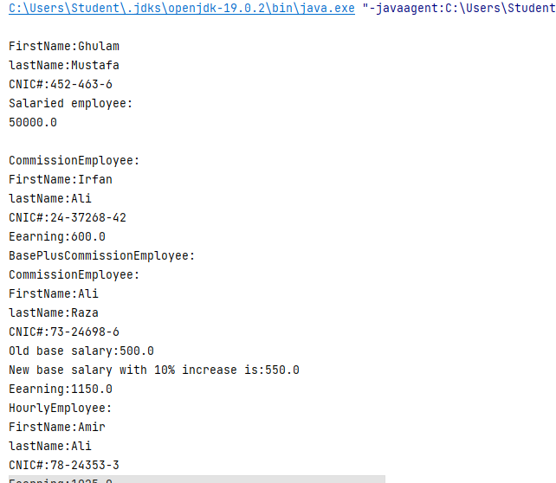

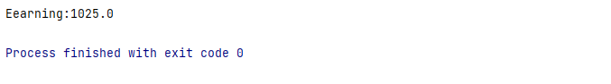

***TASK2***

***public class Animal {***

***String name;***

***int age;***

***String gender;***

***void ProduceSound() {***

***}***

***void display()***

***{***

***System.out.println("Name:" + name + "\nGender:" + gender + "\nAge:" + age);***

***}***

***int getAge()***

***{***

***return age;***

***}***

***}***

***class Dog extends Animal***

***{***

***Dog(){}***

***Dog(String name ,String gender ,int age)***

***{***

***this.name=name;***

***this.gender=gender;***

***this.age=age;***

***}***

***void ProduceSound()***

***{***

***System.out.println("Bow Bow!");***

***}***

***}***

***class Frog extends Animal {***

***Frog() {***

***}***

***Frog(String name, String gender, int age) {***

***this.name = name;***

***this.gender = gender;***

***this.age = age;***

***}***

***void ProduceSound() {***

***System.out.println("Tarn tarn!");***

***}***

***}***

***class Kitten extends Animal {***

***Kitten() {***

***}***

***Kitten(String name, String gender, int age) {***

***this.name = name;***

***this.gender = gender;***

***this.age = age;***

***}***

***void ProduceSound() {***

***System.out.println("Myanoo Myanoo!");***

***}***

***}***

***class TomCat extends Animal {***

***TomCat() {***

***}***

***TomCat(String name, String gender, int age) {***

***this.name = name;***

***this.gender = gender;***

***this.age = age;***

***}***

***void ProduceSound() {***

***System.out.println("Maaono Maaono!");***

***}***

***public static void main(String args[])***

***{***

***Dog d1=new Dog("pupu1","male",10);***

***Dog d2=new Dog("pupu2","female",10);***

***Frog f1=new Frog("GreenF1","male",6);***

***Frog f2=new Frog("GreenF2","male",8);***

***Kitten k1=new Kitten("Kitten1","Female",6);***

***Kitten k2=new Kitten("Kitten2","Female",6);***

***TomCat t1=new TomCat("Biloo1","male",10);***

***TomCat t2=new TomCat("Biloo2","male",14);***

***System.out.println("DOGS:");***

***d1.display();***

***d2.display();***

***System.out.println("\nFROGS:");***

***f1.display();***

***f2.display();***

***System.out.println("\nKITTENS:");***

***k1.display();***

***k2.display();***

***System.out.println("\nTOMCATS:");***

***t1.display();***

***t2.display();***

***int Dog[]=new int[2];***

***Dog[0]=d1.age;***

***Dog[1]=d2.age;***

***int Frog[]=new int[2];***

***Frog[0]=f1.age;***

***Frog[1]=f2.age;***

***int Kitten[]=new int[2];***

***Kitten[0]=k1.age;***

***Kitten[1]=k2.age;***

***int TomCat[]=new int[2];***

***TomCat[0]=t1.age;***

***TomCat[1]=t2.age;***

***int DogAvg=(Dog[0]+Dog[1])/2;***

***int FrogAvg=(Frog[0]+Frog[1])/2;***

***int KittenAvg=(Kitten[0]+Kitten[1])/2;***

***int TomCatAvg=(TomCat[0]+TomCat[1])/2;***

***System.out.println("Averages of Dog's Ages:"+DogAvg);***

***System.out.println("Averages of Frog's Ages:"+FrogAvg);***

***System.out.println("Averages of Kitten's Ages:"+KittenAvg);***

***System.out.println("Averages of TomCat's Ages:"+TomCatAvg);***

***}***

***}***

**OUTPUT:**

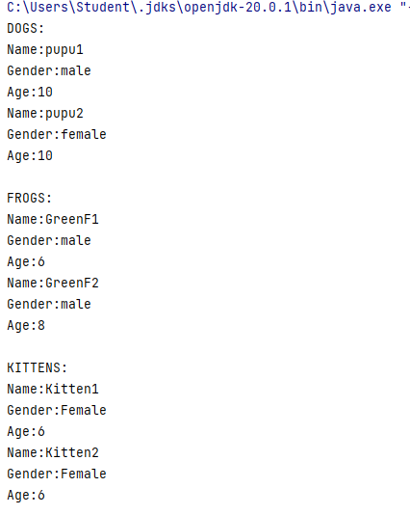

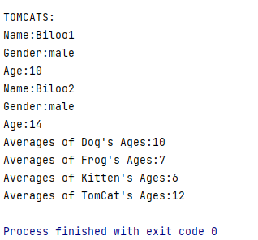

***TASK3***

***class Movie***

***{***

***String MPAA;***

***int IdNo;***

***String movieTitle;***

***int lateDays;***

***Movie(){}***

***Movie(String MPAA, int IdNo, String movieTitle,int lateDays)***

***{***

***this.MPAA=MPAA;***

***this.IdNo=IdNo;***

***this.movieTitle=movieTitle;***

***this.lateDays=lateDays;***

***}***

***String getMPAA(){return MPAA;}***

***int getIdNo(){return IdNo;}***

***String getMovieTitle(){return movieTitle;}***

***void Equal(int Id1,int Id2)***

***{***

***if(IdNo1==IdNo2)***

***{***

***System.out.println("Movies are identical!");***

***}***

***}***

***double CalLateFees(int noOfDays)***

***{***

***return noOfDays*2;***

***}***

***}***

***class Action extends Movie***

***{***

***Action (){}***

***Action(String MPAA, int IdNo, String movieTitle,int lateDays)***

***{***

***super(MPAA,IdNo,movieTitle,lateDays);***

***}***

***int getlateDays(){return lateDays;}***

***double CalLateFees(int noOfDays)***

***{***

***return noOfDays*3;***

***}***

***void Equal(int Id1,int Id2)***

***{***

***if(IdNo1==IdNo2)***

***{***

***System.out.println("Movies are identical!");***

***}***

***}***

***}***

***class Comedy extends Movie***

***{***

***Comedy(){}***

***Comedy(String MPAA, int IdNo, String movieTitle,int lateDays)***

***{***

***super(MPAA,IdNo,movieTitle,lateDays);***

***}***

***int getlateDays(){return lateDays;}***

***double CalLateFees(int noOfDays)***

***{***

***return noOfDays*2.50;***

***}***

***void Equal(int Id1,int Id2)***

***{***

***if(IdNo1==IdNo2)***

***{***

***System.out.println("Movies are identical!");***

***}***

***}***

***}***

***public class Drama extends Movie***

***{***

***Drama(){}***

***Drama(String MPAA, int IdNo, String movieTitle,int lateDays)***

***{***

***super(MPAA,IdNo,movieTitle,lateDays);***

***}***

***int getlateDays(){return lateDays;}***

***double CalLateFees(int noOfDays)***

***{***

***return noOfDays*2;***

***}***

***void Equal(int Id1,int Id2)***

***{***

***if(IdNo1==IdNo2)***

***{***

***System.out.println("Movies are identical!");***

***}***

***}***

***public static void main(String args[])***

***{***

***Action a1=new Action("tg-24",246,"3Idiots",3);***

***Action a2=new Action("fs-25",235,"Dhamal",5);***

***Comedy c1=new Comedy("sd-23",145,"Kapil Sharma",10);***

***Comedy c2=new Comedy("wj-35",145,"Big Boss",3);***

***Drama d1=new Drama("ag-32",123,"Ertugral",12);***

***Drama d2=new Drama("kr-34",123,"Usman",20);***

***System.out.println("Action Movies");***

***System.out.println("\n\nAction1 MPPA:"+a1.MPAA+"\nAction1 ID:"+a1.IdNo+"\nAction1 Name:"+a1.movieTitle+"\nAction1 Late Days:"+a1.getlateDays()+"\nLate fee:"+a1.CalLateFees(a1.getlateDays()));***

***System.out.println("\nAction2 MPPA:"+a2.MPAA+"\nAction2 ID:"+a2.IdNo+"\nAction2 Name:"+a2.movieTitle+"\nAction2 Late Days:"+a2.getlateDays()+"\nLate fee:"+a2.CalLateFees(a2.getlateDays()));***

***a1.Equal(a1.IdNo,a2.IdNo);***

***System.out.println("\n\nComedy Movies");***

***System.out.println("\nComedy1 MPPA:"+c1.MPAA+"\nComedy1 ID:"+c1.IdNo+"\nComedy1 Name:"+c1.movieTitle+"\nComedy1 Late Days:"+c1.getlateDays()+"\nLate fee:"+c1.CalLateFees(c1.getlateDays()));***

***System.out.println("\nComedy2 MPPA:"+c2.MPAA+"\nComedy2 ID:"+c2.IdNo+"\nComedy2 Name:"+c2.movieTitle+"\nComedy2 Late Days:"+c2.getlateDays()+"\nLate fee:"+c2.CalLateFees(c2.getlateDays()));***

***c1.Equal(c1.IdNo,c2.IdNo);***

***System.out.println("\n\nDrama Movies");***

***System.out.println("\nDrama1 MPPA:"+d1.MPAA+"\nDrama1 ID:"+d1.IdNo+"\nDrama1 Name:"+d1.movieTitle+"\nDrama1 Late Days:"+d1.getlateDays()+"\nLate fee:"+d1.CalLateFees(d1.getlateDays()));***

***System.out.println("\nDrama2 MPPA:"+d2.MPAA+"\nDrama2 ID:"+d2.IdNo+"\nDrama2 Name:"+d2.movieTitle+"\nDrama2 Late Days:"+d2.getlateDays()+"\nLate fee:"+d1.CalLateFees(d1.getlateDays()));***

***}***

***}***