**ASSIGNMENT LAB 3**

**Name: GHULAM MUSTAFA**

**CMS:021-22-0099**

**QUESTION 01**

import java.sql.SQLOutput;

class Employee

{

String name;

int yearOfJoining;

String address;

}

public class task1

{

public static void main(String args[])

{

Employee e1=new Employee();

e1.name="Robert";

e1.yearOfJoining=1994;

e1.address="64C-WallsStreat";

Employee e2=new Employee();

e2.name="Sam";

e2.yearOfJoining=2000;

e2.address="68D-WallsStreat";

Employee e3=new Employee();

e3.name="John";

e3.yearOfJoining=1999;

e3.address="26B-WallsStreat";

System.*out*.println("Name\t\tYear of joining\t\tAddress");

System.*out*.println(e1.name+"\t\t"+e1.yearOfJoining+"\t\t\t"+e1.address);

System.*out*.println(e2.name+"\t\t\t"+e2.yearOfJoining+"\t\t\t"+e2.address);

System.*out*.println(e3.name+"\t\t"+e3.yearOfJoining+"\t\t\t"+e3.address);

}

}

**OUTPUT**

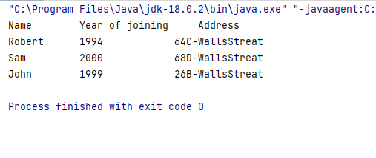

**QUESTION 02**

import java.util.Scanner;

class EmployeeInfo

{

int salary;

int Hours_of_Work;

void getInfo(int salary,int Hours_of_Work )

{

this.salary=salary;

this.Hours_of_Work=Hours_of_Work;

}

int AddWork()

{

if(Hours_of_Work>6)

{

salary+=5;

}

return salary;

}

int AddSal()

{

if(salary<500)

{

salary+=10;

}

return salary;

}

void disp()

{

AddSal( );

AddWork();

System.*out*.println("Total Salary="+salary+"\nTotal number of hours of work per day="+Hours_of_Work);

}

}

public class Task2

{

public static void main(String args[])

{

Scanner sc=new Scanner(System.*in*);

EmployeeInfo obj1=new EmployeeInfo();

System.*out*.println("Enter the salary:");

int sal= sc.nextInt();

System.*out*.println("Enter the number of hours of work per day:");

int no_hour= sc.nextInt();

obj1.getInfo(sal,no_hour);

obj1.disp();

}

}

**OUTPUT**

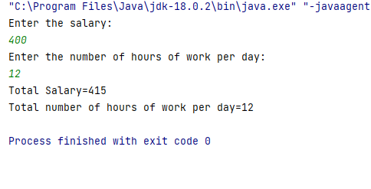

**QUESTION 03**

class Vehcile

{

int no_Of_Seats;

int no_Of_Wheels;

}

public class task3

{

public static void main(String args[])

{

Vehcile motorC=new Vehcile();

Vehcile car=new Vehcile();

motorC.no_Of_Seats=2;

motorC.no_Of_Wheels=2;

car.no_Of_Wheels=4;

car.no_Of_Seats=5;

System.*out*.println("Name\t\tNo Of Wheels\tNo Of Seats");

System.*out*.println("Car\t\t\t\t"+car.no_Of_Wheels+"\t\t\t\t"+car.no_Of_Seats);

System.*out*.println("Motor Cycle\t\t"+motorC.no_Of_Wheels+"\t\t\t\t"+motorC.no_Of_Seats);

}

}

**OUTPUT**

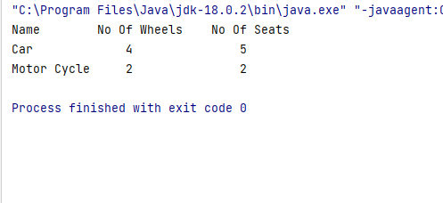

**QUESTION 04**

**class Test**

**{**

**int a = 1;**

**int b = 2;**

**Test func(Test obj)**

**{**

**Test obj3 = new Test();**

**obj3 = obj;**

**obj3.a = obj.a++ + ++obj.b;**

**obj.b = obj.b;**

**return obj3;**

**}**

**public static void main(String[] args)**

**{**

**Test obj1 = new Test();**

**Test obj2 = obj1.func(obj1);**

**System.out.println("obj1.a = " + obj1.a + " obj1.b = " + obj1.b);**

**System.out.println("obj2.a = " + obj2.a + " obj1.b = " + obj2.b);**

**}**

**}**

**Explanation:**

**In above code the values of ‘a’ of both obj 1 and obj2 will be same a=4 and a=4 and the values of ‘b’ of both obj 1 and obj2 will also be same b=3 and b=3 because in func method the ‘a’ value has post increment so the value is assigned before increasement thats why a=4 but ‘b’ value has pre increment that's why it is increased by 1 and then they are added. they will not be concatenated because there is no parentheses bracket between them.in last these values are printed in main method.**

**QUESTION 05**

**OBJECT CLASS:There is an object class in the java.lang package. Every class in Java derives in some way from the Object class. A class is directly derived from Object if it does not extend any other classes, and indirectly derived from other classes. As a result, all Java classes have access to the Object class methods. So, in any Java programme, the Object class serves as the root of the inheritance tree.**

**CODE OF METHODS:**

**1)public String toString()**

**{**

**return getClass().getName() + "@" + Integer.toHexString(hashCode());**

**}**

**2)public class Test {**

**public static void main(String[] args)**

**{**

**Object obj = new String("GeeksForGeeks");**

**Class c = obj.getClass();**

**System.out.println("Class of Object obj is : "**

**+ c.getName());**

**}**

**}**