Data Base Systems Project
Online Food Delivery System

Ghulam Mohiuddin

Queries using filtering conditions:
Query 1: Filtering Condition
Objective: Retrieve all orders that have been cancelled.
Query:
SELECT *
FROM Orders
WHERE Status = 'Cancelled';

Output:

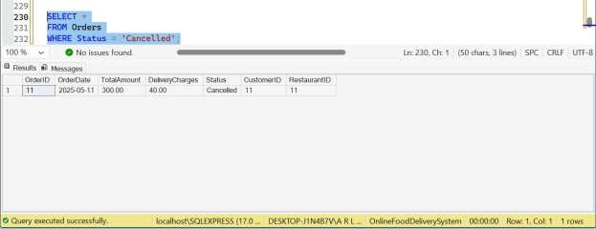

2: Filtering Condition with Logical Operators

Objective: Find all menu items whose price is less than 500 and category is Snacks or Main Course.

Query:

SELECT *
FROM MenuItem
WHERE Price < 500
AND (Category = 'Snacks' OR Category = 'Main Course');

Output:

Query
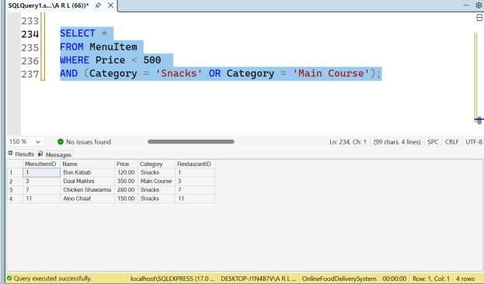

Join operations involving multiple tables

Query 3 : JOIN Operation

Objective: Display OrderID and OrderDate along with the name of the customer who placed it and the restaurant name.

Query:

SELECT O.OrderID, O.OrderDate,
C.Name AS CustomerName,
R.Name AS RestaurantName
FROM Orders O
JOIN Customer C ON O.CustomerID = C.CustomerID
JOIN Restaurant R ON O.RestaurantID = R.RestaurantID;

Output:

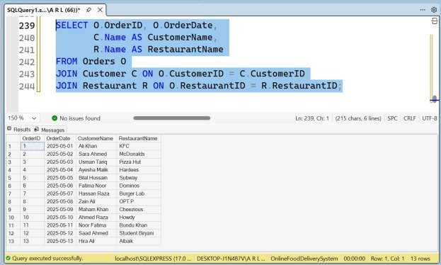

LEFT JOIN Operation

Objective: Display all restaurants along with their menu item details and the orders they have received showing OrderID and OrderDate, including restaurants that have not received any orders yet.

Query:

SELECT R.*,
MI.MenuItemID, MI.Name AS MenuItemName,
MI.Price, MI.Category,
O.OrderID, O.OrderDate
FROM Restaurant R
LEFT JOIN MenuItem MI ON R.RestaurantID = MI.RestaurantID
LEFT JOIN Orders O ON R.RestaurantID = O.RestaurantID;

Output:

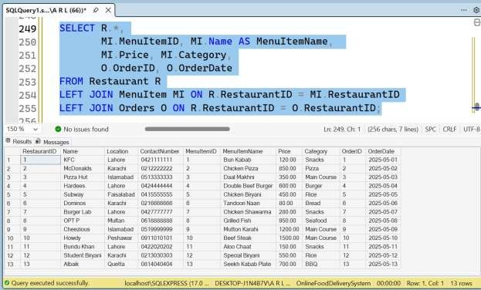

Aggregation functions such as COUNT, SUM, AVG, MAX, and MIN

Query 5 : Aggregation (COUNT, SUM)
Objective: Find the total number of orders and total revenue generated by each restaurant.
Query:

SELECT R.Name AS RestaurantName,
COUNT(O.OrderID) AS TotalOrders,
SUM(O.TotalAmount) AS TotalRevenue
FROM Restaurant R
JOIN Orders O ON R.RestaurantID = O.RestaurantID
GROUP BY R.Name;

Output:

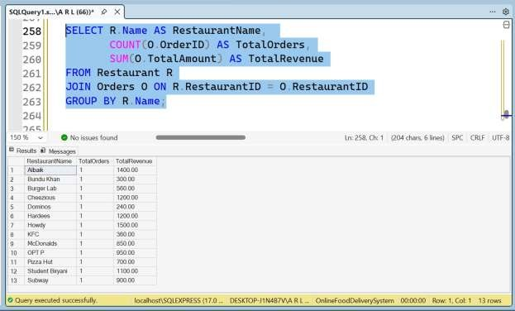

Aggregation (AVG, MAX, MIN)
Objective: Display each menu item category along with its average price, highest price and lowest price.
Query:
SELECT Category,
AVG(Price) AS AveragePrice,
MAX(Price) AS HighestPrice,
MIN(Price) AS LowestPrice
FROM MenuItem
GROUP BY Category;

Output:
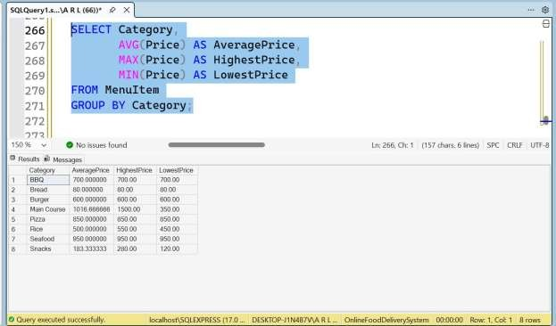

GROUP BY operations

Query 7 : GROUP BY with WHERE clause

Objective: Display the total number of menu items and average price in each category, but only consider menu items whose price is greater than 200.

Query:

SELECT Category,
COUNT(MenuItemID) AS TotalItems,
AVG(Price) AS AveragePrice
FROM MenuItem
WHERE Price > 200
GROUP BY Category;

Output:

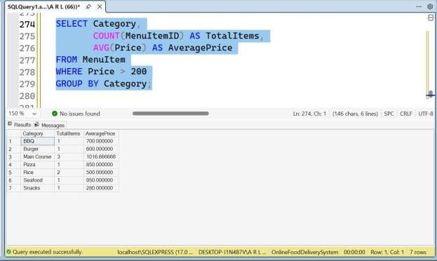

GROUP BY with HAVING clause

Objective: Display each category of menu items along with the average price, but only show categories whose average price is greater than 400.

Query:

SELECT Category,
AVG(Price) AS AveragePrice
FROM MenuItem
GROUP BY Category
HAVING AVG(Price) > 400;

Output:

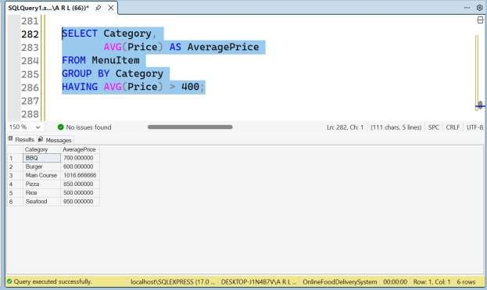

Subqueries

Query 9: Subquery using Aggregate function

Objective: Display all details of the Customer who placed the order with the highest total amount.

Query:

SELECT *
FROM Customer
WHERE CustomerID = (
SELECT CustomerID
FROM Orders
WHERE TotalAmount = (SELECT MAX(TotalAmount) FROM Orders)
);

Output:

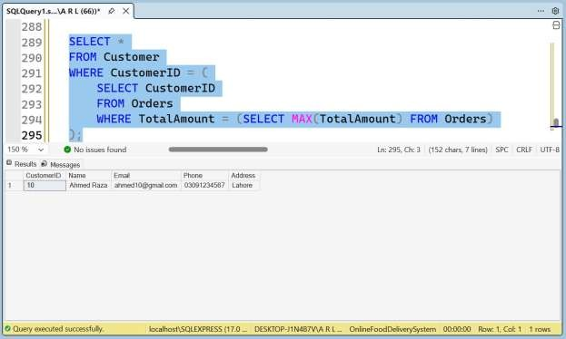

Query 10: Subquery using Aggregate function

Objective: Display the Name and Phone number of Riders who have been assigned a delivery that is currently in transit.

Query:

SELECT Name, Phone
FROM DeliveryRider
WHERE RiderID IN (
SELECT RiderID
FROM Delivery
WHERE DeliveryStatus = 'In Transit'
);

Output:

