# 

**StatueStudio**

**AYUSHI SURYAWASHI (210543181001)**

**ASHISH KATKAR (210543181038)**

**SIDDHARTH DIXIT (210543181106)**

**VAIBHAV GHULE (210543181119)**

**Introduction**

**Online *StatueStudio-God Idol and Accessories* is a web-based project made for shopping through Internet. As the technology is being advanced the way of life is changing accordance. Now a day’s we can place the order for anything from our home. There is no need to go to the shop for the thing we want.**

**This site gives all the information about the statues to provide better service for the customer.**

**It provides the facility to the customers who want to shop online due to lack of time.**

**Features**

* **Menu**
* **Catalog Browsing**

1. **Category List (Idol And Accessiores)**
2. **Idol List**

* **Catalog Management**
* **Product Browsing**

1. **Product Reviews**
2. **Related Products**

* **Shopping Cart**
* **Auto generated Bill**
* **Payment Gatways**

**Modules**

**ADMIN:**

* **The Admin can login the system**
* **Admin can create categories**
* **Admin can create subcategories**
* **Admin can upload**
* **Admin can upload product features**

**USER:**

* **The customer should register**
* **The customer can login the system**
* **The customer can search for a particular product**
* **The customer can order a product**



**Diagram:**

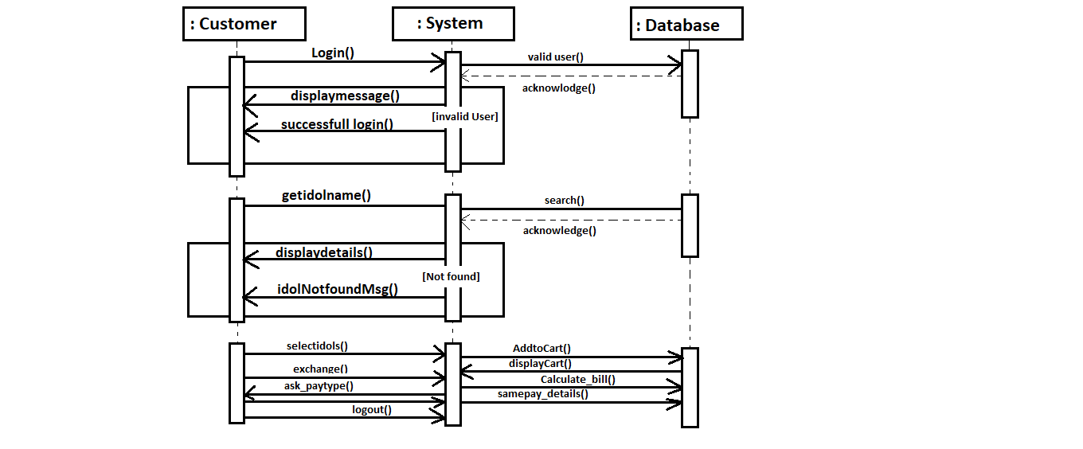

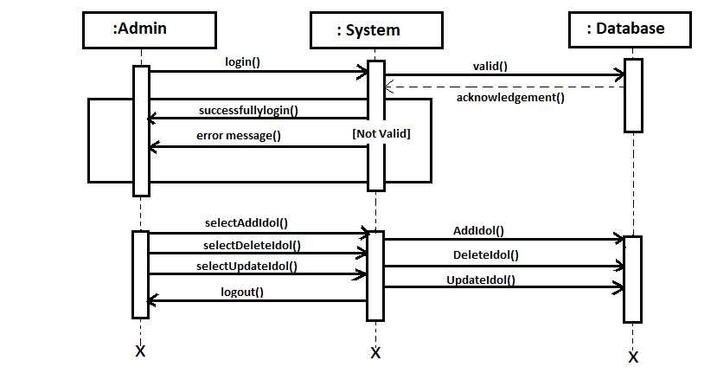

**Advantages**

1. **Can shop for 24*7.**
2. **No need for cash in hand.**
3. **A lot of stores within a click away.**
4. **No queue to wait.**
5. **Shopping Privacy.**
6. **Regular discount available.**



**Disadvantages**

1. **Lack of Personal Touch.**
2. **Price and Product Comparison.**
3. **Need of Internet Access.**

**Future Plan**

**We are thinking of some modification and adding some advanced new features in our application. Some of them are:**

* **GUI modification (more user friendly)**
* **Users can signup/login using their social media account such as facebook, google, etc.**
* **Mobile app can be developed.**
* **Customer can be notified about the orders and new arrivals through emails and text messages.**
* **Combining idol and accessories we can review the things before buying.**



**Database:**

**Customer Table:**

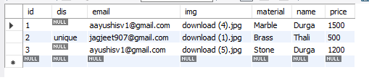

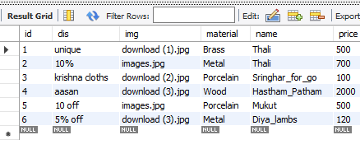

**Screens:**

1. **Main Menu**

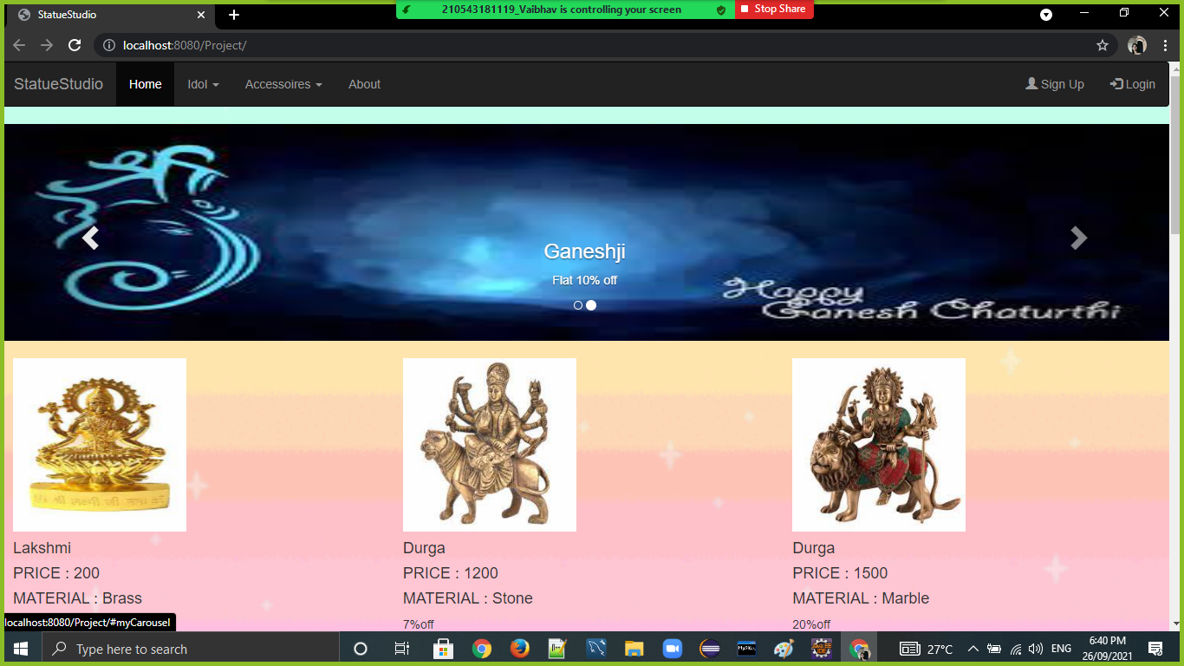

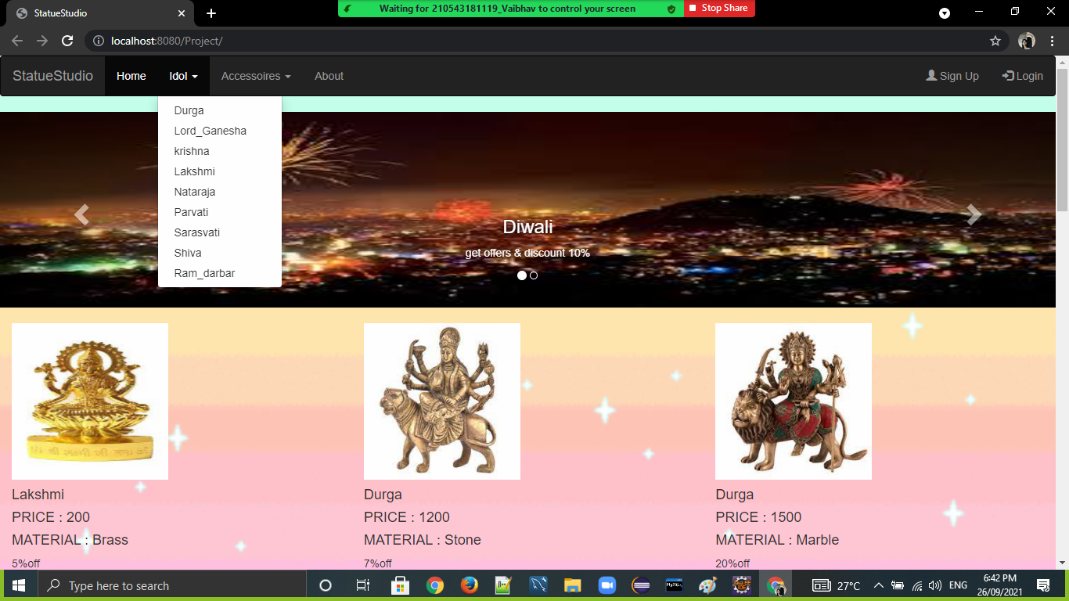

1. **Admin Login**

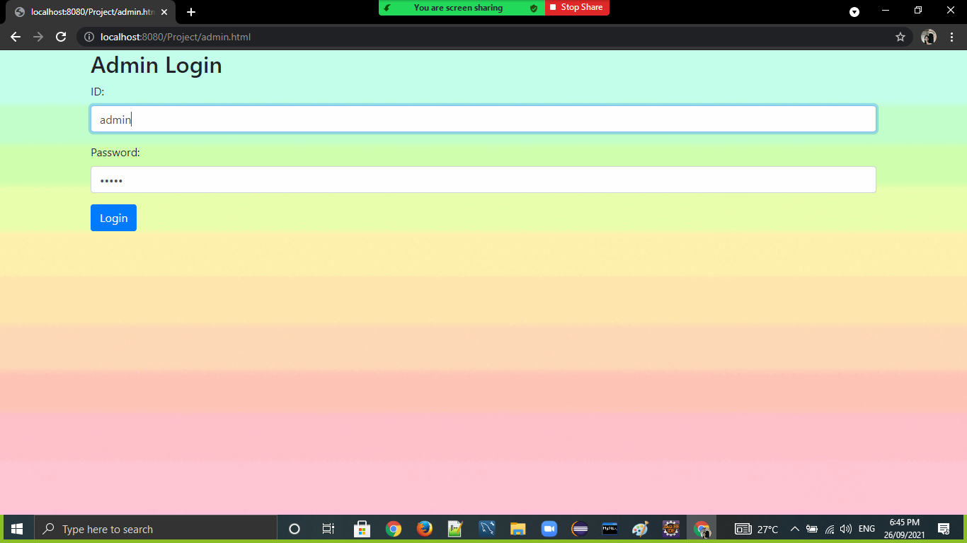

**Admin Panel**