- Introduction :-
  - Its use for create a dynamic web application

- MVT in django :- Model view template
  - 3 words = model + view + template
  - Model :- interface a database (structure data retrive and etc ..)
  - View :- user interface
  - Template :- static part of html

- Installing python & django :-
  - Pyhton website
  - Click on download and select version and download
  - Select path + PiP during installation + install for all user
  - Check in cmd python
  - For django download use commnd(cmd) :- pip install django
  - Check all download foler by using command(cmd) :- Pip freeze

- Create a django project :-
  - List of all admin projects use command :- Django – admin
  - we craete a new project in startproject from admin list .
  - Create one folder (e.g. django_projects)where you store and create django project
  - (like c:\user\\abc\\desktop)
  - Open cmd where your folder (e.g. django_projects) is created
  - Now we create a project use command :-
  - Django-admin startproject myfirstproject
  - now check your project in your folder

- starting a development server :-
  - open cmd from your project folder(django_projects) .
  - Go to your project (myfirstproject)
  - Now apply this command :- python manage.py runserver
  - Given port number paste in browser and your server is start
  - Now if do you want to stop server use key :- ctrl + c
  - Now if you are working multiple project and server port number is same for this so you can change your port number :-
  - python manage.py runserver 4444(4444 port number)
  - You can put your port number which you use

- Download vs code for use python and django :-
  - go to website and select version and download and install
  - Install extention in vs code for python and django
  - Now open your project folder in vc code
  - You can run django in vs code terminal

- Python django Structure
  - In your project you say one more duplicate folder
  - Create a one folder ‘templates’ in your project folder its for html files
  - One more folder ‘static’ its for js ,css ,images etc files.
  - And last folder ‘media ‘ its store dynamic files
  - Go to duplicate folder of your project and open
  - Now go to setting.py in setting file go to template code block and add
  - ‘DIRS’ : [BASE_DIR , “ ”],

- How to migrate Default migration
  - Default migration :- table schema
  - Migarte :- move on place to another
  - Migrate database
  - Django default database use sqlite3
  - In project folder we have one file db.sqlite3
  - you can use other database download database and add setting file database code block .
  - Django provide admin panel in default open this path in browser
  - http://127.0.0.1:8000/admin/
  - Open new terminal in vs code for database
  - Command :- Python manage .py migrate
  - For username and password download db browser

- Download and install db browser
  - Goto sqlitebrowser.org website
  - Select version and download and install
  - open db browser click on open database and open your folder and select db.sqlite file

- Create superuser in django
  - open cmd in your project folder
  - enter the command :-
  - python manage.py createsuperuser(note add witespace between command “createsuperuser”)
  - enter username ,email,password
  - now open db browser and open the db.sqlite file and browse table auth_user and now you show your data .
  - now open admin panel add username and password , you got your deskbord .

- urls and views :-
  - Url is a route of website like homepage -> aboutus -> profile coordinator ->
  - Views is logic is executed for different urls (https methods function and class)
  - You can change urls in file of urls.py

- Creatting urls & views :-
  - open duplicate folder and create one file views .
  - open file and add this code or write

  - from django.http import HttpResponse
  - def aboutus(request):
  - return HttpResponse("welcome to shruti")
  - def courses(request):
  - return HttpResponse("welcome to courses")

  - Open now url file urls.py and write
  - Now add or write code

  - from django.contrib import admin
  - from django.urls import path
  - from django_programs import views
  - urlpatterns = [
  - path('admin/', admin.site.urls),
  - path('aboutus/', views.aboutus),
  - path('courses/', views.courses),
  - ]

  - now open browser and open add your url in browser url

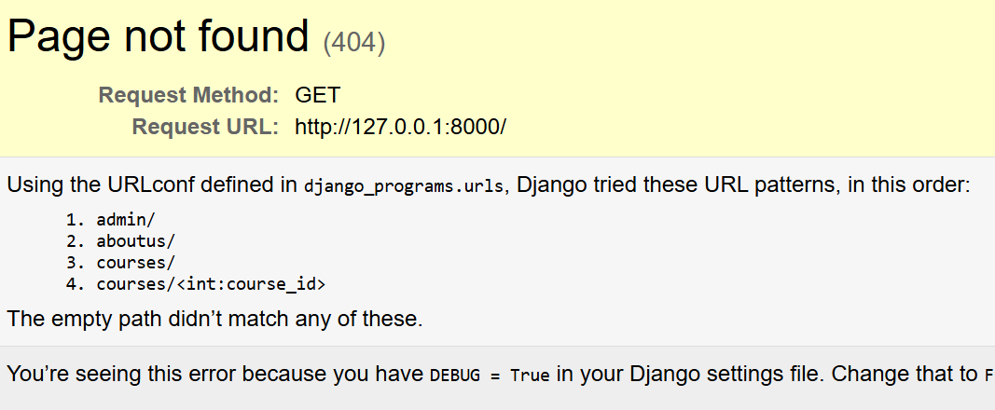
  - now url :- http://127.0.0.1:8000/courses/

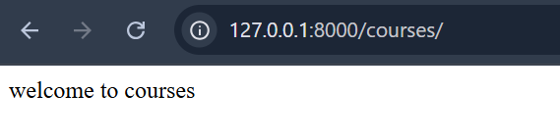

- create dynamic routes :-
  - course detail all course have details then we create dynamci route .
  - e.g course -> python , course -> html
  - here course is main and python, html are sub then we create one detail course for all courses dynamic
  - add code in views.py code

  - def course_details(request, course_id):
  - return HttpResponse("welcome to " + str(course_id))

  - add code in urls.py code

  - path('courses/<int:course_id>/', views.course_details),

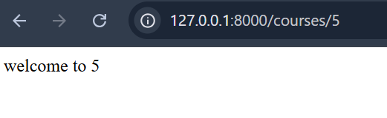

- Creating hompage Templates:-
- Passing data from a django view to a template:-
- Use for loop in template
- Use if else in tempat
- Managing static file (image,js,css etc..) from website template

