- [Day 1]

- introduction & Features :

  - python is programming language as like java c c++.

  - python feature :

    - easy to understand and code - its is familiar language
    - free open source
    - object oriented language
    - python is high level language - any application used
    - Platform independent - Linux ..
    - interpreted language - run line by line code
    - Rich community - error handling, libraries ..
    - its develop web ,scripting language , deep learning , machine learning

- [Day 2]

  - installation python

    - steps:
      - python.org -> select window -> select latest version ->
      - install window download -> run
      - -> check /agree "add python 3. 9 path "
      - -> install python version
      - go to search bar in desktop
      - -> search Run
      - -> write cmd
      - -> c:\user\admin> - pip install jupyter
      - -> c:\user\admin> jupyter notebook (its open web browser )

- [Day 3]

  - basic syntax
    - -print (): use for display message
    - -type(): check variable datatype
    - -input(): get input value

  - comment : - use for understand code logic
    - -single line comment : # is use for single line comment
    - -multiple line comment : """ 3 bracket is use for multiple comment

- [Day 4]

  - Keywords

    - reserved keyword which is provide by python
    - if , else , class , for ...
    - its not use as a variable name
    - help() is used for display list of keyword name .

- [Day 5]

  - Datatype :
    - its type of data which is used type of variable .
    - in python we not defind a datatype before use a variable name ( Ex :- int a = 10 )
    - type of datatype :
      - 1] numberic : int , float , complex number
      - 2]sequence type : list[] , tuple(), string ""
      - 3] boolean
      - 4] set {}
      - 5] dictionary{key ,value}

- [Day 6]

  - variable:

    - its store a data or value
    - variable is store different type of value like : string ,int , list, tuple .
    - in python variable declared based on rules:

      - 1] variable name is start with alphabet only.
      - 2] in variable name you can't use a special character
      - 3]don't use keyword as a variable name
      - 4]don’t use datatype in variable declaration
      - 5]don't put whitespace between variable name
      - 6]variable name is case sensitive (A and a is different variable)
      - 7]allowed multiple variable at a time (a , b , c = 1 , 2 , 3)
      - 8] concat variables ("Hi" + "how") only string values .

    - Type conversion / Type casting
      - convert one datatype to another (a = "hello" print (int(a)))

- [Day 7]

  - Operators :
    - operators are used perform operation on variables
    - type of operators (7)

      - 1] Arithmetic (+,-,*,%,/,//,**)
      - 2] Assignment operator (=,+=,-=,*=,%=,/=,//=,**=)
      - 3] Comparison (==,!=,>,<,>=,<=,===,!==)
      - 4] bitwise (& , | , ^ , ~ , << , >> )
      - 5] logical (and , or , not )
      - 6] identity (is, is not)
      - 7] membership (in, in not)

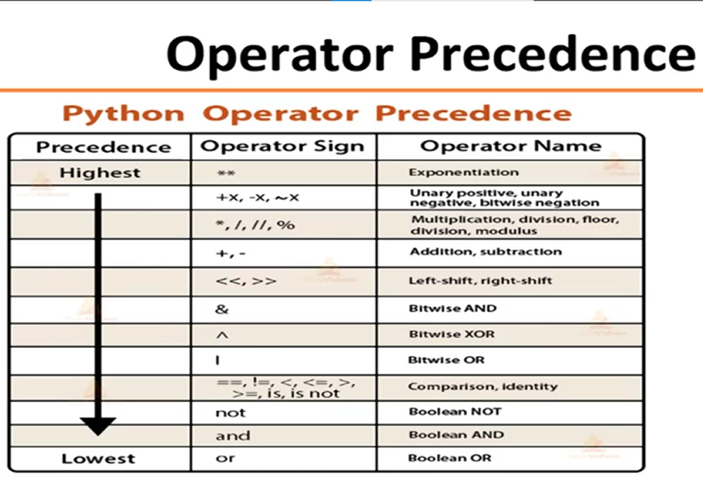
    - operator precedence - which operator evulate first
.

- Example of operator precedence

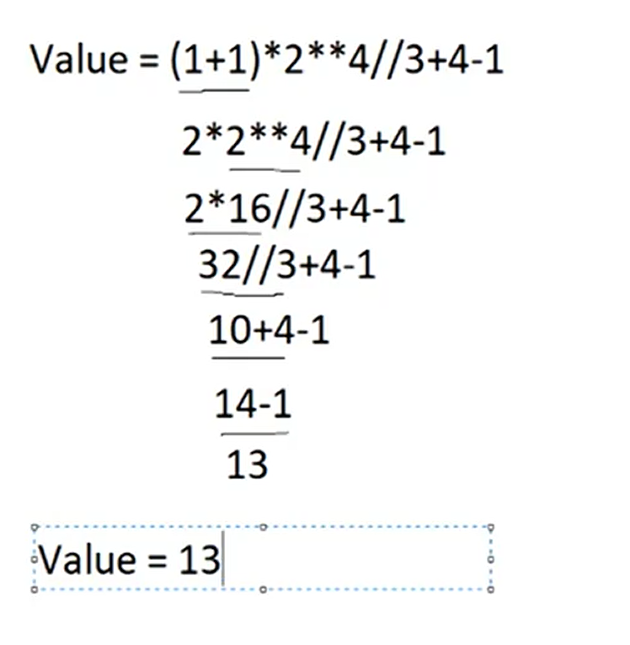

- [Day 8]

  - condition statement

    - used for check condition in boolean value (true or false )
    - condition statement is used a if else for check conditions
    - 1] simple if
    - 2] if_else
    - 3] elif
    - 4] nested if

- [Day 9]

  - Loop statement :-
    - iterate a value of variable , repeat a value
  - type of loop :

    - entry control :
      - for , while ,nested for :- check the condition first after execute loop.
    - exit control:
      - do while - its not provided in python built in but we can construct do while loop by self

- [Day 10]

  - looping control statement
    - break : exit loop after achieve goal
    - continue : skip the value and continue executed
    - pass : empty loop continue block without skip

- [Day 11]

  - String:
    - datatype which is allowed multiple values
    - write in single quote and double
    - collection of character
  - task :
    - i]create :- single quote, double , multiline...
    - ii]indexing and slice string :- slice break
    - iii]use built in function with string :- capitalize ,small, space

- [Day 12]

  - list []:-
    - store the data in sequence .
    - its store a multi type values :- int , string , etc..
    - its work on index value start with 0.
    - list is mutable / changeable
  - Task :
    - i] create :- int, str ,constructer, duplicate value
    - ii] indexing, slicing :- index based value , slice list
    - iii] use built in function :- remove, clear, insert, extends, pop, etc..
    - iv] nested list

- [Day13]

  - Tuple ():-
    - collection
    - immutable its not be change (convert in to list and after change)
    - its allowed a multi type values :- int, string , etc..
    - its work on index value start with 0.

  - Task:
    - i]create :- constructer, convert tuple to list ,
    - ii] indexing ,slicing :- loop , compare,

- [Day 14]

  - Dictionary :-
    - collection in python
    - key value store .
    - duplicate value allowed in different key
    - key immutable , not repeated .

  - Task :-
    - i]create :- create change value
    - ii] indexing ,slicing, method :-
    - access[get (),item(),only keys ,only values]
    - remove[clear(),del(),pop(),pop item()]
    - update[update(),index no based]

- [Day 15]

  - Function :
    - block of code , code run when you call
    - -its use for reusability
    - -def keyword use for function create

  - type of function:
    - i] built in function :- print(),range(),Len(),round(),max(),min()
    - ii]user defined function
    - iii] anonymous function

  - task:-
    - i] create
    - ii] call function
    - iii] argument
    - iv] multiple argument
    - v] anonymous function

- [Day 16]

  - random module :-
    - inbuilt function in by used choose or
    - generate random number in python
    - used by import random
    - method / operation of random :-
    - i]Choice()[ex:-pick random value from list , tuple, dict]
    - ii]Randint()[ex:-otp generate]
    - iii]Shuffle()[ex:-shuffle any value]

  - taks:
    - i]import random
    - ii]random function

- [Day 17]

  - math module:-
    - mathematical task solve by this module
    - any mathematical concept are used in math module

  - method of math
    - i]factorial()
    - ii]ceil() - higher
    - iii]floor() - lower
    - iv]sqrt()

  - task :
    - import math ,method of math

- [Day 18]

  - file handling :-
    - important concept in python
    - - important for web-application ;- its update, delete, read, store and retrieve data in file

  - file handling permission :
    - R(read file)
    - A(append the value in file)
    - W(write in file)

  - task:
    - i] create a file
    - ii] read a file
    - iii] append a file
    - iv] store list into file
    - v] read list from file

  - Note :::---
    - in real word example of file handling :-
      - whatsapp send file,
      - Zoom meeting share file,
      - upload in classroom,
      - Microsoft team use in file shared

- [Day 19]

  - Exception handling:-
    - its situation it occurred at runtime and stop the code execute .

  - type of exception :-

    - i]syntax error :-
      - in the code some syntax are missing or unordered (ex:- missing comma etc.)

    - ii]exception :-
      - code is complete write but some logically error come in to program its called
      - (ex: a variable store a int value
      - but you add float that is create a exception , any number is divide by 0 its infinity so its ....)

    - iii] user defined :-
      - its created by user for solve exception its inherited a exception class
      - use :- try else, except(catch),

- [Day 21]

  - Oops concept:-
    - i] class
    - ii] object
    - iii] abstraction
    - iv] inheritance
    - v] encapsulation
    - vi] polymorphism

  - i]class :-
    - collection of object and methods.

  - object:- instance of class
    - access class using object

  - constructer :-
    - predefined method
    - -its call when object create
    - constructer is identified by _(underscore)
    - _init_function: this is constructer its call when object create
    - how to create :- def__init__(self):
    - constructer body

  - self :-
    - self is predefined instance of class which is dedicate
    - to function its property of that class
    - del variable object : del objectname.variablename

  - ii]inheritance:-
    - means take a property of one class into other class
    - support multiple inheritance
    - inheritance class called are :-
      - (super class & subclass)
      - or ( parent class & child class )
      - or ( base class & derived class)
    - use parent class property by child class object

  - Types:-

    - i] single :- one parent and only one child
    - ii] multiple :- multiple parent in one child
    - iii] multilevel :- grandparent parent child
    - iv] hybrid :- parent class two child and that two child(parent of subchild) have one child
    - v] hierarchical :- two child one parents

  - Note ::: --

    - hierarchical inheritance create 2 object child1 and child2 , Basically both child class object is called a parent class property and self class

  - Note ::: --

    - [ Hybrid inheritance create multiple object child1 and child2 and child3 ]
      - - child1 class object access a property of parent class and it self
      - - child2 class object access a property of parent class and it self
      - - child3 class object access a property of all class parent child1 child2 and it self

- [Day 22]

  - Polymorphism :-
    - - one entity multiple attribute
    - -same name fo multiple form

  - type of :-
    - i] compile time polymorphism :- method overloading
      - (cl = compile,loading)(same name same class, different argument, no inheritance required )
      - its not support in python because pyhton is interpreter language

    - ii] run time polymorphism :- method overriding
      - ( rr = run,riding)(same name sameargument,different class, inheritance required use super() with method name )

- [Day 23]

  - Abstraction :-
    - hide a unnecessary data
    - -abstraction keyword use with method or class
    - -in class have one or more abstract method that class must be abstract
    - ,but in abstract class not required to any abstract method
    - -abstract method no have body its not defined a code in method only declare method
    - -its work on inheritance which one parent class have one abstract method which is dont
    - have body of that method that method body is declare in child class

- [Day 24]

  - Encapsulation :-
    - data binding.
    - -class have multiple method and variable
    - - encapsulation achieve in two way :- private and protected
    - private :- double underscore(__) private property of parent class or other class is not achive by child
    - protected :- single underscore(_) protected property of parent class or other class is achive by child

- [Day 25]
  - Regular expression :-
    - -RegEx
    - - its use for search pettern
    - - import "re" module
    - two type function:-
      - 1] Match :- match beggning string character
        - syntax :- re.match(pattern,string)
      - 2] Search :- match paticular charater in any location of all string character
        - syntax :- re.search(pattern,string)
      - 3]replace :- wrod pattern character are replace -re.sub(pattern(oldword),repl(new word),string)

    - difference between match & search

match | search
its match only beginning of string if found and return match string | its a search all string from start to end

