Class Diagram
  - Design basis
The class diagram and data model are derived directly from the group's three existing documents: the Functional and Non-Functional Requirements, the Data Flow Diagram (Level 0 and Level 1) and the Use Case Specification. The main design decisions are:
Three entity classes User, Contact and ContactGroup correspond to the three data stores D1 Users, D2 Contacts and D3 Groups in the DFD Level 1.
The two roles USER and ADMIN are represented by a role attribute (enumeration Role) instead of two subclasses, because they differ in the operations they may perform, not in the data they store. A Guest is a user who has not logged in, so it is not a stored entity.
Four processing classes AccountManager, ContactManager, GroupManager and AdminManager correspond to the six processes 1.0 to 6.0 of the DFD Level 1. Two helper classes, PasswordHasher and EmailSender, handle password hashing and sending the temporary password.
The system is developed in Python and stores data in MySQL, so attribute and method names follow the snake_case convention and data types follow Python (int, str, bool, date, datetime).
Design assumptions (the group should confirm them or request changes):

The functional requirements mention a single Phone number and a single Email per contact, so each contact stores one phone number and one email. If several numbers are needed later, a separate phone_numbers table can be added.
A contact's full name and phone number are mandatory; email, address and note are optional. The category is expressed through the contact-to-group relationship.
Deleting a contact is permanent after confirmation (use case Delete Contact), so no soft-delete flag is used.
A user's email is unique and serves as the login name (use case Register Account); a contact's email has no uniqueness constraint.

The administration requirements only cover viewing, updating and deleting users and viewing statistics, so there is no account-lock status. The column last_login_at helps administrators identify inactive accounts.
The login session is managed by the application layer and is not stored in the database.

Entity class diagram
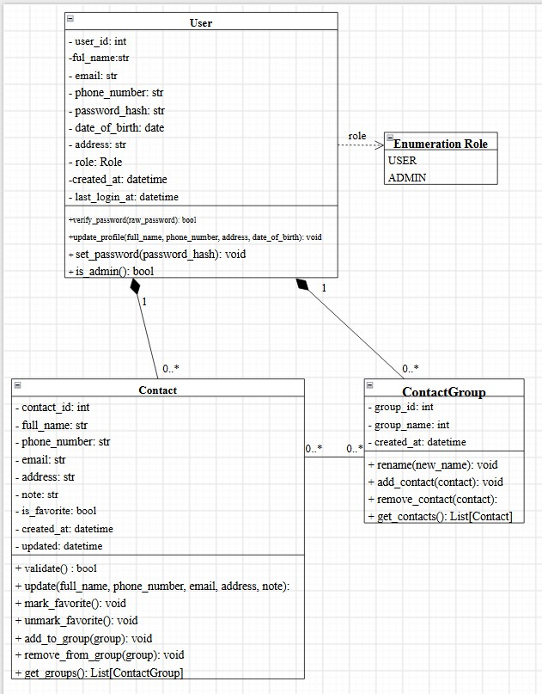

Detailed description of the entity classes Class User
Represents a login account for the system, shared by regular users (USER) and administrators (ADMIN). It supports the use cases Register Account, Login, Update Profile, Reset Password and the user-administration use cases.

Attribute | Data type | Description
user_id | int | User identifier
full_name | str | Full name
email | str | Email address, unique, used as the login name
phone_number | str | Phone number
password_hash | str | Hashed password; the plain password is never stored
date_of_birth | date | Date of birth
address | str | Address
role | Role | Role: USER or ADMIN
created_at | datetime | Time the account was created
last_login_at | datetime | Time of the most recent login (helps identify inactive accounts)

Method | Description
verify_password(raw_password): bool | Compare the entered password with the stored hash
update_profile(full_name, phone_number, address, date_of_birth): void | Update the profile; the login email cannot be changed
set_password(password_hash): void | Set a new (already hashed) password,  e.g. a temporary password
is_admin(): bool | Check whether the user has the administrator role

Class Contact
Represents one contact in a user's personal phone book. It supports the use cases Add, View, Update and Delete Contact, Mark/Unmark Favorite, Search Contacts and Sort Contacts.

Attribute | Data type | Description
contact_id | int | Contact identifier
full_name | str | Contact full name
phone_number | str | Phone number

email | str | Contact email address
address | str | Address
note | str | Note (optional)
is_favorite | bool | Favorite flag
created_at | datetime | Creation time, used to sort by creation date
updated_at | datetime | Time of the most recent update

Method | Description
validate(): bool | Validate the format of name, phone number and email
update(full_name, phone_number, email, address, note): void | Update the contact details
mark_favorite(): void | Mark the contact as a favorite
unmark_favorite(): void | Remove the favorite mark
add_to_group(group): void | Add the contact to a group
remove_from_group(group): void | Remove the contact from a group without deleting it
get_groups(): List[ContactGroup] | Get the groups the contact belongs to

Class ContactGroup
Represents a group (category) of contacts created by a user. It supports the use cases Create, Edit and Delete Category, Assign/Remove Contact to/from Group and Filter Contacts by Category.

Attribute | Data type | Description
group_id | int | Group identifier
group_name | str | Group name (unique per user)
created_at | datetime | Time the group was created

Method | Description
rename(new_name): void | Rename the group
add_contact(contact): void | Add a contact to the group; ignored if already a member

remove_contact(contact): void | Remove a contact from the group
get_contacts(): List[Contact] | Get the contacts in the group

Value | Meaning
USER | A logged-in user who manages their own phone book and profile
ADMIN | An administrator who manages users and views system-wide statistics

Relationships between classes

From class | To class | Relationship | Mult. (from) | Mult. (to) | Meaning
User | Contact | Composition | 1 | 0..* | Each contact belongs to exactly one user; deleting a user deletes all of their contacts.
User | ContactGroup | Composition | 1 | 0..* | Each group belongs to exactly one user; a group is visible only to its owner.
Contact | ContactGroup | Association | 0..* | 0..* | Many-to-many: a contact can be in several groups and a group holds several contacts. Implemented by the junction table contact_group_members.
Note: the class User depends on the enumeration Role through its role attribute.

Processing layer class diagram

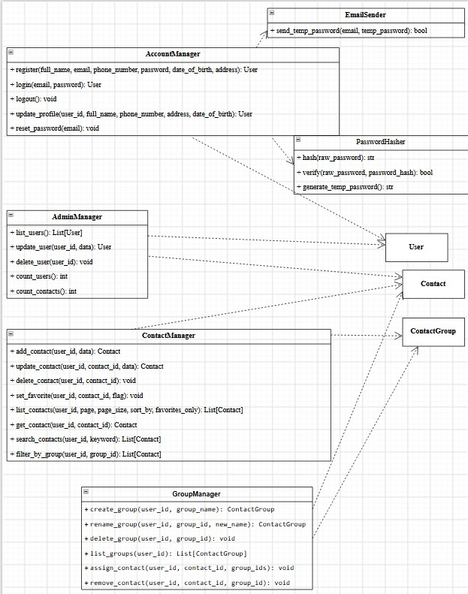

Detailed description of the processing classes
The processing classes receive operations from the interface, validate data, check ownership (every operation on contacts and groups takes the user_id of the logged-in user) and then read or write the database within a transaction.

Class AccountManager
DFD process: 1.0 Manage Accounts

Method | Description
register(full_name, email, phone_number, password, date_of_birth, address): User | Register an account: validate input, check email duplication, hash the password
login(email, password): User | Log in and return the user together with the role
logout(): void | End the current session
update_profile(user_id, full_name, phone_number, address, date_of_birth): User | Update the personal profile
reset_password(email): void | Generate a temporary password, store its hash and send it by email

Class ContactManager
DFD process: 2.0 Manage Contacts, 3.0 Search & View Contacts

Method | Description
add_contact(user_id, data): Contact | Add a contact to the user's phone book
update_contact(user_id, contact_id, data): Contact | Edit contact details
delete_contact(user_id, contact_id): void | Permanently delete a contact after the user confirms
set_favorite(user_id, contact_id, flag): void | Mark or unmark a contact as favorite
list_contacts(user_id, page, page_size, sort_by, favorites_only): List[Contact] | Paginated list, sorted A-Z, Z-A or by creation date
get_contact(user_id, contact_id): Contact | View the details of one contact
search_contacts(user_id, keyword): List[Contact] | Search by part of a name or phone number
filter_by_group(user_id, group_id): List[Contact] | Filter contacts by group

Class GroupManager

DFD process: 4.0 Manage Groups

Method | Description
create_group(user_id, group_name): ContactGroup | Create a group; the name must be non-empty and unique
rename_group(user_id, group_id, new_name): ContactGroup | Rename a group
delete_group(user_id, group_id): void | Delete a group and its links, keeping the contacts
list_groups(user_id): List[ContactGroup] | List the user's groups
assign_contact(user_id, contact_id, group_ids): void | Assign a contact to one or more groups
remove_contact(user_id, contact_id, group_id): void | Remove a contact from a group

Class AdminManager
DFD process: 5.0 Manage Users, 6.0 Monitor System Data

Method | Description
list_users(): List[User] | View the list of all users
update_user(user_id, data): User | Update user details
delete_user(user_id): void | Delete an inactive or violating account
count_users(): int | Total number of users in the system
count_contacts(): int | Total number of contacts stored in the system

Class PasswordHasher DFD process: Supports 1.0
Method | Description
hash(raw_password): str | Hash a password with a modern algorithm (e.g. bcrypt)
verify(raw_password, password_hash): bool | Compare a password with its hash

generate_temp_password(): str | Generate a random temporary password

Class EmailSender
DFD process: Supports 1.0

Method | Description
send_temp_password(email, temp_password): bool | Send the temporary password to the registered email

Data Model
  - Mapping between the DFD, classes and database tables

DFD data store | Class | MySQL table | Note
D1 Users | User | users | Accounts and roles
D2 Contacts | Contact | contacts | Each user's contacts
D3 Groups | ContactGroup | contact_groups, contact_group_members | Groups and the links between contacts and groups
The many-to-many relationship between Contact and ContactGroup is implemented by the junction table contact_group_members, which belongs to the data store D3 Groups.

Entity relationship diagram (ERD)
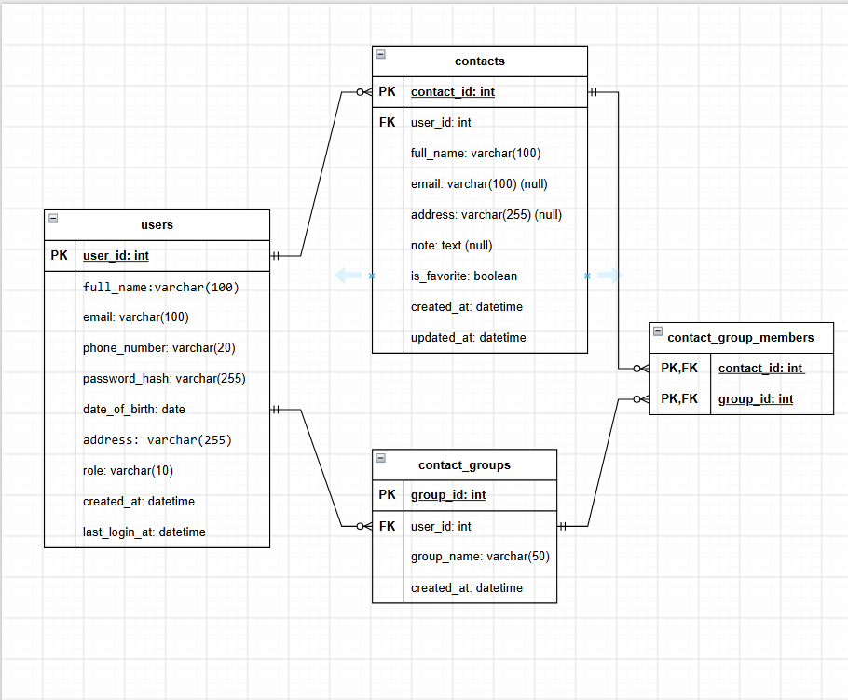

Table specifications
The database management system is MySQL. Tables use the InnoDB engine to support transactions and foreign keys, and the utf8mb4 character set to store Vietnamese text.

Table users
DFD data store: D1 Users. Stores user and administrator accounts.

Column | Data type | Ke y | Constraints | Descriptio n
user_id | INT | PK | PRIMARY KEY; AUTO_INCREMENT | Primary key, auto-increment
full_name | VARCHAR(100  ) |  | NOT NULL | Full name
email | VARCHAR(100  ) |  | NOT NULL; UNIQUE | Email, used as the login name
phone_number | VARCHAR(20) |  | NOT NULL | Phone number
password_has h | VARCHAR(255  ) |  | NOT NULL | Hashed password
date_of_birth | DATE |  | NOT NULL | Date of birth
address | VARCHAR(255  ) |  | NOT NULL | Address
role | VARCHAR(10) |  | NOT NULL; DEFAULT 'USER'; CHECK (role IN ('USER','ADMIN')) | Role
created_at | DATETIME |  | NOT NULL; DEFAULT CURRENT_TIMESTAM P | Time the account was created
last_login_at | DATETIME |  | NULL | Most recent login time

Table contacts
DFD data store: D2 Contacts. Stores each contact in a user's personal phone book.

Column | Data type | Key | Constraints | Description
contact_id | INT | PK | PRIMARY KEY; AUTO_INCREMENT | Primary key, auto-increment

user_id | INT | FK | NOT NULL; FK →  users(user_id) ON DELETE CASCADE | Owner of the contact
full_name | VARCHAR(100) |  | NOT NULL | Contact full name
phone_number | VARCHAR(20) |  | NOT NULL | Phone number
email | VARCHAR(100) |  | NULL | Contact email address
address | VARCHAR(255) |  | NULL | Address
note | TEXT |  | NULL | Note (optional)
is_favorite | BOOLEAN |  | NOT NULL; DEFAULT FALSE | Favorite flag
created_at | DATETIME |  | NOT NULL; DEFAULT CURRENT_TIMESTAMP | Creation time
updated_at | DATETIME |  | NOT NULL; DEFAULT CURRENT_TIMESTAMP | Time of the most recent update

Table contact_groups
DFD data store: D3 Groups. Stores the groups (categories) created by users, e.g. Family, Friends, Work.

Column | Data type | Key | Constraints | Description
group_id | INT | PK | PRIMARY KEY; AUTO_INCREMENT | Primary key, auto-increment
user_id | INT | FK | NOT NULL; FK →  users(user_id) ON DELETE CASCADE | User who created the group
group_name | VARCHAR(50) |  | NOT NULL | Group name
created_at | DATETIME |  | NOT NULL; DEFAULT CURRENT_TIMESTAMP | Creation time
Additional unique constraint: (user_id, group_name).

Table contact_group_members
DFD data store: D3 Groups. Junction table of the many-to-many relationship between contacts and groups.

Column | Data type | Key | Constraints | Description
contact_id | INT | PK, FK | PRIMARY KEY; FK →  contacts(contact_id) ON DELETE CASCADE | Part 1 of the primary key, references the contact
group_id | INT | PK, FK | PRIMARY KEY; FK →  contact_groups(group_id) ON DELETE CASCADE | Part 2 of the primary key, references the group

Indexes
Primary keys and UNIQUE constraints are indexed automatically. The additional indexes support the performance requirements (search results within 0.5 seconds for 10,000 records, up to 50,000 contacts per account):

Index name | Table | Columns | Purpose
idx_contacts_user_name | contacts | (user_id, full_name) | Listing, sorting A-Z / Z-A  and searching by name within one user's contacts
idx_contacts_user_phone | contacts | (user_id, phone_number) | Searching by phone number
idx_contacts_user_created | contacts | (user_id, created_at) | Sorting by creation date
idx_contacts_user_fav | contacts | (user_id, is_favorite) | Viewing the favorites list

idx_members_group | contact_group_members | (group_id) | Filtering contacts by group

Integrity constraints and business rules
Data isolation: every query on contacts and contact_groups filters by the user_id of the logged-in user, so a user cannot access another account's data.
Cascading deletes: deleting a user deletes all of their contacts and groups; deleting a contact deletes its group links; deleting a group removes only the links and keeps the contacts.
The contact and the group in one row of contact_group_members must belong to the same user. MySQL cannot enforce a cross-table rule with CHECK, so the application layer (GroupManager.assign_contact) verifies it, or a trigger can be used if needed.
A group name must be non-empty and unique within one user (UNIQUE user_id, group_name).
Transactions: each add, update or delete runs in one transaction and is rolled back on error to keep the old data, meeting the atomicity requirement under Reliability.
Passwords: the column password_hash stores only a hash (e.g. bcrypt); the temporary password used for recovery is also hashed before it is stored.
The contact list is paginated with LIMIT/OFFSET and sorted with ORDER BY full_name (A-Z, Z-A) or created_at.
Administrator statistics: the number of users is SELECT COUNT(*) FROM users and the number of contacts is SELECT COUNT(*) FROM contacts.

