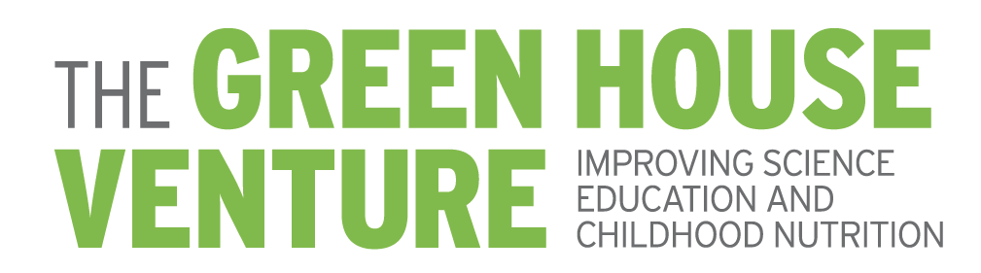

Board of Directors
Thomas Purcell
President

Peter Benoist
Vice President

December 13th, 2025

Bernard Purcell
13900 Clayton Road
Town and Country, MO 63017

Dear Bernard,

I am writing to express my personal appreciation for your recent gift to The Green House Venture.

Your gift of $112,000 will help the Venture to continue moving forward to realize its dream of lifting the community through much-needed agricultural science education at the elementary school level, as well as promoting healthy choices in nutrition.

Thank you for your generous support.

Sincerely,
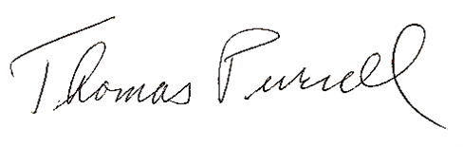
Thomas Purcell
President

The Green House Venture is an exempt organization as described in Section 501(c) of the Internal Revenue Code. As such, your donation is 100% tax deductible.
Please consult your tax advisor if you have any questions.

