Auto-generated report from BCEAweb
Version: 21 December, 2024

Economic Analysis
This section contains a summary of the economic evaluation.

Cost-effectiveness analysis
This sub-section presents a summary table reporting basic economic results as well as the optimal decision, given the selected willingness-to-pay threshold $k=25000$.
Cost-effectiveness analysis summary
Reference intervention: Intervention1
Comparator intervention(s): Intervention2
: Intervention3
: Intervention4
Optimal decision: choose Intervention1 for k < 200
Intervention2 for 200 <= k < 300
Intervention4 for k >= 300
Analysis for willingness to pay parameter k = 25000
Expected net benefit
Intervention1 10263
Intervention2 17423
Intervention3 22289
Intervention4 28182
EIB CEAC ICER
Intervention1 vs Intervention2 -7160.3 0.056 158.66
Intervention1 vs Intervention3 -12026.5 0.006 195.77
Intervention1 vs Intervention4 -17919.7 0.000 198.33
Optimal intervention (max expected net benefit) for k = 25000: Intervention4
EVPI 1545.1

Cost-effectiveness plane
The following graph shows the cost-effectiveness plane. This presents the joint distribution of the population average benefit and cost differential, $\left(Δ_{e},Δ_{c}\right)$.
Each point in the graph represents a ‘potential future’ in terms of expected incremental economic outcomes. The shaded portion of the plane is the ‘sustainability area’. The more points lay in the sustainability area, the more likely that the reference intervention will turn out to be cost-effective, at a given willingness to pay threshold, $k$ (in this case selected at $k=$ 25000)
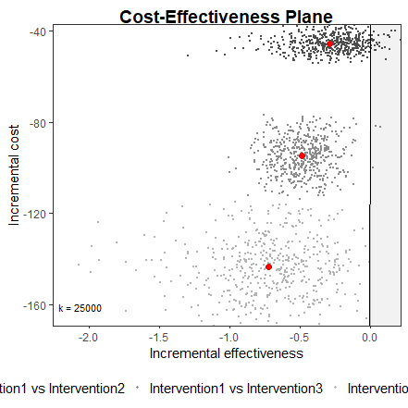

Probabilistic Sensitivity Analysis
This section presents the results of Probabilistic Sensitivity Analysis (PSA). PSA is used to assess the impact of parameter uncertainty on the decision-making process.
## Called from: eval(expr, envir, enclos)

Cost-effectiveness acceptability curve
The following graph shows the cost-effectiveness acceptability curve (CEAC). The CEAC represents the proportion of ‘potential futures’ in which the reference intervention is estimated to be more cost-effective than the comparator. Thus, it can be interpreted as the ‘probability of cost-effectiveness’.
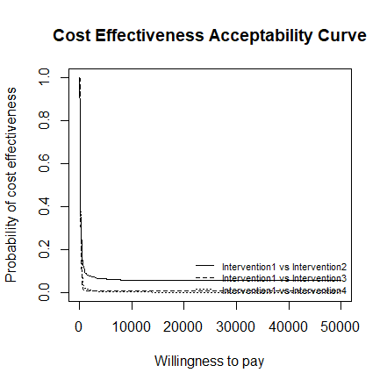

Cost-effectiveness acceptability frontier
