Auto-generated report from BCEAweb

Version: 02 January, 2025

# Distributional assumptions

This sections presents graphical and tabular summaries to check the distributional assumptions used for the parameters included in the economic model. For each parameter, a histogram of the distribution is presented together with a summary table, reporting some relevant statistics.

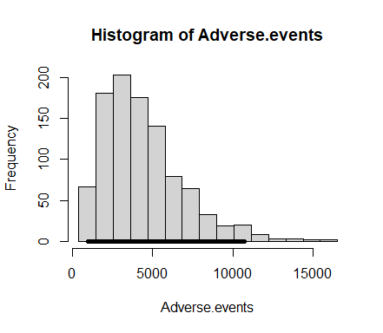

| Mean | Standard deviation | 2.5% | Median | 97.5% | Monte Carlo SE |
| --- | --- | --- | --- | --- | --- |
| 4384.479 | 2518.102 | 969.425 | 3874.5 | 10740.8 | 79.58956 |

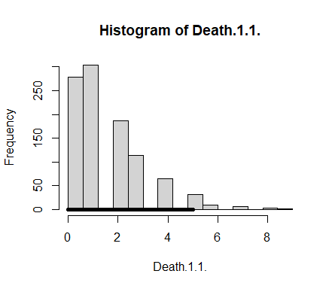

| Mean | Standard deviation | 2.5% | Median | 97.5% | Monte Carlo SE |
| --- | --- | --- | --- | --- | --- |
| 1.573 | 1.539169 | 0 | 1 | 5 | 0.0486484 |

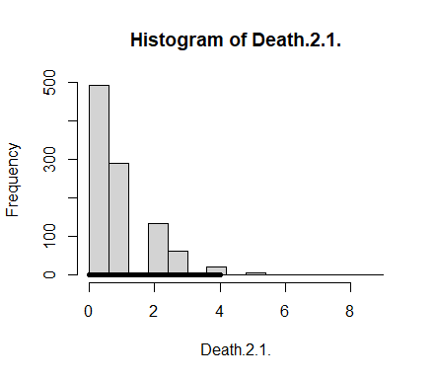

| Mean | Standard deviation | 2.5% | Median | 97.5% | Monte Carlo SE |
| --- | --- | --- | --- | --- | --- |
| 0.85 | 1.083824 | 0 | 1 | 4 | 0.0342564 |

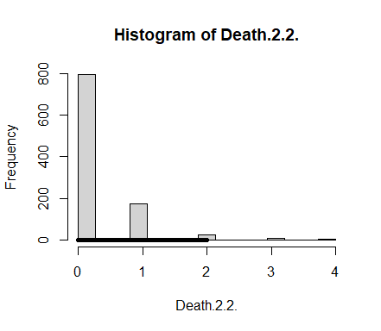

| Mean | Standard deviation | 2.5% | Median | 97.5% | Monte Carlo SE |
| --- | --- | --- | --- | --- | --- |
| 0.248 | 0.5447869 | 0 | 0 | 2 | 0.0172191 |

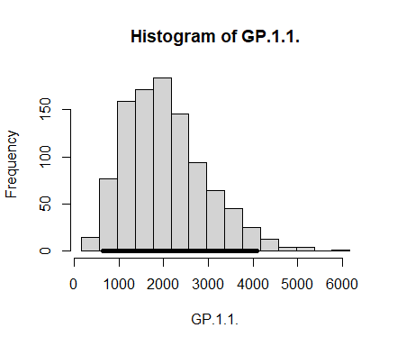

| Mean | Standard deviation | 2.5% | Median | 97.5% | Monte Carlo SE |
| --- | --- | --- | --- | --- | --- |
| 2045.987 | 896.964 | 654.925 | 1938.5 | 4092.15 | 28.35031 |

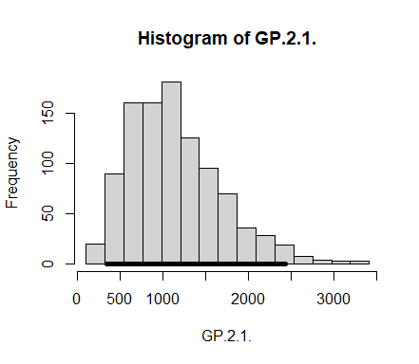

| Mean | Standard deviation | 2.5% | Median | 97.5% | Monte Carlo SE |
| --- | --- | --- | --- | --- | --- |
| 1148.308 | 543.1979 | 340.925 | 1083 | 2435.475 | 17.16883 |

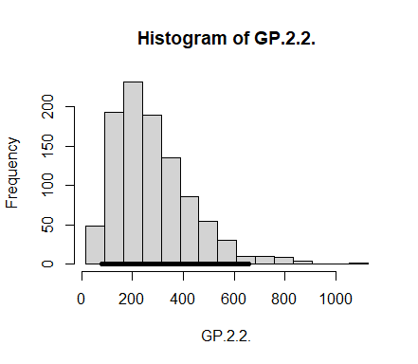

| Mean | Standard deviation | 2.5% | Median | 97.5% | Monte Carlo SE |
| --- | --- | --- | --- | --- | --- |
| 279.658 | 151.5797 | 78 | 249.5 | 658.325 | 4.790975 |

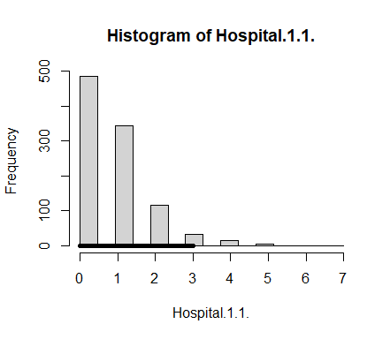

| Mean | Standard deviation | 2.5% | Median | 97.5% | Monte Carlo SE |
| --- | --- | --- | --- | --- | --- |
| 0.764 | 0.9587613 | 0 | 1 | 3 | 0.0303035 |

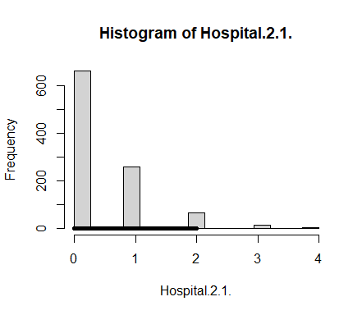

| Mean | Standard deviation | 2.5% | Median | 97.5% | Monte Carlo SE |
| --- | --- | --- | --- | --- | --- |
| 0.438 | 0.6975978 | 0 | 0 | 2 | 0.0220489 |

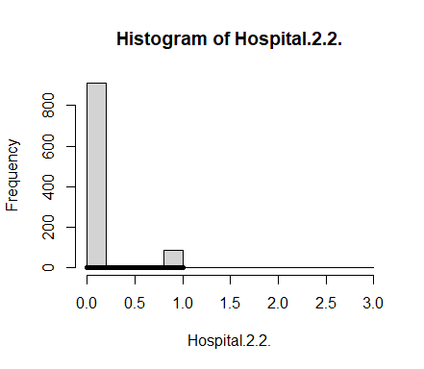

| Mean | Standard deviation | 2.5% | Median | 97.5% | Monte Carlo SE |
| --- | --- | --- | --- | --- | --- |
| 0.091 | 0.3013467 | 0 | 0 | 1 | 0.0095247 |

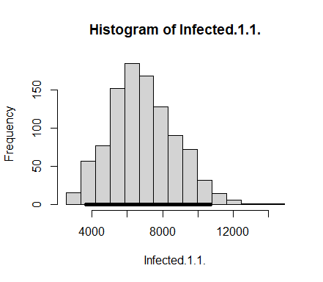

| Mean | Standard deviation | 2.5% | Median | 97.5% | Monte Carlo SE |
| --- | --- | --- | --- | --- | --- |
| 6904.96 | 1850.256 | 3667.9 | 6763 | 10724.17 | 58.48097 |

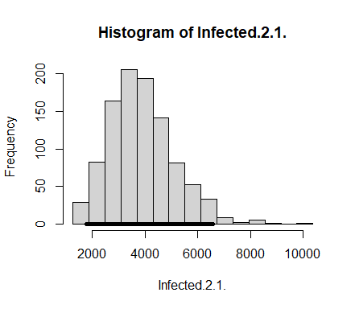

| Mean | Standard deviation | 2.5% | Median | 97.5% | Monte Carlo SE |
| --- | --- | --- | --- | --- | --- |
| 3874.547 | 1236.974 | 1789.575 | 3744 | 6573.125 | 39.097 |

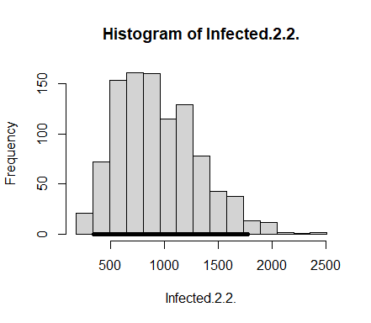

| Mean | Standard deviation | 2.5% | Median | 97.5% | Monte Carlo SE |
| --- | --- | --- | --- | --- | --- |
| 944.874 | 378.7866 | 348.875 | 895 | 1772.5 | 11.97229 |

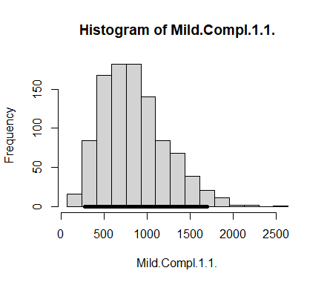

| Mean | Standard deviation | 2.5% | Median | 97.5% | Monte Carlo SE |
| --- | --- | --- | --- | --- | --- |
| 847.747 | 374.6328 | 277.9 | 800 | 1699.1 | 11.841 |

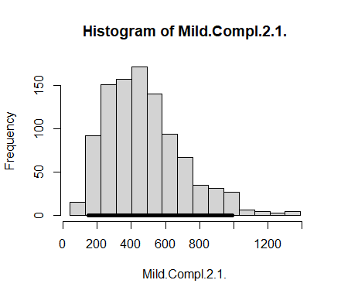

| Mean | Standard deviation | 2.5% | Median | 97.5% | Monte Carlo SE |
| --- | --- | --- | --- | --- | --- |
| 476.486 | 225.2089 | 149.875 | 446 | 993.075 | 7.118168 |

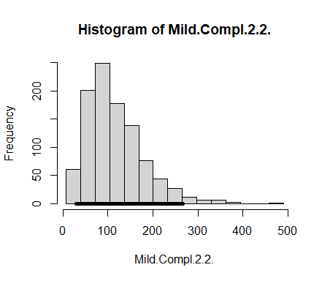

| Mean | Standard deviation | 2.5% | Median | 97.5% | Monte Carlo SE |
| --- | --- | --- | --- | --- | --- |
| 115.59 | 63.15335 | 29 | 102 | 267.05 | 1.996086 |

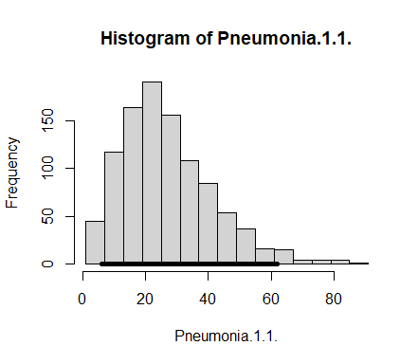

| Mean | Standard deviation | 2.5% | Median | 97.5% | Monte Carlo SE |
| --- | --- | --- | --- | --- | --- |
| 27.438 | 14.51919 | 6 | 25 | 62.025 | 0.4589076 |

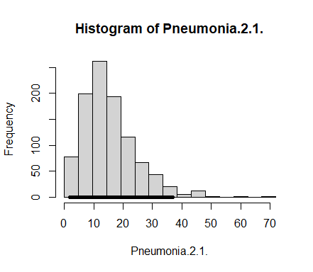

| Mean | Standard deviation | 2.5% | Median | 97.5% | Monte Carlo SE |
| --- | --- | --- | --- | --- | --- |
| 15.353 | 9.095555 | 2 | 14 | 37 | 0.2874829 |

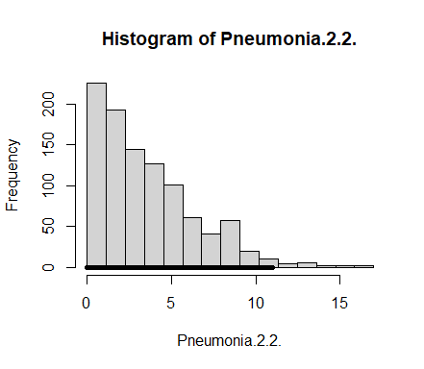

| Mean | Standard deviation | 2.5% | Median | 97.5% | Monte Carlo SE |
| --- | --- | --- | --- | --- | --- |
| 3.672 | 2.859824 | 0 | 3 | 11 | 0.0903904 |

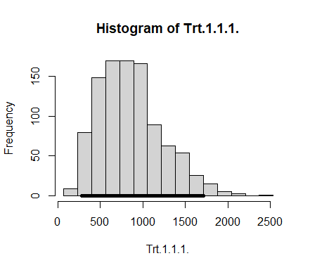

| Mean | Standard deviation | 2.5% | Median | 97.5% | Monte Carlo SE |
| --- | --- | --- | --- | --- | --- |
| 859.031 | 375.9444 | 281 | 816 | 1710.025 | 11.88246 |

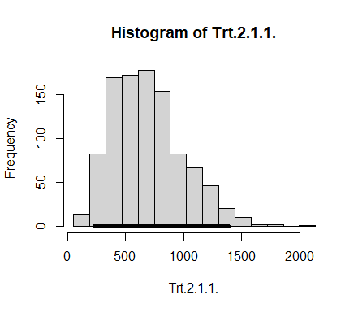

| Mean | Standard deviation | 2.5% | Median | 97.5% | Monte Carlo SE |
| --- | --- | --- | --- | --- | --- |
| 689.768 | 303.9169 | 228.875 | 653 | 1384.2 | 9.605891 |

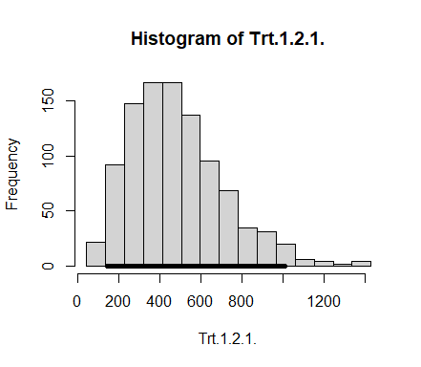

| Mean | Standard deviation | 2.5% | Median | 97.5% | Monte Carlo SE |
| --- | --- | --- | --- | --- | --- |
| 481.877 | 227.604 | 143 | 455 | 1009.075 | 7.19387 |

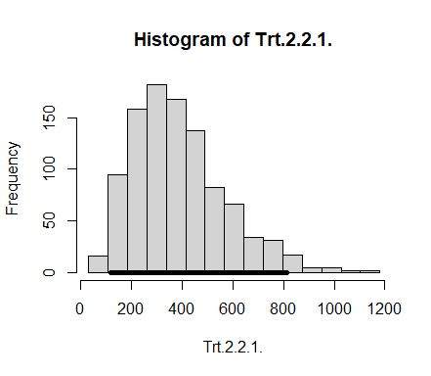

| Mean | Standard deviation | 2.5% | Median | 97.5% | Monte Carlo SE |
| --- | --- | --- | --- | --- | --- |
| 388.103 | 183.2891 | 118.975 | 364 | 811.05 | 5.793213 |

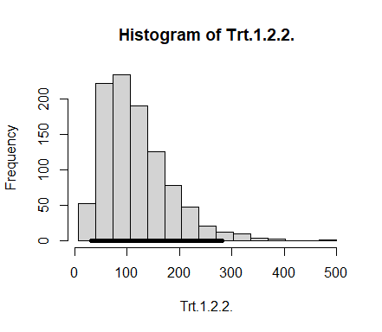

| Mean | Standard deviation | 2.5% | Median | 97.5% | Monte Carlo SE |
| --- | --- | --- | --- | --- | --- |
| 117.33 | 64.61155 | 30.975 | 105 | 281.025 | 2.042175 |

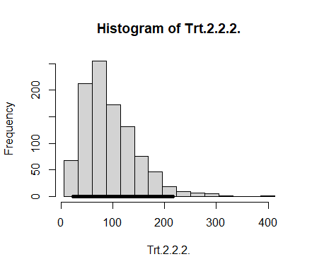

| Mean | Standard deviation | 2.5% | Median | 97.5% | Monte Carlo SE |
| --- | --- | --- | --- | --- | --- |
| 94.158 | 51.4585 | 22.975 | 83 | 216 | 1.626447 |

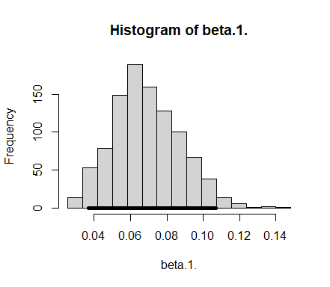

| Mean | Standard deviation | 2.5% | Median | 97.5% | Monte Carlo SE |
| --- | --- | --- | --- | --- | --- |
| 0.0690728 | 0.0185195 | 0.0367975 | 0.0676216 | 0.1069079 | 0.0005853 |

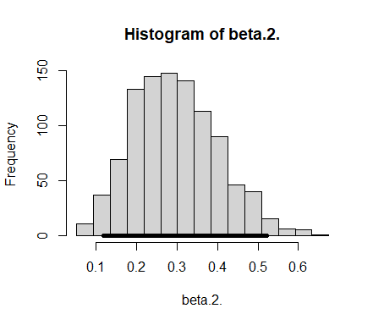

| Mean | Standard deviation | 2.5% | Median | 97.5% | Monte Carlo SE |
| --- | --- | --- | --- | --- | --- |
| 0.2971902 | 0.1047984 | 0.1196443 | 0.2898017 | 0.5211321 | 0.0033124 |

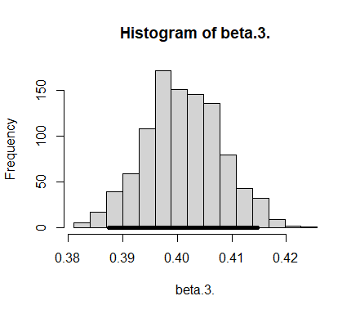

| Mean | Standard deviation | 2.5% | Median | 97.5% | Monte Carlo SE |
| --- | --- | --- | --- | --- | --- |
| 0.4010433 | 0.00703 | 0.3875232 | 0.4009802 | 0.4147382 | 0.0002222 |

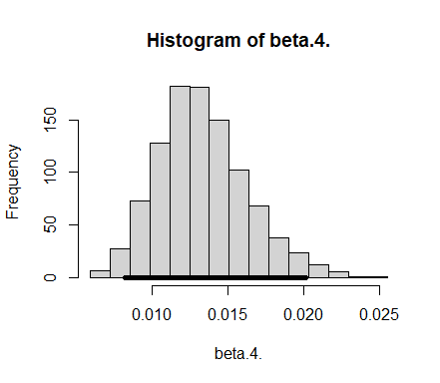

| Mean | Standard deviation | 2.5% | Median | 97.5% | Monte Carlo SE |
| --- | --- | --- | --- | --- | --- |
| 0.013347 | 0.0029279 | 0.0082679 | 0.0130898 | 0.020119 | 9.25e-05 |

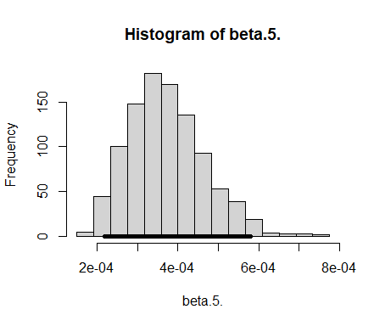

| Mean | Standard deviation | 2.5% | Median | 97.5% | Monte Carlo SE |
| --- | --- | --- | --- | --- | --- |
| 0.0003727 | 9.44e-05 | 0.0002194 | 0.0003636 | 0.0005799 | 3e-06 |

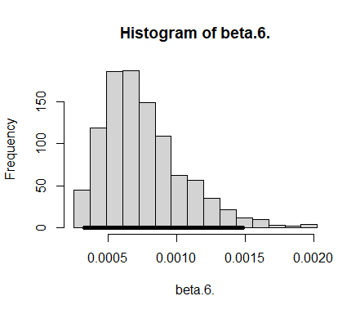

| Mean | Standard deviation | 2.5% | Median | 97.5% | Monte Carlo SE |
| --- | --- | --- | --- | --- | --- |
| 0.0007564 | 0.0002967 | 0.0003294 | 0.0007006 | 0.0014815 | 9.4e-06 |

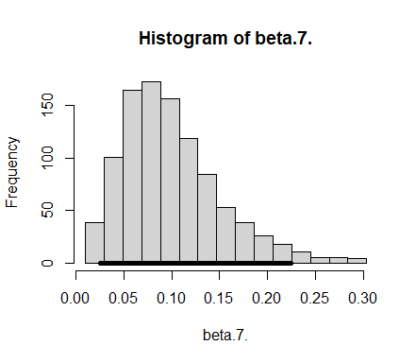

| Mean | Standard deviation | 2.5% | Median | 97.5% | Monte Carlo SE |
| --- | --- | --- | --- | --- | --- |
| 0.0997926 | 0.051201 | 0.0260358 | 0.0906289 | 0.2241951 | 0.0016183 |

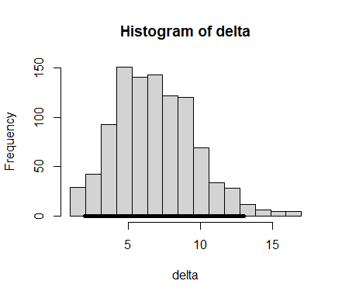

| Mean | Standard deviation | 2.5% | Median | 97.5% | Monte Carlo SE |
| --- | --- | --- | --- | --- | --- |
| 7.004 | 2.643667 | 2 | 7 | 13 | 0.0835583 |

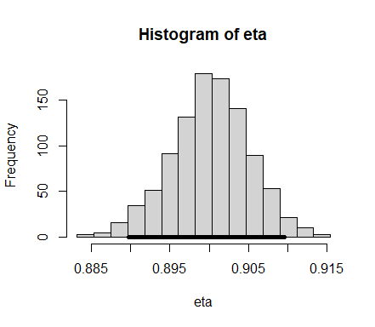

| Mean | Standard deviation | 2.5% | Median | 97.5% | Monte Carlo SE |
| --- | --- | --- | --- | --- | --- |
| 0.9001309 | 0.0050356 | 0.8897217 | 0.9002975 | 0.9096117 | 0.0001592 |

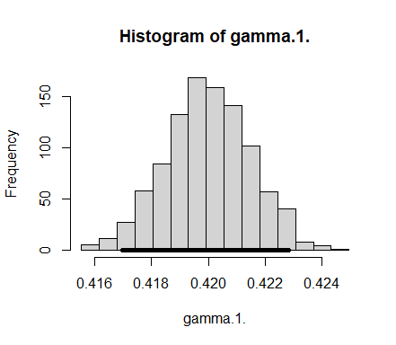

| Mean | Standard deviation | 2.5% | Median | 97.5% | Monte Carlo SE |
| --- | --- | --- | --- | --- | --- |
| 0.4199825 | 0.0014766 | 0.4169795 | 0.4199816 | 0.4228245 | 4.67e-05 |

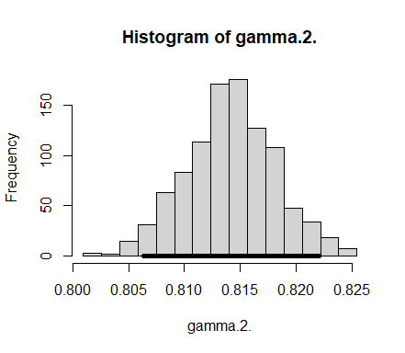

| Mean | Standard deviation | 2.5% | Median | 97.5% | Monte Carlo SE |
| --- | --- | --- | --- | --- | --- |
| 0.8141167 | 0.004001 | 0.8063162 | 0.8141551 | 0.822019 | 0.0001265 |

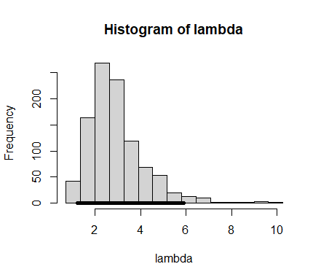

| Mean | Standard deviation | 2.5% | Median | 97.5% | Monte Carlo SE |
| --- | --- | --- | --- | --- | --- |
| 2.905089 | 1.225704 | 1.211919 | 2.681323 | 5.88241 | 0.0387408 |

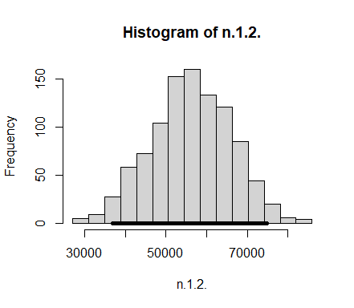

| Mean | Standard deviation | 2.5% | Median | 97.5% | Monte Carlo SE |
| --- | --- | --- | --- | --- | --- |
| 56170.33 | 9860.615 | 36874.55 | 56216.5 | 74843.7 | 311.6641 |

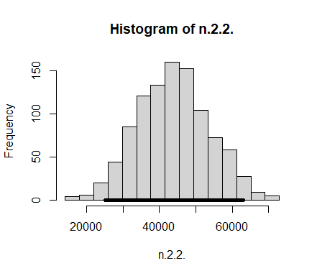

| Mean | Standard deviation | 2.5% | Median | 97.5% | Monte Carlo SE |
| --- | --- | --- | --- | --- | --- |
| 43829.67 | 9860.615 | 25156.3 | 43783.5 | 63125.45 | 311.6641 |

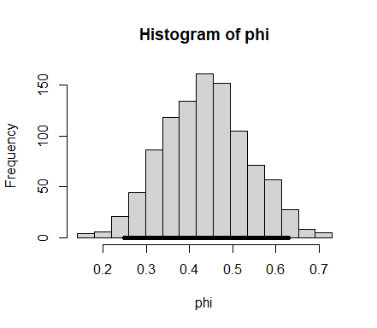

| Mean | Standard deviation | 2.5% | Median | 97.5% | Monte Carlo SE |
| --- | --- | --- | --- | --- | --- |
| 0.4382939 | 0.098694 | 0.2502404 | 0.4381762 | 0.6289504 | 0.0031194 |

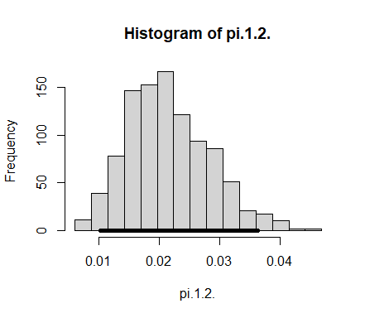

| Mean | Standard deviation | 2.5% | Median | 97.5% | Monte Carlo SE |
| --- | --- | --- | --- | --- | --- |
| 0.0215133 | 0.0068073 | 0.0102327 | 0.0207813 | 0.0362975 | 0.0002152 |

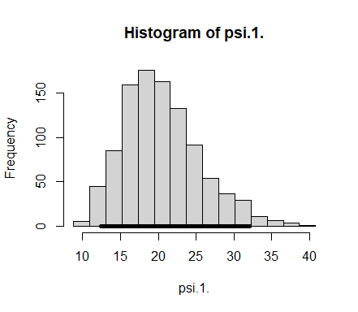

| Mean | Standard deviation | 2.5% | Median | 97.5% | Monte Carlo SE |
| --- | --- | --- | --- | --- | --- |
| 20.50602 | 5.086617 | 12.4331 | 20.01152 | 32.00584 | 0.1607725 |

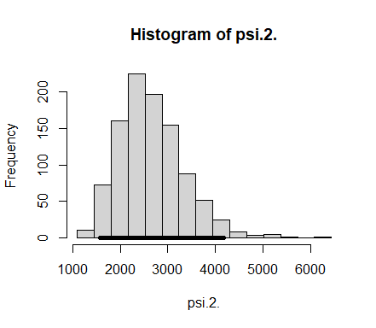

| Mean | Standard deviation | 2.5% | Median | 97.5% | Monte Carlo SE |
| --- | --- | --- | --- | --- | --- |
| 2661.843 | 684.1538 | 1573.676 | 2583.913 | 4181.041 | 21.62402 |

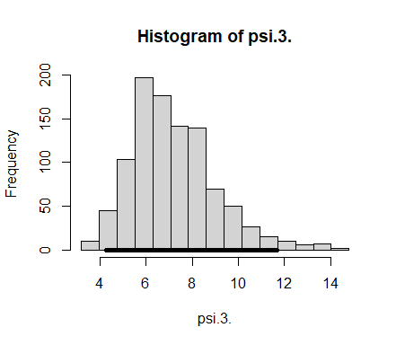

| Mean | Standard deviation | 2.5% | Median | 97.5% | Monte Carlo SE |
| --- | --- | --- | --- | --- | --- |
| 7.199515 | 1.83873 | 4.279942 | 6.90417 | 11.67563 | 0.0581167 |

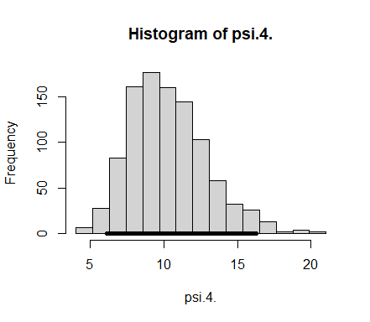

| Mean | Standard deviation | 2.5% | Median | 97.5% | Monte Carlo SE |
| --- | --- | --- | --- | --- | --- |
| 10.29213 | 2.607787 | 6.143624 | 9.955699 | 16.26332 | 0.0824242 |

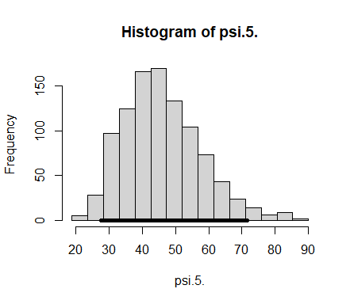

| Mean | Standard deviation | 2.5% | Median | 97.5% | Monte Carlo SE |
| --- | --- | --- | --- | --- | --- |
| 45.91777 | 11.68489 | 27.51898 | 44.53583 | 71.62707 | 0.3693238 |

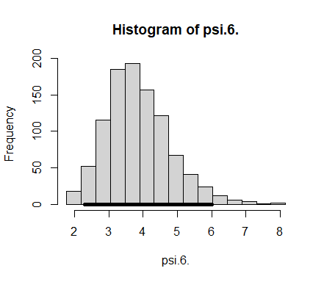

| Mean | Standard deviation | 2.5% | Median | 97.5% | Monte Carlo SE |
| --- | --- | --- | --- | --- | --- |
| 3.854695 | 0.9479262 | 2.292722 | 3.755557 | 6.017339 | 0.0299611 |

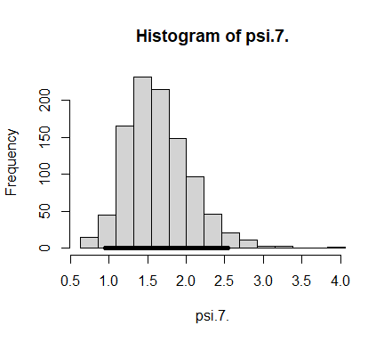

| Mean | Standard deviation | 2.5% | Median | 97.5% | Monte Carlo SE |
| --- | --- | --- | --- | --- | --- |
| 1.635824 | 0.4130969 | 0.9513184 | 1.591567 | 2.543868 | 0.0130567 |

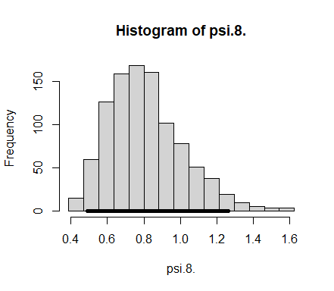

| Mean | Standard deviation | 2.5% | Median | 97.5% | Monte Carlo SE |
| --- | --- | --- | --- | --- | --- |
| 0.8108407 | 0.2026673 | 0.4901607 | 0.7876551 | 1.262942 | 0.0064057 |

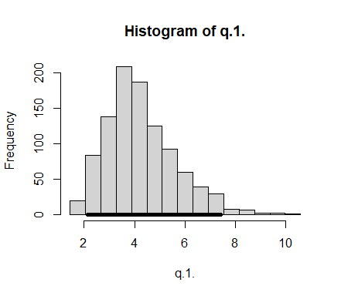

| Mean | Standard deviation | 2.5% | Median | 97.5% | Monte Carlo SE |
| --- | --- | --- | --- | --- | --- |
| 4.245515 | 1.380328 | 2.133401 | 4.020643 | 7.43128 | 0.043628 |

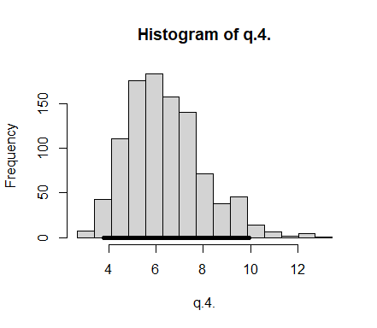

| Mean | Standard deviation | 2.5% | Median | 97.5% | Monte Carlo SE |
| --- | --- | --- | --- | --- | --- |
| 6.414003 | 1.640791 | 3.78795 | 6.185502 | 9.942465 | 0.0518604 |

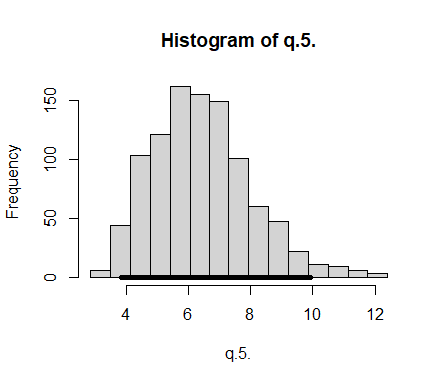

| Mean | Standard deviation | 2.5% | Median | 97.5% | Monte Carlo SE |
| --- | --- | --- | --- | --- | --- |
| 6.42076 | 1.584056 | 3.850581 | 6.285484 | 9.924699 | 0.0500672 |

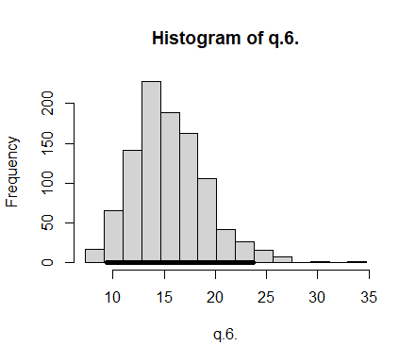

| Mean | Standard deviation | 2.5% | Median | 97.5% | Monte Carlo SE |
| --- | --- | --- | --- | --- | --- |
| 15.48614 | 3.549163 | 9.37079 | 15.09543 | 23.70509 | 0.1121783 |

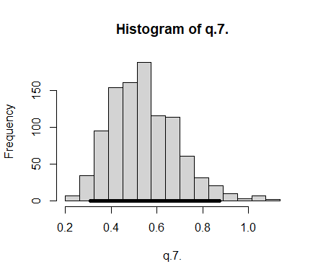

| Mean | Standard deviation | 2.5% | Median | 97.5% | Monte Carlo SE |
| --- | --- | --- | --- | --- | --- |
| 0.5424171 | 0.1463549 | 0.3095674 | 0.528529 | 0.8712211 | 0.0046258 |

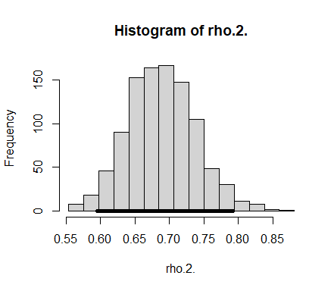

| Mean | Standard deviation | 2.5% | Median | 97.5% | Monte Carlo SE |
| --- | --- | --- | --- | --- | --- |
| 0.6888042 | 0.0496164 | 0.5954323 | 0.6872181 | 0.7924515 | 0.0015682 |

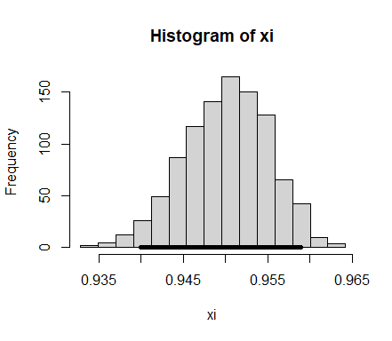

| Mean | Standard deviation | 2.5% | Median | 97.5% | Monte Carlo SE |
| --- | --- | --- | --- | --- | --- |
| 0.9500773 | 0.0049722 | 0.9400008 | 0.9502989 | 0.9588729 | 0.0001572 |