**1.    Lab: HTML Forms and Styling**

**1.1         Login Form Images**

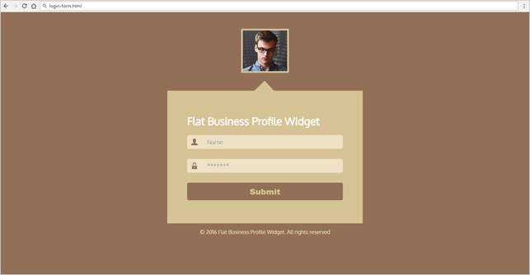

Create files: "**login-form.css**" and "**login-form.html**"

Result:

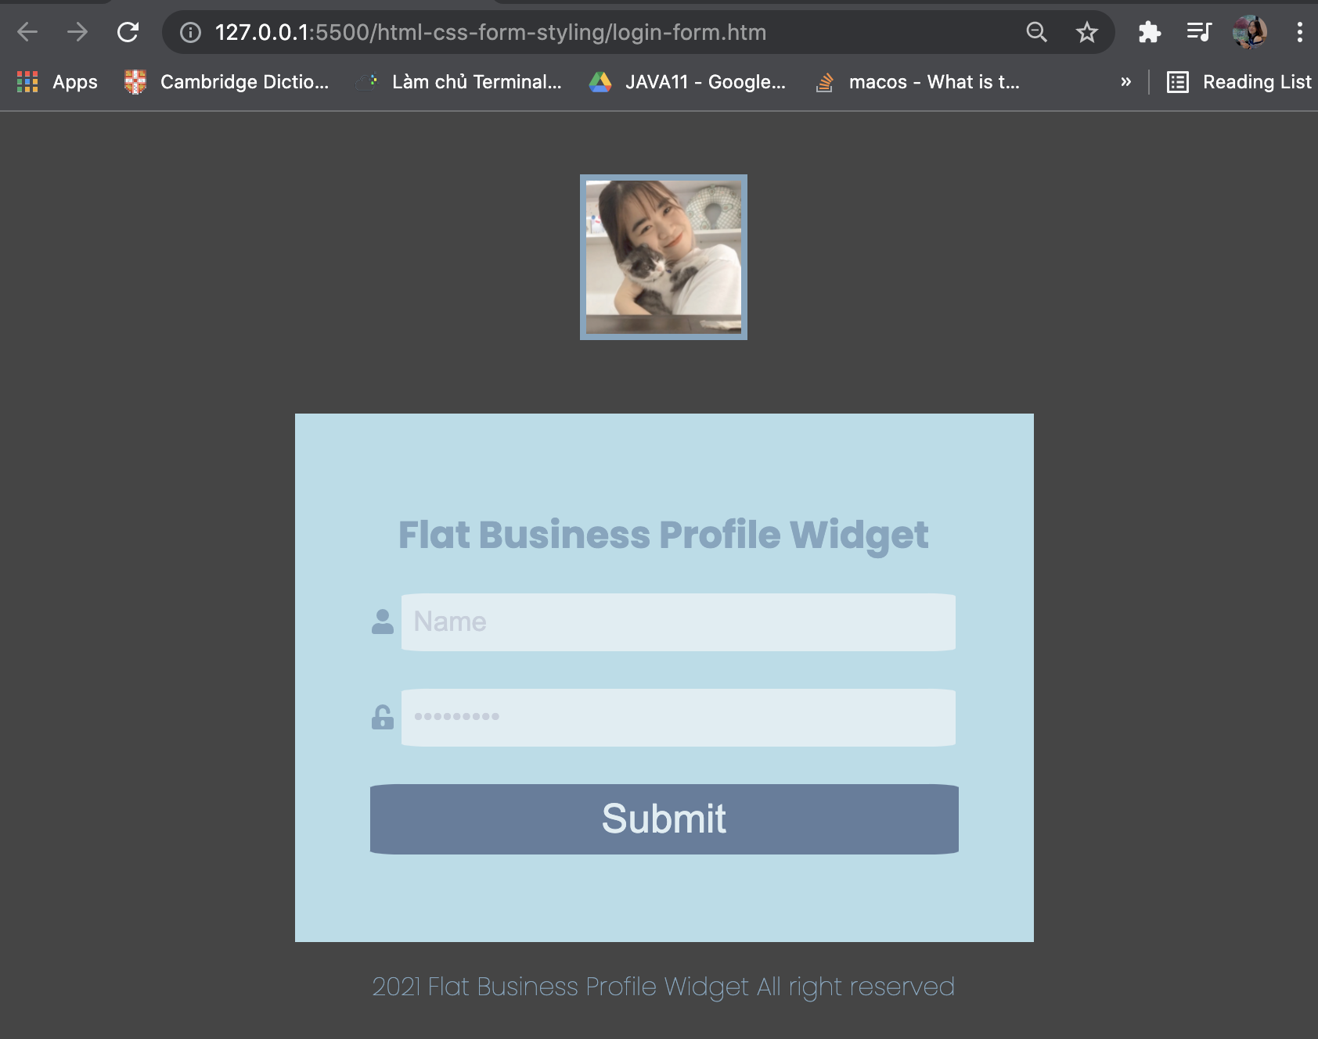

**1.2 Contact Form**

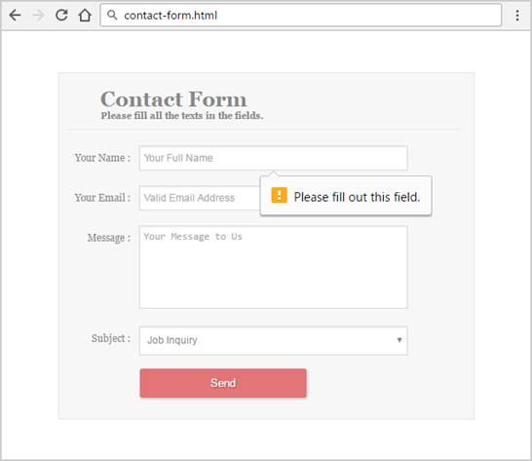

Result:

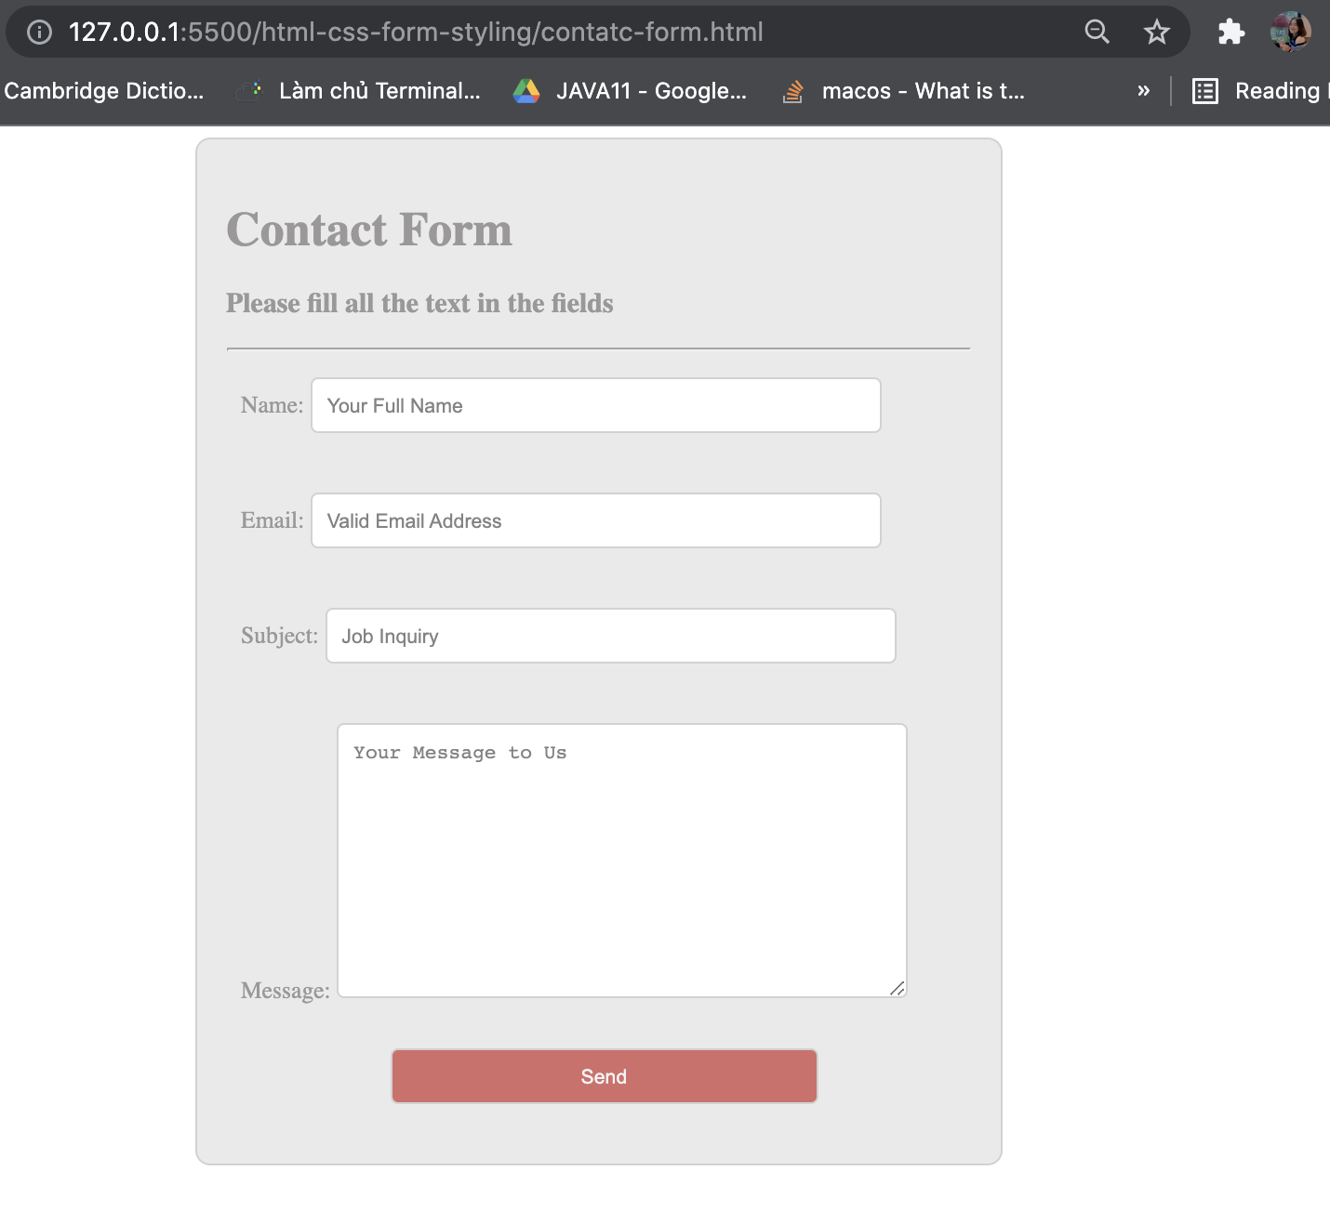

Code:

HTML:

<!DOCTYPE *html*>

<html *lang*="en">

<head>

<meta *charset*="UTF-8" />

<meta *http-equiv*="X-UA-Compatible" *content*="IE=edge" />

<meta *name*="viewport" *content*="width=device-width, initial-scale=1.0" />

<title>Document</title>

<link *rel*="stylesheet" *href*="contact-form.css" />

</head>

<body>

<div *class*="contact-form">

<h1>Contact Form</h1>

<h3>Please fill all the text in the fields</h3>

<hr>

<form *action*="contact-form.php" *method*="post">

<div *class*="form-control">

<label *for*="name">Name: </label>

<input

*type*="text"

*name*="name"

*id*="name"

*placeholder*="Your Full Name"

/>

</div>

<div *class*="form-control">

<label *for*="email">Email: </label>

<input

*type*="email"

*name*="email"

*id*="email"

*placeholder*="Valid Email Address"

/>

</div>

<div *class*="form-control">

<label *for*="subject">Subject: </label>

<input

*type*="text"

*name*="subject"

*id*="subject"

*placeholder*="Job Inquiry"

/>

</div>

<div *class*="form-control">

<label *for*="message">Message: </label>

<textarea

*name*="message"

*id*="message"

*cols*="30"

*rows*="10"

*placeholder*="Your Message to Us"

></textarea>

</div>

<div *class*="form-control">

<input *type*="submit" *name*="submit" *value*="Send"></input>

</div>

</form>

</div>

</body>

</html>

CSS:

*.body* {

background-color: #f2f2f2;

color: lightgray;

font-family: "Open Sans", sans-serif;

font-size: 24px;

}

/* set style for contact-form */

*.contact-form* {

width: 500px;

margin: 0 auto;

padding: 20px;

border: 1px solid #ccc;

border-radius: 10px;

background-color: rgb(231, 231, 231);

justify-content: center;

color: rgb(142, 140, 140);

}

/* set style for form-control */

*.form-control* {

width: 100%;

border-radius: 5px;

padding: 10px;

box-sizing: border-box;

margin-bottom: 10px;

overflow: auto;

}

label {

text-align: center;

}

/* set style for input */

input[*type*="text"],

input[*type*="email"] {

outline: none;

border: 0.5px solid #ccc;

width: 80%;

border-radius: 5px;

padding: 10px;

box-sizing: border-box;

margin-bottom: 10px;

overflow: auto;

}

textarea {

outline: none;

border: 0.5px solid #ccc;

width: 80%;

border-radius: 5px;

padding: 10px;

box-sizing: border-box;

overflow: auto;

}

input[*type*="submit"] {

outline: none;

border: 0.5px solid #ccc;

width: 60%;

border-radius: 5px;

text-align: center;

padding: 10px;

margin-left: 100px;

background-color: rgb(203, 91, 91);

color: #f2f2f2;

}