**HTML and CSS Overview**

**1.    Welcome to HTML**

Create a Web Page like the following.

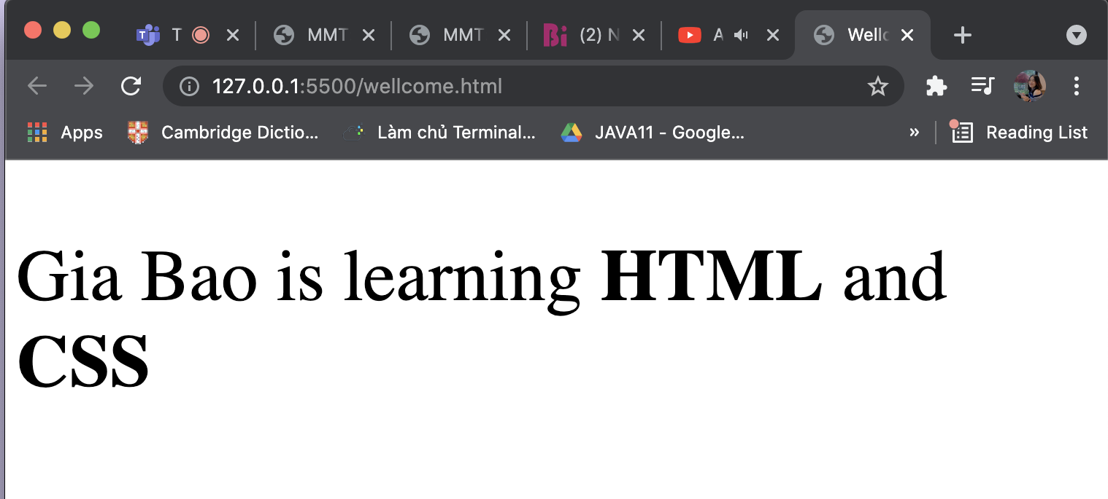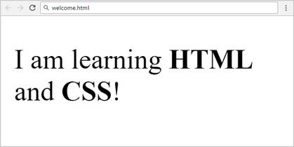

Create "**welcome.html**"

**Constraints**

·         **Title: Welcome**

·        **<strong>** tag for **bold** text

·        **<p>**tag for paragraph

Code:

<!DOCTYPE *html*>

<html *lang*="en">

<head>

<title>Wellcome</title>

</head>

<body>

<p *style*="font-size: 50px">

Gia Bao is learning <strong>HTML</strong> and <strong>CSS</strong>

</p>

</body>

</html>

**2.    Fruits**

Create a Web Page like the following.

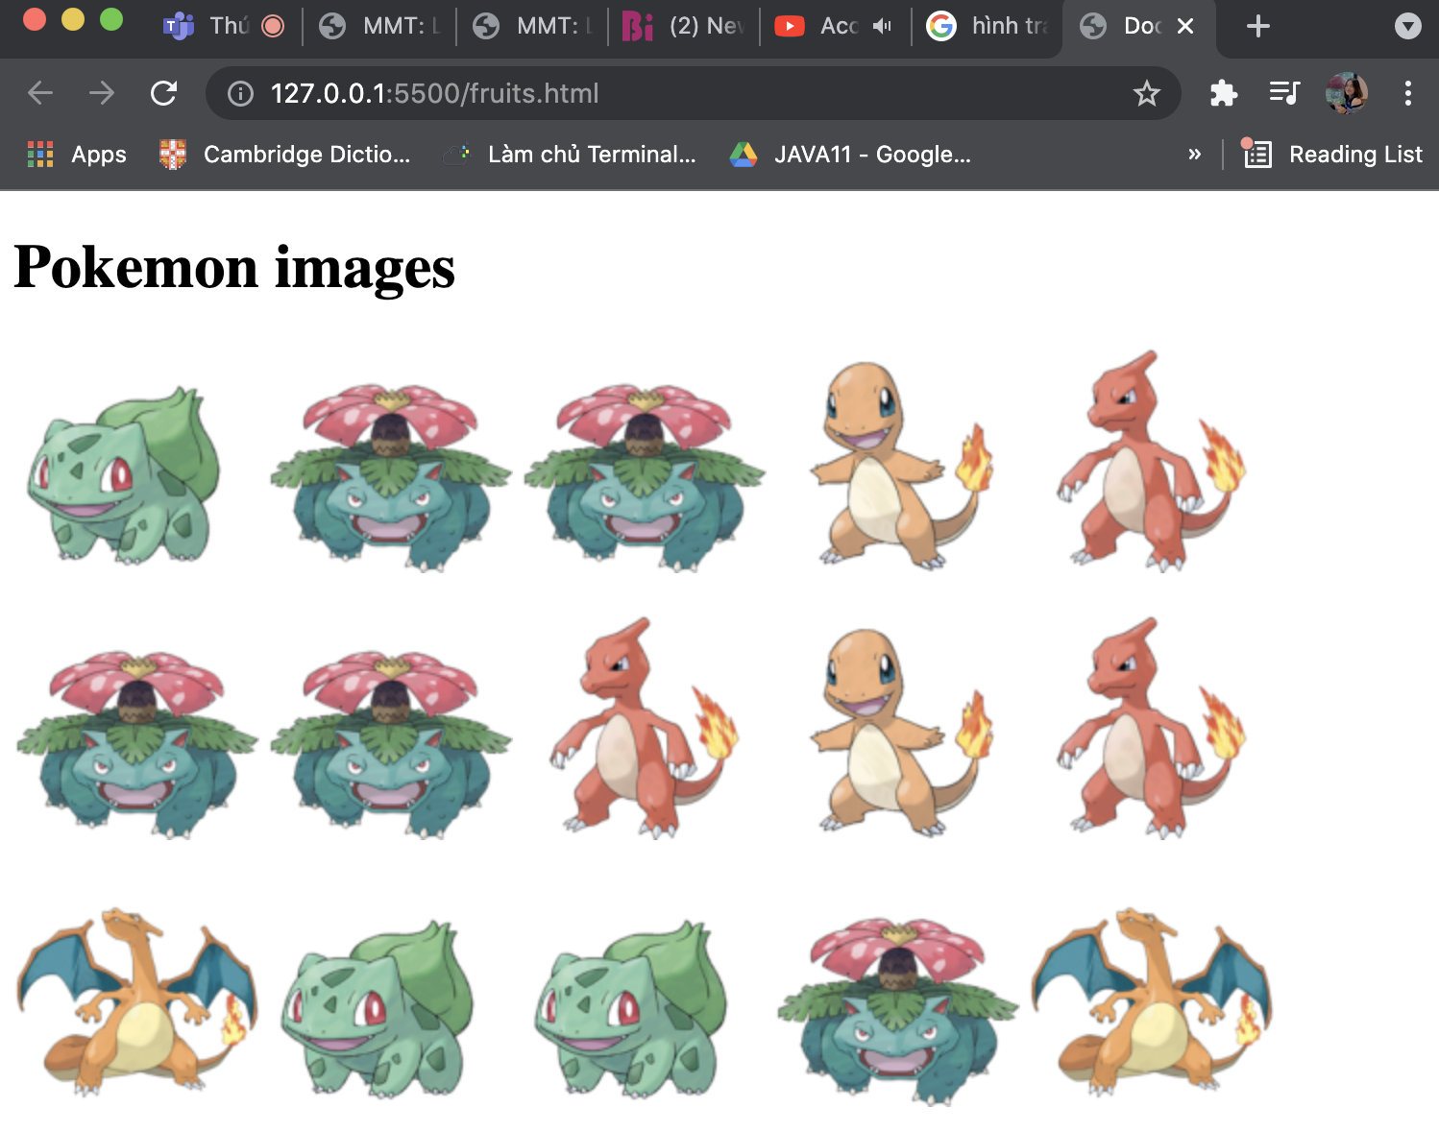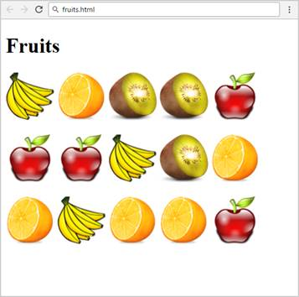

Create "**fruits.html**"

**2.1         Constraints**

·         **Titile: Fruits**

·        **<h1>** tag for **heading**

·         **<img> tag for images**

**2.2         Hints**

Use:

·        Use 3 **paragraphs**, each holding 5 images

Code:

<!DOCTYPE *html*>

<html *lang*="en">

<head>

<title>Pokemon</title>

</head>

<body>

<h1>Pokemon images</h1>

<p>

<img *src*="./images/1.png" *alt*="" />

<img *src*="./images/2.png" *alt*="" />

<img *src*="./images/2.png" *alt*="" />

<img *src*="./images/3.png" *alt*="" />

<img *src*="./images/4.png" *alt*="" />

</p>

<p>

<img *src*="./images/2.png" *alt*="" />

<img *src*="./images/2.png" *alt*="" />

<img *src*="./images/4.png" *alt*="" />

<img *src*="./images/3.png" *alt*="" />

<img *src*="./images/4.png" *alt*="" />

</p>

<p>

<img *src*="./images/5.png" *alt*="" />

<img *src*="./images/1.png" *alt*="" />

<img *src*="./images/1.png" *alt*="" />

<img *src*="./images/2.png" *alt*="" />

<img *src*="./images/5.png" *alt*="" />

</p>

</body>

</html>

**3.    Wiki Page**

Create a Web Page like the following.

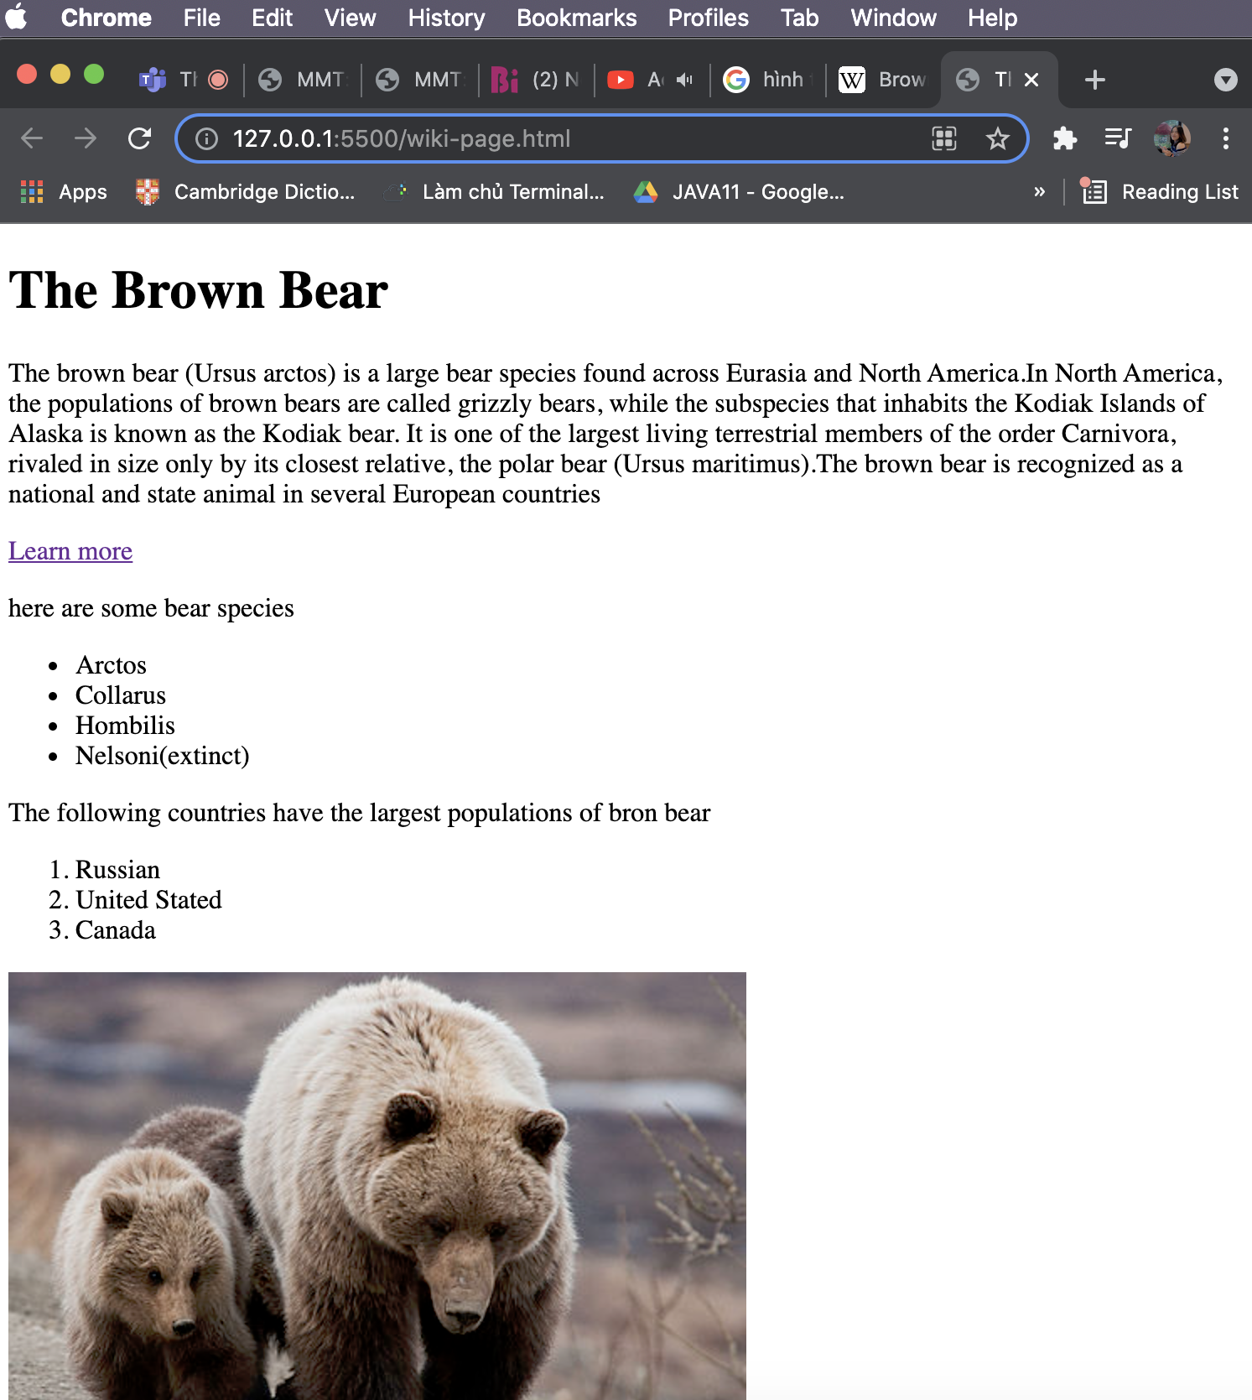

Create file: "**wiki-page**"

**3.1         Constraints**

·        Title: **The Brown Bear**

o   **<h1>** for heading

·        Hyperlink: <https://en.wikipedia.org/wiki/Brown_bear>

·        Text: **use paragraph**

·        List: **use ordered list and unordered list**

·        Image: **bear.jpg**

**Code:**

*<!DOCTYPE html>*

*<html lang="en">*

*<head>*

*<title>The Brown Bear</title>*

*</head>*

*<body>*

*<h1>The Brown Bear</h1>*

*<p>*

*The brown bear (Ursus arctos) is a large bear species found across Eurasia*

*and North America.In North America, the populations of brown bears are*

*called grizzly bears, while the subspecies that inhabits the Kodiak*

*Islands of Alaska is known as the Kodiak bear. It is one of the largest*

*living terrestrial members of the order Carnivora, rivaled in size only by*

*its closest relative, the polar bear (Ursus maritimus).The brown bear is*

*recognized as a national and state animal in several European countries*

*</p>*

*<a href="https://en.wikipedia.org/wiki/Brown_bear">Learn more</a></a>*

*<p>here are some bear species</p>*

*<ul>*

*<li>Arctos</li>*

*<li>Collarus</li>*

*<li>Hombilis</li>*

*<li>Nelsoni(extinct)</li>*

*</ul>*

*<p>The following countries have the largest populations of bron bear</p>*

*<ol>*

*<li>Russian</li>*

*<li>United Stated</li>*

*<li>Canada</li>*

*</ol>*

*<img src="./images/bear.jpg" alt="">*

*</body>*

*</html>*

**4.    To Do List**

Create a Web Page like the following

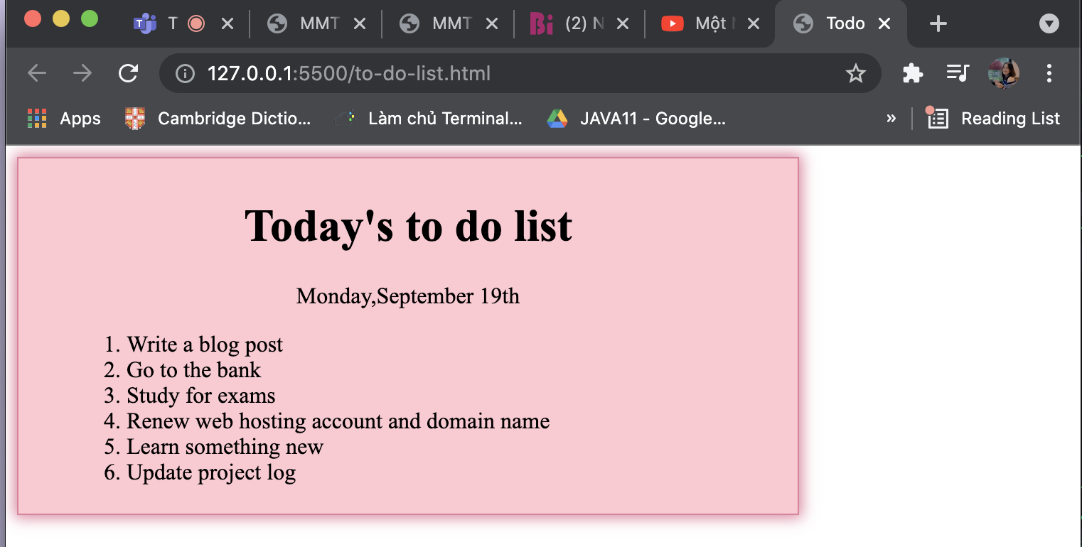

Create two files: "**to-do-list.html**" and "**to-do-list.css**"

**4.1         Constraints**

·        **<div>**with **class="my-list"**as container

o   Background color: **#f7f381;**

o   Padding: **8px 24px**;

o   Width: **500px**;

o   Text size: **30px;**

o   Border: **1px solid #f7f381**;

o   Background Color: **#f7f381**;

o   box-shadow: **0 0 10px 2px #333333;**

·        **<ol>**

o   Margin: **12px;**

·         **<p>**

o   Center the text

**4.2         Hints**

·        Center the **container**

·        Heading: use **<h1>**

·        Date: use **<p>** + center it

·        List: use **<ol>**

**Code:**

Html:

<!DOCTYPE *html*>

<html *lang*="en">

<head>

<title>Todo</title>

<link *rel*="stylesheet" *href*="to-do-list.css" />

</head>

<body>

<div *class*="my-list">

<h1>Today's to do list</h1>

<p>Monday,September 19th</p>

<ol>

<li>Write a blog post</li>

<li>Go to the bank</li>

<li>Study for exams</li>

<li>Renew web hosting account and domain name</li>

<li>Learn something new</li>

<li>Update project log</li>

</ol>

</div>

</body>

</html>

Css:

body {

font-family: "Times New Roman", Times, serif;

}

*.my-list* {

background-color: pink;

padding: 8px 24px;

width: 500px;

text-size-adjust: 30px;

border: 1px solid palevioletred;

box-shadow: 0 0 10px 2px palevioletred;

}

*.my-list* ol {

margin: 12px;

}

*.my-list* p,

h1 {

text-align: center;

}

**4.3         HTML Lists**

Create a Web Page like the following

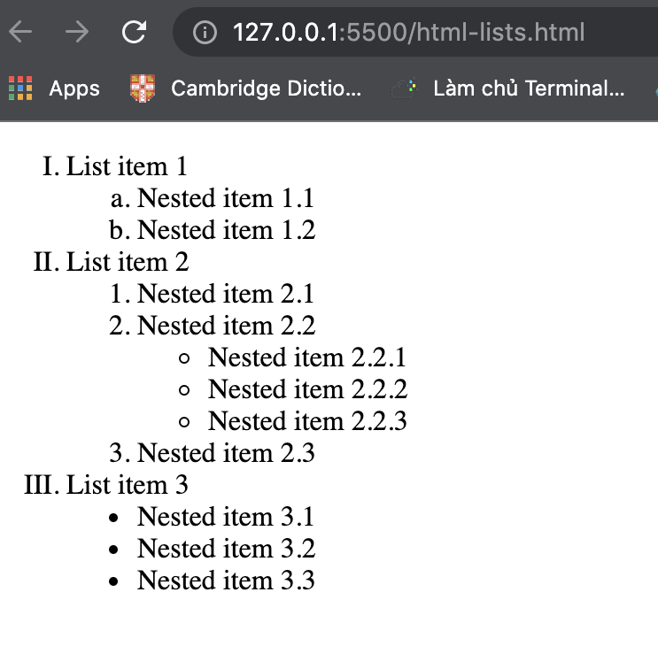

Create file: "**html-lists.html**"

**4.4         Hints**

Use: **<ol>**, **<ul>** and **<li>** and **<span>** for List Item 1, List item 2 and List Item 3

Code:

<!DOCTYPE *html*>

<html *lang*="en">

<head>

<title>List</title>

</head>

<body>

<ol *class*="list" *type*="I">

<li>List item 1</li>

<ol *class*="list-item1" *type*="a">

<li>Nested item 1.1</li>

<li>Nested item 1.2</li>

</ol>

<li>List item 2</li>

<ol *class*="list-item2" *type*="1">

<li>Nested item 2.1</li>

<li>Nested item 2.2</li>

<ul *class*="list-item22" *style*="list-style-type: circle">

<li>Nested item 2.2.1</li>

<li>Nested item 2.2.2</li>

<li>Nested item 2.2.3</li>

</ul>

<li>Nested item 2.3</li>

</ol>

<li>List item 3</li>

<ul *class*="list-item3" *style*="list-style-type: disc">

<li>Nested item 3.1</li>

<li>Nested item 3.2</li>

<li>Nested item 3.3</li>

</ul>

</ol>

</body>

</html>